Geophysical investigation of groundwater potentials and shallow aquifer vulnerability in parts of Lagos, Southwestern Nigeria

.
ABSTRACT

Aims: This study assessed the use of geophysical methods in investigating aquifer properties and vulnerability
Place and Duration of Study: Eti-Osa and its surroundings, Lagos, Southwestern Nigeria; between 2023-2024
Methodology: This study combined electro-geophysical and hydrogeological techniques to investigate aquifer geo-hydraulic parameters. Electrical resistivity was measured using the ABEM SAS 4000 resistivity meter in the Schlumberger configuration, with a maximum current electrode separation of 1000m. Thirteen VES datasets were acquired along profiles and analyzed to produce a layered earth model. Computer-iterative inversion models simulated the VES data, generating resistivity curves for interpretation of the subsurface geo-electrical structure.
Results: Results of the study show that the highest aquifer resistivity recorded within the study area is 961Ωm while the least is 11.7Ωm with a mean resistivity of 289.5Ωm. Aquifer thickness ranged from 25.3m to 11.68m, and aquifer depth varied between 41.5m and 15.23m. Longitudinal conductance of the aquifer across the study area varied from 1.504Ω⁻¹ to 0.015Ω⁻¹ while aquifer transverse resistance ranged from 13564.8Ωm² to 205.92Ωm². Results of aquifer hydraulic parameters show that hydraulic conductivity across the study location varied between 0.6666m/day and 0.1940m/day with aquifer transmissivity varying between 14.94m²/day and 2.8m²/day. Aquifer storativity ranged from 0.000035/m to 0.0000759/m, while hydraulic diffusivity varied between 373403.2$m^{2}$/day and 87687.44$m^{2}$/day. In addition, a novel model equation for accurately predicting longitudinal conductance from aquifer resistivity for the study area and regions with similar geology was generated and validated using statistical parameters. Results of aquifer vulnerability showed that 69.23% of the total sampled area is strongly susceptible to surface pollutants, 23.01% showed moderate susceptibility, and 7.69% possess good aquifer protective capacity.
Conclusion: This study has revealed that measures should be put in place in this area to protect groundwater resources and guarantee their availability for future generations. Effective groundwater management including stakeholder participation, continuous monitoring, and the integration of geophysical methods with other hydrogeological studies is, therefore, recommended.

Keywords: Aquifer, Lagos, Hydraulic conductivity, Transmissivity, Vulnerability, Storativity.

1. INTRODUCTION

In addition to being a significant source of drinkable water for human health, groundwater is a vital natural resource that is essential for industrial, commercial, and agricultural activities (Akaolisa, Agbasi, et al., 2022). It contributes significantly to the world's freshwater supply, making up around 99% of the total volume of freshwater that is now in use (Akakuru et al., 2023). According to reports, water is becoming a limited resource, and is growing increasingly scarce in many parts of the world (Falowo, 2022). Water resources will continue under tremendous pressure from competition among users, including industry, agriculture, and hydroelectricity (Akaolisa, 2006). This is particularly true in dry and semi-arid regions of the globe, where a lack of water might be a major economic constraint. According to (Adegbola et al., 2016), this is the situation in Lagos State where an extraordinary rise in population and urbanization is endangering the availability of water owing to excessive water abstraction that is overstressing the aquifer systems. They further stated that as a result, circumstances regarding the amount and quality of groundwater resources need to be improved for more than 70% of water consumers.
A thorough knowledge of aquifer recharge, carrying capacity, discharge rates, and other related factors is necessary for an accurate evaluation, effective management, and quantitative assessment of groundwater assets (Emberga et al., 2019). It is essential to tackle the many hydrological and hydrogeological obstacles linked to the discovery and use of groundwater. The quantity and quality of groundwater are vital in every given society, especially for domestic use; its depletion might lead to extremely high levels of water stress (Akaolisa, Agbasi, et al., 2022; Ige et al., 2022). As a result, several scientists have identified, described, and estimated the geometric and geo-hydraulic properties of the aquifer systems using a range of geological and geophysical techniques (Akakuru et al., 2023; Ige et al., 2022: Adesola et al., 2023; Adeoti, 2012). Electrical resistivity techniques are becoming increasingly important for groundwater assessment because they provide a non-invasive, cost-effective way to identify potential aquifer locations, create detailed subsurface images, determine aquifer thickness and depth, and map variations in groundwater quality by detecting changes in electrical resistivity based on the water content and composition of different geological layers (Puttiwongrak et al., 2021; Oyeyemi et al., 2022; Osumeje et al., 2024). Using this method, the potential difference that arises from an electrical current sinking into the earth is measured. One such study was conducted by Oyeyemi et al. (2023), which investigated the implications of coastal groundwater resources in Agbado-Ijaye, Lagos, southwestern Nigeria. This study employed a combination of Vertical Electrical Sounding (VES) and Two-Dimensional (2D) electrical resistivity imaging techniques. Twenty VES stations were investigated with electrode spacing of 1-200m, and four 2D imaging traverses were conducted with interelectrode spacing of 10-60m. The imaging sections delineated two distinct aquifers: a shallow, low-yield aquifer (max depth: 5.5m) and a deeper, high-yield aquifer (max depth: 30.4m) belonging to the Benin Formation and Dahomey Basin, respectively.
Vulnerability assessments, on the other hand, usually clarify the aquifer's susceptibility to impurities that may degrade groundwater quality. Studies on groundwater contamination are very essential to assess the quality of life of people residing within contamination-prone areas (Akiang et al., 2024; Akiang et al., 2025). Various circumstances, including inadequate waste management systems, industrialization, urbanization, bad agricultural practices (such as overuse of chemical fertilizers), floods, and so on, may lead to this compromise (Agbasi, 2022). Lagos, the economic hub of Nigeria, has many challenges to its groundwater resources, including exposed trash disposal sites, subterranean petroleum product pipelines, the Olusosun landfill which is a major unplanned garbage disposal site, and extensive surface water bodies such as the Atlantic Ocean and Lagos Lagoon. Aquifer susceptibility to surface pollutants has been the subject of several studies conducted in Lagos state and its environs (Majolagbe et al., 2016; Oli et al., 2022). To estimate aquifer vulnerability, this research instead applied indexing approaches using the Dar-Zarrouk parameter of longitudinal conductance. Several techniques for evaluating and assessing vulnerabilities have also been created, such as the hybrid approach, overlay index method, statistical techniques, modeling, and simulation. According to Fiori et al. (2023), the overlay and index approach was created by connecting regional maps and qualitatively interpreting the data via parameter indexing and weight assignment in the Campania region, Southern Italy.
Groundwater supplies are under tremendous pressure due to growing urbanization and the need for clean water. Zones that have the potential to provide an adequate quantity of groundwater must be identified to facilitate its development (Agbasi, 2022; Okoli et al., 2024). This is because a sustainable and easily accessible groundwater supply is required. These groundwater resources are negatively impacted by the human activities that coincide with the growth of urbanization. The issue of elevated iron levels in water is seen in some parts of Lagos State. This affects the region's water quality, which in turn affects the residents' health. Hence, gathering data on the region's aquiferous zones' sensitivity to contamination and potential for yielding of aquifers is crucial. There are many different approaches used in aquifer vulnerability assessments, such as Lagrande, DRASTIC, SINTACS, GOD, longitudinal conductance, Integrated Electrical Conductance (IEC), etc. Nonetheless, the evaluation of aquifer vulnerability is increasingly reliant on electrical techniques. Despite the existing body of research on aquifer potential and vulnerability to surface pollutants, previous studies have primarily relied on geological methods in isolation. A significant research gap exists in the integration of geophysical approache to provide a more comprehensive understanding of aquifer systems. Furthermore, there is a lack of predictive models that can accurately delineate aquifer hydraulic parameters, hindering the effective management and protection of these vital resources. This study addresses these gaps by using geophysical methods to investigate aquifer potential and vulnerability, and by developing and validating predictive models for aquifer hydraulic parameters using statistical techniques.

1.1 Location, Physiography, and Climate of the Study Area
Eti-Osa and its surroundings constitute the research area. It is situated between latitudes 6°20' N and 6°40' N and longitudes 3°15' E and 3°40' E. The terrain has low relief and is comparatively flat, rising between three and five meters above sea level. The Lagos and Lekki Lagoons, which are supplied by the River Oni in the northeast and the Rivers Oshun and Saga in the northwest, define the drainage system. A tropical climate with fluctuating wet and dry seasons, an average annual temperature of around 28°C, and an annual rainfall of about 1,532 mm are noted in Eti-Osa. There are two known peaks in the wet (rainy) season; typically, they occur in May through July and September through October. The map of the study location and the sampling points are shown in Fig.1.

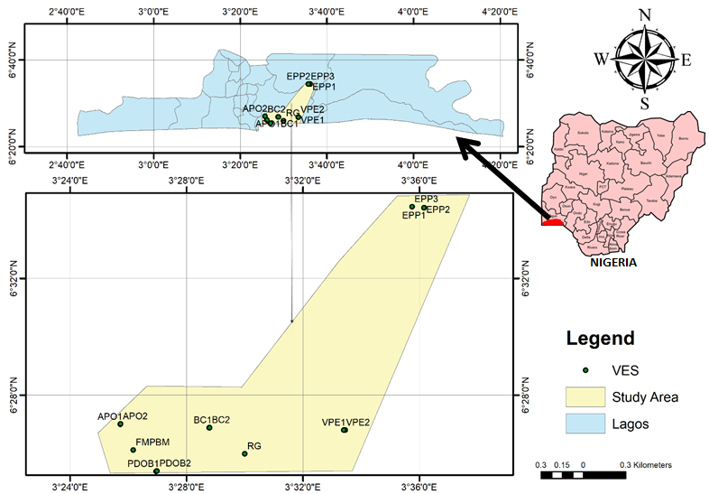
Fig. 1. Map of the study location showing sampling points

1.2 Geology of the Study Area
Eti-Osa, the study area, is located in southwestern Nigeria which is underlain by the sedimentary deposits of the Dahomey basin (Tijani et al., 2020). The geology consists of quaternary alluvial deposits such as red-yellow, red-brown, and grey sandy clays, silt, sand, gravel, and other detrital materials. Dahomey Basin, also known as the Benin Basin, is one of the many sedimentary marginal basins in Nigeria, formed as a result of the opening of the South Atlantic. The basin has two sections; the western section outside of Nigeria, and the eastern section within Nigeria. The eastern section of the basin (i.e. the part of Dahomey basin within Nigeria) is found in southwestern Nigeria. The basin stretches a total latitudinal length of 500km from the eastern part of Accra in Ghana and cuts through Togo and the Republic of Benin before eventually terminating in Nigeria, near Okitipupa (Nwajide, 2015). Fig.2 shows the geological map of the study area.
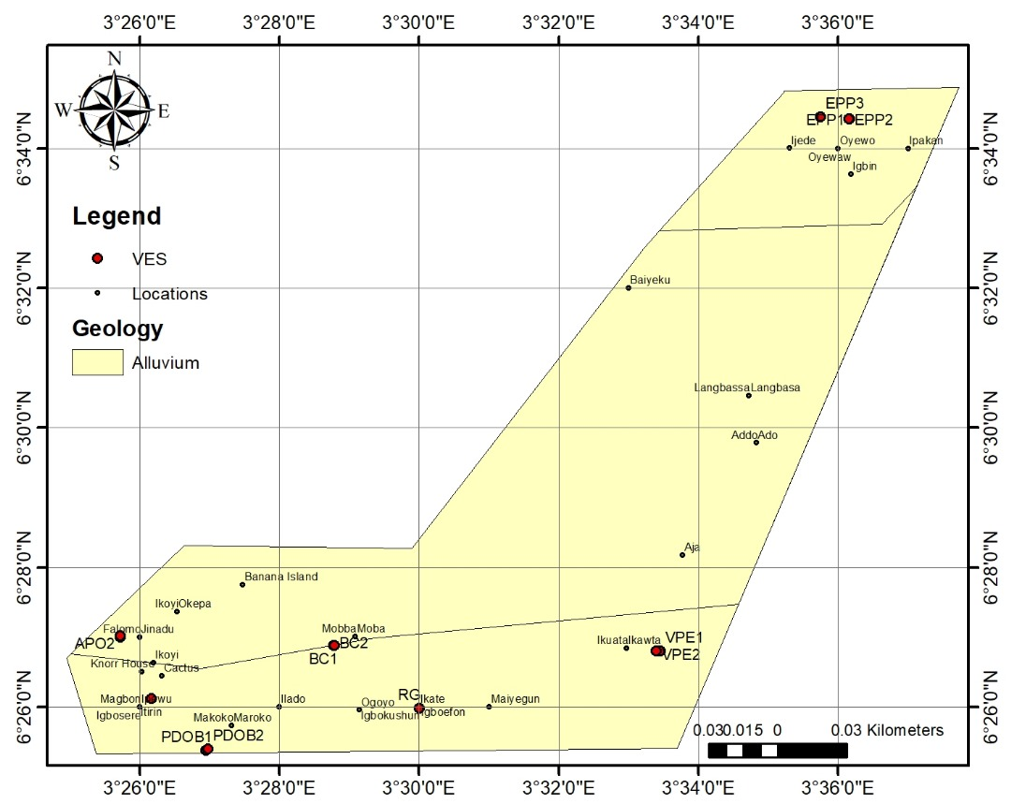

Fig. 2. Geological map of the study area showing the VES points

2. material and methods
This study utilized electro-geophysical techniques to determine aquifer geo-hydraulic parameters and their vulnerability to surface pollutants. The resistivity was measured using the ABEM SAS 4000 resistivity meter employing the Schlumberger configuration. A maximum current electrode separation of 1000m was employed in this investigation. Thirteen VES datasets in all were gathered at different points along profiles. The thirteen VES datasets were conducted at strategically selected points in the study area, informed by geological and hydrogeological mapping, existing borehole locations, topographic features, and land use patterns. After analyzing the half-current electrode spacing and consequent resistivity, a layered earth model with distinct layers of predetermined thickness and apparent resistivity was produced. The acquired VES data were analyzed using IPI2win software to create 1D resistivity curves and 2D geospatial resistivity maps. IPI2win is a software package designed for processing and interpreting electrical resistivity tomography (ERT) and VES data (Raji & Abdulkadir, 2020). The software uses an iterative least-squares inversion algorithm to generate a 1D resistivity model that best fits the measured data. The resulting models were then used to interpret the subsurface resistivity distribution and delineate the aquifer systems.

2.1 Data Analysis
Theoretically, the resistivity (ρ) of a material is directly proportional to the potential difference (V) and inversely proportional to the induced current (I). This is represented in Equations 1 and 2 as
$ρ∝\frac{V}{I}$ (1)
$ρ=K\left(\frac{V}{I}\right)$ (2)
Where, K is the geometric factor and can be obtained with the relationship stated in Equation 3 as
$K=π\left\{\frac{\left[{\left(\frac{AB}{2}\right)}^{2}-{\left(\frac{MN}{2}\right)}^{2}\right]}{MN}\right\}$ (3)
Hence, Equation 2 transforms to Equation 4 as
$ρ=π\left(\frac{a^{2}}{b}-\frac{b}{4}\right)R$ (4)
But ρ = KR
Where R is the resistance. Hence, apparent resistivity was obtained through the multiplication of resistance recorded in the field with the geometric factor.

2.2.1 Aquifer Dar-Zarrouk parameters
The geo-electric characteristic used to identify specific regions of groundwater potential is called longitudinal conductance. According to Onyeanwuna et al. (2024) and Ekwe et al. (2018), areas with high longitudinal conductance values often have a reasonably thick succession and should be given the greatest priority in terms of their groundwater potential. By dividing the aquifer's resistivity (ρ) by its thickness (h), one may get the longitudinal conductance (Niwas & Singhal, 1981) as stated in Equation 5 as
$L_{C} =\frac{h}{ρ}$ (5)
Target locations with excellent groundwater potential are defined by several factors, one of which is the transverse resistance ($R_{T}$). There is a clear correlation between it and transmissivity, and the aquifers with the greatest Transverse Resistance values are probably also those with the highest transmissivity values. The relationship between transverse resistance, layer thickness, and apparent resistivity is given in Equation 6 as
$R_{T}=hρ$ (6)
2.1.3 Aquifer geo-hydraulic parameters
The ease of passage of water through a porous rock unit is directly related to the hydraulic conductivity, K, which expresses the degree of permeability of groundwater through underground rock units. A correlation between the apparent resistivity and bulk resistivity of an aquifer was discovered by Heigold et al. (1979), and this correlation impacts hydraulic conductivity as represented in Equation 7a as
$K={386.40ρa}^{-0.93283}$ (7a)
Where 𝜌a = 𝑎𝑝𝑝𝑎𝑟𝑒𝑛𝑡 𝑟𝑒𝑠𝑖𝑠𝑡𝑖𝑣𝑖𝑡𝑦 𝑖𝑛 Ωm. The unit of 𝐾 is given as m/𝑑𝑎y
Similarly, Niwas and Singhal (1981) generated a geologically-constrained model generated by cross-plotting longitudinal conductance and aquifer resistivity (equation 7b). Using the least squares regression approach and based on the coefficient of determination (R^2), the performance prediction of this model was 0.605.
K_{AK}= 6E-07ρ^{1.720} (7b)
Transmissivity is calculated by multiplying hydraulic conductivity K by the aquifer's thickness h. The ability of an aquifer to transport fluid throughout its complete thickness, or its transmissivity, affects groundwater flow between aquifer units (Eugene-Okorie et al., 2020; Onyeanwuna et al., 2024). The relationship between layer thickness and hydraulic conductivity is given by Niwas and Singhal (1981) in Equation 8 as
$T_{r}$ = Kh (m²/day) (8)
Transmissivity values provide information on an aquifer's permeability and water-bearing capacity in a particular area, according to research by Akakuru et al. (2023). An aquifer's high permeability and water-bearing potential may be inferred from its high transmissivity rating. Todd (1981) provided a generality model, given in Equation 9, which may be used to determine the storativity (S) of both the confined aquifer system and the thick and deep unconfined aquifer that may be hydraulically equivalent to it.
$S={3x10}^{-6}b$ (9)
Where $b$ is the saturated thickness of the aquifer. Hiscock, (2005) found that by integrating the spring properties of transmissivity T and Storage S, it is possible to characterize a single developmental limit called the hydraulic diffusion coefficient D; given in Equation 10 as
$D=\frac{T}{S}$ (10)
2.1.4 Aquifer vulnerability
The capacity of the overburden unit to delay and filter ground surface contaminating fluid penetration into the aquiferous unit is known as integrated electrical conductivity (Onyeanwuna et al., 2024). Using the longitudinal conductance obtained for every VES station, it was assessed for the research region. According to Akakuru et al. (2023), a unit's or layer's longitudinal conductance is obtained using Equation 11 given as:
$L_{C}$ = $\frac{b}{ρ}$ (11)
Where: $L_{C}$ = Longitudinal Conductance; b = Layer Thickness; ρ = Layer Resistivity
Integrated Electrical Conductivity, IEC, can be used to assess the aquifer vulnerability and it is given in Equation 12 as:
IEC = $\sum_{i=1}^{n}{\frac{h_{i}}{ρ_{i}}}$ or $\sum_{i=1}^{n}{σ_{i}h_{i}}$ (12)

Where, $ρ_{i}$ = Resistivity of layer I; $h_{i}$ = Thickness of each layer above the aquifer, obtained from the inversion of resistivity sounding; $σ_{i}$ = Conductivity of layer i. The estimated IEC unit is ${ohm}^{-1}$ ($Ω^{-1}$) or Siemens (S). The vulnerability index or integrated conductivity is calculated for all layers above the groundwater table in the study area

3. results and discussion

3.1 Results
3.1.1 Results of Aquifer Electrical and Geometrical Parameters
The obtained model vertical electrical sounding (VES) curves show the existence of 5 different layers in 7 (APO 1, APO 2, BC, BC 2, RG, PDOB 1, PDOB 2) out of the 13 locations, 6 layers in 5 (EPP 1, EPP 2, EPP 3, VPE 1, and VPE 2), and 4 layers in one location (FMPBM). Fig.3 shows the VES curves obtained at APO 1, EPP 1, FMPBM, and VPE 1 with their corresponding curve types denoted as A, A, K, and, K. Table 1 is the result of aquifer resistivity, thickness, and depth. The selection of the layer inferred to be the aquifer in Table 1 was based on a combination of factors, including resistivity values, thickness, depth, geological and hydrogeological context, and correlation with existing borehole data. Specifically, layers with high resistivity values (>200 Ωm), sufficient thickness (>5 m), and depths ranging from 10-50 m were considered potential aquifers. The selected layer was also consistent with the expected geological and hydrogeological setting of the area, and correlated with existing borehole data showing high water yield in the corresponding zone (Oyeyemi et al., 2023; Adeoti, 2012). The highest aquifer resistivity value recorded within the study location was observed at APO 1 with a value of 961Ωm while the least was observed at FMPBM with a value of 11.7Ωm. A mean aquifer resistivity value of 289.5 was recorded across the study area. The highest aquifer thickness was observed at VPE 2 with the value of 25.3m followed by VPE 1 with an aquifer thickness of 24.6m. The least aquifer thickness value of 11.68m was recorded at BC 2, and the area has a mean aquifer thickness of 17.24m. Aquifer depth ranges from 41.5m at EPP 3 to 15.23m at PDOB 3 with a regional average of 26.1m. Fig.4 shows the geospatial map of the aquifer resistivity of the study area, Fig.5 is the aquifer thickness map, and Fig.6 is the aquifer depth map.

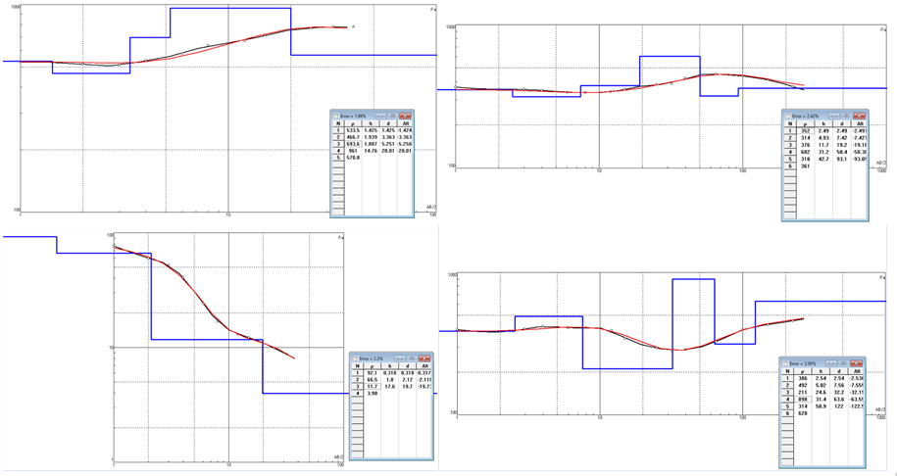
Fig. 3. Obtained VES curves of some locations of the study area

Table 1. Results of aquifer electrical and geometrical parameters
VES | Latitude | Longitude | Aquifer resistivity (Ωm) | Lithology | Aquifer thickness (m) | Aquifer depth  (m)
APO 1 | 6° 27' 0'' N | 3° 25' 43.392'' E | 961.00 | Sand | 14.76 | 20.01
APO 2 | 6° 27' 0.9'' N | 3° 25' 43.5'' E | 70.90 | highly weathered formations | 14.30 | 22.30
BC 1 | 6° 26' 52.908'' N | 3° 28' 46.596'' E | 85.57 | highly weathered formations | 16.54 | 20.00
BC 2 | 6° 26' 53.088'' N | 3° 28' 47.388'' E | 442.10 | Clayey Sand | 11.68 | 20.00
EPP 1 | 6° 34' 25.284'' N | 3° 36' 9.9'' E | 376.00 | Clayey Sand | 11.70 | 19.20
EPP 2 | 6° 34' 25.392'' N | 3° 36' 9.504'' E | 477.00 | Clayey Sand | 22.00 | 35.80
EPP 3 | 6° 34' 27.516'' N | 3° 35' 44.916'' E | 628.00 | Sand | 21.60 | 41.50
FMPBM | 6° 26' 7.116'' N | 3° 26' 9.996'' E | 11.70 | highly weathered formations | 17.60 | 19.70
RG | 6° 25' 59.088'' N | 3° 30' 0'' E | 189.20 | Clayey Sand | 18.29 | 24.41
PDOB 1 | 6° 25' 22.8'' N | 3° 26' 57.084'' E | 179.10 | Clayey Sand | 12.82 | 20.00
PDOB 2 | 6° 25' 23.916'' N | 3° 26' 58.884'' E | 26.94 | highly weathered formations | 12.93 | 15.23
VPE 1 | 6° 26' 48.012'' N | 3° 33' 27'' E | 211.00 | Clayey Sand | 24.60 | 32.20
VPE 2 | 6° 26' 48.012'' N | 3° 33' 24.012'' E | 105.00 | Clayey Sand | 25.30 | 48.00

Fig. 4. 2D geospatial map of aquifer resistivity within the study location

Fig. 5. 2D geospatial map of aquifer thickness within the study location

Fig. 6. 2D geospatial map of aquifer depth within the study location
Fig.7 and Fig.8 are the geospatial maps of the Dar-Zarrouk parameters of aquifer longitudinal conductance and transverse resistance, respectively. The aquifer longitudinal conductance across the study area varies between 1.504Ω⁻¹ to 0.015Ω⁻¹ at FMPBM and APO 1, respectively. A mean longitudinal conductance value of 0.235Ω⁻¹ was observed across the study area. The highest aquifer transverse resistance across the study area is 13564.8 Ωm² observed at EPP 3 with least value of 205.92 Ωm² recorded at FMPBM. An average transverse resistance of 4953.320Ωm² was observed across the study area. The results of aquifer Dar-Zarrouk parameters are presented in Table 2.
Table 2. Results of aquifer Dar-Zarrouk parameters
VES | Longitudinal Conductance ($Ω^{-1}$) | Transverse Resistance  ($Ωm^{2}$)
APO 1 | 0.015359 | 14184.3600
APO 2 | 0.2016925 | 1013.8700
BC 1 | 0.193292 | 1415.3278
BC 2 | 0.0264194 | 5163.7280
EPP 1 | 0.031117 | 4399.2000
EPP 2 | 0.0461216 | 10494.0000
EPP3 | 0.0343949 | 13564.8000
FMPBM | 1.5042735 | 205.9200
RG | 0.0966702 | 3460.4680
PDOB 1 | 0.0715801 | 2296.0620
PDOB 2 | 0.4799555 | 348.3342
VPE 1 | 0.1165877 | 5190.6000
VPE 2 | 0.2409524 | 2656.5000

Fig.7 Geospatial map of aquifer longitudinal conductance within the study area

Fig. 8. Geospatial map of aquifer transverse resistance within the study area
A new model equation constrained by the local geology of the study area was generated by crossplotting longitudinal conductance and aquifer resistivity obtained from the study as shown in Fig.9. Using the least squares regression approach and based on the coefficient of determination ($R^{2}$), the performance prediction of this model is 0.95 (95%). This implies that about 95% of the variation in the longitudinal conductance can be predicted from the aquifer resistivity. Hence, the model can be relied upon for accurate prediction of longitudinal conductance from aquifer resistivity within the study area and other regions with similar geologic settings. The new model is stated in Equation 13.
$c_{L}$= 16.068$ρ^{-0.993}$ (13)
Where $c_{L}$ is the longitudinal conductance, and $ρ$ is the aquifer resistivity.
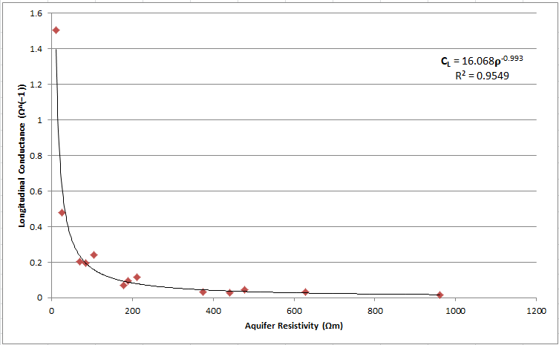
Fig. 9. Cross plot of longitudinal conductance against aquifer resistivity
3.1.2 Results of aquifer geo-hydraulic parameters
Results of aquifer hydraulic parameters are presented in Table 3a. The average aquifer hydraulic conductivity across the study location was recorded as 0.4897 m/day. The highest K value was observed at FMPBM with a value of 0.6666 m/day while the least was recorded at APO 1 with a value of 0.1940 m/day as shown in Fig.10. The result of aquifer transmissivity, T showed that VPE 2 recorded the highest value with a transmissivity of 14.94$m^{2}$/day, while APO 1 showed the least with a value of 2.86 $m^{2}$/day, with a mean value of 8.45$m^{2}$/day recorded across the study area as shown on the geospatial map of Fig.11. Todd (1980) developed a relationship for the estimation of storativity as represented in Equation 9. The highest aquifer storativity value of 0.0000759/m was recorded at VPE 2 with the least observed at BC 2 with a value of 0.00003504/m. Across the study area; the average storativity obtained was 0.00005172/m. On the other hand, the hydraulic diffusivity across the study area ranges from 373403.2$m^{2}$/day at VPE 2 to 87687.44$m^{2}$/day at APO 1. The mean diffusivity across the study area was found to be 238737.94$m^{2}$/day.
Table 3a. Results of aquifer hydraulic parameters
VES | Hydraulic conductivity (m/day) | Transmissivity ${(m}^{2}$/day) | Storativity (/m) | Diffusivity ${(m}^{2}$/day)
APO 1 | 0.1940 | 3.8828 | 0.00004428 | 87687.44
APO 2 | 0.6172 | 13.7637 | 0.0000429 | 320832.2
BC 1 | 0.6055 | 12.1110 | 0.00004962 | 244075
BC 2 | 0.3809 | 7.6188 | 0.00003504 | 217431.5
EPP 1 | 0.4151 | 7.9704 | 0.0000351 | 227076.9
EPP 2 | 0.3640 | 13.0328 | 0.000066 | 197466.7
EPP 3 | 0.2992 | 12.4151 | 0.0000648 | 191591
FMPBM | 0.6666 | 13.1317 | 0.0000528 | 248706.4
RG | 0.5292 | 12.9184 | 0.00005487 | 235436.5
PDOB 1 | 0.5362 | 10.7244 | 0.00003846 | 278845.6
PDOB 2 | 0.6535 | 9.9529 | 0.00003879 | 256584.2
VPE 1 | 0.5144 | 16.5649 | 0.0000738 | 224456.6
VPE 2 | 0.5904 | 28.3413 | 0.0000759 | 373403.2

Table 3b: Summary of hydraulic conductivities using different empirical models
VES | KNM  (K_{NM}= 16.068 ρ^{-0.993}) | KHG  (K_{HG}= 386.4ρ^{-0.9328}) | KAK  (K_{AK}= 6E-07ρ^{1.720})
APO 1 | 0.194 | 0.637768786 | 0.080990761
APO 2 | 0.6172 | 7.256025331 | 0.000914667
BC 1 | 0.6055 | 6.088490364 | 0.001263992
BC 2 | 0.3809 | 1.315879787 | 0.021303283
EPP 1 | 0.4151 | 1.530469363 | 0.016124058
EPP 2 | 0.364 | 1.225842906 | 0.024277438
EPP 3 | 0.2992 | 0.948454329 | 0.038962053
FMPBM | 0.6666 | 38.95841686 | 4.12507E-05
RG | 0.5292 | 2.904402341 | 0.004948295
PDOB 1 | 0.5362 | 3.056905142 | 0.004502727
PDOB 2 | 0.6535 | 17.8944903 | 0.000173155
VPE 1 | 0.5144 | 2.623473701 | 0.005969213
VPE 2 | 0.5904 | 5.030499427 | 0.001797202

Fig. 10. Geospatial map of aquifer hydraulic conductivity within the study location

Fig. 11. Geospatial map of aquifer transmissivity within the study location

3.1.3 Results of aquifer vulnerability and aquifer potential summary
The results of aquifer vulnerability as presented in Table 4 and based on the rating by Atakpo and Ayolabi (2008) showed that 69.23% of the total sampled area is strongly susceptible to surface pollutants from point and nonpoint sources. On the other hand, 23.01% showed moderate susceptibility, while only 7.69% of the sampled locations revealed good aquifer protective capacity.

Table 4 Results of aquifer vulnerability inferred from longitudinal conductance based on the rating by (Atakpo & Ayolabi, 2008)
VES | Longitudinal Conductance ($Ω^{-1}$) | Protective capacity rating | Groundwater supply potential
APO 1 | 0.015359 | Poor | Reduced extraction for personal use of the nearby water source
APO 2 | 0.2016925 | Moderate | Removal of the nearby water source (small village)
BC 1 | 0.193292 | Weak | Removal of the nearby water source (small village)
BC 2 | 0.0264194 | Poor
EPP 1 | 0.031117 | Poor | Reduced extraction for personal use of the nearby water source
EPP 2 | 0.0461216 | Poor | Reduced extraction for personal use of the nearby water source
EPP 3 | 0.0343949 | Poor | Removal of the nearby water source (small village)
FMPBM | 1.5042735 | Good | Removal of the nearby water source (small village)
RG | 0.0966702 | Poor | Removal of the nearby water source (small village)
PDOB 1 | 0.0715801 | Poor | Removal of the nearby water source (small village)
PDOB 2 | 0.4799555 | Moderate | Removal of the nearby water source (small village)
VPE 1 | 0.1165877 | Weak | Reduced extraction for personal use of the nearby water source
VPE 2 | 0.2409524 | Moderate | Removal of the nearby water source (small village)

3.1.4 Statistical Validation of Aquifer Parameter Data
3.1.4.1 Descriptive Statistics
A comprehensive evaluation of empirical resistivity relationships for estimating aquifer hydraulic parameters was conducted to determine their accuracy and reliability. Statistical methods, including descriptive statistics, Pearson's correlation coefficient, and analysis of variance (ANOVA), were employed to assess the predictive capabilities of three empirical equations. These equations estimate hydraulic conductivity from surficial resistivity data in the study area, as presented in Table 3b. The results of the geo-statistical analysis, which provide insights into the relationships between the variables, are summarized in Tables 5, 6, and 7. This analysis enables the ranking and appraisal of the empirical equations, ultimately identifying the most suitable equation for estimating hydraulic conductivity in the study area. The results of the descriptive statistics for hydraulic conductivity estimates across the study area are presented in Table 5. The overall mean of 2.46 was used as a basis for comparing the estimates from different empirical relationships. This allowed for an assessment of the reliability and accuracy of each method. Two of the three methods employed yielded mean values close to the overall mean, indicating their reliability and potential for accurate hydraulic conductivity estimation. Specifically, the New Model equation (KNM) and Heigold et al. (1979) equation produced mean values of 0.5 and 6.9, respectively, suggesting that these methods are effective for estimating aquifer hydraulic conductivity from resistivity data. In contrast, the Akakuru et al. (2023) equation (KAK) yielded a mean value of 0.02, which is significantly lower than the other methods, implying that this technique is not suitable for the study area. This disparity highlights the importance of carefully selecting and validating empirical relationships for hydraulic conductivity estimation in different geological settings. Table 6 presents the results of the analysis of variance (ANOVA) test, which compared the mean hydraulic conductivity values estimated using different empirical relationships. The ANOVA results yielded an F value of 5.0277 and a p value of 0.0119, indicating statistically significant differences between the variances. Since the p value (0.0119) is below the 5% significance level (p≤0.05), it can be inferred that significant variations exist among the mean values obtained from the three empirical equations. This conclusion is supported by the statistical results, F (2, 36) = 5.0277, p<0.05. The results of the ANOVA test provide a robust statistical basis for comparing the performance of the different empirical relationships, and for identifying the most reliable method for estimating aquifer hydraulic parameters from resistivity data. The Pearson correlation matrix (Table 7) revealed significant relationships between the different empirical relationships. Notably, estimates from the New Model (KNM) showed a strong positive correlation with those from the Heigold et al. (1979) equation (KHG), indicating a high degree of agreement between these two techniques. Conversely, KNM estimates exhibited a strong negative correlation with those from the Akakuru et al. (2023) equation (KAK), suggesting a significant divergence between these methods.

Table 5. Descriptive statistics of the different empirical models for estimating hydraulic parameters
 | Count | Mean | Standard Deviation | Standard Error | Confidence Level (95.0%) | Minimum | Maximum | Median | Range
K_{NM} | 13 | 0.489708 | 0.1469679 | 0.040762 | 0.088811828 | 0.194 | 0.6666 | 0.5292 | 0.4726
K_{HG} | 13 | 6.882394 | 10.68007 | 2.962119 | 6.453901895 | 0.637769 | 38.95842 | 2.904402 | 38.32065
K_{AK} | 13 | 0.015482 | 0.023005 | 0.00638 | 0.0139018 | 4.13E-05 | 0.080991 | 0.004948 | 0.08095
Total | 39 | 7.387584 | 10.850043 | 3.009261 | 6.556615523 | 0.83181 | 39.70601 | 3.438551 | 38.8742

3.1.4.2 Analysis of Variance (Single Factor)
Table 6. ANOVA of the different empirical models for estimating hydraulic parameters
SUMMARY
Groups | Count | Sum | Average | Variance
KNM (m/day) | 13 | 6.3662 | 0.489708 | 0.0216
K_{HG} | 13 | 89.47112 | 6.882394 | 114.0639
K_{AK} | 13 | 0.201268 | 0.015482 | 0.000529
ANOVA
Source of Variation | SS | df | MS | F | P-value | F crit
Between Groups | 382.3985 | 2 | 191.1992 | 5.027765 | 0.011868 | 3.259446
Within Groups | 1369.032 | 36 | 38.02868
Total | 1751.431 | 38

3.1.4.3 Pearson Correlation
Table 7. Pearson Correlation of the different empirical models
 | KNM (m/day) | KHG | KAK
KNM (m/day) | 1
KHG | 0.610543 | 1
KAK | -0.90982 | -0.38742 | 1

3.2 Discussion
Throughout the research region, an average aquifer resistivity value of 289.5 was found. It is well known that aquifer resistivity varies with location. The resistivity values, which range from 11.70 Ωm at FMPBM to 961 Ωm at APO 1, are directly related to the characteristics of the aquifer rock materials present in the research area. This often denotes clay-containing sand aquifer sediments. The wide range of resistivity readings demonstrates how diverse the underlying rock formations are. This research is consistent with the findings of Alabi et al. (2010), who discovered that average resistivity values of 226Ωm throughout the Lagos environs indicate clayey sand aquifer material. It is evident from the aquifer resistivity map that resistivity values increase with inland distance. Reduced groundwater quality may also result from the presence of salty water or highly conductive geo-materials in an aquifer, as shown by low resistivity readings. The average thickness value of the aquifer is 17.24, and its depth (m) varies from 41.5 at EPP 3 to 15.23 at PDOB 3. West of the research region is where the aquifer's thickness is lowest. This category includes the APO 2, BC 1, BC 2, PDOB 1, PDOB 2, and FMPBM as specialized regions. Very few locations in the region fall into the zones with high aquifer thickness values (VPE 1, VPE 2, EPP 1, EPP 2, EPP 3), indicating that the region is typically shallow. However, there may be large groundwater accumulation in this area, indicating that groundwater may play a major role as water supply for the study area. Additionally, the depth values in the western portion of the research area are the lowest in the area. The aquifer resistivity and thickness show the same trend in magnitude as the aquifer depth values. As one proceeds northeast of the research area, the depth rises. At FMPBM and APO 1, the aquifer longitudinal conductance ranges from 1.504 to 0.015 across the research region. An indication of an aquifer unit's protective capacity rating is longitudinal conductance. It is well known that areas with high longitudinal conductance can effectively protect aquifers. The longitudinal conductance values in the study area are generally very low, indicating poor protective capacity. Due to an increase in longitudinal conductance, the southwest of the study area was shown to have a relatively better protective capacity on the geospatial map. This suggests that, within this area, the aquifer may be resistant to diffused and point-source surface contaminants. Throughout the research region, an average transverse resistance of 4953.320 was found. A good aquifer potential is anticipated in areas with high transmissivity values (Akakuru et al., 2023). This parameter provides insight into the knowledge of groundwater flow and indicates the resistance to flow in a direction perpendicular to the direction of groundwater flow. The average aquifer hydraulic conductivity within the study area was determined to be 0.4897, measured in K (m/day). The hydraulic conductivity values in the region increase southward, indicating the presence of aquifers that may easily allow water to pass through them. Since these regions often have stronger hydraulic connections and permeability, higher groundwater potential is frequently associated with higher aquifer hydraulic conductivity (Opara et al., 2020). Transmissivity values in the study area range from 3.8828 $m^{2}$/day at APO 1 to 28.3413 $m^{2}$/day at VPE 2. The transmissivity ratings increased eastward from the VES point at APO 1. You may measure the amount or quantity of water that can flow through an aquifer to find its yield or potential. Thus, transmissivity is an important geo-hydraulic criterion for identifying large-yielding aquifers in a given area. Over the study area, an average storativity value of 0.00005172 was calculated. This is consistent with the average storativity range of 5×${10}^{-5}$ to 5×${10}^{-3}$ for a confined aquifer (Todd, 1981; Onyeanwuna et al., 2024). On the other hand, the hydraulic diffusivity over the research region varies from 373403.2 at VPE 2 to 87687.44 at APO 1. According to findings from the aquifer vulnerability analysis, 69.23% of the sampled locations overall are vulnerable, 23.01% are moderately vulnerable, and 7.69% have the least amount of vulnerability. The overburden's sandy composition, which is said by several writers to be characterized by very low longitudinal conductivity, provides the underlying aquifer with very little protection (Onyeanwuna et al., 2024). Since the unconfined aquifer in the study area is vulnerable to pollution, adaptive measures, community involvement, and instrumental approaches should be used to prevent aquifer degradation and ensure groundwater development for quality and sustainable water supply (Ekpo et al., 2016).

4. CONCLUSION
Understanding and managing groundwater resources has been shown to benefit from the use of geophysical methods for estimating aquifer potential and susceptibility. We have learned a great deal about the subsurface properties, aquifer behavior, and any vulnerability by using geophysical methods like the electrical resistivity approach. The study's conclusions have a big impact on groundwater exploration, sustainable water resource management, and pollution prevention. The productivity, storage capacity, and flow characteristics of the aquifer systems have all been greatly enhanced by the evaluation of aquifer potential. The research shows that the aquifers at VES locations APO 1, BC 2, EPP 1, and PDOB 2 have poor aquifer potential. Other VES locations within the area of study have aquifers with moderate aquifer potential. By comparing the results of the longitudinal conductance calculated for each VES location with comparative ratings, it can be inferred from the results that the study area generally has poor aquifer protective capacity. This indicates that the aquifers in the area are vulnerable, with more than 60% of the aquifers susceptible to pollution.

COMPETING INTERESTS

Authors have declared that no competing interests exist.

AUTHORS’ CONTRIBUTIONS
E.A. Okoli, C.C. Amadi, and V. Ihenetu conceptualized the work as presented. Theory development and basic computations were carried out by C.C. Agoha and L. Bakare carried out data collection. U. B. Onyeanwuna and H. M Okeke processed the resistivity data, E.A. Okoli, C.C. Amadi, and V. Ihenetu generated the geospatial maps and cross plots, Agoha C.C., E.A. Okoli, and Joy Njoku prepared the manuscript. The work was carefully read and findings were discussed by all the authors.
Disclaimer (Artificial intelligence)
Option 1:
Author(s) hereby declare that NO generative AI technologies such as Large Language Models (ChatGPT, COPILOT, etc.) and text-to-image generators have been used during the writing or editing of this manuscript.
Option 2:
Author(s) hereby declare that generative AI technologies such as Large Language Models, etc. have been used during the writing or editing of manuscripts. This explanation will include the name, version, model, and source of the generative AI technology and as well as all input prompts provided to the generative AI technology
Details of the AI usage are given below:
1.
2.
3.

References

Akaolisa, C. C. Z., Ibeneche, W., Ibeneme, S., Agbasi, O., & Okechukwu, S. (2022). Enhance groundwater quality assessment using integrated vertical electrical sounding and physio-chemical analyses in Umuahia South, Nigeria. International Journal of Energy and Water Resources. https://doi.org/10.1007/s42108-022-00219-8

Akakuru, O. C., Onyeanwuna, U. B., Opara, A. I., Iheme, K. O., Njoku, A. O., Amadi, C. C., Akaolisa, C. Z., & Okwuosha, O. R. (2023). Electro-geohydraulic estimation of shallow aquifer characteristics of Njaba and environs, Southeastern Nigeria. Arabian Journal of Geosciences, 16(5). https://doi.org/10.1007/s12517-023-11378-1

Falowo, O. O. (2022). Modeling of Hydrogeological Parameters and Aquifer Vulnerability Assessment for Groundwater Resource Potentiality Prediction at Ita Ogbolu, Southwestern Nigeria. Modeling Earth Systems and Environment. https://doi.org/10.1007/s40808-022-01490-8

Adegbola, R. B., Oyedele, K. F., Adeoti, L., & Adeloye, A. B. (2016). Multichannel analysis of the surface waves of earth materials in some parts of Lagos State, Nigeria. Materials and Geoenvironment, 63(2), 81–90. https://doi.org/10.1515/rmzmag-2016-0007

Emberga , T., Opara , A., Onyekuru , S., Omenikolo , O. A., Onwe , R., & Eluwa , N. (2019). Regional Hydro-geophysical study of the groundwater potentials of the Imo River Basin Southeastern Nigeria using surficial resistivity data. AUSTRALIAN JOURNAL of BASIC and APPLIED SCIENCES. https://doi.org/10.22587/ajbas.2019.13.8.12

Ige, O. O., Adunbarin, O. O., & Olaleye, I. M. (2022). Groundwater potential and aquifer characterization within Unilorin campus, Ilorin, Southwestern Nigeria, using integrated electrical parameters. International Journal of Energy and Water Resources, 6(3), 353–370. https://doi.org/10.1007/s42108-021-00160-2

Longe, E. O. (2011). Groundwater Resources Potential in the Coastal Plain Sands Aquifers, Lagos, Nigeria. Research Journal of Environmental and Earth Sciences, 3(1). https://www.researchgate.net/publication/49605116_Groundwater_Resources_Potential_in_the_Coastal_Plain_Sands_Aquifers_Lagos_Nigeria

Osumeje, J. O., Eshimiakhe, D., Oniku, A. S., & Lawal, K. M. (2024). Application of remote sensing and electrical resistivity technique for delineating groundwater potential in north western nigeria. Scientific Reports, 14(1). https://doi.org/10.1038/s41598-024-69633-8
Oyeyemi, K. D., Abuka-Joshua, J., Rotimi, O. J., Dieppois, B., Gomo, M., Olaojo, A. A., Falae, P. O., & Metwaly, M. (2023). Geoelectrical Characterization of Coastal Aquifers in Agbado-Ijaye, Lagos, Southwestern Nigeria; Implications for Groundwater Resources Sustainability. Sustainability, 15(4), 3538–3538. https://doi.org/10.3390/su15043538
Puttiwongrak, A., Men, R., Vann, S., Hashimoto, K., & Suteerasak, T. (2021). Application of geoelectrical survey and time-lapse resistivity with groundwater data in delineating a groundwater potential map: A case study from phuket island, thailand. Sustainability, 14(1), 397. https://doi.org/10.3390/su14010397

Akiang, F.B., Nnaji, V.N., Opara, A.I., Agoha, C.C., Agbasi, O.E., Ulem, E.B. and Njoku, J.O., 2025. Geospatial and geo-electrical assessment of groundwater vulnerability and potential in parts of Cross River, Southern Nigeria. HydroResearch, 8, pp.58-73 https://doi.org/10.1016/j.hydres.2024.09.007

Akiang, F. B., Onyekuru, S. O., Ulem, E. B., Agoha, C. C., Umeh, M. C., Ibeneme, S. I., & Ohakwere-Eze, M. (2024). Geophysical and hydro physicochemical investigation and pollution potential evaluation of an urban landfill in southern Nigeria. International Journal of Environmental Science and Technology, 21(16), 10127–10144. https://doi.org/10.1007/s13762-024-05580-1

Akaolisa, C. C. Z., Agbasi, O., Okeke, O. C., & Okechukwu, S. (2022). An assessment of the groundwater potentials of the farm with preliminary geophysical method and grain size analysis prior to the drilling of boreholes. HydroResearch, 5, 85–98. https://doi.org/10.1016/j.hydres.2022.09.001

Majolagbe, A. O., Adeyi, A. A., & Osibanjo, O. (2016). Vulnerability assessment of groundwater pollution in the vicinity of an active dumpsite (Olusosun), Lagos, Nigeria. Zenodo (CERN European Organization for Nuclear Research). https://doi.org/10.5281/zenodo.1471399

Oli, I. C., Opara, A. I., Okeke, O. C., Akaolisa, C. Z., Akakuru, O. C., Osi-Okeke, I., & Udeh, H. M. (2022). Evaluation of aquifer hydraulic conductivity and transmissivity of Ezza/Ikwo area, Southeastern Nigeria, using pumping test and surficial resistivity techniques. Environmental Monitoring and Assessment, 194(10). https://doi.org/10.1007/s10661-022-10341-z

Fiori, A., Pomarico, I., Zarlenga, A., Catani, V. and Leone, G. (2023). Extending the Overlay and Index: A Simple Method for Assessing Aquifer Vulnerability in a Combined Vadose Zone—Groundwater Flow System. Water, 15(2), p.364. https://doi.org/10.3390/w15020364

Agbasi , O. E. (2022). Hydrogeochemical Data: A Tool for Mapping Aquifer Contamination from Landfill Dumpsites within Owerri Metropolis and Environs Southeastern Nigeria. Civil Engineering beyond Limits, 3(2), 1–7. https://doi.org/10.36937/cebel.2022.1571

Okoli, E., Akaolisa, C. C. Z., Ubechu, B. O., Agbasi, O. E., & Szafarczyk, A. (2024). Using VES and GIS-Based DRASTIC Analysis to Evaluate Groundwater Aquifer Contamination Vulnerability in Owerri, Southeastern Nigeria. Ecological Questions, 35(3), 1–27. https://doi.org/10.12775/eq.2024.031

Tijani, M. N., Adekoya, A. E., Fashae, O. A., Tijani, S. A., & Aladejana, J. (2020). Land-Use Changes And Urbanization Impacts on Livelihood and Groundwater Sustainability of Coastal Areas of Lagos, SW-Nigeria: Integrated GIS-based, Livelihood and Hydrochemical Assessments. Journal of Mining and Geology, 54(2), 187–202. https://www.researchgate.net/publication/345986398_LandUse_Changes_And_Urbanization_Impacts_on_Livelihood_and_Groundwater_Sustainability_of_Coastal_Areas_of_Lagos_SW-Nigeria_Integrated_GIS-based_Livelihood_and_Hydrochemical_Assessments

Nwajide, C. (2015). Geology of Nigeria’s Sedimentary Basins. CSS Bookshop Ltd., Lagos, 1-565. - References - Scientific Research Publishing. Scirp.org. https://www.scirp.org/reference/ReferencesPapers?ReferenceID=1551678

Raji, W. O., & Abdulkadir, K. A. (2020). Geo-resistivity data set for groundwater aquifer exploration in the basement complex terrain of nigeria, west africa. Data in Brief, 31, 105975. https://doi.org/10.1016/j.dib.2020.105975

Onyeanwuna, U. B., Akakuru , O. C., Opara , A. I., Onyekuru , S. O., Ibeneme , S. I., Ofoh , I. J., Aigbadon , G. O., & Hope, I. (2024). Application of geological and geo-electric methods in the assessment of corrosivity, competence, and vulnerability of soils around Southeastern Nigeria. International Journal of Physical Sciences, 19(1), 58–79. https://doi.org/10.5897/ijps2023.5057

Ekwe, A. C., Opara, A. I., & Onwuka, O. S. (2018). Geoelectrical study of corrosivity and competence of soils within Uburu and Okposi areas of Ebonyi State, Southeastern Nigeria. Anti-Corrosion Methods and Materials. https://doi.org/10.1108/acmm-05-2018-1936

Niwas, S., & Singhal, D. C. (1981). Estimation of aquifer transmissivity from Dar-Zarrouk parameters in porous media. Journal of Hydrology, 50, 393–399. https://doi.org/10.1016/0022-1694(81)90082-2

Eugene-Okorie, J. O., Obiora, D. N., Ibuot, J. C., & Ugbor, D. O. (2020). Geoelectrical investigation of groundwater potential and vulnerability of Oraifite, Anambra State, Nigeria. Applied Water Science, 10(10). https://doi.org/10.1007/s13201-020-01304-1

Heigold, P. C., Gilkeson, R. H., Cartwright, K., & Reed, P. C. (1979). Aquifer transmissivity from surficial electrical methods. Ground Water, 17(4), 338–345. https://doi.org/10.1111/j.1745-6584.1979.tb03326.x

Todd, D. K. (1981). Groundwater Hydrology, 2nd edition. Geological Magazine, 118(4), 442–442. https://doi.org/10.1017/s0016756800032477

Hiscock, K. M. (2005). Hydrogeology: Principles and Practice. University of East Anglia; Blackwell Science Ltd. https://research-portal.uea.ac.uk/en/publications/hydrogeology-principles-and-practice

Opara, A. I., Eke, D. R., Onu, N. N., Ekwe, A. C., Akaolisa, C. Z., Okoli, A. E., & Inyang, G. E. (2020). Geo-hydraulic evaluation of aquifers of the Upper Imo River Basin, Southeastern Nigeria using Dar-Zarrouk parameters. International Journal of Energy and Water Resources, 5(3), 259–275. https://doi.org/10.1007/s42108-020-00099-w

Atakpo, E. A., & Ayolabi, E. A. (2008). Evaluation of aquifer vulnerability and the protective capacity in some oil producing communities of western Niger Delta. The Environmentalist, 29(3), 310–317. https://doi.org/10.1007/s10669-008-9191-3

Alabi, A. A., Bello, R., Ogungbe, A. S., & Oyerinde, H. O. (2010). Determination of groundwater potential in lagos state university, ojo using geoelectric methods (vertical electrical sounding and horizontal profiling). 2(5), 68–75.

Ekpo, A. E., Orakwe, L. C., Ekpo, F. E., & Eyeneka, F. D. (2016). Evaluating the protective capacity of Aquifers at Uyo in Akwaibom State, Southern Nigeria, using the Vertical Electrical Sounding (VES) Technique. IARJSET, 3(1), 34–39. https://doi.org/10.17148/iarjset.2016.3108

