Microbial quality analysis of raw and pasteurized milk samples collected from the southern districts of Tamil Nadu, India

.
ABSTRACT

Aims: This study aimed to evaluate the microbial quality of raw and pasteurized milk samples collected from the southern districts of Tamil Nadu.
Study design: Cross-sectional study.
Place and Duration of Study: Raw and pasteurized milk samples were randomly collected from various sources of the Thoothukudi and Tenkasi districts of Tamil Nadu between April 2024- July 2025.
Methodology: From the Thoothukudi and Tenkasi districts of Tamil Nadu, 50 samples of raw (25 from each district) and pasteurized (25 from each district) milk samples (100mL) were collected hygienically and evaluated for the Standard Plate Count (SPC) using the pour plate method. Further Isolation and Identification of E. coli was performed as per the ISO 16654 method by enrichment in Buffered Peptone Water (BPW), followed by streaking in Eosin Methylene Blue (EMB) agar, then the presumptive isolates were confirmed using biochemical assays and molecular PCR targeting the udiA gene. Similarly, Salmonella spp. were isolated as per the ISO 6579 by enrichment in Tetrathionate broth, followed by streaking in Hektoen Enteric (HE) agar, then the presumptive isolates were confirmed biochemically and molecularly by PCR targeting the Salmonella genus-specific InvA gene.
Results: SPC obtained for the pasteurized milk samples were within the range of 10³ to 10⁶/mL, but most samples fell within the 10⁴ range. Raw milk samples had higher SPC levels, ranging from 10⁴ to 10⁷/mL. Additionally, E. coli was isolated from 7 (28%) raw and 1 (4%) pasteurized samples, while Salmonella spp. was isolated from 4 (16%) raw samples. However, none of the pasteurized samples were positive for Salmonella spp.
Conclusion: The results obtained clearly indicated the importance of hygienic milk production and pasteurization in preventing the milk-borne zoonotic threats to humans.

Keywords: Milk, Pasteurization, Microbial analysis, E. coli, Salmonella

1. INTRODUCTION

Globally, bovine milk is considered to be a key component of human nutrition (Smith et al., 2022), which provides essential nutrients required for the growth of children and healthy maintenance in adults, such as proteins, minerals, and vitamins etc. (Abhang et al., 2024). Raw milk is milk that has been directly collected from the animals and not subjected to the process of pasteurization (Fagnani et al., 2021), a heat treatment developed to kill pathogenic and spoilage microbes. Generally, the milk obtained from healthy animals is always sterile inside the udder (Gupta et al., 2024). However, the type and number of bacteria that might be present in the milk subsequently after milking are mainly associated with direct and indirect contact with the contaminated sources in the milking farm environment, such as soil, air, workers' unhygienic hands, dung, urine, grass, and excretion from the infected animals, etc. (Kathiriya, 2024; Gupta et al., 2024). In addition to these, contamination of raw milk may occur at the farm level by improperly cleaned, unhygienic equipment such as milking machines, vessels, and storage cans; during transport; and at the dairy processing plant (Kathiriya, 2024; Stefan and Baraitareanu, 2023).
Diseases transmitted to humans via milk have emerged as an important public health threat worldwide (Kapoor et al., 2023), and the most common well-known milk-borne zoonotic diseases are brucellosis, bovine tuberculosis, salmonellosis, listeriosis, Q fever- coxiellosis, anthrax, leptospirosis, campylobacteriosis, and recently, E. coli O157:H7 has emerged as a new milk-borne bacterial pathogen causing very serious health impacts in humans (Zenu and Bekele, 2024). So, to protect consumers' health from these milk-borne zoonotic diseases, it needs strict hygienic milking practices, handling, transporting, and storage (Kapoor et al., 2023).
The raw milk contains only a few bacteria in the range of 500-1000 /mL when it comes out of a healthy animal's udder (Aslam et al., 2024); however, immediately after milking, the outer environmental conditions drastically increase the total viable bacterial count to 50,000/mL, and in certain circumstances, it even reaches more than several million/mL (Ahmed et al., 2022). The poor, unhygienic milking environment, improper handling, storage, and transportation of milk, as well as milk from diseased or infected animals, play a vital role in increasing the total viable count of raw milk. The presence of E. coli and other coliform bacteria in the raw milk is considered to be an indicator of faecal contamination (Samet Bali et al., 2024), which clearly implies an unsanitized environment and poor hygienic conditions since these coliform groups of bacteria are of faecal origin (Hammad et al., 2022). However, the raw milk contains natural antibacterial inhibitory systems with transient germicidal action, such as lactoferrin, lactoperoxidase, lysozyme, immunoglobulins, and agglutinins, which prevent the significant bacterial count increase in the first 3 hours after milking (Eker et al., 2024).
The pasteurization process was introduced in the dairy sector to kill the pathogenic as well as spoilage bacteria present in the milk and to enhance the shelf life of milk (Rabbani et al., 2025). Pasteurization is a process of heating the milk for a particular period, followed by chilling (Azizi-Lalabadi et al., 2023). There are two types, viz, High temperature short time (HTST - 72°C for 15-30 sec) and low temperature long time (LTLT - 63°C for 30 min). However, the HTST method is commonly followed in the dairy sector (Kontopodi et al., 2022). Pasteurization significantly reduces the risk of foodborne illnesses in humans caused by pathogenic bacteria such as Escherichia coli, Salmonella, Staphylococcus, Streptococcus, and Listeria (Bittante and Cecchinato, 2013). Though the pasteurization process kills most of the live bacterial organisms present in the milk, some exceptional cases exist where some thermoduric microorganisms and a few Gram-negative rods can survive and multiply, which subsequently impact the safety and shelf life of final dairy products (Ghimire, 2022). Although milk is an essential nutrient-rich food in human nutrition, the emergence of milk-borne disease outbreaks warranted research focusing on the microbiological analysis of milk. Specifically, E. coli and Salmonella spp. were the most common microbial contaminants of the milk that cause foodborne illnesses in humans. In view of above said facts, the present study was designed to analyze the microbial quality and isolation of E. coli and Salmonella spp. from raw as well as pasteurized milk samples collected from two southern districts of Tamil Nadu, namely, Thoothukudi and Tenkasi.

2. Materials and methods

2.1 Study area
The present study aimed to examine the microbial quality of raw and pasteurized milk from various sources in Thoothukudi and Tenkasi districts of Tamil Nadu. Thoothukudi is a coastal area with a hot, humid climate, while Tenkasi is a hilly region with a cool, rainy climate in the southern part of Tamil Nadu.
2.2 Sample Collection
Randomly from the Thoothukudi and Tenkasi districts of Tamil Nadu, 50 samples of raw (25 from each district) and pasteurized (25 from each district) milk samples (100mL) were collected in a sterile screw capped plastic container and stored at 4°C. Briefly, a total of 100 samples (50 Raw and 50 pasteurized) were collected from January 2025 to July 2025 by strictly adhering to the hygienic precautions from various sources, viz., the Milking area, departmental stores, milk sellers, etc., and used for the microbial quality analysis. The details of the sample collected are shown in Table 1.
Table 1. Details of Milk sample collection

District | Raw Milk | Pasteurized Milk | Total
Thoothukudi | 25 | 25 | 50
Tenkasi | 25 | 25 | 50
Total | 50 | 50 | 100

2.3 Standard Plate Count
The total number of viable bacteria in the milk samples was estimated using the Standard Plate Count (SPC) pour plate method described earlier (Makararpong et al., 2024), with slight modifications. Briefly, the collected milk samples were serially diluted tenfold in sterile normal saline, and 1 mL of each dilution was transferred to four different sterile petri dishes. 10-15 mL of freshly prepared molten nutrient agar, maintained at 40-45°C, was poured into each petri dish, and the mixture was thoroughly mixed by rotating clockwise and counterclockwise, then allowed to solidify. The solidified plates were then incubated at 37°C for 24-48 hours. After incubation, plates with 30-300 colonies were selected from each of the four plates and counted using a digital colony counter. Finally, the total viable bacterial count was calculated by multiplying the average colony count for a particular dilution by its corresponding dilution factor.
2.4 Isolation and Identification of Escherichia coli
Isolation and identification of E. coli from the collected raw and pasteurized milk samples were performed according to ISO 16654 guidelines, using a two-step enrichment and selective plating process. Briefly, 1 ml of each milk sample was inoculated into 9 ml of freshly prepared Buffered Peptone Water (BPW) and incubated at 37ºC for 18 hours. A loopful of the enriched inoculum was then plated onto E. coli selective Eosin Methylene Blue (EMB) agar and incubated at 37ºC for 24 hours. After incubation, the plates displayed typical black-centered violet colonies with a green metallic sheen, which were presumptively identified as E. coli. Further, the presumptive E. coli isolates underwent morphological and biochemical characterization, including Indole, Methyl Red, Voges-Proskauer, Citrate, and Triple Sugar Iron tests as per the FDA Bacteriological Analytical Manual (2018), and were confirmed molecularly through PCR targeting the E. coli-specific uidA gene (Ali and Al-Dahmoshi, 2022). The nucleotide sequence of the E. coli-specific uidA gene primer is provided in Table 2. In brief, the 25 µl PCR reaction mixture comprised 2.5 µl of 10X PCR buffer (500 mM KCl, 100 mM Tris-HCl buffer, pH 8.3, with 15 mM MgCl2 and 0.01% gelatin), 1 µl of 50 mM MgCl2, 10 picomoles each of forward and reverse primers (Eurofins Pvt. Ltd., Bengaluru), 1 µl of 1 mM dNTP mix, 1 unit of Taq DNA polymerase, 4 µl of DNA template, and nuclease-free water (NFW) to reach a final volume of 25 µl. The reaction was amplified using standard cycling conditions described earlier (Shimpoh et al., 2017) (Fig. 2), and the PCR products were separated on a 1.5% agarose gel with Ethidium Bromide and visualized under ultraviolet light with a gel documentation system. The institute's biosafety guidelines were followed for the disposal of the Ethidium Bromide-stained agarose gel.

Table 2. Nucleotide sequence of the udiA gene primer

Primers | Sequences (5’-3’) | Amplicon size | Reference
uidA | F: TGGTAATTACCGACGAAAACGGC  R: ACGCGTGGTTACAGTCTTGCG | 163bp | Ali and Al-Dahmoshi, 2022

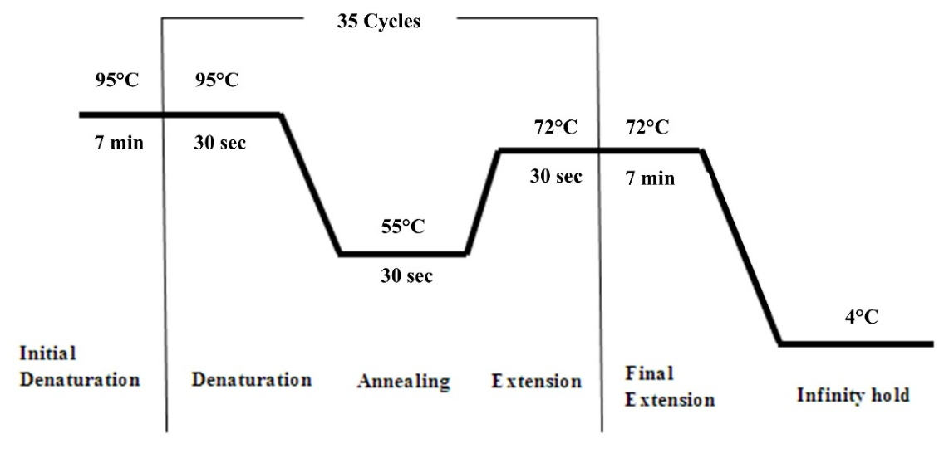
Fig. 1. Standard cycling conditions of the uidA gene PCR

2.5 Isolation and Identification of Salmonella Spp.
[Isolation and identification of Salmonella spp. from the collected raw and pasteurized milk samples were performed as per the ISO 6579 guidelines, with slight modifications by three-step pre-enrichment, enrichment, and selective plating. Briefly, 1 ml of the milk sample was inoculated into 9 ml of freshly prepared Buffered Peptone Water (PBW) and incubated at 37ºC for 18 h. Then 1 ml of pre-enriched inoculum was enriched in 9 ml of Tetrathionate broth and incubated at 37ºC for 24 h. A loop full of enriched inoculum was plated onto Salmonella spp. selective Hektoen Enteric (HE) agar plates and incubated at 37ºC for 24 h. The plates showed typical blue-green colonies with a black center were presumptively identified as Salmonella spp. Further, the presumptive isolates were subjected to morphological as well as biochemical characterization (Indole, Methyl Red, Voges-Proskauer, Citrate, and Triple Sugar Iron test) as per the FDA Bacteriological Analytical Manual (2018) and confirmed molecularly by the PCR targeting the Salmonella genus-specific invA gene (Nair et al.,2015). The Salmonella genus-specific invA gene primer nucleotide sequence used is shown in Table 3. In brief, the 25µl PCR reaction mixture consist of 2.5 µl of 10X PCR buffer (500 mM KCl, 100 mM Tris-HCl buffer pH-8.3 with15 mM MgCl₂, and 0.01% gelatin ),1µl of 50 mM MgCl₂, 10 picomoles forward as well as reverse primers (Eurofins Pvt. Ltd., Bangaluru) 1 µl of 1 mM dNTP mix, 1IU Taq DNA polymerase enzyme, 4µl DNA template and nuclease-free water (NFW) to make up the final volume of 25 µl. The reaction mixture was amplified using the standard cycling conditions (Fig. 2) and visualized under an Ultraviolet gel documentation system.
Table 3. Nucleotide sequence of invA gene primer

Primers | Sequences (5’-3’) | Amplicon size | Reference
invA | F: TCGTGACTCGCGTAAATGGCGAA  R: GCAGGCGCACGCCATAATCAATAA | 423bp | Nair et al.,2015

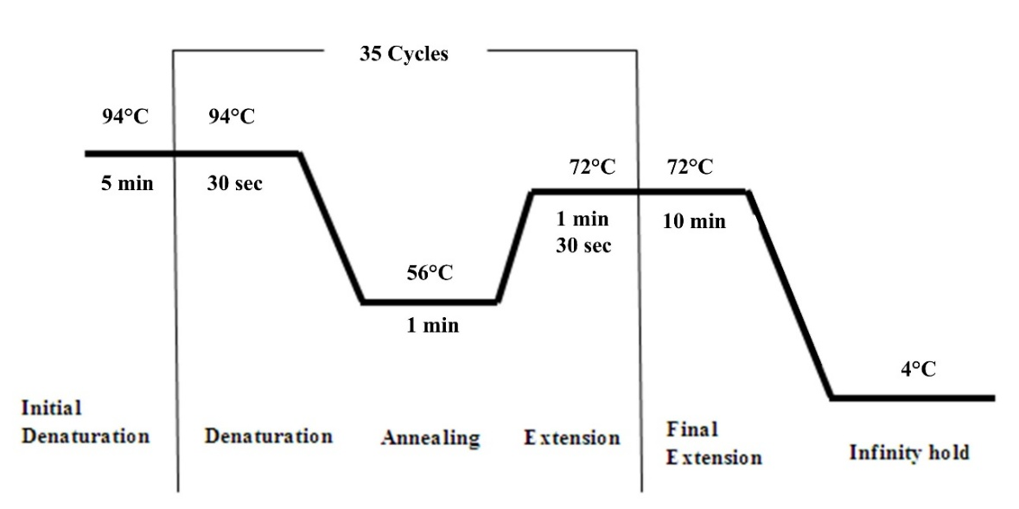
Fig. 2. Standard cycling conditions of the invA gene PCR

3. results and discussion

Milk is a good source of nutrients, and contamination of it encourages the growth of pathogenic microorganisms, leading to the spread of zoonotic diseases to humans (Kumar et al., 2024). Milk, as well as other dairy products, is a primary source of food-borne pathogenic organisms, and many epidemiological reports have shown that inadequately boiled milk and raw milk products are the most common causes of foodborne illnesses (Hasan et al., 2015). Therefore, these milk and dairy products must be obtained from sources as clean as possible to protect consumers’ health. The presence of pathogenic bacteria in milk has become a major public health concern (Sharma et al., 2024). In this study, 25 raw and pasteurized milk samples were randomly collected from each of the Thoothukudi and Tenkasi districts in Tamil Nadu. A total of 100 samples were tested for microbial quality. Initially, all samples underwent total viable count enumeration using SPC via the pour plate method. In samples from Thoothukudi district, 76% of raw and 24% of pasteurized samples had SPC counts in the 10⁶ range; 52% of raw and 24% of pasteurized samples had SPC counts in the 10⁴ and 10⁵ ranges, respectively; and 24% of raw milk samples had higher counts in the 10⁷ range. Similarly, in samples from Tenkasi district, 56% of raw and 8% of pasteurized samples had SPC counts in the 10⁶ range; 12% of raw and 20% of pasteurized samples had SPC counts in the 10⁵ range; and 24% of raw milk samples had higher counts in the 10⁷ range. Complete SPC details of all samples are shown in Table 4. An earlier study also reported SPC counts within a similar range: raw samples ranged between 10⁵ and 10⁶, while pasteurized samples ranged between 10² and 10⁴ (Hasan et al., 2015). However, another study reported lower SPC counts in pasteurized milk, around the 10² range (Rahman et al., 2015). Similarly higher total bacterial count was observed in raw milk than in pasteurized and packeted milk samples collected from the Thiruvarur district of Tamil Nadu (Maheswari and Sabitha, 2015). However, as per the IS-6397-1971 standards, the TVC of pasteurized milk samples should be less than 30000cfu/mL. also, the raw milk will be considered as good if it has <5 lakhs cfu/mL as per IS-1479 Part III-1997 (Sherikar et al., 2013).

Table 4. SPC of raw and pasteurized milk samples

SPC range (Count/ml) | Thoothukudi District |  |  |  | Tenkasi District
SPC range (Count/ml) | Raw Milk (n=25) |  | Pasteurized Milk (n=25) |  | Raw Milk (n=25) |  | Pasteurized Milk (n=25)
SPC range (Count/ml) | No. | % | No. | % | No. | % | No. | %
10³ | - | - | - | - | - | - | 1 | 4%
10⁴ | - | - | 13 | 52% | - | - | 17 | 68%
10⁵ | - | - | 6 | 24% | 3 | 12% | 5 | 20%
10⁶ | 19 | 76% | 6 | 24% | 14 | 56% | 2 | 8%
10⁷ | 6 | 24% | - | - | 8 | 32% | - | -
Total | 25 | 100% | 25 | 100% | 25 | 100% | 25 | 100%

Further, the samples were subjected to isolation and identification of the most common foodborne pathogens, viz., E. coli and Salmonella spp. 7 samples Out of 50 raw milk samples (14%), and 1 sample out of 50 pasteurized milk samples (2%) yielded typical presumptive E. coli black-centered violet colonies with a green metallic sheen in EMB agar (Fig. 3). Also, all the 8 isolates were confirmed to be Gram-negative bacilli, which exhibited typical biochemical characteristics of E. coli such as Indole +ve, Methyl red +ve, Voges Proskauer -Ve, Citrate -Ve (IMViC: + + - -) and yellow slant/butt with gas production in TSI agar (Fig. 4). Then the biochemically characterized isolates were confirmed molecularly by PCR targeting E. coli specific udiA gene, it was observed that all the 8 isolates could amplify the gene (product size 163 bp) (Fig. 5). Totally out of 100 samples tested 8 (8%) were positive for E. Coli. Among those, 7 were from raw samples, and only 1 was from pasteurized samples (Table 5, Fig. 9A), indicating the importance of pasteurization in the dairy sector. However, a lower prevalence rate was reported in an earlier study, where the prevalence of E. coli in raw milk samples was 4.3% (Williams et al., 2023). Similarly, a study by Mubarack et al in 2010 found that E. coli was predominantly isolated from raw milk samples, followed by Lactobacillus and Staphylococcus in the Coimbatore district of Tamil Nadu (Mubarack et al., 2010).

Table 5. Results of isolation of E. coli from the Milk samples

Isolation of E. coli
District | Milk Sample | Cultural positive | Biochemical Positive | PCR Positive | Isolation %
Thoothukudi (n=50) | Raw (n=25) | 4 | 4 | 4 | 16%
Thoothukudi (n=50) | Pasteurized (n=25) | 1 | 1 | 1 | 4%
Tenkasi (n=50) | Raw (n=25) | 3 | 3 | 3 | 12%
Tenkasi (n=50) | Pasteurized (n=25) | - | - | - | -
Total |  | 8 | 8 | 8 | 32%

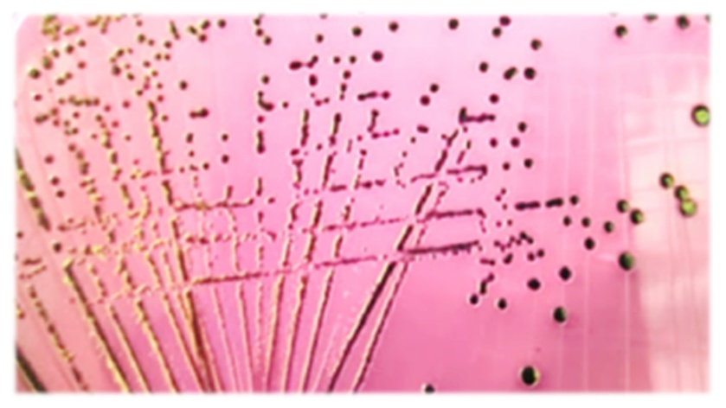
Fig. 3. E. coli on EMB agar
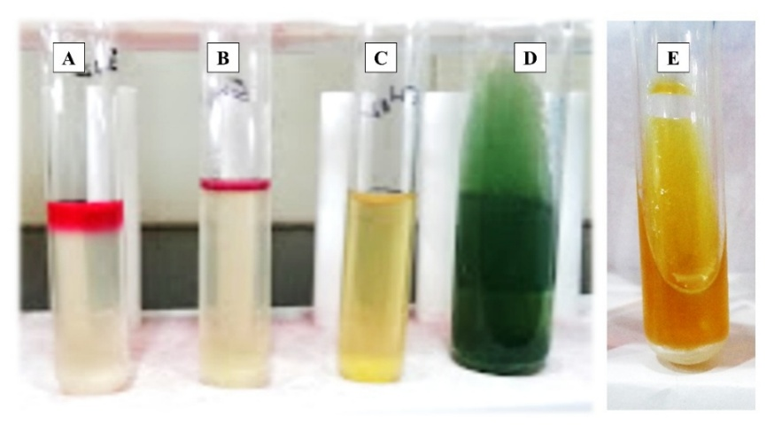
Fig. 4. Biochemical Characterization of E. coli
A- Positive Indole test; B- Positive Methyl Red test; C- Negative Voges Proskauer test; D- Negative Citrate test; E-TSI test (Y/Y H2S-ve, Gas +ve; Acid slant and butt)

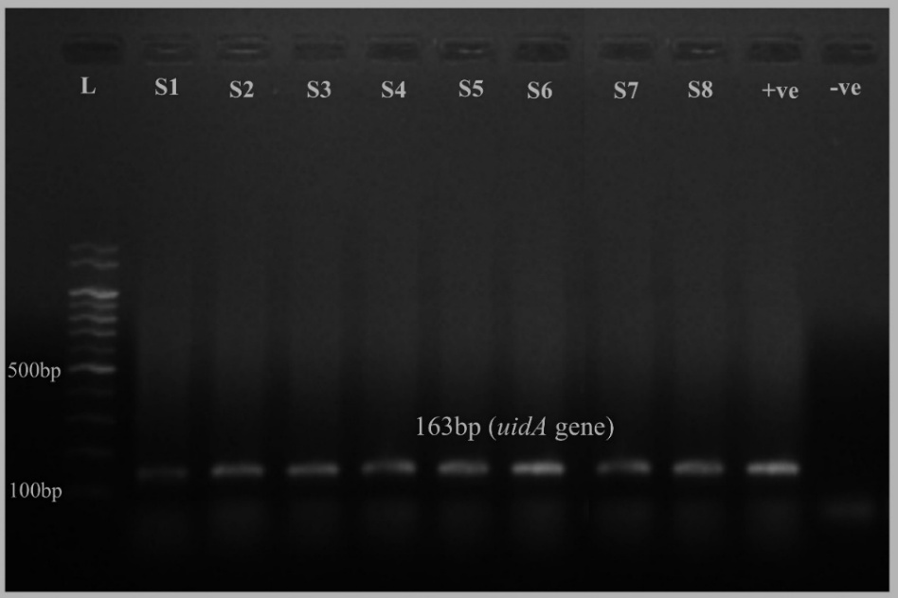
Fig. 5. Results of the E. coli-specific PCR assay
L- 100 bp Ladder; S1-S8 – Samples (163 bp); -Ve – Negative Control; +Ve – Positive Control

Similarly, 4 out of 50 raw milk samples (8%) showed typical presumptive Salmonella spp. colonies with blue-green coloration and a black center on HE agar (Fig. 6). None of the 50 pasteurized milk samples (0%) yielded these colonies. Additionally, all 4 isolates were confirmed as Gram-negative bacilli with biochemical traits typical of Salmonella spp., such as Indole-negative, Methyl red-positive, Voges Proskauer-negative, Citrate-positive (IMViC: - + - +), and exhibited a red slant/yellow butt with gas and H2S production in TSI agar (Fig. 7). The isolates were further confirmed by PCR targeting the Salmonella genus-specific invA gene, revealing amplification of the 423 bp product in all four isolates (Fig. 8). Out of 100 samples tested, 4 (4%) were positive for Salmonella spp. All positives came from raw samples, with none from pasteurized samples (Table 6, Fig. 9B). Similar findings were reported in a previous study, where the prevalence of Salmonella spp. in raw milk was 3.6% (Williams et al., 2023). However, a higher prevalence of 20.5% was reported in Colombia by Castañeda-Salazar and colleagues (Castañeda-Salazar et al., 2021). The variation in prevalence could be attributed to differences in sample source and collection location.

Table 6. Results of isolation of Salmonella spp. from the Milk samples

Isolation of Salmonella spp.
District | Milk Sample | Cultural positive | Biochemical Positive | PCR Positive | Isolation %
Thoothukudi (n=50) | Raw (n=25) | 2 | 2 | 2 | 8%
Thoothukudi (n=50) | Pasteurized (n=25) | - | - | - | -
Tenkasi (n=50) | Raw (n=25) | 2 | 2 | 2 | 8%
Tenkasi (n=50) | Pasteurized (n=25) | - | - | - | -
Total |  | 4 | 4 | 4 | 16%

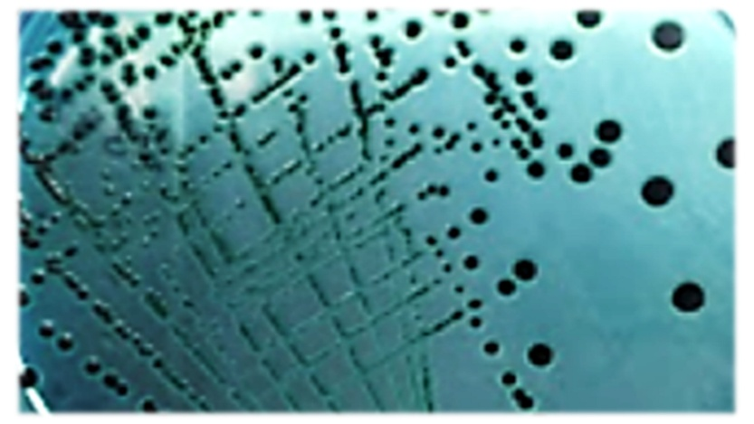
Fig. 6. Salmonella spp. on HE agar

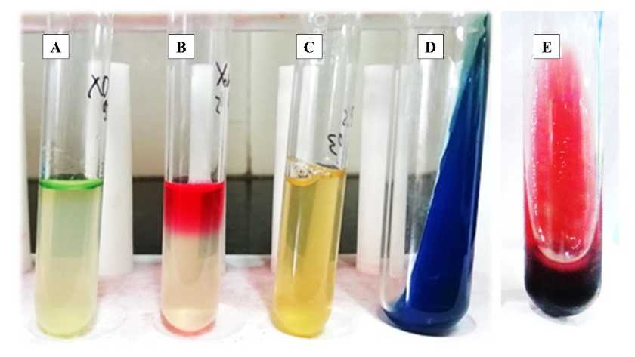

Fig. 7. Biochemical Characterization of Salmonella spp.
A- Negative Indole test; B- Positive Methyl Red test; C- Negative Voges Proskauer test; D- Positive Citrate test; E-TSI test (R/Y H2S+ve, Gas +ve ; Alkaline slant and Acid butt)

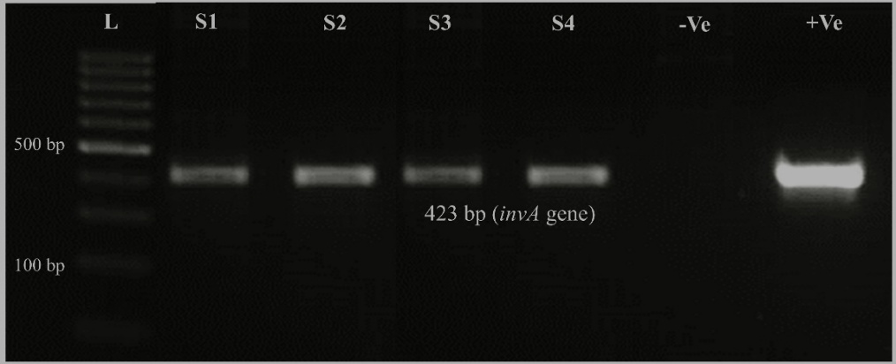
Fig. 8. Results of Salmonella spp. specific PCR assay
L- 100 bp Ladder; S1-S4 – Samples (423 bp); -Ve – Negative Control; +Ve – Positive Control

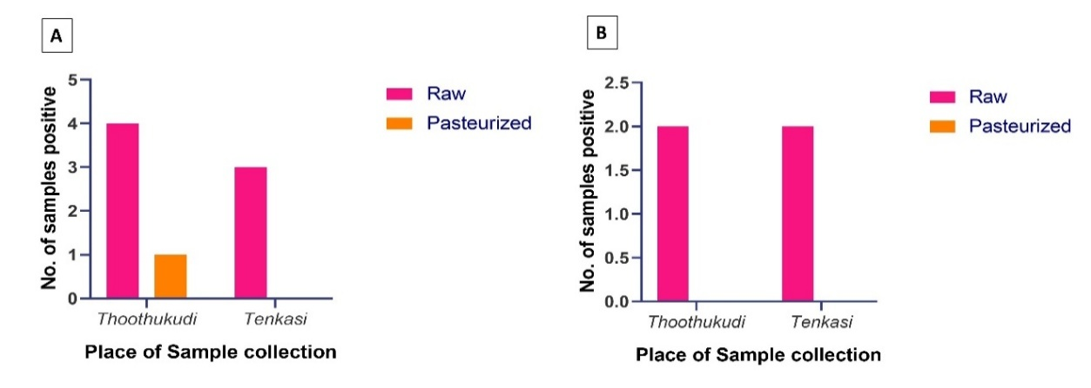
Fig. 9. Results of isolation and identification of pathogens
- Isolation and Identification of E. coli; B- Isolation and Identification of Salmonella spp.
There is a clear difference between the microbiological quality of pasteurized and raw milk samples; the microbial quality in terms of TVC and the presence of specific pathogens is comparatively better in the pasteurized samples than in the raw. Similarly, in an earlier study, a drastic more than 10-fold reduction in TVC and pathogen count was observed after implementation of pasteurization (Nada et al., 2012). Pasteurization destroys most of the spoilage and pathogenic organisms in the milk and makes it stable and safe for human consumption (Reta and Addis, 2015). These results suggest that there is a need for effective communication to the public regarding the hazards and their control measures linked with the consumption of raw milk and improperly boiled or pasteurized milk. Children, pregnant women, infants, old age people, and people with a weak immune system have a life-threatening risk of falling ill from drinking raw milk and improperly pasteurized milk, or boiled milk (Tekilegiorgis, 2018).

4. Conclusion
Globally, milk plays a vital part in human nutrition, providing all the essential macro and micro nutrients needed for children's growth. However, the spread of foodborne zoonotic diseases through milk and dairy products made from contaminated milk has recently become a significant public health concern. To prevent microbial hazards from milk, hygienic production and proper microbial analysis are necessary. In this study, the microbial quality of raw and pasteurized milk samples was assessed, with SPC of pasteurized milk ranging from 10³ to 10⁶/mL; most samples fell within the 10⁴ range. Raw milk had higher SPC levels, ranging from 10⁴ to 10⁷/mL. Additionally, E. coli was isolated from 7 (28%) raw and 1 (4%) pasteurized samples, while Salmonella spp. were found in 4 (16%) raw samples. These results clearly demonstrate that microbial counts and the presence of pathogens such as E. coli and Salmonella spp. are higher in raw milk than in pasteurized milk, highlighting the crucial role of pasteurization in making dairy products safe to consume and improving their shelf life. Hygienic practices need to be strictly followed in all aspects of milk production from farm to fork to safeguard the health of consumers and the public.
.
DISCLAIMER (ARTIFICIAL INTELLIGENCE)
Author(s) hereby declare that NO generative AI technologies such as Large Language Models (ChatGPT, COPILOT, etc) and text-to-image generators have been used during the writing or editing of this manuscript.

References

Abhang, P., Jadhav, D. M., & Pathade, A. (2024). Comparative Analysis of Raw and Pasteurized Milk from Various Milking Animals: A Comprehensive Study. Bulletin of Pure & Applied Sciences-Zoology.
Ahmed, Z. A., Kasim, M. H., Tegegne, B., & Salah, H. M. (2022). Assessment of hygiene practices and bacteriological quality of raw cow milk of selected dairy farm in Dessie, Ethiopia. American Journal of Aquaculture and Animal Science, 1(1), 27-37.

Ali, S. A., & Al-Dahmoshi, H. O. (2022). Detection of efflux pumps gene and relation with antibiotics resistance in Uropathogenic Escherichia coli (UPEC) isolated from patients with cystitis. Iraqi Journal of Science, 2388-2397.

Aslam, A., Qazi, J. I., Hasan, A., & Raza, M. A. (2024). Detection of Coliform Bacteria in Raw Milk Samples Collected from Industrial Cities of Pakistan: Coliform Bacteria in Raw Milk. Futuristic Biotechnology, 19-27.

Azizi-Lalabadi, M., Moghaddam, N. R., & Jafari, S. M. (2023). Pasteurization in the food industry. In Thermal processing of food products by steam and hot water (pp. 247-273). Woodhead Publishing.

Bittante, G., & Cecchinato, A. (2013). Genetic analysis of the Fourier-transform infrared spectra of bovine milk with emphasis on individual wavelengths related to specific chemical bonds. Journal of Dairy Science, 96(9), 5991-6006.

Castañeda-Salazar, R., del Pilar Pulido-Villamarín, A., Ángel-Rodríguez, G. L., Zafra-Alba, C. A., & Oliver-Espinosa, O. J. (2021). Isolation and identification of Salmonella spp. in raw milk from dairy herds in Colombia. Brazilian Journal of Veterinary Research and Animal Science, 58, e172805-e172805.

Eker, F., Akdaşçi, E., Duman, H., Yalçıntaş, Y. M., Canbolat, A. A., Kalkan, Et al. (2024). Antimicrobial properties of colostrum and milk. Antibiotics, 13(3), 251.

Fagnani, R., Nero, L. A., & Rosolem, C. P. (2021). Why knowledge is the best way to reduce the risks associated with raw milk and raw milk products. Journal of Dairy Research, 88(2), 238-243.

Ghimire, M. (2022). Microbiological quality and adulteration of pasteurized milk marketed in dharan, Nepal (Doctoral dissertation, Department of Microbiology Central Campus of Technology, Tribhuvan University).

Gupta, B., Gupta, V. K., Pradhan, S., Singh, R. V., & Kulesh, R. (2024). Milk hygiene, udder health and management. In The Microbiology, Pathogenesis and Zoonosis of Milk Borne Diseases (pp. 191-206). Academic Press.

Hammad, A. M., Eltahan, A., Hassan, H. A., Abbas, N. H., Hussien, H., & Shimamoto, T. (2022). Loads of coliforms and fecal coliforms and characterization of thermotolerant Escherichia coli in fresh raw milk cheese. Foods, 11(3), 332.

Hasan, M. A., Islam, M. A., Mahmud, M. S., Uddin, A. A., & Ahmed, S. (2015). Microbial analysis of raw and pasteurized milk from selected areas of Dinajpur, Bangladesh. Asian Journal of Medical and Biological Research, 1(2), 292-296.

Kapoor, S., Goel, A. D., & Jain, V. (2023). Milk-borne diseases through the lens of one health. Frontiers in Microbiology, 14, 1041051.

Kathiriya, J. B. (2024). Good hygienic practices of dairy equipment during milk production and processing in the milk plant. In The Microbiology, Pathogenesis and Zoonosis of Milk Borne Diseases (pp. 29-49). Academic Press.

Kontopodi, E., Boeren, S., Stahl, B., van Goudoever, J. B., van Elburg, R. M., & Hettinga, K. (2022). High-temperature short-time preserves human milk's bioactive proteins and their function better than pasteurization techniques with long processing times. Frontiers in pediatrics, 9, 798609.

Kumar, M., Jadhav, V. J., Mittal, D., & Khurana, R. (2024). General principles and concepts of milk hygiene in public health. The Microbiology, Pathogenesis and Zoonosis of Milk Borne Diseases, 3-18.

Maheswari, N. U., & Sabitha, K. (2015). Microbiological Assessment of Different Milk Samples from Mannargudi, Thiruvarur (DT). Int. J. Pure App. Biosci, 3(6), 87-92.

Makararpong, D., Tantayanon, S., Gowanit, C., Jareonsawat, J., Samgnamnim, S., Wataradee, S., ... & Inchaisri, C. (2024). Enhancing Raw Bovine Milk Quality using Ultraviolet-C (UV-C) Irradiation: A Microbial and Lipid Peroxidation Study. Food science of animal resources, 44(2), 372.

Mubarack, H. M., Doss, A., Dhanabalan, R., & Balachander, S. (2010). Microbial quality of raw milk samples collected from different villages of Coimbatore District, Tamilnadu, South India. Indian Journal of Science and Technology, 3(1), 61-63.

Nada, S., Ilija, D., Igor, T., Jelena, M., & Ruzica, G. (2012). Implication of food safety measures on microbiological quality of raw and pasteurized milk. Food control, 25(2), 728-731.

Rabbani, A., Ayyash, M., D’Costa, C. D., Chen, G., Xu, Y., & Kamal-Eldin, A. (2025). Effect of Heat Pasteurization and Sterilization on Milk Safety, Composition, Sensory Properties, and Nutritional Quality. Foods, 14(8), 1342.

Rahman, T., Akon, T., Sheuli, I. N., & Hoque, N. (2015). Microbiological analysis of raw milk, pasteurized milk and yogurt samples collected from different areas of Dhaka city, Bangladesh. Journal of Bangladesh Academy of Sciences, 39(1), 31-36.

Reta, M. A., & Addis, A. H. (2015). Microbiological quality assessment of raw and pasteurized milk. International Journal of Food Science and Microbiology, 2(6), 087-091.

Samet Bali, O., Lajnef, R., Felfoul, I., Attia, H., & Ayadi, M. (2024). Detection of Escherichia coli in unpasteurized raw milk. International Journal of Agricultural and Food Science.

Sharma, S., Chauhan, A., Ranjan, A., Mathkor, D. M., Haque, S., Ramniwas, S., ... & Yadav, V. (2024). Emerging challenges in antimicrobial resistance: implications for pathogenic microorganisms, novel antibiotics, and their impact on sustainability. Frontiers in microbiology, 15, 1403168.

Sherikar, A. T., Bachhil, V.N., & Thapliyal, D. C. (2013). Textbook of Elements of Veterinary Public Health (1st ed.). Indian Council of Agricultural Research.

Shimpoh, T., Hirata, Y., Ihara, S., Suzuki, N., Kinoshita, H., Hayakawa, Y., ... & Koike, K. (2017). Prevalence of pks-positive Escherichia coli in Japanese patients with or without colorectal cancer. Gut pathogens, 9(1), 35.

Smith, N. W., Fletcher, A. J., Hill, J. P., & McNabb, W. C. (2022). Modeling the contribution of milk to global nutrition. Frontiers in Nutrition, 8, 716100.

Stefan, G., & Baraitareanu, S. (2023). Approaches of milking biosecurity and milking parlour hygiene in dairy farms. In Recent Developments on Bovine Mastitis-Treatment and Control. IntechOpen.

Tekilegiorgis, T. (2018). Microbiological quality analysis of raw and pasteurized milk samples collected from Addis Ababa and its surrounding in Ethiopia. Approaches in Poultry, Dairy & Veterinary Sciences, 4(5), 1-8.

Williams, E. N., Van Doren, J. M., Leonard, C. L., & Datta, A. R. (2023). Prevalence of Listeria monocytogenes, Salmonella spp., Shiga toxin-producing Escherichia coli, and Campylobacter spp. in raw milk in the United States between 2000 and 2019: A systematic review and meta-analysis. Journal of food protection, 86(2), 100014.

Zenu, F., & Bekele, T. (2024). Major food-borne zoonotic bacterial pathogens of livestock origin: A review. Foods and Raw materials, 12(1), 179-193.

