Clinical and Physiological Characterization of Canine Distemper Virus Infection in Dogs from the Junagadh Region of Gujarat, India

ABSTRACT
Canine distemper virus (CDV) is an infectious disease of canines in the overall world, mainly in developing countries where proper immunization is not enclosed. This study was conducted to evaluate the clinical signs and physiological parameters alterations in canine distemper virus (CDV) affected dogs from the Junagadh region of Gujarat, India. A total of 74 dogs showing clinical signs that indicate CDV were examined from January to June 2025; among these, 28 dogs were confirmed positive through rapid antigen testing, and 35 dogs were positive with PCR. Various clinical signs of CDV-positive dogs were classified into nervous, respiratory, gastrointestinal, ocular, and cutaneous forms. Among these 5 forms of systemic affection, the nervous form was the most prevalent, affecting 91.43% of total positive dogs, followed by respiratory (71.43%), gastrointestinal (45.71%), and ocular/cutaneous forms (42.86%). Mixed-system involvement was recorded in most of the dogs, with seizures, mucopurulent nasal discharge, vomiting, and hardening of the foot pad among the most frequent manifestations. Highly significant increases were noted in rectal temperature, pulse rate, respiratory rate, and capillary refill time (CRT) in CDV-positive dogs when statistically compared with ten healthy dogs, indicating systemic affection and cardiorespiratory stress. The findings designated that CDV is pantropic in nature and suggest the diagnostic value of clinical assessment in field conditions where laboratory facilities are not available. Early detection of multisystemic signs, along with a rapid test kit of CDV, is helpful for early differential diagnosis, prognosis of disease, and therapeutic management of affected dogs.
Keywords: Canine distemper virus, clinical forms, PCR, nervous signs, physiological parameters, Gujarat, dogs.
INTRODUCTION
Canine Distemper Virus (CDV) is a highly fatal and contagious disease of canines that belongs to the genus Morbillivirus (Family: Paramyxoviridae). It is a major global health concern for dogs and a wide range of wild carnivores (Duques-Valencia et al., 2019). As there is no proper vaccination available in stray dogs, CDV is continuously present, particularly in developing nations, where improper immunization coverage contributes to the spread of the disease (Manandhar et al., 2023; Wilkes, 2022). The virus is mainly transmitted through the inhalation of air droplets, and it rapidly invades in systemic circulation and affects multiple systems due to its pantropic nature. It replicates in the epithelial, lymphoid, and nervous tissues (Chludzinski et al., 2023; Loots et al., 2017). In developing countries like India, there is a rise in socioeconomic conditions, leading to an increase in pet ownership (Uddin et al., 2021). CDV remains enzootic and is an important cause of morbidity and mortality, especially in young, unvaccinated dogs (0–6 months), with infections often rising during the winter season (Belsare et al., 2014; Vila et al., 2018; Sarchahi et al., 2022).
The canine distemper infection is classified by various clinical symptoms that characteristically include systemic, nervous, respiratory, gastrointestinal, ocular, and cutaneous forms (Evermann & Kennedy, 2010). Most regularly observed systemic and respiratory signs include lethargy, anorexia, fever, and mucopurulent oculo-nasal discharge (Agnihotri et al., 2017). Gastrointestinal involvement is categorized by vomiting and diarrhea (Mühlebach et al., 2011). The most fatal consequence is observed in central nervous system (CNS) involvement, leading to neurological signs such as myoclonus (muscle twitching), ataxia, and seizures, which often result in a poor prognosis (Appel et al., 1991). Chronic cases may develop hyperkeratosis of the nasal planum and footpads, known as "hard pad disease" (Galán et al., 2014).
In field conditions, advanced molecular diagnostic tools like PCR are often not possible; the specific and systematic evaluation of these various clinical signs is a helpful, vital, and practical diagnostic tool to differentiate CDV infection (Sarchahi et al., 2022). Therefore, the present study was carried out to document and characterize the variety and frequency of clinical manifestations observed in CDV-infected dogs that presented in the Junagadh region of Gujarat.
MATERIALS AND METHODS
The current study was performed on dogs that were carried out to the Veterinary Clinical Complex (VCC) at the College of Veterinary Science and Animal Husbandry, Kamdhenu, located in Junagadh, Gujarat, between January and June 2025. This study included 74 dogs of different breeds, ages, and genders showing clinical symptoms suggesting Canine Distemper Virus (CDV) infection. Each animal undertook a thorough clinical examination, focusing particularly on systemic, gastrointestinal, respiratory, and neurological signs. Clinical parameters such as rectal temperature, respiration rate, heart rate, hydration status, mucous membrane, and lymph-node enlargement were recorded. Detailed clinical manifestations such as ocular and nasal discharge, coughing, diarrhoea, vomiting, chorea, convulsions, and hyperkeratosis of the nasal planum and/or digital pads were recorded and characterized based on severity.
For confirmatory diagnosis, ocular and nasal swabs were collected using sterile cotton swabs and analysed using a rapid antigen detection test (Immunochromatographic Kit) as well as a Polymerase Chain Reaction (PCR) assay, which was targeting the nucleoprotein (N) gene of CDV. Dogs found positive by any of the above two methods were considered confirmed for CDV infection. The frequency and percentage of each clinical sign were counted to determine their relative occurrence among the infected dogs.
RESULT
Among 35 PCR-confirmed cases of canine distemper, various clinical forms—nervous, ocular, respiratory, gastrointestinal, and cutaneous—were observed either singly or in combination.
Nervous Form
The nervous form was the most prevalent, affecting 91.43% (32/35) of CDV-positive dogs. Major neurological manifestations included seizures (81.25%), chewing gum fits (46.88%), crying (45.71%), temporal twitching (40.63%), and ataxia or myoclonus of limbs (37.50%). Myoclonus of the abdomen (15.63%), head shaking or upward extension (9.38%), and paresis (6.25%) were less frequent (Graph 1). Neurological signs were attributed to viral invasion and demyelination of the central nervous system, particularly in the temporal lobes, leading to seizures and motor dysfunction.
Ocular Form
Ocular involvement was noted in 42.56% (15/35) of cases. Mucopurulent ocular discharge was the most common sign (66.67%), followed by serous discharge (33.33%) and conjunctivitis (13.33%) (Graph 2). These signs were likely due to virus-induced inflammation and secondary bacterial infections of ocular tissues.
Respiratory Form
Respiratory manifestations were observed in 71.43% (25/35) of infected dogs. Nasal discharge (64%) and coughing (56%) were the predominant features, often occurring together (Graph 3). The nasal discharge was mostly mucopurulent, indicating secondary bacterial infection or bronchopneumonia.
Gastrointestinal Form
Gastrointestinal involvement was seen in 45.71% (16/35) of CDV-positive dogs. The main signs included vomiting (66.66%), inappetence (53.33%), diarrhea (46.66%), vomiting with diarrhea (40%), and anorexia (33.33%) (Graph 4). These symptoms were attributed to viral replication in the intestinal epithelium, leading to enteritis and secondary infections.
Cutaneous Form
Cutaneous lesions were present in 42.86% (15/35) of dogs. Hyperkeratosis of the footpads and nasal planum was the most frequent finding (60%), followed by pustules on the ventral abdomen (46.66%) and erythematous skin lesions (33.33%) (Graph 5). These were due to viral multiplication in the keratinocytes of the stratum spinosum and granulosum.
Combination of Forms
Multiple organ system involvement was common, with overlapping forms observed in several dogs (Table 1). The most frequent combinations included nervous + respiratory (17.14%), nervous + GI + respiratory + ocular + cutaneous (11.43%), and nervous + GI + respiratory + ocular (8.57%). This highlights the multisystemic nature of CDV infection. (Table 1)

Table 1. Combination of various clinical forms of CDV in affected dogs (n = 35)
Forms of disease involved | No. of cases | Percentage (%)
Nervous only | 2 | 5.71
Nervous + Respiratory | 6 | 17.14
Nervous + GI + Respiratory + Ocular + Cutaneous | 4 | 11.43
Nervous + GI + Respiratory + Ocular | 3 | 8.57
Nervous + Respiratory + Ocular + Cutaneous | 3 | 8.57
Nervous + GI + Cutaneous | 3 | 8.57
Nervous + Respiratory + Cutaneous | 2 | 5.71
GI + Respiratory | 2 | 5.71
Other combinations (less frequent) | 10 | 28.6
Total | 35 | 100.0
Overall, the findings confirm that the nervous form is the most common clinical manifestation of CDV in dogs, followed by respiratory, cutaneous, ocular, and gastrointestinal forms, frequently occurring in combination and indicating the pantropic nature of the virus.
Clinical Parameters in CDV-Affected and Healthy Dogs
Clinical parameters, including rectal temperatures, respiration rates, heart rates, and capillary refill times (CRT), were evaluated in ten healthy control dogs (Group A) and thirty-five CDV-positive dogs to measure the physiological alterations related to infection. These parameters were compared using an unpaired t-test, and the results confirmed statistically significant differences between the healthy and diseased groups (Graph 6).
In CDV-infected dogs, a highly significant rise (P < 0.0001) was noted in mean rectal temperature (103.3 ± 0.23 °F) compared to healthy controls (101.29 ± 0.32 °F). The highly significant increase in mean respiration rate (44.31 ± 2.25 breaths/min) was also noted in CDV-positive dogs as relative to the control group (26.60 ± 1.92 breaths/min), indicating respiratory distress associated with infection. A marked elevation in heart rate was recorded in affected dogs (122.74 ± 4.48 beats/min) compared to healthy dogs (91.10 ± 3.90 beats/min). In CRT, the highly significant (P < 0.0001) increase (1.65 ± 0.10 sec) was noted in CDV-positive dogs when compared with healthy dogs (0.78 ± 0.09 sec), which indicates compromised peripheral perfusion (Table 2)
Table 2: Comparison of mean (±SE) clinical parameters in healthy and CDV-affected dogs (n = 35 total)
Parameters | Healthy dogs (n=10) | CDV-affected dogs (n=35) | p
Rectal Temperature (℉) | 101.29 ± 0.32 | 103.3 ± 0.23**** | <0.0001
Respiration rate  (breaths/min) | 26.60 ± 1.92 | 44.31 ± 2.25*** | 0.0002
Heart rate (beats/min) | 91.10 ± 3.90 | 122.74 ± 4.48**** | <0.0001
Capillary refill time (sec.) | 0.78± 0.09 | 1.65± 0.10**** | <0.0001

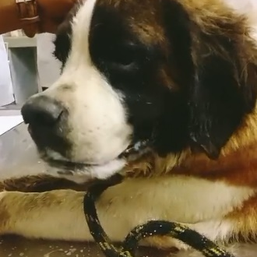 | 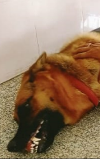 | 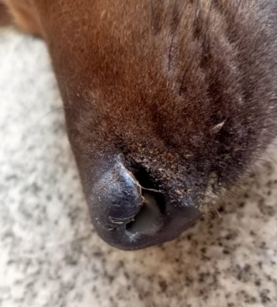
Fig. 1 Chewing gum fits | Fig. 2 Seizure | Fig. 3 Nasal discharge & coughing
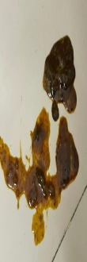 | 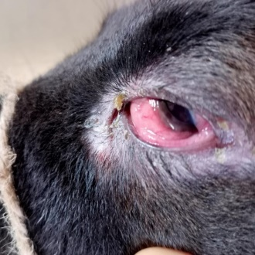 | 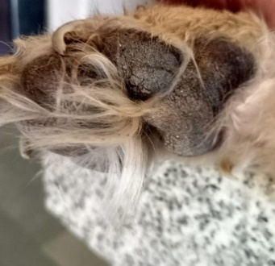
Fig. 4 Vomiting and Diarrhoea | Fig. 5 Ocular discharge & Conjunctivitis | Fig. 6 Hyperkeratosis of the footpad

Graph 1: Nervous signs of canine distemper virus infected dogs

Graph 2: Ocular form of canine distemper virus infected dogs

Graph 3: Respiratory form of canine distemper virus infected dogs

Graph 4: Gastrointestinal form of canine distemper virus infected dogs

Graph 5: Cutaneous form of canine distemper virus infected dogs

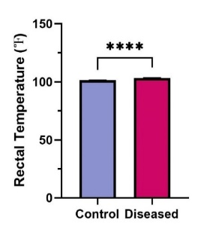 | 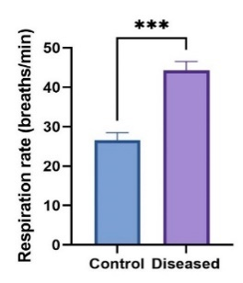 | 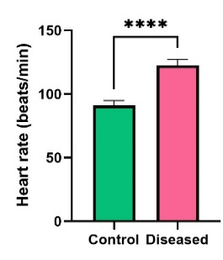 | 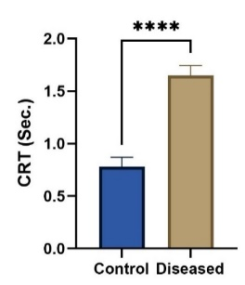

Graph 6: The results confirmed statistically significant differences between the healthy and diseased groups

Note: (a) RT=Rectal temperature, (b) RR=Respiration rate, (c) HR=Heart rate, (d) CRT: *** and **** indicate significance at (P<0.001) and (P<0.0001), respectively
DISCUSSION
Canine distemper virus (CDV) is one of the most infectious diseases affecting canines. It has a high rate of morbidity and mortality, and it can have an impact on several organ systems also. The outcome of this study indicates that CDV infection affects multiple systems and has a wide range. The findings of the present study strongly reaffirm the multisystemic and pantropic nature of CDV infection. Out of the 35 confirmed cases through PCR, the nervous form was found to be the most frequently encountered clinical sign (91.43%), followed by respiratory signs (71.43%), gastrointestinal signs (45.71%), ocular/cutaneous (42.86%), and mixed systemic involvement in 94.29 per cent of dogs. More presentation of neurological signs aligns with earlier studies noting that neurological signs are most frequent in the later course of disease when viral replication reaches the CNS (Agnihotri et al., 2017; Amude et al., 2018). Seizures were the most frequent neurological sign (81.25%), followed by myoclonus, temporal twitching, chewing-gum fits, ataxia, and paresis. These findings are similar to Buragohain et al. (2017) and Shabbir et al. (2010), who also reported encephalitis as the most frequent cause of neurological dysfunction in chronic CDV cases.
Respiratory signs were noted in 71.43% of infected dogs. mucopurulent nasal discharge and coughing were the most predominant signs. Similar. observations were reported by Galán et al. (2014), who also reported nasal discharge and fever as major findings in CDV-infected dogs. Respiratory affection is due to. Virus replicates in the respiratory epithelium, followed by. secondary bacterial infections and immune. suppression. Gastrointestinal signs such as. vomiting, diarrhoea, anorexia, and inappetence were. recorded in 45.71% of cases, which aligns with the findings of Budaszewski et al. (2014), Buragohain et al. (2017), and Shurbe (2019), who also confirmed frequent gastrointestinal. involvement during viremia and systemic spread.
The ocular form of CDV was noted in 42.86% of the presented cases, with mucopurulent ocular discharge being the most frequent clinical sign(66.67%). This finding aligns with the study of Saaed & Al-Obaidi (2021), who also recorded oculo-nasal discharge in 55.55% of cases, and with Sarchahi et al. (2022), who reported ocular discharge in 45% of CVD-affected dogs. Conjunctivitis, serous discharge, and keratitis were also reported in earlier studies as secondary complications of CDV-related immunosuppression (Shabbir et al., 2010).
A statistically significant difference (P<0.0001) was seen in rectal temperature, respiration rate, heart rate, and. capillary refilling time between healthy dogs and CDV-infected dogs. The mean rectal temperature of unhealthy dogs (103.3 ± 0.23°F) was higher than that of healthy. control dogs (101.29 ± 0.32°F), supporting earlier studies by Behera et al. (2014), Lal et al. (2010), and Yama et al. (2020), who reported fever in 70–80% of infected dogs. Fever occurs because in the early viraemic phase, the virus replicates in the lymphoid organs (Carvalho et al., 2012). Respiratory rate showed a notable increase in CDV-infected dogs, supporting the studies that state CDV interferes with pulmonary function via viral pneumonitis and immune-mediated inflammation.
The significant increase in heart rate of CDV-infected dogs (122.74 ± 4.48 beats/min) compared with healthy controls (91.10 ± 3.90 beats/min) may be because of fever, pain, respiratory distress, and. systemic inflammation. Similar findings were also reported by. Agnihotri et al. (2017), indicating cardiovascular affection due to viral pathogenesis. Capillary refilling time was also significantly delayed (P<0.0001) in CDV-affected dogs, indicating reduced perfusion possibly due to dehydration, endothelial damage, or circulatory shock. CRT, therefore, serves as a useful clinical indicator during field diagnosis in suspected CDV outbreaks.
The high frequency of mixed-form presentation (94.29%) in the present study emphasizes that CDV infection rarely manifests as a single-system disease. Instead, it progresses as a systemic viral pathology with simultaneous respiratory, gastrointestinal, and neurological involvement consistent with the classical description of CDV as a pantropic virus (Behera et al., 2014).
Conclusion
The outcomes of this particular study emphasize that canine distemper continues to infect the dogs with various clinical manifestations, with neurological and. respiratory involvement being most frequent among all other clinical signs. Vital clinical parameters such as rectal temperature, heart. Rate, respiratory rate, and CRT are significantly altered between CDV. positive and healthy dogs and serve as valuable diagnostic indicators when incorporated with laboratory confirmation. The study also supports existing literature states that CDV spreads rapidly and affects multiple organ systems, making early clinical recognition and timely diagnostic screening necessary. The higher percentage of mixed clinical forms leads veterinarians to adopt a holistic diagnostic approach rather than a system-specific assessment. Overall, the study contributes to a better understanding of the clinical and physiological parameters alterations associated with CDV infection and underscores the importance of early intervention to improve prognosis in CDV-affected dogs.
Ethical Approval and Consent:
All procedures were performed under the institutional ethical guidelines and with the consent of the animal owners.
Disclaimer (Artificial Intelligence)
The author (s) hereby declare that generative AI technologies have been used during the writing and editing of this manuscript in a limited capacity. The following details are provided:
Name & Version: ChatGPT (GPT-5)
Model: GPT-5 (Large Language Model by OpenAI)
Source: ChatGPT via OpenAI (accessed at chat.openai.com)
Purpose of Use:
Language refinement (grammar correction, sentence restructuring, and clarity improvement).
Formatting assistance for abstract and references.
Minor editing for readability, without altering scientific content, data, or conclusions.
Input Prompts Provided to ChatGPT:
“Improve grammar and clarity without changing meaning.”
“Simplify sentences for better readability.”
All research design, data collection, analysis, interpretation, and conclusions are entirely the work of the authors.

REFERENCES
Agnihotri, D., Singh, Y., Maan, S., Jain, V. K., Kumar, A., Sindhu, N., Jhamb, R., Goel, P., & Kumar, A. (2017). Molecular detection and clinico-haematological study of viral gastroenteritis in dogs. Haryana Veterinarian, 56(1), 72–76.
Amude, A., Alfieri, A., & Alfieri, A. (2018). The nervous form of canine distemper. Veterinária e Zootecnia, 13(2), 125–136.
Appel, M. J., Reggiardo, C., Summers, B. A., Pearce-Kelling, S., Maré, C. J., Noon, T. H., Reed, R. E., Shively, J. N., & Orvell, C. (1991). Canine distemper virus infection and encephalitis in javelinas (collared peccaries). Archives of Virology, 119, 147–152.
Behera, S. K., Bordoloi, G., & Behera, P. (2014). Clinico-hemato-biochemical and therapeutic study of canine distemper: A report from the north-eastern part of India. Indian Journal of Field Veterinarian, 9(3), 18–20.
Belsare, A. V., Vanak, A. T., & Gompper, M. E. (2014). Epidemiology of viral pathogens of free-ranging dogs and Indian foxes in a human-dominated landscape in central India. Transboundary and Emerging Diseases, 61, 78–86.
Budaszewski, R. F., Pinto, L. D., Weber, M. N., Caldart, E. T., Alves, C. D. B. T., Martella, V., & Canal, C. W. (2014). Genotyping of canine distemper virus strains circulating in Brazil from 2008 to 2012. Veterinary Microbiology, 168(1), 108–113.
Buragohain, M., Goswami, S., & Kalita, D. (2017). Clinicopathological findings of canine distemper virus infection in dogs. Journal of Entomology and Zoology Studies, 5, 1817–1819.
Carvalho, O. V., Botelho, C. V., Ferreira, C. G. T., Scherer, P. O., Soares-Martins, J. A. P., Almeida, M. R., & Silva Júnior, A. (2012). Immunopathogenic and neurological mechanisms of canine distemper virus. Advances in Virology, 2012, Article 163860.
Chludzinski, E., Ciurkiewicz, M., Stoff, M., Klemens, J., Krüger, J., Shin, D. L., ... & Beineke, A. (2023). Canine distemper virus alters defense responses in an ex vivo model of pulmonary infection. Viruses, 15(4), 834.
Duque-Valencia, J., Sarute, N., Olarte-Castillo, X. A., & Ruíz-Sáenz, J. (2019). Evolution and interspecies transmission of canine distemper virus—An outlook of the diverse evolutionary landscapes of a multi-host virus. Viruses, 11(7), 582.
Evermann, J. F., & Kennedy, M. A. (2010). Viral infections. In Small Animal Pediatrics (p. 119).
Galán, A., Gamito, A., Carletti, B. E., Guisado, A., de las Mulas, J. M., Pérez, J., & Martín, E. M. (2014). Uncommon acute neurologic presentation of canine distemper in 4 adult dogs. The Canadian Veterinary Journal, 55(4), 373–378.
Lal, R., Sharma, A. K., & Singh, G. (2010). Canine distemper: A review. Indian Journal of Veterinary Medicine, 30(1), 1–4.
Loots, A. K., Mitchell, E., Dalton, D. L., Kotzé, A., & Venter, E. H. (2017). Advances in canine distemper virus pathogenesis research: A wildlife perspective. Journal of General Virology, 98(3), 311–321.
Manandhar, P., Napit, R., Pradhan, S. M., Rajbhandari, P. G., Moravek, J. A., Joshi, P. R., Shrestha, R. D., & Karmacharya, D. (2023). Phylogenetic characterization of canine distemper virus from stray dogs in Kathmandu Valley. Virology Journal, 20(1), 117.
Mühlebach, M. D., Mateo, M., Sinn, P. L., Prüfer, S., Uhlig, K. M., Leonard, V. H. J., & Cattaneo, R. (2011). Adherens junction protein nectin-4 is the epithelial receptor for measles virus. Nature, 480(7378), 530–533.
Saaed, M. M., & Al-Obaidi, Q. T. (2021). Clinical, hematological, and some biochemical changes in dogs infected with canine distemper. Journal of Agriculture and Veterinary Science, 14(5), 26–33.
Sarchahi, A. A., Arbabi, M., & Mohebalian, H. (2022). Detection of canine distemper virus in cerebrospinal fluid, whole blood, and mucosal specimens of dogs with distemper using RT-PCR and immunochromatographic assays. Veterinary Medicine and Science, 8(4), 1390–1399.
Shurbe, M. U. (2019). Isolation and characterization of canine distemper virus from clinical domestic dogs in Addis Ababa pet clinics, Ethiopia (pp. 1–17) [Preprint]. In Review.
Uddin, M. M., Talukder, H., Islam, O., Asaduzzaman, M., Das, M., Ahsan, M. I., & Islam, S. (2021). Magnitudes of diseases in dogs vary among different levels of age, gender, breed, and season: A hospital-based, retrospective cross-sectional study. Heliyon, 7(11), e08287.
Vila Nova, B., Cunha, E., Sepúlveda, N., Oliveira, M., São Braz, B., Tavares, L., Almeida, V., & Gil, S. (2018). Evaluation of the humoral immune response induced by vaccination for canine distemper and parvovirus: A pilot study. BMC Veterinary Research, 14(1), 1–8.
Wilkes, R. P. (2022). Canine distemper virus in endangered species: Species jump, clinical variations, and vaccination. Pathogens, 12(1), 57.
Yama, T., Rajesh, J. B., Prasad, H., Rajkhowa, T. K., Sarma, K., Roychoudhury, P., Deka, D., & Behera, S. K. (2020). Scholarly view of canine distemper cases in Mizoram. International Journal of Current Microbiology and Applied Sciences, 9(9), 3260–3266.

