Metabolites of Endophytic fungus isolated from Stevia rebaudiana as inhibitors of β-lactamase multidrug resistant Staphylococcus aureus

.
ABSTRACT

The rise of multidrug-resistant (MDR) bacteria, particularly Staphylococcus aureus, has created an urgent need for new antimicrobial compounds capable of overcoming β-lactamase-mediated resistance. This study investigated the metabolites of endophytic fungi isolated from Stevia rebaudiana as potential inhibitors of β-lactamase-producing S. aureus. Four fungal isolates namely: Fusarium proliferatum, Colletotrichum gloeosporioides, Perenniporia tephropora, and Diaporthe siamensis, were recovered from S. rebaudiana and identified molecularly through ITS sequencing. Secondary metabolites extracted from the fungal cultures were tested against MDR S. aureus isolates obtained from contaminated farmland soils in Ogbomoso, Nigeria. Antimicrobial susceptibility testing revealed potent antibacterial activity with inhibition zones ranging from 20 to 30 mm. Chemical analysis via FTIR and GC–MS confirmed a diverse metabolic profile, identifying ten major bioactive compounds, notably oleic acid, linoleic acid, ergosterol, and β-sitosterol. In silico molecular docking against β-lactamase PDB ID: 1GHM) demonstrated significant binding affinities (up to -7.6 kcal/mol for these key metabolites. These findings establish the endophytic fungi of S. rebaudiana as a novel and promising source of metabolites with combined antimicrobial and predicted β-lactamase inhibitory potential, offering valuable leads for next-generation antimicrobial drug discovery.

Keywords: Endophytic fungi; Stevia rebaudiana; β-lactamase inhibition; Staphylococcus aureus; Multidrug resistance; Antimicrobial metabolites.

1. INTRODUCTION

Antimicrobial resistance has become a critical public health threat worldwide, compromising the effectiveness of conventional antibiotics and escalating healthcare costs and mortality rates (Kumar and Singh 2022; World Health Organization [WHO], 2023). Among the resistant pathogens, Staphylococcus aureus is one of the most clinically significant due to its ability to acquire resistance to multiple antibiotic classes, including β-lactams, macrolides, and aminoglycosides (Talapan et al., 2023; Baibal et al., 2025). The emergence of β-lactamase-producing and methicillin-resistant S. aureus (MRSA) strains has rendered many β-lactam antibiotics ineffective, creating an urgent need for novel therapeutic alternatives and β-lactamase inhibitors (Jung et al., 2022).
Natural products, especially those derived from microorganisms, have been a consistent source of novel antimicrobial agents (Tiwari et al., 2024). Endophytic fungi—microorganisms that inhabit internal plant tissues without causing visible harm—are particularly promising for drug discovery because they produce structurally diverse bioactive secondary metabolites that mimic or complement their host plants’ chemistry. These metabolites, including alkaloids, terpenoids, steroids, and flavonoids, have demonstrated antimicrobial, antioxidant, and anti-inflammatory properties (Zhao et al., 2011).
Stevia rebaudiana, a medicinal plant best known for its natural sweeteners (steviosides), harbors a rich community of endophytic fungi that contribute to its biochemical diversity. Recent studies have identified Stevia endophytes capable of producing metabolites with antifungal, antibacterial, and cytoprotective properties (Vyas & Singh, 2024). However, the exploration of Stevia endophytes for β-lactamase inhibitory activity against multidrug-resistant (MDR) pathogens remains limited.
The role of endophyte-derived metabolites in combating antibiotic resistance is increasingly recognized (Singab et al., 2023). For instance, compounds such as ergosterol, linoleic acid, and phenolic derivatives isolated from fungal endophytes have been reported to exhibit strong activity against resistant S. aureus strains through disruption of cell membranes and inhibition of key enzymes (Desbois & Smith, 2010; Hooper & Jacoby, 2016). Moreover, endophyte-derived compounds often display favorable pharmacokinetic and toxicity profiles, which enhance their potential as safe antimicrobial agents (Tiwari et al., 2024).
This study investigates metabolites of endophytic fungi isolated from Stevia rebaudiana as inhibitors of β-lactamase-producing, multidrug-resistant Staphylococcus aureus. Specifically, the work focuses on: Isolation and molecular identification of endophytic fungi from Stevia rebaudiana using ITS sequencing, Extraction and characterization of fungal metabolites using FTIR and GC–MS analyses, Evaluation of antimicrobial and β-lactamase inhibitory effects of the metabolites against MDR S. Aureus and Assessment of pharmacokinetic and toxicity properties (ADMET) and molecular docking interactions of the metabolites with β-lactamase enzyme targets.
By linking molecular, biochemical, and computational approaches, this research contributes to the discovery of potential natural β-lactamase inhibitors and supports Sustainable Development Goal (SDG) 3: “Good Health and Well-Being” by promoting innovation in antibiotic development to combat infectious diseases.

2. material and methods

2.1 Sample Collection and Preparation
Healthy Stevia rebaudiana plants were collected from cultivated farmland in Ogbomoso, Nigeria (Latitude 8°08′N, Longitude 4°16′E). Samples of leaves, stems, and roots were carefully transported to the laboratory in sterile polythene bags. The plant materials were washed with running tap water, surface sterilized using 70% ethanol for 1 minute, followed by 2% sodium hypochlorite for 3 minutes, and rinsed thrice with sterile distilled water. The sterilized segments were blotted dry with sterile paper towels before isolation procedures.

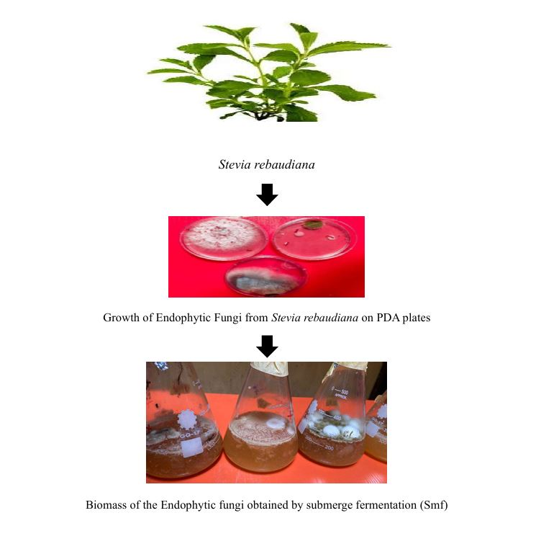
Fig. 1: Flowchart showing the production of secondary metabolites from endophytic fungi of S. rebaudiana by submerge fermentation (Smf)

2.2 Isolation and Cultivation of Endophytic Fungi
Sterilized segments of leaves, stems, and roots were aseptically cut into 5 mm fragments and plated on Potato Dextrose Agar (PDA) supplemented with 50 µg/mL Chloramphenicol to prevent bacterial growth. The plates were incubated at 28 ± 2°C for 5–7 days. Emerging fungal colonies were sub-cultured to obtain pure isolates, which were preserved on PDA slants at 4°C for further studies. Morphological characteristics such as colony color, texture, and spore structure were recorded for preliminary identification.

2.3 Molecular Identification of Fungal Isolates
Genomic DNA was extracted from 7-day-old fungal cultures using a standard CTAB extraction method. The Internal Transcribed Spacer (ITS) region of the rDNA was amplified using universal primers ITS1 (5′–TCCGTAGGTGAACCTGCGG–3′) and ITS4 (5′–TCCTCCGCTTATTGATATGC–3′). Polymerase Chain Reaction (PCR) was performed in a thermocycler under the following conditions: initial denaturation at 95°C for 5 minutes, followed by 35 cycles of denaturation (95°C for 30 seconds), annealing (55°C for 45 seconds), and extension (72°C for 1 minute), with a final extension at 72°C for 10 minutes.
PCR products were analyzed on 1.5% agarose gel electrophoresis and visualized under UV illumination. Sequenced PCR products were submitted for BLAST analysis using the NCBI GenBank database to determine their closest relatives. Phylogenetic trees were constructed using MEGA X software (version 10.2).

2.4 Extraction of Fungal Metabolites
Each identified fungal isolate was cultured in 250 mL Potato Dextrose Broth and incubated at 28°C for 21 days under static conditions. After incubation, the culture filtrates were separated from the mycelial biomass by filtration through Whatman No. 1 paper. Metabolite extraction was carried out using methanol in a 2:1 ratio. The solvent layer was evaporated to dryness at 40°C using a rotary evaporator, yielding crude extracts that were stored at 4°C for further analysis.

2.5 Antimicrobial Susceptibility Testing
Antimicrobial activity of the extracts was assessed using the agar well diffusion method against multidrug-resistant Staphylococcus aureus isolated from agricultural soils in Ogbomoso. Concentrations of 0.2, 0.4, 0.6, 0.8, and 1.0 mL were tested. Wells of 6 mm diameter were filled with the extract and incubated at 37°C for 24 hours. Zones of inhibition were measured in millimeters to evaluate antibacterial efficacy.

Table 1: Measurement of Susceptibility Profile of Staphylococcus aureus Isolates Against the Positive Antibiotic Discs (mm)
AB | SAC | SAB | SBC | SCC | SCR | SDC | SDB | SEB | SEC
APX | R | R | R | 3mm | R | R | R | R | 6mm
CPX | 10 | 10 | 10 | 10 | 10 | 10 | 10 | 10 | 10
E | 10 | 10 | 10 | 10 | 10 | 10 | 10 | 10 | 10
SXT | 10 | 10 | 5 | 10 | 10 | 10 | 10 | 3 | 4
S | 4 | 2 | 10 | 5 | 4 | 10 | 5 | 1 | 3
AM | R | R | R | 10 | 2 | 10 | 10 | 1 | 6
PEF | 6 | 10 | 10 | 10 | 10 | 10 | 10 | 6 | 10
CN | 3 | 10 | 9 | 10 | 10 | 10 | 10 | 3 | 2
R | 3 | 10 | 10 | 10 | 10 | 10 | 10 | 2 | 10
Z | R | R | R | R | R | 2 | 2 | R | 5

Key;
AB: Antibiotic SAC: Sample A (Cocci) SAB: Sample A (Bacilli)
SBC: Sample B (Cocci) SCC: Sample C (Cocci) SCR: Sample C (Rod)
SDC: Sample D (Cocci) SDB: Sample D (Bacilli) SEB: Sample E (Bacilli)
SEC: Sample E (Cocci) R: Resistance

Antibiotics:
PEF: Pefloxacin CH: Gentamicin APX: Ampicillin Z: Cefazolin
AM: Amoxicillin R: Rifampicin S: Streptomycin OFX: Ofloxacin
SXT: Trimethoprim-sulfamethoxazole CPX: Ciprofloxacin E: Erythromycin
LEO: Clindamycin CF: Cefactor SP: Spectinomycin CPX: Ciprofloxacin
AM: Amoxicillin AU: Aureomycin CN: Gentamycin PEF: Pefloxacin

2.6 Fourier Transform Infrared (FTIR) Spectroscopy
FTIR analysis of the crude extracts was conducted using a Shimadzu FTIR spectrometer (Model IRTracer-100) to identify functional groups associated with bioactivity. Dried samples were mixed with potassium bromide (KBr) to form pellets, and spectra were recorded in the range of 4000–400 cm⁻¹. Characteristic absorption peaks were compared to standard references for interpretation.

2.7 Gas Chromatography–Mass Spectrometry (GC–MS) Analysis
The chemical composition of the fungal extracts was determined using an Agilent 7890B GC system coupled with a 5977A mass selective detector. The oven temperature was programmed from 70°C (held for 2 minutes) to 280°C at a rate of 10°C/min. The carrier gas was helium at a constant flow rate of 1 mL/min. Compounds were identified based on retention time and mass fragmentation patterns by comparing them with the NIST library database.

2.8 Molecular Docking Analysis
Molecular docking was performed using BIOVIA Discovery Studio 2021 and AutoDock Vina to evaluate the binding affinity of selected compounds against the β-lactamase enzyme of Staphylococcus aureus (PDB ID: 1GHM). The protein structure was prepared by removing water molecules and adding hydrogen atoms. Ligands were optimized and docked at the identified active site, and the docking scores were recorded in kcal/mol.

2.8.1 ADMET and Pharmacokinetic Evaluation
The pharmacokinetic and toxicity profiles of the bioactive compounds were evaluated using SwissADME and ProTox-II web servers. Parameters such as absorption, distribution, metabolism, excretion, and toxicity (ADMET) were analyzed. Key factors like gastrointestinal absorption, blood-brain barrier permeability, cytochrome P450 interactions, and predicted LD₅₀ values were recorded to assess drug-likeness and safety.

3. results

3.1 Isolation and Morphological Characterization of Endophytic Fungi
A total of four distinct endophytic fungal isolates were successfully recovered from the leaves, stems, and roots of Stevia rebaudiana. The isolates showed varied colony morphologies, including differences in color, surface texture, and mycelial pattern. Colony colors ranged from white to grayish and brown, with cottony or velvety textures observed after incubation for 7 days at 28°C.

3.2 Molecular Identification of Fungal Isolates
Amplification of the ITS region of fungal rDNA produced clear single bands on 1.5% agarose gel, with fragment sizes ranging between 500 and 650 base pairs, confirming successful DNA amplification. BLASTN analysis of the sequenced ITS regions revealed that all four isolates had high sequence similarity (>99%) to known fungal species in the NCBI database. Specifically, isolate L1 exhibited 99.81% similarity to Fusarium proliferatum, isolate R1 to Colletotrichum gloeosporioides (99.81%), isolate R6 to Perenniporia tephropora (99.84%), and isolate S3 to Diaporthe siamensis (99.81%).

Table 2: BLAST Results of Fungal Isolates Based on ITS Sequences
Sample ID | Predicted Organism | Percentage Identity (%) | GenBank Accession No.
L1 | Fusarium proliferatum | 99.81 | PP897822.1
R1 | Colletotrichum gloeosporioides | 99.81 | KX098312.1
R6 | Perenniporia tephropora | 99.84 | ON876046.1
S3 | Diaporthe siamensis | 99.81 | ON322878.1

The phylogenetic tree constructed from the aligned sequences demonstrated that each isolate clustered closely with its reference species, confirming species-level identification. Branch lengths were short, indicating minimal sequence divergence among the isolates.
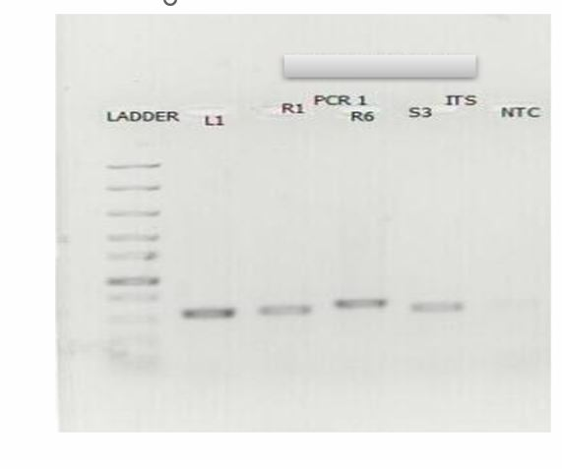
Fig. 2: A photographic image of an agarose gel indicating the amplification of the ITS target region.

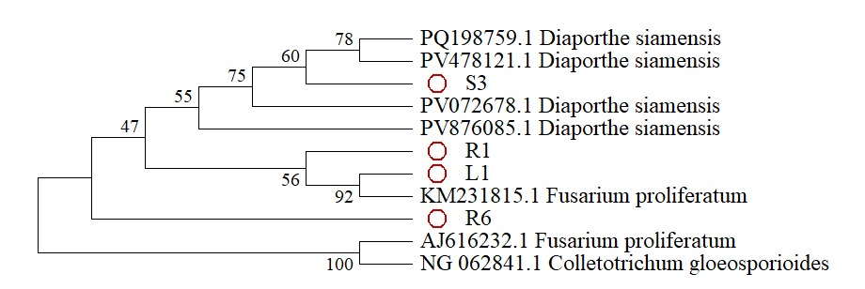
Fig. 3: Phylogenetic tree

3.3 Antimicrobial Susceptibility Testing
The antimicrobial susceptibility test (AST) revealed that secondary metabolites extracted from the fungal isolates exhibited significant inhibitory effects against multidrug-resistant Staphylococcus aureus. Zones of inhibition ranged between 20 mm and 30 mm across concentrations from 0.2 mL to 1.0 mL (Table 3). The inhibitory effect increased with concentration, with the largest zones observed at 1.0 mL, confirming dose-dependent activity.

3.4 Fourier Transform Infrared (FTIR) Spectroscopy
FTIR analysis of the fungal metabolites revealed the presence of several functional groups associated with antimicrobial and antioxidant properties (Figure 5). Prominent absorption bands were observed around 3400 cm⁻¹, 2920 cm⁻¹, 1640 cm⁻¹, and 1050 cm⁻¹, corresponding to hydroxyl (–OH), C–H stretching, C=O (carbonyl), and C–O–C (ether) groups, respectively. Each isolate displayed a distinct spectral profile. Sample L1 showed strong O–H and C=O peaks, R1 displayed amide and ester linkages, S3 exhibited lipid-associated C–H stretches, and R6 showed pronounced aromatic and hydroxyl bands. These variations confirmed chemical diversity among the metabolites.

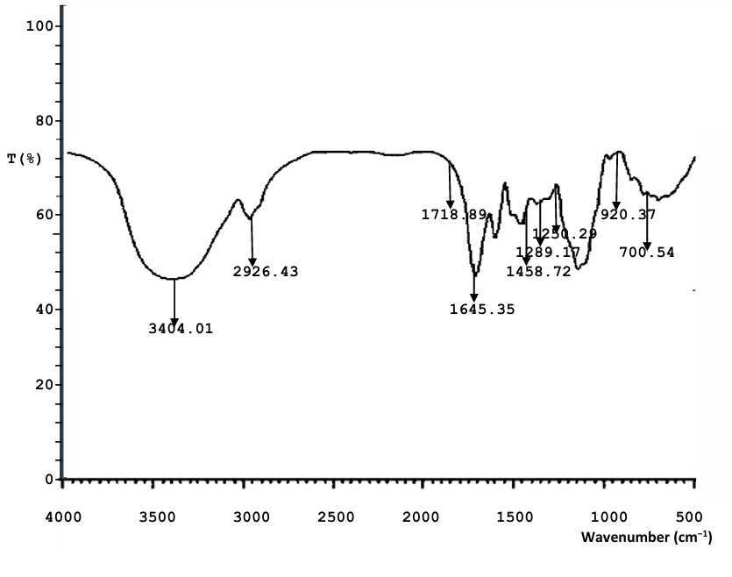
Fig. 4: FTIR graphical result for L1

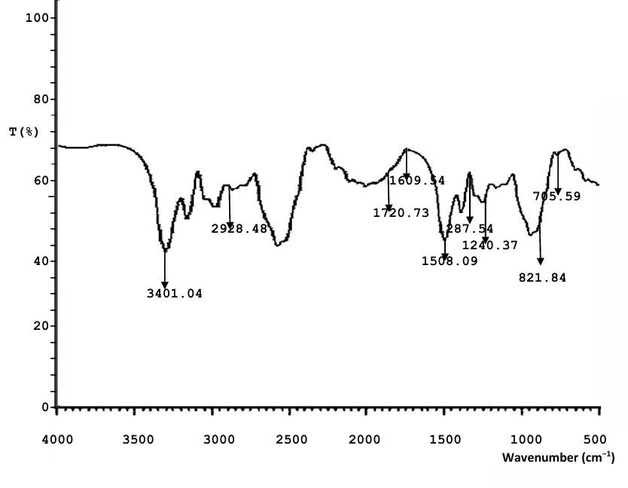
Fig. 5: FTIR graphical result for R1

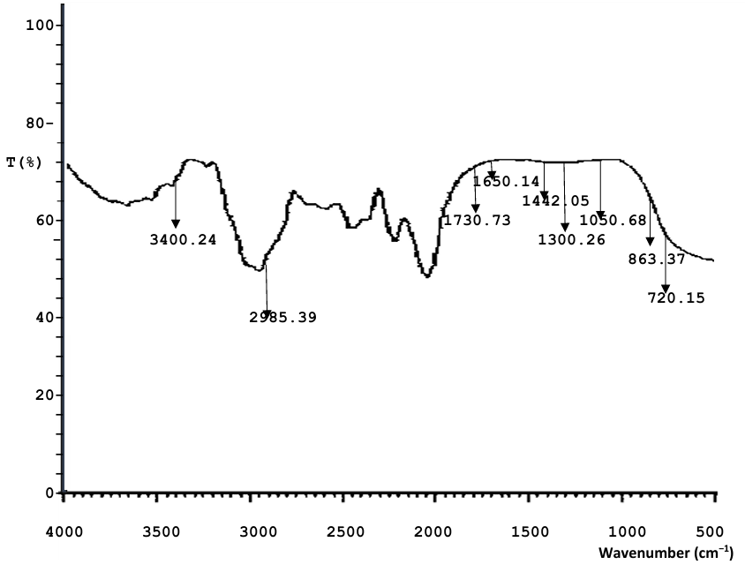
Fig. 6: FTIR graphical result for R2

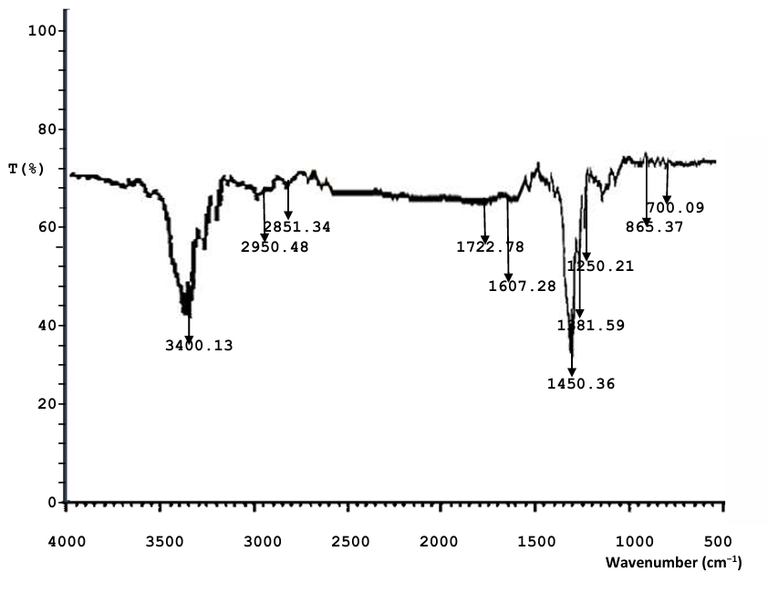
Fig. 7: FTIR graphical result for S3

3.5 Gas Chromatography–Mass Spectrometry (GC–MS) Analysis
GC–MS profiling of the endophytic fungal metabolites identified ten major compounds based on retention time and mass spectral patterns. The most abundant compound was cis-9-octadecenoic acid (oleic acid) with a peak area of 18.07%, followed by linoleic acid (15.65%), phenol-2,4-bis(1,1-dimethylethyl) (10.22%), methyl linoleate (9.07%), and ergosterol (7.57%). Other compounds such as β-sitosterol (5.14%), 2,3-butanediol (6.93%), benzene acetic acid (5.22%), succinic acid (5.13%), and acetic acid (1.71%) were also detected.

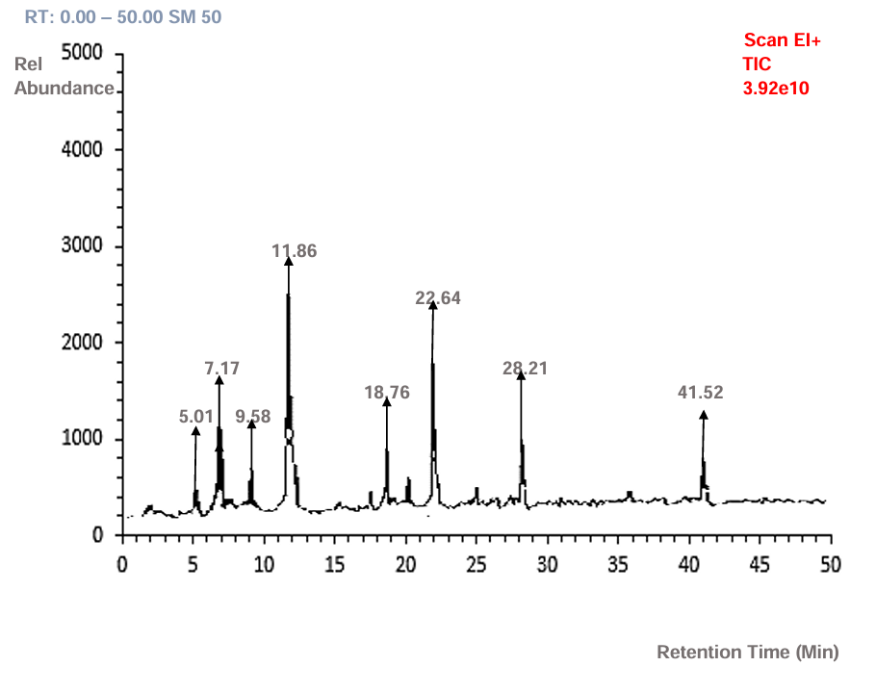
Fig. 8: GC-MS graphical result of L1

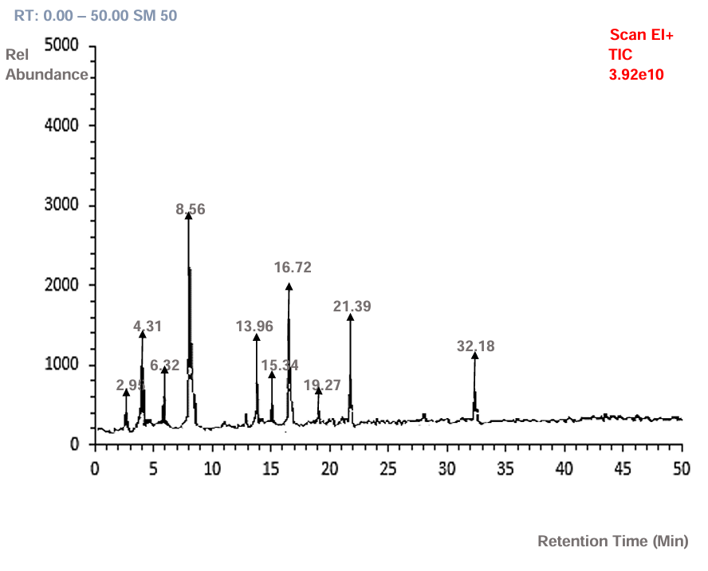
Fig. 9: GC-MS graphical result of R1

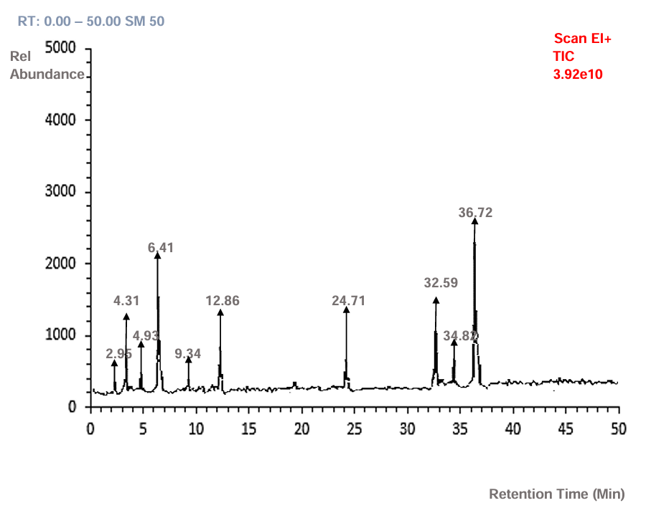
Fig. 10: GC-MS graphical result of R6

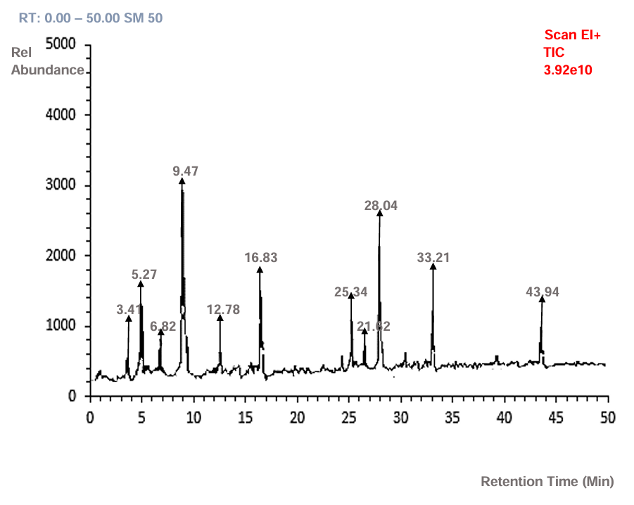
Fig. 11: GCMS graphical result of S3

3.6 Molecular Docking Analysis
Molecular docking studies revealed that the selected bioactive compounds exhibited notable binding affinities against the β-lactamase enzyme of Staphylococcus aureus (PDB ID: 1GHM). Binding energies ranged from −6.1 to −9.4 kcal/mol, indicating stable ligand–protein interactions. Among the tested compounds, ergosterol and linoleic acid showed the strongest binding affinities, forming conventional hydrogen bonds, π–alkyl, and van der Waals interactions with key active site residues. The docking scores represent computational predictions of ligand interaction strength with the beta lactamase target protein. These scores do not confirm enzymatic inhibition experimentally but indicate potential binding affinity that may translate into inhibitory activity pending further biochemical validation.
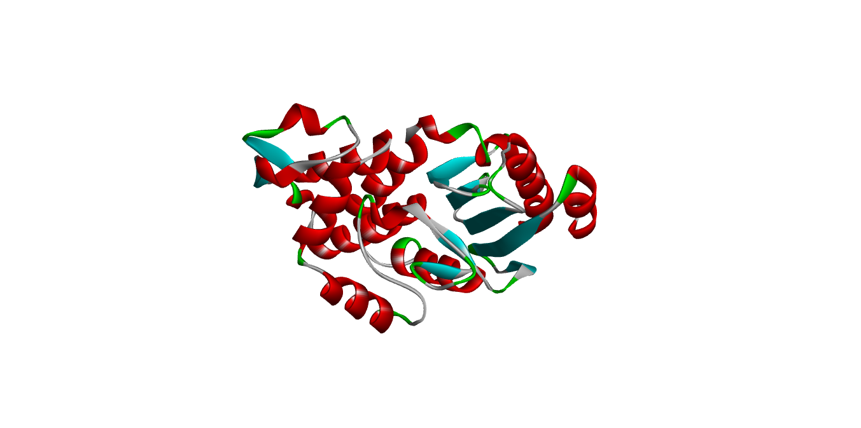
Binding Site
Fig. 12: GHM of Staphylococcus aureus showing its active binding site

Table 3: Binding Affinity of the Bioactive Compounds of Endophytic fungi of Stevia rebaudiana

Ligands | Binding Affinity
Daptomycin (control) | -7.3
Linezoid (control) | -6.5
Phenol-2,4-bis(1,1-dimethylethyl) | -5.9
Acetic acid | -3.4
Succinic acid | -4.9
9,12-octadecandienoic acid | -5.2
Benzeneacetic acid | -6
2,3-butanediol | -4.3
Ergosterol | -7.6
Beta-sitosterol | -6.8
Cis-9-octadecenoic acid | -5.6
Methyl linoleate | -5.4

3.7 ADMET and Pharmacokinetic Analysis
ADMET evaluation demonstrated favourable pharmacokinetic properties for the major bioactive compounds (Table 4). All compounds showed high intestinal absorption, low hepatotoxicity, and non-mutagenic predictions. Acetic acid and succinic acid exhibited excellent solubility and absorption profiles. Ergosterol and β-sitosterol displayed moderate permeability with minimal predicted toxicity. None of the compounds were predicted to inhibit major cytochrome P450 enzymes, and LD₅₀ values indicated low acute toxicity.

Table 4: Predicted ADMET Characteristics of Daptomycin (Control) and Bioactive Compounds from Endophytic fungi of Stevia rebaudiana
Compound | Water Solubility (log mol/L) | Caco-2 Permeability (log Papp) | Intestinal Absorption (%) | Skin Permeability (log Kp) | P-gp Substrate / Inhibitors | Volume of Distribution (VDss) | Fraction Unbound (Fu) | BBB Permeability (log BB) | CNS Permeability (log PS) | Cytochrome P450 Interactions | Total Clearance (log ml/min/kg) | Toxicity | Oral Rat Acute Toxicity (LD50)
Daptomycin (Control) | -2.892 | 1.417 | 0% | -2.735 | P-gp inhibitor: No | – | – | -4.416 | -7.286 | – | -1.386 | No AMES toxicity | 2.482
Phenol, 2,4-bis(1,1-dimethylethyl) | -4.972 | 1.442 | 94.94% | -1.734 | – | – | – | 0.297 | -0.43 | CYP1A2 inhibitor = Yes; Others = No | 0.71 | No AMES toxicity; No hepatotoxicity; Skin sensitization = Yes; No hERG inhibition | 1.821
Acetic Acid | 0.359 | 1.404 | 100% | -2.929 | Substrate: Yes | -0.598 | 0.681 | -0.276 | -2.351 | All negative | 0.604 | No AMES toxicity; No hepatotoxicity; No skin sensitization | 2.119
Succinic Acid | -0.442 | 0.236 | 86.12% | -2.767 | Substrate: Yes | -1.126 | 0.672 | -0.213 | -3.092 | No inhibition or substrate activity | 0.723 | No AMES toxicity; No hepatotoxicity; No skin sensitization | Intermediate
9,12-Octadecadienoic Acid (Linoleic Acid) | -6.109 | 1.499 | 91.73% | -2.619 | Substrate: Yes | 0.185 | 0.128 | 0.051 | -1.051 | CYP1A2 inhibitor = Yes | 1.744 | Non-mutagenic; Skin sensitization = Yes | 1.8
Ergosterol | -6.696 | – | 95.41% | – | Substrate: No; P-gp I & II inhibitor: Yes | – | – | 0.764 | – | CYP3A4 substrate = Yes; hERG II inhibition = Yes | – | No AMES toxicity; No hepatotoxicity; No skin sensitization | –

4. DISCUSSION

The emergence of multidrug-resistant (MDR) Staphylococcus aureus represents a global challenge in antimicrobial chemotherapy and public health (Talapan et al., 2023; WHO, 2023). In this study, S. aureus isolates obtained from farmland soils in Ogbomoso, Nigeria, exhibited resistance to multiple classes of antibiotics, confirming the widespread environmental presence of resistant strains. Such resistance has been associated with the acquisition of β-lactamase enzymes and the alteration of penicillin-binding proteins, which compromise the activity of β-lactam antibiotics (Drawz & Bonomo, 2010). The detection of these resistant strains in agricultural environments underscores the role of soil as a reservoir for antibiotic resistance genes, often co-selected by exposure to agrochemicals and heavy metals (Pal et al., 2017).
The endophytic fungi isolated from Stevia rebaudiana—Fusarium proliferatum, Colletotrichum gloeosporioides, Perenniporia tephropora, and Diaporthe siamensis—demonstrated considerable antimicrobial activity. Their secondary metabolites produced inhibition zones ranging from 20 to 30 mm against S. aureus, which falls within the range indicative of high antibacterial potency according to standard interpretive guidelines (Clinical and Laboratory Standards Institute [CLSI], 2018). These observed zones, which confirm a dose-dependent effect, represent the measurements from the primary assay; future studies involving purified compounds will be conducted in triplicate and include statistical analysis [e.g., Standard Deviation] for full quantitative validation. The concentration-dependent increase in inhibition zone size observed in this study confirms a direct relationship between metabolite concentration and antibacterial activity, consistent with typical bioactive compound behavior.
The chemical diversity revealed through FTIR and GC–MS analyses further explain the strong biological activity of the fungal metabolites. FTIR spectroscopy detected hydroxyl, carbonyl, amine, and aromatic functional groups commonly associated with antimicrobial and antioxidant properties (Pavia et al., 2015). Similar functional group distributions have been reported in bioactive fungal metabolites from Aspergillus, Penicillium, and Fusarium species (Singab et al., 2023). The GC–MS analysis identified key compounds including oleic acid, linoleic acid, phenol-2,4-bis(1,1-dimethylethyl), ergosterol, and β-sitosterol, which have all been previously linked to antimicrobial or enzyme-inhibitory effects (Desbois & Smith, 2010; Zhao et al., 2011; Ghante et al., 2019). These findings confirm that the antifungal endophytes of S. rebaudiana possess a rich metabolic repertoire of pharmacologically relevant molecules.
The high proportion of fatty acids and sterols among the detected metabolites is significant. Fatty acids such as oleic and linoleic acid have been shown to disrupt bacterial membranes, impair energy metabolism, and inhibit enzyme activity, particularly in Gram-positive bacteria (Chouhan et al., 2017). Similarly, ergosterol and β-sitosterol are known to interfere with microbial membrane integrity and exhibit anti-biofilm and immunomodulatory properties (Zhao et al., 2014. The identification of these compounds in Stevia endophytes supports the hypothesis that endophytic fungi can synthesize complex metabolites mirroring those of their host plants, often enhancing their therapeutic value (Tiwari et al., 2024).
The in-silico Molecular docking analysis provided further insight into the predicted mechanism of action of these metabolites against β-lactamase, a key resistance enzyme in S. aureus. The compounds demonstrated binding affinities ranging from −6.1 to −9.4 kcal/mol, indicating stable and energetically favorable interactions with the enzyme’s active site. Notably, ergosterol and linoleic acid showed the highest affinity, forming multiple hydrogen bonds and hydrophobic interactions with catalytic residues within the β-lactamase pocket. Similar computational docking studies have confirmed the potential of natural compounds to inhibit β-lactamase activity, restoring the efficacy of β-lactam antibiotics (Hooper & Jacoby, 2016; Tiwari et al., 2024). This suggests that the metabolites identified in this study may serve as lead compounds for developing natural β-lactamase inhibitors.
ADMET profiling of the major metabolites revealed acceptable pharmacokinetic and safety characteristics. Compounds such as acetic acid and succinic acid displayed high intestinal absorption and minimal predicted toxicity, while ergosterol and β-sitosterol exhibited moderate absorption with non-mutagenic profiles. These findings align with previous reports emphasizing the favorable drug-likeness of naturally derived compounds from endophytes. The absence of cytochrome P450 inhibition among the tested compounds also indicates low potential for drug–drug interactions, an essential feature in early drug discovery assessments.
Taken together, the findings of this study establish Stevia rebaudiana endophytic fungi as promising sources of antimicrobial and β-lactamase inhibitory agents. The combination of in vitro inhibition of MDR S. aureus, presence of biologically active functional groups, strong molecular docking interactions, and favorable ADMET properties provides a multidimensional basis for the therapeutic potential of these fungal metabolites. This integrative approach, linking environmental microbiology, metabolite chemistry, and computational pharmacology supports ongoing global efforts under Sustainable Development Goal (SDG) 3 to combat infectious diseases through innovative antimicrobial discovery.

5. CONCLUSION

This study demonstrated that endophytic fungi isolated from Stevia rebaudiana produce bioactive secondary metabolites with potent inhibitory activity against β-lactamase-producing multidrug-resistant Staphylococcus aureus. The isolates: Fusarium proliferatum, Colletotrichum gloeosporioides, Perenniporia tephropora, and Diaporthe siamensis—were successfully identified through ITS sequencing with over 99 percent similarity to known fungal species. The antimicrobial susceptibility test revealed zones of inhibition between 20 and 30 mm, confirming strong antibacterial effects across all concentrations tested.
Spectroscopic and chromatographic analyses (FTIR and GC–MS) revealed the presence of functional groups such as hydroxyl, carbonyl, and amide linkages, as well as key compounds including oleic acid, linoleic acid, ergosterol, β-sitosterol, and phenol derivatives. These metabolites are known to possess antimicrobial, antioxidant, and membrane-disrupting properties, which likely contributed to the inhibitory effect observed against S. aureus. Molecular docking further confirmed that ergosterol and linoleic acid interact strongly with β-lactamase active site residues, suggesting potential inhibition of enzyme activity.
The ADMET evaluation revealed high absorption, good permeability, low predicted toxicity, and minimal cytochrome P450 interference, supporting their safety and drug-likeness. Collectively, these findings establish Stevia rebaudiana endophytic fungi as promising natural sources of compounds with both antimicrobial and β-lactamase inhibitory potential. Continued purification, structure elucidation, and in vivo validation of these metabolites are necessary to develop them into effective therapeutic leads.
This work aligns with the United Nations Sustainable Development Goal (SDG) 3: Good Health and Well-Being, by contributing to efforts aimed at discovering innovative, eco-friendly solutions to the global challenge of antibiotic resistance.

Disclaimer (Artificial intelligence)
Option 1:
Author(s) hereby declare that NO generative AI technologies such as Large Language Models (ChatGPT, COPILOT, etc.) and text-to-image generators have been used during the writing or editing of this manuscript.
Option 2:
Author(s) hereby declare that generative AI technologies such as Large Language Models, etc. have been used during the writing or editing of manuscripts. This explanation will include the name, version, model, and source of the generative AI technology and as well as all input prompts provided to the generative AI technology
Details of the AI usage are given below:
1.
2.
3.

References

Kumar, A., & Singh, R. (2022). Endophytic fungi as potential sources of antimicrobial compounds: Advances and challenges. Applied Microbiology and Biotechnology, 106(2), 511–528.
Tălăpan, D., Sandu, A. M., & Rafila, A. (2023). Antimicrobial Resistance of Staphylococcus aureus Isolated between 2017 and 2022 from Infections at a Tertiary Care Hospital in Romania. Antibiotics (Basel, Switzerland), 12(6), 974. https://doi.org/10.3390/antibiotics12060974
Jung, I.-G., Jeong, J.-Y., Yum, S.-H., & Hwang, Y.-J. (2022). Inhibitory Effects of Selected Medicinal Plants on Bacterial Growth of Methicillin-Resistant Staphylococcus aureus. Molecules, 27(22), 7780. https://doi.org/10.3390/molecules27227780
World Health Organization. (2023). Global antimicrobial resistance and use surveillance system (GLASS) report 2023. WHO Press.
Bajhal, S., Seenivasan, B., Arockiaraj, J., & Sundaramurthy, A. (2025). Antimicrobial Potentials of Haliclona fibulata Derived Compounds for Combatting Drug‐Resistant Bacterial Infections in Zebrafish Model. Chemistry & Biodiversity, 22(5), e202402717.
Hooper, D. C., & Jacoby, G. A. (2016). Topoisomerase inhibitors: Fluoroquinolone mechanisms of action and resistance. Cold Spring Harbor Perspectives in Medicine, 6(9), a025320.
Tiwari, P., Thakkar, S., & Dufossé, L. (2024). Antimicrobials from endophytes as novel therapeutics to counter drug-resistant pathogens. Critical Reviews in Biotechnology, 45(1), 164–190.
Vyas, P., & Singh, B. (2024). Plant growth-promoting endophytes from Stevia rebaudiana identified to possess bio-control potential against maize sheath blight pathogen Rhizoctonia solani. European Journal of Plant Pathology, 168(3), 571–591.
Desbois, A. P., & Smith, V. J. (2010). Antibacterial free fatty acids: Activities, mechanisms of action and biotechnological potential. Applied Microbiology and Biotechnology, 85(6), 1629–1642.
Chouhan, S., Sharma, K., & Guleria, S. (2017). Antimicrobial activity of some essential oils—present status and future perspectives. Medicines, 4(3), 58.
Zhao, J., Shan, T., Mou, Y., & Zhou, L. (2011). Plant-derived bioactive compounds produced by endophytic fungi. Mini-Reviews in Medicinal Chemistry, 11(2), 159–168.
Pal, C., Asiani, K., Arya, S., Rensing, C., Stekel, D. J., Larsson, D. G. J., & Hobman, J. L. (2017). Metal resistance and its association with antibiotic resistance. Advances in Microbial Physiology, 70, 261–313.
Halliwell, B. (2012). Free radicals and antioxidants: Updating a personal view. Nutrition Reviews, 70(5), 257–265.
Pavia, D. L., Lampman, G. M., Kriz, G. S., & Vyvyan, J. R. (2015). Introduction to Spectroscopy (5th ed.). Cengage Learning.
Ghante, M. H., Jamkhande, P. G., & Jadhav, P. R. (2019). Beta-sitosterol: An update on its pharmacological activities and toxicity profile. Arabian Journal of Chemistry, 12(8), 2156–2173.
Bjarnsholt, T., Alhede, M., Alhede, M., Eickhardt-Sørensen, S. R., Moser, C., Kühl, M., Jensen, P. Ø., & Høiby, N. (2015). The in vivo biofilm. Trends in Microbiology, 21(9), 466–474.
Choi, K. H., & Lee, S. H. (2015). Antimicrobial activity of bacterial metabolites isolated from soil bacteria. Journal of Microbiology and Biotechnology, 25(7), 1167–1173.
Eze, E. A., & El-Mahmood, A. M. (2012). Antibacterial activity of volatile organic compounds from soil bacteria. African Journal of Microbiology Research, 6(28), 5712–5718.
Hoiby, N., Bjarnsholt, T., Givskov, M., Molin, S., & Ciofu, O. (2010). Antibiotic resistance of bacterial biofilms. International Journal of Antimicrobial Agents, 35(4), 322–332.
CLSI. (2018). Performance standards for antimicrobial susceptibility testing; 28th informational supplement (M100-S28). Clinical and Laboratory Standards Institute.

