Original Research Article
Functional characterization and in vitro efficacy of chickpea rhizobacteria against collar rot and dry root rot

ABSTRACT
Background: Chickpea productivity is severely constrained by soil-borne fungal pathogens Sclerotium rolfsii and Rhizoctonia bataticola, which cause collar rot and dry root rot. This study explores the chickpea rhizosphere for beneficial bacteria, that suppress these pathogens and promote plant growth.
Aim: To isolate and functionally characterize rhizobacterial isolates antagonistic to collar rot and dry root rot pathogens.
Methodology: Microbial isolates were isolated from chickpea rhizosphere by standard serial dilution and plating. Antagonistic activity was screened in vitro via dual culture assays, recording percent mycelial growth inhibition. Morphological, biochemical and plant growth promoting (PGP) traits were characterized. Biochemical and PGP traits data was assessed using hierarchical cluster analysis and Principal Component Analysis (PCA).
Results: A total of 223 rhizobacterial isolates were obtained. Ten isolates were highly effective against S. rolfsii, with RCA-05 (72.9±0.09), RSA-02 (72.5±0.12), BSA-17 (72.9±0.07) and BSA-14 (72.5±0.10) exhibiting highest inhibition. Against R. bataticola, 11 isolates exceeded 40% inhibition of mycelial growth, among which BSA-33 (47.9±0.03) and RCA-05 (47.1±0.12) were being the most effective. Multivariate analysis identified BWA-01, RSA-5, and RCA-08 were associated strongly with multiple beneficial traits.
Conclusion: The study identified promising PGP actinomycetes and bacteria that simultaneously promote plant growth and suppress soil-borne pathogens, offering a sustainable bioinoculant solution for chickpea cultivation.
Keywords: Plant growth promotion (PGP), Actinobacteria, Chickpea, Bioinoculants, Sustainability.

- INTRODUCTION
The 21st century has seen a significant surge in human population, intensifying challenges within global agroecosystems and leading to declining productivity and the degradation of sustainable practices. To support a rapidly growing global population, agricultural production must increase by 50% to sustain approximately 9 billion people by 2050 (Shah et al. 2021). However, efforts to boost food production have led to the excessive use of chemical fertilizers, overexploitation of arable land which significantly contribute to greenhouse gas emissions and exacerbate climate change (Pastor et al. 2019). Climate change has potentially reduced agricultural output to 17% with rising CO₂ levels. This reduction not only diminishes crop yields but also drives up agricultural product prices, heightening food insecurity risks for an estimated 77 million people by 2050 (Janssens et al. 2020). Therefore, there is a need to enhance plants’ resilience to this changing climate conditions which causes both abiotic and biotic stresses, for ensuring sustainable agriculture and mitigate the climate change impact on crop production (Al-Turki et al. 2023). Chickpea (Cicer arietinum L.) is a vital legume crop that plays a significant role in sustainable agriculture due to its inherent climate resilience. As a deep-rooted, drought-tolerant crop, chickpea is well-suited for cultivation in semi-arid and rainfed regions, where water scarcity and erratic rainfall are common (Jukanti et al. 2012). Its capacity to fix atmospheric nitrogen improves soil fertility and reduces the dependency on chemical fertilizers, contributing to climate-smart agricultural practices (Kaur et al. 2015). However, because of significant climate changes, chickpea cultivation is under threat of plant disease outbreaks that poses significant risks to global food security and environmental sustainability worldwide. This also results in the loss of primary productivity and biodiversity that negatively impact the environmental and socio-economic conditions of affected regions (Singh 2023). Fusarium wilt has remained the major destructive disease in chickpea cultivation over the past many decades (Sharma et al. 2016). But a major shift in the occurrence and spread of soil-borne diseases has been observed in chickpea over the past decade, in addition to the appearance of new and emerging diseases (Sharma and Ghosh 2017; Chobe et al. 2020). An emerging soil-borne disease of chickpea, collar rot caused by Sclerotium rolfsii, can cause death of 55–95% chickpea seedlings under favourable environmental conditions such as heavy rainfall and high soil temperature (25–30°C) (Sharma et al. 2015). Another major biotic constraint is dry root rot (DRR), caused by Rhizoctonia bataticola, is a serious and widespread disease of chickpea. The causal organism is a soilborne necrotrophic fungus, which can cause massive losses in the areas that were previously unaffected (Khaliq et al. 2020). Chemical control is the only effective control against these pathogens so far. However, usage of chemical fungicides is toxic to flora and fauna of soil ecosystem. of the use of microbial biocontrol agents is an alternative to fungicides with a potential to increase plant tolerance to abiotic and biotic stresses because of their environmentally viable and health-friendly approaches (Anusha et al. 2019; Patel et al. 2023; Pathak et al. 2024).
PGPRs are referred to as the beneficial, free-living rhizosphere bacteria that colonize plant roots and promotes plant growth (Beneduzi et al. 2012). By fixing nitrogen, solubilising phosphate, reducing heavy metals toxicity, producing phytohormones (such as auxin, gibberellins, cytokinin’s etc.), mineralising soil organic matter, decomposing crop residue, suppressing phytopathogens, etc. they significantly enhance crop health (He et al. 2019). Several researchers have highlighted the vital role of plant growth promoting rhizobacteria (PGPR) mediated modulation of systemic resistance against wilt and root rot pathogens in many crops including chickpea (Rudresh et al. 2005; Zaim et al. 2016; Bekkar et al. 2018; Kumari and Khanna 2019; Upadhyay et al. 2022). PGPR provide a plethora of functions by which crop growth and yield can be improved. Indole-3-acetic acid (IAA) producer strains enhance lateral root formation and improve root length, which assist plant to grow under drought conditions (Pandey and Gupta 2019). Siderophore production is one of the main PGPR mechanisms to provide iron for plants in stressful situations. Moreover, there is growing interest in utilizing secondary metabolites such as proteins, toxins, vitamins, amino acids, hormones and antibiotics, derived from rhizosphere microbes particularly actinomycetes, for biocontrol of plant pathogens because of their high specificity, and less harmful effect to the ecosystems (Gopalakrishnan et al. 2011). Actinomycetes are known for their role in plant growth promotion by enhancing root growth, shoot growth and yield. Also, they produce phytohormones, help in nitrogen fixation and solubilisation of minerals, and produce antimicrobial compounds against plant pathogens (Srinivas et al. 2021). Therefore, the present study was aimed to identify beneficial PGP bacteria and actinobacteria from chickpea rhizosphere, and functional characterization of their plant growth promoting activities in chickpea and antagonistic potential against the soil borne pathogens of chickpea.

- MATERIALS AND METHODS
2.1 Sample collection and isolation of microbes
Soil samples were collected from the rhizosphere and rhizoplane regions of chickpea from different soils and locations randomly from the International Crops Research Institute for the Semi-Arid Tropics (ICRISAT), Patancheru (17⁰.5’N latitude 78⁰.2’E longitude). The soil was harvested along with roots into sterile polythene bag and stored in refrigerator at 4℃. Ten grams of rhizospheric soil was added to 90mL of physiological saline of 0.85% and kept for incubation on orbital shaker @110 rpm for 1 hour at 28±2℃. The samples were serially diluted up to 10⁶ dilutions. Dilutions of 10⁴ - 10⁶ were plated on different media such as plate count agar (PCA) (Himedia®-M091A), nutrient agar (NA) (Himedia®-M001), Bacillus differentiation agar (BDA) (Himedia®-M1394) and King’s B agar (Protease peptone- 20g, K₂HPO₄-1.5g, MgSO₄-1.5g, Agar-20g per liter) for isolation of bacteria, and actinomycetes isolation agar (AIA) (Himedia®-M490) for isolation of actinomycetes. The plates were incubated at 28±2℃ for 7 days for actinomycetes and 3 days for bacteria. Isolated morphologically distinct colonies (powdery or dusty colonies of different color, with or without pigment production as actinomycetes) were picked up and purified on AIA and Luria Bertani (LB) agar media and stored in refrigerator at 4℃. Glycerol stocks of all isolates were maintained at -80℃.
2.2 Isolation of pathogens causing collar rot and dry root rot of chickpea
Diseased samples were collected from the chickpea sick plot at ICRISAT, Patancheru (17⁰.4’N latitude 78⁰.25’E longitude). The collected samples were stored in a sterile polythene bag in refrigerator at 4℃. The roots of these samples were washed with tap water, cut into pieces and surface sterilized with sodium hypochlorite solution for 1 min and rinsed thrice with sterile distilled water. Then the root pieces were placed on to the sterilized PDA agar plates and incubated at 28±2℃ for 7 days. Pathogen cultures were maintained in PDA slants at 4℃.
2.3 In vitro screening of isolates against S. rolfsii and R. bataticola pathogens
All the 223 isolates were evaluated for their antagonistic activity against S. rolfsii and R. bataticola which cause collar rot and dry root rot diseases, respectively by dual culture method (Singh et al. 2016). For dual culture screening, bacterial isolates were screened on PDA, while actinomycetes were tested on starch casein agar, glucose casamino acid (Anjaiah et al. 1998) and Mueller Hinton agar media. These specific media were selected to enhance the growth and metabolite production, which is essential for antifungal activity, The isolates were streaked at the one end of the plate (approx. 1 cm away from edge) and pathogen disc of nearly 6mm was kept at another end. The plates with only pathogen culture were considered as control. The plates were incubated for 7 days at 28±2℃ for S. rolfsii and 30±2℃ for R. bataticola. Three replicates were maintained for each isolate. The inhibition percentage was calculated after 7 days of incubation. Mean inhibition percentage (as per Kunova et al. 2016; Singh et al. 2016) was calculated as
I = (C-T) / C × 100
Where, I = % inhibition of mycelial growth, C = mycelial radial growth of pathogen in control plate, T = mycelial radial growth of pathogen in test plate.

2.4 In vitro plant growth promoting (PGP) attributes of selected isolates
The isolates having antagonistic activity were evaluated for their in vitro PGP activities like nutrient solubilization such as phosphorous solubilization (Pikovskaya 1948), potassium solubilization (Hu et al. 2006), zinc solubilization activity using zinc solubilization agar supplemented with 0.1% zinc oxide (Sharma et al. 2012), and silica solubilization (Gopalakrishnan et al. 2011). The development of clear halo zone around colonies was considered as positive for solubilization activity and was measured in mm. Ammonia production was estimated using peptone water to which 1 mL of Nessler’s reagent was added after incubation for 48 h at 30℃. Development of a brown to yellow color after adding the reagent indicates a positive test for ammonia production (Cappuccino and Sherman 1992). Three replicates were maintained for each isolate for all the tests. The uninoculated medium served as a control.
2.4.1 Indole acetic acid (IAA) production
Indole acetic acid (IAA) production was tested as per the protocols of Patten and Glick (1996). Actinomycetes were cultivated in starch casein broth supplemented with L-tryptophan (1 mg/ml) for four days, whereas bacterial isolates were grown in Luria Bertani broth supplemented with L-tryptophan (1 mg/ml) for 48hrs. Following the incubation period, the cultures were centrifuged at 10,000 × g for 10 minutes, and the supernatants were collected. One millilitre of the culture filtrate was then mixed with 2 ml of Salkowski’s reagent (prepared by combining 1 ml of 0.5 M FeCl₃ in 50 ml of 35% HClO₄) and incubated at 28±2 °C for 30 minutes. The formation of a pink colour after incubation signified the presence of indole-3-acetic acid (IAA). IAA concentration was determined by measuring the absorbance at 530 nm using a spectrophotometer, and a standard curve was used to quantify the IAA (µg/ml) in the culture filtrate.

2.4.2 Siderophore production
Siderophore production was determined quantitatively according to the modified standard protocols of Schwyn and Neilands (1987). Actinomycetes were grown in starch casein broth, and bacterial isolates were cultured in LB broth and incubated at 28±2℃ for 7 days and 2 days, respectively. The cultures were centrifuged at 5000 rpm for 12 min at the end of incubation. Supernatant was collected into a test tube and equal amounts of CAS (Chrome azurol S) solution was added and incubated at room temperature to observe the shift in color from blue to orange/yellow indicating positive reaction. The samples were then estimated for siderophore concentrations using spectrophotometer at 630nm absorbance. The amount of siderophore production was calculated and represented as % siderophore units using the formula % Siderophore = Ar – As/Ar*100, where Ar is the absorbance of the reference (CAS reagent) and As is the absorbance of the sample at 630 nm.

2.4.3 Cell wall degrading enzymatic activities of selected isolates
Enzymatic activities like chitinase (standard protocols of Hirano and Nagao 1988), protease and lipase (Bhattacharya et al. 2009), β-1,3-glucanase (as per the protocol of Singh et al. 1999) production were estimated.
2.4.3.1 Chitinase production
5% colloidal chitin was prepared freshly and used in the chitin agar as per the standard protocols of Hirano and Nagao (1998). Actinomycetes isolates were streaked on chitin agar and incubated at 28±2℃ for 7 days. The plates were observed for halo zone around the colonies at the end of the incubation, which indicates positive result for chitinase production. Three replicates were maintained. The uninoculated medium served as control.
2.4.3.2 β-1,3-glucanase production
Estimation of β-1,3-glucanase was done as per the standard protocols of Singh et al. (1999). The strains were cultured individually in tryptic soy broth, supplemented with colloidal chitin 1% (m/v) at 28℃ for 4 days. At the end of incubation, the cultures were centrifuged at 10,000g for 12 min and the supernatants were collected. 1mL of the culture filtrate was allowed to react with 0.1mL of 2% laminarin solution (m/v) in 0.2 mol. L⁻¹ acetate buffer (pH 5.4) at 40℃ for 1 h. The reaction was stopped by adding 3 mL of dinitrosalicylic acid to the mixture and then boiled for 10 min to develop the dark red color, indicating the presence of β-1,3-glucanase. The concentration of the reducing sugar was determined by measuring the absorbance at 530 nm using a spectrophotometer. The experiment was replicated thrice for each isolate. The standards for calibration were prepared using glucose at 0-1mg mL⁻¹ at an interval of 0.2 mg mL⁻¹. One unit of β-1,3-glucanase was defined as the amount of enzyme that produced 1µmol glucose h⁻¹ at defined conditions.
2.4.3.3 protease and lipase production
Qualitative estimation of protease and lipase production was done using the protocols of Bhattacharya et al. (2009). The strains were cultured on casein agar, tween 80 agar for protease and lipase production and incubated at 28℃ for 5-7 days. The plates were observed for halo zones around the colonies at the end of incubation, indicating protease and lipase enzyme production.

2.5 Morphological and biochemical characterization of bacteria and actinomycetes isolates
The isolates which were found positive for antagonistic activity were characterized morphologically and biochemically, according to Bergey’s manual of bacteriology. The isolates were screened morphologically through Gram staining (Christian Gram 1885). Colony characters such as colony size, shape, aerial mycelia, pigmentation were recorded. Biochemical characterization of isolates involved IMVIC tests, catalase (Rangaswami and Bagyaraj 1993), starch hydrolysis (MacFaddin 2000), gelatin hydrolysis (MacFaddin 2000), and triple sugar iron (TSI) agar test.

2.6 Hierarchical clustering of selected isolates
Based on all biochemical, macroscopic and morphological characteristics, hierarchical cluster analysis was performed using SPSS software version 18 and dendrogram generated was based on the average linkage between the groups (Singh et al. 2016).
2.7 Statistical analysis
All the experiments were statistically analyzed by ANOVA using GenStat 10.1 version (Fisher 1918). Dendrogram based on average linkage between the groups was generated using Statistical Package for Social Science (SPSS) software (IBM Statistics) version 18. All the experiments were performed in triplicates and mean values were compared at 5 % level of significance. Principal component analysis (PCA) was used to evaluate the correlation between the microorganisms and the PGPR activities using Origin Pro 2023b version 10.0.5.157 (Origin Lab, Massachusetts, USA) to construct all the figures. The software XLSTAT (version 2019.2.1) was used to statistically examine the data for analysis of variance (ANOVA). Tukey’s test was used to statistically assess significant differences between treatments at 5% level of significance (Tukey 1977).

- RESULTS AND DISCUSSION
3.1 Bacteria and actinobacteria isolation
Chickpea rhizosphere soil and rhizoplane samples were collected from different soils at different locations of ICRISAT, Patancheru. A total of 223 rhizobacteria (including actinomycetes) were isolated based on their distinct morphological characters. Maximum diversity of actinomycetes and bacteria were found in the rhizosphere of black and red soils, respectively.
Microorganisms can indirectly influence crop health and phenotypic plasticity by affecting the plant growth and defence responses because of their co-evolution with plants. The rhizosphere hosts various microorganisms that provide consistently PGPR supplies (El-Saadony et al. 2022). The adoption of plant-growth-promoting (PGP) microorganisms in sustainable agriculture has surged globally, with numerous reports highlighting significant increase in the growth and yield of agriculturally important crops (Gopalakrishnan et al. 2012a, 2012b; Gopalakrishnan et al. 2013; Srinivas et al. 2022; Upadhyay and Chauhan 2022). The present investigation resulted in equivalent findings with Guo et al. 2015 demonstrated that red soils harbor diverse biosynthetic potential actinomycetes where they identified 600 actinomycete strains, that exhibited antagonistic effects against pathogenic fungi by producing polyether ionophores, siderophores and chitinases. The biocontrol of fungal pathogens is primarily attributed to the production of antifungal compounds, competition for nutrients between antagonists and pathogens and the secretion of extracellular enzymes that degrade fungal cell walls.

3.2 Antagonistic screening against S. rolfsii and R. bataticola pathogens
All the 223 isolates were initially screened for their antagonistic activity against the pathogens S. rolfsii and R. bataticola. Among the bacterial isolates, only four fluorescent Pseudomonas strains (RSPF-3, RSPF-4, RSPF-7, RSPF-8) demonstrated significantly high antagonistic activity against S. rolfsii with inhibition of 55.4±0.00, 56.7±0.01, 55.8±0.01 and 56.3±0.00, respectively. However, none of the bacterial isolates showed antagonism to R. bataticola. In contrast, actinomycetes isolates demonstrated promising potential against dry root rot pathogen. Among 75 actinomycete isolates screened, nearly 57 isolates exhibited moderate to strong inhibition of R. bataticola. Of which, 11 isolates exceeded 40% inhibition with BSA-33 (47.9±0.03) and RCA-05 (47.1±0.12) being the most effective (Fig. 1). Similarly, a total of 30 actinomycetes isolates were found to inhibit S. rolfsii when tested on muller hinton agar medium. Six isolates demonstrated more than 70% inhibition with RCA-05 (72.9±0.09) and BSA-17 (72.9±0.07) exhibiting maximum inhibition and a brown discoloration in the medium at the advancing edge of pathogen mycelium which further extended around the pathogen colony. This discoloration is likely due to metabolites produced by the actinomycetes isolates during microbial interaction. Heatmaps (Fig. 2) represents the in vitro screening of isolates against pathogens. Hence, these isolates were selected for metabolite extraction and further screened for in vitro plant growth promoting activities as well as cell wall degrading enzymatic activities.
The current results were aligned with Zhang et al. 2021 who isolated 60 actinomycetes strains exhibiting well-developed aerial and substrate mycelia from rhizosphere soil of Machilus pingii located in the ecological natural reserve of Hainan province, China on different media. Out of 60 isolates, 17 showed antagonism (28.3% of total actinomycetes) against Fusarium oxysporum TR4. When further determined 11 actinomycetes had shown their promising role as potential biocontrol agents by exhibiting over 60% antifungal activity against F. oxysporum TR4. Mageshwaran et al. 2022 where they reported or identified 45 endophytic isolates (out of 225) had shown inhibition against S. rolfsii, collar rot pathogen of chickpea. From these, only 15 isolates demonstrated an inhibition zone exceeding 5 mm radius in dual culture technique.
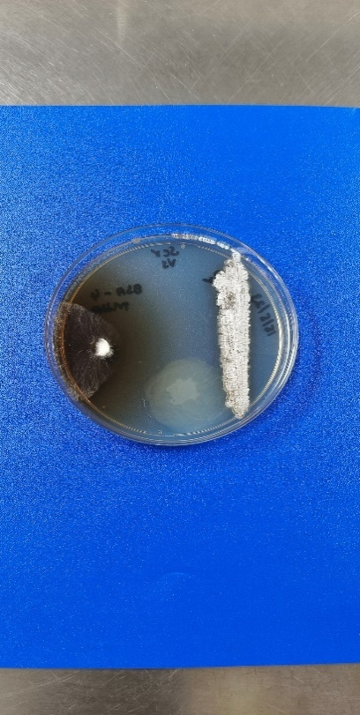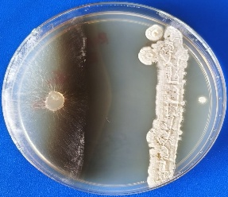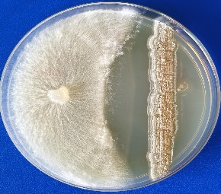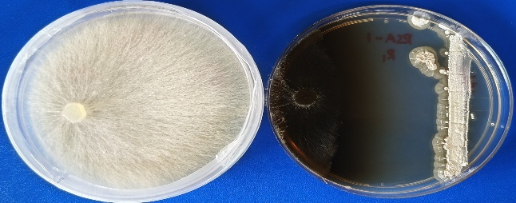

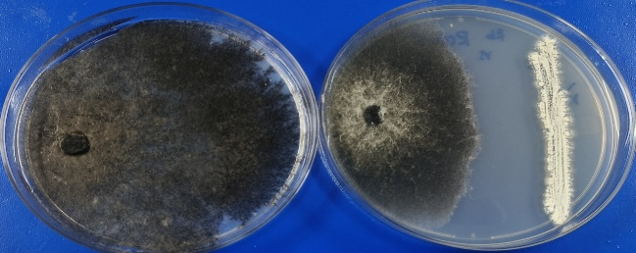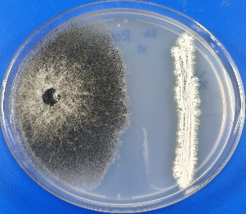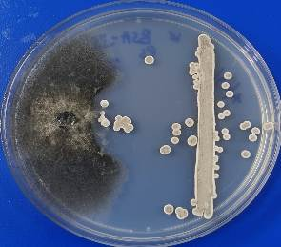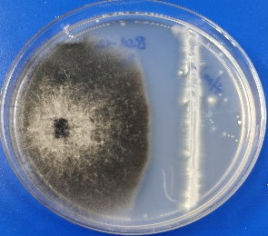
RSA-5
RCA-
Sr
RCA-8
RCA-
BSA-17
RCA-
RCA-5

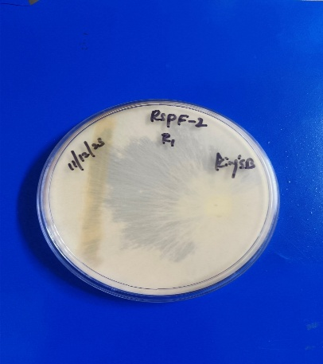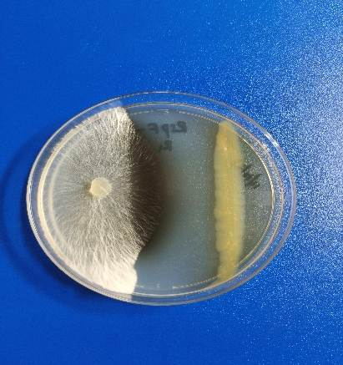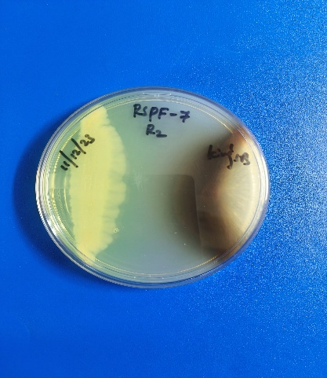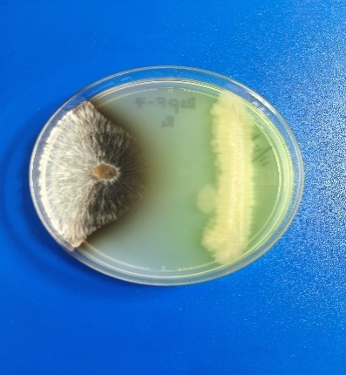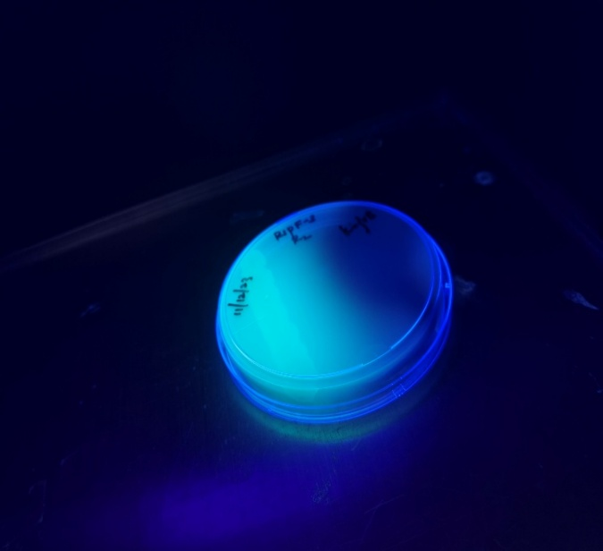
BWA-01
RCA-
BWA-33
RCA-
RSA-2
RCA-
RCA-8
RCA-
Rb
RSPF-7
RCA-
Sr- Sclerotium rolfsii; Rb- Rhizoctonia bataticola
Sr
Fig. 1. Antagonistic screening of actinomycetes and fluorescent Pseudomonas isolates against S. rolfsii and R. bataticola pathogens.
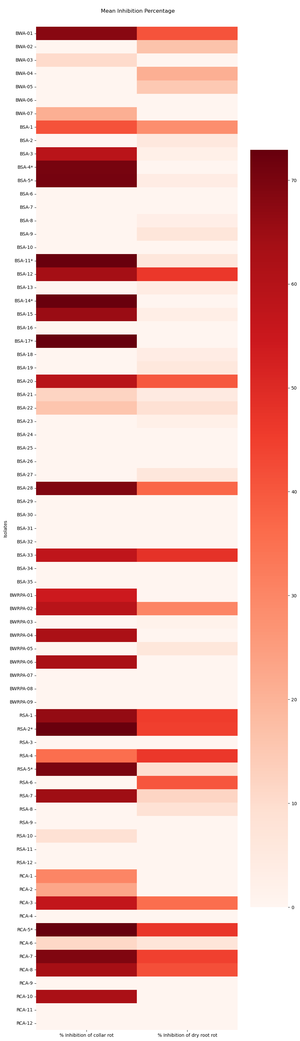
Each small cell corresponds to isolates. Colour of cells represent Mean inhibition percentage.
Fig. 2. Heatmaps representing in vitro screening of isolates against S. rolfsii and R. bataticola.

3.3 In vitro PGP and enzymatic activities by the prominent actinobacteria
A total, 19 isolates antagonistic to pathogens were assessed for their plant growth promoting potential and enzymatic activities. All the test isolates produced β-1,3-glucanase except BSA-17 and fifteen isolates produced siderophores (Fig. 3). The highest siderophore production was observed in RSPF-7 i.e., 73.0 µg/mL. Fourteen isolates produced IAA; BWA-01 being the highest IAA producer (131.6 µg/mL), whereas 6 actinomycetes were found positive for Zn solubilization, and nine isolates showed Si solubilization (Table-1). None of the actinomycetes solubilized phosphorous or potassium. Conversely, all bacterial isolates were positive for phosphorous solubilization, and three isolates showed K solubilization while none exhibited zinc solubilization. Regarding enzymatic activities, 15 isolates produced chitinase, 15 produced lipases, 5 isolates (RCA-8, RSA-5, BSA-12, RSPF-4 and RSPF-7) recorded protease activity and 13 isolates produced ammonia. These results inferred that all the antagonistic isolates significantly possess enzymatic activities, promotes plant growth and are capable of producing secondary metabolites.
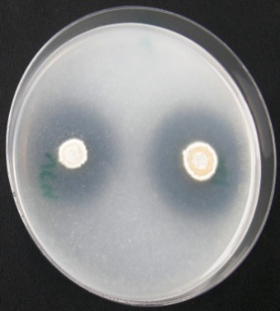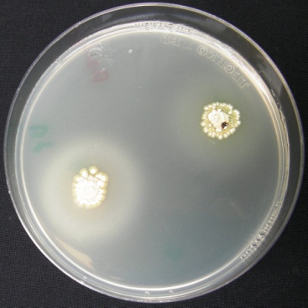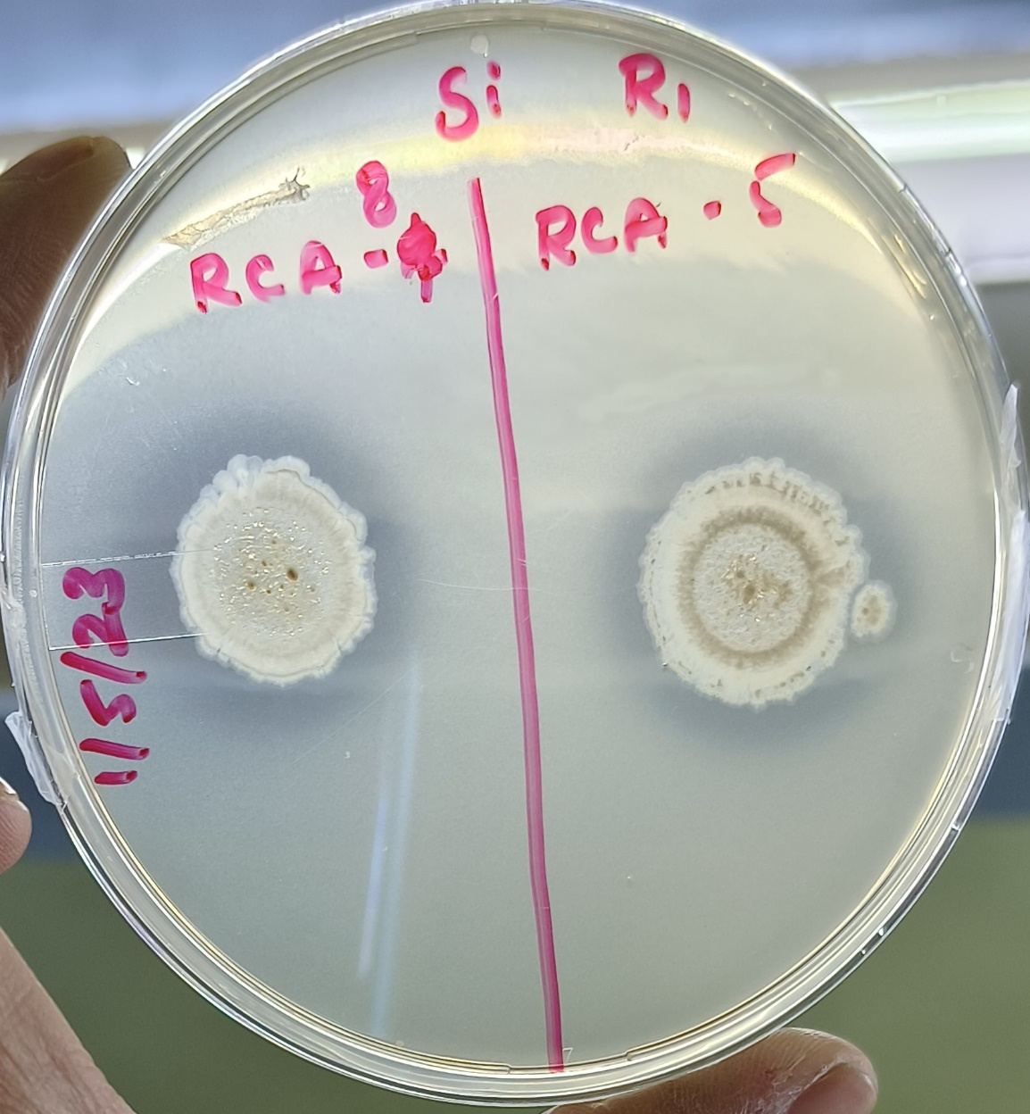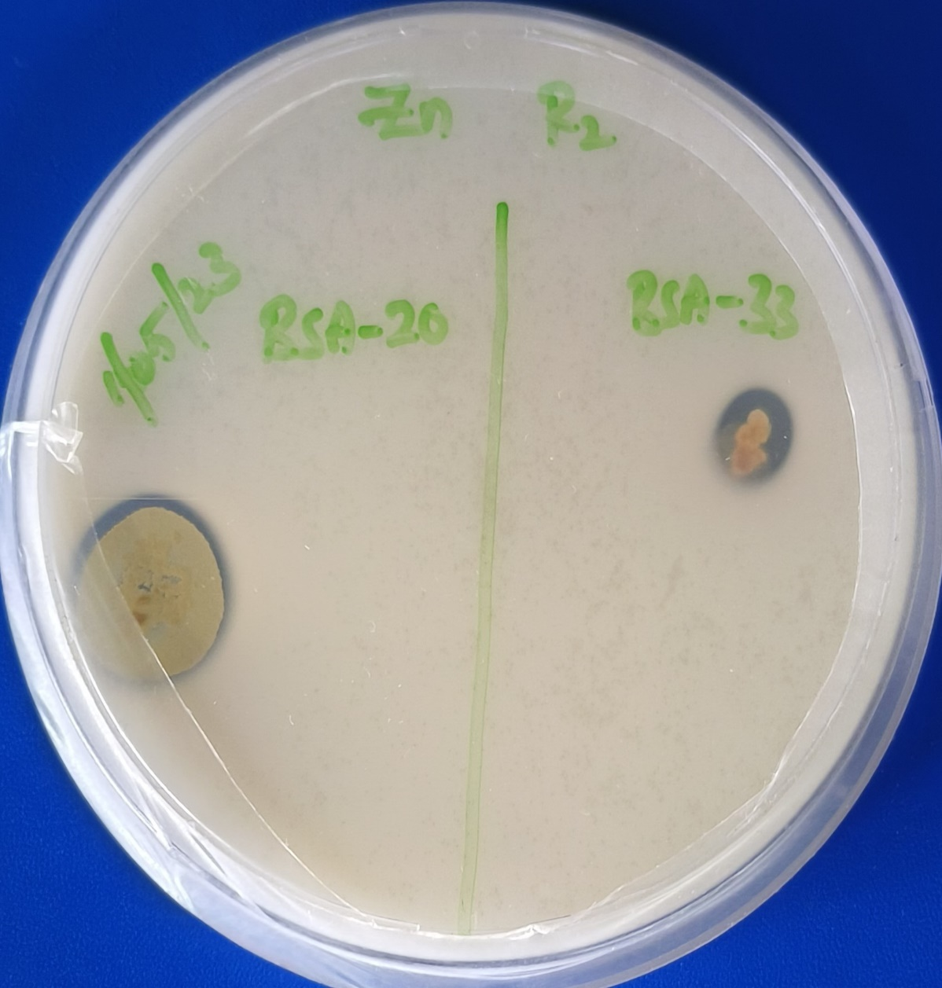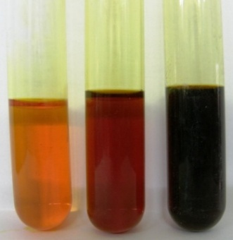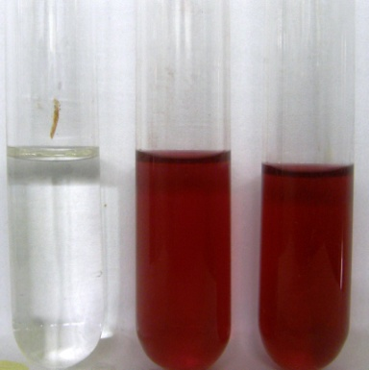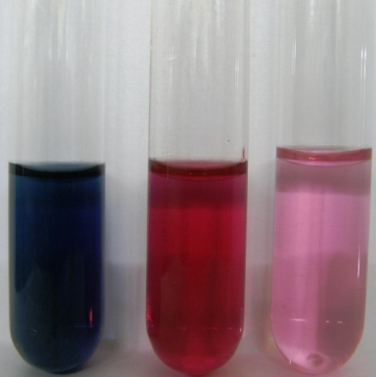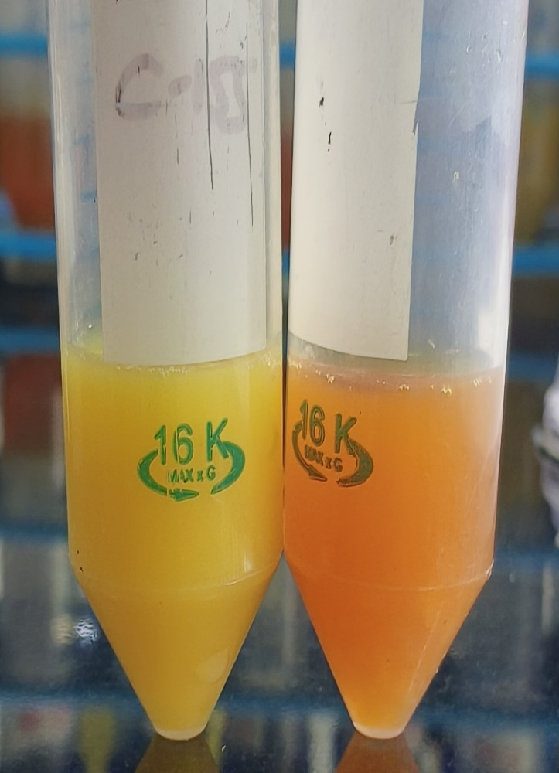
RSA-4
RSA-5
RCA-8
RCA-7
a

b
c
d
e
f
g
h
-ve
+ve
+ve
-ve
+ve
+ve
-ve
-ve
+ve
+ve
+ve

^{-ve - Negative; +ve - Positive}
Fig. 3. In vitro PGP attributes of potential isolates a) Zn solubilization b) Si solubilization c) Chitinase activity d) Lipase activity e) Ammonia Production f) β-1,3-glucanase activity g) IAA production h) Siderophore production
Further, 19 promising isolates were screened for their in vitro PGP activities such as siderophore production, IAA, chitinase, protease, lipase and nutrient solubilization activities like solubilization of phosphorous, potassium, zinc, and silica. Siderophores are iron chelating compounds usually produced by soil microbes including actinomycetes and make it available to plants as well as for their own growth. The hydrolytic extra cellular enzymes such as β-1,3-glucanase, chitinase, lipase and protease producing microbes could act as biocontrol agents of soil borne pathogenic fungi by hydrolyzing and degrading major component of their cell wall apart from their role in nutrient solubilization, organic matter decomposition and plant growth promotion. In the current investigation, all the antagonistic isolates produced siderophores, and β-1,3-glucanase, while sixteen of them produced chitinase, fifteen produced lipase and six of them have shown protease activity. The presence of fungal cell wall degrading enzymes such as β-1,3-glucanase, chitinase, lipase and protease have been proved to be involved in antagonistic activity of the bioagents against phytopathogenic fungi (Gopalakrishnan et al. 2011a; Gopalakrishnan et al. 2011b; Khan et al. 2023). The production of metabolites (antifungal compounds) and lytic enzymes by these isolates might have contributed to moderate to high levels of antagonism observed against S. rolfsii and R. bataticola pathogens of chickpea. Further this can be confirmed by metabolite studies.
Rhizobacteria that produce IAA are known to promote root elongation and plant growth (Patten and Glick 2002; Gopalakrishnan et al. 2011). In the present investigation, 14 bacterial isolates were found to produce IAA with highest production of 131.6 µg/mL (BWA-01) which is 2-10 folds higher than other isolates, suggesting that this isolate could be used for plant growth promotion. Similar studies have shown that IAA production is very common among PGPR to promote plant growth in different crops (Gopalakrishnan et al. 2011a; Islam et al. 2016: Anusha et al. 2019; Kazerooni et al. 2021; Zhang et al. 2021; Timofeeva et al. 2022; Khan et al. 2023; Chauhan et al. 2024). In fact, many isolates in the present study produced higher IAA than previously reported strains (Islam et al. 2016: Anusha et al. 2019; Kazerooni et al. 2021; Srinivas et al. 2022). Further these in vitro results need to be validated by glasshouse/field studies.

Table 1. In vitro plant growth promoting attributes of potential isolates
Isolates | Growth promoting traits |  |  |  |  |  |  |  |  | Nutrient solubilization traits
Isolates |  |  |  |  |  |  |  |  |  | Halo zones in mm
Isolates | IAA  (µg/mL) | β-1,3-glucanase  (mg/mL) | Siderophore (% Sid units) | Chitinase (mm) | Protease  (mm) | Lipase  (mm) | Ammonia |  | HCN | P | K | Zn | Si
RCA-05 | 45.9±0.06* | 2.07±0.01* | 25.3 | 38 | 0 | 16 | + | + |  | - | - | 9 | 22
RCA-07 | 44.8±0.01 | 1.63±0.06 | - | 30 | 0 | 18 | + | - |  | - | - | 0 | 0
RCA-08 | - | 2.36±0.04 | - | 33 | 28 | 19 | - | + |  | - | - | 11.5 | 23
RSA-01 | 14.5±0.09 | 1.61±0.02 | 18.2 | 30 | 0 | 0 | - | - |  | - | - | 0 | 0
RSA-02 | - | 1.30±0.03 | - | 33 | 0 | 16.5 | + | + |  | - | - | 0 | 0
RSA-04 | 20.5±0.02 | 1.16±0.07 | - | 40 | 0 | 20 | - | + |  | - | - | 0 | 0
RSA-05 | 44.1±0.01 | 2.07±0.01 | 15.9 | 40 | 28.5 | 20.5 | + | + |  | - | - | 0 | 22.5
RSA-06 | 19.9±0.08 | 2.16±0.06 | 23.1 | 30.5 | 0 | 15.5 | + | + |  | - | - | 0 | 0
BWA-01 | 131.6±0.04 | 2.67±0.05 | 27.9 | 27.5 | 0 | 13.5 | + | + |  | - | - | 7.5 | 0
BSA-04 | 15.2±0.01 | 2.74±0.05 | 4.8 | 0 | 0 | 0 | + | + |  | - | - | 0 | 0
BSA-12 | 12.0±0.01 | 1.60±0.06 | 25.7 | 0 | 25.5 | 12.5 | + | + |  | - | - | 0 | 0
BSA-14 | - | 1.13±0.05 | 26.5 | 0 | 0 | 10 | - | + |  | - | - | 9 | 0
BSA-17 | - | 0.46±0.01 | 24.5 | 0 | 0 | 12 | - | + |  | - | - | 0 | 0
BSA-20 | - | 0.76±0.04 | 24.7 | 33 | 0 | 0 | + | - |  | - | - | 15 | 21.5
BSA-33 | 50.4±0.01 | 1.46±0.16 | 22.6 | 29.5 | 0 | 14.5 | + | + |  | - | - | 8.5 | 23.5
RSPF-3 | 24.0±0.04 | 2.58±0.07 | 35.9 | 33 | 0 | 21 | - | + |  | 24.5 | 11.5 | 0 | 17
RSPF-4 | 20.8±0.01 | 2.38±0.04 | 60.4 | 28.5 | 22.5 | 25.5 | + | + |  | 14 | 17 | 0 | 17
RSPF-7 | 38.3±0.05 | 2.84±0.07 | 73.0 | 35 | 19.5 | 25 | + | + |  | 15 | 0 | 0 | 18
RSPF-8 | 18.7±0.05 | 1.18±0.04 | 43.8 | 31.5 | 0 | 0 | + | + |  | 15.5 | 15 | 0 | 18.5
Mean | 0.36 | 0.73 | 0.84 | 0.50 | 0.17 | 0.68 | - | - |  | - | - | - | -
SE (m) | 0.26 | 0.73 | 0.53 | 0.41 | 0.24 | 0.20 | - | - |  | - | - | - | -
SE (d) | 0.41 | 0.98 | 0.75 | 0.58 | 0.34 | 0.29 | - | - |  | - | - | - | -
CD (0.05) | 0.074 | 0.162 | 1.51 | 1.17 | 0.68 | 0.58 | - | - |  | - | - | - | -
CV (%) | 2.50 | 3.60 | 2.93 | 2.73 | 5.38 | 2.53 | - | - |  | - | - | - | -
+ indicates positive, – indicates negative, C.D (0.05) represents critical difference at 5% significance, * values are the MEAN ± SE, IAA-indole-3-acetic acid, HCN-hydrogen cyanide, P-phosphorus, K- potassium, Zn- zinc, Si- silica. The experiment was repeated twice with three replicates for each isolate

3.4 Morpho-biochemical attributes of potential actinobacteria
All the promising isolates were characterized based on their morphological and biochemical attributes. The 15 isolates were Gram positive, with the presence of mycelia indicating that all belonged to actinobacteria whereas four isolates were Gram negative, rod shaped, exhibited fluorescence in King’s B medium implying that they belong to fluorescent Pseudomonas. Aerial mycelia of actinomycete isolates were creamy, white, grey in color but orangish white, brown, grey, off-white in the back side of petri dish. When characterized biochemically, all the isolates demonstrated citrate utilization and were capable of hydrolysing gelatin; 12 isolates showed carbohydrate fermentation, 16 isolates were able to hydrolyse starch, four were tested positive for methyl red test and 12 were catalase positive (Fig. 4; Table-2).
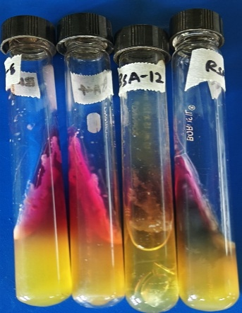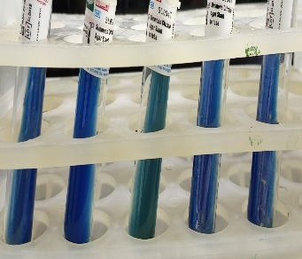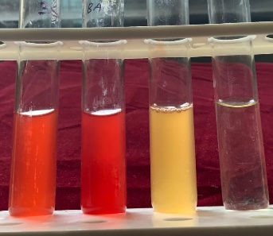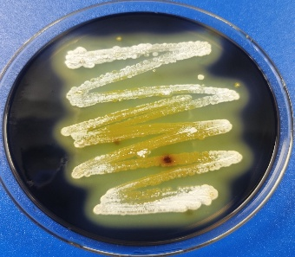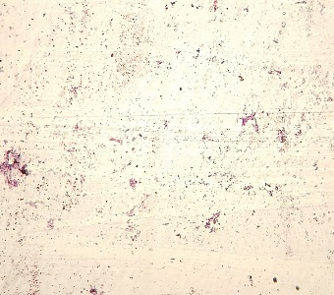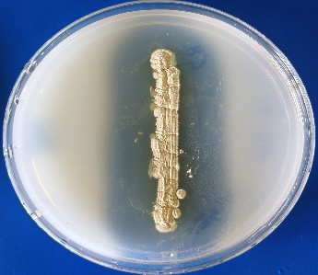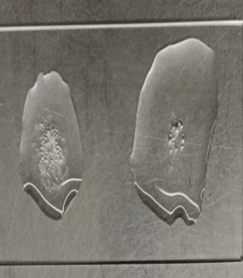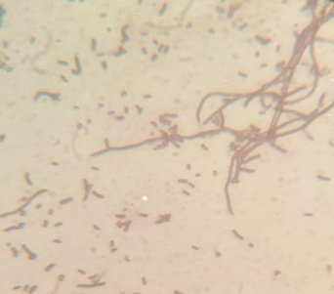
g
a
b
c
d
e
f
h

Fig. 4. Biochemical and morphological characterization of potential isolates. a&e) gram staining b) Methyl red test c) catalase test d) citrate Utilization test f) gelatin hydrolysis test g) triple sugar iron test h) starch hydrolysis test
The results were consistent with Jha 2020; Fasusi et al. 2021 who characterized the isolates for biochemical tests. All the bacterial isolates were found positive for citrate, oxidase, catalase and protease. While, 7 were coagulase positive and 2 isolates were H₂S producers. 6 isolates were able to ferment carbohydrates.

Table 2. Morpho-biochemical characteristics of promising isolates
Isolates | Indole test | Methyl red test | Voges Proskauer test | Citrate utilization test | Catalase test | Gelatine hydrolysis test | Starch hydrolysis test | Triple sugar iron test
RCA-05 | - | - | - | + | + | + | + | +
RCA-07 | - | - | - | + | - | + | + | +
RCA-08 | - | + | + | + | + | + | + | +
RSA-01 | - | - | - | + | - | + | + | +
RSA-02 | - | - | - | + | - | + | + | +
RSA-04 | - | - | - | + | + | + | + | +
RSA-05 | - | - | - | + | - | + | + | +
RSA-06 | - | - | - | + | - | + | + | +
BWA-01 | - | + | - | + | + | + | + | +
BSA-04 | - | - | - | + | - | + | - | -
BSA-12 | - | - | - | + | + | + | + | +
BSA-14 | - | - | - | + | + | + | + | +
BSA-17 | - | - | - | + | + | + | + | -
BSA-20 | - | - | - | + | - | + | + | -
BSA-33 | - | - | - | + | + | + | + | -
RSPF-3 | - | - | - | + | + | + | + | -
RSPF-4 | - | + | + | + | + | + | - | -
RSPF-7 | + | + | - | + | + | + | + | +
RSPF-8 | - | - | - | + | + | + | - | -
+ indicates positive, – indicates negative,

3.5 Hierarchical clustering of prominent isolates
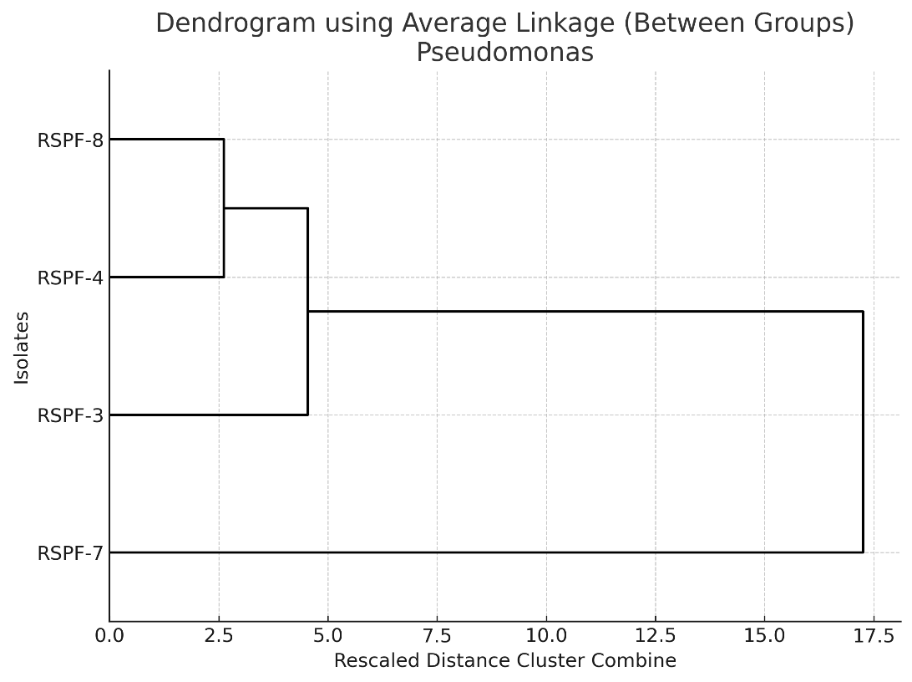
The strains that tested positive in the primary screening, were analysed using hierarchical cluster analysis. Two dendrograms was constructed (separate for actinomycetes isolates and Pseudomonas isolates) with SPSS software (Version 16) through average linkage clustering based on morphological and biochemical characteristics (Fig. 5). Dendrogram generated for Pseudomonas isolates identified two major clusters. RSPF-04, RSPF-08, RSPF-03 isolates were placed in one cluster whereas RSPF-07 placed in separate cluster as it was positive for all the biochemical characteristics. In dendrogram (generated for actinomycetes isolates), the majority of isolates (14) formed cluster-1, merging at relatively lower rescaled distances (<5), indicating close relatedness and high similarity. The second major cluster comprised BWA-01 which were markedly different from cluster-I, suggesting distinct morpho-biochemical profiles. Notably, isolate BWA-01 which was positive for all the biochemical traits and exhibited antimicrobial activity, was placed in the second cluster. The substantial distance separating the two clusters highlights significant microbial diversity, emphasizing the potential to select both distinct and diverse isolates for further functional studies, suggesting possible functional differentiation and adaptive significance.
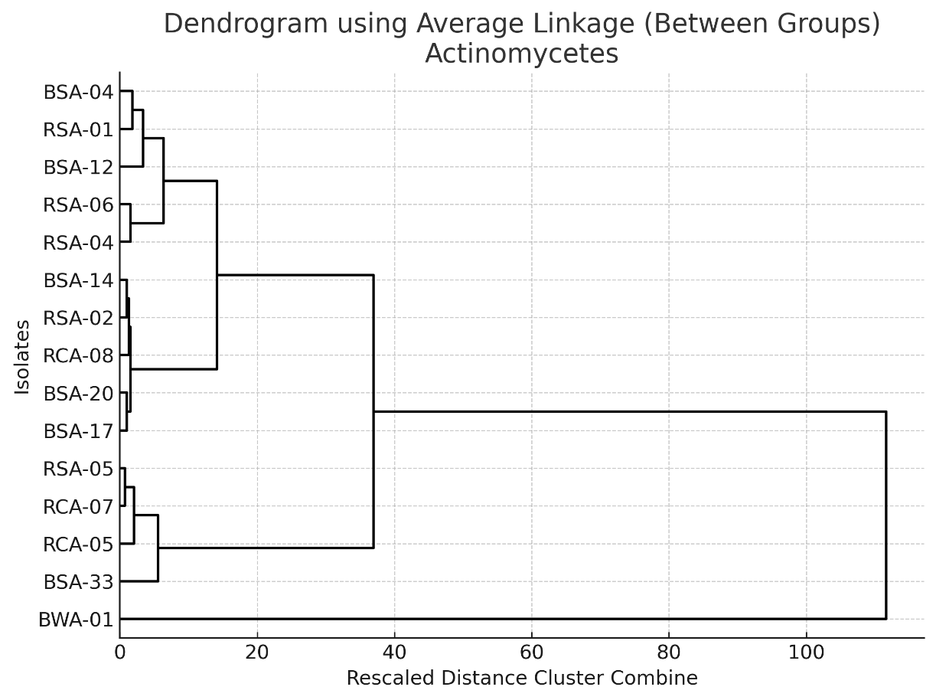
Fig. 5. Dendrograms based on the morphological and biochemical characterization of Pseudomonas and actinomycetes isolates
  - Principal component analysis (PCA)
The PCA biplot illustrates the correlation of test isolates with biochemical, PGP abilities evaluated by production of IAA, siderophore, ammonia, P, K, Zn, Si solubilization, and along with enzymatic traits such as chitinase, lipase, protease, β-1,3-glucanase (Fig. 5a). The first two components (PC1 and PC2), eigen values were 3.23 and 2.09, respectively. The variability expressed by PC1 is 24.92%, while PC2 accounts 16.15% thus PC1 and PC2 together explained 41.08% of total variability in the dataset. The relatively moderate proportion of variance captured by the first two components suggests that the functional traits evaluated are distributed across multiple dimensions, with no pair of traits demonstrating the variation. The graphical biplot reveals that PC1 had a strong influence on lipase and chitinase activity, siderophore production, triple sugar iron and starch hydrolysis. In contrast, PC2 is more closely linked to IAA production, β-1,3-glucanase and other characteristics. The accompanying correlation matrix heatmap (Fig. 5b) further emphasizes the strength and direction of relationships between traits. Among the isolates, BWA-01, RSA-5, and RCA-08 exhibit strong positive associations with multiple traits, indicating their strong functional potential. On the other hand, BSA-04 and BSA-17 are distantly located, suggesting they possess distant or limited trait expressions. Isolates such as RSA-06, RCA-07 and BSA-33 were clustered near the origin, indicating moderate or average expression of multiple traits. The central clustering of several isolates near the centre indicates overlapping biochemical profiles, while isolates positioned on periphery may harbour unique biochemical properties.
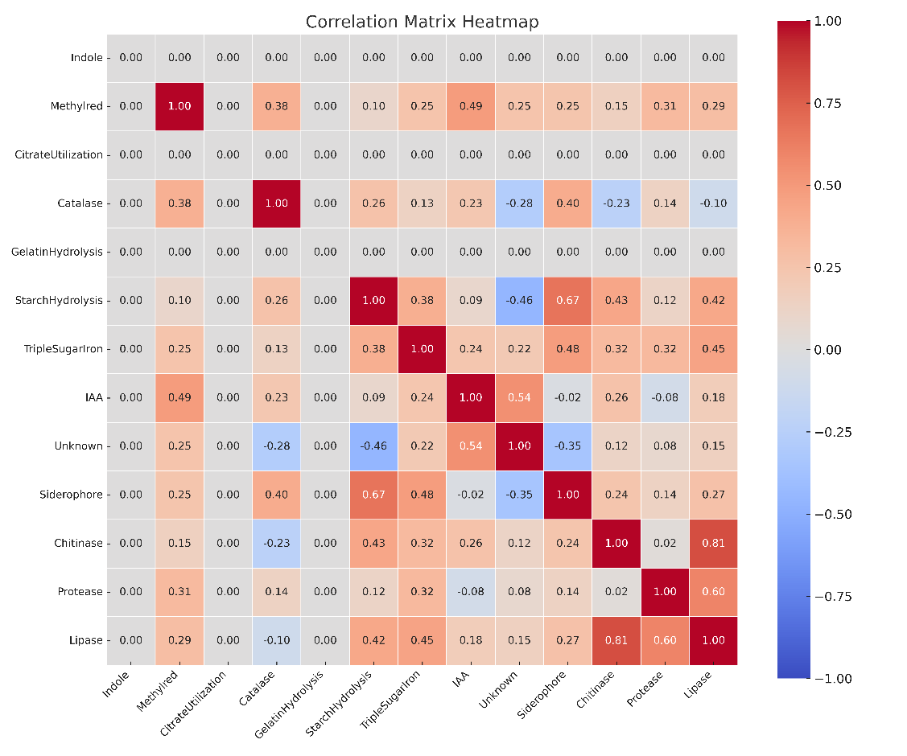
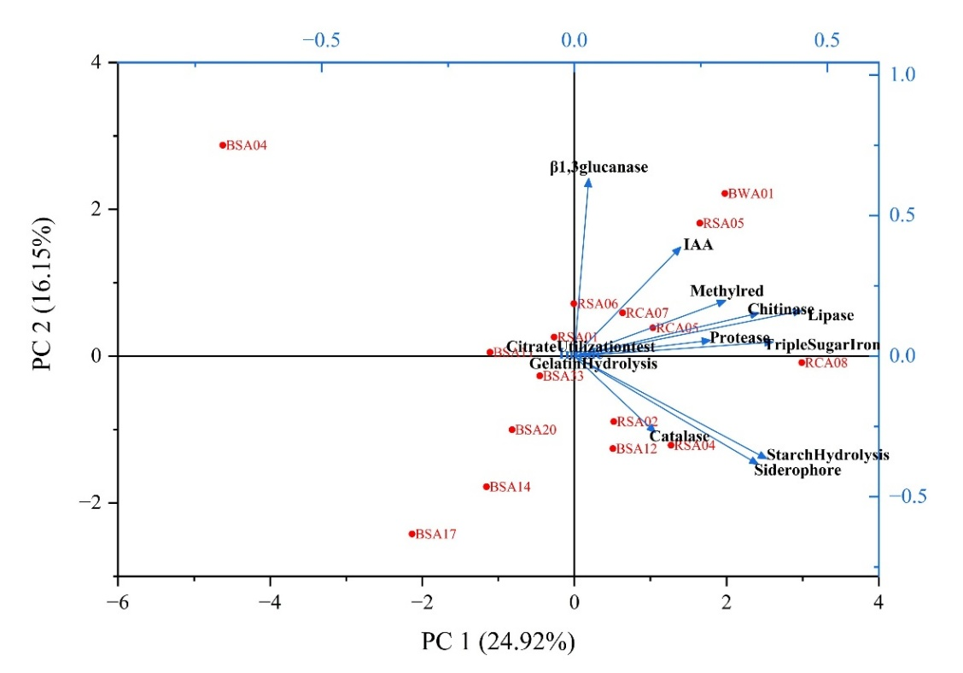
Arrows in the biplot indicate the direction and strength of each trait’s contribution to the principal components. Isolate names are represented in red and biochemical traits in blue. Red shades in the correlation heat maps indicate strong positive correlations. Blue shades indicate negative correlations. White or near-zero values suggest weak or no correlation.
Fig. 6. Principal Component Analysis (PCA) a) PCA biplot showing the distribution of actinomycete isolates based on biochemical and plant growth-promoting traits. b) Correlation matrix heatmaps emphasizing the strength and direction of relationships between traits
Finally, all the PGP, biochemical and enzymatic traits of the test isolates were analysed by multivariate statistical analysis to visualize both the relationships between multiple biochemical traits and characteristic profiles of different microbial isolates, providing insights into their potential as complex and diverse, with each isolate having a unique combination of traits. Through PCA, it was found that traits such as lipase, and chitinase production were positively related to each other that points to potential biocontrol applications, whereas siderophore production correlating with starch hydrolysis suggests adaptations for nutrient acquisition. While IAA production is positively related to β-1,3-glucanase indicating plant growth promotion and stress resistance in contrast to those reported by Barbaccia et al. (2022); Shah et al. (2022) and Khan et al. (2023). Such broad-spectrum PGP activities of selected promising isolates could be effectively used as bio stimulants for enhancing yield and productivity. Therefore, these rhizobacterial isolates are likely to be the effective candidates for the discovery of novel secondary metabolites for various biocontrol applications. Further these in vitro results needs to be confirmed by glasshouse/field studies and metabolite extraction studies for antagonism.

- CONCLUSION
In the present study, 19 isolates showed potential in vitro PGP activities and also in vitro efficacy against S. rolfsii and R. bataticola pathogens were further selected for metabolite extraction and glasshouse screening studies. Functional profiling revealed synergistic combinations of PGP traits and biocontrol mechanisms characterized by the presence of cell wall degrading enzymes and enhanced functional activities of IAA, siderophore, ammonia production, and nutrient solubilization like solubilization of phosphorous, potassium, zinc, silica. These multifunctional attributes of these microbes to simultaneously enhance nutrient availability and supress phytopathogens suggests their promising role as multifunctional bioinoculants. Furthermore, the extraction of secondary metabolites will likely reveal novel bioactive compounds, potentially expanding their applications beyond biocontrol, further highlighting the valuable microbial resources and their potential contribution to sustainable agricultural systems and food security.
ETHICAL APPROVAL This manuscript does not contain any experiments involving human or animal participants.
CONSENT TO PARTICIPATE The authors declare consent to participate in this work.
CONSENT FOR PUBLICATION The authors declare consent to publish this work.

Disclaimer (Artificial intelligence)
Option 1:
Author(s) hereby declare that NO generative AI technologies such as Large Language Models (ChatGPT, COPILOT, etc.) and text-to-image generators have been used during the writing or editing of this manuscript.
Option 2:
Author(s) hereby declare that generative AI technologies such as Large Language Models, etc. have been used during the writing or editing of manuscripts. This explanation will include the name, version, model, and source of the generative AI technology and as well as all input prompts provided to the generative AI technology
Details of the AI usage are given below:
1.
2.
3.

REFERENCES
Al-Turki, A., Murali, M., Omar, A. F., Rehan, M., & Sayyed, R. Z. (2023). Recent advances in PGPR-mediated resilience toward interactive effects of drought and salt stress in plants. Frontiers in Microbiology, 14, 1214845. https://doi.org/10.3389/fmicb.2023.1214845
Anjaiah, V., Koedam, N., Nowak-Thompson, B., Loper, J. E., Hofte, M., Tambong, J. T., et al. (1998). Involvement of phenazines and anthranilate in the antagonism of Pseudomonas aeruginosa PNA1 and Tn5 derivative toward Fusarium spp. and Pythium spp. Molecular Plant-Microbe Interactions, 11, 847–854.
Anusha, B. G., Gopalakrishnan, S., Naik, M. K., & Sharma, M. (2019). Evaluation of Streptomyces spp. and Bacillus spp. for biocontrol of Fusarium wilt in chickpea (Cicer arietinum L.). Archives of Phytopathology and Plant Protection, 52(5–6), 417–442.
Banerjee, P., Bhattacharya, P., Bera, A., & Hossain, A. (2023). Plant growth-promoting rhizobacteria (PGPR): An indispensable tool for climate-resilient crop production. In: Mathur, P., Kapoor, R., & Roy, S. (Eds.), Microbial Symbionts and Plant Health: Trends and Applications for Changing Climate. Springer, Singapore. https://doi.org/10.1007/978-981-99-0030-5_9
Barbaccia, P., Gaglio, R., Dazzi, C., Miceli, C., Bella, P., Lo Papa, G., et al. (2022). Plant growth-promoting activities of bacteria isolated from an anthropogenic soil located in Agrigento Province. Microorganisms, 10(11), 2167. https://doi.org/10.3390/microorganisms10112167
Bekkar, A. A., Zaim, S., & Belabid, L. (2018). Induction of systemic resistance in chickpea against Fusarium wilt by Bacillus strains. Archives of Phytopathology and Plant Protection. https://doi.org/10.1080/03235408.2018.1438819
Beneduzi, A., Ambrosini, A., & Passaglia, L. M. (2012). Plant growth-promoting rhizobacteria (PGPR): Their potential as antagonists and biocontrol agents. Genetics and Molecular Biology, 35, 1044–1051.
Bhattacharya, A., Chandra, S., & Barik, S. (2009). Lipase and protease producing microbes from the environment of sugar beet field. Indian Journal of Agricultural Biochemistry, 22, 26–30.
Chauhan, P. K., Pathak, H. K., Dubey, G., Sharma, H., & Upadhyay, S. K. (2024). Impact of Bacillus cereus SPB-10 on growth promotion of wheat under arsenic-contaminated soil. Current Microbiology, 81(6), 153.
Chobe, D. R., Tarafdar, A., Chandran, U. S. S., Sudharani, & Sharma, M. (2020). First report of Ectophoma multirostrata causing root rot in chickpea. Plant Disease, 104, 1866.
El-Saadony, M. T., Saad, A. M., Soliman, S. M., Salem, H. M., Ahmed, A. I., Mahmood, M., et al. (2022). Plant growth-promoting microorganisms as biocontrol agents of plant diseases. Frontiers in Plant Science, 13, 923880.
Fasusi, O. A., Amoo, A. E., & Babalola, O. O. (2021). Characterization of plant growth-promoting rhizobacterial isolates associated with food plants in South Africa. Antonie van Leeuwenhoek, 114(10), 1683–1708.
Fisher, R. A. (1918). The correlation between relatives on the supposition of Mendelian inheritance. Transactions of the Royal Society of Edinburgh, 52, 399–433.
Gopalakrishnan, S., Humayun, P., Kiran, B. K., Kannan, I. G. K., Vidya, M. S., Deepthi, K., & Rupela, O. (2011). Evaluation of bacteria isolated from rice rhizosphere for biological control of charcoal rot. World Journal of Microbiology and Biotechnology, 27(6), 1313–1321.
Gopalakrishnan, S., Humayun, P., Srinivas, S., Vijayabharathi, R., Ratnakumari, B., & Rupela, O. (2012). Plant growth-promoting traits of biocontrol Streptomyces from vermicompost. Biocontrol Science and Technology, 22(10), 1199–1210.
Gopalakrishnan, S., Srinivas, V., Jalapathi, K., Bendikinda, P., Vijayabharathi, R., & Jayalakshmi Devi, P. (2020). Isolation and assessment of plant growth-promoting traits of Streptomyces species isolated from herbal vermicompost. 3 Biotech, 10, 200.
Gopalakrishnan, S., Vadlamudi, S., Bandikinda, P., Vijayabharathi, R., & Bhimineni, R. K. (2015). Evaluation of monoculture and co-culture of actinomycetes strains for their biocontrol potential against charcoal rot caused by Macrophomina phaseolina. Indian Journal of Microbiology, 55, 139–146.
Guo, X., Liu, N., Li, X., Ding, Y., Shang, F., Gao, Y., et al. (2015). Red soils harbor diverse culturable actinomycetes. Applied and Environmental Microbiology, 81(9), 3086–3103.
He, Y., Pantigoso, H.A., Wu, Z. and Vivanco, J.M. (2019). Co-inoculation of Bacillus sp. and Pseudomonas putida at different development stages acts as a bio stimulant to promote growth, yield and nutrient uptake of tomato. J Appl Microbiol 127:196–207. doi: 10.1111/jam.14273.
Hendricks, C.W., Doyle, J.D., Hugley, B. (1995). A new solid medium for enumerating cellulose-utilizing bacteria in soil. Appl Env Microbiol. 61:2016-2019.
Hirano, S., Nagao, N. (1988). An improved method for the preparation of colloidal chitin by using methanesulfonic acid. Agric Biol Chem 52:2111-2112.
Hu, X., Chen, J., Guo, J. (2006). Two phosphate and potassium solubilizing bacteria isolated from Tianmu Mountain, Zhejiang, China. World J Microbiol Biotechnol 22:983–990. doi: 10.4014/jmb.1106.05063
Janssens, C., Havlík, P., Krisztin, T., Baker, J., Frank, S., Hasegawa, T. et al. (2020). Global hunger and climate change adaptation through international trade. Nature climate change, 10(9):829-835.
Jukanti, A.K., Gaur, P.M., Gowda, C.L.L. and Chibbar, R.N. (2012). Nutritional quality and health benefits of chickpea (Cicer arietinum L.): A review. British Journal of Nutrition, 108(S1): S11–S26.
Jha, S. K. (2020). Isolation and characterization of bacteria with biochemical importance from soil samples of Ranchi city, India. Asian Journal of Microbiology, Biotechnology and Environmental Sciences, 22, 648–653.
Kaur, R., Singh, S., & Singh, R. (2015). Role of legumes in sustainable agriculture. Legume Research – An International Journal, 38(4), 409–412.
Kazerooni, E. A., Maharachchikumbura, S. S., Adhikari, A., Al-Sadi, A. M., Kang, S. M., Kim, L. R., & Lee, I. J. (2021). Rhizospheric Bacillus amyloliquefaciens protects Capsicum annuum cv. Geumsugangsan from multiple abiotic stresses via multifarious plant growth-promoting attributes. Frontiers in Plant Science, 12, 669693.
Khaliq, A., Alam, S., Khan, I. U., Khan, D., Naz, S., Zhang, Y., & Shah, A. A. (2020). Integrated control of dry root rot of chickpea caused by Rhizoctonia bataticola under the natural field condition. Biotechnology Reports, 25, e00423.
Khan, A., Bano, A., Khan, R. A., & Khan, N. (2023). Role of PGPR in suppressing the growth of Macrophomina phaseolina by regulating antioxidant enzymes and secondary metabolites in Vigna radiata (L.) R. Wilczek. South African Journal of Botany, 158, 443-451.
Kumar, V., Menon, S., Agarwal, H., & Gopalakrishnan, D. (2017). Characterization and optimization of bacterium isolated from soil samples for the production of siderophores. Resource-Efficient Technologies, 3, 434–439. https://doi.org/10.1016/j.reffit.2017.04.004
Islam, S., Akanda, A. M., Prova, A., Islam, M. T., & Hossain, M. M. (2016). Isolation and identification of plant growth promoting rhizobacteria from cucumber rhizosphere and their effect on plant growth promotion and disease suppression. Frontiers in Microbiology, 6, 1360.
Kumari, S., & Khanna, V. (2019). Induction of systemic resistance in chickpea (Cicer arietinum L.) against Fusarium oxysporum f. sp. ciceris by antagonistic rhizobacteria in assistance with native Mesorhizobium. Current Microbiology, 77, 85–98. https://doi.org/10.1007/s00284-019-01805-6
Kunova, A., Bonaldi, M., Saracchi, M., Pizzatti, C., Chen, X., & Cortesi, P. (2016). Selection of Streptomyces against soil borne fungal pathogens by a standardized dual culture assay and evaluation of their effects on seed germination and plant growth. BMC Microbiology, 16, 272. https://doi.org/10.1186/s12866-016-0886-1
Lorck, H. (1948). Production of hydrocyanic acid by bacteria. Physiologia Plantarum, 1, 142–146.
MacFaddin, J. F. (2000). Biochemical tests for identification of medical bacteria (3rd ed.). Lippincott Williams and Wilkins, Philadelphia, PA, 6(1), 503–642.
Pan, J., Peng, F., Xue, X., You, Q., Zhang, W., Wang, T., & Huang, C. (2019). The growth promotion of two salt-tolerant plant groups with PGPR inoculation: A meta-analysis. Sustainability, 11(2), 378.
Pandey, S., Gupta, S., & Ramawat, N. (2019). Unravelling the potential of microbes isolated from rhizospheric soil of chickpea (Cicer arietinum) as plant growth promoter. 3 Biotech, 9(7), 277.
Pastor, A. V., Nunes, J. P., Ciampalini, R., Koopmans, M., Baartman, J., Huard, F., Calheiros, T., Le-Bissonnais, Y., Keizer, J. J., & Raclot, D. (2019). Projecting future impacts of global change including fires on soil erosion to anticipate better land management in the forests of NW Portugal. Water, 11(12), 2617.
Patel, P., Sayyed, R. Z., & Patel, P. (2023). PGPR: A sustainable agricultural mitigator for stressed agro environments. In R. Mawar, R. Z. Sayyed, S. K. Sharma, & K. S. Sattiraju (Eds.), Plant Growth Promoting Microorganisms of Arid Region: Status and Prospects. Singapore: Springer.
Pathak, H. K., Chauhan, P. K., Seth, C. S., Dubey, G., & Upadhyay, S. K. (2024). Mechanistic and future prospects in rhizospheric engineering for agricultural contaminants removal, soil health restoration, and management of climate change stress. Science of the Total Environment, 3, 172116.
Patten, C., & Glick, B. R. (1996). Bacterial biosynthesis of indole-3-acetic acid. Canadian Journal of Microbiology, 42, 207–220.
Patten, C. L., & Glick, B. R. (2002). Regulation of indole acetic acid production in Pseudomonas putida GR12-2 by tryptophan and the stationary-phase sigma factor RpoS. Canadian Journal of Microbiology, 48, 635–642. https://doi.org/10.1139/w02-053
Pikovskaya, R. I. (1948). Mobilization of phosphorus in soil in connection with vital activity of some microbial species. Microbiologia, 17, 362–370.
Rangaswami, G., & Bagyaraj, D. J. (1993). Microbial biotechnology. In Agricultural Microbiology (pp. 389–405). Prentice Hall of India Private Limited, New Delhi.
Rudresh, D. L., Shivaprakash, M. K., & Prasad, R. D. (2005). Potential of Trichoderma spp. as biocontrol agents of pathogens involved in wilt complex of chickpea (Cicer arietinum L.). Journal of Biological Control, 19, 157–166.
Schwyn, B., & Neilands, J. B. (1987). Universal chemical assay for the detection and determination of siderophores. Analytical Biochemistry, 160, 47–56.
Shah, A., Nazari, M., Antar, M., Msimbira, L. A., Naamala, J., Lyu, D., Rabileh, M., Zajonc, J., & Smith, D. L. (2021). PGPR in agriculture: A sustainable approach to increasing climate change resilience. Frontiers in Sustainable Food Systems, 5, 667546. https://doi.org/10.3389/fsufs.2021.667546
Shah, G., Fiaz, S., Attia, K. A., Khan, N., Jamil, M., Abbas, A., Yang, S. H., & Jumin, T. (2022). Indole pyruvate decarboxylase gene regulates the auxin synthesis pathway in rice by interacting with the indole-3-acetic acid–amido synthetase gene, promoting root hair development under cadmium stress. Frontiers in Plant Science, 13, 1023723.
Sharma, M., & Ghosh, R. (2017). A reliable method for Phytophthora cajani isolation, sporangia, zoospore production and in planta infection of pigeon pea. Bio-protocol, 6(2), e1706–e1706.
Sharma, M., & Pande, S. (2013). Unravelling effects of temperature and soil moisture stress response on development of dry root rot [Rhizoctonia bataticola (Taub.) Butler] in chickpea. American Journal of Plant Sciences, 4(3), 584–589.
Sharma, M., Ghosh, R., Tarafdar, A., & Telangre, R. (2015). An efficient method for zoospore production, infection and real-time quantification of Phytophthora cajani causing Phytophthora blight disease in pigeon pea under elevated atmospheric CO₂. BMC Plant Biology, 15(1), 1–12.
Sharma, S. K., Sharma, M. P., Ramesh, A., & Joshi, O. P. (2012). Characterization of zinc-solubilizing Bacillus isolates and their potential to influence zinc assimilation in soybean seeds. Journal of Microbiology and Biotechnology, 22, 352–359.
Singh, B. K., Delgado-Baquerizo, M., Egidi, E., Guirado, E., Leach, J. E., Liu, H., & Trivedi, P. (2023). Climate change impacts on plant pathogens, food security and paths forward. Nature Reviews Microbiology, 21(10), 640–656.
Singh, P. P., Shin, Y. C., Park, C. S., & Chung, Y. R. (1999). Biological control of Fusarium wilt of cucumber by chitinolytic bacteria. Phytopathology, 89, 92–99. https://doi.org/10.1094/PHYTO.1999.89.1.92
Singh, V., Haque, S., Singh, H., Verma, J., Vibha, K., Singh, R., Jawed, A., & Tripathi, C. K. M. (2016). Isolation, screening, and identification of novel isolates of actinomycetes from India for antimicrobial applications. Frontiers in Microbiology, 7, 1921. https://doi.org/10.3389/fmicb.2016.01921
Srinivas, V., Naresh, N., Pratyusha, S., Ankati, S., Govindaraj, M., & Gopalakrishnan, S. (2022). Exploring plant growth-promoting Streptomyces spp. for yield and nutrition traits in pearl millet hybrids. Crop and Pasture Science, 73(5), 484–493.
Srinivas, V., Sravani, A., Pratyusha, A., & Gopalakrishnan, S. (2021). Amazing plant growth-promoting actinobacteria from herbal vermicompost. Andhra Pradesh Journal of Agricultural Sciences, 7(2), 89–98.
Timofeeva, A.M., Galyamova, M.R and Sedykh, S.E. (2022). Bacterial siderophores: classification, biosynthesis, perspectives of use in agriculture. Plants. 11 (22), 3065.
Upadhyay, S. K., & Chauhan, P. K. (2022). Optimization of eco-friendly amendments as sustainable asset for salt-tolerant plant growth-promoting bacteria mediated maize (Zea mays L.) plant growth, Na uptake reduction and saline soil restoration. Environmental Research, 211, 113081.
Upadhyay, S. K., Srivastava, A. K., Rajput, V. D., Chauhan, P. K., Bhojiya, A. A., Jain, D., Chaubey, G., Dwivedi, P., Sharma, B., & Minkina, T. (2022). Root exudates: Mechanistic insight of plant growth-promoting rhizobacteria for sustainable crop production. Frontiers in Microbiology, 14, 916488.
Zaim, S., Belabid, L., Bayaa, B., & Bekkar, A. A. (2016). Biological control of chickpea Fusarium wilts using rhizobacteria “PGPR”. In D. K. Choudhary & A. Verma (Eds.), Microbial-Mediated Induced Systemic Resistance in Plants. Singapore: Springer.
Zhang, Y., Hu, A., Zhou, J., Zhang, W., & Li, P. (2021). Comparison of bacterial communities in soil samples with and without tomato bacterial wilt caused by Ralstonia solanacearum species complex. BMC Microbiology, 20(1), 89.

