Cross-Pathogenicity of Colletotrichum sp. Isolates from Avocado and Banana Fruits in Côte d’Ivoire

.

ABSTRACT

Aims: The present study aimed to evaluate the cross-pathogenicity of Colletotrichum isolates obtained from different hosts and production zones using substitute hosts.
Study design: The experimental design followed a completely randomized layout with 19 treatments and five replicates.
Place and Duration of Study: The in vitro assay was conducted in the Plant Pathology and Plant Biology Laboratory at the Institut National Polytechnique Félix HOUPHOUET-BOIGNY, Côte d’Ivoire.
Methodology: A total of 19 morphological groups of Colletotrichum sp. isolates were selected from a collection of 67 isolates obtained initially from avocado and banana fruits and characterized microscopically. Cross-inoculation assays were conducted on the substitute hosts 'Lula' (Avocado) and 'Grande Naine' (banana). Lesion diameters were measured along two perpendicular axes passing through the center of each lesion.
Results: The isolates induced lesions of varying diameters ranging from 2.9 ± 6.5 mm to 24.6 ± 5.2 mm. All 11 Colletotrichum sp. groups isolated from Avocado caused lesions on banana fruits. Conversely, among the eight groups isolated from banana, only three isolates (KB17A, KB37A, and KB06A) produced lesions on avocado fruits. Analysis of variance revealed highly significant differences (P = .001) in lesion diameter among the Colletotrichum isolates at the 5% significance level, allowing for their classification into five homogeneous groups on Avocado and eight on banana. Some lesions were smaller or comparable in size to those observed on the control fruits.
Conclusion: These findings demonstrate that several Colletotrichum isolates are capable of cross-infecting different fruit hosts. The identification of both host-specific and polyphagous isolates suggests potential implications for disease epidemiology, highlighting the risk of pathogen spread between adjacent crops. This knowledge is crucial for developing integrated management strategies, such as advising against the intercropping of susceptible hosts and informing targeted fungicide application programs in Côte d’Ivoire.
.

Keywords: Colletotrichum isolates, pathogenicity, cross-inoculation, fruit diseases, Côte d’Ivoire.

1. INTRODUCTION

The genus Colletotrichum encompasses one of the most prevalent groups of plant-pathogenic fungi globally, with at least one species known to infect nearly every cultivated fruit crop (Dean et al., 2012). Its scientific and economic impact ranks it as the eighth most important plant pathogenic fungus in the world (Dean et al., 2012). Colletotrichum species are the primary causative agents of anthracnose, a disease characterized by black, sunken necrotic lesions often accompanied by orange spore masses (acervuli) (Agrios, 2005). This disease is a major pre- and post-harvest constraint, affecting a wide range of economically significant tropical and subtropical fruits, including mango, banana, and avocado (Keuete et al., 2016).
A key epidemiological feature of this genus is its variable host specificity. While some species are specialists, infecting a narrow range of hosts, others are generalists capable of infecting multiple, botanically unrelated plants (Agrios, 2005). Consequently, a single host species can be affected by several Colletotrichum species, and conversely, a single species can cause disease across multiple hosts (Crouch & Beirn, 2009; Hyde et al., 2009).
In Côte d'Ivoire, Colletotrichum species have been reported on major fruit crops such as mango, dessert banana, papaya, avocado, and cashew (Kouamé et al., 2011; Silué et al., 2018; Kouadia et al., 2019, 2023). However, research on the pathogenic potential of these isolates has been largely confined to mango varieties (N'Guettia et al., 2013), leaving other hosts underexplored. Crucially, the potential for cross-infection between different fruit hosts, a critical factor for understanding disease epidemiology, remains uninvestigated in the Ivorian context.
This study was therefore designed to evaluate the cross-pathogenicity of Colletotrichum sp. isolates obtained from avocado and banana fruits. Specifically, it aimed to assess lesion development following the inoculation of avocado-derived isolates onto banana fruits and vice versa. Determining the host range and cross-infection potential of local Colletotrichum populations is essential for developing effective, integrated disease management strategies at a national scale.

2. MATERIAL AND METHODS

2.1. Plant Material
Two fruit varieties were used in this study: ‘Lula’ for Avocado (Persea americana) and ‘Grande Naine’ (Cavendish subgroup) for banana (Musa spp.). Fruits were collected at the mature but firm stage and appeared to be healthy and free from visible disease symptoms.

2.2. Fungal Material
Colletotrichum isolates were obtained from avocado and banana samples collected from major production areas across Côte d’Ivoire. A total of 67 Colletotrichum isolates were initially recovered. Based on microscopic characterization, these isolates were grouped into 19 distinct morphological groups. Each isolate group was subcultured on Potato Dextrose Agar (PDA) medium and incubated for seven days prior to use in pathogenicity assays.

2.3. Experimental Factor and Treatments
The experimental factor evaluated was the expression of disease symptoms following cross-inoculation of Colletotrichum isolates obtained from one fruit host onto another. Treatments corresponded to the 19 morphological groups of Colletotrichum isolates characterized previously.

2.4. Experimental Design
A completely randomized design was used, consisting of 19 treatments with five replications (Table 1, Figure 1). The fruits were maintained in a controlled incubation chamber at a constant temperature of 28 ± 1°C. Relative humidity was maintained at 85 ± 5% using a humidifier and monitored daily with a digital hygrometer. A 12-hour photoperiod was provided using fluorescent lights to simulate natural day-night cycles, which can influence fungal development and symptom expression.

2.5. Experimental Procedure
For each fruit type, 95 fruits were used, with five fruits per Colletotrichum isolate. Prior to inoculation, all fruits were washed with soapy water using a soft sponge, rinsed with tap water, and disinfected by immersion in 25% commercial bleach (8° chlorine) for 5 minutes. The fruits were then rinsed twice in sterile distilled water for 2 min, surface-sterilized with 70% ethanol using sterile cotton pads and air-dried under aseptic conditions.
Inoculations were performed by wounding the fruit surface using the method described by De Lapeyre de Bellaire et al. (2005) and Riviera-Vargas et al. (2006). A superficial circular wound (4 mm in diameter) was made on one side of the fruit pericarp, and a 4 mm mycelial plug taken from the actively growing margin of a seven-day-old PDA culture was placed on the wound site.
Cross-inoculation involved applying Colletotrichum isolates obtained from Avocados onto banana fruits, and conversely, banana isolates onto avocado fruits. Inoculations performed on the original host served as controls. The inoculated fruits were placed in sterile plastic trays lined with moist sterile paper towels to maintain high local humidity around the fruits. The trays were then sealed with transparent polyethylene film (punched with small aeration holes to prevent anaerobic conditions) and placed in the controlled incubation chamber as described in section 2.4. The incubation period was 7 days.

Table 1. Colletotrichum sp. isolates grouped by host origin and sampling location
Fruit host | Fruits per isolate (replication) | Number of isolate groups | Group code | Isolate code | Sampling location
Avocado | 5 | 11 | 1 | KA09 | Gagnoa
 |  |  | 2 | KA40 | Tiassalé
 |  |  | 3 | KA15 | Toumodi
 |  |  | 4 | KA29 | Aboisso
 |  |  | 5 | KA01 | Abengourou
 |  |  | 6 | KA26 | Yamoussoukro
 |  |  | 7 | KA34 | Sinfra
 |  |  | 8 | KA31 | Aboisso
 |  |  | 9 | KA07 | Azaguié
 |  |  | 10 | KA19 | Guézon
 |  |  | 11 | KA11 | Gagnoa
Banana | 5 | 8 | 1 | KB14 | Tiassalé
 |  |  | 2 | KB18 | Tiassalé
 |  |  | 3 | KB26 | Tiabam (Tiassalé 4)
 |  |  | 4 | KB37 | Bassam (Motobé)
 |  |  | 5 | KB30 | Akressi
 |  |  | 6 | KB19 | Tiassalé 2
 |  |  | 7 | KB17 | Tiassalé
 |  |  | 8 | KB06 | Bana-Comoé
(KA = isolates from avocado; KB = isolates from banana)

REP 1 | KA07 | KA40 | KA15 | KA34 | KA26 | KA31 | KA26 | KA01 | KA29 | KA19 | KA34
REP 2 | KA26 | KA15 | KA07 | KA07 | KA09 | KA26 | KA01 | KA40 | KA11 | KA31 | KA01
REP 3 | KA15 | KA29 | KA19 | KA29 | KA40 | KA29 | KA11 | KA09 | KA11 | KA19 | KA34
REP 4 | KA15 | KA40 | KA11 | KA34 | KA07 | KA11 | KA26 | KA31 | KA31 | KA19 | KA29
REP 5 | KA15 | KA09 | KA09 | KA40 | KA07 | KA09 | KA31 | KA01 | KA29 | KA34 | KA01

Figure 1. Inoculation scheme of Colletotrichum sp. isolates from Avocado onto banana fruits.
KA followed by a number: Code for an isolate obtained from Avocado and then inoculated onto banana.
Rep: Replicate.

2.6. Monitoring of Cross-Infection and Data Collection
Lesion development was monitored daily for seven days after inoculation (DAI). The day of the first visible symptom appearance was recorded as the incubation period for each isolate. Disease severity was quantified based on the size of the necrotic lesions. Lesion diameters were measured along two perpendicular axes (length L and width l) passing through the center of the lesion using a digital caliper (precision ± 0.1 mm), as illustrated in Figure 2. The mean lesion diameter (Dm) for each isolate was calculated following Norva et al. (2011) and Sanders and Korsten (2003) as follows:
$$Dm=\frac{∑(L+l)}{2N_{t}}$$
(1)
where L = lesion length, l = lesion width, and Nₜ = total number of isolates tested per location.
This method provides a reliable and reproducible measure of infection severity, as the lesion size is directly correlated with the aggressiveness of the pathogen.

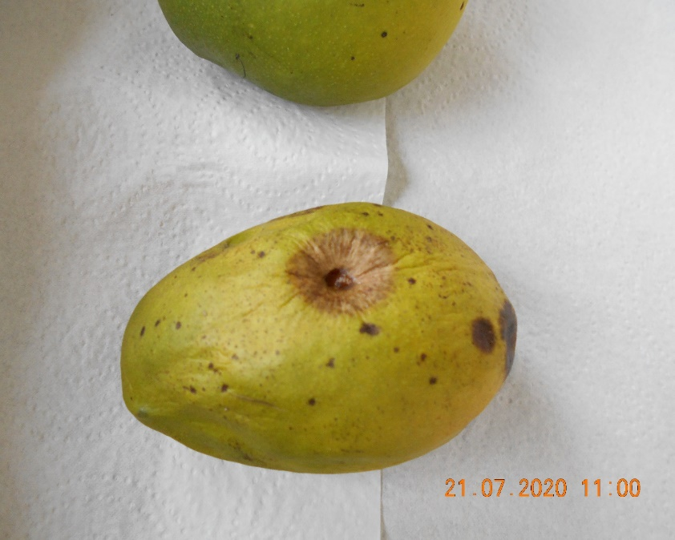
First perpendicular axis
Second perpendicular axis
Blackish brown spot induced by the inoculum
Figure 2. Measurement of lesion diameter along two perpendicular axes.

2.7. Re-isolation of Colletotrichum Isolates
Fungal colonies were re-isolated from symptomatic tissues on PDA medium to confirm pathogenicity. The recovered isolates were morphologically compared with the original inoculum to verify Koch’s postulates.

2.8. Data Analysis
Data on mean lesion diameters were subjected to a one-way analysis of variance (ANOVA) using STATISTICA software (version 7.1). The factor analyzed was the Colletotrichum isolate. Prior to ANOVA, the assumption of homogeneity of variances was verified using Levene's test, and data were checked for normality using the Shapiro-Wilk test. The data met the assumptions for parametric analysis. When the ANOVA indicated significant differences (P ≤ 0.05), a post-hoc comparison of treatment means was performed using the Newman-Keuls multiple range test. This test is appropriate for comparing all pairs of means while controlling the Type I error rate in a balanced design like the one used in this study (completely randomized design with equal replication). Results are presented as mean lesion diameter ± standard deviation.

3. RESULTS

3.1. Cross-pathogenicity of Colletotrichum sp. isolates obtained from Avocado on ‘Grande Naine’ Bananas
All eleven Colletotrichum sp. isolates obtained from avocado fruits caused lesions when inoculated onto both avocado and banana fruits. The mean lesion diameters varied widely, ranging from 2.9 ± 6.5 mm to 21.0 ± 13.2 mm (Table 2). Lesions induced on avocado fruits by avocado-derived isolates served as the control for comparison.
At the inoculation sites, lesions were typically dark brown to black in color. Most isolates produced visible symptoms on banana fruits within the first day after inoculation, while others required two to three days for symptom expression (Figure 3).
Analysis of variance revealed highly significant differences among Colletotrichum isolates (P = .001) for lesion diameter at the 5% significance level. Based on mean lesion size, the isolates were grouped into five statistically homogeneous classes. The lesion diameters on banana fruits were compared with those caused by the same isolates on Avocado.
The first homogeneous group included isolates KA15B, KA01B, and KA31B, originating from Toumodi, Abengourou, and Aboisso, respectively. These isolates produced small lesions, with mean diameters ranging from 2.9 ± 6.5 to 3.0 ± 6.7 mm. The second group consisted solely of isolate KA26B from Yamoussoukro, which induced lesions averaging 3.3 ± 7.4 mm in diameter. Lesions produced by isolates in these two groups were smaller than those recorded on the control fruits (Avocado).
The third group contained the largest number of isolates, which produced lesions with mean diameters ranging from 5.2 ± 7.1 to 18.8 ± 11.9 mm. Notably, isolates from Gagnoa (KA11 and KA09), Azaguié (KA07), and Aboisso (KA29) caused lesions on banana fruits that were comparable in size to those observed on avocado fruits. Groups four and five comprised isolates that were tested only on avocado fruits (controls).
Among the eleven avocado-derived Colletotrichum isolates inoculated on banana fruits, some—particularly those from Toumodi (KA15B), Abengourou (KA01B), Aboisso (KA31B), and Yamoussoukro (KA26B)—induced smaller lesions than on Avocado. In contrast, isolates such as KA07, KA09, KA11, and KA29 produced lesion diameters on banana that were similar to those on Avocado, suggesting a certain degree of cross-pathogenicity between the two hosts.

Table 2. Classification of Colletotrichum sp. isolates from Avocado based on lesion diameters induced on banana fruits
Isolate group | Isolate code | Average lesion diameter (mm)
1 | KA15B | 2.9 ± 6.5 a*
1 | KA01B | 2.9 ± 6.5 a
1 | KA31B | 3.0 ± 6.7 a
2 | KA26B | 3.3 ± 7.4 ab
3 | KA19B | 5.2 ± 7.1 abc*
3 | KA40B | 5.8 ± 7.9 abc
3 | KA09B | 6.4 ± 8.8 abc
3 | KA11B | 6.8 ± 9.3 abc
3 | KA07A | 6.8 ± 9.7 abc
3 | KA29B | 7.6 ± 7.1 abc
3 | KA11A | 8.5 ± 11.6 abc
3 | KA34B | 8.6 ± 8.0 abc
3 | KA07B | 9.4 ± 8.7 abc
3 | KA09A | 10.0 ± 10.0 abc
3 | KA15A | 11.6 ± 11.3 abc
3 | KA01A | 12.6 ± 12.0 abc
3 | KA29A | 16.6 ± 16.1 abc
3 | KA31A | 18.8 ± 11.9 abc
4 | KA34A | 19.1 ± 11.2 bc
5 | KA26A | 19.8 ± 11.8 c*
5 | KA19A | 20.9 ± 13.6 c
5 | KA40A | 21.1 ± 13.2 c
Means within the same column followed by the same letter do not differ significantly at the 5% level according to the Newman–Keuls test (P = .001).
Note: The letter B in the isolate code (e.g., KA07B) designates Colletotrichum isolates obtained from Avocado and inoculated onto banana fruits, whereas A (e.g., KA07A) denotes isolates inoculated onto avocado fruits (control).

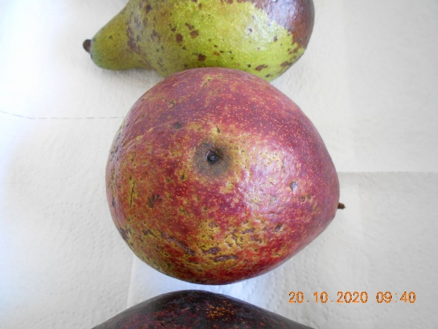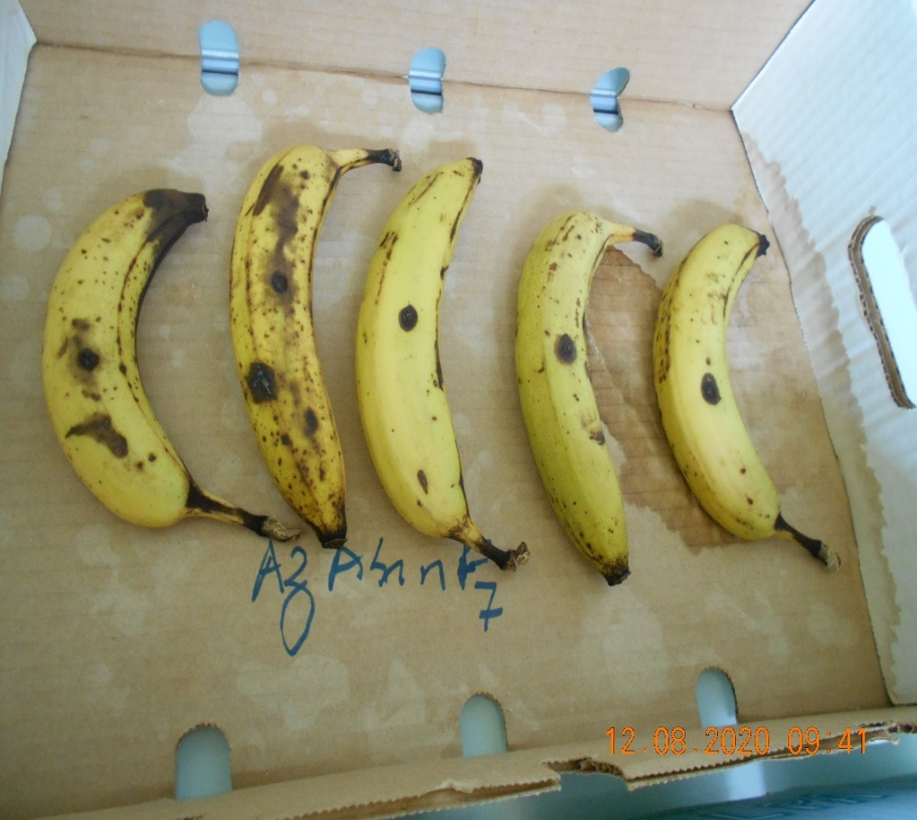
b
a
Induced lesions
Figure 3. Lesions induced by Colletotrichum sp. isolates obtained from Avocado on (a) ‘Grande Naine’ banana and (b) ‘Lula’ avocado (control).

3.2. Cross-pathogenicity of Colletotrichum sp. Isolates Obtained from Banana on ‘Lula’ Avocado Fruits
The majority of Colletotrichum sp. isolates obtained from banana fruits did not induce visible lesions on avocado fruits, except for three isolates: KB17A, KB37A, and KB06A. Among the banana-derived isolates inoculated onto banana fruits, only one isolate, KB18B, failed to cause lesions on its original host. As previously observed, the lesions that developed on fruit surfaces were dark brown to black in color (Figure 4).
Analysis of variance revealed a highly significant difference (P = 0.0001) among isolates for mean lesion diameter at the 5% significance level. Based on mean lesion size, the Colletotrichum isolates were separated into eight statistically homogeneous groups (Table 3).
Isolates originating from Tiassalé, Tiassalé 2, Akressi, and Tiabam (Group 1) did not produce lesions on avocado fruits under the experimental conditions. Similarly, isolate KB18 from Tiassalé failed to induce lesions on both avocado and banana fruits. In contrast, isolate KB17A from Tiassalé caused small lesions on avocado fruits, although these were considerably smaller than those observed on the control (banana).
Two isolates, KB37A from Motobé and KB06A from Bana-Comoé, formed a distinct group (Group 3). Both induced lesions on avocado and banana fruits, with lesion diameters on Avocado comparable to those observed on banana, suggesting similar pathogenic potential on both hosts. In particular, isolate KB06 produced nearly identical symptoms on Avocado and banana, indicating its ability to cross-infect both fruit species.
Groups 4 through 8 consisted exclusively of isolates obtained from banana and inoculated onto banana fruits (controls). Lesion diameters within these groups ranged from 12.2 ± 7.7 mm to 24.6 ± 5.2 mm, with isolate KB37B from Motobé producing the largest lesions on banana fruits.

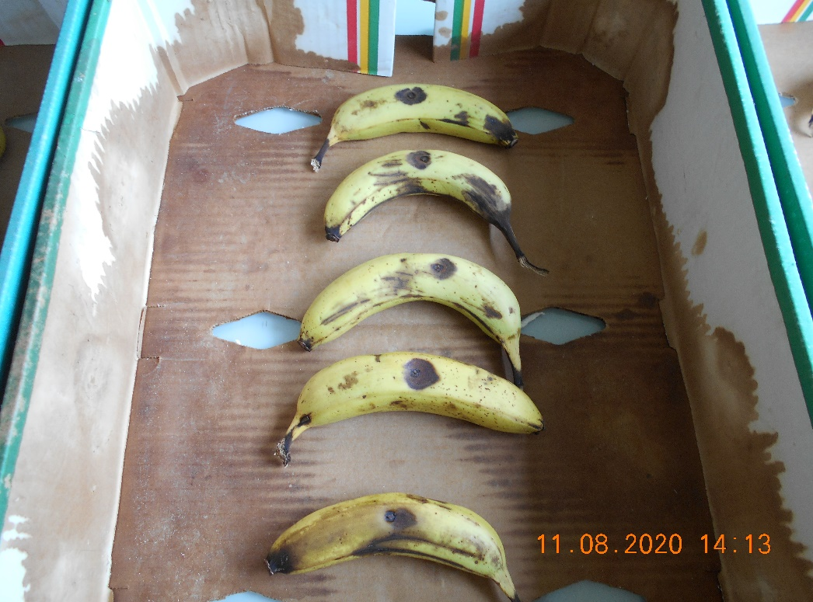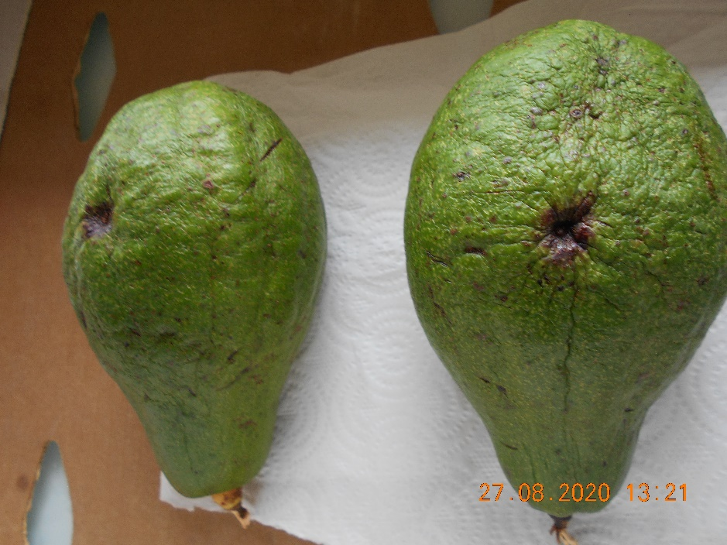
b
a
Induced lesions
Figure 4. Lesions induced by Colletotrichum sp. isolates obtained from banana fruits on (a) ‘Lula’ avocado and (b) ‘Grande Naine’ banana (control).
Table 3. Classification of Colletotrichum sp. isolates from banana based on lesion diameters induced on avocado fruits
Isolate group | Isolate code | Average lesion diameter (mm)
1 | KB18B | 0 a*
1 | KB19A | 0 a
1 | KB14A | 0 a
1 | KB30A | 0 a
1 | KB18A | 0 a
1 | KB26A | 0 a
2 | KB17A | 2.9 ± 6.5 abc
3 | KB06B | 6.4 ± 8.8 abcde*
3 | KB37A | 7.7 ± 7.5 abcde
3 | KB06A | 7.8 ± 10.7 abcde
3 | KB30B | 8.9 ± 8.8 abcde
4 | KB17B | 12.2 ± 7.7 bcde
5 | KB19B | 13.4 ± 7.6 cde
6 | KB14B | 16.6 ± 1.0 def
7 | KB26B | 18.6 ± 2.6 ef
8 | KB37B | 24.6 ± 5.2 f
Means in the same column followed by the same letter do not differ significantly at the 5% level according to the Newman–Keuls test (P = 0.0001).
Note: The letter A in an isolate code (e.g., KB18A) indicates Colletotrichum isolates obtained from banana fruits and inoculated onto ‘Lula’ avocado fruits, while B (e.g., KB18B) refers to banana isolates inoculated onto banana fruits (control).

3.3. Discussion
Pathogenicity tests conducted with Colletotrichum sp. isolates after five replicates revealed either the absence or the development of lesions on the inoculated fruits. These lesions were typically brown to black in color, both on Avocado and banana, consistent with the characteristic symptoms of Colletotrichum infections on these hosts. According to Koch’s postulates, an isolate associated with a disease symptom on a given host must reproduce the same symptom when re-inoculated onto the same host species (Lucasson, 2018). The dark, sunken lesions observed at the inoculation sites in this study are comparable to those reported for cross-inoculations on mango fruits by Wu et al. (2020).
In this study, inoculations were performed on wounded fruits, and visible symptoms appeared within two to three days post-inoculation. Wound inoculation is a standard method for pathogenicity testing, as reported by De Bellaire (2005), Shanthi et al. (2008), Phoulivong et al. (2012), and Drabo et al. (2022). These authors have emphasized that natural openings or wounds on the fruit surface often serve as entry points for fungal pathogens. The latency period between inoculation and symptom expression may reflect the aggressiveness of the isolate (Bernard, 2012). Differences in incubation periods among isolates could also be attributed to physiological differences between fruits, especially their maturity stage. Since the fruits were collected as firm but still unripe, the presence of antifungal compounds in the immature fruit pericarps may have temporarily inhibited enzymatic degradation by Colletotrichum isolates. As fruits ripen, these compounds typically decrease, rendering tissues more susceptible to infection.
The absence of lesions on some fruits could be due to non-pathogenicity of specific isolates or to a loss of aggressiveness through repeated subculturing, as noted by Kimaru (2018). Other possible explanations include insufficient inoculum density or enzymatic inactivation by antifungal compounds in the fruit pericarp. Singh et al. (2017) reported that unripe fruit tissues contain antifungal metabolites that inhibit cell wall–degrading enzymes secreted by fungal pathogens.
Inoculation of Colletotrichum sp. isolates obtained from Avocado onto banana fruits produced lesions of varying diameters. Some isolates—KA07, KA09, KA11, and KA29 from Azaguié, Gagnoa, and Aboisso—induced lesions of similar size on both Avocado and banana, while others produced smaller lesions on banana than on their original host. These findings are consistent with those of Phoulivong et al. (2012). Cross-inoculation studies of this type are frequently employed to assess host range. Freeman et al. (1998) performed similar tests among Colletotrichum species and C. gloeosporioides genotypes on various tropical and subtropical fruits under artificial inoculation, demonstrating that C. gloeosporioides isolates from several fruit crops were capable of cross-infecting different hosts. The lesions produced on banana fruits in this study confirm the capacity of Colletotrichum isolates from Avocado to infect alternative hosts. This is in line with studies from other geographical regions, such as the work of Teja et al. (2022) in India, who reported cross-infectivity of Colletotrichum spp. on various tropical fruits, and Eaton et al. (2021) in the USA, who documented the cross-infection potential of diverse Colletotrichum species in mixed-fruit orchards. As noted by Dubrulle (2019), the genus Colletotrichum comprises species with broad host ranges.
Variation in lesion diameters among isolates may be explained by differences in fruit maturity, inoculum density, or physiological adaptation of isolates through subculturing. Freeman et al. (1998) observed that the success of cross-infection was influenced by inoculum concentration. In the present study, lesions were generally larger on the original host fruits than on the substitute fruits, corroborating observations by Sanders and Korsten (2003), Shanthi et al. (2008), and Phoulivong et al. (2012). However, some isolates produced statistically similar lesions on both banana and Avocado, supporting the findings of Giblin and Coates (2007), who reported that Colletotrichum isolates inoculated onto Avocado and mango produced symptoms of comparable intensity.
Among the eight Colletotrichum isolates obtained from banana, three (KB06, KB37, and KB17) induced lesions on Avocado, with isolate KB06 producing nearly identical lesion sizes on both hosts. The remaining isolates generated smaller lesions on the Avocado than on the Banana. These results agree with those of Phoulivong et al. (2012), who found that C. gloeosporioides isolates produced larger lesions on their original hosts than on substitute hosts. The ability of isolates KB06, KB37, and KB17 to infect both avocado and banana suggests a lack of strict host specificity. This contrasts with the findings of Sagoua (2009), who demonstrated that Colletotrichum isolates from banana failed to cause lesions on mango, papaya, and avocado. However, our results are consistent with other studies which have revealed the presence of generalist species like C. gloeosporioides and C. truncatum among banana rot pathogens (Photita et al., 2005; Priyadarshanie & Vengadaramana, 2015). Many members of the C. gloeosporioides species complex are known to have broad host ranges (Phoulivong et al., 2012; Sharma et al., 2013).
The relatively smaller lesion diameters observed on substitute fruits compared to those on the original hosts, as well as the absence of lesions on five of the eight isolates tested on Avocado, further support the notion that pathogenicity and host range vary among Colletotrichum isolates. These findings emphasize the coexistence of both host-specific and polyphagous isolates within the Colletotrichum complex, in agreement with previous studies (Shanthi et al., 2008; Phoulivong et al., 2012).

4. CONCLUSION

Cross-inoculation of the 19 Colletotrichum sp. isolate groups on two fruit types revealed clear differences in pathogenicity. Some isolates induced lesions on substitute fruits as early as one day after inoculation, while others required two to three days for symptom expression to occur. The majority of the 11 Colletotrichum isolates obtained from Avocado caused lesions on banana fruits, though their severity varied. Isolates from Toumodi (KA15B), Abengourou (KA01B), Aboisso (KA31B), and Yamoussoukro (KA26B) produced smaller lesions, whereas isolates from Gagnoa (KA09 and KA11), Azaguié (KA07), and Aboisso (KA29) induced lesions comparable to those observed on avocado controls.
Among the eight Colletotrichum isolates obtained from banana, only three—KB17A, KB37A, and KB06A from Tiassalé, Motobé, and Bana-Comoé, respectively—could induce lesions on avocado fruits. The remaining five isolates, originating from Tiassalé, Tiassalé 2, Akressi, and Tiabam, exhibited pathogenicity exclusively on their original host (banana), suggesting a degree of host specificity. Notably, isolate KB18B from Tiassalé failed to produce lesions on either banana or Avocado.
Analysis of variance classified the isolates into five homogeneous groups based on lesion diameter on Avocado and eight on banana. Overall, the findings demonstrate that not all Colletotrichum isolates are strictly host-specific; some possess the capacity to infect alternative fruit species. In natural ecosystems, such cross-pathogenic potential may have significant epidemiological implications, facilitating the spread of disease across different crops and complicating integrated disease management strategies.

Disclaimer (Artificial intelligence)
Option 1:
Author(s) hereby declare that NO generative AI technologies such as Large Language Models (ChatGPT, COPILOT, etc.) and text-to-image generators have been used during the writing or editing of this manuscript.
Option 2:
Author(s) hereby declare that generative AI technologies such as Large Language Models, etc. have been used during the writing or editing of manuscripts. This explanation will include the name, version, model, and source of the generative AI technology and as well as all input prompts provided to the generative AI technology
Details of the AI usage are given below:
1.
2.
3.

REFERENCES

Agrios, G. N. (2005). Plant pathology (5th ed.). Academic Press. 922 pp.
Bernard, F. (2012). The development of foliar pathogenic fungi responds to temperature, but at what temperature? PhD thesis in Agronomic and Ecological Sciences. Institute of Life Sciences and Industries and the Environment (AgroParisTech), Paris, France. 145 pp.
Crouch, J. A. & Beirn, L. A. (2009). Anthracnose of cereals and grasses. Fungal Diversity, 39, 19–44.
Damm, U., Cannon, P. F., Woudenberg, J. H. C., & Crous, P. W. (2012). The Colletotrichum acutatum species complex. Studies in Mycology, 73(1), 37–113. https://doi.org/10.3114/sim0010
De Lapeyre de Bellaire, L., Chillet, M., & Chilin-Charles, Y. (2005). Method for evaluating banana plants against storage diseases induced by Colletotrichum musae (Berk. & Curt.) Arx. In Methods for assessing varietal behavior against pests, Special Issue of the Cahier des Techniques, 135–138.
Dean, R., Van Kan, J. A. L., Pretorius, Z. A., Hammond-Kosack, K. E., Di Pietro, A., Spanu, P. D., Rudd, J. J., Dickman, M., Kahmann, R., Ellis, J., & Foster, G. D. (2012). The top 10 fungal pathogens in molecular plant pathology. Molecular Plant Pathology, 13(4), 414–430. https://doi.org/10.1111/j.1364-3703.2011.00783.x
Dubrulle, G. (2019). Infectious processes and intraspecific diversity of Colletotrichum lupini, the causative agent of lupin anthracnose. Doctoral dissertation. Doctoral School No. 600 Ecology, Geosciences, Agronomy and Food, Specialization: Microbiology, Virology and Parasitology. University of Western Brittany / COMUE University of Brittany Loire. 243 pp.
Eaton, M. J., Edwards, S., Inocencio, H. A., Machado, F. J., Nuckles, E. M., Farman, M., Gauthier, N. A., & Vaillancourt, L. J. (2021). Diversity and Cross-Infection Potential of Colletotrichum Causing Fruit Rots in Mixed-Fruit Orchards in Kentucky. Plant Disease, *105*(4), 1115–1128. https://doi.org/10.1094/PDIS-06-20-1273-RE
Freeman, S., Katan, T., & Shabi, E. (1998). Characterization of Colletotrichum species responsible for anthracnose diseases of various fruits. Plant Disease, 82(6), 595–712.
Giblin, F., & Coates, L. (2007). Avocado fruit responses to Colletotrichum gloeosporioides (Penz) Sacc. In Proceedings VI World Avocado Congress, Viña del Mar, Chile: 12–16 November. 6 pp.
Hyde, K. D., Cai, L., McKenzie, E. H. C., Yang, Y. L., Zhang, J. Z., & Prihastuti, H. (2009). Colletotrichum: a catalog of confusion. Fungal Diversity, 39, 1–17.
Keuete, K. E., Tsopmbeng, N. G. R., & Kuiate, J. R. (2016). Cultural and morphological variations of Colletotrichum spp. associated with anthracnose of various fruits in Cameroon. International Journal of Environment, Agriculture and Biotechnology, 1(4), 968–974.
Kimaru, S. K. (2018). Characterization of Colletotrichum gloeosporioides and effectiveness of management strategies of anthracnose disease of avocado in Murang’a County, Kenya. PhD thesis, School of Pure and Applied Sciences, Department of Plant Sciences, Kenyatta University. 162 pp.
Kouadia, A. M.-J., Abo, K., & Kouadio, K. T. (2019). Evolution of natural infections on mangoes, avocados, and bananas in Côte d’Ivoire and main responsible fungi. Journal of Applied Biosciences, 134, 13710–13721.
Kouadia, A. M.-J., Tienebo, E.-O., Kouadio, K. T., Adja, N. A., & Abo, K. (2023). Morphometric analysis of isolated conidia of various species of Colletotrichum sp. from avocado and mango in Côte d’Ivoire. Plant Pathology Journal, 21(1), 1–16.
Kouadio, K. T., Agneroh, T. A., Pohé, J., Tienebo, E.-O., & Ohoussou, N. I. L. V. (2017). Inventory of post-harvest pathogenic fungi of the dessert banana “Cavendish” and evaluation of their susceptibility to azoxystrobin in Côte d’Ivoire. European Scientific Journal, 13(21), 26–43.
Kouamé, G. K., Sorho, F., Koné, D., Bomisso, L. E., Aké, S., & Yatty, J. (2011). Comparative pathological activity of two isolates of Colletotrichum gloeosporioides (Penz.) on two mango varieties (Mangifera indica L.). African Agronomy, 23(1), 33–41.
Lima, N. B., Batista, M. V. de A., de Morais Jr., M. A., Barbosa, M. A. G., Michereff, S. J., Hyde, K. D., & Câmara, M. P. S. (2013). Five Colletotrichum species are responsible for mango anthracnose in northeastern Brazil. Fungal Diversity, 61, 75–88.
Lucasson, A. (2018). Characterization and diversity of the mechanisms of the mortality syndrome affecting juvenile Crassostrea gigas. PhD dissertation, University of Montpellier, France. 230 pp.
N’Guettia, M. Y., Diallo, H. A., Kouassi, N., & Coulibaly, F. (2013). Morphological and pathogenic diversity of Colletotrichum sp. strains responsible for mango anthracnose in Côte d’Ivoire. Journal of Animal & Plant Sciences, 18(3), 2775–2784.
Photita, W., Taylor, P. W. J., Ford, R., Hyde, K. D., & Lumyong, S. (2005). Morphological and molecular characterization of Colletotrichum species from herbaceous plants in Thailand. Fungal Diversity, 18, 117–133.
Phoulivong, S., McKenzie, E. H. C., & Hyde, K. D. (2012). Cross-infection of Colletotrichum species: a case study with tropical fruits. Current Research in Environmental & Applied Mycology, 2(2), 99–111.
Priyadarshanie, H.K.R., & Vengadaramana, A. (2015). Some preliminary studies of Colletotrichum musae associated with banana anthracnose disease in Jaffna District, Sri Lanka. Universal Journal Journal of Agricultural Research, 3(6), 197–202.
Sagoua, W. (2009). Synergistic study of the coupling of the lactoperoxidase system with other active natural molecules having antifungal properties for the improvement of fresh banana preservation. Doctoral thesis, Doctoral School: Process Sciences–Food Sciences, University of Avignon and the Vaucluse region. 220 pp.
Sanders, G. M., & Korsten, L. (2003). A comparative morphological study of South African avocado and mango isolates of Colletotrichum gloeosporioides. NRC Published 877–885.
Shanthi, W. W., Yasodha, D., & Deepthi, W. (2008). Host specificity of Colletotrichum gloeosporioides and Botryodiplodia theobromae isolates from mango, papaya, and rambutan and their response to Trichoderma harzianum. In Proceedings: Conference on International Research on Food Security, Natural Resource Management and Rural Development (University of Hohenheim, Oct. 7-9), pp. 1–5.
Sharma, G., Kumar, N., Weir, B. S., Hyde, K. D., & Shenoy, B. D. (2013). The ApMat marker can resolve Colletotrichum species: a case study with Mangifera indica. Fungal Diversity, 61, 117–138.
Silué, N., Abo, K., Johnson, F., Camara, B., Koné, M., & Koné, D. (2018). In vitro and in vivo evaluation of three synthetic fungicides and one biological fungicide on the growth and severity of Colletotrichum gloeosporioides and Pestalotia heterornis, fungi responsible for foliar diseases of cashew (Anacardium occidentale L.) in Côte d’Ivoire. Agronomie Africaine, 30(1), 107–122.
Singh, B. K., Yadav, S. K., & Verma, A. (2017). Impact of diseases and their management in fruit crops — an overview. Journal of Biology Innovative, 6(5), 749–760.
Teja, A. D. V. R., Samuel, D. K., Ruth, C., Sakthivel, T., & Sriram, S. (2022). Cross infectivity of Colletotrichum spp. on tropical fruit crops and Ageratum spp. (Weed host) in Southern Karnataka and Andhra Pradesh. Pest Management in Horticultural Ecosystems, *28*(1), 1-8. https://pmhe.in/index.php/pmhe/article/view/164
Torres-Calzada, C., Tapia-Tussell, R., Higuera-Ciapara, I., & Pérez-Brito, D. (2012). Morphological, pathological, and genetic diversity of Colletotrichum species responsible for anthracnose in papaya (Carica papaya L.). European Journal of Plant Pathology, 135, 67–79.
Wu, C.-J., Chen, H.-K., & Ni, H.-F. (2020). Identification and characterization of Colletotrichum species associated with mango anthracnose in Taiwan. European Journal of Plant Pathology, 157(1), 1–15.

