Prevalence and phenotypic characterization of extended-spectrum β- lactamase (ESBL)-producing uropathogenic Enterobacteriaceae isolated at the Fann University Hospital

Abstract
Introduction: Urinary tract infections caused by extended-spectrum β-lactamase-producing Enterobacteriaceae (ESBL-producing Enterobacteriaceae) are a public health problem in the world. This study aims to determine the prevalence and resistance profiles of ESBL-producing Enterobacteriaceae isolated at the Fann University Hospital Center.
Methods: This is a retrospective study of urine samples analyzed at the bacteriology laboratory of the Fann University Hospital Center. Bacterial identification and antibiograms were performed according to CA-SFM/EUCAST recommendations.
During the study, 2,852 urine samples were collected from patients who came for consultation or were hospitalized in the study facility.
Results: Of all the enterobacteria isolated from 20% of urine samples, 32% were ESBL-producing. ESBL-producing E. coli were mainly isolated from outpatients (71%) and elderly subjects (≥ 60 years: 44%). The main co-resistances concerned gentamicin (66%), cotrimoxazole (88%), and fluoroquinolones (75%). Good sensitivity to imipenem (80%) and chloramphenicol (80%) was observed.
Conclusion: These results confirm the high community prevalence of ESBL-producing E. coli in Dakar and the threat of multidrug resistance. The continued sensitivity to carbapenems should encourage ongoing surveillance and prudent use of antibiotics in Senegal.
Keywords: Enterobacteriaceae, Phenotypic, ESBL, CHNU Fann

INTRODUCTION
Urinary tract infections (UTIs) are one of the most common reasons for consultation and hospitalization, both in hospitals and outpatient settings [1].
Among the bacterial agents responsible, Enterobacteriaceae are predominant, both in the community and in hospitals [1].
Gram-negative bacilli are responsible for the majority of urinary tract infections with Escherichia coli, followed by Klebsiella pneumoniae, Proteus mirabilis, Staphylococcus saprophyticus, and Pseudomonas aeruginosa [2,3].
A study conducted in Dakar showed that the bacteria isolated were Enterobacteriaceae 61 (77.2%). In order of frequency, these were Escherichia coli 25 (31.6%), Klebsiella pneumoniae 21 (26.6%), Pseudomonas 8 (10.2%) and Enterobacter 5 (6.3%).
In recent years, selective pressure linked to the widespread use of antibiotics has led to a worrying increase in multi-resistant uropathogenic strains, particularly extended-spectrum β- lactamase (ESBL)-producing enterobacteria, which are responsible for numerous treatment failures [1,3].
The rise of these ESBL-producing enterobacteria now represents a real public health challenge, compromising the efficacy of third-generation cephalosporins and limiting treatment options [4].
Enterobacterales-producing extended-spectrum beta-lactamases (ESBL-PE) are resistant to most beta-lactams and often co-resistant to other classes of antibiotics which limits therapeutic options, can lead to delays in an appropriate treatment, and increase the risk of complications [5,6].
E-BLSE are the most common multiresistant bacteria, causing potentially severe infections and leading to prescriptions of broad-spectrum antibiotics, which threaten the activity of last-line molecules. Their involvement in urinary tract infections (UTIs) is a real public health problem [7]. Due to their importance in the field of public health, numerous studies have been conducted around the world.
In West Africa, the prevalence of ESBL-producing Enterobacteriaceae (EBLSE) remains high, estimated at around 28% according to a regional meta-analysis [8].
In Senegal, hospital studies conducted in Dakar have reported ESBL-E isolation rates of 32 strains (40.5%)
In light of this growing threat, it is essential to have up-to-date local data on microbiological profiles and antibiotic susceptibility. Antibiotic therapy must be guided by regular monitoring of bacterial resistance in order to optimize treatment, prevent complications, and limit the spread of resistant strains.
It is therefore crucial to phenotypically characterize these uropathogenic strains isolated in Senegal. Indeed, ESBL-producing uropathogenic enterobacteria are frequently associated with co-resistance (quinolones, aminoglycosides, sulfonamides) and represent an increased risk of treatment failure, longer hospital stays, and economic burden [6].
In this context, the objective of this study is to determine the prevalence of ESBL-producing uropathogenic enterobacteria isolated at the Fann University Hospital Center and to characterize them phenotypically in order to guide the strategy for combating bacterial resistance in Senegal.

METHODOLOGY

This was a prospective, descriptive study aimed at phenotypically characterizing
ESBL-producing Enterobacteriaceae isolated from urine samples in hospitalized patients or outpatients during the period from 2021 to 2022.
This study was conducted at the Fann National University Hospital Center (CHNU) in Dakar, Senegal. The Bacteriology-Virology Laboratory at the Fann CHNU served as the main site for bacteriological analysis.
Sample culture and identification for biochemical characteristics
All urine samples sent to the laboratory were included in our study. These were urine samples collected in sterile containers and quickly sent to the laboratory. The urine samples were analyzed using the calibrated loop method (seeding on Cystine Lactose Electrolyte Deficient (CLED) medium after dilution to 1/100). The identification of bacteria was based on the determination of morphological, cultural, and biochemical characteristics.

Testing of susceptibility
The antibiogram was performed using the agar diffusion technique (Kirby Bauer), which consists of swabbing a bacterial suspension of 0.5 MacFarland onto Muller Hinton medium and placing antibiotic discs on it using a disc dispenser. After incubation in an incubator for 18-24 hours, the diameter of the inhibition zones was measured using a caliper and interpreted according to the recommendations of the Antibiogram Committee of the French Society of Microbiology CA-SFM (2020).
Several antibiotic molecules were tested: tetracycline (30 µg), nitrofurantoin (300 µg), erythromycin (15 µg), chloramphenicol (30 µg), gentamicin (10 µg), ciprofloxacin (5 µg), cephalothin (30 µg), doxycycline (30 µg), 30 µg), cotrimoxazole (25 µg), ceftriaxone (30 µg) and amoxycillin (10 µg).
ESBL testing was performed using the synergy test between an amoxicillin + clavulanic acid combination disc (20/10 µg) and one of the third-generation cephalosporin discs (cefotaxime 30 µg or ceftazidime 30 µg or ceftazidime 30 µg) located on either side at a distance of 20-30 mm (center to center) from the AMC disc combination. ESBL production is characterized by a "champagne cork" image (CASFM-2020). Other families of antibiotics were used to investigate the co-resistance of ESBL-producing Enterobacteriaceae.

Data analysis
For each sample, information on sociodemographic characteristics, inpatient or outpatient status, clinical departments, culture results, and antibiotic susceptibility tests was entered into an Excel spreadsheet.
Data analysis was performed in Excel using pivot tables and visualizations. Statistical tests were also performed in Excel, including the Chi-square test, to assess the significance of the differences observed.
Results
The majority of samples came from men (55%), with a sex ratio of 1.21 in favor of males
The distribution of samples by gender showed that 1,564 (55%) came from male patients, compared to 1,288 (45%) from female patients (Fig.1).

The distribution of patients by age group shows that the most represented population was that of subjects aged 60 and over, with 1,246 samples (44%). Children aged 0 to 14 accounted for 9% of the samples
The distribution of patients by age group showed that 44% were over 60 years old, followed by 21% aged 15 to 29, 16% aged 30 to 44, 10% aged 45 to 59, and finally 9% aged 0 to 14. (Tab.I).
In terms of the origin of the samples, the majority came from outpatients, with 2,244 urine samples, or 78.7%, while 608 samples (21.3%) were from inpatients (Fig.2)
Of all the samples analyzed, 572 tested positive for at least one enterobacterial species, representing a prevalence of 20% (Fig.3).
The study of the sensitivity of enterobacteria to antibiotics showed a prevalence of 32% of ESBL-producing E. coli with a p-value of less than 0.05 (Fig.4).

The distribution of ESBL-producing bacteria according to the origin of the samples shows that 176 isolates (71%) came from outpatients. These results reflect the overall distribution of samples, 79% of which were of external origin, and show community spread of ESBL- producing bacteria (Tab. II).
The majority of ES are found in infectious and tropical disease departments and neurology departments, with 10% in each department (Tab.III).
The study of the behavior of ESBLs to other families of antibiotics tested reveals high rates of resistance, namely 88% f or tetracycline, 86% for sulfamethoxazole-trimethoprim, 81% for nalidixic acid, and over 70% for ciprofloxacin. As for aminoglycosides, we noted a resistance rate of 66% for gentamicin.
However, good sensitivity was noted with imipenem and chloramphenicol at rates of 17% and 15%, respectively (Tab. IV).
DISCUSSION
In this study conducted at Fann University Hospital, we described the epidemiological characteristics and resistance of uropathogenic enterobacteria, with a particular focus on the prevalence of ESBL-producing strains.

Epidemiological profile of patients
Our results show that the majority of urine samples came from men (55%). This observation differs slightly from the trend usually reported in the literature, where urinary tract infections are more common in women due to anatomical features that favor ascending contamination [9]. However, several hospital studies have observed a male predominance among elderly patients or those with urinary catheters, which could explain our findings [10].
The age distribution reveals a high proportion of elderly subjects (≥ 60 years: 44%), confirming that aging is a major risk factor for urinary tract infection who showed a high average age among patients with urinary tract. Similar trends have been reported in Saint-Louis by LO and al. [11] and in Cameroun by Signing A and al. [12] confirming that age is a major determinant of ESBL-producing E. coli infections.
As for the origin of the patients, the majority of samples (79%) came from outpatients, suggesting significant community spread. This trend has also been observed in Senegal, where several studies have shown an increasing circulation of ESBL-producing Escherichia coli in the community [9].

Frequency of enterobacteria of ESBL-producing
Of all the samples tested, 434 (15,22%) were positive for enterobacteria which 32% produced ESBL.This rate is consistent with data reported in Senegal and West Africa. Indeed, Ka R and al reported a frequency of 40,5% of ESBL-producing isolated at the Fann University Hospital [4], while Dia and al. observed 30,17% and 58,23% producing respectively EBSL [9;13]. These rates reflect the high endemicity of ESBL-producing E. coli in urinary tract infections in Senegal.
Several factors may contribute to the emergence of E-ESBLs, including the frequent use of third-generation cephalosporins, the lack of systematic screening for ESBL-producing bacteria and sometimes inadequate hygiene measures that promote dissemination [14].
The majority of isolates came from outpatients (71%), illustrating the growing community spread of these strains, a phenomenon already reported by Ndir and al. [8].
The clinical departments most affected were the SMIT and Neurology (10% each), but 70% of cases came from other external structures, confirming the extra-hospital circulation of resistant strains Another study in Senegal reported that the bla_CTX‑M‑15 gene was detected in 90.63% of ESBL-producing E. coli isolates from Fann University Hospital in Dakar [14,15].
In a Senegalese hospital study, infections due to ESBL-producing E. coli significantly increased length of stay and mortality.

Co-resistance profiles
The ESBLs in our study showed high levels of resistance: 88% to cotrimoxazole, 75% to fluoroquinolones and 66% to gentamicin. These results are consistent with those reported in a study conducted on E.coli ESBL where resistance rates to fluoroquinolones, aminosides and cotrimoxazole reached 96,72%, 70,34% and 58,3% respectively [16].
Several African studies documented these co-resistances highlighting the circulation of multidrug-resistant plasmids carrying bla CTX-M, qnr, sul, and aac(6')-Ib genes [17].
On the other hand, more alarming results were obtained for the combination sulfamethoxazole / trimethoprim or cotrimoxazole (88.4%) and ciprofloxacin (92.5%) [5].
Bouamri and al. in 2014, also showed high resistance to gentamicin (74%) [18].
The preserved sensitivity to imipenem noted in our study is encouraging and consistent with the results of Camara M. and al. [19] suggesting that carbapenems are still effective in our context. Hence the need for particular attention to their prudent use in severe ESBL-E infections.

Perspectives
For perspectives, several avenues could be pursued. First, molecular characterization of ESBL genes in uropathogenic strains would be valuable, allowing comparison with data from other sectors in Senegal. Second, assessing the clinical outcomes such as treatment duration, therapeutic failure, recurrence, and associated costs of infections caused by ESBL-producing uropathogens would provide important insights into their clinical impact. Finally, expanding the study to include other healthcare facilities would help establish a comprehensive national overview of the situation.

Conclusion
This study highlights a high prevalence (32%) of ESBL-E in urinary tract infections at the Fann University Hospital Center. The high proportion of affected outpatients (71%) demonstrates the community spread of resistant strains. The rates of co-resistance to fluoroquinolones, gentamicin, and cotrimoxazole limit the current treatment options, although imipenem and chloramphenicol keeping notable efficiency
These results call for strengthened surveillance, antimicrobial stewardship, and infection control measures to curb the dissemination of ESBL-producing strains.
Limitations of the study
Our study has several limitations. First, it was conducted in a one site which restricts the generalizability of the findings to the broader Senegalese context. Second, relying solely on phenotypic methods did not allow for the identification of specific resistance genes or molecular typing, thereby limiting our understanding of the underlying mechanisms of dissemination. Lastly, not all relevant clinical data, such as patient outcomes, mortality, and comorbidities, were collected, which constrains the interpretation of the clinical impact of ESBL-producing strains.
Ethical Approval:

As per international standards or university standards written ethical approval has been collected and preserved by the author(s).

Consent
As per international standards or university standards, patient(s) written consent has been collected and preserved by the author(s).

Disclaimer (Artificial intelligence)
Option 1:
Author(s) hereby declare that NO generative AI technologies such as Large Language Models (ChatGPT, COPILOT, etc.) and text-to-image generators have been used during the writing or editing of this manuscript.
Option 2:
Author(s) hereby declare that generative AI technologies such as Large Language Models, etc. have been used during the writing or editing of manuscripts. This explanation will include the name, version, model, and source of the generative AI technology and as well as all input prompts provided to the generative AI technology
Details of the AI usage are given below:
1.
2.
3.

REFERENCES
- Flores-Mireles A.L., Walker J.N., Caparon M., Hultgren S.J. Urinary tract infections: Epidemiology, mechanisms of infection and treatment options. Nat. Rev. Microbiol. 2015;13:269–284. doi: 10.1038/nrmicro3432. [DOI] [PMC free article] [PubMed] [Google Scholar]
- Gajdács M., Ábrók M.,Lázár A. and Burián K. Comparative Epidemiology and Resistance Trends of Common Urinary Pathogens in a Tertiary-Care Hospital: A 10-Year Surveillance Study. Medicina 2019, 55(7), 356; https://doi.org/10.3390/medicina55070356.

- Hamza S., Auwal U., Abdulhadi S.k. Antibiotic susceptibility pattern of uropathogens from some selected hospitals in Kano-Nigeria. Journal of Microbiology & Experimentation, 2019; 6(2) :1–7. https://medcraveonline.com/JMEN/JMEN-06-00202.pdf
- Ka R et al. P021: Effect of urinary tract infections at multiresistant bacteria (MRB) in hospital of Dakar, Antimicrobial Resistance & Infection Control, 2013. doi:10.1186/2047-2994-2-S1-P21 . https://aricjournal.biomedcentral.com/articles/10.1186/2047-2994-2-S1-P21

- Stefaniuk E, Suchocka U, Bosacka K, Hryniewicz W. Etiology and antibiotic susceptibility of bacterial pathogens responsible for community-acquired urinary tract infections in Poland. Eur J Clin Microbiol Infect Dis. 2016 Aug;35(8):1363-9. doi: 10.1007/s10096-016-2673-1. Epub 2016 May 18. PMID: 27189078; PMCID: PMC4947106.
- MacVane S.H., Tuttle L.O., Nicolau D.P. Impact of extended-spectrum beta-lactamase-producing organisms on clinical and economic outcomes in patients with urinary tract infection. J. Hosp. Med. 2014;9:232–238. doi: 10.1002/jhm.2157
- M. Sbiti, K. Lahmadi, et L. Louzi, Epidemiological profile of uropathogenic enterobacteria producing extended spectrum beta-lactamases , Pan Afr. Med. J., vol. 28, 2017, doi: 10.11604/pamj.2017.28.29.11402.
- Bertholom C. Epidemiology of community-acquired and nosocomial urinary tract infections. Option/Bio. 2016;27(541-542) :23-24. https://www.scirp.org/reference/referencespapers?referenceid=3406782

- Dia ML, Chabouny H, Diagne R, Kâ R, Ba-DiaLLo A., Lô S, Gassama B., CiSSé MF, Sow AI.
Profil antibiotypique des bactéries uropathogènes isolées au CHU de Dakar antibiotic susceptibility Pattern of uroPathogenic bacterial isolates in a dakar senegalese teaching hosPital. Rev Uro-Andro. 2015;1(2):22-28
https://revue-uroandro.org/index.php/uro-andro/article/view/43/34
- Ndir A, Diop A, Ka R, et al. Infections caused by ESBL-producing Enterobacteriaceae in Dakar. Antimicrob Resist Infect Control. 2016;5:13
https://aricjournal.biomedcentral.com/articles/10.1186/s13756-016-0114-7
- Seynabou L. , Awa B. D. , Oumarou F. D. , Moustapha M. , Makhtar C. , Mamadou D. , Rokhaya D. , Mamadou L. D. , Gérard C. D. , Roughyatou K. , Thérèse D. , Babacar F. and Ahmad I. Profile of bacterial and parasitic urinary infections in Saint Louis Senegal between 2000 and 2010 S. Bull Soc Pathol Exot. 2019;112(4):221-228
https://doi.org/10.5897/AJMR2015.7838
- Signing A, Marbou W, Penlap Beng V, et al. (July 22, 2020) Antibiotic Resistance Profile of Uropathogenic Bacteria in Diabetic Patients at the Bafoussam Regional Hospital, West Cameroon Region. Cureus 12(7): e9345. DOI 10.7759/cureus.9345
https://pdfs.semanticscholar.org/805b/83cc78b1c37dedd6522679df2936b6d79c09.pdf
- Sarr H , Diop A , Diallo F, Niang AA, Dieye B, Diagne R , Lo S , Ka R , Dia ML and Sow AI. Prevalence of Extended-Spectrum Beta-Lactamase Enterobacteriaceae and Resistance To Imipenem In Chnu / Fann Bacteriology And Virology Laboratory – Dakar ; Dakar Med. 2021;66(1) https://rivieresdusud.uasz.sn/bitstream/handle/123456789/1527/sarr_article_2021.pdf?sequence=1&isAllowed=y
- Ouedraogo AS, Jean Pierre H, Banuls AL, Ouedraogo R, Godreuil S. Emergence et diffusion de la resistance aux antibiotiques en Afrique de l’Ouest : facteurs favorisants et evaluation de la menace. Med Sante Trop 2017 ; 27 : 147-154. doi : 10.1684/mst.2017.0678147
- Dia M. L., Ngom B., Diagne R., Ka R., Lo S., Cissé M. F., Arlet G., Sow A. I., Molecular detection of CTX-M-15-type β-lactamases in Escherichia coli strains from Senegal : New Microbes and New Infections, 2016;9:45-46.
https://www.sciencedirect.com/science/article/pii/S2052297515001031#section-cited-by

- Ngom B., Diagne R., Wade S.F., Diop T.A., Sow A.I., Research of Associated Resistance to Antimicrobial Agents of Extended Spectrum Beta-Lactamases Escherichia Coli and Klebsiella pneumoniae Strains Isolated in Senegal, Austin J Microbiol. 2021;6(1):1029.
https://austinpublishinggroup.com/microbiology/fulltext/ajm-v6-id1029.php

- Ruppé E, Woerther PL, Diop A, Sene AM, Da Costa A, Arlet G, Andremont A, Rouveix B. Carriage of CTX-M-15-producing Escherichia coli isolates among children living in a remote village in Senegal. Antimicrob Agents Chemother. 2009 Jul;53(7):3135-7.
doi: 10.1128/AAC.00139-09. Epub 2009 Apr 13. PMID: 19364858; PMCID: PMC2704652.
- C. El Bouamri, L. Arsalane, Y. Kamouni, M. Berraha, et S. Zouhair, « Évolution récente du profil épidémiologique des entérobactéries uropathogènes productrices de βlactamases à spectre élargi à Marrakech, Maroc. [Recent evolution of the epidemiological profile of uropathogenic enterobacteria producing extended-spectrum β-lactamases in Marrakech, Morocco], Prog. En Urol., vol. 24, no 7, p. 451-455, juin 2014.
doi: 10.1016/j.purol.2013.11.010.
- Camara M, Mane MT., Diallo AB., Dieng A,Ndiaye HD, Karam F., Lo S., Diagne-Samb H, Ngom-Cisse S., Toure-Kane C., Gaye-Diallo A., Mboup S. and Boye CSB. pp. 1600-1605, 28 November, 2017
https://doi.org/10.5897/AJMR2017.8716

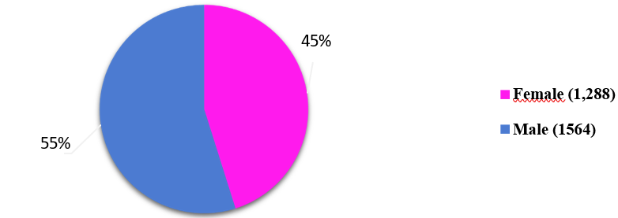

Figure 1: Population distribution by gender

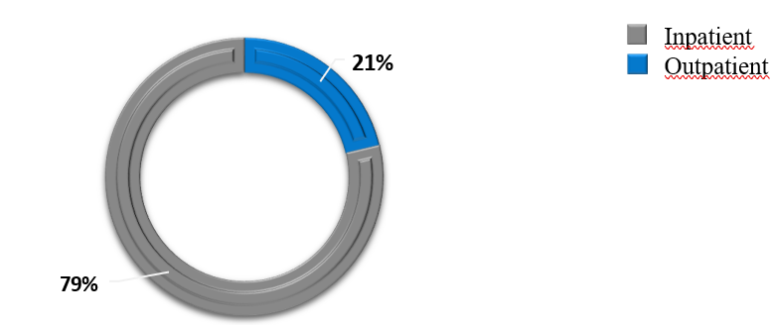
Figure 2: Distribution of the population by origin

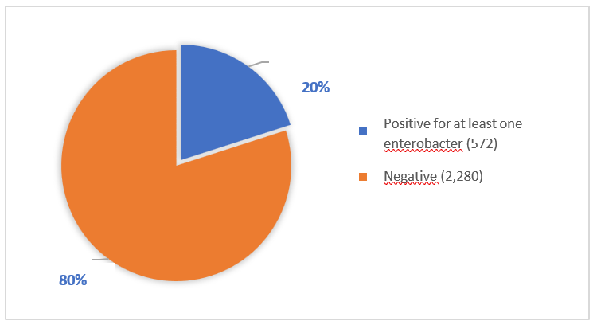
Figure 3: Frequency of uropathogenic Enterobacteria

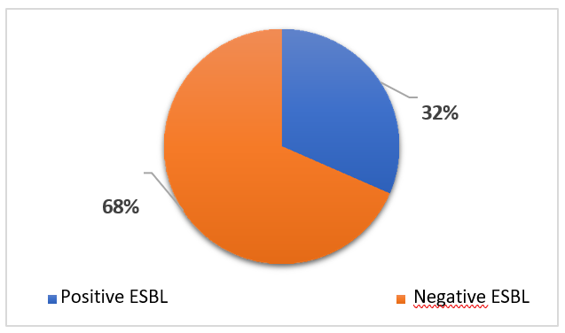
Figure 4: Prevalence of uropathogenic ESBL-producing bacteria

Figure 5 : Co-resistance of ESBL producing E.coli to other antibiotics

R: Resistant S: Susceptible

Figure 6 : Co-resistance of ESBL producing Klebsiella pneumoniae to other antibiotics

Figure 7 : Co-resistance of Enterobacter spp to other antiobiotics

Table 1: Distribution of the population by age group

 | Age group | Number |  | Percentage
 | 0–14 | 258 |  | 9
 | 15–29 | 592 |  | 21
30–44 |  |  | 461 |  | 16
45–59 |  |  | 295 |  | 10
≥ 60 years old |  |  | 1,246 |  | 44
Total |  |  | 2852 |  | 100

Table 2: Distribution of ESBL-producing bacteria according to origin
Origin | ESBL (n) | % of ESBL-E | Total samples | % of total
Inpatient | 71 | 29 | 608 | 21
Outpatient | 176 | 71 | 2244 | 79
Total | 247 | 100 | 2852 | 100

Table 3: Distribution of EBLSE by clinical departments
Clinical departments | Number of ESBL-E | Percentage (%)
NRCH | 6 | 2
SMIT | 24 | 10
CTCV | 5 | 2
NEURO | 24 | 10
GERIATRICS | 9 | 4
PNEUMO | 5 | 2
CRCF | 0 | 0%
INTERNAL MED | 0 | 0%
PNEUNO | 0 | 0%
ORL | 0 | 0%
PSYCHIATRY | 0 | 0%
PNEUMOLOGY | 0 | 0%
Autres | 174 | 70%
Total | 247 | 100%

Table 4: Co-resistance of ESBL-producing E. coli to other antibiotics

Antibiotics tested | % resistance among  ESBL-producing bacteria
IMP | 17
GMN | 66
CHL | 15
SXT | 86
TET | 88
CIP | 75
NAL | 81
IMP :Imipenem ; GMN :Gentamicin ; CHL : Chloramphenicol ; SXT : Sulfamethoxaole- Trimethoprim ; TET : Tetracycline ; CIP : Ciprofloxacin ; NAL : Nalidixic acid.

