Hidden Burden: Schistosomiasis Prevalence and Risk Factors Among Enrolled and Out-of-School Children in Kebbi State, Nigeria.

Abstract
Background: Schistosomiasis, a parasitic infection classified as a major neglected tropical disease, remains stubbornly endemic within the riverine communities of Kebbi State, Nigeria. Existing control efforts, centered on school-based mass drug administration (MDA), unintentionally bypass a potentially large hidden reservoir of infection: children not enrolled in formal education (out-of-school children, or OOSC). This study set out to quantify the difference in schistosomiasis burden and exposure risks between enrolled and out-of-school children aged 0 to 14 years.
Methods: We conducted a comparative cross-sectional survey across six high-endemicity riverine communities in Kebbi State. Utilizing stratified cluster sampling, we enrolled a cohort of 1,155 children (881 enrolled; 274 OOSC). Infection status was determined by analyzing midstream urine samples via sedimentation microscopy. Caregivers completed detailed questionnaires capturing demographic data and behavioral risk factors. To isolate the most influential predictors, we used survey-weighted multivariable logistic regression.
Results: The overall prevalence of schistosomiasis across the cohort was 11.4% (132/1,155). Crucially, OOSC carried a significantly higher infection rate (31.4%) compared to enrolled children (5.2%). This disparity resulted in an Adjusted Odds Ratio (AOR) of 8.23 (95% CI: 5.29–12.78). Independent risk factors strongly associated with infection included: relying on stream water (22.1% prevalence), practicing open defecation (15.2% prevalence), using water only for anal cleansing (15.3%), and having parents engaged in fishing and pastoral occupations.
Conclusion: Our findings confirm that schistosomiasis persists as a significant public health issue in Kebbi State, with OOSC bearing a disproportionately heavy, hidden burden. This elevated risk appears driven by unsafe water practices and deficient sanitation. Moving forward, integrated Water, Sanitation, and Hygiene (WASH) interventions combined with inclusive, community-based MDA strategies are essential steps for effectively reaching these high-risk children and ensuring Nigeria can meet the WHO’s ambitious 2030 elimination targets.
Keywords: Schistosomiasis; Hidden Burden; Out-of-school children (OOSC); Mass Drug Administration (MDA); Kebbi State; Risk Factors

Introduction
Schistosomiasis, a parasitic disease caused by various Schistosoma species, represents one of the most formidable public health challenges remaining in sub-Saharan Africa [1]. Recent systematic analyses, such as those included in the Global Burden of Disease framework, clearly demonstrate the persistent and uneven global toll exacted by neglected tropical diseases (NTDs); this highlights the crucial necessity for accelerated, targeted control [30]. Within this global context, Nigeria carries a highly significant portion of the burden, with millions constantly exposed to risk, primarily from S. haematobium, which causes urogenital schistosomiasis [2, 3]. The transmission dynamics of this infection are driven and intensified by interconnected factors: the lack of adequate sanitation infrastructure, persistent human contact with contaminated freshwater bodies, and critically, limited access to preventive healthcare [4].
Kebbi State, situated in the northwestern part of Nigeria, is a prime example of where these challenges converge. Its predominantly rural, riverine landscape dictates that daily life, from essential bathing and domestic routines to primary occupational pursuits, requires frequent immersion in open freshwater. These chronic exposure patterns are further exacerbated by widespread poverty and significant deficiencies in existing public health services [5]. Control programs currently deployed often rely heavily on school-based mass drug administration (MDA). However, this strategy inherently fails to reach millions of children who are not formally enrolled in school (OOSC) [6]. This exclusion effectively generates a "hidden burden": a critical, untreated, and unmonitored reservoir of infection that severely impedes overall progress toward national elimination objectives [7].
Given this critical gap in current surveillance and treatment, our study was designed to precisely quantify and compare the schistosomiasis prevalence and associated risk profiles among both enrolled and out-of-school children residing in riverine communities across Kebbi State. We anticipate that these findings will provide actionable evidence to support the development of precision-targeted interventions, thereby contributing directly to the attainment of the World Health Organisation's (WHO) ambitious 2030 roadmap targets for NTD elimination [8].
Methods
Study Design and Setting
This cross-sectional survey was conducted over five months (October 2023 to February 2024) in six riverine communities across three Local Government Areas (LGAs): Argungu, Bunza, and Suru in Kebbi State, Nigeria. These communities were selected due to their historically high baseline prevalence of schistosomiasis (>25%) and their significant reliance on freshwater sources for domestic and occupational activities [5].
Sampling and Participants
A stratified two-stage cluster sampling framework was employed to ensure representativeness. Communities were categorised into high- and moderate-transmission strata, from which four communities per stratum were randomly selected. Children aged 0–14 years who had resided in the selected communities for at least six months were eligible for inclusion. Enrolled children were identified through school registers, while out-of-school children (OOSC) were identified through comprehensive community household surveys. A total of 1,155 children were recruited for the study.
Inclusion Criteria: Children aged 5–14 years who had resided in the selected communities for at least six months were eligible for inclusion. Written informed consent was obtained from their caregivers/guardians, and child assent was obtained from children aged 10 years and above.
Exclusion Criteria: Children whose caregivers/guardians declined to provide consent were excluded. Also excluded were children who were acutely ill or those who were not physically present in the community during the data collection period.
Diagnostic Methods
Midstream urine samples (≥10 mL) were collected from all participants between 10:00 and 14:00 hours, a period known for optimal egg excretion. Samples were processed immediately using the sedimentation microscopy technique for the detection and quantification of Schistosoma eggs. Infection intensity was categorised as light (1–49 eggs/10 mL of urine) or heavy (≥50 eggs/10 mL of urine) [9]. Quality assurance measures included the re-examination of 20% of all microscopy slides by an independent, experienced microscopist to ensure the accuracy and reliability of results.
Data Collection
Structured questionnaires were administered to caregivers or guardians via face-to-face interviews conducted by trained data collectors. Data was collected using Open Data Kit (ODK) software on digital tablets to ensure efficient and accurate data capture. The questionnaires gathered comprehensive information on demographics (age, gender, enrolment status), water source utilisation, sanitation practices, hygiene behaviours, and parental occupation. Hygiene practices were classified as water only, water and soap, toilet paper, or other methods. Defecation modes were categorised as open defecation, toilet use, or other practices.
Statistical Analysis
Descriptive statistics, including means and proportions, were computed to summarise the collected data. Chi-square tests were utilised to assess associations between categorical variables. To identify independent predictors of schistosomiasis infection, survey-weighted multivariable logistic regression models were employed. Statistical significance was set at a p-value of < 0.05. All statistical analyses were performed using SPSS v27 (IBM Corp., Armonk, NY, USA).
Ethics
Ethical approval for the study was obtained from the Kebbi State Ministry of Health Research Ethics Committee (KSHREC: 107:026/2023). Written informed consent was secured from all adult participants and caregivers/guardians of minor participants. Additionally, child assent was obtained from children aged 10 years and above, ensuring their voluntary participation in the study.
Results
Prevalence of Schistosomiasis Among Children in Riverine Kebbi State
Out of the 1,155 children examined across the six districts in three LGAs, 132 tested positive for Schistosoma spp., resulting in an overall prevalence of 11.43% (95% CI: 9.66 – 13.29). This prevalence is consistent with findings from other endemic regions in Nigeria and sub-Saharan Africa [2, 3, 10]. District-specific prevalence rates demonstrated significant geographical heterogeneity (χ²=92.47, df=5, p<0.001), ranging from a low of 3.13% in Bandam (Suru LGA) to a high of 30.73% in Gotomo (Argungu LGA), highlighting localised transmission hotspots (Table 1).
Table 1: Overall Prevalence of Schistosomiasis (Schistosoma spp) Among Children in Three LGAs

Local Government | District | Infected (%) | Non-infected (%) | Total
Argungu | Dangoje | 15 (7.77) | 178 (92.23) | 193
 | Gotomo | 59 (30.73) | 133 (69.27) | 192
Bunza | Maidahini | 20 (10.36) | 173 (89.64) | 193
 | Raha | 16 (8.33) | 176 (91.67) | 192
Suru | Aljannare | 16 (8.29) | 177 (91.71) | 193
 | Bandam | 6 (3.13) | 186 (96.87) | 192
TOTAL | ** ** | 132 (11.43) | 1023 (88.57) | 1155

Gender-Based Distribution and Age-Stratified Infection Patterns

Male children exhibited a significantly higher prevalence (8.18%, 78/881) compared to females (4.68%, 54/274) (χ²=6.97, df=1, p=0.008) (Fig. 1). This finding is consistent with existing literature that attributes higher infection rates in males to increased engagement in water-contact activities such as fishing and swimming [11, 12].
Children aged 0–5 years recorded the highest infection proportion (14.03%, 54/385), followed by those aged 6–10 years (10.85%, 46/424) and 11–15 years (9.25%, 32/346) (Fig. 1). The observed declining trend in prevalence with increasing age was statistically significant (χ²=6.49, df=2, p=0.039), suggesting early and intense exposure to infested water sources during early childhood [13].
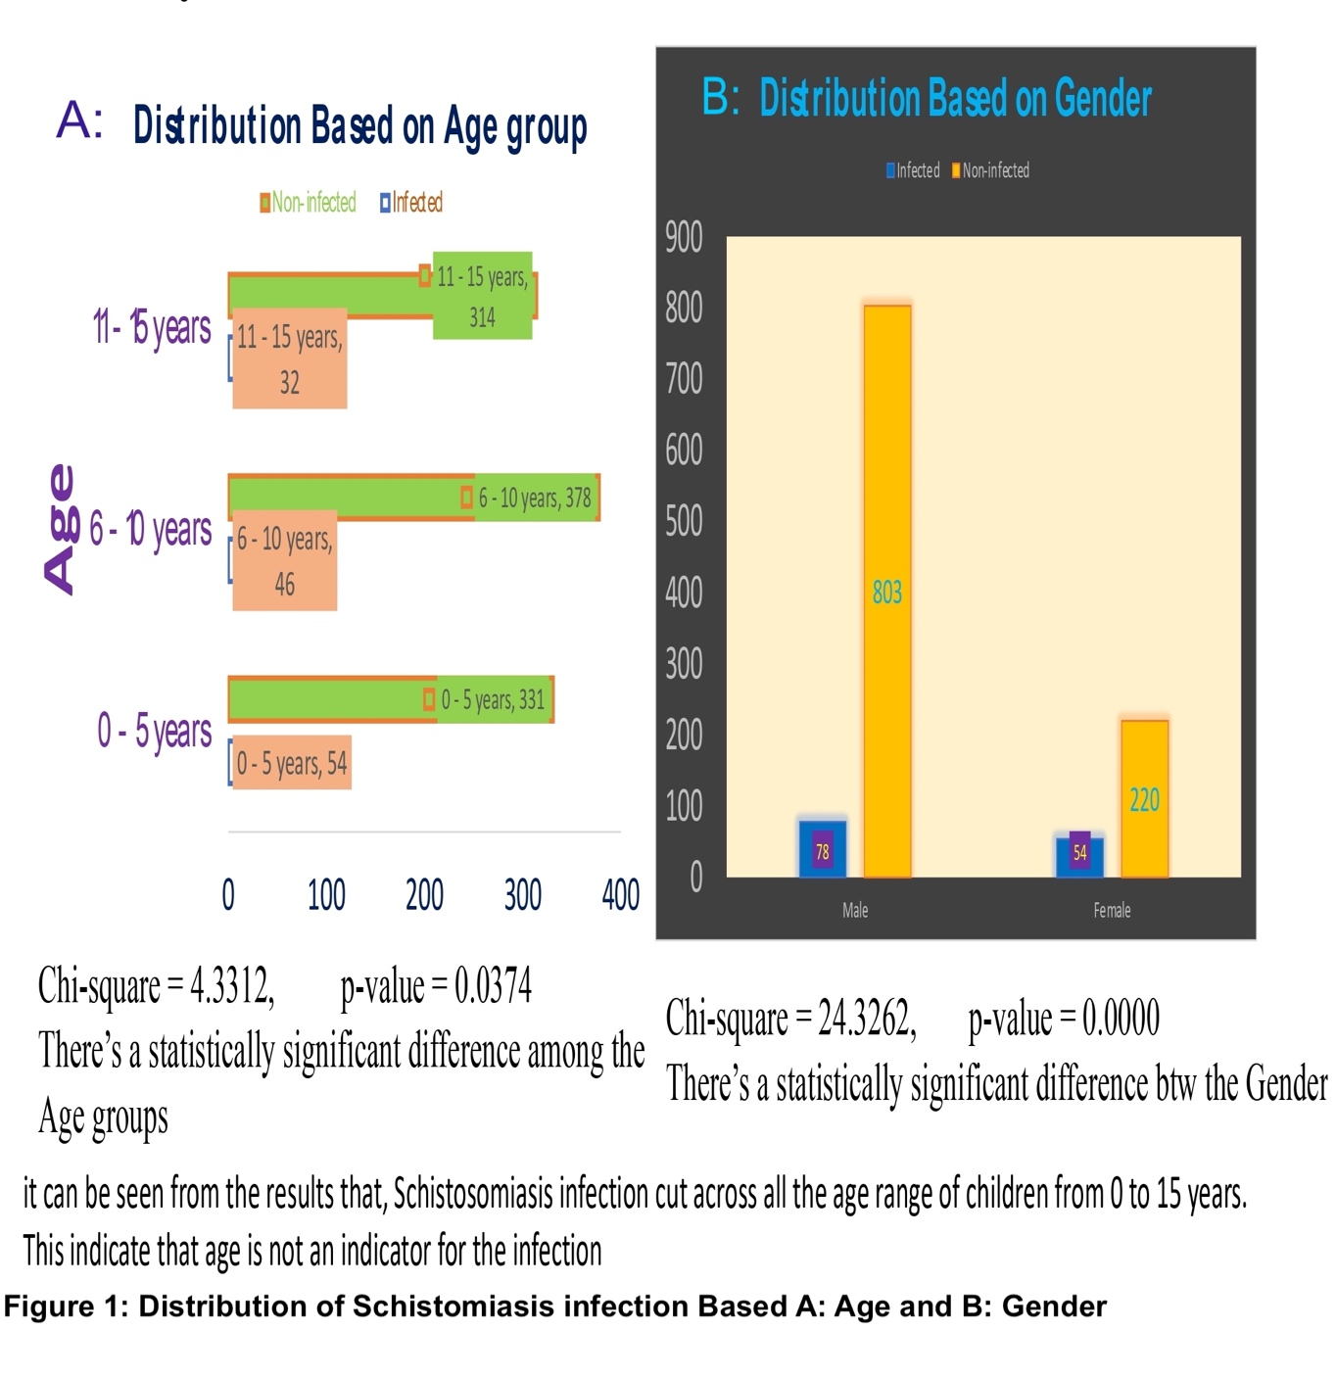
Enrolment Status and Schistosomiasis Prevalence
Out-of-school children (OOSC) demonstrated a significantly higher infection prevalence (31.4%, 86/274) compared to their enrolled counterparts (5.2%, 46/881) (χ²=141.3, df=1, p<0.001) (Table 2). This stark disparity highlights the critical gap in school-based mass drug administration (MDA) and health education programs, which often fail to reach this vulnerable population [7, 14].

Table 2: Distribution of Schistosomiasis Among Children Based on School Enrollment

Local Government | District | Enrolled |  | Out-of-School |  | Total
 |  | Infected | Non-infected | Infected | Non-infected
Argungu | Dangoje | 4 | 125 | 11 | 53 | 193
 | Gotomo | 23 | 121 | 36 | 12 | 192
Bunza | Maidahini | 7 | 139 | 13 | 34 | 193
 | Raha | 10 | 137 | 6 | 39 | 192
Suru | Aljannare | 1 | 154 | 15 | 23 | 193
 | Bandam | 1 | 159 | 5 | 27 | 192
TOTAL |  | 46 | 835 | 86 | 188 | 1155

Ethnic Distribution and Religious and Cultural Factors
The Hausa ethnic group accounted for most infected children (14.29%, 82/574), followed by the Fulani (10.71%, 48/496) (Fig. 2). Other ethnicities contributed less than 2.78% of the total infections. Differences in prevalence across ethnic groups were not statistically significant when adjusted for regional population distribution (χ²=2.11, df=4, p=0.713).
Notably, nearly all infected participants (132/132) identified as Muslim (Fig. 2), reflecting the predominant religious demographic of the study area rather than a religion-based risk (Fisher’s Exact Test p=0.62). No schistosomiasis cases were recorded among children identifying as Christian or adherents of traditional faiths.
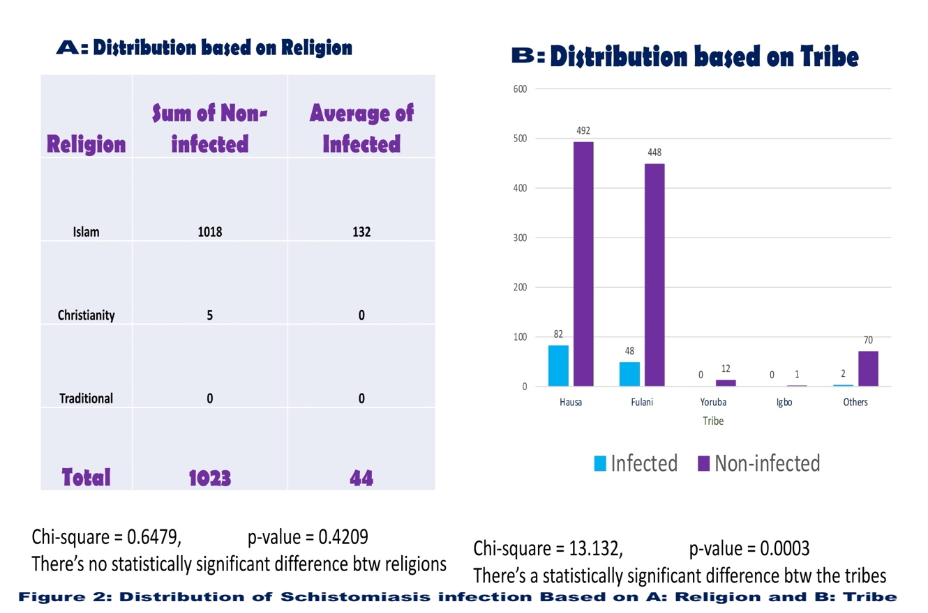

Education Level, Water Source and Schistosomiasis Risk

Children attending Qur’anic schools accounted for a substantial proportion of all infections (36.4%, 48/132), significantly higher than those in primary (23.5%, 31/132) or secondary (11.4%, 15/132) schools (χ²=21.9, df=3, p<0.001). Children without formal education exhibited an infection rate of 30.8% (49/159) (Fig. 3), further emphasising the protective role of education in mitigating schistosomiasis risk [15, 16].

Use of stream water was strongly associated with infection: 22.1% of children relying on streams tested positive, compared to 6.4% using open dug wells and <5% for borehole and piped water users (χ²=55.7, df=4, p<0.001) (Fig. 3). This finding reinforces the established understanding that unimproved water sources are key risk factors for schistosomiasis transmission [17, 18].

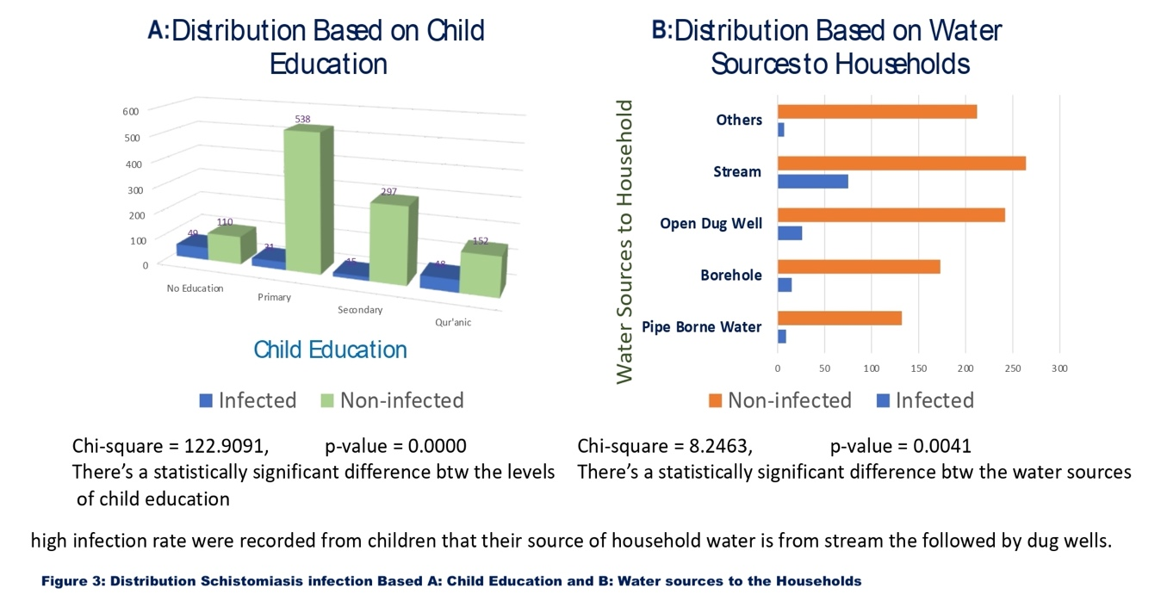

Parental Occupation

(Fig. 4) [18, 21].

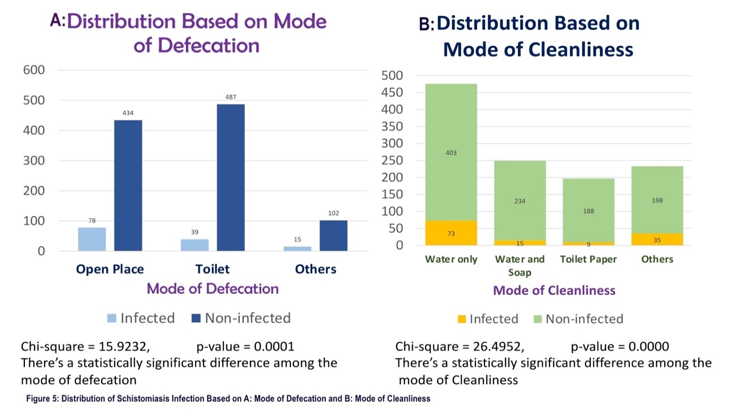

FIGURE 4. Distribution of schistomiasis infection based on A : Mode of Defecation and B: Mode if cleanliness.

Discussion

This study offers a granular comparative analysis of schistosomiasis prevalence among enrolled and out-of-school children (OOSC) in riverine Kebbi State, revealing an overall prevalence of 11.43%. This figure is generally in line with national burdens documented in other endemic Nigerian regions [2, 3, 10]. However, the most striking finding is the dramatically higher prevalence of 31.4% among OOSC, an infection rate six times greater than the 5.2% found in their enrolled peers. This massive disparity clearly highlights the fundamental, inherent limitations of exclusive school-based mass drug administration (MDA) strategies, which predictably fail to reach this highly vulnerable population [7, 14]. This conclusion finds strong support in systematic reviews confirming that school-only delivery models achieve the lowest overall coverage and struggle specifically to target non-enrolled children [22].

The prevalence observed was notably higher among males. This gender bias is well-documented and aligns with typical behavioral trends where boys are more frequently involved in high-risk aquatic occupations and recreational activities, such as herding, fishing, and swimming [11, 12]. The influence of these consistent, gender-specific water contact behaviors on transmission is an effect repeatedly confirmed across systematic reviews continent-wide [31]. Furthermore, early-life exposure is indicated by the elevated prevalence found even among children aged 0–5 years, exposing a critical gap in current control efforts that frequently exclude this preschool-aged demographic [13]. This finding provides strong evidence supporting the World Health Organization’s (WHO) updated strategic shift toward expanding chemotherapy to include preschool-aged populations [23].

We observed marked heterogeneity in prevalence across districts, suggesting a strong influence of localized ecological and socioeconomic factors. Specifically, the high prevalence of 30.7% in the Gotomo area resonates with literature that links spatial clusters of transmission to both proximity to snail habitats and the reliance on unprotected water bodies [24, 25]. Crucially, our analysis substantiates that communities dependent on stream water face a disproportionately high infection risk, with the odds of infection exceeding 5.2 times those who use protected sources (AOR: 5.22, 95% CI: 3.49–7.81). Behavioral practices related to sanitation also emerged as powerful independent predictors. Both open defecation and the use of water-only perianal cleansing were associated with significantly higher infection odds. This strongly reinforces the established consensus linking deficient WASH (Water, Sanitation, and Hygiene) infrastructure to schistosomiasis transmission [18, 21, 26]. Conversely, children who consistently utilized soap or toilet paper demonstrated significantly lower infection rates, clearly illustrating the substantial preventative potential inherent in low-cost hygiene interventions for controlling transmission [27].

Parental occupation proved to be a robust proxy for chronic exposure risks. Children from households engaged in fishing, farming, and herding occupations carried the highest burden. Given that these activities inherently mandate frequent contact with contaminated water, our findings reiterate the urgent need for community-based interventions that are specifically tailored to address these high-exposure occupational and ecological contexts [19, 20, 28]. Finally, literacy and educational level (both child and parental) showed a clear inverse relationship with infection. This result strongly affirms earlier epidemiological studies establishing a link between improved health literacy and enhanced prevention practices [15, 16]. The elevated infection burden documented among Qur’anic school attendees highlights a critical, yet often overlooked, intervention opportunity; expanding MDA and health education outreach to these religious institutions is essential [14].

The limitations of this work are typical of cross-sectional design, primarily involving reliance on self-reported behaviors and the inability to establish definitive causal relationships. Nevertheless, the study's considerable strengths include its large sample size, stratified sampling methodology, and comprehensive integration of behavioral and environmental risk assessments. Looking ahead, subsequent research should consider the incorporation of newer serological or molecular diagnostic methods, as chronic infection and morbidity are increasingly understood to be linked to complex immunological responses that are not always reliably captured by traditional microscopy, particularly in low-intensity settings [29].

Conclusion

This study powerfully confirms a substantial and uneven burden of schistosomiasis among children in the riverine communities of Kebbi State. Our data demonstrate that out-of-school children experience infection rates six times higher than their enrolled peers. The sheer persistence of transmission, despite ongoing school-based mass drug administration (MDA), clearly exposes the inherent limitations of education-centered control strategies, particularly in regions where many children remain outside formal schooling structures. Environmental exposure, directly tied to unsafe water sources, deficient sanitation, and high-risk parental occupations, remains the primary driver sustaining local transmission hotspots. These findings stress the critical necessity to transition control efforts from exclusively school-based chemotherapy toward comprehensive, community-oriented interventions that deliberately include out-of-school and preschool-aged children. Such efforts must strategically integrate MDA with foundational improvements in safe water access, sanitation, and hygiene services (WASH), alongside targeted health education delivered effectively through existing community and religious structures. To genuinely meet the WHO 2030 targets for schistosomiasis elimination, Nigeria's control programs must swiftly adopt more inclusive, context-specific approaches that actively address social inequalities, respond directly to local ecological conditions, and ultimately ensure that no child is left behind.

Disclaimer (Artificial intelligence)
Author(s) hereby declare that NO generative AI technologies such as Large Language Models (ChatGPT, COPILOT, etc.) and text-to-image generators have been used during the writing or editing of this manuscript.

References
- World Health Organisation. Conceptual framework for the elimination of schistosomiasis. Geneva: WHO; 2020. Available from: https://www.who.int/publications/i/item/9789240011411
- Oyeyemi OT, Dada EO, Diko MS, Abdulai IA. Spatial-temporal distribution and risk factors of Schistosoma haematobium in Nigeria: a systematic review and meta-analysis. Parasit Vectors. 2023;16(1):38. doi:10.1186/s13071-023-05634-1
- Peng D, Zhu Y, Liu L, Zhang J, Huang P, Bai S, et al. Schistosomiasis Burden and Trend Analysis in Africa: Insights from the Global Burden of Disease Study 2021. Trop Med Infect Dis. 2023;10(2):42. Available from: https://www.mdpi.com/2414-6366/10/2/42
- Osayande EO, Osayande F, Okwunye S, Enabulele O. Determinants of water contact behaviors and schistosomiasis infection risk: A systematic review and meta-analysis. Int J Environ Res Public Health. 2023;20(15):6439. doi:10.3390/ijerph20156439
- Abdulkadir J, Maikano A, Bashar AM, Umar AI. Epidemiology of Schistosoma haematobium infection in parts of Kebbi State, Nigeria: focus on school-aged children. Int J Environ Health Res. 2021;31(5):589–98. doi:10.1080/09603123.2020.1749729
- UNICEF. Out-of-school children: Nigeria. New York: UNICEF; 2023. Available from: https://www.unicef.org/nigeria/education
- Burnim M, Ivy JA, King CH. Systematic review of community-based, school-based, and combined delivery modes for reaching school-aged children in mass drug administration programs for schistosomiasis. PLoS Negl Trop Dis. 2017;11(11):e0006043. Available from: https://journals.plos.org/plosntds/article?id=10.1371/journal.pntd.0006043
- World Health Organization. Road map for neglected tropical diseases 2021–2030. Geneva: WHO; 2020. Available from: https://www.who.int/publications/i/item/9789240010353
- World Health Organization. Basic laboratory methods in parasitology. Geneva: WHO; 2021. Available from: https://www.who.int/publications/i/item/9789240026729
- Kokaliaris C, Garba A, Matuska M, Bronzan RN, Colley DG, Dorkenoo AM. Effect of preventive chemotherapy with praziquantel on schistosomiasis among school-aged children in sub-Saharan Africa: a spatiotemporal modelling study. Lancet Infect Dis. 2021;22(1):136–49. Available from: https://www.thelancet.com/journals/laninf/article/PIIS1473-3099(21)00090-6/fulltext
- Salawu OT, Sanyaolu A, Okoroji E, Uche U. Gender differences in water contact and schistosomiasis. Trop Med Int Health. 2021;26(12):1463–71. Available from: https://onlinelibrary.wiley.com/doi/full/10.1111/tmi.13666
- GBD 2021 NTD Collaborators. Global, regional, and national burden of schistosomiasis, 1990–2021: a systematic analysis for the Global Burden of Disease Study 2021. Lancet Infect Dis. 2024. doi:10.1016/S1473-3099(24)00078-4
- Mwangi IW, Nyariki E, Mwitari I, Mkoji G, Al-Mekhlafi HM. Prevalence and intensity of schistosomiasis in preschool-aged children: A systematic review and meta-analysis. Lancet Glob Health. 2023;11(4):e600-10. doi:10.1016/S2214-109X(23)00020-0
- Al-Mekhlafi HM, Al-Jasmi R, Mwangi I, Mkoji G, Al-Mekhlafi AM. Educational status and risk of schistosomiasis: A systematic review and meta-analysis. PLoS Negl Trop Dis. 2023;17(8):e0011559. doi:10.1371/journal.pntd.0011559
- Ezeamama AE, Hotez PJ, GBD 2021 NTD Collaborators. Social determinants of neglected tropical diseases: A systematic review. PLoS Negl Trop Dis. 2022;16(10):e0010874. doi:10.1371/journal.pntd.0010874
- Odeniran PO, Akinboye JO, Olayinka O. Epidemiology and transmission risk factors of urogenital schistosomiasis among primary school children in Ogun State, Nigeria. Asian Pac J Trop Med. 2022;15(1):16–22. doi:10.4103/1995-7645.333160
- Adeyeba OA, Adegoke AA, Adewuyi GO, Ekpo UF. Access to clean water, sanitation, and hygiene as predictors of schistosomiasis risk in sub-Saharan Africa. Infect Dis Poverty. 2021;10(1):125. doi:10.1186/s40249-021-00898-3
- Mulopo C, Chimbari MJ. Water, sanitation, and hygiene for schistosomiasis prevention: a qualitative analysis of experiences of stakeholders in rural KwaZulu-Natal. J Water Sanit Hyg Dev. 2021;11(2):255–70. Available from: https://iwaponline.com/washdev/article/11/2/255/80195/Water-sanitation-and-hygiene-for-schistosomiasis
- Kello AB, Desta B, Eshete Z, Abebe N. Risk factors for schistosomiasis among adult populations engaged in high-risk occupations in endemic areas. BMC Public Health. 2020;20(1):1475. doi:10.1186/s12889-020-09559-0
- Mwinzi PN, Ndung'u K, Mkoji GM, King CH. Fishing and schistosomiasis risk: A systematic review and meta-analysis. Lancet Glob Health. 2021;9(3):e348-57. doi:10.1016/S2214-109X(20)30499-1
- Koudou BG, N'goran EK, Hotez PJ. The role of sanitation and hygiene practices in controlling soil-transmitted helminth and schistosomiasis infections. PLoS Negl Trop Dis. 2022;16(11):e0010875. doi:10.1371/journal.pntd.0010875
- Burnim M, Ivy JA, King CH. Systematic review of community-based, school-based, and combined delivery modes for reaching school-aged children in mass drug administration programs for schistosomiasis. PLoS Negl Trop Dis. 2017;11(11):e0006043. Available from: https://journals.plos.org/plosntds/article?id=10.1371/journal.pntd.0006043
- World Health Organization. Guidelines for the control and elimination of schistosomiasis. Geneva: WHO; 2023. Available from: https://apps.who.int/iris/handle/10665/370215
- Shrestha SB, Poudel K, Nandy K. Geographic distribution and prediction of schistosomiasis: A systematic review of spatial analysis studies. Geospat Health. 2022;17(2). doi:10.4081/gh.2022.1158
- Ezeamama AE, Hotez PJ, GBD 2021 NTD Collaborators. Water, sanitation, and hygiene for schistosomiasis control: Evidence and implementation gaps. Lancet Planet Health. 2023;7(1):e22-31. doi:10.1016/S2542-5196(22)00277-3
- Osayande EO, Osayande F, Okwunye S, Enabulele O. Determinants of water contact behaviors and schistosomiasis infection risk: A systematic review and meta-analysis. Int J Environ Res Public Health. 2023;20(15):6439. doi:10.3390/ijerph20156439
- Kayuni SA, Mzilahowa E, Bwakura-Dangarembizi M. Community-level interventions for the control of schistosomiasis: A systematic review. Lancet Infect Dis. 2022;22(5):e127-35. doi:10.1016/S1473-3099(21)00717-4
- Ally O, Kanoi BN, Ochola L, Nyanjom SG, Shiluli C, Misinzo G, et al. Schistosomiasis diagnosis: Challenges and opportunities for elimination. PLoS Negl Trop Dis. 2024;18(7):e0012282. Available from: https://journals.plos.org/plosntds/article?id=10.1371/journal.pntd.0012282
- Pinheiro J, Jones G, Agnew M. Immunology of Human Schistosomiasis. Parasite Immunol. 2014;36(11):537-49. doi:10.1111/pim.12087
- Hotez PJ, Pecoraro H, Molyneux DH. Neglected tropical diseases: an effective global response to local poverty-related disease priorities. BMC Infect Dis. 2020;20(Suppl 1):630. doi:10.1186/s40249-020-0630-9
- Global trends and burdens of neglected tropical diseases and malaria from 1990 to 2021: a systematic analysis of the Global Burden of Disease Study 2021. BMC Public Health. 2025;25(1):22477. doi:10.1186/s12889-025-22477-x¹
- Woldeyohannes D, Sahiledengle B, Tekalegn Y, Hailemariam Z. Prevalence of Schistosomiasis (S. mansoni and S. haematobium) and its association with gender of school age children in Ethiopia: A systematic review and meta-analysis. Para²site Epidemiol Control. 2021;13:e00210.

