Taxonomic Classification of soils in the Vitalapura Sub-Watershed of Kadur taluk, Chikkamagaluru district, Karnataka, India
Abstract
Soil taxonomic classification is essential for understanding soil variability and guiding sustainable land-use planning in watershed ecosystems. In this study, nine representative soil pedons from the Vitalapura sub-watershed of Kadur taluk, Chikkamagaluru district, were examined for their morphological, physical, and chemical characteristics and classified according to the Keys to Soil Taxonomy (Soil Survey Staff, 2017). The classification followed a hierarchical approach considering diagnostic horizons, soil moisture and temperature regimes, and key physico-chemical properties. The soils of the sub-watershed were broadly categorized into two major soil orders, with further differentiation at suborder, great group and subgroup levels. All pedons belonged to the isohyperthermic temperature regime, reflecting the climatic conditions of the region. The study identified multiple soil series and soil phases, providing a detailed pedological framework for the area. These results offer valuable baseline information for land evaluation, crop planning, and effective soil and watershed management in the region.
Keywords: Soil taxonomy, Pedon characterization, Soil order, Soil series, Soil Phases
I Introduction
Soil characterisation and taxonomic classification form the foundation of scientific soil management, enabling a deeper understanding of soil behavior, productivity, and sustainability under diverse land-use systems (Brady & Weil, 2017). In India, where agricultural production and natural resource conservation are closely linked to soil health, systematic characterization at local and regional scales is essential for informed land-use planning, watershed development, and precision agriculture. Soil properties such as morphology, texture, structure, depth, nutrient status, and physico-chemical characteristics provide valuable insights into soil genesis and fertility, ultimately guiding appropriate management interventions (Buol et al., 2011). By integrating these properties with Soil Taxonomy, soils can be grouped into meaningful classes that support long-term conservation and sustainable land-use decisions (Soil Survey Staff, 2014).
The Vitalapura sub-watershed, located in Kadur taluk of Chikkamagaluru district, represents an ecologically and agriculturally significant landscape within the semi-arid to sub-humid transition zone of Karnataka (NBSS&LUP, 2011). The region is characterized by diverse parent materials, undulating topography, variable rainfall distribution, and mixed land-use patterns comprising agriculture, horticulture, fallow lands, grasslands, and scrub vegetation. These variations strongly influence soil formation processes such as weathering, translocation, leaching, and organic matter accumulation (Jenny, 1941). Consequently, the sub-watershed exhibits high spatial heterogeneity in soil types, fertility levels, and physical conditions—information crucial for improving productivity and ensuring sustainable watershed management (Lal, 2004).
Despite its significance, detailed pedological investigations focusing on soil characterization and classification in the Vitalapura sub-watershed are limited. Comprehensive data on soil morphology, horizon differentiation, diagnostic features, and classification up to the family or series level are largely unavailable. Such information is essential for identifying soil constraints related to erosion, nutrient imbalances, moisture stress, salinity, or low organic carbon levels (Havlin et al., 2014). Furthermore, soil taxonomic units serve as a scientific basis for developing land capability maps, assessing crop suitability, and designing soil and water conservation strategies (FAO, 2006).
This study aims to systematically characterize the soils of the Vitalapura sub-watershed through detailed profile examination and laboratory analysis, followed by their classification according to the USDA Soil Taxonomy system (Soil Survey Staff, 2014). By documenting the spatial distribution of soil classes and their inherent properties, this research provides a scientific framework to support sustainable agriculture, watershed development programmes, and resource management in the region. The findings will help researchers, planners, and farmers make informed decisions to enhance soil productivity, conserve natural resources, and promote long-term ecological stability within the sub-watershed.

II Material and Methods:
General description of Vitalapura sub-watershed
Hydrologically, Vitalapura sub-watershed belongs to the larger Vedavathy watershed located in the lower Tungabhadra catchment of Krishna basin. Based on the administrative setup, the sub-watershed is located in Kadur taluk of Chikkamagaluru district of Karnataka.
Location of Vitalapura sub-watershed
The sub-watershed lies between 13°28′20″ N and 13°33′20″ N latitudes and 76°0′0″ E and 75°8′20″ E longitudes (Fig. 1). The sub-watershed comprises of Ballakere, Chikkathangali, Maccheri 1, Maccheri 2, Tangali 1 and Tangali 2 micro-watersheds.
Soil classification
By studying the morphological characteristics, physical and chemical properties, including the climatic condition of the area, the nine pedons of the sub-watershed area were classified up to the family level according to "Keys to Soil Taxonomy" (Anon., 2017).
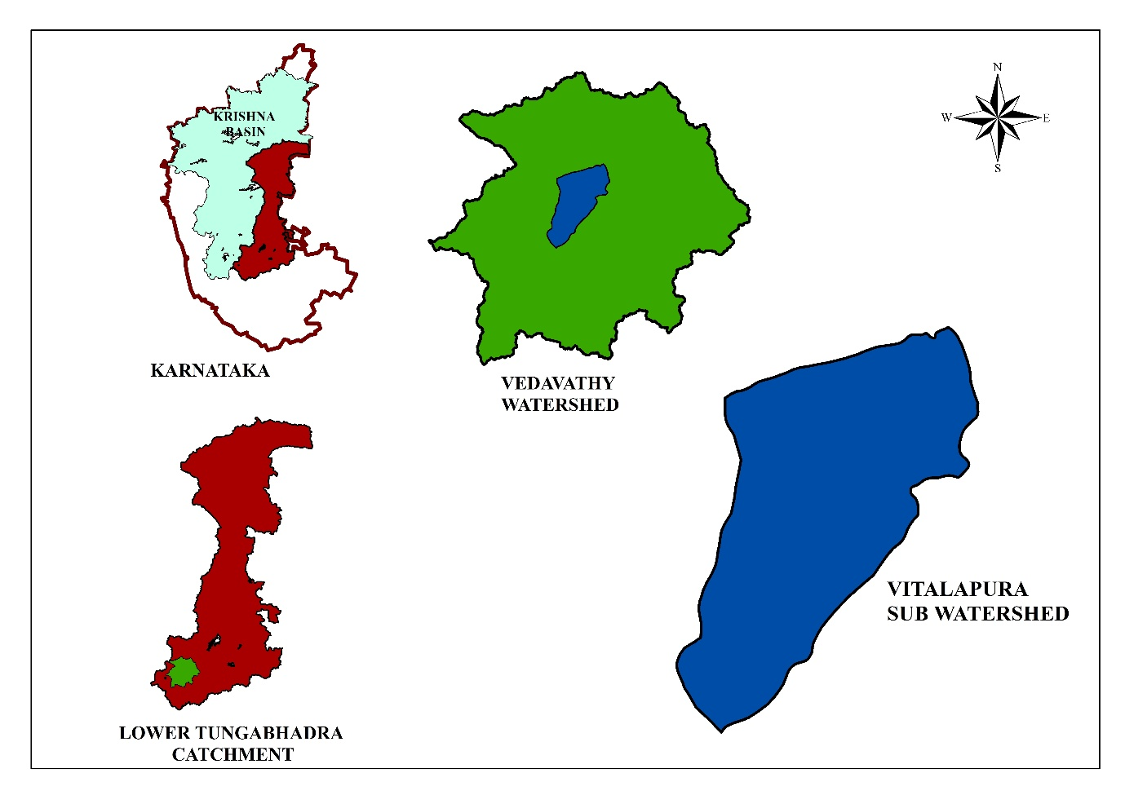Fig.1. Location map of the study area

III Results
The soils of Vitalapura sub-watershed were classified based on their morphological, physical and chemical properties conferring to Soil "Keys to Soil Taxonomy" (Soil Survey Staff 2017). At higher categories (order), the presence or absence of diagnostic horizons indicates the pedogenic process. At the sub-order level, the soil moisture and soil temperature regimes were used. At lower categories (great group, sub-group and family), diagnostic subsurface horizons, soil depth, mineralogy, texture, soil chemical properties and drainage were considered. The nine representative pedons of the Vitalapura sub-watershed were classified up to series level and are presented in Tables 1 and 2.
The soils of Vitalapura sub-watershed area belonged to two soil orders that is Alfisols and Inceptisols. Pedon 2, 3, 4, 5, 7 and 8 belonged to Alfisols order and the remaining pedons belonged to the soil order Inceptisols (Table 2).
At the suborder level, the three representative pedons under Alfisols were classified under Ustalfs and the pedons under Inceptisols were classified under Ustepts (Table 2).
All the representative pedons classified under the soil order Alfisols were grouped under Haplustalfs and Rhodustalfs at the great group level. The pedons belonging to the soil order Inceptisols were grouped under Haplustepts at the great group level.
At the subgroup level, out of 9 soil pedons, 3 soil pedons (pedon 3, 5 and 8) under Alfisols were classified as Typic Rhodustalfs. Soil pedons 2, 4 and 7 were classified as Typic Haplustalfs. Remaining pedons under soil order Inceptisols were classified as Typic Haplustepts (Table 1 and 2). The soils of the Vitalapura sub-watershed were classified at the family level based upon the particle size distribution and temperature regime. All nine representative soil pedons identified in the study area belonged to isohyperthermic soil temperature regime (Table 1 and 2).
A total of nine soil series were identified in Vitalapura sub-watershed area. Each soil series was further divided into 67 soil phases; soil phase boundaries were demarcated keeping the cadastral map as base and characteristics like surface soil texture, slope class, erosion class, percentage of gravel, stoniness, etc. Table 3 depicts the various soil phases identified in the sub-watershed area.
Table 1: Classification of soil pedons of Vitalapura sub-watershed
Pedon | Classification
Pedon 1 | Fine, mixed, isohyperthermic, Typic Haplustepts
Pedon 2 | Fine, mixed, isohyperthermic, Typic Haplustalfs
Pedon 3 | Fine, mixed, isohyperthermic, Typic Rhodustalfs
Pedon 4 | Fine, mixed, isohyperthermic, Typic Haplustalfs
Pedon 5 | Fine, mixed, isohyperthermic, Typic Rhodustalfs
Pedon 6 | Fine, mixed, isohyperthermic, Typic Haplustepts
Pedon 7 | Fine, mixed, isohyperthermic, Typic Haplustalfs
Pedon 8 | Fine, mixed, isohyperthermic, Typic Rhodustalfs
Pedon 9 | Fine, mixed, isohyperthermic, Typic Haplustepts

Table 2: Individual classification of soil pedons of Vitalapura sub-watershed (up to family level)
Sl .No | Order | Suborder | Great Group | Subgroup | Family | Pedon | Series Code
1 | Inceptisols | Ustepts | Haplustepts | Typic Haplustepts | Fine, mixed, isohyperthermic | Kanchikere | KKR
2 | Alfisols | Ustalfs | Haplustalfs | Typic Haplustalfs | Fine, mixed, isohyperthermic | Thammadahalli | TDH
3 | Alfisols | Ustalfs | Rhodustalfs | Typic Rhodustalfs | Fine, mixed, isohyperthermic | Ramenahalli | RNH
4 | Alfisols | Ustalfs | Haplustalfs | Typic Haplustalfs | Fine, mixed, isohyperthermic | Gulur | GLR
5 | Alfisols | Ustalfs | Rhodustalfs | Typic Rhodustalfs | Fine, mixed, isohyperthermic | Balapur | BPR
6 | Inceptisols | Ustepts | Haplustepts | Typic Haplustepts | Fine, mixed, isohyperthermic | Shyanadrahalli | SNH
7 | Alfisols | Ustalfs | Haplustalfs | Typic Haplustalfs | Fine, mixed, isohyperthermic | Kumchahalli | KMH
8 | Alfisols | Ustalfs | Rhodustalfs | Typic Rhodustalfs | Fine, mixed, isohyperthermic | Ranatur | RTR
9 | Inceptisols | Ustepts | Haplustepts | Typic Haplustepts | Fine, mixed, isohyperthermic | Thimmsandra | TSD

Table 3: Soil Phases identified in Vitalapura Sub-watershed
Sl. No. | Soil Series | Soil Phase | Soil Texture | Slope Class | Erosion Class | Gravelliness | Soil Depth | Area
 |  |  |  |  |  |  |  | in ha | in %
1 | KKR | KKRbB2g2 | Loamy sand | Very gently sloping | Moderate | Very gravelly | Moderately deep | 88.50 | 1.98
2 | KKR | KKRcA1 | Sandy loam | Nearly level | Slight | Non gravelly | Moderately deep | 8.86 | 0.19
3 | KKR | KKRcA1g1 | Sandy loam | Nearly level | Slight | Gravelly | Moderately deep | 15.11 | 0.33
4 | KKR | KKRcB1g1 | Sandy loam | Very gently sloping | Slight | Gravelly | Moderately deep | 50.00 | 1.12
5 | KKR | KKRcB2 | Sandy loam | Very gently sloping | Moderate | Non gravelly | Moderately deep | 67.19 | 1.50
6 | KKR | KKRcB2g1 | Sandy loam | Very gently sloping | Moderate | Gravelly | Moderately deep | 62.98 | 1.41
7 | KKR | KKRhB1 | Sandy clay loam | Very gently sloping | Slight | Non gravelly | Moderately deep | 58.74 | 1.31
8 | KKR | KKRhB2 | Sandy clay loam | Very gently sloping | Moderate | Non gravelly | Moderately deep | 71.49 | 1.60
9 | KKR | KKRiB1 | Sandy clay | Very gently sloping | Slight | Non gravelly | Moderately deep | 70.67 | 1.58
10 | KKR | KKRmB1 | Clay | Very gently sloping | Slight | Non gravelly | Moderately shallow | 40.77 | 0.91
11 | KKR | KKRmB1g1 | Clay | Very gently sloping | Slight | Gravelly | Moderately deep | 17.11 | 0.38
12 | KKR | KKRmC2 | Clay | Gently sloping | Moderate | Non gravelly | Moderately deep | 26.60 | 0.59
13 | TDH | TDHcA1 | Sandy loam | Nearly level | Slight | Non gravelly | Moderately shallow | 29.51 | 0.66
14 | TDH | TDHcB2 | Sandy loam | Very gently sloping | Moderate | Non gravelly | Shallow | 20.09 | 0.45
15 | TDH | TDHhB1 | Sandy clay loam | Very gently sloping | Slight | Non gravelly | Moderately shallow | 102.79 | 2.30
*Note: Area is given in hectares indicate per cent of total sub-watershed area

Table 3: Soil Phases identified in Vitalapura Sub-watershed (Contd.)
Sl. No. | Soil Series | Soil Phase | Soil Texture | Slope Class | Erosion Class | Gravelliness | Soil Depth | Area
 |  |  |  |  |  |  |  | in ha | in %
16 | TDH | TDHhB1g1 | Sandy clay loam | Very gently sloping | Slight | Gravelly | Moderately shallow | 7.52 | 0.16
17 | TDH | TDHhB2 | Sandy clay loam | Very gently sloping | Moderate | Non gravelly | Shallow | 55.93 | 1.25
18 | RNH | RNHcB2 | Sandy loam | Very gently sloping | Moderate | Non gravelly | Moderately shallow | 58.49 | 1.31
19 | RNH | RNHhB1 | Sandy clay loam | Very gently sloping | Slight | Non gravelly | Moderately shallow | 75.40 | 1.68
20 | GLR | GLRcB1 | Sandy loam | Very gently sloping | Slight | Non gravelly | Moderately deep | 173.44 | 3.88
21 | GLR | GLRcB1g1 | Sandy loam | Very gently sloping | Slight | Gravelly | Moderately deep | 141.51 | 3.17
22 | GLR | GLRcB2 | Sandy loam | Very gently sloping | Moderate | Non gravelly | Deep | 113.12 | 2.53
23 | GLR | GLRcB2g1 | Sandy loam | Very gently sloping | Moderate | Gravelly | Deep | 68.87 | 1.54
24 | GLR | GLRhA1 | Sandy clay loam | Nearly level | Slight | Non gravelly | Moderately deep | 48.19 | 1.07
25 | GLR | GLRhB1 | Sandy clay loam | Very gently sloping | Slight | Non gravelly | Moderately deep | 97.02 | 2.17
26 | GLR | GLRhB1g1 | Sandy clay loam | Very gently sloping | Slight | Gravelly | Moderately deep | 36.00 | 0.80
27 | GLR | GLRhB2g1 | Sandy clay loam | Very gently sloping | Moderate | Gravelly | Moderately deep | 58.11 | 1.30
28 | GLR | GLRiA1 | Sandy clay | Nearly level | Slight | Non gravelly | Moderately deep | 34.25 | 0.76
29 | GLR | GLRiB1 | Sandy clay | Very gently sloping | Slight | Non gravelly | Deep | 15.29 | 0.34
*Note: Area is given in hectares indicate per cent of total sub-watershed area

Table 3: Soil Phases identified in Vitalapura Sub-watershed (Contd.)
Sl. No. | Soil Series | Soil Phase | Soil Texture | Slope Class | Erosion Class | Gravelliness | Soil Depth | Area
 |  |  |  |  |  |  |  | in ha | in %
30 | GLR | GLRiB2 | Sandy clay | Very gently sloping | Moderate | Non gravelly | Deep | 29.24 | 0.65
31 | GLR | GLRiB2g1 | Sandy clay | Very gently sloping | Moderate | Gravelly | Deep | 34.31 | 0.76
32 | BPR | BPRcA1 | Sandy loam | Nearly level | Slight | Non gravelly | Very deep | 24.78 | 0.55
33 | BPR | BPRhA1 | Sandy clay loam | Nearly level | Slight | Non gravelly | Very deep | 76.31 | 1.70
34 | BPR | BPRiA1 | Sandy clay | Nearly level | Slight | Non gravelly | Very deep | 34.07 | 0.76
35 | BPR | BPRmA1 | Clay | Nearly level | Slight | Non gravelly | Very deep | 30.50 | 0.68
36 | BPR | BPRmB1g1 | Clay | Very gently sloping | Slight | Gravelly | Very deep | 18.71 | 0.41
37 | SNH | SNHbB2 | Loamy sand | Very gently sloping | Moderate | Non gravelly | Deep | 51.74 | 1.15
38 | SNH | SNHcA1 | Sandy loam | Nearly level | Slight | Non gravelly | Deep | 20.28 | 0.45
39 | SNH | SNHcB1 | Sandy loam | Very gently sloping | Slight | Non gravelly | Deep | 163.97 | 3.67
40 | SNH | SNHcB2 | Sandy loam | Very gently sloping | Moderate | Non gravelly | Deep | 27.97 | 0.62
41 | SNH | SNHhB1 | Sandy clay loam | Very gently sloping | Moderate | Non gravelly | Deep | 30.49 | 0.68
42 | SNH | SNHmA1 | Clay | Nearly level | Slight | Non gravelly | Deep | 27.79 | 0.62
43 | SNH | SNHmB1 | Clay | Very gently sloping | Slight | Non gravelly | Deep | 17.98 | 0.40
*Note: Area is given in hectares indicate per cent of total sub-watershed area

Table 3: Soil Phases identified in Vitalapura Sub-watershed (Contd.)
Sl. No. | Soil Series | Soil Phase | Soil Texture | Slope Class | Erosion Class | Gravelliness | Soil Depth | Area
 |  |  |  |  |  |  |  | in ha | in %
44 | KMH | KMHcA1 | Sandy loam | Nearly level | Slight | Non gravelly | Deep | 89.37 | 2.00
45 | KMH | KMHcB1 | Sandy loam | Very gently sloping | Slight | Non gravelly | Deep | 194.08 | 4.34
46 | KMH | KMHcB1g1 | Sandy loam | Very gently sloping | Slight | Gravelly | Deep | 98.51 | 2.20
47 | KMH | KMHcB2 | Sandy loam | Very gently sloping | Moderate | Non gravelly | Deep | 38.40 | 0.86
48 | KMH | KMHhA1 | Sandy clay loam | Nearly level | Slight | Non gravelly | Deep | 35.85 | 0.80
49 | KMH | KMHhB1 | Sandy clay loam | Very gently sloping | Slight | Non gravelly | Deep | 25.41 | 0.56
50 | KMH | KMHhB1g1 | Sandy clay loam | Very gently sloping | Slight | Gravelly | Deep | 55.04 | 1.23
51 | KMH | KMHiB2 | Sandy clay | Very gently sloping | Moderate | Non gravelly | Deep | 26.51 | 0.59
52 | KMH | KMHmA1 | Clay | Nearly level | Slight | Non gravelly | Deep | 31.28 | 0.70
53 | KMH | KMHmB1 | Clay | Very gently sloping | Slight | Non gravelly | Deep | 52.56 | 1.17
54 | RTR | RTRcB1 | Sandy loam | Very gently sloping | Slight | Non gravelly | Very Deep | 46.11 | 1.03
55 | RTR | RTRhA1 | Sandy clay loam | Nearly level | Slight | Non gravelly | Very Deep | 67.59 | 1.51
56 | RTR | RTRiB2 | Sandy clay | Very gently sloping | Moderate | Non gravelly | Very Deep | 43.86 | 0.98
57 | RTR | RTRmA1 | Clay | Nearly level | Slight | Non gravelly | Very Deep | 63.65 | 1.42
58 | RTR | RTRmB2 | Clay | Very gently sloping | Moderate | Non gravelly | Very Deep | 60.82 | 1.36
*Note: Area is given in hectares indicate per cent of total sub-watershed area

Table 3: Soil Phases identified in Vitalapura Sub-watershed (Contd.)
Sl. No. | Soil Series | Soil Phase | Soil Texture | Slope Class | Erosion Class | Gravelliness | Soil Depth | Area
 |  |  |  |  |  |  |  | in ha | in %
59 | TSD | TSDcB1 | Sandy loam | Very gently sloping | Slight | Non gravelly | Very Deep | 27.54 | 0.61
60 | TSD | TSDhA1 | Sandy clay loam | Nearly level | Slight | Non gravelly | Very Deep | 39.97 | 0.89
61 | TSD | TSDhB1 | Sandy clay loam | Very gently sloping | Slight | Non gravelly | Very Deep | 29.37 | 0.65
62 | TSD | TSDhB1g1 | Sandy clay loam | Very gently sloping | Slight | Gravelly | Very Deep | 64.68 | 1.44
63 | TSD | TSDiA1 | Sandy clay | Nearly level | Slight | Non gravelly | Very Deep | 184.15 | 4.12
64 | TSD | TSDiB1 | Sandy clay | Very gently sloping | Slight | Non gravelly | Very Deep | 51.67 | 1.15
65 | TSD | TSDiB2 | Sandy clay | Very gently sloping | Moderate | Non gravelly | Very Deep | 15.18 | 0.34
66 | TSD | TSDmA1 | Clay | Nearly level | Slight | Non gravelly | Very Deep | 291.70 | 6.53
67 | TSD | TSDmB1 | Clay | Very gently sloping | Slight | Non gravelly | Very Deep | 62.24 | 1.39
*Note: Area is given in hectares indicate per cent of total sub-watershed area

IV Discussion
By studying the morphological characteristics, physical and chemical properties, including the climatic condition of the area, the nine pedons of the sub-watershed area were classified up to the family level according to "Keys to Soil Taxonomy" (Anon., 2017).
Soil pedons 2, 3, 4, 5, 7 and 8 were classified as ‘Alfisol’ order due to the presence of silicate clay illuviated horizon i.e., Argillic horizon. At sub-order level, these pedons were categorized as “Ustalfs” at sub-order level. Since the soil moisture regime identified was ustic soil moisture regime. At the great group level, the soils were categorized into three great groups viz., Rhodustalfs and Haplustalfs. Pedon 3, 5 and 8 were grouped under Rhodustalfs since Hue of 2.5 YR or redder, Value, moist of 3 or less and Dry value no more than one unit higher than the moisture.
Soil pedons 1, 6 and 9 were classified under ‘Inceptisols’ soil order because of cambic horizon. At the sub-order level, the soil pedons were grouped under “Ustepts” because of the soil moisture regime was between ustic regime. At the great group level, the soil pedons were categorized under Haplustepts.
At Sub-group level all the pedons were categorized as “Typic”, since no lithic contact was observed within 50 cm of mineral soil surface. Soils were classified as “isohyperthermic” temperature regime. All pedon soils have been classified as a mixed mineralogical class. At family level, the texture of the soil was taken into consideration.
Arunkumar et al. (2024) taxonomically classified the soils of an experimental farm in the Tiruvannamalai District, Tamil Nadu, into Typic Rhodustalfs, Typic Haplustalfs, Vertic Haplustepts and Typic Haplustepts at the subgroup level. Badana (2024) classified soils in Tekkali mandal of Srikakulam district in andhra Pradesh into Typic Ustochrept, Calcic Ustochrept and Typic Haplustalf at the sub-group level. Anand (2021) classified the soils of Nagavangala micro-watershed as Typic Haplustepts, Typic Haplustalfs and Typic Rhodustalfs at the sub-group level. Ravikumar (2020) grouped the soils of Koranahalli sub-watershed under Alfisols and Inceptisols soil order. He also classified the pedons belonging to the Inceptisols soil order under Typic Haplustept at sub sub-subgroup level.
Local village names were used to name the particular soil found in each area, soils were classified at the series level. A total of 9 soil series were identified out of 113 pedons studied in Vitalapura sub-watershed area. The geographical distribution of the different soil series identified is illustrated in Fig. 2.
Soil map and mapping units
Maps of one or more soil features can be made through field observations or by selection and generalization from soil maps. The primary step of a soil survey is the establishment of units of classification to be shown on the maps (Murthy et al., 1972). The distribution of soil types, along with prominent physical and cultural features of the earth's surface are denoted on the soil map. Based on the field survey, the surface soil texture, soil erosion classes, slope classes, gravelliness classes and stoniness of the sub-watershed area were assessed and mapped. These maps were further intersected with soil series map to effectively delineate the soil phases. Accordingly, 67 soil phases were identified in the sub-watershed area (Fig. 3).
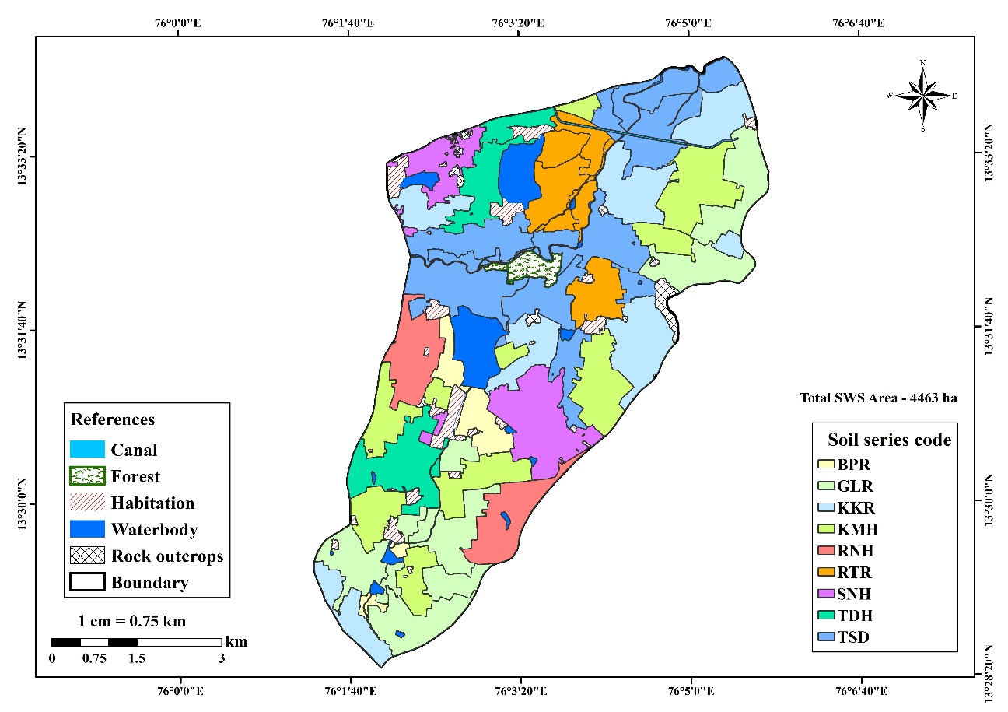
Fig. 2: Soil series map of Vitalapura sub-watershed

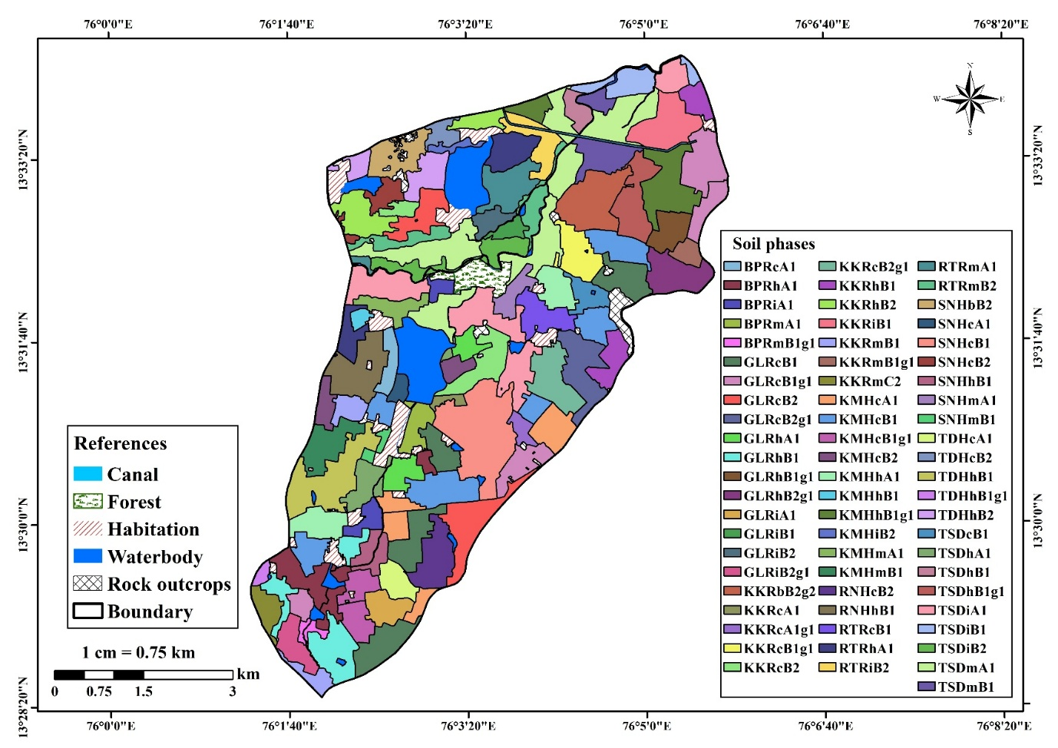
Fig. 3: Soil phase map of Vitalapura sub-watershed
Conclusion
The taxonomic characterization of soils in the Vitalapura sub-watershed provided a clear understanding of the pedogenic processes and soil diversity across the landscape. Based on detailed morphological, physical and chemical examinations, the soils were classified into two major orders—Alfisols and Inceptisols—reflecting the influence of climate, parent material, and landscape position. Further classification at the suborder, great group and subgroup levels revealed meaningful variation in diagnostic horizons, moisture regimes and soil development stages. All pedons belonged to the isohyperthermic temperature regime, consistent with the agro-climatic conditions of the region. The identification of nine soil series and their subdivision into 67 soil phases highlights the considerable spatial heterogeneity within the sub-watershed. These findings provide a valuable scientific foundation for land capability assessment, crop suitability planning and sustainable soil and watershed management. Overall, the study offers essential baseline information that can support effective resource utilization and long-term ecological stability in the Vitalapura sub-watershed.

Acknowledgements
This Study was part of the REWARD project (KSNUAHS Shivamogga) funded by the World Bank and Government of Karnataka and Centre of Excellence on Watershed Management, GKVK, Bangalore. The authors duly acknowledged the technical and financial support.

Disclaimer (Artificial intelligence)
Option 1:
Author(s) hereby declare that NO generative AI technologies such as Large Language Models (ChatGPT, COPILOT, etc) and text-to-image generators have been used during writing or editing of manuscripts.
Option 2:
Author(s) hereby declare that generative AI technologies such as Large Language Models, etc have been used during writing or editing of manuscripts. This explanation will include the name, version, model, and source of the generative AI technology and as well as all input prompts provided to the generative AI technology
Details of the AI usage are given below:
1.
2.
3.

V References
ANAND, S., 2021, Digital Land Resource Appraisal and Planning of Nagavangala micro-Watershed in Tarikere taluk, Chikkamagaluru district of Karnataka. M. Sc. (Agri.) Thesis, Univ. Agric. Horti. Sci., Shivamogga, Karnataka, India.
ARUNKUMAR, V., DHANASEKARAN, D., ANANTHI, K. AND VIJAYAKUMAR, M., 2024, Characterization and classifications of soils in an experimental farm in the Tiruvannamalai District, Tamil Nadu, India. Asian Res. J. Agric., 17(2): 242–248.
ARUNKUMAR, V., DHANASEKARAN, D., ANANTHI, K. AND VIJAYAKUMAR, M., 2024, Characterization and Classifications of Soils in an Experimental Farm in the Tiruvannamalai District, Tamil Nadu, India. Asian Res. J. Agric., 17(2): 242-248.
BADANA, S., 2024, Taxonomic studies on major soils in tekkali mandal of srikakulam district of Andhrapradesh. Ph.D. (Agri.) Thesis, Acharya NG Ranga Agricultural University.
BRADY, N. C. AND WEIL, R. R., 2017, The nature and properties of soils. 15th ed., Pearson.
BUOL, S. W., SOUTHARD, R. J., GRAHAM, R. C. AND McDANIEL, P. A., 2011, Soil genesis and classification. 6th ed., Wiley-Blackwell.
FAO, 2006, Guidelines for soil description. 4th ed., Food and Agriculture Organization of the United Nations.
HAVLIN, J. L., TISDALE, S. L., NELSON, W. L. AND BEATON, J. D., 2014, Soil fertility and fertilizers. 8th ed., Pearson.
JENNY, H., 1941, Factors of soil formation: A system of quantitative pedology. McGraw-Hill, New York.
LAL, R., 2004, Soil carbon sequestration impacts on global climate change and food security. Science, 304(5677): 1623–1627.
NBSS&LUP, 2011, Soils of Karnataka for optimising land use. National Bureau of Soil Survey and Land Use Planning, Nagpur.
RAVIKUMAR, D., 2020, Micro level land and water resource development plan for Koranahalli sub watershed in Tarikere taluk, Chikmagalur district using remote sensing and GIS techniques. Ph.D. (Agri.) Thesis, Kuvempu Univ., Shivamogga.
SEHGAL, J., 1996, Pedology: Concepts and applications. Kalyani Publishers, New Delhi.
SOIL SURVEY STAFF, 2014, Keys to soil taxonomy. 12th ed., USDA–NRCS.

