IoT and Edge Computing Integration for Intelligent Fault Diagnosis and Self-Healing in 132 kV Transmission Networks

.
ABSTRACT

Traditional SCADA and relay-based protection, with typical latencies of 2–10 seconds, are inadequate for the resilience required in modern 132kV transmission networks. This paper reviews the integration of Internet of Things (IoT) sensor fabrics, including Phasor Measurement Units (PMUs) and distributed sensors, with a hierarchical Edge Computing infrastructure to enable autonomous fault diagnosis and self-healing. The authors analysed the deployment of computational intelligence across device, substation, and fog layers, emphasising how local processing mitigates cloud latency. The review examined optimised AI/ML models (such as wavelet-based Support Vector Machines and pruned 1D-CNNs) for real-time fault detection, classification, and location at the network edge. Furthermore, the study explored the role of IEC 61850 GOOSE protocols, with $<4 ms$ latency, in enabling closed-loop actuation for autonomous isolation. This synthesis demonstrates a viable architecture for sub-second self-healing. This paper's primary contribution is its holistic synthesis of these technologies into a single, cohesive framework, highlighting critical research challenges in cybersecurity, interoperability, and data integrity that must be addressed for industrial applications.

Keywords: Edge Intelligence, Fault Detection Isolation and Restoration (FDIR), Phasor Measurement Unit (PMU), SCADA, Wavelet Transform, Convolutional Neural Networks (CNN).

1. INTRODUCTION

The electrical power transmission network must be reliable and robust for the economy to remain stable and secure. 132 kV transmission systems serve as a critical backbone between extra-high-voltage corridors and sub-transmission networks. A single 132 kV line or substation outage can cascade into widespread blackouts and significant socio-economic losses (Zhou et al., 2023). Historically, Supervisory Control and Data Acquisition (SCADA) systems and electromechanical or solid-state protective relays were the foundation for grid operation and fault management. Although effective for decades, these systems exhibit limitations, such as slow scanning rates (typically 2–10 seconds) and inadequate temporal granularity, making them unsuitable for real-time grid resilience and situational awareness (Ghosh & Dey, 2022). Traditional relay-based protection also lacks the adaptive and system-wide intelligence necessary for coordinated self-healing.

The modern paradigm of power system control is shifting from reactive control to proactive resilience. The concept of a self-healing grid—a grid capable of autonomously detecting, analysing, isolating, and restoring service following a disturbance—has evolved into a crucial pillar of smart grid research and implementation (Liu et al., 2024). Achieving this vision, however, is hindered by two persistent technical constraints: the scarcity of high-fidelity, time-synchronised edge data and the latency inherent in centralised, cloud-based analytics.

Recent advancements in the Internet of Things (IoT) and Edge Computing provide transformative solutions. IoT-enabled sensor fabrics, including Phasor Measurement Units (PMUs) and distributed fault indicators, generate fine-grained, time-aligned measurements that vastly outperform legacy SCADA telemetry (Kumar et al., 2023). Yet transferring these dense data streams to the cloud reintroduces delay and bandwidth inefficiencies. Edge computing mitigates this by embedding computational intelligence near substations and feeders, enabling millisecond-level analytics and actuation. This architectural shift enables the deployment of intelligent fault-diagnosis models at the network edge, thereby achieving near-real-time self-healing behaviour (Zhang et al., 2024).

This review paper critically evaluated recent progress at the convergence of IoT and edge computing for 132 kV transmission systems. It explored how these technologies advance fault detection, classification, and localisation by decentralising intelligence from control centres to edge devices.

2. Background and the Evolution of Protection Schemes

The pursuit of grid reliability has been a core focus since the inception of power systems. To appreciate the transformative role of IoT and edge computing, it is necessary to understand the limitations of legacy fault-management architectures and their gradual evolution toward intelligent, autonomous protection frameworks.

2.1 Conventional Protection Systems in 132kV Networks

The first line of defence in transmission systems has traditionally been the protective relay infrastructure, dominated by impedance-based distance protection for 132 kV lines (Phadke & Thorp, 2017). These systems calculate apparent impedance from local voltage and current measurements to determine the proximity of faults. While highly effective for isolating faults on specific line segments, these systems possess inherent and significant constraints, such as (Sinha & Venkatesan, 2023):
- Localised Vision: Each relay has visibility only of the measurements at its own location. It cannot "see" the state of the entire network or dynamically adapt to changing system conditions, such as load flow variations or the injection of distributed generation.
- Fixed Logic: Their operation is based on pre-set, fixed logic (for example, Zone 1, Zone 2, and Zone 3 timing). They are not designed to diagnose the type of fault or make complex restoration decisions.
- Communication Dependence: Schemes like pilot-wire or transfer trip, which require communication between line ends for high-speed clearance of all faults, are expensive to install and maintain and can be a single point of failure.

Conventional relays, whether electromechanical, solid-state, or early numerical, are inherently localised, unable to assess the system-wide state or dynamically adapt to changing grid topologies. Their fixed operating logic (like the predefined zone settings) restricts adaptive response under high-penetration distributed generation or fluctuating load conditions. Communication-assisted schemes, such as pilot-wire or permissive trip, although providing faster fault clearance, incur high deployment costs and are susceptible to single-point communication failures (Youssef et al., 2022).

Supervisory Control and Data Acquisition (SCADA) systems, which operate at the supervisory layer, have historically augmented relays by enabling centralised monitoring and control (Northcote-Green & Wilson, 2006). However, traditional SCADA platforms suffer from latency, typically on the order of seconds, and are unsuitable for real-time decision-making in high-voltage environments (Ding et al., 2023). Consequently, they are used mainly for post-event analysis rather than active protection. Fig. 1 depicts a schematic diagram of zone-based power system protection.

2.2 The Shift Towards Automation and Self-Healing

The limitations of centralised, human-in-the-loop systems motivated the development of automation frameworks such as Distribution Automation (DA) and Fault Location, Isolation, and Service Restoration (FLISR). These systems coordinate automated switches and reclosers to restore service after disturbances using data analytics and rule-based logic (Mohan et al., 2022; Short, 2013). While FLISR is well-established in medium-voltage distribution, its application at the transmission level remains constrained by latency and a reliance on centralised computation. At 132 kV, fault clearance must occur within cycles rather than seconds. Hence, centralised algorithms, even when combined with SCADA, are inadequate for stability-critical transmission operations. Recent studies emphasise decentralised automation using digital substations and intelligent electronic devices (IEDs) interconnected through high-speed protocols, such as IEC 61850 Sampled Values and GOOSE messaging (Huang et al., 2024). These frameworks form the foundation for near-real-time decision loops essential to self-healing. The architecture of the healing smart grid is illustrated in Fig. 2.

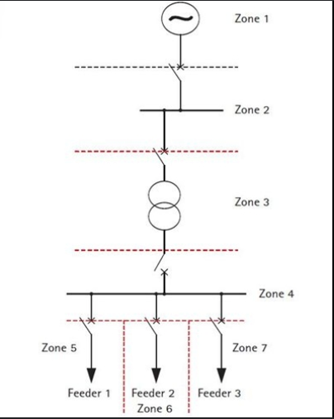

Fig. 1. Zone-based power system protection schematic (Jayaprakas et al., 2016)
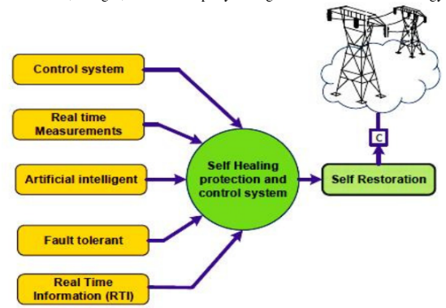

Fig. 2. Self-healing smart grid architecture (Kumar et al., 2021)

2.3 The Data Revolution: Phasor Measurement Units (PMUs)

The advent of Wide-Area Measurement Systems (WAMS) based on Phasor Measurement Units (PMUs) represented a paradigm shift toward synchronised, high-resolution grid observability. PMUs provide time-aligned voltage and current phasors at rates of 30–240 samples per second, synchronised to microsecond accuracy via GPS or IEEE 1588 Precision Time Protocol (Nayak et al., 2023). A characteristic PMU schematic is presented in Fig. 3.

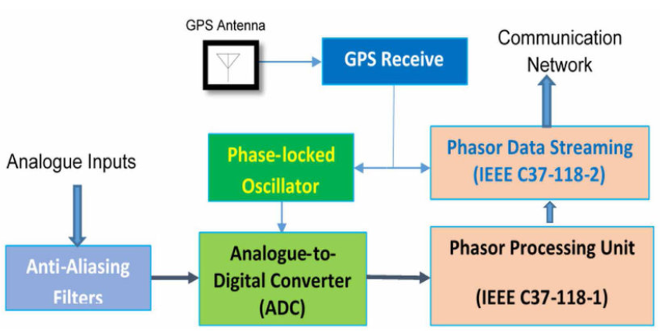
Fig. 3. Phasor measurement unit (Gharavi & Hu, 2017)

Modern WAMS enables system-wide monitoring, oscillation detection, and fault localisation. For instance, real-time phase-angle measurements between dispersed PMUs can reveal stress and incipient instability before line tripping (Liu et al., 2023). Moreover, double-ended PMU-based fault location algorithms now achieve sub-kilometre accuracy without the need for source impedance estimation.

However, conventional WAMS architectures rely on centralised Phasor Data Concentrators (PDCs) for data aggregation and analysis, creating latency and bandwidth bottlenecks that hinder time-critical automation. Contemporary research, therefore, advocates decentralised intelligence, deploying lightweight analytics at the edge to complement centralised situational awareness (Qin et al., 2024). This decentralised processing is precisely where IoT-integrated edge computing bridges the gap, moving the grid from automated to truly autonomous operation.

3. The IoT Ecosystem for Transmission System Monitoring

The transformation of the 132kV network into an intelligent, responsive entity is fundamentally predicated on the collection and analysis of data. The IoT paradigm in power systems (as depicted in Fig. 4) provides the sensory nervous system for this digital transformation, enabling a density and diversity of measurement previously unattainable. This section reviews the core sensing technologies, communication architectures, and data challenges constituting the IoT ecosystem for high-voltage transmission monitoring.

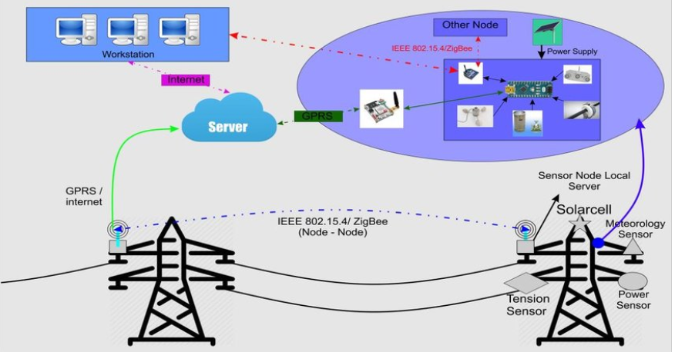

Fig. 4. IoT-based transmission system (Hidayatullah et al., 2018)

3.1 Advanced Sensing Technologies

The cornerstone of any diagnostic system is its ability to perceive the state of the system accurately. While conventional current transformers (CTs) and voltage transformers (VTs) remain essential, the IoT ecosystem incorporates more advanced and distributed sensors:
- Phasor Measurement Units (PMUs) and Micro-PMUs (μPMUs): As introduced in Section 2, PMUs are the gold standard for time-synchronised, high-resolution phasor measurements of voltage and current. Their deployment at 132kV substations provides the critical data for wide-area observability and precise fault analysis (Bolognani & Zampieri, 2016). μPMUs, with even higher accuracy for distribution-level applications, are being used on the lower-voltage sides of 132/33kV substations, providing enhanced visibility for downstream network management.
- Non-Conventional Sensors: The IoT paradigm extends beyond electrical parameters. A suite of other sensors is critical for comprehensive condition monitoring and incipient fault detection, which is a proactive form of diagnosis:
  - Partial Discharge (PD) Sensors: Acoustic, ultra-high frequency (UHF), and TEV (Transient Earth Voltage) sensors detect PD activity within transformers, switchgear, and cable terminations, a key indicator of insulation degradation (Stone et al., 2014).
  - Dissolved Gas Analysis (DGA) Monitors: Online DGA sensors provide continuous analysis of gases dissolved in transformer oil, enabling real-time assessment of thermal and electrical faults within the transformer, rather than relying on periodic manual sampling.
  - Line Monitoring Sensors: These include optical-based Dynamic Line Rating (DLR) sensors that measure conductor temperature and sag, as well as Lidar systems for monitoring vegetation encroachment, which helps prevent faults before they occur.

3.2 Communication Architectures and Protocols

Fig. 5 depicts a secure communication protocol in a smart grid. The harsh electromagnetic environment of a 132kV substation imposes rigorous requirements on communication networks. A hybrid approach is often necessary:

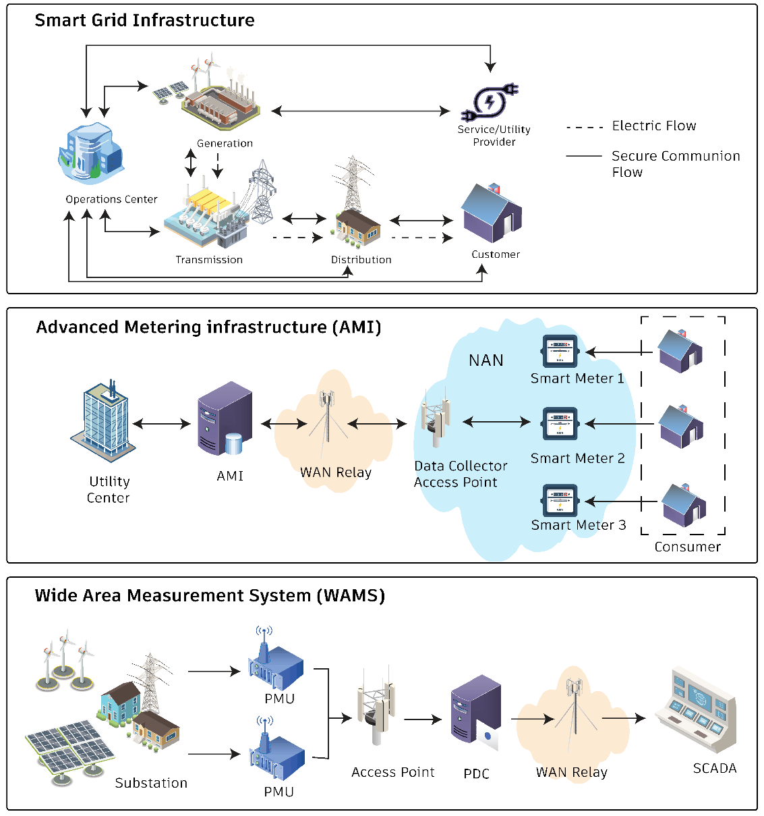

Fig. 5. Secure communication between nodes in smart grid (Hafeez et al., 2025)
- Local Area Networks (Within Substation): The IEC 61850 standard has become the seminal framework for substation automation. Its Sampled Values (SV) protocol is used for streaming high-speed digitised CT/VT data, and the Generic Object-Oriented Substation Event (GOOSE) protocol provides peer-to-peer messaging for critical protection and control signals with ultra-low latency (<4 ms) (Brand et al., 2017). This forms the high-speed, reliable backbone for intra-substation data exchange.
- Wide Area Networks (Back to Control Centre/Edge Cloud): Various protocols transport aggregated data from the substation gateway to wider networks. Fibre-optic cables, often embedded in the ground wire (OPGW), provide the highest bandwidth and immunity to EMI. Where fibre is unavailable, licensed spectrum wireless (such as microwave links) or cellular technologies, like 4G LTE and emerging 5G with its enhanced Mobile Broadband (eMBB) and Ultra-Reliable Low-Latency Communication (URLLC) capabilities, are viable options for less time-critical data (Gungor et al., 2013).

Recent integration efforts focus on creating hybrid communication architectures to guarantee data integrity and low latency. This involves dynamically routing IoT sensor data over a combination of OPGW, 5G URLLC (Ultra-Reliable Low-Latency Communication), and RF-Mesh networks (Chamran et al., 2022). The use of 5G, in particular, is emerging as a critical technology for deploying sensors in geographically challenging or remote transmission corridors where fibre is not viable, with recent studies validating its latency and reliability for protection and control applications (Hovila et al., 2019). This hybrid approach ensures that time-critical data (like PMU streams) and less-critical data (like DLR sensor readings) can coexist efficiently on the same network infrastructure.

3.3 The Data Deluge Challenge

The proliferation of IoT sensors creates a fundamental challenge: a massive, continuous stream of heterogeneous data. A single PMU can generate dozens of data points per cycle. When combined with data from other sensors, the volume from a single substation can quickly overwhelm traditional central processing systems, resulting in bottlenecks in communication links and control centre servers. This data deluge is the primary reason why a purely cloud-centric model is infeasible for real-time self-healing applications. It necessitates a paradigm of processing data closer to its source—filtering, compressing, and analysing it locally to extract actionable intelligence before transmitting only essential information upstream. This requirement directly motivates the Edge Computing layer, which is discussed in the next section.

4. Edge Computing and AI: The Intelligent Core for Real-Time Autonomy

The deluge of data from the IoT sensor layer, if sent to a centralised cloud, would overwhelm communication networks and introduce crippling latency. Edge Computing directly addresses this by embedding computational resources physically close to the data sources (at substations or even directly on transmission line towers). This architectural shift is not merely a logistical change but the essential enabler for the millisecond-level decision-making required for true self-healing. This section reviews the architecture of edge intelligence and the AI algorithms that empower it. Fig. 6 shows a distinctive edge computing architecture.

4.1 The Edge Computing Architecture for Transmission Networks

This architectural shift is being practically realised through advancements in modular software deployment on edge devices. The application of lightweight containerisation technologies, such as Docker and Kubernetes adapted for the edge (e.g., KubeEdge), is a key area of recent work (Kim & Kim, 2023). This approach allows for the modular deployment and independent updating of specific AI-driven microservices, such as a 'fault classification' module or a 'cybersecurity' module, on substation edge gateways. This modular, software-defined architecture is a critical enabler for managing the complex software lifecycle of edge intelligence in a high-availability utility environment (Yildirim et al., 2025). A hierarchical deployment model is most effective for managing the computational load and response times across a 132kV network:
- Device Edge (Line-mounted): The most granular level involves intelligent electronic devices (IEDs) or ruggedised computing modules installed directly on transmission infrastructure. Their role is to execute ultra-fast, pre-programmed functions (such as a travelling wave fault detection algorithm) and preprocess raw sensor data (compressing waveform data, for example) before sending it upstream.
- Substation Edge (Local): The substation gateway is a powerful local aggregation and processing node. It receives data from all line-mounted devices, including CTs/VTs and other sensors, within the substation. Here, more complex analytics can be performed, such as correlating data from multiple points to precisely classify and locate a fault, or running a local state estimator. This layer is critical for making autonomous isolation decisions that require a substation-wide view.
- Fog Node (Regional): A fog node serves multiple substations or regional control centres situated at a key substation or a regional control centre. It handles tasks that require a slightly broader perspective, such as coordinating the restoration path between two adjacent substations after an isolated fault, which may involve analysing the load flow on surrounding lines (Bonomi et al., 2012). This cloud-like layer has more computational power but remains geographically closer than a national control centre.

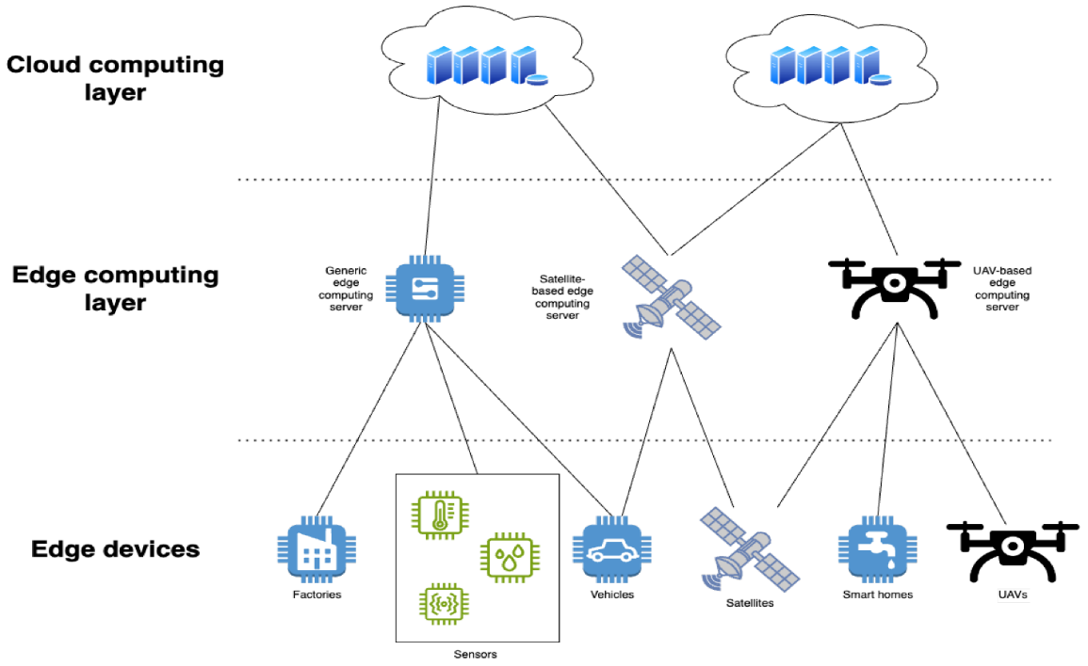
Fig. 6. Edge computing architecture (Grzesik & Mrozek, 2024)

A variant algorithm incorporating an edge computing setup in power transmission, known as the Short Supply Circuit Internet of Things (SSCIoT), is depicted in Fig. 7.

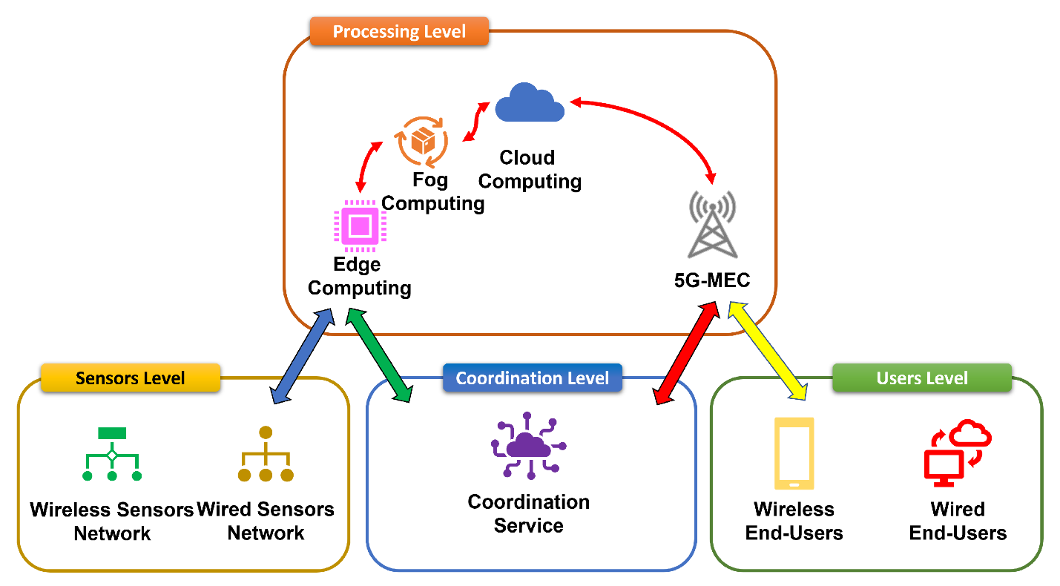

Fig. 7. Short Supply Circuit Internet of Things (Debauche et al., 2022)

4.2 AI and Machine Learning for Edge-Based Fault Diagnosis

Lightweight and efficient AI/ML models trained for specific diagnostic tasks provide the real intelligence at the edge. The primary challenge is optimising the model to run on hardware with constrained processing, memory, and power.
- Feature Extraction: Raw waveform data is processed to extract discriminative features. The Wavelet Transform (WT) is particularly effective for this purpose, as it can localise transient features in both the time and frequency domains, making it ideal for detecting and characterising fault transients (Silva et al., 2016).
- Lightweight Machine Learning Models: For tasks such as fault classification (e.g., Phase-Ground, Phase-Phase) and location, traditional ML models often strike the best balance between accuracy and computational efficiency for edge deployment. Models like Support Vector Machines (SVM) and Random Forests, trained on historical fault data and extracted features (e.g., wavelet coefficients, harmonic components), can achieve high accuracy with minimal inference time.
- Deep Learning on the Edge: While more computationally intensive, deep learning models like 1D Convolutional Neural Networks (1D-CNNs) can automatically learn features from raw current/voltage signals, eliminating the need for manual feature extraction. Advances in model compression techniques, such as pruning, quantisation, and knowledge distillation, are making it increasingly feasible to deploy compact versions of these powerful models on edge hardware (Wang et al., 2020).

4.3 From Diagnosis to Action: Closing the Loop for Self-Healing

The output of these edge-resident AI models is not merely an alert; it is a validated, precise diagnosis that can directly trigger an action. The edge node can execute a predefined, validated action script upon confirming a fault. Crucially, this can be achieved by issuing commands through ultra-fast protocols, such as IEC 61850 GOOSE, to trip specific circuit breakers and isolate the faulted section (Feng et al., 2025).

5. Synthesis, Challenges, and Future Directions

Integrating IoT and Edge Computing represents a paradigm shift in managing 132kV transmission networks, moving from reactive, centralised protection to proactive, decentralised autonomy. This synthesis has demonstrated that the technological components for a self-healing grid (ubiquitous sensing, high-speed communication, distributed computation, and intelligent algorithms) are not merely conceptual but are actively being developed and deployed. The IoT layer provides the necessary high-resolution, time-synchronised data. In contrast, the Edge Computing layer furnishes the intelligence to process this data into actionable insights within the stringent timeframes required for stability. This final section consolidates the reviewed material, addresses the remaining significant challenges, and proposes critical avenues for future research.

5.1 Synthesis of a Cohesive Self-Healing Architecture

The reviewed literature touches on a hierarchical architecture for fault management:
- Perception (IoT Layer): A network of PMUs, fault indicators, and condition monitoring sensors captures the real-time state of the network.
- Processing (Edge Layer): Data is analysed locally at substation or device-level edge nodes using optimised AI/ML models for rapid fault diagnosis (detection, classification, and location).
- Action (Actuation Layer): Based on the edge-processed diagnosis, autonomous commands are executed via protocols like IEC 61850 GOOSE to isolate the faulted segment.
- Restoration (Coordination Layer): A slightly higher-level fog or edge node coordinates the reconfiguration of the network to restore power to unaffected sections via alternative pathways, all within a sub-minute timeframe.
This closed-loop process effectively creates a "digital immune system" for the grid, where localised intelligence allows it to respond to and recover from disturbances automatically.

5.2 Persistent Challenges and Barriers to Adoption

Despite the promising advancements, several formidable challenges impede widespread implementation:
- Cybersecurity: The expansion of the attack surface is the most critical risk. This has been consistently identified as the single greatest barrier to Industrial Internet of Things (IIoT) adoption in critical infrastructure, as it introduces a complex landscape of new threats and privacy concerns (Ţălu, 2025a). Every IoT sensor and edge node represents a potential entry point for malicious actors. A successful cyberattack could disable the self-healing system or, worse, force it to take destabilising actions. Developing robust, lightweight cryptographic solutions and intrusion detection systems that can run on resource-constrained edge devices is paramount (Wang, Lu, & Qu, 2018). To move beyond simply identifying threats, recent frameworks focus on implementing specific, auditable security specifications at the network edge. A primary requirement is the rigorous application of IEC 62351, which provides standards for securing power system protocols, such as IEC 61850 GOOSE and SV, using Transport Layer Security (TLS) and digital certificates (Rodriguez et al., 2021). However, traditional encryption introduces latency, which has led to research into optimised cryptographic hardware acceleration on edge devices. Furthermore, a 'Zero Trust Architecture' (ZTA) is being increasingly advocated for this new, decentralised IoT/edge model, moving away from a traditional 'perimeter' defence (NIST, 2024). In a ZTA, every device and data packet must be authenticated and authorised, mitigating lateral movement by an attacker. This is often implemented at the substation edge gateway, which acts as a 'Zero Trust Policy Enforcement Point,' inspecting and encrypting all traffic from IoT sensors before it traverses the wider network (Ajimatanrareje and Agbesi, 2025). Deploying lightweight, AI-based Intrusion Detection Systems (IDS) directly on edge nodes to monitor for anomalous communication patterns is also a key emerging specification (Qahtani, 2025).
- Interoperability and Standardisation: The ecosystem comprises devices and protocols from multiple vendors. A significant engineering challenge is ensuring seamless interoperability between legacy systems (like traditional relays), modern IEC 61850-based IEDs, and new IoT sensors. A lack of universal standards for edge computing platforms and API interfaces can lead to proprietary, siloed solutions.
- Data Management and Quality: The effectiveness of edge AI depends entirely on the quality of the data it receives. Noisy, missing, or corrupted sensor data can lead to incorrect diagnoses and catastrophic false operations. Robust data validation, cleansing, and fusion techniques must be integral to the edge processing pipeline.
- Validation and Testing: Deploying autonomous systems on critical infrastructure requires unparalleled reliability. Thoroughly testing and validating the performance of edge-based self-healing algorithms under a wide range of real-world fault and system conditions, possibly through large-scale digital twin simulations, is essential before live deployment.

5.3 Directions for Future Research

To overcome these challenges and advance the field, future research should focus on:
- Explainable AI (XAI) for Grid Operations: Moving beyond "black box" AI models to develop techniques that provide grid operators with transparent reasoning for the decisions made by edge algorithms. This is crucial for building trust in autonomous systems and for post-event analysis.
- Hybrid Cloud-Edge Architectures: Optimising the division of labour between edge nodes and the cloud. The edge would handle time-critical diagnostics and control, while the cloud performs long-term model retraining, fleet-wide performance analysis, and strategic planning using aggregated data. This hybrid model, however, requires securing both the edge and the cloud components; this includes applying ML algorithms to enhance the security of the cloud-based data repositories themselves, protecting them from anomalous access or data exfiltration (Ţălu, 2025b)
- Quantum-Resistant Cryptography: Preparing for future threats by developing and implementing cybersecurity protocols for IoT and edge devices that are secure against attacks from quantum computers. This is part of a necessary, forward-looking research direction to anticipate and mitigate a new generation of cyber-physical attacks that challenge our current cybersecurity concepts (Ţălu, 2025c).
- Scalability for Extra-High-Voltage (EHV) Networks: Another critical research avenue is the adaptation and scalability of this architecture for EHV networks, such as 220 kV and 400 kV systems. While the core principles of edge-based diagnosis remain valid, the challenges are amplified (Ifeanyi et al., 2025). EHV systems have far more stringent stability requirements, demanding even faster fault clearance times (often under $80 ms$) than 132 kV systems. This places extreme constraints on the total latency of the perceive-process-act loop (Wang et al., 2021). Furthermore, the sheer volume of data from a 220 kV switchyard's instrumentation, combined with the catastrophic economic and stability consequences of a false trip or a successful cyber-attack, necessitates a new level of algorithmic reliability and security hardening (Sun et al., 2016). Future work should focus on demonstrating the performance of this architecture in high-fidelity, real-time hardware-in-the-loop (HIL) simulations of 220 kV networks before pilot deployment.
- Standardisation Efforts: Active participation in international standards bodies (such as IEEE, IEC) to develop open standards and frameworks for edge computing in power systems, ensuring interoperability and reducing vendor lock-in.

6. Conclusion

The journey towards a fully self-healing 132kV transmission network is well underway. The convergence of IoT and Edge Computing has provided a viable architectural blueprint to address the latency and data volume limitations of traditional systems. This review has outlined how this synergy enables a new class of applications that can autonomously diagnose faults and restore service, vividly improving grid resilience and reliability. While significant technical and operational challenges remain, the trajectory is clear. The focus must now shift to hardening these systems against cyber threats, ensuring their interoperability and reliability, and fostering the collaborative research needed to turn the promise of the self-healing grid into a universal reality.

Competing interests

Authors have declared that no competing interests exist.

References

Ajimatanrareje, A., & Agbesi, J. (2025). AI-powered zero trust architectures for critical infrastructure protection: A comprehensive framework for next-generation cybersecurity. International Journal of Scientific Research and Modern Technology, 4, 40–56. https://doi.org/10.38124/ijsrmt.v4i9.792.
Al-Abadi, A., Jha, S. K., & Sharma, V. (2023).
Amin, M., & Stringer, J. (2008). The electric power grid: Today and tomorrow. MRS Bulletin, 33(4), 399–407.
Bie, Z., Zeng, P., & Fang, J. (2017). Power system reliability evaluation. Springer.
Bolognani, S., & Zampieri, S. (2016). A distributed control strategy for reactive power compensation in smart microgrids. IEEE Transactions on Automatic Control, 58(11), 2818-2833.
Bonomi, F., Milito, R., Zhu, J., & Addepalli, S. (2012). Fog computing and its role in the internet of things. In Proceedings of the first edition of the MCC workshop on Mobile cloud computing (pp. 13-16).
Borghetti, A., Nucci, C. A., Paolone, M., Ciappi, G., & Solari, A. (2017). Synchronised phasors monitoring during the islanding maneuver of an active distribution network. IEEE Transactions on Smart Grid, 2(1), 82-91.
Brand, K. P., Ostertag, M., & Braun, M. (2017). IEC 61850: Principles and applications. Siemens AG.
Chamran, M. K., Yau, K.-L. A., Ling, M. H., & Chong, Y.-W. (2022). A Hybrid Route Selection Scheme for 5G Network Scenarios: An Experimental Approach. Sensors, 22(16), 6021. https://doi.org/10.3390/s22166021
Debauche, O., Mahmoudi, S., & Guttadauria, A. (2022). A New Edge Computing Architecture for IoT and Multimedia Data Management. Information, 13(2), 89. https://doi.org/10.3390/info13020089
Ding, R., Gao, F., & Li, J. (2023). Latency-aware SCADA and PMU integration for real-time situational awareness in power transmission networks. IEEE Transactions on Smart Grid, 14(2), 1467–1478.
Feng, J., Yu, T., Zhang, K., & Cheng, L. (2025). Integration of Multi-Agent Systems and Artificial Intelligence in Self-Healing Subway Power Supply Systems: Advancements in Fault Diagnosis, Isolation, and Recovery. Processes, 13(4), 1144. https://doi.org/10.3390/pr13041144
Gharavi, Hamid & Hu, Bin. (2017). Synchrophasor Sensor Networks for Grid Communication and Protection. Proceedings of the IEEE. PP. 1-21. 10.1109/JPROC.2017.2696881.
Ghosh, A., & Dey, S. (2022). Review of SCADA system limitations and latency challenges for modern power networks. IEEE Access, 10, 42854–42868.
Grzesik, P., & Mrozek, D. (2024). Combining Machine Learning and Edge Computing: Opportunities, Challenges, Platforms, Frameworks, and Use Cases. Electronics, 13(3), 640. https://doi.org/10.3390/electronics13030640
Gungor, V. C., Sahin, D., Kocak, T., Ergut, S., Buccella, C., Cecati, C., & Hancke, G. P. (2013). A survey on smart grid potential applications and communication requirements. IEEE Transactions on Industrial Informatics, 9(1), 28-42.
Hafeez, M. A., Shakib, K. H., & Munir, A. (2025). A Secure and Scalable Authentication and Communication Protocol for Smart Grids. Journal of Cybersecurity and Privacy, 5(2), 11. https://doi.org/10.3390/jcp5020011
Hidayatullah, Nur & Kurniawan, A & Kalam, A. (2018). Power Transmission and Distribution Monitoring using Internet of Things (IoT) for Smart Grid. IOP Conference Series: Materials Science and Engineering. 384. 012039. 10.1088/1757-899X/384/1/012039.
Hovila P, Horsmanheimo S, Borenius S, Li Z, Uusitalo M, Kokkoniemi-Tarkkanen H, Syväluoma P. 5G networks enabling new smart grid protection solutions. In: 25th International Conference on Electricity Distribution (CIRED 2019); 2019 Jun 3–6; Madrid, Spain.
Huang, Y., Wang, H., & Lin, X. (2024). Digital substations and IEC 61850-based coordination for self-healing transmission protection. Electric Power Systems Research, 234, 110809.
Ifeanyi, C., Linus, C., & Onyegbadue, I. (2025). Improving power stability in extra high voltage transmission lines protection using hybrid technology. International Journal of Computer Applications, 187, 28–47. https://doi.org/10.5120/ijca2025925369.
J, Jayaprakash & Angelin, Mercy & R, Jothi & J, Juanola. (2016). Planning and Coordination of Relay in Distribution System using ETAP. Pakistan Journal of Biotechnology. 13. 252-256.
Kim, S.-H., & Kim, T. (2023). Local scheduling in KubeEdge-based edge computing environment. Sensors, 23, 1522. https://doi.org/10.3390/s230315
Kumar, Sarath & Srinivasan, Mohanambigai & Alexander, Dr.S.Albert & Ravi, Samikannu & Narasimha Rao, Dasari & Antony Raj, Raymon. (2021). A Technical Review on Self-Healing Control Strategy for Smart Grid Power Systems. IOP Conference Series: Materials Science and Engineering. 1055. 012153. 10.1088/1757-899X/1055/1/012153.
Kumar, V., Reddy, P. S., & Basha, M. S. (2023). Edge-enabled IoT framework for adaptive fault detection in smart transmission networks. IEEE Internet of Things Journal, 10(8), 7143–7156.
Liu, J., Wu, Y., Zhao, H., & Li, Z. (2024). Self-healing grid architectures for high-voltage transmission networks using AI and edge computing. Electric Power Systems Research, 232, 110731.
Liu, Z., Zhao, J., & Chen, Q. (2023). Phasor measurement-based fault location and resilience assessment in high-voltage transmission systems. IEEE Transactions on Power Delivery, 38(1), 315–326.
Mohan, A., Rahman, M. S., & Patel, D. (2022). AI-driven FLISR for adaptive distribution automation in smart grids. IEEE Access, 10, 105832–105845.
Nayak, P., Das, S., & Gupta, A. (2023). Advancements in wide-area measurement systems using next-generation PMUs and precision timing. IET Generation, Transmission & Distribution, 17(4), 849–861.
NIST. (2024). Implementing Zero Trust Architectures (NIST Special Publication 800-207B). National Institute of Standards and Technology.
Northcote-Green, J., & Wilson, R. (2006). Control and automation of electrical power distribution systems. CRC Press.
Phadke, A. G., & Thorp, J. S. (2017). Synchronised phasor measurements and their applications (Vol. 1). Springer.
Qahtani, N. (2025). Lightweight IDS for resource-constrained IoT devices using artificial neural networks.
Qin, L., Zhang, W., & Gao, T. (2024). Edge-enabled WAMS for low-latency event detection in transmission grids. IEEE Internet of Things Journal, 11(9), 15476–15488.
Rodriguez, M., Lázaro, J., Bidarte, U., Jimenez, J., & Astarloa, A. (2021). A fixed-latency architecture to secure GOOSE and sampled value messages in substation systems. IEEE Access, PP, 1–1. https://doi.org/10.1109/ACCESS.2021.3069088.
Shi, W., Cao, J., Zhang, Q., Li, Y., & Xu, L. (2016). Edge computing: Vision and challenges. IEEE Internet of Things Journal, 3(5), 637-646.
Short, T. A. (2013). Electric power distribution handbook. CRC press.
Silva, K. M., Souza, B. A., & Brito, N. S. D. (2016). Fault detection and classification in transmission lines based on wavelet transform and ANN. IEEE Transactions on Power Delivery, 31(1), 62-70.
Sinha, A., & Venkatesan, R. (2023). Modern relay coordination and distance protection challenges in hybrid AC-DC transmission systems. International Journal of Electrical Power & Energy Systems, 150, 109076.
Stone, G. C., Boulter, E. A., Culbert, I., & Dhirani, H. (2014). Electrical insulation for rotating machines: design, evaluation, aging, testing, and repair (Vol. 90). John Wiley & Sons.
Sun, C.-C., Liu, C.-C., & Xie, J. (2016). Cyber-Physical System Security of a Power Grid: State-of-the-Art. Electronics, 5(3), 40. https://doi.org/10.3390/electronics5030040
Wang, K., Lu, T., & Qu, Z. (2018). Cybersecurity in smart grids: A review of threats, challenges, and solutions. IEEE Transactions on Industrial Informatics, 14(8), 3601-3611.
Ţălu, M. (2025a. Security and privacy in the IIoT: threats, possible security countermeasures, and future challenges. Computing & AI Connect, 2, 1–12. https://doi.org/10.69709/CAIC.2025.139199
Ţălu, M. (2025b. Exploring machine learning algorithms to enhance cloud computing security. Digital Technologies Research and Applications, 4(2), 33–47. https://doi.org/10.54963/dtra.v4i2.1272
Ţălu, M. (2025c. Cyberattacks and cybersecurity: Concepts, current challenges, and future research directions. Digital Technologies Research and Applications, 4(1), 44–60. https://doi.org/10.54963/dtra.v4i1.919
Wang, M.-H., Lu, S., & Liao, R.-M. (2021). Fault diagnosis for power cables based on convolutional neural network with chaotic system and discrete wavelet transform. IEEE Transactions on Power Delivery, PP, 1–1. https://doi.org/10.1109/TPWRD.2021.3065342.
Wang, X., Li, Y., & Wang, X. (2020). A compressed deep learning model for fault diagnosis of power systems. IEEE Transactions on Instrumentation and Measurement, 69(10), 7942-7952.
Yıldırım, F., Yalman, Y., Bayindir, K., & Terciyanlı, E. (2025). Comprehensive review of edge computing for power systems: State of the art, architecture, and applications. Applied Sciences, 15, 4592. https://doi.org/10.3390/app15084592.
Youssef, A., Nassar, M., & Saleh, A. (2022). High-speed communication-assisted protection for 110–220 kV lines in IEC 61850 environments. Energies, 15(21), 7874.
Zhang, X., Huang, C., & Chen, B. (2024). Low-latency edge intelligence for autonomous fault diagnosis in power transmission systems. IEEE Transactions on Smart Grid, 15(3), 2842–2854.
Zhou, Q., Wang, T., & Yan, J. (2023). Resilience evaluation of 110–220 kV transmission networks under cascading failure scenarios. International Journal of Electrical Power & Energy Systems, 151, 109067.

