Original Research Article

Factors affecting ice fraction during freezing of aqua glycol salt solution

ABSTRACT

In this study, the primary objective of formulating aqua–glycol–salt solutions (AGSS) is to develop an effective thermal energy storage material (TESM). The ice fraction plays an important role in TESM as it directly reflects the amount of latent cooling energy stored within the material. The ice fraction in AGSS at different PG and NaCl concentration was determined as a function of freezing time and statistically analyzed using a two way ANOVA. The maximum concentration (9.6 °Bx) of AGSSs after freezing of 180 min was observed in 6% PG with 5% NaCl and minimum concentration (0.6°Bx) in 2% PG with 0% NaCl AGSS. The maximum ice fraction (0.79) of AGSS was observed in the formulation containing 2% Propylene glycol (PG) with 0% NaCl. While the minimum ice fraction (0.25) was obtained in the 6% PG with 5% NaCl formulation after 180 minutes of freezing. The results highlight the influence of component concentration and freezing time on ice formation. As the concentration of PG and NaCl in AGSS is increased, ice fraction decreased significantly because of the freezing point depression. This study provides valuable insights for deciding the concentrations of PG and NaCl to achieve desired thermal performance of TESM in various cooling applications such as industrial refrigeration system, food preservation and thermal energy storage systems.

Keywords: Cooling, energy storage, formulation, ice fraction, propylene glycol, solute concentration

1. INTRODUCTION

Pure water exhibits a well-defined freezing and melting point at 0 °C under standard atmospheric pressure, because of that it is not suitable for subzero cooling application [1]. Although water possesses a high latent heat of fusion (334 kJ/kg), inexpensive, easily available and non-toxic, it is not commonly used alone as phase change material (PCM) due to some practical and thermophysical limitations [2]. A suitable PCM require minimal degree of subcooling, fast ice crystal nucleation and low volumetric expansion during freezing; these characteristics makes water a less suitable PCM for cold thermal energy storage application [3]. However, addition of antifreeze chemicals disrupts the hydrogen-bonding network of water molecules, lowering chemical potential of liquid phase and resulting in freezing point depression [4]. Additionally, antifreeze chemical also makes it flexible for the customizable freezing and melting points suited to a targeted cooling application.

When selecting an antifreeze chemical, it is important to consider its heat transfer properties, physical properties like viscosity and density. It should require low pumping power to ensure a small pressure drop, which helps to maintain low energy consumption. To keep maintenance costs low, it's necessary to pay attention to toxicity, material compatibility, corrosion, and handling security of antifreeze chemical [5]. To make operational cost low, it should have low freezing point, high specific heat, and cold thermal energy storage during phase change [6]. However, there is no ideal antifreeze chemical that consist all desirable thermo physical characteristics and suits all applications. Thus, it's essential to identify the most crucial parameter for the particular application and choose the most preferred antifreeze chemical for that particular case [7].

Glycol and salt are often used as antifreeze chemicals in sub-zero temperatures application because of their ability to significantly decrease the freezing point of water while maintaining desirable thermophysical and chemical stability [8]. Glycols such as ethylene glycol (EG) and Propylene glycol (PG) are widely act as antifreeze agents owing to their high boiling points, low freezing point, low volatility,and chemical inertness, compatibility with water, metals and polymers.Instead of EG, a non-toxic food-grade PG is widely suitable in food cooling application [9]. Although PG has lower specific heat and latent heat than water solvent, it can modify the thermophysical properties of water by reducing its degree of sub-cooling and freezing point.The freezing point depression of PG is also comparatively higher than many antifreeze chemicals. By using 60% (vol/vol) PG-water solution, very low freezing point of -48 °C can be achieved [10].

Mixing of inorganic salts such as calcium chloride (CaCl2), Sodium chloride (NaCl), or potassium chloride (KCl) helps to modify the thermophysical and colligative properties of the base solution. Such additives provide additional control over freezing characteristics.Salts dissociate into ions that interfere with ice crystal nucleation and growth, delaying the onset of solidification [11].

Although the freezing properties of binary systems (e.g., water–glycol or water–salt) have been studied and relatively well understood, research on ternary mixtures remains comparatively limited [12,13]. Empirical correlations derived for binary solutions fail to accurately describe ternary mixture due to synergistic effects between solutes. Ternary mixtures of water–glycol–salt combine the advantages of both solute types, offering greater control over freezing and melting behavior compared to binary mixtures [14]. Therefore multi-component solutions are increasingly being investigated for use in sustainable refrigeration systems, cryogenic preservation, antifreeze formulation, subzero cooling systems and energy-efficient cold storage applications [15, 16].

Shahbaz et al. [17] studied the eutectic properties of choline chloride (ChCl) and ethylene glycol (EG) mixtures, showing that interactions at the molecular level between hydroxyl groups and chloride ions lead to a synergistic but nonlinear decrease in freezing point. Zarghampour et al. [18] investigated aqueous mixtures of choline chloride (ChCl) and PG, demonstrating that both ionic and hydrogen-bonding chemical interactions play a crucial role in determining density and volumetric thermal expansion over a wide temperature range. Zhou et al. [19] and Mohammed et al. [20] highlighted that ionic strength and molecular size of solutes significantly affect the local structuring of water and formation of ice nuclei during freezing of ternary mixture.

Ternary aqua glycol salt mixtures can be used as cooling medium where low operating temperatures without freezing is required and at the same time it can be also used as thermal energy storage material (TESM) [21]. Moreover, to take benefits of synergistic effect of salt and glycol, there is a need to investigate ice fraction during freezing of glycol and salt aqueous solution. Therefore, in the present research ice fraction formation during freezing was investigated. Understanding the freezing mechanisms of non-ideal solutionis essential for optimizing their formulation, ensuring reliable low-temperature operation, and predicting their cooling performance under dynamic conditions.

2. material and methods

2.1 Formulation of aqua glycol salt solution (AGSS)
The primary purpose of formulation of AGSS is to act as a thermal energy storage material (TESM). The most common base chemicals to prepare cooling medium are aqua-glycol and aqua-salt solution [22, 23]. Therefore, in the present study, PG was selected as a base solution, and NaCl was used to get similar freezing properties while substituting PG (Table 1). Therefore, AGSS was prepared with Propylene glycol (PG), Sodium chloride (NaCl), and multistage filtered reverse osmosis (RO) water. The Propylene glycol (PG) aqueous solutions were prepared and mixed based on volume ratios rather than weight ratios. All sample preparations were carried out at room temperature, and the NaCl mass was measured using an analytical balance (Model: AUX220). In order to formulate different AGSSs, different concentration of PG (2, 4 and 6%) and NaCl (0, 1, 2, 3, 4, and 5%) were mixed in RO water and in this way total 18 AGSSs were formulated. All trials for each experimental condition and measured property were conducted in triplicate. A 100 mL sample formulation was prepared for each set of experiment.

Table 1: Properties of Propylene glycol (PG) and Sodium chloride (NaCl)
Properties | Propylene Glycol | Sodium chloride
Chemical formula | C3H8O2 | NaCl
Molecular Weight | 76.10 | 58.44
Assay (GC) min | 99.5% | 98%
Weight per ml | 1.035-1.037g | 2.17g
Refractive index(20°C) | 1.432-1.433 | 1.54

2.2 Freezing process of different AGSS
The experimental setup comprised of sampling bottle, PT-100 temperature sensors, data logger, temperature controller, and deep freezer. Different AGSSs of 100 ml were filled in different sampling bottle and subjected to the identical chilling conditions (-18 °C) inside the deep freezein order to conduct a comparative study (Fig. 1 & 2). The sampling bottle was designed to accommodate a PT-100 temperature sensor, which was connected to a multichannel temperature data logger. The temperature of the aqua–glycol–salt solutions (AGSSs) during freezing was measured and continuously recorded at 1-minute intervals using the PT-100 sensors and data logger. A temperature controller was employed to maintain the deep freezer temperature at –15 °C throughout the experiment. When the temperature exceeded –15 °C, the cooling system was automatically switched off through a temperature controller (Model: Selec TC-513) and three pole power contactor (Rating: 230V/16 A). Temperatures versus time plots were generated for each AGSS formulation containing different concentrations of Propylene glycol (PG) and Sodium chloride (NaCl).
PT-100 Temperature sensor

Data Logger

Sampling bottle
Deep fridge

Fig. 1: Schematic of experimental setup for analyzing Freezing process of different AGSS

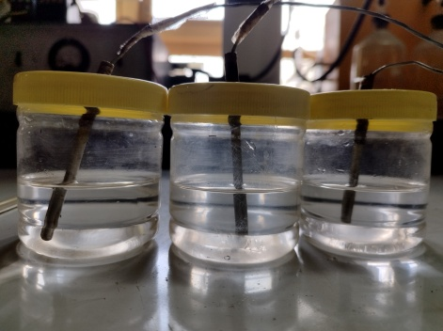 | 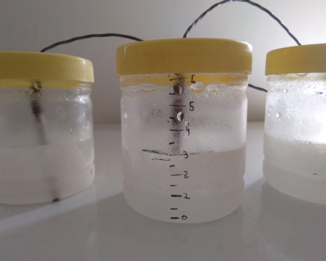
Fig. 2: AGSSs before freezing | Fig. 3: AGSSs after freezing

2.3 Melting characteristicsof different AGSS
Once freezing was complete after attaining the set point temperature of –15 °C the entire sampling bottles filled with the AGSSs kept in ambient condition (25 ± 2 °C). Temperature of AGSS during melting was continuously measured and recorded with the help of PT-100 temperature sensors and data logger. Temperature versus time plots was prepared for each AGSS at different PG and NaCl concentrations.

2.4 Concentration of AGSS during freezing
A refractometer (Model: Erma, range: 0–32%) was used to determine the concentration of aqua–glycol–salt solutions (AGSS) in terms of degree Brix (°Bx) at 30-minute intervals during the freezing process. The concentration of AGSS varied with freezing time. As the ice fraction increased, the concentrations of Propylene glycol (PG) and Sodium chloride (NaCl) in the unfrozen liquid phase increased continuously with time due to progressive ice formation and solute exclusion.

2.5 Ice fractionof AGSS during freezing
Ice fraction of AGSSs during freezing was determined based on the concentration of PG and NaCl in AGSSs. Ice fraction (Ci) of AGSSs (kg ice/ kg total solution) during freezing was calculated from the mathematical equation [7].
$C_{i}=\frac{C_{cf\left(T\right)}-C_{A{(T}_{0})}}{C_{cf(T)}}$ (1)
Where, C_{A(T0)} is the initial additive concentration (kg additive/kg total), giving the solution a freezing point, and C_{cf(T)} is the concentration of unfrozen solution after freezing.

Initial additive concentration, C_{A(T0)} (kg additive/kg total) remains constant for each AGSS and C_{cf(T)} is the concentration of unfrozen solution after each 30 min time interval during freezing was checked using refractometer (Model: Erma, range: 0–32%).

2.6 Statistical Analysis
Three replicates of each dataset were used to calculate the average value of measured parameter, and all parameters were statistically analyzed using the SPSS software. A two-way analysis of variance (ANOVA) was performed on the experimental data at a 95% confidence level (P < 0.05).

3. results and discussion
3.1 Freezing process of different AGSS
Temperature (°C) versus time (min) cooling plots of AGSS formulated using different concentrations of PG (2, 4, and 6%) and NaCl (0, 1, 2, 3, 4, and 5%) are shown in Fig. 4. The freezing point depression increased significantly (P= .05) with increasing concentrations of Propylene glycol (PG) and Sodium chloride (NaCl) in the AGSS formulations.The temperature of the AGSSs decreased rapidly in the initial 60 minutes of freezing, indicated by the sharp decline in the cooling curves. Subsequently, the curves exhibited a less rapid decline, and a notable variance in temperature reduction was noted during freezing as the PG and NaCl concentration increased in unfrozen solution. All AGSSs noted a sudden rise in temperature before the start of freezing, indicating the occurrence of subcooling (Fig. 4).The temperature profile plots displayed a notable variation in the phase transition, which may be linked to the freezing point depression (FPD) of various AGSS formulations. The temperature of AGSSs drops below 0 °C without solidifying because antifreeze components prevent crystallization of water molecules. The progressive concentration of PG and NaCl in the unfrozen solution during freezing process leads to further drop in the freezing point. Therefore freezing of AGSSs did not occur at a consistent temperature but within a temperature range, which is similar to the findings of previous experiment [23].

The lowest temperature observed on a cooling curve represents the nucleation point at which ice crystals first begin to form. This stage is followed by a slight temperature increase due to release of latent heat as the solution undergoes a phase change. The temperature attained after this rise is referred to freezing point, which corresponds to growth of ice crystal. The difference between the freezing point and the lowest temperature on the curve is called the degree of subcooling. The cooling curve of AGSSs at various NaCl concentrations (ranging from 0 to 5%) produced clear differences in the degree of subcooling and freezing temperature ranges. Eutectic salt-water mixtures often exhibit subcooling phenomena, impeding rapid solidification when cooled below the freezing point. At a 5% NaCl concentration, the freezing process was sluggish and lasted longer than at lower NaCl concentrations in AGSSs, potentially because of increased latent heat storage and depression of the freezing point [25]. The cooling curve’s slope of different AGSSs might be due to the ongoing rise in the concentration of NaCl and PG in unfrozen solution, as the RO water froze out of the AGSS. This leads to gradual freezing point depression, aligning with the result of previous study [26]. As the NaCl concentration increased from 0 to 5% (by weight), freezing point decreased to 2.5 ± 0.5 °C; similarly, as the PG concentration increased from 0 to 6% (by volume), freezing point decreased to 2.7 ± 0.2 °C [27].
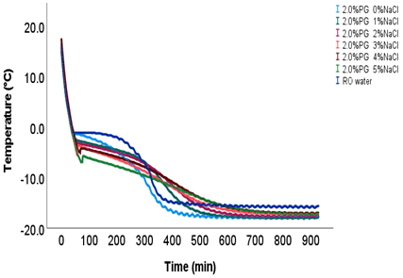 | 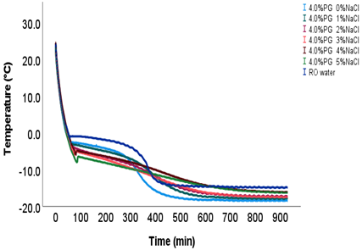
(a) | (b)
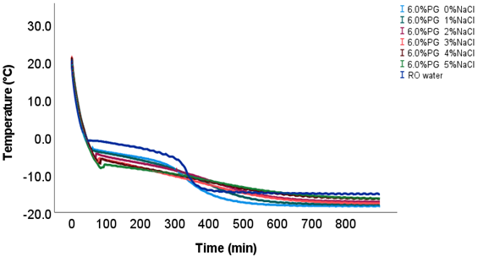
(c)
Fig. 4: Cooling curve of AGSSs at different concentration of PG (a) 2% PG (b) 4% PG and (c) 6% PG with NaCl concentration of 0, 1, 2, 3, 4, and 5 %

3.2 Melting characteristics of AGSS

Fig. 5 graphically represents the melting profile of formulated AGSSs using different concentrations of PG (2, 4, and 6%) and NaCl (0, 1, 2, 3, 4, and 5%). The melting behavior of AGSSs at different concentrations of NaCl and PG with respect to time differed significantly (P= .05).The melting of AGSSs did not occur at a constant temperature, unlike reverse osmosis (RO) water, which melted at a constant temperature of 0 °C. As the concentrations of Sodium chloride (NaCl) and Propylene glycol (PG) in the formulations increased, the freezing point further decreased, thereby influencing the melting behavior. From the melting profiles, it was observed that the phase change occurred over a range of temperatures rather than at a single, constant temperature. The initial ice fraction was identified as one of the key factors affecting the melting characteristics of the AGSSs. In case of RO water, the phase transition temperature was at a constant temperature (0°C) instead of a wide temperature range (Fig. 5c). Benson et al. [28] proposed an equation for estimating the melting point of the ternary water/Sodium chloride/ethylene glycol system, which depends on the overall solute mass fraction and the freezing point depression of the mixture. Singh et al. [29] synthesized three-component deep eutectic solutions (DESs) of Choline chloride (ChCl), Poly Ethylene glycol (PEG), and Glycerol with ratios of 1:3:2, 1:4:2, and 1:5:2. The melting temperature (Tm) of PEG-based DESs was around 18 °C.
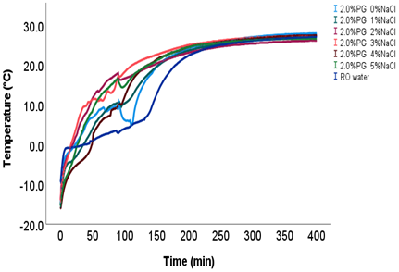 | 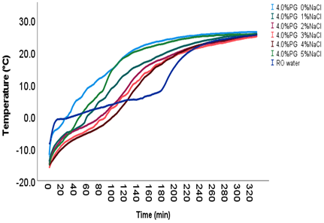
(a) | (b)
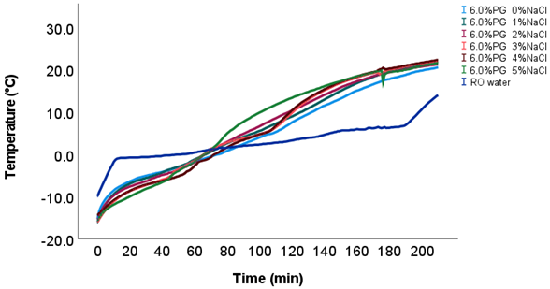
(c)
Fig. 5: Melting characteristics AGSSs at different concentration of PG (a) 2% PG (b) 4% PG and (c) 6% PG with NaCl concentration of 0, 1, 2, 3, 4, and 5 %

3.3 Concentration of AGSSduring freezing

The concentration of formulated AGSSs in terms of total soluble solids (TSS) (°Bx) during freezing was graphically represented in Fig. 6. The initial concentration of PG (2, 4, and 6%) and NaCl (0, 1, 2, 3, 4 and 5%) in the formulation significantly (P=.05) affected the final concentration of AGSSs after freezing. As the freezing progressed, the ice formed from pure water led to gradual concentration of PG and NaCl in the remaining unfrozen solution. The effect of NaCl concentration on the concentration of glycol-salt solution is more pronounced than that of PG. It is because NaCl, being an ionic solute, dissociates completely into Na⁺ and Cl⁻ ions in water. This dissociation significantly increases the number of solute particles in the solution, thereby exerting a stronger colligative effect [30]. It leads to lowering the freezing point and increasing the refractive index or density. In contrast, Propylene glycol (PG) is a non-ionic compound that does not dissociate in water, resulting in a comparatively weaker influence on this properties.Therefore, a small change in NaCl concentration cause more substantial variations in the solution’s physicochemical properties than equivalent changes in PG concentration [31, 32].

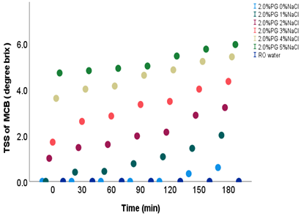 | 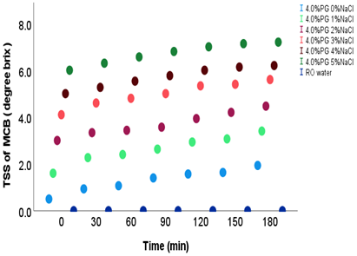
(a) | (b)
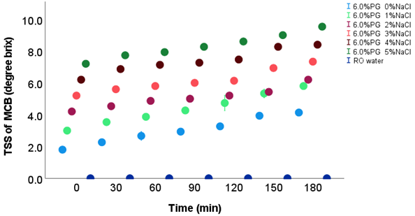
(c)
Fig. 6: Concentration of AGSSs (ºBx) at different concentration of PG (a) 2% PG (b) 4% PG and (c) 6% PG with NaCl concentration of 0, 1, 2, 3, 4, and 5 %

The maximum concentration (9.6 ºBx) of AGSSs after freezing of 180 min was observed in 6% PG with 5% NaCl and minimum concentration (0.6 ºBx) in 2% PG with 0% NaClAGSS. In previous study, Mach–Zehnder optical interferometry was used to study the distribution of solute concentration near the ice–solution interface under quasi-steady-state conditions, aiming to quantitatively understand freeze concentration [33]. The study concluded that the quasi-steady state approximation for describing freeze concentration at the ice/solution interface is applicable only to low molecular weight (non-entangled) solutes, slow ice growth rates, and when there are minimal interactions between solutes and ice. In subzero cooling application concentration of cooling medium play a very important role in heat transfer process. At lower solute concentrations, the behaviour of solution follows ideal colligative laws; however, at higher concentrations, non-ideal interactions dominate and deviate from Raoult’s law, leading to complex freezing and melting curves with potential formation of eutectic points [34]. As the concentration of cooling medium increased, viscosity of the solution is also increased and this reduced the convection heat transfer process. It was observed that salt diffusion increased with greater container length during freezing. In all container shapes, the movement of saline ions occurred from the bottom toward the top of the forming ice [35].

3.4 Ice fraction of AGSS during freezing

Ice fractions of formulated AGSS using different concentrations of PG (2, 4 and 6%) and NaCl (0, 1, 2, 3, 4 and 5%) during freezing are depicted in Fig. 7. Initial concentration of PG and NaCl significantly (P= .05) affects the ice fraction of AGSSs during freezing. At higher initial concentrations of Propylene glycol (PG) and Sodium chloride (NaCl) in the solution, the freezing point depression was greater, and a longer time was required to initiate the freezing process. Therefore, at higher initial concentrations of AGSSs, the final ice fraction obtained after a specific freezing period was comparatively lower. In contrast, at lower initial concentrations of PG and NaCl in AGSSs, the freezing point was relatively higher, leading to earlier initiation of ice formation and a greater ice fraction during the freezing period. Zobrist et al. [36] investigated the freezing characteristics of aqueous polyethylene glycol (PEG) solutions with molar masses between 300 and 6000 g·mol⁻¹. In such solutions, homogeneous ice nucleation is independent of the solute type and depends entirely on the water activity of the solution. Huang et al. [37] investigated the formation of ice crystal nuclei and the development of the ice layer in saline solutions during freezing. At a lower concentration of saline water (0.09 wt%), the ice crystal nuclei and ice layer developed uniformly and eventually occupied the entire volume of the saline solution.When the saline solution concentration exceeded 10 wt%, complete freezing was not achieved within 90 minutes.

It was also observed that lower NaCl concentrations (up to 2%) acted as volumetric nucleating agents, promoting ice formation. However, at higher NaCl concentrations (3%, 4%, and 5%), the increased freezing point depression delayed ice nucleation and prolonged the freezing process (Fig. 7). Ice fraction was significantly different (P = .05) with respect to PG and NaCl concentration of different AGSSs. The maximum ice fraction (0.79) of AGSS was obtained in the formulation containing 2% PG with 0% NaCl, while the minimum ice fraction (0.25) was observed in the 6% PG with 5% NaCl formulation after 180 minutes of freezing. The freezing process of ternary mixture at microscopic level is more complex than binary solution. Influence of NaCl concentration on ice fraction is more significant as compared to PG concentration. Glycol molecules being polar easily associate with water molecules and reduced the free water molecules for the agglomeration of ice crystals. At the same time, salt solutes dissociate into ions and further disrupt the tetrahedral structure of water. On the surface of small sized salt particles, ice crystals easily forms and start phase change. The combined effect of these two antifreeze chemical synergistically depress the freezing point [38, 39].

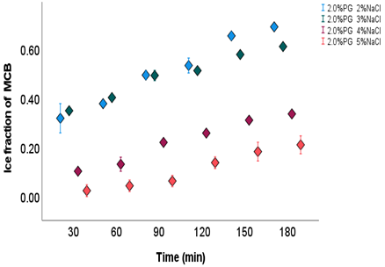 | 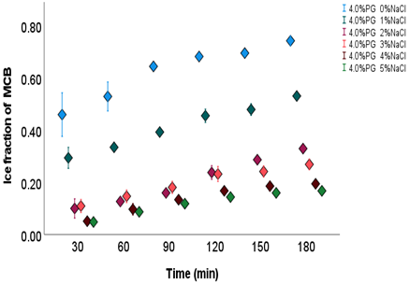
(a) | (b)
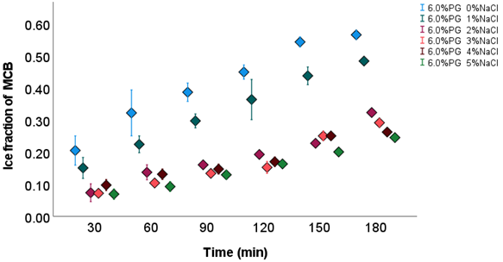
(c)
Fig. 7: Ice fraction of AGSSs at different concentration of PG (a) 2% PG (b) 4% PG and (c) 6% PG with NaCl concentration of 0, 1, 2, 3, 4, and 5 %

4. Conclusion

Ternary mixtures comprising different antifreeze components exhibit enhanced freezing point depression and improved heat transfer performance compared to binary solutions. Experimental analysis of the ice fraction in a ternary mixture of aqua–glycol–salt solutions (AGSS) was carried out as a function of freezing time. The results show that the addition of antifreeze components in certain ratios allows for flexible control over the freezing and melting points, enabling customization for specific cooling applications. The maximum concentration (9.6 °Bx) of AGSS was observed in the formulation containing 6% PG with 5% NaCl, whereas the minimum concentration (0.6 °Bx) occurred in 2% PG with 0% NaCl after 180 min of freezing period. Lower NaCl concentrations (up to 2%) acted as volumetric nucleating agents, promoting ice formation; however, at higher NaCl concentrations (3%, 4%, and 5%), increased freezing point depression delayed ice nucleation. The maximum ice fraction (0.79) of AGSS was obtained in the formulation with 2% PG and 0% NaCl. While the minimum ice fraction (0.25) was observed in 6% PG with 5% NaCl AGSS. These findings provide valuable insights for developing more efficient and sustainable thermal energy storage materials (TESMs).

Disclaimer (Artificial intelligence)
Option 1:
Author(s) hereby declare that NO generative AI technologies such as Large Language Models (ChatGPT, COPILOT, etc.) and text-to-image generators have been used during the writing or editing of this manuscript.
Option 2:
Author(s) hereby declare that generative AI technologies such as Large Language Models, etc. have been used during the writing or editing of manuscripts. This explanation will include the name, version, model, and source of the generative AI technology and as well as all input prompts provided to the generative AI technology
Details of the AI usage are given below:
1.
2.
3.

References
- Wang, Q., Zhao, L., Li, C., & Cao, Z. (2016).The decisive role of free water in determining homogenous ice nucleation behavior of aqueous solutions. Scientific reports, 6(1), 26831.
- Preet, S. (2018). Water and phase change material based photovoltaic thermal management systems: A review. Renewable and Sustainable Energy Reviews, 82, 791-807.
- Shamseddine, I., Pennec, F., Biwole, P., &Fardoun, F. (2022).Supercooling of phase change materials: A review. Renewable and Sustainable Energy Reviews, 158, 112172.
- Gao, Y., Qi, H., & Zhang, L. (2023). Advances in antifreeze molecules: from design and mechanisms to applications. Industrial & Engineering Chemistry Research, 62(20), 7839-7858.
- Hägg, C., & Melinder, Å. (2002). Selecting fluids suitable for ice slurry applications at low Temperatures. Zero leakage–Minimum Charge.
- Zhang, Z., & Liu, X. Y. (2018). Control of ice nucleation: freezing and antifreeze strategies. Chemical Society Reviews, 47(18), 7116-7139.
- Hägg, C. (2005). Ice slurry as secondary fluid in refrigeration systems: fundamentals and applications in supermarkets (Doctoral dissertation, KTH).
- Prakash, R., Manjunatha, M., Kumar, M., & Ravindra, M. R. (2018). Sub-zero temperature profile and chilling energy storage behaviour of aqua-glycol eutectics for milk cold chain. Journal of Pharmacognosy and Phytochemistry, 7(2), 3358-3362.
- Bokov, D., AL-ETHAFA, L. F., Abilmazhinov, Y., Thangavelu, L., Surendar, A., Pokrovskii, M., &Abdelbasset, W. K. (2022). Study on the preservative properties of glycol on food. Food Science and Technology, 42, xxxx.
- Perez, A. F., Taing, K. R., Quon, J. C., Flores, A., & Ba, Y. (2019). Effect of type i antifreeze proteins on the freezing and melting processes of cryoprotective solutions studied by site-directed spin labeling technique. Crystals, 9(7), 352.
- Zhang, Y., Li, B., Liu, J., Han, D., Rohani, S., Gao, Z., & Gong, J. (2024). Inhibition of crystal nucleation and growth: a review. Crystal Growth & Design, 24(6), 2645-2665.
- Yuan, H., Sun, K., Wang, K., Zhang, J., Zhang, Z., Zhang, L., ...& Li, Y. (2020). Ice crystal growth in the freezing desalination process of binary water-NaCl system. Desalination, 496, 114737.
- Li, G., Hwang, Y., Radermacher, R., & Chun, H. H. (2013).Review of cold storage materials for subzero applications. Energy, 51, 1-17.
- Amoroso, R., Hollmann, F., &Maccallini, C. (2021).Choline chloride-based DES as solvents/catalysts/chemical donors in pharmaceutical synthesis. Molecules, 26(20), 6286.
- ASHRAE Handbook – Refrigeration. Chapter 31: Physical Properties of Secondary Coolants (Brines). ASHRAE, 2023.
- Grace A. Cookey, Valentine Osi, Favour C. Umah. Conductivity of Sodium Halides in Binary Mixtures of Ethylene and Propylene Glycol with Water.Walisongo Journal of Chemistry, 8(1), 2025.
- Shahbaz M. et al. The Eutectic Point in Choline Chloride and Ethylene Glycol Mixtures.Chemical Communications, 2022.
- Zarghampour A., Jafari P., Rahimpour E., Jouyban A. Thermodynamic Investigation on the Aqueous Mixtures of Choline Chloride/Propylene Glycol Deep Eutectic Solvent at T = (293.15–313.15) K. BMC Chemistry, 2024.
- Zhou T., Mirzadeh M., Pellenq R. J.-M., Bazant M. Z. Freezing Point Depression and Freeze–Thaw Damage by Nanofluidic Salt Trapping.Physical Review Fluids, 5, 124201 (2020).
- Mohammed S., et al. Elucidating Molecular-Scale Interactions Underlying the Freezing Behavior of Salt Solutions in Silica Nanopores.Physical Chemistry Chemical Physics, 2025.
- Li, J., Huang, J., Liu, Z., Cao, M., Chen, R., & Zhang, Y. (2023). Developing ternary composite phase change materials with two different phase change temperatures for battery thermal management. Applied Thermal Engineering, 227, 120357.

- Rohit H K, Chitrnayak, Minz P S, Dabas J K and Ray A. 2023. Characterization of multi-component antifreeze liquids for sub-zero cooling applications. Journal of AgriSearch 10(4):259-265
- Prakash, R., Manjunatha, M., Kumar, M., & Ravindra, M. R. (2018). Freezing behaviour and cooling energy storage capabilities of aqua-salt eutectics for milk cold chain. Journal of Pharmacognosy and Phytochemistry, 7(2), 3363-3367.
- Rohit H. K., Chitranayak C., Minz P. S., Dabas J. K., Kumari K. Estimation of Freezing Point of Ternary Coolant Mixture. Material Science Research India, 19(3), 2022.
- Rokhim, I. N., & Fitri, S. P. (2023). Effect of Propylene Glycol on Supercooling NaCl-H2O Solution as PCM to Reduce Energy Consumption in Hybrid Reefer Container. Applied Mechanics and Materials, 913, 59-65.
- Conde, M. M., Rovere, M., & Gallo, P. (2018). Molecular dynamics simulations of freezing-point depression of TIP4P/2005 water in solution with NaCl. Journal of Molecular Liquids, 261, 513-519.
- Rohit, H.K., Chitranayak, Minz, P.S., Deshmukh, A.K., and Arijit Ray. 2025. “Effect of Salt and Glycol on Ice Crystal Nucleation and Growth During Freezing”. Archives of Current Research International 25 (11):15–25.
- Benson, J. D., Bagchi, A., Han, X., Critser, J. K., & Woods, E. J. (2010). Melting point equations for the ternary system water/sodium chloride/ethylene glycol revisited. Cryobiology, 61(3), 352-356.
- Singh, A., Walvekar, R., Khalid, M., Wong, W. Y., & Gupta, T. C. S. M. (2018).Thermophysical properties of glycerol and polyethylene glycol (PEG 600) based DES. Journal of Molecular Liquids, 252, 439-444.
- Rublova, Y., Kityk, A., Danilov, F., & Protsenko, V. (2020). Mechanistic study on surface tension of binary and ternary mixtures containing choline chloride, ethylene glycol and water (components of aqueous solutions of a deep eutectic solvent, ethaline). Zeitschrift für Physikalische Chemie, 234(3), 399-413.
- Masoudi, R., Tohidi, B., Anderson, R., Burgass, R. W., & Yang, J. (2004). Experimental measurement and thermodynamic modelling of clathrate hydrate equilibria and salt solubility in aqueous ethylene glycol and electrolyte solutions. Fluid Phase Equilibria, 219(2), 157-163.
- Woods, E. J., Zieger, M. A., Gao, D. Y., &Critser, J. K. (1999). Equations for obtaining melting points for the ternary system ethylene glycol/sodium chloride/water and their application to cryopreservation. Cryobiology, 38(4), 403-407.
- Butler, M. F. (2002). Freeze concentration of solutes at the ice/solution interface studied by optical interferometry. Crystal growth & design, 2(6), 541-548.
- Warren, M. (2020).Understanding specific ion effects and interfacially active solutes using the colligative properties of microemulsions.
- Castillo-Téllez, B., Pilatowsky Figueroa, I., Allaf, K., Marzoug, R., & Castillo Téllez, M. (2020).Experimental analysis of saline diffusion during saltwater freezing for desalination purposes. Water and Environment Journal, 34, 929-936.
- Zobrist, B., Weers, U., & Koop, T. (2003).Ice nucleation in aqueous solutions of poly [ethylene glycol] with different molar mass. The Journal of chemical physics, 118(22), 10254-10261.
- Huang, S. C., Cheng, C. C., & Cheng, H. P. (2024).Phase and thermal diffusivity variation of saline water diagnosed by visual and temperature method during freezing process. Results in Engineering, 24, 103452.
- Rohit, H. K., Minz, P. S., Dabas, J. K., Sain, M., & Kumari, K. (2023). Determination of cooling characteristics of multicomponent phase change coolant. Current Advances in Agricultural Sciences, 15(2), 180-185.
- Xia, M., Zhou, J., & Lu, B. (2025).Comprehensive insights into aqueous potassium‐ion batteries. Advanced Energy Materials, 15(12), 2404032.

