Assessment of Genetic Variability and Trait Associations in Advanced Rice Lines

Abstract:
Rice (Oryza sativa L.) is one of the world’s most important cereal crops, serving as a staple food and a key component of food and livelihood security across Asia. However, rice productivity has stagnated in several regions due to multiple biotic and abiotic stresses, variable climate and a narrow genetic base in modern cultivars. To sustain productivity and enhance yield potential, understanding genetic parameters and interrelationships among yield components is essential for effective selection and crop improvement. The present study was carried out at the Agricultural Research Station, Ragolu, Andhra Pradesh, during the Kharif 2024 season to assess the genetic variability, heritability and associations among yield-related traits in 22 advanced rice breeding lines in RCBD. Significant variability was observed among genotypes for all traits, indicating sufficient genetic diversity within the experimental material. The close relationship between genotypic and phenotypic variation suggested limited environmental influence on trait expression. High h² (>60%) combined with high GAM (>20%) for major yield components revealed that additive gene action was predominant, implying that direct selection would be effective for improving these traits. Correlation analysis showed that grain yield was positively associated with several yield-contributing characters such as filled grains per panicle, plant height, test weight and ear bearing tillers, suggesting that simultaneous improvement in these traits could enhance yield. Path coefficient analysis further confirmed that filled grains per panicle, test weight and plant height exerted strong direct effects on yield (0.30-0.99), whereas unfilled grains had negative effects. The study revealed wide genetic divergence, highlighting FGP and TW as key traits for selection, offering valuable opportunities for selection and breeding of high-yielding, resilient rice cultivars suited to diverse environments.
Keywords:
Additive gene action, Correlation, Genetic variability, Heritability, Path analysis, Rice breeding

Introduction:
Rice (Oryza sativa L.) is a major cereal crop and serves as the primary source of calories for over half of the global population (Mohapatra et al., 2025). It holds a critical place in the agricultural economies of Asia, particularly in countries such as India, China and Bangladesh, where it is both a staple food and a key contributor to livelihoods (Satyanaryana et al., 2023). In India, rice covers nearly a quarter of the total cropped area and plays an essential role in ensuring national food and nutritional security (Reddy et al., 2024). With the global population rising, the demand for rice is projected to increase substantially, which intensifies pressure on limited natural resources and challenges the sustainability of current production systems (Kumar et al., 2022).
Despite advances in crop breeding and agronomic practices, rice yields in many regions have stagnated due to a combination of biotic and abiotic stresses. Environmental factors such as drought, salinity, submergence, high temperature and nutrient deficiencies constrain productivity across diverse agro-ecologies (Udayababu et al., 2024). Simultaneously, diseases like bacterial blight, blast, sheath blight and pests including brown planthopper continue to threaten yield stability. Soil degradation, climate variability and a narrow genetic base among modern cultivars further complicate sustainable production. The reliance on a limited gene pool increases vulnerability to pests and environmental fluctuations, highlighting the need to expand genetic diversity for long-term resilience (Madhukumar et al., 2022). Genetic variability forms the foundation of effective rice breeding. It represents differences among individuals within a population and determines the potential for selection and genetic gain. Assessing variability for yield and its components provides insight into the scope for improvement. Parameters such as genotypic and phenotypic coefficients of variation, heritability and genetic advance are crucial for partitioning total variation into heritable and non-heritable components (Duppala et al., 2022). Traits with high heritability and genetic advance are predominantly controlled by additive genes and respond well to direct selection, whereas low values indicate non-additive gene effects, necessitating hybridization or population improvement (Talekar et al., 2022).
In addition to variability, understanding the relationships among yield traits is essential. Rice yield is a complex trait influenced by plant height, ear bearing tillers, panicle length, grains per panicle and 1000-grain weight. Correlation analysis identifies associations among these traits, while path coefficient analysis partitions direct and indirect effects, offering insights into cause-and-effect relationships. These analyses guide breeders in selecting traits that have the most significant impact on yield (Sadimantara et al., 2021).
Materials and Methods:
The present study was conducted at the Agricultural Research Station (ARS), Ragolu, located in the North Coastal Zone of Andhra Pradesh (18.240° N latitude, 83.240° E longitude) at an elevation of 27 meters above mean sea level. The region experiences an average annual rainfall of around 1111 mm over approximately 57 rainy days (Madhukumar et al., 2023). The experiment was carried out during the Kharif 2024 season under a typical monsoon rice-growing system. The experimental field had sandy clay loam soil, slightly acidic in reaction (pH ~6.0), low in organic carbon (~0.30%) and of medium fertility. Climatic records for Srikakulam district indicate normal annual rainfall of about 1162 mm, with the southwest monsoon contributing approximately 705 mm and the northeast monsoon 277 mm. During the cropping period, around 820 mm of rainfall was recorded, mainly between July and September. Mean temperatures ranged from 30°C to 34°C (maximum) and 24°C to 27°C (minimum), while relative humidity remained high (78–90%) during vegetative and reproductive stages, creating favorable conditions for rice growth (Udayababu et al., 2025).
Advanced rice breeding lines developed at Acharya N G Ranga Agricultural University were evaluated in a Randomized Complete Block Design (RCBD) with 22 entries and two replications. Each plot measured 4.0 m × 3.0 m and included 15 rows with 20 cm inter-row and 15 cm intra-row spacing, with border rows to reduce edge effects. Standard agronomic practices were followed, including nursery-raised seedlings transplanted at 21–25 days, three seedlings per hill and fertilization with N–P₂O₅–K₂O (120:60:40 kg ha⁻¹) following local recommendations. Nitrogen was applied in three splits, while phosphorus and potassium were applied at transplanting. Irrigation was maintained at 3–5 cm water depth until 20 days before harvest, with standard pest, weed and disease management practices implemented uniformly.
Data were recorded from five randomly selected competitive plants from central rows for eight traits: days to 50 per cent flowering, plant height, ear-bearing tillers, panicle length, filled and unfilled grains per panicle, test weight and grain yield per plot. Statistical analysis including ANOVA, mean comparisons (LSD) and estimation of genetic parameters (phenotypic and genotypic variance, PCV, GCV, heritability, genetic advance and genetic advance as percent of mean) was performed following standard procedures. Correlation and path coefficient analyses were conducted to assess interrelationships and direct/indirect effects on grain yield. All analyses were performed using Indosat software (version 9.3.0) and data transformations were applied where necessary to meet ANOVA assumptions, with back-transformed means reported.
Classification | Value for GCV/ PCV
Low | Less than 10%
Moderate | 10 – 20%
High | More than 20%
Classification | Value for Heritability
Low | Less than 30%
Moderate | 30 – 60%
High | More than 60%
Classification | Value for GAM
Low | Less than 10%
Moderate | 10 – 20%
High | More than 20%
Classification | Value for Direct or Indirect effect
Negligible | 0.00-0.09
Low | 0.10-0.19
Moderate | 0.20-0.29
High | 0.30-0.99
Very high | More than 1.00

List 1:

Results and Discussions:
Genetic Variability and Mean Performance
Genetic variability is fundamental for crop improvement, as it provides the essential basis for effective selection and breeding programs. It enables the identification of superior genotypes possessing desirable traits related to yield, quality, and adaptability. The presence of variability indicates the potential for genetic gain and the extent of response to selection in subsequent generations. Moreover, studying genetic variability helps breeders distinguish between genetic and environmental influences on trait expression (Duppala et al., 2024). The analysis of genetic parameters revealed considerable variation among the evaluated genotypes for all the studied traits, including days to 50 per cent flowering (DFF), plant height (PH), number of ear bearing tillers per plant (EBT), panicle length (PL), filled grains per plant (FGP), infertile grains per plant (IFGP), test weight (TW) and grain yield per plot (GYP). The recorded mean values, ranges, coefficients of variation and genetic parameters such as genotypic variance (σ²g), phenotypic variance (σ²p), heritability (h²) and genetic advance as percent of mean (GAM) are summarized in Table 1and Figure 1.
The mean performance of the genotypes showed significant differences across all traits, indicating the presence of ample genetic variability within the experimental material. Days to 50 per cent flowering ranged from early- to late-maturing genotypes, while plant height exhibited considerable variation, reflecting differences in vegetative growth. The number of ear bearing tillers per plant and panicle length also varied widely, suggesting diverse plant architecture and potential for selection based on structural traits. Among yield-related components, filled grains per plant ranged extensively, indicating considerable differences in reproductive efficiency and seed-setting ability. Infertile grains per plant varied substantially, reflecting genetic differences in grain sterility, which could be harnessed for improving fertility restoration in breeding programs. Test weight and grain yield per plot also showed broad variability, highlighting opportunities for selecting high-yielding genotypes Similar extent of variability was also acknowledged by Shrestha et al., 2021 and Sabri et al., 2020.
Phenotypic and Genotypic Coefficients of Variation
The magnitude of genotypic coefficient of variation (GCV) and phenotypic coefficient of variation (PCV) provides insights into the relative contribution of genetic and environmental factors to total trait variation. In this study, GCV ranged from low values for DFF to high values for IFGP, whereas PCV slightly exceeded GCV for all traits, indicating that environmental influence on trait expression was relatively limited. Low GCV was observed in DFF, PH and EBT; whereas moderate GCV was noted in PL and GYP; However high GCV was observed in FGP, IFGP and TW. Low PCV was observed in DFF; whereas moderate GCV was noted in majority of the traits viz., PH, EBT, PL and GYP; However high PCV was observed in FGP, IFGP and TW. Similar variability was reported by Suman et al. (2020) and Awad et al. (2022).
Traits such as FGP, IFGP and TW exhibited high GCV and PCV, suggesting that these traits are primarily under genetic control and can be improved effectively through direct selection, similar findings were earlier reported by Girma et al. (2018) and Sandeep et al. (2018). However, moderate GCV and PCV were observed for PL and GYP suggesting that these characters may require recurrent selection or hybridization for significant improvement, similar results were reported by Pragnya et al. (2018) for PL and Sameera et al. (2016) for GYP. Low variability for DFF indicates slower progress through conventional selection methods. The small differences between PCV and GCV for key yield traits reinforce the minimal impact of environmental factors and the reliability of phenotypic selection.
Heritability and Genetic Advance
Broad-sense heritability estimates for all the traits studied, exhibited high heritability, indicating that observed variation is largely genetically determined. However, High genetic advance was observed in PL, FGP, IFGP, TW and GYP, whereas moderate genetic advance was noted in DFF, PH and EBT. The combination of high heritability and high genetic advance for PL, FGP, IFGP, TW and GYP suggest the predominance of additive gene action, making direct selection highly effective for improving these characters, similar findings were reported by Kalyan et al. (2017) for PL; Bhinda et al. (2017) for FGP; Shivani et al. (2018) for TW and GYP. Traits with high heritability but moderate genetic advance, such as DFF, PH and EBT indicate a mix of additive and non-additive gene effects, requiring hybridization or multi-generation selection strategies for significant genetic gain, these results were accorded with earlier findings of Hari et al. (2018) for DFF and PH and Parimala and Devi (2019) for EBT. The high heritability coupled with substantial genetic advance for key yield components emphasizes their potential as priority traits in breeding programs aimed at enhancing productivity.
Association Studies:
Association studies are fundamental in plant breeding as they help identify the relationships between different traits, enabling breeders to predict how selection for one character may influence others. Understanding these associations allows for more efficient selection, particularly for complex quantitative traits like grain yield, which is influenced by multiple interrelated components (Kumar et al., 2024). Results from Table 2 and Figure 2 are discussed here under in detail.
Correlation Coefficient Analysis
Correlation analysis plays a vital role in plant breeding by determining the interrelationships among various traits that contribute to yield and other agronomic parameters. It assists in identifying important traits that can be used for indirect selection to enhance complex characters such as yield. By understanding these relationships, breeders can design more efficient and targeted selection strategies for crop improvement Satyanarayana et al., 2024. Understanding trait associations is critical for effective selection in breeding programs. Correlation analysis revealed that grain yield per plot was positively and significantly correlated with several yield-contributing traits. Filled grains per plant, ear bearing tillers and test weight showed strong positive associations with yield, suggesting that improvements in these traits can directly enhance productivity, these results are in accordance with findings of
Saha et al. (2019) for EBT, FGP and Nithya et al. (2020) for TW. Inter- character associations were observed between DFF and PH, FGP and TW, FGP with PH, EBT and PL, further TW with EBT, PL and FGP. A positive correlation between filled and panicle length indicates a synergetic relationship, while ear bearing tillers per plant positively correlated with both filled grains and test weight, highlighting the interdependence of reproductive traits. Conversely, certain negative associations, such as between panicle length and days to 50 per cent flowering or infertile grains and plant height, indicate potential trade-offs that must be considered in selection strategies. These correlations demonstrate that selection for traits like FGP, TW and EBT can lead to cumulative gains in grain yield, The results were in broad agreement with the
Archana et al. (2018) for DFF with PH, Singh et al. (2020) for FGP and Santhipriya et al. (2017)
For DFF with TW; Saha et al. (2019) for FGP with DF, Devi et al. (2017) for FGP with EBT and Singh et al. (2020) for FGP with PL; Lakshmi et al. (2014) for TW with EBT, Santhipriya et al. (2017) for TW with PL and TW with FGP Archana et al. (2018).

Path Coefficient Analysis
Path analysis is a valuable tool in plant breeding that partitions correlation coefficients into direct and indirect effects of traits on yield. It helps identify the most influential traits contributing directly to yield improvement. This understanding enables breeders to prioritize key characters in selection programs for effective genetic advancement (Madhukumar et al., 2023). To complement correlation findings, path coefficient analysis was performed to partition correlations into direct and indirect effects on grain yield. Filled grains per plant exhibited the highest positive direct effect on yield, confirming its role as the primary determinant of productivity. DFF, PH, TW and FGP executed high direct effects on GYP, whereas EBT executed low direct effect on GYP. In contrast IFGP exerted high negative direct effect on GYP and PL exerted low negative direct effect on GYP, the results were in broad agreement with Archana et al. (2018). FGP also contributed indirectly through DFF, PH, EBT and PL, indicating its central role in both direct and indirect yield enhancement. Test weight and plant height showed moderate positive direct effects, reinforcing their importance for improving seed quality and assimilate partitioning. Ear bearing tillers and days to 50 per cent flowering contributed indirectly through their influence on FGP and TW. In contrast, infertile grains had a strong negative direct effect, emphasizing the importance of reducing grain sterility to enhance yield. Panicle length showed minor negative direct effects, primarily influencing yield indirectly through other traits. These results underline that selection should prioritize traits with high positive direct effects; while simultaneously managing indirect influences to optimize overall productivity, Similar findings were earlier reported by Edukondalu et al. (2017) and Harsha et al. (2017).
The combined analysis of genetic variability, heritability, correlation and path coefficients highlights that filled grains per plant, test weight and plant height are critical traits for yield improvement. Genotypes excelling in these traits can be used as parents to develop superior lines. The substantial genetic variability, high heritability and strong direct effects of these key traits suggest that phenotypic selection will be highly effective, enabling rapid genetic gains (David et al., 2021). Additionally, understanding indirect associations and compensatory relationships among traits allows breeders to design strategies that enhance yield without compromising other important agronomic attributes (Laxmi et al., 2023). Integrating these findings into selection programs can accelerate the development of high-yielding, resilient cultivars suited to diverse environments.
Conclusion
Overall, the study demonstrates that substantial genetic variability exists among the evaluated genotypes for all studied traits. Traits with high heritability and genetic advance, especially FGP, IFGP, TW and GYP, should be prioritized in breeding programs. The positive correlations and significant direct effects identified through path analysis provide a strong basis for selecting superior genotypes to achieve enhanced yield potential. Simultaneous selection for highly interrelated traits such as filled grains, test weight and plant height is likely to result in cumulative improvements in productivity. Conversely, management of negatively associated traits like infertile grains is necessary to minimize yield loss. These findings collectively provide actionable insights for breeders aiming to improve rice productivity through genetically informed selection, thereby contributing to sustainable agricultural development and food security.
Future Scope
Future research should focus on validating the identified high-yielding genotypes across multiple locations and seasons to assess their stability and adaptability under varying environmental conditions. Molecular and genomic tools can be integrated to identify markers linked to key yield-contributing traits, which will enhance selection efficiency through marker-assisted breeding. Further studies on physiological and biochemical traits related to grain filling, fertility and stress tolerance can provide deeper insights into yield improvement mechanisms. Additionally, combining promising genotypes through hybridization can help develop new lines with improved productivity, stability and resilience to environmental stresses, contributing to sustainable rice production in the long term.
Disclaimer (Artificial intelligence):
Author(s) here by declare that NO generative AI technologies such as Large Language Models (ChatGPT, COPILOT, etc.) and text-to-image generators have been used during the writing or editing of this manuscript.
Disclaimer (Ethical issues):
Authors here by declare that, this research article is original work submitted compiling all the guidelines, there is no deviation from any ethical issues.
CONFLICT OF INTEREST
The authors declare that they have no conflict of interest.
Acknowledgement
We gratefully acknowledge the financial support provided by Acharya N. G. Ranga Agricultural University, Lam, Guntur, which enabled the execution of the plant breeding program at the Agricultural Research Station, Ragolu, Andhra Pradesh. The resources and planned budget facilitated field experiments, proper crop management and data collection. We sincerely appreciate the dedicated efforts of the scientists involved in developing the advanced paddy lines evaluated in this study. Their expertise, guidance and commitment were invaluable in conducting the research successfully. The contributions of both the university and the scientific team were crucial and we extend our heartfelt gratitude for their support.
Literature Cited:
Awad-Allah, M. M., Elekhtyar, N. M., El-Abd, M. A. E. M., Abdelkader, M. F., Mahmoud, M. H., Mohamed, A. H and Abdein, M. A. 2022. Development of new restorer lines carrying some restoring fertility genes with flowering, Yield and grains quality characteristics in rice (Oryza sativa L.). Genes. 13 (3): 458.
Bhinda, M.S., Karnwal, M.K and Choudhary, M.K. 2017. Estimates of genetic variability, heritability and genetic advance for yield contributing and quality traits in advance breeding lines of rice (Oryza sativa L.). International Journal of Advanced Biological Research. 7 (2): 229-233.
David, G. S., Agah, L. J., Ukatu, P. O., & F Uwah, D. (2021). Correlation and path analysis of yield and related traits of upland rice genotypes across weeding regimes. International Journal of Plant & Soil Science, 33(19), 130-138.
Devi, U.M., Sarawathi, R., Shanthi, P., Suresh, R., Sanjeeva Rao, D and Rajendran, R. 2017. Assessment of genetic variability in traditional rice varieties based on agro- morphological traits and iron, zinc content for crop improvement. International Journal of Science and Nature. 7(2): 244-250.
Duppala M.K., Srinivas, T., Rao, L.S., Suneetha, Y., Sundaram, R.M. and Kumari, V.P., 2022. Study of genetic variability and trait associations in F2 Population of YH3 x AKDRMS 21-54 intra-specific cross of rice. The Pharma Innovation Journal. 11(9): 1735-1742.
Duppala, M.K., Nair, B., Srinivas, T., Suneetha, Y., Reddy, D. V and Kumar, K. M. 2024. Genetic studies of genetic variability and trait associations in mustard spp. (Brassica juncea L. & Brassica carinata A.). International Journal of Research in Agronomy. 7(2): 435-440.
Edukondalu, B., Reddy, V.R., Rani, T.S., Kumari C.H.A and Soundharya, B. 2017. Studies on Variability, Heritability, Correlation and Path Analysis for Yield, Yield Attributes in Rice (Oryza sativa L.). International Journal of Current Microbiology and Applied Science. 6 (10): 2369-2376.
Girma, B.T., Kitil, M.A., Banje, D.G., Biru, H.M and Serbessa, T.B. 2018. Genetic variability study of yield and yield related traits in rice (Oryza sativa L.) genotypes. Advances in Crop Science and Technology. 6: 4.
Hari, R.K.B., Satyanarayana, P.V., Babu, D.R., Chamundeswari, N., Rao, V.S and Raju, S.K. 2018. Genetic variability estimates for yield and yield components traits and quality traits in rice (Oryza sativa L.). International Journal of Current Microbiology and Applied Sciences. 7 (5): 551-559.
Harsha., Deo, I., Kumar, S and Talha, M. 2017. Assessment of Genetic Variability and Inter-Character Association Studies in Rice Genotypes (Oryza sativa L.). International Journal of Current Microbiology and Applied Sciences. 6(9): 2041-2046.
Kalyan, B., Krishna, K.V.R and Rao, L.V.S. 2017. Studies on variability, heritability and genetic advance for quantitative characters in rice (Oryza sativa L.) germplasm. International Journal of Pure Applied Bioscience. 5 (5): 1619-1624.
Kumar, D.M, Nair, B., Srinivas, T., Suneetha, Y., Kumar, K. M and Reddy, D. V. 2024. Elucidation of genetic variability and inter-relationship studies for seed yield and quality traits in advanced lines of Mustard spp. International Journal of Advanced Biochemistry Research. 8(3): 25-30.
Kumar, M.D., Srinivas, T., Rao, L.S., Suneetha, Y., Sundaram, R.M. and Kumari, V.P., 2022. Genetic Variability and trait association analysis in F₃ population of YH3 x AKDRMS 21-54 cross. The Andhra Agricultural Journal. 69 (1): 46-57.
Lakshmi, V.M., Suneetha, Y., Yugandhar, G and Lakshmi, V.N. 2014. Correlation studies in rice (Oryza sativa L.). International Journal of Genetic Engineering and Biotechnology. 5(2): 121-126.
Laxmi, T. G., Lal, G. M., & Bara, B. M. (2023). Direct and indirect effects of yield contributing traits in rice (Oryza sativa L.). International Journal of Plant & Soil Science, 35(19), 2091-2099.
Madhukumar, K., Satyanarayana, P.V., Udayababu, P., Sreenivas, G and Manojkumar, D. 2022. Elucidation of genetic variability and Intra and Inter association analysis in advanced lines of blackgram [Vigna mungo (L.) Hepper]. The Pharma Innovation Journal. 11(8): 3780-3784.
Madhukumar, M., Satyanarayana, P. V., Babu, P. U., Sreenivas, G., & Manojkumar, D. 2023. Studies on Genetic Parameters and Trait Association Analysis of Yield and Yield Factors in the Advanced Breeding Lines of Greengram. International Journal of Theoretical & Applied Sciences, 15(1): 75-80.
Mohapatra, P. K., Sarkar, R. K., Panda, D., & Kariali, E. (2025). Origin and Evolution of Rice as Domesticated Staple Food Crop. In Tillering Behavior of Rice Plant (pp. 1-17). Singapore: Springer Nature Singapore. (pp. 1-17).
Nithya, N., Beena, R., Stephen, R., Abida, P.S., Jayalekshmi, V.G., Viji, M.M. and Manju, R.V. 2020. Genetic Variability, Heritability, Correlation Coefficient and Path Analysis of Morph physiological and Yield Related Traits of Rice under Drought Stress. Chemical Science Review and Letters. 9(33): 48-54.
Pragnya, K., Krishna, K.V.R., Rao, L.V.S and Suneetha, K. 2018. Estimation of genetic variability parameters in soft rice (Oryza sativa L.) Genotypes. International Journal of Current Microbiology and Applied Science.7 (6): 2029-2042.
Principal Component Analysis for Yield in Black Gram Genotypes (Vigna mungo L. Hepper) under Rice Fallow Pulse Cropping System. Biological Forum – An International Journal. 15(3): 930-934.
Reddy, D.V., Suneetha, Y., Ravikumar, B.N.V.S.R., Ramesh, D., Manojkumar, D and Srinivas, T. 2024. Combining Ability Studies of Promising Restorer Lines for Yield and Yield Components in Rice (Oryza sativa L.). Agricultural Science Digest. 1(1):1-7.
Sabri, R. S., Rafii, M. Y., Ismail, M. R., Yusuff, O., Chukwu, S. C., & Hasan, N. A. (2020). Assessment of agro-morphologic performance, genetic parameters and clustering pattern of newly developed blast resistant rice lines tested in four environments. Agronomy, 10(8), 1098.
Sadimantara, G. R., Yusuf, D. N., Febrianti, E., & Leomo, S. (2021). The performance of agronomic traits, genetic variability, and correlation studies for yield and its components in some red rice (Oryza sativa) promising lines. Biodiversitas: Journal of Biological Diversity, 22(9).
Saha, S.R., Hassan, L., Haque, A., Islam, M.M and Rasel, M. 2019. Genetic variability, heritability, correlation and path analyses of yield components in traditional rice (Oryza sativa L.) landraces. Journal of Bangladesh Agricultural University. 17(1): 26–32.
Sameera, S.K., Srinivas, T., Rajesh, A.P., Lakshmi, V.J and Nirmala, P.J. 2016. Variability and path co-efficient for yield and yield components in rice. Bangladesh Journal of Agricultural Research. 41 (2): 259-271.
Sandeep, S., Sujatha, M., Subbarao, L.V and Neeraja, C.N. 2018. Genetic Variability, Heritability and Genetic Advance studies in rice (Oryza sativa L.). International Journal of Current Microbiology and Applied Sciences. 7 (12): 3719-3727.
Santhipriya, C., Suneetha, Y., Babu, D.R., and Srinivasa, V.R. 2017. Inter-relationship and path analysis for yield and quality characters in rice (Oryza sativa L.). International Journal of Science, Environment and Technology. 6(1): 381 – 390.
Satyanarayana, P.V., Madhukumar, K., Udayababu, P., Srinivas, T and Manojkumar, D. 2023. Association Studies for Identifying the Selection Criteria Among Early varieties of Rice in North Coastal Zone of Andhra Pradesh. Biological Forum – An International Journal 15(11): 329-335.
Satyanarayana, P.V., Madhukumar, K., Udayababu, P., Srinivas, T and Manojkumar, D. 2024. Genetic Architecture, Studies to Identify the Selection Criteria for Yield in Long Duration Rice Lines (Oryza sativa L.). International Journal of Environment and Climate Change. 14(4):842-851.
Shivani, D., Cheralu, C., Neeraja, C.N and Shankar, V.G. 2018. Genetic Variability Studies in Swarna X Type 3 RIL Population of Rice (Oryza sativa L.). International Journal of Pure & Applied Bioscience. 6 (2): 384-392.
Shrestha, J., Subedi, S., Kushwaha, U. K. S., & Maharjan, B. (2021). Evaluation of rice genotypes for growth, yield and yield components. Journal of Agriculture and Natural Resources, 4(2), 339-346.
Singh, K.S., Suneetha, Y., Kumar, G.V., Rao, V.S., Raja, D.S. and Srinivas, T., 2020a. Variability, correlation and path studies in coloured rice. International Journal of Chemical Studies, 8(4),: 2138-2144.
Suman, K., Madhubabu, P., Rathod, R., Rao, S.D., Rojarani, A., Prashant, S., Subbarao, L.V., Ravindrababu, V and Neeraja, C.N. 2020. Variation of grain quality characters and marker-trait association in rice (Oryza sativa L.). Journal of Genetics. 99 (5): 1-12.
Talekar, S. C., Praveena, M. V., & Satish, R. G. (2022). Genetic variability and association studies for grain yield and yield related traits in rice (Oryza sativa L.). International Journal of Plant Sciences, 17(2), 202-208.
Udayababu, P., Madhu Kumar, K., Srinivasa Rao, M., Sreenivas, G., Satyanarayana, P.V., and Manojkumar, D. 2025. Evaluation of Insecticide Strategies for Gall Midge and Yellow Stem Borer Management in Rice in Coastal Andhra Pradesh, India. Archives of Current Research International. 25(6): 401-409.
Udayababu, P., Satyanarayana, P.V., Madhu Kumar, K and Manojkumar, D. 2023. Efficacy of Biorational Insecticides Against Major Insect Pests of Rice. Biological Forum – An International Journal 15(6): 966-971.

Table 1. Study of Variability Parameters in advanced breeding lines of paddy
Genetic Parameters | DFF | PH | EBT | PL | FGP | IFGP | TW | GYP
Mean | 90.59 | 118.93 | 278.95 | 26.33 | 204.48 | 35.64 | 18.08 | 6.14
C.V. | 1.02 | 3.31 | 5.40 | 3.08 | 6.39 | 21.38 | 2.60 | 7.38
S.E. | 0.65 | 2.78 | 10.65 | 0.57 | 9.25 | 5.39 | 0.33 | 0.32
C.D. 5% | 1.92 | 8.18 | 31.33 | 1.69 | 27.19 | 15.84 | 0.98 | 0.94
Range Lowest | 80.00 | 98.00 | 222.50 | 20.54 | 116.50 | 12.50 | 11.77 | 4.04
Range Highest | 102.00 | 140.00 | 315.00 | 32.05 | 328.00 | 77.50 | 29.44 | 7.78
Var Environmental | 0.85 | 15.46 | 226.96 | 0.66 | 170.98 | 58.04 | 0.22 | 0.21
ECV | 1.02 | 3.31 | 5.40 | 3.08 | 6.40 | 21.38 | 2.60 | 7.38
Var Genotypical | 31.85 | 138.04 | 654.21 | 8.92 | 2994.95 | 316.80 | 20.95 | 1.13
GCV | 6.23 | 9.88 | 9.17 | 11.34 | 26.76 | 49.95 | 25.31 | 17.28
Var Phenotypical | 32.70 | 153.50 | 881.17 | 9.58 | 3165.93 | 374.83 | 21.17 | 1.33
PCV | 6.31 | 10.42 | 10.64 | 11.76 | 27.52 | 54.33 | 25.45 | 18.79
h2 (Broad Sense) | 97.40 | 89.90 | 74.20 | 93.10 | 94.60 | 84.50 | 99.00 | 84.60
Gen.Adv as % of Mean 5% | 12.67 | 19.30 | 16.28 | 22.55 | 53.62 | 94.59 | 51.87 | 32.74

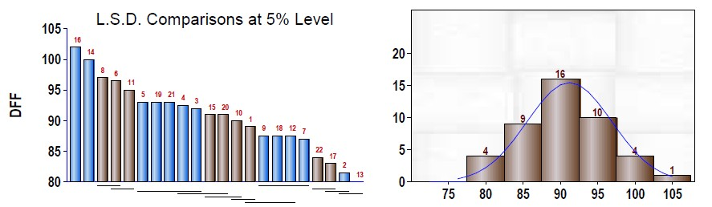 | 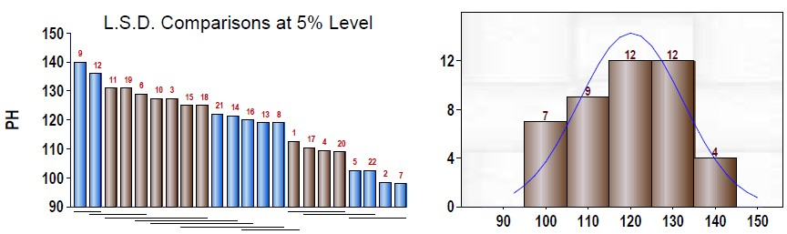
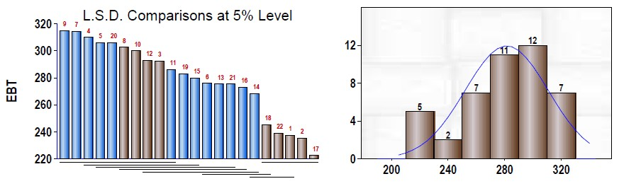 | 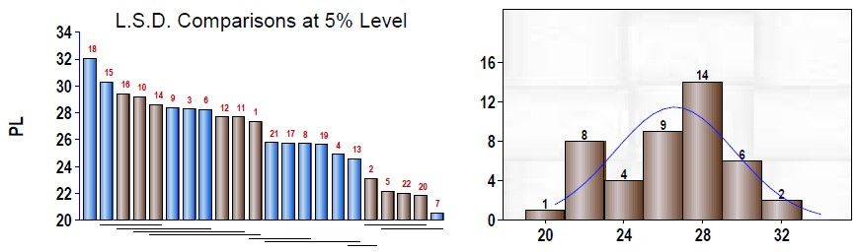
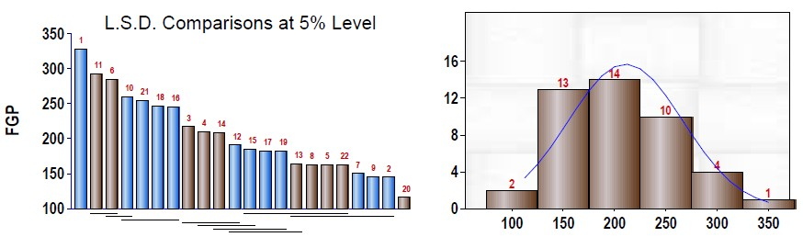 | 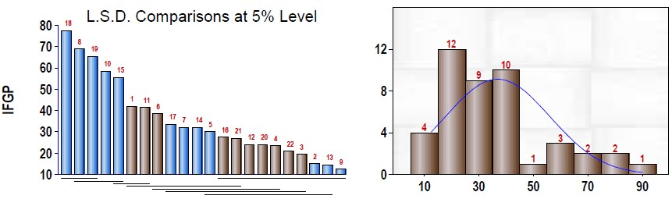
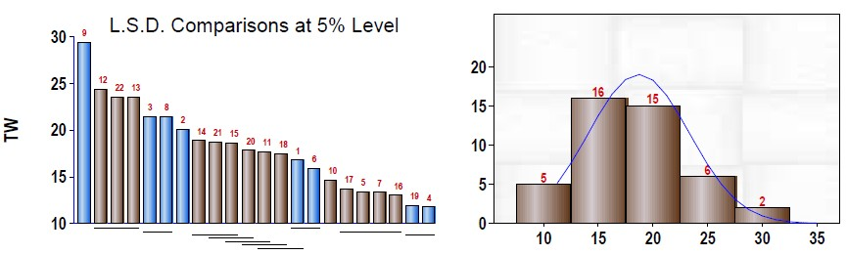 | 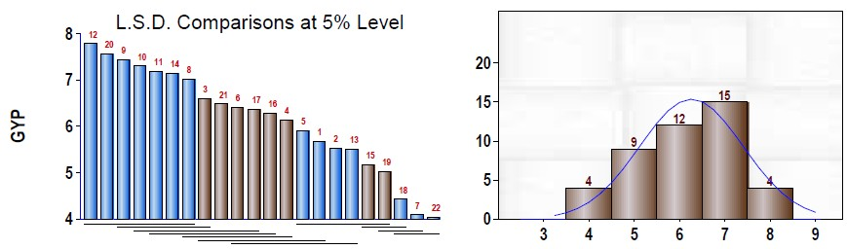
Figure 1. Genotypic Comparison and Frequency Distribution among the advanced breeding lines of paddy

Table 2. Study of Correlation and Path analysis in advanced breeding lines of paddy
Correlation coefficient analysis
 | DFF | PH | EBT | PL | FGP | IFGP | TW | GYP
DFF | 1.000 | 0.369* | 0.389 | -0.345 | 0.325* | 0.349 | 0.286* | 0.389
PH |  | 1.000 | -0.297 | 0.029 | 0.276* | -0.202 | -0.111 | 0.417
EBT |  |  | 1.000 | -0.283 | 0.378* | 0.596 | 0.340* | 0.289*
PL |  |  |  | 1.000 | 0.350* | 0.102 | 0.374* | 0.254
FGP |  |  |  |  | 1.000 | 0.812 | 0.290* | 0.545*
IFGP |  |  |  |  |  | 1.000 | 0.462 | 0.271
TW |  |  |  |  |  |  | 1.000 | 0.187*
Path coefficient analysis
 | DFF | PH | EBT | PL | FGP | IFGP | TW | GYP
DFF | 0.497 | 0.183 | 0.193 | -0.171 | 0.162 | 0.173 | 0.142 | 0.389
PH | -0.158 | 0.427 | 0.127 | -0.013 | -0.118 | 0.086 | 0.047 | 0.417
EBT | -0.076 | 0.058 | 0195 | 0.055 | -0.074 | -0.116 | -0.066 | 0.289*
PL | 0.067 | -0.006 | 0.055 | -0.193 | -0.068 | -0.020 | 0.072 | 0.254
FGP | 0.466 | 0.397 | 0.542 | 0.503 | 1.434 | 1.164 | 0.416 | 0.545*
IFGP | -0.288 | 0.166 | -0.491 | -0.084 | -0.669 | -0.824 | -0.380 | 0.271
TW | -0.120 | 0.046 | -0.143 | 0.157 | -0.121 | -0.193 | 0.419 | 0.187*
Residual Effect = 0.343; * and ** Significant at 5 % and 1 % levels respectively; Diagonal bold values indicate direct effects

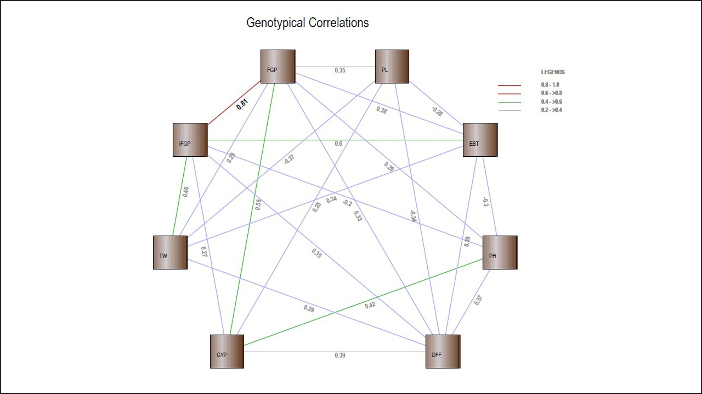 | 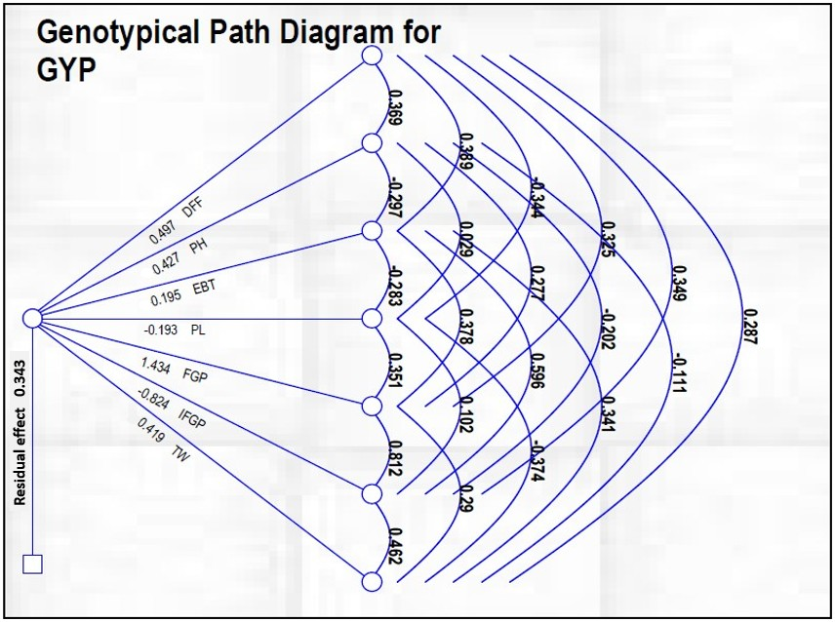
Figure 2. study of Correlation and Path analysis in the advanced breeding lines of paddy

