Performance Assessment of Soil Moisture Sensors for Precision Irrigation Scheduling

Abstract
Efficient water management is critical where water scarcity limits crop productivity. In order to overcome this problem, soil moisture sensors have been used for precision irrigation scheduling; however very less studies have compared different sensor types and their impact in vegetable crops. The study was conducted at Water and Land Management Training and Research Institute (WALAMTARI), Hyderabad to evaluate the performance of Electrical Resistance and Capacitance basedsoil moisture sensors for precision irrigation scheduling in a bottle gourd crop. Sensors were installed at two soil depths (0-15 cm, 15-30cm) and readings were compared with gravimetric soil moisture measurements and performance metrics included Mean Square Error (MSE) and Root Mean Squared Error (RMSE) were calculated. Results indicated that capacitance sensors provided more consistent and responsive measurements across varying soil moisture levels, while ER sensors showed greater variability under field conditions. Capacitance sensors were installed in bottle guard field and yield matrices were recorded. From the results, it can be concluded that Capacitance-based soil moisture sensor based irrigation system improved yield by 21% and irrigation water use efficiency by 51% compared to existing manual irrigation practice. Thus, it is recommended for precision irrigation scheduling to improve water use efficiency and crop productivity.
Keywords: Capacitance Soil Moisture Sensor, Electrical Resistance Soil Moisture Sensor, Irrigation Scheduling

Introduction
Soil moisture is a hydrological variable that influences numerous hydrological, climatic, and vegetation growth processes. Soil water storage is the main source of water for plants in between rainfall events, which affects crop yields. Soil moisture levels also influence decisions about on-farm water management, such as when to plant, when to use pesticides and herbicides, when to apply fertiliser, and when to schedule irrigation.(Brocca et al.2017;Sarwar et al.2021,Zhang et al 2019; Talukder et al.2023).Although soil moisture plays a major role in agricultural water security, it is also a reliable indicator of future crop output (Tian et al.2019; Efty et al.2025; Tabassum,2024). In terms of soil moisture, the depth of soil water storage is the most important factor. Soil moisture is primarily controlled by the depth of the root zone, which is the area where plants can receive water. The amount of precipitation, the amount of water applied to the soil, and the ground's drainage all influence how deep the root zone should be. When it comes to agricultural hydrologic features of soil moisture, the Surface Soil Moisture (SSM )(moisture depth up to 10 cm), is seen to be a better representative sample of soil for these kinds of agricultural water management studies(Corti et al. 2011).
The methods of soil moisture measurement can be divided into (i) direct methods, which physically measure the amount of moisture in the soil sample by weighing the soil (a portion of its total weight) using thermo gravimetric analysis, and (ii) indirect methods, which measure another variable influenced by soil moisture to determine the amount of moisture available in the soil for laboratory and field measurements(Dorigo et al.2011;Robock et al.2000).The most precise technique for measuring Soil Volumteric Content (SVWC), gravimetric measurement, is laborious, time-consuming and does not provide real time data (Kargas et al.2012). This resulted in development of indirect techniques for measuring SVWC(Zhang et al.2016;Yu et al.2013).Different types of soil moisture sensors used in indirect techniques are Capacitance based soil moisture sensor, Time and Frequency domain reflectometer, Watermark (Electrical resistance blocks), Tensiometer,Resistor type sensors etc.,(BK Rao and Rajput, 2008; BK Rao and Rajput, 2009;Ramya et al.2025)
The most popular indirect methods for estimating soil moisture in research and on-farm applications are capacitance and electrical resistance (ER) sensors because of their ease of use, low cost, and suitability for ongoing field monitoring(Adla et al.2019). While electrical resistance sensors measure the change in electrical conductivity between electrodes embedded in a porous medium as it equilibrates with the surrounding soil moisture, capacitance sensors use changes in the soil's dielectric constant to estimate the water content of the soil. The main objectives of this study are: 1) To evaluate the performance of electrical resistance (ER) and capacitance-based soil moisture sensors under controlled conditions and determine suitable sensor.2)To evaluate the impact of sensor-based irrigation scheduling on yield and irrigation water use efficiency of bottle gourd compared to general manual irrigation practices. In this study,the performance of capacitance and electrical resistance soil moisture sensors were tested and assessed. Their capacity to record changes in soil moisture at various depths and soil moisture regimes was the main focus of the evaluation. This comparison offers important insights for choosing the right sensor types to assist precise irrigation scheduling and effective soil water management in water-scarce contexts and extensive use in agricultural water management.
2.MATERIALS AND METHODS
The study was carried out in the Research farms of Water and Land Management Training and Research Institute (WALAMTARI) which is situated in Rajendra nagarmandal of Hyderabad district, Telangana. The Coordinates of the study area are 17°19'37.17"Nʺ latitude and 78°22'45.75"Eʺ longitude and it is situated 542m above mean sea level. The study area falls in arid area and except during the south west monsoon season it is generally dry area. The Average rainfall of the study area is 745 mm, of which major share is from the south west monsoon. The average annual maximum temperature is: 34° Celsius (92° Fahrenheit) and the average annual minimum temperature is: 22° Celsius (72° Fahrenheit).
2.1 Soil Moisture Sensors Used
2.1.1 Electric Resistance Soil Moisture Sensor
The sensor consists of two probes are used to measure the water's volumetric content. To determine the volumetric water content, an electrical resistance (ER) sensor typically consists of two probes or electrodes inserted into the soil. When a small electrical current is passed between these probes, the resistance to the current flow is measured. Since water is a better conductor of electricity than dry soil, the resistance decreases as soil moisture increases. Conversely, when the soil becomes dry, its electrical conductivity decreases, resulting in higher resistance values. Therefore, the measured resistance is inversely related to the soil’s moisture content, allowing estimation of volumetric water content based on established calibration relationships.(Aravind et al.2015;Saleh et al. 2016)

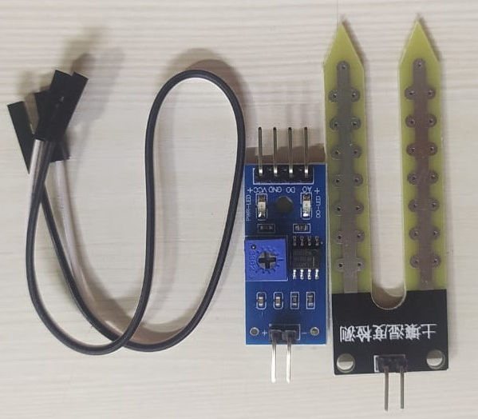
Fig.1.Resistance based Soil Moisture Sensor- YL-69
2.1.2 Capacitance Soil Moisture Sensor
To determine the volumetric water content, a capacitance-based soil moisture sensor operates on the principle of measuring the dielectric constant of the soil. The sensor typically consists of two electrodes that form an electrical capacitor, with the soil acting as the dielectric medium between them. Because the dielectric constant of water is much higher than that of air or dry soil minerals, the overall capacitance of the sensor increases as the soil moisture content rises. The sensor measures the change in capacitance, which is then converted into volumetric water content through calibration. Thus, capacitance sensors indirectly estimate soil moisture based on variations in the soil’s dielectric properties associated with changes in water content.(Adla et al.2019)
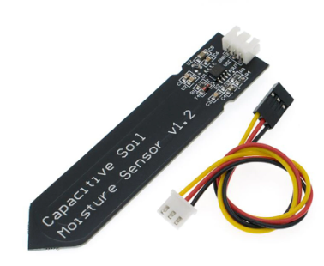
Fig.2.Capacitance based Soil Moisture Sensor
Table 1. Description of sensors used in the study.
Measurement  Technique | Soil Moisture Sensor (Company) | Specifications | Cost
Resistance based | YL-69 | Operating Voltage: 3.3V – 5V  Output:Analog/Digital | 100
Capacitance based | Df Robot | Operating Voltage: 3.3V – 5.5V  Output: Analog (0–3V) | 900

2.2 Soil Moisture Sensor Selection and Sensor Evaluation
Sensor based soil moisture measurement unit was developed and evaluated at research farm of WALAMTARI,Hyderabad.In this system, two sensors of different types as mentioned earlier were placed at two different depthsi.e. 15 cm and 30 cm as shown in Fig.3. Soil samples were collected along with the readings of each type of sensor at two depths. In order to validate sensor accuracy, moisture content was determined using gravimetric method and compared with readings obtained by two different sensors. Mean Square Error(MSE) and Root Mean Square Error (RMSE) were determined for Resistance based and Capacitance based soil moisture readings at two different depths to assess the accuracy and reliability of the sensors.
To evaluate the performance of the sensors, soil moisture readings from resistance-based and capacitance-based sensors were compared against gravimetric measurements at two different soil depths ( 0–15 cm and 15–30 cm). The accuracy of the sensors was quantified using Mean Square Error (MSE) and Root Mean Square Error (RMSE), calculated as follows (Adla et al.2020;Kumat et al.2025):
MSE(%)=$\frac{1}{n}\sum_{i=1}^{n}{(}\frac{S\text{i}-G\text{i}}{G\text{i}}×100$)²
RMSE=$\sqrt{MSE\% }$

where S_{i} is the soil moisture measured by the sensor, G_{i} is the corresponding gravimetric measurement, and n is the total number of observations. These metrics provide insight into the deviation of sensor readings from the reference values and help in assessing their reliability for field applications.
A comparative study was conducted between the resistance based and Capacitance based soil moisture sensors. The capacitance-based sensor performed better than the resistance sensor, displaying reduced MSE and RMSE values at both depths, according to the comparative study. As a result, the capacitance sensor was chosen for ongoing field monitoring, and it was used for all field observations of soil moisture and irrigation scheduling in the bottle gourd field.
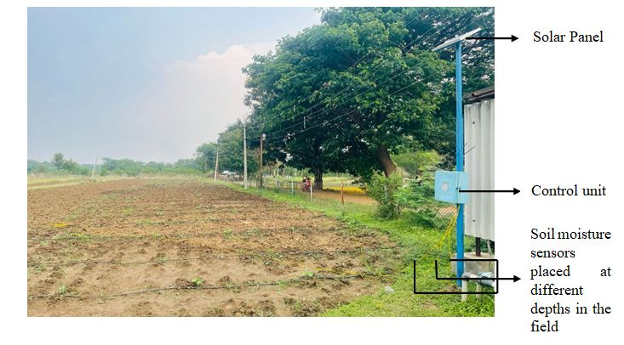
Fig.3. Deployed sensor based soil moisture measurement system in the Bottle guard field
2.3 Field Evaluation in Bottle Guard Field
After sensor selection, capacitance-based soil moisture sensor was installed in the bottle gourd field to determine the soil moisture status in the field during the growing season. To help with irrigation scheduling and guarantee the best possible soil water management in the research area's dryland conditions, ongoing observations were documented (Fig.4).In order to schedule the irrigation, field capacity and permanent wilting point were determined using pressure plate apparatus.Observations were recorded during the growing season to schedule the irrigation and ensure optimal soil water management in the study area.Yield-related metrics were measured at harvest, including total yield per hectare, average fruit weight, and number of fruits per plant.

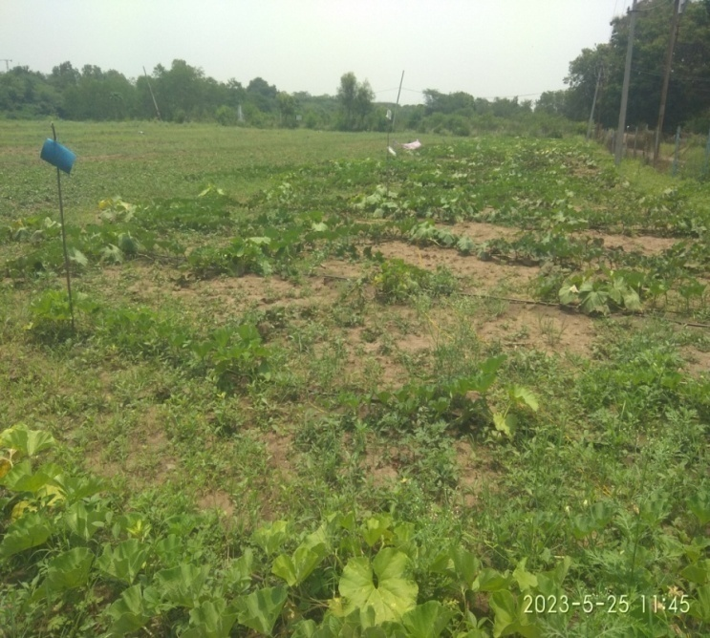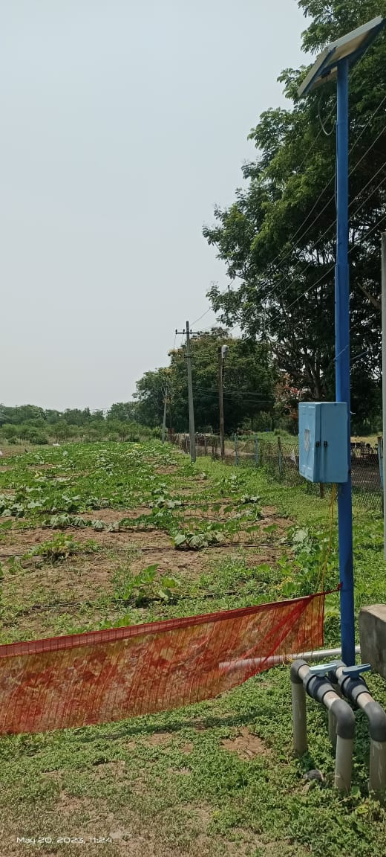
Fig.4Field evaluation of developed sensor based soil moisture measurement system
3. RESULTS AND DISCUSSION
3.1 Performance Assessment of Electrical Resistance and Capacitance based Soil Moisture Sensors
Soil moisture status was determined using gravimetric method and compared with readings obtained by resistance and capacitance based soil moisture sensors. From fig 5 and 6, it can be seen that, the gravimetric method yielded significantly higher results compared to sensor-based measurements, demonstrating its accuracy as a direct method. The capacitive sensor closely followed the gravimetric trend and demonstrated good calibration accuracy and dependability. Overall, the use of capacitive sensors for field monitoring is validated by the strong agreement between gravimetric and capacitive data.

Fig.5.Soil Moisture Dynamics during Irrigation Events (at 15 cm depth)

Fig.6Soil Moisture Dynamics during Irrigation Events (at 30 cm depth)
The Mean Squared Error (MSE), a measure of sensor accuracy, at two distinct soil depths (Fig.7) (15 cm and 30 cm) showed a notable difference between the two sensor types. The MSE values of the ER sensor were significantly higher, showing a larger variation from the reference gravimetric readings and, consequently resulted in a lower level of accuracy. At both depths, however, the capacitive sensor reported significantly lower MSE values, indicating higher precision and closer agreement with the gravimetric approach when calculating soil moisture. Both sensors' somewhat lower MSE at 30 cm suggests increased stability and less surface variability at deeper layers. Findings of the study showed that the capacitive sensor performed well compared the ER sensor in accuracy and consistency across soil depths, making it a more reliable tool for in situ soil moisture monitoring under field conditions. Similarly, Root Mean Squared Error (RMSE) which is also a measure of sensor accuracy, showed the greater deviation between the two sensor types. The RMSE values of ER sensor were higher showing larger deviation from the gravimetric readings resulted in lower accuracy. Unlike ER sensor, Capacitive sensor showed lower RMSE values resulted in higher accuracy.From the Fig. 7 and 8, it can be concluded that capacitive sensor performed well compared to ER sensor in determining soil moisture status. Similar findings were reported by Adla et al.2020;Kargas and Soulis, 2012; who reportedthat capacitance based soil moisture performedwellin field conditions.

Fig.7Comparison of sensor accuracy (MSE) at different soil depths

Fig.8Comparison of sensor accuracy (RMSE) at different soil depths

3.2 Field Observations
The field capacity and permanent wilting point were calculated as 42.6% and 20.5% respectively. Irrigation was scheduled at 50% of available water i.e 31.5%. Irrigation was provided once the soil moisture reading reached to 31.5 %. Yield-related metrics were measured at harvest, including total yield per hectare, average fruit weight, and number of fruits per plant. The impact of sensor based irrigation technique on yield and water use efficiency was assessed using these data.From the table.2, it is concluded that sensor based irrigation system provide more yield and other parameters compared to manual irrigation. In comparison to manual irrigation, sensor-based irrigation showed a significant improvement in crop performance and water productivity (Table 2). The overall yield of bottle gourd rose by almost 21% from 25.4 t ha⁻¹ (Manual) to 30.7 t ha⁻¹(Sensor irrigation). No of fruits per plant (10), and a greater average fruit weight (920 g), were the main factors contributing to the yield increase. This suggests that optimal soil moisture availability enhanced fruit development and decreased water stress throughout crucial developmental stages of bottle guard. Sensor-based irrigation also improved fruit size characteristics, including as length (30.2 cm) and diameter (6.9 cm), indicating improved nutrient and water uptake efficiency.When compared to manual irrigation, the implementation of soil moisture sensor-based irrigation increased irrigation water use efficiency by almost 51%, showing noticeably higher water productivity and enhanced irrigation control.
Results were in line with the study conducted by Mahmoud (2020), who reported that irrigation applied using soil moisture sensor improved yield and irrigation water use efficiency in bottle guard field. Ahuchaogu et al.2024 reported that automated drip irrigation system using soil moisture sensor increase efficiency, productivity and profitability of farming operations as well as the maximum crop yield with minimum use of irrigation waterstudy. Wheeler et al.2018 conducted a study on sensor based automated irrigation in Floriculture production and reported that the number of plants under sensor-controlled irrigation systems increased steadily as the technology gained confidence and was adopted more widely. Automated sensor-based irrigation made it easier to reallocate workers from regular watering duties to other vital functions, especially during periods of high production and shipment. Additionally, the study showed that the system's full-scale implementation would pay for itself in about 1.5 years, mostly as a result of lower labour costs and increased irrigation efficiency.Thus, the automated soil moisture based irrigation system ismore efficient in optimizing crop productivity and resource use(Monica et al.2017;Pramanick et al.2022; Munyaradzi et al.2022).
Table.2Comparison of Yield-Related Parameters under Manual and Sensor-Based Irrigation
Sl. No. | Parameter | Unit | Manual Irrigation | Sensor-Based Irrigation
1 | Total Yield | t/ha | 25.4 | 30.7
2 | Average Fruit Weight | g | 840 | 920
3 | Number of Fruits per Plant | Count | 8 | 10
4 | Fruit Length(Average) | cm | 28.1 | 30.2
5 | Fruit Diameter(Average) | cm | 6.5 | 6.9
6 | Irrigation Water Use Efficiency | Kg/m³ | 4.23 | 6.39

4.CONCLUSION
A field test was conducted at WALAMTARI, Hyderabad using Electrical Resistance (ER) and Capacitance-based soil moisture sensors to determine their suitability for precise irrigation scheduling in semi-arid conditions. The field evaluation of Electrical Resistance (ER) and capacitance soil moisture sensors in a bottle gourd crop, demonstrated that both sensor types can effectively monitor soil moisture trends for irrigation scheduling. Capacitance sensors showed higher accuracy, stronger correlation with gravimetric measurements, and faster response to irrigation events, making them more reliable for precision irrigation scheduling on the other hand ER sensors, while sensitive at low soil moisture levels, exhibited greater variability under field conditions and are more suited for general monitoring with careful calibration. This study highlights the importance of selecting the appropriate soil moisture sensor to optimize water use efficiency and crop productivity in semi-arid regions. Capacitance sensors were installed in a bottle gourd field, and yield parameters were recorded to assess their effectiveness in irrigation scheduling. Results of the study showed that, in comparison to existing manual irrigation techniques, the capacitance-based soil moisture sensor irrigation system increased yield by 21% and improved irrigation water use efficiency by 51%. In order to ensure improved water use efficiency, increased crop output, and sustainable resource utilization in semi-arid conditions, it is recommended that capacitance-based soil moisture sensors be used for precision irrigation scheduling.

Disclaimer (Artificial intelligence)
Author(s) hereby declare that NO generative AI technologies such as Large Language Models (ChatGPT, COPILOT, etc.) and text-to-image generators have been used during the writing or editing of this manuscript.

REFERENCES
Adla, S., Rai, N. K., Karumanchi, S. H., Tripathi, S., Disse, M., &Pande, S. (2020). Laboratory calibration and performance evaluation of low-cost capacitive and very low-cost resistive soil moisture sensors. Sensors, 20(2), 363.
Ahuchaogu, I. I., Okwong, E. E., Udoumoh, U. I., Ehiomogue, P. O., & Wilson, U. (2024). Development of an automated drip irrigation system using soil moisture sensor. PoljoprivrednaTehnika, 49(4), 1–15.
Aravind, P., Gurav, M., Mehta, A., Shelar, R., John, J., Palaparthy, V. S., Singh, K. K., Sarik, S., &Baghini, M. S. (2015). A wireless multi-sensor system for soil moisture measurement. IEEE Sensors Conference Proceedings, 1–4.
Brocca, L., Ciabatta, L., Massari, C., Camici, S., &Tarpanelli, A. (2017). Soil moisture for hydrological applications: Open questions and new opportunities. Water, 9, 140.
Corti, T., Wüest, M., Bresch, D., & Seneviratne, S. I. (2011). Drought-induced building damages from simulations at regional scale. Natural Hazards and Earth System Sciences, 11, 3335–3342.
Dorigo, W. A., Wagner, W., Hohensinn, R., Hahn, S., Paulik, C., Xaver, A., Gruber, A., Drusch, M., Mecklenburg, S., & van Oevelen, P. (2011). International Soil Moisture Network: A data hosting facility for global in situ soil moisture measurements. Hydrology and Earth System Sciences, 25, 5749–5804.
Kargas, G. and Soulis, K.X., 2012. Performance analysis and calibration of a new low-cost capacitance soil moisture sensor. Journal of Irrigation and Drainage Engineering, 138(7), pp.632-641.
Mahmoud, A. K. (2020). Modelling of water requirements for some vegetable crops under Ismailia conditions. [Master’s thesis or report].
Monica, M., Yeshika, B., Abhishek, G. S., Sanjay, H. A., &Dasiga, S. (2017, October). IoT-based control and automation of smart irrigation system: An automated irrigation system using sensors, GSM, Bluetooth and cloud technology. In 2017 International Conference on Recent Innovations in Signal Processing and Embedded Systems (RISE) (pp. 601–607). IEEE.
Pramanik, M., Khanna, M., Singh, M., Singh, D. K., Sudhishri, S., Bhatia, A., & Ranjan, R. (2022). Automation of soil moisture sensor-based basin irrigation system. Smart Agricultural Technology, 2, 100032.
Ramya, B., Tripathi, M. P., Rao, B. K., &Khalkho, D. (2025). Effectiveness of rainfall for major crops grown under the canal command areas of Musi Irrigation Project in Telangana, India. International Journal of Environment and Climate Change, 15(8), 209–216.
Rao, B. K., & Rajput, T. B. S. (2008). Rainfall effectiveness for different crops in canal command areas. Unpublished/Institutional Report.
Rao, B. K., & Rajput, T. B. S. (2009). Decision support system for efficient water management in canal command areas. Current Science, 96(1), 90–98.
Robock, A., Vinnikov, K. Y., Srinivasan, G., Entin, J. K., Hollinger, S. E., Speranskaya, N. A., Liu, S., &Namkhai, A. (2000). The Global Soil Moisture Data Bank. Bulletin of the American Meteorological Society, 81, 1281–1300.
Saleh, M., Elhajj, I. H., Asmar, D., Bashour, I., &Kidess, S. (2016). Experimental evaluation of low-cost resistive soil moisture sensors. In Proceedings of the IEEE International Multidisciplinary Conference on Engineering Technology (IMCET) (pp. 179–184). Beirut, Lebanon.
Sarwar, A., Peters, R. T., Shafeeque, M., Mohamed, A., Arshad, A., Ullah, I., Saddique, N., Muzammil, M., & Aslam, R. A. (2021). Accurate measurement of wind drift and evaporation losses could improve water application efficiency of sprinkler irrigation systems—A comparison of measuring techniques. Agricultural Water Management, 258, 107209.
Spectrum Technologies. (2014). Waterscout SM100 Soil Moisture Sensor Product Manual. Spectrum Technologies, Inc., Plainfield, IL, USA. Retrieved from https://www.specmeters.com/assets/1/22/6460_SM1002.pdf=
Tian, H., Huang, N., Niu, Z., Qin, Y., Pei, J., & Wang, J. (2019). Mapping winter crops in China with multi-source satellite imagery and phenology-based algorithm. Remote Sensing, 11, 820.
Wheeler, W. D., Thomas, P., van Iersel, M., & Chappell, M. (2018). Implementation of sensor-based automated irrigation in commercial floriculture production: A case study. HortTechnology, 28(6), 719–727.
Yu, X. Q., Wu, P. T., Han, W. T., & Zhang, Z. L. (2013). A survey on wireless sensor network infrastructure for agriculture. Computer Standards & Interfaces, 35, 59–64.
Zhang, D. J., & Zhou, G. Q. (2016). Estimation of soil moisture from optical and thermal remote sensing: A review. Sensors, 46, 1308.
Zhang, K., Wang, S., Bao, H., & Zhao, X. (2019). Characteristics and influencing factors of rainfall-induced landslide and debris flow hazards in Shaanxi Province, China. Natural Hazards and Earth System Sciences, 19, 93–105.
Munyaradzi, M., Hapanyengwi, G., Masocha, M., Mutandwa, E., Raeth, P., Nyambo, B., Murwira, A. and Mashonjowa, E., 2022. Precision Irrigation Scheduling Based on Wireless Soil Moisture Sensors to Improve Water Use Efficiency and Yield for Winter Wheat in Sub‐Saharan Africa. Advances in Agriculture, 2022(1), p.8820764.
Talukder, M. A. R., Hore, S., & Hore, R. (2023). A review of soil chemical properties for Bangladesh perspective. Western European Journal of Modern Experiments and Scientific Methods, 1(1), 52–65.
Efty, S., Hore, S., Sakib, F. A., & Kumar, J. (2025). Phosphate removal from water: A comparison of adsorbents. Journal of Global Ecology and Environment, 21(3), 230–241.
Kumar, A., Sarangi, A., Singh, D. K., Khanna, M., Mani, I., Dash, S., & Bandyopadhyay, K. (2025). Assessing capacitance soil moisture sensors for precision irrigation scheduling in wheat crop. Agriculture Bioscience, 6(1), 25.* https://doi.org/10.31058/j.agbs.2025.61025
Tabassum, M. (2024). Precision irrigation scheduling using real-time environmental data. International Journal on Computational Modelling Applications, 1(2), 20–34.*

