ORIGINAL RESEARCH PAPER

DIFFERENTIAL IMPACT OF FLOOD PRONE AREAS ON HOUSEHOLD INSECURITY IN BIHAR: AN ANALYSIS OF FINANCIAL AND DIETARY ACCESS DISPARITIES

ABSTRACT
This study assessed the impact of flooding on food security in Bihar by comparing 250 households each from flood-prone and non-flood-prone areas, selected through stratified random sampling. The adapted Household Food Security Survey Module measured food security status. The research identifies significant differences between the two groups and examines socio-economic factors influencing food security. Statistical methods included mean, median, chi-square, Kruskal-Wallis, and Mann-Whitney tests. Findings show that flooding significantly worsens food insecurity, making flood-prone regions especially vulnerable. Food insecurity in Bihar is linked not only to environmental factors like flooding but also to structural poverty, weak governance, and ongoing malnutrition. These results highlight the need for targeted interventions in flood-affected areas that address both immediate and underlying socio-economic issues. Flooding increases existing vulnerabilities and hinders progress toward Sustainable Development Goal 2: Zero Hunger. An integrated approach that considers both environmental and socio-economic factors is essential to effectively address food insecurity in Bihar.
Keywords: Household food security, Flood-prone areas, Non-flood areas, and Sustainable Development Goals
Introduction
According to the Food and Agriculture Organization (FAO, 2008), food security is when everyone has reliable physical, social, and economic access to enough safe, wholesome food to live an active and healthy life. This definition is very important for people to grow. The National Food Security Act (NFSA, 2013) and the Sustainable Development Goals (SDGs) are two examples of national and international policies that stress how complex food security is. Bihar, which had more than 104 million people living there in 2011, is an example of a place where people don't have enough food. This is because of long-term poverty, a growing population, climate change, and problems with the government. Despite its significant agricultural output, Bihar still grapples with issues concerning food security and nutritional indicators (NITI Aayog, 2022). The Food and Agriculture Organization's (FAO) four-pillar framework was used to look at the factors that affect food security in Bihar. These are marketplace access, sanitation and wellness, agriculture productivity, and political and socioeconomic stability. Socioeconomic factors like caste, gender, landholding size, and migration are also part of the study. The study also looks into the link between food security outcomes in Bihar and the Sustainable Development Goals (SDGs), focusing on the roles of state initiatives, institutional capacity, and community-based interventions. The Food and Agriculture Organization (FAO) framework defines four interrelated aspects of food security: availability, access, usage, and stability (FAO, 2008). Food availability means that food is physically present, which is affected by how it is made, how it is distributed, and how it is brought in from other countries. Access is difficult in Bihar because land is divided into small plots, farming isn't very productive, irrigation isn't good enough, and a lot of crops are lost after harvest (World Bank, 2022). Access to food is determined by financial and physical constraints. Poverty, migration during the season, and restricted accessibility to markets in Bihar significantly hinder adequate nutrition. (Sen and Himanshu, 2004). Utilization is about how safe and healthy meals are and how well the body can absorb nutrients. In Bihar, the problems of bad sanitation, unsafe drinking water, and a high rate of anemia and stunting show how hard it is to make good use of the health and nutrition assets that are available. (NFHS-5, 2021). Stability means being able to handle things like floods, droughts, and changes in prices. Flood-prone riverine areas, drought-affected districts, and pervasive wage insecurity all make Bihar more vulnerable (Mall et al., 2019). These factors together make food security less stable. Bihar, especially the northern section, has a lot of humanitarian problems because it is so prone to flooding. North Bihar is one of the most flood-prone areas in the world, covering about 12.7% of India's total flood-prone area. This flooding happens all the time, usually because Himalayan rivers like the Kosi and Ganga overflow. It kills a lot of people and hurts the economy a lot.
For instance, NFHS-5 data indicate a stunting rate of 42.9%. Therefore, the flood hazard does not create vulnerability in a vacuum; rather, it acts as a severe destabilizing force on already fragile socio-economic systems. Even areas classified as NFPA (analogous to minimal-hazard zones like FEMA Zones C or X, generally above the 500-year flood level) maintain a "meaningful" low flood risk, suggesting that population resilience is low across the state. Bihar is once again in the grips of a familiar crisis: rising water levels causing floods and a paralyzed system. The Ganga has breached the danger mark, affecting over 9 districts in the state. According to the Central Water Commission, six river-monitoring stations exceeded the danger mark and nine stations breached the warning level. Satellite images show that around 15 per cent of the Patna district is flooded. In Bhagalpur, the affected area is slightly higher at 15.7 per cent. Begusarai has about 6.4 per cent of its land underwater, while in Khagaria, 8.5 per cent of the area is currently flooded (India Today’s Report 2025).

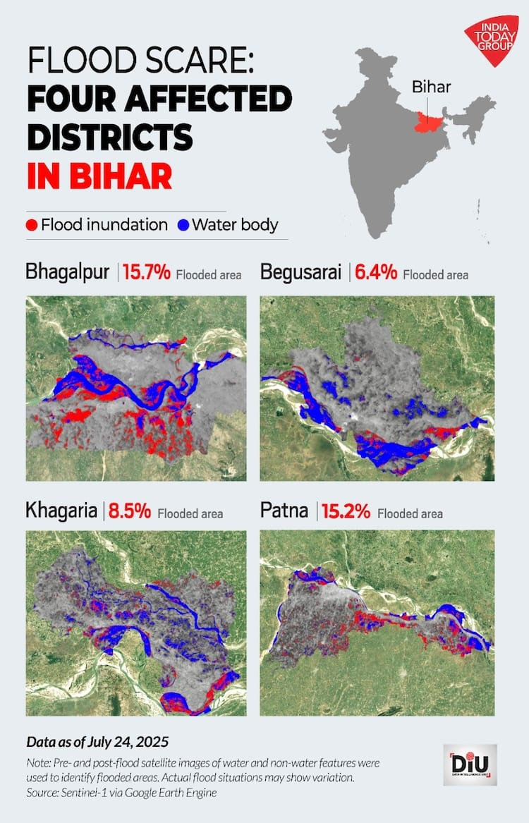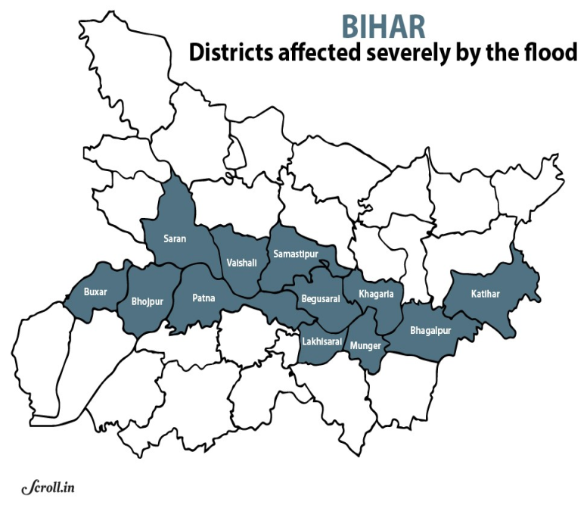
Map 1 Flood-affected district in Bihar
Sources:https://universalinstitutions.com/wp-content/uploads/2024/10/Bihar.png
The present floods are affecting almost 7.6 million people in 17 districts. North Bihar is thought to be "India's most flood-prone" territory, with 76% of its people at risk of flooding. The state has to deal with flash floods, river floods, drainage congestion floods, and waterlogging that lasts for a long time (PIB, The Hindu, Indian Express, Hindustan Report, 2025). Bihar is especially prone to flooding, which hurts people's livelihoods and, in turn, puts communities' food security and nutritional health at risk. It is very important to look into how disasters affect food security in flood-prone areas of Bihar. The main goal of this study is to look into the differences in financial and dietary availability that lead to food insecurity in various areas.
Methodology and Data Collection
Flood-prone and non-flood-prone areas were selected for analysis. The survey included 500 households, with 250 from flood-prone areas (Chhapra, Gopalgunj, and Siwan) and 250 from non-flood-prone areas. A cross-sectional design and multi-stage random sampling were employed. The sample comprised household heads, mothers, and children under five years. Data collection utilized a structured questionnaire and interview schedule, which was pretested and subsequently revised to ensure validity.
Data analysis entailed transforming qualitative responses from the Household Food Security Survey Module (HFSSM) into quantitative scores and categorized variables. Data on food security were gathered for groups that were likely to flood and groups that were not likely to flood. We used the right statistical tests to compare the groups, and we categorized HFSSM replies as "1" for yes and "0" for no. An inferential statistical analysis of the 500-household sample indicates that flood exposure is a key factor contributing to acute food poverty. The findings indicate consistent differences between the two groups in all aspects of household food access and utilization. The main statistical finding shows a very substantial difference (p-value < 0.001) between the FPA and NFPA groups on three important measures: being worried about food in general, not having enough money for food, and not being able to buy a balanced meal. The dual application of the Chi-Square test for association and the Mann-Whitney U test for directional severity (Saul M, 2025) strengthens this statistical assurance.

Results and discussion
The Household Food Security Survey Module (HFSSM) addresses financial and dietary access disparities.
Socio-economic statistical analysis of respondents
This section analyzes data on respondents' age and annual income.
Table 1: Socio-Economic Analysis of respondents(N=500)
Variables | Areas | Mean | Median
Age (years) | Flood-prone area (n=250) | 39.81 | 40.00
 | Non flood area (n=250) | 40.24 | 39.00
Annual Income(Rs.) | Flood-prone area (n=250) | 100742.63 | 90,000.00
 | Non flood area (n=250) | 165037.76 | 130000.00

Table 1 describes the socio-economic data analysis of respondents (N=500), i.e., the prone area (n=250) and non-flood-prone areas (n=250) (age group, annual income). The average age of the respondents was found to be 40 years old, suggesting a generally mature and economically active population. The mean and median (39.81 and 40.00) were very close, indicating a symmetrical age distribution in the case of flood-prone areas. In the other case, in the non-flood-prone areas the mean and median age was i.e 40.24 and 39.00 years old respectively, slightly higher than the flood-prone areas. This indicates that the relatively similar age across both areas, with no significant age difference based on flood exposure.
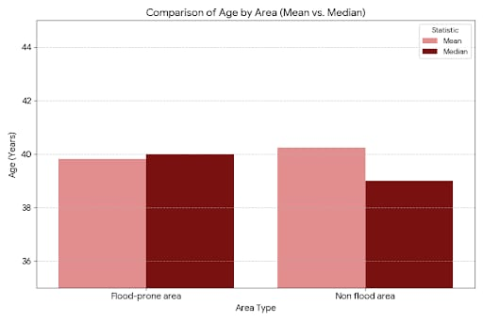
Figure 1. Comparison of ages by flood and non-flood-prone areas of Bihar
Annual income analysis indicates that households in flood-prone areas have a lower median income (Rs. 90,000), with the mean exceeding the median. In contrast, non-flood-prone areas report significantly higher incomes (mean: Rs. 165,037.76; median: Rs. 130,000). This disparity aligns with disaster research findings, where socio-economically disadvantaged populations are more likely to reside in hazard-prone areas. The median income difference between groups is Rs. 40,000.

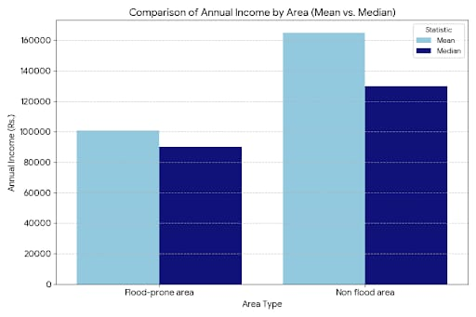
Figure 2. Comparison of Annual Income by flood and non-flood-prone areas of Bihar
The sex ratio in Table 1 showed that the mean (1.26) and median (1.00) suggest that the variables were coded as binary (1 for male and 2 for female). The mean being closer to 1.00 indicates a higher proportion of the group coded as ‘1’ (likely male) in the sample for the prone area. The values were almost identical to the flood-prone areas, suggesting a highly similar gender distribution across both groups.
Inferential Analysis: Disparities in Food Security
The high statistical significance (p<0.001) observed for all three variables provides strong evidence to reject the null hypothesis that there is no difference in food security outcomes between FPA and NFPA groups. A p-value less than 0.001 indicated that the probability of observing these results by random chance, assuming no actual difference exists, is less than 0.1%. However, the practical relevance of these differences was assessed using Cramér's V, an effect-size metric that measures the strength of association between the flood status variable and the food insecurity variables, ranging from 0 (no association) to 1 (perfect association). The interpretation of Cramer's V test is contextual and depends on the degrees of freedom (df=2 in this study).
Analysis of Generalized Worry: The Weakest Association (Variable 1, V=0.19)
The variable "Worried about food" resulted in a statistically significant association (X^2=18.52, p < 0.001), but the effect size (V=0.19) is classified as a weak association, falling just below the general threshold of 0.2. Although it is approaching the medium effect threshold (V=0.21) for df=2, its relative position is lowest among the three variables (www.ibm.com).
This finding suggests that while FPA households are statistically more worried about food, this anxiety is a widespread background condition throughout Bihar, rooted in structural poverty, dependence on volatile agriculture, and systemic issues in program delivery. The flood event (FPA status) contributes to this baseline worry, but other chronic factors contribute heavily to overall household anxiety, thus diluting the unique predictive power of FPA status on generalized worry. The weak effect size suggests that efforts focusing solely on reducing the psychological stress related to food (V=0.19) without addressing the fundamental economic instability (V=0.30) will likely be insufficient to improve overall household resilience (Kumar R, 2025).
The gradient of effect sizes (V=0.30 > V=0.25 > V=0.19) maps the precise transmission path of vulnerability: acute economic shock leads rapidly to utilization failure, which contributes to, but is not solely responsible for, generalized anxiety. This statistical pattern serves as a definitive guide for policy prioritization, indicating that interventions must address financial capacity (V=0.30) before expecting significant improvement in dietary quality (V=0.25) or generalized insecurity (Table 2).
Table 2: Inferential results for Household-Level questions of two groups i. e. Flood Prone Area (FPA) and Non-Flood Prone Area (NFPA) of Bihar(N=500)
S.No | Variables | Chi-Square test | df | Cramer's V (Effect Size) | Mann-Whitney U (p-value)
1 | Worried about food | 18.52 | 2 | 0.19 | <0.001
2 | Have no money for food | 45.18 | 2 | 0.30 | <0.001
3 | Not to afford to eat a balanced diet | 30.70 | 2 | 0.25 | <0.001

All variables in Table 2 demonstrated a statistically significant difference in response distribution between the Flood Prone Area (FPA) and Non-Flood Prone Area (NFPA) groups (p < 0.001). Variable 2 i.e, having no money for food, showed the highest practical relevance, with Cramer's V =0.30, indicating a medium effect size. This finding strongly supports the hypothesis that residing in an explicitly flood-prone area significantly increases psychological perceptions of vulnerability compared to non-flooded areas. The Mann-Whitney U tests confirmed that the FA group systematically ranked higher across all variables (1), indicating that the flood-prone population possesses demonstrably greater perceived risk and specific flood knowledge.
Crucially, the magnitude of this disparity, quantified using Cramer's V (Effect Size), establishes a clear hierarchy of impact, mandating prioritization of risk mitigation strategies. The strongest association with FPA status is the acute financial constraint ("Have no money for food," V=0.30), indicating that flood vulnerability acts primarily as an economic shock multiplier on household purchasing power. The impact on nutritional quality ("Not afford to eat a balanced diet," V=0.25) follows closely, reflecting the subsequent failure of food utilization. In contrast, generalized "Worry about food" (V=0.19) shows the weakest association (Table 3), suggesting this variable is less uniquely attributable to flood exposure than to the region's underlying chronic vulnerability.
The statistical evidence provides a clear policy imperative: integrated risk mitigation strategies must prioritize financial stabilization through proactive economic support and the enhancement of agricultural and market resilience to buffer the acute economic shock, as indicated by the highest effect size (V=0.30).
Table 3: Interpretation of effect size (Cramer’s V) for df=2
Variables | Carmer’s V | General classification | Cohen’s Guideline Comparison (df=2) | Practical Significance
Worried about food | 0.19 | Weak Association (ES≤0.2) | Approaching medium (Medium threshold=0.21) | FPA status is a weak differentiation of generalized worry
Not to afford eat balanced diet | 0.25 | Moderate Association (0.2< ES≤0.6) | Exceeds Approaching medium (Medium threshold=0.21) | FPA status is a robust, noticeable impact on constraining dietary quality
Have no money for food | 0.30 | Moderate Association (0.2<ES≤0.6) | Approaching large (large threshold=0.35) | FPA status is strongly associated with accurate financial barriers to food access.
Analysis of financial access: The highest impact (Variable 2, V=0.30)
The most pronounced difference between FPA and NFPA households centers on the question, "Have no money for food." This variable yielded the highest Chi-Square statistic (X^2=45.18) and the strongest effect size (V=0.30) (Bobbit Z 2024).
An effect size of V=0.30 represents a robust, practical difference between the two groups. Based on Cohen's guidelines for a contingency table with df=2, a medium effect is classified at V=0.21, and a large effect at V=0.35. The observed V=0.30 falls significantly above the medium threshold and is approaching the large effect boundary. This magnitude is the most critical differentiator between FPA and NFPA status, indicating that flood exposure disproportionately targets and demolishes the economic foundation necessary for food access (Cohen, J, 1988).
The highly significant Mann-Whitney U-test confirms that FPA households systematically report a greater lack of money for food compared to their NFPA counterparts. This means that floods do not merely disrupt earning capacity; they create an immediate and severe economic shock that results in acute financial barriers to food procurement. The data strongly indicate that floods degrade household food security primarily through the economic channel, in which livelihood losses and asset destruction translate immediately into an inability to maintain the cash flow needed to purchase food (Sam S S et al., 2021).
Analysis of Dietary Quality: The Nutritional Consequence (Variable 3, V=0.25)
The inability of households to afford a balanced diet resulted in the second highest association, with a Chi-Square statistic of X^2=30.70 and a moderate effect size of V=0.25. This association clearly exceeds the medium practical effect threshold (V=0.21 for df=2).
This finding demonstrates that flood exposure noticeably hinders households' ability to secure nutritionally adequate food. The magnitude of this effect (V=0.25) is logically after the acute financial shock (V=0.30). When cash is severely constrained and prices for fresh or diverse foods rise due to infrastructure and market disruptions, families are economically forced to ration or switch to cheaper, less nutritious alternatives. The strong correlation between FPA status and reduced balanced diet affordability highlights the direct threat floods pose to nutritional outcomes, which is of critical concern given the severe pre-existing malnutrition, wasting, and anemia issues prevalent in the region.
Conclusion
In Bihar’s flood-prone regions, food insecurity is more than just numbers. It is the daily reality for families whose lives are often disrupted by floods. Each season, floods take away not only crops and homes but also people’s livelihoods, dignity, and nutrition. The analysis shows that households in flood-prone areas face much greater challenges than those in safer regions. Floods make existing risks worse, turning a natural disaster into a long-term struggle with money and nutrition. The data show that the most direct impact is economic. When families lose their crops or daily income, they quickly face financial problems (V = 0.30), which soon leads to a poorer and less varied diet (V = 0.25). This is not just a theory; it is clear in every village where floods have forced families to eat less, cut back on protein, or rely on relief food. The results from both the Chi-Square and Mann–Whitney U tests confirm that living in a flood-prone area brings more hardship. To change this, we need to move from just reacting to floods to planning. It is also important to support farming that uses flood-tolerant crops, better drainage, and early warning systems to reduce both money loss and poor nutrition. Building these safety nets will help protect people’s livelihoods and give hope and stability to those living with the threat of floods.
Disclaimer (Artificial intelligence)
Option 1:
Author(s) hereby declare that NO generative AI technologies such as Large Language Models (ChatGPT, COPILOT, etc.) and text-to-image generators have been used during the writing or editing of this manuscript.
Option 2:
Author(s) hereby declare that generative AI technologies such as Large Language Models, etc. have been used during the writing or editing of manuscripts. This explanation will include the name, version, model, and source of the generative AI technology and as well as all input prompts provided to the generative AI technology
Details of the AI usage are given below:
1.
2.
3.

References
- FAO. An introduction to the basic concepts of food security. Food and Agriculture Organisation of the United Nations, 2008. 4. Government of Bihar. Economic Survey of Bihar 2021– 22. Finance Department, Government of Bihar, 2022.
- Mall RK, Gupta A, Singh R, Singh RS, Rathore LS. Water resources and climate change: An Indian perspective. Current Science, 2019: 101 (3): 356–371.
- NITI Aayog. National Multidimensional Poverty Index: A progress review. Government of India, 2022.
- NFHS-5. National Family Health Survey-5, 2019–21: Bihar factsheet. International Institute for Population Sciences (IIPS) & Ministry of Health and Family Welfare, 2021.
- World Bank. Agricultural transformation in Bihar: Opportunities and challenges. World Bank Group, 2022
- Sen A, Himanshu. Poverty and inequality in India: Getting closer to the truth. Economic and Political Weekly,2004:39(38):4247–4263.
- PIB, The Hindu, Indian Express, HindustanReport, 2025, https://universalinstitutions.com/annual-flood-crisis-north-bihars-ongoing-struggles/
- Understanding P-Values and Statistical Significance - Simply Psychology, https://www.simplypsychology.org/p-value.html
- Agricultural Resilience in Flood-prone Areas through Post-flood Crop Management and IBFI, https://www.icar.org.in/en/node/5304
- Flood Hazard and Risk Zonation in North Bihar Using Satellite-Derived Historical Flood Events and Socio-Economic Data- MDPI, https://www.mdpi.com/2071-1050/14/3/1472
- Flood Hazard and Risk Zonation in North Bihar Using Satellite-Derived Historical Flood Events and Socio-Economic Data–Research Gate, https://www.researchgate.net/publication/358143296_Flood_Hazard_and_Risk_Zonation_in_North_Bihar_Using_Satellite-Derived_Historical_Flood_Events_and_Socio-Economic_Data
- Challenges and Issues of Management of Flood Disaster Risk Reduction in North Bihar - IJIRT, https://ijirt.org/publishedpaper/IJIRT161839_PAPER.pdf
- Dimensions and determinants of food security in Bihar, https://www.socialsciencejournal.in/assets/archives/2025/vol11issue5/11120.pdf
- Flood vulnerability and food security in eastern India: A threat to the achievement of the Sustainable Development Goals | Request PDF– Research Gate, https://www.researchgate.net/publication/354627237_Flood_vulnerability_and_food_security_in_eastern_India_A_threat_to_the_achievement_of_the_Sustainable_Development_Goals
- What is my Flood Zone |National Flood Insurance Program, https://www.floodsmart.gov/flood-zones-and-maps/what-is-my-flood-zone
- What is My Flood Risk, https://www.floodsmart.gov/flood-zones-and-maps/what-is-my-flood-risk
- Food Insecurity Experience Scale | Voices of the Hungry, https://www.fao.org/in-action/voices-of-the-hungry/fies/en/
- The 18 Household Food Security Survey items provide valid food security classifications for adults and children in the Caribbean–Pub Med Central, https://pmc.ncbi.nlm.nih.gov/articles/PMC1459858/
- A simple guide to the use of Student's t-test, Mann-Whitney U test, Chi-squared test, and Kruskal-Wallis test in biostatistics-PMC–Pub-Med Central, https://pmc.ncbi.nlm.nih.gov/articles/PMC12366075/
- Cramér's V - IBM, https://www.ibm.com/docs/en/cognos-analytics/12.1.0?topic=terms-cramrs-v
- Mann-Whitney U Test [Simply explained]-YouTube, https://www.youtube.com/watch?v=LcxB56PzylA
- Categorical ordinal data: which test is better? [closed]- Cross Validated-Stack Exchange, https://stats.stackexchange.com/questions/518930/categorical-ordinal-data-which-test-is-better 16. How to Interpret Cramer's V (With Examples)-Statology, https://www.statology.org/interpret-cramers-v/
- Effect Size Chi-square Test | Real Statistics Using Excel, https://real-statistics.com/chi-square-and-f-distributions/effect-size-chi-square/
- Impact of flood on rural population and strategies for mitigation: A case study of Darbhanga district, Bihar state, India- Murray State's Digital Commons, https://digitalcommons.murraystate.edu/context/crsw/article/1109/viewcontent/Impact_of_Floods_on_Rural_Pop_and_Strat_for_Mitigation_A_Case_Study_in_India_Vikash_Kumar_et_al.pdf
- Bihar Flood 2021-Sphere India, https://www.sphereindia.org.in/sites/default/files/2022-05/4%20Floods%20in%20Bihar%20JRNA%20Report%20-%2013%20July%2021-1.pdf
- The impact of a flood forecasting tool on socioeconomic outcomes in Bihar, India - IDinsight, https://www.idinsight.org/project/the-impact-of-a-flood-forecasting-tool-on-socioeconomic-outcomes-in-bihar-india/
- Reducing Farmers' Risk through Flood-Tolerant Rice in India, https://www.povertyactionlab.org/evaluation/reducing-farmers-risk-through-flood-tolerant-rice-india

