Original Research Article

In silico analysis of andrographolide, a bioactive compound of Andrographis paniculata, against the androgen receptor and Steroid 17-alpha-hydroxylase/17,20 lyase as an anti-prostate cancer agent

Abstract
Prostate cancer incidence is high in male humans and male dogs. Increased male sex hormones play a vital role in pathogenesis. The treatment for prostate hyperplasia and prostate cancer is an androgen receptor inhibitor that inhibits the synthesis of androgen by blocking the enzyme Steroid 17-alpha-hydroxylase/17,20 lyase. This study aims to evaluate, using in silico approaches, the potential of andrographolide—a bioactive compound of Andrographis paniculata—to interact with the androgen receptor and steroid 17-alpha-hydroxylase/17,20-lyase, and to assess its potential as an anti-prostate cancer agent. Medicinal plant is an integral part of human life to combat suffering, and people depend either directly or indirectly on medicinal plants for the first line of treatment. Andrographis paniculata is an important medicinal plant and has a broad range of pharmacological effects. The active principle Andrographolide belongs to the class of diterpenoids. using Discover Studio and Auto Dock version 4.2, the docking score for the 30 phytochemicals of A. paniculatus is higher than -5. The docking for andrographolide against the target androgen receptor and Steroid 17-alpha-hydroxylase/17,20 lyase are -6.7 and -8.6, respectively. Andrographolide has been shown to comply with all aspects of Lipinski’s Rule of 5, indicating its drug-like properties. Consequently, it represents a promising lead compound for additional clinical investigations targeting prostate cancer. Further in vitro and in vivo evaluations are warranted to confirm its efficacy, safety, and potential for development as a promising lead molecule for further preclinical studies aimed at developing novel anti-androgen therapies for prostate cancer.
Keywords: Andrographolide, Androgen receptor, Medicinal plant ,20 lyase, prostate cancer

1. INTRODUCTION
Prostate cancer (PC) ranks as the second most frequently diagnosed cancer and is the fifth leading cause of cancer-related mortality among men globally, with more than 1,460,000 estimated cases and 396,000 deaths in 2022 (Ferlay et al., 2020). It is predicted that by 2040, the PC burden will have increased to approximately 2.4 million cases and 712,000 deaths solely because of the ageing and growing global population (Sung et al., 2021). The estimation by GLOBOCAN data shows 1,276,000 cases of prostate cancer worldwide in 2018, which is the same as an incidence rate of 29.3/100,000 men, and accounts for 7.1% prostate cancer cases when compared to all other cancer diagnoses (Nancy Jenifer et al., 2023). The androgen hormones, along with their corresponding androgen receptors, are recognised for their significant roles in the initiation and advancement of prostate cancer. The link between prostate cancer and androgens was initially established in 1941 by Huggins and his team, who demonstrated that lowering serum androgen levels through orchiectomy or the administration of exogenous oestrogen resulted in tumour regression and symptom relief, a breakthrough that earned Huggins a Nobel Prize. Since that time, the depletion of gonadal androgens has been the cornerstone of treatment for advanced prostate cancer. Nevertheless, while many patients show an initial positive response to androgen deprivation therapy, they almost always experience a relapse and develop resistance, leading to a transition of the disease into a castration-resistant form. Androgen-refractory tumours show increased intratumor synthesis of androgen and contain mutations in the androgen-receptor gene. These mutations increase the number of ligands that can activate the receptor. Thus, over the year, androgen receptor and enzymes for androgen synthesis have emerged as a potential and attractive target for Prostate cancer therapy (Messner et al., 2020). The drugs used against prostate cancer are getting resistance, so screening of herbs against prostate cancer is necessary. Structure-based virtual screening and subsequent analysis are emerging tasks in the realm of computer-aided drug discovery. Combining these two approaches to significantly minimise false positives from an extensive compound database is regarded as a crucial step in identifying lead compounds. Andrographis paniculata, commonly known as the "King of Bitterness," belongs to the Acanthaceae family. studies have identified 187 chemical constituents in Andrographis paniculata has been documented to exhibit a diverse array of pharmacological effects, including antiretroviral, immunomodulatory, analgesic, antimalarial, anticancer, antipyretic, hepatoprotective, antifertility, antimicrobial, anti-inflammatory, antivenom, antioxidant , cardioprotective, antidiabetic properties (Singha et al., 2003; Dai et al., 2019; Kaushik et al., 2020). Extracts of Andrographis effectively treat various ailments, as well as cancer. The most active molecule in Andrographis paniculata is andrographolide, a diterpene and lactone. Andrographis paniculata and its derivatives have long been used to treat various ailments (Deshmukh et al., 2024; Vetvicka & Vannucci, 2021). The present study focused on In-Silico analysis of andrographolide with the androgen receptor and enzyme for androgen synthesis against prostate cancer.
2. MATERIALS AND METHODS
2.1 Protein Preparation
The 3 Dimensional structures of the target proteins Androgen Receptor (AR; PDB ID-4OH6) (fig 1) and Steroid 17-alpha-hydroxylase/17,20 lyase (CYP17A1; PDB ID-5IRV) (fig 2) were sourced from the Protein Data Bank (PDB), an online repository for protein structures. The structures were resolved using the X-ray Diffraction technique and included ligands associated with the binding. The protein was subsequently cleaned by removing the bound complex molecule, the non-essential water molecules and all the heteroatoms.

2.2 Preparation of ligand
The structures of andrographolide (Fig. 3, 4) were retrieved from Pubchem in SDF format and transformed into PDB format through the Online SMILES Translator and Structure File Generator provided by the NCI/CADD Group (https://cactus.nci.nih.gov/translate). These structures were subsequently used for molecular docking analysis.

2.3 Molecular Docking
Following the preparation of the receptor and ligand, molecular docking analysis was conducted using AutoDock Version 4.2, which employs the Lamarckian Genetic Algorithm and an empirical free energy scoring function to assess hydrogen bond interactions and binding affinities. The AutoDock calculations are executed in several phases: 1) the preparation of coordinate files via AutoDockTools. These files are formatted in a specific AutoDock coordinate file format known as PDBQT, which entails adding polar hydrogen atoms, incorporating Kollman charges, assigning partial charges, defining atom types for proteins, and identifying the root for ligands. 2) The precalculation of atomic affinities is performed using AutoGrid, 3) ligands are docked using AutoDock, and 4) the results are analysed with AutoDockTools. After the minimisation process, the grid box resolution was set at 60× 60 × 60 Å along the x, y and z axes, respectively, at a grid resolution of 0.375 Å to define the binding site.

2.4 Drug Likelihood and Bioavailability
It is crucial for any compound to adhere to Lipinski's Rule of Five (Yang and Chen, 2004) to be developed as a pharmaceutical agent. The parameters of Absorption, Distribution, Metabolism, Elimination, and Toxicity (ADMET) are highly significant for a drug's availability within the system. To ascertain whether the phytochemicals meet the requirements for druglikeness, drug scans were performed. Drug likeness characteristics such as the number of hydrogen acceptors (which should not exceed 10) and hydrogen donors (which should not exceed 5), the molecular weight (which should exceed 500 daltons), and the partition coefficient log P (which should not fall below 5) were examined using Lipinski's filters. Drug scans were carried out to determine whether the phytochemicals fulfil the drug-likeness conditions. Lipinski’s filters were applied for examining drug likeness attributes as including quantity of hydrogen acceptors (should not be more than 10), quantity of hydrogen donors (should not be more than 5), molecular weight (mass should be more than 500 daltons) and partition coefficient log P (should not be less than 5).

3. RESULT AND DISCUSSION
Docking score

In the present in silico study, the docking interactions of andrographolide with the target proteins, androgen receptor (AR; PDB ID: 4OH6) and CYP17A1 (Steroid 17α-hydroxylase/17,20-lyase; PDB ID: 5IRV), were analysed. The docking score (ΔG) of the ligand–protein complex is a key indicator of binding affinity; values below 5 kcal/mol generally denote stable and potent interactions. The compound andrographolide exhibited binding energies of –6.7 kcal/mol and –8.6 kcal/mol with AR and CYP17A1, respectively (Fig. 5,6). These negative binding energies indicate strong interactions with both target proteins and reflect a high probability of receptor–ligand stability. When compared with standard inhibitors (Fig. 7, 8), andrographolide showed comparable binding affinities, suggesting its potential as a competitive ligand for both targets. Molecular interaction analysis revealed that andrographolide fits snugly within the ligand-binding domains of AR and CYP17A1, forming multiple hydrogen bonds and hydrophobic interactions with functionally important amino acid residues. The binding energy of –8.6 kcal/mol with CYP17A1suggests a particularly strong potential for interaction, which could inhibit androgen biosynthesis, an essential procedure in the development of prostate cancer. These results are in line with past research showing that andrographolide inhibits the production of AR and the growth of prostate cancer cells (Rajagopal et al., 2003). The medicinal potential of andrographolide is still supported by recent research as a natural inhibitor of signalling pathways implicated in tumorigenesis (Banerjee et al., 2016).

Drug likeness and ADMET prediction

Drug likeness and ADMET forecasting. In line with Lipinski’s Rule of Five, a compound is deemed drug-like if its molecular weight is under 500 Da, the log P value is 5, hydrogen bond donors are ≤ 5, and hydrogen bond acceptors are ≤ 10. According to Table 3, andrographolide has a molecular weight of 350.458 Da, a log P of 1.801, three hydrogen bond donors, and five hydrogen bond acceptors. Furthermore, the substance possesses a Topological Polar Surface Area (TPSA) of 86.99 Å². These values indicate that andrographolide satisfies all the physicochemical requirements for oral bioavailability and membrane permeability. Compounds following these criteria generally exhibit favourable pharmacokinetic behaviour. As poor absorption and bioavailability often hinder the success of natural products, andrographolide's compliance with Lipinski’s parameters supports its suitability as a drug-like molecule.

Comparative and Functional Implications
The docking analysis demonstrated that andrographolide binding affinities were comparable to those of clinically relevant AR and CYP17A1inhibitors (Tab 1&2). The ability of andrographolide to interact with both the androgen receptor and the enzyme responsible for androgen biosynthesis suggests a dual-target mechanism. This mechanism is therapeutically advantageous, as it could simultaneously suppress androgen production and receptor activation, thereby inhibiting prostate cancer progression through two converging pathways. Recent reports emphasise the potential of plant-derived terpenoids, including andrographolide, in modulating key cancer-related processes such as proliferation, apoptosis, and androgen signalling (Cheng et al., 2024; Dai et al., 2019). The results of the present study corroborate these findings, revealing energetically favourable interactions within both receptor and enzyme active sites. Pharmacokinetic predictions further reinforce its potential as a promising bioactive compound with oral bioavailability.

Limitations and Future Directions

While the docking scores suggest potent inhibitory potential, in silico results alone cannot confirm biological efficacy. The actual therapeutic performance of andrographolide depends on receptor occupancy in the cellular environment, compound stability, and its ability to penetrate tumour tissues. Resistance to AR-targeted therapies is often mediated by receptor splice variants lacking the ligand-binding domain and by androgen synthesis bypass mechanisms (Daniels et al., 2024). The dual-target inhibition of both AR and CYP17A1observed in this study may therefore help overcome such resistance mechanisms. For CYP17A1inhibition, abiraterone remains a clinically validated inhibitor; however, it is associated with adverse effects such as adrenal suppression and compensatory up-regulation of steroidogenic pathways (Attard et al. 2011). Andrographolide’s strong affinity for CYP17A1suggests that it may serve as a natural alternative with potentially lower toxicity, though this hypothesis requires validation through in vitro and in vivo research. Additional investigations should concentrate on enzyme inhibition tests, receptor-binding assays, cytotoxicity evaluations on prostate cancer cell lines, and animal studies to define andrographolide’s pharmacodynamic and pharmacokinetic characteristics. Optimising the structure-activity relationship (SAR) may enhance its selectivity, stability, and potency.

Table 1: Docking score of androgen receptor (AR; PDB ID:4OH6) against andrographolide and bicalutamide

LIGAND | Binding affinity energy (kcal/mol) | Intermolecular H bonds Distance (Å)
Phytochemical-andrographolide | -6.7 | 2.74
Drug-Bicalutamide | -6.5 | 1.81,1.97,2.17,2.43,2.59

Table 2: Docking score of steroid17-alpha hydroxylase/17, 20 lyase (CYP17A1; PDB ID: 5IRV) against andrographolide and abiraterone acetate

LIGAND | Binding affinity energy (kcal/mol) | Intermolecular H bonds Distance (Å)
Phytochemical-andrographolide | -8.6 | 1.99,2.44,2.47,2.75
Drug-Abiraterone Acetate | -10.5 | 2.69,3.05

Table 3: The drug- like parameters of Andrographolide
S. No | Properties | Value
1 | Slog P | 1.699
2 | Slog D | 1.699
3 | Mlog P | 1.801
4 | Molecular weight | 350.458
5 | Hydrogen Bond Donor | 3.000
6 | Hydrogen Bond Donor (MNo) | 5.000
7 | Topological polar Surface Area (TPSA) | 86.990
8 | Rule of 5 | 0
9 | Violation of Rule of 5 | Nil

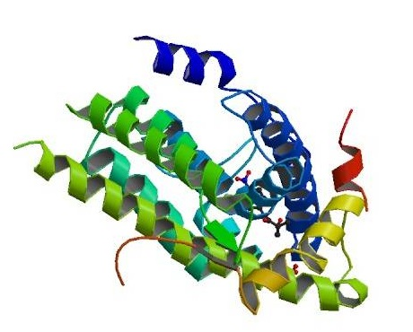  Figure 1:The crystal structure of the targets androgen receptor (AR; PDB ID: 4OH6) and | 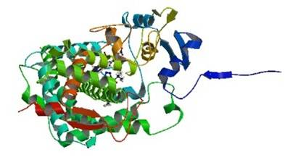  Figure 2:The Crystal structure of the targets CYP17A1 (Steroid 17α-hydroxylase/17,20-lyase; PDB ID: 5IRV)
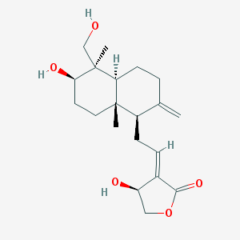  Figure 3:2D structure of andrographolide | Figure 4:3D structure of andrographolide

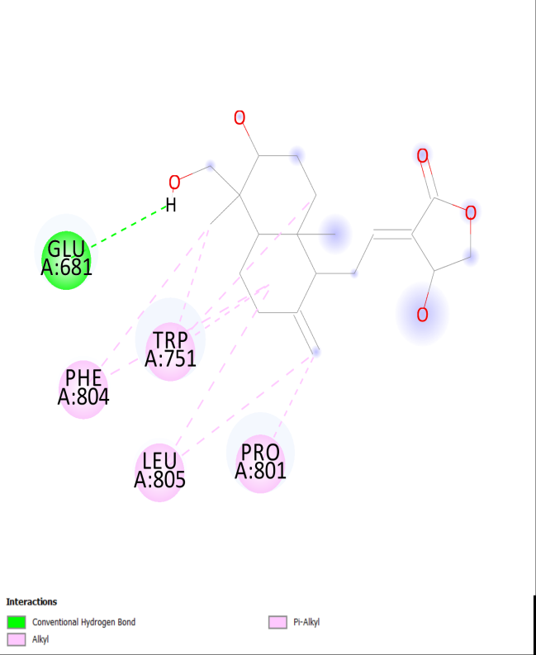 | 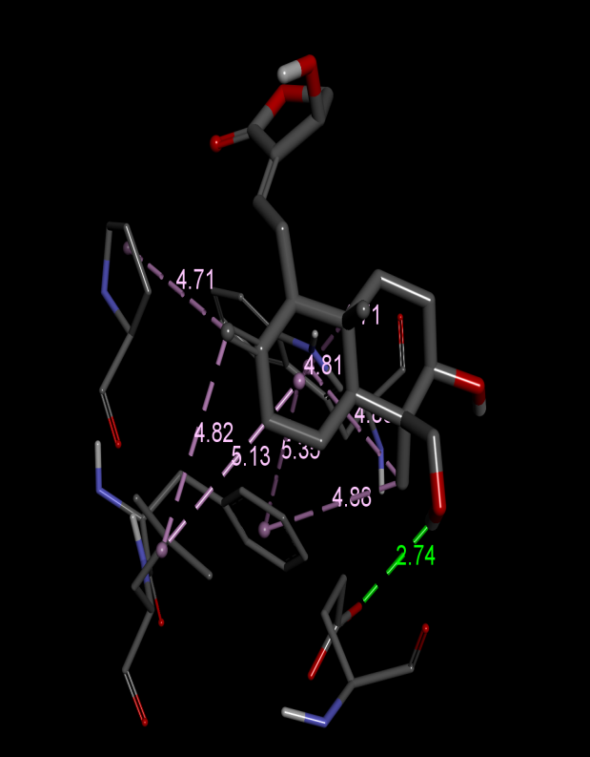
Figure 5:Interaction of andrographolide and androgen receptor

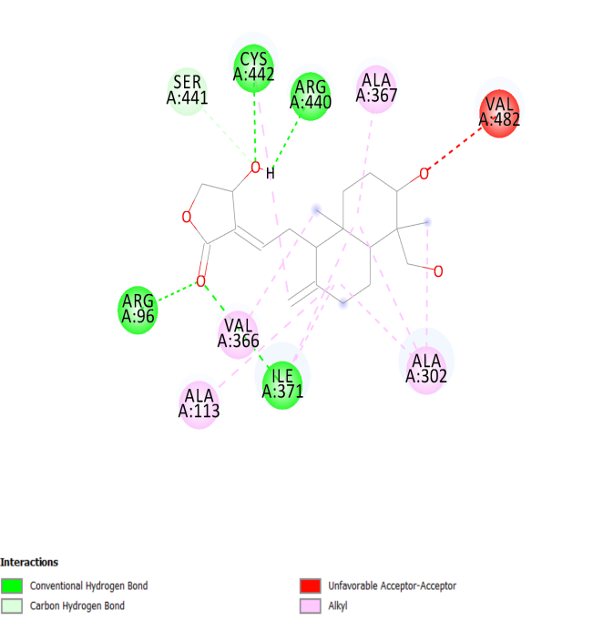 | 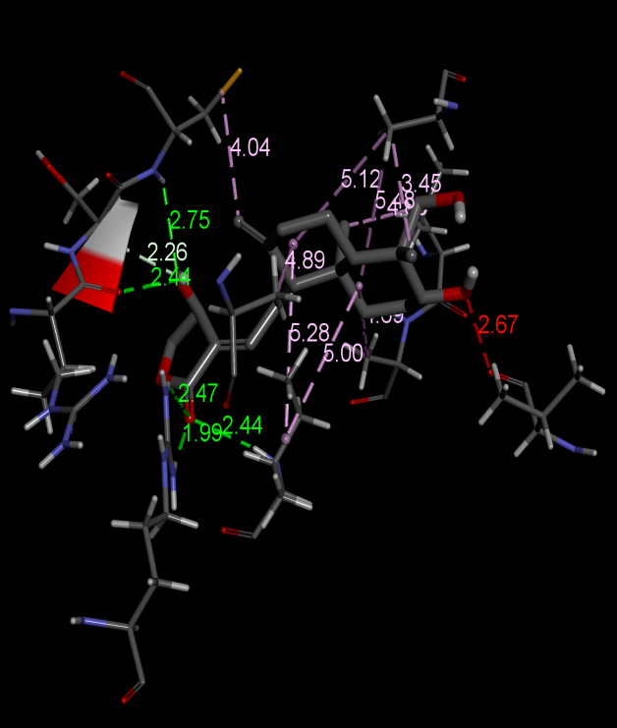
Figure 6:Interaction of andrographolide and steroid 17-alpha-hydroxylase/17,20 lyase

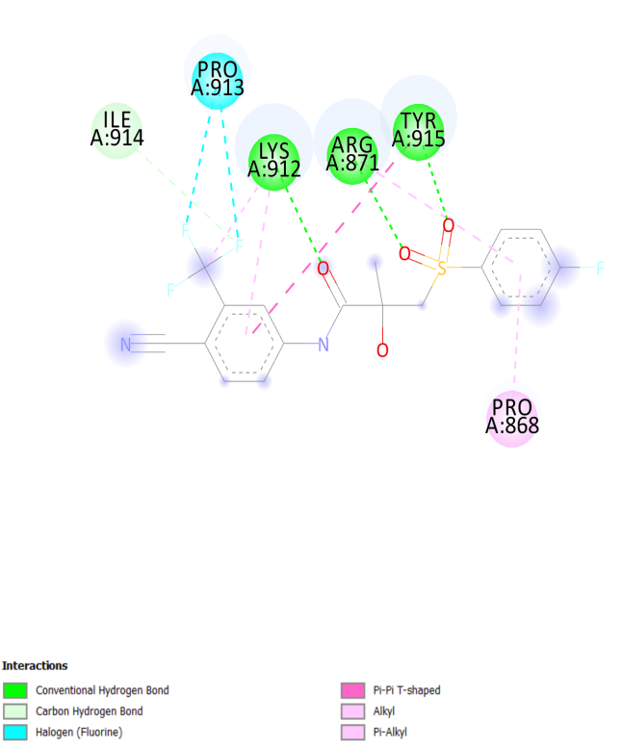 | 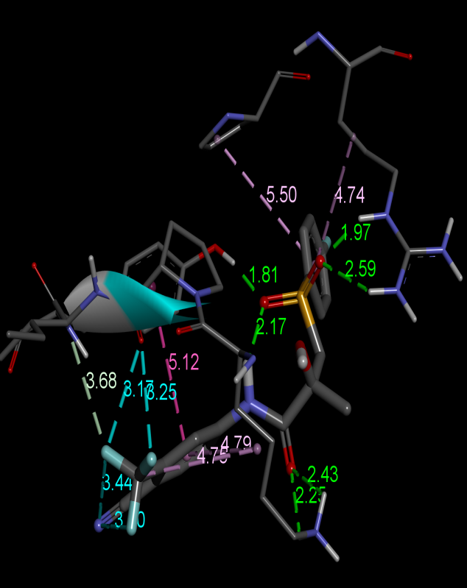
Figure 7:Interaction of Bicalutamide and androgen receptor

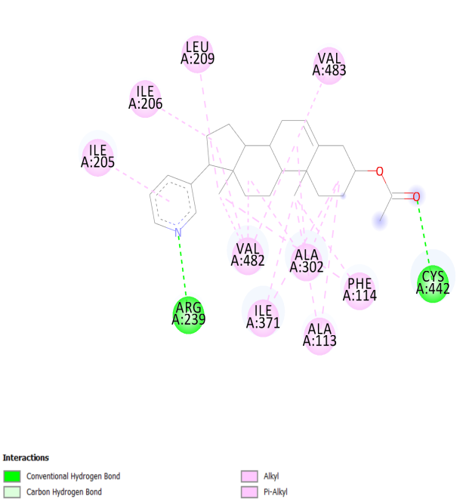 | 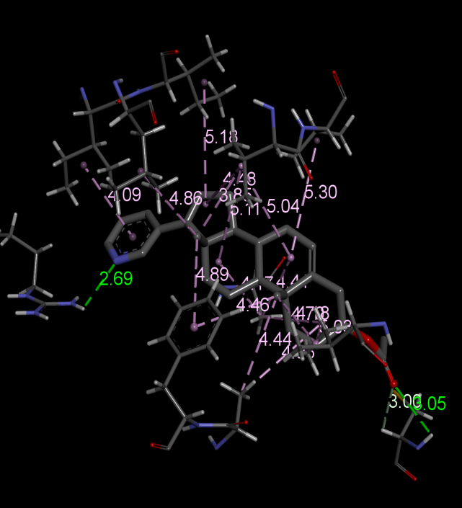
Figure 8:Interaction of abiraterone acetate and steroid 17-alpha-hydroxylase/17,20 lyase

CONCLUSION
The present in silico investigation demonstrates that andrographolide exhibits strong and energetically favourable interactions with both the androgen receptor and CYP17A1enzyme, with binding energies exceeding the threshold for potent inhibition. Its compliance with Lipinski’s Rule of Five and favourable physicochemical properties support its classification as a drug-like molecule. These findings indicate that andrographolide possesses significant potential as a natural dual-target inhibitor in androgen-dependent prostate cancer. Further in vitro and in vivo evaluations are warranted to confirm its efficacy, safety, and potential for development as a promising lead molecule for further preclinical studies aimed at developing novel anti-androgen therapies for prostate cancer.
Disclaimer (Artificial intelligence)
Author(s) hereby declare that NO generative AI technologies such as Large Language Models (ChatGPT, COPILOT, etc.) and text-to-image generators have been used during the writing or editing of this manuscript.
REFERENCES
Attard., Gerhardt., Alison HM Reid., Richard J., Auchus, Beverly A. Hughes, Amy Mulick Cassidy, Emilda Thompson, Nikhil Babu Oommen et al.(2012). clinical and biochemical consequences of CYP17A1 inhibition with abiraterone given with and without exogenous glucocorticoids in castrate men with advanced prostate cancer. The Journal of Clinical Endocrinology & Metabolism 97(2): 507-516.
Banerjee, M., Chattopadhyay, S., Choudhuri, T., Bera, R., Kumar, S., Chakraborty, B., Mukherjee, S.K. (2016). Cytotoxicity and cell cycle arrest induced by andrographolide lead to programmed cell death of MDA-MB-231 breast cancer cell line. J. Biomed. Sci. 16;23:40
Cheng, C.R., Zheng, Z., Liang, R.M., Li, X.F., Jiang, Q.Q., Yue, L., Wang, Q., Ding, J., and Liu, Y. (2020). Preparation and cytotoxic Activity of 3,19-analogues of 12-thioether andrographolide. Chem Nat Compd. 56:264–269.
Dai, Y., Chen, S.R., Chai, L., Zhao, J., Wang, Y., & Wang, Y., (2019). Overview of pharmacological activities of Andrographis paniculata and its major compound andrographolide. Crit. Rev. Food Sci. Nutr. 59:17-29.
Daniels, V,A., Luo, J., Paller, C,J., Kanayama, M. (2024). Therapeutic Approaches to Targeting Androgen Receptor Splice Variants. Cells. 4;13(1):104. doi: 10.3390/cells13010104.
Ferlay, J., Ervik, M., Lam, F., Colombet, M., Mery, L., Piñeros, M., Znaor, A., Soerjomataram, I. & Bray, F. (2020). Global cancer observatory: cancer today. Lyon: International agency for research on cancer, 2018-2020.
Hu, J., Li, Y., Xie, X., Song, Y., Yan, W., Luo, Y., & Jiang, Y. (2024). The therapeutic potential of andrographolide in cancer treatment. Biomedicine & Pharmacotherapy 180: 1174382024.
Huggins, C., Stephens, R.E., & Hodges, C.V. (1941). Studies on prostate cancer II. The effects of castration on advanced carcinoma of the prostate. Arch. Surg. 43: 209-223.
Kaushik, S., Dar, L., Kaushik, S., & Yadav, J.P (2020). Identification and characterization of new potent inhibitors of dengue virus NS5 proteinase from Andrographis paniculata supercritical extracts on in animal cell culture and in silico approaches. J. Ethnopharmacol. https://doi.org/10.1016/j.jep.2020.113541.
Messner, Elisabeth A., Thomas M. Steele, Maria Malvina Tsamouri, Nazila Hejazi, Allen C. Gao, Maria Mudryj, & Paramita M. Ghosh (2020). The Androgen Receptor in Prostate Cancer: Effect of Structure, Ligands and Spliced Variants on Therapy. Biomedicines 8(10): 422.
Rajagopal, S., Kumar, R.A., Deevi, D.S., Satyanarayana, C., and Rajagopalan, R., (2003). Andrographolide, a potential cancer therapeutic agent isolated from Andrographis paniculata. Journal of Experimental therapeutics and Oncology, 3(3), pp.147-158.
Singha, P.K., Roy, S., & Dey, S. (2003). Antimicrobial activity of Andrographis paniculata. Fitoterapia 74: 692-694.
Sung, H., Ferlay, J., Siegel, R.L., Laversanne, M., Soerjomataram, I., Jemal, A. & Bray, F. (2021). Global cancer statistics 2020: GLOBOCAN estimates of incidence and mortality worldwide for 36 cancers in 185 countries. CA: a cancer journal for clinicians, 71(3):209-249.
Yang J.M and Chen C.C. (2004). GEMDOCK: A generic evolutionary method for molecular docking. Proteins: Structure, Function and Bioinformatics. ; 55:288-304.
Nancy Jenifer, S. E., Evelyn Rainy, J. W., & Janaki Velmurugan. (2023). Role of nanotrace elements in prostate cancer: An update. Journal of Cancer and Tumor International, 13(4), 33–54.

Deshmukh, R., Jain, A. K., Singh, R., Paul, S. D., & Harwansh, R. K. (2024). Andrographis paniculata and andrographolide-a snapshot on recent advances in nano drug delivery systems against cancer. Current drug delivery, 21(5), 631-644.

Vetvicka, V., & Vannucci, L. (2021). Biological properties of andrographolide, an active ingredient of Andrographis Paniculata: A narrative review. Annals of translational medicine, 9(14), 1186.

