Shelf-life evaluation and microbiological quality analysis of Dahi (yogurt) available in local market of Suddhowala, Dehradun, India

Abstract The goal of the current investigation was to isolate and describe microorganisms from Dahi samples that were gathered from the Sudhowala area. Five different cultures were obtained by serial dilution, plating, and streaking five samples (Ananda, Paras, Heritage, Good Health, and Local). The microbial characteristics, biochemical characterization, Gram staining, and colony morphology determined using microbiological standard methods. Ananda was the only isolate that was Gram-positive; the others were all Gram-negative. All isolates tested positive for catalase, oxidase, methyl red, Voges-Proskauer, and citrate, but negative for coagulase, according to biochemical tests. Studies conducted over seven days at different temperatures (0, 10, and 20 degrees Celsius) showed that as temperature and storage time increased, titratable acidity and total plate count increased while pH decreased. Using a 9-point hedonic scale, sensory evaluation revealed that fresh samples' color, flavour, and aroma were generally acceptable; however, overall acceptability dramatically declined with extended storage, especially at higher temperatures. Differences in milk sources, handling, and processing may be reason for variations in microbial activity and product quality. The results emphasize how crucial ideal storage conditions are for guaranteeing Dahi's microbiological safety and sensory appeal for consumer acceptance.
Keywords: Biochemical; Cultures; Contamination; Dahi; Microbiological; Storage
Introduction
The curd that is produced when milk ferments with lactic acid is called dahi. Dahi, is most well-known fermented milk product in Suddhowala. The main source of proteins, vitamins, and calcium that are easier to digest than when they are fresh is dahi. The curd that is produced when milk ferments with lactic acid is called dahi. Ayurveda suggests dahi usage to treat gastrointestinal disorders, including dyspepsia and dysentery. Lactic acid bacteria stimulate macrophage B and T cells, which increases appetite. People really like Dahi as it composed of 85-88% water, 5-8% fat, 3.2-3.4% protein, 4.6-5.2% lactose, 0.5-1.1% lactic acid, 0.7-0.75% ash, and 0.12-0.14% calcium. Although cows are the world's primary source of milk, buffaloes are also a second-largest source. Buffalo milk fat contains more tocopherol and less cholesterol. Milk from all sources collected is used to make milk products. Milk products can be divided into two categories: fermented and non-fermented. Dahi, yoghurt, butter milk, cheese, kefir, and acidophilus milk are examples of fermented milk products. Flavored milk, chocolate milk, and ice cream are examples of non-fermented milk products.
Dahi was defined as fermented or cultured dairy products (Bhatt et al., 2024; Nawaz et al., 2025). Streptococcus lactis, S. thermophilus, S. citrophilus, L. bulgaricus, L. planetarium, and other mixed cultures are used to make dahi. Dahi preparation requires a longer incubation period (8–15 hours) and a lower temperature (37–42 °C). According to Laxminarayana et al. (1952), dahi is composed of 85-88% water, 5-8% fat, 3.2-3.4% protein, 4.6-5.2% lactose, 0.5-1.1% lactic acid, 0.70-0.75% ash, 0.12-0.14% calcium, and 0.09-0.1% phosphorous.
A popular food item worldwide, dahi is made commercially in the US using two bacterial species, Lactobacillus bulgaricus and Streptococcus thermophilus, to ferment cow's milk under controlled conditions (Tamime and Robinson 1989; Tamime 2008; Ustunol 2014).
Functional foods, such as functional fermented milk and milk products, have a larger place in the current environment. Dahi is a yoghurt-like product that is widely consumed in Indian households. Therefore, a better method of delivering bioactive functional ingredients, such as polyphenolic compounds, may include incorporating strawberry polyphenol extract, either in puree or concentrate form. The addition of strawberry polyphenols and probiotic culture to fermented dairy products would improve the product's functionality even more (Mehla 2019). Probiotic strains help fight off other infectious bacteria by preventing their colonization and competing with them for nutrients and cell surfaces. It is also known that some strains generate active enzymes that prevent the growth of other harmful bacteria. Probiotics potential to maintain their availability, viability, digestibility, and ability to provide health benefits to the host without compromising the food's safety or organoleptic qualities has long been the focus of research on their health benefits. Viable probiotic strains with advantageous functional qualities are now marketed as food preservatives, probiotic-fortified foods, fermented dairy products like yogurt, and ingredients in foods and beverages (Jennifer et al., 2024).
Since fermented milk products contain high concentrations of organic acids and other compounds that may aid in the treatment of disease, many researchers have identified the nutritional and therapeutic benefits of consuming them (Deeth and Tamime, 1981; Speck 1984; Owusu-Kwarteng et al 2017). Additionally, dahi has been shown to reduce blood cholesterol levels (Mann and Sperry 1947). A variety of microorganisms can grow well in dahi as it acts as good growth medium. As some old studies showed upon eight days of storage, the microbial growth in Dahi increases, causing the pH to drop and the acidity to rise. After twenty-one days, the microbial growth decreases. The different microorganisms that produce toxins and, regrettably, shorten the product's shelf life include Salmonella species, E. Coli, and Pseudomonas species. Dahi, which includes macronutrients like protein, carbs, and fat as well as minerals like calcium and phosphorus, is very appetizing and simple for the human digestive system to digest (Sivakumar et al 2010).
Numerous bacterial, yeast, and fungal species that come from a variety of contamination sources, including the external udder surface, milking equipment, air, water, feed, grass, and soil, can be found in Dahi's microbial communities, which can be extremely complex. While some of these microbes can lead to spoiling or jeopardize the safety of dairy products, others are crucial to the dairy industry, particularly in fermented foods. Microbial communities use their growth and metabolic processes to help transform milk in fermented foods like cheese and Dahi. The production of numerous dairy products that are well-known and valued by consumers around the world depends on these collective genomes within microbial communities. Recent years have seen tremendous advancements in the study of entire microbial communities in dairy products.
The advancement of high-throughput sequencing technologies, which enable researchers to examine the makeup and operation of microbial communities on a far larger scale than was previously feasible, has been the driving force behind this. The functional potential of both individual microorganisms and entire communities in their environments has been made clear by developments in metagenomics and meta transcriptomics research. Furthermore, because of their rich and varied microbial populations, fermented dairy products have been demonstrated to improve consumer health. Thus, investigating the variety of microbial communities and microbiomes found in milk and dairy products like Dahi, as well as their interactions and possible health advantages, is especially crucial. Due to their extensive use in the manufacturing of fermented foods, lactic acid bacteria have gained considerable significance in the dairy industry (Farnwarth 2005). By producing antimicrobial substances like organic acids, hydrogen peroxide, and bacteriocins, this organism stops the growth of harmful bacteria in various ecosystems. While E. coli was extremely sensitive to any fermented milk product, such as curd, cheese, butter, etc., Amul Dahi was found to be extremely effective against all pathogens except Klebsiella (Arokiyamary and Sivakumar 2011).
After being inoculated with specific species of lactic acid bacteria added to milk as a starter culture, dahi is made from heat-treated milk. Lactic acid bacteria use the lactose in milk to grow, multiply, and produce lactic acid, acetic acid, and carbon dioxide. Some bacteria use milk's citric acid to create volatile organic compounds, primarily diacetyl, which gives Dahi its flavor. Making Dahi with a firm body and good flavor requires a careful balance of microorganisms in the starter that produce both acid and flavor. Yogurt and dahi have been shown to have a number of health benefits (Arvind et al., 2009; Pala et al., 2011). The significance of probiotic cultures' nutritional and health benefits such as their antimicrobial activity, improved lactose metabolism, decreased serum cholesterol, increased body weight, immune system stimulation, antimutagenic effects, restoration of the normal flora in the small intestine, anticarcinogenic qualities, etc. have been well-reviewed in the literature. For instance, Lactobacillus acidophilus and Bifidobacterium species, or dairy products that contain these cultures, as well as the technological traits of these organisms (Stenger et al 2011).
The use of suitable strains of B. bifidum and L. acidophilus, which have a greater potential to synthesize antibiotic-like substances, vitamins, and essential amino acids, has been recommended as a way to improve the therapeutic values and dietary qualities of fermented milk products (Kim 1988). This study's primary goal was to identify the microbial communities found in Dahi that are sold in the neighborhood market and in locally made Dahi products so that their effects on human health could be better understood. Keeping in view main objectives for our study were; to analyze the samples for different microbial counts and to carry out the shelf life, physico chemical and sensory evaluations of Dahi.
Materials and method
Sample collection
Samples (Five) of Dahi (Ananda, Paras, Heritage, Good health and Local) were collected from Suddhowala market area of Dehradun (U.K.) and analyzed further. Each sample was analyzed for different microbial counts, various physicochemical characteristics and sensory profile.
Microbial Analysis
Total plate count (TPC), Coliform count of the Dahi samples were determined under aseptic conditions.
Pure culture preparation
Pour plate method
Samples weighing one milliliter per gram were serially diluted in nine milliliters of sterile water. Using the pour plate technique, samples with varying dilutions were placed in NAM. After that, the plates were incubated for 24 hours at 37°C (Harrigan WF and McCance 1990) Colonies with varying morphologies were chosen.
Spread plate method
First, the sterile petriplates were filled with the NAM. Then, kept for solidification. Poured the cultured broth onto a plate after opening the culture. Used a sterile inoculating loop to smear the plates. After being inverted, the plates were incubated for 24 to 48 hours at 37°C (APHA, 2004).
Identification
Gram staining
A tiny piece of colony was taken using an inoculating loop, and a drop of water was placed on a sterile glass slide. A colony smear was prepared and fixed with heat. For one minute, the smear was flooded with the primary stain crystal violet. After removing the extra dye, a gentle wash given with tap water. Gram's iodine was added to the smear and left for one minute and thereafter, gently rinsed with water from the faucet. Methanol was applied to the smear for one minute. After that, given with a gentle rinse with tap water. Safranin added flooded the smear for one minute. Then another gentle rinse given with tap water. It was dried appropriately and examined under a microscope. It was observed that the bacteria were Gram-positive if they remained purple. The bacteria were considered Gram-negative if they turned pink or red (Cappuccino and Sherman 2014).
Biochemical test
Catalase test
A bottle of hydrogen peroxide and a glass slide were needed. A tiny amount of colony growth was transferred to the surface of a dry, clean glass slide using a loop or toothpick. Topped the bacteria with a drop of hydrogen peroxide. After that, checked for bubbles right away: bubbles appeared indicate catalase positivity. On opposite, catalase negative if there are no bubbles.
Imvic tests
Indole production test
Four milliliters of tryptophan broth was taken in sterile test tubes. The growth from the 18 to 24-hour culture was used to aseptically inoculate the tube. The tube was incubated for 24 to 28 hours at 37°C. Kovac's reagent (0.5 ml) was added to the broth culture. Observed properly to see if there was a ring or not.
Methyl red test
MRVP broth was prepared in test tubes. Aseptically inoculated the broth with two loopfuls of the corresponding bacterial culture. Put the name of the organism that was inoculated on the test tube labels. The test tubes were incubated for 48–72 hours at 37°C. Methyl red indicator was added in small drops to the incubated tubes. Observed the outcomes.
Voges-Proskauer test
MRVP broth was prepared in test tubes. Two loopfuls of the corresponding bacterial culture were added to the broth aseptically. Put the name of the organism that was inoculated on the test tube labels. The test tubes were incubated for 48–72 hours at 37°C. Barrit's reagents A (α-napthol) and B (40 percent KOH) were then added. The tubes were shaken for aeration after the cotton plug was taken out. After ten to fifteen minutes, the results were seen (Cappuccino and Sherman 2014).
Citrate Utilization test
Prepared a Simmons Citrate Agar slant. The designated organism is stabbed into the medium using an inoculating needle, which is then zigzagged up the slant's surface. The tube was incubated for a minimum of 48 hours. Examine the slant following the incubation period (Cappuccino and Sherman 2014).
Storage Studies
During normal and refrigerated storage, the Dahi's pH, titratable acidity, microbial parameters, and sensory qualities were assessed at regular intervals of the first, third, fifth, and seventh days. Standard techniques as outlined by AOAC (1996) were applied for Physico-Chemical Analysis, including pH and titratable acidity (% Lactic acid). The pH was measured using a digital pH meter (Younus et al 2002). The Mojjonier method was used to determine fat. The AOAC determined the amount of ash (1996).
Sensory Analysis
A panel of five trained members used a 9-point hedonic scale to evaluate the Dahi sample's sensory qualities, including texture, color, taste, aroma, mouthfeel, and overall acceptability. Color, flavor, taste, aroma, and general acceptability were all evaluated. On the first, third, fifth, and seventh days, the sensory evaluation was conducted.

Results and discussion

Experiments were carried out to isolate organisms from Dahi samples and to further identify them. Curd samples collected from Sudhowala region to carry out the research. A total of five samples were taken and serial dilution were done. Thereafter, pour plating or spread plating method applied and further to isolate pure culture streak plate method carried results in isolated colonies in Nutrient Agar medium. These colonies were characterized for their colony morphology and Gram reaction. Table 1 gives the total viable count of the individual sample taken for study namely curd. Total of 5 different cultures were isolated by streak plate method and used for further studies. During gram staining experiment only Ananda sample found to be gram positive while other as Paras, Heritage, Good health and Local observed to be gram negative as shown in Table 2 and Fig 1. Results of various biochemical tests showed the biochemical properties of the bacteria present that may help in clarification of its presence or absence from the culture taken (Table 3 and Fig. 2-6). A catalase positive culture produced bubbles of oxygen within one minute after addition of H2O2. Release of free oxygen gas bubbles was observed shows the presence of Catalase positive bacteria, thus showing catalase positive test. Ananda is catalase positive Whereas other sample showed formation of no bubble indicates negative catalase test. In MR test the methyl red indicator in the pH range of 4 were remained red which indicates a positive test while turning of methyl red to yellow indicates negative test. All the sample found to be MR positive. In VP test the development of a crimson to ruby pink color may be the most intense of the surface is indicative of positive VP test while no change in coloration indicates negative test. All the samples were VP Positive. In citrate utilization test the inoculated slant growth visible on the surface and the medium color was blue. It showed it was citrate positive while if there were no growth and no change in color of the medium (i.e. green) then considered as citrate negative test. All samples were observed as citrate positive. The development of cherry color in the top layer of tube showed positive results for indole production while absence showed negative results for indole production. All samples showed positive results for catalase as well as oxidase test while negative towards coagulase test. Similar to our results, Anjum et al (2020) studied four commercially produced dahi samples which were kept stored under 0°C, 10 °C and 20 °C temperatures subjected to microbiological examination, pH, titrable acidity and sensory attributes at various temperatures for a period of seven days. Some scientific reports showed that the rate of pH slightly decreases during the increasing days of storage (Farnsworth 2006; Bonisch et al 2007; Chaudhary et al 2018). The findings are in line with the observation of Younus et al (2002). The study carried out indicated an increase in microbial activity and titrable acidity when providing more temperature and storage period (Table 4-8). pH of Dahi samples decreased with an increase in temperature and storage period indicating increase in acidity (Table 9-11). The microbiological studies showed increase in TPC along with the increase in days of storage. Overall, it was concluded that it can happen due to variations in sources of raw milk, handling, manufacturing, processing and storage conditions. As also reported by some researcher in their study, which suggested that starter culture standardization and improved sanitation ensure consistent quality and safety (Harun-ur-Rashid and Miyamoto 2005; Chowdhury et al 2011; Poorani et al 2025). Moreover, uniformity in the quality cannot be maintained in market products especially. The different samples of Dahi were analyzed for various sensorial attributes for their acceptance by using 9-point hedonic scale. The scores obtained with respect to colour, flavor, taste and aroma show good results and overall acceptability (Table 12). Nawaz et al (2025) carried out sensory evaluation that observed with microbial diversity was linked to attributes such as fruity aroma, creamy texture, and sour taste. Organoleptic quality of Dahi samples under storage conditions at set temperature value of 0 and 20ºC was represented for 0th, 3rd,5th and 7th day in Table 14. Overall acceptability was also found to decrease significantly with increase in days of storage under refrigerated conditions. Dahi samples stored at high temperature along with the increasing days of storage are not feasible for consumption. Also during the days of storage the TPC get increased.
Conclusion
Overall, it is concluded that because of variations in raw milk sources, handling, processing, and storage conditions, Dahi samples from the Sudhowala region displayed a range of microbiological and physicochemical characteristics. Both Gram-positive and Gram-negative bacteria were found by microbial isolation and characterization; the majority of the samples had catalase, MR, VP, and citrate positivity, but no coagulase activity. According to storage studies, total plate counts increased over time, but pH dropped and titratable acidity rose with higher temperatures and longer storage times, indicating continued microbial activity. Dahi initially retained good color, flavor, taste, and aroma, according to sensory evaluation; however, with prolonged storage, particularly at higher temperatures, overall acceptability drastically decreased. These results emphasize how crucial stringent quality control, consistent processing, and suitable storage are to ensure microbial safety, physiochemical stability as well as acceptability of available Dahi.
Conflict of interest
Author declares no conflict of interest.
Disclaimer (Artificial intelligence)
Author(s) hereby declare that NO generative AI technologies such as Large Language Models (ChatGPT, COPILOT, etc.) and text-to-image generators have been used during the writing or editing of this manuscript.

References
American Public Health Association (APHA). (2004). Standard Methods for the Examination of Dairy Products (17th ed.). Washington, DC: APHA Press.
Anjum, F., Rahman, R., & Gani, M. U. A. (2020). Microbiological quality analysis and shelf life evaluation of dahi available in Kashmir. Journal of Food, Technology and Nutrition Sciences, 2(2), Article 106. https://doi.org/10.47363/jftns/2020(2)106
AOAC International. (1996). Official methods of analysis of AOAC International (P. Cunniff, Ed.; 16th ed., 3rd rev.). Gaithersburg, MD: AOAC International.
Arokiyamary, A., & Sivakumar, P. K. (2011). Antibacterial activity of bacteriocin producing Lactobacillus sp., isolated from traditional milk products. Current Botany, 2, 5–8.
Arvind, S., Sinha, P. R., Singh, N. K., & Kumar, R. (2009). Effect of Acidophilus-casei dahi (probiotic curd) on lipids in 1,2-dimethylhydrazine induced intestinal cancer in rats. International Journal of Probiotics and Prebiotics, 4(3–4), 195–200.
Bhatt, V. D., et al. (2024). 16S metagenomics and metabolomics unveil the microbial and metabolite diversity of indigenous dahi. Frontiers in Microbiology. PMID: 39917349.
Bonisch, M. P., Heidebach, T., & Kulozik, U. (2007). Influence of temperature and pH on the survival of probiotic cultures in fermented milk products during storage. International Dairy Journal, 17(6), 646–653. https://doi.org/10.1016/j.idairyj.2006.08.006.
Cappuccino, J. G., & Sherman, N. (2014). Microbiology: A Laboratory Manual (10th ed.). Boston: Pearson Education. ISBN 978-0321840226.
Chaudhary, G. V., Sreeja, V., & Prajapati, J. B. (2018). Textural, sensory and physico-chemical changes in Dahi made using EPS and non-EPS producing cultures during storage. International Journal of Fermented Foods, 7(1), 1–10.
https://doi.org/10.5958/2321-712X.2018.00001.3.
Chowdhury, N. A., Paramanik, K., & Zaman, W. (2011). Study on the quality assessment of curd (Dahi), locally available in Bangladeshi market. International Journal of Biological Research, 2(1), 15–20.
Deeth, H. C., & Tamime, A. Y. (1981). Effects of starter and fermentation conditions on the properties of set yoghourt. Journal of Food Protection, 44(1), 78–86.
Farnworth, E. R. (2005). Kefir: A complex probiotic. Journal of Nutraceuticals, Functional & Medical Foods, 4(3–4), 93–117.
Fransworth, J. P., Li, J., Hendricks, G. M., & Guo, M. R. (2006). Effects of transglutaminase treatment on functional properties and probiotic culture survivability of goat milk yogurt. Small Ruminant Research, 65(1–2), 113–121.
Harrigan, W. F., & McCance, M. E. (1990). Laboratory Methods in Food and Dairy Microbiology (8th ed.). London: Academic Press. ISBN 978-0123260437.
Harun-ur-Rashid, M., & Miyamoto, T. (2005). Quality evaluation of traditional fermented milk “Dahi” in Bangladesh. Asian-Australasian Journal of Animal Sciences, 18(1), 103–107.
https://doi.org/10.5713/ajas.2005.103.
Kim, H. S. (1988). Characterization of lactobacilli and bifidobacteria as applied to dietary adjuncts. Cultured Dairy Products Journal, 23(3), 6–9.
Laxminarayana, H., Nambadripad, V. K. N., Lakshmi, N. V., Nantaramiah, S. N., & Sreenivasamurthy, V. (1952). [Title not specified]. Indian Journal of Veterinary Science and Animal Husbandry, 22(1), 27–49.
Mann, E. J., & Sperry, J. F. (1947). The heat resistance of coliform bacteria in milk. Journal of Dairy Science, 30(7), 419–429. https://doi.org/10.3168/jds.S0022-0302(47)92434-7
Mehla, R., Bajaj, R., & Nalla, D. B. (2019). Compositional and microbiological changes in dahi added with strawberry polyphenols extract. International Journal of Current Microbiology and Applied Sciences, 8(11), 1265–1270.
Nawaz, F., Barkaat, M., Khan, M. N., et al. (2025). Impact of microbial composition on nutritional and organoleptic quality of an indigenous fermented milk product (Dahi). Journal of Food Science and Technology. https://doi.org/10.1007/s13197-025-06342-8
Owusu-Kwarteng, J., Akabanda, F., Johansen, P., Jespersen, L., & Nielsen, D. S. (2017). A West African fermented yogurt-like milk product. In N. P. Shah (Ed.), Yogurt in health and disease prevention (pp. 257–270). London, UK: Academic Press.
Pala, V., Sieri, S., Berrino, F., Vineis, P., Sacerdote, C., Palli, D., et al. (2011). Yogurt consumption and risk of colorectal cancer in the Italian EPIC cohort. International Journal of Cancer, 129(11), 2712–2719. https://doi.org/10.1002/ijc.26193
Pekhlui, J. V. L., Pant, H., Thapliyal, J., Prakriti, Kapri, P., Kumari, G., Aakriti, & Lalhmangaihzuali. (2024). Review on importance of microbiological quality evaluation in dairy products. Progressive Research: An International Journal, 19(2), 248–255.
Poorani, A., Elango, A., Pugazhenthi, T. R., & Manivannan, C. (2025). Descriptive sensory analysis of cow milk curd incubated at moderately higher temperatures and stored under refrigerated conditions using a variety of lactic starter cultures. International Journal of Veterinary Sciences and Animal Husbandry, SP-10(8), 168-173.
Sivakumar, N., & Kalaiarasu, S. (2010). Microbiological approach of curd samples collected from different locations of Tamil Nadu, India. International Journal of Current Research, 2(10), 27–30.
Speck, M. L. (Ed.). (1984). Compendium of methods for the microbiological examination of foods (2nd ed.). Washington, DC: American Public Health Association.
Stenger, M. R., Reber, K. M., Giannone, P. J., & Nankervis, C. A. (2011). Probiotics and prebiotics for the prevention of necrotizing enterocolitis. Current Infectious Disease Reports, 13(1), 13–20.
Tamime, A. Y. (Ed.). (2008). Fermented milks. Oxford, UK: John Wiley & Sons.
Tamime, A. Y., & Robinson, R. K. (1989). Yoghurt: Science and technology. Oxford, UK: Pergamon Press.
Ustunol, Z. (2014). Dairy starter cultures. In A. Y. Tamime (Ed.), Dairy microbiology and biochemistry (pp. 25–50). Chichester, UK: Wiley Blackwell.
Younus, S., Masud, T., & Aziz, T. (2002). Quality evaluation of market dahi/yoghurt. Pakistan Journal of Nutrition, 1(5), 226–230.

Table 1. Total viable count of freshly collected Dahi samples
Sampling done from local Market at Dehradun |  | Microbial count/ml
Sample Collected | Place of sample collection | Bacteria
Ananda | Suddhowala | 420
Paras | Suddhowala | 200
Heritage | Suddhowala | 310
Good health | Suddhowala | 220
Local | Suddhowala | 180

Table 2. Gram Staining Test
S. No. | Samples | Result
1. | Ananda | Gram positive
2. | Paras | Gram negative
3. | Heritage | Gram negative
4. | Good health | Gram negative
5. | Local | Gram negative

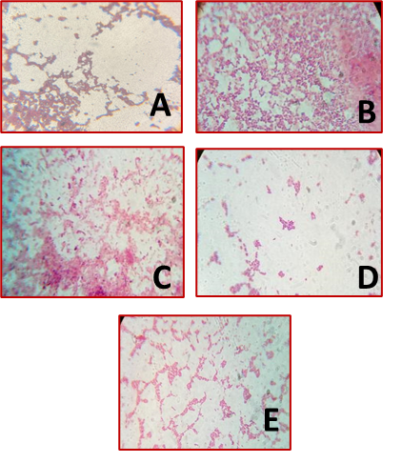
Fig. 1: Microscopic view of Gram staining results of samples of Dahi
A. Showing Gram positive bacteria presence in Ananda
B. Showing Gram positive bacteria presence in Paras
C. Showing Gram positive bacteria presence in Heritage
D. Showing Gram positive bacteria presence in Good health
E. Showing Gram positive bacteria presence in Local

Table 3. Table represents the positive and negative results for the Biochemical test performed for the bacterial sample
Samples | Catalase | Coagulase | Citrate | Indole | MR | VP
Ananda | Positive | Negative | Positive | Positive | Positive | Positive
Paras | Negative | Negative | Positive | Positive | Positive | Positive
Heritage | Negative | Negative | Positive | Positive | Positive | Positive
Good health | Negative | Negative | Positive | Positive | Positive | Positive
Local | Negative | Negative | Positive | Positive | Positive | Positive

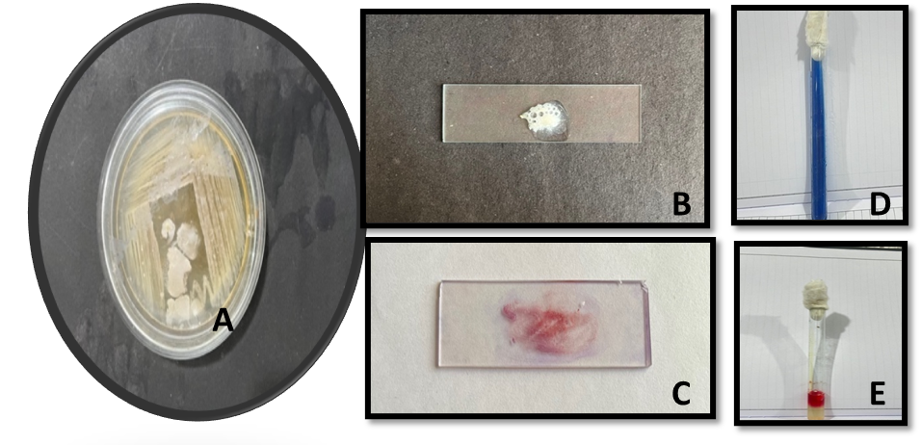

Fig.2: Ananda Dahi Sample
A. Bacterial colonies view for sample taken, B Catalase positive, C Coagulase negative, D Citrate positive, E Indole positive

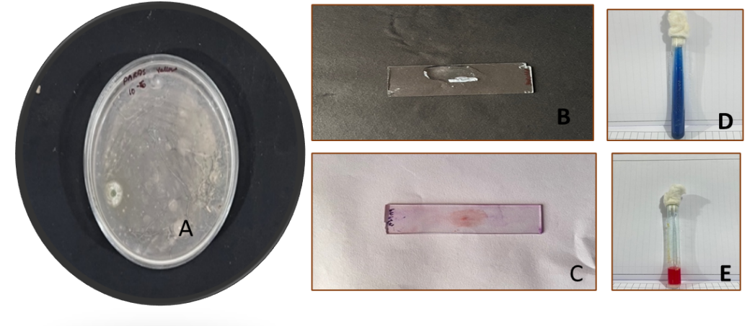
Fig.3: Paras Dahi Sample

- Bacterial colonies view for sample taken, B Catalase negative, C Coagulase negative, D Citrate positive, E Indole positive
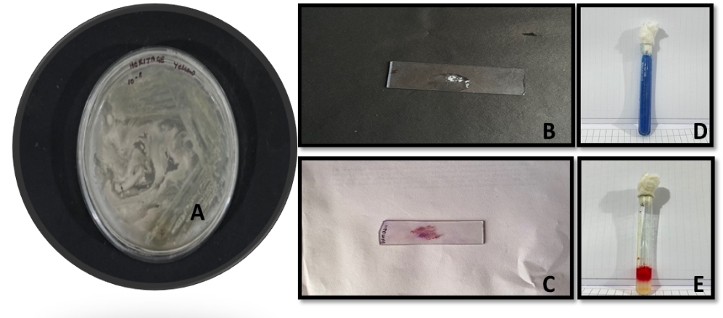
Fig.4: Heritage Dahi Sample
A. Bacterial colonies view for sample taken, B Catalase negative, C Coagulase negative, D Citrate positive, E Indole positive
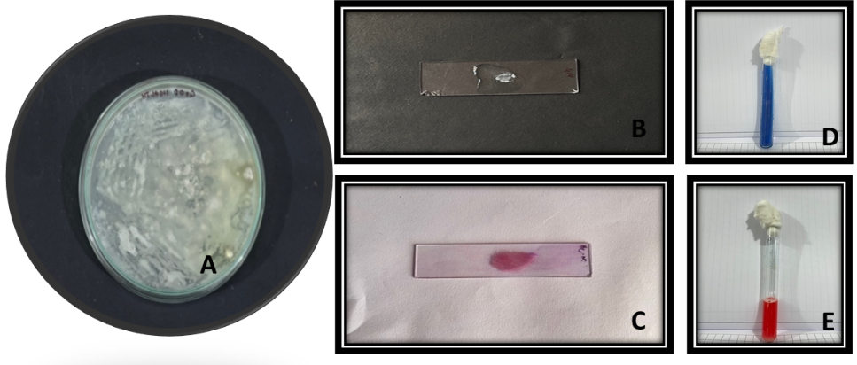
Fig.5: Good health Dahi Sample
- Bacterial colonies view for sample taken, B Catalase negative, C Coagulase negative, D Citrate positive, E Indole positive
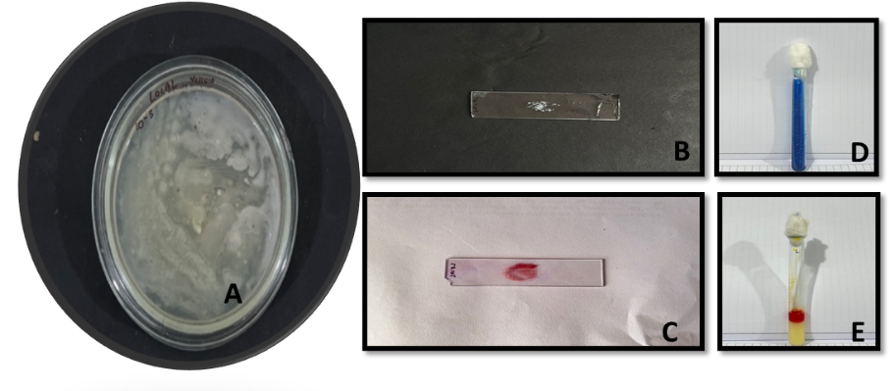
Fig.6: Local Dahi Sample
A. Bacterial colonies view for sample taken, B Catalase negative, C Coagulase negative, D Citrate positive, E Indole positive
Storage studies:
Table 4: Total plate count for different samples of Dahi at 0ºC temperature
Storage days | Ananda | Paras | Heritage | Good Health | Local
0 | 1.69*10⁶ | 2.0*10⁶ | 1.5*10⁶ | 0.3*10⁶ | 3.5*10⁶
3 | 3.4*10⁶ | 4.0*10⁶ | 2.5*10⁶ | 0.3*10⁶ | 5.2*10⁶
5 | 5.2*10⁶ | 4.5*10⁶ | 4.5*10⁶ | 0.5*10⁶ | 5.4*10⁶
7 | 5.6*10⁶ | 4.5*10⁶ | 5.0*10⁶ | 0.7*10⁶ | 5.5*10⁶

Table 5: Total plate count for different samples of Dahi at 20ºC temperature
Storage days | Ananda | Paras | Heritage | Good Health | Local
0 | 2.1*10⁶ | 2.2*10⁶ | 1.8*10⁶ | 0.5*10⁶ | 3.8*10⁶
3 | 4.9*10⁶ | 4.5*10⁶ | 2.5*10⁶ | 0.6*10⁶ | 5.5*10⁶
5 | 5.5*10⁶ | 4.6*10⁶ | 4.6*10⁶ | 0.8*10⁶ | 5.8*10⁶
7 | 6.0*10⁶ | 5.0*10⁶ | 5.4*10⁶ | 1.2*10⁶ | 6.0*10⁶

Table 6: Acidity values of fresh samples
Ananda | Paras | Heritage | Good Health | Local
1.46 | 1.20 | 1.29 | 1.42 | 0.98

Table 7: Effect of refrigeration temperature on Acidity values of Dahi samples
Storage days | Ananda | Paras | Heritage | Good Health | Local
0 | 0.71 | 0.50 | 0.52 | 0.61 | 0.73
3 | 0.73 | 0.53 | 0.55 | 0.73 | 0.71
5 | 0.76 | 0.66 | 0.67 | 0.73 | 0.76
7 | 0.86 | 0.68 | 0.70 | 0.80 | 0.80

Table 8: Effect of 20ºC temperature on Acidity values of Dahi samples
Storage days | Ananda | Paras | Heritage | Good Health | Local
0 | 0.92 | 0.52 | 0.57 | 0.61 | 1.20
3 | 1.20 | 0.56 | 0.59 | 0.78 | 1.22
5 | 1.50 | 0.66 | 0.68 | 0.82 | 1.34
7 | 1.56 | 0.69 | 0.70 | 0.81 | 1.66

Table 9: pH values of fresh Dahi samples
Ananda | Paras | Heritage | Good Health | Local
5.3 | 5.4 | 5.10 | 4.9 | 4.9

Table 10: Effect of refrigeration storage on pH values of Dahi samples
Storage days | Ananda | Paras | Heritage | Good Health | Local
0 | 5.2 | 5.3 | 4.9 | 4.8 | 4.6
3 | 4.9 | 4.6 | 4.8 | 4.2 | 3.9
5 | 4.7 | 4.4 | 4.8 | 4.0 | 3.7
7 | 4.4 | 4.2 | 4.2 | 4.0 | 3.5

Table 11: Effect of 20ºC storage on pH values of Dahi samples
Storage days | Ananda | Paras | Heritage | Good Health | Local
0 | 5.1 | 5.3 | 4.9 | 4.6 | 4.6
3 | 4.8 | 4.5 | 4.7 | 4.0 | 3.9
5 | 4.6 | 4.4 | 4.8 | 3.8 | 3.7
7 | 4.3 | 4.2 | 4.1 | 4.0 | 3.5

Sensory evaluations
Table 12 Organoleptic quality of fresh Dahi samples
Dahi sample | Color | Flavor | Aroma | Taste
Ananda | 9 | 9 | 9 | 8.0
Paras | 9 | 8.0 | 9 | 7.0
Heritage | 9 | 9 | 9 | 9
Good Health | 9 | 8.0 | 9 | 9
Local | 9 | 9 | 7 | 8.0
Table 13 Organoleptic quality of referigerated Dahi samples
Dahi sample | Storage period | Color | Flavor | Aroma | Taste
Ananda | 0  3  5  7 | 8.0  7.8  7.5  7.0 | 8.5  8.0  7.0  6.8 | 7.0  8.0  7.4  6.5 | 7.0  7.0  6.0  6.0
Paras | 0  3  5  7 | 7  8.8  8.0  7.8 | 8.0  8.1  8.0  7.8 | 7.0  8.2  8.0  7.5 | 6.8  6.5  6.0  6.8
Heritage | 0  3  5  7 | 8  8.5  8.0  7.5 | 8.9  8.6  8.3  7.9 | 7.3  7.0  6.2  6.0 | 5.7  5.5  5.0  5.0
Good Health | 0  3  5  7 | 8  8.8  8.6  8.4 | 7.9  7.8  7.6  7.4 | 7.0  6.5  6.3  6.0 | 6.0  6.8  6.7  6.5
Local | 0  3  5  7 | 7  7.8  7.6  7.4 | 7  6.8  6.6  6.4 | 7  6.5  6.3  6.0 | 7.0  6.8  6.7  6.5

Table 14 Organoleptic quality of Dahi samples at 20ºC
Dahi sample | Storage period | Color | Flavor | Aroma | Taste
Ananda | 0  3  5  7 | 7.0  6.8  6.5  6.0 | 6.5  6.0  6.0  5.8 | 7.0  8.0  7.4  6.5 | 6.8  6.6  6.2  6.0
Paras | 0  3  5  7 | 6  6.8  6.0  5.8 | 7.0  6.1  6.0  5.8 | 7.0  8.2  8.0  7.5 | 6.4  6.5  6.0  6.0
Heritage | 0  3  5  7 | 7  6.5  6.0  5.5 | 7.9  7.6  7.3  6.9 | 7.3  7.0  6.2  6.0 | 5.7  5.5  5.0  5.0
Good Health | 0  3  5  7 | 7.8  7.8  7.6  7.4 | 6.9  6.8  6.6  6.4 | 7.0  6.5  6.3  6.0 | 6.0  6.8  6.7  6.5
Local | 0  3  5  7 | 7  6.4  6.2  6.2 | 7.9  7.6  7.5  7.3 | 7  6.5  6.3  6.0 | 6.9  6.8  6.7  6.5

