(Original Article)
ANN Modelling, and Economic Evaluation of Chimney-Assisted Greenhouse Solar Dryer under no load condition

Abstract
The paper focuses on ANN-based prediction of dryer temperature in chimney-assisted greenhouse solar dryers (GSDs) used for crop drying, coupled with economic analysis to evaluate the feasibility for small-scale use. The paper aims to explore the ANN modelling and economic evaluation of the chimney-assisted greenhouse solar dryer under no load conditions. The increasing need for cost-effective and energy-efficient agricultural drying methods has driven innovation in solar drying technologies, with artificial intelligence (AI) playing a key role. This study implemented an Artificial Neural Network (ANN) to model the thermal performance of a chimney-assisted greenhouse solar dryer under no load conditions. A 3-2-1 ANN architecture, trained using the Levenberg-Marquardt algorithm, achieved a high predictive accuracy with a coefficient of determination (R²) of 0.99. Using input variables like ambient temperature, solar irradiance, and relative humidity, the model accurately predicted maximum internal dryer temperatures, 50.4 °C and minimum 30°C during the day, significantly higher than ambient conditions. The ANN model demonstrated reliability through low Mean Squared Error (MSE) values of 0.8107 (training), 0.4597 (validation), and 0.5324 (testing). These findings confirm the ANN’s effectiveness in capturing complex environmental interactions and predicting thermal behaviour with precision. The resulting model supports optimised dryer control for enhanced moisture removal efficiency. Furthermore, an economic analysis showed a short payback period of 8 months, emphasising the financial feasibility of such systems for small-scale farmers. The integration of AI modelling with economic assessment presents a comprehensive framework for advancing solar drying technologies, promoting wider adoption of renewable and intelligent solutions in the agricultural sector. In conclusion, the combined approach of ANN modelling and economic evaluation provides a valuable framework for optimising solar drying systems and promoting sustainable agricultural practices.

Keywords: Artificial Neural Network (ANN); Chimney Assisted Greenhouse Solar Dryer; agricultural; Mean Squared Error (MSE);artificial intelligence 1. Introduction
Solar drying is a vital process for preserving agricultural products, especially in regions with abundant sunlight. The phenomenon of drying is quite complex in nature as it involves both the heat and the mass transfer. Heat is circulated from the heat source to the crop (or the sample mass) being dried, and the transfer of mass occurs from the sample mass to the atmosphere in the form of moisture (moist air). A product possesses a moisture content and a fixed dried mass (Kumar et al., 2025; Das et al., 2025). Solar drying of agricultural products offers a sustainable alternative to traditional sun drying by reducing product contamination and improving drying efficiency. However, solar dryers’ performance depends heavily on ambient conditions and system design. The integration of Artificial Neural Networks (ANNs) enables precise modelling of complex, nonlinear drying processes, facilitating system optimisation and control. Artificial Neural Networks (ANN) are valuable tools for data analysis used to identify and represent functional correlations between variables. ANNs are currently being used to address, forecast, and classify challenges in diverse fields (Baashar et al., 2022). This paper focuses on ANN-based prediction of dryer temperature in chimney-assisted greenhouse solar dryers (GSDs) used for crop drying, coupled with economic analysis to evaluate the feasibility for small-scale use. Sharma, N.K. (2018) highlighted that India, being a tropical country, receives abundant sunlight with high intensity throughout the year. The nation has significant potential for harnessing solar energy, with daily solar radiation ranging between 4 to 7 kWh per square meter. Annually, the solar radiation across India varies from 1200 to 2300 kWh/m². On average, the country experiences about 250 to 300 clear sunny days and receives approximately 2300 to 3200 hours of sunshine per year, making it highly suitable for solar power generation. Bontempi et al. (2013) emphasised that supervised learning in Artificial Neural Networks (ANNs) relies on training with datasets containing both inputs and predefined outputs (targets), allowing the network to improve its predictions by comparing them against known results. Beigi et al. (2017) explored the drying behaviour of rough rice using both traditional mathematical models and ANN approaches under varying air conditions. They found that while the Midilli model was the most suitable among nine mathematical models, an ANN model with a 4-18-18-1 architecture (using a hyperbolic tangent sigmoid function and trained with the Levenberg-Marquardt algorithm) outperformed it in prediction accuracy, achieving higher correlation coefficients and lower Mean Squared Error (MSE). This demonstrated the ANN’s superior ability to model complex drying kinetics compared to conventional approaches. Nur et al. (2014) discussed the significance of optimising ANN weights, highlighting that performance is highly dependent on the training method and initial parameter selection. They reviewed meta-heuristic algorithms such as Genetic Algorithm (GA) and Particle Swarm Optimisation (PSO) for improving ANN weight optimisation and compared them with local search-based methods, noting their strengths and limitations. Additionally, they highlighted key ANN features, including self-organisation, adaptability, and real-time learning, which have made ANNs valuable in fields like pattern recognition and data mining. However, challenges remain in selecting optimal parameters. Boateng,I. D. (2023) explores recent developments in solar and solar-assisted drying technologies for fresh produce, with a focus on drying kinetics and maintaining product quality. The review underscores a transition from conventional artificial dryers to more sustainable solar-based systems, driven by increasing energy costs. It also highlights the application of modelling tools such as thin-layer models, CFD, ANFIS, and ANN to enhance the efficiency of drying processes. Aghbashlo et al. (2015) observed that the architecture of an ANN, such as the number of hidden layers and neurons per layer, is typically determined through trial and error, relying on experiential knowledge. As a result, the time required to develop an effective ANN model depends on the number of iterations needed to optimise its structure. Sachithanandhan et al. (2024) assessed an indirect solar dryer with a wicked heat pipe system for efficient passive heat transfer. The system achieved a 21 °C temperature rise over ambient conditions and reduced banana slice moisture from 150% to 11% (dry basis) in 12 hours. Average drying rates ranged from 0.1452 to 0.1613 kg water/kg dry matter/h, with effective moisture diffusivity significantly higher than in open sun drying. The dryer showed 26% thermal efficiency and a short payback period of 0.57 years, making it well-suited for rural agricultural use. Serm Janjai (2012) developed a greenhouse solar dryer featuring an 8 m × 20 m parabolic polycarbonate roof and a 100 kW LPG burner for continuous drying. Tested on osmotically dehydrated tomatoes, the dryer reached air temperatures of 35– 65°C, reducing drying time by around 3 days compared to open sun drying. The system showed a payback period of approximately 0.65 years. Successfully installed at multiple sites in Thailand, it combines technical efficiency with economic viability and is part of the country’s official dissemination program.
2. Materials and Methods
Artificial Neural Network (ANN) modelling effectively captures the dynamic and nonlinear thermal response of the chimney-assisted greenhouse solar dryer, making it a reliable tool for optimising system design and operation without the need for extensive physical trials.The ANN model was developed with the data obtained by the experimental trial in the no-load condition. Due to the unsteady ambient conditions and continuous nature of the data collected during the drying experiments, ANN modelling was employed to handle the complexity and nonlinearity of the experimental observations. Although the current ANN model showed strong performance with limited data, it is acknowledged that larger datasets can further enhance its accuracy. An ANN with a 3-2-1 topology was developed to predict dryer temperature based on input variables ( ambient temperature, solar irradiance, and relative humidity). An Experimental Dryer was developed by our own effort for PhD research. The sigmoid activation function was used, and the Levenberg-Marquardt algorithm facilitated efficient training. The model was trained, validated, and tested using experimental data from no-load conditions in Matlab R2016a Nftool.Results shown in Table 1.

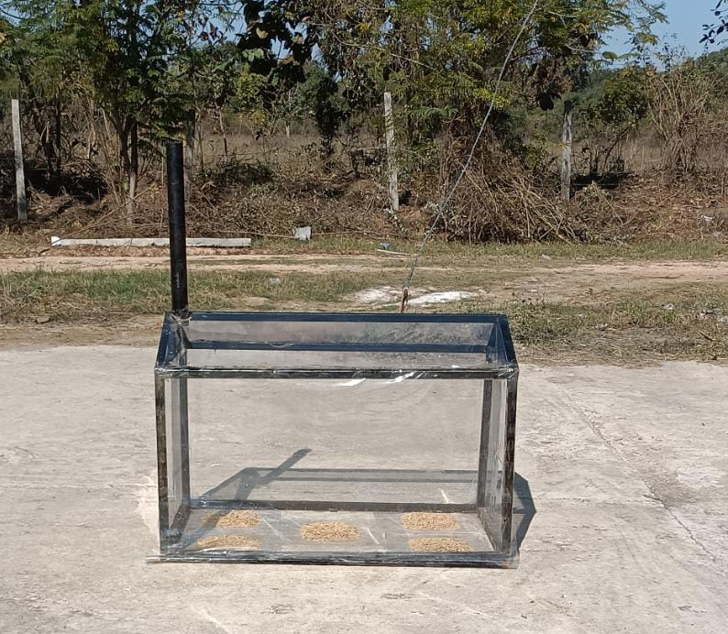
Fig. 1 Chimney-assisted greenhouse solar dryer for crop (Department of Mechanical Engineering, FET, AKS University, Satna, MP, India

Time of the day | Ambient Temperature (⁰C) | Solar irradiance (W/m²) | Ambient Relative Humidity (%) | Dryer Temperature (⁰C)
Maximum | 40.0 | 834 | 27.2 | 50.4
Minimum | 20.8 | 208 | 12.0 | 30.0

Table 1 Effect of Ambient Parameter on Dryer Temperature under no load condition

Model Topology | Activation Function and Training Algorithm | Error Metric (MSE) & R² (Coefficient of Determination |  |  | R² (Coefficient of Determination  (ANN Model)
Model Topology | Activation Function and Training Algorithm | Training | Validation | Testing | R² (Coefficient of Determination  (ANN Model)
3-2-1 | Sigmoid and Levenberg-Marquardt (LM) | 0.8107 & 0.99 | 0.4597 & 0.99 | 0.5324 & 0.99 | 0.99
Table 2 ANN Model Performance parameter for dryer performance
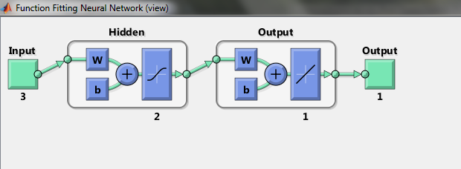
Fig. 2 ANN Architecture for Chimney assisted green house solar dryer (Topology is 3-2-1)

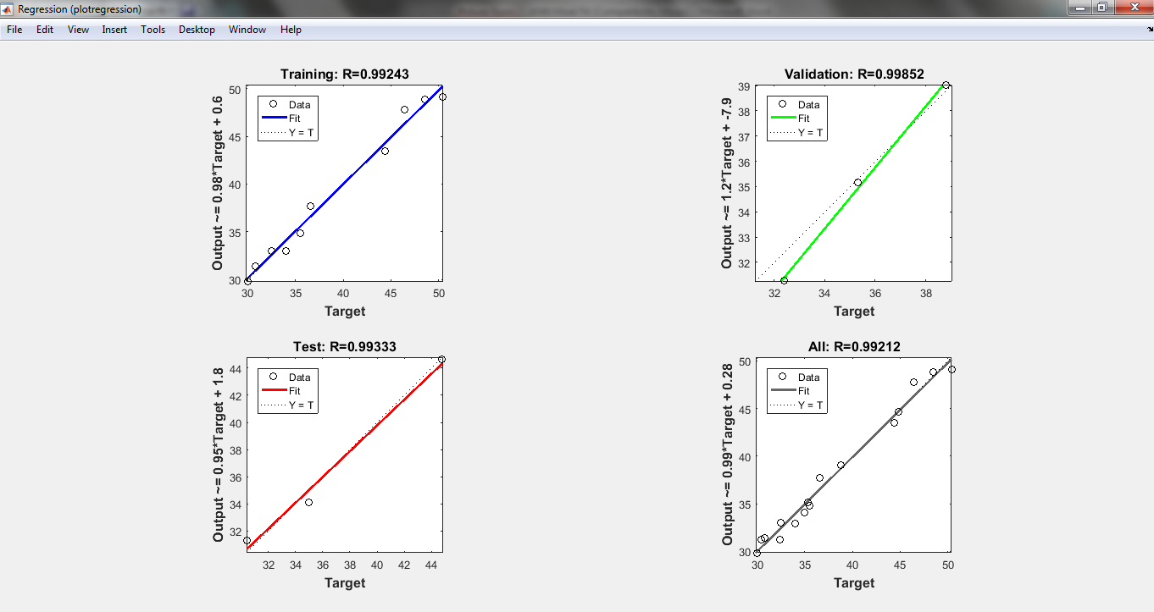
Fig. 3 Regression Plot of Developed ANN Model for Chimney assisted green house solar dryer (no load condition)
3. Results and Discussion
3.1 ANN Model Performance
A 3-2-1 architecture Artificial Neural Network (ANN) model was developed to predict the internal temperature of the chimney-assisted greenhouse solar dryer under no-load conditions. The model utilised three input variables: ambient temperature, solar irradiance, and relative humidity, processed through sigmoid activation functions. The training was carried out using the Levenberg-Marquardt algorithm, known for its fast convergence and high accuracy in nonlinear systems. Experimental data were divided into training, validation, and testing subsets to ensure balanced evaluation of the model’s performance. The ANN model showed excellent prediction capabilities with Mean Squared Error (MSE) values of 0.8107,0.4597,0.5324 for Training, Validation and Testing consecutively. The coefficient of determination (R²) was 0.99 across all datasets, indicating a strong correlation between predicted and actual dryer temperatures. This demonstrates the ANN’s ability to capture the complex relationships between environmental factors and dryer performance, enabling reliable temperature forecasting for process control. The ANN model demonstrated excellent predictive accuracy, with Mean Squared Error (MSE) values of 0.8107, 0.4597, and 0.5324 for the training, validation, and testing phases, respectively. The coefficient of determination (R²) was consistently high at 0.99 across all datasets, confirming a strong correlation between actual and predicted dryer temperatures. These results indicate the ANN’s effectiveness in capturing the complex, nonlinear interactions among environmental variables and the dryer’s thermal response. Given the unstable nature of ambient conditions and the continuous nature of the recorded data, ANN modelling provided a more suitable analytical approach. Although the dataset used was limited, the model performed well; however, future studies with larger datasets may further improve prediction accuracy.
3.2 Economic Analysis of Chimney-Assisted Greenhouse Solar Dryer for crop
Andharia, J.K. and Solank, J.B. (2023) designed a mixed-mode solar dryer using black pebbles for heat storage to enhance shrimp drying. The system allowed drying up to seven hours after sunset, achieving 25.47% thermal efficiency and better shrimp quality than open sun drying. Field tests in Gujarat showed a 1.7-year payback period and a 38% increase in user income, making it a sustainable and cost-effective option for coastal communities. The economic evaluation of the chimney-assisted greenhouse solar dryer revealed strong financial viability, with a short payback period of 8 months. The total construction cost was estimated at INR 3500, with minimal annual maintenance expenses of INR 250, as the dryer operates solely on solar energy, eliminating fuel or electricity costs. Capable of drying 15 kg of crops per 3 day cycle and completing approximately 70 batches annually, the dryer achieves an annual drying capacity of 1050 kg. With an estimated cost saving of INR 5 per kilogram compared to conventional methods, the system generates INR 5250 in annual savings, fully recovering the initial investment within the first year. This makes it a cost-effective, low-maintenance, and environmentally friendly solution, particularly suited for small and marginal farmers in rural or off-grid areas, offering long-term benefits such as reduced post-harvest losses, improved crop quality, and sustainable operation.
4. Conclusion
This study successfully integrated ANN modelling with experimental and economic analyses to evaluate chimney-assisted greenhouse solar dryers for wheat and paddy drying. The ANN model exhibited high accuracy in predicting dryer temperature, enabling effective process monitoring and control. The dryers demonstrated superior drying performance, with an improvement in dryer temperature. The economic assessment confirmed the affordability and practicality of these systems for smallholder farmers, with a payback period of 8 months. The combined approach of ANN modeling and economic evaluation provides a valuable framework for optimizing solar drying systems and promoting sustainable agricultural practices.
Future Recommendations
Investigation into Thermal efficiency with different crop drying is the requirement of conducting future research.

Conflict of Interest
This Research is the PhD thesis of Rajesh Kumar Mishra. The author declares that the ANN Model presented in this research may have commercial applications, and a patent application is intended in the near future for this dryer design. This is disclosed in accordance with standard publication ethics.
Design data availability statement
All dimensional design data for the dryer are available from the first author, Rajesh Kumar Mishra. This work is part of his PhD thesis in Mechanical Engineering. The full thesis will be published on the UGC Shodhganga portal after submission, and the design data can be shared upon reasonable request.

Funding Statement
This research received no external funding. All material costs were covered by Rajesh Kumar Mishra, with fabrication done in the Mechanical Engineering workshop at AKS University, Satna (MP). Laboratory instruments were provided by the Departments of Agriculture and Food Technology Engineering at the same university.
Acknowledgment
The authors express sincere gratitude for the support received during the testing of the chimney-assisted greenhouse solar dryer. Investigation of the theoretical concept of Heat and Mass Transfer in drying of crop, and an ANN model was developed by Rajesh Kumar Mishra¹, who led the experimental work. The contributions of Dr. Shrihar Pandey², Dr. Shivbilas Maurya³, Dr. Ankit Bharti⁴, Vijay Singh⁵, and Dr. Ajeet Sarathe⁶ in article preparation are gratefully acknowledged.

Disclaimer (Artificial intelligence)
Author(s) hereby declare that NO generative AI technologies such as Large Language Models (ChatGPT, COPILOT, etc.) and text-to-image generators have been used during the writing or editing of this manuscript.

References
- Bontempi, G., Ben Taieb, S., & Le Borgne, Y. A. (2013). Machine learning strategies for time series forecasting. In M. A. Aufaure & E. Zimányi (Eds.), Business Intelligence: eBISS 2012 ,(pp.62–77) Springer.
- Beigi, M., Torki-Harchegani, M., & Tohidi, M. (2017). Experimental and ANN modeling investigations of energy traits for rough rice drying. Energy, 141, 2196–2205.
- Sharma, NK., Tiwari, PK., Sood, YR. (2018). “Solar energy in India: Strategies, policies, perspectives and future potential” Renewable and Sustainable Energy Reviews, Volume 16, page 933– 941
- Nur, A. S., Radzi, N. H. M., & Ibrahim, A. O. (2014). Artificial neural network weight optimization: A review. TELKOMNIKA Indonesian Journal of Electrical Engineering, 12 (9), 6897–6902.
- Piwsaoad, J. (2024) Thermal efficiency of greenhouse solar dryer for drying sticky rice and heat transfer modeling. Life Sciences and Environment Journal, 25(1), January–June.
- Boateng, I. D. (2023). A review of solar and solar-assisted drying of fresh produce: State of the art, drying kinetics, and product qualities. Journal of the Science of Food and Agriculture, 103(13), 6137–6149.
- Aghbashlo, M., S. Hosseinpour, and A. S. Mujumdar. 2015. Application of artificial neural networks (ANNs) in drying technology: A comprehensive review. Drying Technology 33 (12):1397–462.
- Sachithanandhan, V. K., Monicka, A. A., Solomon, A. B., Jeevarathinam, G., Yadav, T., & Ajith, R. (2024). Experimental investigation of indirect solar dryer integrated with wicked heat pipe.Journal of Mechanical Science and Technology, 38, 4397–4408.
- Andharia, K., Solanki, J. B., & Maiti, S. (2023). Performance evaluation of a mixed-mode solar thermal dryer with black pebble-based sensible heat storage for drying marine products. Journal of Energy Storage, 57, 106186.
- Serm Janjai. (2012). A greenhouse type solar dryer for small-scale dried food industries: Development and dissemination. International Journal of Energy and Environment, 3(3), 383–398.
- Kumar, A., Biswas, S., Kumar, R., & Mandal, A. (2025). Experimental appraisal & dual efficiency optimisation of a modified indirect solar dryer: Heat & mass transfer analysis with a hybrid ANN approach. Renewable Energy, 123098.
- Das, M., Catalkaya, M., & Akpinar, E. (2025). Hot Air Assisted Solar Greenhouse Dryers: Improving Drying Performance by Numerical, Experimental, and Artificial Intelligence Approaches. Renewable Energy, 124427.
- Baashar, Y., Alkawsi, G., Mustafa, A., Alkahtani, A. A., Alsariera, Y. A., Ali, A. Q., ... & Tiong, S. K. (2022). Toward predicting student’s academic performance using artificial neural networks (ANNs). Applied Sciences, 12(3), 1289.

