Impact of Traditional Processing Methods on Total and Soluble Oxalate Levels in Five Hibiscus Species from Kwilu Province, DR Congo
ABSTRACT
Aims: Hibiscus species are widely recognised for their rich nutritional profile, which includes essential micronutrients such as iron, calcium, magnesium, and vitamins A and C. They also contain a range of compounds classified as anti-nutritional factors, including oxalates, cyanogenic glycosides, tannins and others, which can interfere with the bioavailability and absorption of key nutrients.

Study Design: In this experimental study we investigated the oxalate content across five Hibiscus species subjected to traditional processing methods. Treatments included sun drying, soaking, and the application of artisanal potash. Quantitative analyses were conducted to evaluate the impact of each practice on total and soluble oxalate levels, with species and provenance as variables.
Place and Duration of Study: Hibiscus samples were collected from Kikwit and Idiofa cities across Kwilu Province, Democratic Republic of Congo (DRC). Laboratory analyses were subsequently performed at the Department of Chemistry, Higher Institute of Education (ISP), Kikwit, Kwilu Province, DRC.

Methodology: Hibiscus species were collected from Kikwit and Idiofa (Kwilu State, DRC), and their total and soluble oxalate contents were determined before and after traditional treatments using volumetric titration with a standard potassium permanganate solution.
Results: Analysis revealed that traditional processing practices exert variable effects on the oxalic acid content of Hibiscus leaves, with oxalate levels differing by species and provenance. Sun drying significantly influenced oxalate concentrations in sorrel (H. sabdariffa), resulting in a reduction of total oxalate by 1-31% and soluble oxalate by 51–91.4%. Notably, H. sabdariffa var. sabdariffa exhibited an unexpected increase of approximately 50.5% in total oxalate following sun drying. The application of indigenous potash (Kompos) also impacted oxalate levels: total oxalate decreased by 3-29%, while soluble oxalate increased across all samples, ranging from 56-87%. Furthermore, soaking dried sorrel leaves in water led to a marked reduction in oxalate content, with total oxalate decreasing by 3.5-32.4% and soluble oxalate by 35.5-55.9%, compared to untreated controls.

Conclusion: Five Hibiscus species analyzed in this study exhibited significant oxalate levels, shaped by their geographic origin. Traditional processing, specifically sun drying and soaking, reduced soluble oxalate concentrations by 51-92%. While treatment with local potash decreased total oxalate, it simultaneously elevated soluble oxalate, likely through the transformation of insoluble forms mediated by bicarbonate and hydroxide ions.
Keywords: Hibiscus, Oxalate, Sun drying, traditional potash, soaking
1. INTRODUCTION
Kwilu Province, located in the southwestern region of the Democratic Republic of Congo (DRC), is renowned for its extensive history of cultivating and ingesting a variety of Hibiscus species. The dietary practices of communities throughout the province include this botanical genus, which is locally recognized for its nutritional and medicinal properties. Some of the most frequently ingested Hibiscus species in urban centers like Kikwit and Idiofa are Hibiscus sabdariffa and Hibiscus acetosella. These leaves are typically dried and preserved for use during the dry season, which is indicative of both practical food preservation strategies and cultural preference [1-2].
Although Hibiscus species are widely recognized for their rich nutritional profile, which include essential micronutrients such as iron, calcium, magnesium, and vitamins A and C, which are playing keys roles to immune function, cellular metabolism, and overall physiological health [3-4]. They also contain a range of compounds classified as anti-nutritional factors (ANFs), these include oxalates, phytates, tannins, and cyanogenic glycosides, which can interfere with the bioavailability and absorption of key nutrients [4-5]. For instance, oxalates are known to chelate calcium and magnesium, forming insoluble complexes that reduce intestinal uptake, while phytates can bind iron and zinc, limiting their absorption and contributing to micronutrient deficiencies in populations reliant on plant-based diets [6-7].
The dual nutritional and anti-nutritional characteristics of Hibiscus species have attracted heightened scientific interest, especially in the domains of food, chemistry, ethnobotany, and nutritional epidemiology [8-11]. A previous study on the oxalate content of different Hibiscus species grown in and around Kikwit, Democratic Republic of Congo, found that many cultivars contained high levels of both soluble and insoluble oxalates [12]. These variations raise important nutritional and toxicological concerns, particularly given the widespread consumption of Hibiscus leaves as a staple vegetable in Kwilu Province, Democratic Republic of Congo. Consequently, it became essential to investigate the culturally embedded food preparation practices in this region to better understand their impact on oxalate levels and potential health implications. To tackle this issue, the aim is to study the influence of traditional processing techniques on oxalate levels. This includes the impacts of sun drying, artisanal potash treatment, soaking of dried leaves, and varietal provenance within Kwilu state on oxalate concentrations in five distinct Hibiscus varieties widely found in this region.
2. MATERIAL AND METHODS
Five different species of Hibiscus, H. sabdariffa var sabdariffa (HSS) H. sabdariffa var altisima (HSA), H. acetosella red shied (HARS), H. acetosella cranberry (HAC), and H. canabinus (HC) were collected in Kikwit and Idiofa gardens around houses. Leaves were placed in airtight containers and taken to the ISP-Kikwit chemical laboratory for analysis. They were washed, dried, and ground to obtain powders used for analysis.

Sun-drying was carried out by imitating the traditional technique of exposing fresh leaves, previously washed with drinking water, to the sun for 4 days. Other leaves were oven-dried at 60°C for 48 hours to compare results with those obtained using the traditional technique.
The same applies to traditional potash, which was also obtained using the traditional technique as reported in 2010 by Babayemi et al. [13], which involved drying oil palm inflorescences at 80°C for 72 hours to remove water. After drying, they were incinerated in a muffle furnace at 550° C for five hours until the ash was grey, light, or whitish in colour. After cooling, a 5 g aliquot of the ash was dissolved in 40 ml of distilled water and homogenised for 20 min using a magnetic stirrer. After homogenization, the suspension is centrifuged at 5000 rpm for 15 min. The supernatant is collected, and the pellet is discarded. The supernatant is filtered through filter paper, and the filtrate is used as traditional potash.

The effect of soaking was studied by placing 100g of dried leaves in 300 mL of distilled water for 30 minutes and measuring oxalate afterwards. The influence of traditional potash was assessed by adding 10 mL of potash to 100g of the leaves during cooking.
Several analytical methods have been reported for the determination of oxalate content. In this study, permanganometric titration was employed, as described in previous reports [12, 14-15].
Statistical significance was assessed using analysis of variance (ANOVA), followed by Tukey’s pairwise comparison of means at a 5% significance level (P = 0.05). All computations were performed using Origin 2024b (OriginLab, Northampton, MA, USA).
3. RESULTS AND DISCUSSION
3.1. Influence of Hibiscus Species Origin on Total and Soluble Oxalate Content
Growing interest in the relationship between diet and health has intensified the need for detailed compositional data on traditional food sources. This study investigated the total oxalate (TO) and soluble oxalate (SO) contents of five Hibiscus species commonly consumed in Idiofa and Kikwit was conducted, with a focus on the influence of plant origin and drying method on oxalate levels.
As shown in Fig. 1a–b, TO and SO contents varied markedly between samples from Idiofa and Kikwit. For instance, the TO content of Hibiscus sabdariffa subsp. sabdariffa (HSS) was significantly higher in the Kikwit sample (415.3 mg/100 g) compared to the Idiofa sample (182.5 mg/100 g). Conversely, Hibiscus sabdariffa subsp. altissima (SA) exhibited a much higher TO concentration in the Idiofa sample (657.8 mg/100 g) than in the Kikwit counterpart (195.3 mg/100 g). These findings suggest that geographic origin plays a substantial role in oxalate accumulation, potentially influenced by environmental factors such as soil composition and mineral availability.
Statistical analysis further revealed that TO content did not differ significantly (p < 0.05) between Idiofa_HAS and Idiofa_HARS, followed by Idiofa_HC, Kikwit_HSS, and Kikwit_HC. Similarly, no significant differences were observed among Kikwit_HARS, Idiofa_HSS, Kikwit_HAS, Kikwit_HAC, and Idiofa_HAC. For SO content, Idiofa_HC showed the highest concentration, significantly exceeding other samples (p < 0.05), followed by Idiofa_HAC, Idiofa_HSA, Kikwit_HSA, and Idiofa_HSS. No significant differences were found among Kikwit_HSS, Kikwit_HARS, Idiofa_HARS, and Kikwit_HAC.
Traditionally, Hibiscus leaves are preserved through air drying. To assess the impact of this practice, we replicated the traditional method was replicated and compared it with oven drying. Figure 2 presents TO and SO contents across all species used in this study post-drying. Preliminary observations indicate that drying Hibiscus leaves influences oxalate retention, although further analysis is required to quantify these effects and determine optimal processing conditions for minimising oxalate exposure.
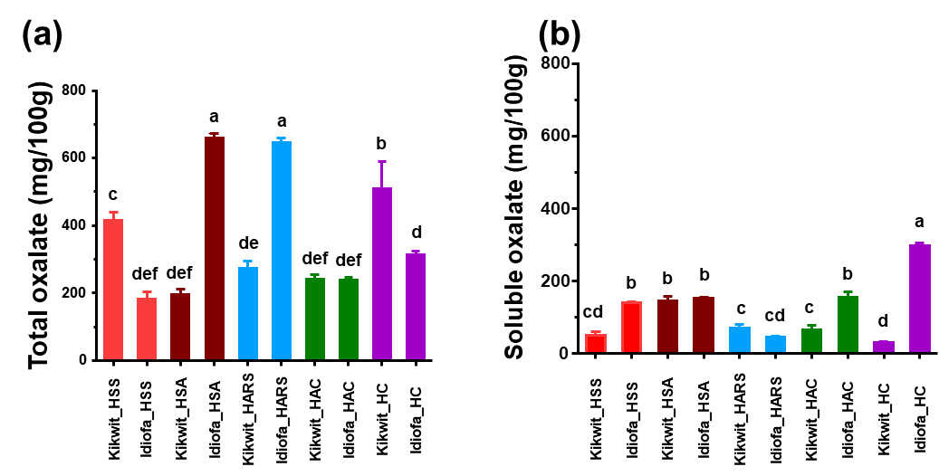
Fig.1. Total and soluble oxalate content in Hibiscus species from Kikwit and Idiofa. (a) Total oxalate; (b) Soluble oxalate. Hibiscus sabdariffa var sabdariffa (HSS); Hibiscus sabdariffa var altisima (HSA); Hibiscus acetosella red shied (HARS); Hibiscus acetosella cranberry (HAC) and Hibiscus canabinus (HC)

3.2. Influence of drying hibiscus leaves on total and soluble oxalate content
Traditionally, hibiscus leaves are preserved by drying. In this study, the traditional drying method was reproduced and carried out in order to assess the impact of this process on the total and soluble oxalate content of the studied species. The Fig.2 shows total oxalate (TO) and soluble oxalate (SO) contents in all five species after air and oven drying.
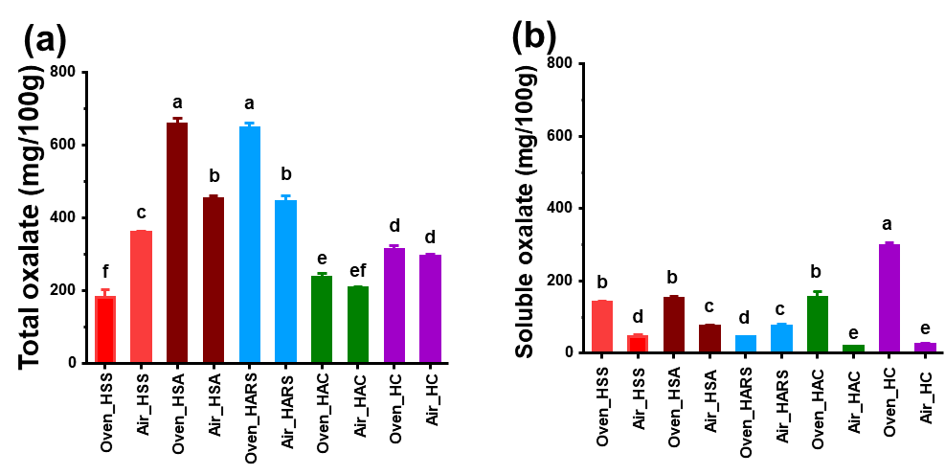
Fig.2. Total and soluble oxalate content after air and oven drying. (a) Total oxalate; (b) Soluble oxalate. Hibiscus sabdariffa var sabdariffa (HSS); Hibiscus sabdariffa var altisima (HSA); Hibiscus acetosella red shied (HARS); Hibiscus acetosella cranberry (HAC) and Hibiscus canabinus (HC)

The results revealed that Oven_HARS and Oven_HSA had the highest TO, followed by Air_HARS and Air_HSA. There is no significant difference between Oven_HC and Air_HC. Oven_HAC and Air_HAC did not exhibit a significant difference. Oven_HSS had the lowest TO compare to Air_HSS. By analysing the SO, it appears that Oven_HC had the highest SO, followed respectively by Oven HSS, Oven_HSA, Oven_HAC, Air_HSA, Air_HARS, Air_HSS, and Oven_HARS. The lowest value was recorded by Air_HC and Air_HAC. These results show that traditional drying contributes to reducing oxalate content. This involves drying in the sun or over a fire in the kitchen. Sun-drying results in a greater drop in oxalate than that observed in samples dried over a cooking fire. It is known that oxalate can undergo thermal decomposition accompanied by a loss of CO according to the following reaction.
This loss of CO occurs at temperatures above 200°C. In addition, oxalate undergoes photochemical decomposition in the presence of nitrate ions, which also undergo photochemical decomposition according to the following mechanism [14].
${NO}_{3}^{-}$+ hυ ${NO}_{2}^{-}$ + ½O₂
H₂C₂O₄ + 2${NO}_{2}^{-}$ 2NO + 2CO₂
Drying in full sunlight, while not reaching oxalate decomposition temperatures, exposes hibiscus leaves to the sun's UV rays. This could explain the more pronounced oxalate decomposition in sun-dried leaves than in oven-dried ones, as the nitrates are surely present in hibiscus leaves. This traditional method of drying allows for a reduction of the TO from 3 to 29% and SO from 56 to 87%

3.3. Artisanal potash treatment with Hibiscus sample affected TO and SO content
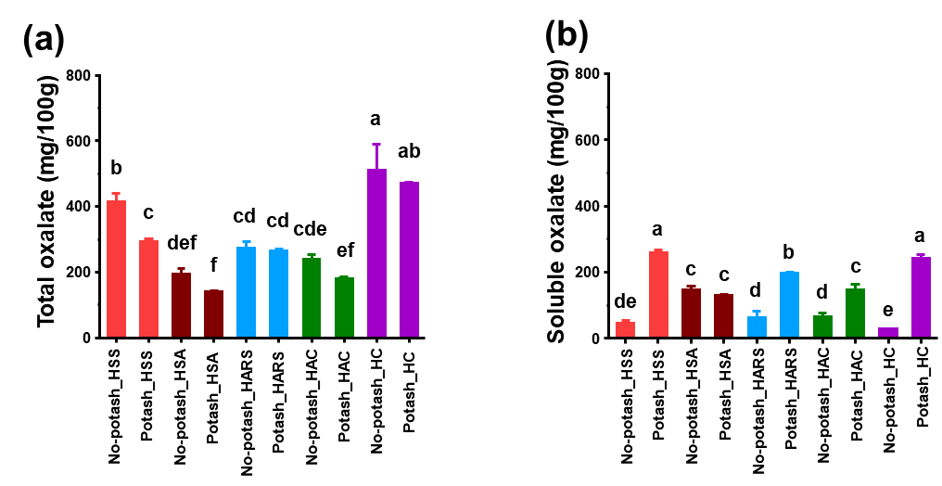
One cooking technique involves the use of potash (ash from the male inflorescence of palm called KOMPOS in a local language) as a condiment to reduce the acidic taste of the sorrel and ensure its rapid softening. Fig.3 shows the obtained results for all studied species of Hibiscus
Fig.3. Oxalate content of samples (in mg/100g dry weight) before and after treatment with artisanal potash. (a) Total oxalate; (b) Soluble oxalate. Hibiscus sabdariffa var sabdariffa (HSS); Hibiscus sabdariffa var altisima (HSA); Hibiscus acetosella red shied (HARS); Hibiscus acetosella cranberry (HAC), and Hibiscus canabinus (HC)
The results indicate that treatment with indigenous potassium bicarbonate leads to a pronounced reduction in total oxalates (TO), accompanied by a marked increase in soluble oxalates (SO). Although potash addition did not significantly affect TO within individual samples, it did produce notable differences across sample types. The highest TO levels were observed in No-potash_HC and Potash_HC, followed by No-potash_HSS, Potash_HSS, No-potash_HARS, and Potash_HARS. Moderate TO levels were recorded for No-potash_HSA, No-potash_HAC, and Potash_HAC, while Potash_HSA exhibited the lowest TO content.
In terms of soluble oxalates, potash addition significantly influenced SO both within and across species. Potash_HSS and Potash_HC showed the highest SO levels, followed by Potash_HARS. No significant differences were observed among No-potash_HSA, Potash_HSA, and Potash_HAC. These findings can be attributed to the alkaline conditions induced by potash, under which calcium oxalate reacts with bicarbonate ions to form soluble calcium complexes. The mechanism involves the dissolution of oxalate and subsequent complexation, as illustrated in the following steps:
The global reaction is
The reaction between calcium oxalate and potassium bicarbonate is not a simple precipitation or conventional ion exchange process. Potassium bicarbonate provides bicarbonate ions which, in the presence of calcium, form soluble calcium bicarbonate—accounting for the observed reduction in solid oxalate. This mechanism aligns with findings by Liu et al. (2017) [16], who reported that calcium oxalate undergoes solubilization in alkaline media containing carbonate or aluminate, yielding soluble oxalate species according to the following equations:

3.4. Effect of Soaking dried Hibiscus prior cooking on TO and SO content
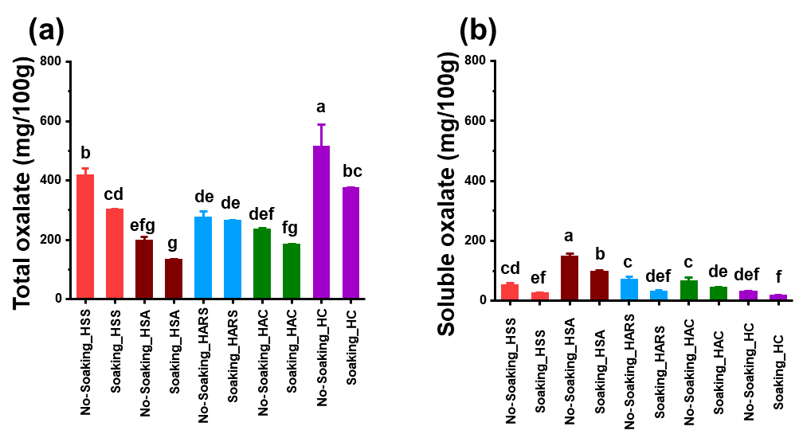
The traditional cooking process for dried Hibiscus begins with soaking the material in drinking water for 15 minutes, after which the water is discarded prior to cooking. As shown in Fig. 4, this initial step significantly affects the levels of total and soluble oxalates.
Fig.4. Oxalate content of dried leaves before and after soaking in water. (a) Total oxalate; (b) Soluble oxalate. Hibiscus sabdariffa var sabdariffa (HSS); Hibiscus sabdariffa var altisima (HSA); Hibiscus acetosella red shied (HARS); Hibiscus acetosella cranberry (HAC), and Hibiscus canabinus (HC)
Analysis of oxalate content in dried Hibiscus leaves before and after soaking revealed that pre-soaking significantly reduced total oxalate (TO) levels in HSS and HC samples. In contrast, no significant difference was observed between soaked and unsoaked samples for HAS, HARS, and HAC. Regarding soluble oxalate (SO), soaking led to a significant reduction in HSS, HAS, HARS, and HAC samples, while HC showed no notable change.
These findings demonstrate that soaking dried sorrel leaves can effectively reduce both TO and SO content, ranging from 3.7% to 27.4% for TO and 34.1% to 55.9% for SO. These results are consistent with those previously reported [12], where a substantial reduction in oxalate levels was observed when the first cooking water was discarded. The observed decrease in soluble oxalate is primarily attributed to the diffusion of water-soluble oxalates during soaking. Interestingly, our findings contrast with those of Soudy et al. (2011) [17], who reported no significant difference in oxalate levels between soaked and control samples of taro flour. This discrepancy may be explained by the difference in sample type: while Soudy used flour from taro tubers, our study focused on whole dried sorrel leaves, which likely exhibit different diffusion dynamics.
4. CONCLUSION
The studied Hibiscus varieties exhibited high oxalate levels, which appear to be influenced by both soil composition and the genetic traits of each species. Traditional processing methods such as sun drying and pre-soaking of dried sorrel leaves were effective in reducing soluble oxalate content, with reductions ranging from 51% to 92%. In contrast, the use of indigenous potash (Kompos) led to a decrease in total oxalate content but caused a notable increase in soluble oxalate across all samples likely via a conversion of insoluble forms in basic conditions. These findings highlight the complex and practice-dependent nature of oxalate modulation in Hibiscus leaves, with implications for dietary safety and traditional food preparation.

COMPETING INTERESTS
Authors have declared that no competing interests exist.

Disclaimer (Artificial intelligence)
Author(s) hereby declare that NO generative AI technologies such as Large Language Models (ChatGPT, COPILOT, etc.) and text-to-image generators have been used during the writing or editing of this manuscript.

REFERENCES
- Silva, L. Y. D. S., Da Silva Ramos, A., Cavalcante, D. N., Kinupp, V. F., Da Silva Rodrigues, J. V., Ventura, B. M. L., De Oliveira Mendes, T. A., Sanches, E. A., Campelo, P. H., & De Araújo Bezerra, J. (2023). Hibiscus acetosella: An Unconventional Alternative Edible Flower Rich in Bioactive Compounds. Molecules, 28(12), 4819. https://doi.org/10.3390/molecules28124819
- Onyeukwu, O. B., Dibie, D. C., & Njideaka, O. T. (2023). Hibiscus sabdariffa - uses, nutritional and therapeutic benefits - A review. Journal of Bioscience and Biotechnology Discovery, 8(2), 18-23. https://doi.org/10.31248/jbbd2023.178
- Khan, M. (2017). Nutritional and Health Importance of Hibiscus Sabdariffa: A review and Indication for research needs. Journal of Nutritional Health & Food Engineering, 6(5), 00212. https://doi.org/10.15406/jnhfe.2017.06.00212
- Kujoana, T. C., Weeks, W. J., Van Der Westhuizen, M. M., Mabelebele, M., & Sebola, N. A. (2023). Potential significance of kenaf ( Hibiscus cannabinus L.) to global food and feed industries. Cogent Food & Agriculture, 9(1), 2184014. https://doi.org/10.1080/23311932.2023.2184014
- Salami, S. O., & Afolayan, A. J. (2021). Evaluation of nutritional and elemental compositions of green and red cultivars of roselle: Hibiscus sabdariffa L. Scientific Reports, 11(1), 1030. https://doi.org/10.1038/s41598-020-80433-8
- Ticinesi, A., Nouvenne, A., Chiussi, G., Castaldo, G., Guerra, A., & Meschi, T. (2020). Calcium Oxalate Nephrolithiasis and Gut Microbiota: Not just a Gut-Kidney Axis. A Nutritional Perspective. Nutrients, 12(2), 548. https://doi.org/10.3390/nu12020548
- Oliveira, M. O. D. S., Castiglioni, G. L., Pereira, J., Da Macena, M. A., Morais, R. A., De Souza Martins, G. A., & Asquieri, E. R. (2025). Evaluating the nutritional and bioactive composition of grape, jaboticaba, and hibiscus by-product flours as potential ingredients for the food industry. Journal of Food Measurement & Characterization, 19, 3725-3740. https://doi.org/10.1007/s11694-025-03222-9
- Alharbi, A. E., AlHussaini, A. M., & Alshami, I. (2024). A comprehensive review of the antimicrobial effects of hibiscus species. Cureus, 16(11), e73062. https://doi.org/10.7759/cureus.73062
- Pérez-Torres, I., Castrejón-Téllez, V., Soto, M. E., Rubio-Ruiz, M. E., Manzano-Pech, L., & Guarner-Lans, V. (2021). Oxidative stress, plant natural antioxidants, and obesity. International Journal of Molecular Sciences, 22(4), 1786. https://doi.org/10.3390/ijms22041786
- Amtaghri, S., Qabouche, A., Slaoui, M., & Eddouks, M. (2023). A Comprehensive Overview of Hibiscus rosa-sinensis L.: Its Ethnobotanical Uses, Phytochemistry, Therapeutic Uses, Pharmacological Activities, and Toxicology. Endocrine Metabolic & Immune Disorders - Drug Targets, 24(1), 86-115. https://doi.org/10.2174/1871530323666230522113405
- Abdelhafez, O. H., Othman, E. M., Fahim, J. R., Desoukey, S. Y., Pimentel‐Elardo, S. M., Nodwell, J. R., Schirmeister, T., Tawfike, A., & Abdelmohsen, U. R. (2019). Metabolomics analysis and biological investigation of three Malvaceae plants. Phytochemical Analysis, 31(2), 204-214. https://doi.org/10.1002/pca.2883
- Jean, K., Odon, M., Seraphin, M., Maurice, N., & Junior, K. (2018). A study of oxalate content of some selected species of hibiscus cultivated in Kwilu State/Democratic Republic of Congo. Journal of Scientific Research and Reports, 19(4), 1-7. https://doi.org/10.9734/jsrr/2018/38342
- Babayemi, J., Dauda, K., Nwude, D., & Kayode, A. (2010). Evaluation of the Composition and Chemistry of Ash and Potash from Various Plant Materials-A Review. Journal of Applied Sciences, 10(16), 1820-1824. https://doi.org/10.3923/jas.2010.1820.1824
- Karamad, D., Khosravi-Darani, K., Hosseini, H., & Tavasoli, S. (2019). Analytical procedures and methods validation for oxalate content estimation. Biointerface Research in Applied Chemistry, 9(5), 4305-4310.
- Sarifudin, A., Ratnawati, L., Indrianti, N., Ekafitri, R., Sholichah, E., Afifah, N., Desnilasari, D., Nugroho, P., & Yuniar, A. D. (2022). Evaluation of some analytical methods for determination of calcium oxalate in Amorphophallus muelleri flour. Food Science and Technology, 42, e09522. https://doi.org/10.1590/fst.09522
- Liu, G., Dong, W., Qi, T., Zhou, Q., Peng, Z., & Li, X. (2017). Behavior of calcium oxalate in sodium aluminate solutions. Transactions of Nonferrous Metals Society of China, 27(8), 1878-1887. https://doi.org/10.1016/s1003-6326(17)60212-7
- Soudy, I. D., Delatour, P., & Grancher, D. (2010). Effects of traditional soaking on the nutritional profile of taro flour (Colocasia esculenta L. Schott) produced in Chad. Revue de Medecine Veterinaire, 161(1), 37-42. https://www.cabdirect.org/abstracts/20103085843.html

