Review Article

REFRACTANCE WINDOW DRYING: TECHNOLOGY AND PRODUCT QUALITY CHARACTERISTICS

.
ABSTRACT
Refractance Window drying (RWD) is an innovative and energy-efficient dehydration technology that preserves the quality and nutritional integrity of food products. Utilizing conduction, convection, and radiation, it operates at relatively low temperatures (39–70°C), making it ideal for heat-sensitive materials. The process involves heat transfer through an infrared-transparent membrane in contact with heated water, enabling rapid moisture removal while minimizing the degradation of ascorbic acid, carotenoids, and phenolics. Compared to conventional drying methods, RWD offers superior energy efficiency, lower operational costs, and enhanced retention of sensory and functional properties. Dried products exhibit vibrant colours, high rehydration ratios, and minimal textural changes, comparable to freeze-dried products but with significantly lower energy demands. This manuscript aims to provide a comprehensive review of RWD technology, focusing on its working principles, key process parameters, and impact on product quality. Additionally, it highlights recent advancements such as hybrid IR-assisted RWD and discusses its potential applications in the food industry. The novelty of this study lies in its detailed assessment of RWD’s role as a sustainable alternative to conventional drying methods, emphasizing its ability to enhance energy efficiency and product integrity while addressing challenges related to scalability.
Keywords: Refractance Window Drying, Energy Efficiency, Nutrient Retention, Product Quality, Sustainablity

1. INTRODUCTION
Drying is a process that entails the transfer of thermal energy and moisture, where moisture is removed from materials by applying heat, leaving behind a solid end product. The dried product can take on various physical forms, including sheets, flakes, films, powders, or granules. In the food industry, drying is a critical operation to enhance shelf life through microbial safety and chemical preservation, improving handling efficiency, decreasing storage requirements, as well as enabling long-term preservation.
The energy demands associated with industrial drying are substantial. More than 85% of drying systems in industrial applications utilize convective mechanisms that rely on hot air (Zarein et al., 2015). However, convective drying often results in substantial quality deterioration in the end product when compared to its original, fresh state. A significant challenge in drying involves retaining the quality attributes and physicochemical properties of heat-sensitive food materials, including rehydration potential, solubility, colour, and antioxidant activity. The escalating demand for superior-quality dehydrated foods continues to stimulate research and innovation in drying technologies. Throughout the years, drying methods have advanced through different stages, culminating in modern techniques that incorporate microwave, infrared, heat pump, fluidized bed, radiofrequency, and Refractance Window (RW) drying (Raghavi et al., 2018).
Freeze-drying is known for its ability to produce products of high quality because it operates at lower temperatures, which helps in preserving the nutritional value. However, this process is often impractical for producing low-cost products due to its high production expenses, significant energy consumption, and limited capacity (Dehnad et al., 2016). For example, RWD requires nearly 1/23 of the energy consumed in freeze drying to process 1 kg of apple slices (Baeghbali et al., 2019). Conversely, spray drying exposes products to elevated temperatures, often resulting in notable losses of nutritional content. Sun drying and hot air drying are commonly associated with considerable degradation of colour, while drum drying is limited by quality deterioration due to the high temperatures applied during the process. These challenges point to the necessity for alternative drying techniques that can offer a balance between high capacity, optimal process regulation, product quality, cost-effectiveness, time efficiency, and environmental sustainability. RWD produces high-quality products often on par with freeze-drying, but at a much lower cost in terms of equipment, making it a promising sustainable alternative. Refractance Window (RW) drying, a cutting-edge, non-thermal, thin-layer drying technology, emerges as a promising alternative for drying food pastes, powders, and thin slices, addressing many of the limitations posed by traditional drying methods. The novelty of this study lies in its detailed assessment of RWD’s role as a sustainable alternative to conventional drying methods, emphasizing its ability to enhance energy efficiency and product integrity.

2. REFRACTANCE WINDOW DRYING TECHNOLOGY
Refractance Window Drying (RWD), also known as conductive hydro-drying (Baeghbali, 2019), uses hot water at atmospheric pressure to transfer heat, operating below the boiling point of water. In this process, food materials are evenly spread over a thin, infrared-transparent membrane placed on the surface of heated water. Heat transfer occurs through a combination of conduction and radiation Mahanti et al. (2021). The RWD process utilizes all three modes of heat transfer: conduction, convection, and radiation. Heat transfer via conduction and radiation occurs through the membrane, whereas convection happens at the interface between the air and the membrane. This is a self-governing drying technology and the evaporative cooling effects protects the product from overheating and is associated with better retention of flavour, colour and bioactive compounds and retards their quality degradation (Sabarez, 2016). The process operates under atmospheric conditions, using an indirect contact method that minimizes the risk of cross-contamination. This process is also characterised by the high thermal efficiencies and better cost economics. The major components of this dryer are water bath, thin infrared transparent membrane (contact film) and a heating unit as depicted in Figure 1.
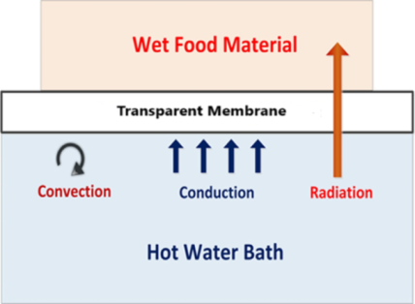
Fig. 1 Components of a Refractance window dryer (source: Oritz-Jerez et al., 2015)
2.1 Principle
The transfer of radiant energy occurs through the membrane, governed by the variations in refractive index within the water-film-food system. In the absence of a food product on the transparent membrane, the contrast of refractive index between water and air becomes more noticeable. This increased difference causes the incident rays to reflect back into the water surface, effectively "closing the window," as illustrated in Figure 2.
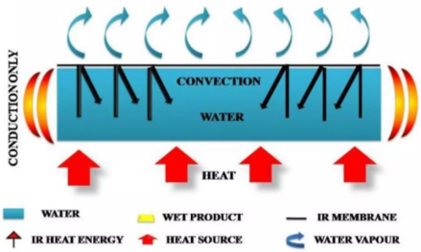
Fig. 2 Large difference in refractive index (Source: Trivedi et al., 2017)
When a food product is placed on the transparent membrane, the refractive index disparity between the water and the food decreases. This reduction allows radiant energy to effectively pass through the membrane and be absorbed by the food, signifying that the "window is open," as illustrated in Figure 3.
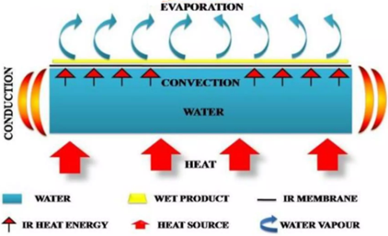
Fig. 3 Smaller difference in refractive index (Source: Trivedi et al., 2017)
This mechanism enhances the transfer of thermal radiation through the membrane towards the food material. As drying progresses, the refractive index of the product rises, leading to a mismatch that causes most of the thermal radiation to be reflected back into the water. This self-regulating process ensures gentle drying during the final stages of the procedure (Mahanti et al., 2021). Consequently, it reduces product degradation and preserves quality, with the food temperature typically staying below 70°C, generally ranging between 39°C and 47°C
2.1 Working mechanism
The mechanism operates based on the refractive behavior of infrared radiation, which is emitted from the surface of heated, circulating water. Infrared radiation forms a part of the electromagnetic spectrum between visible light and microwaves, with wavelengths ranging from 0.78 to 1000 µm. Within this spectrum, water molecules exhibit strong absorption of infrared radiation in the range of 3.0 to 15.3 µm, inducing vibrational motions at frequencies between 60,000 and 150,000 MHz (Aboud et al., 2019; Zalpouri et al., 2022). The absorbed vibrational energy is subsequently converted into thermal energy, enabling efficient heat transfer.
Food materials are placed on a thin, membrane capable of transmitting infrared radiation, such as polyethylene film (e.g., Mylar film), or Pyrex glass which floats atop heated circulating water. This membrane is buoyed by the water and can either remain stationary or move in tandem with the water flow. In systems employing a moving membrane, the food advances along the water’s surface at belt speeds typically ranging from 0.6 to 3 m/min (Kudra and Mujumdar, 2009). Heat is delivered to the food from the water through a combination of radiative and conductive transfer mechanisms, ensuring efficient energy utilization.
Although the water temperature is controlled between 90 and 95°C, the product temperature remains considerably lower, typically ranging from 60 to 70°C, due to the combined effects of evaporative cooling and convective heat transfer to the surrounding air. This rapid heat transfer mechanism facilitates efficient moisture evaporation, maintaining thermal equilibrium throughout the process. The evaporated moisture is effectively removed via an exhaust system or directed airflow. To optimize thermal efficiency, the water is frequently recycled and reheated for sustained operation. The entire drying system functions under standard atmospheric conditions, ensuring operational simplicity and reliability.
3. EFFECT OF PROCESS PARAMETERS ON RW DRYING
The drying rate and drying duration in RWD are predominantly governed by several critical parameters, such as the temperature of the water, the product's initial temperature, the product's thickness, the nature of the radiant energy source, the duration of exposure (residence time), and the thickness of the membrane or film employed in the process (Mahanti et al., 2021). Each of these parameters significantly impacts product quality and is therefore outlined in detail in the following sections.
3.1 Water temperature
In the RWD process, hot water serves a pivotal function by acting as the primary medium for heat transfer. This occurs at sub boiling temperatures (< 99°C) and under atmospheric pressure. Heat is transferred from the hot water to the product through conduction and radiation via the Mylar membrane. As illustrated in Figure 4, kheto et al. (2025) examined the changes in dry basis moisture content of Spanish cherry pulp under different water bath temperatures (55°C to 90°C) and observed that increasing the water temperature reduced the total drying time substantially, from 320 minutes to just 80 minutes. Similarly, for peach slices, RWD treatment at 86∘C successfully reduced the water content to 0.05 kg H2​O/kg dry solid in only 40 minutes for 1 mm slices (Largo-Avila et al., 2024).
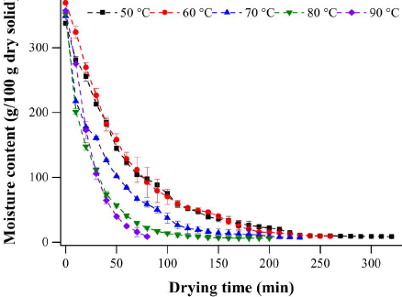
Fig. 4 A kinetic curve showing MC vs. time for Spanish cherry pulp at 50 ℃ to 90℃
An increase in the temperature of water bath significantly enhances the rate of moisture removal, thereby expediting the drying process of the sample. At higher water temperatures, the temperature of sample also increases; however, it remains considerably lower than the temperature of the water bath. This phenomenon is attributed to both internal and external barriers to heat transfer, along with the effects of evaporative cooling. Furthermore, as drying advances, the material's effective thermal conductivity experiences a significant decline. Consequently, RWD offers more rapid moisture removal (higher drying rate) while preserving superior product quality, as the product remains at relatively low temperatures even when the water bath temperature is high. This occurs because quality degradation processes are governed by temperature and time-dependent reaction kinetics (Mahanti et al., 2021). A 10°C increase in water temperature results in a 16% rise in evaporation rate (Nindo and Tang, 2007). However, when water temperatures surpass 95°C, moisture bubbles may form at the interface between the water and the film. These bubbles interfere with heat transfer and reduce the effectiveness of the RWD process. To overcome this challenge, additives like glycol, which have a boiling point of 197°C at atmospheric pressure, can be mixed with water. This enables the water bath temperature to rise above 95°C without boiling, thereby enhancing the drying rate as required (Shende and Datta, 2019).
3.2 Product temperature
The thermal characteristics of the material undergoing RWD is characterized by maintaining a mild product temperature, typically remaining within the range of 60−70℃ [Kumar et al., 2024; Mahanti et al., 2021; Kaveh et al., 2024; Borse et al., 2025]. The product temperature profile consistently displays a rapid initial rise, followed by a steady plateau [Kumar et al., 2024; Ortiz-Jerez et al., 2015], a phenomenon central to the self-regulating mechanism of RWD [Lalita et al., 2024; Baeghbali et al., 2010]. The resulting maximum product temperature usually remains below 80∘C [Kumar et al., 2024; Borse et al., 2025; Lalita et al., 2024]. This thermal stability is achieved through processes such as intense evaporative cooling [Lalita et al., 2024; Pal et al., 2023] and the fundamental principle that the "refractance window" for infrared energy transfer gradually closes as the moisture content decreases [Borse et al., 2025; Baeghbali et al., 2010]. Experimental confirmation of this mild thermal profile is seen across recent literature, exemplified by studies on jamun pulp, which showed a maximum product temperature of 78.9∘C in standard Hot Water RWD (HW-RWD) as illustrated in Figure 5 [Zhang et al., 2024]. Maintaining this controlled temperature is crucial for preserving quality attributes such as observed in the optimization study of aonla slices, where measured product temperatures varied safely between 46.95∘C and 62.84∘C across tested water temperatures [Lalita et al., 2024].
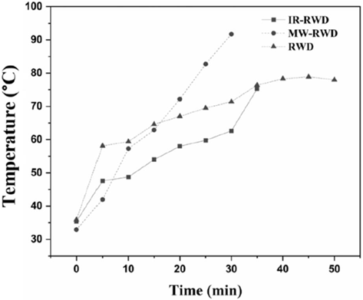
Fig. 5 Product temperature profile during jamum pulp drying by methods IR-RWD, MW-RWD, and HW-RWD (Zhang et al., 2024)

The initial sharp increase in the product temperature at the start of the drying process can be attributed to the intense conductive heat transfer from the hot water to the product, driven by the considerable temperature difference between the water and the food (Ortiz-Jerez et al., 2015). As the drying continues, evaporation of moisture leads to stabilization in temperature as most of the moisture is removed. Subsequently, as evaporation reduces and moisture diffusivity declines with lower moisture content, the temperature rises slowly during the final stages of drying. However, the food's temperature stays below that of the water bath. Additionally, as drying advances, thermal conductivity within the sample decreases while the gas phase expands, due to air’s lower thermal conductivity (Castoldi et al., 2015).
3.3 Product thickness
Product thickness plays a crucial role in determining the rate and duration of drying. Ochoa-Martinez et al. (2012) reported that mango slices with a thickness of 1 mm required 30 minutes to reduce moisture content from 86% to below 5%, which was half the time needed for slices with a thickness of 2 mm (60 minutes). Thinner samples exhibited shorter drying times due to the reduced distance for moisture migration (Ocoro and Ayala, 2013). A thickness increase from 2 mm to 3 mm resulted in a nearly 30% increase in drying time and a 43% reduction in the drying rate at a water temperature of 95°C, reaching a final moisture content of 3% (dry basis) (Oliveira et al., 2016). Castoldi et al. (2015) reported that an increase in sample thickness adversely impacts the efficiency of infrared energy transfer during the drying process, while significantly enhancing resistance to thermal conduction and mass transfer mechanisms. This heightened resistance subsequently reduces the rate of moisture evaporation from the drying material, leading to a slower drying process. Additionally, the attenuation of radiation within the pulp decreases exponentially with increased thickness, in line with Beer’s law.
As the thickness of the product increases, the time required for moisture migration from its core to the surface is prolonged, resulting in a decreased drying rate and a longer drying duration. Products with reduced thickness exhibit better retention of colour, flavour, nutrients, and functional components due to their accelerated drying kinetics and reduced processing duration. Consequently, thinner products achieve lower moisture content and water activity levels, which significantly contribute to an extended shelf life (Mahanti et al., 2021).
3.4 The contact film
The core component of RWD technology is the contact film, with Mylar being the most commonly utilized material due to its high infrared energy wavelength transmittance. Mylar is a biaxially oriented polyethylene terephthalate (PET) film, recognized for its superior tensile strength, adhesive properties, and resistance to moisture and chemicals. It is capable of withstanding a wide temperature range, from −73°C to 150°C. This material has been widely adopted for RWD systems, owing to its favourable thermal and physical properties, including a density of 1.39 g/cm³, specific heat of 0.28 Cal/g°C and thermal conductivity of 0.24 W/mK under ambient condition (Ortiz-Jerez and Ochoa-Martínez, 2015).
The transmission of radiant heat is enhanced by higher temperatures of the heat source and a reduction in the thickness of the plastic film. The efficiency of thermal radiation transfer through plastic films can be assessed by evaluating their optical characteristics. Table 1 provides transmittance values of mylar fim at specific wavelengths. Mylar exhibits high transmissivity bands (~90%) for thermal radiation at wavelengths of approximately 3, 4.7, and 6 µm. According to Sandu (1986), water shows strong absorption of infrared radiation at these specific wavelengths.
Table 1. Transmittance of mylar at specific wavelength (source: Oritz-Jerez et al., 2015)
Wave length, λ (µm) | Transmission (%)
3 | 88
4.7 | 90
6 | 75
8 | 0

3.5 Film thickness
The efficiency of energy transfer through radiation and conduction in food processing applications is greatly affected by the thickness and type of the film (Ortiz-Jerez et al., 2015). Small changes in thickness, chemical composition, or measurement techniques can considerably impact the optical properties of the film, impacting its performance Makhlouka et al. (2022). Zotarelli et al. (2015) demonstrated that reducing the thickness of Mylar film by half results in a twofold increase in its transmissivity, highlighting the importance of film thickness in controlling heat transfer. However, Shende and Datta (2019) optimized the Mylar film thickness to 0.25 mm, balancing increased transmissivity with sufficient mechanical strength to withstand operational stresses. The percentage of radiant energy transmitted through the film is thickness-dependent, as shown in Table 2, which underscores its importance in maintaining uniform heat transfer and process efficiency in food drying and preservation systems.
Table 2. Mylar transmittance observed at wavelengths around 6.5 and 14.5 µm (source: Oritz-Jerez et al., 2015)
Temperature of the radiation source | Thickness of Mylar film (mm) | Total transmittance (%)
60℃ | 0.1 | 15
60℃ | 0.2 | 5
90℃ | 0.1 | 16
90℃ | 0.2 | 7

Oritz-Jerez et al. (2015) observed that reducing film thickness from 0.2 mm to 0.1 mm at a source temperature of 90°C resulted in approximately a 128% increase in total transmittance. In a related study, Zotarelli et al. (2015) compared the performance of Mylar film coated with black paint (BF) and polyester Mylar film (Mylar) at a thickness of 0.8 mm for RWD of mango pulp. Significant differences were observed in the drying and evaporation rates between the RW and RW-BF drying methods. For pulp thicknesses of 2 mm and 3 mm, the drying rates varied by 43–55% and 26–57%, respectively, with RW-BF exhibiting lower rates. The black coating on the film obstructed thermal radiation emitted by the hot water, which led to a reduction in drying efficiency. Additionally, the coating increased the film's thickness by approximately 25%, leading to higher thermal resistance and reduced heat transfer efficiency. The surface temperature of Mylar film (without pulp) ranged from 85.6–89.5°C for RW-BF and 89–89.3°C for RW. Meanwhile, after 20 minutes of drying, the surface temperature of the 2 mm pulp was between 65.6°C and 85.2°C for RW-BF and 73.6°C and 89.4°C for RW, while the water bath temperature was maintained at 95°C. These findings highlight that thin films facilitate higher heat and mass transfer rates, resulting in accelerated drying. Therefore, the selection of an optimal film thickness must balance efficient heat transfer and adequate mechanical strength to withstand operational conditions.
3.6 Residence time
Residence time is a pivotal parameter affecting the quality characteristics of dried products in food processing. In refractance window (RW) drying, the residence time is significantly reduced compared to conventional drying methods owing to the rapid increase in the product's temperature. This rapid thermal response facilitates efficient moisture removal in a short duration. Following this initial phase, the product temperature stabilizes below the water bath temperature, preventing thermal degradation. As a result, RWD ensures preservation of superior key quality attributes such as colour, nutritional content, flavour and antioxidant compounds, making it a preferred technique over traditional drying methods (Kaur et al., 2017). The drying kinetics in RWD are influenced by critical process parameters, including the hot water temperature, air velocity across the product's surface and product thickness. Excessive thermal exposure can lead to quality deterioration, underscoring the importance of optimizing the drying time. Precise control of these parameters is essential to achieve maximum efficiency and preserve the functional and sensory qualities of the dried product (Mahanti et al., 2021).
3.7 Quantitative contributions of conduction and radiation
Ortiz-Jerez et al. (2015) investigated the comparaative contributions of conductive and radiative heat transfer mechanisms involved in RWD. Their findings showed that conductive heat flux, varying between 3571 and 8714 W/m², is the predominant factor influencing the drying process, while radiative heat flux, ranging from 79.43 to 110 W/m², has a significantly lower impact (Figure 7). Conductive flux, being significantly higher during the initial drying phase, is primarily responsible for the rapid temperature increase in the product. Radiative heat flux contributes only about 1% of the total conductive flux. Although radiation accounts for merely 5% of the total thermal energy transferred through the Mylar film during RWD, the process achieves enhanced drying rates, better nutrient retention, and minimized aroma and flavor loss. Over time, both conductive and radiative heat fluxes decrease as the product's temperature rises, thereby reducing the overall heat transfer rate and preventing thermal degradation. At elevated temperatures, radiative heat transfer becomes more significant relative to conduction, as it follows a proportional relationship to (temperature to the fourth power), whereas conduction depends linearly on the temperature gradient (Castoldi et al., 2015).
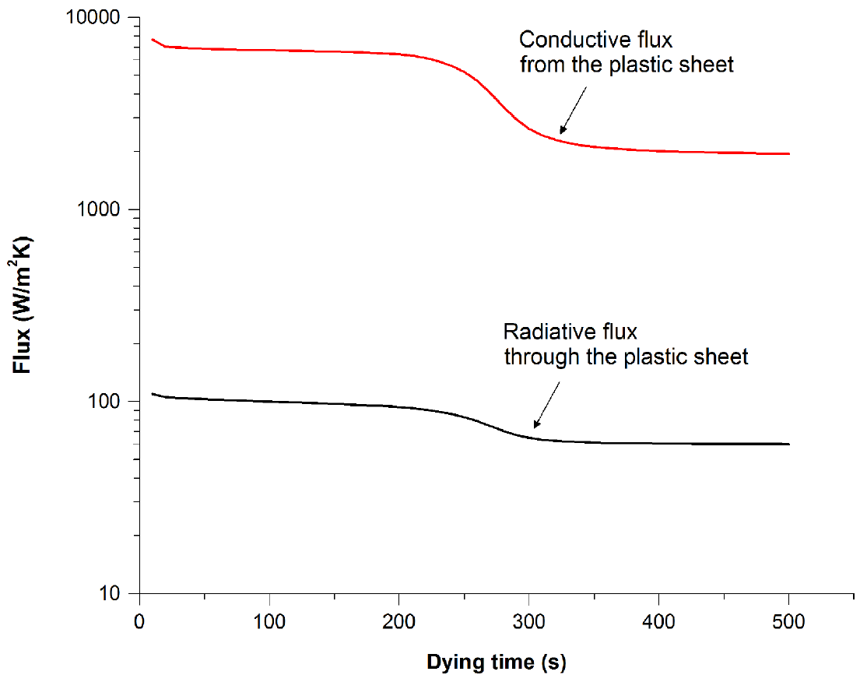
Fig. 6 Estimated Conductive and Radiative Heat Transfer through Mylar Film (Source: Oritz-Jerez et al., 2015)
4. IMPACT OF RW DRYING ON QUALITY PARAMETERS
The effect of quality parameters such as colour, microstructure, thermal properties, textural properties, biochemical properties, functional properties and microbial properties plays a crucial role in determining product quality and is therefore briefly explored in the subsequent section.
4.1 Colour
The colour of a food product is a critical quality parameter influencing consumer acceptance or rejection. The change in the colour of dried products serves as an indicator of the intensity and conditions of the applied drying methods. Additionally, the colour of food products is intrinsically associated to the concentration and stability of the pigments they contain. RWD facilitates a controlled and gentle drying process, minimizing the development of undesirable pigments and preserving the product's colour parameters. Caparino et al. (2012) evaluated the impact of diverse drying methods on the colour attributes of mango powder at various particle sizes, as depicted in Figure 8. The study revealed no significant difference in colour between powders dried using the refractance window (RW) method and freeze drying (FD). However, spray-dried (SD) powders exhibited the lightest colour, while drum-dried (DD) powders appeared the darkest. The dominant yellow colour in mango powder, indicated by the b* value, showed no significant difference between RW and FD samples. However, a notable variation was found between the SD and DD samples, as shown in Figure 8. The hue angle of RW-dried flakes and powder across all particle sizes was notably higher, signifying a more vibrant yellow colour in the RW-dried sample. This enhanced yellow colour in RW-dried products can be attributed to the high retention of β-carotene, facilitated by the low product temperature (74 ± 2°C) during the drying process.
Fig. 7 Photographs of mango flakes or powders at varying particle sizes produced using RWD, freeze drying (FD), drum drying (DD), and spray drying (SD) (Source: Caparino et al., 2012)
Puente-Diaz et al. (2020) performed a comparative study of RWD and freeze drying for golden berry pulp, demonstrating that RWD efficiently preserves the colour quality of the dried product, maintaining a close resemblance to both the fresh and freeze-dried samples. The minimal colour deviation observed between RW and FD samples underscores the effectiveness of RWD in yielding high-quality products. The superior colour retention in RW dried samples can be attributed to the reduced degradation of carotenoids, lower formation of undesirable pigments, and the relatively mild drying conditions, including lower temperatures and shorter processing times, in comparison to other drying technologies.
4.2 Microstructure
The microstructure of a product is essential in determining its long term stability, transport properties and overall quality. RW-dried powder is characterized by smooth, uniformly thick flakes, a result of the precise and controlled feeding of puree into the RW dryer’s inlet. Minjares-Fuentes et al. (2017) examined the morphological variations in aloe vera powder dried through RW, freeze drying, and spray drying techniques, with a reference sample for comparison, as depicted in Figure 9.
Fig. 8 SEM micrographs of dried products: (a) Aloe vera reference sample and samples dried using (b) spray drying, (c) freeze drying, and (d) RWD.
As depicted in Figure 9d, RW-dried flakes exhibit a uniform thickness and smooth surface. When these flakes are crushed into powder, the resulting particles retain a consistent thickness but exhibit asymmetrical shapes. The reduced specific surface area associated with the smooth particle morphology diminishes the interfacial area available for oxidative reactions and subsequently minimizes oxidation potential. This characteristic also enhances the powder's free flowability, making it less prone to clumping or degradation.
Caparino et al. (2012) performed a detailed microscopic analysis of mango powder particles produced obtained through RW, freeze, drum, and spray drying processes, as illustrated in Figure 10. The RW-dried powder was characterized by a unique composite sheet-like morphology with visible internal pores. This indicates that voids formed during evaporation remain unfilled throughout the drying process, likely contributing to higher porosity in the final product. Conversely, the freeze-dried mango powder demonstrated the greatest porosity among all samples. Drum-dried particles were characterized by irregular shapes and sharp edges, while spray drying yielded a powder composed of uniformly spherical particles.
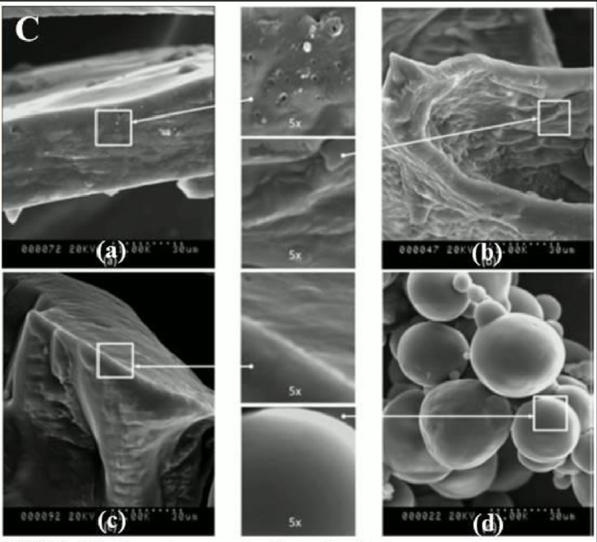
Fig. 9 SEM images of individual dried mango particles; RW drying (a), FD (b), DD (c) and SD (d)
4.3 Glass transition temperature
Glass transition temperature (Tg) serves as a critical indicator of food product stability, reflecting the physicochemical transformations that occur during processing and storage, particularly in relation to water activity (aw). Retention of the glassy state is crucial for product stability, as the transition to the rubbery state compromises structural integrity. Elevated Tg values correlate with increased product stability. Caparino et al. (2012) investigated the Tg of mango powder obtained using various drying methods, under controlled conditions of water activity (aw) ranging from 0.169 to 0.177 and moisture content below 5% (dry basis) as illustrated in Figure 11. The spray-dried (SD) sample exhibited the highest Tg due to the incorporation of a drying aid with a higher Tg, whereas the Tg of the drum-dried (DD), freeze-dried (FD), and RW-dried samples showed no significant differences. This indicates that the drying technique and conditions had minimal impact on Tg. Additionally, the initial (Tgi), midpoint (Tgm), and final (Tge) glass transition temperatures were measured, with Tgi being the most relevant for determining safe storage conditions. The minimum Tgi value of 18.7°C was recorded in the RW-dried mango powder, whereas the maximum Tgi value of 24.4°C was noted in the spray-dried product.

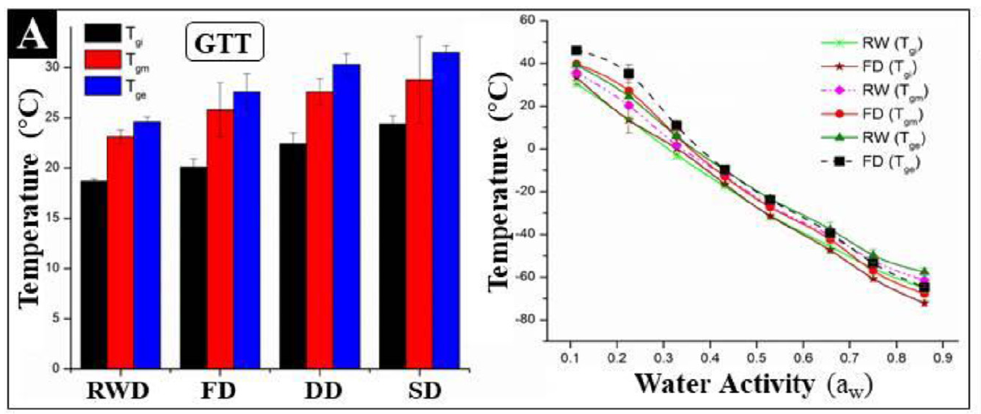
Fig. 10 Effect of RW drying, FD, DD and SD on glass transition temperature and water activity
The glass transition temperature (Tg) exhibits a negative correlation with increasing water activity (aw), as depicted in Figure 11. This opposing trend can be explained by water's plasticizing effect on the amorphous phase within the food matrix. For RW-dried mango powder, the lowest Tg value of -65.3°C was observed at the maximum aw of 0.86, indicating significant plasticization due to the presence of water. Conversely, the maximum Tg value for RW-dried samples, 30.6°C, was recorded at the lowest aw of 0.113. The predicted water activity (aw) of RW-dried mango powder at 23°C (0.16) was found to be below the monolayer moisture content aw (0.34), suggesting safe storage at or below this temperature with a maximum aw of 0.34 (equivalent to 0.081 kg water/kg dry basis). Storage of dried foods below their respective glass transition temperatures (Tg) is known to enhance shelf life by minimizing molecular mobility. While limited studies have examined the Tg of RWD in comparison to other drying methods, the existing data suggests that the differences are statistically insignificant. Further investigation is required to fully assess the impact of RWD on the Tg of various food products compared to other drying technologies.
4.4 Textural properties
The texture of food is a critical attribute that influences the tactile sensation during mastication and significantly impacts consumer acceptability. The texture of food products is closely related to both the drying rate and temperature. Consequently, the texture of food materials often differs before and after drying. The Refractance Window (RW) drying method is particularly effective for drying liquids or semi-liquid foods. For solid foods, such as fruit and vegetable pieces, RWD yields a more porous structure with reduced shrinkage, preserving the integrity of the product.
A comparative study by Jafari et al. (2016) on kiwifruit samples dried using oven drying and RWD at temperatures of 80, 90, and 100°C revealed that RW dried samples exhibited lower textural hardness compared to oven dried samples. This indicates hat RWD offers superior texture retention in the final product. This effect may be attributed to the minimal energy transfer in RWD, which occurs in the form of irradiation between the water and the sample. Additionally, the greatest hardness was recorded at 80°C, potentially due to the increased crispness imparted by higher drying temperatures and the converse softening effect at lower temperatures.
Sample firmness is significantly affected by both its inherent composition and the drying technique employed (Franco et al., 2019). RW-dried apple samples (0.18–0.47 N/mm) exhibited lower firmness values when compared to conventionally dried samples (0.40–0.94 N/mm), likely due to the more fragile matrix that develops during RWD. Similarly, RW-dried chickpea protein isolate gels exhibited reduced hardness, cohesiveness, and gumminess compared to freeze-dried samples (Tontul et al., 2018). Furthermore, material thickness is a crucial factor influencing the final texture of RW-dried products. Hernández-Santos et al. (2016), in a study on carrot slices, demonstrated that thinner slices led to both shorter drying times and minimal textural changes, whereas thicker slices exhibited greater puncture resistance.
4.5 Biochemical properties
The biochemical composition and properties of food products are critically dependent on the drying process parameters, namely temperature, time, and the chosen drying method. The effects of RWD on the biochemical properties of different food products are discussed in the following sections
4.5.1 Ascorbic acid
Ascorbic acid serves as a sensitive marker for nutrient quality in food products, with its retention influenced by oxygen, moisture, light, and temperature (Rajoriya et al., 2020). Refractance Window Drying (RWD) has been shown to retain ascorbic acid more effectively than conventional hot-air drying, largely due to shorter drying times and self-regulating lower product temperatures (Tontul et al., 2018a; Borse et al., 2025; Lalita et al., 2024). Rajoriya et al. (2021)` found that banana dried at 90°C via RWD retained more ascorbic acid than samples processed at lower temperatures, mainly attributable to shorter exposure to heat.
Optimal retention also occurs at a pulp thickness of around 3 mm; thinner and thicker samples experience increased losses due to greater surface oxidation or prolonged drying, respectively (Rajoriya et al., 2021). For aonla slices, RWD preserved 4–6% more ascorbic acid than hot-air drying (Lalita et al., 2024). Similar results with mango and guava confirm RWD’s advantage over hot-air and freeze-drying in preserving ascorbic acid and other nutrients (Borse et al., 2025; Liu et al., 2024; Nasr et al., 2024). Milder RWD temperatures (e.g., 50°C) also closely match freeze-drying in retaining vitamin C (Kheto et al., 2025).
4.5.2 Phenolic compounds
Phenolic compounds, which are vital plant secondary metabolites, play a crucial role in promoting health due to their bioactive properties. The drying process and its associated conditions, such as temperature and material thickness, significantly affect the retention and transformation of these compounds. Shende and Datta (2019) highlighted that RWD of mango leather led to a substantial increase in total phenolic content with rising drying temperatures. This enhancement can be attributed to the thermal disruption of cellular structures, which facilitates the release of bound phenolic compounds. Furthermore, The retention of phenolic compounds during RWD was found to be dependent on pulp thickness, with thicker samples exhibiting increased total phenolic content. This observation may be attributed to the increased thermal processing experienced by thicker samples due to longer drying times, which facilitates the generation of Maillard reaction products. These products, in turn, contribute to the synthesis of new phenolic compounds, thereby enhancing the bioactive profile of the dried product
Niakousari (2018) investigated the impact of various drying techniques, including Refractance Window (RW) drying, freeze drying, and spray drying, on the total phenolic content of pomegranate juice. The study demonstrated that freeze drying resulted in the highest retention of phenolic compounds, followed by RWD, with spray drying exhibiting the lowest retention. This disparity is attributed to the sensitivity of phenolic compounds, which degrade upon exposure to heat during the drying process, leading to a reduction in total phenolic content in relative to freeze-dried samples.
4.5.3 Carotenoids content
Carotenoids are vulnerable to heat and oxidation, making their retention vital for maintaining both color and nutritional quality in dried foods. Their degradation is exacerbated by high temperatures, light, and oxygen during processing (Durigon et al., 2016; Puente et al., 2020). Studies indicate that Refractance Window Drying (RWD) achieves higher carotenoid preservation than conventional drying, due to its mild temperatures (typically below 80 °C) and faster processing, thereby minimizing thermal and oxidative damage (Borse et al., 2025; Raghavi et al., 2018; Largo-Avila et al., 2024; Kheto et al., 2025). For instance, mango powders dried by RWD had greater carotenoid retention compared to hot air or freeze-drying, contributing to improved color and nutritional profiles (Borse et al., 2025; Liu et al., 2024; Shende & Datta, 2019). While freeze-drying generally achieves the highest carotenoid retention, RWD shows intermediate levels, outperforming infrared and hot-air drying, as demonstrated with golden berry and Spanish cherry pulp (Puente et al., 2020; Kheto et al., 2025). Notably, carotenoid losses still occur with increased slice thickness or higher RWD temperatures, as seen in peach slices, underscoring the importance of optimizing drying parameters to maximize retention (Largo-Avila et al., 2024).
4.6 Functional properties
The functional attributes of food materials are critical determinants of both their quality parameters and processing behaviour (Dehnad et al., 2016). These properties are essential for effective food processing and product formulation. These characteristics dictate the performance of food materials during processing, manufacturing, storage, and end-use. The subsequent section examines the impact of RWD on selected functional properties.
4.6.1 Hygroscopicity
Hygroscopicity is a key attribute of powdered food products, which describes their capacity to attract and retain moisture when exposed to environments with high relative humidity (Canuto et al., 2013). A comparative study of RW, freeze, drum, and spray drying of mango puree was conducted by Caparino et al. (2012). The results revealed that the hygroscopicity of RW-dried mango powder was comparable to that of freeze-dried mango powder, as depicted in Figure 12. In contrast, drum-dried samples exhibited significantly higher hygroscopicity than those dried using RW, freeze, and spray methods. The moisture content of the samples, determined on a dry weight basis, was 0.017, 0.03, 0.013, and 0.043 kg water/kg solid for RW, FD, DD, and SD, respectively. Sample hygroscopicity was strongly correlated with moisture content, with the spray-dried (SD) sample exhibiting the lowest hygroscopicity, potentially due to the incorporation of maltodextrin prior to drying.
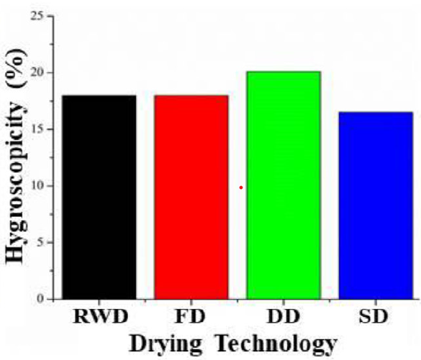
Fig. 11 Effect of different drying technologies on hygroscopicity
Figure 13 illustrates the water absorption behavior of RW dried, spray-dried (SD), drum-dried (DD), and freeze-dried (FD) mango powders after 7 days of storage at 23°C and 75.5% relative humidity. The results demonstrate that the RW dried, FD, and SD mango powders exhibited significantly lower moisture absorption compared to the drum dried product, in which the particles nearly disintegrated upon contact with water.
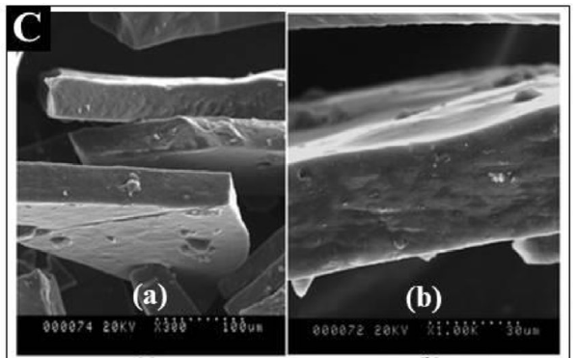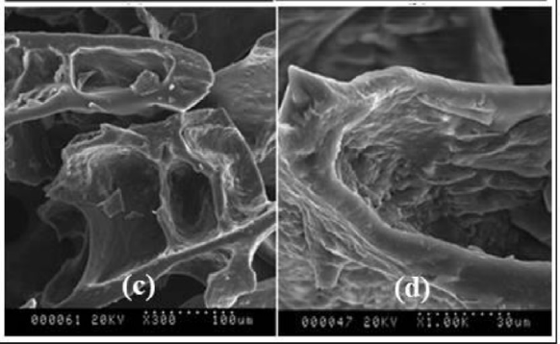
Fig. 12 Field emission scanning electron micrographs of dried mango powder (a) RWD, (b) FD, (c) DD and (d) SD
4.6.2 Rehydration ratio
Rehydration properties are a crucial quality parameter for dried products, as they offer valuable insights into the physicochemical transformations occurring during the drying process. These changes are influenced by factors such as processing conditions, pretreatment of the sample, and its composition. Rehydration is quantified by calculating the ratio of the rehydrated sample's drained weight to its initial dry weight (Chaudhary and Kumar, 2020). Abul-Fadl and Ghanem (2011) evaluated the rehydration characteristics of tomato powder produced by RWD at temperatures ranging from 60 to 90°C, in comparison with powder produced by convective air drying at 60°C. The RW dried samples showed rehydration ratios between 3.14 and 3.24, which were 6 to 9% higher compared to the tomato powder dried using convective air drying.
In a recent study by Zalpouri et al. (2021) investigating potato flake production, comparable outcomes were observed across different drying methods. The research involved blanching potato slices for 3-5 minutes, followed by purée production with a total solids content within the 8-12% range. Subsequent drying was conducted using both Refractance Window Drying and conventional convective tray drying. The results demonstrated a superior rehydration capacity in flakes produced via RWD. This enhancement was attributed to the prolonged drying times and elevated surface temperatures inherent in convective tray drying. These conditions likely facilitated the formation of a surface barrier layer, impeding the rehydration process and hindering the restoration of the original product form and volume. Additionally, an increase in drying temperature was observed to negatively impact rehydration capacity. This phenomenon was primarily attributed to the caramelization of sugars at elevated temperatures, leading to the blockage of surface pores and consequently diminishing water absorption. Additional factors such as increased shrinkage, collapse of the cellular matrix, and case hardening at elevated temperatures also contributed to this phenomenon (Azizi et al., 2017).

5. ENERGY EFFICIENCY
Refractance Window Drying (RWD) operates by transferring thermal energy to the drying material, facilitating moisture evaporation at the material-air interface. The efficiency of this process is often evaluated by calculating the thermal efficiency, defined as the ratio of energy utilized for product heating and water evaporation to the total energy input. RWD employs circulating hot water to transfer thermal energy, inherently enhancing energy efficiency compared to methods like freeze drying, drum drying, spray drying, and hot air drying. This improved efficiency stems from the recirculation mechanism, where the processing water is reheated within a reservoir instead of being discarded, resulting in significant energy conservation (Nindo and Tang, 2007). Table 3 illustrates a comparison of energy consumption and overall efficiency across drying methods. Notably, RWD requires approximately half the energy used in cabinet drying and nearly 1/23 of the energy consumed in freeze drying to process 1 kg of apple slices. Furthermore, RWD is environmentally advantageous, as it produces significantly lower carbon dioxide emissions compared to freeze and spray drying systems.
Table 3. Comparison of Energy Utilization and Efficiency in RW Drying Versus Alternative Drying Techniques
Drying sample | Type of Dryer | Specific energy consumption (kWh/kg) | Overall energy efficiency (%) | Reference
Pomegranate juice | Freeze Dryer | 130.65 | 1.12 | Baeghbali et al. (2016), Niakousari (2018)
Pomegranate juice | Spray Dryer | 11.01 | 12.92 | Baeghbali et al. (2016), Niakousari (2018)
Pomegranate juice | RWD | 4.31 | 31.56 | Baeghbali et al. (2016), Niakousari (2018)
Apple slices | Freeze Dryer | 35.13 | 2.02 | Baeghbali et al. (2019)
Apple slices | Cabinet Dryer | 2.10 | 27.62 | Baeghbali et al. (2019)
Apple slices | RW Dryer | 1.54 | 37.66 | Baeghbali et al. (2019)
Aloe vera gel | Hot air Dryer |  | 7.00 | Seyfi et al. (2021)
Aloe vera gel | RWD |  | 20.00 | Seyfi et al. (2021)

6. HYBRID RWD
Various drying methods employ unique energy forms, and their integration can improve the effectiveness of heat and mass transfer across a wide range of feed materials. Employing multiple drying methods for food dehydration often yields synergistic benefits, improving process efficiency and enhancing overall drying performance. This approach leverages the advantages of individual methods, leading to better product quality, reduced energy consumption, and shorter drying times.
6.1 Infrared-assisted RWD
Infrared (IR) radiation is regarded as a highly promising drying technique, particularly for its energy efficiency and effectiveness in delivering high-quality dried products. Within the framework of RWD, the pulp's thickness presents a constraint on its applicability. In contrast, IR radiation can penetrate the food matrix, converting its energy into heat, thereby facilitating rapid volumetric heating when exposed to an electromagnetic field. This unique heating mechanism enables IR drying to achieve uniform heating, higher drying rates and superior product quality (Liu et al., 2014).
According to Rajoriya et al. (2020), conventional RW dryers consume energy in the range of 5.75–5.83 kWh per kilogram of water removed. However, FIR-assisted RWD exhibited a notably lower energy requirement, ranging between 3.96 and 4.38 kWh per kilogram of water removed. Furthermore, combining IR with RWD significantly reduced the drying duration by 50%, owing to improved heat and mass transfer efficiency, establishing it as a highly efficient and effective hybrid drying technique.
Puente-Díaz et al. (2020) utilized near-infrared radiation (NIR) within the wavelength range of 700–1200 μm in their research, revealing that the incorporation of IR-assisted RWD led to a reduction in drying time by approximately 60%, mainly attributed to the enhanced volumetric heating effect.
The RW-dried products exhibit a microstructure characterized by more prominent voids and an interconnected network, in contrast to those obtained through alternative drying techniques. When FIR is combined with RWD, the void size further increases, contributing to a higher effective diffusion coefficient. This integration improves both the efficiency of heat and mass transfer and the overall quality of the dried product. The synergistic benefits of combining IR with RWD make it a highly efficient technique suitable for large-scale applications in food processing.

7. ADVANTAGES AND LIMITATION OF RWD TECHNOLOGY
7.1 Advantages
Refractance Window (RW) drying is an advanced, energy-efficient technology that prioritizes both drying performance and the preservation of food quality. As a cutting-edge method, RWD optimizes energy use while maintaining the functional, nutritional, and sensory characteristics of the final product, making it a sustainable and cost-effective solution for food dehydration.
RWD is particularly well-suited for converting liquid food matrices into powders, flakes, or sheets. Its operation at low temperatures and atmospheric pressure makes it highly suitable for heat-sensitive foods, minimizing the risk of thermal degradation of sensitive compounds such as vitamins, antioxidants, and bioactive components. Furthermore, the absence of direct contact between the food material and the heating medium effectively prevents cross-contamination, thereby ensuring the safety and integrity of the final product.
This technique leverages a combination of heat transfer mechanisms, primarily conduction and radiation, facilitated by circulating hot water, enabling rapid moisture removal and significantly reducing drying time. The synergistic heat transfer mechanism results in a uniform drying process, preserving the structural integrity and quality of the dried product. RWD thus emerges as a promising technology for industrial applications, offering superior energy efficiency and high-quality outcomes compared to conventional drying methods.
7.2 Limitations
- A significant limitation of the RWD technique lies in its scalability. Scaling up RWD for industrial production requires a large surface area for efficient heat exchange, presenting a significant challenge for processing large volumes of product
- RWD is less suitable for drying high-sugar purees, as these products have a tendency to adhere to the conveyor belt, creating operational challenges.
- The conveyor belt requires cleaning after each drying cycle or prior to loading the next batch of material, which adds to the maintenance requirements and can reduce the efficiency of the overall process.
8.0 CONCLUSION
Refractance Window (RW) drying, also known as conductive hydro-drying, is a highly effective method with significant potential for preserving the nutritional value and overall quality of food products. Studies have shown that RWD is a gentle dehydration process that produces safe dried products while effectively retaining sensitive nutrients, such as ascorbic acid and phenolic compounds, due to its operation at relatively low temperatures. The quality and physicochemical properties of the final product are significantly influenced by key factors such as the drying temperature and the thickness of the food sample.
Compared to traditional drying methods, RWD offers significant energy savings while producing high-quality products, often on par with freeze-drying, but at a much lower cost in terms of equipment. This method is particularly effective in preserving sensory and nutritional properties, making it a valuable alternative in food processing. Beyond its energy efficiency, RWD also provides advantages in terms of safety, cost-effectiveness, and a reduced environmental footprint. As consumer demand for nutritious, high-quality food products continues to rise, RWD shows substantial promise as a preferred technology in the food industry. It enables the production of value-added, premium-quality food products while providing an economically feasible solution. However, scalability remains a significant challenge for RWD, requiring further investigation. Given the increasing consumer focus on safety and food quality, RWD technology is well-positioned to play a pivotal role in the future of food processing.

Disclaimer (Artificial intelligence)
Option 1:
Author(s) hereby declare that NO generative AI technologies such as Large Language Models (ChatGPT, COPILOT, etc.) and text-to-image generators have been used during the writing or editing of this manuscript.
Option 2:
Author(s) hereby declare that generative AI technologies such as Large Language Models, etc. have been used during the writing or editing of manuscripts. This explanation will include the name, version, model, and source of the generative AI technology and as well as all input prompts provided to the generative AI technology
Details of the AI usage are given below:
1.
2.
3.

References

Aboud, S. A., Altemimi, A. B., Al-HiIphy, A., Yi-Chen, L., & Cacciola, F. (2019). A Comprehensive Review on Infrared Heating Applications in Food Processing. Molecules. 24(22), 4125. https://doi.org/10.3390/molecules24224125.
Abul-Fadl, M. M. & Ghanem, T. H. (2011). Effect of refractance window (RW) drying method on quality criteria of produced tomato powder as compared to the convection drying method. World Appl. Sci. J. 15, 953–965
Azizi, Dariush, Jafari, Seid Mahdi, Mirzaei, Habibollah & Dehnad, Danial. (2017). The Influence of Refractance Window Drying on Qualitative Properties of Kiwifruit Slices. International Journal of Food Engineering. 13(2), 20160201. https://doi.org/10.1515/ijfe-2016-0201
Baeghbali, V., Niakousari, M., & Kiani, M. (2010). Design, manufacture and investigating functionality of a new batch refractance window system. In Proceedings of 5th International Conference on Innovations in Food and Bioprocess Technology.
Baeghbali, V., Niakousari, M., & Farahnaky, A. (2016). Refractance Window drying of pomegranate juice: Quality retention and energy efficiency. LWT - Food Sci. Technol. 66,34–40. https://doi.org/10.1016/j.lwt.2015.10.017.
Baeghbali, V., Niakousari, M., Ngadi, M. O., & Hadi E. M. (2019). Combined ultrasound and infrared assisted conductive hydro-drying of apple slices. Dry. Technol. 37(14),1793–1805. https://doi.org/10.1080/07373937.2018.1539745.
Borse, E. S. M., Gupta, S. V., & Patil, B. N. (2025). A review on refractance window drying of fruits. International Journal of Advanced Biochemistry Research, 9(1), 472–482. https://doi.org/10.33545/26174693.2025.v9.i1f.3558
Canuto, H. M. P., Afonso, M. R. A., & Costa, J. M. C. D. (2013). Hygroscopic behavior of freeze-dried papaya pulp powder with maltodextrin. Acta Sci. Technol., 36(1),179–185. https://doi.org/10.4025/actascitechnol.v36i1.17499.
Caparino, O. A., Tang, J., Nindo, C. I., Sablani, S. S., Powers, J. R., & Fellman, J. K. (2012). Effect of drying methods on the physical properties and microstructures of mango (Philippine ‘Carabao’ var.) powder. Journal of Food Engineering, 111(1), 135–148. https://doi.org/10.1016/j.jfoodeng.2012.01.010
Castoldi, M., Zotarelli, M.F., Durigon, A., Carciofi, B.A.M., & Laurindo, J. B. (2015). Production of tomato powder by refractance window drying . Drying Technol., 33(12), 1463-1473.
Chaudhary, V. & Kumar, V. (2020). Study on Drying and Rehydration Characteristics of Tray Dried Beetroot (Beta Vulgaris L.) and Functional Properties of its Powder. 10.37273/chesci.CS082050061.
Dehnad, D., Jafari, S. M., & Afrasiabi, M. (2016). Influence of drying on functional properties of food biopolymers: From traditional to novel dehydration techniques. Trends Food Sci. Technol., 57, 116–131. https://doi.org/10.1016/j.tifs.2016.09.002.
Durigon, A., De Souza, P. G., Carciofi, B. A. M., & Laurindo, J. B. (2016). Cast-tape drying of tomato juice for the production of powdered tomato. Food Bioprod. Process., 100,145–155. https://doi.org/10.1016/j.fbp.2016.06.019.
Franco, S., Jaques, A., Pinto, M., Fardella, M., Valencia, P., Núñez, H., Ramírez, C., & Simpson, R. (2019). Dehydration of salmon (Atlantic salmon), beef, and apple (Granny Smith) using Refractance windowTM: Effect on diffusion behavior, texture, and color changes. Innov. Food Sci. Emerg. Technol. 52, 8–16. https://doi.org/10.1016/j.ifset.2018.12.00.
Hernández-Santos, B., Rodríguez-Miranda, J., Herman-Lara, E., Torruco-Uco, J., Carmona-García, R., Juárez-Barrientos, J., Chávez-Zamudio, R., & Martinez Sanchez, C. (2016). Effect of oil extraction assisted by ultrasound on the physicochemical properties and fatty acid profile of pumpkin seed oil (Cucurbita pepo). Ultrasonics Sonochemistry, 31. 10.1016/j.ultsonch.2016.01.029.
Jafari, S., Mahdavi-Khazaei, K., & Abbas H., (2016). Microencapsulation of saffron petal anthocyanins with cress seed gum compared with Arabic gum through freeze drying. Carbohydrate Polymers. 140, 20-25. https://doi.org/10.1016/j.carbpol.2015.11.079.
Kaur, G., Saha, S., Kumari, K., & Datta, A.K., (2017). Mango pulp drying by refractance window method. Agri. Eng. Int., 19(4), 145-151
Kaveh, M., Zomorodi, S., Mariusz, S., & Dziwulska-Hunek, A. (2024). Determination of Drying Characteristics and Physicochemical Properties of Mint (Mentha spicata L.) Leaves Dried in Refractance Window. Foods, 13(18), 2867. https://doi.org/10.3390/foods13182867
Kheto, A., Achary, J. V., Bebartta, R. P., Sehrawat, R., Gul, K., & Mujumdar, A. S. (2025). Refractance window drying of Spanish cherry (Mimusops elengi Linn) pulp: Impacts on drying kinetics, color, and phytochemical properties. Drying Technology, 43(1–2), 348–361. https://doi.org/10.1080/07373937.2024.2407955
Kudra, T. & Mujumdar, A. S. 2009. Adv. Dry. Technol. (0 ed.). CRC Press. https://doi.org/10.1201/9781420073898.
Kumar, M., Madhumita, M., Prabhakar, P. K., & Basu, S. (2024). Refractance window drying of food and biological materials: Status on mechanisms, diffusion modelling and hybrid drying approach. Critical Reviews in Food Science and Nutrition, 64(11), 3458–3481. https://doi.org/10.1080/10408398.2022.2132210
Lalita, Giri, S. K., Mohapatra, D., Tripathi, M. K., Kate, A., & Wahid, A. (2024). Optimization of process parameters of refractance window drying for aonla slices and comparison with other drying techniques. Journal of the Science of Food and Agriculture, 104(13), 7854–7863. https://doi.org/10.1002/jsfa.13615
Largo-Avila, E., Rico-Rodríguez, F., Peñaloza-Figueroa, J. K., & López-Padilla, A. (2024). Effect of refractance window and oven drying on physicochemical and sensory properties of peach (Prunus persica L.) surplus. Frontiers in Nutrition, 11.
Liu, J., Xu, X., Zhang, T., Wang, J., Wang, R., & Xu, Q. (2024). Combined effects of low pressure superheated steam drying and vacuum drying on sugar reduction and quality attribute in mango (Mangifera indica L.) slices. International Journal of Food Engineering.
Liu, Y., Zhu, W., Luo, L., Li, X., & Yu, H. 2014. A Mathematical Model for Vacuum Far-Infrared Drying of Potato Slices. Dry. Technol., 32(2), 180–189. https://doi.org/10.1080/07373937.2013.811687.
Mahanti, N. K., Chakraborty, S. K., Sudhakar, A., Verma, D. K., Shankar, S., Thakur, M., Singh, S., Tripathy, S., Gupta, A. K., & Srivastav, P. P. 2021. Refractance WindowTM-Drying vs. other drying methods and effect of different process parameters on quality of foods: A comprehensive review of trends and technological developments. Future Foods. 3, 100024. https://doi.org/10.1016/j.fufo.2021.100024.
Makhlouka, Y., Sanaâ, F., & Gharbia, M. (2022). Ordinary and extraordinary complex refractive indices extraction of a Mylar film by transmission spectrophotometry. Polymers, 14(9), 1805. https://doi.org/10.3390/polym14091805
Minjares-Fuentes, R., Rodríguez-González, V. M., González-Laredo, R. F., Eim, V., González-Centeno, M. R., & Femenia, A. (2017). Effect of different drying procedures on the bioactive polysaccharide acemannan from Aloe vera (Aloe barbadensis Miller). Carbohydr. Polym., 168, 327–336. https://doi.org/10.1016/j.carbpol.2017.03.087.
Nasr, A., Hasan, M. M., EL-Badry, N., & Ghanem, T. H. (2024). Quality attributes of dried guava pulp using refractance window Vs. hot air drying. Al-Azhar Journal of Agricultural Research V., 49(2), 34–49.
Niakousari, M. (2018). A review on mechanism, quality preservation and energy efficiency in Refractance Window drying: A conductive hydro-drying technique. J. Nutr. Food Res. Technol., 1(2), 50–54. https://doi.org/10.30881/jnfrt.00011.
Nindo, C. I. & Tang, J. (2007). Refractance Window Dehydration Technology: A Novel Contact Drying Method. Drying Technol., 25(1), 37–48. https://doi.org/10.1080/07373930601152673.
Ocoro-Zamora, M.U. & Ayala-Aponte, A.A. (2013). Influence of thickness on the drying of papaya puree (Carica papaya L.) through Refractance Windows TM technology. Dyna, 80(182),147–154.
Oliveira, C. F., Gurak, P. D., Cladera-Olivera, F., & Marczak, L. D. F. (2016). Evaluation of physicochemical, technological and morphological characteristics of powdered yellow passion fruit peel. Int. Food Res. J., 23(4), 1653–1662.
Ortiz-Jerez, M. J. & Ochoa-Martínez, C. I. (2015). Heat Transfer Mechanisms in Conductive Hydro-Drying of Pumpkin ( Cucurbita maxima ) Pieces. Dry. Technol., 33(8), 965–972. https://doi.org/10.1080/07373937.2015.1009538.
Ortiz-Jerez, M. J., Gulati, T., Datta, A. K., & Ochoa-Martínez, C. I. (2015).. Quantitative understanding of Refractance WindowTM drying. Food Bioprod. Process. 95, 237–253. https://doi.org/10.1016/j.fbp.2015.05.010.
Pal, L., Giri, S. K., Mohapatra, D., Tripathi, M. K., & Kate, A. (2024). Mass transfer parameters and quality characteristics of aonla slices under refractance window drying. Drying Technology, 42(3), 492–505. https://doi.org/10.1080/07373937.2023.2234473
Puente, L., Vega-Gálvez, A., Ah-Hen, K. S., Rodríguez, A., Pasten, A., Poblete, J., Pardo-Orellana, C., & Muñoz, M. (2020). Refractance window drying of goldenberry (Physalis peruviana L.) pulp: A comparison of quality characteristics with respect to other drying techniques. LWT, 131, 109772. https://doi.org/10.1016/j.lwt.2020.109772
Puente-Díaz, L., Spolmann, O., Nocetti, D., Zura-Bravo, L., & Lemus-Mondaca, R. (2020). Effects of Infrared-Assisted Refractance WindowTM Drying on the Drying Kinetics, Microstructure, and Color of Physalis Fruit Purée. Foods., 9(3), 343. https://doi.org/10.3390/foods9030343.
Raghavi, L. M., Moses, J. A., & Anandharamakrishnan, C. (2018). Refractance window drying of foods: A review. Journal of Food Engineering, 222, 267–275. https://doi.org/10.1016/j.jfoodeng.2017.11.032
Rajoriya, D., Bhavya, M. L., & Hebbar, H. U. (2021). Impact of process parameters on drying behaviour, mass transfer and quality profile of refractance window dried banana puree. LWT., 145, 111330. https://doi.org/10.1016/j.lwt.2021.111330.
Rajoriya, D., Shewale, S. R., Bhavya, M. L., & Hebbar, H. U. (2020). Far infrared assisted refractance window drying of apple slices: Comparative study on flavour, nutrient retention and drying characteristics. Innov. Food Sci. Emerg. Technol., 66,102530. https://doi.org/10.1016/j.ifset.2020.102530.
Sabarez, H., (2016). Drying of Food Materials. Reference Module in Food Science. Elsevier, Amsterdam, 3-5p
Sandu, C. (1896). Infrared Radiative Drying in Food Engineering: A Process Analysis. Biotechnology Progress., 2(3),109-119
Seyfi, A., Rezaei Asl, A., & Motevali, A. (2021). Comparison of the energy and pollution parameters in solar refractance window (photovoltaic-thermal), conventional refractance window, and hot air dryer. Sol. Energy, 229, 162–173. https://doi.org/10.1016/j.solener.2021.05.094.
Shende, D. & Datta, A. K. (2019). Refractance window drying of fruits and vegetables: A review. J. Sci. Food Agric., 99(4), 1449–1456. https://doi.org/10.1002/jsfa.9356.
Tontul, I., Eroğlu, E., & Topuz, A. (2018a). Convective and refractance window drying of cornelian cherry pulp: effect on physicochemical properties. J. Food Process. Eng., 41, 1–8.
Tontul, İ., Kasimoglu, Z., Asik, S., Atbakan, T., & Topuz, A. (2018). Functional properties of chickpea protein isolates dried by refractance window drying. Int. J. Biol., 109, 1253–1259. https://doi.org/10.1016/j.ijbiomac.2017.11.135.
Trivedi, M., D'costa, V., Shitut, J., & Srivastav, S. (2017). Refractance window technology: A promising drying technique for the food industry. Int. J. Innov. Emerging Res. Eng., 4, 6-16.
Zalpouri, R., Kaur, P., Kaur, A., & Sidhu, G. K. (2021). Comparative analysis of optimized physiochemical parameters of dried potato flakes obtained by refractive and convective drying techniques. J. Food Process. Preserv. 45(1). https://doi.org/10.1111/jfpp.15077.
Zalpouri, R., Singh, M., Kaur, P., & Singh, S. (2022). Refractance Window Drying–a Revisit on Energy Consumption and Quality of Dried Bio-origin Products. Food Eng. Rev. 14(2), 257–270. https://doi.org/10.1007/s12393-022-09313-3.
Zarein, M., Samadi, S. H., & Ghobadian, B. (2015). Investigation of microwave dryer effect on energy efficiency during drying of apple slices. J. Saudi Soc. Agric. Sci. 14(1), 41–47. https://doi.org/10.1016/j.jssas.2013.06.002.
Zhang, Q., Pertin, O., Kamdi, H. S., Durgawati, Xiao, H. W., & Sutar, P. P. (2024). Modified refractance window drying of jamun pulp (Syzygium cumini) based on innovative infrared and microwave radiation techniques. Drying Technology, 42(5), 775–794. https://doi.org/10.1080/07373937.2024.2317739
Zotarelli, M. F., Carciofi, B. A. M., & Laurindo, J. B. (2015). Effect of process variables on the drying rate of mango pulp by Refractance Window. Food Res. Int. 69, 410–417. https://doi.org/10.1016/j.foodres.2015.01.013.

