Sustainable Nutrient Management Strategies for Enhancing Soybean Productivity through Biochar and Manure Integration
ABSTRACT

Soybean (Glycine max L.) is an important legume crop, and sustainable nutrient management is crucial for boosting productivity and maintaining soil health. The aim of the study is to investigate sustainable nutrient management strategies for enhancing soybean productivity through biochar and manure integration. A field experiment was conducted during Kharif 2024–25 at Shri Vaishnav Institute of Agriculture, Indore, using a Randomized Block Design with eight treatments and three replications. The soil of the study location was medium black clay with clayey loam texture, belonging to the Vertisol order. Soybean variety JS 9560 was sown on 3rd July 2024 at a spacing of 30 cm × 10 cm with a seed rate of 75 kg ha⁻¹. Treatments combined biochar (BC), farmyard manure (FYM), vermicompost (VC), and recommended fertilizer dose (RDF). Growth parameters including plant height, dry matter per plant, number of leaves and branches per plant were recorded at 30, 45, 60, and 75 DAS and at harvest, with measurements taken from five randomly selected plants per plot. Results showed that T8 (50% RDF + 2.5 t BC ha⁻¹ + 2.5 t VC ha⁻¹) significantly improved plant growth parameters and gave the highest grain (12.52 q ha⁻¹) and straw yield (18.74 q ha⁻¹). T8 was statistically similar to T7 (50% RDF + BC + FYM) and T2 (100% RDF). Economically, T2 gave the highest net return (₹35,368 ha⁻¹) and benefit-cost ratio (2.38), making it most profitable. Although T8 had the highest gross return (₹62,600 ha⁻¹), higher input costs reduced its net return and B:C ratio (1.17), indicating better sustainability than short-term profit. In conclusion, integrating biochar and vermicompost with 50% RDF (T8) enhanced yield and soil health, offering a sustainable soybean production strategy.

Keywords: biochar, farmyard manure, oilseed, vermicompost, and recommended fertilizer dose

Abbreviations
BC - Biochar
FYM - Farmyard Manure
VC - Vermicompost
RDF - Recommended Fertiliser Dose

1. INTRODUCTION

Soybean (Glycine max L.), a vital leguminous oilseed crop, is extensively cultivated as a rainfed crop, predominantly in the Vertisols of Central India (Bandyopadhyay et al., 2010). Soybean protein is one of the least expensive sources of dietary proteins and is considered a good substitute for animal protein, as soybean protein contains all the essential amino acids, including lysine, which is especially low in other staple crops (Agyenim-Boateng et al., 2023; Ogbemudia et al., 2018). Additionally, soybeans are also considered an abundant source of polyphenols, proteins, and fibres and therefore suggested as a potential ingredient to produce functional foods and beverages (Spréa et al., 2024; Singh Soni et al., 2024). It holds immense economic significance, ranking third among Indian oilseeds (Singh et al., 1999) and contributing globally to about 25% of edible oil and nearly two-thirds of the world’s protein concentrate used in livestock feed. Its meal is a key component in poultry and fish diets (Agarwal et al., 2013). Traditionally known as the ‘Cow of the field’ and ‘Gold from soil’ (Horvath, 1926), soybean is prized for its high-quality protein and potential health benefits, such as reducing risks associated with heart disease and diabetes (Agarwal et al., 2013).
Despite its importance, soybean productivity remains low. This is largely due to erratic monsoonal rainfall, imbalanced application of nutrients, continuous monocropping, and especially poor soil fertility caused by low soil organic carbon content (Tiwari et al., 2019). The hot climate and limited use of organic inputs further worsen soil conditions, leading to severe nutrient deficiencies (Bandyopadhyay et al., 2010).
To address these productivity gaps, enhancing soil nutrition becomes essential. Among the approaches, inorganic fertilisers have improved yields significantly. However, their long-term and excessive use results in soil acidification, compaction, reduced microbial activity, and environmental pollution (Chadha et al., 2020; Yang et al., 2019; Cui et al., 2018). Overreliance on chemical fertilisers can deteriorate soil health, reduce crop productivity over time, and increase greenhouse gas emissions. Thus, there is an urgent need for sustainable alternatives that maintain yield without compromising environmental and soil quality.
Organic manures provide a promising alternative, enhancing soil quality, restoring fertility, and improving yield sustainably (Trupiano et al., 2017). Derived from plant or animal sources, organic manure contains essential nutrients that improve soil fertility and microbial activity (Zhou et al., 2022; Gelaye, 2023). A wide variety of organic manures are used in agriculture, including farmyard manure, vermicompost, compost, green manure, biogas slurry, poultry manure, fish manure, biochar and others.
Farmyard Manure (FYM) is one of the most traditional and widely used organic manures in agriculture. It provides a broad spectrum of essential plant nutrients, including both macro (N, P, K, Ca, Mg, S) and micronutrients (Fe, Mn, Cu, Zn) (Sutaliya and Singh, 2005). FYM stimulates soil microbial activity, which enhances nutrient cycling and increases the availability of nutrients to crops (Kumar et al., 2010). Its application improves soil structure, water holding capacity, and cation exchange capacity, creating a more favourable environment for root development and plant growth.
Another manure which is widely used is vermicompost (VC) is a superior organic amendment produced through the biological decomposition of organic waste using earthworms. It is characterised by its fine structure and high nutrient availability. Nutrients such as nitrate-N, soluble P and exchangeable K, Ca, and Mg are readily available in vermicompost, promoting quick and effective nutrient uptake by plants (Orozco et al., 1996). Moreover, it contains various beneficial enzymes like chitinase, amylase, lipase, and cellulase that assist in the breakdown of organic matter and enhance nutrient absorption (Aslam et al., 2023). Vermicompost also improves soil structure, microbial diversity, and water retention capacity, leading to improved plant growth and resilience (Srivastava et al., 2011).
In recent years, biochar has attracted considerable scientific interest, and numerous studies are being conducted to explore its properties, benefits and potential application in agriculture and environmental management. Biochar may play a pivotal role in creating a sustainable future by contributing to the circular economy and addressing current and emerging environmental challenges (Khan et al., 2025). It is a carbon-rich byproduct obtained from the pyrolysis of biomass such as crop residues, wood chips, or animal waste under limited or no oxygen conditions. It is considered an environmentally friendly soil amendment with long-term benefits. Biochar significantly improves soil physical properties such as aggregate stability, porosity, water retention, and aeration (Hossain et al., 2020). Chemically, biochar enhances soil fertility by increasing pH (especially in acidic soils), boosting cation exchange capacity (CEC), and reducing nutrient leaching (Glaser et al., 2002). Biologically, it promotes microbial abundance and diversity, creating a more active rhizosphere environment that supports better plant nutrition and growth (Jemal and Yakob, 2021). The effectiveness of biochar varies depending on the feedstock used and the conditions of pyrolysis, such as temperature and duration (Kloss et al., 2012). Biochar production may involve higher initial costs, and inconsistent quality can affect its impact on crops. In some cases, issues such as potential weed contamination or reduced nutrient availability may occur (Spokas et al., 2010).
Organic manures play a vital role in improving soil fertility; however, they present certain limitations. These include relatively low nutrient content, the requirement for proper knowledge and management during their preparation, limited availability of raw materials, and slow mineralisation rates. Due to this slow release, nutrient availability often does not synchronise well with crop demand, which can result in reduced yields. Therefore, Integrated Nutrient Management (INM), which combines organic, inorganic, and biological sources of nutrients, is considered the most effective strategy for sustaining soil health and optimising crop productivity.
Integrated Nutrient Management (INM) is a sustainable agricultural practice that involves the combined use of organic and inorganic sources of nutrients to maintain soil fertility and achieve optimal crop productivity. INM is based on the principle that organic and mineral fertilisers are complementary rather than mutually exclusive. Organic sources such as FYM, compost, vermicompost, and biochar contribute to the improvement of soil organic matter, enhance microbial activity, and promote soil structure. Inorganic fertilisers address specific nutrient deficiencies and provide an immediate supply of essential nutrients. The integration of both sources creates a synergistic effect that not only improves crop yield but also ensures long-term soil health and environmental sustainability (Buresh et al., 1997; Vanlauwe et al., 2002).
INM also helps reduce the dependence on chemical fertilisers, minimises nutrient losses, and addresses the emerging deficiencies of secondary and micronutrients, which are often overlooked in conventional fertilisation. Given these challenges and the potential of biochar, this study aims to evaluate the effect of biochar integrated into a sustainable fertilisation regimen on soybean growth and yield.
2. material and methods

The present experiment of the effect of biochar on the growth and yield of soybean (Glycine max L.) was conducted during Kharif 2024 at the experimental farm of SVIAg, SVVV, Indore. The soil was medium black clay with clayey loam texture, belonging to the Vertisol order. Initial soil analysis showed pH 7.31 (Piper, 1950), electrical conductivity (EC) 0.70 dS m⁻¹ (Piper, 1950), organic carbon 0.50% (Walkley and Black, 1934), available nitrogen 230 kg ha⁻¹ (Subbiah and Asija, 1956), available phosphorus 13.10 kg ha⁻¹ (Watanabe and Olsen, 1965), and available potassium 367 kg ha⁻¹ (Jackson, 1973).
The experiment was laid out in a randomised block design (RBD) with eight treatments and three replications, resulting in 24 plots. The treatments included: T1 (absolute control), T2 (100% recommended dose of fertilizer (RDF) at 20-60-40 N-P₂O₅-K₂O kg ha⁻¹), T3 (50% RDF), T4 (50% RDF + 2.5 t ha⁻¹ biochar), T5 (50% RDF + 5 t ha⁻¹ farmyard manure (FYM)), T6 (50% RDF + 2.5 t ha⁻¹ vermicompost (VC)), T7 (50% RDF + 2.5 t ha⁻¹ biochar + 5 t ha⁻¹ FYM), and T8 (50% RDF + 2.5 t ha⁻¹ biochar + 2.5 t ha⁻¹ VC).
Soybean variety JS 9560 was sown on 3rd July 2024 at a spacing of 30 cm × 10 cm with a seed rate of 75 kg ha⁻¹. The gross plot size was 3.60 m × 4.50 m, and the net plot size was 3.00 m × 4.30 m. The recommended dose of fertiliser was applied in split doses, with half the nitrogen and the full phosphorus and potassium at sowing, and the remaining half nitrogen at 30 days after sowing (DAS) in the 100% RDF treatment. Organic manures, namely FYM, VC, and biochar, were applied 15 days before sowing on a dry weight basis after nutrient analysis, which showed nutrient contents as follows: FYM (N 0.52%, P 0.25%, K 0.50%), vermicompost (N 2.00%, P 1.00%, K 1.00%), and biochar (N 0.50%, P 0.50%, K 1.31%).
Seeds were treated with Rhizobium japonicum before sowing to promote nodulation. Growth parameters, including plant height, dry matter per plant, number of leaves and branches per plant, were recorded at 30, 45, 60, and 75 DAS and at harvest, with measurements taken from five randomly selected plants per plot. Root nodules were counted on two randomly selected flowering plants per plot after careful washing of roots.
Yield attributes such as number of pods per plant, pod yield per plant, seed yield per plant, and 1000-seed weight were recorded at harvest. The harvest index was calculated using the formula by Donald and Humblin (1976), expressed as the ratio of economic yield to biological yield multiplied by 100. Seed yield and straw yield per hectare were computed from the net plot data, and biological yield was calculated as the sum of seed and straw yields.
Economic analysis was performed by estimating the total cost of cultivation, including all inputs and labour charges. Gross monetary returns were calculated based on the prevailing market price of soybean seeds, and net returns were obtained by subtracting the cost of cultivation from gross returns. The benefit-cost (B:C) ratio was computed by dividing the gross returns by the cost of cultivation.

3. results and discussion

Plant height
At 30 DAS, plant height showed minimal variation among treatments and was statistically non-significant (Fig. 1.A). The highest plant height (12.62 cm) at this stage was recorded under T8 (50% RDF + 2.5 t ha⁻¹ biochar + 2.5 t ha⁻¹ VC), followed closely by T7 (50% RDF + 2.5 t ha⁻¹ biochar + 5 t ha⁻¹ FYM, 12.60 cm) and T2 (100% RDF, 12.14 cm), compared to the absolute control (11.40 cm). However, at 45 and 60 DAS, as well as at harvest, T8 recorded the highest plant height increases (48.8%, 26.6%, and 25.7%, respectively), which were statistically on par with T7 (45.0%, 23.5%, and 22.8%) and T2 (42.9%, 23.3%, and 22.6%) compared to the control. Plant height, a crucial indicator of biomass and growth, is enhanced by biochar (BC) and vermicompost (VC) due to improved nutrient availability- especially phosphorus, which promotes root development (Alvarez et al., 2017). Additionally, plant hormones like gibberellins, auxins, and cytokinins present in VC stimulate growth and yield (Souri et al., 2019; Arancon et al., 2010). Biochar improves nutrient retention through its porous structure, while vermicompost supplies readily available nutrients and growth hormones, leading to more immediate effects. Inorganic fertilisers also increase plant height by maximising nutrient uptake, which boosts protein synthesis, cell division, and enlargement, contributing to cell wall formation and overall growth (Sutaliya et al., 2005). These findings align with previous studies (Aon et al., 2015; Dawar et al., 2022; Liu et al., 2022).
Dry matter accumulation plant⁻¹
At 30 DAS, dry matter accumulation showed only slight differences among treatments, and these variations were statistically non-significant (Fig. 1.B). The highest value of dry matter accumulation (67.3, 37.7, 15.6 and 15.9%) was found in T8 (50% RDF + 2.5 t ha⁻¹ biochar + 2.5 t ha⁻¹ VC) followed by T7 (61.4, 37.4, 14.4 and 14.6%) and T2 (60.0, 35.6, 13.4 and 12.2%) compared to the control. Increased dry matter accumulation results from timely nitrogen availability via organic sources like FYM and biochar, which reduce nutrient losses and enhance photosynthesis and chlorophyll content (Agegnehu et al., 2015). Biochar improves microbial activity and nutrient cycling (N fixation, P release, K mobilisation), enhancing nutrient supply for soybean growth (Lehmann et al., 2006). Its combined use with vermicompost shows synergistic effects on plant growth and soil fertility. Inorganic fertilisers (T2) provide immediate nutrient availability (NPK), supporting physiological metabolism (Roba et al., 2018; Canatoy et al., 2021). Findings align with Danish et al. (2014), Aon et al. (2015), and Varma et al. (2025).
No. of leaves plant⁻¹
At 30 DAS, the increment is statistically non-significant (Fig. 1.C). From 45 DAS onwards, there are significant increases in leaf number over control in all three treatments, especially in T8 (31.18, 35.34 and 38.74%) and T7 (29.94, 34.81, and 38.13%), indicating enhanced vegetative growth due to integrated nutrient use. Inorganic fertilisers also increase the number of leaves plant⁻¹ (35.05, 31.82 and 34.86%) over the control. The increased number of leaves in T7 and T8 is attributed to the combined use of biochar and manure, which slows organic matter decomposition (Lehmann et al., 2003) and enhances nutrient availability from FYM and vermicompost. Biochar improves yield, nutrient retention, and release (Widowati and Asnah, 2014; Spokas et al., 2014; Iqbal et al., 2022), while manure promotes microbial activity and nutrient cycling (Liu et al., 2022). Their synergy enhances nutrient use efficiency and plant growth (Schulz et al., 2013). In T2, increased leaf number is due to rapid nutrient supply from inorganic fertilisers (Sarker et al., 2017). These findings concur with Garamu et al. (2020) and Arunkumar and Ghippeshappa (2020).
No. of branches plant⁻¹
At 30 DAS, the increment in the number of branches was statistically non-significant (Fig. 1.D). However, from 45 DAS onwards, there were significant increases in branch number over control across all three treatments. The highest improvements were observed in T8 with 62.50%, 49.91%, 40.36% and 36.27% increases at 45, 60, 75 DAS, and harvest, respectively, followed by T7 with 57.10%, 46.33%, 38.82% and 35.09%. This clearly indicates the enhanced vegetative response due to integrated nutrient application. Inorganic fertiliser alone (T2) also showed a considerable increase over control with 54.00%, 44.65%, 34.46% and 33.67% at the same respective stages. The highest number of branches in T8 (50% RDF + 2.5 t BC + 2.5 t VC ha⁻¹) is attributed to biochar’s porous structure and large surface area, which improve nutrient availability, soil physical properties, and organic matter (Agegnehu et al., 2016; Abiyen et al., 2011). Combined BC and VC application enhances nutrient supply and plant growth more effectively than sole applications. These findings align with Manolikaki and Diamadopoulos (2019), Yooyean et al. (2015), Hashim et al. (2019), and Varma et al. (2025).
FIG 1. Effect of different nutrient sources on growth parameters of soybean
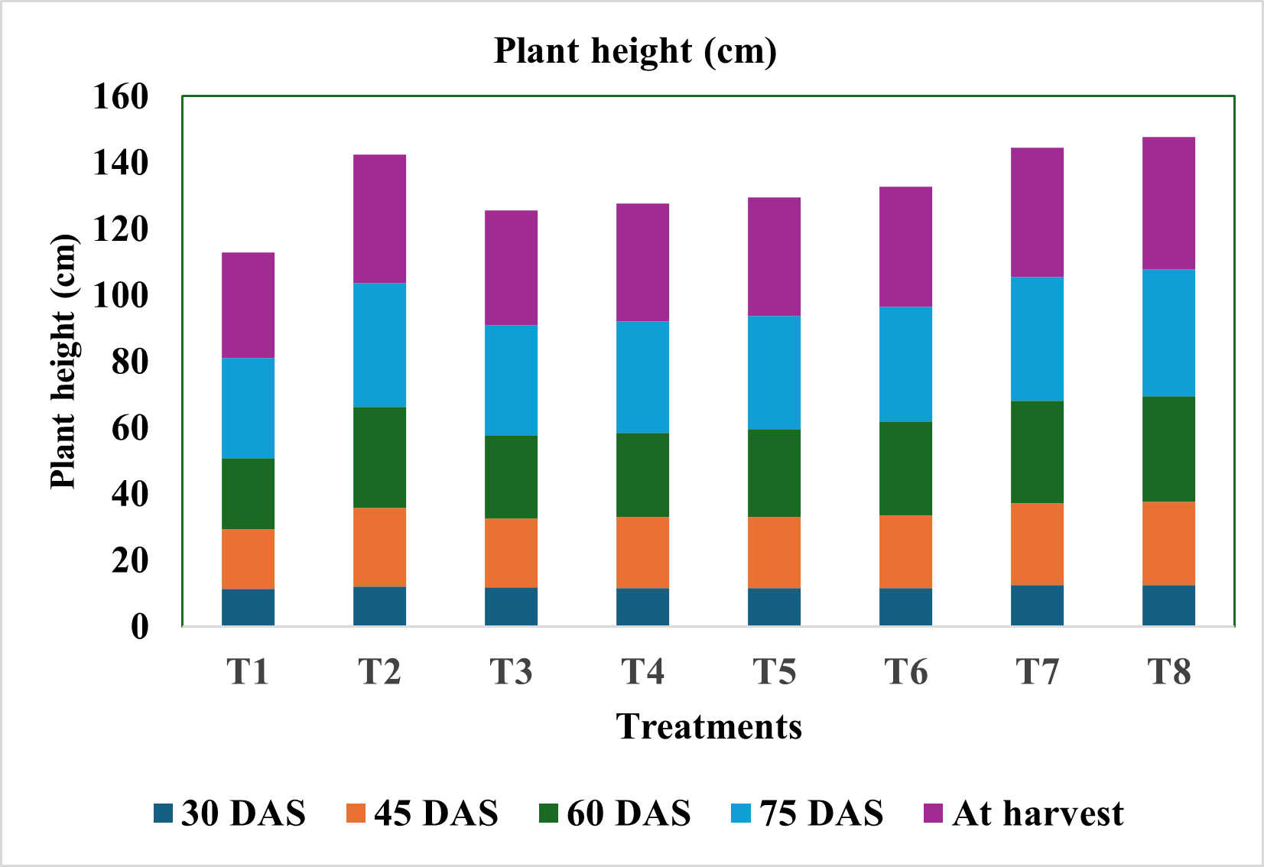 | 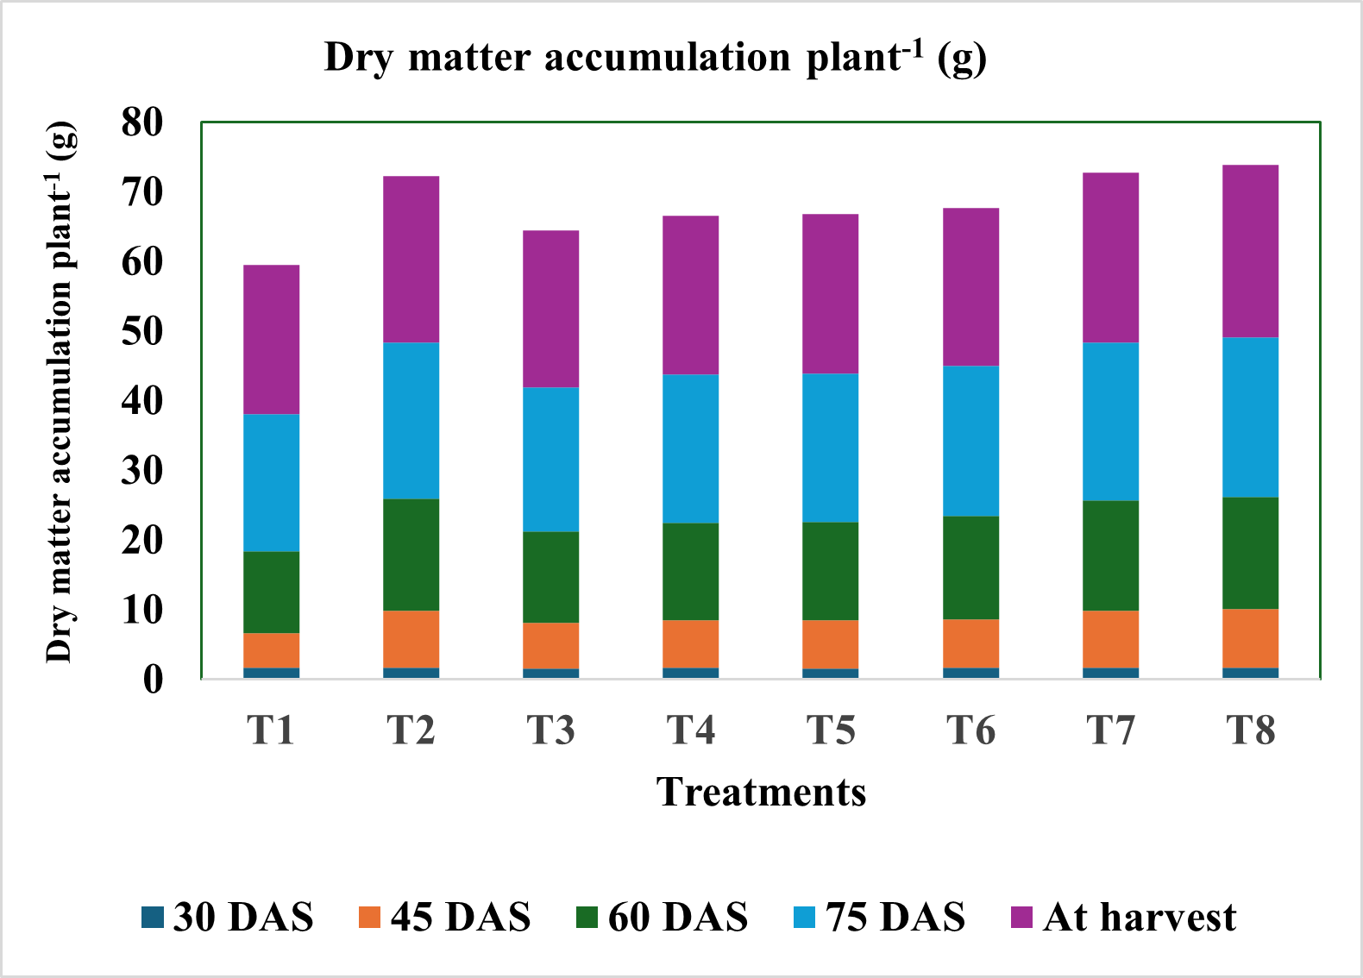
Fig 1.A | Fig. 1.B
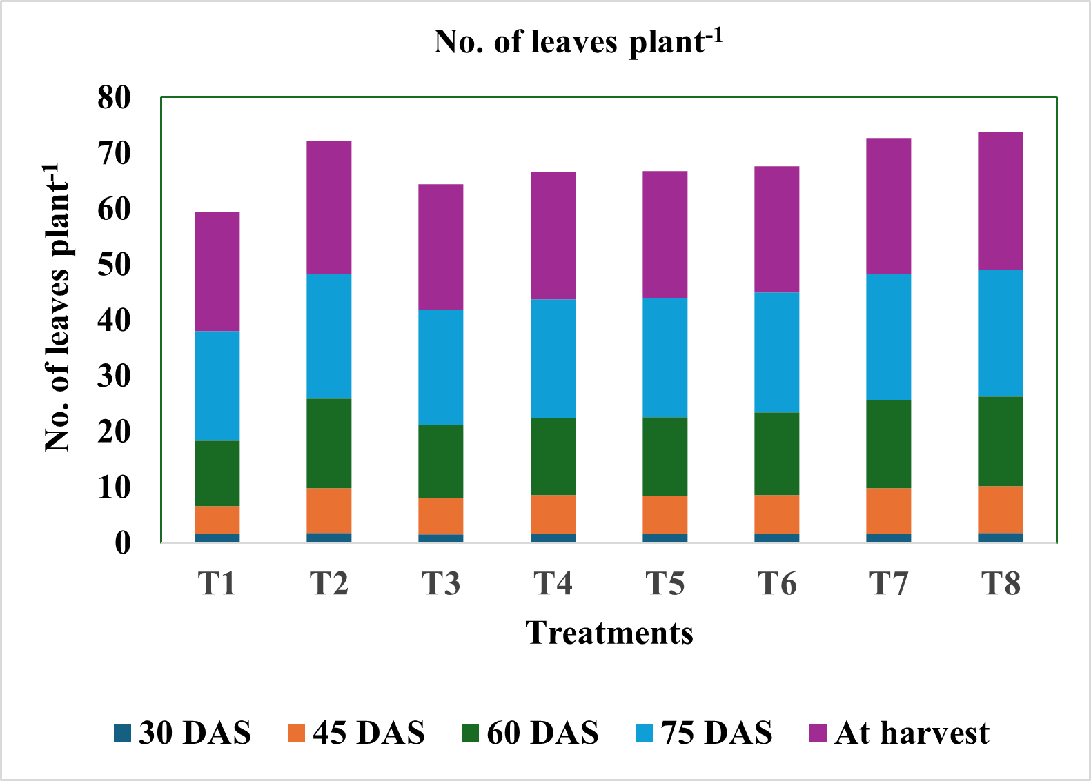 | 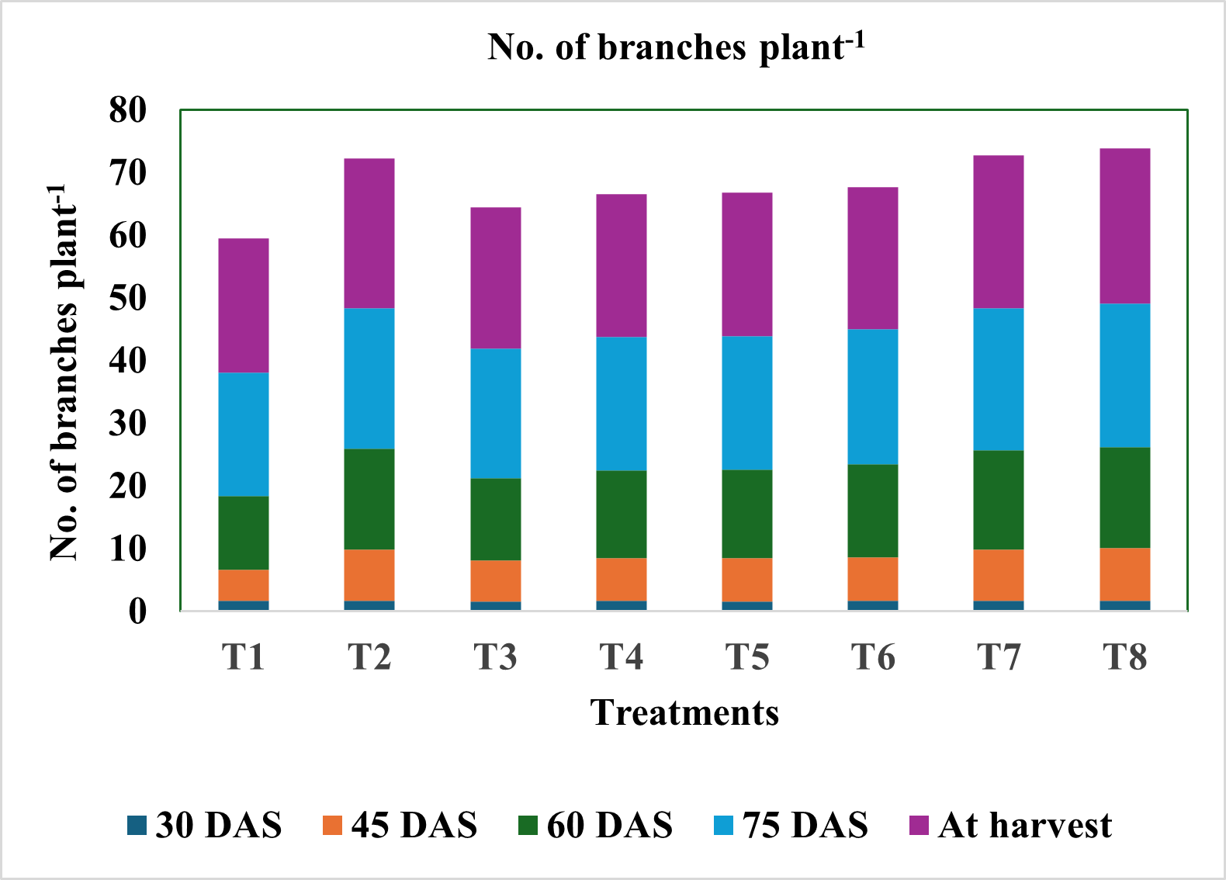
Fig 1.C | Fig 1.D
Treatment details of the experiment: T1 (absolute control), T2 (100% recommended dose of fertilizer (RDF) at 20-60-40 N-P₂O₅-K₂O kg ha⁻¹), T3 (50% RDF), T4 (50% RDF + 2.5 t ha⁻¹ biochar), T5 (50% RDF + 5 t ha⁻¹ farmyard manure (FYM)), T6 (50% RDF + 2.5 t ha⁻¹ vermicompost (VC)), T7 (50% RDF + 2.5 t ha⁻¹ biochar + 5 t ha⁻¹ FYM), and T8 (50% RDF + 2.5 t ha⁻¹ biochar + 2.5 t ha⁻¹ VC).
Seed and Straw Yield
In terms of seed yield, there were significant improvements across all major treatments compared to the control. The highest increase was observed in T8, with a 100.32% and 99.79% rise over control, followed by T7 with 96.96% and 94.14% and T2 (100% RDF) showing a 94.72% and 94.14% increase. This demonstrates the effectiveness of integrated nutrient application in enhancing grain productivity, even with reduced chemical inputs. BC and VC effectively enhance vegetative growth and overall biomass by increasing nutrient availability, water retention, and microbial activity. Biochar improves nutrient retention and reduces nitrogen leaching (Khan et al., 2022), while vermicompost supplies readily available nutrients and promotes root development. These findings align with studies on rice and oats showing biochar’s positive impact on growth (Wang et al., 2012, 2014; Schulz and Glaser, 2012). Increased grain and straw yield in T2 is due to rapid nutrient mineralisation and availability, consistent with reports on mineral fertilisers enhancing yield (Tamele et al., 2020; Munecheru-muna et al., 2007; Zhang et al., 2012; Budania et al., 2014; Arunkumar et al., 2019).
Economics Study
Gross Monetary Returns
The highest gross return was recorded in T8 (₹62,600 ha⁻¹), followed by T7 (₹61,550 ha⁻¹) and T2 (₹60,850 ha⁻¹). The control had the lowest gross return (₹31,250 ha⁻¹).
Cost of Cultivation
T8 incurred the highest cultivation cost (₹53,085 ha⁻¹), followed by T7 (₹50,585 ha⁻¹) and T4 (₹40,585 ha⁻¹). The control had the lowest cost (₹20,688 ha⁻¹).
Net Monetary Returns
Maximum net return was in T2 (₹35,368 ha⁻¹). Moderate returns were seen in T6 (₹16,615 ha⁻¹) and T5 (₹13,615 ha⁻¹). Treatments T4, T7, and T8 showed lower net returns (₹4,365, ₹10,965, and ₹9,515 ha⁻¹, respectively) due to higher input costs. The lowest net return was in T4.
Benefit: Cost Ratio (B:C)
T2 exhibited the highest B:C ratio (2.38), indicating superior economic efficiency. T3 also showed a good ratio (1.85) with 50% RDF. The lowest B:C ratios were in T4 (1.10), T8 (1.17), and T7 (1.21).
While T2 (100% RDF) is most profitable with the highest net returns and B:C ratio, integrated treatments T7 and T8 achieved competitive gross returns but incurred higher costs, lowering net returns and B:C ratios. Despite lower short-term profitability, organic-integrated treatments (T4–T8) enhance soil health and nutrient efficiency, suggesting long-term sustainability benefits. T8, combining biochar and vermicompost with 50% RDF, shows strong potential for sustainable agriculture due to the highest gross returns, albeit with moderate immediate profits.
Table 1. Effect of different sources of nutrients on the yield and economics of soybean
Treatments | Grain yield | Straw yield | Gross monetary returns  (₹ ha⁻¹) | Cost of cultivation  (₹ ha⁻¹) | Net monetary returns  (₹ ha⁻¹) | B:C Ratio
T1 | 6.25 | 9.38 | 31250 | 20688 | 10562 | 1.51
T2 | 12.17 | 18.20 | 60850 | 25482 | 35368 | 2.38
T3 | 8.57 | 12.87 | 42850 | 23085 | 19765 | 1.85
T4 | 8.99 | 13.46 | 44950 | 40585 | 4365 | 1.10
T5 | 9.34 | 14.02 | 46700 | 33085 | 13615 | 1.41
T6 | 10.44 | 15.64 | 52200 | 35585 | 16615 | 1.46
T7 | 12.31 | 18.41 | 61550 | 50585 | 10965 | 1.21
T8 | 12.52 | 18.74 | 62600 | 53085 | 9515 | 1.17
S. Em ± | 0.55 | 0.61
CD at 5% | 1.67 | 1.85
Treatment details of the experiment: T1 (absolute control), T2 (100% recommended dose of fertilizer (RDF) at 20-60-40 N-P₂O₅-K₂O kg ha⁻¹), T3 (50% RDF), T4 (50% RDF + 2.5 t ha⁻¹ biochar), T5 (50% RDF + 5 t ha⁻¹ farmyard manure (FYM)), T6 (50% RDF + 2.5 t ha⁻¹ vermicompost (VC)), T7 (50% RDF + 2.5 t ha⁻¹ biochar + 5 t ha⁻¹ FYM), and T8 (50% RDF + 2.5 t ha⁻¹ biochar + 2.5 t ha⁻¹ VC).

4. Conclusion

The integration of 50% RDF with biochar and vermicompost or FYM achieves soybean growth and yields comparable to 100% RDF. Treatments T8 and T7 offer high returns and promote long-term soil health, supporting sustainable and environmentally friendly soybean cultivation. This balanced nutrient management approach provides an effective, sustainable alternative to full fertiliser use.

Disclaimer (Artificial intelligence)

Option 1:

Author(s) hereby declare that NO generative AI technologies such as Large Language Models (ChatGPT, COPILOT, etc.) and text-to-image generators have been used during the writing or editing of this manuscript.

Option 2:

Author(s) hereby declare that generative AI technologies such as Large Language Models, etc. have been used during the writing or editing of manuscripts. This explanation will include the name, version, model, and source of the generative AI technology and as well as all input prompts provided to the generative AI technology

Details of the AI usage are given below:
1.
2.
3.

References

Agarwal, D. K., Billore, S. D., Sharma, A. N., Dupare, B. U., & Srivastava, S. K. 2013. Soybean: introduction, improvement, and utilization in India—problems and prospects. Agricultural Research; 2(4): 293-300.
Agegnehu, G., Bass, A. M., Nelson, P. N., & Bird, M. I. 2016. Benefits of biochar, compost and biochar–compost for soil quality, maize yield and greenhouse gas emissions in a tropical agricultural soil. Science of the Total Environment; 543: 295–306.
Agegnehu, G., Bass, A. M., Nelson, P. N., Muirhead, B., Wright, G., & Bird, M. I. 2015. Biochar and biochar-compost as soil amendments: Effects on peanut yield, soil properties and greenhouse gas emissions in tropical North Queensland, Australia. Agriculture ecosystems & environment; 213: 72-85.
Alvarez, J. M., Pasian, C., Lal, R., Lopez Nunez, R., & Fernandez Martinez, M. 2017. Vermicompost and biochar as substitutes of growing media in ornamental-plant production; 19(3): 205–214.
Aon, M., Khalid, M., Zahir, Z. A., & Ahmad, R. 2015. Low temperature produced citrus peel and green waste biochar improved maize growth and nutrient uptake, and chemical properties of calcareous soil. Pakistan Journal Agricultural Science; 52(3): 627-636.
Arancon, N., Edwards, C. A., Webster, K. A., & Buckerfield, J. C. 2010. The potential of vermicomposts as plant growth media for greenhouse crop production. Vermiculture technology: earthworms, organic wastes, and environmental management. CRC, Boca Raton; 103-128.
Arunkumar, B. R., & Thippeshappa, G. N. 2020. Effect of levels of biochar and FYM on physico-chemical properties, nutrients release and carbon dioxide evolution from the soil. International Journal of Current Microbiology and Applied Sciences; 8(1): 2389-2395.
Aslam, Z., Ahmad, A., Bellitürk, K., Kanwal, H., Asif, M., & Ullah, E. 2023. Integrated use of simple compost, vermicompost, vermi-tea and chemical fertilizers N P on the morpho-physiological, yield and yield related traits of tomato. Journal of Innovative Science; 9(1): 1-12.
Bandyopadhyay, K. K., Misra, A. K., Ghosh, P. K., & Hati, K. M. (2010). Effect of integrated use of farmyard manure and chemical fertilizers on soil physical properties and productivity of soybean. Soil and Tillage research; 110(1): 115-125.
Budania, K., & Yadav, A. 2014. Effects of PGPR blended biochar and different levels of phosphorus on yield and nutrient uptake by chickpea. Annals of Agri Bio Research; 19(3): 408-412.
Buresh, R. J., Sánchez, P. A., & Calhoun, F. 1997. Soil Science Society of America and American Society of Agronomy. Replenishing soil fertility in Africa; 51: 111-149.
Canatoy, R. C., & Daquiado, N. P. 2021. Fertilization influence on biomass yield and nutrient uptake of sweet corn in potentially hardsetting soil under no tillage. Bulletin of the National Research Centre; 45: 1-15.
Chadha, S., Sharma, P., Abrol, V., Sharma, K. R., Sharma, V., Bharat, R., & Bashir, O. 2020. Effect of integrated use of biochar and organic amendments on soil properties and crop yield. International Journal of Chemical Studies; 8(6): 1176-1179.
Cui, Z., Zhang, H., Chen, X., Zhang, C., Ma, W., Huang, C., & Dou, Z. 2018. Pursuing sustainable productivity with millions of smallholder farmers. Nature; 555(7696): 363-366.
Danish, S., Younis, U., Akhtar, N., Ameer, A., Ijaz, M., Nasreen, S., & Ehsanullah, M. 2015. Phosphorus solubilizing bacteria and rice straw biochar consequence on maize pigments synthesis. International Journal of Biosciences; 5(12): 31-39.
Dawar, K., Khan, A., Mian, I. A., Khan, B., Ali, S., Ahmad, S., & Danish, S. 2022. Maize productivity and soil nutrients variations by the application of vermicompost and biochar. PloS one; 17(5).
Donald, C. M. 1962. In search of yield. Journal of Australian Instructional Agricultural Science; 28: 1971-1978.
Garamu, T. 2019. Effect of different source and rates of biochar application on the yield and yield components of mungbean on the acidic soil in western Ethiopia. Academic Research Journal of Agricultural Science and Research; 7(7): 530-538.
Glaser, B., Lehmann, J., & Zech, W. 2002. Ameliorating physical and chemical properties of highly weathered soils in the tropics with charcoal. Biology and fertility of soils; 35: 219-230.
Hashem, A., Kumar, A., Al-Dbass, A. M., Alqarawi, A. A., Al-Arjani, A. B. F., Singh, G., & Abd_Allah, E. F. 2019. Arbuscular mycorrhizal fungi and biochar improves drought tolerance in chickpea. Saudi journal of biological sciences; 26(3): 614-624.
Hossain, M. Z., Bahar, M. M., Sarkar, B., Donne, S. W., Ok, Y. S., Palansooriya, K. N., & Bolan, N. 2020. Biochar and its importance on nutrient dynamics in soil and plant. Biochar; 2(4): 379-420.
Iqbal, A., Liang, H., McBride, S. G., Yuan, P., Ali, I., Zaman, M., & Jiang, L. (2022). Manure applications combined with chemical fertilizer improves soil functionality, microbial biomass and rice production in a paddy field. Agronomy Journal; 114(2): 1431-1446.
Jackson ML. 1973. Soil Chemical Analysis prentice Hall of India Private Limited New Delhi.
Javier, E. Q., Cruz, P. S., & Santos, R. T. 2002. Effect of organic amendments on soil properties and crop productivity in upland rice systems. Philippine Journal of Crop Science; 27(2): 105–111.
Jemal, K., & Yakob, A. 2021. Role of biochar on the amelioration of soil acidity. Agrotechnology; 10(1): 212.
Khan, M. A., Basir, A., Fahad, S., Adnan, M., Saleem, M. H., Iqbal, A., & Nawaz, T. 2022. Biochar optimizes wheat quality, yield, and nitrogen acquisition in low fertile calcareous soil treated with organic and mineral nitrogen fertilizers. Frontiers in Plant Science; 13: 879788.
Kloss, S., Zehetner, F., Dellantonio, A., Hamid, R., Ottner, F., Liedtke, V., & Soja, G. 2012. Characterization of slow pyrolysis biochars: effects of feedstocks and pyrolysis temperature on biochar properties. Journal of environmental quality; 41(4): 990-1000.
Kumar, S., Singh, A. P., & Tiwari, S. 2010. Impact of long-term application of green manuring on vertical distribution of DTPA-extracTablezinc and organic carbon. Journal of the Indian Society of Soil Science; 58(1): 91-93.
Lehmann, J., da Silva Jr, J. P., Steiner, C., Nehls, T., Zech, W., & Glaser, B. 2003. Nutrient availability and leaching in an archaeological Anthrosol and a Ferralsol of the Central Amazon basin: Fertilizer, manure and charcoal amendments. Plant and Soil; 249(2): 343–357.
Lehmann, J., Gaunt, J., & Rondon, M. (2006). Bio-char sequestration in terrestrial ecosystems. Mitigation and adaptation strategies for global change; 11: 403-427.
Liu, M., Linna, C., Ma, S., Ma, Q., Guo, J., Wang, F., & Wang, L. 2022. Effects of biochar with inorganic and organic fertilizers on agronomic traits and nutrient absorption of soybean and fertility and microbes in purple soil. Frontiers in Plant Science; 13: 871021.
Manolikaki, I., & Diamadopoulos, E. (2016). Ryegrass yield and nutrient status after biochar application in two Mediterranean soils; 63(8): 1093–1107.
Mia, S., Van Groenigen, J.W., Van de Voorde, T.F.J., Oram, N.J., Bezemer, T.M., Mommer, L., & Jeffery, S. 2014. Biochar application rate affects biological nitrogen fixation in red clover conditional on potassium availability. Agriculture, ecosystems & environment; 191: 83-91.
Mucheru-Muna, M., Mugendi, D., Kung’u, J., Mugwe, J., & Bationo, A. 2007. Effects of organic and mineral fertilizer inputs on maize yield and soil chemical properties in a maize cropping system in Meru South District, Kenya. Agroforestry Systems; 69: 189-197.
Olsen SR, Cole CV, Watanabe FS and Dean LA. 1954. Estimation of available phosphorous in soils by extraction with sodium bicarbonate. Circular 939. US Department of Agriculture.
Orozco, F. H., Cegarra, J., Trujillo, L. M., & Roig, A. 1996. Vermicomposting of coffee pulp using the earthworm (Eisenia foetida) effects on C and N contents and the availability of nutrients. Biology and fertility of soils; 22: 162-166.
Piper CS. 1950. Soil and Plant analysis. Inter. Science Publisher, Inc. New York.
Roba, T. 2018 Review on: The Effect of Mixing Organic and Inorganic Fertilizer on Productivity and Soil Fertility. Open Access Library Journal; 5: 1-11.
Sarker, U. K., Uddin, M. R., Sarkar, M. A. R., Salam, M. A., & Hasan, A. K. 2017 Influence of organic and inorganic nitrogen on the growth and yield of irrigated rice. Asian-Australasian Journal of Bioscience and Biotechnology; 2(1): 9-23.
Schulz, H., & Glaser, B. 2012. Effects of biochar compared to organic and inorganic fertilizers on soil quality and plant growth in a greenhouse experiment. Journal of Plant Nutrition and Soil Science; 175(3): 410-422.
Schulz, H., Dunst, G., & Glaser, B. 2013. Positive effects of composted biochar on plant growth and soil fertility. Agronomy for sustainable development; 33: 817-827
Singh, G. K., Yadav, D. D., Verma, V. K., Kumar, J., Verma, S., Lal, C., & Prajapati, S. K. 2022. Effect of FYM, phosphorus and PSB on growth, yield attributes, quality, nutrient content (%) and uptake by kharif greengram. International Journal of Plant Soil Science; 34(24): 661-671.
Singh, M., Tripathi, A. K., Kundu, S., & Takkar, P. N. 1999. Nitrogen requirement of soybean - wheat cropping system and biological N fixation as influenced by integrated use of fertilizer N and farmyard manure in Typic Haplustert. The Indian Journal of Agricultural Sciences; 69(5): 379-381.
Singh, P., Yadav, K.K., Meena, F.S., Singh, B. and Singh, R. 2017. Effect of phosphorus and sulphur on yield attributes, yield and nutrient uptake of mungbean (Vigna radiata L.) in central plain zone of Punjab. Plant Archives; 17(2): 1756-1760.
Souri, M. K., & Sooraki, F. Y. 2019. Benefits of organic fertilizers spray on growth quality of chili pepper seedlings under cool temperature. Journal of plant nutrition; 42(6): 650-656.
Spokas, K. A., Baker, J. M., & Reicosky, D. C. 2010. Ethylene: potential key for biochar amendment impacts. Plant and soil; 333: 443-452.
Spokas, K. A., Novak, J. M., Masiello, C. A., Johnson, M. G., Colosky, E. C., Ippolito, J. A., & Trigo, C. 2014. Physical disintegration of biochar: an overlooked process. Environmental Science & Technology Letters; 1(8): 326-332.
Srivastava, P., Singh, R., & Kumar, V. 2011. Effect of integrated nutrient management on soil fertility, yield and quality of rice (Oryza sativa L.). Journal of the Indian Society of Soil Science; 59(2): 123–129.
Subbiah BV and Asija GL. 1956. A rapid procedure for estimation of the available Nitrogen in soil. Current Science; 25: 259-260.
Sutaliya, J. M., & Singh, R. 2005. Effect of integrated nutrient management on growth and yield of wheat (Triticum aestivum L.). Indian Journal of Agronomy; 50(1): 48–50.
Tamele, R. A., Ueno, H., Toma, Y., & Morita, N. 2020. Nitrogen recoveries and nitrogen use efficiencies of organic fertilizers with different C/N ratios in maize cultivation with low-fertile soil by 15N method. Agriculture; 10(7): 272.
Tiwari, R., Sharma, Y.M., Dwivedi, B.S., Mitra, N.G., and Kewat, M.L., 2019 Nutrient content and uptake by soybean as influenced by continuous application of fertilizer and manure in black soil. Journal of Pharmacognosy and Phytochemistry; 8(4): 140-144.
Vanlauwe, B., Bationo, A., Chianu, J., Giller, K. E., Merckx, R., Mokwunye, U., & Sanginga, N. 2010. Integrated soil fertility management: operational definition and consequences for implementation and dissemination. Outlook on agriculture; 39(1): 17-24.
Vanlauwe, B., Diels, J., Sanginga, N., & Merckx, R. 2002. Integrated plant nutrient management in sub-Saharan Africa: from concept to practice
Varma, D.R., Naik, A., Reddy, M., Bellakki, Balanagoudar, M.A., S.R. and Siddaram. 2025. Impact of various levels of biochar on growth and yield of chickpea (Cicer arietinum L.). International Journal of Plant & Soil Science; 37(1): 34–39.
Walkley, A., and Black, JA. 1934. Estimation of soil organic carbon by chromic acid titration method. Soil Science; 17: 29–38.
Wang, J., Pan, X., Liu, Y., Zhang, X., & Xiong, Z. 2012. Effects of biochar amendment in two soils on greenhouse gas emissions and crop production. Plant and soil, 360, 287-298.
Widowati, W., & Asnah, A. 2014. Biochar can enhance potassium fertilization efficiency and economic feasibility of maize cultivation.
Wu, D., Zhang, W., Xiu, L., Sun, Y., Gu, W., Wang, Y., ...& Chen, W. 2022. Soybean yield response of biochar-regulated soil properties and root growth strategy. Agronomy; 12(6): 1412.
Yang, Q., Liu, P., Dong, S., Zhang, J., & Zhao, B. 2019. Effects of fertilizer type and rate on summer maize grain yield and ammonia volatilization loss in northern China. Journal of Soils and Sediments; 19: 2200-2211.
Yooyen, J., Wijitkosum, S., & Sriburi, T. 2015. Increasing yield of soybean by adding biochar. Journal of Environmental Research and Development; 9(4): 1066.
Zhang, A., Liu, Y., Pan, G., Hussain, Q., Li, L., Zheng, J., & Zhang, X. 2012. Effect of biochar amendment on maize yield and greenhouse gas emissions from a soil organic carbon poor calcareous loamy soil from Central China Plain. Plant and soil; 351: 263-275.

Agyenim-Boateng, K. G., Zhang, S., Zhang, S., Khattak, A. N., Shaibu, A., Abdelghany, A. M., ... & Sun, J. (2023). The nutritional composition of the vegetable soybean (maodou) and its potential in combatting malnutrition. Frontiers in Nutrition, 9, 1034115.
Spréa, R. M., Finimundy, T. C., Calhelha, R. C., Pires, T. C., Prieto, M. A., Amaral, J. S., & Barros, L. (2024). Comprehensive analysis of soybean (Glycine max L.) by-products: Nutritional value, phenolic composition, and bioactive properties. Food Bioscience, 62, 105382.
Ogbemudia, R. E., Nnadozie, B. C., & Anuge, B. (2018). Mineral and proximate composition of soya bean. Asian Journal of Physical and Chemical Sciences, 4(3), 1–6. https://doi.org/10.9734/AJOPACS/2017/38530
Singh Soni, Saini, P. K., Bhati, J., Kumar, D., Shukla, S., & Yadav, S. (2024). Management of nutrients in soybean (Glycine max) crops: A review. Journal of Advances in Biology & Biotechnology, 27(10), 820–833. https://doi.org/10.9734/jabb/2024/v27i101505
Gelaye, Y. (2023). Effect of combined application of organic manure and nitrogen fertilizer rates on yield and yield components of potato: A review. Cogent food & agriculture, 9(1), 2217603.
Zhou, W., Ma, Q., Wu, L., Hu, R., Jones, D. L., Chadwick, D. R., ... & Chen, Y. (2022). The effect of organic manure or green manure incorporation with reductions in chemical fertilizer on yield-scaled N₂O emissions in a citrus orchard. Agriculture, Ecosystems & Environment, 326, 107806.

Khan, M. R., Arofi, S., Priti, M. S., Reza, M. S., & Tarafder, M. A. (2025). Global Meta-analyses Review of Biochar in Agriculture. Journal of Global Agriculture and Ecology, 17(4), 1-18.

