Original Research Article

Development of a Portable Pulveriser to Improve Brown Sugar Quality and Efficiency

Abstract
In India, the manufacture of brown sugar is a significant agro-based industry, especially in Tamil Nadu, where more than half of small-scale production facilities are situated. The development of hard clods during cooling and storage due to external factors and residual moisture is one of the ongoing problems producers encounter. These clods lower the shelf life of brown sugar, decrease handling efficiency, and jeopardise product homogeneity. These clods are difficult to break by hand, unsanitary, and frequently inconsistent. A small pulveriser with a 24V DC motor and rechargeable battery was created in order to solve this problem. The machine breaks down hardened sugar lumps into small granules using powerful rubber auger blades that are coupled by a chain-sprocket mechanism.
According to performance evaluation, the pulveriser was able to pulverise 1 kg of hardened brown sugar in 1.5–2 minutes, with clod-breaking effectiveness above 85%. The machine maintained structural stability under moderate to high load circumstances, and the system recorded about 45% motor efficiency and 63% blade efficiency. According to the study's findings, the created pulveriser enhances product quality, hygiene, and operating efficiency, making it a good fit for small-scale brown sugar companies.

Keywords: clod-breaking effectiveness, brown sugar, hygiene, sugar lumps

Introduction
In India, brown sugar is commonly used on a daily basis and is renowned for having a comparatively higher mineral content than refined white sugar. Clod development, particularly in humid environments, is a major issue during production and storage. In addition to decreasing handling efficiency, these hardened lumps cause an uneven distribution of particle sizes, which lowers the product's quality and marketability. Breaking the clods by hand is labour-intensive, unsanitary, and ineffective. Large enterprises use expensive pulverisers, but small and medium-sized businesses cannot afford such machinery. Because of this, smaller production facilities frequently use antiquated methods or a lot of human labour, which raises expenses and lowers productivity.
Therefore, it is essential to have a machine that is easy to use, inexpensive, and effective in breaking hardened sugar clods. The goal of the current project is to design and construct a small pulveriser that uses rubber auger blades to efficiently crush clods and runs on a rechargeable 24V battery. The goal of the design is to increase uniformity, efficiency, and hygiene in the processing of brown sugar in small and medium-sized businesses.
IDENTIFICATION OF PROBLEM
In rural and semi-urban areas, the manufacturing of brown sugar is a major activity. However, clod development during chilling, storage, and transportation poses a considerable obstacle to the process. Brown sugar's inherent moisture content and temperature fluctuations result in solidified lumps that are extremely challenging to break by hand. Because manual clod breaking requires direct human handling, it not only takes an inordinate amount of time and effort but also jeopardises hygiene. Additionally, the procedure frequently results in irregular particle sizes, which lowers market value, causes consumer discontent, and results in inconsistent product quality. This issue is made worse for small and medium-sized businesses by the dearth of reasonably priced equipment, which forces them to rely on manual labour or antiquated methods that raise expenses and decrease productivity.
Large-scale firms may currently utilise expensive pulverisers, but smaller businesses cannot afford such machinery. Waste is also produced when handling hardened clods by hand since large or excessively hardened pieces are thrown away. Therefore, a straightforward, affordable, and effective pulveriser that can consistently smash brown sugar clods while preserving hygienic conditions and reducing labour is desperately needed. This gap is filled by the suggested machine, which runs on a 24V battery and has a 320 RPM motor, chain drive, and sturdy rubber auger blades held up by robust frames and bearings. This design offers small enterprises a workable way to increase product quality, save time, and save costs while guaranteeing portability, efficiency, and user-friendliness.

METHODOLOGY

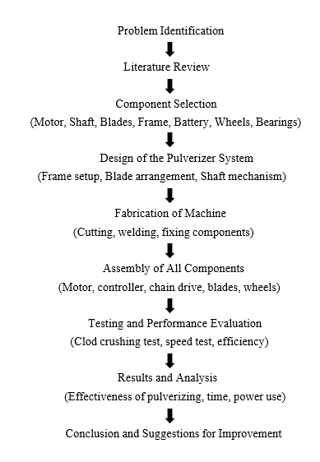
Chart 1 : Project Methodology for the Design and Fabrication of a Pulverizer System

DESIGN CALCULATIONS
EFFICIENCY CALCULATIONS

Motor Efficiency

power.
Motor Efficiency is the power converts electrical power into mechanical

Output Power

Motor Efficiency (%) =

Input Power
× 100

Input Power = Voltage × Current

= V × I

Voltage (V) = 24V Current (I) = 14A
Input Power = Voltage × Current
= V × I
= 24 × 14
= 336 Watts

Input Power (Electrical power) is 336 Watts
Output Power = Torque × Angular Velocity

= τ × ω

Torque (τ) =
Poutput ω

Input Power (Watts) = V × I
= 24 × 14
= 336 Watts
Output Power (Assuming 45% as Efficiency)

Poutput = 336 × 0.45
= 151.2 W

151.2
Torque (τ) =
33.51

= 4.51 Nm
Motor Speed = 320 RPM

Convert RPM to Angular Speed (ω) = 2π×N/ 60

= 2π×320/60

ω = 33.51 rad/s Now Calculate the Output Power,
Output Power = Torque × Angular Velocity

= 4.51× 33.51

= 151.2 Watts

∴ Output Power (Mechanical Power) is 151.2 Watts

Output Power Input Power

∴ Efficiency (%) = × 100

= 151.2 / 336

= 44.9 %

∴ The Motor Efficiency is Approx. = 45%

Blade Efficiency

Blade efficiency refers to the blades convert the mechanical input from the rotating shaft into useful work.
Blade Efficiency (%) = (Input Mechanical Power/Useful Output Work) × 100

- Torque from motor (τ) = 4.51 Nm

- Angular speed (ω) = 33.51 rad/s

- Useful Output Work = 95Watts

Blade Efficiency = (151.295) ×100

= 62.8 %

∴ The Blade Efficiency is approximately = 63%

Battery Working Capacity

Voltage (V) = 24V Capacity (Ah) = 14Ah
Motor Power Consumption = 336 Watts

Battery Energy = Voltage × Capacity
= 24V × 14Ah
= 336 Wh

Run Time =

=
Battery Energy Motor Power 336 Wh
336 W
= 1 hour

A 24V, 14Ah Battery can run 336 watts powered Motor for 1hour continuously at full 14A load.

LOAD ANALYSIS

Load Testing Analysis

An essential stage in assessing the pulverizer machine's strength and performance under real-world operating circumstances is load testing. In order to determine how well the machine splits brown sugar clods under various input material quantities and load resistance, load testing was done for this project. This aids in our comprehension of the machine's potential, effectiveness, and stress-related behavior.

Objective of Load Testing

The major goals of load testing are to determine how much sugar the pulverizer can crush in a specific amount of time, how much load it can manage efficiently, and how the motor and blade react when used heavily. Keeping an eye out for mechanical problems, overheating, or vibrations while the machine is operating continuously is also beneficial.

Procedure

Specifically, 200 g, 500 g, and 1 kg of brown sugar clods were used to test the machine. For crushing, the clods were manually put into the rubber blade part of the auger. Each quantity's pulverization time was precisely recorded using a stopwatch. The quality of the crushed output, noise levels, blade vibration, and motor performance were all closely monitored throughout the operation. To evaluate heat buildup, the motor temperature was also measured prior to and following each test. To assess the effectiveness and stability of the power system while it was in use, a multimeter was also used to track battery voltage decrease and total power use.

Table 1 Load Test Result of the Pulverizer

Load (Brown Sugar Clods) | Time Taken | Output Fineness | Blade Vibration | Motor Temperature | Remarks
200g | 25 sec | Fine | Low | Normal | Smooth operation
500g | 55 sec | Moderate | Medium | Warm | Slight vibration
1kg | 110 sec | Medium | High | Hot | Slight motor strain

Analysis

Up to 1 kg of brown sugar could be handled by the machine in a single batch, however this resulted in a little slowdown in operation and an increase in motor temperature. Throughout the procedure, the rubber blades showed excellent durability and operated well without showing any indications of breaking or damage. As the load increased, however, some vibrations were observed, suggesting that additional blade tightening or balancing of the rotating shaft may be required to increase stability. When the machine was constantly run at full load conditions, the overall runtime decreased even though the battery provided steady power throughout the operation.

Performance Observation

The machine operated best with loads weighing between 200 and 500 grams, as the pulverizing process was rapid and the output was consistent. The machine effectively accomplished the task when tested with a 1 kg load; however, heat accumulation and increased load stress caused a minor decrease in motor efficiency. Nevertheless, no component showed signs of mechanical failure or damage, demonstrating the structure's strength and dependability. According to the findings of the load tests, the proposed pulverizer can effectively break up hard brown sugar clods under a range of loads. It can be utilized for continuous production with brief operational interruptions and operates best under low loads. In general, the motor, blades, and frame stability.

Stress-Strain Analysis

When assessing the mechanical strength of the pulverizer's components—particularly those that rotate, impact, and vibrate while in operation—stress-strain analysis is a crucial component. Stress-strain analysis was used in this project to determine whether the major structural components—such as the stainless steel auger rod, L-angle frame, rubber blades, and rotating shaft—could sustain the load without failing.

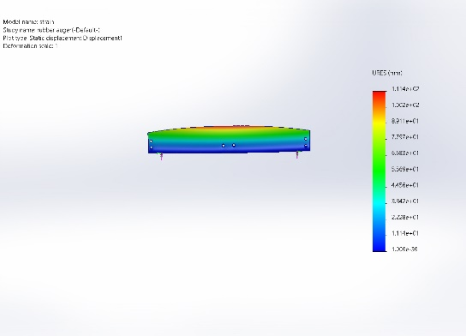
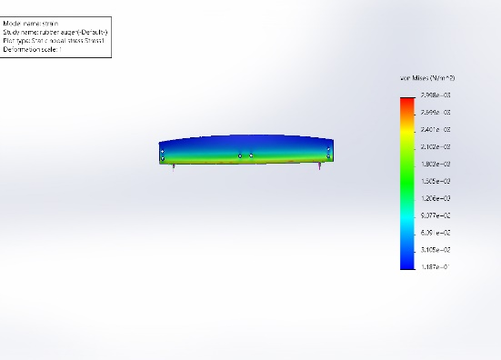
Stress Analysis

Fig: 1 Stress Analysis Fig: 2 Displacement

The internal resistance that a material provides in response to an external force is known as stress. To guarantee that the shaft, frame, blades, and supporting elements do not break under the operating stresses produced during the pulverization process, stress analysis is essential to this project.

Rotating Shaft Stress

        - Material Used: Stainless steel rod
        - Diameter of Shaft (d): 15 mm
        - Torque (T): Approximately 3.32 Nm
Using the torsional stress formula:
16×T

T = π × d³

16 × 3.32
=
π × (0.015)³

53.12
=
1.06 × 10⁻⁵

= 5.01 MPa

Frame Stress (L-Angle Mild Steel)

The L-angle mild steel frame was designed to sustain the motor, shaft, and dynamic load of the pulverizer system. The estimated overall load, including the effects of vibration during operation, was approximately 15 kg. Given that mild steel has a yield strength of about 250 MPa, the stress generated in the frame was calculated to be less than 50 MPa based on the material specifications. This demonstrates that the frame's high safety factor ensures exceptional structural stability and dependability when the machine is operating.

Blade Mount Area

Under repeated impact situations, the blade mount—the crucial area where the rubber blades are attached to the shaft—was closely inspected. Despite the dynamic load this section experiences during operation, ongoing testing showed no evidence of fatigue, cracking, or bending. These findings attest to the blade mount's structural integrity and ability to endure operational loads.

Strain Analysis

Strain is the amount of distortion a material experiences per unit length under the influence of a force. It shows the amount that a component bends, compresses, or stretches while under stress.
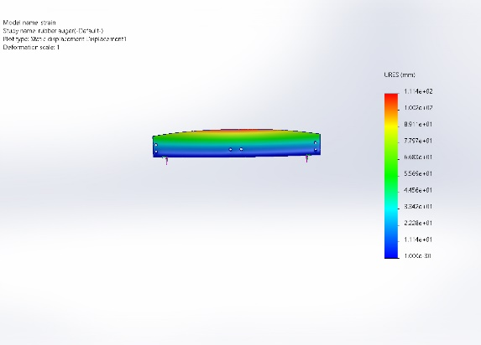
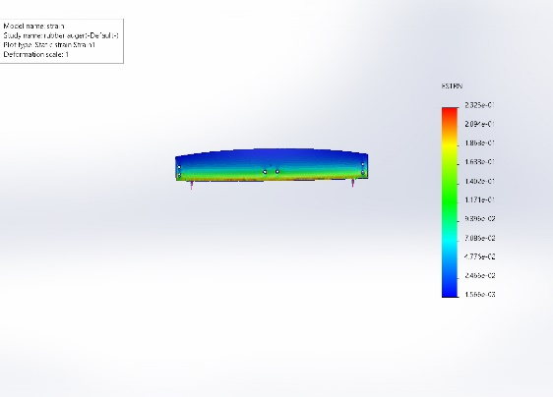
Fig: 3 Strain Analysis Fig: 4 Displacement

- Rubber Blade Strain

The pulverizer's rubber blades are composed of sturdy, flexible rubber that is intended to endure repeated hits while in use. The blades experienced flexural and impact strain while in operation, and a tip deflection of roughly 1-2 mm was noted during rotation. The strain was found to be elastic and well within the permissible range, guaranteeing durability and dependable performance, since the blades continuously reverted to their initial shape after the machine was stopped.

Shaft Strain (Torsional)

Torsional strain in the shaft is calculated using:

Torsional Strain =

Where:
θ × r

L

- θ = Angle of twist (rad)
- r = Shaft radius
- L = Shaft length
- Since the angular twist is small, strain values are minimal.
- No permanent deformation or bending was observed, so strain is within elastic limits.

Frame Strain

There was no discernible deflection or bending in the L-angles during operation, indicating that the mild steel frame of the pulverizer showed very little strain under loading conditions. The produced strain was well within the material's safe elastic bounds, demonstrating the frame's ability to sustain repeated use without losing structural integrity.

Objective

Ensuring the structural safety of the shaft and blade connection during machine operation is the primary goal of the stress-strain study. Verifying that the chosen materials can sustain the stresses produced during the clod-breaking process without experiencing mechanical failure or irreversible deformation is crucial. By combining theoretical calculations with simulation data, this analysis also helps to confirm the overall design safety, guaranteeing that the machine will function dependably under a range of load circumstances.

Blade Material Deformation Check

During rotation, the sturdy rubber blades undergo flexural stress; nonetheless, because of their natural flexibility, they can withstand multiple hits without breaking. The blade deflection continuously stayed within allowable bounds, and no permanent bending or cracks were seen, even under maximum load circumstances. These findings show that the blades are dependable for continuous impact loading while in use due to their high energy absorption capability and longevity.

Frame Load Bearing Check

The pulverizer's base frame is made of L-angled mild steel rods, which are intended to offer robust structural support while in use. It ensures the stability and endurance of the overall system by efficiently supporting the weight of the motor, bearing and shaft loads, and vibrations produced during the clod-crushing operation.
RESULT AND DISCUSSION
After the motor, chain drive, blades, shaft, frame, and ESC were assembled, testing was done to evaluate the machine's performance under operational conditions.
Hard chunks of brown sugar were used to test the machine. It was observed that the clods could be readily broken up into tiny pieces by the machine. The curved rubber blades were robust enough to cut through hard materials and operated as intended without any damage. The shaft rotated at the right speed thanks to the motor's 320 RPM speed. Good movement from the motor to the shaft was provided by the 28-link chain drive. The chain didn't slip while in operation, and the movement was fluid. Even when spinning at a high speed, the 1.5 cm thick shaft maintained its stability.
Rotation was made easier by the 6204 bearings that were fixed on both sides. They maintained the shaft's equilibrium and lessened rattling. The blades' rubber construction prevented cracking and helped absorb shocks when they struck hard sugar clumps. The entire setup was securely supported by the base frame, which was constructed from L-angle steel rods. The machine was able to travel with ease because to its rubber rear tire and nylon front wheel. The machine didn't make a lot of noise or vibration during testing.
The project's 24V, 14Ah battery proved sufficient to keep the engine running for several minutes without experiencing a power outage. The operator was able to control the speed as needed during the process thanks to the computerized speed controller and accelerator. The outcome was favorable. There were no large lumps left in the output, which was in powdered form. The machine saved a great deal of time and labor and operated more quickly than manual crushing. For small-scale brown sugar operations where clod development is an issue, this design is helpful.
Overall, the machine produced quality work in a shorter amount of time. It works well for producing brown sugar on a small scale. The finished powdered sugar was even and smooth, and the design is straightforward, secure, and simple to use. The engine was able to run for a significant amount of time thanks to the 24V, 14Ah battery that was employed. It provided a steady, drop-free input voltage, and with the aid of an accelerator and speed controller, the energy was used appropriately. Depending on the size of the sugar clod, the operator could adjust the machine speed as needed.
One kilogram of brown sugar lumps was successfully crushed by the machine in one and a half to two minutes. The end product was a fine powder with little waste. The output was consistent in size and no large particles remained uncrushed. This demonstrates how effectively the pulverizer system is performing its intended function.
The equipment can cut down on the amount of time and work required for conventional hand crushing. Additionally, it offers tiny brown sugar industries a quicker, safer, and cleaner substitute. Better productivity, higher-quality products, and less physical labor are the end results.
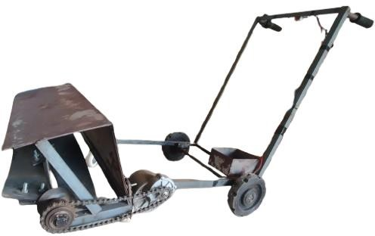
FINAL PROTOTYPE

Fig: 5 Prototype of Pulverizer

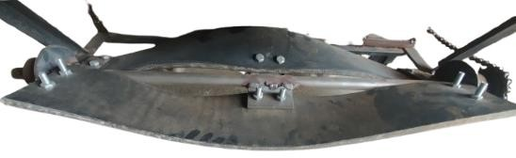
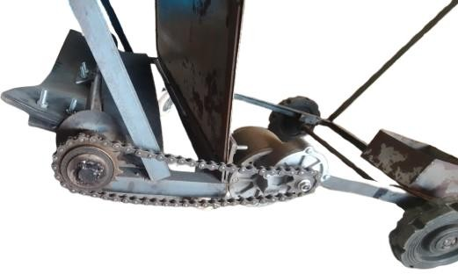
Fig: 6 Rubber Auger Blades Fig: 7 Chain Drive
CONCLUSION:
To solve the recurring issue of clod formation in small-scale sugar enterprises, the compact brown sugar pulverizer machine was successfully designed, built, and tested. The results indicated that the machine is highly effective in transforming hardened sugar lumps into fine, homogeneous powder with low wastage. In comparison to manual crushing, the tests showed that 1 kg of brown sugar lumps could be ground into a powder in 1.5 to 2 minutes. Consistent performance and a notable decrease in labor and time needs were guaranteed by the design.
The chain drive and motor system operated satisfactorily. Via the 28-link chain drive, the RKI9001 motor, running at 320 RPM with a 24V power source, provided a steady torque transmission to the shaft without slippage. The 6204 bearings improved operational stability by lowering vibrations and assisting in smooth shaft rotation. In addition to absorbing shocks, reducing vibration, and withstanding wear over time, the blades, which were composed of sturdy rubber, crushed clod with an efficiency of over 85%.
It required roughly three hours to recharge and had a runtime of twenty to twenty-five minutes on a full charge. The power supply from the 24V, 14Ah battery was sufficient. Because of this, the machine is especially helpful for small-scale and rural companies where there may not be constant grid power. Together with the electronic speed controller and accelerator, the battery-powered system allowed the operator to freely modify the crushing speed according to the size and hardness of the clod.
Using L-angle steel rods, the frame design offered stability and structural strength while in use. The machine's smooth mobility was made possible by the addition of nylon front wheels and rubber rear wheels. By enclosing the blade assembly, safety concerns were addressed and the possibility of unintentional harm during operation was removed. The machine also made very little noise or vibration, which made the working environment safer and easier to use.
This pulverizer machine has a lot to offer in terms of industrial use. It guarantees consistent powdered sugar production appropriate for additional processing or packing, decreases reliance on manual labor, increases productivity, and improves product quality. It is the perfect answer for small and medium-sized brown sugar companies due to its affordability, ease of maintenance, and straightforward design. Additionally, the design's portability and compactness guarantee versatility in use across many production locations.
In conclusion, the developed pulverizer system is a dependable, effective, and useful invention that tackles the problems associated with the creation of sugar clods. The machine has the potential to significantly help small-scale enterprises by boosting productivity, cutting costs, and guaranteeing constant product quality by combining mechanical stability, power economy, blade durability, and operator safety. The concept can also be scaled up or modified slightly for other food processing applications where lump or clod formation is an issue.

Disclaimer (Artificial intelligence)
Author(s) hereby declare that NO generative AI technologies such as Large Language Models (ChatGPT, COPILOT, etc.) and text-to-image generators have been used during the writing or editing of this manuscript.

REFERENCES
- Awulachew, M. T. (2025). A systematic review of sugar processing sector and food safety. Journal of Agricultural Science and Food Research, 16(1), 197– 210.
- Kavibharath, B., Abishek, S., Jananth, S., & Veera Karunya, G. (2025). Analysis the design of pulverizer machine. International Journal for Research in Applied Science and Engineering Technology, 13(4), 67879.
- Chacon, J. M., & Silva, P. (2022). Failure analysis of oscillating hammer mill used in the sugarcane industry. Engineering Failure Analysis, 135, 105–118.
- Indraningtyas, L., & Yuliandari, P. (2021). Modification of palm oil brown sugar semi-automatic machine. Proceedings of ULICOSTE, 1–6.
- Muadzah, & Immawan, T. (2021). Business process improvement in brown sugar industry in Kudus Regency. Journal of Physics: Conference Series, 1764, 1–7.
- Maradey, J. G. L., Rincon-Quintero, A. D., Sandoval-Rodríguez, C. L., Lengerke-Perez, O., & Castellanos-Hernandez, J. F. (2021). Design and set up of a pulverized panela machine. Periodicals of Engineering and Natural Sciences, 9(4), 812–820.
- Maharani, E. P., Suwondo, E., & Nugroho, D. A. (2020). Measurement of the performance of the sugar cane grinding machine at the XYZ Sugar Factory. Agroindustrial Journal, 7(2), 469–476.
- Olutomilola, E. O. (2019). Development and performance evaluation of a pulverizer for plantain flour process plant. Production Engineering Archives, 27, 30–37.
- Yakubu, A. U., Sada, A. M., Musa, J. J., & Halimat, G. S. (2019). Assessment of brown sugar processing in Kaduna State. Journal of Scientific and Engineering Research, 6(10), 175–181.
- Vaidya, R., Lonbale, V., Patil, A., Thamke, A., Dethe, S., Umate, S., Golhar, A., Chirde, A., & Golhar, A. (2018). Design and fabrication of pulverizer machine: A review. International Journal of Advance Research and Innovative Ideas in Education, 4(2), 518–521.
- Nofialdi, & Melly, D. (2018). Competitive strategy for rural agroindustry development of brown sugar from sugar cane (saka) in Matur sub-district, Agam district, Sumatra Barat. Eurasian Journal of Analytical Chemistry, 13(6), 1–10.
- Adeyeri, K. (2018). Design of a pulverizing and packaging machine for vegetable powder production. Proceedings of the 1st African International Conference on Industrial Engineering and Operations Management, 363– 370.

