Short Research Article

Acute Oral Toxicity study of Exapar Premix in Wistar Rats: A Polyherbal Formulation for Uterine Cleansing and Restoration in Veterinary Practice

ABSTRACT

Aims: The present study evaluated the acute oral toxicity potential of Exapar Premix in Wistar rats following the OECD-423 and 425 guidelines.
Study Design: Acute oral toxicity study based on a single-dose administration protocol.
Place and Duration of Study: The study was conducted at the Laboratory Animal Facility, Department of Veterinary Pharmacology and Toxicology, Post Graduate Institute of Veterinary and Animal Sciences (PGIVAS), Akola, Maharashtra, India (MAFSU, Nagpur). The experiment was carried out in a controlled laboratory setting over a 14-day observation period, preceded by a five-day acclimatization phase.
Methodology: Experiment was conducted on six adults female Wistar rats (108–123 g). The Exapar Premix was administered orally to separate single rat @ 300 mg/kg and 2000 mg/kg body weight in a sighting study and in main test 4 rats were taken separately received 2000 mg/kg of product orally. The animals were continuously monitored for clinical signs of toxicity, behavioral changes and mortality. Body weight was recorded during the 14-day period. On the last day of experiment, biochemical parameters including aspartate aminotransferase (AST), alanine aminotransferase (ALT), alkaline phosphatase (ALP) and creatinine levels, were analyzed. The rats were then humanely euthanized using diethyl ether and histopathological examinations of the heart, liver, kidneys and lungs were performed to examine any microscopic abnormalities.
Results: No mortality or adverse clinical signs were observed in any of the treated animals. Body weight remained within the normal physiological range throughout the study. The estimated biochemical analytes AST, ALT, ALP and creatinine were observed within normal reference ranges, indicating no systemic toxicity. Histopathological examination showed no significant microscopic abnormalities in the examined vital organs.
Conclusion: Exapar Premix upon oral administration do not cause acute oral toxicity in Wistar rats, with an LD₅₀ exceeding 2000 mg/kg body weight. These findings confirm its safety for oral administration.

Keywords: Exapar Premix; OECD 423; wistar rat; polyherbal formulation

1. INTRODUCTION
Postpartum reproductive efficiency is crucial for the economic viability of the dairy industry. The post-calving period involves significant endocrine, metabolic and immunological changes, increasing susceptibility to uterine infections, retention of fetal membrane and delayed involution of uterus. These uterine affections result from the disruption of anatomical barriers during parturition, bacterial contamination and immunosuppression around calving. The compromised immune function before and after parturition further predisposes dairy cattle to infectious diseases, impacting overall reproductive health and productivity [1]). A healthy uterine environment is crucial for maintaining optimal fertility in dairy animals, as any disruption to the endometrium can impair normal reproductive functions, leading to infertility. Postpartum uterine infections are influenced by immune status, bacterial load and pathogen virulence, induce persistent inflammatory responses that delay uterine involution, disrupt ovarian follicular development and cause luteal dysfunction. These infections negatively impact postpartum ovarian resumption, increase the number of services required per conception, and prolong the inter-calving interval, ultimately reducing overall fertility. Furthermore, uterine affections adversely affect milk production by altering ovarian follicular dynamics, impairing steroidogenesis and disrupting estrus expression, thereby compromising reproductive efficiency and lactational performance in dairy animals [2].
The failure of fetal membrane separation and expulsion within the normal physiological duration of the third stage of labor is referred to as retained fetal membranes. Retention for 3 to 8 hours post-calving is considered a normal process; however, if the placenta remains beyond 12 to 24 hours postpartum in cows and buffaloes, it is classified as a pathological condition. Retained placenta is a significant reproductive disorder in dairy animals [3]. The extensive and improper use of antimicrobial agents in veterinary medicine has raised concerns regarding milk residues, drug toxicity, delayed diagnosis and therapeutic failures. As a result, herbal remedies have gained significance as alternative treatment options for livestock, with historical references dating back to 5000 BC in the Nakul Samhita. Various herbal uterine cleanser and restorative tonics in dairy animals have been identified and commercialized for managing reproductive disorders [4].
Exapar® has been developed as an oral herbal uterine cleanser and restorative, specifically formulated for the management of repeat breeder cows, aiding in the expulsion of retained fetal membranes, regulation of lochial discharge and correction of delayed uterine involution. It plays a vital role in enhancing local immune function and reducing the incidence of postpartum reproductive disorders in dairy cattle. The therapeutic and prophylactic efficacy of Exapar® is attributed to its potent uterotonic, anti-inflammatory and immunomodulatory properties. Additionally, it serves as an effective uterine cleanser following manual removal of retained fetal membranes and facilitates the timely expulsion of the placenta, thereby supporting optimal postpartum uterine health [5].
Exapar® is a combination of herbal ingredients, like Plumbago zeylanica (Chitrak), Aloe barbadensis (Gwarpatha), piper longum (Pippali) and Lepidium sativum (Chandrashoor) along with some other medicinal herbs [6]. Plumbago zeylanica is rich in secondary metabolites, contributing to its strong antioxidant and antimicrobial properties. It shows significant antibacterial activity against Clostridium septicum and Candida albicans. The presence of phenolic compounds supports its use in ethno-veterinary medicine for bacterial infections, highlighting its role in animal disease management [7]. Lepidium sativum (Chandrashoor) seeds are added to the diet of lactating mothers to enhance milk production throughout the postpartum period [8,9]. Piper longum (Pippali) is a potent herb traditionally used in the postpartum period to strengthen the digestive system and enhance nutrient absorption. It contains piperine, which improves bioavailability, stimulates digestive enzymes and promotes the efficacy of other medicinal substances. Additionally, Pippali exhibits antioxidant, anti-inflammatory and antimicrobial properties, helping to reduce postpartum inflammation and prevent infections [10].
Aloe vera extract prolonged the proestrus and estrus phases in female rats, significantly increasing estrogen levels while reducing progesterone concentrations. This effect is attributed to its phytoestrogen components, such as beta-sitosterol, suggesting its potential use as a contraceptive [11]. Lepidium sativum (LS) seeds exhibit diverse reproductive effects. They stimulate luteinizing hormone (LH) secretion, enhancing the conception rate in female rabbits and promoting reproductive health. Additionally, LS seeds demonstrate mammogenic and lactogenic properties by increasing prolactin and progesterone levels, leading to improved milk yield in lactating buffaloes. Roasted LS seeds mixed with sugar are traditionally used to enhance breast milk production [12]. Plumbago zeylanica contains plumbagin, naphthoquinones and tannins. It is traditionally used in ruminants as a digestive stimulant and carminative, enhancing enzyme activity, bile secretion and gut motility. Additionally, it exhibits anthelmintic properties, effectively reducing gastrointestinal parasitic load with a broad safety margin [13].
To establish the safety profile of Exapar® for veterinary applications, a comprehensive toxicological evaluation is essential. Acute oral toxicity assessment serves as a critical parameter in determining the potential adverse effects associated with a single high-dose administration. In accordance with OECD Guidelines 423 and 425, the present study is designed to evaluate the acute oral toxicity of Exapar® in Wistar rats. The study involves systematic clinical observations, assessment of mortality rates, behavioral alterations and histopathological examinations to detect any toxicological manifestations. The outcomes of this investigation will contribute to the scientific validation of Exapar®'s safety, facilitating its appropriate therapeutic application in dairy cattle.
2. MATERIALS AND METHODS
The study was conducted at the Department of Veterinary Pharmacology and Toxicology, College of Veterinary and Animal Sciences, Akola, Maharashtra, India, situated at 20.70° N latitude and 77.070° E longitude, with an elevation ranging from 287 to 316 meters above sea level in a tropical climate. Six adults female Wistar rats, each weighing between 108-123 grams, were obtained from the Laboratory Animal Resource Section at COVAS, Akola. The animals were housed in polypropylene cages for five days to ensure proper acclimatization, in accordance with OECD guidelines (2001). Four rats were housed together in a single cage with corn cob bedding used to simplify observation and monitoring. Picric acid was applied for identification purposes. The experiment was conducted under regulated environmental conditions, maintaining the ambient temperature at 25±2°C and humidity was between 45-65% during the study period. The animals were kept on a 12-hour light-dark cycle and were given unrestricted access to standard pelleted feed and fresh water [14,15].
2.1 Experimental Design and Animal Grouping
The experimental rats were divided into three distinct groups, as detailed in Table 1. Before administration of the test substance, all animals underwent an overnight fasting period, during which food was withheld, while water remained accessible. After fasting, the body weight of each rat was recorded. The test formulation, Exapar Premix (M/s Zenex Animal Health India Private Limited, Baddi), was prepared as a suspension in distilled water and administered to a single rat from Group I and Group II at dose levels of 300 mg/kg and 2000 mg/kg body weight, respectively. Following administration, all animals were closely monitored for any signs of toxicity.
Table 1. Experimental study in rats
Group No. | Type of study | Number of animals used | Dose (mg/kg body weight orally)
I | Step 1:  Sighting study | 01 | 300
II | Step 2:  Sighting study | 01 | 2000
III | Main study | 04 | 2000

2.2 Main Study and Toxicity Assessment
Since no signs of toxicity were observed in the preliminary assessment of sighting study in Groups I and II, further main study was conducted in which all four rats in Group III were administered the test compound at a dose of 2000 mg/kg body weight. After dosing, food was withheld from all animals in Groups I, II, and III for 1 to 2 hours. The animals were continuously observed for toxic manifestations and mortality during the first 30 minutes, followed by periodic monitoring over the next 24 hours and intermittent assessments for a total duration of 14 days [15].
2.3 Observations and Euthanasia
All animals were carefully monitored for any signs of mortality, tremors, convulsions, abnormal respiratory patterns (such as abdominal breathing), excessive salivation, lethargy, piloerection, coma or other atypical clinical symptoms. Changes in body weight, coat condition, ocular appearance, mucous membrane integrity and behavioral patterns were systematically recorded. After a 14-day observation period, the animals were humanely euthanized using diethyl ether. Post-mortem examination (necropsy) was performed, during which vital organs including the heart, liver, kidneys and lungs, were excised and preserved in 10% neutral buffered formalin for histopathological analysis.
2.4 Histopathological and Biochemical Assessments
Thin tissue sections measuring 4 to 6 µm in thickness were prepared using a rotary microtome and stained with hematoxylin and eosin (H&E) for histopathological evaluation as per standard procedure described by Luna [16]. Additionally, 1–2 mL of blood was collected from the retro-orbital plexus using a capillary tube and stored in EDTA vials for biochemical analysis. The biochemical parameters assessed included ALT, AST, ALP and creatinine.
3. RESULTS AND DISCUSSION
The body weight of each rat was measured individually on days 0, 7, and 14 of the experimental period. Throughout the study, all four rats in main test group (Group III) were found healthy and active as usual and demonstrated progressive weight gain within the normal physiological range (Table 2).

Table 2: Weekly body weight of rats received Exapar Premix @2000mg/kg
Formulation | Dose | Animal No | Sex | Body Weight (g) on Day
 |  |  |  | 0 | 7 | 14
Exapar premix | 2000 mg/kg b.wt. orally | 1 | F | 108 | 124 | 139
Exapar premix | 2000 mg/kg b.wt. orally | 2 | F | 123 | 136 | 147
Exapar premix | 2000 mg/kg b.wt. orally | 3 | F | 117 | 135 | 150
Exapar premix | 2000 mg/kg b.wt. orally | 4 | F | 117 | 132 | 146
Exapar premix | 2000 mg/kg b.wt. orally | Total (Mean±SE) |  | 116.25±3.09 | 131.75±2.71 | 145.5±2.32
*Rat No. 1, 2 3 and 4, are from main test group III, F= Female, Total values are expressed as Mean±SE (standard error)
Biochemical assessments revealed that the levels of alanine aminotransferase (ALT), aspartate aminotransferase (AST), alkaline phosphatase (ALP) and creatinine were observed within standard physiological reference limits indicating normal liver and kidney functions (Table 3) and these analyte leves correspond with the related study on liver protective Repchol premix administration in Wistar Rats showed ALT, AST, ALP and creatinine in normal physiological range [14]. Oral administration of Exapar Premix @ 2000 mg/kg neither induced any adverse clinical signs nor mortality in rats (Table 4), indicating product’s safety for oral use and the LD₅₀ of the compound exceeds 2000 mg/kg body weight.
Table 3: AST, ALT, ALP and creatinine in rats treated with Exapar Premix @2000mg/kg
Dose of Exapar Premix | Rat No. | Biochemical parameters
 |  | AST(U/L) | ALT(U/L) | ALP(U/L) | Creatinine(mg/dL)
2000mg/kg | 1 | 35.47 | 16.82 | 68.85 | 0.51
2000mg/kg | 2 | 54.8 | 26.11 | 84.20 | 0.48
2000mg/kg | 3 | 48.26 | 15.5 | 66.73 | 0.27
2000mg/kg | 4 | 59.82 | 19.39 | 81.42 | 0.38
 | Total | 49.58±5.26 | 19.45±2.36 | 75.3±4.39 | 0.41±0.05
*Rat No. 1, 2 3 and 4, are from main test group III, Values are expressed as Mean±SE
Table 4. Mortality records in rats treated with Exapar Premix
Group No | Dose  Exapar premix | Number of animals used | Mortality after Dosing at |  |  |  |  |  |  | Mortality
Group No | Dose  Exapar premix | Number of animals used | 1-3  hr | 6  hr | 24  hr | 48  hr | 72  hr | 4-7 Days | 8-14 Days | Total mortality | Mortality %
I | 300mg/kg  Sighting study | 1 | No | No | No | - | - | - | - | Nil | Nil
II | 2000mg/kg  Sighting study | 1 | No | No | No | - | - | - | - | Nil | Nil
III | 2000mg/kg  Main study | 4 | No | No | No | No | No | No | No | Nil | Nil
Key: No= No mortality

During the observation period, no adverse clinical signs such as death, tremors, abnormal respiratory patterns (including abdominal breathing), piloerection, convulsions, excessive salivation, lethargy or coma were noted. Additionally, gross and histopathological evaluations of vital organs, viz. heart, liver, kidneys and lungs, showed no significant pathological changes that could be linked to the adverse effect of test substance (Figure 1).
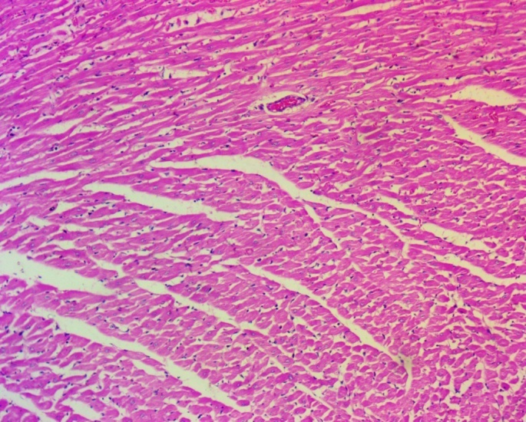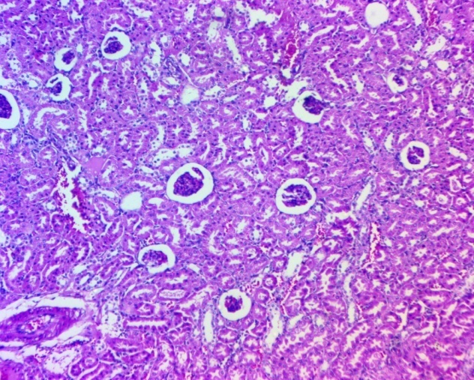
B
A
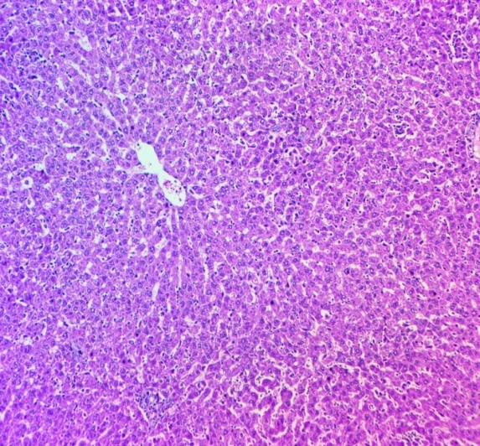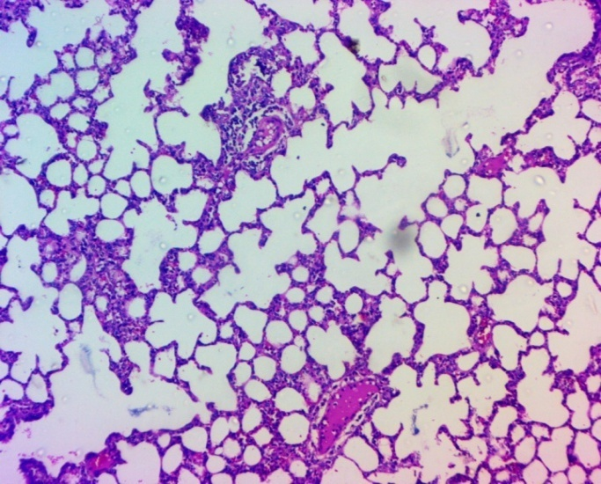
D
C
Fig 1 Histopathological observations of tissue sections showing normal histoarchitecture of Heart (A), Kidney (B), Lung (C) and Liver (D) from group III rats received Exapar Premix formulation @2000mg/kg BW
Exapar Premix is a polyherbal formulation composed of medicinal plant extracts, including Plumbago zeylanica, Aloe barbadensis, piper longum and Lepidium sativum along with other therapeutic herbs. These botanical constituents are well-documented for their safety and pharmacological efficacy. The formulation is considered non-toxic when administered at practical dose levels, which are much more below its LD₅₀ (LD₅₀>2000mg/kg). Exapar® serves as an oral herbal uterine cleanser and restorative, specifically designed to facilitate the expulsion of retained fetal membranes, regulate lochial discharge and correct delayed uterine involution. Additionally, it enhances local immune function, minimizes the risk of postpartum reproductive disorders and supports optimal uterine recovery post-calving, as reported by Adenuga et al. (2024) and Koppad KK et al. (2009). Dhakal (1999) reported that Exapar, effectively aided expulsion of retained placenta in cows and buffaloes, either alone or with antibiotics. Treated animals showed improved conception rates (72% in cows, 55% in buffaloes) compared to controls, suggesting Exapar® as a useful herbal uterotonic for managing retained placenta and enhancing fertility [17].
4. CONCLUSION
The present study demonstrated that Exapar Premix upon oral dosing did not induce acute toxicity, even at the highest tested dose of 2000 mg/kg body weight in Wistar rats. This conclusion is supported by the absence of mortality, clinical signs of toxicity and any significant gross or histopathological alterations in vital organs. Based on these findings, Exapar Premix can be considered safe for oral administration with no observed adverse effects.

ETHICAL APPROVAL
All experimental procedures involving animals were conducted in compliance with the Standard Operating Procedures (SOPs) of the Institutional Animal Ethics Committee (IAEC) and the regulations set forth by the Committee for the Control and Supervision of Experiments on Animals (CCSEA). Prior to the commencement of the study, the research protocol received ethical approval from the IAEC of PGIVAS, Akola (Approval No. 312/01/2000/03/22, dated 08.04.2022), under the registration 312/GO/ReBi/2000/CPCSEA.

COMPETING INTERESTS DISCLAIMER:
Authors have declared that they have no known competing financial interests OR non-financial interests OR personal relationships that could have appeared to influence the work reported in this paper.
Disclaimer (Artificial intelligence)
Also, author(s) hereby declare that NO generative AI technologies such as Large Language Models (ChatGPT, COPILOT, etc.) and text-to-image generators have been used during the writing or editing of this manuscript

References

- Koppad KK, Hari Babu Y, Ravikanth K, Maini S, Rekhe DS, & Honnogopal SS. (2009) Polyherbal formulation exapar liquid improves local immunity in post-partum cows. Bulgarian Journal of Veterinary Medicine, 12(3), 178−184.
- Ganaie BA, Sultan F, Kumar S, Pathak P, & Nayak V. (2018). Effect of uterine infection on milk production and reproductive performance in dairy animals-A review. Journal of Pharmacognosy and Phytochemistry,7(1), 200-202.
- Gautam, R. P., R. P. Tiwari, K. M. Koley, & S. K. Hore. (2005). Efficacy of Exapar in induction of uterine contraction in vitro and expulsion of fetal membranes in buffaloes. Indian Journal of Animal Reproduction, 26(2), 126-128.
- Arunsingh Paradeshi, S. S. Honnappagol, M. K. Tandle, & M. S. Dodamani. (2009). Therapeutic efficacy of herbal uterine cleanser and restorative tonic for the management of repeat breeder cows. Royal Veterinary Journal of India, 5(1/2), 10-13.
- Sudhir Khanna, K. L. Khurana, V. N. Tripathi, & Anju Manujah Anju Manujah. (1997). Effect of Exapar on some parameters of reproductive efficiency in buffaloes. Indian Journal of Animal Reproduction, 18(1), 41-43.
- Adenuga, Y. O., & S. I. Ola. (2024). Efficacy of selected polyherbal products to improve reproductive performance in rabbit does. Nigerian Journal of Animal Production, 49, 369-372.
- Usha, S. K., Sandhya, D. D., Laxmi, S. K., & Karimulla, S. K. (2021). Studies on Plumbago zeylanica: an ethnoveterinary plant. Journal of Biology and Today's World, 10(1), 001-004.
- Khalid, L., Jabeen, I., Inam-ur-Raheem, M., Khan, U. M., Khaneghah, A. M., & Aadil, R. M. (2025). Garden cress seed: A review of its functional and medicinal properties. Journal of Scientific Research and Reports, 101894.
- Shail, M. D., Neeraj, K., & Gupta, L. N. (2016). Nutritional importance of Lepidium sativum L. (Garden cress/Chandrashoor): A review. Journal of Scientific Research and Reports, 5(1), 152–160.
- Nayak, D., & Meher, S. (2025). Exploring Ekala Dravya Prayoga in Sutika - A comprehensive Ayurvedic review. Journal of Scientific Research and Reports, 10(7), 245–254.

- Helal EG, El Sayed RA, & Abu-Taleb HM. (2015). Studies on the Use of Aloe vera Extract as a Contraceptive in Female Rats. The Egyptian Journal of Hospital Medicine,60(1), 271-81.
- Imade OV, Smith OF, & Gazal OS. (2018). Effects of dietary inclusion of Lepidium sativum (garden cress) seed on plasma luteinizing hormone and reproductive performance in female rabbits. Journal of African Association of Physiological Sciences,6(1), 79-84.
- Parganiha, R. (2025). Comparative pharmacognostic evaluation and standardization of root extracts of selected Ayurvedic plants. Journal of Scientific Research and Reports, 18–35.
- Tripura M, Vaidya MG, Belkhede SA, Damekar SC, Gupta S, Hajare SW. Acute Oral Toxicity Assessment of Repchol in Wistar Rats: A Liver-protective Herbal Premix for Poultry. Uttar Pradesh Journal of Zoology. 2024;45(20):459-464.
- OECD Guidelines (2001) Guidance document on acute oral toxicity testing Series on testing and assessment No. 23, http://www.Oecd.org/ehs
- Luna, L. G. (1968). Manual of histologic staining methods of the Armed Forces Institute of Pathology (12th ed.). Armed Forces Institute of Pathology.
- Dhakal, I. P. (1999). Efficacy of Exapar for the expulsion of placenta and as uterine tonic in cows and buffaloes. Journal of Scientific Research and Reports, 5(3), 1–6.

