Morpho-cultural development of Sclerotium rolfsii, the causative agent of collar rot in chickpea (Cicer arietinum L.) using grain and host stem extract-based culture media

Abstract
Sclerotium rolfsii Sacc., the causal agent of collar rot in chickpea (Cicer arietinum L.), is a serious soil-borne pathogen that also causes significant yield losses in several crops. This study evaluated the effect of different host grain and host stem extract-based culture media on the mycelial growth and sclerotial formation of S. rolfsii under in vitro conditions. Pure culture was inoculated on Potato Dextrose Agar (PDA), Grain Dextrose Agar (10g grain powder, 2g dextrose, and 2g agar in 100 ml), and Host Extract Dextrose Agar (10g stem part, 2g dextrose, and 2g agar in 100 ml). Significant variation in mycelial growth was observed among various grain and host extract media. The highest radial growth (90.00 mm) was observed on PDA, followed by Rice Dextrose Agar (89.25 mm) and Pearl millet Dextrose Agar (88.75 mm), while the lowest growth (59.75 mm) occurred on Chickpea Dextrose Agar. Sclerotial production was highest on Rice Dextrose Agar (288 sclerotia) and Pearl millet Dextrose Agar (282 sclerotia), whereas Chickpea Dextrose Agar supported the lowest number (174 sclerotia). In the case of plant extract dextrose agar media, including Pea Dextrose Agar, Lentil Dextrose Agar, Linseed Dextrose Agar, Mustard Dextrose Agar, and Wheat Dextrose Agar, significant growth was supported, which was comparable to that of Potato Dextrose Agar. Through examining mycelial development and sclerotial formation, media based on Corn, Pea, Rice, Sorghum, and Pearl millet grains could be suitable for the mass multiplication of this pathogen. This study also revealed that host stem extract media significantly affects the pathogen's development, and the rapid development might be due to the presence of more supportive nutrients in the host. Overall, the results showed that various grain and host extract-based media could effectively support the rapid mass multiplication of the pathogenic agent.

Key Words
Chickpea, Host Grain media, Host stem extract media, Sclerotium rolfsii, Collar rot

Introduction
The chickpea (Cicer arietinum L.) crop can be affected by numerous airborne, seedborne, and soilborne pathogens (Chattopadhyay et al., 2001). Soilborne diseases such as Fusarium wilt (Fusarium oxysporum f. sp ciceris), dry root rot (Rhizoctonia bataticola), and collar rot (Sclerotium rolfsii) pose significant challenges to chickpea cultivation in central India (Ghosh et al. 2013; Singh et al. 2022; Bankoliya et al. 2022). Among these, one of the key threats is collar rot caused by Sclerotium rolfsii, which usually affects crops, particularly during the early stages of crop development (Shrivastava et al., 1984; Sharma et al., 2012; Singh et al., 2022; Paroda et al., 2024). The pathogen is particularly destructive in legume crops such as chickpea (Cicer arietinum L.), where it causes severe yield losses under favourable environmental conditions (Maurya et al. 2008; Sharma et al. 2012).
Symptoms of collar rot are characterised by the presence of white mycelial mats at the base of the stem and the formation of mustard-sized sclerotia in the affected tissues or the adjacent soil. This infection may lead to the yellowing and wilting of leaves, followed by the collapse and decay of seedlings. Sclerotium rolfsii is a resilient, aerobic pathogen known for its broad host range and considerable economic consequences (Mordue, 1974; Punja et al., 1985; Sharma et al., 2012). The growth and development of this pathogen are affected by different media with varying nutrient compositions (Sravani & Chandra, 2019; Pandey & Gaire, 2019). Media made from various grains and host stem extract could effectively influence the pathogen's development. The rapid growth observed may be attributed to the higher availability of supportive nutrients found in the host.
The identification of carbon source-rich and high-nutrition content media suitable for the faster development and mass multiplication of pathogens could be useful for further field trials, resistance screening, and disease management. In this regard, different grain- and host-extract media were evaluated under the present investigation to determine their effect on the mycelial growth and sclerotial development of the pathogen causing collar rot.
Materials and methods
Isolation of pathogen
The collar rot-affected samples, collected from the research field of AICRP on Chickpea, JNKVV, Jabalpur (latitude 23.21307; longitude 79.94595; elevation 415±8m) were used for the isolation of Sclerotium rolfsii (Figure 1). The infected collar regions of the plants were cut into small pieces of approximately 0.5 cm using a sterilized scalpel blade and surface sterilized with 1% sodium hypochlorite solution for 30 seconds under aseptic conditions in a laminar airflow cabinet. Subsequently, the pieces were rinsed three times with sterilized distilled water. The surface-sterilized pieces were dried on sterilized blotting paper and then transferred onto potato dextrose agar (PDA) medium in Petri plates. The plates were incubated at 25 ± 1°C in a BOD incubator for fifteen days, and the growth of fungal colonies around the plant bits was observed regularly. Single sclerotia transfer method was applied for the purification of the pathogenic culture. Pure colonies were obtained from the transfer of single sclerotia to fresh PDA. A five mm mycelia bit of emerging colony was cut with help of sterilized cork-borer and carefully transferred to fresh PDA plates, and the pathogen was identified based on the morphological characteristics of S. rolfsii as described by Barnett and Hunter (1972). Pure cultures of S. rolfsii were maintained on PDA at 4°C until further use.

Preparation of Grain dextrose agar and Host extract dextrose agar medium
To investigate the growth and development of the pathogen, different grain and host extract media were prepared. For the preparation of grain dextrose agar medium, 10 g of grain powder was mixed with 50 ml of water, heated thoroughly for 5 minutes, and filtered through a muslin cloth. Separately, 2 g of dextrose and 2 g of agar-agar were dissolved in 50 ml of boiling distilled water. The grain extract and dextrose-agar solution were combined, and the final volume was made up to 100 ml with distilled water. Similarly, to prepare the host extract dextrose agar medium, 10 g of lower stem tissue from different hosts was collected, cut into small pieces, and boiled in 50 ml of distilled water over low heat for 10 minutes. The extract was filtered through muslin cloth. Separately, 2 g of dextrose and 2 g of agar-agar were dissolved in 50 ml of boiling distilled water. The host stem extract and the dextrose-agar solution were combined, and the final volume was adjusted to 100 ml with distilled water. After boiling for a few minutes, the medium was dispensed into 250 ml flasks (approximately 100 ml each) and autoclaved at 15 lbs and 121.6°C for 15 minutes.

Experimental details
A total of seven grain dextrose agar and eight host stem extract dextrose agar media were evaluated, compared with standard potato dextrose agar. Under aseptic conditions in a laminar airflow cabinet, pure cultures of Sclerotium rolfsii were transferred onto Petri plates containing different grain dextrose agar and host extract dextrose agar media. A 5 mm mycelial bit (mycelial transfer method) from an actively growing culture was inoculated at the centre of each plate (Karoda et al. 2025). The plates were incubated at 25 ± 1°C, and each treatment was replicated four times. Radial colony growth, colony characteristics, and the number of sclerotia were recorded. Radial growth was measured every 48 hours until the mycelium completely covered the Petri plate, and sclerotia formation was observed over an incubation period of up to 15 days.

Results and Discussion
Symptoms of collar rot in chickpea
During field visit, Collar rot of chickpea, caused by Sclerotium rolfsii, was observed 10 25 days after sowing and was characterized by greyish lesions at the collar region that later turned brown and girdled the stem, leading to seedling collapse (Figure 1). Infected plants exhibited yellowing and drooping of leaves. Under warm, humid conditions, white, cottony mycelium and numerous mustard seed-like sclerotia developed at the stem base and in the surrounding soil.

Cultural characteristics of Sclerotium rolfsii
The pathogenic fungus was isolated from the infected part of the chickpea plant. After incubation of four days, the pathogen produced cottony, white colonies on PDA. The colony colour ranged from dull white to pure white, and sclerotial bodies appeared after 7–15 days of incubation (Figure 2). The sclerotia were brown in color, round, and resembled mustard seeds in shape. Based on these cultural and morphological features of mycelium and sclerotia, the pathogen was identified as Sclerotium rolfsii.
Effect of different Grain dextrose agar media on S. rolfsii
Significant differences in the radial growth of S. rolfsii mycelium were noted at 2nd, 4th and 6th day after inoculation across various culture media (table 1). The highest growth in PDA (53.00 mm) and lowest growth in chickpea dextrose agar (33.25 mm) was seen at 2nd days after inoculation. The maximum growth in sorghum dextrose agar (75.50 mm) and minimum growth in chickpea dextrose agar (70.00 mm) was seen at 4th days after inoculation. The higher colony diameter was observed on Potato Dextrose Agar (90.00 mm), followed closely by Rice Dextrose Agar (89.25 mm), Pearl Millet Dextrose Agar (88.75 mm), and Pea Dextrose Agar (88.00 mm). Colony texture was also varied among different media at 6th days after inoculation. Conversely, the lower colony diameter (72.25 mm) was recorded on Wheat Dextrose Agar (Table 1 and figure 3). Regarding sclerotial production at 15 Day after inoculation, the highest average number of sclerotia was found on Rice Dextrose Agar (288), followed by Pearl Millet Dextrose Agar (282) and Corn Dextrose Agar (265). The least sclerotial production (174) occurred on Chickpea Dextrose Agar. The present study demonstrated that culture media significantly influenced both mycelial growth and sclerotial production of Sclerotium rolfsii. Potato Dextrose Agar (PDA) supported the highest radial growth (90.00 mm), confirming its suitability for the rapid vegetative development of the pathogen. Similar observations were made by Rangaswami and Mahadevan (2004), who reported PDA as a standard medium for the growth of many soil-borne fungi. The higher sclerotial production on rice and millet-based media may be attributed to their starch-rich composition, which favours differentiation into survival structures. Meena et al. (2014) also highlighted that the nutritional profile of the substrate significantly affects the initiation and abundance of sclerotia in S. rolfsii. These results indicate that while PDA remains the best medium for rapid colony growth, rice and millet-based media are superior for sclerotial production. Such findings are consistent with earlier studies emphasising the role of media composition in determining growth and reproductive behavior of S. rolfsii (Punja, 1985; Singh & Singh, 2004).
Effect of host stem extracts dextrose agar medium on Sclerotium rolfsii
All media tested demonstrated significant radial mycelial growth of S. rolfsii at 2nd, 4th and 6th day after inoculation (Table 2). Highest mycelial growth 90 mm observed on Pea stem Dextrose Agar (M₂), Lentil stem Dextrose Agar (M₃), Linseed stem Dextrose Agar (M₄), Mustard stem Dextrose Agar (M₆), Wheat stem Dextrose Agar (M₈), and Potato Dextrose Agar (M₉) followed by Corn Dextrose Agar (87.50 mm) and Soybean Dextrose Agar (84.75 mm) both indicating slightly lower growth. While lowest colony diameter was recorded on Chickpea Dextrose Agar (M₁), measuring (59.75 mm).Colony texture was also varied among different media. Regarding sclerotial formation at 15th day, the highest average number of sclerotia (227) was observed on Potato Dextrose Agar (M₉), followed by Soybean Dextrose Agar (M₇) with 185 sclerotia, and Linseed Dextrose Agar (M₄) with 150 sclerotia. No sclerotia were found on Chickpea, Pea, Lentil, Corn, Mustard, or Wheat Dextrose Agars. These results agree with Rangaswami and Mahadevan (2004) and Punja (1985), who reported that PDA and cereal extract-based media generally support rapid vegetative growth of soil-borne fungi, including S. rolfsii. In contrast, no sclerotia were formed on Chickpea, Pea, Lentil, Corn, Mustard, or Wheat Dextrose Agars. These observations align with those of Meena et al. (2014), who emphasised that the nutritional composition of the substrate plays a crucial role in sclerotial initiation and abundance. The superiority of PDA for both growth and sclerotial formation supports its continued use as a standard medium for isolation and maintenance of the pathogen (Sharma et al., 2012). Overall, the results confirm that while several media promote vigorous radial growth, PDA remains the most effective for both mycelial growth and prolific sclerotial production, consistent with earlier findings (Punja, 1985; Rangaswami & Mahadevan, 2004; Meena et al., 2014; Sharma et al., 2012; Singh & Singh, 2004).
Conclusion
Culture media significantly influenced the mycelial growth and sclerotial formation of Sclerotium rolfsii. Media based on Corn, Pea, Rice, Sorghum, and Pearl millet grains showed faster development of pathogen and could be suitable for the mass multiplication. Chickpea dextrose agar showed the lowest growth and sclerotial formation. The rapid growth observed may be attributed to the higher availability of supportive nutrients found in the host. These findings highlight the importance of selecting appropriate media for in vitro studies and provide insights for pathogen maintenance and disease management strategies.

Disclaimer (Artificial intelligence)
Author(s) hereby declare that NO generative AI technologies such as Large Language Models (ChatGPT, COPILOT, etc.) and text-to-image generators have been used during the writing or editing of this manuscript.

References
Bankoliya, M., Yadav, V., Kumar, A., Amrate, P., Bhatt, J., 2022. The resistance screening and in-vitro efficacy of fungicides for the management of dry root rot of chickpea caused by Rhizoctonia bataticola. Environment Conservation Journal 23(3), 8–13. https://doi. org/10.36953/ECJ.11702317.
Barnett HL & Hunter BB. (1972). Illustrated genera of imperfect fungi, 3rd edition. Burgess Publishing Company, USA. 273 pp.
Chattopadhyay SB, Roy A & Bandopadhyay RN. (2001). Association of soil borne fungi with chickpea and interaction of inocula on disease development. Environment and Ecology. 19(1): 51–55
Ghosh, R., Sharma, M., Telangre, R.,Pande, S. 2013. Occurrence and distribution of chickpea diseases in central and southern parts of India. Amer. J. Plant Sci. 4: 940-944.
Karoda, C., Amrate, P. K., Lovewanshi, L. S., Patidar, S., & Kharte, S. (2025). Efficacy of Pre-mixed Fungicides Against Rhizoctonia solani and Macrophomina phaseolina Isolated from Soybean. International Journal of Economic Plants, 12(Jan, 1), 01–07. https://doi.org/10.23910/2/2025.5785b
Hulse JH. (1991). Nature, composition and utilization of grain legumes. FAO.
Mahadevakumar, S., Gopala, K., & co-authors. (2015). First report of Sclerotium rolfsii causing southern blight and leaf spot on common bean (Phaseolus vulgaris) in India. Plant Disease (First report / short communication).
Maurya SD, Singh H, Singh J, Srivastava. Management of collar rot of Chickpea (Cicer arietinum) by Trichoderma harzianum and plant growth promoting Rhizobacteria. Journal of Plant Protection Research. 2008;48(3):347-354.
Meena PD, Chattopadhyay C and Kumar A. (2014). Role of botanicals and natural products in disease suppression. Journal of Food Legumes. 27(2): 89–95.
Mordue JEM. (1974). Sclerotium rolfsii. C.M.I. Descriptions of Pathogenic Fungi and Bacteria. No. 410.
Pandey P & Gaire SP. (2019). Effect of different media on mycelium growth of Sclerotium rolfsii in vitro condition. Agriculture and Forestry University, Rampur, Chitwan, Nepal; Texas A&M AgriLife Research Center, Beaumont, TX, U.S.A.
Paroda M., Wasnikar A.R., Kumawat A., Kumar S., Amrate P.K., Jaiswal S. and Rawat J. S. (2024). Evaluation of crude extracts of oyster and button mushroom, spent mushroom substrate of Pleurotus ostreatus and spent mushroom compost of Agaricus bisporus against major soil borne pathogens of chickpea. J. Mycopathol. Res. 63(1): 169-176
Punja ZK. (1985). The biology, ecology and control of Sclerotium rolfsii. Annual Review of Phytopathology. 23(1): 97–127.
Rangaswami G and Mahadevan A. (2004). Diseases of Crop Plants in India (4th ed.). Prentice Hall of India Pvt. Ltd., New Delhi.
Sharma M, Ghosh R and Pande S. (2012). Occurrence of collar rot caused by Sclerotium rolfsii on chickpea in India. Journal of Food Legumes. 25(1): 63–65.
Shrivastava KM, Pathak S & Mishra SK. (1984). Collar rot in chickpea. Indian Phytopathology. 37(3): 449–451.
Singh G., Khare U.K, Babber A., Wasnikar A.R., Kumar A., Amrate P.K. 2022. Present status of collar rot in Major chickpea growing state of India. Biological Forum – An International Journal 14: 1095-1101.
Singh RS and Singh H. (2004). Soilborne diseases of chickpea: Distribution, epidemiology and management. Indian Journal of Pulses Research. 17(1): 1–9.
Sravani B & Chandra R. (2019). Influence of media, pH and temperature on the growth of Sclerotium rolfsii (Sacc.) causing collar rot of chickpea. Journal of Pharmacognosy and Phytochemistry. 9(1): 174–178.

Table: 1 Morpho-cultural characteristics of S. rolfsii on different Grain dextrose agar media
S. No. | Culture media | Radial mycelial growth (mm) |  |  | Colony texture | No. of Sclerotia  (15th Day)
S. No. | Culture media | 2ndDay | 4thDay | 6th Day | Colony texture | No. of Sclerotia  (15th Day)
M₁ | Corn Dextrose Agar | 41.25 | 73.75 | 84.75 | Dense, fluffy | 265
M₂ | Chickpea Dextrose Agar | 33.25 | 70.00 | 81.50 | Fluffy to compact, dense | 174
M₃ | Wheat Dextrose Agar | 34.25 | 70.25 | 72.25 | Sparse cottony, dence | 181
M₄ | Pea Dextrose Agar | 38.50 | 70.75 | 88.00 | Cottony, dense, fluffy | 241
M₅ | Rice Dextrose Agar | 41.00 | 74.00 | 89.25 | Flat, loose cottony | 288
M₆ | Sorghum Dextrose Agar | 40.25 | 75.50 | 85.75 | Dense and compact | 256
M₇ | Pearl millet Dextrose Agar | 42.50 | 72.50 | 88.75 | Loose, Flat, white colony | 282
M₈ | Potato Dextrose Agar | 53.00 | 72.25 | 90.00 | Dense, fluffy, uniform | 227
 | SE(m) | 0.621 | 0.995 | 0.652 | - | 11.524
 | C.D. | 1.823 | 2.921 | 1.913 | - | 33.837

Table 2 Morpho-cultural characteristics of S. rolfsii on different host stem dextrose agar medium
S. No. | Culture media | Radial mycelial growth (mm) |  |  | Colony texture | No. of Sclerotia  (15th Day)
S. No. | Culture media | 2nd Day | 4thDay | 6thDay | Colony texture | No. of Sclerotia  (15th Day)
M₁ | Chickpea stem dextrose agar | 19.50 | 42.50 | 59.75 | Fluffy and dense | -
M₂ | Pea stem dextrose agar | 36.25 | 77.50 | 90.00 | Flat, modrate fluffy | -
M₃ | Lentil stem dextrose agar | 36.50 | 83.00 | 90.00 | Flat, dense, patchy | -
M₄ | Linseed stem dextrose agar | 41.50 | 83.25 | 90.00 | Compact, Flat | 150
M₅ | Corn stem dextrose agar | 40.25 | 85.00 | 87.50 | Flat, patchy | -
M₆ | Mustard stem dextrose agar | 34.50 | 83.50 | 90.00 | Thin, smooth fluffy | -
M₇ | Soyabean stem dextrose agar | 42.50 | 75.00 | 84.75 | Compact, fluffy, radial | 185
M₈ | Wheat stem dextrose agar | 37.75 | 85.00 | 90.00 | Thin, flat, loose | -
M₉ | Potato dextrose agar | 53.00 | 72.25 | 90.00 | Dense, smooth, fluffy | 227
 | SE(m) | 0.968 | 0.831 | 0.819 | -
 | C.D. | 2.825 | 2.423 | 2.390 | -

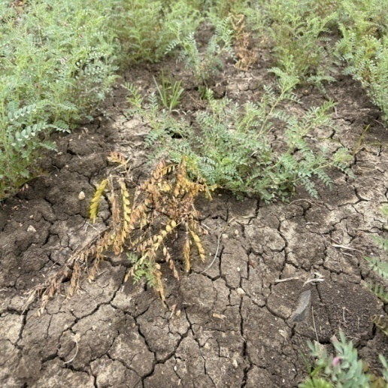
A
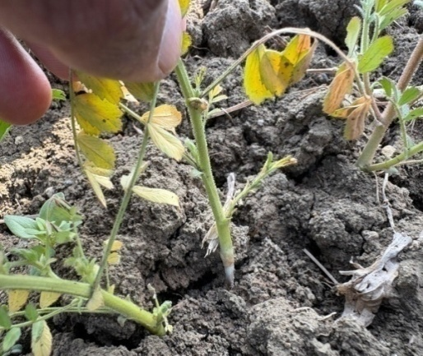
B
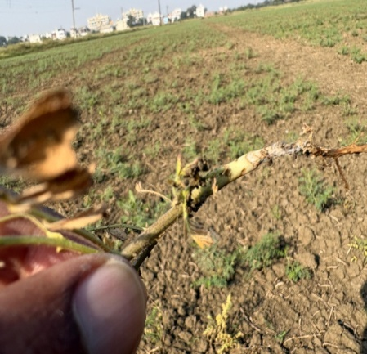
C
Figure 1 Symptoms of collar rot in chickpea yellowing of plant (A), whitish mycelia development of pathogen on collar region and girdling at collar region (C), respectively.
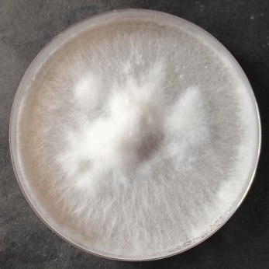 | 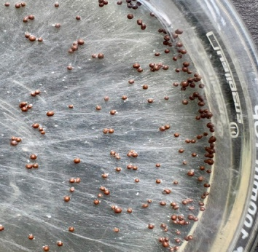
A | B
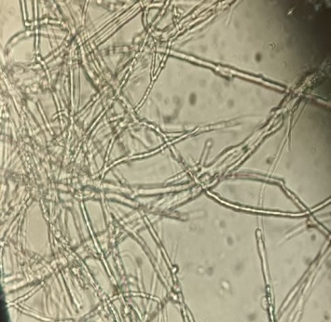 | 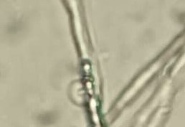
C | D

Figure 2 Cultural characteristics S. rolfsii on PDA: 6th days growth (A), Mustard seed like sclerotia formation in culture plate at 15 DAI (B), Mycelia mat and clamp connection (C and D)

 | 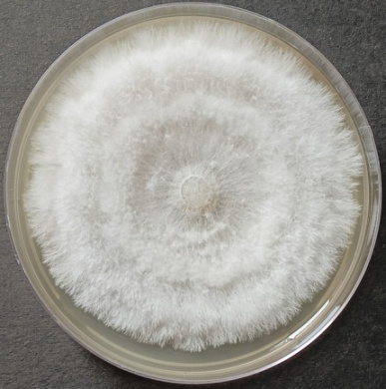 | 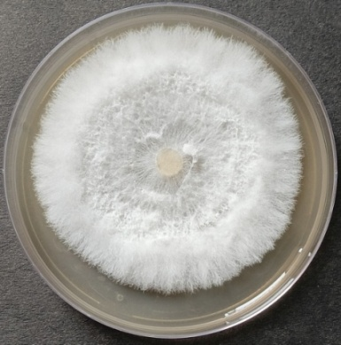 |  | 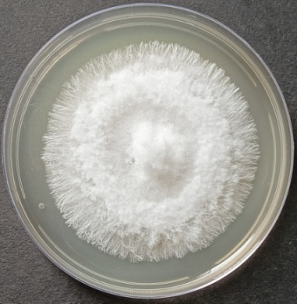
 | M₁ | M₂ |  | M₃
 | 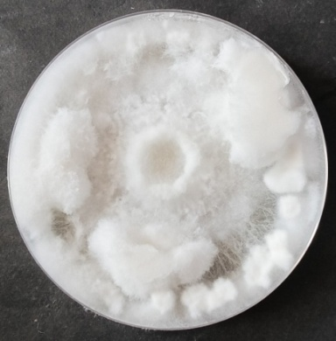 | 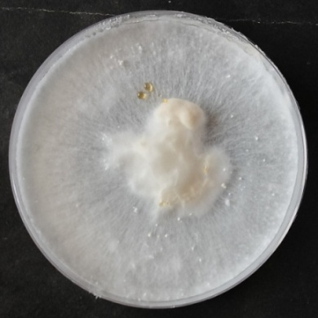 |  | 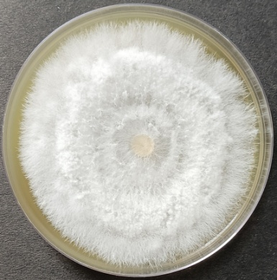
 | M₄ | M₅ |  | M₆
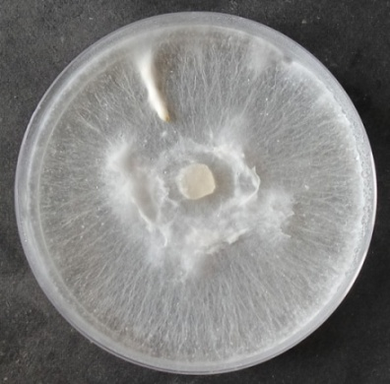 |  |  | 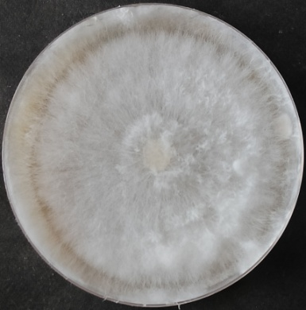
M₇ |  |  | M₈
Figure 3 Mycelial growth of the pathogen on different grain dextrose agar medium (M₁ = Corn Dextrose Agar, M₂ Chickpea Dextrose Agar, M₃ Wheat Dextrose Agar, M₄ Pea Dextrose Agar, M₅ Rice Dextrose Agar, M₆ Sorghum Dextrose Agar M₇ Pearl millet Dextrose Agar M₈ Potato Dextrose Agar)

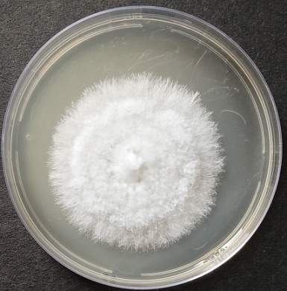 | 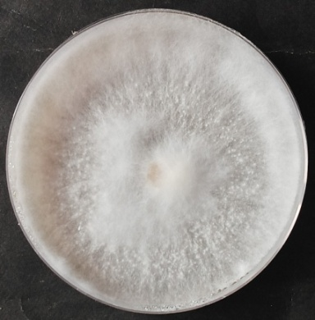 | 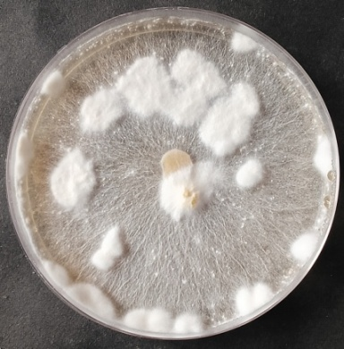
M₁ | M₂ | M₃
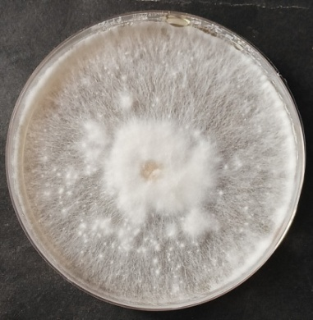 | 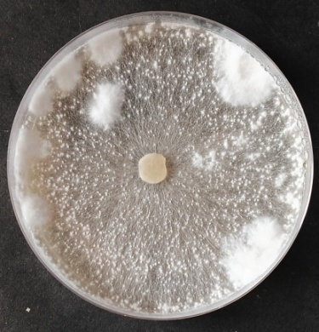 | 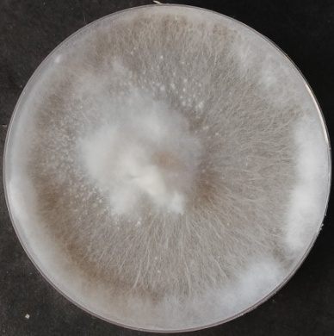
M₄ | M₅ | M₆
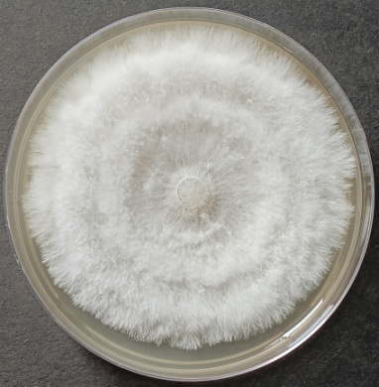 | 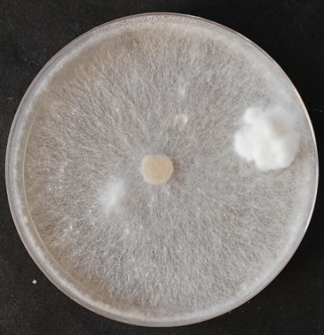
M₇ | M₈ | M₉
Figure 4 Mycelial growth of the pathogen on different host extract dextrose agar media (M₁ Chickpea stem dextrose agar, M₂ Pea stem dextrose agar, M₃ Lentil stem dextrose agar, M₄ Linseed stem dextrose agar, M₅ Corn stem dextrose agar, M₆ Mustard stem dextrose agar, M₇ Soybean stem dextrose agar, M₈ Wheat stem dextrose agar)

