Whitefly associated plant viral diseases and their interactions

Abstract:
There are more than 2000 virus species and those affecting plants include viruses of at least 21 families and 8 unassigned genera, many of which cause important diseases of various plants that humans grow for food and/or fiber. Plant-infecting viruses must have an efficient means to move from one plant host to another. The transmission of plant viruses from infected to healthy host plant is a process in which insects play a major role, using various transmission strategies. Viruses that manage to pass through the gut into the haemolymph and then to the salivary glands are known as persistent. There are two sub-classes of persistent viruses: propagative and circulative. Four possible scenarios are suggested including, virion binding through dimer or monomer, formed by the virus-encoded P1b protein, formed by the virus-encoded P1 protein, direct binding of the virion to the putative whitefly receptors located on the cuticle lining the maxillary stylet. Schematic representation illustrating putative modes of interaction of ipomoviral virions with putative receptors located in the whitefly maxillary stylet detailed in the study and the study aims to investigate Whitefly-associated plant viral diseases and their interactions.
- Introduction
There are more than 2000 virus species and those affecting plants include viruses of at least 21 families and 8 unassigned genera, many of which cause important diseases of various plants that humans grow for food and/or fiber (Hull, 2014). In addition, many plant viruses have been found associated with non-cultivated plants and new plant viruses are being discovered every day. Virus diseases make up 47% of the new emerging diseases affecting plants (Anderson et al., 2004). Thus, plant infecting viruses are very successful. In order to survive, plant-infecting viruses must have an efficient means to move from one plant host to another. To do so, the great majority of plant viruses utilize specific vectors to ensure their ability to move from one plant to another, and to ensure their survival, plant viruses encode for specific proteins that facilitate this process (Kritzman et al., 2002; Moreno et al., 2012; Moritz et al., 2004).
Although there are different types of plant-associated organisms including fungi, nematodes and various types of invertebrates that serve as vectors for different plant viruses, the majority of plant viruses utilize specific plant feeding insects as their primary vector (s), and here we focus on insect-transmitted plant viruses. Proteins encoded by different plant viruses have been identified to specifically interact with their respective insect vectors and facilitate virus transmission (Ammar et al., 2009; Hogenhout et al., 2008; Ng and Falk, 2006). In particular, geminiviruses may constitute a family of plant viruses who are in the process of acquiring, or loosing abilities to interact actively with their insect vector, the whitefly Bemisia tabaci, to a point reminiscent of a host-pathogen relationship. This assumption is particularly pertinent when examining the relationship between B. tabaci and begomoviruses (Henryk and Murad, 2012).
Whiteflies transmit begomoviruses in a persistent, circulative manner, criniviruses, ipomoviruses, and torradoviruses in a semi-persistent manner, and carlaviruses in a non-persistent manner. Over the past few decades, the spread of whiteflies has significantly contributed to the dissemination of whitefly-borne plant viruses. Notable whitefly-borne viruses, including tomato yellow leaf curl virus, African cassava mosaic virus, cotton leaf curl Multan virus, and tomato chlorosis virus, have become major disease agents worldwide (Shi-Xing Zhao et al., 2025).
- Insect vectors for plant viruses:
Bemisia tabaci can transmit an immense diversity of viruses, reflected in numerous species and strains. In general, diseases resulting from these viruses have a serious negative impact on crops. They belong to the genera Begomovirus, Crinivirus, Ipomovirus, Carlavirus and Torradovirus and have significant differences in the mode of virus transmission. Begomoviruses have single-stranded DNA genomes and are circulative, persistently transmitted plant viruses. Once the virus is acquired, the insect remains viruliferous to transmit the virus often for the rest of its life. Crinivirus, Ipomovirus, Carlavirus and Torradovirus have singlestranded RNA genomes and are non-circulative viruses, thus, whiteflies remain viruliferous only by continuous uptake of the virus from the plant sap.

- Insect vectors of plant viruses are found in 7 orders of the class Insecta.
- The majority of vectors are found in the two orders of insects with pierce-sucking mouthparts. (Anna, et al., 2015).
Hemiptera (300)
Thysanoptera (6).
- Other vector species are found in five orders of chewing insects:
Coleoptera (30)
Orthoptera (10),
Lepidoptera (4),
Diptera (2)
Dermaptera (1)

- Taxonomic Position of Whitefly
Kingdom : Animalia
Phylum : Arthropoda
Class : Insecta
Order : Hemiptera
Family : Aleyrodidae
Genus : Bemisia
Species : tabaci
The whitefly was first reported in Greece (David, 2002).
4) Whitefly species:
1) Greenhouse whitefly - Trialeurodes vaporariorum
2) Silverleaf whitefly - Bemisia argentifolii
3) Sweet potato whitefly - Bemisia tabaci
4) Bandedwing whitefly - Trialeurodes abutilonea
5) Spiralling white fly - Aleurodicus dispersu

- There are 3 important species. About 114 viruses are transmitted by these 3 spp.
Sweet potato whitefly- Bemisia tabaci -108 viruses
Greenhouse whitefly- Trialeurodes vaporariorum -3 viruses
Bandedwing whitefly- Trialeurodes abutilonea -3 viruses
Most plant viruses depend on vectors for their survival and spread. Most vectors are piercing-sucking insects that transmit plant viruses.
- whitefly-transmitted virus species,
90% belong to the Begomovirus genus,
6% to the Crinivirus genus
4% are in the Closterovirus, Ipomovirus or Carlavirus genera.
- Other named, whitefly-transmitted viruses that have not yet been ranked as species are also documented (David, 2002).

- Mode of transmission of viruses by whitefly:
- Viruses that manage to pass through the gut into the haemolymph and then to the salivary glands are known as persistent. There are two sub-classes of persistent viruses: propagative and circulative.
- Propagative viruses are characterized by replication and systemic invasion of vector insect tissues prior to transmission via salivary glands.
- Propagative viruses are able to replicate in both the plant and the insect (and may have originally been insect viruses), whereas circulative cannot.
- Begomoviruses have single-stranded DNA genomes and are circulative, persistently transmitted plant viruses.
- Semi-persistent viral transmission involves the virus entering the foregut of the insect.
- Crinivirus, Ipomovirus, Carlavirus and Torradovirus have single stranded RNA genomes and are non-circulative viruses, thus, whiteflies remain viruliferous only by continuous uptake of the virus from the plant sap.

Circulative Transmission: Begomoviruses
A mode of viral transmission, primarily involving insects, where the virus enters the vectors body, circulates through its internal systems and is the transmitted to a new host. The process involves the virus crossing the insect gut and travelling through the haemolymph before reaching and passing through the salivary glands, where it is inject with saliva.
- These viruses are single stranded closed circular DNA.
- Many begomoviruses have a bipartite genome: this means that the genome is segmented into two segments (referred to as DNA A and DNA B) that are packaged into separate particles.
- Both segments are generally required for successful symptomatic infection in a host cell but DNA B is dependent for its replication upon DNA A.
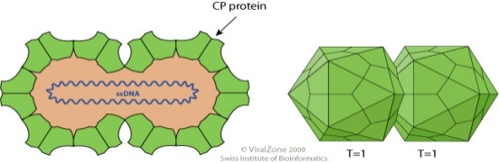
Begomovirus Particle
Movement of begomovirus in different parts of whitefly
oesophagus with in 10 Min

Midgut after 40 min

They cross the filter chamber and the midgut area into the haemolymph after 90 min

Translocate into the primary salivary glands (PSGs) where they can be detected 4–7 h after the onset of feeding
Minimum of 8 h (latent period) require from the beginning of ingestion until virus can be transmitted to plants.
The amount of Tomato yellow leaf curl virus(TYLCV) accumulating in individual 4–7 day-old adult B. tabaci, B or Q biotypes, during continuous feeding on infected tomato plants reaches a limit after 12–48 h, not exceeding about 600 million viral genomes.
Amazingly, this amount remains nearly constant while the insects continue to feed on infected plants, and they have the potential to ingest about 600 million viruses every 24 h, implying mechanisms controlling the viral amounts in the insect. (Wen-Qiang Xia et al., 2018).

- Model of begomovirus trafficking in epithelial cells of whitefly midgut.

Following clathrin-mediated endocytosis, begomoviruses are first delivered to early endosomes after clathrin-mediated endocytosis, then transported directly to the basal membrane of midgut epithelial cells. The fusion between virus-containing endocytic vesicles and early endosomes is mediated by Rab5 and the CORVET complex. Then, some of the viral particles may be transported to the basal membrane by tubular vesicles induced by Snx12. Whether some viral particles are transported to lysosomes remains uncertain (Fig. 1).

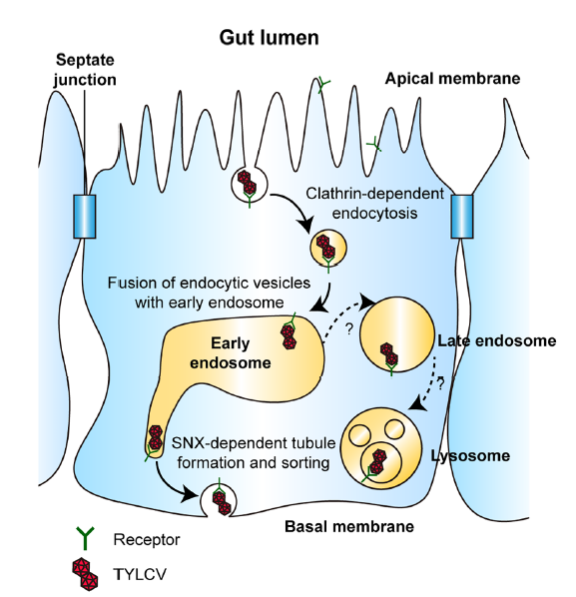
Fig 1: Begomovirus trafficking in epithelial cells of whitefly midgut.

Persistent circulative transmission pathway for begomoviruses (red colour particles) acquired and transmitted by whitefly (B. tabaci) vector (Fig. 2). After acquisition, viruses reach to the gut via food canal where viruses interact with hsp (heat shock proteins), which help the virions in crossing gut epithelia to reach the haemolymph, where virus particles interact with GroEL protein (light blue colour) secreted by primary symbiotic bacteria in the bacteriocytes (bc). After that, virions enter into the salivary glands (Sg) and transmit to the host plants through salivary secretion during feeding. Secondary symbiotic bacteria (dark blue) present in most of the body cavity of insects and influence virus-vector interactions. (Priyanka and Sangeeta 2017).

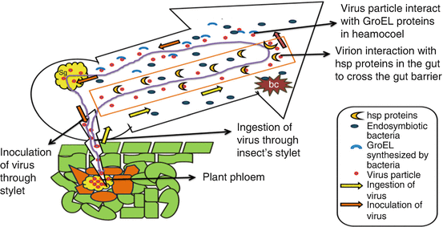
Fig 2: Interaction of virus particles with different proteins in heamocoel.

Non circulative transmission: a type of viral transmission, where the virus does not enter the vectors body and does not replicate. Instead, it attaches to the external mouth parts, such as the stylets of an insect vector. The virus is then transmitted when the vector feeds on a new host, with the entire process- from acquisition to inoculation – often happening very quickly in a matter of minutes.
- Genus: Crinivirus
Family: Closteroviridae
- Viruses with a linear, positive-stranded ssRNA genome that is up to 20 kb and encapsidated in very long and flexuous particles.
- Bipartite genomes that add up to 7,500–19,500 nucleotides in length.
- The genome of criniviruses is composed of two molecules that are independently encapsidated. RNA-1 encodes proteins involved in replication, and RNA-2 (and RNA-3) encodes proteins involved in viral encapsidation, movement, and vector transmission.
- Two different genera transmitting criniviruses.
Bemisia (B. tabaci)
Trialeurodes (T. vaporariorum and T. abutiloneus).

Table 1: Whitefly transmission specificity of criniviruses:

Whitefly Vector | diseases
Banded wing whitefly (T. abutilonea) | Abutilon yellows virus(AYV)  Lettuce chlorosis virus (LCV)  Tomato chlorosis virus (ToCV)
Greenhouse whitefly (T. vaporariorum) | Beet pseudo yellows virus (BPYV)  Strawberry pallidosis associated virus (SPaV) Tomato chlorosis virus (ToCV)  Tomato infectious chlorosis virus (TICV)
Silverleaf whitefly (B. tabaci biotype B) | Cucurbit yellow stunting disorder virus (CYSDV)  Sweet potato sunken vein virus (SPSVV) Tomato chlorosis virus (ToCV)
Sweet potato whitefly (B. tabaci biotype A) | Lettuce infectious yellows virus (LIYV)  Tomato chlorosis virus (ToCV)

- Genus: Ipomovirus
Family: Potyviridae
- Ipomovirus are non-enveloped, with flexuous and filamentous geometries.
- The diameter is around 12-15 nm, and may have a variety of lengths depending on the species (200-300 nanometers (nm): 500-600 nm: 650-900 nm).
- The capsid has helical symmetry with a pitch of 3.4 nm. They induce characteristic inclusion bodies (pinwheels) within infected plant cells
Diseases transmitted by Ipomovirus
Cassava brown streak virus (CBSV)
Cucumber vein yellowing virus (CVYV)
Squash vein yellowing virus (SqVYV)
Sweet potato mild mottle virus (SPMMV)

- Genus:Carlavirus
Family: Betaflexiviridae
- The virions are non enveloped, filamentous, 610–700 nanometers (nm) and 12–15 nm in diameter.
- The linear 5.8–9 kilobase genome is positive sense, single-stranded RNA.
- The 3’ terminus is polyadenylated. In some species the 5’ end is capped.
- The genome encodes 3 to 6 proteins including a coat protein located at the 3' end and an RNA-dependent RNA polymerase located at the 5' end of the genome.
Diseases transmitted by carlavirus
Cowpea mild mottle virus (CpMMV)
Melon yellowing-associated virus (MYaV)

- Genus:Torradovirus
Family: Secoviridae
- Non-enveloped, about 30 nm in diameter, T=pseudo3 icosahedral capsid. Genome segments are encapsidated separately into two different types of particle similar in size.
Tomato torrado virus (ToTV)
Tomato chocolate virus (ToChV)
Tomato necrotic dwarf virus (ToNDV)

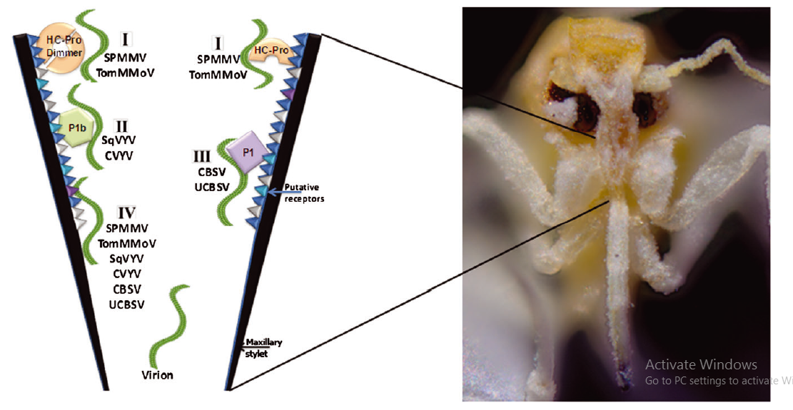
Fig 3. Non circulative transmission of different viruses
Schematic representation illustrating putative modes of interaction of ipomoviral virions with putative receptors located in the whitefly maxillary stylet (Fig- 3). Four possible scenarios are suggested: (I) virion binding through a virus-encoded HC-Pro ‘bridge’ dimer or monomer [relevant to Sweet potato mild mottle virus (SPMMV) and Tomato mild mottle virus (TomMMoV)]; (II) virion binding through a ‘bridge’ formed by the virus-encoded P1b protein [relevant to Squash vein yellowing virus (SqVYV) and Cucumber vein yellowing virus (CVYV)]; (III) virion binding through a ‘bridge’ formed by the virus-encoded P1 protein [relevant to Cassava brown streak virus (CBSV) and Ugandan cassava brown streak virus (UCBSV)]; (IV) direct binding of the virion to the putative whitefly receptors located on the cuticle lining the maxillary stylet. This option is relevant for all of the described ipomoviruses ( Dombrovsky et al., 2014).

Transovarial Transmission: Recent studies revealed that some whitefly transmitted virusus can be passed to offsprings through transovaririal transmission. Gosh & Ghanin (2021) studied the whitefly, B. tabac transmitting dolichos yellow mosaic virus (DoYMV, Begomovirus) in dolichos bean (Lablab purpureus(L.) Sweet). Tests for transovarial transmission of DoYMV in next-generation B. tabaciby PCR, real-time PCR, Southern blot hybridization, and biological transmission showed that eggs, laid by DoYMV-exposed B. tabaci, carry the virus in a unique pattern. Further, Jing Wei et al. 2017 conducted tresearch on transovarial transmission of Tomato yellow leaf curl virus (TYLCV) and Papaya leaf curl China virus (PaLCuCNV) by Mediterranean (MED) whiteflies, which is another invasive species of the B. tabaci complex (17). MED whiteflies of 1 days after eclosion (DAE) transmitted TYLCV only to the eggs and nymphs of their progeny; however, whiteflies of 11 DAE transmitted TYLCV to eggs, nymphs, and adults of their progeny efficiently (67–85%).

Conclusion:

Whitefly transmitted plant viruses pose growing threat to agriculture and cause major economic losses across many crops. B. tabaci transmits over 400 viruses species mostly single strandard DNA begomoviruses via persistent circulative pathway that requires crossing the insects gut, haemolymph and salivary glands through specific interactions with vector proteins. Understanding the virus-vector-host interaction is crucial for devising new control strategies. The appearance of a new vector biotype and increases in vector populations have contributed to the emergence of virus disease problems. Thus, there is a need for a better understanding of the factors that have led to the increase in the vector populations in diverse cropping systems.

In the past decade, extensive and intensive surveys of B. tabaci have been conducted to detect the spread of the B biotype, and identify other biotypes within the B. tabaci species complex. The diverse array of tools utilized for molecular analysis and interpretation of results has made it difficult to compare results and draw conclusions. However, knowledge is advancing rapidly, and improved understanding of B. tabaci systematics and epidemiologically useful distribution patterns are likely in the near future. In consideration of the alarming rate with which new geminiviruses are emerging in tomato, there is an urgent need to develop appropriate conceptual frameworks. It is probable that only through this multicomponent approach can economically and environmentally sound approaches be developed for the successful management of these viruses.

Disclaimer (Artificial intelligence)

Option 1:
No AI tools were used for writing or editing of manuscript.

Author(s) hereby declare that NO generative AI technologies such as Large Language Models (ChatGPT, COPILOT, etc.) and text-to-image generators have been used during the writing or editing of this manuscript.

Option 2:

Author(s) hereby declare that generative AI technologies such as Large Language Models, etc. have been used during the writing or editing of manuscripts. This explanation will include the name, version, model, and source of the generative AI technology and as well as all input prompts provided to the generative AI technology

Details of the AI usage are given below:
1.
2.
3.

References:

Ammar, el-D., Tsai, C. W., Whitfield, A. E., Redinbaugh, M. G & Hogenhout, S. A. (2009). Cellular and molecular aspects of rhabdovirus interactions with insect and plant hosts. Annual Review of Entomology.54,447–468.
Anderson, P. K., Cunningham, A. A., Patel, N. G., Morales, F. J., Epstein, P. R & Daszak, P. (2004). Emerging infectious diseases of plants: pathogen pollution, climate change and agro technology drivers. Trends Ecol.Evol.19,535–544.
Anna, E. W., Bryce, W., & Dorith, R. (2015). Insect vector-mediated transmission of plant viruses. Virology. 479-480: pp. 278–289.
David, R. J. (2002). Plant Viruses Transmitted by Whiteflies: European Journal of Plant Pathology.
Dombrovsky, A., Reingold, V & Antignus, Y. (2014). Ipomovirus – an atypical genus in the family Potyviridae transmitted by whiteflies Pest Management Science ; 70: 1553–1567.
Ghosh, R., & Ghanim, M. (2021). Factors determining transmission of persistent viruses by Bemisia tabaci: insights into virus-vector interactions. Viruses, 13(9), 1808.
Henryk, C & Murad, G. (2012). Back to Basics: Are Begomoviruses Whitefly Pathogens. Journal of Integrative Agriculture. 2012, 11(2): 225-234.
Hogenhout, S. A., Ammar,el-D., Whitfield, A. E., Redinbaugh, M. G. (2008). Insect vector interactions with persistently transmitted viruses. Annual Review Phytopathology.46, 327–359.
Hull, R. (2014). Matthew's Plant Virology. Academic Press, USA p. 1056.
Jing Weia., Ya-Zhou Hea., Qi Guoa., Tao Guoa., Yin-Quan Liua., Xue-Ping Zhoub., Shu-Sheng Liua. & Xiao-Wei Wang. (2017). Vector development and vitellogenin determine the transovarial transmission of begomoviruses. Proceedings of the National Academy of Sciences. Vol.114(26): 6746-6751.
Kritzman, A., Gera, A., Raccah, B., van Lent, J. W & Peters, D. (2002).Theroute of tomato spotted wilt virus inside the thrips body in relation to transmission efficiency. Archives of Virology.147, 2143–2156.
Moreno, A., Tjallingii, W. F., Fernandez-Mata, G & Fereres, A. (2012). Differences in the mechanism of inoculation between a semi-persistent and anon-persistent aphid-transmitted plantvirus. Journal General Virology. 93,662–667.
Moritz, G., Kumm, S & Mound, L. (2004). Tospovirus transmission depends on thrips ontogeny. Virus Research.100,143–149.
Ng, J. C. & Falk, B. W. (2006). Virus–vector interactions mediating non-persistent and semi-persistent transmission of plant viruses. Annual Review of Phytopathology.44,183–212.
Priyanka, V & Sangeeta, S. (2017). Transmission of Begomoviruses. Asia and Africa. 51-69.
Shi-Xing Zhao, Su-Dan Wang, Yin-Quan Liu, Li-Long Pan (2025). Modulation of Plant Interactions with Whitefly and Whitefly-Borne Viruses by Salicylic Acid Signaling Pathway: A Review. Viruses. 7;17(6):825.
Wen-Qiang Xia, Yan Liang, Yao Chi, Li-Long Pan, Jing Zhao, Shu-Sheng Liu, Xiao-Wei Wang (2018). Intracellular trafficking of begomoviruses in the midgut cells of their insect vector. PLOS. Pathogens. Pp. 1-25.

