Assessing the Farmers’ decision on Neem-Based Bio pesticide Adoption in Tamil Nadu, India
Abstract
Objectives:
The study aimed to examine the determinants influencing farmers’ intention and behaviour toward the adoption of neem-based bio pesticides in Tamil Nadu, India, by integrating the Protection Motivation Theory (PMT) and the Unified Theory of Acceptance and Use of Technology (UTAUT).
Methodology:
A descriptive research design was employed and data were collected during 2023-2024 using a structured interview schedule. The measurement and structural models were validated using Partial Least Squares Structural Equation Modelling (PLS-SEM). Reliability, convergent and discriminant validity were assessed and relationships among constructs were analysed through SmartPLS 4 with 5,000 bootstrap resamples.
Sampling Method:
A multistage random sampling technique was adopted to select 450 farmers from nine major agricultural districts of Tamil Nadu cultivating crops prone to pest incidence.
Findings:
The results revealed that coping appraisal strongly enhances adoption intention (β = 0.817, p < 0.001; f² = 0.482), followed by threat appraisal (β = 0.354, p < 0.001; f² = 0.168) and performance expectancy (β = 0.213, p < 0.05; f² = 0.046), while efficacy expectation negatively influences intention (β = –0.548, p < 0.001; f² = 0.120). Facilitating conditions positively support adoption (β = 0.102, p < 0.05; f² = 0.032), whereas social influence is non-significant (β = 0.035, p > 0.05; f² = 0.006). Adoption intention significantly mediates the relationship between motivational and contextual factors and actual adoption behaviour (β = 0.319, p < 0.001; f² = 0.165). The integrated model explains (77.50%) of variance in adoption intention and (62.00%) in actual behaviour (R²). Conclusion:
The study concludes that farmers’ motivation to adopt neem-based bio pesticides largely depends on their confidence in coping ability and perceived performance benefits, whereas perceived complexity hinders adoption.
Recommendation:
Policy interventions should focus on enhancing farmers’ self-efficacy, simplifying product use, improving awareness through field demonstrations and ensuring market availability of quality neem-based bio pesticides to promote eco-friendly pest management practices in Tamil Nadu.
Keywords: Adoption behaviour, Bio pesticides, PLS-SEM, Tamil Nadu
1. INTRODUCTION
Agricultural intensification has long relied on chemical pesticides to protect crops from pests and diseases. However, indiscriminate use of synthetic pesticides has resulted in severe ecological and health concerns, including pesticide resistance, soil and water contamination and biodiversity loss (Popp et al., 2013; Wyckhuys et al., 2023). In India, pesticide overuse and misuse have been linked to adverse impacts on farmers’ health and declining environmental quality (Tudi et al., 2021). These challenges have prompted global and national efforts to promote sustainable pest management practices such as Integrated Pest Management (IPM) and the use of bio pesticides, which are derived from natural plant, microbial, or mineral origins (Kumar et al., 2021).
Among various bio pesticides, neem (Azadirachta indica)-based formulations have attracted significant attention because of their broad-spectrum efficacy against insect pests, biodegradability and safety to non-target organisms (Isman, 2020). Neem acts as a natural pest deterrent and is compatible with organic and IPM systems, making it a viable alternative to chemical pesticides. Despite these advantages, the adoption rate of neem-based bio pesticides among Indian farmers remains relatively low (Narayanan et al., 2021). Limited awareness, inconsistent product quality and perceptions of reduced efficacy have constrained their widespread use (Reddy & Chowdary, 2021). Understanding the behavioural, psychological and contextual determinants influencing farmers’ adoption decisions is therefore critical for designing effective interventions to promote eco-friendly pest management.
Neem (A. indica) contains a complex mixture of biologically active compounds responsible for its insecticidal, fungicidal and antimicrobial properties. More than 300 phytochemicals have been identified from different parts of the plant, with azadirachtin, salannin, nimbin, nimbidin, meliantriol and gedunin being the most potent constituents (Isman, 2020). Azadirachtin, the major limonoid, disrupts insect growth and reproduction by interfering with ecdysteroid and juvenile hormone regulation, thereby preventing moulting and metamorphosis. Salannin and meliantriol function as strong feeding deterrents and oviposition inhibitors, while nimbin and nimbidin exhibit antifungal and antibacterial activities by altering fungal cell wall synthesis and membrane permeability. Additionally, gedunin interferes with chitin biosynthesis and digestive enzymes, producing antifeedant and growth-inhibitory effects in pests. The synergistic action of these compounds targets multiple physiological pathways in insect pests, leading to effective and sustainable pest suppression without inducing resistance. These unique biochemical mechanisms make neem-based bio pesticides an environmentally sound and economically feasible alternative for sustainable pest management in Indian agriculture.
Hence, the present study integrates PMT and UTAUT to identify the determinants influencing farmers’ intention and behaviour toward adopting neem-based bio pesticides in Tamil Nadu, India, during 2023-2024. Using Partial Least Squares Structural Equation Modelling (PLS-SEM), the study quantifies the relationships between cognitive appraisals, technology perceptions and behavioural outcomes. The results are expected to provide theoretical insights into sustainable input adoption behaviour and practical guidance for promoting environmentally safe pest management among smallholder farmers.

2. THEORETICAL FRAMEWORK
The adoption of neem-based bio pesticides is not only a technical choice but also a behavioural process shaped by cognitive, psychological and social factors. To capture these dynamics, this study integrates Protection Motivation Theory (PMT) (Rogers, 1975) and the Unified Theory of Acceptance and Use of Technology (UTAUT) (Venkatesh et al., 2003). PMT explains adoption as a protective response driven by threat appraisal (perceptions of pest risk, yield loss and chemical pesticide hazards) and coping appraisal (beliefs in neem efficacy, self-efficacy and manageable costs). UTAUT complements this by focusing on performance expectancy (yield and cost benefits), effort expectancy (ease of use), social influence (peer and institutional support) and facilitating conditions (access, training and availability). Integrating PMT and UTAUT provides a comprehensive model, recognizing that farmers’ decisions involve both risk-response motivations and technology acceptance drivers. The conceptual framework (Figure 1) posits that motivational and contextual determinants influence adoption intention, which in turn predicts actual adoption behaviour.
Hypotheses
- H1: Threat appraisal → adoption intention
- H2: Coping appraisal → adoption intention
- H3: Performance expectancy → adoption intention
- H4: Effort expectancy → adoption intention
- H5: Social influence → adoption intention
- H6: Facilitating conditions → adoption intention and actual use
- H7: Adoption intention → actual adoption behaviour
To test these hypotheses, Structural Equation Modeling (SEM) was employed to simultaneously assess measurement and structural relationships among constructs. This framework offers a robust basis for understanding and scaling neem-based bio pesticide adoption in sustainable agriculture.

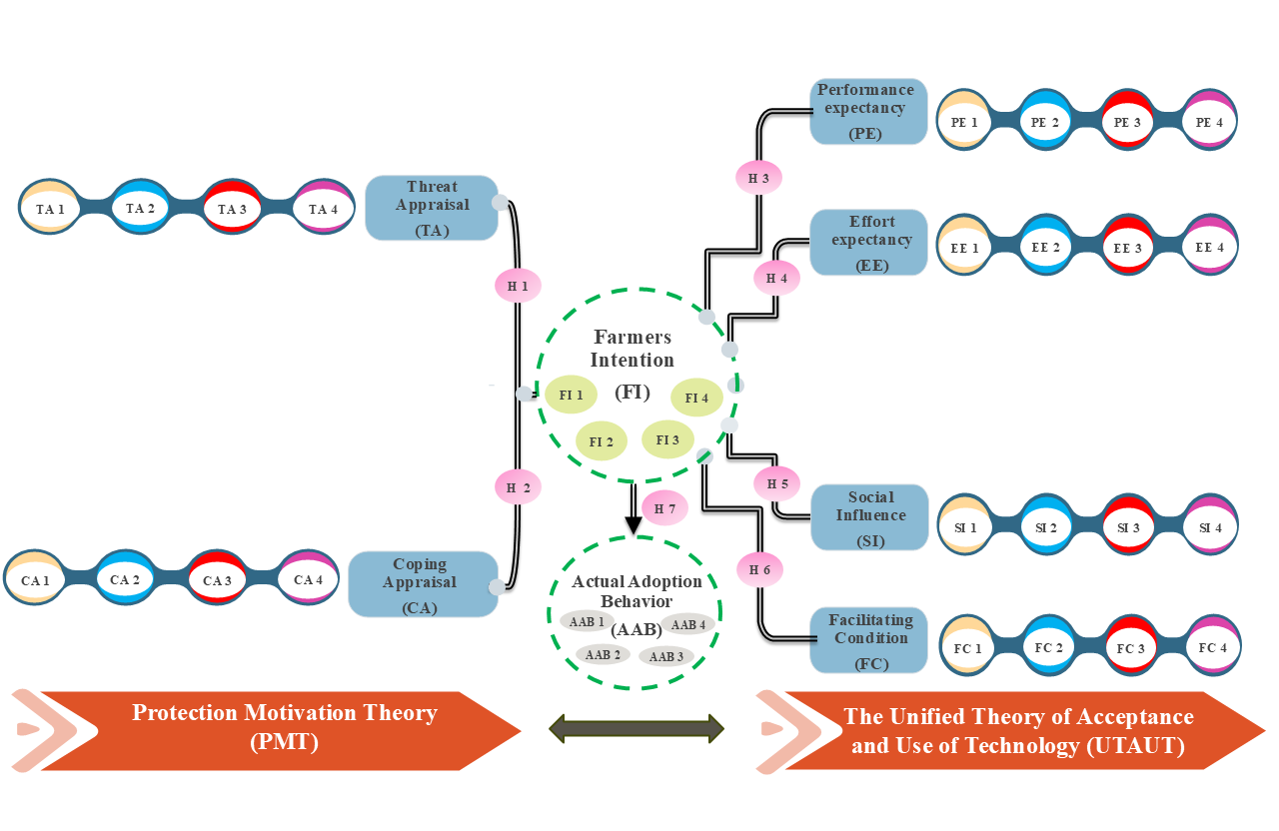Figure 1. Integrated conceptual framework for farmers’ adoption of neem-based bio pesticides
3. RESEARCH METHODOLOGY
The study was conducted in Tamil Nadu, India, where diverse agro-ecological zones and intensive cultivation make pest management a critical issue. A multistage sampling technique was employed. In the first stage, nine districts with relatively higher pesticide consumption and intensive cropping were purposively selected such as Madurai, Dindigul, Theni, Virudhunagar, Tirunelveli, Thoothukudi, Sivagangai, Tenkasi and Ramanathapuram. In the second stage, one block from each district was selected based on cropping intensity, pest vulnerability and the presence of active farmer communities. At the final stage, two representative villages from each block were chosen, resulting in a total of 18 villages. Within each village, farm households were selected using simple random sampling, yielding a total sample of 450 farmers. A structured questionnaire, based on Protection Motivation Theory (PMT) and the Unified Theory of Acceptance and Use of Technology (UTAUT), measured variables such as threat appraisal, coping appraisal, performance expectancy, effort expectancy, social influence, facilitating conditions and behavioural intention using a five-point Likert scale. The instrument was pre-tested with 30 farmers for clarity and contextual relevance and data were collected through face-to-face interviews. Analysis was conducted using Partial Least Squares Structural Equation Modeling (PLS-SEM) in SmartPLS 4.0, with measurement reliability and validity assessed through Cronbach’s alpha, composite reliability, average variance extracted (AVE) and discriminant validity (Fornell-Larcker and HTMT). Structural relationships were tested using bootstrapping with 5,000 resamples and the sample size was considered adequate under the “10-times rule” for SEM.
4. RESULTS
4.1. Measurement model evaluation
The measurement model demonstrated satisfactory reliability and validity. Cronbach’s alpha and composite reliability (ρc) values exceeded 0.70 and AVE values were above 0.50, confirming internal consistency and convergent validity, while all item loadings surpassed 0.70 (Table 1, Table 2). Discriminant validity was established as the square root of AVE values exceeded inter-construct correlations and all HTMT ratios were below 0.90 (Table 3, Table 4). CFA results also indicated a good model fit (Table 5) (χ²/df = 2.45, CFI = 0.927, TLI = 0.965, GFI = 0.912, NFI = 0.939, RMSEA = 0.055, RMR = 0.060), thereby confirming that the constructs were reliable, valid and suitable for subsequent structural analysis.
Table 1. Reliability and convergent validity statistics for the measurement model constructs
 | Cronbach's alpha | Composite reliability (rho_a) | Composite reliability (rho_c) | Average variance extracted (AVE)
AAB | 0.857 | 0.870 | 0.903 | 0.700
CA | 0.915 | 0.916 | 0.940 | 0.797
EE | 0.956 | 0.959 | 0.968 | 0.883
FC | 0.900 | 0.927 | 0.930 | 0.769
FI | 0.920 | 0.920 | 0.943 | 0.806
PE | 0.926 | -0.123 | 0.852 | 0.600
SI | 0.868 | 0.908 | 0.908 | 0.713
TA | 0.851 | 0.855 | 0.900 | 0.694
Table 2. Indicator loadings and item reliability for the measurement model constructs
 | AAB | CA | EE | FC | FI | PE | SI | TA
AAB1 | 0.822
AAB2 | 0.811
AAB3 | 0.874
AAB4 | 0.837
CA1 |  | 0.889
CA2 |  | 0.882
CA3 |  | 0.893
CA4 |  | 0.907
EE1 |  |  | 0.945
EE2 |  |  | 0.952
EE3 |  |  | 0.934
EE4 |  |  | 0.928
FC1 |  |  |  | 0.902
FC2 |  |  |  | 0.908
FC3 |  |  |  | 0.822
FC4 |  |  |  | 0.873
FI1 |  |  |  |  | 0.894
FI2 |  |  |  |  | 0.893
FI3 |  |  |  |  | 0.907
FI4 |  |  |  |  | 0.897
PE1 |  |  |  |  |  | 0.812
PE2 |  |  |  |  |  | 0.868
PE3 |  |  |  |  |  | 0.965
PE4 |  |  |  |  |  | 0.885
SI1 |  |  |  |  |  |  | 0.861
SI2 |  |  |  |  |  |  | 0.844
SI3 |  |  |  |  |  |  | 0.902
SI4 |  |  |  |  |  |  | 0.766
TA1 |  |  |  |  |  |  |  | 0.875
TA2 |  |  |  |  |  |  |  | 0.873
TA3 |  |  |  |  |  |  |  | 0.742
TA4 |  |  |  |  |  |  |  | 0.835

Table 3. Fornell-Larcker criterion results confirming discriminant validity of the constructs in the neem-based bio pesticide adoption model
 | AAB | CA | EE | FC | FI | PE | SI | TA
AAB
CA | 0.435
EE | 0.069 | 0.227
FC | 0.117 | 0.302 | 0.267
FI | 0.355 | 0.595 | 0.418 | 0.166
PE | 0.177 | 0.195 | 0.431 | 0.219 | 0.063
SI | 0.119 | 0.333 | 0.239 | 0.243 | 0.121 | 0.078
TA | 0.151 | 0.301 | 0.265 | 0.339 | 0.371 | 0.352 | 0.222
Table 4. HTMT ratio of correlations demonstrating discriminant validity among latent constructs in the integrated Protection Motivation-UTAUT framework
 | AAB | CA | EE | FC | FI | PE | SI | TA
AAB | 0.836
CA | 0.387 | 0.893
EE | -0.034 | 0.211 | 0.940
FC | -0.107 | -0.267 | -0.251 | 0.877
FI | 0.319 | 0.546 | -0.394 | 0.155 | 0.898
PE | -0.125 | -0.209 | 0.408 | 0.168 | -0.107 | 0.775
SI | -0.031 | 0.298 | 0.215 | -0.169 | 0.083 | 0.008 | 0.845
TA | -0.126 | -0.265 | -0.245 | 0.295 | 0.330 | 0.160 | -0.178 | 0.833
Table 5. Goodness-of-fit indices of the CFA model
Fit Index Category | Fit Statistic | Obtained Value | Threshold | Reference | Assessment
Absolute Fit Measure | TLI | 0.951 | ≥ 0.90 | Bentler (1990) | Accepted
Absolute Fit Measure | RMSEA | 0.061 | ≤ 0.08 | Hu and Bentler (1999) | Accepted
Incremental Fit Indices | NFI | 0.921 | ≥ 0.90 | Hair et al. (2010) | Accepted
Incremental Fit Indices | GFI | 0.905 | ≥ 0.90 | Hair et al. (2010) | Accepted
Incremental Fit Indices | CFI | 0.936 | ≥ 0.90 | Bentler (1990) | Accepted
Incremental Fit Indices | RMR | 0.057 | ≤ 0.08 | Hu and Bentler (1999) | Accepted
Chi-Square Fit | χ² / df | 2.62 | ≤ 3.00 | Wheaton et al. (1977) | Accepted

4.2. Structural model evaluation
The structural model showed strong explanatory power, with R² values of 0.775 for adoption intention (FI) and 0.620 for actual adoption behaviour (AAB), indicating that the integrated PMT–UTAUT framework effectively captured farmers’ decision-making. Effect size (f²) analysis revealed that coping appraisal (CA) had a substantial impact on intention (f² = 0.482), threat appraisal (TA) and intention on behaviour (FI → AAB) had medium effects (f² = 0.168 and 0.165), performance expectancy (PE) and facilitating conditions (FC) had small effects (f² = 0.046 and 0.032), efficacy expectation (EE) had a medium negative effect (f² = 0.120) and social influence (SI) was trivial (f² = 0.006). Path coefficient analysis confirmed these patterns: CA strongly predicted intention (β = 0.817, p < 0.001), followed by TA (β = 0.354, p < 0.001), PE (β = 0.213, p < 0.05) and FC (β = 0.102, p < 0.05), while EE negatively influenced intention (β = –0.548, p < 0.001) and SI was non-significant (β = 0.035, p > 0.05). FI significantly predicted AAB (β = 0.319, p < 0.001), highlighting its mediating role. Detailed path coefficients, effect sizes and explanatory power for all constructs are presented in Table 6, demonstrating that cognitive appraisals and perceived benefits are key drivers of neem-based bio pesticide adoption, whereas social pressures have minimal influence in this context. Structural relationships were assessed via SmartPLS 4 (Figure 2).
Table 6. Path coefficients, effect sizes (f²) and explanatory power (R²) of the structural model for neem-based bio pesticide adoption
Predictor → Endogenous Construct | β (Path Coefficient) | t-value | p-value | f² (Effect Size) | Results
Coping Appraisal (CA) → FI | 0.817 | 15.526 | 0.000 | 0.482 | Substantial
Threat Appraisal (TA) → FI | 0.354 | 6.084 | 0.000 | 0.168 | Medium
Performance Expectancy (PE) → FI | 0.213 | 2.354 | 0.029 | 0.046 | Small
Facilitating Conditions (FC) → FI | 0.102 | 2.179 | 0.000 | 0.032 | Small
Efficacy Expectancy (EE) → FI | –0.548 | 5.931 | 0.019 | 0.120 | Medium
Social Influence (SI) → FI | 0.035 | 0.872 | 0.383 | 0.006 | Trivial
Adoption Intention (FI) → AAB | 0.319 | 4.240 | 0.000 | 0.165 | Medium
Model explanatory power (R²):
- Adoption Intention (FI) = 0.775
- Actual Adoption Behaviour (AAB) = 0.620
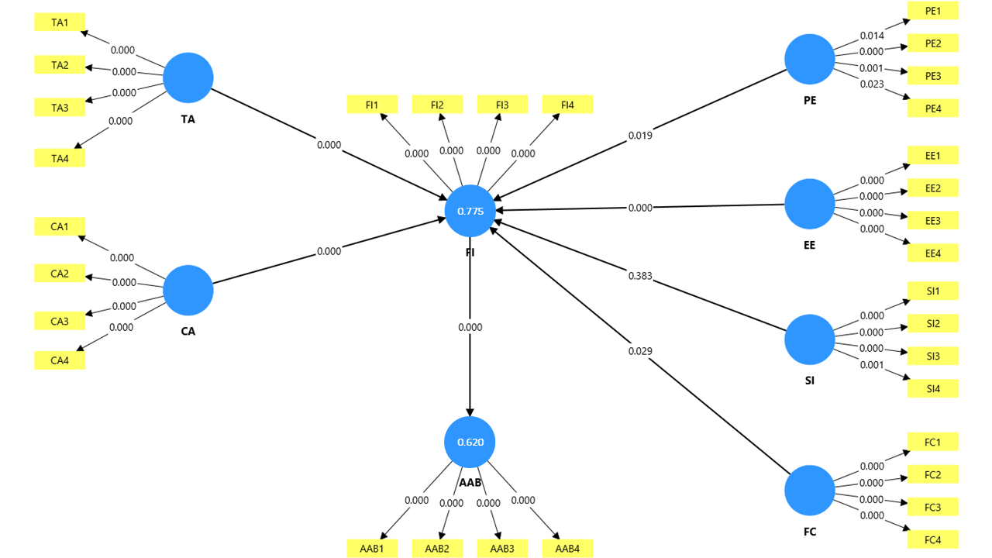
Figure 2. Structural model results of neem-based bio pesticide adoption showing standardized path coefficients and significance levels (Smart -PLS 4 output).
5. DISCUSSION
The results demonstrated that coping appraisal, performance expectancy and facilitating conditions significantly and positively influenced farmers’ intention and actual adoption, while effort expectancy exhibited a negative influence. Social influence was found to be non-significant. These findings collectively highlight that farmers’ adoption of eco-friendly pest control technologies is strongly determined by perceived efficacy, ease of use and resource support rather than external social pressure.
The strong and significant effect of coping appraisal (β = 0.817) on behavioural intention suggests that farmers’ confidence in their ability to effectively use neem-based bio pesticides is central to adoption. This finding aligns with the core tenet of Protection Motivation Theory, which emphasizes that individuals with higher self-efficacy and response efficacy are more likely to adopt protective behaviours (Floyd et al., 2000; Rogers, 1983). Therefore, strengthening farmers’ self-efficacy through field demonstrations and experiential learning can substantially enhance bio pesticide adoption rates.
Performance expectancy had a positive and significant relationship with intention (β = 0.254), indicating that farmers adopt neem-based bio pesticides when they perceive tangible benefits such as pest control efficiency, improved crop quality and reduced environmental harm. When farmers recognize the superior long-term benefits of neem-based formulations compared to synthetic pesticides such as reduced pest resurgence and lower input costs they are more inclined to use them consistently.
Interestingly, effort expectancy exhibited a negative effect (β = - 0.548) on intention, suggesting that the perceived difficulty or labour intensiveness of preparing or applying neem-based bio pesticides discourages adoption. This aligns with earlier findings by (Narayanan et al., 2021), who reported that farmers often perceive neem-based formulations as cumbersome due to the need for frequent applications and difficulties in handling homemade extracts. In behavioural terms, a high level of perceived effort reduces behavioural intention, as posited by UTAUT (Venkatesh et al., 2003). Therefore, simplifying product formulation and providing user-friendly commercial bio pesticides could reduce this psychological barrier.
Facilitating conditions were also found to significantly influence adoption behaviour, indicating that access to technical guidance, input supply and institutional support encourages farmers to implement neem-based pest management. This finding resonates with previous research highlighting that infrastructural and extension support are essential for technology diffusion in rural areas (Kumar et al., 2021). When farmers have access to reliable input dealers, timely product availability and practical demonstrations, they are more likely to sustain bio pesticide use over time.
The non-significant influence of social factors indicates that peer or community pressure played a limited role in farmers’ decision-making regarding neem-based bio pesticides. This is contrary to some earlier studies (Graf-Vlachy et al., 2018) where social norms significantly influenced adoption of climate-smart or organic practices. One plausible explanation is that neem-based bio pesticide adoption is still viewed as an individual and experimental practice rather than a community-level norm in Tamil Nadu. As such, farmers’ personal attitudes and perceived control weigh more heavily than collective influence.
The structural model explained (77.50%) of the variance in behavioural intention and (62.00%) in actual adoption, which indicates strong predictive power and model robustness. These results are comparable to those obtained in recent agricultural behavioural studies using PLS-SEM (Borges & Oude 2016). The high explanatory power underscores the suitability of integrating PMT and UTAUT in understanding farmers’ sustainable technology adoption.
Overall, the findings reinforce the importance of psychological readiness, perceived benefits and institutional support in promoting eco-friendly pest control. By enhancing farmers’ self-efficacy, providing hands-on training and ensuring availability of standardized neem-based products, policymakers can significantly improve adoption rates. Future initiatives should also integrate behavioural insights into extension programmes and promote farmer-to-farmer diffusion to normalize the use of neem-based bio pesticides within farming communities.
6. CONCLUSION
This study investigated farmers’ adoption of neem-based bio pesticides using an integrated PMT-UTAUT framework. Findings indicate that coping appraisal, threat appraisal and performance expectancy are key drivers of adoption intention, with facilitating conditions providing additional support, while efficacy doubts negatively influence intention and social influence is negligible. Adoption intention strongly mediates actual behaviour, linking motivational and contextual factors to practice. The study validates the integration of behavioural and technology adoption models for sustainable agriculture and emphasizes the practical importance of institutional support, input access and incentives. Neem-based bio pesticides emerge as a viable eco-friendly innovation, offering a pathway to reduce chemical dependency and enhance resilience in farming systems.
7. RECOMMENDATIONS
To promote the adoption of neem-based bio pesticides among farmers, efforts should focus on enhancing farmers’ self-efficacy through hands-on training, field demonstrations and continuous extension support. Simplifying and standardizing neem formulations into ready-to-use products will reduce perceived effort and improve user convenience. Strengthening institutional and market linkages can ensure timely availability of quality bio pesticides through local cooperatives and agri-entrepreneurs. Awareness campaigns and community-based demonstrations should be organized to foster positive attitudes and peer learning. Policymakers should integrate bio pesticide promotion into sustainable agriculture schemes by providing incentives, certification support and quality regulation. Further, research institutions should focus on developing more efficient, long-lasting neem formulations and assessing their field-level performance under diverse cropping systems. These combined efforts can accelerate the transition toward eco-friendly pest management and sustainable agricultural practices in Tamil Nadu.
Disclaimer (Artificial Intelligence)
The author(s) hereby declare that no generative AI technologies, including Large Language Models (e.g., ChatGPT, Copilot) or text-to-image generators, were used in the writing, editing, or preparation of this manuscript.
Acknowledgments
The authors sincerely thank Tamil Nadu Agricultural University (TNAU) and the Directorate of Open and Distance Learning (DODL), TNAU, Coimbatore, for their institutional support. Special appreciation is extended to Coromandel International Limited for funding and collaboration. The authors also gratefully acknowledge the farmers whose participation and insights into neem-based biopesticide adoption greatly enriched the study.
Conflict of Interest
The authors declare no conflict of interest regarding the conduct or reporting of this study.
Funding
This research was financially supported by Coromandel International Limited in collaboration with the Directorate of Open and Distance Learning, TNAU, Coimbatore. The funding agency had no role in data collection, analysis, interpretation, or publication decisions.

References
Bentler, P. M. (1990). Comparative fit indexes in structural models. Psychological bulletin, 107(2), 238.
Borges, J. A. R., & Oude Lansink, A. G. (2016). Identifying psychological factors that determine cattle farmers' intention to use improved natural grassland. Journal of Environmental Psychology, 45, 89-96. https://doi.org/10.1016/j.jenvp.2015.12.001
Floyd, D. L., Prentice‐Dunn, S., & Rogers, R. W. (2000). A meta‐analysis of research on protection motivation theory. Journal of applied social psychology, 30(2), 407-429. https://doi.org/10.1111/j.1559-1816.2000.tb02323.x
Graf-Vlachy, L., Buhtz, K., & König, A. (2018). Social influence in technology adoption: taking stock and moving forward. Management Review Quarterly, 68(1), 37-76. https://doi.org/10.1007/s11301-017-0133-3
Hair JR, J. F., Black, W. C., Babin, B. J., & Anderson, R. E. (2010). Multivariate Data Analysis (7th Ed.). Upper Saddle River, NJ: Pearson Prentice Hall.
Hu, L. T., & Bentler, P. M. (1998). Fit indices in covariance structure modeling: Sensitivity to underparameterized model misspecification. Psychological methods, 3(4), 424.
Isman, M. B. (2023). Commercialization and regulation of botanical bio pesticides: a global perspective. Development and commercialization of bio pesticides (pp. 25-36). Academic Press. https://doi.org/10.1016/B978-0-323-95290-3.00001-7
Kumar, J., Ramlal, A., Mallick, D., & Mishra, V. (2021). An overview of some bio pesticides and their importance in plant protection for commercial acceptance. Plants, 10(6), 1185. https://doi.org/10.3390/plants10061185
Narayanan, M., Kandasamy, S., He, Z., & Kumarasamy, S. (2022). Ecological impacts of pesticides on soil and water ecosystems and its natural degradation process. Pesticides in the natural environment (pp. 23-49). Elsevier. https://doi.org/10.1016/B978-0-323-90489-6.00002-1
Popp, J., Pető, K., & Nagy, J. (2013). Pesticide productivity and food security. A review. Agronomy for sustainable development, 33(1), 243-255. https://doi.org/10.1007/s13593-012-0105-x
Reddy, D. S., & Chowdary, N. M. (2021). Botanical biopesticide combination concept-a viable option for pest management in organic farming. Egyptian Journal of Biological Pest Control, 31(1), 1-10. https://doi.org/10.1186/s41938-021-00366-w
Rogers, E. M., & Williams, D. (1983). Diffusion of. Innovations (Glencoe, IL: The Free Press, 1962).
Rogers, R. W. (1975). A protection motivation theory of fear appeals and attitude change1. The journal of psychology, 91(1), 93-114. https://doi.org/10.1080/00223980.1975.9915803
Tudi, M., Daniel Ruan, H., Wang, L., Lyu, J., Sadler, R., Connell, D., & Phung, D. T. (2021). Agriculture development, pesticide application and its impact on the environment. International journal of environmental research and public health, 18(3), 1112. https://doi.org/10.3390/ijerph18031112
Venkatesh, V., Morris, M. G., Davis, G. B., & Davis, F. D. (2003). User acceptance of information technology: Toward a unified view. MIS quarterly, 425-478. https://doi.org/10.2307/30036540
Wheaton, B., Muthen, B., Alwin, D. F., & summers, G. F. (1977). Assessing reliability and stability in panel models. Sociological methodology, 8, 84-136. https://doi.org/10.2307/270754
Wyckhuys KA, Tang FH, Hadi BA. Pest management science often disregards farming system complexities. Communications Earth & Environment. 2023 Jun 22; 4(1):223. https://doi.org/10.1038/s43247-023-00894-3

