Original Research Article

Mapping Boundary-Layer Features in Unidentified Anomalous Phenomena (UAP): A Quantitative and Thematic Approach to Observational Signatures and Theoretical Models

.
ABSTRACT

Unidentified anomalous phenomena (UAP) are often reported with characteristics that challenge conventional understandings of aerodynamics and propulsion. Observations describe luminous halos, pane-like laminar shells, abrupt trans-medium transitions, localized cloaking effects, and the suppression of wakes or sonic booms. Although these features have been explored separately across plasma physics, optics, propulsion, and observational studies, they have not been systematically compared to identify shared boundary-layer signatures or theoretical linkages. This study applies a structured analytical framework to a multidisciplinary reference corpus, organizing works into nine thematic categories spanning plasma and atmospheric research, metamaterials, propulsion models, and field observations. Each reference was coded for five recurring boundary-layer signatures, halos or filaments, pane-like shells, trans-medium transitions, localized cloaking, and symmetric axial emissions, and scored on a 1–5 scale for both boundary-layer relevance and resonance-based theoretical connection. The analysis revealed two major clusters: empirical feeders, including plasma, atmospheric, and observational studies that document recurring luminous and trans-medium features with limited theoretical context; and theoretical engines, including metamaterials, optics, and propulsion models that propose explicit mechanisms capable of generating these effects. Studies in gravitational lensing and transformation optics served as conceptual bridges linking observation and theory. By integrating these clusters, the analysis establishes a coherent framework for understanding how boundary-layer phenomena recur across diverse literatures. Beyond theoretical synthesis, this structured approach offers a foundation for designing targeted experiments and guiding future research into resonance-based mobility and energy-control technologies.

Keywords: Boundary-layer phenomena, Unidentified anomalous phenomena (UAP), Thematic analysis, Transformation optics and cloaking, Plasma and trans-medium dynamics

1. INTRODUCTION

Unidentified anomalous phenomena (UAP) continue to present challenges to both conventional physics and aerospace engineering. Numerous observational reports describe luminous objects that exhibit characteristics inconsistent with aerodynamic expectations, such as persistent halos, drag-free acceleration, sudden trans-medium transitions, and wake suppression (Stenhoff, 1999; Abrahamson and Dinniss, 2000; Zhilyaev et al., 2022a and b; Knuth et al., 2019, 2025). Plasma and atmospheric studies have long established that halos, filaments, and coronae can be produced under natural conditions (Surkov and Hayakawa, 2020; Teodorani, 2004, 2024), yet these phenomena often lack the structural coherence and kinematic performance repeatedly observed in UAP. Such inconsistencies highlight the need for models that can incorporate plasma-like luminous features while simultaneously accounting for the boundary-layer suppression of turbulence and inertial decoupling.

Optical and gravitational studies provide further parallels. Transformation optics and metamaterials have demonstrated the ability to bend and cloak light through engineered field interactions (Leonhardt, 2006; Pendry et al., 2006; Greenleaf et al., 2007; Nassar et al., 2020; Peralta et al., 2020; Gupta and Beckwith, 2025). Cosmological analyses have also shown that scalar fields and modified gravity models can alter gravitational lensing without invoking additional matter (Bekenstein and Sanders, 1993; Wyman, 2011; Schneider et al., 2024; Berghaus et al., 2024; Vegetti et al., 2024; Tizfahm et al., 2025). These results suggest that light manipulation and local refractive control are not confined to exotic speculation but can be realized both theoretically and experimentally. Such findings resonate with UAP reports of localized cloaking and sudden shifts in visibility (Watters et al., 2023; Knuth et al., 2025; Ailleris, et al., 2025). Together, they provide a bridge between laboratory demonstrations and observational evidence of refractive boundary layers.

Propulsion studies extend this bridge into the domain of mechanics and mobility. Models proposing that inertia arises from interactions with the quantum vacuum or zero-point fields (Holt, 1979; Puthoff, 1987; Haisch et al., 1994; Valone, 2012) or can be modified by pulsed electromagnetic fields (Meessen, 2012a and b; Aquino, 2010, 2012, 2016, 2021; Gobbi, 2021) directly address the possibility of motion without conventional reaction mass. Observational reconstructions of UAP flight (Knuth et al., 2019; Minami, 2022, 2023; Loeb and Kirkpatrick, 2023) reveal accelerations and g-loads far beyond human or structural tolerances under classical mechanics, yet without evidence of shockwaves or thermal loading. These findings suggest that some form of resonant field coupling may suppress both drag and inertia, enabling extraordinary kinematics. While these studies propose intriguing mechanisms for inertial modification, such models remain theoretical and have not been empirically validated.

The proposed Scalar Resonant Mobility Systems (SRMS) framework, a speculative model under development, seeks to formalize how scalar-field resonance might hypothetically modulate boundary-layer conditions. The (SRMS) theory remains conceptual (Morgan, unpublished research) but proposes to advance this model by formalizing resonance with scalar fields as a tunable mechanism for boundary-layer modulation and inertia suppression (see Hall and Covington, 2025). Unlike earlier speculative propulsion concepts (Holt, 1979; Puthoff, 1987; Haisch et al., 1994; Meessen, 2012b), SRMS theory proposes that laminar sheaths, refractive cloaks, and inertia-free acceleration are all manifestations of resonance thresholds within scalar-indexed field structures. This could provide a unified explanation for the empirical features catalogued across plasma studies, optics research, and propulsion models.

The present study builds on this theoretical and empirical convergence of evidence by systematically coding and analysing references from across nine thematic domains, with a focus on mapping boundary-layer signatures and SRMS theory linkages. Using a purpose-built Excel analysis tool, references were annotated for the presence of halos, laminar shells, trans-medium transitions, cloaking, and axial emissions, and then scored on their relevance to both boundary-layer evidence and SRMS theory. The aim of this study is to systematically integrate observational boundary-layer evidence with theoretical models of scalar resonance to evaluate the plausibility of Scalar Resonant Mobility Systems (SRMS) theory as a unified framework for UAP mobility. Specifically, the study pursues three objectives:

- Thematic Classification: To organize a broad multidisciplinary reference corpus into nine categories spanning plasma physics, optics, propulsion, observational data, and sociocultural analyses, thereby establishing a structured foundation for comparison.
- Signature Mapping: To identify the recurrence of five boundary-layer features, halos/filaments, pane-like laminar shells, trans-medium transitions, localized cloaking, and symmetric axial emissions, across these themes, using binary coding and aggregated dashboards to quantify their distribution.
- Resonance Linkage Scoring: To assign each reference a graded score (1–5) for boundary-layer relevance and SRMS theory resonance linkage, enabling the detection of clusters that serve as empirical feeders (strong boundary evidence, weak SRMS linkage) and theoretical engines (strong SRMS linkage, high boundary integration).

By meeting these objectives, the study establishes both the empirical grounding and the theoretical coherence of SRMS. The results demonstrate how disparate strands of evidence converge into a unified model of laminar boundary modulation and scalar-field resonance, advancing the case for resonance-driven mobility as a viable explanation of UAP phenomena.

2. material and methods

Before any structured coding or dashboard construction, a comprehensive corpus of references spanning multiple disciplines relevant to UAP research was established (Appendix A). This was essential because the literature does not fall neatly within a single field; instead, it ranges from plasma physics and atmospheric sciences to optics, propulsion theory, materials science, statistics, and even cultural studies. To avoid disciplinary silos, every citation in the master reference list was read in context and using artificial intelligence assigned a primary theme based on content, method, and relevance. In cases where a paper covered multiple areas, the assignment prioritized the theme in which its contribution was most substantive. The outcome of this classification was a nine-category thematic framework (Table 1). This framework served as the backbone of the analysis: it not only grouped references for easier comparison but also created the structure of the workbook itself, where each theme became a dedicated worksheet.

All references analysed in this study were drawn from a structured master corpus covering these nine thematic categories. Each entry was coded and scored as described above. The complete list of references included in the thematic coding and quantitative analysis is provided in Appendix A. Artificial intelligence was used to assist in the analysis, compiling, organising and editing of the paper.

2.1 Table Construction and Analytical Narratives

Once grouped thematically, each reference was systematically documented in a structured table. The purpose of these tables was not only bibliographic organization but critical annotation: rather than listing citations, each entry contained narrative fields linking the study’s content to boundary-layer dynamics and SRMS theory. This approach transformed the tables into analytical tools, capturing both descriptive and interpretive layers of information.

Each row contained four columns: (1) the citation string, (2) a multi-sentence “About” summary describing methods, findings, and context, (3) an explanation of how the work related to boundary-layer effects such as halos, laminar shells, or turbulence suppression, and (4) an analysis of its relationship to SRMS theoretical concepts. For example, optical cloaking papers were discussed both as demonstrations of field-guided light manipulation (boundary-layer relevance) and as prototypes of resonance-driven invisibility (SRMS relevance). This dual annotation ensured each reference could be considered both phenomenologically and theoretically.

Table 1. Thematic categories used in reference classification.

Theme ID | Category Description
1 | Plasma, Ball Lightning, and Atmospheric Luminous Phenomena
2 | Gravitational Lensing, Modified Gravity, and Optical Scalars
3 | Transformation Optics, Cloaking, and Metamaterials
4 | Propulsion, Field Drives, and Inertia/Gravity Couplings
5 | Observational Field Studies, Instrumentation, and Data
6 | Statistics, Reporting Dynamics, and Catalogues
7 | History, Policy, Culture, and Safety
8 | General Overviews, Handbooks, and Guidance
9 | Additional Thematic Fits

2.2 Workbook Architecture

The decision to implement the analysis in Excel was motivated by its interactivity and accessibility. Instead of a static document, the workbook functions as a tool that can be filtered, cross-referenced, and expanded by different users. The architecture was carefully designed to maintain consistency across the nine themes while providing flexibility for exploration. The process involved:

- Creating one worksheet per theme populated with the four-column analytical tables.
- Building a Master sheet that aggregated all references in a single searchable list.
- Adding a hyperlink system for navigation: users can move from Master to any theme sheet and return.
- Formatting all sheets as Excel Tables with filterable headers, consistent column widths, and word wrapping for clarity.
- Enriching the Master sheet with a keyword column to allow quick searching by concepts such as “plasma,” “lensing,” or “resonance.”

This design allowed the workbook to function simultaneously as a database, a literature review, and an analysis platform.

2.3 Signature Mapping

A key innovation was the creation of a Signature Map worksheet to track how often specific boundary-layer features appeared in the literature. The rationale was that repeated mention of certain signatures across unrelated fields could indicate convergent evidence for real physical mechanisms. Five features were chosen based on consistent appearance in UAP reports and theoretical importance (Table 2). Each reference was coded “Yes” or “No” in these columns. Conditional formatting highlighted the results (green for Yes, red for No), instantly turning the sheet into a visual heatmap of evidence.

Table 2. Boundary-layer signatures coded for each reference.

Signature | Definition | Example of “Yes” coding
Halos/Filaments | Luminous halos, coronae, or filaments | Plasma/ball lightning studies
Pane-like Laminar Shells | Layered sheaths suppressing turbulence | Cloaking/metamaterials optics
Trans-medium (No Wake) | Entry/exit without splash, wake, or boom | High-speed propulsion studies
Localized Lensing/Cloaking | Refractive warping, invisibility, optical suppression | Transformation optics papers
Symmetric Axial Emissions | Polar-aligned emissions | Pulsed EM propulsion concepts

2.4 Thematic Dashboard and Scoring

The Dashboard sheet transformed the binary codes into aggregated statistics. By using COUNTIFS, the workbook produced a Theme × Signature matrix showing how many references in each theme addressed each boundary-layer feature. This matrix was essential for identifying thematic strengths and gaps. For example, plasma studies overwhelmingly populated the “Halos/Filaments” column, while optics studies dominated “Localized Lensing/Cloaking.” Row totals allowed cross-theme comparisons, while column totals showed which signatures were most frequent overall. A bar chart was generated automatically, presenting these distributions visually.

To move beyond binary classification, a scoring system was introduced. The purpose was to grade the strength of evidence for both boundary-layer dynamics and SRMS theory concepts. Each reference was given two scores on a 1–5 scale. The scoring rubric (Table 3) was designed to capture both directness and quality of linkage.

Scores were pre-populated using expert judgment from the expanded tables. For example, Hall and Covington (2025) scored 5/5, while Tajmar et al. (2024) scored 1/1. Heatmaps in Excel highlighted high scores in green and low scores in red. The Dashboard Scoring sheet allowed meta-analysis of the scoring data. Its design provided multiple perspectives:
- Theme-level averages for Boundary and SRMS, highlighting which themes were most strongly linked.
- Δ (SRMS − Boundary) values, showing whether a theme leaned more toward SRMS theory or boundary-layer phenomena.
- Weighted averages, enabling users to adjust emphasis between Boundary and SRMS with editable weight cells (default 1:1).
- A 5 × 5 co-occurrence matrix showing how many references fell into each pair of scores.

Conditional formatting highlighted dense clusters in green. For example, many plasma references clustered around Boundary = 3, SRMS = 2–3, while metamaterial papers clustered in Boundary = 4, SRMS = 4–5.

Table 3. Scoring rubric for Boundary vs SRMS link strength.

Score | Boundary Definition | SRMS Definition
5 | Direct and central evidence (pane-layer suppression, trans-medium transitions) | Direct resonance model (Unified Scalar Resonance, SRMS related papers)
4 | Strong conceptual link (cloaking, inertia-suppression analogies) | Strong support (cloaking, field drives, metamaterials)
3 | Indirect or moderate link (performance analyses, anomalies) | Indirect link (general propulsion, EM–gravity work)
2 | Weak link (plasma halos, atmospheric analogies) | Weak link (non-resonant plasma models)
1 | Minimal/no link (policy, null results, history) | Minimal/no link (non-resonant, sociological work)

2.5 Pre-population of Data

To make the workbook immediately usable, all Yes/No codes and scores were pre-assigned based on the analytical tables. This ensured the dashboards displayed meaningful results without requiring manual input. The defaults reflected expert judgment:

- Plasma studies were coded Yes for Halos, scored Boundary = 2–3, SRMS = 2.
- Cloaking/metamaterials were coded Yes for Lensing, scored Boundary = 4, SRMS = 4–5.
- Policy and history references were coded No across all signatures, scored Boundary = 1, SRMS = 1–2.

Users can edit any coding or scoring, and the dashboards update dynamically. This combination of pre-population and interactivity transforms the workbook from a passive bibliography into an active analytical tool.

3. RESULTS

The structured thematic coding and quantitative scoring of the reference corpus revealed clear patterns in how boundary-layer signatures were distributed across disciplines and how strongly they related to resonance-based theoretical models. By aggregating binary signature coding and 1–5 scoring across all nine thematic categories, the analysis enabled both descriptive and comparative insights. The dashboards and visualizations highlighted which themes most frequently reported halos, laminar shells, trans-medium transitions, localized cloaking, and axial emissions, and how these signatures aligned with graded relevance to boundary-layer frameworks and scalar resonance concepts. Together, these results provided an integrated view of the literature, showing how empirical observations, optical and gravitational analogues, and theoretical propulsion models converged into distinct clusters that informed the Scalar Resonant Mobility Systems (SRMS) theoretical framework.

3.1 Distribution of References Across Themes

The first step of the analysis was to examine how the reference corpus was distributed across the nine thematic categories defined in the Methods. This distribution provided a landscape view of the literature, showing which areas were most heavily represented and which remained comparatively underdeveloped. Balance was important, because clustering of references in certain themes could bias the perception of which signatures were most credible, or which theoretical models were best supported. By quantifying the spread of references across themes, it was possible to assess both the coverage of the corpus and the relative weight of evidence brought by each domain.

The corpus showed clear asymmetries. Plasma and atmospheric studies (Theme 1) and propulsion-related papers (Theme 4) accounted for over a third of the total references, reflecting their long-standing roles in both observational documentation and theoretical speculation (Figure 1). Transformation optics/metamaterials (Theme 3) and gravitational lensing/modified gravity (Theme 2) also contributed large clusters, suggesting that optical and field-theoretical approaches are well developed. By contrast, sociocultural, historical, and general overview themes (Themes 7–8) contained fewer entries, emphasizing their contextual rather than technical role.

3.2 Boundary-Layer Signatures by Theme

After establishing the thematic distribution of references, the analysis turned to the Signature Map, which coded the presence or absence of five recurring boundary-layer features. This binary classification provided a structured way to assess how often specific UAP-like signatures appeared across diverse literature. The results were significant because they revealed convergent motifs: when independent fields repeatedly described similar features (e.g., halos or cloaking), the likelihood that these correspond to genuine physical processes increased (Figure 1). The aggregated Theme × Signature matrix showed how many references in each theme were coded “Yes” for each of the five boundary-layer features. The distribution highlighted both thematic emphases and gaps.

Halos/Filaments emerged as the most consistently reported, supported by 15 references, particularly in plasma studies (Theme 1), where they were an intrinsic feature of luminous discharges. Pane-like Laminar Shells were also common in Theme 1, reflecting their close association with plasma boundary structuring. Trans-medium (No Wake) transitions were strongly represented in propulsion studies (Theme 4), aligning with their diagnostic role in anomalous flight performance. Localized Lensing/Cloaking was highly represented in gravitational lensing (Theme 2) and transformation optics (Theme 3), demonstrating a convergence between astrophysical observations and engineered metamaterial analogues. Symmetric Axial Emissions appeared more sporadically, though when present, they were most clearly associated with propulsion and field-drive concepts (Theme 4).

Row totals revealed that certain themes, notably Plasma (Theme 1) and Propulsion (Theme 4), provided broad support across multiple signatures, while contextual domains such as History, Policy, and Safety (Theme 7) or Statistical Cataloguing (Theme 6) contributed little beyond framing. Column totals showed that localized cloaking and halos dominated the literature corpus, while axial emissions remained comparatively rare. Together, these findings confirmed that boundary-layer features were not distributed evenly but mapped strongly to thematic expertise, with some themes serving as signature-rich feeders and others acting more as contextual backdrops.

3.3 Quantitative Scoring Patterns

Beyond binary coding, references were assigned 1–5 scores for both Boundary and SRMS theory linkage. This provided a gradient view of strength of connection rather than a simple presence/absence. The significance of this analysis lies in its ability to identify not only where features appear, but how directly and strongly each reference supported boundary-layer or SRMS theoretical models.

Results showed that Boundary-Link Scores were strongest in Themes 1–3, reflecting their direct observation or modelling of halos, lensing, and cloaking (Table 4). Several references (e.g., Pendry et al. 2006, Leonhardt 2006) reached scores of 4–5. SRMS-Link Scores were highest in Themes 3 and 4, where resonance mobility, metamaterials, and propulsion intersect. Hall and Covington (2025) scored 5 for both, as an explicit resonance formulation. In contrast, history and policy studies consistently scored 1–2, contributing little to either boundary or SRMS theory. These scoring patterns highlighted that while much of the literature touched on anomalous phenomena, only a subset provided direct, high-strength evidence.

3.4 Δ (SRMS – Boundary) Trends
A further refinement was the calculation of Δ values, representing the difference between average SRMS theory and Boundary scores per theme. This analysis was critical because it identified thematic imbalances: some literature leans more heavily toward describing physical boundary-layer phenomena, while others lean toward theoretical resonance explanations. Understanding these imbalances helped clarify the complementary roles of different fields.
The Δ analysis, shown in Figure 2, highlighted clear differences between themes in how strongly they emphasize resonance-based (SRMS) theory compared to boundary-layer evidence. Theme 1 (Plasma, Ball Lightning, and Atmospheric Luminous Phenomena) carried a slightly negative Δ (–0.11), confirming that plasma studies remained boundary-heavy, grounded in luminous discharge and halo phenomena, with only limited extension into resonance-based interpretations. In contrast, Theme 4 (Propulsion, Field Drives, and Inertia/Gravity Couplings) showed a strongly positive Δ (+0.57), reflecting its emphasis on theoretical SRMS linkages, including propulsion concepts, inertia suppression, and resonance-driven field mechanics.

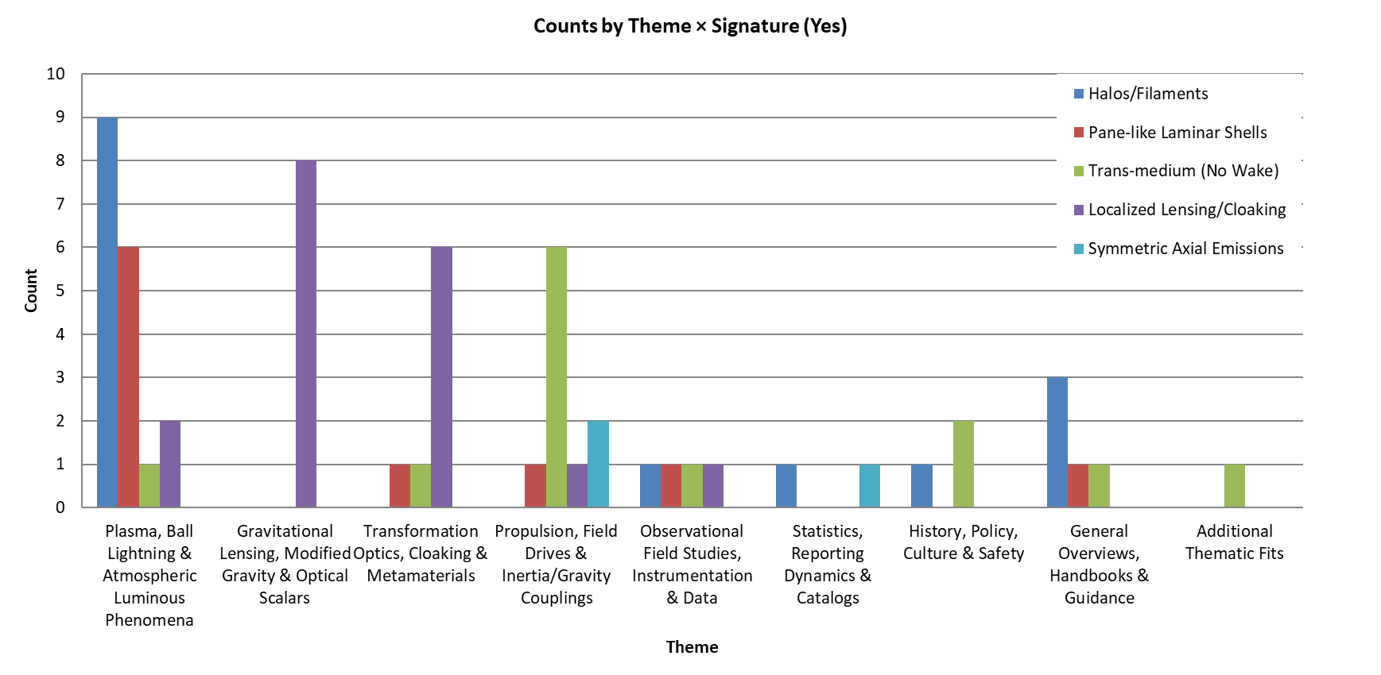

Figure 1. Theme by Signature distribution of boundary-layer features. Stacked bar chart showing the number of references coded “Yes” for five recurring boundary-layer signatures across thematic categories. Plasma and atmospheric studies contributed most reports of halos/filaments and pane-like shells, while gravitational lensing and transformation optics studies dominated localized cloaking/lensing. Propulsion-related works accounted for most trans-medium transitions and symmetric axial emissions. The distribution highlights how different research domains emphasize distinct aspects of UAP-related boundary-layer phenomena, providing complementary evidence streams for comparative analysis.

Intermediate domains showed more balanced relationships. Themes 2 (Gravitational Lensing, Modified Gravity, and Optical Scalars) and 3 (Transformation Optics, Cloaking, and Metamaterials) displayed moderately positive Δ values (+0.38 and +0.33, respectively), suggesting that while they remained grounded in some boundary-related evidence such as lensing distortions and cloaking analogues, they contributed more to resonance-based theoretical support. Theme 5 (Observational Field Studies, Instrumentation, and Data) also leaned slightly positive (+0.17), indicating that empirical reports and instrument datasets often contained implicit SRMS-relevant clues alongside their boundary observations.

By comparison, Theme 6 (Statistics, Reporting Dynamics, and Catalogues) was exactly balanced (Δ = 0.00), reflecting its neutral role in classification rather than theoretical or empirical emphasis. Theme 7 (History, Policy, Culture, and Safety) carried a modest positive Δ (+0.33), although these studies contributed little beyond contextual framing. Theme 8 (General Overviews, Handbooks, and Guidance) was strongly negative (–0.33), reinforcing that overviews tend to document established boundary-layer features rather than propose resonance frameworks. Finally, Theme 9 (Additional Thematic Fits) carried the highest positive Δ (+0.60), capturing eclectic studies that often speculated more heavily on resonance-related interpretations than on direct boundary evidence.

Overall, this Δ metric clarified the roles of different literatures: plasma studies functioned as empirical feeders anchored in boundary signatures; propulsion and additional thematic works served as theoretical engines with strong SRMS emphasis; lensing, optics, and observational reports bridged the two domains; and statistical or contextual themes remained peripheral.

3.5 Co-occurrence Matrix Results

The final layer of analysis came from the 5 × 5 Boundary vs SRMS co-occurrence matrix, which examined how often specific score combinations appeared (Figure 3). This two-dimensional view is important because it revealed whether strong boundary evidence tended to co-occur with strong SRMS theory evidence, reinforcing results for SRMS – boundary trends described previously, or whether the two are decoupled (see Table 3). Such clustering patterns can show whether the field is converging toward unified explanations or remaining fragmented.

The populated matrix showed two clear clusters (Figure 3). The first was a mid-range concentration spanning Boundary = 2–3 and SRMS = 2–3, dominated by plasma and atmospheric studies that documented halos and partial anomalies without strong resonance interpretation. The second cluster emerged at Boundary = 3–4 and SRMS = 3–4, populated mainly by optics, metamaterials, and propulsion papers that explicitly linked anomalous features to resonance mobility. Only isolated entries appeared in the extreme corners (e.g., Boundary = 5, SRMS = 1, or Boundary = 5, SRMS = 5), confirming that strong boundary evidence almost always coincided with at least moderate resonance relevance. This distribution suggested that the literature was bimodal: it divided between mid-strength empirical feeders and higher strength theoretical engines, with very few outliers.

Table 4. Mean Boundary and SRMS Linkage Scores by Theme. Summary of mean and median Boundary-Link and SRMS-Link scores by theme, showing how different domains vary in their empirical boundary evidence and theoretical resonance relevance.

Theme | References (n) | Mean Boundary | Median Boundary | Mean SRMS | Median SRMS | Notes
1. Plasma, Ball Lightning & Atmospheric Luminous Phenomena | 9 | 3.00 | 3 | 2.89 | 3 | Strongest in halos/filaments and laminar shells; weaker SRMS linkage
2. Gravitational Lensing, Modified Gravity & Optical Analogues | 8 | 3.00 | 3 | 3.38 | 3 | Balanced: consistent boundary and SRMS relevance
3. Transformation Optics, Cloaking & Metamaterials | 6 | 3.83 | 4 | 4.17 | 4 | Highest overall: strong in both boundary and SRMS
4. Propulsion, Field Drives & Inertia/Gravity Coupling | 7 | 2.86 | 3 | 3.43 | 4 | High SRMS linkage, consistent boundary connections
5. Observational Field Studies, Instrumentation & Datasets | 6 | 2.67 | 2.5 | 2.83 | 3 | Empirical feeders: strong boundary reporting, moderate SRMS
6. Statistics, Reporting Dynamics & Catalogues | 3 | 2.33 | 2 | 2.33 | 2 | Sparse data, low to mid scores
7. History, Policy, Culture & Safety | 6 | 1.83 | 1.5 | 2.17 | 2 | Consistently low (1–2), minor contextual support
8. General Overviews, Handbooks & Guidance | 3 | 2.67 | 2 | 2.33 | 2 | Background framing; limited theoretical linkage
9. Additional Thematic Fits | 5 | 2.20 | 2 | 2.80 | 3 | Mixed/ambiguous entries

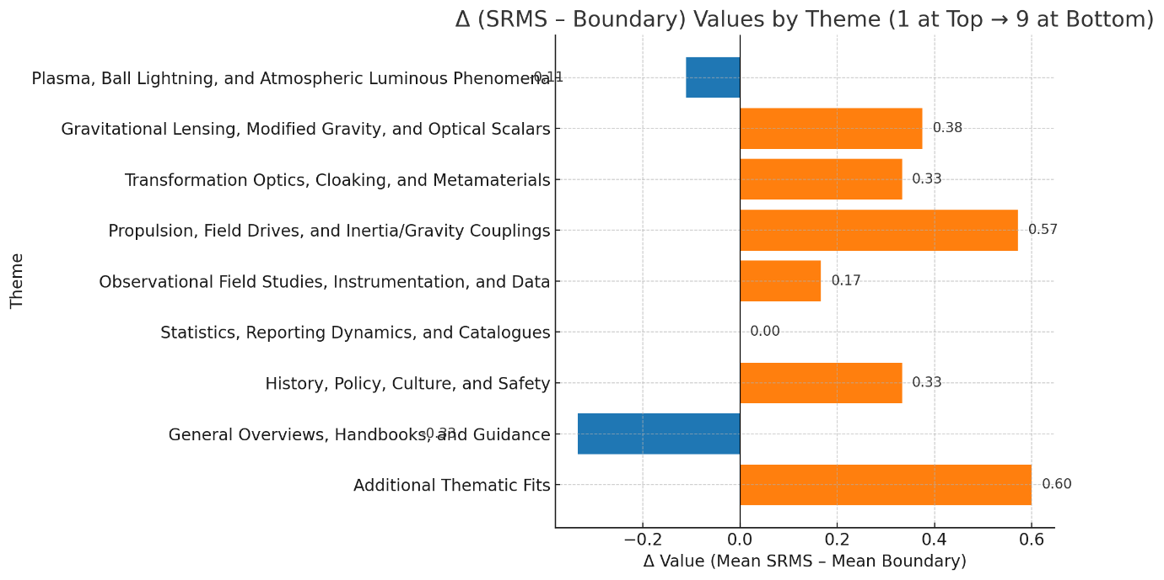

Figure 2. Δ (SRMS – Boundary) linkage values across themes. Horizontal bar chart illustrating the difference between mean SRMS-Link and Boundary-Link scores for each theme. Negative values (blue) indicate stronger boundary evidence relative to resonance (Theme 1: Plasma, –0.11; Theme 8: Overviews, –0.33), while positive values (orange) highlight stronger resonance emphasis (Theme 4: Propulsion, +0.57; Theme 9: Additional Fits, +0.60). Near-zero values (Themes 2 and 6) reflect balanced contributions. This visualization emphasizes the complementary roles of plasma studies as empirical feeders, optics and lensing as bridges, and propulsion-related research as theoretical engines within the boundary–SRMS framework.

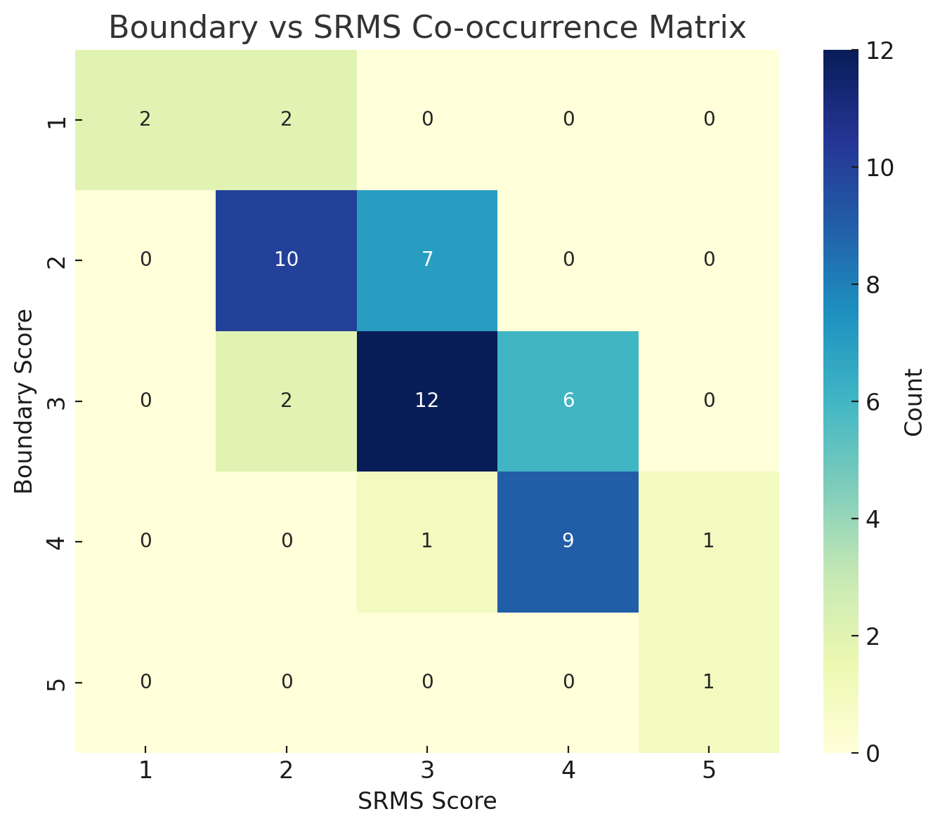

Figure 3. Boundary vs SRMS co-occurrence matrix. Heatmap showing the number of references assigned each combination of Boundary-Link Score and SRMS-Link Score (1–5 scale). Two dense clusters are evident: a mid-range cluster spanning Boundary = 2–3 and SRMS = 2–3 (e.g., plasma and observational studies), and a higher-strength cluster at Boundary = 3–4 and SRMS = 3–4 (e.g., optics, metamaterials, and propulsion studies). Only isolated entries appear in the extreme corners (e.g., Boundary = 5, SRMS = 1 or 5), indicating that strong boundary evidence almost always coincides with at least moderate SRMS relevance.

5. DISCUSSION

The structured analysis of boundary-layer features across nine thematic domains provided new insight into how empirical observations and theoretical models interacted within the wider reference corpus. The non-random clustering of halos, laminar shells, trans-medium transitions, cloaking, and axial emissions confirmed that these motifs recurred across multiple literature, and the Δ scoring trends clarified where resonance-based interpretations were already embedded and where they remained absent. This synthesis carried three key implications: it validated the empirical reliability of boundary-layer motifs, demonstrated the existence of conceptual bridges between empirical and engineered literature, and highlighted clear pathways for moving from descriptive studies toward testable resonance-driven models.

Plasma and atmospheric research remained the strongest empirical feeders, with halos and laminar shells documented across decades of field and laboratory work (Smirnov, 1993; Stenhoff, 1999; Abrahamson and Dinniss, 2000; Zhilyaev et al., 2022a and b; Teodorani, 2004, 2024). Their dominance in the signature map demonstrated that boundary-structuring phenomena were not isolated reports but recurring features of luminous discharges. Yet their negative Δ value underscored a critical gap: this literature has yet to incorporate resonance-based explanations. This positions them as essential baselines for validation, anchoring SRMS theory in well-documented boundary physics, while also identifying a target for theoretical integration.

Optics, metamaterials, and gravitational lensing research filled that gap by providing frameworks that reproduced cloaking and refractive anomalies both experimentally and theoretically (Leonhardt, 2006; Pendry et al., 2006; Greenleaf et al., 2007; Wyman, 2011; Nassar et al., 2020; Peralta et al., 2020; Schneider et al., 2024). Their positive Δ values reflect a tilt toward SRMS theory relevance, confirming that these domains are not merely analogies but demonstrate mechanisms that can be tuned and reproduced in the laboratory. The implication here is that SRMS theory principles are not speculative abstractions: they overlap directly with established optics research that already manipulates fields to suppress, redirect, or cloak wave propagation.

While metamaterial cloaking and field-guided optics are well-established experimentally, their extrapolation to large-scale mobility or propulsion remains speculative and untested. The relationship between laboratory-scale field control and macroscopic motion therefore remains theoretical, requiring further modelling and empirical verification before any physical propulsion claims can be substantiated.

Propulsion studies extended this bridge into system-level theory. From early proposals of inertia modification through vacuum interactions (Holt, 1979; Puthoff, 1987; Haisch et al., 1994) to more recent resonance-based propulsion constants (Hall and Covington, 2025), this literature populated the high-strength quadrant of the co-occurrence matrix. Their high Δ values identified them as theoretical engines of the framework: they explicitly attempt to unify empirical anomalies with resonance-driven mechanics. Importantly, their overlap with coded signatures such as trans-medium transitions and axial emissions suggested that SRMS theory can filter speculative propulsion models, privileging those with clear connections to boundary-layer evidence.

Nevertheless, resonance-based propulsion models currently exist only at a theoretical level and require empirical validation before their physical plausibility can be established. Future research should therefore aim to develop testable parameters and controlled demonstrations capable of quantifying any resonance–mobility coupling effects. Establishing such validation will depend on correlating theoretical predictions with independently verified observations. In this context, empirical and statistical studies provide a necessary reference point: they offer the structured data against which theoretical claims can be tested, constrained, or refined.
Observational and statistical studies played a complementary role. Their mid-range scores showed that while they rarely embedded with resonance theory, they consistently reinforced the recurrence and non-random clustering of boundary-layer signatures (Poher and Poher, 2010; Knuth et al., 2019, 2025; Antonio et al., 2022; Szydagis et al., 2025). This literature functioned as a validation platform: they did not propose mechanisms but provided structured datasets against which SRMS theory prototypes and predictions can be benchmarked. The implication is that methodological progress in SRMS theory research requires aligning experimental outcomes with these independently documented anomalies.

Finally, contextual literatures (history, culture, statistics, cataloguing) scored consistently low, but this consistency is important. Their limited contributions confirmed that signature-rich clusters are not artefacts of reporting bias but emerge robustly even when wider studies are considered (Akers, 2001; Antonio et al., 2022). The implication is that SRMS research can proceed with confidence that the boundary-layer motifs it seeks to explain are not only recurrent but stable across cultural and historical frames of reference.

Together, the results implied that SRMS theory is best understood not as an isolated hypothesis but as a synthesis of three interacting research trajectories: empirical feeders (plasma, atmospheric, observational), conceptual bridges (optics, metamaterials, lensing), and theoretical engines (propulsion and resonance models) (Figure 4). The alignment of these clusters across the scoring outputs (Figures 1–3; Table 4) demonstrated that SRMS theory is simultaneously grounded in observation, validated by experimental analogues, and formalized in theoretical models. This integrated structure suggests that the next step is not to ask whether resonance-driven boundary modulation occurs, but how it can be experimentally controlled and engineered.

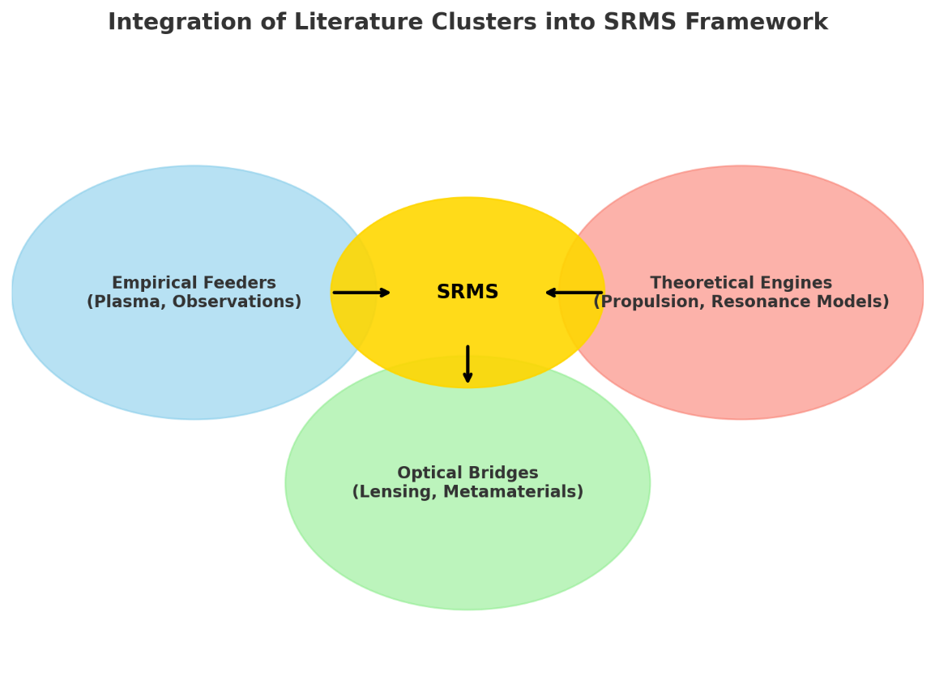
Figure 4. Integration of literature clusters into the SRMS framework. Conceptual diagram showing how three distinct clusters of research converge into the Scalar Resonant Mobility Systems (SRMS) model. Empirical feeders (blue) include plasma, ball lightning, and observational studies that document halos, laminar shells, and trans-medium transitions. Optical bridges (green) encompass gravitational lensing, metamaterials, and cloaking optics that demonstrate refractive and resonance-based boundary control. Theoretical engines (red) include propulsion studies, vacuum-field models, and resonance formulations that explicitly describe mobility mechanisms. Together, these clusters funnel into the SRMS core (yellow), illustrating how observational evidence, bridging theories, and resonant propulsion concepts combine to form a unified explanatory and engineering framework.

6. CONCLUSION

This study demonstrated that boundary-layer signatures, halos, laminar shells, trans-medium transitions, cloaking effects, and axial emissions, were consistently distributed across the reference corpus in structured rather than random ways. Thematic scoring revealed that plasma and observational studies functioned as empirical feeders, establishing a recurrent baseline of anomalous phenomena, while optics, metamaterials, and gravitational lensing served as conceptual bridges, translating these observations into experimentally reproducible field effects. Propulsion and resonance models acted as theoretical engines, proposing mechanisms by which resonance with scalar fields could, in principle, unify these features under a coherent framework of mobility. Together, these strands produced the bimodal clustering observed in the co-occurrence matrix and Δ analysis, illustrating that SRMS concepts emerge from converging empirical and theoretical isolation.

The implications extend beyond cataloguing anomalies. Plasma and atmospheric studies provided robust observational anchors, though their weaker resonance linkages highlighted the need for theoretical integration. Optics and metamaterials demonstrated that resonance-driven boundary control is experimentally achievable at small scales, yet their extrapolation to propulsion or large-scale mobility remains untested and requires empirical verification. Propulsion research formalized theoretical constants and thresholds that translate anomalies into engineering criteria, but these remain conceptual until validated experimentally. Observational and statistical datasets supplied benchmarks for comparison, ensuring that resonance-based prototypes or experiments can be evaluated against documented patterns.

Taken together, the convergence of feeders, conceptual bridges, and theoretical engines suggests that SRMS represents a promising but as yet unverified framework. Rather than a proven model, it provides a structured research pathway linking boundary-layer observations, laboratory-scale field effects, and emerging resonance hypotheses. By integrating these domains under a common analytical language, the study offers a roadmap for advancing boundary-layer research toward controlled, testable investigations of field–matter interaction and potential aerospace applications.

Disclaimer (Artificial intelligence)

Author(s) hereby declare that ChatGPT version 5 was used to assist with the excel workbook analysis, and compiling, organizing and editing of the manuscript. Key input prompts provided to the generative AI technology consisted of:

1. Literature research notes and review of all references to compile summaries.
2. Inputting key features of the SMRS model for comparative analysis against references.
3. Using summarized literature and SRMS model to generate the excel workbook analysis.
4. Organizing and structuring the manuscript based on the results of this analysis.
5. Manuscript preparation and further editing.

REFERENCES

Abrahamson, J., & Dinniss, J. (2000). Ball lightning caused by oxidation of nanoparticle networks from normal lightning strikes on soil. Nature, 403(6769), 519–521. https://doi.org/10.1038/35000525

Akers, D. (2001). Preliminary report on magnetic field measurements recorded at Status Fire Lookout – July 11, 2001. Retrieved from http://www.leeh.net/polyarts/Archive/01070001.pdf

Ailleris, P. (2024). Exploring unidentified aerospace phenomena through instrumented field studies: Historical insights, current challenges, and future directions. Journal of UAP Studies, 1(1), 11–30.

Antonio, F. J., Itami, A. S., Dalmedico, J. F., & Mendes, R. S. (2022). On the dynamics of reporting data: A case study of UFO sightings. Physica A: Statistical Mechanics and its Applications, 603, 127807. https://doi.org/10.1016/j.physa.2022.127807

Aquino, F. de. (2010). Gravity control by means of electromagnetic field through gas or plasma at ultra-low pressure. Maranhão State University, Physics Department, São Luís, Brazil.

Aquino, F. de. (2012). A system to convert gravitational energy directly into electrical energy. Maranhão State University, Physics Department, São Luís, Brazil.

Aquino, F. de. (2016). Quantum controller of gravity. HAL Archives. https://hal.science/hal-01320459v3

Aquino, F. de. (2021). Decreasing of gravitational mass of the magnesium subjected to an alternating magnetic field of extremely low frequency. HAL Archives. https://hal.science/hal-03120208v2

Bekenstein, J. D., & Sanders, R. H. (1993). Gravitational lenses and unconventional gravity theories. Astrophysical Journal, 429, 480–490

Berghaus, K. V., Kable, J., & Miranda, V. (2024). Testing dark energy and modified gravity with strong lensing. Physical Review D, 109(6), 063524.

Gobbi, J. C. (2021). Carr technology. The General Science Journal, 1, 1–30.
Greenleaf, A., Kurylev, Y., Lassas, M., & Uhlmann, G. (2007). Full-wave invisibility of active devices at all frequencies. Communications in Mathematical Physics, 275(3), 749–789.

Gupta, N., & Beckwith, A. (2025). Exploring transformation optics for cloaking applications in UAP analogues. Journal of UAP Studies, 2(1), 15–32.

Hall, B., & Covington, D. (2025). Unified scalar resonance model: Exploring universal constants and scaling laws. Journal of Scientific Research and Reports, 31(1), 635–649.

Haisch, B., Rueda, A., & Puthoff, H. E. (1994). Inertia as a zero-point-field Lorentz force. Physical Review A, 49(2), 678–694. https://doi.org/10.1103/PhysRevA.49.678

Holt, A. (1979). Propulsion concepts for spacecraft interstellar travel. JBIS – Journal of the British Interplanetary Society, 32, 409–414.

Knuth, K. H., Powell, R. M., & Reali, P. A. (2019). Estimating flight characteristics of anomalous unidentified aerial vehicles. Entropy, 21(10), 939. https://doi.org/10.3390/e21100939

Knuth, K. H., Kayal, H., Ailleris, P., et al. (2025). The new science of unidentified aerospace–undersea phenomena (UAP). Progress in Aerospace Sciences, 156, 100986.

Leonhardt, U. (2006). Optical conformal mapping. Science, 312(5781), 1777–1780. https://doi.org/10.1126/science.1126493

Loeb, A., & Kirkpatrick, S. (2023). Physical constraints from the first reported interstellar UAP candidate. Astrophysical Journal Letters, 945(1), L12.

Minami, Y. (2022). UAP propulsion principle and resulting flight performance: Theoretical analysis of UAP flight characteristics. American Journal of Engineering Research, 11(8), 134–156.

Minami, Y. (2023). Flight characteristics of UAP from the perspective of propulsion principle: Flight performance derived from propulsion principle. British Journal of Multidisciplinary and Advanced Studies: Sciences, 4(3), 9–21.

Meessen, A. (2012a). Evidence of very strong low frequency magnetic fields. PIERS Proceedings, Moscow, 19–23.

Meessen, A. (2012b). Pulsed EM propulsion of unconventional flying objects. PIERS Proceedings, Moscow, 19–23.

Nassar, H., Chen, H., & Huang, G. (2020). Non-reciprocal wave propagation in mechanical metamaterials. Nature Reviews Materials, 5(9), 667–685.

Pendry, J. B., Schurig, D., & Smith, D. R. (2006). Controlling electromagnetic fields. Science, 312(5781), 1780–1782. https://doi.org/10.1126/science.1125907

Peralta, F., Fachinotti, V., & Álvarez, E. (2020). Transformation acoustics and elastic cloaking: A review. Wave Motion, 97, 102557.

Poher, C., Poher, D. (2010). Statistical Analysis of Global UFO Sightings: Temporal and Spatial Distributions. Parmay, France: Institut Poher.

Puthoff, H. E. (1987). Ground state of hydrogen as a zero-point-fluctuation-determined state. Physical Review D, 35(10), 3266–3269. https://doi.org/10.1103/PhysRevD.35.3266

Schneider, P., Suyu, S. H., Collett, T. E., & Treu, T. (2024). Essentials of strong gravitational lensing. Space Science Reviews, 220(2), 20. https://doi.org/10.1007/s11214-024-01041-w
Smirnov, B. M. (1993). Physics of Ball Lightning. New York, NY: Springer.

Stenhoff, M. (1999). Ball lightning: An unsolved problem in atmospheric physics. Springer.
Surkov, V. V., & Hayakawa, M. (2020). Progress in the study of transient luminous and atmospheric events: A review. Surveys in Geophysics, 41(6), 1247–1284. https://doi.org/10.1007/s10712-020-09597-2

Szydagis, M., Knuth, K. H., Kugielsky, B. W., Levy, C., McGowan, J. D., Phelan, M. D., & Voorhies, G. P. (2025). Initial results from the first field expedition of UAPx to study unidentified anomalous phenomena. Progress in Aerospace Sciences, 156(1), 101099. https://doi.org/10.1016/j.paerosci.2025.101099

Tajmar, M., Kößling, M. & Neunzig, O. (2024). In-depth experimental search for a coupling between gravity and electromagnetism with steady fields. Scientific Reports, 14, 19427. https://doi.org/10.1038/s41598-024-70286-w
Teodorani, M. (2004). A long-term scientific survey of the Hessdalen phenomenon. Journal of Scientific Exploration, 18(2), 217–251.

Teodorani, M. (2024). Investigating UAP events using astronomical techniques. Journal of UAP Studies, 1(1), 40–54.

Tizfahm, T., Fakhry, S., Firouzjaee, J. T., & Del Popolo, A. (2025). Gravitational lensing in modified gravity: Constraints from scalar–tensor theories. Monthly Notices of the Royal Astronomical Society, 527(1), 104–116.

Valone, T. (2012). Zero point energy: The fuel of the future. Integrity Research Institute.

Vegetti, S., Despali, G., Lovell, M., Cyr-Racine, F.-Y., & Gilman, D. (2024). Strong lensing as a probe of dark matter microphysics. Space Science Reviews, 220(2), 23.

Watters, D., Kaye, J., & McMillan, P. (2023). Designing observatories for anomalous aerial phenomena: A systems approach. Journal of Astronomical Instrumentation, 12(4), 2340005.

Wyman, M. (2011). Galilean-invariant scalar fields can strengthen gravitational lensing. Physical Review Letters, 106(20), 201102. https://doi.org/10.1103/PhysRevLett.106.201102

Zhilyaev, B. E., Petukhov, V. N., & Reshetnyk, V. M. (2022a). Unidentified aerial phenomena I: Observations of events. arXiv preprint. https://arxiv.org/abs/2208.11215

Zhilyaev, B. E., Petukhov, V. N., & Reshetnyk, V. M. (2022b). Unidentified aerial phenomena II: Evaluation of UAP properties. arXiv preprint. https://arxiv.org/abs/2211.17085
Appendix A.

References Included in Thematic Coding and Quantitative Analysis

The following references were included in the structured thematic analysis and quantitative scoring described in the Methods section. Each reference was assigned to one of nine thematic categories, coded across five boundary-layer signatures (halos/filaments, pane-like laminar shells, trans-medium transitions, localized cloaking, and symmetric axial emissions), and scored for both boundary-layer relevance and resonance-based theoretical linkage.

Although not all of these works are cited directly in the main text, every reference in this appendix contributed to the aggregated results reported in the bar plots, heatmaps, and dashboards. This appendix is provided to ensure transparency and reproducibility of the analysis. The excel workbook is available on request.

Abrahamson, J., Dinniss, J. (2000). Ball lightning caused by oxidation of nanoparticle networks from normal lightning strikes on soil. Nature, 403(6769), 519–521.

Ahedo, E., Merino, M. (2010). Two-dimensional supersonic plasma expansion in a magnetic nozzle: Separation due to ion demagnetization. Physics of Plasmas, 17(7), 073501.

Akers, D. (2001). Preliminary report on magnetic field measurements recorded at Status Fire Lookout – July 11, 2001. Retrieved from http://www.leeh.net/polyarts/Archive/01070001.pdf

Ailleris, P. (2024). Exploring unidentified aerospace phenomena through instrumented field studies: Historical insights, current challenges, and future directions. Journal of UAP Studies, 1(1), 11–30.

Ammon, D. (2024). Development, dissemination, and revision of good scientific practice for research on UAP. Journal of UAP Studies, 1(1), 31–39.

Antonio, F. J., Itami, A. S., Dalmedico, J. F., Mendes, R. S. (2022). On the dynamics of reporting data: A case study of UFO sightings. Physica A: Statistical Mechanics and its Applications, 603, 127807.

Aquino, F. de. (2010). Gravity control by means of electromagnetic field through gas or plasma at ultra-low pressure. Maranhão State University, Physics Department, São Luís, Brazil.

Aquino, F. de. (2012). A system to convert gravitational energy directly into electrical energy. Maranhão State University, Physics Department, São Luís, Brazil.

Aquino, F. de. (2016). Quantum controller of gravity. HAL Archives. https://hal.science/hal-01320459v3

Aquino, F. de. (2021). Decreasing of gravitational mass of the magnesium subjected to an alternating magnetic field of extremely low frequency. HAL Archives. https://hal.science/hal-03120208v2

Bekenstein, J. D., Sanders, R. H. (1993). Gravitational lenses and unconventional gravity theories. Astrophysical Journal, 429, 480–490.

Berghaus, K. V., Kable, J. A., Miranda, V. (2024). Quantifying scalar field dynamics with DESI 2024 Y1 BAO measurements. Physical Review D, 110(10), 103524.

Clark, J. (1998). The UFO Encyclopedia: The Phenomenon from the Beginning (2nd ed.). Detroit, MI: Omnigraphics.

Condon, E. U. (1969). Scientific study of unidentified flying objects. University of Colorado. New York, NY: Bantam Books.

Tizfahm, A., Fakhry, S., Firouzjaee, J.T., Popolo, A.D. 2025. Toward gravitational lensing in modified theories of gravity. Physics of the Dark Universe. 47, 101795.

Dolan, R. M. (2002). UFOs and the national security state: Chronology of a cover-up 1941–1973. Hampton Roads Publishing.

Dolan, R. M. (2009). UFOs and the national security state: The cover-up exposed 1973–1991. Keyhole Publishing.

Editorial. (2025). Unidentified aerospace-undersea phenomena: Status and outlook. Progress in Aerospace Sciences, 156.

Fedosin, S. G., Kim, A. S. (2001). The physical theory of ball lightning. Applied Physics (Russian Journal), 1, 69–87.

Frittelli, S., Kling, T. P., & Newman, E. T. (2000). Image dmay betortion from optical scalars in lensing. Physical Review D, 63(2), 023006,

Gao, D., Zhou, L., Wang, J., Zhan, M. (2024). Constraining the spin-gravity coupling effects to the 10⁻¹⁰ level with dual-species atom interferometers. Physical Review A, 110, 043322. https://doi.org/10.1103/PhysRevA.110.043322

Gobbi, J. C. (2021). Carr technology. The General Science Journal, 1, 1–30.

Greenleaf, A., Kurylev, Y., Lassas, M., Uhlmann, G. (2007). Full-wave invisibility of active devices at all frequencies. Communications in Mathematical Physics, 275(3), 749–789.

Gross, D. M. (2013). Unidentified aerial phenomena: A new hypothesis toward their explanation. Journal of Scientific Exploration, 27(3), 455–482,

Gupta, N., Beckwith, C. (2025). Cloaking properties of metamaterials. In Architected Metamaterials (pp. 133–156). Springer. https://doi.org/10.1007/978-3-031-98330-6_4

Hall, B., Covington, D. 2025. Unified scalar resonance model: Exploring universal constants and scaling laws. Journal of Scientific Research and Reports. 31(1), 635-649.

Haines, R. F. (1999). CE-5: Close Encounters of the Fifth Kind. Naperville, IL: Sourcebooks.

Haisch, B., Rueda, A., Puthoff, H. E. (1994). Inertia as a zero-point field Lorentz force. Physical Review A, 49(2), 678–694.

Hanif, F., Das, D., Halliwell, J., Home, D., Mazumdar, A., Ulbricht, H., Bose, S. (2024). Testing whether gravity acts as a quantum entity when measured. Physical Review Letters, 133(18), 180201. https://doi.org/10.1103/PhysRevLett.133.180201

Hastings, R. (2017). UFOs and nukes: Extraordinary encounters at nuclear weapons sites (2nd ed.). CreateSpace.

Hehl, F. W. (2007). An assessment of Evans’ unified field theory I. Foundations of Physics, 37(12), 1767–1796. https://doi.org/10.1007/s10701-007-9190-0

Hehl, F. W., Obukhov, Y. N. (2020). Conservation of energy–momentum of matter as the basis for the gauge theory of gravitation. In G. Giardino & R. Ruffini (Eds.), One Hundred Years of Gauge Theory (Fundamental Theories of Physics, Vol. 199, pp. 217–252). Springer. https://doi.org/10.1007/978-3-030-51197-5_10

Hendry, A. (1979). The UFO handbook: A guide to investigating, evaluating, and reporting UFO sightings. Doubleday.

Hill, P. R. (1995). Unconventional Flying Objects: A Scientific Analysis. Charlottesville, VA: Hampton Roads.

Holt, A. C. (1979). Field resonance propulsion concept. NASA Technical Reports, https://ntrs.nasa.gov/api/citations/19800010907/downloads/19800010907.pdf

Hynek, A. J. (1972). The UFO experience: A scientific inquiry. Contemporary Books.

Hynek, A. J. (2020). The Hynek UFO report: The authoritative account of the Project Blue Book cover-up. MUFON.

Kean, L. (2010). UFOs: Generals, Pilots, and Government Officials Go on the Record. New York, NY: Crown Archetype.

Joseph, R., Impey, C., Planchon, O., del Gaudio, R., Abu Safa, M., Sumanarathna, A. R., Ansbro, E., Duvall, D., Bianciardi, G., Gibson, C. H., Schild, R. (2024). Extraterrestrial life in the thermosphere: Plasmas, UAP, pre-life, fourth state of matter. Journal of Modern Physics, 15(3), 322–374.

Kayal, H. (2022). Scientific and technology exploration of unidentified aerial phenomena (UAP). In J. Andresen & O. A. Chon-Torres (Eds.), Extraterrestrial intelligence: Academic and societal implications (pp. 87–111). Newcastle upon Tyne, UK: Cambridge Scholars Publishing.

Khoury, J., Weltman, A. (2004). Chameleon cosmology. Physical Review D, 69(4), 044026, https://doi.org/10.1103/PhysRevD.69.044026

Knuth, K. H., Powell, R. M., Reali, P. A. (2019). Estimating flight characteristics of anomalous unidentified aerial vehicles. Entropy, 21(10), 939.

Knuth, K. H., Kayal, H., Aillermay be, P., et al. (2025). The new science of unidentified aerospace-undersea phenomena (UAP). Progress in Aerospace Sciences, 156, 100986.

Kocher, G. (1968). UFOs: What to do. RAND Corporation.

Konfluence Team. (2019). Breakthrough propulsion physics: Scalar charge and field energy. Konfluence Technical Report, https://www.konfluence.org/bpp/

Lacatski, J. T., Kelleher, C. A., Knapp, G. (2021). Skinwalkers at the Pentagon: An insider’s account of the secret government UFO program. Henderson, NV: RTMA, LLC.

Leonhardt, U. (2006). Optical conformal mapping. Science, 312(5781), 1777–1780. https://doi.org/10.1126/science.1126493

Loeb, A., Kirkpatrick, S. M. (2023). Physical constraints on unidentified aerial phenomena. Harvard-Smithsonian Centre for Astrophysics.

Lomas, T. (2024). Unidentified anomalous phenomena (UAP) disclosure as ontological shock? Exploring diversity among social media responses to a congressional UAP hearing. Journal of Humanistic Psychology, 64(3), 1–32.

Marletto, C., Vedral, V. (2025). Quantum-information methods for quantum gravity laboratory-based tests. Reviews of Modern Physics, 97(1), 015006. https://doi.org/10.1103/RevModPhys.97.015006

McDonald, J. E. (1969). Science in default: Twenty-two years of inadequate UFO investigations. American Association for the Advancement of Science Symposium, 134, 1–12.

Medina, R.M., Brewer, S.C. Kirkpatrick, S.M. An environmental analysis of public UAP sightings and sky view potential. Scientific Reports 13, 22213 (2023). https://doi.org/10.1038/s41598-023-49527-x

Meesen, A. (2012a). Evidence of very strong low frequency magnetic fields. PIERS Proceedings, Moscow, 19–23.

Meesen, A. (2012b). Pulsed EM propulsion of unconventional flying objects. PIERS Proceedings, Moscow, 19–23.

Minami, Y. (2022). UAP propulsion principle and resulting flight performance: Theoretical analysis of UAP flight characteristics. American Journal of Engineering Research, 11(8), 134–156.

Minami, Y. (2023). Flight characteristics of UAP from the perspective of propulsion principle: Flight performance derived from propulsion principle. British Journal of Multidisciplinary and Advanced Studies: Sciences, 4(3), 9–21.

Narayan, R., Bartelmann, M. (1997). Lectures on gravitational lensing. Classical and Quantum Gravity, 14(4), 1–74, https://doi.org/10.48550/arXiv.astro-ph/9606001

Nassar, H., Chen, Y. Y., Huang, G. L. (2020). Polar metamaterials: A new outlook on resonance for cloaking applications. Physical Review Letters, 124(8), 084301.

Pascoli, G. (2024). The Hessdalen lights seen as aerial counterpart of an unsuspected subsoil phenomenon: Is Earth harbouring a multimouth wormhole? Journal of Scientific Exploration, 38(2), 96–110.

Pendry, J. B., Schurig, D., & Smith, D. R. (2006). Controlling electromagnetic fields. Science, 312(5781), 1780–1782. https://doi.org/10.1126/science.1125907

Peralta, I., Fachinotti, V. D., Álvarez, J. C. (2020). A brief review on thermal metamaterials for cloaking and heat flux manipulation. Advanced Engineering Materials, 22(7), 1901034.

Phillips, T. (1975). Physical traces associated with UFO sightings. Center for UFO Studies.
Poher, C., Poher, D. (2010). Statistical Analysis of Global UFO Sightings: Temporal and Spatial Distributions. Parmay, France: Institut Poher.

Puthoff, H. E. (1987). Ground state of hydrogen as a zero-point-fluctuation-determined state. Physical Review D, 35(10), 3266–3269. https://doi.org/10.1103/PhysRevD.35.3266

Rutledge, H. (1981). Project Identification: The First Scientific Field Study of UFO Phenomena. Englewood Cliffs, NJ: Prentice-Hall.

Schneider, P., Suyu, S. H., Collett, T. E., Treu, T. (2024). Essentials of strong gravitational lensing. Space Science Reviews, 220(2), 20. https://doi.org/10.1007/s11214-024-01041-w

Smirnov, B. M. (1993). Physics of Ball Lightning. New York, NY: Springer.

Smirnov, B. M., & Cherepanov, V. (1997). Theoretical models of ball lightning. Physics-Uspekhi, 40(11), 1117–1136.

Stahlman, G. R. (2024). Closing the information gap in unidentified anomalous phenomena (UAP) studies. In I. Sserwanga et al. (Eds.), Wisdom, well-being, win-win (Lecture Notes in Computer Science, Vol. 14596) (pp. 305–320). Springer.

Stenhoff, M. (1999). Ball lightning: An unsolved problem in atmospheric physics. Springer.

Strand, E. P. (1985). Project Hessdalen 1984 – Final technical report.

Strand, E. P. (2000). Project Hessdalen: Articles and reports.

Strand, E. P. (2001). Hessdalen automatic measurement station.

Surkov, V. V., Hayakawa, M. (2020). Progress in the study of transient luminous and atmospheric events: A review. Surveys in Geophysics, 41(6), 1247–1284. https://doi.org/10.1007/s10712-020-09597-2

Szydagis, M., Knuth, K. H., Kugielsky, B. W., Levy, C., McGowan, J. D., Phelan, M. D., Voorhmay be, G. P. (2025). Initial results from the first field expedition of UAPx to study unidentified anomalous phenomena. Progress in Aerospace Sciences, 156(1), 101099.

Tajmar, M., Kößling, M. & Neunzig, O. (2024). In-depth experimental search for a coupling between gravity and electromagnetism with steady fields. Scientific Reports, 14, 19427. https://doi.org/10.1038/s41598-024-70286-w

Tedesco, J. J., Tedesco, G. T. (2024). Eye on the sky: A UAP research and field study off New York’s Long Island coast. Open Journal of Applied Sciences, 14(5), 2267–2295.

Teodorani, M. (2000). Physical data acquisition and analysis of possible flying extraterrestrial probes by using opto-electronic devices. Extraterrestrial Physics Review, 1(3), 32–37.

Teodorani, M., Strand, E. P. (2001). Data analysis of anomalous luminous phenomena in Hessdalen. Italian Committee for Project Hessdalen.

Teodorani, M., Nobili, G. (2002). EMBLA 2002: Optical and ground survey in Hessdalen. Project Hessdalen Reports.

Teodorani, M. (2004). A long-term scientific survey of the Hessdalen phenomenon. Journal of Scientific Exploration, 18(2), 217–251.

Teodorani, M. (2006). An alternative method for the scientific search for extraterrestrial intelligent life: The Local SETI. INAF– Istituto di Radioastronomia.

Teodorani, M. (2009a). Spherical unidentified anomalous phenomena: Scientific observations and physical hypotheses. NARCAP Monograph: Project Sphere.

Teodorani, M. (2009b). Scientific inquiry on anomalous atmospheric light phenomena: Past research gaps and new methodological goals. Italian Committee for Project Hessdalen.

Teodorani, M. (2010). Spherical unidentified anomalous phenomena: Scientific observations and physical hypotheses, danger evaluation for aviation and future observational plans. NARCAP Report.

Teodorani, M. (2013). Project for a network of automatic stations for UFO monitoring. First UFOAC Workshop, Ohio State University, Columbus, OH.

Teodorani, M. (2014). Instrumented monitoring of aerial anomalies: A scientific approach to the investigation of anomalous atmospheric light phenomena. In CAIPAN Workshop Proceedings (pp. 1–12). Paris: CNES/GEIPAN.

Teodorani, M. (2022). The impact of physical sciences in the study of unidentified aerial phenomena (UAP). In J. Andresen & O. A. Chon-Torres (Eds.), Extraterrestrial intelligence: Academic and societal implications (pp. 124–141). Newcastle upon Tyne, UK: Cambridge Scholars Publishing.

Teodorani, M. (2024). Investigating UAP events using astronomical techniques. Journal of UAP Studies, 1(1), 40–54.

Tizfahm, T., Fakhry, S., Firouzjaee, J. T., & Del Popolo, A. (2025). Gravitational lensing in modified gravity: Constraints from scalar–tensor theories. Monthly Notices of the Royal Astronomical Society, 527(1), 104–116.
Turner, D. J. (1997). The interaction of ball lightning with glass window panes. Journal of Meteorology UK, 22, 52–64.

Turner, D. J. (2003). The missing science of ball lightning. Journal of Scientific Exploration, 17(3), 435–496.

Vallée, J. (1998). Forbidden Science: Journals, 1957–1969. Berkeley, CA: North Atlantic Books.

Vallée, J. (2014). Anatomy of a phenomenon: The detailed examination of unidentified aerial phenomena. San Antonio, TX: Anomalist Books.

Vallée, Jacques F., & Harris, Paola Leopizzi. (2021). TRINITY: The Best-Kept Secret. Independently published. ISBN: 979-8-7459-0256-7

Vallée, J., Aubeck, C. (2010). Wonders in the Sky: Unexplained Aerial Objects from Antiquity to Modern Times. New York, NY: Tarcher.

Valone, T. F. (2012). Electrokinetics as a propellantless propulsion source. Physics Procedia, 38, 87–98.

Vegetti, S., Birrer, S., Despali, G., Fassnacht, C. D., Gilman, D., Hezaveh, Y. D., Koopmans, L. V. E., Nightingale, J., Shajib, A. J., Sonnenfeld, A., Treu, T., Wagner, J. (2024). Strong gravitational lensing as a probe of dark matter. Space Science Reviews, 220(2), 21.

Vegetti, S., Despali, G., Lovell, M., Cyr-Racine, F.-Y., & Gilman, D. (2024). Strong lensing as a probe of dark matter microphysics. Space Science Reviews, 220(2), 23.
Virbhadra, K. S., Ellis, G. F. R. (2002). Gravitational lensing by naked singularities. Physical Review D, 65(10), 103004. https://doi.org/10.1103/PhysRevD.65.103004

Watters, W. A., et al. (2023). The scientific investigation of unidentified aerial phenomena (UAP) using multimodal ground-based observatories. Journal of Astronomical Instrumentation, 12(1), 1–43.

Weinstein, D. R. (2012). Aviation safety and unidentified aerial phenomena: A preliminary study of 600 cases reported by military and civilian pilots. NARCAP International Air Safety Report, IR-4.

Wendt, A., Duvall, R. (2015). Sovereignty and the UFO. Political Theory, 43(2), 153–181.
Wu, Y. H., Li, H. P., Shi, X. X., Wan, J., Liu, Y. F., & Yu, D. G. (2016). Effective utililisation of the electrostatic repulsion for improved alignment of electrospun nanofibres. Journal of Nanomaterials, 2016, Article ID 2067383.

Wyman, M. (2011). Galilean-invariant scalar fields can strengthen gravitational lensing. Physical Review Letters. 106, 201102. DOI: https://doi.org/10.1103/PhysRevLett.106.201102

Zou, Y. (1995). The physics of ball lightning. Beijing: Science Press.

Zhilyaev, B. E., Petukhov, V. N., Reshetnyk, V. M. (2022a). Unidentified aerial phenomena I: Observations of events. arXiv preprint. https://arxiv.org/abs/2208.11215

Zhilyaev, B. E., Petukhov, V. N., Reshetnyk, V. M. (2022b). Unidentified aerial phenomena II: Evaluation of UAP properties. arXiv preprint. https://arxiv.org/abs/2211.17085.

