Smart IoT-based Solar Panel Cleaning System

Abstract:
The power generation efficiency of solar panels is hampered by high dust buildup and bird droppings. Since the output power in a solar system depends on the intensity of light falling on it, when these modules are utilised in a dusty environment, a tiny piece of dust occurs on the solar panel, which will try to reduce its efficiency and productivity. Manually cleaning a solar panel is time–consuming and difficult. So, this problem can be avoided by having a suitable cleaning system for the panel. This study suggests a brush–based programmed system using IOT technology for cleaning solar panels. The microcontroller and an Android device are used to control the system. The proposed work provides automatic tracking of solar light using a light intensity diode and directs the panel according to it, and if there is any dust and dirt present in the panel, an automatic cleaning system is used for cleaning purposes. This technique will lead to increased output power. Suitable sensors are used for detecting the dust, and this arrangement is connected to the controller. It offers a higher integrity, consistency, cost-effective and scalable solution for the elimination of dust and specks. The amount of labour required to clean solar panels is also reduced by this technology.

Keywords: Solar Panel, Microcontroller, IOT, Sensors, Cleaning, Automation

INTRODUCTION

The efficiency of solar energy produced by photovoltaic modules can be affected by two main factors: environmental factors, such as humidity, wind speed, precipitation, and temperature, and non-environmental factors, which take into account factors such as atmospheric pollution, dust accumulation, and bird droppings. Dust accumulation, dirt, and bird droppings are some leading causes that lead to the poor functionality of solar panels (Derakhshandeh et al., 2021). Traditional solar cleaning and monitoring systems have some limitations, such as high cost, complexity, and low accuracy compared to automated solar panel cleaning. To achieve this target, there is a need for an efficient and cost-effective solution to enhance the performance of solar panels and increase their output. Conventionally, the panels are cleaned with water, and the process is labour-intensive and is proven to be expensive in large-scale solar panel systems. A wiper and a water spray are used to clean the solar panel. Internet of Things (IOT) emerges as a transformative technology, enhancing the functionality of everyday objects by networking them through a common protocol and utilising cloud-based storage and processing systems (Balamurugan & Nithya, 2025). Real-time solar monitoring system, enabled by IOT, becomes essential in optimising solar panel performance. Data on dust accumulation, solar radiation levels, and weather conditions are just a few of the variables that the IoT-based solar array cleaning system monitors in real time through a network of attached sensors (Ghafoor et al., 2024). Press monitoring parameters such as voltage, temperature, and humidity in real time allow for data-driven decision-making and proactive measures to maintain peak efficiency, contributing to the long-term reduction of harmful emissions and the preservation of the ozone layer. We have developed an automated solar panel cleaning system using IOT, providing transparency and control through a mobile application. The system included sensors for monitoring and predicting the suitable time for cleaning actions, offering in potential solution for large-scale farms. Overall, these studies emphasise the importance of automated cleaning systems in maintaining the efficiency of solar panels, particularly in regions with challenging environmental conditions. The integration of IOT and advanced technologies further enhances the monitoring and effectiveness of

the system. Manual cleaning has challenges such as risk of employee injuries and panel damage, movement difficulties, and poor maintenance etc. The performance of solar panels is greatly impacted by dust collection.

As renewable sources like solar power become more integral to global energy strategies, the adoption of IoT-enabled automatic cleaning systems becomes a crucial step towards sustainable and efficient energy production by harnessing the power of optimisation techniques and IOT connectivity. Solar panel cleaning can be streamlined, efficient and environmentally friendly, solidifying the place of solar energy as a key player in the transition to a greener and more sustainable future.

OBJECTIVES

  - To design and develop the solar panel cleaning system
  - To analyse the efficiency of an IoT-based solar panel.
  - To analyse the energy conservation with a dusted solar panel

LITERATURE REVIEW
According to Muhammad Ahmad Baballe et.al. (2024), when compared to water-based cleaning, dry cleaning is less efficient. This is because dust particles are more able to be transported away from the modules by fluids like water. The robotic devices have a significant upfront cost. Consequently, it is not ideal for a home system. The operation of robotic cleaners requires electricity. The additional expense of this electricity mounts up. Since robotic technology is relatively new, there is still a great deal of research and development (R&D) to be done in this field. Artificial intelligence and other sophisticated technologies are still needed for this machine.

According to Dhanashri Ingole et.al. (2023), the design prototype is to clean the solar panel using an electrical mechanism, such that efficiency or quality of the solar panel is not compromised. Saudi Arabia is facing a lot of dust storms, and the solar panels need to be cleaned frequently. If the task is performed manually, it will be very costly and time-consuming. Water sprinklers and a special wiping material shall be used in the conceived mechanism design to ensure the quality of cleaning. If the panel is not wiped clean, then 50% of the module performance might be reduced. The 8051 microcontroller is used to control the tools' motors
and to implement the automated gadget. The mechanism consists of a sensor and also consists of the sliding brushes while cleansing the PV module. The analysis of the dust can be examined below the different conditions with the deposition of the unique pollutants like ash, sand, silica, calcium carbonate and crimson soil.
According to Satish A. Patil et al. (2023), the reduction in the peak power generation can be up to 10-30%. Power reduction was observed due to dust accumulation on the panels, and this can be improved by using a robotic cleaning method. It has increased the power generation capacity of the solar panels. The issues vary based on the specific surrounding of the installation sites. Industrial areas might emit various particles such as fly ash and brick powder, whereas areas with low buildings and residential zones could face issues like bird droppings. Dry regions like deserts are susceptible to sand accumulation due to frequent sandstorms.

According to Nasib khadka et.al., (2020), Solar photovoltaic energy is harnessed from solar radiation for a monocrystalline solar PV panel under standard test condition, its seen that only 15-18% of solar radiation is utilized to produce electricity Achieving maximum efficiency has been a challenge and this efficiency changes due to several factor like lower irradiance, higher air mass, higher temperature, regardless of this solar radiance is failed to be harnessed due to accumulation of foreign particles like dust, bird excrement, snow and many other. Large-scale PV systems are immensely affected by dust deposition on solar panels. Conventionally, the panels are cleaned with water, and the process is labour-intensive and is proven to be expensive in large-scale PV systems.

PROBLEM IDENTIFICATION
  - Reduce panel efficiency, especially in dry and desert areas.
  - Using the wrong cleaning tools or excessive pressure can cause scratches or cracks.
  - Traditional cleaning methods consume a large amount of water.

METHODOLOGY
  - Problem Identification
  - Literature Review
  - Design study
  - Components Selection

  - Fabrication Process
  - Field Testing & Analysis

DESIGN OF THE MACHINE MANUFACTURING PROCESS
Manufacturing processes are the steps through which raw materials are transformed into a final product. The manufacturing process begins with the creation of the materials from which the design is made. These materials are then modified through manufacturing processes to become the required part. Manufacturing processes can include treating (such as heat treating or coating), machining, or reshaping the material.
The manufacturing process also includes tests and checks for quality assurance during or after the manufacturing, and planning the production process prior to manufacturing.

CUTTING
Cutting the stand at the centre for solar panel fixing. The solar panel is fixed at the centre of the stand. Stand is a crucial part of the fabrication process to ensure proper fit, alignment, and structural stability.

WELDING

The welding process for fixing a solar panel onto a stand primarily involves arc welding techniques such as MIG (Metal Inert Gas) welding or TIG (Tungsten Inert Gas) welding. These methods are used to fabricate and secure the metal mounting structure, ensuring durability and stability. The stand, usually made of galvanised steel or aluminium, is welded together to form a strong framework that can withstand environmental conditions like wind and rain. Spot welding may also be used to reinforce joints in pre-fabricated structures. After welding, anti-corrosion coatings are applied to prevent rusting. The solar panel is then fixed onto the welded stand using bolts and clamps, ensuring it is securely mounted without damaging the panel itself.

GRINDING
Grinding of a solar panel is not a standard process in its installation or maintenance, as solar panels are delicate and made of tempered glass, silicon cells,
and protective layers. However, in solar panel manufacturing, grinding is used in the edge trimming process to smooth and shape the glass, ensuring uniformity and preventing sharp edges that could lead to breakage. Special diamond grinding wheels or precision grinding machines are used to achieve smooth, polished edges without damaging the panel's structure.
Additionally, in rare cases, grinding may be required to remove surface defects from the frame or mounting structures, but extreme caution is needed to avoid weakening the panel.

PAINTING

Painting the solar panel stand is an essential step to protect it from corrosion and enhance its durability. The stand, usually made of galvanised steel or aluminium, is first cleaned to remove dust, grease, or rust. A primer coat is applied to improve paint adhesion and provide an extra layer of protection against moisture. After the primer dries, a weather-resistant paint, such as epoxy or polyurethane-based paint, is used to coat the structure. This helps the stand withstand harsh environmental conditions, including rain, UV exposure, and humidity. In some cases, powder coating is preferred over traditional painting for better durability and a uniform finish. Properly painted stands ensure a longer lifespan and stable support for the solar panels.

IoT IMPLEMENTATION

It is an IoT server that provides free IoT App server facilities, showing the IoT server monitoring interface from where the generated voltage status and connection status can be monitored. If the automated cleaning system does not work properly, then it can be handled manually by using the ON/OFF button of the interface displayed on the smartphone’s screen. This screen shows the corresponding branch connection status. The red colour circle represents the disconnection or short circuit condition of the branch, and the white circle represents the normal connection of the branch.

Fig.1: Solar Cleaning Robot
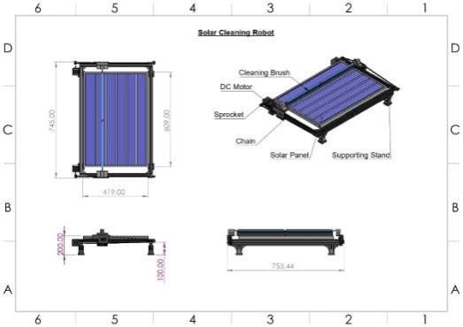

COMPONENTS

- Temperature sensor
- Solar panel
- Arduino Uno
- Dc motor
- Dc water pump
- LCD display
- Relay
- Battery
- Cycle chain & sprocket
- Blower
- IOT
- Limit switch
- Humidity sensor
- LDR switch

WORKING PRINCIPLE
The potential transformer will step down the power supply voltage (0-230V) to (0-9V & 15-0-15V) level. Then the secondary of the potential transformer will be connected to the precision rectifier, which is constructed with the help of op–amp. The advantages of using a precision rectifier are that it will give peak voltage output as DC, rest of the circuits will give only RMS output. When four diodes are connected as shown in the figure, the circuit is called as bridge rectifier. The input to the circuit is applied to the diagonally opposite corners of the network, and the output is taken from the remaining two corner. Let us assume that the transformer is working properly and there is a positive potential, at point A and a negative potential at point B.
the positive potential at point A will forward bias D3 and reverse bias D4.The negative potential at point B will forward bias D1 and reverse bias D2. At this time, D3 current flow is from point B through D1, up through RL, through D3, through the secondary of the transformer back to point B. This path is indicated by the solid arrows. Waveforms
(1) and (2) can be observed across D1 and D3.
One-half cycle later, the polarity across the secondary of the transformer reverses, forward-biasing D2 and D4 and reverse-biasing D1 and D3. Current flow will now be from point A through D4, up through RL, through D2, through the secondary of T1, and back to point A.

Fig.2 Solar Panel Tracking System Prototype with
Mechanical Movement Mechanism

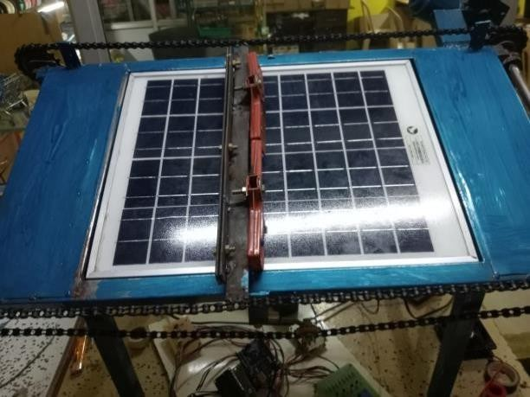

This path is indicated by the broken arrows. Waveforms (3) and (4) can be observed across D2 and D4. The current flow through RL is always in the same direction. In flowing through RL this current develops a voltage corresponding to that shown waveform (5).
Since current flows through the load (RL) during both half cycles of the applied voltage, this bridge rectifier is a full-wave rectifier.

RESULT AND DISCUSSION
The IoT-based solar panel cleaning system efficiently removes dust and debris, ensuring optimal energy generation and reducing manual maintenance efforts.
By integrating Arduino, sensors, a DC motor, a water pump, and IOT connectivity, the system enables automated operation and real-time monitoring. The LDR sensor detects day or night, while the voltage sensor monitors power output, triggering the cleaning mechanism when necessary. Additionally, temperature and humidity sensors provide environmental data to enhance system efficiency. The use of IoT allows remote monitoring through a mobile app, making the system user-friendly, cost-effective, and sustainable. With optimised water usage and reduced human intervention, this smart cleaning solution enhances the lifespan and performance of solar panels, making it an ideal choice for residential, industrial, and large-scale solar farms. A considerable and encouraging outcome has been obtained from an automated solar panel cleaning initiative, the initiative decreased reliance on traditional energy sources by incorporating renewable energy sources. Customers saved a significant amount of money as a result, and by lowering carbon emissions, improved the energy supply chain. Furthermore, because PV systems have a balanced energy flow. More clean solar electricity may be produced with less manpower working when real-time monitoring and precise values are used. The outcomes brought to light the significance of this scheme in promoting the use of renewable energy, reducing environmental impact, and creating a more robust and efficient energy infrastructure.
da y | Tym (hrs) | Voltage (v) | Current (amp) | Power output | Daily energy | W  used
1 | 5 | 17.0 | 1.15 | 19.55 | 97.75 | 0.2lit
2 | 5 | 17.0 | 1.16 | 19.72 | 98.6 | 0.2lit
3 | 5 | 17.1 | 1.17 | 20.01 | 100.05 | 0.2lit
4 | 5 | 17.0 | 1.15 | 19.55 | 97.75 | 0.2lit
5 | 5 | 17.0 | 1.16 | 19.72 | 98.6 | 0.2lit
6 | 5 | 17.1 | 1.18 | 20.18 | 100.9 | 0.2lit
7 | 5 | 17.0 | 1.15 | 19.55 | 97.75 | 0.2lit

By introducing a more efficient logistics system, it will be possible to use the collected data more efficiently. As it is an IoT-based system, the platform is open and flexible and can be continuously upgraded to improve the system’s performance. By incorporating many more features, the system will help create various future opportunities. With more features, machine learning, deep learning, more updated dust detection sensors, and customised efficient cleaning brushes, an efficient cleaning system can be built to improve solar power generation.
Conclusion
Table 1: Daily Solar Energy Output and Consumption Data
The proposed technique will lead to increased output power. Suitable sensors are used for detecting the dust, and this arrangement is connected to the controller. It offers a higher integrity, consistency, cost-effective and scalable solution for the elimination of dust and specks.

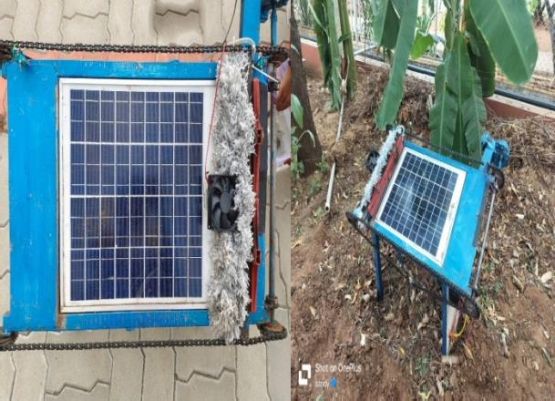

Fig. 3: Comparison of a dusted solar panel vs. a cleaned solar panel

- CALCULATION

Average efficiency dirty panel = 70.07 Average efficiency cleaned panel = 98.77% Total efficiency gain (98.77-70.77) = 20.7%

REFERENCES
- Shasoto Biswas, Muhibul Haque Bhuyan, Md. Kamrul Hassan, "IoT-Based Automated Solar Panel Cleaning and Monitoring Technique," Journal of
- Benjamin Oluwamuyiwa Olorunfemi, Omolola A et.al., (2022)entitled as Solar Panels Dirt Monitoring and Cleaning for Performance Improvement: A Systematic Review on Smart Systems. Sustainability 2022,14(17),10920; https://doi.org/10.3390/su141710920.

Engineering Research and Reports, vol. 25, no. 8, pp.

56-69, September 2023.
- Alaa Younus Rawdhan, Mohammed Sh. Ahmed, "Exploiting PV System Performance: A Combined Approach Using MPPT, IoT, Cleaning, Cooling, and Neural Networks," Unconventional Resources, November 2024.

- Nazmun Nahar Karima, Mahmudul Hasan Saikat, Md Sumon Molla, Muhibul Haque Bhuyan, "A Real Time IoT-Enabled Automated Solar Panel Cleaning System with Dust Detection Employing Advanced Image Processing Technique," 2024 3rd International Conference on Advancement in Electrical and Electronic Engineering (ICAEEE 2024), Gazipur, Bangladesh, June 2024.
- Charity M. Nkinyam et al., "Design and Implementation of a Waterless Solar Panel Cleaning System,"UnconventionalResources,November.

- Deeraj C et al., "IoT Based Solar Panel Cleaning System," International Journal of Advanced Research in Science, Communication and Technology, June 2024.
- Md. Rawshan Habib, Md Shahnewaz Tanvir, Ahmed Yousuf Suhan, Abdelrhman Alrashed, "Automatic Solar Panel Cleaning System Based on Arduino for Dust Removal," Conference Paper, March 2021.

- Manoj Kumar Swain, Manohar Mishra, Ramesh Bansal, Shazia Hasan, "A Self-Powered Solar Panel Automated Cleaning System: Design and Testing Analysis," Article, July 2021.

- Charity M. Nkinyam et al., "Design and Implementation of a Waterless Solar Panel Cleaning System," Unconventional Resources, November 2024.
- Deeraj C et al., "IoT Based Solar Panel Cleaning System," International Journal of Advanced Research in Science, Communication and Technology, June 2024
- V. S. G, R. R. K, M. S. N, K. S, K. K & H. K,
(2023). IoT based Smart and Automated Solar Panel Cleaning System. 2023 Second International Conference on Electronics and Renewable Systems (ICEARS), Tuticorin, India .
- Dhanashri Ingole, Maroti Kavale, et.al., (2023) entitled as IOT BASED SOLAR PANEL CLEANING
SYSTEM ,Volume:05/Issue:05/May-2023, e-ISSN: 2582-5208.
- Deeraj. C', Annu Sharma², Divya K³ (2024)entitled as IOT Based Solar Panel Cleaning System, Volume 4, Issue 4, June 2024, DOI: 10.48175/IJARSCT-19017,
ISSN (Online) 2581-9429.
- Hussein A. Kazem a, b., Miqdam T. Chaichan, Ali
H.A. Al-Waeli, K. Sopian (2020) A review of dust accumulation and cleaning methods for solar photovoltaicsystems, https://doi.org/10.1016/j.jcleoro.2020.123187.

- Isa Ali Ibrahim, 2 Muhammad Ahmad Baballe*(2024) entitled as Implementation Guidelines for an Automated Solar Panel Cleaning System, Volume 04/Issue 05/ Sept.-Oct./2024, ISSN: 2583- 2727.

- Milan Vaghani¹, Jayesh Magtarpara², Keyur Vahani³, Jenish Maniya+, Prof. Rajiv Kumar Gurjwar (2019) entitled as Automated Solar Panel Cleaning System using IOT, volume: 06 Issue: 04/Apr 2019,e-ISSN: 2395-0056 ,p-ISSN: 2395-0072.

- Manju B¹ Abdul Bari and Pavan CM². (2018) entitled as Automatic Solar Panel Cleaning System, Volume 4, Issue 7 July – 2018, E-ISSN : 2454-8006.
- Nouhaila Najmi and Ahmed Rachid * (2023)entitled as A Review on Solar Panel Cleaning Systems and Techniques, Energies 2023, 16, 7960.

- Puviarasi Ramalingam', Jayashree Kathirvel², Arul Doss Adaikalam³,Deepa Somasundaram³, Pushpa Sreenivasan. (2024)entitled as ” Smart solar maintenance: IoT-enabled automated cleaning for enhanced photovoltaic efficiency, Vol. 35, No. 1, July 2024, pp. 14~19 ,ISSN: 2502-4752, DOI: 10.11591.

- Reeka Narang¹, Varsha Sharma² (2019) entitled as A Review on Solar Panel Cleaning Robot using IOT Volume: 06 Issue: 11/ Nov 2019 ,e-ISSN: 2395-005 , p- ISSN: 2395-0072
ISO 9001:2008.

- Khadka, N., Bista, A., Adhikari, B., Shrestha, A., & Bista, D. (2020, March). Smart solar photovoltaic panel cleaning system. In IOP Conference Series: Earth and Environmental Science (Vol. 463, No. 1, p. 012121). IOP Publishing.
- Derakhshandeh, J. F., AlLuqman, R., Mohammad, S., AlHussain, H., AlHendi, G., AlEid, D., & Ahmad, Z. (2021). A comprehensive review of automatic cleaning systems of solar panels. Sustainable Energy Technologies and Assessments, 47, 101518.
- Ghafoor, M., Amin, A. A., & Khalid, M. S. (2024). Design of IoT-based solar array cleaning system with enhanced performance and efficiency. Measurement and Control, 57(8), 1099-1111.
- Balamurugan, R., & Nithya, R. (2025). Advancements in solar panel maintenance: a review of IoT-integrated automatic dust cleaning systems. Informatyka, Automatyka, Pomiary w Gospodarce i Ochronie Środowiska, 15.

Disclaimer: - This manuscript title was presented in a Conference.
Conference name: 2018 3rd IEEE International Conference on Recent Trends in Electronics, Information & Communication Technology (RTEICT)
Available link: - https://ieeexplore.ieee.org/document/9012432/author s

