ORIGINAL RESEARCH ARTICLE

Incidence and Severity of Pod Sucking Bugs on Pigeon Pea in Telangana, India

ABSTRACT
A roving survey was conducted in two major pigeon pea growing districts of Telangana, namely Warangal and Vikarabad, at the flowering and pod formation stages of the crop during the 2024 Kharif season. In Telangana, four species of pod sucking bugs, viz., Clavigralla gibbosa, Riptortus pedestris, Nezara viridula and Anoplocnemis spp, were diagnosed for infesting pigeon pea crop at all the surveyed locations. The maximum incidence of pod sucking bugs was recorded at the pod formation to maturation stage of the crop. The maximum incidence of Clavigralla gibbosa was recorded during pod formation stage and ranged from 0.87 to 2.25 egg masses, 5.97 to 7.35 nymphs and 4.2 to 5.45 adults per plant, and also maximum incidence of Riptortus pedestris was recorded during pod formation stage and ranged from 0.20 to 0.51 egg masses, 0.42 to 1.90 nymphs and 0.98 to 2.24 adults per plant, The maximum incidence of Nezara viridula and Anoplocnemis spp were recorded during pod formation stage and ranged from 0.04 to 0.07 egg masses, 0.13 to 0.16 nymphs and 0.49 to 0.50 adults per plant and 0.01 to 0.04 adults per plant, respectively. In surveyed districts, the percentage of pod damage was recorded as highest in Gavicherla village (32.4%), followed by Gandhinagar (30.1%), and the lowest rate of pod damage was recorded in Kodangal (7.4%), followed by Venkatapur (8.9%). In all the surveyed locations across both districts, Clavigralla gibbosa is found to be highly dominant with 78-80 per cent, followed by Riptortus pedestris, Nezara viridula, and Anoplocnemis spp. The grain yield loss across all surveyed areas is attributed to insufficient knowledge regarding the occurrence and impact of pod sucking bugs, a lack of understanding of suitable insecticides for pod bug control, the cultivation of local varieties that are vulnerable, the implementation of inadequate management techniques, and prevalent weed issues in the fields.
Keywords: Incidence, Pigeon pea, Pod Sucking bugs, Roving survey, Severity.
1. INTRODUCTION
Pigeon pea (Cajanus cajan L. Millsp.), popularly known as tur, red gram or arhar, is one of the major pulse crop of the tropics and subtropics endowed with several unique characteristics. It is the fourth most important pulse crop grown in the world and also the second most important pulse crop of India after chickpea (Sunilkumar et al., 2024). It is the most versatile legume crop with diversified uses viz., food, feed, fodder and fuel (Anonymous, 2024). The productivity and production of pigeon pea are hampered by biotic and abiotic factors. The most prominent biotic stress causing losses in storage and the field is insect infestations. Pigeon pea is infested by around 300 insect species from 8 orders and 61 families, from seedling to harvest and storage (Davies and Lateef, 1977). The relative economic importance of insects and diseases varies from one area to another, depending upon the local agronomic practices, the environment and the cropping patterns. The pests that cause significant damage in one location (major pest status) are considered minor pests in other locations. The flower chafer beetle (Oxycetonia versicolor Fabricius) is on the verge of becoming a major pest on cotton in the Telangana region of India, reported by Daravath et al., (2020). Some pests are widely distributed and cause economic reduction, while others are restricted in distribution and are confined to a few areas. Moreover, the pest scenario of the crops is changing year after year, and more and more new pests are being added to the existing list. Heavy infestation and damage by invasive thrips species, Thrips parvispinus (Karny), the first of its kind reported on chilli in Telangana state of India (Veeranna et al., 2022)
In recent years, in pigeon pea, the pod sucking bug Clavigralla gibbosa has become a significant threat to quality grain production (Chakravarty et al., 2016). The pest is assumed to be causing major economic losses in early, mid-early, medium and late pigeon pea cultivars. The pod bug alone recorded 25 to 40% damage in pigeon pea and also reported that pod and grain weight were reduced by as much as 27 and 30 times, respectively, at a population density of 12 nymphs/plant (Adati et al., 2007). Infestation by Clavigralla gibbosa often results in shrivelled or malformed seeds, leading to significant yield losses (Nath et al., 2008). Various pod sucking bug species attack pigeon pea during its reproductive stage. The most prevalent among them include the spiny brown bug (Clavigralla spp.), riptortus bug (Riptortus spp.), green stink bug (Nezara viridula), lablab bug (Coptosoma cribaria) and giant coreid bug (Anoplocnemis spp.) (Sharma et al., 2010). Though the area and production of pigeon pea in major pigeon pea growing districts of Telangana are increasing, the prevalence of the pod sucking bugs is not documented properly. Hence, a survey for the incidence of pod sucking bugs, species dominance and their natural enemies in the major pigeon pea growing districts of Telangana state would help in formulating suitable management practices and the timely management of the pod bugs.

2. MATERIAL AND METHODS
To document the pod sucking bugs incidence and extent of damage caused by pod sucking bugs on pigeon pea in all the major pigeon pea growing districts of Telangana, a roving survey was conducted in Warangal and Vikarabad districts of Telangana during kharif 2024. Three mandals of Warangal district, viz., Sangem, Duggondi and Parvathagiri and three mandals of Vikarabad, Tandur, Basheerabad and Kodangal were selected where the highest pigeon pea cultivation is present. From each mandal, two villages were selected, and from each village, three fields were selected for the study area (Table 1). Observations on the number of pod sucking bugs per plant and the percentage of pod damage by different species of pod sucking bugs were recorded from five randomly selected plants from each location at both the flowering and pod formation stages. Further, egg masses of pod sucking bugs from each location were collected, and observations on the emergence of egg parasitoids were recorded.
Vector maps of the geographical position of location data were developed in QGIS with grid coordinates expressing latitude and longitude. At first, the district vector map was developed, denoting each surveyed district in Telangana; further, each district map was developed, denoting surveyed areas (Fig. 1).
Table 1 The following locations were selected to determine the severity of pod sucking bugs on Pigeon pea in the Warangal and Vikarabad districts of Telangana.
S. No | District | Mandal | Village | GPS Coordinates  (Latitudes & Longitudes)
1 | Warangal | Sangem | Gavicherla | 17.8675° N, 79.6794° E
1 | Warangal | Sangem | Gandhinagar | 17.8603° N, 79.7199° E
1 | Warangal | Duggondi | Duggondi | 18.0141° N, 79.8067° E
1 | Warangal | Duggondi | Venkatapur | 18.0100° N, 79.8061° E
1 | Warangal | Parvathagiri | Parvathagiri | 17.7542° N, 79.7045° E
1 | Warangal | Parvathagiri | Doulathnagar | 17.7554° N, 79.7596° E
2 | Vikarabad | Tandur | Tandur | 17.2377° N, 77.5919° E
2 | Vikarabad | Tandur | Antaram | 17.2313° N, 77.5921° E
2 | Vikarabad | Basheerabad | Basheerabad | 17.2184° N, 77.4417° E
2 | Vikarabad | Basheerabad | Khasimpur | 17.2078° N, 77.5182° E
2 | Vikarabad | Kodangal | Kodangal | 17.1670° N, 77.5978° E
2 | Vikarabad | Kodangal | Udimeswar | 17.1363° N, 77.6048° E
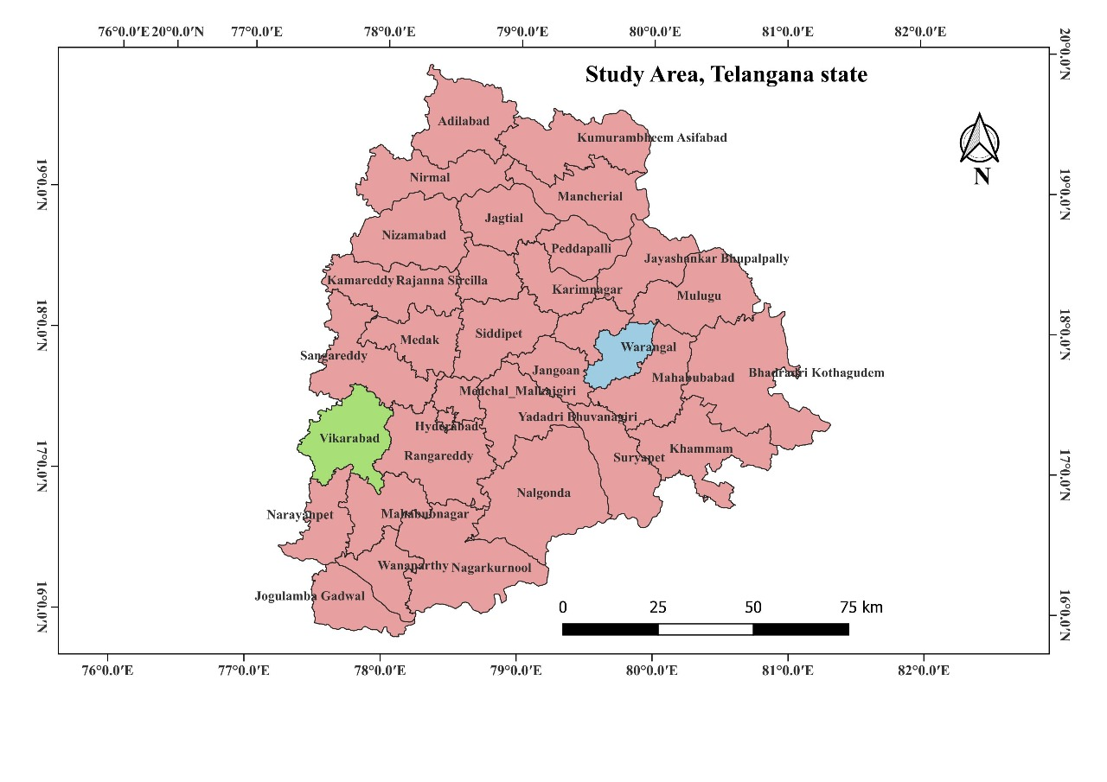
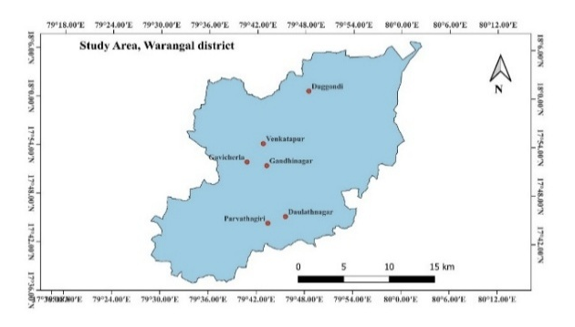Surveyed villages in the Warangal district
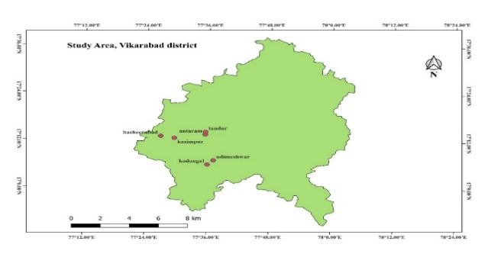
Surveyed villages in the Vikarabad district
Telangana state map indicating study area

Fig. 1. Locations of surveyed areas for the incidence of pod sucking bugs in pigeon pea in
Telangana region of India

3. RESULTS AND DISCUSSION
3.1 Incidence of pod sucking bugs on pigeon pea in Warangal district
In Warangal district, the incidence of Clavigralla gibbosa on pigeon pea revealed that high incidence was recorded in Gavicherla village of Sangem mandal at flowering stage with 0.87 egg masses, 2.4 nymphs and 1.4 adults/ plant and at pod formation stage with 3.5 egg masses, 9.3 nymphs and 6.7 adults/ plant. The incidence of Riptortus pedestris on pigeon pea revealed that high incidence was recorded in Gavicherla village of Sangem mandal (at flowering stage, 0.27 egg masses, 0.53 nymphs and 0.6 adults/ plant and at pod formation stage, 1.8 egg masses, 5.7 nymphs and 7.9 adults/ plant). The incidence of Nezara viridula on pigeon pea revealed that at the flowering stage, maximum population was recorded in Gavicherla village of Sangem mandal (no egg masses, 0.07 nymphs and 0.4 adults/ plant) and at the pod formation stage, maximum population was recorded from Gandhinagar village of Sangem mandal (0.07 egg masses, 0.27 nymphs and 0.87 adults/ plant) (significantly low population). The incidence of Anoplocnemis spp on pigeon pea revealed that it is not observed at the flowering stage, but it was observed at the pod maturation stage in Gavicherla village of Sangem mandal with 0.04 adults/ plant (very negligible population) (Table 2 & Table 3). The overall mean incidence of pod sucking bugs revealed that the peak incidence was recorded during the pod formation stage rather than the flowering stage. Among all the surveyed locations of the Warangal district, maximum infestation was noticed by Clavigralla gibbosa, followed by Riptortus pedestris, Nezara viridula and Anoplocnemis spp (Fig. 2). But in Gavicherla village of Sangem mandal Riptortus pedestris is found to be dominant along with Clavigralla gibbosa.
In the Warangal district, the percentage of pod damage was recorded as highest in Gavicherla village (32.4%), followed by Gandhinagar (30.1%), and the lowest percentage of pod damage was recorded in Venkatapur (8.9%), followed by Duggondi (10.7%) (Table 3).
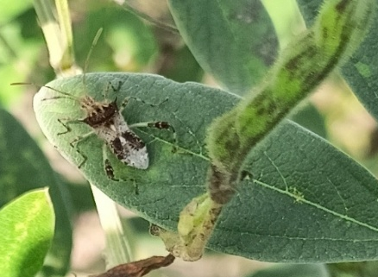  Clavigralla gibbosa | 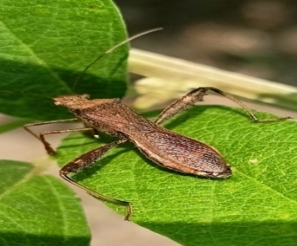  Riptortus pedestris
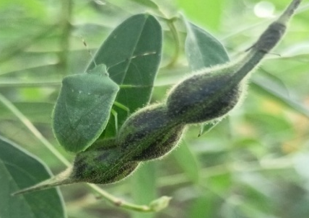  Nezara viridula | 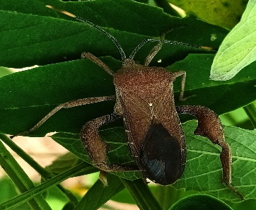  Anoplocnemis spp
Fig. 2 Different pod sucking bug species identified in farmer fields during a roving survey in Waranagal and Vikarabad districts
3.2 Incidence of pod sucking bugs on pigeon pea in Vikarabad district
In Vikarabad district, the incidence of Clavigralla gibbosa on pigeonpea revealed that high incidence was recorded in Basheerabad village of Basheerabad mandal at the flowering stage, with 0.6 egg masses, 0.87 nymphs and 1.53 adults/ plant and at pod formation stage, with 1.06 egg masses, 9.4 nymphs and 6.8 adults/ plant. The incidence of Riptortus pedestris on pigeonpea revealed that high incidence was recorded in Basheerabad village of Basheerabad mandal at the flowering stage, with 0.07 egg masses, 0.6 nymphs and 0.47 adults/ plant and at pod formation stage, maximum population was recorded from Khasimpur village of Basheerabad mandal (0.13 egg masses, 0.8 nymphs and 1.67 adults/ plant). The incidence of Nezara viridula on pigeonpea revealed that at the flowering stage, maximum population was recorded in Basheerabad village of Basheerabad mandal (0.13 egg masses, 0.07 nymphs, and 0.2 adults/ plant). At the pod formation stage, maximum population was recorded from Antaram village of Tandur mandal (0.13 egg masses, 0.47 nymphs and 0.8 adults/ plant) (significantly low population). The incidence of Anoplocnemis spp on pigeonpea revealed that it is not observed at both the flowering stage and the pod formation stage (Table 4). The overall mean incidence of pod sucking bugs revealed that the peak incidence was recorded during the pod formation stage rather than the flowering stage. Among all the surveyed locations of the Vikarabad district, maximum infestation was noticed by Clavigralla gibbosa, followed by Riptortus pedestris, Nezara viridula and Anoplocnemis spp.
In the Vikarabad district, the percentage of pod damage was recorded as highest in Basheerabad village (23.1%), followed by Antaram (18.8%), and the lowest percentage of pod damage was recorded in Kodangal (7.4%), followed by Udimeswar (11.1%) (Table 5).
A study was conducted to examine the emergence of egg parasitoids from the egg mass of pod sucking bugs. Egg masses were collected from all the surveyed locations of Warangal and Vikarabad districts during the flowering and pod formation stage, and kept in the laboratory for observing the emergence of egg parasitoids, viz., Gryon clavigrallae (Hymenoptera: Scelionidae), for two months. No emergence of egg parasitoids was noticed from the collected egg masses from different locations.
Initial incidence of pod sucking bugs on pigeon pea crop in farmer fields was noticed at the vegetative stage and continued up to pod formation and pod maturation stage till harvesting. The maximum infestation was found at the pod formation stage in both the Warangal and Vikarabad districts. This is due to a lack of awareness about pod sucking bug incidence and damage caused, no awareness of effective insecticides for controlling pod bugs, cultivating local susceptible varieties, adoption of poor management practices, and high weed conditions in the field and farmers are adopting management practices to control pod borers only. The present findings were in line with those of Kumari et al. (2023), who found that tur pod bug infestation appeared in the 32nd SMW and was maximum at the pod development stage of the crop. The bug population varied from 1.96 to 6.51, 0.72 to 6.21 and 2.07 to 6.63 bugs/plant in Mahendergarh, Rewari and Gurugram districts, respectively. These results were in accordance with Uddin et al. (2013) who reported that green stink bugs infestation occurred at the vegetative stage, flowering stage and fruiting stages in different locations of Bangladesh, causing minor damage to the crop.
Four different species of pod sucking bugs, viz., Clavigralla gibbosa, Riptortus pedestris, Nezara viridula, and Anoplocnemis spp were observed infesting pigeonpea crop at all the surveyed locations of Warangal and Vikarabad districts. Among four different species of pod sucking bugs, Clavigralla gibbosa was the dominant species and reported a high incidence of 70-80%. The present findings are in agreement with the findings of Muchhadiya et al. (2024) indicated that the potential yield loss caused by insect pests in pigeon pea could be as high as 38.48% in the absence of any plant protection strategies. Among the various insect pests, the highest level of damage was attributed to the Helicoverpa armigera (34.90%), followed by the Clavigralla gibbosa (29.75%), and Melanogromyza obtusa (23.64%).
In both the surveyed districts, the percentage of pod damage was recorded as highest in Gavicherla village (32.4%), followed by Gandhinagar (30.1%), and the lowest percentage of pod damage was recorded in Kodangal (7.4%), followed by Venkatapur (8.9%). Khamoriya et al. (2017) concluded that maximum per cent grain damage by pod bugs was observed in Tikari (16.90%) followed by Tariya (16.09%), Narayanpur (16.00%) Ramna (13.55%) and minimum per cent grain damage by pod bugs was observed in Narottampur (12.30%) village.
4. CONCLUSION
In all the surveyed locations, the maximum incidence of pod sucking bugs in pigeon pea was recorded at the pod formation stage rather than the flowering stage, which is due to a lack of awareness among the farming community about pod sucking bugs and their damage. Among four different species of pod sucking bugs, Clavigralla gibbosa is found to be highly dominant, followed by Riptortus pedestris, Nezara viridula, and Anoplocnemis spp and these pod sucking bugs cause up to 32.4 % pod damage in surveyed locations.
COMPETING INTERESTS DISCLAIMER:
Authors have declared that they have no known competing financial interests, non-financial interests, personal relationships that could have appeared to influence the work reported in this paper.

Disclaimer (Artificial intelligence)
Author(s) hereby declare that NO generative AI technologies such as Large Language Models (ChatGPT, COPILOT, etc.) and text-to-image generators have been used during the writing or editing of this manuscript.

REFERENCES
- Sunilkumar, N.M., Kamthane, J., Mallikarjun, N., Bulla, G., Goudappa, S.B., Rayudu, B.T. et al. (2024). Transplanting in redgram for resource effective crop production to unleash the potential yield. Indian Farming, 74(3), 80-84.
- Anonymous. (2024). Available online: https://www.dpd.gov.in/Annual%20Report%20%202023-24%2014.01.2025.pdf.
- Davies J.C. and Lateef S.S. (1977). Pulse Entomology. Annual Report Part-A Pigeon pea Entomology, ICRISAT, Hyderabad (AP), India.
- Daravath, V., Kasbe, S.S. and Musapuri, S. (2020). Flower chafer beetle (Oxycetonia versicolor Fabricius) on the verge of becoming a major pest on cotton in Telangana region of India: a first report. Journal of Entomology and Zoology Studies,8, 242-246.
- Veeranna, D., Reddy, R.U., Moguloju, M. and Padmaja, G. (2022). Report on heavy infestation and damage by invasive thrips species, Thrips parvispinus (Karny) on chilli in Telangana state of India. The Pharma Innovation Journal, 11(7), 3845-3848.
- Chakravarty, S., Agnihotri, M., Kumar, L. and Ahmad, M.A. (2016). Influence of weather parameters on natural egg parasitization of pod bug, Clavigrallagibbosa Spinola (Hemiptera: Coreidae) on pigeon pea. The Bioscan, 11(3), 1759-1763.
- Adati, T. Tamo, M. Yusuf, S.R., Downham, M.C.A., Singh, B.B. and Hammond, W. (2007). Integrated pest management for cowpea cereal cropping systems in the West African savannah. International Journal Tropical Insect Science, 27(1), 123-137.
- Nath, P., Singh, R.S., Keval, R. and Singh, P.S. (2008). Effect of intercropping and application of biopesticides on the pod and grain damage by pod borer complex in pigeon pea. Journal of Applied Zoological Research, 19, 111-19.
- Sharma, O.P., Gopali, J.B., Yelshetty, S., Bambawale, O.M., Garg, D.K. and Bhosle, B.B. (2010). Pests of pigeon pea and their management, NCIPM, LBS building. New Delhi: IARI.
- Singh NK, Thakur A, Srivastava OP. (2008). Evaluation of certain newer insecticides against insect pest complex on pigeon pea (Cajanus cajan (L.) Millsp.). Journal of Applied Zoological Researches, 19(1), 46-49.
- Kumari, S., Singh, B. and Dumra, N. (2023). To survey the incidence of insect-pests of pulses in South-West Haryana. The Pharma Innovation Journal, 12(9), 432-437.
- Uddin, M.S., Rahman, M.M., Alam, M.Z., Awal, A. and Mazed, M.A. (2013). Insect pests of yard long bean (Vigna unguiculata subsp. Sesquipedalis L.) in major growing areas of Bangladesh. The Agriculturists, 11(2), 66-73.
- Muchhadiya, D.V., Patel, J.J., Patel, D.R. and Patel, R.B. (2024). Estimation of yield losses caused by insect pests on pigeon pea (Cajanus cajan (L.) Millsp.). International Journal of Plant & Soil Science, 36, 410-414.
- Khamoriya, J., Keval, R., Chakravarty, S. and Mishra, V.K. (2017). Survey of the farmers’ fields for studying the extent of damage caused by major insect pests on long duration pigeon pea in different villages of Varanasi region. Journal of Experimental Zoology India, 20(2), 1071-1073.

Table 2. Incidence of pod sucking bugs on pigeonpea in Warangal district during flowering stage.
Mandal | Village | Variety | No.of Clavigralla gibbosa / Plant |  |  | No.of Riptortus pedestris / Plant |  |  | No.of Nezara viridula / Plant
Mandal | Village | Variety | E M | N | A | E M | N | A | E M | N | A
Sangem | Gavicherla | Local varieties, WRG 97 (Warangal Kandi) | 0.87 | 0.24 | 1.4 | 0.27 | 0.53 | 0.6 | 0 | 0.07 | 0.4
Sangem | Gandhinagar | ICPL 87119 (Asha), Local varieties | 0.2 | 0.53 | 0.2 | 0.07 | 0.4 | 0.07 | 0.07 | 0 | 0.33
Duggondi | Duggondi | WRGE 93, WRGE 121, WRG 97 (Warangal Kandi) | 0.2 | 0.27 | 0.3 | 0 | 0.2 | 0.27 | 0 | 0 | 0.2
Duggondi | Venkatapur | WRG 97 (Warangal Kandi), WRGE 93, WRG 255 | 0.13 | 0.27 | 0.1 | 0 | 0.07 | 0.07 | 0.13 | 0 | 0.13
Parvathagiri | Parvathagiri | ICPL 87119 (Asha), Local varieties, WRG 97 (Warangal Kandi) | 0.67 | 1.06 | 0.4 | 0.27 | 0.33 | 0.53 | 0.07 | 0.07 | 0.13
Parvathagiri | Daulath Nagar | WRGE 93, WRG 255, Local varieties | 0.34 | 0.7 | 0.8 | 0.2 | 0 | 0.46 | 0 | 0 | 0.2
 |  | MEAN | 0.40 | 1.02 | 0.53 | 0.13 | 0.25 | 0.33 | 0.04 | 0.02 | 0.23
E M= Egg masses, N= Nymphs, A=Adults
Table 3. Incidence and pod damage of pod sucking bugs on pigeonpea in Warangal district during pod stage.
Mandal | Village | Variety | No.of Clavigralla gibbosa / Plant |  |  | No.of Riptortus pedestris / Plant |  |  | No.of Nezara viridula / Plant |  |  | No.of Anoplocnemis spp. / Plant |  |  | pod damage (%)
Mandal | Village | Variety | E M | N | A | E M | N | A | E M | N | A | E M | N | A | pod damage (%)
Sangem | Gavicherla | Local varieties, ICPL 87119 (Asha), Local varieties | 3.5 | 9.3 | 6.7 | 1.8 | 5.7 | 7.9 | 0.2 | 0.27 | 0.6 | 0 | 0 | 0.04 | 32.4
Sangem | Gandhinagar | ICPL 87119 (Asha), Local varieties, WRGE 97 (Warangal Kandi) | 2.9 | 8.6 | 5.9 | 1.13 | 4.47 | 3.4 | 0.07 | 0.27 | 0.87 | 0 | 0 | 0 | 30.1
Duggondi | Duggondi | WRGE 93, WRGE 121, WRG 255 | 1.4 | 4.9 | 4.5 | 0.07 | 0.07 | 0.2 | 0.03 | 0 | 0.13 | 0 | 0 | 0 | 10.7
Duggondi | Venkatapur | WRGE 97 (Warangal Kandi), WRGE 93, WRGE 121 | 1.1 | 5.7 | 4.1 | 0 | 0 | 0 | 0 | 0 | 0.4 | 0 | 0 | 0 | 8.9
Parvathagiri | Parvathagiri | Local varieties, WRGE 93, WRG 255 | 2.7 | 7.7 | 5.8 | 0 | 0.33 | 0.73 | 0.07 | 0.2 | 0.27 | 0 | 0 | 0 | 16.8
Parvathagiri | Daulath Nagar | WRGE 97, Local varieties, ICPL 87119 (Asha) | 1.9 | 7.9 | 5.7 | 0.07 | 0.87 | 1.2 | 0.03 | 0.2 | 0.7 | 0 | 0 | 0 | 17.3
 |  | MEAN | 2.25 | 7.35 | 5.45 | 0.51 | 1.90 | 2.24 | 0.07 | 0.16 | 0.49 | 0 | 0 | 0.007 | 19.4
E M= Egg masses, N= Nymphs, A=Adults

Table 4. Incidence of pod sucking bugs on pigeonpea in Vikarabad district during flowering stage.
Mandal | Village | Variety | No.of Clavigralla gibbosa / Plant |  |  | No.of Riptortus pedestris / Plant |  |  | No.of Nezara viridula / Plant
Mandal | Village | Variety | E M | N | A | E M | N | A | E M | N | A
Tandur | Tandur | Local varieties, BSMR 736 | 0.4 | 0.8 | 1.3 | 0.07 | 0.27 | 0.07 | 0.07 | 0 | 0.2
Tandur | Antaram | ICPL 87119 (Asha), PRG-176 (Ujwala) | 0.47 | 0.93 | 1.5 | 0 | 0.13 | 0 | 0 | 0 | 0.2
Basheerabad | Basheerabad | WRGE 97 (Warangal Kandi), Local varieties, TDRG 4 | 0.6 | 0.87 | 1.5 | 0.07 | 0.6 | 0.47 | 0.13 | 0.07 | 0.2
Basheerabad | Khasimpur | ICPL 87119 (Asha), Local varieties, PRG-176 (Ujwala) | 0.47 | 0.87 | 1.1 | 0.07 | 0.07 | 0.4 | 0 | 0.07 | 0.07
Kodangal | Kodangal | TDRG-59 (Telangana Kandi 3), BSMR 736, TDRG 4 | 0.07 | 0 | 0.2 | 0 | 0 | 0.07 | 0 | 0 | 0
Kodangal | Udimeswar | PRG-176 (Ujwala), BSMR 736, WRGE 97, TDRG 4 | 0.13 | 0 | 0.3 | 0 | 0 | 0 | 0 | 0 | 0.07
 |  | MEAN | 0.36 | 0.57 | 0.98 | 0.035 | 0.18 | 0.17 | 0.03 | 0.02 | 0.12
E M= Egg masses, N= Nymphs, A=Adults
Table 5. Incidence and pod damage of pod sucking bugs on pigeonpea in Vikarabad district during pod stage.
Mandal | Village | Variety | No.of Clavigralla gibbosa / Plant |  |  | No.of Riptortus pedestris / Plant |  |  | No.of Nezara viridula / Plant |  |  | pod damage (%)
Mandal | Village | Variety | E M | N | A | E M | N | A | E M | N | A | pod damage (%)
Tandur | Tandur | PRG-176 (Ujwala), Local varieties, | 1.13 | 6.27 | 3.6 | 0.4 | 0.33 | 0.67 | 0.07 | 0 | 0.7 | 16.1
Tandur | Antaram | Local varieties, ICPL 87119 (Asha), WRGE 97 (Warangal Kandi) | 1 | 6.7 | 4.9 | 0.4 | 0.4 | 1.4 | 0.13 | 0.47 | 0.8 | 18.8
Basheerabad | Basheerabad | Local varieties, ICPL 87119 (Asha) | 1.06 | 9.4 | 6.8 | 0.27 | 0.33 | 0.8 | 0 | 0.2 | 0.67 | 23.1
Basheerabad | Khasimpur | Local varieties, WRGE 97 (Warangal Kandi), PRG-176 (Ujwala) | 0.8 | 7.06 | 5.7 | 0.13 | 0.8 | 1.67 | 0.07 | 0.13 | 0.4 | 16.7
Kodangal | Kodangal | TDRG-59 (Telangana Kandi 3), TDRG 4 | 0.4 | 3.2 | 1.5 | 0 | 0.13 | 0.67 | 0 | 0 | 0.2 | 7.4
Kodangal | Udimeswar | BSMR 736, WRGE 97, TDRG-59 (Telangana Kandi 3) | 0.86 | 3.2 | 2.73 | 0 | 0.26 | 0.73 | 0 | 0 | 0.26 | 11.1
 |  | MEAN | 0.87 | 5.97 | 4.2 | 0.2 | 0.42 | 0.98 | 0.04 | 0.13 | 0.5 | 15.5
E M= Egg masses, N= Nymphs, A=Adults

