Performance of wheat (Triticum aestivum L.) as affected by different densities of Ranunculus spp. under temperate conditions of Kashmir Valley

Abstract
A field study entitled “Effect of different densities of weed (Ranunculus spp.) on the performance of wheat crop under temperate conditions of Kashmir” was carried out at the Agronomy research farm of Sher-e-Kashmir University of Agricultural Sciences and Technology during 2021-22 and 2022-23. The experiment was conducted in RCBD comprising of six weed densities viz., D₀ (0), D₁ (25), D₂ (50), D₃ (75), D₄ (100), and D₅ (125) plants m⁻². The results revealed that wheat yield and yield-related attributes were significantly influenced by Ranunculus spp. densities, and increasing densities showed a corresponding decrease in yield. Ranunculus produced higher biomass at its higher densities of 100 and 125 plants m⁻² as compared to the lowest densities of 25 plants m⁻² which significantly affected the growth and yield of crop. The wheat yield and yield attributes were negatively affected by an increase in the Ranunculus weed density. The data revealed that during both the years of study, maximum reductions in the number of effective tillers m⁻² (23-24%), grains per ear (23-23.7%), ear weight (32-33%), 1000-grain (7-7.8%) weight, and grain yield (41- 45%) were recorded at the highest Ranunculus spp. density (125 plants m⁻²). However, the lowest density of 25 plants m⁻² also caused only 8% and 6.3% losses in wheat yield during the years 2021-22 and 2022-23 respectively. Moreover, the yield losses were higher during the year 2021-22 because of the more competitive nature of the weed during the year. Thus, the study suggested that the weed is highly competitive in wheat-Ranunculus mixtures during early stages of the crop growth and pre-emergence herbicide (pendimethalin) after sowing of wheat and post-emergence herbicide (sulfosulfuron) in the 2nd week of March have been found effective in curbing the weed (Ranunculus spp.) and attaining higher wheat yield in Kashmir valley.
Keywords: Wheat, Ranunculus spp. weed density, herbicide, yield.
Introduction
Wheat is one of the important cereal crops in the world and is a staple food of over one-third of the world population. Globally it ranks first among the cereal crops in terms of both area (219.51 million ha) and production (758.02 million metric tons) (USDA, report 2017-18). The crop is used both as human food as well as livestock feed thus serving as a dominant crop in temperate countries. In India, it is one of the important crops covering over 31.5 M ha with an annual production of 108.7 MMT and productivity of 3424 kg ha⁻¹ (Progress Report, 2021). The production has increased from a mere 11.0 MT during 1960-61 to 112.7 MT during 2022-23 (Sharma et al., 2024). This more than eight-fold increase in production was mainly due to the adoption of short stature high yielding varieties, increased fertilizer use, irrigation, and herbicides (Banjara et al., 2022). The crop provides around 21% of the per capita food energy and 18% of dietary protein in the country (Balasubramanian et al., 2012), thus playing a crucial role in ensuring food security (Chhokar et al., 2006). In the valley of Kashmir, it is grown mostly in winter as a rabi crop except in higher elevations where it is cultivated as a single summer crop. The crop is ecologically adapted to various growing environments but faces numerous challenges due to various biotic and abiotic factors. Among biotic factors, weeds are the most problematic competing for the essential growth factors (Singh et al., 2018). In addition to resource competition, these also exhibit allelopathic effects, serve as reservoirs for pathogens, act as alternate hosts for insects and fungi, and contribute to increased harvest costs (Singh et al., 2020). Substantial yield reductions have been observed due to increased pressure of the weed population (Mehra and Gill, 1988). Global studies suggest that crop losses due to weed competition exceed the combined losses caused by diseases and insect pests. The extent of these losses due to weed infestations is influenced by factors like specific weed species, their density, emergence timing, and the duration of their competition with the crop (Hussain et al., 2015; Fahad et al., 2015). Typically, the yield losses are greater as the weed density and the duration of interference increase, with losses being particularly severe when weeds and crops emerge simultaneously and the resources are scarce (Zimdahl, 2007). Thus, understanding the dynamics of weed interference is critical for predicting yield losses caused by weed infestations and for developing sustainable weed management strategies (Fahad et al., 2014). In India, yield losses due to weed infestation are approximately 18.6% resulting in huge economic that account for about USD 3,376 million (Gharde et al., 2018). Infestation by broad-leaved weeds alone in wheat can reduce grain yields by 20-30% (Wilson, 1984). Ranunculus spp. (L.), one of the important broad-leaf weeds of wheat in temperate environments poses a significant challenge to its cultivation. Four species of this weed namely, Ranunculus arvensis, R. muricatus, R. diffusus, and R leutus have been documented infesting various field crops, especially winter wheat, of which R. arvensis is the most prevalent (Singh, 2012). Prolonged infestation by this species alone can lead to a grain yield reduction of 20-40%, along with substantial depletion of soil nutrients (Kumar et al., 2010). The leaves of these plants contain protoanemonin (ranunculin), an acrid compound that renders them unpalatable to livestock (Connor, 1977). This weed once established, developed a robust, deep-rooted corm system, making its manual control difficult. High weed infestation and their competition with wheat crops for the long term is responsible for serious yield reduction (Reddy, 2004). It is therefore important to study the effect of different densities of a particular weed species on crop yields to determine the economic thresholds to control that weed species (Bajwa et al., 2018). Keeping the above points in view this study was conducted to analyse the impact of different densities of Ranunculus spp. on the performance of wheat crop under temperate conditions of Kashmir valley.
Materials and methods
The present field experiment was carried out at Agronomic Research Farm of Faculty of Agriculture, Sher-e-Kashmir University of Agricultural Sciences & Technology of Kashmir, Wadura, Sopore, Baramulla during Rabi seasons of 2021-22 and 2022-23. The experiment was sited at 34° 21' N latitude, 74° 23' E longitude and 1590 m altitude above mean sea level in the temperate zone. The region experiences a temperate climate, characterized by very severe winters and moderately hot summers. Throughout the growing period, rainfall was 675.3 mm in the year 2021-22 and 736.2 mm in the year 2022-23. The experiment was carried in RCBD with three replications. The treatments consisted of six different densities of Ranunculus spp. viz., 0, 25, 50, 75, 100 and 125 plants m⁻² that were established within 3-4 weeks after its emergence. The seeds (achenes) of Ranunculus spp. were collected from its naturally occurring local weed populations. The seeds were mixed with fine soil and broadcasted uniformly on the soil surface in each experimental plot except in the control treatment (0 weeds m⁻²). After uniform emergence of the Ranunculus weed (approximately three weeks post-crop emergence), the required densities were maintained by removing the excess seedlings. Throughout the crop growing season weed densities were maintained by regularly removing any additional emerging Ranunculus seedlings. Other weed species were manually removed from all treatments. Moreover, herbicides pendimethalin and sulfosulfuron were used as pre and post emergence in the treatment with zero density of weeds (Ranunculus ssp.) for weed management.

Results and discussion
Weed (Ranunculus spp.) biomass
The biomass of Ranunculus spp. was significantly influenced by its different densities during both years of the study (Fig. 1). Weed biomass increased hyperbolically with increasing weed densities. At lower densities the increment was rapid but as densities increased there was a marginal increase in weed biomass which could be because individual weeds acquired more biomass due to less intraspecific competition at lower weed densities. However as weed populations grew denser, there was more competition among them, which limited the amount of biomass that each plant could accumulate. significantly higher weed biomass was observed in D₅ (125 plants m⁻²) than in other densities during both years and lower weed biomass was found in D₁ (25 plants m⁻²). The increase in weed biomass per square meter with increased density could be because of the higher number of weeds per square meter. Higher weed biomass at higher weed density was also reported by Mamolos and Kalburtji (2001). Sharma et al., 2018 and Tiwari and Singh, 2024 also observed the similar results.
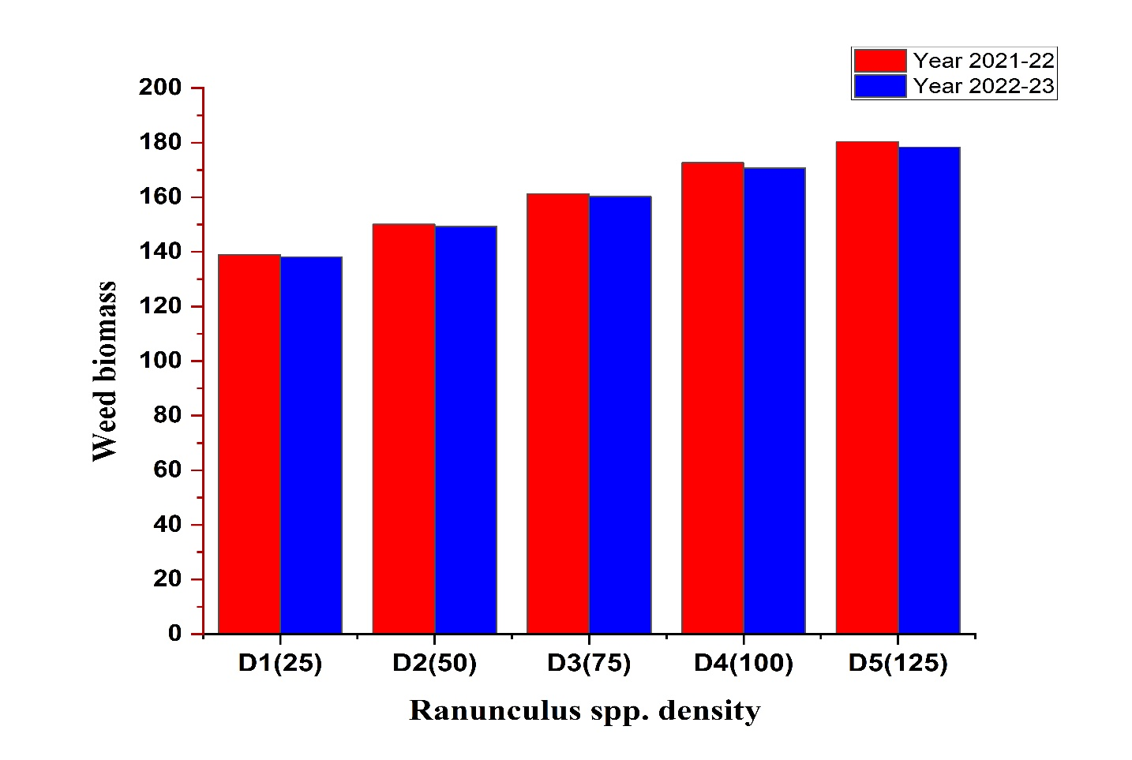
Fig.1 Effect of different densities of Ranunculus spp. on its biomass

Yield attributes and yield of wheat
Effect of different Ranunculus spp. densities on effective tillers per square meter was significant. Maximum number of tillers (356) and (368) during the year 2021-22 and 2022-23 respectively were recorded in the control (D₀) treatment. The number of effective tillers decreased with increase in weed densities (Table 1). This is probably because of higher number of total tillers m⁻² in D₀ and reduction in the number of total tillers m⁻² with increased density of weed species. Bertholdsson (2004) also observed the negative effect on effective tillers due to severe weed infestation. Moreover, Similar results were reported by Kaur et al., 2013, Jaidka and Kaur 2014 and Raj et al., 2020. Treatment D₅ resulted in minimum number of effective tillers during both the years of study. Similar effect was observed for grains per ear and ear weight which decreased successively and significantly with the increase in Ranunculus spp. densities from D₀ (0 plants m⁻²) to D₅ (125 m⁻²). Significantly higher grains ear⁻¹ and ear weight was observed in D₀ as compared to all other densities during both the years. The lowest grains ear⁻¹ and ear weight was observed in D₅ during the two years. Decrease in ear weight and grains per ear with increased density of weeds may be because of limiting resource availability, impeding photosynthesis and diverting of assimilates due to weed competition. Similar results were also observed by Bertholdsson (2004) and Kaur et al. (2013). Results also depicted that 1000 grain weight was significantly influenced by different Ranunculus spp. densities, however all the treatments were statistically at par with each. Numerically higher 1000-grain weight was recorded in D₀ (41.2 g) in 2021-22 and 42.8 g in 2022-23, respectively. The reduction in test weight with increased weed densities was also reported by Kaur et al. (2013), Jaidka and Kaur (2014) and Kulsoom et al. 2018.
Table 1 Effect of different weed (Ranunculus spp.) densities and nitrogen levels on yield attributes of wheat
Treatment Ranunculus density (m⁻²) | Yield attributes of Wheat
Treatment Ranunculus density (m⁻²) | Effective tillers (m⁻²) |  | Ear Weight (g) |  | Grains per Ear |  | Test Weight (g)
Treatment Ranunculus density (m⁻²) | Year  2021-22 | Year  2022-23 | Year 2021-22 | Year 2022-23 | Year 2021-22 | Year  2022-23 | Year 2021-22 | Year 2022-23
D₀ | 356 | 368 | 3.2 | 3.3 | 41.9 | 43.0 | 41.2 | 42.8
D₁ | 336 | 346 | 3.0 | 3.1 | 40.0 | 41.0 | 40.9 | 42.4
D₂ | 313 | 326 | 2.8 | 2.9 | 38.0 | 39.0 | 40.2 | 41.7
D₃ | 294 | 312 | 2.6 | 2.7 | 36.2 | 36.9 | 39.4 | 40.9
D₄ | 282 | 295 | 2.4 | 2.5 | 34.2 | 34.9 | 38.6 | 40.2
D₅ | 269 | 283 | 2.2 | 2.2 | 32.2 | 32.8 | 38.1 | 39.8
SEm (±) | 5.6 | 5.2 | 0.06 | 0.06 | 0.63 | 0.7 | 0.35 | 0.44
CD (P ≤ 0.05) | 16.0 | 14.8 | 0.16 | 0.19 | 1.80 | 1.9 | 1.02 | 1.27

The results also showed significant effect of Ranunculus spp. densities on grain yield of wheat during both the years (Fig.2). Highest grain yields (5.1 t ha⁻¹) and (5.3 t ha⁻¹) during the years 2021-22 and 2022-23 respectively was obtained with zero density of Ranunculus spp. m⁻². The grain yield decreased by 45 % & 41.5 % from D₀ to D₅ during 2021-22 and 2022-23 respectively. The decline in grain yield with increased density of weeds may be because of the influence on crop growth and development throughout the season and by directly competing with the crop for limiting resources like sunlight, water and nutrients (Singh et al. 2022). Comparable outcomes were noted by Negewo et al., 2006. in barley where significant yield reductions were observed as the total weed population increased per unit area. Moreover, the yield attributes like effective tillers, ear weight, grains per ear and test weight were reduced in higher densities which may be responsible for lower yields in higher densities. Similar results of decreased yield with increased densities were also reported by Walia et al. (2004), Kolb et al. (2012), Kaur et al. (2013) and Kulsoom et al. 2018. Both straw yield and biological yield were significantly influenced by weed (Ranunculus spp.) density. Among weed densities D₀ resulted in significantly higher straw yield and biological yield during both the years (Fig. 2) However, the straw yield in D₄ was statistically at par with D₅ during the two years. Higher straw yield and biological yield in D₀ was because of higher plant height, Leaf area, dry matter and maximum tillers in the treatment. Armin (2011) also observed the reduction in biological yield of wheat with increased population of weeds. Similar observations were reported by Kolb et al. 2012, Hussain et al. 2016 and Deepak and Reema, 2024.

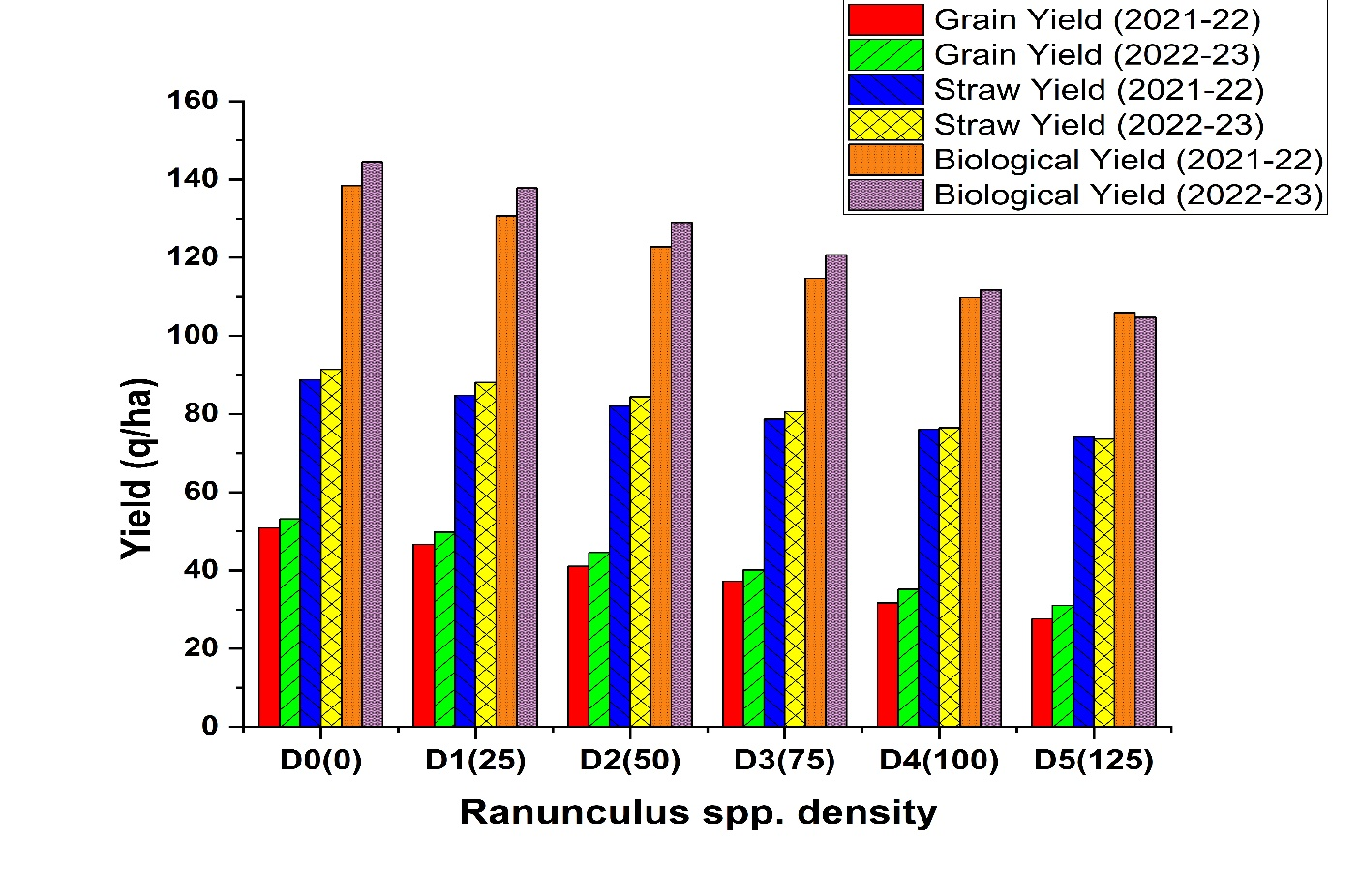
Fig.2 Effect of different densities of Ranunculus spp. on grain yield, straw yield and biological yield of wheat

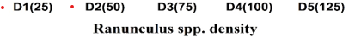
Conclusion
Based on the generalisation of results obtained from the current study, it could be concluded that co-existing plant species interact with each other for limited growth resources. The weed (Ranunculus spp.) has been found potential competent in wheat cultivation and increasing the density of this weed caused huge yield reductions due to competition for different resources. The magnitude of yield loss due to the weed ranged from 7.6 % (D₁) to 43.2% (D₅) as observed from the pooled data of the two years. Therefore, curbing the Ranunculus before critical period of weed control is highly desirable. Moreover, preemergence herbicide (pendimethalin) after sowing of wheat and post emergence herbicide (sulfosulfuron) in the 2nd week of march have been found effective in attaining higher wheat yield in Kashmir valley.

Disclaimer (Artificial intelligence)
Option 1: NO generative AI technologies have used for preparation of the manuscript and is based on original research carried out at FoA, SKUAST-K, Wadura Sopore.
Author(s) hereby declare that NO generative AI technologies such as Large Language Models (ChatGPT, COPILOT, etc.) and text-to-image generators have been used during the writing or editing of this manuscript.
Option 2:
Author(s) hereby declare that generative AI technologies such as Large Language Models, etc. have been used during the writing or editing of manuscripts. This explanation will include the name, version, model, and source of the generative AI technology and as well as all input prompts provided to the generative AI technology
Details of the AI usage are given below:
1.
2.
3.

References
Anonymous (2017) (USDA) Economic survey of India. Economics Division, Ministry of Finance, Govt. of India
Bajwa, A. A., Ullah, A., Farooq, M., Chauhan, B. S., & Adkins, S. (2019). Effect of different densities of parthenium weed (Parthenium hysterophorus L.) on the performance of direct-seeded rice under aerobic conditions. Archives of Agronomy and Soil Science, 65(6), 796-808.
Balasubramanian, V., Adhya, T. K. and Ladha, J. K. 2012. Enhancing ecoefficiency in the intensive cereal-based systems of the Indo-Gangetic Plains In: Issues in Tropical Agriculture Eco efficiency From Vision to Reality. CIAT Publication, Cali, CO.
Banjara, T. R., Bohra, J. S., Kumar, S., Ram, A., & Pal, V. (2021). Diversification of rice–wheat cropping system improves growth, productivity and energetics of rice in the Indo-Gangetic Plains of India. Agricultural Research, 1-10.
Bertholdsson, N.O. 2004. Variation in allelopathic activity over 100 years of barley selection and breeding. Weed Research 44: 78-86.
Chhokar, R.S., Sharma, R.K., Chauhan, D.S. and Mongia, A.D. 2006. Evaluation of herbicides against Phalaris minor in wheat in north-western plains. Weed Research 46:40–49.
Connor, H. E. 1977. The Poisonous Plants in New Zealand, 247 pp. Wellington, Government Printer
Deepak, Prajapat AL, Reema. 2024. Effect of Different Herbicides on Weed Dynamics in Wheat (Triticum aestivum L.). Asian Res. J. Agric. 17(4):348-53.
Fahad, S., Hussain, S., Chauhan, B. S., Saud, S., Wu, C., Hassan, S., & Huang, J. (2015). Weed growth and crop yield loss in wheat as influenced by row spacing and weed emergence times. Crop Protection, 71, 101-108.
Fahad, S., Hussain, S., Saud, S., Hassan, S., Muhammad, H., Shan, D., & Huang, J. (2014). Consequences of narrow crop row spacing and delayed Echinochloa colona and Trianthema portulacastrum emergence for weed growth and crop yield loss in maize. Weed Research, 54(5), 475-483.
Hussain, S., Khaliq, A., Bajwa, A. A., Matloob, A., Areeb, A., Ashraf, U., Hafeez, A. and Imran, M. 2016. Crop growth and yield losses in wheat due to little seed canary grass infestation differ with weed densities and changes in environment. Planta Daninha issn 0100-8358.2016
Hussain, S., Khaliq, A., Matloob, A., Fahad, S., & Tanveer, A. (2015). Interference and economic threshold level of little seed canary grass in wheat under different sowing times. Environmental Science and Pollution Research, 22, 441-449.
Jaidka, M. and Kaur, R. 2014. Spatial variability of Malva neglecta and Rumex spinosus in wheat (Triticum aestivum)– discrimination through remote sensing. Agricultural Diversification for Sustainable livelihood and Environmental Security.
Kaur, R., Jaidka, M. and Kingra, P.K. 2013. Study of Optimum Time Span for Distinguishing Rumex spinosus in Wheat Crop Through Spectral Reflectance Characteristics. Proceedings of the National Academy of Sciences, India, Section B: Biological Sciences.
Kolb, L. N., Gallangt, E. R. and Mallory, E. B. 2012. Impact of spring wheat planting density, row spacing and mechanical weed control on yield, grain protein and economic return in Maine. Weed Science 60: 244-53.
Kulsoom, U. E., Gul, J., Bakht, T. and Kanwal, S. 2018. Increasing densities of Avena fatua and Rumex dentatus reduce the yield of wheat under field conditions. Pakistan Journal of Weed Science Research 24 (2): 155-164.
Mamolos, A. P. and Kalburtji, K. L. 2001. Competition between Canada thistle and winter wheat. Weed Science 49 (6):755-759.
Mehra, S.P. and Gill, H.S. 1988. Effect of temperature on germination of Phalaris minor and its competition with wheat. Journal of Research Punjab Agricultural University 25:529–533
Negewo, T., Mekuria, M., & Hussien, T. (2006). Competition effects of major weed species at various densities on yield and yield components of barley (Hordeum vulgare L.). Pest Managment Journal of Ethiopia, 10, 53-59.

Progress report. 2020-21. ICAR–Indian Institute of Wheat and Barley Research PO Box - 158, Agrasain Marg, Karnal – 132001 Haryana, India.
Raj, R., Das, T. K., Kaur, R., Shekhawat, K., Singh, R. and Singh, V. K. 2020. Effects of nitrogen and densities on interference and economic threshold of Phalaris minor in wheat. Crop protection, 135, 105215.
Sharma, J., Tomar, S. S., Singh, A., Rajput, R. L., Tomar, S. S., & Gupta, V. (2018). Effect of fertility levels and weeds management practices on weeds dynamics, yield and economics of wheat (Triticum aestivum L.). Journal of Pharmacognosy and Phytochemistry, 7(2S), 25-28.
Sharma, R. P., Pathak, S. K., and Singh, R. C. 2007. Effect of nitrogen and weed management in direct-seeded rice (Oryza sativa) under upland conditions. Indian Journal of Agronomy 52(2):114-119.
Sharma, V., Thejesh, C., & Kumari, A. (2024). Weed Management in Wheat: A Review. (2024). Agricultural Reviews. doi: 10.18805/ag. R-2645
Singh, A., Jain, K.K. and Upadhyaya, S.D. 2018. Effect of weed control methods on weeds and wheat under Eucalyptus tereticornis based agroforestry system. International Journal of Current Microbiology and Applied Sciences 7 (8): 2856–2867.
Singh, R. P., Verma, S.K. and Kumar, S. 2020. Weed management for enhancing yield and economics of wheat in Eastern India. Indian Journal of Agricultural Sciences 90 (7): 1352–1355.
Singh, R.J .2012. Weed management in irrigated wheat (Triticum aestivum) with special reference to buttercup weed (Ranunculus spp.) in north-west Himalayas. Indian Journal of Agricultural Sciences 82 (8): 706–10
Tiwari, D., & Singh, A. K. (2024). Results of Weed Density, Yield Attributes, and Yield on Wheat Crop were Influenced by Varying Broad-spectrum Herbicide Treatments in Eastern UP, India. Journal of Experimental Agriculture International, 46(1), 96-102.
Walia, U. S. Singh, D. and Singh, M. 2004. Competitive Ability of Variable Levels of Kandyali Palak (Rumex spinosus) with Wheat (Triticum aestivum L.). Indian Journal of Weed Science 36 (l -2): 12-14
Wilson, B.J. and Cussans, G.M.1984.The effect of weeds on yield and quality of winter wheat cereals in U.K. Weed Abstract 23: 298.
Zimdahl R.L. Fundamentals of weed science. 3ª.ed. New York: Elsevier, 2007. p.151-6

