Short Research Article

Effect of Oxidative Stress on Sperm TERRA Expression and Chromatin Function in Infertile Males: Preliminary Findings

Abstract

Telomeres are vital for cellular function. Oxidative stress is detrimental to telomere function as it causes telomere attrition. Increase in oxidative stress has anegative impact on sperm telomere and chromatin integrity and therefore, on sperm function and male fertility. TERRA, a long non-coding RNA is a fundamental component required for telomere length homeostasis. Aim: The present work aimed to study the effect of H₂O₂ induced oxidative stress on sperm TERRA expression and chromatin function. Methodology: 5 infertile and 5 fertile males were selected for the study. Baseline semen analysis was done as per WHO manual 2021. Sperm TERRA expression was assessed byreal time qPCR. To assess chromatin function nuclear chromatin decondensation test was done. Results: Study showedthat 500µM H₂O₂increased TERRA expression as compared to untreated groups and the difference was found statistically significant. As compared to controls, cases showed more fold increase in TERRA expression.When the treated samples of control and cases were compared, cases had more TERRAexpression than controls however, the baseline TERRA expressions in untreated samples were less in cases as compared to controls. Both comparisons yielded statistically nonsignificant results.When nuclear chromatin decondensation was compared before and after H₂O₂treatment, the percentage of sperm head decondensationdecreased in both cases and controls. When treated and untreated samples of cases and controls were compared, the difference was statistically nonsignificant. Conclusion: Oxidative stress led to an increase in the expression of sperm TERRA and had a negative impact on nuclearchromatindecondensation.Similar studieswith greater sample size can provide much more insight intoTERRA mediated regulation of telomere function and chromatin integrity and how it is affected by oxidative stress.

Keywords: Oxidative stress, TERRA, Chromatin integrity

Introduction
Telomeres are 5’ TTAGGG 3’ tandem repeats located at the end of the chromosomes. They are a complex of DNA and proteins associated with RNA where protein and RNA contribute to the homeostasis and protection of telomeres. Telomeres provide the cells with a limited life span as telomeric repeats are lost with every cell replication due to end replication problem. Hence, telomeres act as biological clocks and regulate cell ageing. As the cell divides the telomere length keeps shortening [1].
Reactive oxygen species (ROS) are subproducts of cellular respiration. These are unstable oxygen containing molecules and primarily include O2−, H₂O₂, and OH•. Mitochondria is one of the major sources of ROS production [2]. When production of ROS exceeds the cell’s ability to neutralize them with antioxidants it leads to oxidative stress which can be detrimental to DNA, RNA as well as protein. When DNA gets oxidized there is an addition of oxygen to the nitrogenous bases which causes alteration in their structure making the DNA unstable and more susceptible to double and single stranded breaks. Out of the four nitrogenous bases, Guanine is most susceptible to oxidation. Telomeres are guanine rich structures which make them more prone to oxidative damage. Oxidative stress is known to be elevated in semen samples of infertile males and is a major contributor to DNA damage and telomere attrition [3]. Increased ROS concentrations and lower antioxidant levels in seminal plasma of infertile males were common findings as also reported in recent study [4]. Sperm and seminal plasma quality gets altered even in surgical conditions [5]. Spermatozoa with damaged or degraded DNA are linked to various conditions like poor embryonic development, poor fertilization rates and birth defects [6]. Sperm has highly compact nucleus still it is prone for oxidative damage [2]. Sperm contains mitochondria that generates ROS and is relatively deficient in antioxidative defense system [7]. Oxidative stress is also the cause of decreased fertilization potential of cryopreserved sperms [8-10].
Telomeres are heterochromatin structures hence they were thought to be transcriptionally silent, but it was recently discovered that they are transcribed by enzyme RNA polymerase II into telomeric repeat containing RNA also known as TERRA. TERRA is not translated into protein; it is a single stranded long noncoding RNA (lncRNA). TERRA originates from the transcription of C rich DNA strand hence it is G rich containing 5′- UUAGGG-3′ repeats. Recent work suggests that TERRA sustains several important functions. Long noncoding RNA TERRA plays a crucial role in maintenance of telomere homeostasis [11]. Almost 7% of TERRA is polyadenylated at 3’ and most of it is methylated at 5’ end. TERRA is localized at the chromosome cap and forms DNA RNA hybrid structures called R loops by base pairing with one of the DNA strands and displacing the other to form a loop which are involved in telomere length shortening by inhibiting complete telomere replication. In cells where telomerase activity is absent TERRA increases in telomere length by homologous recombination [12]. Excessive TERRA expression can also lead to stalled replication fork and disruption of replication leading to telomere degradation. Long telomeres have high TERRA expression localized near the 3' overhang blocking the telomerase while short telomeres show low TERRA expression hence 3' end remains accessible for telomerase activity [13]. The availability of the 3’ end of the chromosome for telomerase enzyme is essential for telomere lengthening as it acts as a substrate for telomerase enzyme. Excessive telomerase activity at the telomeric ends can lead to elongation of the chromosomes, stabilizing the telomere length hence cells avoiding aging and senescence.The oxidative stress caused by increased ROS production causes telomere attrition and DNA damage. ROS levels are elevated in sperms of infertile patients and contributes to male infertility.
TERRA regulates sperm telomere integrity and telomeres are considered regulators of sperm chromatin. Sperm chromatin decondensation is a prerequisite for male pronuclear formation. By evaluating the effect of oxidative stress on TERRA expression and nuclear decondensation, a functional association can be established between TERRA and chromatin function.
Material and Methods
As it was a preliminary study, total of 5 infertile and 5 fertile males were enrolled for the study. The cases were selected from Obstetrics and Gynecology department of All India Institute of Medical Science, New Delhi. Both cases and controls were 25-40 years of age. Cases were apparent idiopathic infertile males having at least one subnormal semen parameter. Controls were normozoospermic males having at least one live birth. Cases with any known cause of infertility such as genital infection, endocrinological disorders, genital tract obstruction, varicocele, anti-sperm antibody, and chromosomal aneuploidy were excluded from the study.The protocol for this study was approved by the Institute’s ethical committee (IECPG-209/24.03.2022, OT-07/22.12.2022) and written informed consent was taken from all the infertile cases and fertile controls.
Semen sample was collected after 2-7days of abstinence period and baseline semen analysis was performed as per WHO manual 2020 [14]. After semen analysis, the samples from cases as well as controls were treated with 500µM H₂O₂ to induce oxidative stress. The concentration was chosen after preliminary experiments which showed 500µM H₂O₂ to produce maximum ROS levels. ROS levels were measured in relative light units/second (RLU/Sec) with chemiluminescence assay after adding luminol to the sample.

Sperm Preparation (By Swim Up)
After complete liquefaction, 1 ml of semen was placed in a conical tube and centrifuged at 400g for 10 minutes. Post centrifugation, the supernatant was carefully discarded and the pellet layered with 1.5 ml fresh sperm rinse medium (Vitrolife). The tube was then incubated at an angle of 45° at 37°C for 1 hour time. The upper layer rich in motile sperm calls was collected carefully without disturbing the pellet. After extracting the upper layer containing motile cells, the media was divided into two aliquots and a treatment of 500µM H₂O₂ was given for 1 hour in one aliquot while one aliquot was left untreated.

Chemiluminescent assay
The chemiluminescence method is most frequently used as a direct approach for determining the production of ROS by spermatozoa. This assay was conducted to determine basal semen ROS levels and ROS levels of semen on exposure to 500µM concentration of H₂O₂ as this concentration giving maximum ROS was taken as a standard for further experiments.
The semen sample upon liquefaction was processed for ROS measurement. Aliquots of liquefied semen were prepared in centrifuge tubes of 1.5 ml. The first tube with no H₂O₂ treatment (0μM) was used to assess basal semen ROS levels. The remaining tubes with liquified semen were subjected to H₂O₂ 500μM. The tubes were incubated at 37℃ for 1 hour. A 5mM stock of luminol (5-amino-2,3,-dihydro-1,4-phthalazinedione) in DMSO was prepared as a working solution and ten microliters were added to each tube and served as the probe. The luminometer measured chemiluminescence per second for 10 min after addition of luminol and values of ROS were recorded for each sample.
Nuclear chromatin decondensation test:
The nuclear chromatin decondensation test (NCDT) was used to assess the spermatozoa's capacity to decondense during fertilization. The test was carried out using the nuclear chromatin decondensation test kit (Hi-Tech Solutions). All the reagents were kept at 37°C for at least 30 minutes before the start of the experiment. 100 μl of liquefied semen was taken in each of the two centrifuge tubes. The second tube was subjected to H₂O₂ treatment of 500μM concentration and both aliquots were incubated at 37℃ for 1 hour. 1 ml of wash buffer (provided in the kit) was added to the tubes, mixed well, and centrifuged for 5 min at 1500 rpm. After centrifugation, the supernatant was carefully discarded without disturbing the pellet. 200 μl of NCD solution (provided in the kit) was added to the pellet and mixed well. The tubes were incubated at 37°C for 30 min. 50 μl of stop solution (provided in the kit) was added to the tubes and incubated again at 37°C for 5 min. A drop of mixture solution was transferred onto the glass slide and examined under the microscope at 40x magnification. A minimum number of 200 condensed and decondensed heads were counted. Normal percentage for decondensed spermatozoa should be> 70%.
TERRA Expression
After sperm preparation using swim up method, sperm RNA was isolated using Qiagen RNeasy kit following the manufacturer’s protocol. Total RNA was converted into cDNA. qPCR was done to check the relative fold change in TERRA expression. Cycles for RT qPCR were 95°C for 15 s, 60°C for 1 min for 40 cycles. Relative quantities of TERRA were calculated as the ratio of TERRA to GADPH (control) as (ΔCt = Ct TERRA − Ct GADPH) and-2^{ΔΔct} assay was done to assess the fold change. TERRA and GAPDH specific primers were used for cDNA synthesis as well as qPCR (Table 1-4).

RNA isolation
RNA extraction was done after sperm preparation using Qiagen RNeasy kit following the manufacturer’s protocol. Approximately 10 million cells were pelleted down, the media was carefully removed and 600µl of RLT lysis buffer was added to the pellet. The solution was vortexed for 1 minute and 600µl of 70% ethanol was added in the tube. The solution was mixed well by pipetting. Up to 700 µl of the sample, including any precipitate was transferred, to a RNeasy spin column placed in a collection tube. The column along with the collection tube was centrifuged for 15 s at ≥8000g. The flow through was discarded. 700 µl Buffer RW1 was added to the spin column and centrifuged for 15 s at ≥8000g to wash the spin column membrane. The flow through was discarded. 500 µl Buffer RPE was added to the spin column and centrifuged for 15 s at ≥8000g to wash the spin column membrane. The flow through was discarded. 500 µl Buffer RPE was again added to the spin column and the column along with the collection tube was centrifuged for 2 min at ≥8000g. The spin column was placed in a new collection tube and centrifuged at maximum speed for 1 minute. The Spin column was placed in a new 1.5 ml collection tube. 30µl of RNAse-free water was directly added to the spin column membrane and centrifuged for 1 min at ≥8000g. The concentration and purity of the eluted RNA was checked with the help of a nanodrop spectrophotometer. The RNA was stored at -80°C.

cDNA synthesis-

Total RNA was reverse transcribed into gene specific complementary-DNA (cDNA). Reverse transcription (RT) reaction was performed by using the Super Script™ III First-Strand Synthesis System kit (Invitrogen) according to the manufacturer's protocol. 280ng of total RNA was converted into cDNA. A reaction mixture of 12µl was prepared and incubated for 5 minutes at 65°C (Table 1).

Table 1 showing components for reaction mixture

Component | Amount | Final concentration
Up to 280ng total RNA | As calculated
dNTP mix | 1μl | 10mM
TERRA specific Primer | 1μl | 2µM
GAPDH specific Primers | 1μl | 2µM
Nuclease free water | As calculated
Total | 12μl

An extension mixture was prepared and 8µl per tube was added to make the up to 20µl. (Table 2). The 20 µl solution was then incubated at 55°C for 60 minutes followed by enzyme inactivation at 70°C for 15 minutes. The cDNA was stored at -20°C.

Table 2 showing components of extension mixture

Component | volume
Buffer | 4μl
DTT | 1μl
RNaseOUT | 2μl
SuperScript reverse transcriptase | 1μl
Total | 8μl

cDNA synthesis was done on thermocycler as following-

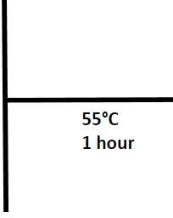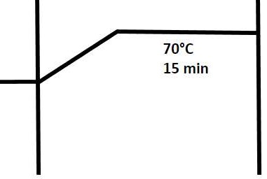

qPCR-

The above prepared cDNA was used for qPCR (Table 3). Cycles for RT qPCR: 95°C for 15 s, 60°C for 1 min for 40 cycles. Relative quantities of TERRA were calculated as the ratio of TERRA to GADPH (control) as (ΔCt = Ct TERRA − Ct GADPH). -2ΔΔct assay was done to assess the fold change (Table 4).
.

Table 3 showing components for qPCR

Components | volume | concentration
cDNA | 2μl
Primers (forward + reverse) | 1μl | 500nm
Sybr select master mix | 5μl
Nuclease free water | 2μl
Total | 10μl

PCR was performed for 40 cycles as following-
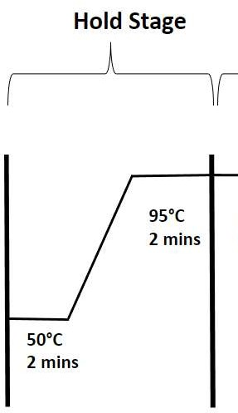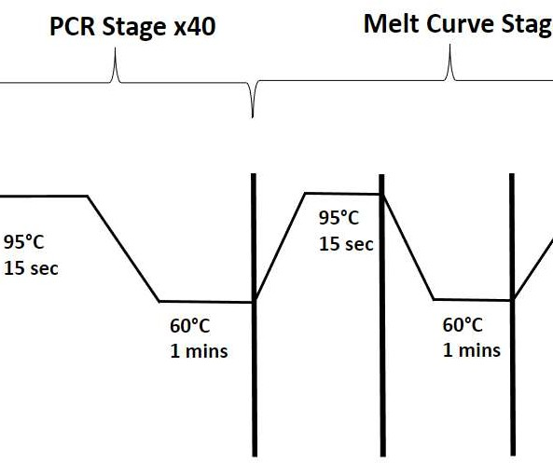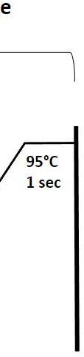

Table 4: Primer sequence of TERRA and GAPDH
PRIMER SEQUENCE | Company
TERRA primers Forward- 5'GAGATTCTCCCAAGGC AAGG 3’  Reverse- 5'ACATGAGGAATGTGGG TGTTAT 3’ | IDT
GAPDHprimers Forward- 5'AGCCACATCGCTCAGA CAC 3’  Reverse- 5'GCCCAATACGACCAAA TCC 3’ | IDT

Statistical Analysis
Data was analyzed using MS Excel and GraphPad Prism 9.5.1 with student t test and p value of < 0.05 was considered statistically significant.
Results
5 infertile cases and 5 fertile controls were recruited, and routine semen analysis was performed. Results of semen analysis are shown in tables 5 and 6. Mean motility, vitality and morphology were higher and statistically significant in controls as compared to cases (table 7). After semen analysis, the samples from cases as well as controls were treated with 500µM H₂O₂ to induce oxidative stress. ROS was measured with chemiluminescence assay after adding luminol to the sample. ROS levels were measured in relative light units/second (RLU/Sec). There was no significant difference observed in ROS levels between cases and controls in both treated and untreated experiments (figures 1 and 2).

Table 5: Semen parameters of cases

 | P1 | P2 | P3 | P4 | P5
Age | 38 | 32 | 27 | 33 | 28
pH | 8.0 | 8.0 | 8.0 | 8.0 | 8.0
Volume(ml) | 1.2 | 3 | 2.6 | 2.7 | 3.2
Motility | 42% | 43% | 54% | 58% | 49%
Concentration (million/ml) | 140 | 82 | 43 | 39 | 34
Vitality | 49% | 52% | 63% | 60% | 57%
Morphology | 1% | 1% | 1% | 1% | 2%

Table 6: Semen parameters of controls
 | C1 | C2 | C3 | C4 | C5
Age | 33 | 37 | 35 | 35 | 38
pH | 8.0 | 8.0 | 8.0 | 8.0 | 8.0
Volume(ml) | 2 | 2.5 | 3.5 | 2.5 | 3
Motility | 70% | 68% | 62% | 65% | 59%
Concentration  (millionperml) | 132 | 70 | 23 | 70 | 30%
Vitality | 84% | 81% | 68% | 72% | 65%
Morphology | 9% | 7% | 6% | 8% | 8%

Table 7: Comparison of semen parameters (mean±SD) between Cases and Controls

 | Concentration  (million/ml) | Motility | Vitality | Morphology
Cases( n=5) | 67.6±44.72 | 49%±0.069 | 56%±0.057 | 1%±0.004
Controls( n=5) | 65±44.38 | 74%±0.082 | 74%±0.082 | 8%±0.011
Pvalue | 0.92 | <0.001 | 0.004 | <0.001

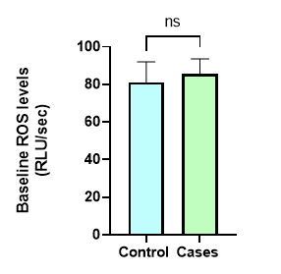
Figure 1: Baseline ROS levels (Untreated).
Data analysis was done using student’s t-test. Statistical graph was generated using graph pad prism software. p = 0.73; ns = nonsignificant.

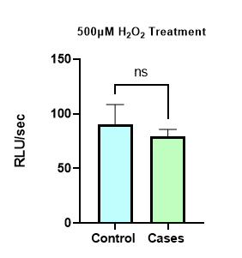
Figure 2: Mean ROS levels after 500µM H₂O₂ treatment.
Data analysis was done using student’s t-test. Statistical graph was generated using graph pad prism software p = 0.52.

To study TERRA expression, real time polymerase chain reaction was done after cDNA synthesis. Relative expression of TERRA between patient and control was assessed by 2^{-ΔΔct} method using a reference gene. It was observed that TERRA expression was increased after treatment in both cases and control after 1 hour incubation with 500µM H₂O₂ (Figure 3).

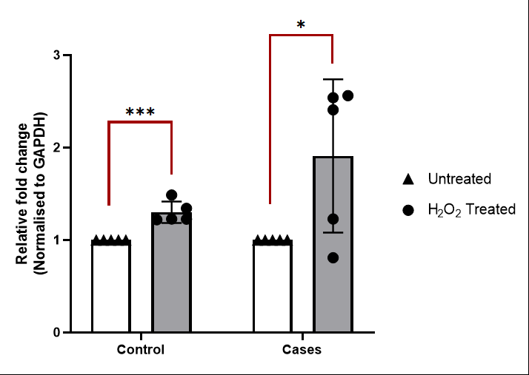

Figure 3: Relative fold change in TERRA mRNA levels before and after H₂O₂ treatment within the Controls and Cases. Normalized to GAPDH.
Data analysis was done using student’s t-test. Statistical graph was generated using graph pad prism software. P (control) < 0.001, P (cases) = 0.04

In treated samples of cases and controls, TERRA expression was seen to be higher in cases as compared to controls. The difference statistically found to be non-significant. In untreated samples of cases and controls, cases had less TERRA expression as compared to controls. The difference was statistically non-significant (figures 4 and 5).
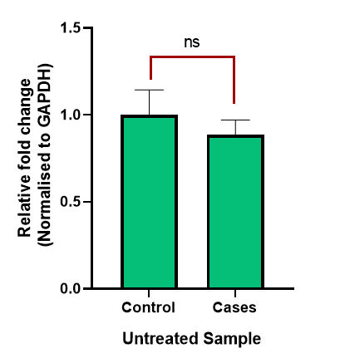
Figure 4: Relative fold change in TERRA mRNA levels in Controls and Cases (Without treatment).
Normalized to GAPDH. Data analysis was done using student’s t-test. Statistical graph was generated using graph pad prism software. P = 0.5; ns = non-significant

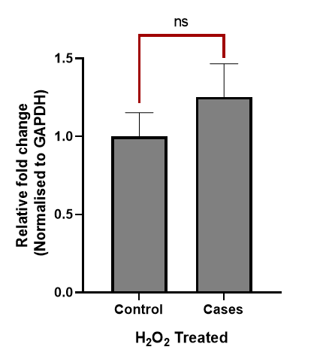

Figure 5: Relative fold change in TERRA mRNA levels in Controls and Cases after H₂O₂ treatment.
Normalized to GAPDH. Data analysis was done using student’s t-test. Statistical graph was generated using graph pad prism software. P = 0.3; ns = non-significant

After treatment with 500µM H₂O₂, it was seen that sperm head decondensation was reduced in both cases and controls. The reduction in both cases and controls after treatment was statistically significant. When the sperm head decondensation was compared between untreated samples of cases and controls and between treated samples of cases and controls, the difference was seen to be minimal, and both the comparisons were statistically non-significant (photomicrograph 1; Tables 8-10; figures 6-8).

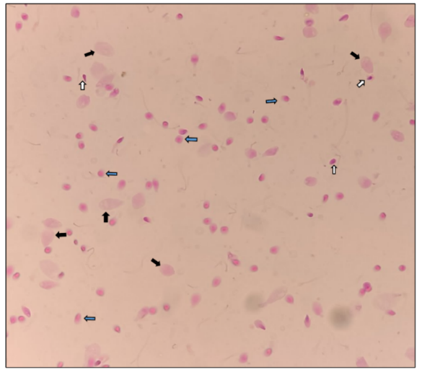
Picture 1:Condensed sperm heads marked with white arrows, moderately decondensed heads marked with blue arrows and grossly decondensed sperm heads marked with black arrows.
Table 8: Sperm nuclear decondensation of controls before and after H₂O₂treatment.
Nuclear decondensation (%) | C1 | C2 | C3 | C4 | C5
untreated group | 78 | 82 | 85 | 86 | 81
treated group | 68 | 76 | 80 | 75 | 78

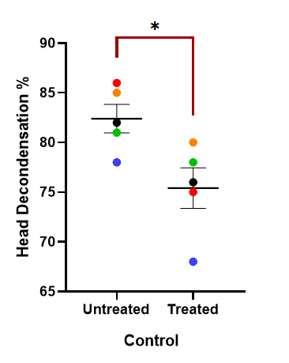

Figure 6: Nuclear decondensation before and after H₂O₂ treatment in Controls.
Data analysis was done using student’s t-test. Statistical graph was generated using graph pad prism software. p = 0.02.

Table 9: Sperm nuclear decondensation in cases before and after H₂O₂treatment.
Nuclear decondensation (%) | P1 | P2 | P3 | P4 | P5
untreated group | 84 | 79 | 80 | 84 | 85
treated group | 74 | 66 | 75 | 65 | 78

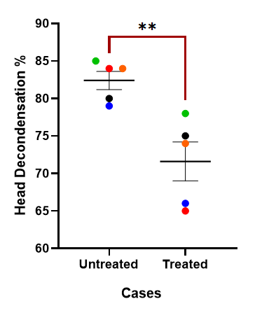
Figure 7: Nuclear decondensation before and after H₂O₂ treatment in Cases.
Data analysis was done using student’s t-test. Statistical graph was generated using graph pad prism software. p = 0.005.

Table 10: Comparison of sperm nuclear decondensation (mean ± SD) between cases vs controls (treated and untreated samples)
 | Untreated | Treated | p value
Cases | 82% ± 0.02 | 72% ± 0.05 | 0.005
Control | 82% ± 0.03 | 75% ± 0.04 | 0.02
p value | 0.99 | 0.22

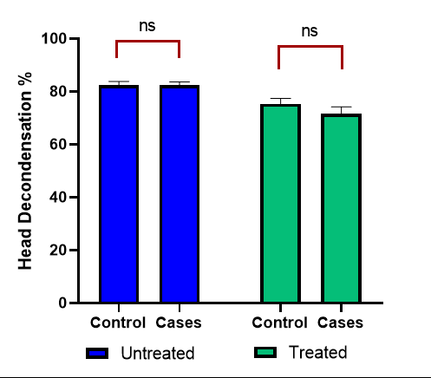
Figure 8: Nuclear decondensation before and after H₂O₂ treatment in Controls and Cases (treated and untreated samples).
Data analysis was done using student’s t-test. Statistical graph was generated using graph pad prism software. Untreated p value = 0.99, Treated p value = 0.22.

Discussion
Oxidative stress was induced by treating semen samples with 500µM concentration of H₂O₂after few preliminary experiments that showed maximum ROS produced by 500µM H₂O₂. The baseline ROS levels were higher in cases as compared controls though the difference was not significant. This finding indicates that the effect of H₂O₂treatment produced a similar extent of oxidative stress in cases and controls. Studies have shown the effect of 500µM H₂O₂ treatment on sperm and the embryo quality that it yields [15]. The effect of 500µM H₂O₂is also seen on sperm capacitation and acrosomal reaction [16]. After treatment with 500µM H₂O₂, sperm RNA was isolated to assess the effect of treatment on TERRA expression. It was seen that after the treatment TERRA expression increased in both cases and controls. Controls showed a 0.3 folds increase when compared to untreated samples while cases showed a 0.9 folds increase when compared to baseline untreated samples. 500µM H₂O₂treatment is also seen to be increasing the TERRA expression in somatic cells as a protective response towards the telomeres [17]. The antioxidant defense in semen sample of infertile males is also seen to be poor as compared to fertile males [18]. The reason for more TERRA expression in cases as compared to controls could be that the antioxidant capacity in fertile males is higher that protected the telomeres from being affected by the oxidative stress. In infertile cases this antioxidant capacity was compromised leading to telomeres getting affected by oxidative stress hence, an elevated TERRA expression. Transcription is known to be repressed in sperm due to chromatin condensation, but these cells still have transcription potential as the telomeric ends are not fully condensed [19]. Chromatin in mature sperms is seen to be associated with various transcription factors and promotor sequences [20]. Effect of oxidative stress has also been studied in another regulator of telomere which is TRF1(telomeric repeat-binding factor 1). Shelterin complex, a specialized complex of six proteins consists of TRF1, TRF2 (telomeric repeat-binding factor 2), POT1 (Protection of telomere 1), TIN2 (TRF1-interacting nuclear factor 2), TPP1 (TIN2 and POT1-interacting nuclear protein 1), and RAP1 (repressor and activator protein 1). Treatment with H2O2 altered the expression of TRF1 in both fertile and infertile males [21]. Despite of sperms being transcriptionally inert, studies have shown that factors like cryopreservation and treatment with fluoride, which is a pollutant can induce effect on their gene expression. After treatment with fluoride, both repression and induction of several genes was seen at transcription level in mice sperms [22]. Both cryopreservation and fluoride are known to induce oxidative stress in cells [23]. Exposure to H₂O₂and induction of oxidative stress can act as a stimulus and induce the cell to increase TERRA expression to protect the telomeres in sperm.When comparison was made between the untreated samples of cases and controls, TERRA expression was seen to be slightly more in controls as compared to cases, but the difference was not statistically significant. When treated control and cases samples were compared, cases showed more TERRA expression than controls, but the difference was not statistically significant.
Nuclear decondensation was decreased in both cases and controls after treatment. A drop of about 10% in head decondensation percentage was seen in cases where the average decondensation percentage before treatment was 82% and after treatment it was 72%. In controls nuclear decondensation was reduced by 7% where the average decondensation percentage before treatment was 82% and after treatment it was 75%. Both the comparisons showed a statistically significant difference between treated and untreated samples of cases and controls.
When untreated samples of cases and controls were compared, the difference was minimal showing both cases and controls had almost same nuclear decondensation ability. Case group had a lower mean motility, vitality and morphology despite of that, the group showed equivalent decondensation as fertile control groups. It can be inferred that whatever the cause of their infertility was, it was not affecting the chromatin packaging and head decondensation ability of the sperms. A comparison between treated samples of cases and controls was also done which showed that cases had slightly less head decondensation percentage as compared to controls, but the difference was non-significant.After treatment it was seen in both cases as well as controls that the TERRA expression went up whereas the nuclear chromatin decondensation percentage went down. Compensatory rise in TERRA expression and lower nuclear chromatin decondensationwere the result of oxidative stress.
CONCLUSION
Telomeres are prone to damage by oxidative stress leading to telomere attrition. Increase in oxidative stress has a negative effect on male fertility and sperm health. This study was focused on the effect of oxidative stress on TERRA which is a fundamental component required for telomere homeostasis. Induced oxidative stress increased a compensatory rise in TERRA expression whereas it decreased extent of sperm nuclear decondensation. Therefore, it can be suggested that oxidative stress commonly seen in infertile males affects chromatin integrity that may be associated with failed fertilization outcome seen in these patients. But whether rise in TERRA is beneficial or detrimental to sperm telomeres needs further studies to be conducted in larger cohorts.
Disclaimer (Artificial intelligence)
Author(s) hereby declare that NO generative AI technologies such as Large Language Models (ChatGPT, COPILOT, etc) and text-to-image generators have been used during writing or editing of manuscripts.
Conflict of interest: Authors declare no conflict of interest
Authors contribution:
Conceptualization: Mona Sharma
Research design: Mona Sharma
Experimental work: Ankur
Data analysis and Result interpretation: Mona Sharma, Ankur
Manuscript writing: Ankur
Laboratory assistance: Ashutosh Halder, Rima Dada, Neeraj Kumar
Patient selection: Reeta Mahey

References
- Valdes AM, Andrew T, Gardner JP, Kimura M, Oelsner E, Cherkas LF, et al. Obesity, cigarette smoking, and telomere length in women. The lancet. 2005;366(9486):662-664.
- Murphy MP. How mitochondria produce reactive oxygen species. Biochemical journal. 2009; 417(1):1-13.
- Aitken RJ and Clarkson JS.. Cellular basis of defective sperm function and its association with the genesis of reactive oxygen species by human spermatozoa. Reproduction. 1987;81(2):459-469.
- Dipankar SP, Kumar T, Begum HA, Naik BN, Kumar Y, Sharma M, et al. Semen Quality in Males Suffering From COVID-19: A Pilot Study. Cureus. 2022;14(11): e31776.
- Asuri K, Mohammad A, Prajapati OM, Sagar R, Kumar A, Sharma M, et al. A prospective randomized comparison of sexual function and semen analysis following laproscopic totally extraperitoneal inguinal hernia repair. Surgical Endoscopy. 2020 Jun.
- Sukcharoen N, Keith J, Irvine DS and Aitken RJ.. Predicting the fertilizing potential of human sperm suspensions in vitro: importance of sperm morphology and leukocyte contamination. Fertility and sterility. 1995;63(6):1293-1300.
- Sharma M, Kumar A. The Sperm. In: Basics of Human Andrology, 1st ed. Kumar and Sharma, eds. Springer Nature, Singapore. 2017; 171-203.
- Sharma Y, Sharma M. Sperm cryopreservation: Principles and Biology. J Infertil Reprod Biol. 2020;8(3):43-48.
- Sharma Yashaswi, Sharma Mona. Biophysics of Cryopreservation. International Journal of Thermodynamics. 2022;25 (1):17-27.
- Sharma Y, Sharma M, Halder A, Mahey R, Kumar N, Dipankar S. Temporal analysis of cryopreservation effects on human sperm phospholipase C zeta expression profile: Laboratory preliminary findings. J Lab Physicians. July 2024
- Azzalin CM, Reichenbach P, Khoriauli L, Giulotto E. and Lingner J.. Telomeric repeat–containing RNA and RNA surveillance factors at mammalian chromosome ends. Science. 2007;318(5851):798-801.
- Wang C, Zhao L and Lu S. Role of TERRA in the regulation of telomere length. International journal of biological sciences. 2015;11(3):316.
- Cusanelli E and Chartrand P. Telomeric noncoding RNA: telomeric repeat‐containing RNA in telomere biology. Wiley Interdisciplinary Reviews: RNA. 2014;5(3):407-419.
- WHO Laboratory Manual for the examination and processing of human semen. 6th ed. 2021.
- Silva PF, Gadella BM, Colenbrander B and Roelen BA. Exposure of bovine sperm to pro-oxidants impairs the developmental competence of the embryo after the first cleavage. Theriogenology. 2007;67(3):609-619.
- Rivlin J, Mendel J, Rubinstein S, Etkovitz N, Breitbart H. Role of hydrogen peroxide in sperm capacitation and acrosome reaction. Biol Reprod. 2004;70(2):518-22.
- Galigniana NM, Charó NL, Uranga R, Cabanillas AM and Piwien-Pilipuk G. Oxidative stress induces transcription of telomeric repeat-containing RNA (TERRA) by engaging PKA signaling and cytoskeleton dynamics. Biochimica et Biophysica Acta (BBA)-Molecular Cell Research. 2020;1867(4):118643.
- Pahune PP, Choudhari AR. and Muley PA.. The total antioxidant power of semen and its correlation with the fertility potential of human male subjects. JCDR. 2013;7(6):991-995.
- Ren X, Chen X, Wang Z. and Wang D. Is transcription in sperm stationary or dynamic? Journal of Reproduction and Development. 2017; 63(5):439-443.
- Jung Y H, Sauria MEG, Lyu X, Cheema MS, Ausio J, Taylor J, Corces VG. Chromatin States in Mouse Sperm Correlate with Embryonic and Adult Regulatory Landscapes. Cell Reports. 2017; 18(6):1366–1382.
- Anisha J, Mona S, Rima D,Reeta M, Ashutosh H, Deepak P. Effect of Oxidative Stress on Sperm Shelterin TRF1 Expression and 008 Chromatin Function in Infertile Males: Preliminary Findings. Glob J Reprod Med. 2024; 10(5): 555800.
- Sun Z, Niu R, Wang B, Jiao Z, Wang J, Zhang J, et al. Fluoride-induced apoptosis and gene expression profiling in mice sperm in vivo. Archives of toxicology. 2011;85:1441-1452.
- Agarwal A. Saleh RA, Bedaiwy MA. Role of reactive oxygen species in the pathophysiology of human reproduction. Fertil Steril; 2003;79:829-843.

