Enhancing Community Health Programs: Roles, Operations, and Data-Driven Innovations

ABSTRACT

Aims: To examine how data-driven strategies can be integrated into community health programs as innovative approaches for effective operation.
Problem Statement: Numerous government engagements in different crucial sectors have limited her concerns about health provision and distribution to many citizens living in remote communities. Health provision characterized with easy accessibility and low cost should not be marginalized and should be the right of every citizen. However, many lives have been lost due to lack of this in some communities.
Significance of Study: To curb this, non-profit sectors are now engaging in community health programs to ameliorate the difficulties faced by distanced citizens living in remote localities. With the advent of this program, it is imperative to incorporate data-driven strategies as innovative approaches to improve and enhance the current state of operations in community health programs.
Discussion: A medical practice that addresses the well-being of people within a particular geographical location is referred to as community health. This technical review paper discusses the concepts, roles and mode of operations of community health workers and the programs that are embedded. The attributes of a robust well-functioning health system as stated by World Health Organisation (WHO) were discussed alongside program components that are often executed by village workers. Value-based care, patient-centered care and P4 medicine were identified as the major ideologies behind data-driven strategies and the characteristic features of each were adequately discussed.
Conclusion: A data-driven healthcare innovative approach must put into consideration the real definition of data management policies, organize training for health care workers who are handling health data and also support the implementation in order to secure the designed information systems.

Keywords: Community Health Programs, Data-Driven Strategies, Innovative Approaches, Non-profit sectors,

1. INTRODUCTION
Community health is an agglomeration of social responsibilities and health care services putting economics into consideration as well. The socioeconomic conditions and health risks of citizens living together in a particular domain are usually peculiar [1]. A medical practice that addresses the well-being of people within a particular geographical location is referred to as community health. This crucial public health division entails programs that are beneficial to members within a neighborhood in order to protect and improve their health conditions, prevent infectious diseases transmission, and equally strategize for any unexpected natural calamities. For instance, members within a community may remain unprotected from kinds of industrial pollutants or ground water contaminants or dump site wastes and become vulnerable if quick medical intervention is not sourced [2]. Thus, public wellness programs consider the concerned citizens in treatment decision-making policies for them to seek preventive health services with drastic reduction in hospital costs. Community health is usually mistakenly interpreted for population health. Though the duo are interrelated but they possess some different features. Community health entails organization or individual collective efforts for the provision of better health care for people within a well-defined cultural group or a geographical location while population health adopts outcome-based driven methodologies for the health welfares of some certain group of people who are basically classified via attribution [3].
All the aforementioned are crucial selfless services that are usually placed within community-based programs under different circumstances. Additionally, they are also charged with the responsibility of increasing people’s ability to have access to both resources and technology that will enhance their health well-being and caring practices. The programs also serve as catalysts for social demand services mobilization alongside policy change generation. Both the part-time and full-time workers in community-based programs usually volunteer to engage in household interaction in order to protect their nutrition and health; and also grant them easy access to medical attentions [4]. The major focus are usually children and their mothers while others within the household are also put into consideration aftermath. Usually, a particular central point is usually allocated within a community for people to visit and seek for medical attentions. Alternatively, are visited at home for growth promotion and monitoring by both nutrition and health workers. The essential characteristics of these programs with reference to the community and immediate health facilities include the training, existence, supervision and support of the community worker. A major aspect of community-based health and nutrition programs (CHNPs) are the community organizations. Figure 1 is the diagrammatic representation of the steps involved in the framework of community-based programs.
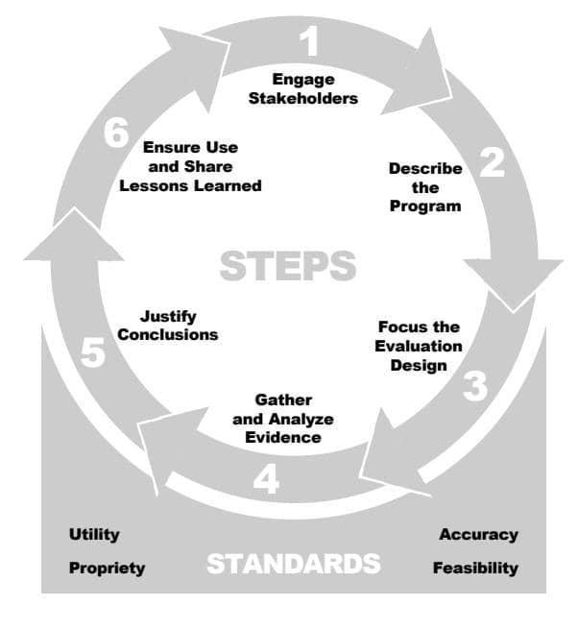
Figure 1: Diagrammatic representation of the steps involved in the framework of community-based programs [2]
Economic and social status such as nutrition, poverty, war, water source, transport services and crime have been identified as major population influencing factors by health care workers in urban areas. They also resolve how the education and health services of the community are related to peoples’ lives and necessary measures to be taken. Crucial components of community health include (1) development of an intervention plan to tackle urban infrastructure deficiencies like setting up of mobile clinics, community health centers and outreach services (2) substantial public health issues Identification like environmental and social impacts on healthy living around a particular geographical location (3) informing people about safe lifestyles and medical treatment importance; and promoting life changes (4) advocating for urgent treatment intervention for high risk communities to both federal and state officials (5) safeguarding the provision of critical medical services like therapy, screenings and counseling (6) address medical emergency cases having to do with reduction of costs for expensive hospitalizations and treatments; and lastly (7) working hand-in-hand with other neighborhood members to deliberate on physical, emotional, social and cultural attributes of the city together with nutrition, housing and transportation [5].
However, there are needs for innovative approaches to enhance all the aforementioned community health services. Access to healthcare and its quality improvement is currently a world-wide challenge owing by the daily increase in population lifespans and increase in chronic diseases [6]. The recent COVID-19 pandemic health crises claimed more than three million lives globally and also caused mental health problems, chronic diseases risk and increase in maternal morbidity which further emphasize trials in healthcare provisioning. Based on this pathetic experience, pre-pandemic, delivery amidst low-income countries and disparities to healthcare delivery have been characterized with many factors such as poor technological and physical infrastructure; unproductive regulations and policies; social discrepancies; improper awareness, lack of appropriate capabilities to enhance the sustainability of executed health system interventions. Furthermore, the distribution of healthcare staff around urban and rural areas has been a subject of concern which has been a major contributor to perceived inequities. Thus, it is essential to improve global health systems via innovative approaches involving the integration of data-driven methodologies [6].
A robust well-functioning health system has been described by the World Health Organisation (WHO) to possess the following basic building blocks, namely (1) well-functioning health workforce (2) delivery of worthy health service (3) enhances access to vital medications and other supplies (4) reliable health information scheme (5) exhibits operational governance/ leadership and lastly (6) adopts an effective health financing scheme. However, attainment of these excellent goals are usually very challenging for numerous low-income countries [7]. Despite this, enhancement of both non-technological and technological innovative capacities in providing healthcare solutions by middle and low income countries have been adopted in avoiding the intrinsic challenges faced. While inventions are considered essential in reacting to the biases in healthcare, systemic obstacles such as personalities that alleviate innovations, high workload, suboptimal communication and workers resistance as a result of improper benefits understanding are in existence. Therefore, it is compulsory to couple health innovations with the increased need of stakeholder education on the system alongside the expected benefits to be gained [8].
Healthcare solutions basically involve the adoption of innovative technologies for the provision of health care services, delivery of medicines to demoted geographical locations and promotion of perfect health information. Many low- and middle-income countries have adopted the use technology-based solutions to expand health systems and delivery of services such as child and newborn health services, diabetes care, maternal behavioural change communication, telepsychiatry, vaccination, cardiovascular risks reduction and delivery of integrated health services [2]. Furthermore, studies have shown that mobile technologies permit efficacy in services delivery because of easy accessibility to data. In addition to this, social media was also recognized as an efficient instrument of information dissemination for healthcare services, healthcare monitoring and epidemic surveillance. However, the use of social media and mobile technologies for these purposes are limited by improper access to devices, poor internet connectivity, low literacy levels and cost-prohibitive service provision in numerous low- and middle-income countries [9].
Additionally, the prevalence of health misinformation with the aid of social media platforms stresses that encouraging a technology on its own as a resolution is not sufficient. Therefore, for a globally susceptible population yearning for social media, it is important to monitor health information for reliability and quality [3]. Conclusively, the understanding of innovative strategies in the reinforcement of health systems demands a multi-dimensional survey of (1) health information design systems involving the examination of platforms utilized for health information dissemination (2) health systems planning which entails discussion of any approved policies during planning processes together with human resources and financing issues (3) engagement of stakeholder in the design of health systems as a means for the identification of stakeholder and involvement during design processes and (4) adoption of health service delivery technologies which entails the mobile technologies application in the provision of service [10].
The use of data-driven innovative is becoming applicable in community health care services. Data is revolutionizing and dominating healthcare industry in extraordinary ways. They are becoming prevailing and promising in the creation of foundations for a new prototype of medicine in association with the new technologies of artificial intelligence focusing on each person individuality. In current decades, nonprofit sector has come under substantial inspection by clients, funders, and the general public has resulted in focusing on organizational and programmatic outcomes data assembling and reporting which are basically aimed at improving accountability in the entire sector [11].

2.0 What are Community Health Programs?

Community health programs (CHPs) are usually started and managed by the health sector, but occasionally a separate ministry or service is organized. Efforts to engage national coordinating body seem to be ineffective causing widespread community programs. This incompetence stems from the propensity of the coordinating body not to have direct autonomy on fieldworkers or the budget to form a national program with abundant coverage and intensity to have a measurable influence. In most cases, the services attached with social welfare programs and poverty alleviation can execute this role [12]. Engagement of health services remains crucial because most times operational agencies needed for the programs are usually based on referral. Community health programs have been highly significant and responsive to communicable diseases than the non-communicable ones putting poverty into consideration and in cases where under-nutrition is prevailing. However, behavior change promotion occurs via counseling in cases where diet-related chronic diseases are manifesting as a result of poverty. Promotion of improved diets necessitates access to outlets for vegetables and fruit usually displaced by fast foods. This should be a subject of concern which should be included in community activities just like the usual lifestyle developments such as using recreational facilities and daily exercise [13].
Activities such as behavior change and direct prevention are usually included as part of CHPs. As visualized with primary health care, sanitation, water, and other areas of environmental health are often involved together with agricultural interventions. Figure 2 represents the structure showing the relations between supervision services and community contacts (i.e. the facilitators) and the community workers (called mobilizers). The activities involved in CHPs that is the program content are accustomed and are briefly discussed for referencing purposes. Program components executed by village workers are categorized below and form a menu with the actual mix based on local conditions and capabilities [14].
- Prenatal care program involves pre-pregnancy weight checking; inspection of weight gain in pregnancy; monitoring of blood pressure and anemia; immunization for tetanus; provision of numerous micronutrient supplementation; diet counseling; workload and breastfeeding; and lastly delivery prediction and arrangement.
- Women’s health and nutrition program engages in health and nutrition counseling together with checkups; promotion of better status and resource allocation within and outside home; promotion of advanced health services access; and also involvement in women counselling on family-planning services.
- Breastfeeding program includes provision of information on knowledge and practices involving initial, continued and exclusive breastfeeding; mutual support arrangement; building of confidence; undermining and misinformation factors prevention; facilitation of breastfeeding time; and information provision during the infant formula code.
- Complementary feeding program involves counseling and knowledge provision (such as timing of type, introduction, energy density, frequency, and so on); sometimes promotion of village or urban area production regarding foods weaning; marketing of inexpensive food; facilitation of mother’s time distribution; and technological advancement with reference to food preservation, storage and hygiene methods (such as refrigeration and fermentation).
- Growth promotion and monitoring program entails equipment (charts, scales, manuals); supervision and training; weigher training purposely to counsel mother and interpret charts; and referral coordination for problems involving counseling, treatment, or preventive intervention in cases where growth is wavering). Monthly weighing and weighing at birth should possibly be involved coupled with satisfactory weight gain. All these should be adopted for urgent intervention and guidance on counseling.
- Micronutrient supplementation as part of community health programs should involve distribution of vitamin A for both pregnant and non-pregnant women (low dose on weekly basis); massive dosing of pregnant women with vitamin A for those whose delivery expectation is within one month in order to safeguard infant via breast milk; massive dose for children and infants at nine months immunization contact and thereafter every six months and when stated medically. Micronutrient supplementation should also entail vitamin A on weekly or daily basis supported with immunization campaigns. For pregnant women, adolescents and children, dosage of iron should also be on daily and weekly basis. Provision of iron is often done with folic acid and may be provided as part of several micronutrient supplementation. Provision of iodine is usually via fortification and this exercise is done based on necessity. Thus, it can be infrequently executed six-monthly as oral supplement. However, it should be included in multiple micronutrients for pregnant women.
- Micronutrient fortification is not frequently involved locally as part of community health programs, although it is an imperative central program. However, local monitoring is an expected opportunity, particularly of iodized salt testing kits.
- Supplementary feeding program may be necessary in cases of extreme poverty with the aid of external supplies involving provision of 200 to 500 kilocalories per person daily but otherwise it is to be eluded as costly when high opportunity cost sets in, and not very operational; moreover, it can alter programs, which come to be perceived largely as an origin of free food. Also, supplementary feeding with the aid of local supplies can be helpful for complementary feeding in terms of weaning if well-organized requiring some resources. Community processing and production in villages are often instrumental in this regard if feasible which enables the system movement to coupon method.
- Oral rehydration program includes highly operational local provisions for dehydration in acute diarrhea coupled with oral rehydration salts. Mothers counseling are required in these preparations and it consumes many parents’ precious time. Persistent diarrhea needs other intervention which are nutritional. In this discourse, children care during sickness particularly foods and continued breastfeeding should be adequately stressed. This is applicable to other illnesses.
- Immunization and deworming programs includes referring, informing and facilitating. It also requires dosage supervision and distribution of mebendazole on monthly basis. This is a highly effective nutrition interference but the distribution methods can be an issue.
In summery to this, the comparative appropriateness of facility- and community-based operations for the various components is a function of the local conditions, and these operations should be corresponding. Community activities are crucial for child and infant feeding; other caring activities, environmental hygiene, and the likes. Facilities are major factors in prenatal care, immunization and referral for treatment. However, micronutrient interventions, monitoring of growth, oral rehydration and related activities can be fully focused in either. A community-based program, due to its attribute in regular contact with clients, may be a more effective tool in truly reaching children and mothers with the component interventions than the one that has been recognized already as facility based [15].
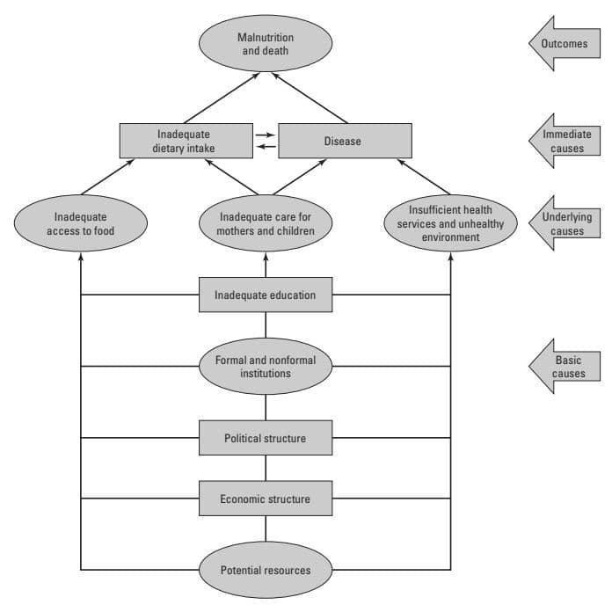
Figure 2: Structure showing the relations between supervision services and community contacts and the community workers

2.1 Importance of Community Health

The huge population living in rural areas have limited access to appropriate care and treatments at the point of their needs. Pregnant women, elderly people, persons with chronic illness and many neo-natal living at a distant location from a hospital are usually at high risk. Community health system is a promising tool in this regard. The major importance are stated therein:
2.1.1 Addressing discrepancies in getting access to good health care
Small and rural cities having less per capita income; doctors’ shortage; unavailability of hospitals; and healthcare disparities may be tremendously pronounced in community health. Such populations are usually at high exposure risk characterized with drug abuse, extreme poverty and many other risks to life and human health. The general community service level can be intensely increased if a regional health system who accounts for the particular attributes of the community is orderly arranged to meet the required needs.
2.1.2 Health care costs minimization
Social health is a significant section of health policy reforms determined at reducing healthcare public spending. Public health services execute tasks within a patient-centered model treatment which also includes decisions making with reference to patients on care. This model enables physicians to guide patients away from costly visits to the emergency department to discourage deteriorations.
2.1.3 Public health centers and programs establishment
Community health services have become vibrant instrument in public health efforts such as HIV epidemic halting, war against drug crisis and ongoing Covid-19 pandemic. The universal strategy of health treatment allows physicians to avoid and manage a variety of disorders concurrently. Figure 3 is the general structure of community health programs.

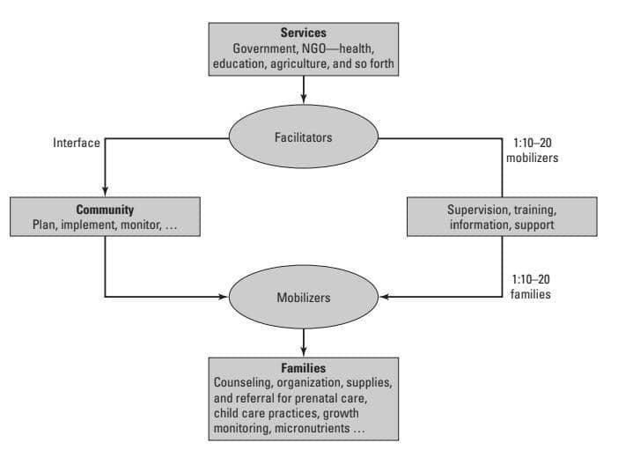
Figure 3: General structure of community health programs [16]

3.0 MAJOR IDEOLOGIES OF DATA-DRIVEN STRATEGIES AS RELATED TO COMMUNITY HEALTH PROGRAMS

The major ideologies behind data-driven strategies include value-based care, patient-centered care and P4 medicine. The two overlapping but distinct care ideologies are value-based care and patient-centered care. Patient-centered care involves numerous dimensions of patient-centeredness and places the patient and relatives central to all evaluations and decisions of quality [10]. The patient-centered care areas include (1) friends and family involvement; (2) education and information; (3) care coordination; (4) secure transition and continuity between health care settings; (5) respect for the patient’s preferences, values and expressed needs; (6) care access; (7) physical comfort; and (8) emotional support in order to relieve anxiety and fear. Though these dimensions have been fundamentally applied in relation to hospital-based care, they are also applicable to care in the ambulatory setting. In contrary, value-based care could be regarded as the care quality majorly evaluated by cost and healthcare outcomes. Based on this value conception, patient-centeredness is one significant but not essentially principal quality measure [17].
In merging value-based care and patient-centered model together, patients should equally be allowed to collect their outcomes data and be given autonomy to have access to using their health data in applicable means like self-managing their health in collaboration with their health care providers. In an ideal environment, the clinician-patient relationship is influenced by computer-based guidance and communications systems. With this, medical records are available everywhere and internet-based in a way that patients could frequently complete surveys on their experiences which are in real time fed back to clinicians in order to improve their care. Patient-centered care is a major element of a health system which warrants that all patients have access to their suitable and working care type. This model is dominant not only in treating the disease but also to meet the patient’s personal and social desires to guarantee the best outcomes including satisfaction and quality. The patient treatment with this whole kind of personalization needs a 360-degree assessment of patient data that is accessible to both the care team and the patient. In order to achieve better patient outcomes for value-based healthcare, smarter and better partnership between healthcare professionals are needed [18].
The vision of medicine that is preventive, predictive, participatory are personalized is termed “P4” which has been advocated by systems medicine pioneers. Systems methodologies to medicine and biology are now becoming to provide consumers, patients and physicians with personalized information regarding each individual’s distinctive health experience on both disease and health at the cellular, molecular and organ levels. This precise piece of information is allowing disease care to be additionally cost effective via care personalization to individual’s distinctive biology and causes treatment rather than the disease symptoms. It is also providing the foundation for tangible action by consumers to improve their health as they perceive their lifestyle decisions impact [15]. P4 medicine possesses great promise to lessen chronic diseases burden via harnessing technology and a progressively better understanding of evidence-based interventions, environment-biology interactions and the underlying chronic diseases mechanisms. The P4 medicine supports that the individual‘s participation is major in putting other three aspects of P4 into practice with individual patient. The active participation of patients is essential to assure effective self-management which involves sharing of decisions with patients for their therapeutical or clinical approach and using novel technologies to execute the patient’s involvement in the disease management to assure obtaining relevant and significant improvement in terms of outcomes [19].

3.1 APPLICATION OF DATA-DRIVEN STRATEGIES IN COMMUNITY HEALTH PROGRAMS AS INNOVATIVE APPROACHES

Huge volumes of data are usually routinely generated by healthcare sector from various sources such as electronic medical records, biochemical exams, patient-reported outcomes, vital signs, clinical trials, health surveys, administrative data, insurance claims and more recently omics such as transcriptomics, genomics, metabolomics, proteomics, microbiomics and radiomics just like in numerous other industries. Overall, these datasets symbolize huge data collections which are crucial to better patient care quality, supporting decision-making, reduction of readmissions and overall improvements in outcomes. However, huge data collection is not similar to data-driven healthcare. While the availability and increase of data can enhance a complete new epoch of fact-based innovation in healthcare, automation is needed to clarify decision-making and streamline processes in a manner that advances both operational agility and clinical outcomes [8].

With reference to the new regulatory system tailoring progressively toward value-based and patient-centered care, healthcare institutions must transit to becoming data-driven healthcare institutions from healthcare data collection institutions. Resources and new investment are required to become a data-driven healthcare institution in order to team members in making the most cognizant decision and allow the organization in reaching its goals. New data-driven health management must be adopted in clinical decision-making so as to reduce future individual disease risks and chronic health effects and to progress value-based and patient-centered care models [14].
In order to attain this new rank, it is imperative to organize data-driven processes, a data infrastructure, a cybersecurity framework and a data-centric culture. Data-driven healthcare can be divided into four different categories which include (1) data regulation for perfect privacy, accountability and security purposes; (2) data utilization by healthcare professionals, patients and organizations; (3) data-driven innovations enhancing new data production and (4) computational methods and technologies that assist healthcare professionals in making data-driven decisions in order to improve health outcomes. In order to advance and incorporate the effective data use by all patients, stakeholders, organizations and healthcare professionals, a data-driven healthcare technique must envisage the following goals: (1) advocating literacy and education to broadcast awareness about data-driven healthcare significance among healthcare professionals and patients; (2) establishment of an incorporated healthcare system that basically focuses on the patient via the provision of broad and easy data access; (3) promotion of investment and management initiatives in governing data to minimize resistance to alteration within healthcare organizations [20].

Presently, organizational culture has become the biggest obstacle in data-driven healthcare. Overcoming of investment and technological challenges in this regard may prove difficult. Data privacy, accountability and its security in healthcare are often complex topics, targeting at ensuring protection of medical records and applications, securing information exchange integrity about a patient and controlling access to healthcare applications and systems containing personal data. Assessing and monitoring regulatory data processing compliance is a key factor at both personal and organizational level [12].

A data-driven healthcare innovative approach must put into consideration the real definition of data management policies, organize training for health care workers who are handling health data and also support the implementation of secure by design information systems. Moreover, the revolution toward data-driven healthcare is unlimited to the way data is collected, analysed, processed and utilized but also involves responsibility and surveillance from all stakeholders who are majorly patients, healthcare providers, government, suppliers of healthcare providers and insurance companies [13]. Existent technologies already enable patients and healthcare professionals to participate more actively together to increase health outcomes. The increase in remote medical monitoring enhanced with utilization of medical mobile devices to strongly monitor patients’ conditions; the utilization of cloud-based storage and applications in order to allow better communication and improving patient experience; and the rising acceptance of wearable medical devices indicate that health technology is becoming a serious area of specialization [18].

All these aforementioned technologies are enhanced by innovative computational methods designed to execute intelligent monitoring; develop predictive models for prevention, diagnosis, early disease detection, prognosis and treatment and; propose or analyse interventions and treatment plans. Computational methods have the capacity to extract value from huge data but in most cases, they face some difficulties such as data readability and accessibility problem; input data size and its relevance; and data interoperability challenges. To make data more applicable, the data collected must be complete, clean, standardized and accurate for utilization across systems. It should also be easily readable by and accessible to various stakeholders with kinds of task like the regulatory entities, scientific community and healthcare professionals so as to guarantee peer-review [18]. These continuing trends have made proficient foundation for the coming generation of innovations including using artificial intelligence to develop preventive, precise and personalized medicine which entails combining statistical methods and big data analytics commonly referred to as machine learning algorithms [19].

4. Conclusion

A medical practice that addresses the well-being of people within a particular geographical location is referred to as community health. In this technical review paper, the concepts, roles and community health workers mode of operations and the programs that are embedded are discussed. The attributes of a robust well-functioning health system as stated by World Health Organisation (WHO) were listed to include well-functioning health workforce; delivery of worthy health service; enhances access to vital medications and other supplies; reliable health information scheme; exhibits operational governance/ leadership; and lastly adopts an effective health financing scheme. Additionally, value-based care, patient-centered care and P4 medicine were identified as the major ideologies behind data-driven strategies and the characteristic features of each were adequately discussed. Amongst these, the identified features of patient-centered care areas were stated to include friends and family involvement; education and information; care coordination; secure transition and continuity between health care settings; respect for the patient’s preferences, values and expressed needs; care access; physical comfort; and emotional support in order to relieve anxiety and fear. In conclusion, a data-driven healthcare innovative approach must put into consideration the real definition of data management policies, organize training for health care workers who are handling health data and also support the implementation in order to secure the designed information systems.

Disclaimer (Artificial intelligence)
Option 1:
Author(s) hereby declare that NO generative AI technologies such as Large Language Models (ChatGPT, COPILOT, etc) and text-to-image generators have been used during writing or editing of manuscripts.
Option 2:
Author(s) hereby declare that generative AI technologies such as Large Language Models, etc have been used during writing or editing of manuscripts. This explanation will include the name, version, model, and source of the generative AI technology and as well as all input prompts provided to the generative AI technology
Details of the AI usage are given below:
1.
2.
3.

References

1. Rahman MA, Halder HR, Islam SMS. Effects of COVID-19 on maternal institutional delivery: fear of a rise in maternal mortality. J Glob Health 2021 Mar 1;11, (03041).

2. Fayyaz Z, Ebrahimian M, Nawara D, Ibrahim A, Kashef R. Recommendation systems: algorithms, challenges, metrics, and business opportunities. Appl Sci, 2020, 10:7748

3. Moorhead S, Hazlett DE, Harrison L, Carroll JK, Irwin A, Hoving C. A new dimension of health care: systematic review of the uses, benefits, and limitations of social media for health communication. J Med Internet Res 2024;15(4):e85.

4. Adeyanju O, Tubeuf S, Ensor T. Socio-economic inequalities in access to maternal and child healthcare in Nigeria: changes over time and decomposition analysis. Health Policy Plan 2017 Oct 1;32(8):1111–8.
5. Sharma V, Ortiz MR. A holistic approach to redefining Nepal’s health-care system. Lancet Global Health 2019 Mar 01;7(3):E305. https://doi.org/10.1016/S2214-109X(18)30530-8.
6. Plum A, Tanniru M, Khuntia J. An innovation platform for diffusing public health practices across a global network. Health Policy Technol 2020;9(2):225–34. Jun.
7. Little A, Medhanyie A, Yebyo HG, Spigt MG, Dinant G, Blanco R. Correction: meeting community health worker needs for maternal health care service delivery using appropriate mobile technologies in ethiopia. PLoS ONE 2022 Jan 30;9(1).
8. Moorhead S, Hazlett DE, Harrison L, Carroll JK, Irwin A, Hoving C. A new dimension of health care: systematic review of the uses, benefits, and limitations of social media for health communication. J Med Internet Res 2023;15(4):e85.
9. Wilson SL, Wiysonge C. Social media and vaccine hesitancy. BMJ Global Health 2020;5(10):e004206.
10. Alaslawi, H., Berrou, I., Al Hamid, A., Alhuwail, D., & Aslanpour, Z. (2022). Diabetes self-management apps: systematic review of adoption determinants and future research agenda. JMIR diabetes, 7(3), e28153.
11. Al-Kubaisi, H., Shahbal, S., Batool, R., & Khan, A. (2023). Artificial intelligence as Revolutionary Era in Handling Financial Burden in Education Field-A Meta-Analysis Based Study. Journal of Population Therapeutics and Clinical Pharmacology, 30(8), 172-182.
12. Al-Rawashdeh, M., Keikhosrokiani, P., Belaton, B., Alawida, M., & Zwiri, A. (2022). IoT adoption and application for smart healthcare: a systematic review. Sensors, 22(14), 5377.
13. Alshammari, A., & Fayez Alanazi, M. (2023). Use of Technology in Enhancing Learning Among Nurses in Saudi Arabia; a Systematic Review. Journal of Multidisciplinary Healthcare, 1587-1599.
14. Binyamin, S. S., & Zafar, B. A. (2021). Proposing a mobile apps acceptance model for users in the health area: A systematic literature review and meta-analysis. Health Informatics Journal, 27(1), 1460458220976737.
15. da Fonseca, M. H., Kovaleski, F., Picinin, C. T., Pedroso, B., & Rubbo, P. (2021, September). E-health practices and technologies: a systematic review from 2014 to 2019. In Healthcare (Vol. 9, No. 9, p. 1192). MDPI.
16. Dankoly, U. S., Vissers, D., El Farkouch, Z., Kolasa, E., Ziyyat, A., Rompaey, B. V., & Maamri, A. (2021). Perceived barriers, benefits, facilitators, and attitudes of health professionals towards multidisciplinary team care in type 2 diabetes management: a systematic review. Current diabetes reviews, 17(6), 50-70.
17. Dionisio, M., de Souza Junior, S. J., Paula, F., & Pellanda, P. C. (2023). The role of digital social innovations to address SDGs: A systematic review. The Journal of High Technology Management Research, 34(1), 100442.
18. Gonçalves, R. L., Pagano, A. S., Reis, Z. S. N., Brackstone, K., Lopes, T. C. P., Cordeiro, S. A., Ribeiro, A. L. P. (2023). Usability of Telehealth Systems for Noncommunicable Diseases in Primary Care From the COVID-19 Pandemic Onward: Systematic Review. Journal of medical Internet research, 25, e44209.
19. Karavasileiadou, S., Almegewly, W., Alanazi, A., Alyami, H., & Chatzimichailidou, S. (2022). Self-management and self-efficacy of women with gestational diabetes mellitus: a systematic review. Global Health Action, 15(1), 2087298.
20. Longhini, J., Rossettini, G., & Palese, A. (2022). Digital health competencies among health care professionals: systematic review. Journal of Medical Internet Research, 24(8), e36414.
21. Lopo, C., Razak, A., Maidin, A., Rivai, F., Mallongi, A., & Sesa, E. (2023). Technology impact on healthcare quality of the hospital: A literature review. Enfermería Clínica, 30, 81-86.

