An Efficient Random Forest Model for Predicting Respiratory Toxicity of Organic Chemicals

Abstract:
This study developed a random forest (RF) model based on a large and diverse dataset to classify whether organic chemicals or drugs are respiratory toxicants. Indeed, the concerns regarding drug-induced respiratory remains a major cause of drug candidate failure in clinical trials resulting in the high cost of bringing drugs to market. In addition, animal models for experimental determination of respiratory toxicity of chemicals are very lengthy, costly and time-consuming. It is therefore urgent to develop theoretical model based on machine learning to qualitatively identified toxicants from a large dataset of drug/chemical compounds associated to respiratory system toxicity. However, it should be noted that the use of an excessive number of descriptors has the potential to increase the risk of overfitting, thereby reducing the model's ability to generalize. It is essential to implement more robust methods, capable of capturing relevant information without burdening the model with unnecessary variables. In this study, random forest (RF) machine learning method combined with only nine (09) descriptors was used to build an efficient binary classification model for predicting the pulmonary or respiratory toxicity of chemicals. To demonstrate its predictive reliability, the global respiratory toxicity model was assessed using 10-fold internal cross-validation alongside external test set validation. RF model achieved a prediction accuracy of 76.66% and AUC of 0.83 for the compounds in the test set. These findings emphasize the importance of rigorous descriptor selection and streamlined models to achieve reliable predictions in real-world scenarios, and they offer valuable contributions to respiratory toxicity assessment during early-stage drug discovery and environmental safety evaluations.
Key words: Forest Model, Organic Chemicals, Respiratory Toxicity, random forest (RF), machine learning

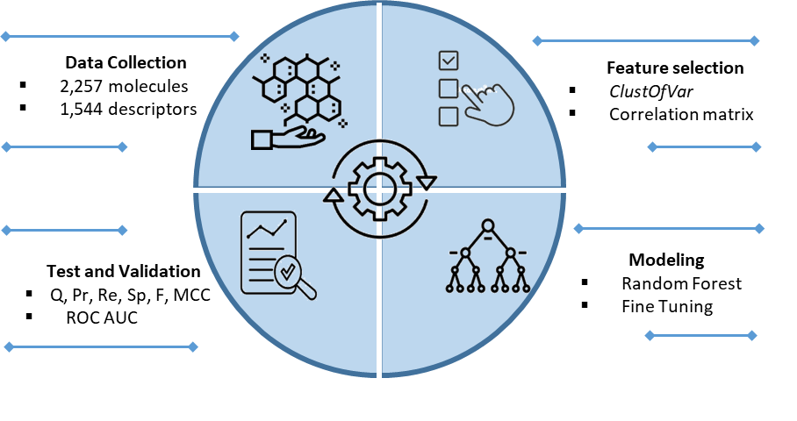
Graphical abstract:

Introduction
Among the concerns regarding drug-induced toxicity, respiratory chemical toxicity remains a major cause of drug candidate failure in clinical trials, resulting in the high cost of bringing drugs to market [1]. Adverse reactions to drugs and chemicals can trigger respiratory toxicity and various lung disorders, constituting a significant public health challenge with potentially life-threatening consequences. Drugs or chemicals can cause respiratory reactions that are not immediately obvious, the main symptoms being pneumonia, bronchitis, congestion, asthma and rhinitis [2, 3]. With the growing impact of omics technology and models generated by Artificial Intelligence (GenAI) to create new molecules, the number of chemicals responsible for serious lung diseases is also increasing. Therefore, industry and regulatory bodies need accurate and interpretable computational approaches to evaluate drug toxicity broadly, and respiratory toxicity specifically [4]. The study of the relationship between the chemical structure and its activity in terms of respiratory toxicity plays an important role in the safety of drug before they are placed on the market. Historically, experimental determination of drug or chemical toxicity can provide more reliable data, but it is a very long, expensive and tedious process involving laboratory animals and synthetic molecular materials [5]. Unlike experimental testing, QSTR in silico methods allow quick and affordable screening to identify the structural fingerprints linked to toxic properties.
The official birthday of QSAR is the 1962 publication of Hansch et al., which established relationship between encoded molecular structures (called descriptors) and their biological responses by using linear regression analysis (LRA) as a significant tool [6]. Because of their ease of application, which leads to an easily understood result, several linear regression methods such as multiple linear regression (MLR), partial linear regression (PLS) or principal component regression (PCR) were used to develop QSTR models that capture only the linear association between dependent and independent variables. However, the functional relationships between structure and drug/chemical-induced respiratory toxicity are not always linear, as the pathogenic mechanism of pulmonary toxicology is complex and therefore poorly understood, particularly in humans [3]. Most animal models and preclinical data cannot be directly extrapolated to humans because patient drug response is multifactorial, including intrinsic and extrinsic factors that influence drug biotransformation [2]. In addition, the performance of learning algorithms suffers from the curse of dimensionality, since QSTR modeling remains a supervised learning method. Addressing this situation and providing models that are unambiguous, non-subjective and easily validated requires model development that can account for the complex structure-toxicity relationships that sometimes occur in QSTR models built on large datasets. In order to predict the toxicity of new drugs or chemicals, numerous machine learning techniques have been applied to model the complex relationship between molecular descriptors and drug/chemical-induced respiratory toxicity [1, 3, 6].
Lei et al. used machine learning and molecular descriptors to assess and compare six classification and six regression models using data from 1,403 compounds and 20 representative descriptors. The top-performing XGBoost model obtained an MCC of 0.644, a global accuracy of 82.62%, and an AUC of 0.893 on the test set. Regarding regression, the best SVM model yielded an adjusted $R_{adj}^{2}$ of 0.743 during training and a $q^{2}$ value of 0.707 when evaluated on the test set [7]. Zhang et al. built QSTR classification models based on a dataset of 1,241 compounds. The Naïve Bayes model performed best, with 84.3% accuracy on the external test set and 91.8% accuracy on the internal training set [8]. Wang et al. investigated respiratory toxicity by applying six machine learning algorithms to a dataset of 2,529 compounds, namely support vector machine (SVM), decision tree (DT), k-nearest neighbor (k-NN), naïve Bayes (NB), random forest (RF), and artificial neural network (ANN) [3]. Recently, Jaganathan et al. developed predictive models for respiratory toxicity using a dataset of 2,527 compounds characterized by 132 molecular descriptors. Among the optimized models, the support vector machine (SVM) classifier produced superior predictive performance, with 10-fold cross-validation resulting in an accuracy of 86.2 percent and an MCC value of 0.722 on the external test set [1]. They later introduced an optimized tree-based ensemble model trained on the same dataset, which yielded an accuracy of 85.07% during 10-fold cross-validation and 86.88% on the test set [9]. Although previous models performed well, they were difficult to apply in practice due to: (i) the absence or weakness of dimensionality reduction techniques, which makes fine-tuning of machine learning hyper-parameters difficult; (ii) overfitting problems, which generate specific decision boundaries with low bias and high variance constructed from high-dimensional descriptor space; and (iii) the lack of explainable predictions, as well as the limited number of compounds used to build the models.
In this study, a comprehensive dataset of 2,527 compounds with documented respiratory toxicity profiles was assembled to construct predictive models using the Random Forest algorithm. Prior to model development, a feature selection procedure based on the ClustOfVar algorithm was applied to identify the most informative molecular descriptors associated with respiratory toxicity [10, 11]. Model performance was assessed through 10-fold cross-validation and an independent external validation set to ensure robustness and generalization. Additionally, key descriptors driving toxicity classification were identified and interpreted. The novelty of this approach lies in the integrated use of feature engineering with ClustOfVar and Random Forest to enhance both predictive accuracy and mechanistic insight.

Material and methods
- Data collection and molecular descriptors
In the field of QSTR modeling, binary classification is the process of classifying compounds on the basis of two predefined classes. Thus, binary classification approaches use training data to build a classification model to predict a new sample's class label. In our respiratory toxicity prediction investigation, we reviewed respiratory toxicity literature and identified chemicals data from Wang et al. [1, 3]. We collected a total of 2,527 compounds, and compounds that have a negative effect on the human respiratory system are labeled as toxic, while compounds that do not affect the respiratory system are labeled as non-toxic. An important step in this study is the coding of compounds into vectors of numerical descriptors as representations of molecular properties using logical and mathematical functions that transform chemical information. Jaganathan et al. used the open source software PaDEL-descriptors, available in a web-based platform called ChemDes, to compute different classes of descriptors and molecular fingerprints [1]. From this study, we found that for each compound of the dataset, 1544 structural 1- and 2-D descriptors have been calculated. After data curation, the entire data set of our study, consisting of a 2,234 x 1,544 matrix, was our starting point for the development of a QSTR model for the prediction of respiratory toxicity of organic chemicals.

- Feature selection
Based on the data table provided by Jaganathan et al. the hierarchical clustering algorithm, implemented in the hclustvar function of the R package ClustOfVar, was used for partitioning or clustering the set of linearly dependent quantitative chemical descriptors [10]. Hierarchical clustering of variables is a way of arranging variables into homogeneous clusters, i.e. groups of variables that are strongly related to each other and thus carry the same information. These approaches, which can be used to reduce and select variables, organize the variables or descriptors into hierarchical representations in which the clusters at each level of the hierarchy are created by merging clusters at the next lower level [10, 11]. When the variables in a cluster are strongly related to a central synthetic variable, the R package ClustOfVar provides useful tools for visualization of the relationships between variables and redundancy in a dataset using the homogeneity method.

- Model implementation
In this study, random forest (RF) algorithm was used for model implementation using scikit-learn module (3.9.2 python version) to develop classification model for the prediction of drug/chemical-induced respiratory toxicity [12]. Random Forest (RF) is an ensemble-based machine learning estimator in which numerous decision trees are combined to improve classification performance and reduce the risk of overfitting. It builds a forest of decision trees by randomly selecting subsets of data and features for each tree. As a result, randomness increases the diversity of decision trees and improves overall model performance. Each tree makes a prediction, and the final output is determined by averaging (for regression) or voting (for classification) across all the trees [13]. This approach enhances robustness and generalizes better than individual decision trees.

- Binary classification assessment methods
RF model performance was assessed using internal 10-fold cross-validation and an independent test set. The binary classification performance is represented by different metrics such as accuracy (Q), precision (Pr), recall (Re), specificity (Sp), F_score (F) and Matthews correlation coefficient (MCC) defined mathematically as follows:

 | $$Q=\frac{TP+TN}{TP+TN+FP+FN} ×100$$ |  |  | $$(1)$$
 |  | $$Pr=\frac{TP}{TP+FN}×100$$ |  |  | $$(2)$$
 |  | $$Re= \frac{TP}{TP+FN}×100$$ |  |  | $$(3)$$
 |  |  | $$F=\frac{2×TP}{2×FN+TP+FP} ×100$$ |  | $$(4)$$
 |  |  | $$Sp=\frac{TN}{TN+FP} ×100$$ |  | $$(5)$$
 |  |  | $$MCC=\frac{TN×TP-FP×FN}{\sqrt{\left(TP+FP\right)\left(TP+FN\right)\left(TN+FP\right)\left(TN+FN\right)}}$$ |  | $$(6)$$

The scalars TP, FN, TN and FP are defined as true positives, false negatives, true negatives and false positives respectively. Beyond common evaluation metrics, we also plotted the Receiver Operating Characteristic (ROC) curve and calculated its area under the curve (AUC) to visually and quantitatively evaluate classification performance [14].

Results and discussion
- Optimal descriptor subset
Feature selection methods have been used for dimension reduction, and this technique is essential for mitigating the effects of the curse of dimensionality and improving the performance of machine learning algorithms. In this work, we have horizontally cut the dendrogram, which shows the link between the quantitative variables in terms of Pearson squared correlation coefficient, into forty (40) homogeneous clusters, i.e., groups of descriptors that are strongly related to each other and therefore provide the same information [10]. After grouping the descriptors, we selected one variable from each group, i.e. the one that best correlated with its centroid.

- Descriptors involved in the models
ClustOfVar algorithm for detecting a nested partition extracted from a dendrogram obtained by hierarchical representation of quantitative variables have been used. Thus, each level of the hierarchy is created by merging the clusters at the level immediately below, starting at the lowest level with the most homogeneous partition, i.e. the partition whose cluster contains a single variable [10]. The main difference between PCA and the clustering approach is that the cluster centroids can be correlated, whereas the principal components are not. Therefore, the correlation matrix of the 40 descriptors was performed to detect residual redundancy, which could negatively affect the model by increasing variance and making it difficult to determine the significance and effect of individual predictors. Finally, after discarding redundant, non-informative and irrelevant features from the high dimensional feature space, we obtained 9 descriptors for respiratory toxicity prediction.
Table 1 lists a total of 9 molecular descriptors selected by clustering algorithm. In addition, figure 1 presents correlation matrix; a statistical tool that measures the strength and direction of relationships between two or more variables for obtained descriptors. As we can see, there is no redundancy in the dataset. Therefore, the problem of the curse of dimensionality appears to have been resolved prior to the modeling phase.
Obtained descriptors correspond in whole or in part to the descriptors used in published QSTR models to predict respiratory toxicity. As illustrated in Table 1, the majority of the selected descriptors belong to 2D category. The most important class of descriptors obtained is the class of autocorrelation descriptors calculated by Moran (MATS) at lag 2 and 3, weighted by the polarizability and electronegativity, followed by the average centred Broto-Moreau (AATSC) descriptor from lag 0, weighted by the relative atomic mass [1]. The topological index and bond information, which encode the chemical constitution using descriptors such as MPC3 and BIC5, are also selected as features to be captured by the model. The list of characteristics selected to model the prediction of respiratory toxicity also includes the descriptor Mare, which is of quantum origin [15].
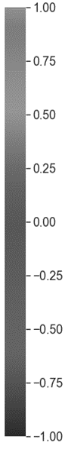
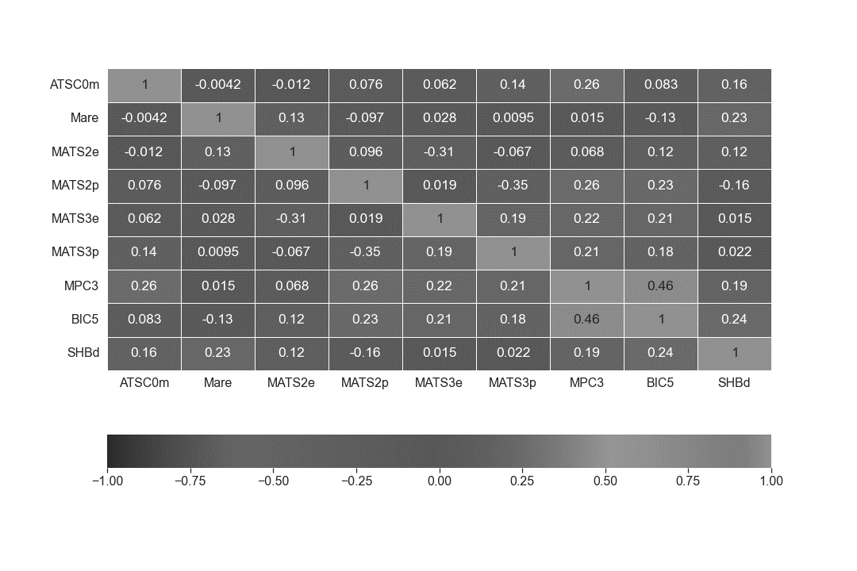

Figure 1: Correlation matrix of 9 non-redundant and informative selected descriptors

Table 1: Molecular descriptors using in this work

N° | Descriptor | Description | Category
1 | ATSC0m | Average Broto-Moreau autocorrelation - lag 0 / weighted by mass | 2D
2 | Mare | Mean atomic Allred-Rochow electronegativities (scaled on carbon atom) | 2D
3 | MATS2e | Moran autocorrelation - lag 2 / weighted by Sanderson electronegativities | 2D
4 | MATS2p | Moran autocorrelation - lag 2 / weighted by polarizabilities | 2D
5 | MATS3e | Moran autocorrelation - lag 3 / weighted by Sanderson electronegativities | 2D
6 | MATS3p | Moran autocorrelation - lag 3 / weighted by polarizabilities | 2D
7 | MPC3 | Molecular path count of order 3 | 2D
8 | BIC5 | Bond information content index (neighborhood symmetry of 5-order) | 2D
9 | SHBd | Sum of E-States for (strong) hydrogen bond donors | 2D

• Overall prediction accuracy
In this work, the training data set for the modelling of respiratory toxicity consists of a total of 1,867 observations with 9 variables, which are divided into 1,029 toxicants and 838 non-toxicants. Table 2 gives an overview of the samples employed in the experimental procedures, both for training and testing. Following the detailed methodological considerations for variable selection presented in our previous paper, we perform internal validation modelling experiments using a 10-fold cross-validation computed on the training dataset to evaluate model performance [11]. The predictive performance of the RF model was further evaluated using an independent test set of 467 molecules, allowing assessment of how effectively the classifier distinguishes toxic from non-toxic compounds. After solving the curse of dimensionality problem with data mining techniques using variable clustering with the ClustOfVar algorithm, random forest (RF) algorithm approach was used to construct binary classification model of drug/chemical-induced respiratory toxicity. In regard of all metrics delineated in equations 1 to 6, the performance of RF was given. The overall accuracy (Q%), the precision (Pr%), the specificity (Sp%), the recall (Re%), F-score (F%) and MCC were 78.20% ($±1.72)$, 79.86% ($±2.78)$, 74.68%($±5.15$), 81.05%($±3.69$), 80.36%($±1.61$) and 0.56 ($±0.03$) respectively in regard of internal cross-validation scheme. In external validation scheme, the statistical results were 76.66%, 79.08%, 69,58%, 81,69%, 80.36% and 0.52 respectively. Thus, we can see that our RF model correctly predicted 223 of the 273 toxic substances in the test dataset. In addition, our model correctly identified 135 of the 194 non-toxic compounds. Confusion matrix (CM), a table that summarizes the performance of a classification model by comparing the predicted labels with the true labels, is presented Table 3. The findings suggest that the proposed RF model demonstrates sufficient reliability to support early-stage drug development efforts by predicting compounds with potential respiratory toxicity. A useful visualization method has been implemented to facilitate further analysis of our obtained RF model. Figure 2 shows the ROC curve of the external test set of our machine learning model. As Figure 2 shows, the performance of our model significantly surpasses that of the random model represented by the main diagonal of the x- and y-axes coordinate system, the equation of which is $f\left(x\right)=x$. In binary classification model, the area under the curve (AUC) measures how well the model separates the positive class from the negative class, independently of the decision threshold [14]. When the decision threshold is set to 0.5, the class predicted is toxic if the predicted probability is greater than 0.5 and non-toxic if the predicted probability is less than 0.5. This decision threshold assumes a balanced prior, meaning that both classes are equally important and equally likely. Thus, the ROC curve is generated by changing the threshold on the confidence score, with each threshold generating only one point on the curve, from which the AUC is obtained [14]. In this study, the RF model reached an AUC score of 0.83, demonstrating its ability to effectively discriminate between positive and negative classes independently of the decision threshold.

Table 2: The training and test set data composition.

 | Training Set | Test set | Total
Non-Toxic | 838 | 194 | 1,032
Toxic | 1,029 | 273 | 1,302
Total | 1,867 | 467 | 2,334

Table 3: 2 X 2 confusion matrix of RF binary classification model

Predicted Class | Toxic | 223 | 59
Predicted Class | Non-Toxic | 50 | 135
 |  | Toxic | Non-toxic
 |  | Actual/ True Class

Figure 2: Receiver operating characteristics (ROC) curve for the test set RF machine learning method and AUC.
- RF model's feature importance and interpretation mechanism.
Random Forest models inherently provide a measure of feature importance, which is crucial for understanding and explaining their predictions. In contrast, XAI models are designed to provide explanations for other models [11, 16]. Before explaining RF model, it is important to noted that, hyper parameters, the settings that control how the ensemble of decision trees is built and how they make predictions, are obtained using GridsearchCV method [12]. In the context of random forest, the model's complexity and performance are influenced by a number of hyper parameters. These include the depth of the tree, the number of trees, and the impurity measure. In this study, the tree's depth is set to a value of none, the number of trees in the forest is set to 150, and the Gini index is utilized as the impurity measure for selecting a feature at a node [17, 18]. It is evident that the remaining parameters have been configured to their default values.
The central aim of this work is to elucidate the molecular descriptors that significantly affect model behavior, providing a foundation for accurately predicting respiratory toxicity induced by drugs or chemicals. The random forest model, as with a decision tree, calculates the importance of features using the mean decrease impurity (MDI); which is the reduction in impurity of nodes by a feature [11, 18]. In this work, the RF model ranks all nine features as follows: BIC5 > MPC3 > Mare > ATSC0m > MATS2p > SHBd > MATS3p > MATS3e > MATS2e.

- Model comparison
We evaluated the effectiveness of Random Forest combined with data-mining-based feature selection in relation to earlier machine learning models designed to predict respiratory toxicity caused by drugs and chemicals. It should be noted, however, that direct comparison is not strictly valid, because each study relied on different datasets, classification procedures, and hyper-parameter settings. Although previous machine learning models have been accurate, they have been trained using a large number of descriptors and demonstrate less generalization or overfitting. In computational drug discovery, high-complexity models such as SVM, XGBoost, and LightGBM, trained using large or high-dimensional descriptor spaces, are capable of capturing subtle non-linear relationships associated with respiratory toxicity [1, 3, 9]. Their flexible decision boundaries generally enhance binary classification performance relative to simpler modeling approaches. However, expanding the descriptor space amplifies the curse of dimensionality problem, whereby insufficient sampling in high-dimensional feature domains can promote model instability and make it less able to reliably predict outcomes for new compounds [6, 7]. This limitation is reflected in the discrepancy between internal and external validation metrics, with superior performance on external validation indicating that the models may rely on patterns not consistently represented within the training dataset (Table 4). Conversely, using a small number of molecular descriptors yields models that are easier to interpret and that produce robust decision boundaries for distinguishing drug-induced respiratory toxic versus non-toxic compounds. Because these models are less complex, they are less prone to overfitting and allow a clearer understanding of how particular physicochemical properties drive classification. Consequently, the model that has been obtained is more reliable under practical conditions (Table 4).

Table 4: Comparison with previous binary classifier models
Model Name | Dataset shape  (Obs. X Feat.) | Validation scheme | Q(%) | MCC
SVM [1] | 2,527 X 132 | 10-fold CV | 86.20 | 0.717
SVM [1] | 2,527 X 132 | Test set | 86.20 | 0.722
PubchemFP-SVM [3] | 2,529 X 881 | 10-fold CV | 84.10 | 0.680
PubchemFP-SVM [3] | 2,529 X 881 | Test | 86.90 | 0.736
XGBoost [7] | 1,403 X 20 | 10-fold CV | 100.00 | 1.0
XGBoost [7] | 1,403 X 20 | Test | 82.62 | 0.644
Naïve Bayes-2 [8] | 1,241 X 6 | 5-fold CV | 91.8 | -
Naïve Bayes-2 [8] | 1,241 X 6 | Test | 84.3 | -
Mordred_LightGBoost [9] | 2,527 X 1613 | 10-fold CV | 85.07 | 0.650
Mordred_LightGBoost [9] | 2,527 X 1613 | Test | 86.90 | 0.734
RF Model proposed | 2,334 X 9 | 10-fold CV | 78.20 | 0.560
RF Model proposed | 2,334 X 9 | Test set | 76.66 | 0.520

Conclusion
In this work, we assembled a substantial dataset of compounds from published source and developed a predictive model for chemical-induced respiratory toxicity using the Random Forest method in combination with a minimal set of nine molecular descriptors. Indeed, we used the ClustOfVar algorithm, which hierarchically groups descriptors in order to eliminate irrelevant or noisy ones with the aim of select significant and informative features for model implementation. The global model of respiratory toxicity was validated using 10-fold internal and external test set validations to prove the predictive capability of the model. Our RF model achieved a prediction accuracy of 76.66% and AUC of 0.83 for the compounds in the test set. This study extensively explored the effectiveness of employing random forest model and few descriptors to efficient and robust binary classification model. Then, proposed RF model prediction have been explained with model inherent feature importance approach, which prioritizes the relevance of key modeling descriptors influencing the prediction of respiratory toxicity. Consequently, our prediction model could be used to identify chemicals that are likely to cause acute respiratory disease during the drug development process. This innovation, which combines ClustOfVar-based descriptor selection with a minimal descriptor subset within the Random Forest framework, can provide valuable insights into toxic chemical structures, offering a theoretical basis for optimizing promising lead compounds.

ACKNOWLEDGMENTS:
The authors would like to thank the Laboratory of Fundamental and Applied Physics at NANGUI ABROGOUA University, in Côte d’Ivoire, for providing the facilities necessary for this work.

AUTHOR’S CONTRIBUTION:
Aubin N’guessan performed the data collection, curation, the study, and wrote the manuscript with the assistance and intellectual input and substantial manuscript editing from Ludovic Akonan, Désiré Mélèdje, Hermann N’guessan, Gabin Placide Allangba, Logbo Moussé, Nahossé Ziao, Melalie Kéita, Raymond Kré and Eugène Megnassan. All authors have read and agreed to the published version of the manuscript.

Supplementary Information:
The data used in this study are available at https://www.mdpi.com/article/10.3390/pharmaceutics14040832/s1

DISCLAIMER (ARTIFICIAL INTELLIGENCE)
The author(s) hereby declare that generative AI technologies were used in a limited capacity for language refinement and technical editing, without influencing the scientific content, interpretation of data or originality of ideas.
The following tools were used:
Tools:
- DeepL Translator (DeepL Write, https://www.deepl.com/fr/translator)
- ChatGPT (GPT-5, OpenAI, https://chat.openai.com)

Purpose:
- Translations of texts from English to French and vice versa.
- Reformulation of texts

REFERENCES

[1] | K. Jaganathan, H. Tayara and K. T. Chong, "An Explainable Supervised Machine Learning Model for Predicting Respiratory Toxicity of Chemicals Using Optimal Molecular Descriptors," Pharmaceutics, vol. 14, 2022.
[2] | M. Schwaiblmair, W. Behr, T. Haeckel, B. Märkl, W. Foerg and T. Berghaus, "Drug induced interstitial lung disease," The open respiratory medicine journal, vol. 6, p. 63, 2012.
[3] | Z. Wang, P. Zhao, X. Zhang, X. Xu, W. Li, G. Liu and Y. Tang, "In silico prediction of chemical respiratory toxicity via machine learning," Computational Toxicology, vol. 18, p. 100155, 2021.
[4] | L. Tonoyan and A. G. Siraki, "Machine learning in toxicological sciences: opportunities for assessing drug toxicity," Frontiers in Drug Discovery, Vols. Volume 4 - 2024, 2024.
[5] | A. O. Basile, A. Yahi and N. P. Tatonetti, "Artificial intelligence for drug toxicity and safety," Trends in pharmacological sciences, vol. 40, p. 624–635, 2019.
[6] | C. Hansch, P. P. Maloney, T. Fujita and R. M. Muir, "Correlation of biological activity of phenoxyacetic acids with Hammett substituent constants and partition coefficients," Nature, vol. 194, p. 178–180, 1962.
[7] | T. Lei, F. Chen, H. Liu, H. Sun, Y. Kang, D. Li, Y. Li and T. Hou, "ADMET evaluation in drug discovery. Part 17: development of quantitative and qualitative prediction models for chemical-induced respiratory toxicity," Molecular pharmaceutics, vol. 14, p. 2407–2421, 2017.
[8] | H. Zhang, J.-X. Ma, C.-T. Liu, J.-X. Ren and L. Ding, "Development and evaluation of in silico prediction model for drug-induced respiratory toxicity by using naı̈ve Bayes classifier method," Food and chemical toxicology, vol. 121, p. 593–603, 2018.
[9] | K. Jaganathan, P. R. Geethika, S. Ramakrishnan and D. Sundaram, "Explainable AI and tree-based ensemble models: a comparative study in predicting chemical pulmonary toxicity," The European Physical Journal Special Topics, p. 1–13, 2024.
[10] | M. Chavent, V. Kuentz-Simonet, B. Liquet and J. Saracco, "ClustOfVar: An R Package for the Clustering of Variables," Journal of Statistical Software, vol. 50, p. 1–16, 2012.
[11] | A. N’guessan, B. Dali, E. A. Esmel, L. M. Moussé, N. Ziao, R. K. N’guessan and E. Megnassan, "Pollution risk assessment by designing predictive binary classification models of substituted benzenes centered on data mining and machine learning techniques," Environmental Science and Pollution Research, 2025.
[12] | F. Pedregosa, "Scikit-learn: Machine learning in python Fabian," Journal of machine learning research, vol. 12, p. 2825, 2011.
[13] | L. Breiman, "Random forests," Machine learning, vol. 45, p. 5–32, 2001.
[14] | A. Tharwat, "Classification assessment methods," Applied computing and informatics, vol. 17, p. 168–192, 2021.
[15] | T. Puzyn, J. Leszczynski and M. T. Cronin, "Recent advances in QSAR studies: methods and applications," 2010.
[16] | A. B. Arrieta, N. Díaz-Rodríguez, J. D. Ser, A. Bennetot, S. Tabik, A. Barbado, S. García, S. Gil-López, D. Molina, R. Benjamins, R. Chatila and F. Herrera, Explainable Artificial Intelligence (XAI): Concepts, Taxonomies, Opportunities and Challenges toward Responsible AI, 2019.
[17] | J. A. Ilemobayo, O. Durodola, O. Alade, O. J. Awotunde, A. T. Olanrewaju, O. Falana, A. Ogungbire, A. Osinuga, D. Ogunbiyi, A. Ifeanyi, I. E. Odezuligbo and O. E. Edu, "Hyperparameter Tuning in Machine Learning: A Comprehensive Review," Journal of Engineering Research and Reports, vol. 26, p. 388–395, June 2024.
[18] | T. Hastie, The elements of statistical learning: data mining, inference, and prediction, Springer, 2009.

