Review Article

ARTIFICIAL INTELLIGENCE-ENABLED MEDICAL DEVICES IN ORTHOPEDICS AND CARDIOLOGY: A REVIEW OF CURRENT APPLICATIONS AND REGULATORY LANDSCAPE"

ABSTRACT
Future medical equipment is being gradually shaped by artificial intelligence, which offers accuracy, personalization, and efficiency in healthcare. By improving patient outcomes and enhancing surgical and diagnostic precision, artificial intelligence (AI) is transforming orthopedic bio-engineering. This review focusses on the application of AI in orthopedics to bone-regeneration devices, smart implants, intraoperative robotics, and preoperative planning. Orthopedic practices have undergone a significant transformation due to robotic-assisted surgery, AI-powered imaging, and automated 3D anatomical modelling. Orthopedic AI developments are exciting, but there are still issues to be resolved, such as the requirement for standardized validation procedures, the moral implications of AI-generated judgement, and real-world implementation in clinical settings. Cardiovascular medicine is using AI technologies more and more, which hold promise for better diagnosis, prognostic modelling and care personalization. Wearable technology for the detection of malignant arrhythmias, non-invasive coronary artery disease diagnosis, precise cardiovascular outcome prediction, and customized treatment for patients with heart failure are all made possible by artificial intelligence. However, there are still many obstacles to overcome, including data privacy, legal frameworks, clinical workflow integration, algorithm transparency, and real-world validation. These issues also help clinicians in emergency situations by providing prompt risk assessments and decision support. In addition to these, AI medical devices are employed in radiological imaging, ophthalmology analysis, and dental diagnostics for patient care. Overall, this review concludes that AI-driven advancements in orthopedic and cardiology devices are a major step towards precision medicine, improving patient care outcomes, safety, and efficiency while highlighting the continued need for clinical validation and ethical supervision.

Keywords: cardiac implants, machine learning, robotic assisted surgery.

1. INTRODUCTION
John McCarthy coined the phrase "artificial intelligence" (AI) in 1956 at a landmark conference for a summer research project. Machine learning (ML)-enabled medical devices are becoming more and more common in healthcare as artificial intelligence (AI) has advanced significantly over the past ten years.^{[1]}
In recent years, AI has shown promise as a solution to traditional methods used in injury predictions. They have already proved valuable in healthcare, especially in medical imaging, diagnostics, and personalized treatment. AI in sports offers a greater number of advantages over conventional techniques. To find patterns and risk factors that could otherwise be overlooked, it examines big and complicated datasets. Subtle patterns or irregularities that can point to a higher risk of harm can be identified by AI. AI can provide real-time assessments of the effects of collisions. This helps predict the risk of injury related to repeated impacts and physical strain.^{[2]}
Medical technologies are essential for diagnosing and treating patients due to their direct interaction with users, including doctors, medical staff, and patients. According to the official site of the Asian Pacific Technologies Medical Association, medical technologies diagnose, treat, and improve a person’s health and well-being. Deep medicine (DM) refers to the branch of medicine that uses AI applications to gather, process, and study medical and clinical data. DM involves creating and using machine learning algorithms, apps, and software, which are key components of medical AI. Those involved in developing, producing, and selling in the healthcare market are also focused on applying AI technologies and addressing the issue of mistrust.^{[3]}
The medical device Industry has continually evolved from simple tools like bandages and syringes to advanced devices like pacemakers and magnetic resonance imaging (MRI) machines. Recently, artificial intelligence (AI) has emerged as a software that examines data from various devices. It helps in early detection and accurate diagnosis of health problems and offers effective treatments, leading to better patient health. The significance of medical devices and their software cannot be exaggerated. The United States Food and Drug Administration (FDA) regulates all medical devices and their software.^{[4]}
Currently, AI applications in orthopedics include machine learning (ML) algorithms that grade osteoarthritis by analyzing radiographs and augmented reality-based medical training systems that improve implant orientation in hip replacements.^{[5]} In surgical applications, AI-based robotics and navigation systems are changing how orthopedic surgeries are planned and carried out. These systems improve the precision and reduce recovery time. Together, these advancements support the goals of precision medicine, providing personalized treatments for individual patients. In recent years, there has been an increase in interest in applying AI to orthopedic surgery. ^{[6]}
The primary cause of death globally, particularly in developed nations, is cardiovascular disease. As people age, the prevalence of heart failure, arrhythmias, and coronary heart disease rises. Particular therapeutic considerations with implantable cardiac devices are crucial to lowering death and disease, in addition to prescription drugs for preventive and treatment. There are several implanted cardiac devices, such as pacemakers, ICDs, CRTs, VADs, and LLAs. ^{[7]}
Advances in digital technology have led to the quick adoption of commercial wearable biosensors, or “wearables,” among consumers, including athletes. Currently, twenty percent of Americans own a smart wearable device. This market is expected to exceed 929 million connected devices this year. All the wearables are low-cost technology with a broad range of possible uses. They can monitor arrhythmia and hemodynamic changes, track physical activity and calorie burning, and provide information about general health and well-being. Additionally, these devices connect through smartphones to give almost instant feedback about personal health metrics in real time. ^{[8]}
In fields such as dentistry, radiology, and ophthalmology, nowadays, artificial intelligence is utilized in every branch of dentistry, including prosthodontics, orthodontics, periodontics, operative dentistry, and oral and maxillofacial surgery. The major of Artificial Intelligence Applications in dentistry focuses on radiography or optical image diagnosis. Other applications are less relevant, mainly due to limitations in data availability, consistency, and computing power needed to handle 3D data.^{[9]} Medical images from computed tomography (CT), ultrasound, magnetic resonance imaging, and X-rays are among the most intriguing kinds of health data. They have great potential for research and clinical use. Radiologists are top in the digital era of medicine. They can now embrace AI as a new ally in their work, which could enhance the role of radiology in healthcare.^{[10]}
Artificial intelligence (AI) is rapidly changing healthcare, and it has the potential to transform many specialties. In ophthalmology, AI can improve diagnostic accuracy, offer insights into systemic diseases, streamline clinical and research processes, and optimize treatment. The primary objective is to enhance patient outcomes. Regulatory licensing requirements for artificial intelligence as a medical device (AIaMD) are currently less clear than those for more well-established treatments, such as medications, which must pass stringent review procedures before being put on the market.^{[11]}

1.1 BENEFITS AND CHALLENGES IN AI MEDICAL DEVICES
^{1.1.1BENEFITS}
Cost Efficiency: AI streamlines tasks and improves diagnostic accuracy. This cuts healthcare costs by reducing unnecessary tests and hospital stays. Predictive tools help hospitals use resources more efficiently.
Better Patient Outcomes: Personalized treatment and continuous monitoring lead to faster recovery and higher patient satisfaction. AI enables early, proactive care that is tailored to each person’s needs.
Higher Accuracy: By spotting details that people might miss, AI reduces errors and provides more precise diagnoses from medical data and images. Early Detection: AI can identify early signs of diseases like cancer or heart problems. This allows for timely treatment and improves survival rates.^{[23]}
1.1.2 CHALLENGES
Data Privacy: Protecting patient data is crucial. Strong security measures are needed to prevent breaches and keep sensitive medical information confidential.

Regulatory Compliance: Understanding FDA and EU regulations requires strict adherence to changing guidelines. With increased attention on cybersecurity, medical device makers must meet tougher standards to ensure patient safety.

Algorithm Bias: If AI systems learn from unbalanced data, they can produce biased results. Eliminating bias is essential for providing fair and accurate care for all patients.

System Integration: Adding AI to existing healthcare systems can be challenging and expensive. Hospitals may need significant upgrades and training to fully benefit from AI technology.^{[23]}

2. METHODS
This review looks at how artificial intelligence (AI) is used in orthopedics and cardiac medical devices. This includes diagnostic tools, surgical aids, monitoring systems, and rehabilitation technologies. The search included terms like “artificial intelligence” ,machine learning”, “deep learning,” “orthopedic devices” ,“cardiac implants”,“wearable devices” and “medical robotics.”
Cabita et.al. (2018), in their systematic review reported that. Showed a trend of increased use of AI in orthopedics, with almost a tenfold increase since 2010. They discovered that AI was mostly utilized for imaging diseases of the joints, bones, and spine, as well as for diagnostic reasons, such as predicting or detecting osteoarthritis. Today, many smart tracking devices and phones are widely used, not only by professional players but also by amateur athletes and everyday individuals during their daily activities. The amount of data collected by these devices, along with advances in deep learning and machine learning, may improve the usefulness of these tracking devices. We could expect personalized treatment plans, from specific training programs to reduce the risk of certain injuries, to plans for returning to play after sports injuries. AI has been studied extensively for image interpretation in radiology and other orthopedic fields, and it is slowly being integrated into sports medicine practice and research. Stajduhar et al. used a semi-automated technique to evaluate magnetic resonance imaging (MRI) images for detecting anterior cruciate ligament (ACL) injuries. Developments in AI have improved orthopedic imaging. This is especially true for the automated segmentation and localization of anatomical structures. AI provides practical tools for completing complex tasks and supports techniques in diagnosing and treating orthopedic conditions. This is connected with machine learning and deep learning. Orthopedic image analysis has gained from segmentation algorithms that identify structures such as cartilage, bone, muscle, and other neural elements. ^{[12]}

Physiologic sensor
Movement sensor
Wearable devices

ACCELEROMETER
1.Motion detection
2.Orientation and rotation
3.Fall detection
4.Posture monitoring
5.Sports performance
PEDOMETER
1.Track steps
2.Distance travelled
3.Calories burned
4.Speed estimation

TEMPERATURE MONITOR
1.Skin temperature
2.Core temperature
3.Fever detection
4.Recovery monitoring
HEART RATE MONITOR
1.ECG
2.PPG
3.Arrythmia detection

INERTIAL MEASUREMENT UNITS
1.Combine accelerometer gyroscope and magnetometer
2.Advanced motion analysis

MAGNETOMER
1.Compass orientation
2.Navigation assistance
RESPIRATION MONITOR
1.Breathing rate
2.Sleep quality analysis
3.Chest\abdomen expansion sensor

Chart.1. Wearable devices
This flowchart divides wearable technology into two primary sensor Categories: Physiologic sensors(e.g., heart rate monitors, temperature monitors, CGMs) and Movement sensors (e.g., Pedometers, accelerometers, IMUs). The functions of each type of sensor are explained, emphasizing their uses in fitness, Health monitoring, and rehabilitation. These include motion tracking, fall detection, heart rate monitoring, glucose level Measurement, and more.From detecting exercise-related arrhythmias and identifying hidden heart conditions to providing information about training and recovery, wearables seem to have many roles in cardiology practice. The aim is to lower the risk of exercise-related heart issues and improve cardiovascular performance.^{[8]} The intense and ongoing exercise training leads to various cardiovascular (CV) changes, commonly called the athlete’s heart. This condition includes several adaptations, such as an increase in left Ventricular (LV) mass, a balanced remodeling of the heart chambers to improve cardiac output, a decrease in sympathetic tone and an increase in parasympathetic tone, and changes in ventricular depolarization visible on the resting electrocardiogram (ECG). However, both athletes and sedentary people may have hidden or early signs of structural CV diseases. These need to Be identified to prevent serious incidents like sudden cardiac death (SCD), which can occur due to intense exercise and other influencing factors like competition. The main goal of preparticipation screening (PPS) is to find cardiac issues that could lead To SCD in athletes. Additionally, research shows that physical activity can uncover arrhythmic conditions and speed up the progression of some cardiomyopathies, such as arrhythmogenic cardiomyopathy. ^{[20]}
2.1 Medical devices in orthopedics
Orthopedic medical devices have significantly helped millions regain mobility, reduce pain, and improve their quality of life each year. Their impact is clear in the global biomaterials market. Orthopedic devices led sales at about $14 billion in 2002. Of that, $12 billion was spent on joint replacements alone. Despite their success, these devices come with risks. Issues can occur from wear and corrosion over time, which can complicate joint replacements. Infections and manufacturing defects can also lead to device failure. This emphasizes the need for continuous innovation and safety improvements.^{[24]} The GoLIF lumber inter body System is a set of sterile instruments and implants for lumbar spine fusion using TLIF or PLIF techniques. It is intended for minimally invasive procedures that use bone grafts and fixation to restore spinal height and stability. Surgeons can order patient-specific guides and optimize implant size and placement with the help of the My Shoulder Planner, a CT-based program that generates 3D preoperative plans for shoulder replacement. With the help of artificial intelligence and CT imaging, the Precision AI Surgical Planning System creates 3D shoulder models, models implant placement, and creates personalized surgical guides for precise arthroplasty. To plan and execute total knee replacements, the United Orthopedic Knee Patient Specific Instrumentation creates 3D anatomical models and guides from CT or X-ray data for accurate prosthesis placement. It does this by combining AI-driven software with customized hardware.^{[15,16,17,18]}

2.1.1.Lumbar Interbody Fusion System
2.1.1.1 Device description
GoLIF! Lumbar Interbody Fusion System is are sterile implantable cage and sterile instruments to be placed in the intervertebral Body space of the lumbosacral spine and are designed for intervertebral body fusion. The GetSet GoLIF! The aim of implants is to revive the posterior, middle, and anterior spinal columns’ biomechanical integrity. The implants are designed for a unilateral posterior transforaminal (TLIF) approach or posterior lumbar interbody fusion (PLIF) approach. It is specifically designed for minimally invasive small incision, leading to a comparably atraumatic procedure for the patient. Implants, utilized with Supplemental fixation and bone graft, offer enhanced stability, restoration of height, and lordosis to achieve maximum fusion. Due to anatomical considerations, implants will be made available in 22mm and 26mm lengths, 8-14mm heights in 1mm Increments, and 10mm widths. The implant features a tapered tip to enable distraction during insertion, and teeth on both the Superior and inferior sides enable the implant to resist expulsion as well as implant migration. The domed shape enables 7-18 Degree lordosis when positioned at a TLIF Oblique or PLIF position while retaining coronal alignment because of the neutral Area in the mid-length of the implant when placed in a lateral position. The portals provide access for bone graft packing. The GoLIF! The Lumbar Interbody Fusion System also comprises instruments to enable implantation of the subject implant devices. Instruments are made of Polyacrylamide (IXEF), Polybutylene terephthalate (PBT), and medical-grade stainless steel. The GoLIF! Lumbar Interbody Fusion System was the focus of two earlier withdrawn applications – K201409 and K230368. Throughout the review for both of those submissions, the agency sought supplemental information. All that was previously offered by way of change to the FDA in response to AI and interactive questions has been incorporated in the subject submission, and the remaining questions outstanding regarding packaging and biocompatibility are answered in those respective sections.^{[15]}
2.1.1.2 Intended use
The Get Set GoLIF! The IBF system is designed for interbody fusion with auto graft and/or allogeneic bone graft made up of Cancellous and/or corticocancellous bone graft in patients with symptomatic degenerative Disc Disease (DDD) at one or two Adjacent levels in the lumbar spine, from L1-L2 to L5-S1. These DDD patients can also have up to Grade 1 Spondylolisthesis or Retrolisthesis at the involved levels. DDD stands for discogenic back pain. Disc degeneration was established by history and Radiographic examination. These patients must be skeletally mature and must have undergone six months of non-operative Management. These implants can be implanted using an open or a minimally invasive posterior method. Alternatively, these Implants can also be implanted using a transformational method. The FDA has approved additional posterior fixation for the Lumbar spine, which is how these tools are intended to be used.^{[15]}
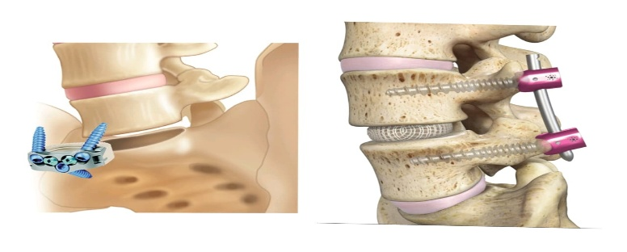
Fig 1: Lumber interbody fusion system.
These pictures demonstrate implant-based spinal fusion procedures. After the disc is removed, vertebrae are stabilized and fused using an interbody cage secured with screws, as seen on the left. On the right. Stability is restored in degenerative or damaged spinal segments by using pedicle screws and rods with an intervertebral cage to provide fixation and encourage bone fusion between vertebrae.
2.1.2 My Shoulder Planner (5.3SSWPL)
2.1.2.1 Device description
The My Shoulder Planner is an application that prepares patient-specific preoperative plans from CT scans. It is utilized to visualize the impact of various device options and positioning alternatives on the patient’s shoulder joint biomechanics. It Enables the surgeon to preoperatively plan the glenoid and humeral components in total shoulder replacement following Segmentation of a 3D model of the patient anatomy that can automatically be done by the software, which employs a machine Learning algorithm or by a specific Medacta engineer manually. Following the planning, via the software, the user can order Patient-matched guides along with an intraoperative guidance system compatible file.^{[16]}

2.1.2.2 Intended use
Surgeons can utilize the My Shoulder Planner program as a preoperative planning tool while doing Complete shoulder replacement surgery on patients who are skeletally mature. My Shoulder Planner Software is intended specifically to aid planning of the humeral and glenoid components in a total shoulder Replacement with the Medacta Shoulder System prosthesis. My Shoulder Planner software is not used for Diagnosis. The My Shoulder Planner software interprets CT scan images in DICOM(Digital imaging and Communications) format to enable surgeons to visualize, measure, and reconstruct anatomic information. These capabilities enable surgeons to decide on the size and position of the implant, including annotating anatomical structures. The My Shoulder Planner Software culminates in the creation of patient-specific planning reports, which capture the initial decisions of Implant size and positioning. My Shoulder Planner application permits the surgeons to order the My Shoulder Patient matched guides based on the pre-surgical plan.^{[16]}

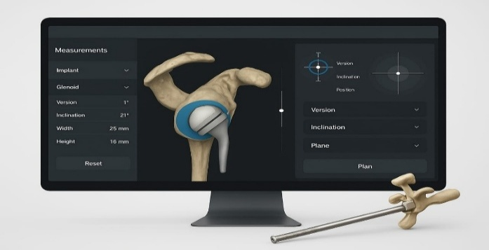
Fig 2: My shoulder planner (5.3SSWPL).
A computer-aided surgical planning system for replacing a shoulder joint is depicted in this picture. Implant size, version, inclination, and placement are optimized using a 3D model of the scapula and glenoid cavity. Precise alignment is guaranteed by such digital planning. Enhancing surgical results and implant stability.

2.1.3 The Precision AI Surgical Planning System (PAI-SPS)
2.1.3.1 Device description
Precision AI Surgical Planning System (PAI-SPS) is an AI-powered medical device that helps surgeons plan and execute shoulder joint replacements. The system relies on CT scan images to build a 3D model of the patient’s shoulder, facilitates surgeons to simulate and optimize implant placement, and can generate custom surgical guides that are used during surgery. The system improves surgical precision and outcomes for patients undergoing shoulder arthroplasty.^{[17]}

2.1.3.2 Indicated Use and purpose of use:
Software
Precision AI Planning Software is designed to be a pre-surgical planner for simulation of surgical procedures for shoulder joint arthroplasty, helping position shoulder components by generating 3D bone constructs and resulting in surgery reports and data For patient-specific guides and biomodels.
Hardware
The Precision AI Planning System Guides and Biomodels are designed to be applied as patient-specific surgical tools to aid in The intraoperative positioning of shoulder implant components utilized with total and reverse shoulder arthroplasty by referencing shoulder anatomic landmarks that can be identified on preoperative CT-imaging scans. The Humeral guide is used to place the humeral pin during humeral head resection, while the Glenoid guide is used to position the K-wire. The Precision AI guides and Biomodels are single-use instruments. Adult patients who have given their approval for shoulder joint replacement Are to use the Precision AI Surgical Planning System. Both humeral and glenoid guides are appropriate for the delto-pectoral Approach only. ^{[17]}

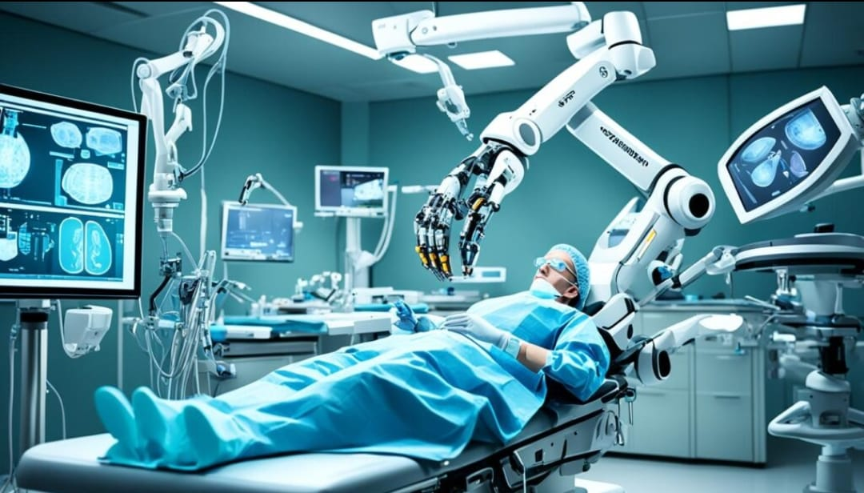
Fig 3: Precision ai surgical planning system.
This picture depicts a robotic-assisted surgery setup, in which highly precise surgical procedures are carried out or assisted by sophisticated robotic arms. Using computer guidance and real-time imaging on monitors, the surgeon operates the system. Such technology improves patient recovery outcomes, decreases invasiveness, and increases accuracy.
2.1.4 United Orthopedic Knee Patient Specific Instrumentation
2.1.4.1 Device description:
The United Orthopedic Knee Patient Specific Instrumentation includes the following: anatomical models (physical replica), United Orthopedics (UO) surgical guides (hardware), the Intelligent Surgery Knee CT/X-ray Segmentation Engine (software), And the Intelligent Surgery Knee Implant Recognition Engine. Enhatch is responsible for the system’s design and development in All three areas. The target device is designed to simplify the implantation of U2 Knee protheses within the U2 Knee System Produced and marketed by United Orthopedics Corporation, U2 Total Knee System.^{[18]}
SOFTWARE
Intelligent Surgery Knee Segmentation Engine is composed of two imaging modalities, CT (Knee CT Segmentation) and X-ray (Knee X-ray Segmentation). The Intelligent Surgery Knee CT Segmentation Engine and X-ray Segmentation Engine are web-Based applications that employ deep learning algorithms to identify and extract region of interest (ROI) data (femur and tibia) From medical imaging information (DICOM). The segmentation engines produce 3D models that can be utilized for the treatment planning of Total Knee Arthroplasty (TKA), surgical guide design, or creation of 3D printed anatomical models. The Intelligent Surgery Knee Implant Recognition Engine is a web-based application that employs an optimization algorithm as a Total knee arthroplasty treatment planning tool. It helps to choose the implant size and location, out of a set of implants of a Total knee implant system, based on a set of run parameters depending upon the TKA surgery technique of that system. The software recognizes patients’ bony anatomy, anatomical landmarks, and articular surface topographies to use as landmarks for the positioning and alignment of the femoral and tibial implant components. This positioning and alignment, in turn, allows for The design of surgical guides and of the United Orthopedic Knee Patient Specific Instrumentation. Note, these algorithms are static and non-adaptive; they do not alter their behavior over time based on user input. ^{[18]}
HARDWARE
The UO surgical guides and the anatomical models are patient-specific devices intended to ease the implantation of the United Orthopedics Knee prosthesis. The UO surgical guides are constructed using a preoperative plan made by the software intelligence Surgery Knee Implant recognition Engine. The United Orthopedic Knee Patient Specific Instrumentation is an Orthopedic instrument system indicated to help position compatible total knee arthroplasty systems. It consists of surgical planning software (Intelligent Surgery Knee CT segmentation Engine/Knee X-ray segmentation Engine, and Implant recognition Engine) to preoperatively plan the intraoperative placement of the United Orthopedics Knee implants based on inputted patient radiological images and 3D bone reconstructions with recognizable anatomical landmarks, and surgical Instrument pieces including patient specific or customized guides manufactured based on the surgical plan to refer intra- operatively to the implant piece placement in accordance with the surgical plan. United Orthopedic Knee Patient Specific Instrumentation is appropriate for patients with no extreme bone deformities, i.e., a HKA of greater than 15°or deformity resulting from a previous fracture of the distal femur or proximal tibia. The U2 Total Knee System is used when the clinical evaluation and the approved indications for use of the instruments are fulfilled. You should only use the instruments once.^{[18]}

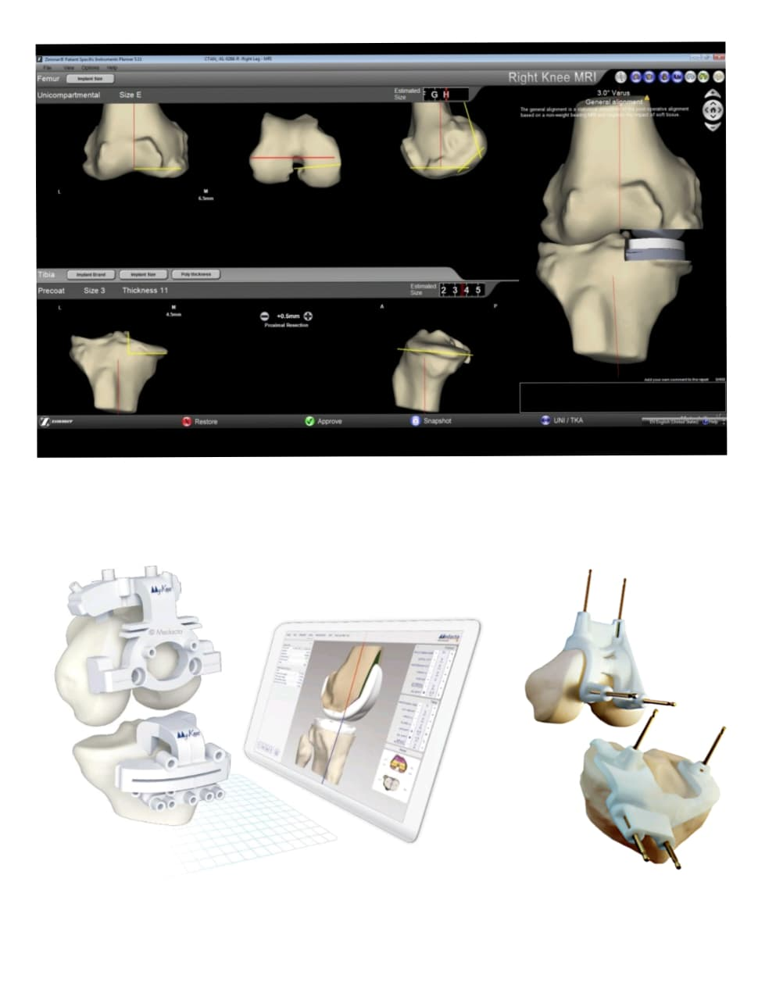
Fig 4. United Orthopedic Knee Patient Specific Instrumentation.
This picture demonstrates how patient-specific instrumentation (PSI) and computer-assisted surgical planning are used during knee replacement procedures. While the bottom section shows PSI guides and instruments used for precise bone cutting that are tailored to the patient’s anatomy, the top section displays 3D modeling and preoperative planning based on MRI data.
2.2 Medical devices in cardiology
Cardiovascular disease is still the top cause of death around the world, especially in developed countries. As people get older, issues like coronary heart disease, arrhythmia, and heart failure become more frequent. Today, implantable cardiac devices are a common part of clinical practice in many medical fields. Pacemakers, which have leads positioned according to the condition and more recent models that are compatible with MRIs, control irregular heart rhythms by sending electrical impulses to the heart. Cardiac Resynchronisation Therapy (CRT) can lower mortality and improve heart function in patients with severe heart failure, especially when used in conjunction with a defibrillator. In order to help monitor conditions like prolonged COVID, wearable sensors measure vital signs like heart rate, respiratory rate, oxygen saturation, and activity levels. A vital diagnostic technique that has been improved by machine learning is electrocardiography (ECG), and wearable respiratory and activity sensors use motion detection and photoplethysmography to continuously monitor health.They play an important role in managing and improving the lives of patients with heart conditions.^{[8,19,20]}Recently used AI medical devices in cardiology are:
1. Evolut FX+ TAVR System (Medtronic) – March 2024 For severe aortic stenosis; improved coronary access.
2. TriClip Transcatheter Valve Repair (Abbott) – April 2024 For tricuspid valve regurgitation; minimally invasive repair.
3. FARAPULSE Pulsed Field Ablation System (Boston Scientific) – July 2025 For atrial fibrillation; non-thermal ablation technology.
4. Ranger Drug-Coated Balloon (Boston Scientific) – March 2024 For peripheral and coronary artery disease; improves vessel patency.
5. Flurpiridaz F-18 (GE HealthCare) – 2024 PET imaging agent for diagnosing coronary artery disease. ^{[25]}
2.2.1 Pacemakers
Pacemakers are pulse generators, having one or more leads depending on the underlying cardiac electrical disturbance. They cause stimulation of the myocardial muscles and deliver an impulse resulting in contraction. New techniques of septal pacing are evolving, but conventionally, ventricular leads were placed into the right ventricular apex. The His-Purkinje system is used to conduct electrical conduction efficiently via the ventricles, while biventricular pacing implies implanting a lead in the Coronary sinus for pacing the left ventricle. Especially, readmissions were more in patients with single-chamber pacemakers than dual-chamber pacemakers. Around one-tenth of the patients were readmitted due to secondary arrhythmias, myocardial Infarction, heart failure, or due to the requirement of lead adjustment. Magnetic resonance imaging (MRI) compatibility is also a Safety issue. Although MRI-compatible devices are widely available, the operation of older-generation devices may become an issue upon exposure to the magnetic field. Electromagnetic interference with the ferromagnetic elements.^{[19]}

Fig 5: An artificial cardiac pacemaker
A medical device used to control irregular heartbeats, is depicted in this picture. To encourage the heart to beat at a regular pace and rhythm, it sends electrical impulses.
2.2.2 Cardiac Resynchronization Therapy (CRT)
CRT may be implanted separately or may be added to a defibrillator to avoid sudden cardiac death and minimize mortality Among heart failure patients. They are recommendations for patients with large left ventricular dysfunction (ejection fraction <35%), left bundle branch block with prolonged QRS (>150 ms), and patients with advanced New York Heart Association (NYHA) functional classes who were resistant to optimal medical therapy. Patients with atrial fibrillation can be improved by CRT if they have heart failure of ischemic origin with an ejection fraction of 30% or lower. The cardiac resynchronization heart Failure trial and the comparison of medical therapy, pacing, and defibrillation in heart failure trial showed reduced morbidity and Mortality in patients 65 years and CRT pacemakers outperformed optical medical therapy alone, older patients with CRT defibrillators compared to those with CRT pacemakers, and CRT pacemakers were superior to optimal medical therapy alone. The Multicenter Automatic Defibrillator Implantation trial demonstrated a more significant reduced risk of heart failure and Death with CRT defibrillators in patients aged 60 or above. Such a decision was stratified based on clinical risk scoring systems, taking into account factors such as age, the presence of concomitant atrial fibrillation, comorbidities such as renal or Hepatic dysfunction, and the extent of left ventricular dysfunction. Frailty screening supported by Kubala et al. Had reduced CRT response with increased frailty scores, and an increased rate of hospital admissions, secondary to heart failure, and mortality. All these notwithstanding, the patient’s wishes and goals of care, overall quality of life, functional status, and cognition need to be taken into consideration in determining the treatment plan.^{[19]}
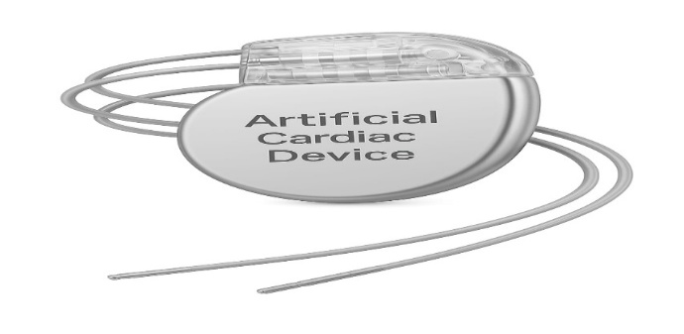
Fig 6: CRT Device.
Cardiac Resynchronization Therapy (CRT) device is depicted in this picture. By sending electrical impulses to both of the heart’s lower chambers and coordinating their contractions to increase the heart’s efficiency and blood flow, CRT devices aid in the management of heart failure.
2.2.3 Wearable Physiological Sensors
Physiological parameters monitored by currently available wearables include, but are not limited to, heart rate (HR), heart rate variability (HRV), respiratory rate (RR), blood oxygen saturation (SpO2), and skin temperature. More advanced devices can also estimate VO2max, a reflection of aerobic capacity. These metrics were selected due to their applicability to the symptoms of long COVID, including fatigue, autonomic dysfunction, and respiratory distress. ^{[8,20]}
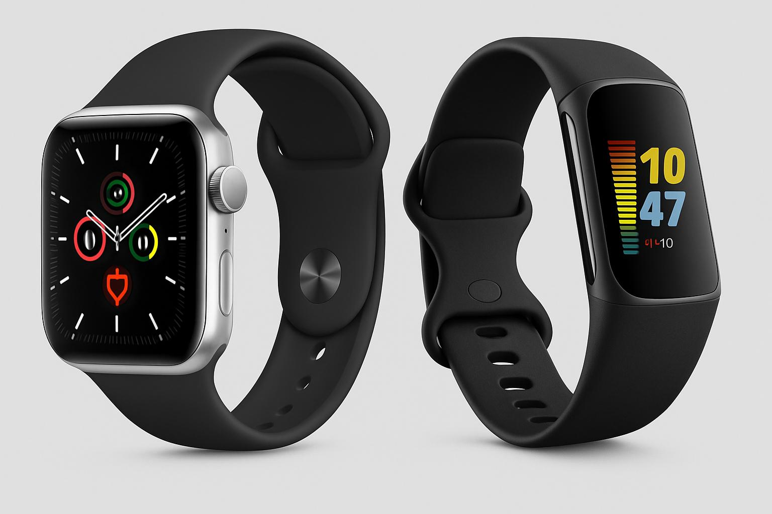
Fig 7:Wearable physiological sensor A) apple smartwatch B) Fitbit fitness tracker.
A smartwatch with several health and activity tracking functions and a fitness band that shows time, heart rate, and activity levels are the two types of wearable fitness devices depicted in this image. Both are employed to track regular fitness and health-related activities.
2.2.4 Electrocardiography
ECG is a commonly applied diagnostic tool in CV screening because it is simple, rapid, inexpensive, and non-invasive, although the high false-positive yield remains one of the primary criticisms leveled against it.35 Automated electrocardiogram interpretation by computerized ECG machines has now become near universal, and ECG analysis is the most advanced application of ML techniques in cardiology.ML algorithms can recognize significant ECG features such as the P and T waves, QRS complexes, heart rate (HR), cardiac axis, different interval lengths, ST-changes, and frequent rhythm abnormalities such as atrial fibrillation (AF). To train AI modes for the diagnosis of hypertrophic cardiomyopathy, silent AF, and left ventricular failure, large databases of digitized ECGs with rich clinical data have been used. It might be difficult to interpret ECGs in Athletes because they usually present with distinctive ECG patterns that are different from those of non-athletes. These patterns are misclassified as abnormalities, and it is required to undertake unnecessary testing and interventions. Numerous DL models have proven to be able to perform tasks that are beyond the scope of a skilled ECG operator. This may be a new avenue that will be developed in the future for further studies specifically aimed at athletes and the identification of SCD- related CV conditions.^{[8]}

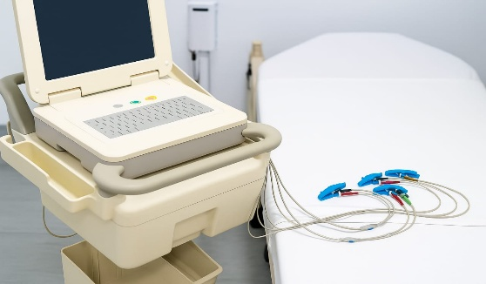
Fig 8: Electrocardiography.
This picture displays a hospital bed next to an electrocardiogram (ECG) machine. Using the electrodes and colored lead wires that are attached, the device records the electrical activity of the heart.
2.2.5 Wearable Respiratory Rate Sensors
PPG shows respiratory modulations that are utilized by wearables to create algorithms to estimate respiratory rate. These modulations comprise baseline wander, amplitude modulation, and frequency modulation, and are well explained here. Briefly, PPG(Photoplethysmography) measures tissue blood volume changes resulting from i) decreased stroke volume with inspiration (due to decreased Intrathoracic pressure), ii) arterial vasoconstriction with inspiration, iii) increased HR with inspiration (baroreflex-mediated Response to falling stroke volume). Such modulations vary between populations; for instance, frequency modulation-based Respiratory signals are of poorer quality in older persons. There exists a multitude of algorithms of RR derived from PPG in Literature, and most wearable devices utilize these algorithms to yield measures of RR.^{[8]}

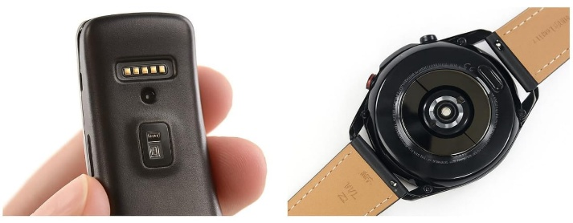
Fig 9: Wearable respiratory rate sensor
This picture displays the sensors and internal parts of wearable technology, including fitness trackers and smartwatches. It highlights circuit boards, optical modules, heart rate sensors, and charging connectors used for activity and health monitoring.

2.2.6 Wearable activity-related Sensors
Activity-related sensors record activities like walking, cycling, running, etc. This is made possible through the application of biaxial or triaxial accelerometers to record movements and changes in motion according to inertia principles. Accelerometers are usually combined with global positioning systems to measure accurate positioning in space during movement, barometers to monitor changes in altitude/elevation, and gyroscopes to measure angular movement. ^{[8,20]}

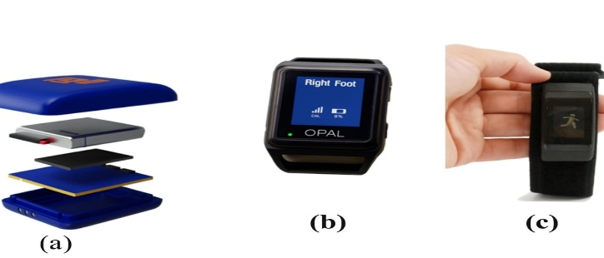
Fig 10: Wearable activity related devices a) Shimmer b) APDM Opal c) Autograph.
Several wearable sensor types are depicted in this image: (a) an internal component of a wearable sensor device in an exploded view; (b) an OPAL wearable sensor for motion and gait analysis; and (c) an activity tracker worn on the wrist to track physical movement. These gadgets are frequently used for biomechanical evaluations and activity tracking in sports science and health.
2.2.7 Echocardiography
Echocardiography is a useful second-line test where suspicion of a structural CV disease arises in the first step of athlete PPS(Pre-participation screening). Trial applications of ML in echocardiography are still in their infancy relative to its application in ECG, but AI-based methodologies can potentially enhance the diagnostic utility of this method through additional tools that produce valid, reproducible, and automated reports of echocardiograms.DL methods can effectively assess virtually all structures and Conditions involved in a thorough echocardiographic evaluation of athletes, including many potentially hazardous CV conditions, e.g., cardiomyopathy, valvular disease, aortic root disease, pericardial effusion, and congenital heart disease. Although few studies have directly assessed these conditions in athletes. Athletes will demonstrate. ^{[8,19]}
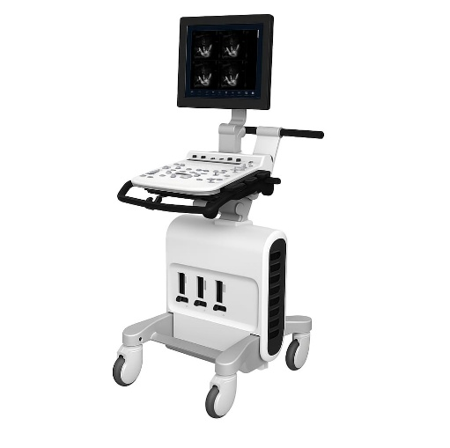
Fig 11: Echocardiography.
This picture displays a contemporary echocardiography (echo) machine, a kind of ultrasonography equipment mainly used to view the anatomy and physiology of the heart. Mounted on a wheeled cart for portability in clinical settings, it has a real-time imaging monitor, a control panel for adjustments, and ports for connecting ultrasound probes.
2.2.8 Cardiac magnetic resonance
Cardiac magnetic resonance (CMR) is a well-established imaging technique for CV evaluation in athletes and can be regarded as the modern gold standard in terms of its ability to assess myocardial architecture and tissue structure. It is difficult to interpret CMR images accurately, and mistakes can be very important even for athletes. The use of ML to incorporate into CMR can improve efficiency and accuracy in interpretation. AI solutions have been suggested to make image acquisition, reconstruction, and quality easier, making the process of CMR less cumbersome.AI-based CMR analysis has been investigated in differential diagnosis between cardiac phenotypes. An original design based on dimensionality reduction PCA, PLS (principle component analysis and partial least square) and logistic regression facilitated visualization and classification of cardiac remodelling patterns from CMR imaging in endurance athletes. Likewise, the new field of radiomics, which harvests quantitative imaging features, holds promise in distinguishing hypertensive heart disease from conditions such as HCM(Hypertrophic Cardiomyopathy) and may assist in dissolving diagnostic “grey zones” in athletes, but validation studies are still lacking. ^{[8]}
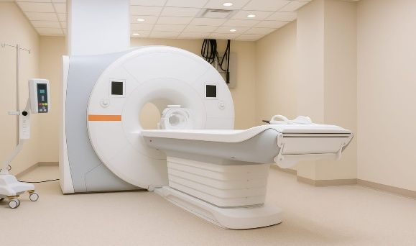
Fig 12: Cardiac magnetic resonance imaging.
This picture displays a contemporary MRI (Magnetic Resonance Imaging) scanner, which is used for in-depth internal body scans, particularly of soft tissues. In a sterile, clinical setting, the setup consists of a patient table and control unit.

2.2.9 RECALLED DEVICES IN CARDIOLOGY
DATE | ISSUE | PRODUCT AREA | STATUS
01/13/2025 | Outpatient Telemetry Correction: Philips Issues Correction for Monitoring Service Application used with Mobile Cardiac Outpatient Telemetry Due to Potential for Missed Information or Notifications That May Impact Patient Care | Mobile Cardiac Telemetry Monitoring | Recall Confirmed
07/15/2025 | Endoscopic Vessel Harvesting (EVH) System Correction: Getinge and Maquet Cardiovascular Update Use Instructions for VasoView HemoPro 2 (VH-4000 and VH-4001) EVH Systems due to Risk for Bent or Detached Heater Wires and Silicone Peeling or Detaching During Use | Endoscopic Vessel Harvesting (EVH) System | Recall confirmed
08/15/2025 | Early Alert: Cardiac Cannula Issue from Medtronic | Cardiac cannula | Early alert -FDA collecting information
09/16/2025 | Early Alert: Medline Kits May Contain Recalled Medtronic Cardiac Cannulas | Cardiac cannula | Early alert -FDA collecting information

Table 1:Recalled devices in cardiology. ^{[25]}

3. RESULT
AI-based tools in orthopedics, such as machine learning algorithms and robotic navigation systems, enable more accurate preoperative planning and surgical procedures. Specific devices like the GoLIF! Lumbar Interbody Fusion System, My Shoulder Planner, Precision AI Surgical Planning System, and United Orthopedic Knee Patient Specific Instrumentation use data-driven methods for personalized patient care and improved implant alignment. This leads to greater surgical precision and shorter recovery times. In cardiology, devices like pacemakers, cardiac resynchronization therapy devices (CRT), and wearable physiological sensors are now enhanced by AI algorithms. This significantly improves arrhythmia detection, cardiac performance checks, and hemodynamic monitoring. AI-driven analysis of ECG, echocardiography, and cardiac magnetic resonance imaging has increased diagnostic capability, especially in distinguishing adaptive changes in athletes from pathological conditions. Wearable biosensors and smart tracking devices benefit both orthopedics and cardiology by offering non-invasive, continuous monitoring of patient health. This supports faster recovery and preventive care.
Comparative Overview: Orthopedics vs. Cardiology.

Category | Orthopedics | Cardiology | Comparison Summary
Integration Rate of AI Devices.^{[26]} | 60% are imaging-based, focusing on preoperative planning. | 70% are monitoring-based, emphasizing continuous monitoring. | Orthopedics → Imaging & surgery; Cardiology → Monitoring & diagnostics.
Data Dependency and Challenges.^{[27]} | High data requirements; affected by algorithm bias and lack of standardized datasets. | High data requirements; faces regulatory issues and cybersecurity concerns. | Both fields show >65% devices with bias and regulatory challenges; need for data standardization.
Diagnostic Accuracy.^{[28]} | Improved by 20–35%, enhancing early detection and surgical planning. | Improved by 20–35%, strengthening predictive and monitoring accuracy. | Equal performance gain in both specialties.
Cost Efficiency.^{[28]} | Reduction in hospital stays and unnecessary surgeries by 10–25% | Reduction in hospital stays and redundant tests by 10–25% | Both show similar economic benefits via resource optimization.
Patient Outcomes.^{[29]} | Recovery speed increased by 40–50%; improved post-surgical mobility and satisfaction. | Recovery speed increased by 40–50%; better cardiac stability and quality of life. | Comparable improvement in recovery and patient satisfaction.

Table 2:Compartive overview of Orthopedic and Cardiac medical devices. ^{[26,27,28,29]}

4. FUTURE OUTLOOK
The destiny of future medical devices in Orthopedics and cardiovascular diseases is expected to be influenced by embedding artificial intelligence (AI), machine learning (ML), robotics, and digital health technologies that will transform the typical diagnostic and therapeutic devices into intelligent, data-driven, and patient-focused healthcare platforms. In Orthopedics, the medical devices of the future are likely to include AI-based imaging and predictive analytics, monitoring of disease progression, and tailored treatment plans. Robot-assisted surgery with 3D printing and augmented reality will make custom implants and minimally invasive procedures possible, ensuring improved surgical precision, fewer complications, and faster recovery. In addition, the integration of smart orthopedic implants with biosensors will allow constant monitoring of bone healing, joint performance, and patient activity, giving clinicians real-time information and encouraging early postoperative interventions.^{[21,22]}
Orthopedic surgery is trending towards less invasive, more accurate methods, with numerous operations now performed on an outpatient or short-stay basis. New technologies are causing operations to become more specific, enabling surgeons to concentrate on healing injuries and diseases more efficiently. The future of orthopedic research relies on close teamwork between technology specialists and clinicians. They can design responsive models that enhance diagnosis, individualize treatments, and enable enhanced rehabilitation. Training programs also change, with young orthopedic surgeons becoming more reliant on digital tools.^{[22]} Digital learning, through online platforms, virtual classrooms, and interactive resources, is more efficient and cost-effective than traditional instruction. However, it is not enough to supplant hands-on supervision in surgery. A blended model, which combines direct and digital learning, works best. Nanobiomaterials are another emerging field. These substances are designed to replicate natural cartilage and bone, but it has yet to be overcome how to design structures that will endure stress without collapsing. In the future, integrating nanotechnology with bio printing could transform Orthopedics by developing sophisticated scaffolds, regenerative muscle, tendon, and bone solutions, and second-generation biodegradable implants. ^{[6,22]}
In cardiovascular care, new-generation devices will progress beyond the reactive therapy of today to real-time disease monitoring and prevention. Wearable devices, intelligent pacemakers, and implantable hemodynamic sensors will provide instant feedback regarding cardiac function, enabling the early identification of arrhythmias, ischemic events, and heart failure decompensation. AI-assisted imaging and clinical decision-support tools will enhance diagnostic capacity, while robotic-assisted procedures and AI-assisted device placement will enhance the safety and accuracy of interventions like stent deployment, valve replacement, and bypass surgery. Throughout both specialties, the development of large-scale, multicenter, and ethnically diverse data platforms will be crucial to building strong, generalizable, and clinically valid AI models. At the same time, the creation of clear regulatory frameworks and ethics standards will be crucial to providing patient safety, data protection, and accountability among stakeholders.^{[7,20,21]}
Overall, orthopedic and cardiovascular medical devices will transform into integrated ecosystems that not only treat but anticipate and prevent disease. By facilitating continuous monitoring, personalized interventions, and iterative optimization through real-world evidence, these devices will help drive a shift from episodic, hospital-based care towards a continuous, patient-centric model, ultimately improving clinical outcomes and long-term quality of life.^{[12]}
5. SUMMARY
This review explores the revolutionary role of artificial intelligence (AI) in the construction and use of medical devices, with a specific focus on orthopedic and cardiovascular fields. The deployment of AI in healthcare technologies has facilitated improvements in diagnostic precision, surgical planning, rehabilitation, and monitoring in real-time. Artificial intelligence has improved imaging analysis, made predictive modeling possible, and allowed the application of robotic-assisted surgical systems and implants in orthopedics to enhance accuracy and reduce postoperative problems. Examples involve the GoLIF! Lumbar Interbody Fusion System, shoulder and knee arthroplasty AI-driven planning software, and smart segmentation systems that enhance preoperative planning. In cardiovascular medicine, AI has made tremendous contributions to implantable and wearable devices. Pacemakers, resynchronization therapy devices, and physiological monitors now incorporate AI-driven algorithms for arrhythmia detection, cardiac performance evaluation, and hemodynamic monitoring. Additionally, machine learning applications of electrocardiography, echocardiography, and cardiac magnetic resonance imaging enhance diagnostic precision, especially in differentiating pathological states from adaptive changes among athletes. Other than of orthopedics and cardiology, Artificial intelligence has also been applied to dentistry, radiology, and ophthalmology, though data availability, computing capability, and regulatory clearance barriers persist.
6. CONCLUSION
Artificial intelligence is changing how we think about medical devices. Instead of only reacting to health problems after they happen, AI is helping us move toward care that is proactive, personalized, and even preventive. In orthopedics, AI-powered tools and digital technologies can make surgeries more accurate, tailor treatments to each patient, and provide ongoing monitoring after procedures. In cardiology, AI is already improving devices by detecting heart rhythm issues earlier, making implantable devices smarter, and supporting continuous health tracking through wearables. Looking ahead, the future of medical devices will likely incorporate Artificial intelligence with robotics, biosensors, machine learning, and even nanotechnology—creating systems that are more clever, adaptable, and patient-focused. But for this future to work, we need to talk about the challenges like strict regulatory approval, privacy, ethics, and building trust with both patients and doctors. collaboration between healthcare professionals, engineers, and computer scientists will be important for the work of medical devices. If done right, Artificial intelligence in medical devices can lead to more exact diagnoses, better treatment outcomes, and a healthcare system that’s more stable and technology-driven.
Competing interests
The authors declare that they have no competing interests.
Data availability statement
The data that support the findings of this study are available from the US FDA Government ai enabled medical devices website and the corresponding authors upon the reasonable request.

COMPETING INTERESTS DISCLAIMER:
Authors have declared that they have no known competing financial interests OR non-financial interests OR personal relationships that could have appeared to influence the work reported in this paper.

Disclaimer (Artificial intelligence)
Author(s) hereby declare that generative AI technologies such as Large Language Models, etc. have been used during the writing or editing of manuscripts. This explanation will include the name, version, model, and source of the generative AI technology and as well as all input prompts provided to the generative AI technology

Details of the AI usage are given below:
1.ChatGPT was used during image conversion
2.ChatGPT version 5

REFERENCES
1)Geeta Joshi, Aditi Jain, Shalini Reddy Araveeti, Sabina Adhikari, Harshit Garg et.al.2024FDA Approved Artificial Intelligence and Machine Learning (AI/ML)-Enabled Medical Devices: An Updated Landscape 2024 Jan https://doi.org/10.3390/electronics13030498
2)Carmina Liana Musat , Claudiu Mereuta , Aurel Nechita , Dana Tutunaru , et.al.2024Diagnostic Applications of AI in Sports: A Comprehensive Review of Injury Risk Prediction Methods Diagnostics (Basel). 2024 Nov 10;14(22):2516. Doi: 10.3390/diagnostics14222516
3) Olga Vl Bitkina , Jaehyun Park , Hyun K Kim et al. Application of artificial intelligence in medical technologies: A systematic review of main trends Digit Health. 2023 Jul 18;9:20552076231189331. Doi: 10.1177/20552076231189331
4) Felix Tettey-Engmann, Santosh Kumar Parupelli, Steven R. Bauer, Narayan Bhattarai et al..Advances in artificial intelligence based medical devices for healthcare benefits Biomedical Materials & Devices https://doi.org/10.1007/s44174-025-00379-1
5)Lakshmi Nathan , Veerabahu Muthusamy Uses, benefits and future of artificial intelligence (AI) in orthopedics Indian J Med Sci. 2024;76:95-7. Doi: 10.25259/IJMS_205_2023
6) Song, J., Wang, GC., Wang, SC. et al. Artificial intelligence in orthopedics: fundamentals, current applications, and future perspectives. Military Med Res 12, 42 (2025). https://doi.org/10.1186/s40779-025-00633-z
7) Christine, Pui Sum Ho1; Sunny, Chi Lik Au2, et.al.Cardiac implantable therapeutic medical devicesJournal of Acute Disease 10(3):p 93-97, May 2021. | DOI: 10.4103/2221-6189.316672
8) Prashant Rao , Dhruv R Seshadri ,Jeffrey J Hsu.Current and Potential Applications of Wearables in Sports Cardiology Curr Treat Options Cardiovasc Med. 2021 Oct 14;23(10):65. Doi: 10.1007/s11936-021-00942-1
9) Ding H, Wu J, Zhao W, Matinlinna JP, Burrow MF and Tsoi JKH (2023) Artificial Intelligence in dentistry— A review.Front. Dent. Med 4:1085251.Doi: 10.3389/fdmed.2023.1085251
10) Pesapane, F., Volonté, C., Codari, M. et al. Artificial intelligence as a medical device in radiology: ethical and regulatory issues in Europe and the United States. Insights Imaging 9, 745–753 (2018). https://doi.org/10.1007/s13244-018-0645-y
11) Ong, A.Y., Taribagil, P., Sevgi, M. et al. A scoping review of artificial intelligence as a medical device for ophthalmic image analysis in Europe, Australia and America. Npj Digit. Med. 8, 323 (2025). https://doi.org/10.1038/s41746-025-01726-8
12).Aly M. Fayed , Nacime Salomao Barbachan Mansur, Kepler Alencar de Carvalho, et.al.Artificial intelligence and ChatGPT in Orthopedics and sports medicine.J Exp Orthop. 2023 Jul 26;10(1):74. Doi: 10.1186/s40634-023-00642-8.
13). Jian Song , Guang-Chao Wang , Si-Cheng Wang ,, Chong-Ru He , Ying-Ze Zhang , Xiao Chen , Jia Can Su Artificial intelligence in orthopedics: fundamentals, current applications, and future perspectives.Mil Med Res. 2025 Aug 4;12:42. Doi: 10.1186/s40779-025-00633-z
14).Ryan T Li , Scott R Kling , Michael J Salata , Sean A Cupp , Joseph Sheehan , James E Voos, 2016 Wearable Performance Devices in Sports Medicine Sports Health. 2016 Jan;8(1):74–78. Doi: 10.1177/1941738115616917
15)GoLIF! Lumbar Interbody Fusion SystemK250186.pdf https://www.accessdata.fda.gov/cdrh_docs/pdf25/K250186.pdf Decision date:25/03/20252)
16) MyShoulder Planner (5.3SSWPL)K241292Pdf https://share.google/mbp39FNAdosZ5zfXD Decision date: 30/01/20253)
17)Precision AI Surgical Planning System (PAI-SPS)Precision AI Surgical Planning System (PAI-SPS) | FDA Radiology AI Device https://share.google/oUe6iZJnarrz4OjBi Decision date: 21/01/20254)
18)United Orthopedic Knee Patient Specific Instrumentation K230850.pdf https://www.accessdata.fda.gov/cdrh_docs/pdf23/K230850.pdf Decision date:20/12/2023
19)Annachiara Pingitore , Mariangela Peruzzi , Sofia Calaciura Clarich ,et.al. An overview of the electrocardiographic monitoring devices in sports cardiology: Between present and futureClin Cardiol. 2023 Jun 22;46(9):1028–1037. Doi: 10.1002/clc.24073
20)Shikha Kukreti , Meng-Ting Lu,Chun-Yin Yeh , Nai-Ying Ko.Physiological Sensors Equipped in Wearable Devices for Management of Long COVID Persisting Symptoms: Scoping ReviewJ Med Internet Res. 2025 Mar 26;27:e69506. Doi: 10.2196/69506
21)Mathew G Wilson , Julien D Periard , Carmen Adamuz , Abdulaziz Farooq , Victoria Watt , Sebastien Racinais .Does passive heat acclimation impact the athlete’s heart continuum?European Journal of Preventive Cardiology, Volume 27, Issue 5, 1 March 2020, Pages 553–555
22)Nicole Tueni , Farid Amirouche ,Branding a New Technological Outlook for Future Orthopedics – PMC Bioengineering (Basel). 2025 May 7;12(5):494. Doi: 10.3390/bioengineering12050494
23)Use of Artificial intelligence in medical devices https://mavenprofserv.com/blog/artificial-intelligence-in-medical-devices/
24)Philip H. Long et.al Medical devices in orthopedic application https://journals.sagepub.com/doi/10.1177/0192623307310951
25) Medical Device Recalls and Early Alerts https://www.fda.gov/medical-devices/medical-device-safety/medical-device-recalls-and-early-alerts#:~:text=Table_title:%20Recent%20Medical%20Device%20Recalls%20and%20Early,Baxter%20%7C%20Product%20Area:%20Infusion%20Pump%20%7C
26) Brown, T., & Diaz, F. (2023). Comparative adoption of artificial intelligence tools in surgical and cardiac specialties. Health Informatics Journal, 29(2), 001–015.
27) Saini, R., Kumar, N., & Thomas, P. (2022). Ethical, data, and regulatory considerations for clinical AI adoption. Journal of Medical Ethics, 48(10), 783–79
28)Johnson, R. et al. (2021). Improving clinical efficiency through AI integration: A cross-specialty evaluation. Journal of Healthcare Management, 66(4), 255–270.
29)Silva, M., & Cho, E. (2020). AI-assisted rehabilitation: Impact on recovery speed and patient satisfaction. BMC Health Services Research, 20, 522.

