Review Article

Harm Reduction for Methamphetamine and Related Drug Use Disorders in Zimbabwe: Narrative Review

ABSTRACT

Drug and substance abuse is a growing public health threat in Zimbabwe, with potential to affect the economic growth of the nation. Globally, there is an increase in the number of people who use drugs. In 2013, UNODC estimated that 246 million people had used a drug in the previous year. This number has greatly increased, actually UNODC World Drug Report 2025, recently estimated that in 2023, 316 million people had used a drug in the previous year. A systematic literature review was conducted, analysing articles and case studies relevant to drug use or substance abuse in Zimbabwe, incorporating both local and international perspectives. The overall goal of this study was to collate a scoping review of drug use or substance abuse with particular focus on content related to harm reduction in Zimbabwe. The pharmacology behind methamphetamine was reviewed. Key drugs identified include crystal methamphetamine; marijuana/cannabis; alcohol; bronchleer; nicotine; Lysergide (LSD); Methylenedioxymethamphetamine (Ecstacy); illicit alcoholic brews like skokiaan, nipa, barberton and; isomers of Tetrahydrocannabinols. Drug peddlers in Zimbabwe are using various linguistic terminologies when discussing their products, these include mutoriro, ngoma, guka, dombo, kachasu, kambwa, tumbwa, kushamira, mangemba, maragada, madhembare, kukweva, kudhipisa, qilika, mabutternuts, chamba, isityimiyana, hopana, qediviki, uhali, kutsomwa, and kudira. Regulatory frameworks surrounding drugs and substances of abuse were briefly reviewed. Clinical health professionals such as pharmacists, medical doctors, and psychiatrists, as well as epidemiologists, and food scientists, all play a crucial role in the harm reduction from drug and substance abuse. Despite their efforts to enhance public health outcomes, the currently existing funding limitations, brain drain of well-trained health professionals and infrastructural deficits in Zimbabwe, results in poor overall control of this public health crisis in the nation. By implementing a multisectoral approach, Zimbabwe can improve the quality of life for its citizens and foster sustainable development.

Keywords: drug, use, substance, abuse, disorder, harm, reduction, methamphetamine

INTRODUCTION
Drug abuse overview
The World Health Organization (WHO) defines drug abuse or substance abuse as the harmful or hazardous use of psychoactive substances, including alcohol and illicit drugs (Reichert et al., 2021; Volkow and Blanco, 2023). Drug abuse stems from a mix of social, familial, cultural, and psychological factors. Family instability and lack of supervision further increase vulnerability, especially among youth (Siddiqui et al., 2022). Peer influence, media exposure, and easy access contribute to initiation, while emotional distress may drive self-medication (Siddiqui et al., 2022; Heidari et al., 2025). Drug abuse causes not only physiological harm, emotional instability, and impaired judgment, but also significant societal disruption. It disrupts family relationships, academic performance, and social behaviour, often leading to secrecy, truancy, legal issues, and risky peer associations (Martini et al., 2022). Under the influence of methamphetamine, youth may engage in criminal acts such as theft, assault, or drug trafficking, and adopt unconventional lifestyles that can lead to further criminal involvement (Saladino et al., 2021). Effective drug prevention requires coordinated efforts across families, schools and communities (Fishbein and Sloboda, 2023). Youth empowerment through employment, public awareness campaigns, recreational programs, and religious engagement plays a crucial role in reducing vulnerability to substance use. These efforts are not just beneficial but essential in the fight against drug abuse (Geleta et al., 2021).

Crystal methamphetamine
Methamphetamine is a powerful stimulant with a high potential for addiction, and it can be consumed through smoking, snorting, injection, or oral ingestion. (Yang et al., 2018). It is an amphetamine type of drug with many derivates. The substance is commonly consumed in its crystalline form, referred to as "meth" or "ice". In 2016, global estimates placed the number of users at around 35 million, a figure projected to rise as meth increasingly supplants other illegal drugs like cocaine and marijuana across various nations (Rommel et al., 2016). The chemical structure of the stable conformers of amphetamine and methamphetamine are shown in Figure 1 below.

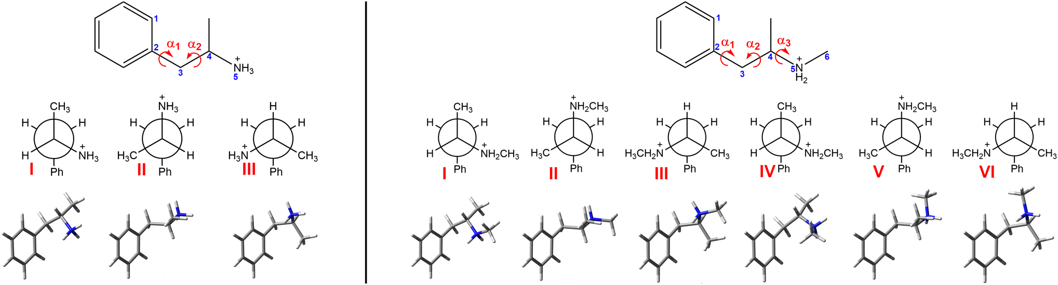
Figure 1: The chemical structures of 3 stable conformers of (S)-amphetamine hydrochloride on the left side and 6 stable conformers of (S)-methamphetamine hydrochloride on the right side, respectively. Torsional angles depicted are defined as α1 = ∠(1, 2, 3, 4); α2 = ∠(2, 3, 4, 5) and; α3 = ∠(3, 4, 5, 6) (Dobšíková, K. et al., 2023).

Mechanism of Action
Methamphetamine exerts its effects by promoting the release of monoamine neurotransmitters such as dopamine, norepinephrine, and serotonin from presynaptic terminals. These neurotransmitters play crucial roles in regulating mood, pleasure, and alertness in the brain (Ferrucci et al., 2019). Figure 2 below illustrates the activity of methamphetamine in neurotransmission. Due to its high lipid solubility, methamphetamine rapidly enters the brain and elevates dopamine, norepinephrine, and serotonin levels. It reverses monoamine transporters, inhibits reuptake, and redistributes neurotransmitters via VMAT2 (Omidvari et al., 2023). The resulting surge enhances alertness, euphoria, and appetite suppression, while cardiovascular stimulation - primarily via norepinephrine release - raises heart rate and blood pressure. Although its role in treating attention-deficit hyperactivity disorder is not fully understood, it likely involves the activation of central noradrenergic pathways. At high doses, these mechanisms can lead to severe toxicity, including fatal cardiovascular events or even death (Kish, 2008).

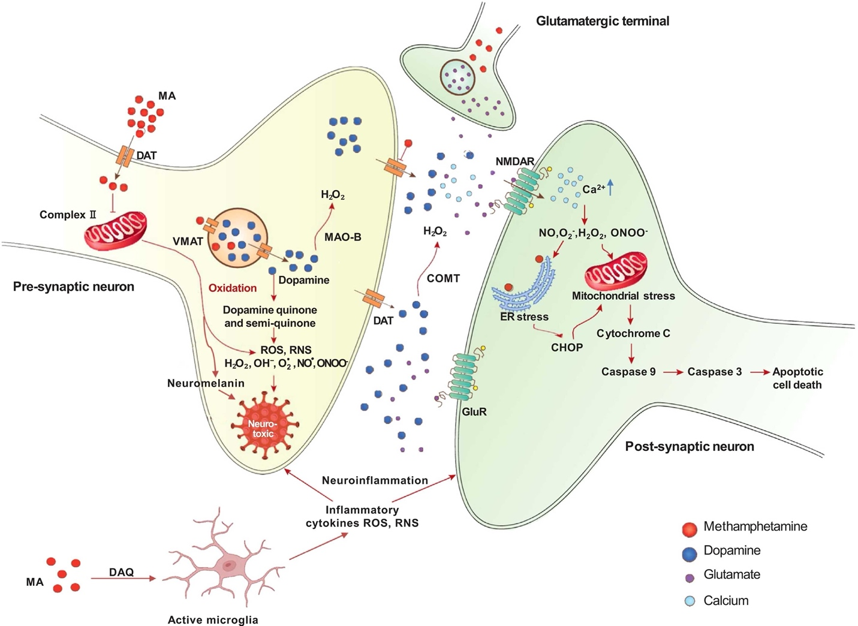
Figure 2: Diagram showing the effects of methamphetamine in neurotransmission (Prabhat et al., 2022).

Synthesis
Methamphetamine is commonly manufactured through two primary synthetic routes: the pseudoephedrine reduction method and the phenylacetone (P2P) method. The pseudoephedrine route typically uses over-the-counter medications like Sudafed as the precursor, which contains pseudoephedrine or ephedrine. These compounds are chemically reduced using agents such as hydrogen iodide and red phosphorus, or metal catalysts like palladium, platinum, or rhodium in the presence of hydrogen gas. Laboratories employing this method often contain hydrochloric acid, organic solvents like ether, benzene, chloroform, kerosene or white gas, and alkaline substances such as lye or washing soda (Brown, 2015).

The phenylacetone route involves the use of phenylacetone (P2P), methylamine or its hydrochloride salt, and reducing agents to produce methamphetamine via reductive amination. Additional chemicals found in labs using this method include formaldehyde, ammonia, hydrochloric acid, aluminum foil, mercuric chloride, and similar organic solvents and alkaline agents. In cases where P2P must be synthesized first, labs may also contain magnesium turnings, benzyl chloride or bromide, sodium cyanide or acetic anhydride, ether or tetrahydrofuran, phenylacetic acid, and thorium oxide. These methods pose significant risks due to the toxicity and volatility of the chemicals involved (Brown, 2015).

Adverse effects and toxicities
In a recent study by Amber N. Edinof and colleagues (2022), methamphetamine was labelled as “America’s most dangerous drug”. There are many medical complications which are associated with the use of methamphetamine and its derivatives, and they affect anyone regardless of ethnicity, race, gender, skin color or sex. Methamphetamine-induced psychosis is a common medical complication, and it may unmask underlying psychiatric disorders (Amber N. Edinof et al., 2022). The common central nervous symptoms that users presents with include; hallucinations, anxiety, seizures, agitation, and delusions. In the cardiovascular systems, symptoms usually include; palpitations, chest pain and shortness of breath. Figure 3 below illustrates the methamphetamine cardiovascular stimulation. Methamphetamine can also cause ischemic strokes, cortical blindness and even cerebral vasculitis. In serotonergic systems, the use of methamphetamine can induce neurotoxicity, encompassing brain anatomical structures such as the hypothalamus, amygdala, striatum, septum and hippocampus, resulting in memory impairment, mood changes and psychosis (Amber N. Edinof et al., 2022).

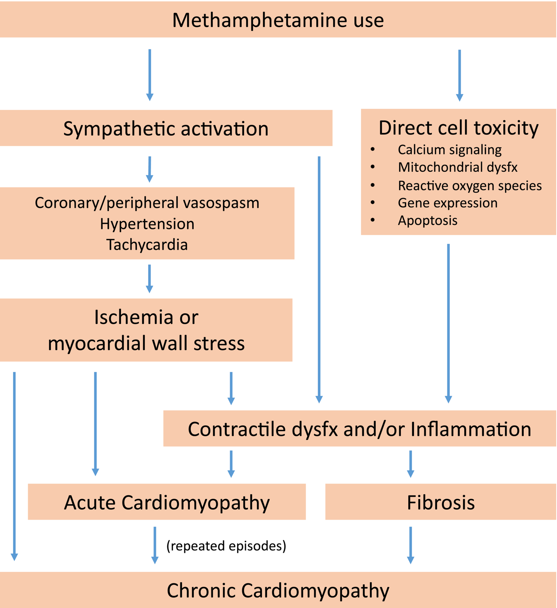
Figure 3: Flowchart illustrating methamphetamine associated cardiovascular stimulation (Pavan et al., 2020).

EPIDEMIOLOGY OF CRYSTAL METHAMPHETAMINE USE
Global
Drug use is on the rise globally, as depicted in Figure 4 below. In the decade between 2012 and 2022, the use of amphetamine drugs has shown an increasing trend globally (Romann et al., 2021). These statistics are believed to be an understatement, however, given the huge data gaps in reporting of illicit drug use in general. An estimated 30 million people were using methamphetamine and amphetamine in 2022, and 75% of those users are male, according to the United Nations Office on Drugs and Crime (2024). More than 1,000 cases of direct drug-related deaths were reported as a result of amphetamines in 2022, 77% of whom were men (UNODC, 2024). Disease-adjusted life years (DALYS) attributable to amphetamines increased from 1.27 million in 2010 to 1.41 million in 2019.

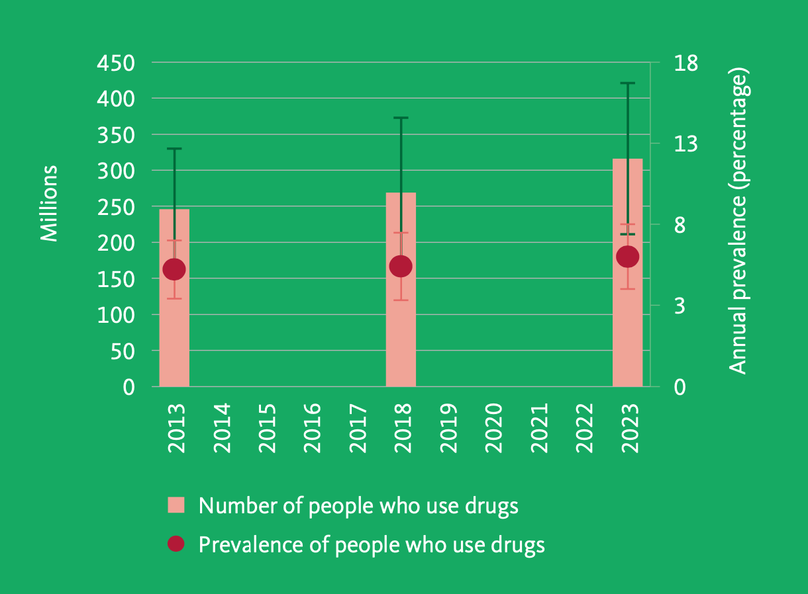
Figure 4: Overview of the global estimated numbers of people who use drugs and the prevalence of drug use, for 2013, 2018 and 2023 (UNODC, 2025b).

Geographically, the use of crystal meth is more prevalent in the North America, Oceanica, and South East Asia regions. In Europe, studies have reported an increasing trend in the use of crystal meth in recent years in Germany, Greece, and Turkey, adding to the burden traditionally attributable mostly to the Czech Republic and Slovakia in the region (Romann et al., 2021). In a study of drug abuse among adolescents in 47 countries, Son et al. (2025) found the prevalence to be highest among countries in the African region, with a prevalence of 4.34%.

Young adult males are the demographic experiencing the highest prevalence of crystal meth use. Son et al. (2025) found that the prevalence of amphetamine /methamphetamine use among school-going children aged between 12 and 15 years was 4.05% across the 47 countries studied. Boys exhibited higher amphetamine/methamphetamine use, at a prevalence of 9.20%, which was five percentage points higher than girls (4.20%).

In Zimbabwe
In Zimbabwe, crystal methamphetamine is the most used synthetic stimulant drug, and is popularly referred to as ‘mutoriro’, ‘guka’, or ‘dombo’ (Government of Zimbabwe, 2024; Tome & Abur, 2023; United Nations Office on Drugs and Crime, 2024). The prevalence of the use of meth among other illicit drugs in Zimbabwe shows a concerningly increasing trend, especially among young people (Government of Zimbabwe, 2024; Mukwenha et al., 2022). Figure 5 below shows a diagram representation of provinces in Zimbabwe, and percentages of the participants recruited who reported having used methamphetamine in the past year. (BRTI and National Institute of Health Research of the Ministry of Health and Child Welfare, 2008); UNICEF, 2023). During the COVID-19 pandemic, the use of crystal meth in Zimbabwe was reported to surge among young people who were idle as a result of not being able to go to school or work (Mukwenha et al., 2022; Muzuva et al., 2023).

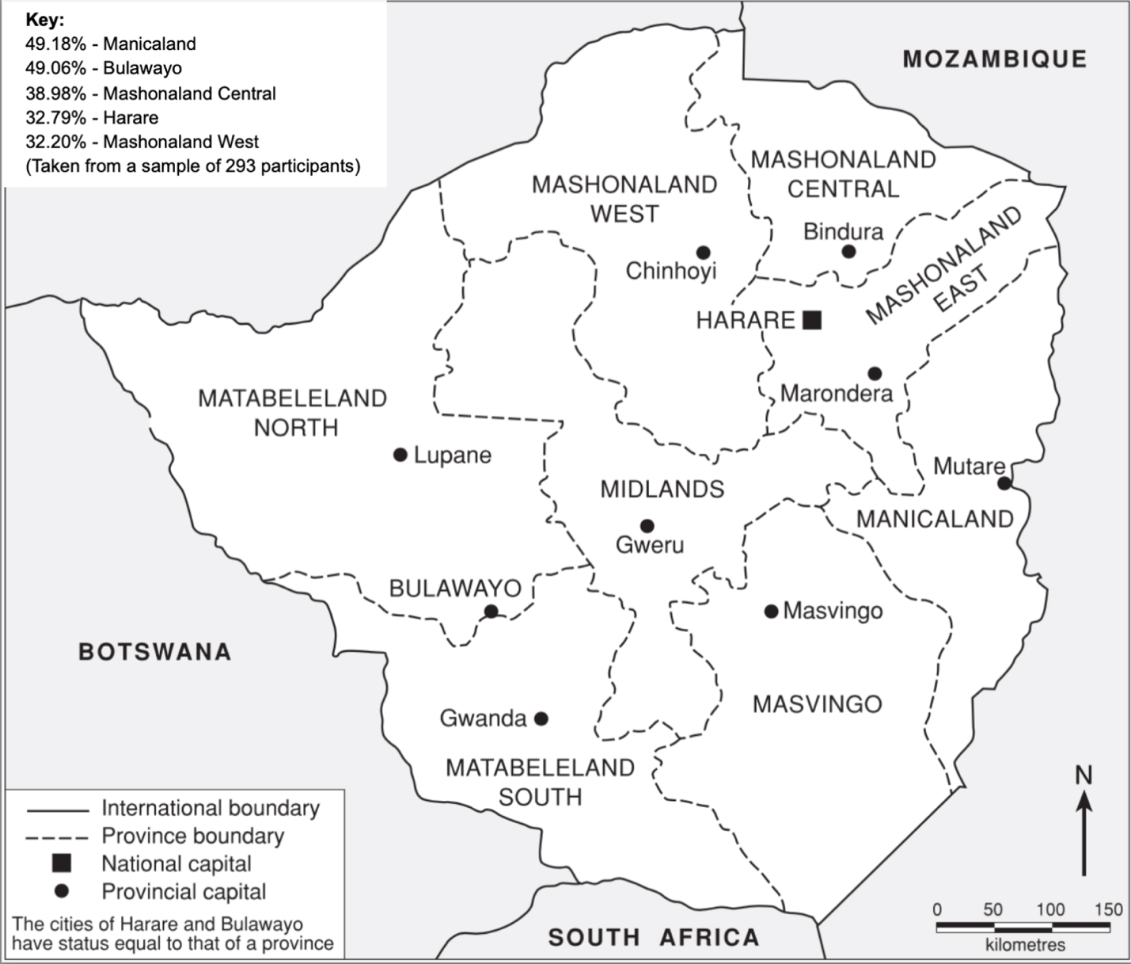
Figure 5: Diagram illustrating the provinces in Zimbabwe and corresponding percentage of the participants recruited who reported having used methamphetamine in the past year. Map adapted from BRTI and National Institute of Health Research of the Ministry of Health and Child Welfare, (2008); key data from UNICEF, (2023).

The use of crystal meth as with other illicit drugs in Zimbabwe is prevalent mainly among adolescent and young adult males especially in high density suburbs in the capital city, Harare (Muzondo, 2023; Muzuva et al., 2023). The high prevalence of meth use in this demographic has been linked to the high unemployment rate and stress that is prevalent in the economically ailing country (Muzuva et al., 2023). Homeless children or as they are commonly referred to in Zimbabwe, ‘street kids’ are also another key population that has high prevalence of meth use as they result to the stimulant drug to help cope with their homelessness situation (Mukwenha et al., 2022; Muzuva et al., 2023). In their study of causes and effects of women’s use of illicit drugs in Zimbabwe, (Muzondo, 2023) found increasing trend on the use of drugs including crystal meth by women which is associated with effects of the COVID-19 pandemic.

Cough mixtures that contains codeine and alcohol are also being abused by drug abusers in Zimbabwe and drug peddlers are taking this illegal opportunity. Broncleer is one of the cough mixtures abused, which is used medically for treating coughs in other countries (Chibvamindu Mitchell, 2024). This syrup is derived from a plant found within the poppy family, and the syrup comes in different colours. The unfocused youths in Mbare refer to Broncleer as ngoma, kushamira or kudira. They also use other terminology like kukweva or kufema when refering to the abuse of glue. Furthermore, they also use the words like mangemba or maragada when refering to psychiatric pills (Chibvamindu Mitchell, 2024). When it comes to psychiatric pills, valium is oftenly referred to as mabutternuts by the drug dealers, because of its yellow colour and, diazepam pills are oftenly called madembare because they are blue in colour similar to dynamos football team dressing kits. In a study by Manase Kudzai Chiweshe (2016), one fan claimed that even if 5 years old children were dressed in blue called Dynamos, they would still support the team. Lastly, marijuana is oftenly referred to as chamba. Some illicit drugs may cause a sensation of relaxed state or drowsiness, and the drug peddlers use linguistic terminology like kutsomwa or kudhipisa to describe them (Chibvamindu Mitchell, 2024).

PHARMACOLOGICAL TREATMENT OF SUBSTANCE USE DISORDERS
Pharmacological management forms a significant component in treating substance use disorders (SUDs), complementing psychosocial interventions within a harm reduction framework. However, globally, medications remain inadequate or non-existent for some substances, notably due to complex biology of addiction, legal barriers, and pharmaceutical corporations' historical reluctance to invest in this disease space (Jhanjee, 2014; Raymond et al., 2025). These pharmacotherapies aim to correct neurobiological alterations resulting from chronic substance use, managing withdrawal symptoms, reducing cravings, and preventing relapse (Hayes et al., 2020). However, pharmacological options may differ significantly worldwide depending on substance classes, regulatory approvals, and healthcare system capabilities.

Substance Use disorders
Opioid Use Disorder
Opioid agonist maintenance treatment (OAMT), primarily involving methadone or buprenorphine coupled with psychological support, remains the cornerstone treatment. These medications stabilize altered neural pathways, significantly reducing cravings and withdrawal symptoms. Naltrexone, an opioid antagonist, offers an alternative for detoxification and relapse prevention in motivated individuals (WHO, 2009; Volkow and Blanco, 2021). Nonetheless, barriers persist, including limited access to methadone clinics and the requirement for specialized prescribers for buprenorphine, leading patients to seek alternative therapies, including gabapentin or clonidine off-label, and high-dose loperamide (Toce et al., 2018; National Academies of Sciences et al., 2019).

Alcohol Use Disorder (AUD)
AUD is a prevalent yet inadequately addressed illness, with merely three widely recognized pharmacological treatments available (Burnette et al., 2022). Disulfiram which is an anti-dipsotropic medication which inhibits aldehyde dehydrogenase, causing unpleasant reactions when alcohol is consumed modulates glutamate neurotransmission, reducing cravings, whereas naltrexone reduces the reinforcing effects of alcohol by blocking opioid receptors (Jonas et al., 2014). These drugs as well as EMA-approved nalmefene, an anticraving drug, are among the drugs currently approved by numerous international authorities, including the US FDA and EMA, for the treatment of AUD (Attilia et al., 2018). Baclofen and sodium oxybate, have also been authorized for the treatment of AUD by European agencies. Since AUD is a highly diverse illness, not all AUD sufferers will benefit from the same drug. Consequently, to enhance care and augment utilization, it is imperative to discover novel, diverse, and more efficacious pharmacological therapy choices for AUD (Burnette et al., 2022).

Nicotine dependency
Nicotine dependence has shown benefits from nicotine replacement therapy (NRT), varenicline, and bupropion, which have demonstrated significant increase in cessation rates. NRT alleviates withdrawal by providing controlled nicotine doses, varenicline partially agonizes nicotine receptors to ease cravings, and bupropion inhibits dopamine and norepinephrine reuptake, decreasing nicotine withdrawal symptoms. Russia and other socialist nations also have licenses to use cytisine, a medication that is pharmacologically similar to varenicline (Cahill et al., 2013). Clonidine and nortriptyline are examples of second-line therapies. The effectiveness of monoamine oxidase inhibitors and selective serotonin reuptake inhibitors, two other therapy approaches that have been investigated, has not yet been established (Frishman, 2007).

Cannabis Use Disorder
To date there is no approved pharmacological treatment for cannabis However, research has shown investigational trials exploring different agents. Promising alternatives include cannabinoid agonists , which may serve a similar role to nicotine patches in supporting tobacco cessation, while long-acting opioid agonists like methadone and buprenorphine are commonly used to manage heroin dependence (Connor et al., 2021). These pharmacological agents help ease cannabis withdrawal symptoms and reduce the motivation to use cannabis by activating the CB1 cannabinoid receptor (Rømer Thomsen et al., 2022). Conversely, CB1 receptor antagonists can block cannabis effects and potentially aid in quitting. Preclinical research has identified notable interactions between the opioid and cannabinoid systems, indicating that opioid antagonists such as naltrexone might lower the rewarding effects of cannabis and decrease its use.
Other intriguing agents investigated comprise topiramate, N-acetylcysteine, varenicline, oxytocin, and gabapentin (Connor et al., 2021).

Pharmacological Treatments for Methamphetamine Use Disorder (MUD)
Methamphetamine use disorder poses unique challenges due to a lack of globally approved medications (UNODC-WHO, 2020). A significant issue in addressing methamphetamine use disorder (MUD), similar to other psychostimulant use disorders, is the absence of pharmacological treatments that can diminish cravings and facilitate sobriety (Yates, 2024). Pharmacotherapies assessed for MUD sought to diminish the reinforcing effects of METH, reduce cravings and withdrawal symptoms, or alleviate concomitant psychiatric disorders and cognitive deficits associated with METH misuse. (Moszczynska, 2021). At present, there are no sanctioned medications for the management of methamphetamine dependence, nor are there any forthcoming pharmaceuticals supported by scientific literature that sufficiently indicate a significant therapeutic effect. Several agents have demonstrated some negligible potential in clinical settings, often through off-label use with the predominant categories of attempted pharmacotherapies being antidepressants, antipsychotics, and substitution/replacement therapies (Stoner, 2018).

Several medications indicated favorable signals that necessitate additional examination in larger-scale research. A review by (Hersi et al., 2023), highlighted the drug classes and drugs to have been tested for their potential use in MUD. These include opioid antagonists (e.g., naltrexone), gamma-aminobutyric acid agents like baclofen (Heinzerling et al., 2006), antipsychotics (e.g., aripiprazole). Moreover, antidepressants (e.g., sertraline, bupropion, mirtazapine, imipramine), and cognitive enhancers were also evaluated. Other agents studied include, topiramate, galantamine, modafinil, varenicline, rivastigmine, , and oxytocin (Hamel et al., 2020).

In a study by Soares and Pereira (2019), methylphenidate and mirtazapine were identified as pharmacologically active drugs that have a modest effect on methamphetamine use disorder. A heterogeneous profile observed among methamphetamine-dependent individuals hinders the generalization of clinical trial results and prevents conclusions that can be applied to more diverse populations (Soares & Pereira, 2019). In the same study, Soares and Pereira (2019) found that male participants who were medication-compliant and abstinent or light methamphetamine users at baseline were more likely to respond positively to pharmacotherapy. Expert opinion on the pharmacotherapeutic management of methamphetamine use disorder emphasizes that urinalysis and other objective measures of methamphetamine use are mandatory when conducting clinical trials. Furthermore, predictors of pharmacotherapy success or failure include the monitoring of medication compliance and early treatment response (Soares & Pereira, 2019).

Antidepressants
Bupropion, primarily used for depression and nicotine dependence, functions as a selective norepinephrine-dopamine reuptake inhibitor. It is suggested that it mitigates methamphetamine cravings by enhancing dopaminergic signaling disrupted by chronic stimulant abuse as observed in some trials and may be efficacious in methamphetamine dependence who use methamphetamine less than daily and are highly adherent to the treatment (Elkashef et al., 2008; Trivedi et al., 2021). Mirtazapine, an antidepressant acting via antagonism of serotonin (5-HT2 and 5-HT3) receptors and enhancing norepinephrine and serotonin neurotransmission, has been associated with reductions in methamphetamine use and associated risk behaviors (Colfax et al., 2011; Siefried et al., 2020).

Psychostimulants
Psychostimulants may function as maintenance therapy for the management of substance use in these patients. Modafinil, a wakefulness-promoting drug, which modulates dopamine release and uptake, potentially alleviating methamphetamine-induced cognitive deficits and withdrawal symptoms. Results are mixed, but clinical interest remains due to its favorable safety profile (Anderson et al., 2012; Gonzalez et al., 2014) Additionally, Methylphenidate SR, an attention deficit drug, was safe and well accepted by active methamphetamine users, considerably decreasing methamphetamine consumption, cravings, and depressive symptoms (Rezaei et al., 2015). Siefried et al., (2020) indicated that the most dependable advantageous results have been noted with stimulant agonist treatment which are methylphenidate and dexamphetamine. Other psychostimulants showed some potential in users though not sustained over time (Rezaei et al., 2015).

Anticonvulsants
Topiramate, an anticonvulsant, modulates glutamate and GABA neurotransmission, thereby reducing cravings and impulsive behavior associated with stimulant use. Clinical trials have indicated moderate efficacy in reducing methamphetamine relapse rates and weekly median urine methamphetamine levels significantly decreased and observer-assessed severity of dependent ratings (Elkashef et al., 2012, 2012). Baclofen a selective GABAB agonist was indicated to exhibit a modest therapeutic effect when compared to placebo (Heinzerling et al., 2006).

Antipsychotics
Long-acting injectable antipsychotics like aripiprazole and risperidone have been employed off-label, particularly beneficial in patients experiencing methamphetamine-induced psychosis, providing symptom relief and improving adherence through reduced dosing frequency (Wang et al., 2016). Apripiprazole was also found to enhance treatment adherence and diminish the intensity of psychotic episodes (Sulaiman et al., 2013).

Additional medications
Naltrexone, an opioid antagonist, may reduce methamphetamine reinforcement indirectly by modulating reward pathways in the brain. Notably, combined therapy using bupropion and naltrexone showed significant efficacy in recent randomized clinical trials, improving abstinence rates compared to placebo (Trivedi et al., 2021). Buprenorphine augmentation, relative to the placebo, markedly diminished the urge for METH during treatment with the Matrix program (Salehi et al., 2015). Prometa® which comprises the antihistamine hydroxyzine, the GABA agonist gabapentin, and the benzodiazepine receptor agonist flumazenil showed decreased MA utilization was noted in one of investigation (Morley et al., 2017)

Despite ongoing research, significant challenges persist in the pharmacological management of Methamphetamine Use Disorder. These challenges include the absence of medications officially approved for MUD treatment, limited effectiveness of current pharmacotherapies, and patient adherence issues often driven by side effects, stigma, and accessibility barriers, especially in low- and middle-income countries (UNODC-WHO, 2020). Furthermore, complex psychiatric comorbidities frequently associated with MUD complicate treatment regimens, demanding multidisciplinary approaches (Moszczynska, 2021). Therefore, future recommendations should emphasize the development and rigorous testing of novel pharmacological agents specifically targeting methamphetamine addiction pathways, enhancement of patient-tailored combination therapies (e.g., bupropion and naltrexone), and integration of pharmacological treatments within broader psychosocial and harm-reduction frameworks (Siefried et al., 2020; Trivedi et al., 2021). Addressing regulatory barriers, improving medication availability, and training healthcare professionals on the nuanced aspects of pharmacotherapy for stimulant addiction should be integral components of future policy and clinical practice guidelines (Hersi et al., 2023; Raymond et al., 2025).

NON-PHARMACOLOGICAL TREATMENT OPTIONS FOR METHAMPHETAMINE USE DISORDER - HARM REDUCTION
A range of non-pharmacological interventions with strong empirical support are employed in the treatment of substance use disorders (SUD) (AshaRani et al., 2020). The International Standards for the Treatment of Drug Use Disorders, developed by the United Nations Office on Drugs and Crime (UNODC) and the World Health Organization (WHO), advocate for several psychosocial strategies grounded in evidence. These include Cognitive-Behavioural Therapy (CBT), Contingency Management (CM), the Community Reinforcement Approach, Motivational Interviewing (MI), Motivational Enhancement Therapy (MET), family-based interventions, peer-support groups, and recovery-oriented services (WHO & UNODC, 2020). Such interventions aim to reshape cognitive processes, behavioral patterns, and environmental influences that sustain substance use. The following Table 1 below, details some of the most prominent and effective non-pharmacological interventions (WHO & UNODC, 2020). In a recent study conducted by Asharani et al. (2020), contingency management (CM) interventions were identified as the behavioral approach with the strongest evidence for desirable patient outcomes. Tailored cognitive behavioral therapy (CBT), either alone or in combination with CM, was also found to be an effective behavioral intervention. A key conclusion from the study was that behavioral interventions should be considered the first-line treatment for methamphetamine use disorder (Asharani et al., 2020).

Table 1: Evidence-Based Non-Pharmacological Interventions for Methamphetamine Use Disorder
Intervention Name | Core Components/ Description | Key Evidence of Effectiveness | Applicability/Considerations
Contingency Management (CM) | Motivational incentives (e.g., vouchers) for abstinence, based on verified drug-negative tests (Moszczynska A,2021). Escalating reward schedules. | Strong evidence for reducing METH use, improving retention, reducing psychiatric symptoms and risky behaviours. Effective in research and community settings (Boonlue T, 2025). | Effectiveness can vary by demographics (e.g., less effective for long-term users, more effective in Caucasian populations). Requires consistent funding for incentives (AshaRani et al., 2020; UNODC & WHO, 2009).
Cognitive Behavioural Therapy (CBT) | Structured, one-on-one sessions to identify and reshape negative thoughts and behaviours. Focus on coping, relapse prevention, and trauma processing (McHugh and Hearon, 2010). | Effective for MUD, alone or with CM. Alters brain response to cues, reduces cravings (Zamboni L et al, 2021). | Highly adaptable, can be delivered by paraprofessionals with training, making it scalable for resource-limited settings (AshaRani et al., 2020).
The Matrix Model | Intensive outpatient program (16 weeks) combining relapse prevention, education, social support groups, individual counselling, and regular drug testing (Magidson J.F et al, 2017). | Supported efficacy for METH users, improves drug use, cravings, retention, and completion, especially when combined with pharmacotherapy (Shoptaw S et al., 1995). | Resource-intensive due to duration, multiple components, and frequent testing. Requires significant infrastructure and trained personnel (AshaRani et al., 2020).
Motivational Interviewing (MI) & Motivational Enhancement Therapy (MET) | Client-centred counselling to resolve ambivalence and enhance intrinsic motivation for behaviour change (WHO & UNODC, 2020; UNODC & WHO, 2009). | Effective for unmotivated or resistant individuals, inspires changes in health-negative behaviours  (Volkow & Blanco, 2023). | Adaptable for various settings and can be integrated into brief interventions by general health providers (UNODC & WHO, 2009).
Family & Couples Counselling | Involves family members or partners in the treatment process to build support systems and improve communication (WHO & UNODC, 2020; UNODC & WHO, 2009). | Very useful, especially for adolescents, providing crucial support for abstinence and maintenance (Boonlue T, 2025). | Requires specialised family therapists but can leverage existing social structures.
Group Therapy | Regular sessions with peers to discuss drug use, abstinence efforts, and mutual support, led by a professional. | Promotes mutual support, peer confrontation, and shared experiences in recovery (WHO & UNODC, 2020; Boonlue T, 2025). | Cost-effective and scalable, can be implemented in various inpatient and outpatient settings.

The UNODC/WHO guidelines advocates for integrating drug dependence treatment into primary health care and empowering non-specialist healthcare providers to deliver specific mental health interventions with appropriate training (UNODC & WHO, 2009). This "task-shifting" approach is important for resource-limited settings like Zimbabwe (Zirima H, 2022). For instance, family therapy and group therapy leverage existing social structures, which are strong in Zimbabwean communities (Masunungure et al., 2025). This multi-modal strategy, combining formal therapies with community-based support and psychoeducation, offers a more resilient and comprehensive continuum of care.

ZIMBABWE HEALTH SYSTEMS
Public health institutions form the backbone of Zimbabwe's health system, supported by private, municipal, and faith-based organisations. The health system has four levels: primary, secondary, tertiary, and quaternary (MOHCC, 2021). Most primary healthcare facilities are run by nurses, with medical doctors often present at the secondary level and specialists from tertiary institutions upwards. The country has been experiencing an economic crisis for years, contributing to the brain drain of its well-trained workforce. In 2023, Zimbabwe was included in the WHO Health Workforce Support and Safeguards List as the density of doctors, nurses, and midwives was below the global median of 49 per 10,000 population (WHO, 2023).

Public health infrastructure has deteriorated over time, with the private sector stepping in to bridge the gap. However, the private sector is unaffordable for the majority of Zimbabweans who are uninsured. According to the Zimbabwe Demographic Health Survey, 92% of women and 93% of men who participate did not have health insurance, which aligns with the findings of the Zimbabwe National Accounts report of 2017, which stated that only 10% of Zimbabweans had private health insurance (Mhazo et al., 2023; ZIMSTAT & ICF, 2024). The government is currently working on a national health insurance scheme to improve health financing and work towards universal health coverage (MOHCC, 2021). Zimbabwe’s health sector is primarily funded by the government from tax revenue, which contributes about 44.1% of the total health expenditure, with additional support from external donors (Mhazo et al, 2023). Services are predominantly out of pocket, with free maternal and mental health services, and a waiver of fees for those under five and over 65 years of age. Even though services are subsidised in the public sector, they are often affected by resource shortages, resulting in patients accessing investigations and medications from private providers.

Based on the MDPCZ public register, as of June 2025, Zimbabwe has 22 specialist psychiatrists and in terms of health infrastructure, the country has 6 psychiatry hospitals, and 2 forensic psychiatry centres (MDPCZ, 2025; Mangezi & Chibanda, 2010). Mental health services are also integrated with, at secondary and primary health level, referral of patients in need of specialists care to the psychiatric hospitals (Mangezi & Chibanda, 2010). Public mental health institutions and services are primarily funded by the government of Zimbabwe and are not spared from the resource constraints faced by other public health institutions. This results in the institutions being overwhelmed by patients and individuals being forced to pay for investigations and medications from out of pocket.

Drug and substance abuse has become a growing challenge in Zimbabwe, with substance use disorders accounting for an estimated 60% of patients admitted to mental health facilities (GoZ, 2024). This has stimulated the establishment of rehabilitation centres in Zimbabwe, with the Association of Health Funders of Zimbabwe listing at least 18 rehabilitation centres, most of which are concentrated in major cities (AHFOZ, 2025). However, the majority of Zimbabweans cannot afford the costs of rehabilitation in most private centres, leaving the public sector as the backbone of this response.

Zimbabwe has set up the National Committee on Drug and Substance Abuse (DSA), which led the development of a Multisectoral Drug and Substance Abuse Plan 2024-2030 (GoZ, 2024). This plan aims to support a multi-sectoral and system-wide response to the drug crisis in the country. The use of most substances, including Methamphetamine, is illegal in Zimbabwe, with the policy environment posing structural barriers for those affected to seek care or for the implementation of harm reduction initiatives. The needs of drug and substance users are also included in HIV key population programming, where the government works closely with civil society and non-governmental organisations in providing HIV prevention services for those at risk. While the focus is on HIV prevention services, networks such as the Zimbabwe Civil Liberties and Drug Network (ZCLDN) has consistently promoted approaches grounded in human rights and dignity, notably advocating for the inclusion of harm reduction services (IDPC, 2025). Harm reduction, treatment, and rehabilitation have been formally recognized as key components within Zimbabwe’s multisectoral strategy to address drug and substance abuse, thereby marking a progressive shift in national policy.

CURRENT LEGISLATION FOR DRUG ABUSE IN ZIMBABWE
Additionally, the Zimbabwe Republic Police (ZRP) has played a pivotal role in combating drug-related challenges across the country. They play a huge role in enforcement and public awareness campaigns. In the beginning of 2023, ZRP launched a tactical operation to mitigate drug abuse, and by February 2023, 1 903 drug peddlers and addicts had been arrested (Mugari, 2024). In 1969, the Drugs and Allied Substances Control Act (Chapter 15.03) was promulgated, and it marked the beginning of medicines regulation in Zimbabwe. This was then followed by the Medicines and Allied Substances Control Act which was released in 1997 (Sithole et al., 2021). The Medicines and Allied Substances Control Act (Chapter 15.03), amongst other lists, has a list of approved medicines used in both humans and animals, including narcotic medicines. This act also stipulates the penalties involved for contravening it. For example it states that, “Any person who contravenes the provisions of these regulations, other than a provision for the contravention of which a penalty is provided by subsection (3) of section 38 or subsection (2a) of section 39 of the Act, shall be guilty of an offence and liable to a fine not exceeding level seven or to imprisonment for a period not exceeding six months or to both such fine and such imprisonment” (MCAZ, 2025a, para 106).

In addition, there is also the Dangerous Drugs Act (Chapter 15:02) in Zimbabwe, that has been instrumental in arresting people who are found in possession, or involved in public violence under drug influence. Both males and females are involved in conflicting with the law, in fact it was also established that 48% of female drug users had been involved in conflict with the law at some point (Muzondo E, 2022). The Dangerous Drugs Act (Chapter 15:02) amongst other things, has a list of substances that are considered, in Zimbabwe, to be dangerous drugs and prohibited drugs. This act also stipulates the penalties involved for contravening it. For example, when it comes to dangerous drugs it states that, “Any person who contravenes any provision of regulations made in terms of subsection (1) shall be guilty of an offence and liable to a fine not exceeding level twelve or to imprisonment for a period not exceeding ten years or to both such fine and such imprisonment” (MCAZ, 2025b, para 6). This is for coca bush, coca leaf, raw opium. cannabis plant, medicinal opium, cocaine, morphine, prohibited drugs and other drugs. Law enforcers were also empowered in the same act through a section which states that, “Any person who resists, hinders or obstructs an inspector or other person in the lawful exercise of his powers under this section shall be guilty of an offence and liable to a fine not exceeding level five or to imprisonment for a period not exceeding six months or to both such fine and such imprisonment” (MCAZ, 2025b, para 14D). Notable prohibited drugs listed include, Bufotenine, Cocaine, Lysergamide, Etryptamine, Glutethimide, Cathinone, Mescaline, Lysergide (LSD), Methaqualone, Methylenedioxymethamphetamine (Ecstacy) Tenamfetamine (MDA); and all isomers of Tetrahydrocannabinols.

The Harmful Liquids Act (Chapter 9:10) has been instrumental when it comes to arresting people who conflicts with it in Zimbabwe, in the dealings with liquids such as Kachasu, Skokiaan, Nipa, Barberton, Qilika, Isityimiyana, Hopana, Qediviki, and Uhali. It states that, “Any person who contravenes any provision of this section shall be guilty of an offence and liable to a fine not exceeding level seven or to imprisonment for a period not exceeding two years or to both such fine and such imprisonment” (Law.co.zw, 2025, para 6). The law enforcers were also empowered in the same act by the section which states that, If an individual, upon request by a police officer, provides a name or address that the officer reasonably suspects to be false, that person may be arrested and held for up to twelve hours to allow for verification of the provided information. Furthermore, any person who either refuses to disclose their full name and address when lawfully asked by a police officer, or knowingly provides false details, commits an offence. Such an offence is punishable by a fine not exceeding level four, imprisonment for up to three months, or both (Law.co.zw, 2025, para 6).

In 2025, the Harmful Liquids Act (Chapter 9:10) was amended by the Statutory Instrument 62 of 2025, in order to keep up with the illicit brews activities. This was achieved through the addition of , “Any unregulated, unauthorised or illegally produced alcoholic beverages containing ethanol, colloquially referred to by such names as kambwa, musombodhiya or by any other name whatsoever.” (ZimLII, 2025a, para 2). Previously in 2024, the Dangerous Drugs Act (Chapter 15:02) was also amended by the Statutory Instrument 167 of 2024, which aimed to control the emerging drug abuse problem involving ‘guka’, ‘dombo’ , ‘mutoriro’ or crystal methamphetamine. Interestingly, this new regulatory instrument is contributing in the control of drug abuse in Zimbabwe. It was suggested that this new regulation may be cited as the Dangerous Drugs (Amendment) Regulations, 2024 (No. 11) (ZimLII, 2025b). It has a section which states that; “Part II of the Schedule to the Dangerous Drugs Act [Chapter 15:02] is amended by the insertion as the last item on the Schedule of the following - “Amphetamine type medicines in the form of— (a) a-methylphenethylamine; (b) b- methylphenethylamine; (c) a-ethylphenethylamine; (d) any synthetic compound structurally derived from any of the substances mentioned in items (a), (b), or (c) .... amphetamine; benzphetamine; chlorphentamine; ... methamphetamine; methamphetamine racemate; N-ethylamphetamine; (e) any substance derived from any of the medicines mentioned in terms of (a)-(d) other than- hydroxyamphetamine; (i) methoxyphenamine; (iii) phenylpropanolamine; (iv) pholedrine; (v) isoprenaline; (vi) orciprenaline sulphate; (vii) phenylephrine; — ; Dipipanone hydrochloride; Etretinate; Isotretinoin” (ZimLII, 2025b, para 2).

CONCLUSIONS AND RECOMMENDATIONS
Drug and substance abuse is a growing, and significant public health threat in Zimbabwe, which can potentially affect the country’s economic growth. This public health threat requires a multi-sectoral approach as it is a multi-dimensional challenge driven by behavioural, medical, institutional, economic, and social factors (GoZ, 2024). Globally, the prevalence of drug use is increasing. In 2023, the estimate number of people who used a drug in the previous year was 316 million people, which is an increase from 246 million people in 2013 who were estimated to had used a drug in the previous year as well (UNODC, 2025). The importance of psychiatrists cannot be emphasized any further in the reduction of the harm caused by drug and substance abuse. The professional responsibilities of psychiatrists have undergone significant transformation over time, from serving as asylum physicians and specialists in psychopathology, psychoanalysis, and psychopharmacology, to emerging as leaders in mental health care (Potash et al., 2025). Similarly, pharmacists play a vital role in addressing drug and substance use disorders. Their deep understanding of pharmacodynamics and pharmacokinetics equips them to recognize individuals at heightened risk of addiction and contribute meaningfully to prevention and treatment strategies (Dave, 2024). The number of people dying from drug and substance use disorders continues to increase, largely because of the lack of pharmacologically effective treatments for psychostimulant dependence (Soares & Pereira, 2019). The current unmet medical needs within the field of mental health, can also be met through pharmaceutical sciences, which is a discipline at the forefront of drug development (Mark et al., 2024). Epidemiology is fundamental to effective healthcare management. It facilitates the identification and prioritization of health issues, uncovers causal relationships, and guides the design and execution of interventions. Through ongoing surveillance, monitoring, and evaluation of healthcare quality, epidemiology enables the assessment of health outcomes and supports continuous improvement efforts. By grounding decisions in scientific evidence and focusing on population-level health, epidemiologists serve as a cornerstone for shaping sound healthcare policies and strategic planning (Tabish, 2024). The food supply chain stages, from farm-to-fork is a continuum. For this reason, food scientists play a crucial role in the mental health and food nexus (Asogwa et al., 2022). There is an urgent need for funding prioritization in mental healthcare systems, especially in the drug use disorders or substance abuse discipline, as this will contribute to harm reduction.

DISCLAIMER (ARTIFICIAL INTELLIGENCE)
Author(s) hereby declare that no generative AI technologies such as Large Language Models (ChatGPT, COPILOT, etc.) and text-to-image generators have been used during the writing or editing of this manuscript.

COMPETING INTERESTS DISCLAIMER:
Authors have declared that they have no known competing financial interests or non-financial interests or personal relationships that could have appeared to influence the work reported in this paper.

REFERENCES
- Amber N. Edinof , Sarah E. Kaufman , Keionne M. Green , Daniel A. Provenzano , Jesse Lawson , Elyse M. Cornett , Kevin S. Murnane , Adam M. Kaye , Alan D. Kaye. (2022). Methamphetamine Use: A Narrative Review of Adverse Effects and Related Toxicities. HPR, 10(3), 1. https://doi.org/10.52965/001c.38161
- Anderson, A.L. et al. (2012) ‘Modafinil for the treatment of methamphetamine dependence’, Drug and Alcohol Dependence, 120(1), pp. 135–141. Available at: https://doi.org/10.1016/j.drugalcdep.2011.07.007
- AshaRani, P.V.; Hombali, A.; Seow, E.; Ong, W.J.; Tan, J.H.; Subramaniam, M. (2020). Non-pharmacological interventions for methamphetamine use disorder: a systematic review. Drug and Alcohol Dependence 2020, 212, 108060. https://doi.org/10.1016/j.drugalcdep.2020.108060
- Asogwa, I. S; Eze, C. M; Nwezeh, E. A; & Ugwu, A. C. (2022). Mental Health Improvement: The Roles of Foods and Food Scientists. J. of Family & Society Res., pages 123-138. ISSN 2955 –1668 (Online). https://jfsr.afass.org.ng/index.php/JFSR/article/view/29/27
- Association of Healthcare Funders of Zimbabwe. (AHFOZ). (2025). ZIM DRUG ADDICTION REHABILITATION LIST – [cited 2025 Jun 22]. Available from: https://ahfoz.org/zim-drug-addiction-rehabilitation-list/
- Attilia, F. et al. (2018) ‘Pharmacological treatment of alcohol use disorder. Scientific evidence’, Rivista di Psichiatria, 53(3), pp. 123–127.
- Biomedical Research and Training Institute (BRTI) and National Institute of Health Research of the Ministry of Health and Child Welfare. (2008). Situational analysis of orphaned and vulnerable children in eight Zimbabwean districts. HSRC Press. South Africa. Page 25. https://www.researchgate.net/publication/310627104_Situation_analysis_of_orphaned_and_vulnerable_children_in_eight_districts_in_Zimbabwe [Accessed on 31 Oct 2025].
- Boonlue, T. (2025) Emerging Therapeutic Applications for Treating Methamphetamine Use Disorder.
- Brown, E. (2015) “UNC Meth Presentation 29 Oct 2015.” UNC School of Government. Available at: https://share.google/M1OWkpjkITCGtEsma
- Burnette, E.M. et al. (2022) ‘Novel Agents for the Pharmacological Treatment of Alcohol Use Disorder’, Drugs, 82(3), pp. 251–274. Available at: https://doi.org/10.1007/s40265-021-01670-3
- Cahill, K. et al. (2013) ‘Pharmacological interventions for smoking cessation: an overview and network meta-analysis’, The Cochrane Database of Systematic Reviews, 2013(5), p. CD009329. Available at: https://doi.org/10.1002/14651858.CD009329.pub2
- Chibvamindu Mitchell. (2024). Demystifying the lexicon of drug dealers: A linguistic analysis of illicit drug sales in Mbare and its security implications on the war on drugs. International Journal of Humanities and Arts 2024; 6(2): 115-123. https://doi.org/10.33545/26647699.2024.v6.i2b.102
- Colfax, G.N. et al. (2011) ‘Mirtazapine to reduce methamphetamine use: a randomized controlled trial’, Archives of General Psychiatry, 68(11), pp. 1168–1175. Available at: https://doi.org/10.1001/archgenpsychiatry.2011.124
- Connor, J.P. et al. (2021) ‘Cannabis use and cannabis use Disorder’, Nature reviews. Disease primers, 7(1), p. 16. Available at: https://doi.org/10.1038/s41572-021-00247-4
- Dave, P. (2024). The Role of Pharmacists in Opioid Addiction Management. Indian Journal of Pharmacy & Drug Studies, 3(2), 57-62. https://www.mansapublishers.com/ijpds/article/view/4528
- Dobšíková, K., Michal, P., Spálovská, D., Kuchař, M., Paškanová, N., Jurok, R., Kapitán, J. & Setnička, V. (2023). Conformational analysis of amphetamine and methamphetamine: a comprehensive approach by vibrational and chiroptical spectroscopy. Analyst, 148(6), 1337-1348. https://doi.org/10.1039/D2AN02014A
- Elkashef, A. et al. (2012) ‘Topiramate for the treatment of methamphetamine addiction: a multi-center placebo-controlled trial’, Addiction, 107(7), pp. 1297–1306. Available at: https://doi.org/10.1111/j.1360-0443.2011.03771.x
- Elkashef, A.M. et al. (2008) ‘Bupropion for the treatment of methamphetamine dependence’, Neuropsychopharmacology: Official Publication of the American College of Neuropsychopharmacology, 33(5), pp. 1162–1170. Available at: https://doi.org/10.1038/sj.npp.1301481
- Ferrucci, M. et al. (2019) “The Effects of Amphetamine and Methamphetamine on the Release of Norepinephrine, Dopamine and Acetylcholine From the Brainstem Reticular Formation,” Frontiers in Neuroanatomy, 13, p. 48. Available at: https://doi.org/10.3389/fnana.2019.00048
- Fishbein, D.H. and Sloboda, Z. (2023) “A National Strategy for Preventing Substance and Opioid Use Disorders Through Evidence-Based Prevention Programming that Fosters Healthy Outcomes in Our Youth,” Clinical Child and Family Psychology Review, 26(1), pp. 1–16. Available at: https://doi.org/10.1007/s10567-022-00420-5
- Frishman, W.H. (2007) ‘Smoking cessation pharmacotherapy--nicotine and non-nicotine preparations’, Preventive Cardiology, 10(2 Suppl 1), pp. 10–22. Available at: https://doi.org/10.1111/j.1520-037x.2007.05963.x
- Geleta, T.A. et al. (2021) “Why are Youth Engaged in Substance Use? A Qualitative Study Exploring Substance Use and Risk Factors Among the Youth of Jimma Town, Southwest Ethiopia,” Substance Abuse and Rehabilitation, Volume 12, pp. 59–72. Available at: https://doi.org/10.2147/SAR.S328079
- Gonzalez, B. et al. (2014) ‘Modafinil improves methamphetamine-induced object recognition deficits and restores prefrontal cortex ERK signaling in mice’, Neuropharmacology, 87, pp. 188–197. Available at: https://doi.org/10.1016/j.neuropharm.2014.02.002
- Government of Zimbabwe. (2024). Drug and Substance Abuse Plan 2024-2030. https://www.cite.org.zw/wp-content/uploads/2024/06/Drug-and-Substance-Abuse-Plan-2024-2030.pdf
- Hamel, C. et al. (2020) ‘Psychosocial and pharmacologic interventions for methamphetamine addiction: protocol for a scoping review of the literature’, Systematic Reviews, 9(1), p. 245. Available at: https://doi.org/10.1186/s13643-020-01499-z
- Hayes, A. et al. (2020) ‘The neurobiology of substance use and addiction: evidence from neuroimaging and relevance to treatment’, BJPsych Advances, 26(6), pp. 367–378. Available at: https://doi.org/10.1192/bja.2020.68
- Heidari, M. et al. (2025) “Exploring Peer Influence: A Phenomenological Analysis of Adolescent Propensities for Association with Deviant Peers and Substance Use,” Deviant Behavior, pp. 1–23. Available at: https://doi.org/10.1080/01639625.2025.2516637
- Heinzerling, K.G. et al. (2006) ‘Randomized, placebo-controlled trial of baclofen and gabapentin for the treatment of methamphetamine dependence’, Drug and Alcohol Dependence, 85(3), pp. 177–184. Available at: https://doi.org/10.1016/j.drugalcdep.2006.03.019
- Hersi, M. et al. (2023) ‘Psychosocial and pharmacologic interventions for problematic methamphetamine use: Findings from a scoping review of the literature’, PloS One, 18(10), p. e0292745. Available at: https://doi.org/10.1371/journal.pone.0292745
- International Drug Policy Consortium (IDPC). (2025). Zimbabwe Civil Liberties and Drug Network (ZCLDN). [cited 2025 Jun 22]. Available from: https://idpc.net/members/zcldn
- Jhanjee, S. (2014) ‘Evidence Based Psychosocial Interventions in Substance Use’, Indian Journal of Psychological Medicine, 36(2), pp. 112–118. Available at: https://doi.org/10.4103/0253-7176.130960
- Jonas, D.E. et al. (2014) ‘Pharmacotherapy for adults with alcohol use disorders in outpatient settings: a systematic review and meta-analysis’, JAMA, 311(18), pp. 1889–1900. Available at: https://doi.org/10.1001/jama.2014.3628
- Kish, S.J. (2008) “Pharmacologic mechanisms of crystal meth,” Canadian Medical Association Journal, 178(13), pp. 1679–1682. Available at: https://doi.org/10.1503/cmaj.071675
- Law.co.zw. (2025). Harmful Liquids Act (Chapter 9:10). Zimbabwe Legal Resources Website. https://www.law.co.zw/download/1673/ [Accessed on 19 October 2025].
- Magidson, J.F.; Gouse, H.; Burnhams, W.; Wu, C.Y.Y.; Myers, B.; Joska, J.A.; Carrico, A.W. (2017) Beyond methamphetamine: Documenting the implementation of the Matrix model of substance use treatment for opioid users in a South African setting. Addictive behaviors, 66, 132-137.
- Manase Kudzai Chiweshe. (2016). Till death do us part: football as part of everyday life amongst Dynamos Football Club fans in Zimbabwe. Pages 101-113. African identities. https://doi.org/10.1080/14725843.2015.1102703
- Mangezi, W., & Chibanda, D. (2010). Mental health in Zimbabwe. International psychiatry : bulletin of the Board of International Affairs of the Royal College of Psychiatrists, 7(4), 93–94. https://pmc.ncbi.nlm.nih.gov/articles/PMC6734988/
- Mark Brader, Hai-Young Anne Kim, Otilia Koo, Karthik Nagapudi, and Yongchao Su. (2024). Industrial Horizons in Pharmaceutical Science. Molecular Pharmaceutics. volume 21 (9), 4183-4188. https://doi.org/10.1021/acs.molpharmaceut.4c00544?urlappend=%3Fref%3DPDF&jav=VoR&rel=cite-as
- Martini, F. et al. (2022) “Substance-Related Disorders,” in Roberto Cavallaro and C. Colombo (eds.) Fundamentals of Psychiatry for Health Care Professionals. Cham: Springer International Publishing, pp. 263–295. Available at: https://doi.org/10.1007/978-3-031-07715-9_9
- Masunungure, E.V.; Moyo-Nyede, S.; Muruvi, M.T. (2025). Zimbabweans say drug and substance abuse is rampant, see it as a society-wide challenge. Afrobarometer, dispatch 939. https://www.afrobarometer.org/wp-content/uploads/2025/01/AD939-Zimbabweans-say-drug-abuse-is-rampant-Afrobarometer-24jan25.pdf
- McHugh, R.K.; Hearon, B.A.; Otto, M.W. (2010) Cognitive-behavioral therapy for substance use disorders. The Psychiatric Clinics of North America, 33, 511.
- Medical and Dental Practitioners Council of Zimbabwe (MDPCZ). (2025). Public register | [Internet]. [cited 2025 Jun 22]. Available from: https://www.mdpcz.co.zw/public_register
- Medicines Control Authority of Zimbabwe (MCAZ). (2025b). Dangerous Drugs Act (Chapter 15:02). Government of Zimbabwe. Legal framework. [Accessed on 19 October 2025]. https://www.mcaz.co.zw/wp-content/uploads/2021/11/Dangerous-Drugs-Act-1.pdf
- Medicines Control Authority of Zimbabwe (MCAZ). 2025a. Medicines and Allied Substances Control Act chapter 15:03. Government of Zimbabwe. Legal framework. [Accessed on 19 October 2025]. https://www.mcaz.co.zw/wp-content/uploads/2021/11/Medicines-and-Allied-Substances-Control-General-Regulations-1991SI-150-of-1991-1.pdf
- Mhazo AT, Maponga CC, Mossialos E.(2023). Inequality and private health insurance in Zimbabwe: history, politics and performance. Int J Equity Health. 2023 Dec 1;22(1).
- Ministry of Health and Child Care (MOHCC). (2021). National Health Strategy for Zimbabwe 2021-2025. Government of Zimbabwe. https://faolex.fao.org/docs/pdf/zim225019.pdf
- Morley, K.C. et al. (2017) ‘Pharmacotherapeutic agents in the treatment of methamphetamine dependence’, Expert Opinion on Investigational Drugs, 26(5), pp. 563–578. Available at: https://doi.org/10.1080/13543784.2017.1313229
- Moszczynska, A. (2021) ‘Current and Emerging Treatments for Methamphetamine Use Disorder’, Current Neuropharmacology, 19(12), pp. 2077–2091. Available at: https://doi.org/10.2174/1570159X19666210803091637
- Moszczynska, A. (2021) Current and emerging treatments for methamphetamine use disorder. Current neuropharmacology 2021, 19, 2077-2091
- Mugari, I. (2024). The Emerging Trends and Response to Drug and Substance Abuse among the Youth in Zimbabwe. Social Sciences, 13(9), 469. https://doi.org/10.3390/socsci13090469
- Mukwenha, S., Murewanhema, G., Madziva, R., Dzinamarira, T., Herrera, H., & Musuka, G. (2022). Increased illicit substance use among Zimbabwean adolescents and youths during the COVID-19 era: An impending public health disaster. http://hdl.handle.net/2263/83118
- Muzondo, E. (2022). Accessibility of human rights and sexual & reproductive health services by female drug users in Zimbabwe: Challenges and opportunities. Journal of Social Issues in Non-Communicable Conditions & Disability, 1(1), 38-50. https://www.researchgate.net/profile/Edward-Muzondo/publication/363861616_Accessibility_of_human_rights_and_sexual_reproductive_health_services_by_female_drug_users_in_Zimbabwe_Challenges_and_opportunities/links/6332b34b165ca2278776c5de/Accessibility-of-human-rights-and-sexual-reproductive-health-services-by-female-drug-users-in-Zimbabwe-Challenges-and-opportunities.pdf
- Muzondo, E. (2023). WOMEN AND ILLEGAL DRUG USE IN ZIMBABWE: CAUSES AND EFFECTS. Sprin Journal of Arts, Humanities and Social Sciences, 2(07), Article 07. https://doi.org/10.55559/sjahss.v2i07.128
- Muzuva, P., Gwiza, A., & Mudangwe, P. (2023). The Emerging War On Drug And Substance Abuse The Case Of Harare Central Business District, Zimbabwe. Ngenani: The Zimbabwe Ezekiel Guti Journal of Community Engagement and Societal Transformations, 59–74. https://doi.org/10.71458/dzyz3f54
- National Academies of Sciences, E. et al. (2019) ‘Barriers to Broader Use of Medications to Treat Opioid Use Disorder’, in Medications for Opioid Use Disorder Save Lives. National Academies Press (US). Available at: https://www.ncbi.nlm.nih.gov/books/NBK541389/ (Accessed: 14 June 2025)
- Omidvari, S. et al. (2023) “Molecular mechanisms and treatment strategies for methamphetamine‑induced neurodegeneration, inflammation and neurotoxicity,” Acta Neurobiologiae Experimentalis, pp. 84–101. Available at: https://doi.org/10.55782/ane-2023-2488
- Pavan K. V. Reddy, Tien M. H. Ng , Esther E. Oh, Gassan Moady, and Uri Elkayam. 2020. Clinical Characteristics and Management of Methamphetamine‐Associated Cardiomyopathy: State‐of‐the‐Art Review. Journal of the American Heart Association. volume 9, number 11. https://doi.org/10.1161/JAHA.120.016704
- Potash, J. B., McClanahan, A., Davidson, J., Butler, W., Carroll, N., Ruble, A., … Wills, M. (2025). The Future of the Psychiatrist. Psychiatric Research and Clinical Practice, 7(2), 80–90. https://doi.org/10.1176/appi.prcp.20240130
- Prabhat Shrestha, Nikita Katila, Sooyeun Lee, Ji Hae Seo, Jee-Heon Jeong, Simmyung Yook. (2022). Methamphetamine induced neurotoxic diseases, molecular mechanism, and current treatment strategies. Biomedicine & Pharmacotherapy. Volume 154, 113591, ISSN 0753-3322. https://doi.org/10.1016/j.biopha.2022.113591
- Raymond, J.S. et al. (2025) ‘Emerging medications and pharmacological treatment approaches for substance use disorders’, Pharmacology Biochemistry and Behavior, 248, p. 173952. Available at: https://doi.org/10.1016/j.pbb.2024.173952
- Reichert, R.A. et al. (2021) “Drug Abuse: Classifications, Effects and Risks,” in S.M. Oliani, R.A. Reichert, and R.A. Banaco (eds.) Behaviour Analysis and Substance Dependence. Cham: Springer International Publishing, pp. 3–20. Available at: https://doi.org/10.1007/978-3-030-75961-2_1
- Rezaei, F. et al. (2015) ‘Sustained-release methylphenidate in methamphetamine dependence treatment: a double-blind and placebo-controlled trial’, DARU Journal of Pharmaceutical Sciences, 23(1), p. 2. Available at: https://doi.org/10.1186/s40199-015-0092-y
- Romann, V., Illgen, M., Derungs, A., Klukowska-Rötzler, J., Ricklin, M. E., Exadaktylos, A., & Liakoni, E. (2021). Presentations with reported methamphetamine use to an urban emergency department in Switzerland. Swiss Medical Weekly, 151, w30099. https://doi.org/10.4414/smw.2021.w30099
- Rømer Thomsen, K. et al. (2022) ‘Cannabinoids for the treatment of cannabis use disorder: New avenues for reaching and helping youth?’, Neuroscience & Biobehavioral Reviews, 132, pp. 169–180. Available at: https://doi.org/10.1016/j.neubiorev.2021.11.033
- Rommel, N. et al. (2016) “Sympathomimetic effects of chronic methamphetamine abuse on oral health: a cross-sectional study,” BMC Oral Health, 16(1), p. 59. Available at: https://doi.org/10.1186/s12903-016-0218-8
- Saladino, V. et al. (2021) “The Vicious Cycle: Problematic Family Relations, Substance Abuse, and Crime in Adolescence: A Narrative Review,” Frontiers in Psychology, 12, p. 673954. Available at: https://doi.org/10.3389/fpsyg.2021.673954
- Salehi, M. et al. (2015) ‘The Effect of Buprenorphine on Methamphetamine Cravings’, Journal of Clinical Psychopharmacology, 35(6), p. 724. Available at: https://doi.org/10.1097/JCP.0000000000000408
- Shoptaw, S.; Rawson, R.A.; McCann, M.J.; Obert, J. (1995) The Matrix model of outpatient stimulant abuse treatment: evidence of efficacy. Journal of Addictive Diseases, 13, 129-141.
- Siddiqui, S.A. et al. (2022) “Cultural, Social and Psychological Factors of the Conservative Consumer towards Legal Cannabis Use—A Review since 2013,” Sustainability, 14(17), p. 10993. Available at: https://doi.org/10.3390/su141710993
- Siefried, K.J. et al. (2020) ‘Pharmacological Treatment of Methamphetamine/Amphetamine Dependence: A Systematic Review’, CNS drugs, 34(4), pp. 337–365. Available at: https://doi.org/10.1007/s40263-020-00711-x
- Sithole, T., Mahlangu, G., Salek, S., Walker S. (2021). Evaluation of the Regulatory Review Process in Zimbabwe: Challenges and Opportunities. Ther Innov Regul Sci 55, 474–489 https://doi.org/10.1007/s43441-020-00242-z
- Soares, E., & Pereira, F. C. (2019). Pharmacotherapeutic strategies for methamphetamine use disorder: mind the subgroups. Expert opinion on pharmacotherapy, 20(18), 2273-2293. https://doi.org/10.1080/14656566.2019.1681970
- Son, Y., Hong, S., Yim, Y., Kim, S., Lee, H., Lee, K., Kim, H. J., Jo, H., Park, J., Oh, J., Lee, S., Lee, H., Nehs, C. J., Smith, L., Yon, D. K., & Kang, J. (2025). Global prevalence of cannabis and amphetamine/methamphetamine use among adolescents in 47 countries: A population-based study from WHO database. World Journal of Pediatrics: WJP, 21(3), 291–305. https://doi.org/10.1007/s12519-025-00883-w
- Stoner, S.A. (2018) Stoner: Effective treatments for methamphetamine... - Google Scholar. Available at: https://scholar.google.com/scholar_lookup?title=Effective%20treatments%20for%20methamphetamine%20use%20disorder:%20a%20review&author=S%20Stoner&publication_year=2018 (Accessed: 15 June 2025)
- Sulaiman, A.H. et al. (2013) ‘A randomized, placebo-controlled trial of aripiprazole for the treatment of methamphetamine dependence and associated psychosis’, International Journal of Psychiatry in Clinical Practice, 17(2), pp. 131–138. Available at: https://doi.org/10.3109/13651501.2012.667116
- Tabish, S.A. (2024). An Epidemiological Perspective for Health Care Management. In: Health Care Management: Principles and Practice. Springer, Singapore. https://doi.org/10.1007/978-981-97-3879-3_3
- Toce, M.S. et al. (2018). ‘Pharmacologic Treatment of Opioid Use Disorder: a Review of Pharmacotherapy, Adjuncts, and Toxicity’, Journal of Medical Toxicology, 14(4), pp. 306–322. Available at: https://doi.org/10.1007/s13181-018-0685-1
- Tome, R. A., & Abur, W. (2023). Analysis of mental health challenges faced by young people abusing crystal methamphetamine in Africa: A case of Harare Metropolitan Province, Zimbabwe. People Centred – The Journal of Development Administration, 8(1), Article 1. https://www.ajol.info/index.php/jda/article/view/255388
- Trivedi, M.H. et al. (2021). ‘Bupropion and Naltrexone in Methamphetamine Use Disorder’, New England Journal of Medicine, 384(2), pp. 140–153. Available at: https://doi.org/10.1056/NEJMoa2020214
- UNICEF. 2023. Understanding drug use and substance abuse by Zimbabwean adolescents and young people. Let the evidence speak. Research brief September 2023. Page 5. https://www.unicef.org/zimbabwe/media/8871/file/Alcohol%20drugs%20and%20substance%20abuse%20Research%20Brief_UNICEF_Sept2023.pdf [Accessed on 31 October 2025].
- United Nations Office on Drugs and Crime (UNODC). (2025). World Drug Report 2025. United Nations publication. Geneva. https://www.unodc.org/documents/data-and-analysis/WDR_2025/WDR25_B1_Key_findings.pdf
- United Nations Office on Drugs and Crime, W.H.O. (2009) UNODC-WHO Programme on Drug Dependence Treatment and Care; Vienna, Austria,; p. 6.
- United Nations Office on Drugs and Crime. (2024). World Drug Report 2024—Drug market patterns and trends. https://www.unodc.org/unodc/en/data-and-analysis/wdr2024-drug-market-trends.html
- UNODC and WHO .(2020). International Standards for the Treatment of Drug Use Disorders. Geneva, Switzerland, p. 95. Available at: https://www.who.int/publications/i/item/international-standards-for-the-treatment-of-drug-use-disorders (Accessed: 14 June 2025).
- Volkow, N.D. and Blanco, C. (2021) ‘The changing opioid crisis: development, challenges and opportunities’, Molecular Psychiatry, 26(1), pp. 218–233. Available at: https://doi.org/10.1038/s41380-020-0661-4
- Volkow, N.D. and Blanco, C. (2023) “Substance use disorders: a comprehensive update of classification, epidemiology, neurobiology, clinical aspects, treatment and prevention,” World Psychiatry, 22(2), pp. 203–229. Available at: https://doi.org/10.1002/wps.21073
- Wang, G. et al. (2016). ‘Aripiprazole and risperidone for treatment of methamphetamine-associated psychosis in Chinese patients’, Journal of substance abuse treatment, 62, pp. 84–88. Available at: https://doi.org/10.1016/j.jsat.2015.11.009
- WHO .(2009). Guidelines for the psychosocially assisted pharmacological treatment of opioid dependence. Available at: https://www.who.int/publications/i/item/9789241547543 (Accessed: 14 June 2025)
- World Health Organization. (2023) WHO Health Workforce Support and Safeguards List 2023. Geneva. https://iris.who.int/server/api/core/bitstreams/7a4c60c5-0610-44da-ad9d-6e20fd938d92/content
- Yang, X. et al. (2018) “The Main Molecular Mechanisms Underlying Methamphetamine- Induced Neurotoxicity and Implications for Pharmacological Treatment,” Frontiers in Molecular Neuroscience, 11, p. 186. Available at: https://doi.org/10.3389/fnmol.2018.00186
- Yates, J.R. (2024) ‘Pharmacological Treatments for Methamphetamine Use Disorder: Current Status and Future Targets’, Substance Abuse and Rehabilitation, 15, pp. 125–161. Available at: https://doi.org/10.2147/SAR.S431273
- Zacher, A. et al. (2024) “Chemical cousins with contrasting behavioural profiles: MDMA users and methamphetamine users differ in social-cognitive functions and aggression,” European Neuropsychopharmacology, 83, pp. 43–54. Available at: https://doi.org/10.1016/j.euroneuro.2024.04.010
- Zamboni, L.; Centoni, F.; Fusina, F.; Mantovani, E.; Rubino, F.; Lugoboni, F.; Federico, A. (2021) The effectiveness of cognitive behavioral therapy techniques for the treatment of substance use disorders: a narrative review of evidence. The Journal of nervous and mental disease 2021, 209, 835-845.
- Zimbabwe Legal Information Institute (ZimLII), (2025a), Harmful Liquids Act (Amendment of Schedule to Act) Notice, 2025. Statutory Instrument 62 of 2025. [Accessed on 19 October 2025]. https://zimlii.org/akn/zw/act/si/2025/62/eng@2025-06-06
- Zimbabwe Legal Information Institute (ZimLII), (2025b). Dangerous Drugs (Amendment) Regulations, 2024 (No. 11). Statutory Instrument 167 of 2024. [Accessed on 19 October 2025]. https://zimlii.org/akn/zw/act/si/2024/167/eng@2024-10-11
- Zimbabwe National Statistics Agency (ZIMSTAT) and ICF. (2024) Zimbabwe Demographic and Health Survey 2023– 24: Final Report. Harare, Zimbabwe, and Rockville, Maryland, USA: ZIMSTAT and ICF. https://veritaszim.net/sites/veritas_d/files/Zim%20Demographi%26%20Health%20Survey%202023-4.pdf
- Zirima, H. (2022) Sustainable Mental Health Provision Options in Zimbabwe: Insights from Non-Pharmacological Practitioners. Sustainable Communities Review. Vol 15, issue 1. http://scrjournal.org/SCR%20Spring%202022/1_Zirima.pdf

