Formulation And Predicted Property Properties of Carbonized Palm Kernel Shell, Stone Dust, And Coconut Fiber Hybrid Reinforced Epoxy Composites
Abstract
The development of sustainable composite materials using natural-mineral reinforcements has received considerable scrutiny as an alternative to conventional or synthetic fillers. In this short communication, epoxy-based hybrid composites were formulated using carbonized palm kernel shell (CPKS), stone dust, and coconut fiber as reinforcing materials. Two sets of formulations were developed: a binary hybrid system (CPKS-stone dust) and a ternary hybrid system (CPKS-stone dust-coconut fiber), with reinforcement weight fractions varied from 2 wt.% to 10 wt.%, while the polymer matrix content decreased correspondingly from 98 wt.% to 90 wt.%. This short research communication aimed to predict the influence of reinforcement type and loading on the mechanical, wear, and thermal properties of the composites based on established strengthening and toughening mechanics. Results from theoretical and mechanistic analyses indicate that low to moderate reinforcement levels (4–6 wt.%) are expected to enhance tensile, flexural, and impact strength due to good filler dispersion and improved interfacial adhesion. Oladele and his team conducted this research in 2025. CPKS and stone dust contribute to stiffness, hardness, and wear resistance, while coconut fiber improves ductility and energy absorption through fiber pull-out and crack-bridging effects. Higher reinforcement levels (8 wt.% and above) may lead to agglomeration, void formulation, and reduced tensile strength (Adeyanju et al., 2025; Lamidi et al., 2025). Overall, the ternary hybrid system demonstrates a synergistic balance of strength and toughness compared to the binary composite, potentially suitable for structural and automotive applications.
Keywords: Hybrid composites, Carbonized palm kernel shell, Stone dust, Coconut fiber, Epoxy resin, Sustainable materials, Mechanical properties, Reinforcement mechanism, Waste to wealth.

Introduction
The increasing demand for sustainable and low-cost engineering materials has driven extensive research into hybrid composites that use locally available agro-waste and mineral by-products as reinforcing phases (Lamidi et al., 2025; Oladele et al., 2025; Adeyanju et al., 2025). Natural fibers and ashes derived from agro wastes provide environmental benefits, reduced density, and attractive mechanical properties when combined with polymer matrices (Asonye et al., 2025). Several researchers have revealed that there is a growing interest in plant-fiber reinforced polymers and the effectiveness of fiber treatments to improve interfacial bonding and impact performance.
Carbonized palm kernel shell (CPKS), a by-product of the carbonization of palm kernel shell, is an abundant agrowaste in many tropical regions and has been explored as a particulate filler and reinforcement in metal and polymer matrices, demonstrating potential for enhancing stiffness, hardness, and thermal stability when suitably processed (Achukwu et al., 2015; Oladele & Okoro, 206; Iyasele, 2018). The solid waste from the palm oil mill industry in Nigeria has been increasing annually. According to Ohimain and Izah, who reported that over 4.6 million metric tonnes of fresh fruit bunches are produced annually, which means that PKS is always available. The use of coconut fiber in fiber-reinforced composites (FRCs) has garnered significant attention due to their lightweight nature coupled with exceptional strength and durability, making them ideal for a wide range of applications across industries such as wind energy, sports, automotive, and aerospace (Tarikul et al., 2024; Shukla & Behera, 2022; Jayan et al., 2021). Natural fibres have gained interest because of their high specific strength and modulus, light weight, low cost, and biodegradability (Vasiliev & Morozov 2013; Aleksendrić & Carlone 2015; Lamidi et al., 2025). Similarly, stone dust, which is a by-product of stone processing (quarry sites), has been successfully employed as a hard particulate filler in polymer composites to improve wear resistance and surface hardness in prior studies, including Hariharan et al. (2023) and Lamidi et al. (2025). These waste-derived fillers are attractive for a waste-to-wealth approach and for reducing material costs while achieving desirable tribological and mechanical performance (Kazeem et al., 2023; Bello et al., 2020; Risti, 2023). Hybridization combining mineral particulates with natural fibers aims to generate synergistic behaviour (Elfaleh et al., 2023; Rasego, 2024; Rakesh & Singh, 2014). The mineral phase contributes stiffness and abrasion resistance, while the fibrous phase improves toughness and energy absorption through mechanisms such as fiber pull-out and bridging. Recent literature reviews on hybrid polymer composites emphasize that well-designed hybrid systems can outperform single-reinforcement composites when dispersion and interfacial adhesion are properly controlled (Fong et al., 2025; Akinwande & Oladele, 2021; Li et al., 2025).
Despite a growing number of studies on individual uses of CPKS, stone dust, and coconut fiber in composites, there is comparatively limited documentation on their combined (ternary) hybridization in an epoxy matrix with systematic, low-weight-fraction formulations (2–10 wt%). This paper presents formulation tables for a binary CPKS-stone dust hybrid and a ternary CPKS-stone dust-coconut fiber hybrid in epoxy and provides a mechanistic prediction of how these formulations are expected to influence tensile, flexural, impact, hardness, wear, and density-related behaviour, a necessary design step that guides experimental validation and application selection (e.g., lightweight panels, wear components, or eco-friendly automotive parts).
The objective of this short communication is to (1) present a transparent and reproducible set of formulation matrices for CPKS-stone dust and CPKS-stone dust-coconut fiber hybrid epoxy composites (2–10 wt% reinforcement), (2) interpret expected property trends and mechanisms based on established reinforcement physics, and (3) highlight the most promising application areas and next experimental steps for validation.
2.0 Methodology and material selection
The materials used in this research were chosen based on their availability, processability, excellent mechanical properties, and environmental sustainability (Kazeem et al., 2023; Bello et al., 2020; Lamidi et al., 2025). The following materials were used:
a) Coconut Fiber (CF): Selected as a reinforcement due to its high tensile strength, thermal resistance, and biodegradability (Osarenmwinda and Efedi, 2021; Agunsoye et al., 2020). The fiber is an agricultural waste byproduct commonly available in tropical regions.
b) Palm Kernel Shell (PKS): Carbonized Kernel Shell (CPKS) was derived from the combustion of palm kernel shells. CPKS is rich in Silica (SiO₂) which gives it the tendency of high wear resistance and abrasive properties. It is also known for its excellent thermal stability (Amaren et al., 2019; Lawal et al., 2020).
c) Stone Dust (SD): Granite stone dust is a mineral waste product from stone-cutting industries. Granite dust was included as a filler material for its hardness and wear resistance (Hiteshi and Ruchika, 2022).
d) Epoxy Resin: Chosen as the matrix material for its superior bonding strength, chemical resistance, and ease of processing (Oladele et al., 2025)

2.1 Experimental Procedure
Preparation Process of Coconut Fiber
According to Lamidi et al., matured coconut fiber husk was sourced from the School of Agriculture and Agricultural Technology farmland, Akure, Ondo State. Fibers were extracted from the coconut husk manually; the fibers were cleaned to remove impurities such as dirt and other organic matter. The cleaning process involved washing the fibers with clean water and then sun-drying them for 5 hours, as shown in Figure 1. The dried coconut fibers were chemically retted by soaking in 1M of sodium hydroxide solution (NaOH) for 24 hours to enhance fibre-matrix adhesion by removing lignin and hemicellulose. After soaking, the fibers were rinsed thoroughly and dried in a convection oven at 105°C for 5 hours to remove all moisture content, which is critical for bonding with the resin. The dried coconut fibers were cut into smaller pieces using a mechanical shredder to obtain a uniform length of 10 mm. The shredded fibers were then sieved through a 2 mm mesh to remove oversized particles, ensuring consistency in the reinforcement phase, which was highlighted in the research of Lamidi et al. (2025), Oladele et al. (2025) and Aigbodion et al. (2010).
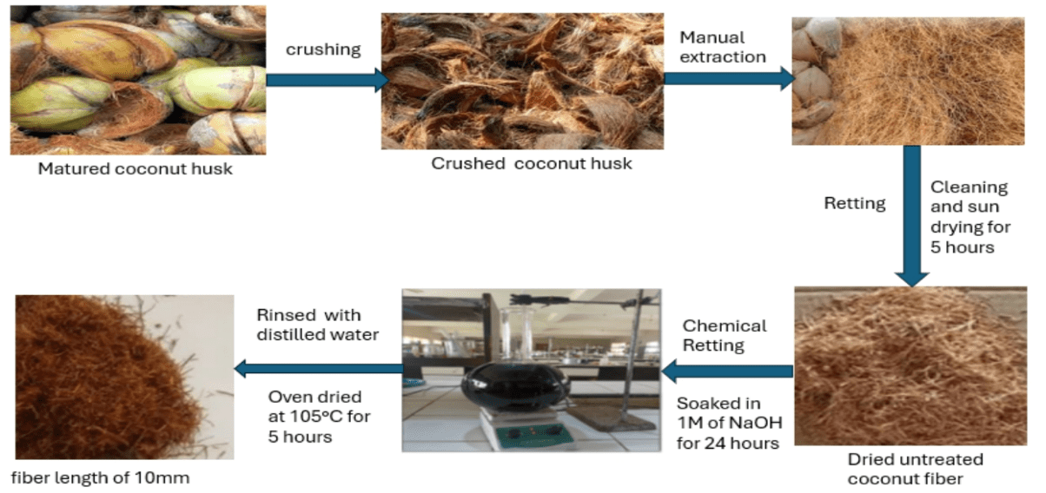
Figure.1: Preparation process of coconut fiber (Lamidi et al., 2025; Oladele et al., 2025)
2.2 Preparation Process of Palm Kernel Shell Ash
Several researchers reported the preparation and carbonization process of palm kernel shells to obtain carbonize palm kernel shell (CPKS) (Okoroigwe et al., 2014; Lamidi et al., 2025; Oladele et al., 2022). Palm kernel shells were washed and oven-dried for 5 hours at 105°C to remove moisture content and oily residual organic matter. Carbonization of the palm kernel shells was done by burning in a muffle furnace at 700°C for 5 hours to obtain carbonized ash. The muffle furnace ensures uniform heating and protects the PKS from direct heating, as shown in Figure 2. The ashes were crushed, ground using a ball milling machine and sieved through a 106 µm mesh to ensure uniform particle size distribution (Maedah et al., 2011).
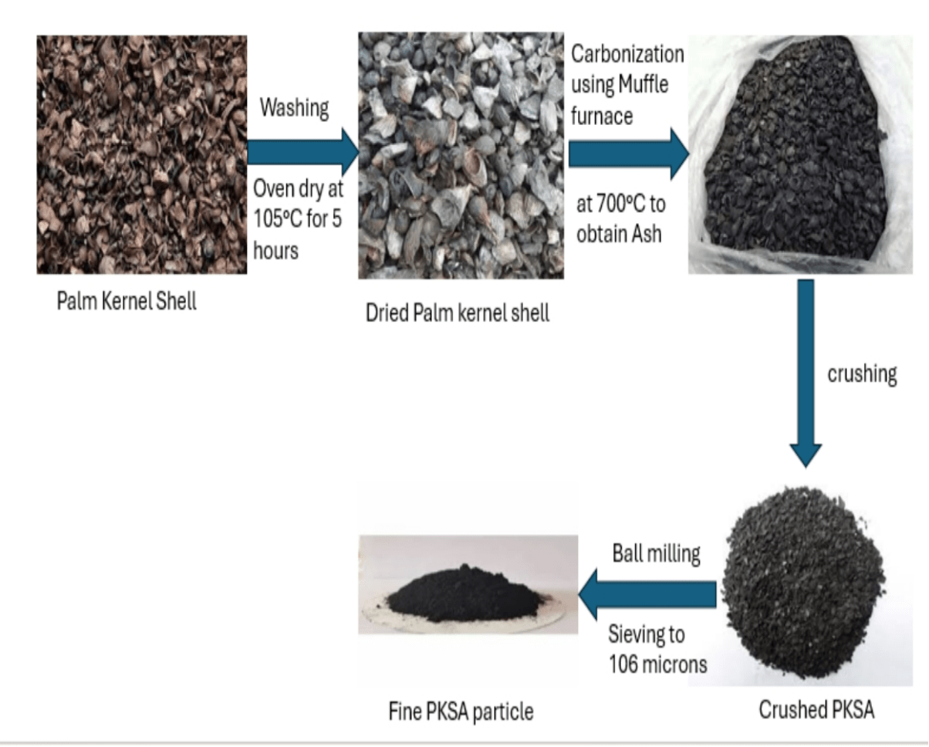
Figure 2: Preparation process of Palm kernel shell ash (Lamidi et al., 2025; Yawas et al., 2016)
2.3 Preparation Process of Granite Stone Dust
Granite stone dust, a byproduct of stone cutting, is to be sun-dried for 2 days to remove all moist content present in it. The dried stone dust is to be sieved through a 106 µm mesh to remove oversized particles and ensure homogeneity (Oladele et al., 2025; Lamidi et al., 2025), as shown in figure 3.
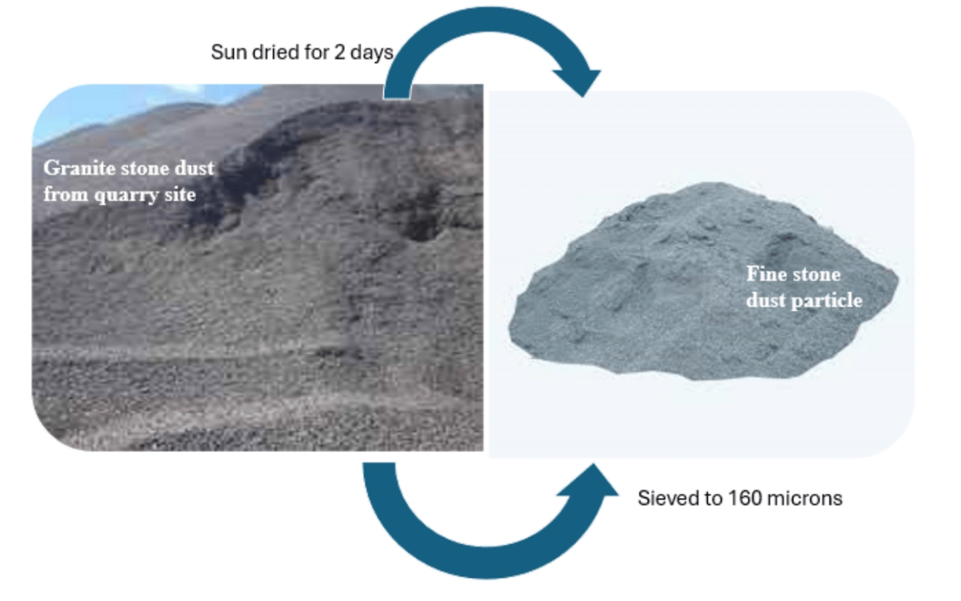
Figure 3: Preparation process of Stone Dust (Lamidi et al., 2025; Oladele et al., 2025)
3.6 Composite Fabrication
The use of the hand-layup technique could be used to produce composites since it provides low-cost tooling, simple processing and a high production rate. Tensile, impact, flexural and wear moulds are to be prepared by applying a releasing agent to enable easy removal of the specimens after fabrication. Epoxy and hardener were to be mixed in a 2:1 ratio. The weight fractions of the resin, palm kernel shell ash, stone dust and coconut fiber were to be determined using the formulation table. Pre-determined weight fractions of palm kernel shell ash alongside stone dust, as shown in Tables 1 and 2, are to be mixed with the resin by manual stirring to avoid agglomeration and then introduced into the moulds. Spreading is to be carried out to remove air bubbles and excess resin. The experiment should be carried out for all the chosen weight fractions, and curing of the hybrid composites should be done at room temperature for 24 hours. After curing, the samples were to be removed from the moulds and subjected to mechanical tests according to the ASTM standards mentioned. Carbonize palm kernel shell-coconut fiber and stone dust-coconut fiber run along with the same formulation table across all weight fractions as shown in Table 3, while the blend of the three (coconut fiber, carbonize palm kernel shell and stone dust) follows through the formulation table as seen in Tables 1 and 2.
In this short research communication, we developed two formulation tables representing the formulation matrices for hybrid reinforced epoxy composites developed with carbonize palm kernel shell (CPKS) and stone dust, i.e., Table 1, and in the second case, carbonize palm kernel shell, stone dust, and coconut fiber as shown in Table 2. The detailed breakdown of the tables is clearly presented for a clearer understanding of the compositional logic, purpose, and scientific insights behind them. These formulation tables represent systematic experimental designs in composite material research which enable controlled study of reinforcement effects on material properties, comparison between inorganic-only and inorganic–organic hybrid composites, and identification of optimal reinforcement ratio balancing strength, stiffness, and toughness.
Table 1: Formulation table for Carbonize Palm Kernel Shell-Stone dust Hybrid Reinforced Epoxy Composite
Sample | Polymer Matrix (wt.%) | Carbonize Palm Kernel Shell (wt.%) | Stone Dust (wt.%)
2 | 98 | 1 | 1
4 | 96 | 2 | 2
6 | 94 | 3 | 3
8 | 92 | 4 | 4
10 | 90 | 5 | 5
Control | 100 | 0 | 0

Insights from Table 1: Epoxy resin (polymer matrix) serves as the continuous phase responsible for binding and transferring load to the reinforcement (Carbonize Palm Kernel Shell and stone dust). Its percentage decreases progressively from 98 wt% to 90 wt% as the reinforcement content increases. Carbonize Palm Kernel Shell, a hard inorganic filler with good thermal and mechanical stability, and the stone dust contributes to density, improves stiffness, and increases wear resistance. Both are introduced equally in increasing weight fractions, from 1 wt% each (total 2 wt%) up to 5 wt% each (total 10 wt%). The gradual increase in reinforcement allows the researcher to evaluate how different filler loadings affect the composite’s mechanical, thermal, and wear properties. Also, the control sample (100% epoxy) serves as a baseline to compare how reinforcement alters the material’s performance.
Table 2: Fomulation table for Carbonize Palm Kernel Shell-Stone dust-Coconut fiber Reinforced Epoxy Composite.
Sample | Polymer Matrix (wt.%) | Palm Kernel Shell Ash (wt.%) | Stone dust (wt.%) | Coconut Fiber (wt. %)
2 | 98 | 0.67 | 0.67 | 0.67
4 | 96 | 1.33 | 1.33 | 1.33
6 | 94 | 1.67 | 1.67 | 1.67
8 | 92 | 2.33 | 2.33 | 2.33
10 | 90 | 2.67 | 2.67 | 2.67
Control | 100 | 0 | 0 | 0

Insights from Table 2: The epoxy matrix decreases from 90 wt% to 98 wt% as the reinforcement content increases, similar to Table 1. The three reinforcements used are carbonize palm kernel shell, stone dust, and coconut fibre. The coconut fiber introduces ductility, flexibility, and impact resistance due to its fibrous lignocellulosic nature. This hybridization can achieve synergistic effects with the CPKS and stone dust to enhance mechanical and wear properties, while coconut fiber improves toughness and energy absorption. The increasing weight fractions allow evaluation of optimum reinforcement content where properties are maximized without deteriorating interfacial bonding. It is worthy to note that control (100% epoxy) serves again as a reference, helping to determine the effect of reinforcement addition on composite behaviour in line with the findings of Baffour et al. (2021) and Adeyanju et al. (2025).
Table 3: Comparative Insights Between the two Formulation Tables
Aspects | Table 1(CPKS-Stone dust) | Table 2(CPKS-Stone dust-Coconut fiber)
Reinforcement | 2 inorganic fillers | 2 inorganic + 1 natural fiber
Purpose | To enhance strength, hardness, and wear resistance | To combine strength with ductility and impact strength
Expected density | Higher (due to minerals) | Slightly lower (fiber is lighter)
Flexibility | Brittle at higher loadings | More flexible due to fiber presence
Applications | Brake pads, structural components | Automotive interior/exterior parts, eco-composites, panels
4.0 Discussions on the Fomulation Table for Hybrid Reinforced Epoxy Composites
The formulation tables presented in Tables 1 (Carbonize Palm Kernel Shell–Stone Dust hybrid) and 2 (Carbonize Palm Kernel Shell–Stone Dust–Coconut Fiber hybrid) describe the systematic variation of reinforcement weight fractions incorporated into an epoxy polymer matrix to develop hybrid composite materials. The purpose of these formulations is to determine how the ad dition of different reinforcements and their combinations influence the mechanical, thermal, and wear properties of the resulting composites. Each formulation series includes a control sample containing 100% epoxy resin without reinforcement, serving as the reference baseline for comparison.
4.1 Palm Kernel Ash-Stone Dust Hybrid Reinforced Epoxy Composite
According to Table 1, which is the formulation of the palm kernel shell ash–stone dust hybrid composite, it involved varying the total reinforcement content from 2 to 10 wt%, with both reinforcements contributing equally at each level. The polymer matrix percentage decreased correspondingly from 98 wt% to 90 wt% as the reinforcement content increased. This composition strategy was designed to evaluate the reinforcing efficiency of two inorganic agro-mineral fillers within the epoxy system. The inclusion of palm kernel shell ash (CPKS), which contains silica, alumina, and potassium oxide, enhances thermal stability and stiffness due to its ceramic-like properties (Ossia et al., 2020; Lamidi et al., 2025). On the other hand, stone dust, a fine-grained mineral by-product, improves surface hardness, compressive strength, and wear resistance (Oladele et al., 2025; Adeyanju et al., 2025). At lower filler loadings (2–4 wt%), the reinforcements are expected to be well dispersed within the matrix, promoting good interfacial bonding and efficient stress transfer between the matrix and fillers. This can lead to improved mechanical strength, hardness, and dimensional stability. However, as the reinforcement content increases beyond 8 wt%, there is a likelihood of particle agglomeration, poor wetting, and micro-void formation within the epoxy matrix, which may reduce impact strength and ductility. The progressive reduction of the polymer matrix ensures that the effect of reinforcement addition on material performance can be systematically evaluated. This approach also enables the determination of the optimum filler concentration at which maximum property enhancement occurs before the onset of property deterioration due to excessive filler content (Idris and Aigbodian 2019).
4.2 Palm Kernel Shell Ash–Stone Dust–Coconut Fiber Hybrid Reinforced Epoxy Composite
Table 2 shows the second formulation incorporated three reinforcements – palm kernel shell ash, stone dust, and coconut fiber in equal weight proportions across five composite samples. The total reinforcement content varied from 2 wt% to 10 wt%, while the polymer matrix decreased from 98 wt% to 90 wt%. This hybridization approach was developed to achieve a synergistic balance between the mechanical stiffness of inorganic fillers and the toughness of natural fibers (the palm kernel shell ash and stone dust contribute to hardness, wear resistance, and dimensional stability, while coconut fiber introduces ductility, improved impact resistance, and better energy absorption characteristics due to its fibrous and lignocellulosic structure. At low reinforcement levels (2–4 wt%), evenly distributing the three reinforcements throughout the epoxy matrix improves the interfacial adhesion and stress transfer capability, which in turn increases the tensile and flexural strengths. At moderate filler levels (6–8 wt%), a balance between stiffness and toughness is achieved, making the composite suitable for applications requiring both load-bearing capacity and shock resistance (e.g., automotive interior panels, covers, and low-friction structural parts). At higher filler loading (10 wt%), however, the increase in particulate and fibrous content may cause interfacial incompatibility, uneven dispersion, or clustering, leading to microstructural defects and potential reduction in mechanical integrity.
4.3 Table 4: Comparative Discussion of Both Formulation Systems
The two formulation strategies represent distinct reinforcement systems within the same epoxy polymer framework. While the PKSA-stone dust emphasizes hardness, strength and wear resistance, the second formulation (PKSA-stone dust-coconut fiber) is engineered for improved strength, flexibility and environmental sustainability. Table 4 below shows a comparative discussion of both formulation systems.

Parameter | PKSA-Stone dust- Hybrid | PKSA-Stone dust-Coco fiber Hybrid
Reinforcement type | Two inorganic fillers | Two inorganic + one natural
Matrix reduction | From 98 wt% - 90 wt% | From 98 wt% - 90 wt%
Reinforcement Progression | Equal CPKS and Stone dust | Equal CPKS, Stone dust, and Coconut fiber
Objective | Improve strength, hardness, wear resistance. | Achieve balanced strength, ductility and toughness
Expected behaviour | High density, brittle behaviour at high filler load. | Lower density, improved toughness and flexibility
Application Potential | Brake pads, wear resistant coatings, mechanical housings | Lightweight components, eco-friendly composites, energy-absorbing parts.

4.4 Expected Property Trends and Strengthening Mechanism
The type, amount, and interaction of the reinforcements with the epoxy matrix generally influence expected trends in the mechanical, thermal, and wear properties of the developed hybrid composites. The reinforcement loading ranges between 2 wt% and 10 wt%, with the polymer matrix serving as the continuous phase that transfers stress to the embedded particulate and fibrous phases. The interaction between the matrix and the reinforcements significantly influences the overall performance of the composites.
4.4.1 Tensile Strength
4.4.2 Flexural Strength and Modulus
Based on the findings of Olanrewaju and Abas. It is expected that flexural strength and modulus follow a similar pattern to the tensile strength. Therefore, at lower and moderate filler loading (2 - 6 wt%), improved stiffness and flexural strength are expected due to the rigid nature of CPKS and stone dust particles, which restrict the deformation of the polymer matrix under bending loads. The incorporation of coconut fiber enhances the ability of the composite to resist crack propagation, increasing the flexural modulus at intermediate loadings. At higher loadings, the flexural strength may drop due to filler clustering, poor stress distribution, and microcrack formation at particle–matrix interfaces. It is expected that the CPKS-Stone Dust hybrid composite exhibits higher stiffness but more brittle at high load. Similarly, CPKS-Stone Dust-Coconut Fiber hybrid is expected to possess a slightly lower stiffness but improved flexibility and toughness (Dholi et al., 2025).
4.4.3 Impact Strength
The impact strength represents the material’s ability to absorb and dissipate energy under sudden load. The control epoxy (100% matrix) has low impact strength due to its brittle nature. The inclusion of reinforcements up to 6 wt% enhances impact strength, particularly in the CPKS-Stone Dust-Coconut Fiber composite, because the natural fiber component (coconut fiber) absorbs and redistributes impact energy effectively. In contrast, the purely inorganic CPKS–Stone Dust hybrid may exhibit reduced impact energy absorption due to the rigidity of both fillers. Beyond 8 wt%, increased filler concentration can lead to microvoids and interfacial defects that initiate crack propagation, thus lowering impact resistance. It is expected that the CPKS-Stone Dust composite exhibits moderate improvement, peak at 4–6 wt%. Alternatively, the CPKS-Stone Dust-Coconut Fiber composite would exhibit higher improvement, peak at 6–8 wt%.
4.4.4 Hardness
Hardness measures the material’s resistance to indentation and surface deformation or abrasion. The CPKS-Stone Dust Composite is expected to exhibit a significant increase in hardness as the filler content increases because both CPKS and stone dust are hard, mineral-based materials with high microstructural rigidity. Therefore, at low to moderate filler content (2-6 wt%), the improvement in hardness is due to uniform dispersion and the restriction of polymer segment mobility. Then at high loadings (8-10 wt%), hardness continues to rise slightly or stabilizes due to particle clustering, but excessive loading could create brittle zones, compromising toughness. In contrast, for the CPKS-Stone Dust-Coconut Fiber hybrid, the natural fiber has a lower hardness compared to mineral fillers, so overall hardness may increase at a slower rate but with improved toughness (Ikumapayi and Akinlabi 2018). The expected trend is that the CPKS-Stone Dust composite at 8-10 wt% shows highest hardness values. The CPKS-Stone Dust-Coconut Fiber composite is expected to exhibits moderate hardness, and more balanced ductility.
4.4.5 Wear Resistance
Similar to the research by Sharma et al., The wear resistance of both composites is expected to improve significantly compared to the neat epoxy resin. The incorporation of CPKS (rich in silica and alumina) and stone dust (rich in silicates and quartz) introduces hard particles that enhance surface resistance to abrasion. At low loadings (2–4 wt%), the reinforcement particles are well integrated within the matrix, providing an even distribution of resistance to wear. At higher loadings (8–10 wt%), reinforcement clustering and poor matrix wetting may lead to localized wear due to the detachment of weakly bonded particles. Furthermore, the CPKS-Stone dust composite is expected to show better wear resistance than the fiber-containing hybrid due to its higher inorganic filler content, while the Coconut fiber may show slightly reduced wear resistance but better resistance to surface cracking under frictional stress (Baffour-Awuah et al., 2021; Patel et al., 2024).
4.4.6 Density and Weight Variation
According to several researchers (Balaji et al., 2022; Garcia et al., 2024; Oladele et al., 2022 and Lamidi et al., 2025). The density of the CPKS-Stone Dust composite is expected to be higher due to the mineral nature of both fillers (Dirisu et al., 2024). Conversely, the inclusion of coconut fiber in the hybrid system will reduce the overall density, creating a lightweight composite that is advantageous for applications where reduced mass is critical (e.g., automotive interiors, aerospace panels) similar to Sarafat at al., 2022.

4.4.7 Strengthening and Toughening Mechanisms in the Hybrid Composites
The observed and predicted improvements in the mechanical and wear properties of the hybrid epoxy composites can be explained through several fundamental reinforcement mechanisms. Firstly, the load transfer mechanism plays a dominant role in both the binary (CPKS-stone dust) and ternary (CPKS-stone dust-coconut fiber) systems (Joseph & Mathew 2023; Aulin 2024). In this mechanism, the epoxy matrix functions as a continuous phase that transfers externally applied stresses to the stiffer and stronger reinforcement phases. The inclusion of carbonize palm kernel shell, stone dust, and coconut fiber facilitates efficient stress transmission across the matrix–reinforcement interface, thereby enhancing tensile and flexural strengths. This mechanism is particularly effective at moderate filler loadings, where the interfacial bonding between the epoxy and the reinforcement phases is strong and uniform (Bilvatej 2023; Adeyanju et al., 2024).
Secondly, the particle reinforcement mechanism contributes significantly to the improved surface hardness and wear resistance observed in the composites. The hard mineral fillers – carbonize palm kernel shell and stone dust – act as rigid microstructural barriers within the polymer matrix (Lamidi et al., 2025; Eriksson, 2020; Ossia et al., 2020; Lee and Filip, 2013). These particles impede the mobility of polymer chains and restrict plastic deformation under load. Consequently, the composites exhibit higher hardness, greater stiffness, and improved resistance to abrasion and surface wear (Oladele et al., 2025; Sarafat et al., 2022).In the ternary hybrid composite, the fiber pull-out and crack-bridging mechanism is an additional and crucial factor influencing toughness. The embedded coconut fibres act as micro-scale bridges across propagating cracks, absorbing fracture energy through gradual fiber stretching and controlled pull-out. This mechanism delays catastrophic failure and enhances impact resistance and energy absorption capacity. It provides the ternary hybrid composite with superior ductility and toughness compared to the binary composite containing only mineral fillers. The constraint effect also contributes to the observed mechanical behaviour. As the filler loading increases, the presence of rigid particles constrains the mobility of the polymer molecular chains. This restriction results in enhanced stiffness and modulus at low-to-moderate filler concentrations. However, at higher reinforcement levels, excessive constraint may lead to localized stress concentrations and reduced ductility, rendering the composite more brittle, which is comparable to earlier research by Lamidi et al. (2025) and Oladele et al. (2025).Finally, the hybrid synergy mechanism emerges from the combined presence of inorganic (CPKS and stone dust) and organic (coconut fiber) reinforcements. The inorganic fillers contribute to improved stiffness, hardness, and wear resistance, while the organic fibers enhance toughness and energy absorption reference to several other similar researches such as Adeyanju et al., 2025; Oladele et al., 2025; Lamidi et al., 2025; Eriksson, 2020; Ossia et al., 2020; Lee and Filip 2013). This synergistic interaction between dissimilar reinforcements results in a balanced mechanical performance combining the strength and rigidity of the mineral fillers with the flexibility and toughness imparted by the natural fibers (Oladele et al., 2025; Lamidi et al., 2025). Together, these mechanisms explain the complex yet complementary roles of each reinforcement phase in optimizing the overall performance of the hybrid epoxy composites. The result is a sustainable material system that exhibits a favorable balance between strength, stiffness, wear resistance, and impact toughness, making it suitable for both structural and functional engineering applications (Oladele et al., 2025).
4.5 Table 5: Summary of Expected Property Trend
Property | CPKS-Stone Dust Hybrid | CPKS-Stone Dust-Coconut Fiber Hybrid
Tensile Strength | ↑ up to 6 wt%, ↓ beyond 8 wt% | ↑↑ up to 6–8 wt%, mild ↓ beyond 10 wt%
Flexural Strength | ↑ up to 6 wt%, brittle after 8 wt% | ↑ up to 8 wt%, retains ductility
Impact Strength | Slight ↑ up to 4–6 wt% | Significant ↑ up to 8 wt%
Hardness | Continuous ↑ up to 10 wt% | Significant ↑ up to 8 wt%
Wear Resistance | High Improvement | Moderate improvement, better surface integrity
Density | High | Lower
Ductility | Low | Higher

5.0 Conclusion
This work proposes a practical formulation strategy for two sustainable hybrid epoxy composite systems: a CPKS-stone dust binary hybrid and a CPKS-stone dust-c
oconut fiber ternary hybrid, with reinforcement levels varied from 2 wt% to 10 wt%. Mechanistic analysis predicts that low-to-moderate reinforcement loadings (approx. 4-6 wt%) are likely to maximize tensile and flexural performance due to effective filler dispersion and interfacial load transfer, while the ternary hybrid is expected to show superior impact resistance and toughness because of fiber-mediated energy dissipation mechanisms (fiber pull-out and bridging). High reinforcement levels (>8 wt%) are anticipated to risk agglomeration, void formation, and subsequent reductions in tensile ductility unless dispersion and surface treatments are optimized. From an application perspective, the binary CPKS-stone dust system is especially promising for wear- and hardness-critical components (e.g., brake-pad backing layers, wear-resistant housings), whereas the ternary CPKS-stone dust-coconut fiber system is better suited to lightweight structural elements and impact-resistant parts (e.g., interior automotive panels, protective casings). The proposed formulations thus offer an adaptable, waste-to-wealth pathway for locally sourced reinforcements that align with circular-economy goals.
Disclaimer (Artificial intelligence)
Author(s) hereby declare that generative AI technologies such as Large Language Models, etc. have been used during the writing or editing of manuscripts.
Details of the AI usage are given below:
The authors declare that generative AI technology was used to assist in the editing of this manuscript. Specifically, OpenAI's GPT-5.0, accessed via the OpenAI platform, was employed to enhance clarity, text summarization, grammar, and structural flow.
The AI assistance was limited to linguistic refinement and organization of content. All input prompts were carefully designed by the authors; below are the input prompts:
1. Refine the grammar in the above text for the introduction section of a manuscript. Suggest some relevant literature too (hybrid polymer composites).
2. List some research where carbonize shell, fibers and stone dust was used. Summarize the findings by the authors.
- Correct the grammatical errors in in the text above. Ensure the meaning in the text are retained.

References
1. Hariharan Arumugam, Mohamed Iqbal M, Cheol-Hee Ahn, Sarawut Rimdusit, Alagar Muthukaruppan, (2023). Development of high-performance granite fine fly dust particle reinforced epoxy composites: structure, thermal, mechanical, surface and high voltage breakdown strength properties,Journal of Materials Research and Technology, Volume 24,2023, Pages 2795-2811.
2. Sheriff Babatunde Lamidi, Kasali A. Adedeji, Nurudeen A. Raji, Oladele O. Isiaka, Mathew A. Ajayi, Adesina Oluwole, Olalere K. Rafiu, Dele D. Elizabeth, and Mubaraq A. Olojo. 2025. “Experimental Investigation of Physical, Mechanical and Wear Index in Polymer Matrix Composites for Potential Structural Applications”. Journal of Materials Science Research and Reviews 8 (4):805–820. https://doi.org/10.9734/jmsrr/2025/v8i4442.
3. Fong A, Wong DH, Lau S, et al. (2025). A review on the hybrid polymer composites comprising natural fibre and nanomaterial reinforcement. Journal of Composite Materials. 59(22):2615-2646. doi:10.1177/00219983251334861
4. Elfaleh I, Abbassi F, Habibi M, et al. (2023) A comprehensive review of natural fibers and their composites: an eco-friendly alternative to conventional materials. Results Eng 19: 101271.
5. Tarikul Islam, Mehedi Hasan Chaion, M. Abdul Jalil, Abu Sayed Rafi, Faujia Mushtari, Avik Kumar Dhar, Shahin Hossain (2024). Advancements and challenges in natural fiber-reinforced hybrid composites: A comprehensive review. SPE Polymers, Volume 5(4), Pages 481-506. https://doi.org/10.1002/pls2.10145
6. Shukla S, Behera BK. (2022). Auxetic fibrous structures and their composites: a review. Compos Struct. 290:115530. doi:10.1016/j.compstruct.2022.115530
7. Jayan JS, Appukuttan S, Wilson R, Joseph K, George G, Oksman K. 1 – An introduction to fiber reinforced composite materials. In: K Joseph, K Oksman, G 8. George, R Wilson, S Appukuttan, eds. Fiber Reinforced Composites. Woodhead Publishing; 2021: 1-24. doi:10.1016/B978-0-12-821090-1.00025-9
9. Vasiliev VV, Morozov EV. (2013) Introduction. Advanced Mechanics of Composite Materials. Elsevier 1-27. doi:10.1016/B978-0-08-098231-1.00001-7
10. Aleksendrić D, Carlone P. (2015). Introduction to composite materials. Soft Computing in the Design and Manufacturing of Composite Materials. Elsevier;1-5. doi:10.1533/9781782421801.1
11. Sheriff Babatunde Lamidi, Oluwole A. Adesina, Kasali Aderinmoye Adedeji, Nurudeen Adekunle Raji (2025). Modeling and Development of Local Raw Materials for Automotive Brake Pad. International Journal of Latest Technology in Engineering, Management, and Applied Science. DOI: 10.51583/IJLTEMAS Volume XIV, Issue III.
12. Akinwande, O. O., & Oladele, I. O. (2021). Mechanical and wear properties of granite dust filled recycled polyethylene composites. Journal of Materials Research and Technology, 15, 521-530.
13. Li, Q., Zhang, H., & Wang, J. (2025). Alkali treatment of granite stone dust for improved mechanical interlocking in polymer composites. Materials Today Communications, 34, 105231.
15. Achukwu, E.O, A. M. Barnabas1, A. Mamman1, M. I. Uzochukwu (2015). Fabrication Of Palm Kernel Shell Epoxy Composites And Study Of Their Mechanical Properties. Nigerian Journal of Material Science and Engineering. Volume 6, issue1.
16. Iyasele, Edgar Omondiale (2018). Comparative Analysis On The Mechanical properties Of A Metal-Matrix Composite (Mmc) Reinforced With Palm Kernel/Periwinkle Shell ash. Global Scientific Journal. Volume 6, issue 8.
17. Isiaka Oluwole Oladele and Avwerosuoghene Moses Okoro (2016). The effect of palm kernel shell ash on the mechanical properties of as-cast aluminium alloy matrix composites. Leonardo Journal of Science. Issue 28. p 15-30.
18. Bello S.K, Bajela G.G, Lamidi S.B, Oshinlaja S., (2020). Design and Fabrication of Pneumatic Can Crushing Machine. International Journal of Advances in Scientific Research and Engineering. Volume 6, Issue 10. https://doi.org/10.31695/IJASRE.2020.33914
19. Ayomide Z. Kazeem, Sheriff B. Lamidi, Yakub O. Bankole, Murisiku Onigemo, Lateefah A. Apete, Abiodun Y. Akinsanya (2023). Smart Materials: Awareness and Impact in the Construction Industry in Lagos State. International Research Journal of Advanced Engineering and Science. Volume 8, Issue 3. Pp 58-62.
20. Lawal S.S , Ademoh N.A , Bala K.C , A.S.Abdulrahman (2020). A Review of the Compositions, Processing, Materials and Properties of Brake Pad Production. Journal of Physics: Conference Series.
21. Hitesh Bhakuni, Muley A.V and Ruchika (2022). Fabrication, testing & analysis of particulate ceramic matrix composite for automotive brake pad application. Materials Today: Proceedings of the International Conference on Advancement in Manufacturing engineering, https://doi.org/10.1016/j.matpr.2023.01.413
22. Rakesh Singh, V. C. (2014). Polyester/Kota Stone Dust Composite: A Comprehensive Investigation of Mechanical and Sliding Wear Properties. Mechanics of Advanced Composite Structures, 11(2), 375 - 384. doi:https://doi.org/10.22075/MACS.2024.31203.1537
23. Resego Phiri, S. M. (2024). Agro-waste for renewable and sustainable green production: A review. Journal of Cleaner Production, 434, 0959-6526. doi:https://doi.org/10.1016/j.jclepro.2023.139989
24. Risti Ragadhita, D. F. (2023). Techno‐Economic Evaluation of The Production of Resin-Based Brake Pads using Agricultural Wastes: Comparison of Eggshells/Banana Peels Brake Pads and Commercial Asbestos Brake Pads. ASEAN Journal of Science and Engineering, 3(3), 243-250. doi:http://ejournal.upi.edu/index.php/AJSE
- Edmund C. Okoroigwe, Christopher M. Saffron and Pascal D. Kamdem (2014). Characterization of palm kernel shell for materials reinforcement and water treatment. Journal of Chemical Engineering and Materials Science. Vo l. 5(1), pp. 1-6, DOI: 10.5897/ JCEMS2014.0172.
- Maedeh M, Ghasem DN, Abdul RM (2011). Production of Carbon Molecular Sieves from Palm Shell through Carbon Deposition from Methane. Chem. Ind. Chem. Eng. Q. 17(4):525-533.
- E. Baffour-Awuah, S. A. Akinlabi, T. C. JEN, S. Hassan, I. P. Okokpujie , F. Ishola (2021). Characteristics of Palm Kernel Shell and Palm Kernel ShellPolymer Composites: A Review. International Conference on Engineering for Sustainable World. doi:10.1088/1757-899X/1107/1/012090
- O. M. Ikumapayi and E. T. Akinlabi, “Composition, Characteristics and Socioeconomic benefits of palm kernel shell exploitation – An overview” Journal of Environmental Science and Technology, vol.1(5), pp. 220-232, 2018.
29. Dholi, A., Yadav, S., Agrawal, A., and Gupta, G. (2025). Development of epoxy/red stone dust composites and their characterization for light duty structural and automotive applications. Journal of Adhesion Science and Technology. https://www.semanticscholar.org/paper /bf1b7a1ea54d89f9d57c5d6bab800dc915fcb7b3
30. Sharma, V., Kumar, A., and Singh, R. (2023). Influence of granite stone dust loading on the wear behavior of epoxy composites. Journal of Composites Science, 7(2), 45-58.
31. Patel, P., and Gupta, S. (2024). Effect of granite stone dust particle size on the tribological properties of polyester composites. Tribology International, 190, 108992
32. J. Balaji, M.M. Nataraja, Achunala Rajesh (2022). Experimental investigation on mechanical properties of polymer composites reinforced with aluminium nitride and rice husk,Materials Today: Proceedings,Volume 52, Part 3,Pages 1781-1787,ISSN 2214-7853,
33. Garcia, M., Rodriguez, L., and Perez, A. (2024). Sustainable composites: Utilizing granite stone dust in polylactic acid (PLA) matrices. Journal of Cleaner Production, 410, 137245.
34. Isiaka Oluwole Oladele, Simbiat Olawunmi Aliu, Anuoluwapo Samuel Taiwo, Newton Itua Agbeboh (2022). Comparative investigation of the influence of stone-dust particles and bagasse fiber on the mechanical and physical properties of reinforced recycled high-density polyethylene bio-composites
35. Dirisu, J.O., Okokpujie, I.P., Apiafi, P.B. et al. (2024). Development of eco-friendly brake pads using industrial and agro-waste materials. J. Eng. Appl. Sci. 71, 55 https://doi.org/10.1186/s44147-023-00345-y
36. Joseph, A., and Mathew, G. (2023). Wear characterization of granite dust reinforced hybrid polymer composites. Wear, 512-513, 204567.
37. Aulin, V. R. (2024). Revealing patterns of change in the tribological efficiency of composite materials for machine parts based on phenylone and polyamide reinforced with arimide-T and fullerene. Eastern-European Journal of Enterprise Technologies, 12(129), 6-19. doi: https:/doi.org/10.15587/1729-4061.2024.304719
38. B. Bilvatej, J. N. (2023). Progress in polymeric and metallic brake pads: A comprehensive review. Proc IMechE Part J J Engineering Tribology. doi: https://doi.org/0.1177/13506501231204655.
39. Adeyanju, B. B., Adewuyi, B. O., Oladele, I. O., Daramola, O. O., Aramide, F. O., Adekunle, A. M., ... and Samson, I. A. (2024). Agro-based nanoparticles composite: A novel approach for enhanced ballistic applications. Chemistry and Materials Research Journal, 4(2), 10-32.
40. Adeyanju, B. B., Adewuyi, B. O., Oladele, I. O., Daramola, O. O., Ajayi, M. A., and Omotoso, G. S. (2025). Exploring the Impact of Graphene and Nanoparticles on Economic Growth and Advancements in Material Science: A Comprehensive Review. African Journal of Advances in Science and Technology Research, 19(1), 64-85.
41. Oladele, I. O., Ajayi, M. A., Bichang’a, D. O., Fasinu, A. I., Alabi, A. O., Oyegunna, S. A., and Abraham, O. F. (2025). Characterization of Spider Cobwebs Derived Silk Fiber as Potential Decomposable and Sustainable Strengthening Material in Polymer Based Biocomposites. Hybrid Advances, 100560.
42. Oladele, I. O., Ajayi, M. A., Taiwo, A. S., Ajileye, J. O., Oyegunna, S. A., and Orisawayi, A. O. (2025). Constituents, morphological and thermal stability characteristics of wood ash and wood charcoal microparticles for composites application. Next Materials, 9, 101045.
43. Uche Asonye, Angela Ofoma, Izuchi Duruanyim, Juliet Duruanyim (2025). Development of Automobile Brake Pads Using Three Biological Materials. Nigerian Journal of Engineering Science Research (NIJESR). 8(1), 101-111. https://doi.org/10.5281/zenodo.15829213
44. Achebe, C., Chukwuneke, J., Anene, F., Ewulonu, C. (2018). A Retrofit for Asbestos Based Brake Pad Employing Palm Kernel Fiber as the Base Filler Material. Journal of Materials: Design and Applications: Part L, 13-17.
45. Aigbodion, V., Akadike, U., Hassan, S., Asuke, F., Agunsoye J. (2010). Development of Asbestos-Free Brake Pad using Bagasse. Tribology in Industry, 32, 12 – 17.
46. Lee, P.W. and Filip, P. (2013). Friction and Wear of Cu-Free and Sb-Free Environmental Friendly Automotive Brake Materials. Journal of Wear, 302, 1404–1413.
47. Mgbemena, C.O., Mgbemena, C. E. and Okwu, M.O. (2014). Thermal Stability of Pulverized Palm Kernel Shell (PKS) Based Friction Lining Material Locally Developed from Spent Waste, ChemXpress, 5, 115–122.
48. Dagwa, I.M. and Ibhadode, A.O.A (2008). Development of Asbestos-Free Friction Lining Material from Palm Kernel. Journal of Brazilian Society of Mechanical Engineering, 30(2), 173.
49. Yawas, D. S., Aku, S. Y., Amaren, S. G. (2013). Morphology and Properties of Periwinkle Shell Asbestos-Free Brake Pad. Journal of King Saud University – Engineering Sciences. 2(1), 7.
50. Ossia, C.V., Big-Alabo, A., Ekpruke, E. O. (2020). Effect of Grain Size on the Physico-Mechanical Properties of Automobile Brake Pads. Advances in Manufacturing Science and Technology, 44(4), 135-144.
51. Sarafat Ali, Naresh Kumar, Jasmaninder Singh Grewal Grewal, Vikas Thakur, Kwok Wing Chau, Mukesh Kumar (2022). Coconut waste fiber used as brake pad reinforcement polymer composite and compared to standard Kevlar-based brake pads to produce an asbestos free brake friction material. Polymer Composites. Vol. 43, Issue 3, Pages 1518-1525. https://doi.org/10.1002/pc.26472.
52. Kharate Nilesh Kisanrao, Ankur Vasava, Vishal Sulakhe (2025). A comprehensive review on brake pad materials and geometries: Performance, environmental impact, and emerging technologies, Proceedings of the Institution of Mechanical Engineers, Part D: Journal of Automobile Engineering, 10.1177/09544070251382756
53. Halil Kılıç (2025). Tribo‐Evaluation With Multi‐Criteria Decision‐Making Approach of Fly Ash‐Filled Hybrid Flax/Basalt Fiber Reinforced Brake Friction Composites, Polymer Composites, 10.1002/pc.70272, 46, 15, (14506-14522).
54. Lixin Yang, Nengbin Hua, Zhenlong Liao (2025). Preparation, Mechanical Properties, and Wear Resistance of Non-Asbestos Organic Brake Pads with Waste Shell Powder, Journal of Materials Engineering and Performance, 10.1007/s11665-025-11528-4
55. E. Manoj, G. Selvakumar, V. Sivaprakash, Arivoli C (2025). Fabrication and Characterization of Porous Biochar and Si3N4 Bioceramic Toughened Natural Fibre Epoxy Composite, Silicon, 10.1007/s12633-025-03335-2, 17, 10, (2417-2428)

