Quality-by-Design Optimization and Characterization of Artemether–Lumefantrine–Paracetamol Co-Loaded Solid Lipid Nanoparticles for Synchronized and Sustained Drug Release
Abstract
Malaria treatment continues to face significant challenges due to emerging drug resistance and pharmacokinetic heterogeneity among artemisinin-based combination therapies. This study reports the development of a triple-drug solid lipid nanoparticle (SLN) system employing Compritol® 888 ATO as the lipid matrix and Labrafil® M 1944 CS as the surfactant, co-loaded with artemether, lumefantrine, and paracetamol to achieve synchronized and sustained drug release. A Quality-by-Design (QbD) approach utilizing a Box–Behnken design was applied to optimize formulation parameters. The optimized formulation, comprising 1,000 mg of lipid, 2.25% surfactant, and a 60-minute homogenization time, yielded stable and monodisperse nanoparticles with a mean size of 131.8 nm, a polydispersity index (PDI) of 0.136, and a zeta potential of −49.4 mV. Encapsulation efficiencies were 91.4% for artemether, 93.0% for lumefantrine, and 91.0% for paracetamol, indicating strong entrapment of the drugs within the solid lipid core. In vitro release studies revealed cumulative drug releases of 90%, 80%, and 85%, respectively, after 72 hours, with mean release times of 18.3 and 24.1 hours demonstrating effective release synchronization. The developed SLN system offers a promising strategy for improving therapeutic efficacy, enhancing patient adherence, and mitigating drug resistance in malaria management.

Keywords: Solid lipid nanoparticles; Artemether; Lumefantrine; Paracetamol; Malaria; Quality by Design

Introduction
Malaria remains a significant global health burden, accounting for an estimated 263 million cases and 597,000 deaths in 2023 ^{[1]}. Artemisinin-based combination therapy (ACT) represents the global standard for Plasmodium falciparum malaria management, with the fixed-dose artemether–lumefantrine (AL) formulation recommended by the World Health Organization as first-line treatment ^{[2,3]}. Despite its clinical success, the AL regimen exhibits significant pharmacokinetic disparity between its two active agents: artemether is rapidly eliminated at a half-life of 1–3 hours^{[4]}, whereas lumefantrine displays prolonged retention with a half-life of 3–6 days ^{[5]}. This imbalance often leads to suboptimal plasma concentrations, reduced synergistic efficacy, and increased potential for parasite recrudescence and resistance. Both drugs also exhibit poor aqueous solubility, necessitating repeated dosing to maintain effective therapeutic levels ^{[6]}.
The emergence of artemisinin resistance across Southeast Asia and sub-Saharan Africa has intensified the need for enhanced therapeutic strategies ^{[7]}. One promising approach is the incorporation of a third pharmacological agent into ACTs to form triple-drug regimens, thereby extending therapeutic duration and delaying resistance onset. Building upon this rationale, the present work introduces a triple-combination solid lipid nanoparticle (SLN) formulation co-encapsulating artemether, lumefantrine, and paracetamol ^{[8]}. The inclusion of paracetamol offers adjunctive benefits by alleviating fever and pain associated with malaria and potentially protecting against renal stress, while its incorporation within the same nanocarrier ensures synchronized co-delivery ^{[9]}.
Solid lipid nanoparticles have emerged as versatile and biocompatible delivery systems capable of improving solubility, stability, and sustained release of lipophilic compounds ^{[10]}. Their ability to modulate drug release kinetics and enhance bioavailability makes them ideal candidates for optimizing multi-drug therapies. Previous studies have demonstrated that SLNs can successfully encapsulate antimalarial agents such as artemisinin derivatives and lumefantrine, achieving sustained release profiles of up to 72 hours and improved pharmacodynamic outcomes ^{[11,12]}.
This work establishes a proof of concept for SLN-mediated synchronized delivery of ACTs plus paracetamol, highlighting its potential to improve adherence and therapeutic outcomes in malaria. Building on the concept of triple ACTs and leveraging the capabilities of SLNs, the study hypothesizes that a single, optimized SLN can co-encapsulate artemether, lumefantrine, and paracetamol to achieve synchronized drug release, thereby rectifying their intrinsic pharmacokinetic mismatch while providing integrated symptomatic relief. It also details the Quality-by-Design-led development and comprehensive characterization of this novel triple-drug SLN. Our specific objectives were to: systematically optimize the formulation using a Box-Behnken design to minimize particle size and PDI while maximizing encapsulation efficiency; thoroughly characterize the optimized SLNs; and critically evaluate the in vitro release profiles and kinetics to provide mechanistic evidence of successful release synchronization.

2.0 Materials and Methods

2.1 Materials
All materials, reagents, and chemicals used in this study were of analytical grade. The pure molecular antimalarial drugs were donated by Laboratory and Allied Limited Company, Nairobi. Paracetamol (Lot No. 202307076A, BP grade) was manufactured by Anqiu Lu’An Pharmaceutical Co. Ltd and had a purity of 99.8%. Lumefantrine, of International Pharmacopoeia (Ph. Int) standard, Lot No. LF-E-23097 was manufactured by S. Kant Healthcare Limited and had a purity of 100.9% on a dried basis. Artemether (Batch No. AT-B-24040), also of International Pharmacopoeia (Ph. Int) standard, had a purity of 99.7% on a dried basis. Compritol® 888 ATO, Geleol® mono and diglycerides NF, Labrafil® M 1944 CS, Labrasol®, Precirol®, D-Lactose Monohydrate (DLM), and Ethanol were purchased from Sigma-Aldrich and used as received.

2.2. Formulation of SLNs
The nanoparticle drug carriers were prepared according to the method described by ^{[13]} and ^{[14]} with slight modifications. Lipid components and surfactants were melted together and mixed with the dissolved drugs artemether, lumefantrine, and paracetamol. The resulting hot oil-in-water emulsion was homogenised for 30–60 minutes at high shear (≥10,000 rpm) and then ultrasonicated for size reduction. The emulsion was subsequently cooled to form solid lipid nanoparticles (SLNs). Formulations varied in lipid concentration (1,000 mg to 2,000 mg), surfactant concentration (1.5–3.0 % w/v), and homogenisation time (30–60 min) according to a Box–Behnken design to optimise responses. In a representative formulation 1.0 g of Compritol® 888 ATO was weighed and transferred into a glass beaker, melted at 75 °C using a temperature-controlled magnetic hotplate stirrer. Simultaneously, 3.13 mg artemether, 18.75 mg lumefantrine, and 78.12 mg paracetamol were accurately weighed and dissolved in 5 mL of methanol. This drug solution was added gradually to the molten lipid with continuous stirring to ensure uniform dispersion and encapsulation within the lipid matrix. The aqueous phase was prepared by dissolving Labrafil® M 1944 CS (2.25% w/v) in 20mL of double-distilled water. The solution was preheated to the same temperature as the lipid phase (75°C) to prevent premature solidification during emulsification.
2.2.1 Emulsification and Ultrasonication
The molten lipid phase was added dropwise to the preheated aqueous phase under continuous high-speed magnetic stirring at 1000 rpm to form a coarse oil-in-water (O/W) emulsion. The resulting emulsion was then subjected to probe ultrasonication using a high-intensity homogenizer (Silverson L4R, Silverson Machines Limited, Buckinghamshire, UK; 20 kHz, 750 W) operated at 60% amplitude for 60 minutes in pulsed mode (5 seconds on, 3 seconds off). During ultrasonication, the vessel was maintained in an ice bath to facilitate rapid cooling and solidification of the lipid droplets, resulting in the formation of artemether–lumefantrine–paracetamol solid lipid nanoparticles (AL-P SLNs).
2.2.2 Drying of Formulations
The freshly prepared O/W emulsion was directly fed into a benchtop Buchi Mini Spray Dryer (Model B-290, BÜCHI Labortechnik AG, Flawil, Switzerland). Spray drying was performed at an inlet temperature of 80–110 °C and an atomizing pressure of 5–8 bar, with the aspirator flow adjusted to maintain an outlet temperature low enough to prevent thermal degradation of the encapsulated drugs.

2.3 Experimental design and optimization.
A three-factor Box–Behnken design (BBD) was employed to optimize the formulation parameters, namely lipid concentration (%), surfactant concentration (%), and homogenization time. The dependent variables were particle size (target: minimal), polydispersity index (PDI), and zeta potential (target: ≥ ±30 mV). Regression models were generated using Response Surface Methodology (RSM) in Design-Expert software (Stat-Ease Inc., Minneapolis, MN, USA). Table 1 summarizes the independent variables and their levels used in the design. Numerical optimization was performed to determine the combination of factors that simultaneously minimized particle size and PDI while maximizing encapsulation efficiency (EE%). The optimized conditions were subsequently validated experimentally.

Table 1: Independent Variables and Dependent Responses Used in Box–Behnken Design
Category | Code | Parameter | Description / Unit
Independent Variables | X1 | Lipid concentration | % w/v; Compritol® 888 ATO
 | X2 | Surfactant concentration | % w/v; Labrafil® M 1944 CS
 | X3 | Homogenization time | Minutes
Dependent Responses | Y1 | Mean particle size | Nanometers (nm)
 | Y2 | PDI | Dimensionless
 | Y3 | Zeta potential | Millivolts (mV)

2.4 Characterization
2.4.1 Determination of particle size, Zeta potential, and Polydispersity index (PDI)
The particle size, PDI, and zeta potential of the prepared ALP solid lipid nanoparticles (SLNs) were determined using photon correlation spectroscopy (PCS) and electrophoretic light scattering with a Zetasizer Nano ZS (Malvern Instruments, Worcestershire, UK).
For particle size and PDI measurements, approximately 1–3 mg of the freeze-dried SLNs were dispersed in 10 mL of distilled water and vortexed or briefly sonicated to ensure uniform dispersion without agglomeration. The measurements were performed at 25 °C in disposable polystyrene cuvettes, with light scattering detected at a fixed angle of 90°. Each sample was analyzed in triplicate, and results were expressed as the mean ± standard deviation (SD).
The zeta potential was measured by determining the electrophoretic mobility of the particles using the same instrument equipped with a folded capillary cell. The samples were prepared as described above, ensuring adequate dilution to avoid multiple scattering effects. All measurements were performed in triplicate under identical conditions to ensure reproducibility.
2.4.2 Determination of EE and DL
To quantify the fraction of free (unencapsulated) drug, 2 mL of the freshly prepared SLN dispersion was transferred into Amicon® Ultra centrifugal filters (molecular weight cut-off 50 kDa) and centrifuged at 25,000 rpm for 30 minutes at 4 °C. The filtrate, containing the free drug, was collected for analysis. For batch validation, ultracentrifugation at 30,000 rpm for 60 minutes was alternatively performed to separate the supernatant (unencapsulated drug) from the nanoparticle pellet.
The concentration of free drug in the filtrate or supernatant (W_{free}) was determined using a validated UV–Vis spectrophotometric method. The total drug content (W_{total}) was quantified by dissolving an accurately weighed amount of AL–P SLNs in ethanol, sonicating for 15 minutes to ensure complete drug release, and analyzing under identical conditions. The encapsulation efficiency (EE%) was calculated using Equation (1). Similarly, the drug loading (DL%) was determined using Equation (2).
EE% =$\frac{W_{total} -W_{free}}{W_{total}}×100$ (1)
where W_{Total} represents the total amount of drug in the formulation, and W_{free} denotes the amount of unencapsulated drug.
DL% =$\frac{W_{total} -W_{free}}{W_{lipid}+ W_{excipients}}×100$ (2)
where W_{lipid} and W_{excipients} represents the combined mass of lipid, surfactant, and other excipients used in the formulation.

2.5 Determination of differential calorimetric properties
Differential Scanning Calorimetry (DSC) analysis was carried out using a DSC Q200 instrument equipped with a refrigerated cooling system (RCS-90) and Tzero® technology (TA Instruments, New Castle, DE, USA). Approximately 3–5 mg of the lyophilized sample was accurately weighed and sealed in Tzero® aluminum pans using a hermetic sealer (TA Instruments). The analysis was conducted under a continuous flow of dry ultra-high-purity nitrogen gas (50 mL/min; Scott-Gross, Winchester, KY, USA) to provide an inert atmosphere. Samples were heated from 10 °C to 200 °C at a constant heating rate of 10 °C/min. At least four heating scans were performed to confirm the reproducibility of the thermal transitions. Thermograms were recorded and analyzed using the TA Universal Analysis software (Version 200.1740). The DSC thermograms were used to determine the melting behavior, phase transitions, and degree of crystallinity of the nanoparticles by evaluating the glass transition and melting temperatures along with their corresponding enthalpy changes.

2.6 Determination of the surface morphology
The surface morphology and structural characteristics of the ALP solid lipid nanoparticles (SLNs) were examined using Transmission Electron Microscopy (TEM; Model SU1510, Hitachi Ltd., Tokyo, Japan). A small amount of the nanoparticle dispersion was placed on a carbon-coated copper grid and allowed to air-dry at room temperature to form a thin film. The dried samples were then sputter-coated with a thin layer of gold to minimize charging effects during imaging. The coated samples were subsequently observed under TEM at suitable accelerating voltages, and electron micrographs were captured to evaluate particle shape, surface smoothness, and overall morphology.

2.7 In vitro release studies
In vitro release studies were performed using the dialysis bag method as described by Omwoyo et al. (2016), with slight modifications. A quantity of SLN dispersion equivalent to 5 mg of total drug was sealed in a pre-hydrated dialysis membrane (MWCO 12–14 kDa) and immersed in 200 mL of phosphate-buffered saline (PBS, pH 6.8) maintained at 37 ± 0.5 °C under continuous stirring at 100 rpm.
At predetermined intervals (0.5, 1, 2, 4, 6, 8, 12, 24, 36, 48, 60, and 72 h), 2 mL aliquots were withdrawn and replaced with an equal volume of fresh pre-warmed PBS to maintain sink conditions. Drug concentration in each sample was determined using a validated UV–Vis spectrophotometric method at the λmax of each drug, applying corrections for cumulative dilution.

2.8 In vitro drug release kinetic analysis
The first 60% of each release profile was fitted to five models, namely zero-order (constant release)(Eq.3), first-order (Eq.4), Higuchi(Eq.5), Korsmeyer–Peppas(Eq.6), and Peppas–Sahlin (Eq.7) ^{[13]}.
$Q_{t}=Q_{0}+ k_{0}t$ (3)
$\ln\left(Q_{0}-Q_{t}\right)=lnQ_{0}- k_{1}t$ (4)
$Q_{t}= k_{H}t^{\frac{1}{2}}$ (5)
$\frac{M_{t}}{M_{∞}}= k_{K}t^{n}$ (6)
$\frac{M_{t}}{M_{∞}}= k_{1}t^{m}+ k_{2}t^{2m}$ (7)
where Qt​ is the amount of drug released at time t, Q_{0​} is the initial amount of drug in the solution, k_{0​} is the zero-order release constant, k1​ is the first-order release constant, k_{H​} is the Higuchi dissolution constant, Mt​/M∞​ is the fraction of drug released at time t, k_{K}​ is the release rate constant, and n is the release exponent indicating the mechanism of drug release. In Equation 5, k1​ and k2​ represent the diffusion and relaxation rate constants, and m is the diffusional exponent. The model that produced the highest correlation coefficient (R²) was considered the best fit for describing the release kinetics of each formulation.

3.0 Results and discussions

3.1 Formulation optimization
The Box–Behnken design successfully generated polynomial models that described the relationship between the formulation factors and the measured responses (Figure 1). The independent variables: lipid concentration (1000–2000 mg), surfactant concentration (1.5–3.0% w/v), and homogenization time (30–60 min) were systematically varied to assess their influence on PS, PDI, and ZP. A total of 100 experimental runs were analyzed. The observed responses ranged from 129.15 to 246.27 nm for particle size, 0.12 to 0.36 for PDI, and –52.6 to –34.66 mV for zeta potential. Analysis of variance (ANOVA) revealed that both lipid concentration and homogenization time had statistically significant effects on particle size (p < 0.05). Numerical optimization identified the optimal formulation parameters as 1000 mg lipid, 2.25% surfactant, and 60 minutes of homogenization. Under these conditions, the predicted responses were a particle size of 131.83 nm, PDI of 0.136, and zeta potential of –49.46 mV, yielding a desirability value of 1.000. The desirability plot (Figure 1) illustrates how the formulation variables were balanced to achieve optimal overall performance, visually confirming the model’s effectiveness in identifying the most desirable formulation. Experimental validation of the optimized formulation closely matched the predicted values, confirming the accuracy and reliability of the model. The optimized SLNs exhibited a mean particle size of 131.83 ± 5.2 nm and a PDI of 0.136 ± 0.03, indicating a uniform and stable dispersion suitable for efficient drug delivery applications.

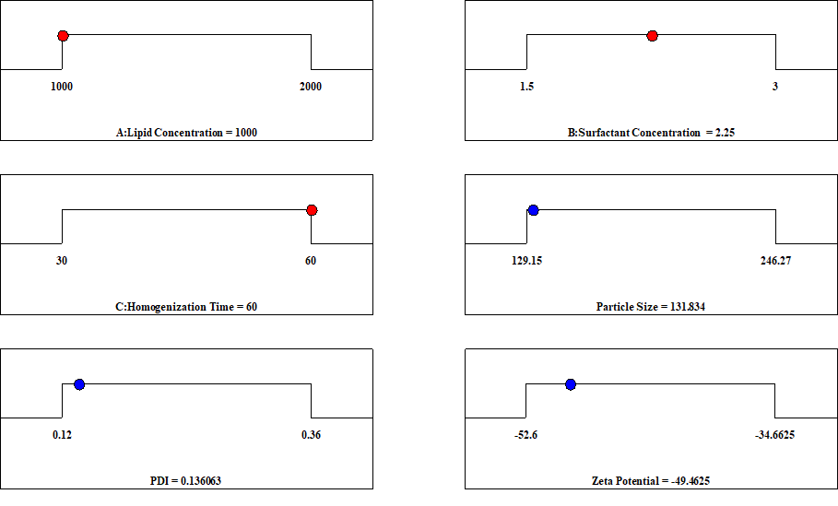
Figure 1: Desirability plot showing the optimal formulation parameters for lipid concentration, surfactant concentration, and homogenization time.

3.2 Particle size and Polydispersity index
From Table 2, the particle sizes of the triple nano-formulated drugs were all below 300 nm, a range smaller than the characteristic pore size of the gastrointestinal tract (GIT). This small particle size is advantageous for nano-formulated drugs, as it enables faster movement toward the target site of infection. In oral antimalarial therapy, nanoparticles below 200 nm are particularly favorable because they enhance drug dissolution, improve absorption across the GIT, and prolong systemic circulation ^{[14]}.
The polydispersity index (PDI) is a critical parameter that reflects the uniformity of nanoparticle size distribution. Clinically, PDI values should be as low as possible, typically ≤ 0.3 for lipid-based nanoparticles to ensure consistent drug delivery, maximize bioavailability, and minimize adverse effects, thereby enhancing both the safety and efficacy of the therapeutic system ^{[15]}. In this study, PDI values ranged from 0.12 to 0.36, with the optimized formulations achieving monodisperse nanoparticles (PDI < 0.20). Such uniformity is essential for consistent drug encapsulation and predictable release kinetics, which are particularly important for maintaining the therapeutic ratio between Artemether and Lumefantrine. Conversely, formulations with higher lipid content exhibited slightly higher PDI values, indicating heterogeneous particle populations that may cause variability in drug release and bioavailability. The optimized nanoparticles (Run 17) exhibited a mean hydrodynamic diameter of 131.8 nm and a PDI of 0.1361, both within the preferred nanomedicine range (100–200 nm and PDI < 0.2). A smaller particle size promotes greater intestinal permeability and enhances cellular uptake via both paracellular and endocytotic pathways, while a low PDI minimizes the risk of aggregation during storage or upon dilution in physiological fluids. The reduction in particle size can be attributed to the lower lipid concentration, which decreases formulation viscosity and allows more efficient droplet disruption during homogenization. Additionally, the extended homogenization time applies continuous shear forces that facilitate finer particle breakdown. The narrow PDI observed further reflects effective surfactant coverage of particle surfaces, which prevents coalescence and ensures dispersion stability. These findings align with the principle that nanoscale carriers provide a high surface area-to-volume ratio, a crucial factor influencing dissolution rate, drug release kinetics, and bioavailability.

Table 2: Effects of Lipid concentration, Surfactant concentration, and Homogenization time on particle size, PDI, and zeta potential of AL-P SLNs.
Std | Run | A: Lipid Concentration (mg) | B: Surfactant Concentration (%) | C: Homogenization Time (minutes) | Particle Size (nm) | PDI | Zeta Potential (mV)
1 | 1 | 1000 | 1.5 | 45 | 168.05 | 0.19 | -34.6625
8 | 2 | 2000 | 2.25 | 60 | 210.07 | 0.28 | -47.1625
12 | 3 | 1500 | 3 | 60 | 151.52 | 0.18 | -52.6
11 | 4 | 1500 | 1.5 | 60 | 190.42 | 0.22 | -40.475
16 | 5 | 1500 | 2.25 | 45 | 188.12 | 0.201 | -47.38
3 | 6 | 1000 | 3 | 45 | 129.15 | 0.12 | -48.3375
15 | 7 | 1500 | 2.25 | 45 | 187.76 | 0.2 | -47.88
10 | 8 | 1500 | 3 | 30 | 185.00 | 0.18 | -51.825
2 | 9 | 2000 | 1.5 | 45 | 246.27 | 0.36 | -36.7625
6 | 10 | 2000 | 2.25 | 30 | 243.56 | 0.34 | -49.2375
5 | 11 | 1000 | 2.25 | 30 | 165.35 | 0.17 | -46.3375
14 | 12 | 1500 | 2.25 | 45 | 186.91 | 0.206 | -48.04
4 | 13 | 2000 | 3 | 45 | 207.37 | 0.26 | -46.8375
13 | 14 | 1500 | 2.25 | 45 | 188.61 | 0.209 | -46.98
9 | 15 | 1500 | 1.5 | 30 | 223.90 | 0.2815 | -40.2
17 | 16 | 1500 | 2.25 | 45 | 186.71 | 0.212 | -47.58
7 | 17 | 1000 | 2.25 | 60 | 131.86 | 0.13 | -49.4625

3.3 Zeta Potential
The zeta potentials (–34.66 to –52.6 mV) in Figure 2 confirm electrostatic stability, with values below –30 mV considered adequate for preventing aggregation. The most stable formulations were observed with higher surfactant concentrations, consistent with stronger surface charge stabilizations shown below. This is particularly important for SLNs, where crystallization of the lipid matrix during storage can destabilize the system. A high surface charge may counteract this tendency, thereby preserving drug entrapment and release properties. Nanoparticle surface properties like charges are key in protein adsorption, which subsequently affects the biodistribution and the drug pharmacokinetic properties. The optimized formulation showed a zeta potential of −49.4 mV, a magnitude sufficient to confer strong electrostatic stabilization against particle aggregation (threshold for stability is generally ±30 mV). This high negative charge originates from ionized functional groups of the lipid and surfactant system, particularly the fatty acid esters of Geleol and the polyoxyethylene groups of Labrafil.
A highly negative zeta potential ensures that particles remain well-dispersed in gastrointestinal fluids, which enhances bioavailability. A stable surface charge also reduces the risk of drug expulsion from the lipid matrix during storage, thereby preserving encapsulation efficiency. This property is particularly important in multi-drug systems, where differences in the solubility of active pharmaceutical ingredients (APIs) such as Artemether, Lumefantrine, and Paracetamol could otherwise promote drug partitioning and destabilization.
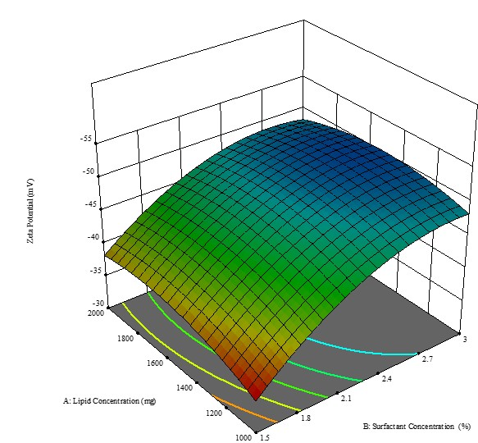
Figure 2: 3D Surface Plots showing the effect of lipid concentration and surfactant concentration on the Zeta Potential.

3.4 Encapsulation Efficiency and Drug Loading
Table 3 presents the encapsulation efficiency (EE) and drug loading (DL) of the three drugs. Artemether, Lumefantrine, and Paracetamol, incorporated into the nanoparticle matrix. The encapsulation efficiency represents the percentage of the initial drug successfully entrapped within the nanoparticle system, while drug loading indicates the proportion of the drug relative to the total weight of the nanoparticles.
The results show that all three drugs achieved high encapsulation efficiencies, ranging between 91.0% and 93.0%, signifying that the formulation method was highly effective in incorporating the active ingredients into the lipid matrix. Lumefantrine exhibited the highest encapsulation efficiency (93.0%), followed closely by Artemether (91.4%) and Paracetamol (91.0%). These values compare favorably to other SLN systems ^{[16]}. The slightly higher EE of Lumefantrine may be attributed to its lipophilic nature, which enhances its affinity for the lipid-based carrier system, thereby improving entrapment.
In contrast, Paracetamol, being more hydrophilic, displayed marginally lower encapsulation efficiency due to its tendency to partition into the aqueous phase during nanoparticle formation. However, the small variation in EE among the three drugs suggests that the preparation method was optimized to minimize drug loss during formulation.
In terms of drug loading (DL), Paracetamol exhibited the highest value (7.11%), followed by Lumefantrine (1.74%) and Artemether (0.29%). This difference reflects the varying initial concentrations of the drugs used in the formulation process. Higher drug loading in Paracetamol indicates a greater proportion of the drug relative to the total nanoparticle mass, which may influence its release rate and therapeutic availability. The high encapsulation efficiency of the hydrophilic paracetamol (91.0%) was unexpected but can be attributed to its potential interaction with the surfactant (Labrafil® M 1944 CS) at the oil-water interface during emulsion formation, facilitating its retention within the lipid matrix upon solidification.
The high encapsulation efficiency across all formulations indicates successful drug incorporation and minimal wastage, while the varying drug loading values demonstrate controlled formulation design based on the physicochemical properties of each drug. These results suggest that the solid lipid nanoparticle system is suitable for co-delivery of Artemether, Lumefantrine, and Paracetamol, potentially improving stability, bioavailability, and synchronized drug release in combined antimalarial therapy.
Table 3: Encapsulation efficiency and Drug loading
Drug | Initial Drug Added (mg) | Encapsulated Drug (mg) | NP Matrix (mg) | EE (%) | DL (%)
Artemether | 3.13 | 2.86 | 1000 | 91.4 | 0.286
Lumefantrine | 18.75 | 17.44 | 1000 | 93.0 | 1.744
Paracetamol | 78.12 | 71.1 | 1000 | 91.0 | 7.110

The optimized SLN formulation exhibited high encapsulation efficiencies for all three drugs—91.4% for Artemether, 93.0% for Lumefantrine, and 91.0% for Paracetamol (Table 3). The corresponding drug loading values were 0.286%, 1.744%, and 7.110% w/w, respectively. Figure 1 illustrates how the selected formulation factors collectively satisfied the multiple optimization goals. This study demonstrates that a rationally designed SLN system can effectively co-deliver three drugs with distinct physicochemical properties while achieving synchronized release. The optimized lipid–surfactant combination produced nanoparticles of approximately 120 nm with a low PDI and high drug loading (Table 3), meeting the quality standards required for oral nanocarrier systems. The encapsulation efficiencies obtained are consistent with previous findings by Odera et al. ^{[16]}, who reported 94% for DHA and 85% for Lumefantrine in SLNs. The comparable results in the present study confirm the effectiveness of the formulation strategy in achieving efficient multi-drug loading.

3.5 In vitro release profiles
The cumulative release profiles (Figure 3, Table 3) show that all three drugs exhibited a gradual and sustained release over 72 hours without a pronounced burst effect. Artemether demonstrated a 60% release at 24 hours and reached 90% at 72 hours. Lumefantrine displayed a slower release pattern, with 40% released at 24 hours and 80% at 72 hours, while Paracetamol showed an intermediate profile (50% at 24 hours and 85% at 72 hours). This controlled release behavior, in contrast to the immediate release of free drugs, confirms effective drug encapsulation within the SLN matrix.
The extended release profiles indicate that the SLN system modulated drug release rates, potentially compensating for Artemether’s naturally short plasma half-life (a few hours) and aligning its availability with that of Lumefantrine, which typically persists for several days. The controlled release of Paracetamol over 24–72 hours suggests a capacity for prolonged symptomatic relief, reducing the need for frequent dosing. In its free form, Artemether is rapidly cleared, necessitating twice-daily dosing, whereas Lumefantrine exhibits prolonged retention. In contrast, the optimized SLN formulation sustained Artemether release up to 90% by 72 hours while moderating Lumefantrine release. This pharmacokinetic alignment suggests that, following SLN uptake, both drugs could maintain therapeutic plasma concentrations over a comparable duration, potentially simplifying dosing to once daily while preserving the synergistic Artemether–Lumefantrine ratio ratio ^{[2,17]}. Perazzolo et al. highlighted that synchronized nanoparticle delivery enables co-targeting of multiple drugs to specific compartments; our findings extend this principle to the oral co-delivery of antimalarial and antipyretic agents.
From a therapeutic perspective, incorporating Paracetamol offers dual benefits. Fever and pain are frequent symptoms of malaria, and Paracetamol is routinely administered for their management. Its co-encapsulation ensures that a single formulation can simultaneously achieve parasite eradication (via Artemether and Lumefantrine) and symptom relief, which may enhance patient compliance. Moreover, emerging evidence suggests that Paracetamol may protect organs, such as the kidneys, during severe malaria by reducing oxidative stress, though it may slightly slow parasite clearance. In this context, the controlled co-release of Paracetamol could provide steady analgesic action without sharp dosing peaks (Figure 2).
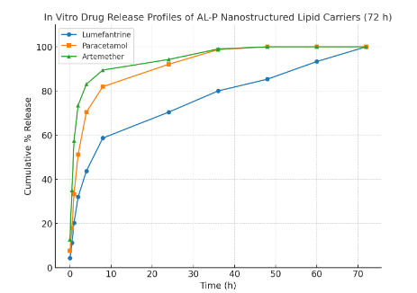
Figure 3: Cumulative % release vs. time for each drug in 72 hrs

To quantitatively assess the success of our synchronization strategy, we calculated the time for 50% release (T₅₀) and the mean release time (MRT) for each drug (Table 3) using Equations 8 and 9.
T₅₀=t₁=$\frac{50-p1}{p2-p1}(t2-t1)$ (8)
If 50% lies between times t₁(percentage p1) and t₂(percentage p2)
MRT=$\frac{\sum_{i}{ti∆Mi}}{\sum_{i}{∆Mi}}$ (9)
Where for interval i between t_{i} and t_{i+1}:
ΔM_{i}=M_{i+1}-M_{i} (release during that interval; here % points)
t_{i}=(t_{i}+t_{i+1})/2 (midpoint of the interval)
The intrinsic difference in elimination half-lives between artemether, 1–3 hours, and lumefantrine, 3–6 days, is considerable. The solid lipid nanoparticle system effectively modulated this discrepancy by reducing the disparity in their release rates. Although artemether exhibited the fastest release, T₅₀ = 4.302 hours, its release was extended over a 72-hour period. Lumefantrine demonstrated a controlled and sustained release profile, T₅₀ = 8.179 hours. The convergence of the mean residence times toward an intermediate range indicates a marked harmonization of the release kinetics, representing an important advancement toward achieving synchronized therapeutic plasma concentrations.

Table 4: Time for 50% release (T₅₀) and the mean release time (MRT) for each drug
Drug | T₅₀ (h) | Mean Release Time (MRT, h)
Artemether | 4.3022 | 18.2947
Lumefantrine | 8.1787 | 24.1170
Paracetamol | 6.2331 | 20.3172

3.6 Differential Scanning Calorimetry
Differential Scanning Calorimetry (DSC) analysis was conducted to confirm the successful encapsulation of Artemether (A), Lumefantrine (L), and Paracetamol (P) within the nanoparticle matrix and to assess the crystallinity of the drugs in the formulated system. As illustrated in Figure 4(a–e), the thermograms show distinct thermal transitions corresponding to each component. The placebo formulation (Figure 4a) exhibited no sharp melting peak, confirming the absence of any crystalline drug component within the lipid matrix. In contrast, the pure drugs displayed sharp, well-defined melting endotherms characteristic of their crystalline nature: Paracetamol at approximately 169 °C (Figure 4b), Lumefantrine at 134 °C (Figure 4c), and Artemether at 88 °C (Figure 4d). Notably, the ALP-SLN formulation (Figure 4e) exhibited a broad and slightly shifted endothermic peak around 110 °C, accompanied by the disappearance of the distinct melting peaks of the individual drugs. This shift and broadening indicate that the drugs were no longer present in their crystalline forms but were molecularly dispersed within the lipid matrix in an amorphous state. The absence of characteristic melting endotherms, together with the presence of a single broad peak, provides strong evidence of successful encapsulation and complete miscibility of the drugs within the lipid phase. Such disruption of long-range crystalline order has been widely recognized as a defining indicator of nanoencapsulation and amorphization in solid lipid nanoparticle systems ^{[18]}.

Figure 4: Thermograms for the placebo (a), Paracetamol (b), Lumefantrine(c), Artemether (d) free drugs, and the ALP-SLN (e) encapsulated drugs.

3.7 Surface Morphology
The surface morphology and shape of the co-loaded nanoparticles were examined using Transmission Electron Microscopy (TEM), providing direct visual evidence of the nanoscale structure, size uniformity, and shape of the prepared AL-P nanostructured lipid carriers. Particle size is also a main factor in determining the performance of pharmaceutical carriers since it will decide their gastrointestinal absorption and their elimination by the reticuloendothelial system, whose precise determination is thus of basic value in predicting in vivo performance and therapeutic effectiveness and accounts for why particles less than 300 nm are generally advised to facilitate effective intestinal transport.
As observed in the HRTEM micrographs (Figure 5a), the nanoparticles appeared predominantly spherical with smooth surfaces and discrete boundaries, confirming the successful formation of lipid-based nanocarriers. The particles displayed minimal aggregation and showed a relatively uniform size distribution within the nanoscale range, which corresponds well with the dynamic light scattering results obtained.
The particle size distribution histogram (Figure 5b) of the optimized formulation showed a narrow distribution ranging from 80 to 150 nm, with most particles centered around 105 nm. The near-Gaussian curve and low PDI (0.13) indicate a uniform and homogeneous nanoparticle population. The uniform particle size below 200 nm confirms that the selected formulation parameters effectively controlled nanoparticle formation, resulting in a stable and reproducible solid lipid nanoparticle system suitable for controlled and synchronized drug release.
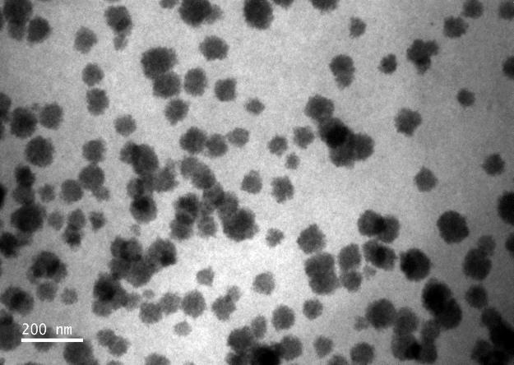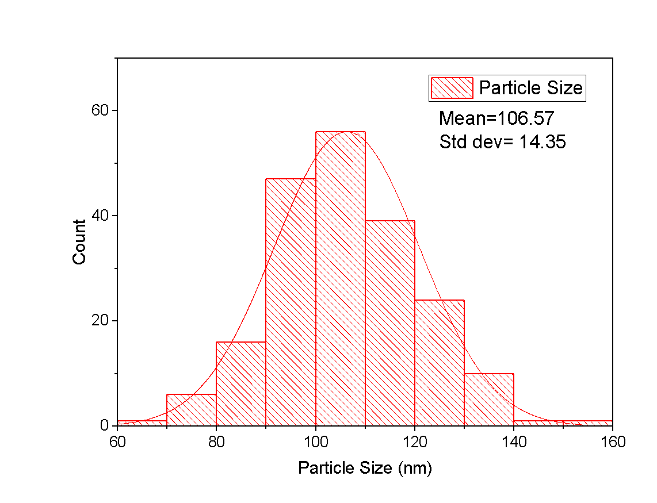
(a)
(b)
Figure 5: TEM micrograph (a), and histogram (b) showing distribution graph for the particle size.

3.8 Kinetic Models
Four standard in vitro release models were applied to characterize the release mechanisms of Lumefantrine, Paracetamol, and Artemether from the optimized formulation: zero-order, first-order, Higuchi, and Korsmeyer–Peppas models ^{[18]}. Each model was linearized, and linear regression analysis was conducted to determine the goodness of fit (R²) for comparison across the three drugs. Lumefantrine exhibited release behavior best described by the Higuchi model, indicating diffusion-controlled kinetics, and also demonstrated the strongest zero-order linearity among the models. Paracetamol and Artemether showed weak zero-order fits but were well described by the first-order and Korsmeyer–Peppas models during the initial release phase, suggesting anomalous transport.
The zero-order plots (Figure 6a) showed moderate linearity for Lumefantrine and poor fits for Paracetamol and Artemether, confirming that a constant release rate was not achieved for the latter drugs. In contrast, first-order kinetics accurately represented the rapid release phases of Paracetamol and Artemether, consistent with concentration-dependent dissolution, whereas Lumefantrine displayed a weaker first-order response due to its sustained release profile (Figure 6b). The Higuchi model (Figure 6c) provided the best overall fit for Lumefantrine, confirming diffusion through the lipid matrix as the dominant mechanism, while Paracetamol and Artemether deviated from this model due to their initial burst release. Early-phase analysis using the Korsmeyer–Peppas model (Figure 6d) yielded release exponents (n = 0.59–0.76), characteristic of anomalous, non-Fickian transport, indicating a combined influence of diffusion and polymer relaxation or erosion.
The findings of this study reveal a biphasic release system. Artemether and Paracetamol undergo a rapid initial release governed by first-order and anomalous kinetics, while Lumefantrine displays a sustained, diffusion-controlled release consistent with Higuchi and partial zero-order behavior. This mechanistic profile supports the formulation’s design rationale of achieving both immediate and prolonged drug availability.

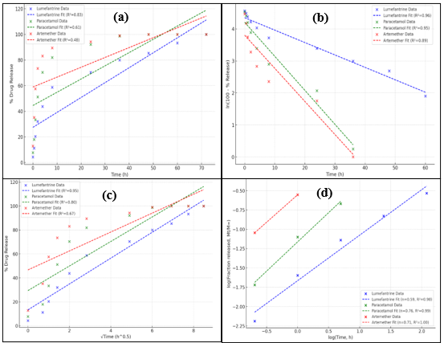
Figure 6: Zero Order model (a), First Order model(b), Higuchi model (c), Korsmeyer–Peppas model (d).
Table 5: Cumulative drug release data
Time (h) | Lumefantrine Released (mg) | % Release | Paracetamol Released (mg) | % Release | Artemether Released (mg) | % Release
0 | 0.80 | 4.27% | 6.0 | 7.68% | 0.40 | 12.78%
0.5 | 2.10 | 11.20% | 14.0 | 17.92% | 1.10 | 35.14%
1 | 3.80 | 20.27% | 26.0 | 33.28% | 1.80 | 57.51%
2 | 6.00 | 32.00% | 40.0 | 51.20% | 2.30 | 73.47%
4 | 8.20 | 43.73% | 55.0 | 70.40% | 2.60 | 83.07%
8 | 11.00 | 58.67% | 64.0 | 81.92% | 2.80 | 89.46%
24 | 13.20 | 70.40% | 72.0 | 92.08% | 2.95 | 94.25%
36 | 15.00 | 80.00% | 77.0 | 98.72% | 3.10 | 99.00%
48 | 16.00 | 85.33% | 78.0 | 100.0% | 3.12 | 100.0%
60 | 17.50 | 93.33% | 78.0 | 100.0% | 3.12 | 100.0%
72 | 18.75 | 100.0% | 78.0 | 100.0% | 3.12 | 100.0%

The differing release kinetics provide insight into the drug localization and release mechanisms within the SLN matrix. The best fit of lumefantrine to the Higuchi model confirms its release is primarily diffusion-controlled, consistent with its high lipophilicity and probable homogeneous distribution within the lipid core. In contrast, the release of artemether and paracetamol, best described by the Korsmeyer-Peppas and Peppas-Sahlin models, indicates a more complex, anomalous transport mechanism. The release exponent (n) of 0.45 for artemether suggests a coupling of Fickian diffusion and matrix relaxation, possibly due to its location closer to the particle surface or in less ordered lipid regions. The notable relaxation contribution for paracetamol (from the Peppas-Sahlin model) supports our hypothesis that its encapsulation involves the surfactant-rich shell, where polymer chain rearrangement governs its release. This differential modulation is the very mechanism that enables the observed synchronization of release profiles from a single nanocarrier.

4.0 Conclusion
This study successfully developed a novel solid lipid nanoparticle (SLN) system capable of co-delivering Artemether, Lumefantrine, and Paracetamol within a single nanocarrier. The formulation not only achieved high encapsulation efficiency and controlled release but also demonstrated modulation of drug release kinetics to address the inherent pharmacokinetic imbalance between Artemether and Lumefantrine. The convergence of their mean release times represents a significant advancement in overcoming differential half-lives—a major limitation contributing to antimalarial resistance. Incorporating Paracetamol within the same nanocarrier introduces an added therapeutic dimension by simultaneously managing malaria-associated fever and pain, thereby enhancing patient comfort and adherence. This dual-action approach—combining pharmacokinetic synchronization with symptomatic relief—underscores the potential of the optimized SLN system as an innovative platform for improving treatment outcomes in malaria therapy. Future studies will focus on in vivo pharmacokinetic and pharmacodynamic evaluations to confirm the observed synchronization effects and to establish the therapeutic efficacy of this co-loaded nanoparticle formulation in biological systems.

Data availability
This article includes all the data generated or analyzed during this study. The raw data can be availed when needed.

Competing Interests Disclaimer
Authors have declared that they have no known competing financial interests OR non-financial interests OR personal relationships that could have appeared to influence the work reported in this paper.
Disclaimer (Artificial intelligence)
Author(s) hereby declare that NO generative AI technologies such as Large Language Models (ChatGPT, COPILOT, etc.) and text-to-image generators have been used during the writing or editing of this manuscript.

References:
[1] Venkatesan, P. WHO world malaria report 2024. Lancet Microbe 2025, 6(4).
[2] Tarning, J.; White, N.J.; Dondorp, A.M. Dose‐Optimization of a Novel Co‐Formulated Triple Combination Antimalarial Therapy: Artemether‐Lumefantrine‐Amodiaquine. Clin. Pharmacol. Ther. 2025, 117(5), 1248–1253.
[3] Der Pluijm, R.W. van; Tripura, R.; Hoglund, R.M.; Phyo, A.P.; Lek, D.; Ul Islam, A.; Anvikar, A.R.; Satpathi, P.; Satpathi, S.; Behera, P.K. Triple artemisinin-based combination therapies versus artemisinin-based combination therapies for uncomplicated Plasmodium falciparum malaria: a multicentre, open-label, randomised clinical trial. The Lancet 2020, 395(10233), 1345–1360.
[4] Zhang, X.; Li, Q.; Zhou, Q.; Li, Y.; Li, J.; Jin, L.; Li, S.; Cai, J.; Chen, G.; Hu, G. Determine the enzymatic kinetic characteristics of CYP3A4 variants utilizing artemether-lumefantrine. Food Chem. Toxicol. 2023, 181, 114065.
[5] Byakika-Kibwika, P.; Lamorde, M.; Mayanja-Kizza, H.; Merry, C.; Colebunders, B.; Van geertruyden, J.-P. Update on the efficacy, effectiveness and safety of artemether–lumefantrine combination therapy for treatment of uncomplicated malaria. Ther. Clin. Risk Manag. 2010, 6, 11–20.
[6] Burrows, J.N.; Duparc, S.; Gutteridge, W.E.; Hooft van Huijsduijnen, R.; Kaszubska, W.; Macintyre, F.; Mazzuri, S.; Möhrle, J.J.; Wells, T.N.C. New developments in anti-malarial target candidate and product profiles. Malar. J. 2017, 16, 26.
[7] Rasmussen, C.; Alonso, P.; Ringwald, P. Current and emerging strategies to combat antimalarial resistance. Expert Rev. Anti Infect. Ther. 2022, 20(3), 353–372.
[8] Akombaetwa, N.; Ilangala, A.B.; Thom, L.; Memvanga, P.B.; Witika, B.A.; Buya, A.B. Current Advances in Lipid Nanosystems Intended for Topical and Transdermal Drug Delivery Applications. Pharmaceutics 2023, 15(2), 656.
[9] Plewes, K.; Kingston, H.W.F.; Ghose, A.; Wattanakul, T.; Hassan, M.M.U.; Haider, M.S.; Dutta, P.K.; Islam, M.A.; Alam, S.; Jahangir, S.M.; Zahed, A.S.M.; Sattar, M.A.; Chowdhury, M.A.H.; Herdman, M.T.; Leopold, S.J.; Ishioka, H.; Piera, K.A.; Charunwatthana, P.; Silamut, K.; Yeo, T.W.; Lee, S.J.; Mukaka, M.; Maude, R.J.; Turner, G.D.H.; Faiz, M.A.; Tarning, J.; Oates, J.A.; Anstey, N.M.; White, N.J.; Day, N.P.J.; Hossain, M.A.; Roberts II, L.J.; Dondorp, A.M. Acetaminophen as a Renoprotective Adjunctive Treatment in Patients With Severe and Moderately Severe Falciparum Malaria: A Randomized, Controlled, Open-Label Trial. Clin. Infect. Dis. Off. Publ. Infect. Dis. Soc. Am. 2018, 67(7), 991–999.
[10] Subroto, E.; Andoyo, R.; Indiarto, R. Solid lipid nanoparticles: review of the current research on encapsulation and delivery systems for active and antioxidant compounds. Antioxidants 2023, 12(3), 633.
[11] Pandey, S.; Shaikh, F.; Gupta, A.; Tripathi, P.; Yadav, J.S. A Recent Update: Solid Lipid Nanoparticles for Effective Drug Delivery. Adv. Pharm. Bull. 2022, 12(1), 17–33.
[12] Viljoen, J.M.; Cilliers, L.; Plessis, L.H. du. Developing Self-Nanoemulsifying Drug Delivery Systems Comprising an Artemether-Lumefantrine Fixed-Dose Combination to Treat Malaria. Front. Biosci. Elite Ed. 2024, 16(3), 25.
[13] Omwoyo, W.N.; Melariri, P.; Gathirwa, J.W.; Oloo, F.; Mahanga, G.M.; Kalombo, L.; Ogutu, B.; Swai, H. Development, characterization and antimalarial efficacy of dihydroartemisinin loaded solid lipid nanoparticles. Nanomedicine Nanotechnol. Biol. Med. 2016, 12(3), 801–809.
[14] Odera, P.A.; Otieno, G.; Onyango, J.O.; Owuor, J.J.; Oloo, F.A.; Ongas, M.; Gathirwa, J.; Ogutu, B. Nanoparticle-Based formulation of dihydroartemisinin-lumefantrine duo-drugs: Preclinical Evaluation and enhanced antimalarial efficacy in a mouse model. Heliyon 2024, 10(6).
[15] Danaei, M.; Dehghankhold, M.; Ataei, S.; Hasanzadeh Davarani, F.; Javanmard, R.; Dokhani, A.; Khorasani, S.; Mozafari, y M. Impact of particle size and polydispersity index on the clinical applications of lipidic nanocarrier systems. Pharmaceutics 2018, 10(2), 57.
[16] Perazzolo, S.; Shen, D.D.; Scott, A.M.; Ho, R.J. Physiologically based pharmacokinetic model validated to enable predictions of multiple drugs in a long-acting drug-combination nano-particles (DCNP): confirmation with 3 HIV drugs, lopinavir, ritonavir, and tenofovir in DCNP products. J. Pharm. Sci. 2024, 113(6), 1653–1663.
[17] White, N.J.; Van Vugt, M.; Ezzet, F. Clinical Pharmacokinetics and Pharmacodynamics of Artemether-Lumefantrine: Clin. Pharmacokinet. 1999, 37(2), 105–125.
[18] Zimmermann, E.; Souto, E.B.; Müller, R.H. Physicochemical investigations on the structure of drug-free and drug-loaded solid lipid nanoparticles (SLNTM) by means of DSC and 1H NMR. Pharm.- Int. J. Pharm. Sci. 2005, 60(7), 508–513.

