Analyzing Land Use and Land Cover Changes using Remote Sensing and GIS in Churachandpur District, Manipur, Northeast India

Abstract
Over the past decade, Churachandpur district in Manipur has seen significant changes in land use and land cover (LULC), influenced by both natural processes and human activities. This study looks at these changes from 2017 to 2024 using Geographic Information Systems (GIS) and remote sensing tools to understand how the landscape has developed. Multi-temporal satellite imagery was analysed and verified changes across forest cover, rangelands, agricultural areas, and urban settlements, showing major land transformations. Forest cover dropped by about 78 sq. km, reflecting a 1.65% decrease. Rangelands increased by roughly 67.23 sq. km, or 1.42%, while urban areas grew by 17.49 sq. km, a 0.37% rise. A transition matrix indicated that much of this conversion came from forested areas being changed into rangelands or built-up zones, showing increased human pressure on natural ecosystems. The classification results were reliable, with overall accuracy improving from 83.33% in 2017 to 93.33% in 2024. Kappa coefficients also rose from 75.84%, which indicates substantial agreement, to 91.92%, showing almost perfect agreement. Although forests still cover about 93.24% of the district’s area, the decline points to ongoing degradation and fragmentation of forest ecosystems. The findings also underscore how socio-economic changes affect land use, reflecting a broader trend across Northeast India. Small reductions in agricultural land of 5.62 sq. km (0.12% decrease) and water bodies of 1.35 sq. km (0.03% decrease) suggest a move away from traditional farming and possible stress on local water systems. Overall, this study offers important insights to guide sustainable land management, biodiversity conservation, and community-based development in Churachandpur. The findings emphasize balancing development with environmental protection via policy and community involvement. This approach applies to other Eastern Himalayan regions with similar ecological pressures.
Keywords: Land use and land cover, GIS, Remote sensing, Forest change, Urban expansion, Ecosystem conservation, Churachandpur district

1 INTRODUCTION
Land use and land cover (LULC) change is a crucial environmental process that shapes the Earth’s surface today. It significantly influences ecosystem functions, biodiversity patterns, and the potential for sustainable development (Lambin et al., 2001; Turner et al., 2007). Understanding how land is used and how it changes over time helps researchers and policymakers see the complex link between human activities and the natural environment. This understanding is vital for developing effective land management strategies and ensuring long-term ecological balance (Foley et al., 2005; Verburg et al., 2015).
Globally, human-driven changes in land use - through urban expansion, increased agriculture, deforestation, and infrastructure development - have caused significant ecological and social-economic changes (Hussain et al., 2019). The same patterns are visible in India, where rapid population growth and economic development have put pressure on limited land resources, making sustainable management more critical (Lalhmachhuana et al., 2022). In the northeastern states, especially in Manipur, demographic growth, changes in livelihoods, and modernization of agricultural practices have led to significant alterations in natural landscapes (Sharma et al., 2019; Ramachandra et al., 2017).
The Churachandpur district of Manipur is a notable example of these changes. Known for its rich ecological diversity and varied terrain, this district has experienced significant shifts in land use patterns in recent years. As the largest district in the state, Churachandpur’s mostly forested landscape has been increasingly changed by human activities like shifting cultivation (jhum), deforestation, agricultural changes, and urban growth (Kumar et al., 2013; Temjen et al., 2022). Like other areas of Northeast India, the region’s fragile ecosystems are facing increasing stress from these activities. Without careful monitoring, such changes can lead to soil erosion, habitat fragmentation, loss of biodiversity, and long-term resource degradation (Puyravaud, 2003;Roy & Joshi, 2002; Remlalruata, 2023).
Modern technologies such as Remote Sensing (RS) and Geographic Information Systems (GIS) now allow for accurate and efficient tracking of these land changes. By analyzing satellite images over time, these tools give a clear view of how landscapes change. In this study, GIS and remote sensing methods are used to examine LULC changes in the district over a seven-year period, from 2017 to 2024. Multi-temporal satellite imagery and advanced classification techniques (Lu et al., 2004; Rawat and Kumar, 2015) were applied to identify and quantify variations across major land cover categories, which include forests, rangelands, agricultural zones, built-up areas, and water bodies. Previous studies have shown that supervised classification using satellite data, especially from Landsat and Sentinel sensors, can create reliable and accurate LULC maps, often achieving classification accuracies over 80% (Islami et al., 2022; Lalhmachhuana et al., 2022).
Despite the increasing number of LULC studies in India, Churachandpur district has not been thoroughly examined through systematic spatial analysis. Given its ecological importance and cultural diversity, understanding the district’s landscape dynamics is essential for guiding conservation and planning efforts. The ongoing challenges of urbanization, deforestation, and shifting cultivation make it crucial to monitor recent land changes and assess their broader impacts on sustainability. This paper aims to address this gap by using RS and GIS to evaluate land use and land cover changes in Churachandpur district from 2017 to 2024. The main objectives of the study are:
- To classify and map land use and land cover for the years 2017 and 2024 using multi-temporal satellite imagery;
- To quantify and interpret the spatial extent and nature of land transformation; and
- To provide evidence-based insights that can help planners and policymakers promote sustainable land management in the region.

2. LOCATION OF THE STUDY AREA
Churachandpur district is in the southwestern part of Manipur, a state in northeastern India. It covers about 4,715 km², making it the largest district in the state. The district stretches between latitudes 23°45′ N and 24°45′ N, and longitudes 93°45′ E and 94°30′ E. It holds a key geographic position, sharing an international border with Myanmar to the south and domestic borders with Mizoram to the southwest, Chandel district to the southeast, and Bishnupur and Imphal West districts to the north. For the purpose of this study, Pherzawl district is still considered part of Churachandpur district, following the old district boundaries before administrative separation, thus analyzing the entire original geographical extent. The terrain in Churachandpur is mostly hilly and rugged, with elevations ranging from about 200 meters to over 2,500 meters above mean sea level. Several river systems, like the Tuivai and Tuiruong (Barak) rivers and their tributaries, flow through the district. These rivers create fertile valleys that allow for some agriculture amidst largely forested slopes. Figure 1 shows the location of Churachandpur district along with its major administrative sub-divisions. These aspects make the district an ideal site for studying changes in land use and cover in a mountainous area impacted by both natural and human factors.

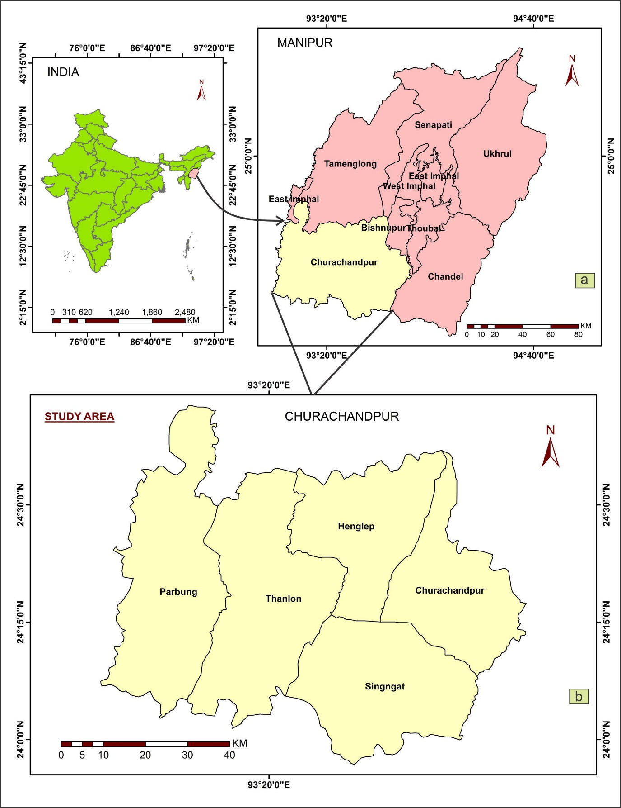
Figure 1: Map showing the location of study area: (a) District-wise administrative divisions of Manipur state (based on Diva-GIS boundary data, which reflects the pre-reorganization districts), (b) Churachandpur district with sub-divisional boundaries (study area).

3. MATERIALS AND METHODS
3.1 Data Acquisition and Preparation
The study used Sentinel-2 Global Land Use/Land Cover data with a spatial resolution of 10 meters for the years 2017 and 2024. To enhance the reliability of the analysis, additional reference data were obtained from the Esri Living Atlas of the World. All satellite imagery was processed in ArcGIS software. The imagery was clipped to match the administrative boundary of Churachandpur district, and composite bands were created from both Landsat and Sentinel datasets to improve the spectral detail required for classification.
3.2 Land Use Classification Method
Land use and land cover were mapped using a supervised classification technique, which enables the identification of known land cover types based on training samples (Karan & Samadder, 2018). This method was selected for its capacity to measure and compare spectral signatures of surface features and to assign unknown pixels to predefined land cover classes with measurable accuracy (Sari et al., 2021). Although supervised classification depends on representative training data, it provides greater control over class definitions and tends to yield higher classification accuracy (Samaniego, 2008). The multispectral classification process, widely used for digital mapping (Islami et al., 2022), was carried out in three major steps: creation of composite bands; execution of supervised classification; and assessment of classification accuracy. Using ArcGIS, the classified outputs were grouped into broader land cover categories to simplify interpretation. The “zonal histogram” and “zonal statistics” tools were then employed to compute the area (in square kilometers) covered by each land cover type.
3.3 Change detection analysis
To identify and quantify changes between 2017 and 2024, the change detection wizard and raster calculator tools in ArcGIS were used. This analysis generated change matrices that revealed how different land cover types transitioned over time - for example, forest areas converting into rangelands or built-up area. The process provided a detailed view of the spatial and temporal patterns of land transformation across Churachandpur district.
3.4 Accuracy assessment
Accuracy assessment was performed for the classified maps of 2017 and 2024 using 30 randomly distributed validation points. Since field verification was not feasible, high-resolution Google Earth imagery was used to visually confirm the land cover types at each point. This method aligns with contemporary remote sensing validation practices that rely on satellite-based verification when ground surveys are limited (Plourde et al., 2002).
According to Anderson (1976), interpretation accuracy in LULC classification should not fall below 80%. In this study, an error matrix was used to evaluate accuracy levels, recording both errors of omission and commission (Congalton, 1991; Foody, 2002). The validation points were chosen to represent all major land cover categories within the district, ensuring a balanced evaluation.
Four key metrics were calculated to determine classification performance:
User’s Accuracy: the proportion of correctly classified pixels within each category, relative to the total pixels assigned to that class.
User’s Accuracy = $\frac{Number of Correctly Classified Pixels in each Category}{Total Number of Reference Pixels in that Category (The Row Total)} x 100$
Producer’s Accuracy: the ratio of correctly classified pixels in a category to the total reference pixels for that class.
Producer Accuracy = $\frac{Number of Correctly Classified Pixels in each Category}{Total Number of Reference Pixels in that Category (The Column Total)} x 100$
Overall Accuracy: the total number of correctly classified pixels divided by the total number of reference pixels.
Total Accuracy = $\frac{Total Number of Correctly Classified Pixels (Diagonal)}{Total Number of Reference Pixels} x 100$
Kappa Coefficient: a statistical measure that accounts for agreement occurring by chance.
Kappa Coefficient (T) = $\frac{(TSxTCS)-∑(Column Total x Row Total)}{TS2- ∑(Column Total- Row Total)} x 100$
As per (Landis & Koch, 1977) categorization, the resulting Kappa values were interpreted following the standards outlined in Table 1, which classify the strength of agreement from poor to almost perfect.
Table 1. Rating criteria of Kappa statistics.
Sl.No | Kappa statistics | Strength of agreement
1 | < 0 | Poor
2 | 0.00 - 0.20 | Slight
3 | 0.21 - 0.40 | Fair
4 | 0.41 - 0.60 | Moderate
5 | 0.61 - 0.80 | Substantial
6 | 0.81 - 1.00 | Almost perfect

The Google Earth-based verification allowed for a detailed visual examination of major land cover types without the need for on-site field surveys. This method ensured a close match between the classified satellite data and the actual features visible on the ground. Although supervised classification and remote validation each have certain limitations, combining these approaches offered a reliable and practical way to evaluate land use and land cover changes in the district during the study period.

4. RESULTS
4.1 Land cover classification and mapping
The multi-temporal analysis of satellite images for the study area produced detailed land use and land cover (LULC) maps for 2017 and 2024. Four major land cover types were identified: forest (tree cover), rangeland, cropland, and built-up areas, and three minor land cover types include water bodies, flooded vegetation, and bare ground. The spatial arrangement of these categories highlights the varied landscape features and ecological diversity of the district, as shown in Figures 2 and 3. These figures provide a foundation for analyzing changes and understanding the landscape dynamics over time.
To check the reliability of the classification, an accuracy assessment was conducted. The results showed that the mapping method worked well in both years. In 2017, the overall accuracy was 83.3%, with 25 out of 30 points correctly classified. For 2024, the accuracy improved to 93.3% (28 out of 30 points correct). Among the individual categories, the forest class did particularly well, reaching 100% user accuracy in both periods. The accuracy for the rangeland category also saw a notable increase, from 40% producer’s accuracy in 2017 to 71.4% in 2024. Table 2 and 3 summarizes the area of each land cover category for both years.

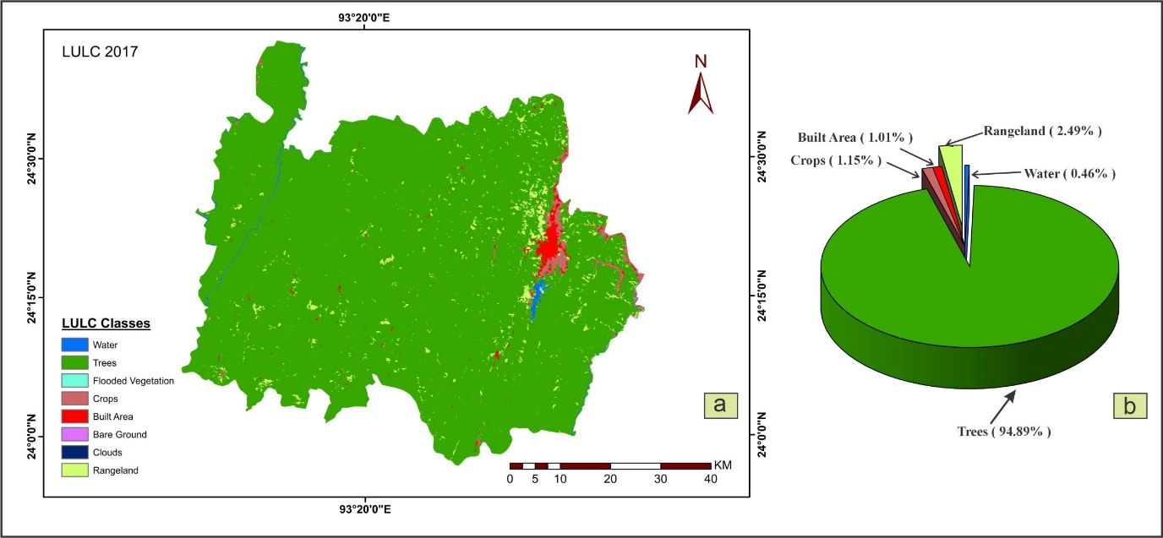
Figure 2: a) LULC map of Churachandpur district ,2017, and b) Percentage distribution of LULC classes.

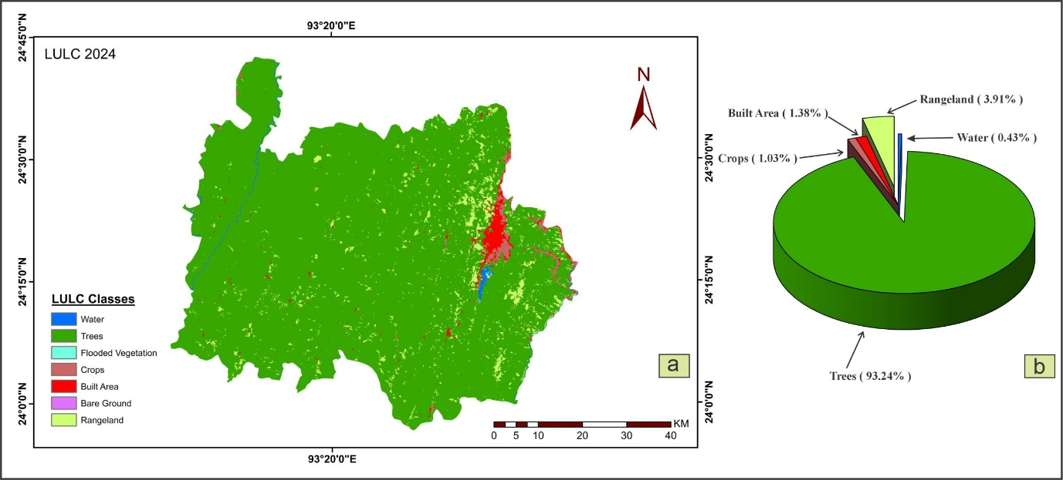
Figure 3: a) LULC map of Churachandpur district ,2024, and b) Percentage distribution of LULC classes.

Table 2: Land Cover Area Statistics for Churachandpur District (2017-2024)
LULC Classes | 2017 |  | 2024 |  | Net Change (sq. km) | % Change
 | Area  (sq. km) | Area  ( % ) | Area  (sq. km) | Area percent | Net Change (sq. km) | % Change
Water | 21.61 | 0.46 | 20.26 | 0.43 | -1.35 | - 6.16
Trees | 4474.24 | 94.89 | 4396.24 | 93.24 | - 78.00 | - 1.65
Flooded vegetation | 0.25 | 0.01 | 0.54 | 0.01 | + 0.29 | + 69.05
Crops | 54.12 | 1.15 | 48.5 | 1.03 | - 5.62 | - 10.40
Built Areas | 47.52 | 1.01 | 65.01 | 1.38 | + 17.49 | + 36.80
Bare Ground | 0.09 | 0 | 0.06 | 0 | - 0.03 | - 33.33
Range land | 117.29 | 2.49 | 184.52 | 3.91 | + 67 | + 57.30
Total |  |  |  |  | 0.00

Table 3: Accuracy Assessment
LULC Classes | 2017 |  | 2024
LULC Classes | User (%) | Producer (%) | User (%) | Producer (%)
Water | 100 | 100 | 100 | 100
Trees | 100 | 81.25 | 88.89 | 100
Flooded vegetation | - |  | 100 | 100
Crops | 66.67 | 80 | 85.71 | 100
Built Areas | 100 | 80 | 100 | 100
Range land | 40 | 100 | 100 | 71.43
Total Accuracy | 83.33 |  | 93.33
Kappa Coefficient | 75.84 |  | 91.92

4.2 Quantitative analysis of land transformation
a) Forest cover dynamics
Forest remains the most dominant land cover in Churachandpur district, but the analysis revealed a gradual decline over the study period. Between 2017 and 2024, forest area decreased from 4,474.24 km² (94.89%) to 4,396.24 km² (93.24%). This indicates a net loss of 78 km², as shown in Figure 4. This translates to an estimated annual deforestation rate of 11.14 km², or about 0.25% per year. This rate is slightly higher than India’s national average of 0.15 - 0.20%, as reported by Reddy et al. (2015). The observed forest loss matches regional deforestation patterns across Northeast India. Fragmentation is often linked to shifting cultivation, settlement expansion, and resource extraction (Rathore et al., 2012). The pattern of deforestation tends to follow accessibility gradients, meaning forests close to roads and populated areas are more likely to be converted.

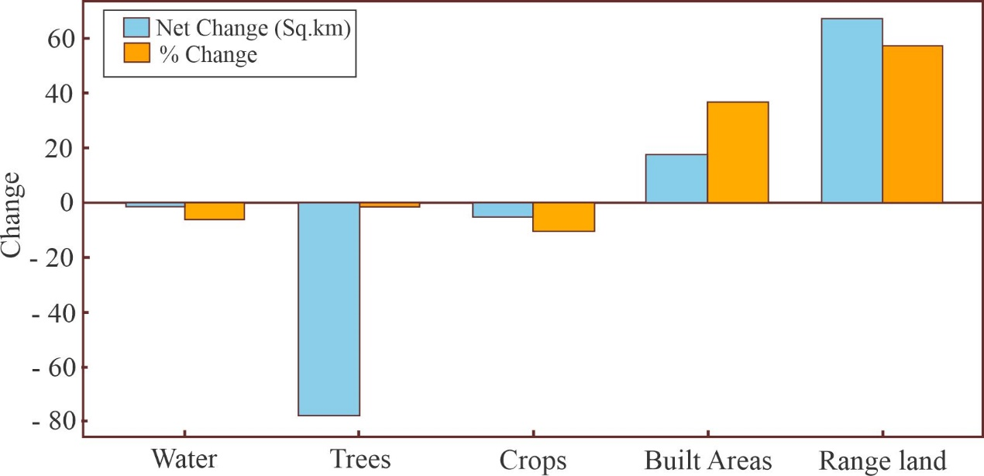

Figure 4: Net and percentage change in major LULC classes during the study period (2017-2024).

b) Rangeland expansion
Rangeland showed the most significant growth among all land cover categories. The area expanded from 117.29 km² (2.49%) in 2017 to 184.52 km² (3.91%) in 2024. This is a 57.3% increase, equivalent to +67.23 km². This change accounts for roughly 86% of the total forest loss, indicating that the conversion of forest to rangeland was the main cause of deforestation in the district. The significant increase in rangeland can be traced back to locations where jhum was cultivated before the study period. These abandoned jhum fields eventually turned into open grass- and shrub-dominated landscapes as soil fertility declined and forest regrowth slowed. This pattern shows a broader shift in land management techniques, with communities relying more on livestock-based economies. Such changes align with larger trends in Northeast India, where shifting economic opportunities and climate challenges have led to alterations in traditional farming systems (Behera et al., 2017).
c) Built-up area expansion
Built-up or urban areas noticeably expanded during the study period. The extent increased from 47.52 km² (1.01%) in 2017 to 65.01 km² (1.38%) in 2024, marking a 36.8% rise (+17.49 km²). The rate of expansion exceeds the average population growth of 1 - 2% per year, suggesting that this growth is driven not only by population increases but also by infrastructure development and changes in where people settle (Kumar et al., 2013). Urban growth in the district likely involved both concentric expansion around existing towns and linear spread along major roads. This type of land change is usually irreversible and can have long-term effects on ecosystems, agriculture, and resource management.
d) Agricultural land changes
Cropland area slightly decreased during the study period, from 54.12 km² (1.15%) in 2017 to 48.5 km² (1.03%) in 2024. This is a decline of 5.62 km² (-10.4%). While modest, this reduction suggests a gradual shift in land use priorities. When viewed alongside the increase in rangeland, the trend reflects a larger movement away from crop-based farming. In many areas of the district, households increasingly rely on alternative livelihood options. These include wage employment outside the region, small-scale business activities, and to some extent, livestock rearing. This has contributed to the abandonment or reduced cultivation of cropland. Socio-economic changes, along with variable returns from small-scale agriculture and local environmental pressures, help explain the observed decline in cropland (Temjen et al., 2022).
e) Minor land cover changes
Other land cover categories experienced relatively minor changes between 2017 and 2024. Water bodies slightly decreased by 1.35 km² (-6.16%), while flooded vegetation showed a small but notable increase of 0.29 km² (+69.05%). Bare ground remained limited throughout the study, reducing slightly from 0.09 to 0.06 km² (-33.33%). Although these changes are small, they may indicate subtle hydrological adjustments possibly linked to variations in rainfall or changes in land use that affect watershed behavior (Bandyopadhyay et al., 2009).

5. DISCUSSION
5.1 Factors influencing land use and land cover change
The changes in land cover across the district result from a mix of social, economic, environmental, and institutional factors at various levels. Understanding how these factors interact is crucial for creating effective land management strategies and informed development policies.
a) Demographic and socioeconomic factors
Population growth, even at moderate rates typical in Northeast India (about 1 to 2% per year), remains a significant cause of land use change. As the population increases, the demand for land for housing, infrastructure, and natural resource extraction also rises (Roy & Joshi, 2002). The sharp increase in built-up areas—36.8% over seven years—indicates that urban growth in Churachandpur results not only from population growth but also from changing lifestyles, improved connectivity, and shifted housing preferences.
Infrastructure initiatives like the Pradhan Mantri Gram Sadak Yojana (PMGSY) and the North East Special Infrastructure Development Scheme (NESIDS) have improved access to previously isolated areas, indirectly promoting forest clearance and settlement growth (Sati, 2019). At the same time, expanding markets and new job opportunities are influencing land use decisions—whether for forestry, farming, or other economic activities.
b) Policy and institutional factors
Policies and governance systems at both national and state levels significantly shape land use outcomes. Changes to community forest rights under the Forest Rights Act (2006) can change how local people manage and use forest resources (Bray, 2018). Similarly, agricultural subsidies and development programs can affect the balance between cropland and rangeland, contributing to observed land-use shifts. Ongoing forest loss, despite conservation measures, suggests weaknesses in enforcement and implementation. Additionally, the rapid growth of urban areas indicates the need for better planning that integrates land use, transportation, and environmental issues.
c) Technological and agricultural system changes
Advancements in agricultural technology have also played a key role. The adoption of high-yield crop varieties, fertilizers, and better cultivation methods allows farmers to produce more from smaller plots. This might explain the decline in total cropland despite ongoing food demand (Ray et al., 2019). Improved road networks and market access further influence farmers’ choices, as some may shift to more profitable or less labor-intensive activities. The notable increase in rangeland suggests a move toward livestock-oriented systems. This shift may reflect adaptation to new market opportunities, limited farm labor, or climate challenges affecting crop production.
d) Environmental and biophysical factors
The area's physical environment, with its steep slopes and mountainous terrain, naturally limits land use. Most changes occur in more accessible valleys or on gentler slopes. Altered rainfall patterns, temperature variations, and broader climate issues also impact vegetation and agricultural productivity (Mishra et al., 2019). Differences in soil fertility further influence land-use decisions, as less productive farms are often converted to rangeland or left fallow. The slight reduction in surface water area reported in this study may be linked to changes in rainfall or watershed conditions, though confirming this would require detailed hydrological data.
5.2 Implications of land cover change
The changes in land cover in Churachandpur have broad consequences, impacting the environment, agriculture, and socioeconomic and policy areas.
a) Ecological implications
The loss of about 78 km² of forest from 2017 to 2024 presents serious ecological challenges. This loss reduces habitat for forest-dependent species. The fragmentation of remaining forests can create "edge effects" that harm ecological quality and disrupt wildlife movements (Laurance et al., 2017). A smaller forest area also weakens vital ecosystem services like carbon storage, water regulation, and soil stability. Deforestation raises greenhouse gas emissions, though the extent varies based on how the cleared land is used. Even small changes, like the 1.35 km² reduction in water bodies, can influence watershed dynamics, streamflow, and sedimentation, especially when related to vegetation loss (Zhang et al., 2016).
b) Agricultural sustainability implications
The reduction in farmland area (-5.62 km²) raises concerns for the long-term sustainability of local agriculture. Unless productivity on existing farmlands improves, losing cultivated land might threaten food security. Increasing rangeland suggests some households are shifting toward livestock rearing, while others rely on wage work or small businesses, putting less stress on crop farming. While animals can provide extra income, uncontrolled grazing, especially on steep slopes, can lead to erosion, soil compaction, and nutrient loss (Apollo et al., 2018). With less arable land and a rising population, there will be more pressure to improve cultivation on remaining farmlands, highlighting the need for sustainable, locally suitable land management practices.
c) Socioeconomic implications
The observed changes also indicate a broader shift in local livelihoods and the regional economy. The transition from crop farming to livestock, urban jobs, and service sector activities shows increased diversification. The expansion of developed areas reflects growing economic opportunities but may also result in higher land prices and unequal access to resources (Khan, 2013). Land conversion often alters who can access and control land, sometimes undermining traditional communal rights and creating social inequalities. These shifts, although associated with development, need careful management to prevent increasing inequality.
d) Policy and planning implications
These findings highlight several key challenges from a governance perspective. Ongoing forest loss, despite protective laws, shows the need for better enforcement and community involvement. Meanwhile, the 36.8% growth in developed areas emphasizes the urgency of proper spatial planning to balance growth and sustainability. Agricultural and livestock policies should support efficient, environmentally friendly practices that maintain productivity without harming natural resources. Given the interconnected nature of these land changes, an integrated landscape management approach is vital—one that coordinates forest, agricultural, and urban policies instead of treating them separately (Rathore et al., 2012).
5.3 Methodological considerations
Some limitations must be acknowledged when interpreting these results. The classification used broad land cover categories, which may have hidden smaller transitions—like the differences between plantation forests and natural forests or among crop types. Additionally, the imagery dates for 2017 and 2024 might not represent the same season, potentially affecting vegetation classification. The accuracy assessment, based on 30 points, provides a reasonable overview but might not fully capture spatial variation, particularly for less common classes. While overall accuracy improved from 83.3% in 2017 to 93.3% in 2024, some uncertainty remains, especially for rangeland in the earlier dataset. The higher accuracy in 2024 could result from better-quality imagery, refined classification methods, or the analyst's greater familiarity with local landscapes. Although these improvements increase confidence in the findings, all interpretations should take into account the underlying methodological constraints (Chen et al., 2014).

6. CONCLUSION
This study achieved its main goals of classifying and mapping land use and land cover (LULC) for Churachandpur district in 2017 and 2024. It also measured spatial changes and provided insights to support sustainable land management. The analysis of satellite images over time showed clear signs of landscape change. There was a decline in forest cover by 78 km², a significant increase in rangeland by 67.23 km², growth of built-up areas by 17.49 km², and a slight decrease in cropland by 5.62 km². These changes reflect the effects of population growth, infrastructure development, policy changes, and environmental variations. Together, they depict a changing landscape where natural ecosystems are gradually being replaced by human-made environments, influenced by expanding settlements, road networks, and livestock farming. Although forests still cover the majority of the district (93.24% in 2024), the ongoing loss of forest area and the rise of land used for human activities indicate a slow but steady change that needs ongoing monitoring and informed management.

The results highlight the pressing need for balanced land management strategies that align development with environmental protection. Due to the district’s ecological sensitivity and rich biodiversity, it is crucial to maintain a balance between human activities and environmental sustainability. The rapid urban growth and continued forest loss require proactive policies and careful planning to guide development in a way that protects ecosystem services while also supporting livelihoods and community well-being.
To promote sustainable land use, the study recommends the following key measures:
- Preserve forests in high-risk deforestation zones, especially near expanding communities and major roads.
- Plan urban growth more effectively to encourage dense development and minimize unnecessary loss of forests and farmland.
- Improve rangeland management to ensure livestock production does not harm soil or vegetation.
- Boost crop productivity on current farmland instead of expanding into forest areas.
- Enhance watershed protection in regions showing signs of environmental stress.
- Increase coordination among policies and sectors to address the interconnected nature of land use changes.

Future Study:
For future research, a closer investigation into specific pathways of land cover change is suggested, along with better integration of socioeconomic data to clarify the main drivers of change. Validating findings in the field, especially regarding the significant rangeland expansion, would provide useful context for satellite observations. Additionally, creating predictive models or scenario analyses could help anticipate future land use patterns and guide policymakers in making well-informed decisions. Monitoring land use more frequently would also enable early identification of emerging trends that may need timely policy actions.

Disclaimer (Artificial intelligence)
Option 1:
Author(s) hereby declare that NO generative AI technologies such as Large Language Models (ChatGPT, COPILOT, etc.) and text-to-image generators have been used during the writing or editing of this manuscript.
References
Anderson, J. R., Hardy, E. E., Roach, J. T., & Witmer, R. E. (1976). A land use and land cover classification system for use with remote sensor data. USGS Professional Paper. https://doi.org/10.3133/pp964

Apollo, M., Andreychouk, V., & Bhattarai, S. (2018). Short-Term Impacts of Livestock Grazing on Vegetation and Track Formation in a High Mountain Environment: A Case Study from the Himalayan Miyar Valley (India). Sustainability, 10(4), 951. https://doi.org/10.3390/su10040951

Bandyopadhyay, S., Jaiswal, R. K., Hegde, V. S., & Jayaraman, V. (2009). Assessment of land suitability potentials for agriculture using a remote sensing and GIS based approach. International Journal of Remote Sensing, 30(4), 879–895. https://doi.org/10.1080/01431160802395235

Behera, M., Tripathi, P., Das, P., Srivastava, S., Roy, P., Joshi, C., Behera, P., Deka, J., Kumar, P., Khan, M., Tripathi, O., Dash, T., & Krishnamurthy, Y. (2017). Remote sensing based deforestation analysis in Mahanadi and Brahmaputra river basin in India since 1985. Journal of Environmental Management, 206, 1192–1203. https://doi.org/10.1016/j.jenvman.2017.10.015

Bray, D. B. (2018). Democracy in the Woods: environmental conservation and social justice in India, Tanzania, and Mexico. International Journal of the Commons, 12(1), 596–598. https://doi.org/10.18352/ijc.883

Chen, J., Chen, J., Liao, A., Cao, X., Chen, L., Chen, X., He, C., Han, G., Peng, S., Lu, M., Zhang, W., Tong, X., & Mills, J. (2014). Global land cover mapping at 30 m resolution: A POK-based operational approach. ISPRS Journal of Photogrammetry and Remote Sensing, 103, 7–27. https://doi.org/10.1016/j.isprsjprs.2014.09.002

Congalton, R. G. (1991). A review of assessing the accuracy of classifications of remotely sensed data. Remote Sensing of Environment, 37(1), 35–46. https://doi.org/10.1016/0034-4257(91)90048-b

Foley, J. A., DeFries, R., Asner, G. P., Barford, C., Bonan, G., Carpenter, S. R., Chapin, F. S., Coe, M. T., Daily, G. C., Gibbs, H. K., Helkowski, J. H., Holloway, T., Howard, E. A., Kucharik, C. J., Monfreda, C., Patz, J. A., Prentice, I. C., Ramankutty, N., & Snyder, P. K. (2005). Global consequences of land use. Science, 309(5734), 570–574. https://doi.org/10.1126/science.1111772

Foody, G. M. (2002). Status of land cover classification accuracy assessment. Remote Sensing of Environment, 80(1), 185–201. https://doi.org/10.1016/s0034-4257(01)00295-4

Hussain, S., Mubeen, M., Ahmad, A., Akram, W., Hammad, H. M., Ali, M., Masood, N., Amin, A., Farid, H. U., Sultana, S. R., Fahad, S., Wang, D., & Nasim, W. (2019). Using GIS tools to detect the land use/land cover changes during forty years in Lodhran District of Pakistan. Environmental Science and Pollution Research, 27(32), 39676–39692. https://doi.org/10.1007/s11356-019-06072-3

Islami, F. A., Tarigan, S. D., Wahjunie, E. D., & Dasanto, B. D. (2022). Accuracy assessment of land use change analysis using Google Earth in Sadar Watershed Mojokerto Regency. IOP Conference Series Earth and Environmental Science, 950(1), 012091. https://doi.org/10.1088/1755-1315/950/1/012091

Karan, S. K., & Samadder, S. R. (2018). A comparison of different land-use classification techniques for accurate monitoring of degraded coal-mining areas. Environmental Earth Sciences, 77(20). https://doi.org/10.1007/s12665-018-7893-5

Khan, M. L. (2013). Deka J., Tripathi O. P., and Khan M. L. (2012). Urban growth trend analysis using Shannon Entropy approach – a case study in north east India, International Journal of Geomatics and Geosciences 2(4):1072-1078. https://www.academia.edu/3488091/Deka_J_Tripathi_O_P_and_Khan_M_L_2012_Urban_growth_trend_analysis_using_Shannon_Entropy_approach_a_case_study_in_north_east_India_International_Journal_of_Geomatics_and_Geosciences_2_4_1072_1078

Kumar, D. S., Arya, D., & Vojinovic, Z. (2013). Modeling of urban growth dynamics and its impact on surface runoff characteristics. Computers Environment and Urban Systems, 41, 124–135. https://doi.org/10.1016/j.compenvurbsys.2013.05.004

Lalhmachhuana, H., Lalnuntluanga, Prof., Lalramdina, Dr., & Dept. of Environmental Science, Mizoram University, Aizawl, Mizoram, India. (2022). Analysis Of Land Use Land Cover Change Using Remote Sensing And Geographical Information System At Aizawl District, Mizoram, India. In Journal of Emerging Technologies and Innovative Research (Vol. 9, Issue 7) . https://www.jetir.org/papers/JETIR2207552.pdf

Lambin, E. F., Turner, B., Geist, H. J., Agbola, S. B., Angelsen, A., Bruce, J. W., Coomes, O. T., Dirzo, R., Fischer, G., Folke, C., George, P., Homewood, K., Imbernon, J., Leemans, R., Li, X., Moran, E. F., Mortimore, M., Ramakrishnan, P., Richards, J. F., . . . Xu, J. (2001). The causes of land-use and land-cover change: moving beyond the myths. Global Environmental Change, 11(4), 261–269. https://doi.org/10.1016/s0959-3780(01)00007-3

Landis, J. R., & Koch, G. G. (1977). A One-Way component of variance model for categorical data. Biometrics, 33(4), 671. https://doi.org/10.2307/2529465

Laurance, W. F., Campbell, M. J., Alamgir, M., & Mahmoud, M. I. (2017). Road expansion and the fate of Africa’s tropical forests. Frontiers in Ecology and Evolution, 5. https://doi.org/10.3389/fevo.2017.00075

Lu, D., Mausel, P., Brondízio, E., & Moran, E. (2004). Change detection techniques. International Journal of Remote Sensing, 25(12), 2365–2401. https://doi.org/10.1080/0143116031000139863

Mishra, V., Tiwari, A. D., Aadhar, S., Shah, R., Xiao, M., Pai, D. S., & Lettenmaier, D. (2019). Drought and famine in India, 1870–2016. Geophysical Research Letters, 46(4), 2075–2083. https://doi.org/10.1029/2018gl081477

Plourde, S., Dodson, J., Runge, J., & Therriault, J. (2002). Spatial and temporal variations in copepod community structure in the lower St. Lawrence Estuary, Canada. Marine Ecology Progress Series, 230, 211–224. https://doi.org/10.3354/meps230211

Puyravaud, J. (2003). Standardizing the calculation of the annual rate of deforestation. Forest Ecology and Management, 177(1–3), 593–596. https://doi.org/10.1016/s0378-1127(02)00335-3

Ramachandran, R. M., Roy, P. S., Chakravarthi, V., Sanjay, J., & Joshi, P. K. (2017). Long-term land use and land cover changes (1920–2015) in Eastern Ghats, India: Pattern of dynamics and challenges in plant species conservation. Ecological Indicators, 85, 21–36. https://doi.org/10.1016/j.ecolind.2017.10.012

Rathore, C. S., Dubey, Y., Shrivastava, A., Pathak, P., & Patil, V. (2012). Opportunities of Habitat Connectivity for Tiger (Panthera tigris) between Kanha and Pench National Parks in Madhya Pradesh, India. PLoS ONE, 7(7), e39996. https://doi.org/10.1371/journal.pone.0039996

Rawat, J., & Kumar, M. (2015). Monitoring land use/cover change using remote sensing and GIS techniques: A case study of Hawalbagh block, district Almora, Uttarakhand, India. The Egyptian Journal of Remote Sensing and Space Science, 18(1), 77–84. https://doi.org/10.1016/j.ejrs.2015.02.002

Ray, D. K., West, P. C., Clark, M., Gerber, J. S., Prishchepov, A. V., & Chatterjee, S. (2019). Climate change has likely already affected global food production. PLoS ONE, 14(5), e0217148. https://doi.org/10.1371/journal.pone.0217148

Reddy, C. S., Jha, C. S., Dadhwal, V. K., Krishna, P. H., Pasha, S. V., Satish, K. V., Dutta, K., Saranya, K. R. L., Rakesh, F., Rajashekar, G., & Diwakar, P. G. (2015). Quantification and monitoring of deforestation in India over eight decades (1930–2013). Biodiversity and Conservation, 25(1), 93–116. https://doi.org/10.1007/s10531-015-1033-2

Reed, J., Van Vianen, J., Deakin, E. L., Barlow, J., & Sunderland, T. (2016). Integrated landscape approaches to managing social and environmental issues in the tropics: learning from the past to guide the future. Global Change Biology, 22(7), 2540–2554. https://doi.org/10.1111/gcb.13284

Remlalruata. (2023). Studies On Land Use And Land Cover Change In Aizawl District, Mizoram. Zenodo (CERN European Organization for Nuclear Research). https://doi.org/10.5281/zenodo.8042670

Roy, P. S., & Joshi, P. K. (2002). Forest cover assessment in north-east India--the potential of temporal wide swath satellite sensor data (IRS-1C WiFS). International Journal of Remote Sensing, 23(22), 4881–4896. https://doi.org/10.1080/01431160110114475

Samaniego, L., Bardossy, A., & Schulz, K. (2008). Supervised Classification of Remotely Sensed Imagery Using a Modified $k$-NN Technique. IEEE Transactions on Geoscience and Remote Sensing, 46(7), 2112–2125. https://doi.org/10.1109/tgrs.2008.916629

Sari, I. L., Weston, C. J., Newnham, G. J., & Volkova, L. (2021). Assessing Accuracy of Land Cover Change Maps Derived from Automated Digital Processing and Visual Interpretation in Tropical Forests in Indonesia. Remote Sensing, 13(8), 1446. https://doi.org/10.3390/rs13081446

Sati, V. P. (2019). Himalaya on the threshold of change. In Advances in global change research. https://doi.org/10.1007/978-3-030-14180-6

Sharma, R., Rimal, B., Baral, H., Nehren, U., Paudyal, K., Sharma, S., Rijal, S., Ranpal, S., Acharya, R. P., Alenazy, A. A., & Kandel, P. (2019). Impact of land cover change on ecosystem services in a tropical forested landscape. Resources, 8(1), 18. https://doi.org/10.3390/resources8010018

Temjen, W., Singh, M. R., & Ajungla, T. (2022). Effect of shifting cultivation and fallow on soil quality index in Mokokchung district, Nagaland, India. Ecological Processes, 11(1). https://doi.org/10.1186/s13717-022-00386-w

Turner, B. L., Lambin, E. F., & Reenberg, A. (2007). The emergence of land change science for global environmental change and sustainability. Proceedings of the National Academy of Sciences, 104(52), 20666–20671. https://doi.org/10.1073/pnas.0704119104

Verburg, P. H., Crossman, N., Ellis, E. C., Heinimann, A., Hostert, P., Mertz, O., Nagendra, H., Sikor, T., Erb, K., Golubiewski, N., Grau, R., Grove, M., Konaté, S., Meyfroidt, P., Parker, D. C., Chowdhury, R. R., Shibata, H., Thomson, A., & Zhen, L. (2015). Land system science and sustainable development of the earth system: A global land project perspective. Anthropocene, 12, 29–41. https://doi.org/10.1016/j.ancene.2015.09.004

Zhang, M., Liu, N., Harper, R., Li, Q., Liu, K., Wei, X., Ning, D., Hou, Y., & Liu, S. (2016). A global review on hydrological responses to forest change across multiple spatial scales: Importance of scale, climate, forest type and hydrological regime. Journal of Hydrology, 546, 44–59. https://doi.org/10.1016/j.jhydrol.2016.12.040

