Spatio-Temporal Analysis and Long-term Trends of Groundwater Levels in the Chittur Block, Kerala, India

ABSTRACT
The accelerated global pressures stemming from population growth and industrial expansion have led to the overexploitation of groundwater resource, particularly in hard rock terrains, resulting in a rapid and concerning decline in water table levels. Consequently, a detailed analysis of spatio-temporal groundwater dynamics is crucial for developing effective and sustainable water management strategies. This study undertook a comprehensive spatio-temporal assessment and trend analysis of groundwater levels in the Chittur block, Palakkad district, Kerala, utilizing data spanning a 29-year period (1994–2022). Data from nine observation wells were subjected to rigorous statistical analysis, including the Mann-Kendall test and Sen’s slope estimator, alongside Geographic Information System techniques for spatial mapping. The results confirmed statistically significant decreasing trends in groundwater levels throughout the block, both seasonally and long-term. The most severe declining trends were concentrated in the northern and southeastern regions, a trend primarily attributed to intensive groundwater withdrawal (overexploitation) coupled with insufficient natural recharge. Spatial interpolation further highlighted a heterogeneous distribution of the resource. Significantly deeper water levels (up to 18 m bgl) were observed in areas of high demand, contrasting sharply with shallower levels (less than 6 m bgl) found in zones potentially benefiting from river influence, such as those adjacent to the Bharatapuzha river system. The study strongly recommends targeted interventions, including the implementation of artificial recharge structures and water harvesting techniques, to effectively mitigate depletion. This research provides a robust scientific foundation that policymakers can leverage to deploy localized interventions in critically affected areas, thereby ensuring water security for both the agricultural and domestic sectors within the Chittur block.
Keywords: Groundwater depletion; Spatio-Temporal analysis; Trend detection; Chittur Block; GIS; Mann-Kendall; Sen’s slope

- INTRODUCTION
Groundwater is a critical, often renewable, natural resource that underpins essential domestic, agricultural, and industrial activities globally. However, the relentless pressures of population growth, rapid urbanization, and industrial expansion have placed immense strain on water availability, leading to chronic shortages across multiple economic sectors. This escalating demand for freshwater, particularly for drinking and irrigation, has intensified substantially in recent decades (Kshetrimayum and Bajpai, 2012). Globally, groundwater is indispensable for human sustenance and development, supplying approximately 43% of irrigation water and 50% of drinking water. Monitoring and understanding this vital resource is therefore paramount for future water security (Jasechko and Perrone, 2021).
Managing groundwater resources presents unique challenges, especially in regions characterized by semi-arid or humid climatic conditions where extraction is often unregulated. Overexploitation has consistently driven significant declines in groundwater levels (Aggarwal et al., 2009; Tapoglov et al., 2014; Jasechko et al., 2024; Bekir et al., 2025), contributing to severe environmental consequences such as groundwater depletion, increased drought susceptibility, and land subsidence. To effectively mitigate these impacts, regular monitoring and robust trend analysis of water levels are essential (UNESCO, 2022).
The Mann–Kendall (MK) test is a widely recognized, non-parametric statistical method employed for analyzing temporal variations in hydrological data (Mann, 1945; Kendall, 1975). This robust technique has been extensively utilized by researchers worldwide to detect long-term trends in groundwater levels (Duhan and Pandey, 2013; Tabari et al., 2012). Trend analysis often reveals complex seasonal and spatial variations influenced by factors like aquifer geology, land use changes, and landscape features (Burn and Elnur, 2002; Abdullahi et al., 2015; Abdul et al., 2024). Furthermore, the severity of these changes is commonly quantified using Sen’s slope estimator and spatial patterns are often explored using geostatistical techniques (Arya and Subramani, 2015; Amrita et al., 2016). Multiple studies have documented a general global decline in groundwater reserves, emphasizing the urgency of regional assessments (Bui et al., 2012; Goyal et al., 2010).
The declining water table critically impacts agricultural productivity, particularly the efficiency of irrigation systems (Kshetrimayum and Bajpai, 2012). Hence, effective and sustainable management strategies are crucial to support the region's socio-economic development. In this context, the present study focuses on understanding the groundwater dynamics within the Chittur block of Palakkad district, Kerala. Given the region’s heavy reliance on groundwater for domestic, agricultural, and industrial needs, this research analyses data spanning 29 years (1994–2022) with specific objectives: 1. To analyze the long-term spatio-temporal variations in groundwater levels across the Chittur block using spatial interpolation methods 2. To quantitatively assess the temporal trends in groundwater levels using non-parametric statistical techniques.
- STUDY AREA DETAILS
The Chittur Block, situated in the Palakkad District of Kerala, lies between latitudes 10°37′–10°48′ N and longitudes 76°41′–76°54′ E, encompassing an area of approximately 271 km². The region forms part of the midland physiographic zone of Kerala and is characterized by undulating terrain with elevations ranging from 95 m to 250 m above mean sea level (amsl). The location map of the study area is shown in Fig. 1.
2.1 Climate and Rainfall
The area experiences a humid tropical climate. The average annual temperature fluctuates between a minimum of 22 °C and a maximum of 36 °C. During the peak summer months, particularly April and May, temperatures can rise to approximately 38 °C. Crucially, the Chittur Block is positioned in a rain-shadow zone on the leeward side of the Western Ghats. Consequently, it receives comparatively lower rainfall than the western parts of Kerala. The mean annual precipitation is approximately 1,413 mm, predominantly received during the southwest monsoon (June–September), with supplementary rainfall contributed by the northeast monsoon.
2.2 Physiography, Hydrogeology, and Groundwater Scenario
Topographically, the Chittur Block exhibits a varied landscape, transitioning from gently sloping plains to moderately elevated landscapes (95 – 250 m amsl). The area features interspersed pediments, residual hills, and alluvial plains. This physiographic diversity, combined with its underlying hard-rock geology and seasonal rainfall pattern, significantly influences the patterns of groundwater recharge and availability.
The hydrogeological foundation of the Chittur Block is composed of Archaean metamorphic complex rocks, primarily consisting of the granulite group and gneisses, which are often overlain by laterite and alluvium. Groundwater is present in all these geological formations, ranging from the Archaean crystalline (hard rock) base to the recent alluvium (soft rock). Groundwater occurrence in these formations is primarily fracture-controlled. Specifically, phreatic groundwater is hosted within the laterite and the weathered crystalline materials (CGWB, 2014). The hard rock province, where hornblende biotite gneiss serves as the main aquifer, constitutes the majority of the block.
Due to intense usage and limited recharge potential in the hard rock terrain, the Chittur Block currently faces the dual challenge of a lowering water table and persistent water scarcity. Based on groundwater resource assessment norms established by the Central Groundwater Board (CGWB), the Chittur Block is officially classified as 'Over Exploited', highlighting the critical nature of water management in this area.
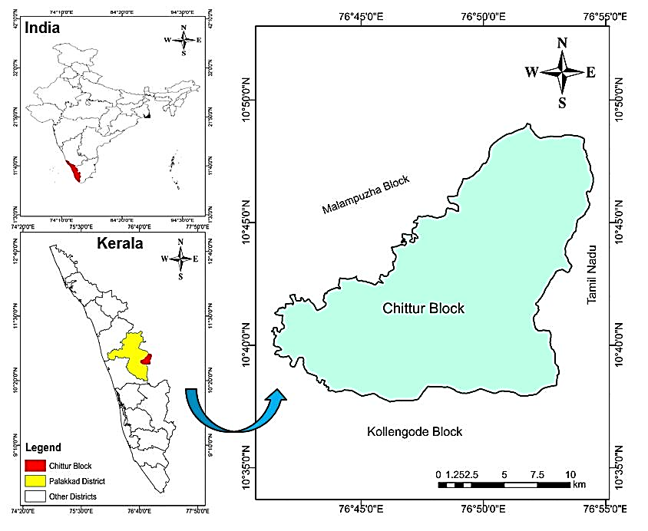
Fig. 1. Location map of the study area
- METHODOLOGY
3.1 Data Acquisition
The present study utilized monthly groundwater level data sourced from the State Groundwater Department, Palakkad District, Kerala. The Groundwater Department maintains a network of nine groundwater monitoring wells (GWMW) within the Chittur block. The dataset comprised measurements taken from four dug wells and five bore wells across the Chittur Block. The dug wells are situated in the lateritic formations representing the phreatic aquifer system, while the bore wells are established in the fractured crystalline basement rocks, representing confined to semi-confined aquifer conditions. To ensure adequate spatial representation across the entire basin, nine observation wells were strategically chosen for analysis as shown in Fig. 2. The data span a continuous period of 29 years, from 1994 to 2022, allowing for a robust assessment of long-term temporal and seasonal fluctuations in the water table. The geographic and physical details of the nine selected observation wells are provided in Table 1.
Table 1. The geographic and physical details of the wells selected
S. No. | Well ID (as per state and central GW Dept. norms) | Panchayat | Latitude (Decimal degrees) | Longitude (Decimal degrees) | Well type | Elevation (m)
1 | 126 | Chittur Muncipality | 10.703 | 76.738 | Dug well | 121
2 | 139 | Nallepilly | 10.741 | 76.816 | Bore well | 152
3 | 141 | Vadakarappathy | 10.796 | 76.889 | Bore well | 218
4 | 149 | Pattenchery | 10.597 | 76.663 | Bore well | 89
5 | 150 | Chittur Muncipality | 10.678 | 76.701 | Bore well | 117
6 | 151 | Nallepilly | 10.728 | 76.779 | Bore well | 118
7 | PKD S-6 | Kozhinjampara | 10.757 | 76.751 | Dug well | 125
8 | PKD S-7 | Kozhinjampara | 10.736 | 76.833 | Dug well | 152
9 | PKD S-8 | Perumatty | 10.652 | 76.752 | Dug well | 143
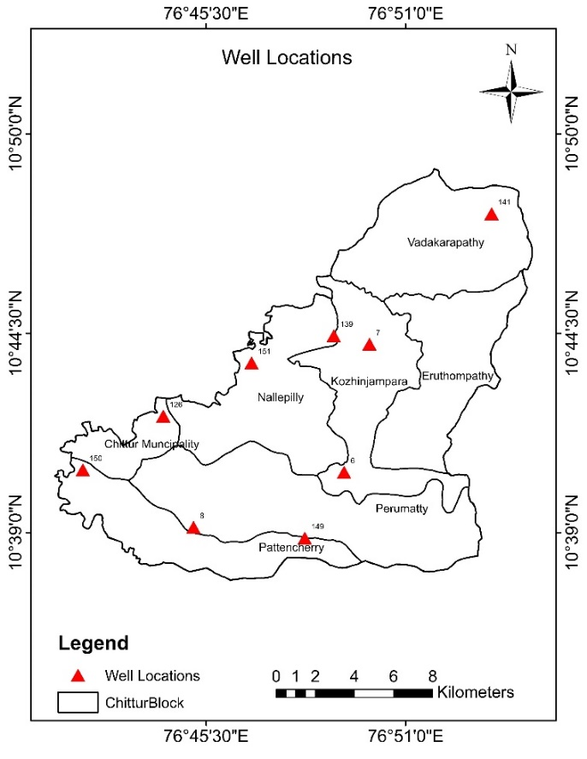
Fig. 2 Location map of observation wells in the Chittur block

3.2 Overall conceptual framework of the study

To evaluate seasonal variation, the monthly data were organized into two distinct hydrologic periods: 1. Pre-Monsoon season- data representing the lowest annual water table levels, typically recorded during March -May, 2. Post-Monsoon Season- data representing the highest yearly water table levels, typically recorded in October -November. A schematic representation of the overall workflow is organized in Fig.3. The water level data were subjected to both statistical (temporal) and spatial analysis. ArcGIS 10.3 was used for spatial data analysis and preparation of spatial maps. Microsoft Excel was used to show temporal variation graphs and to detect trends.
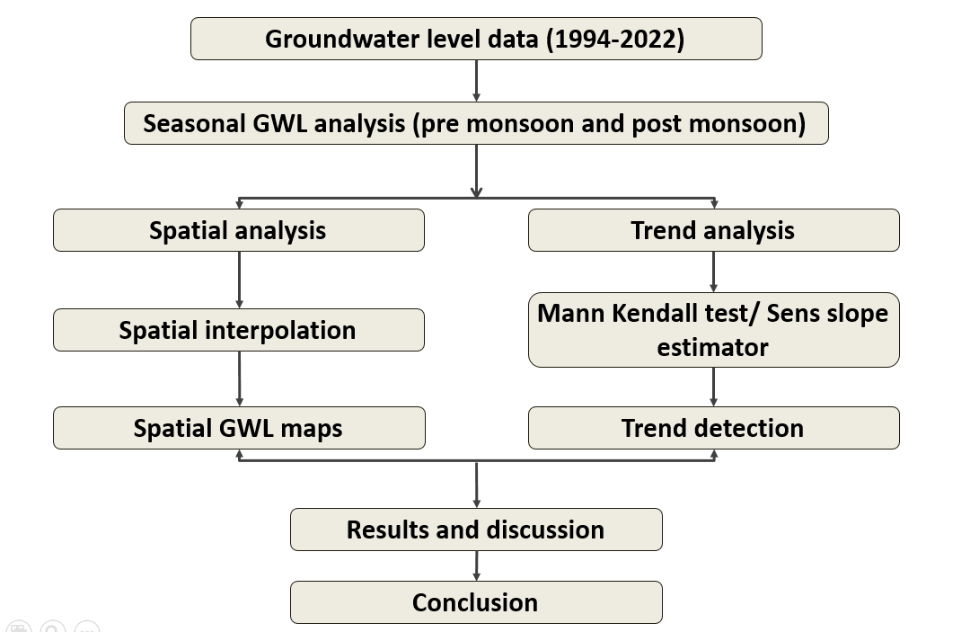
Fig. 3. Detailed methodology of the present research work
3.3 Spatial Interpolation and Mapping
Geospatial technique is an important approach for groundwater management studies in recent years (Karunanidhi et al., 2012; Subramani et al., 2013). Spatial analysis tool in the Geographical Information System (GIS) was used to study the spatiotemporal variation of groundwater levels over the period of 29 years (1994–2022). The mean annual and mean seasonal (pre- and post-monsoon) water level depths were computed for all nine wells. The pre-monsoon (Mar-May) and post-monsoon (Oct-Nov) water level trends were separately mapped using ArcGIS 10.3.
The Inverse Distance Weighting (IDW) interpolation technique was applied to generate continuous groundwater level maps (piezometric maps). IDW is an accurate deterministic method that estimates cell values using a linear combination of values at known sample points, with the weight of each point inversely proportional to the distance from the cell being estimated. This approach allowed for the clear identification of high-demand (deeper water table) and high-recharge (shallower water table) zones within the Chittur Block.
3.4 Temporal Trend Analysis
The temporal trend analysis was carried out to understand the seasonal fluctuations, long-term variations, and overall groundwater behaviour in the study area. This analysis provides valuable insights into the dynamics of groundwater recharge, extraction, and sustainability within the Chittur block. To detect statistically significant trends in the 29-years’ time series data (both annual and seasonal), the non-parametric Mann-Kendall (MK) test was employed. The MK test is widely preferred in hydrological studies as it does not require the data to be normally distributed and is less sensitive to outliers. The significance of the trend was tested at the 5% level (alpha = 0.05). The magnitude of the trend (rate of water level change per year) was estimated using Sen's Slope Estimator. This robust, non-parametric method provides an accurate measure of the linear rate of change over the study period.
3.4.1 Mann-Kendall Test (MK)
The Mann–Kendall (M–K) test is a widely used non-parametric statistical method for detecting monotonic trends in time-series data, particularly when the data do not conform to a normal distribution. The M-K test has been extensively used in hydrological and environmental studies for analyzing trends in parameters such as precipitation, streamflow, groundwater levels, and water quality (Obot et al., 2010; Sai and Joseph, 2018; Siddharam et al., 2022). This test evaluates whether a consistent upward or downward trend exists over time without requiring the trend to be linear.
The Mann-Kendall statistic (S) is given in equation 1.
$S=\sum_{i=1}^{n-1}{\sum_{j=i+1}^{n}{sign(x_{j}-x_{i})}}$ ……………………. (1)
where,
$sign(x_{j}-x_{i})$ = 1, if $(x_{j}-x_{i})$ ˃ 0
$sign(x_{j}-x_{i})$ = 0, if $(x_{j}-x_{i})$ = 0
$sign(x_{j}-x_{i})$ = -1, if $(x_{j}-x_{i})$ ˂ 0
A positive value of S indicates a rising trend and a negative value indicates a falling trend. However, it is necessary to perform the statistical analysis for the significance of the trend. This test assumes that there are not many tied values within the dataset. The variance (S) is calculated by the following equation 2.
$Var \left(S\right)=\frac{1}{18}[n\left(n-1\right)\left(2n+5\right)-\sum_{p=1}^{g}{t_{p}(t_{p}-1)(2t_{p}+5)]}$ …………. (2)
Where,
n- Number of data points,
g- Number of tied groups and
$t_{p}$- Number of data points in the p^{th} group.
The absolute value of the Z_{MK} statistic is compared against a critical value from the standard normal distribution table corresponding to the chosen significance level (α).
The normal Z-statistic is computed as follows:
$Z= \frac{S-1}{\sqrt{Var (S)}}$ , if S ˃ 0
$Z= 0$ , if S = 0 …………………. (3)
$Z= \frac{S+1}{\sqrt{Var (S)}}$ , if S ˂ 0
The trend is said to be rising if Z is positive and the computed Z-statistics is greater than the Z-value corresponding to the 5% level of significance. If the computed Z-statistics is less than the Z-value corresponding to the 5% level of significance, there is no trend.
- The Z-value is 1.645 at 10% level of significance.
- The Z-value is 1.96 at 5% level of significance.
- The Z-value is 2.33 at 1% level of significance.
    - Sen’s slope Estimator
The Sen's Slope Estimator tells the rate (magnitude and direction) of the trend (a numerical value with units). Sen’s slope has the advantage over the regression slope in the sense that it is not much affected by gross data errors and outliers. The Sen’s slope is estimated as the median of all pairwise slopes between each pair of points in the dataset. Each individual slope (m_{ij}) is estimated using the following equation:
$m_{ij}=\frac{(Y_{j}-Y_{i})}{(j-i)}$ ……………………. (4)
where,
i=1 to n-1 and j= 2 to n,
Y_{j} and Y_{i} are data values at time j and i (j ˃ i), respectively.
If there are n values of Y_{j} in the time series, there will be N= n (n-1)/2 slope estimates. The Sen’s slope is the median slope of these N values of slopes.
The Sen’s slope is:
$m=m_{(\frac{N+1}{2})}$, if n is odd
$m=\frac{1}{2}(m_{\left(\frac{N}{2}\right)}+m_{\left(\frac{N+1}{2}\right)})$, if n is even
Positive Sen’s slope indicates a rising trend, while the negative Sen’s slope indicates a falling trend.

4. RESULTS AND DISCUSSION
4.1 Temporal variation of groundwater level dynamics
The analysis of the mean groundwater level (m bgl) relative to rainfall (Fig. 4) revealed a strong climatic dependency of the shallow hard-rock aquifer system in the Chittur Block. Groundwater level observations showed considerable spatial variability, a characteristic of hard-rock terrains where water storage is controlled by fracture patterns and weathered zones (Shaji et al., 2018). Wells like PKD S-7 and well no. 141 recorded substantially deeper water levels (up to 20 m bgl) in areas Perumatty and Vadakarapathy panchayats. This deep water table signals areas under intense, sustained groundwater abstraction, likely for irrigation, combined with limited recharge potential. Conversely, wells such as 126, 139, 149, 150, 151, PKD S-6, and PKD S-8 exhibited shallower, relatively stable water levels (mostly within 10 m bgl) in areas Chittur municipality, Nallepilly, Pattenchery panchayats indicating favourable recharge conditions or lower abstraction stress.
Temporal hydrographs clearly demonstrated that rainfall served as the primary driver of groundwater recharge. Deeper water levels were consistently observed during drought periods (notably post-2016), reflecting a significant net depletion of storage, while a partial recovery was noted during years with higher precipitation (e.g., 2018, during which high rainfall and floods in Kerala). This direct correlation confirmed the unconfined nature of the phreatic aquifer and its immediate response to monsoonal input.
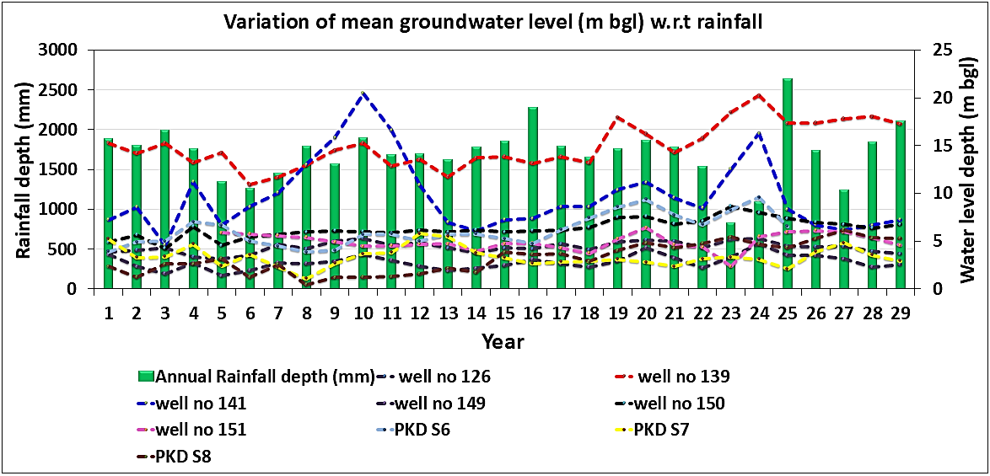
Fig. 4 Variation of mean groundwater level (m bgl) with respect to rainfall
The coexistence of deeply stressed wells and shallow, stable wells reflected the spatial heterogeneity of aquifer resilience in the hard-rock environment. The deeper wells are likely tapping highly utilised localised fracture systems or are situated in areas classified as 'over-exploited' by the Central Ground Water Board (CGWB) due to intensive agriculture, a known scenario in the Chittur block (Praseeja and Younus, 2024; Shaji et al., 2018). Long-term sustainability, therefore, is not solely dependent on total rainfall but critically relies on local hydrogeology, land use, and abstraction intensity, which collectively determine the depth and recovery pattern of the groundwater table.
4.2 Spatial variation of groundwater level dynamics
Spatial groundwater level variation maps (Fig. 5 and Fig.6) generated for key years (1994, 2000, 2010, 2017, and 2022) illustrated the long-term evolution of groundwater storage under coupled hydroclimatic and anthropogenic influences. These maps were prepared for both pre-monsoon (March–May) and post-monsoon (October–November) periods, thereby enabling the identification of zones of recharge, decline, and fluctuation.
4.2.1 Pre-monsoon groundwater levels
Pre-monsoon Groundwater levels (GWLs) showed (Fig. 5) substantial spatial variation, ranging between 3.65 m bgl and 25.5 m bgl. The distribution consistently showed shallower GWLs in the southern region and deeper levels in the northern and certain central parts. The southern region's relatively shallow levels were attributed to favourable physiographic and lithological conditions (e.g., gently sloping pediments and enhanced weathering) that facilitate infiltration and recharge. In contrast, the northern sector's persistent deep GWL zones reflect higher abstraction pressures associated with intensive farming and/or comparatively lower recharge potential due to less permeable geological formations. The persistence of these deep zones across multiple years (1994–2022) clearly marks them as hydrologically stressed areas requiring urgent management.
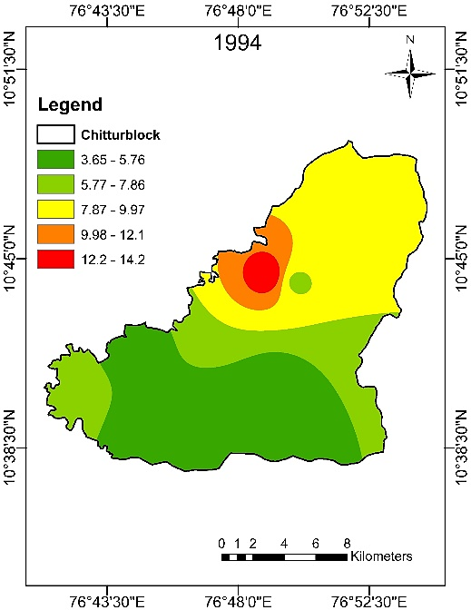  (a) | 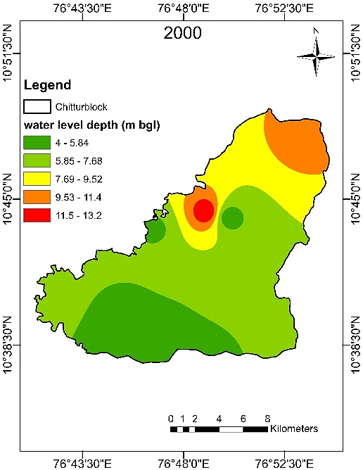  (b)
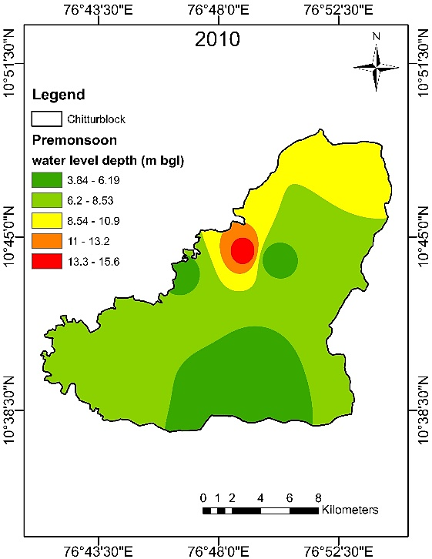  (c) | 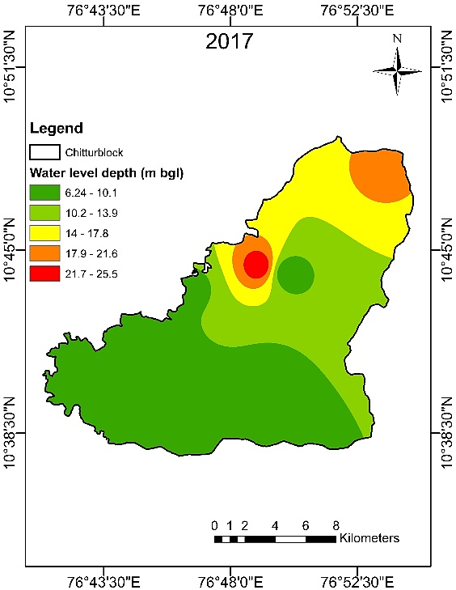  (d)
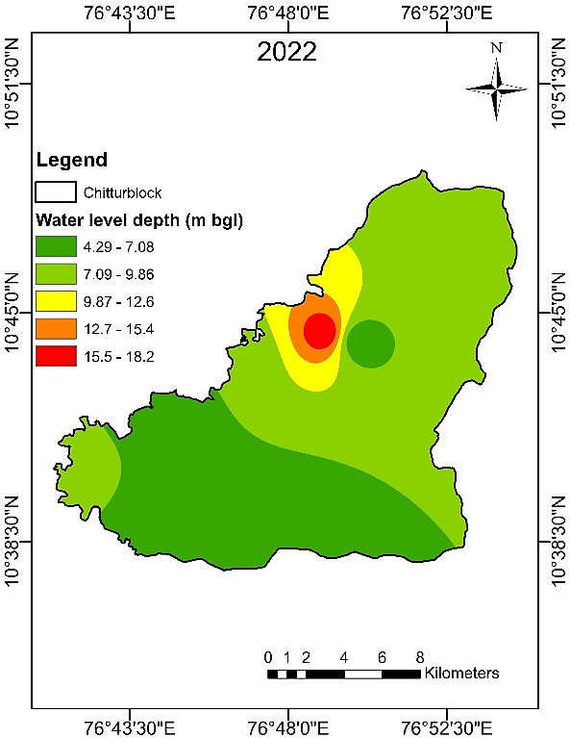
(e)
Fig. 5 Spatial variation of pre-monsoon groundwater level in the years (a) 1994, (b) 2000, (c) 2010, (d) 2017, (e) 2022
4.2.2 Post-monsoon groundwater levels
The post-monsoon GWLs (Fig. 6) showed a significant improvement, ranging from 1.12 m bgl to 15.2 m bgl, confirming the monsoon's role as the dominant recharge mechanism. Widespread shallow water levels were observed, particularly in the central and southern regions, demonstrating efficient aquifer recovery and favourable hydrogeological conditions. This seasonal rise underscores the direct, critical relationship between monsoonal precipitation and the replenishment of the hard-rock aquifer reserve. This pattern is typical for the Kalpathypuzha sub-basin near Chittur as reported by Assainar and Joseph (2023).
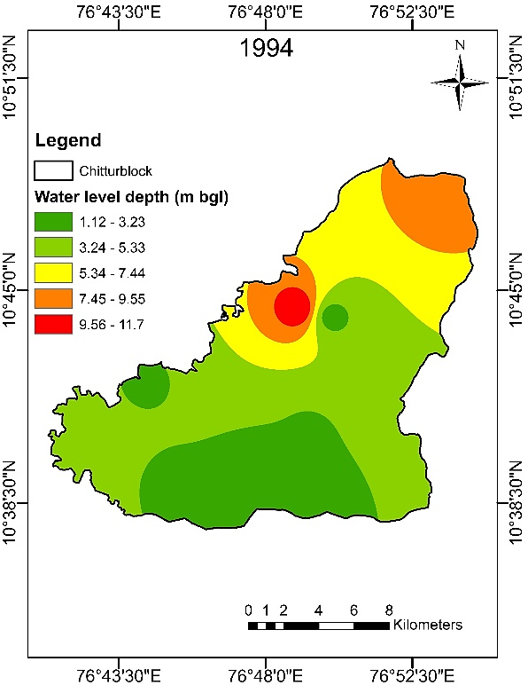  (a) | 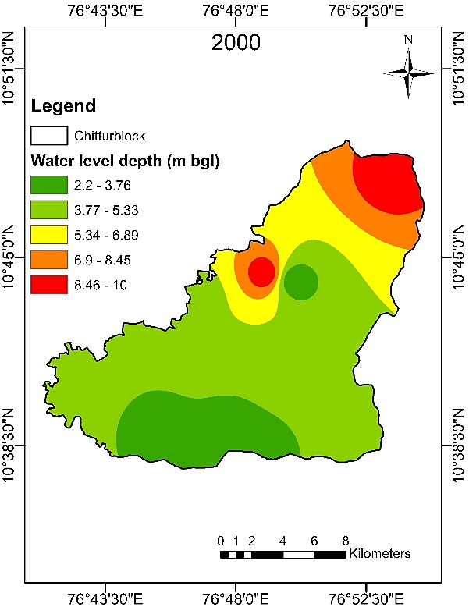  (b)
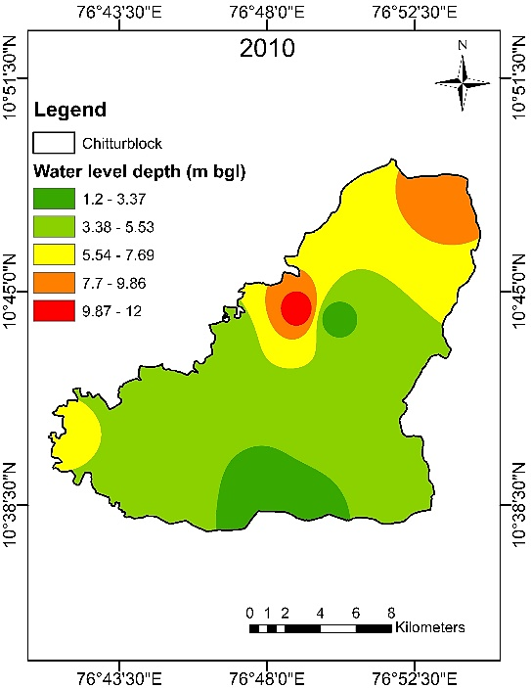  (c) | 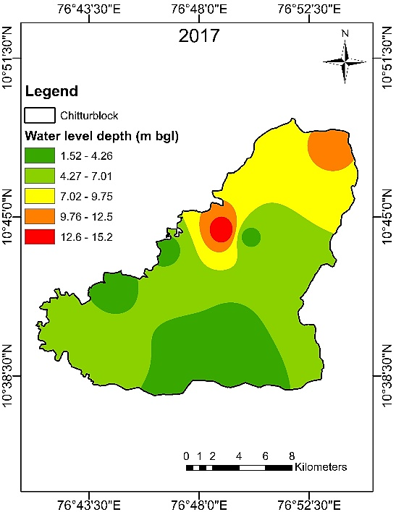  (d)
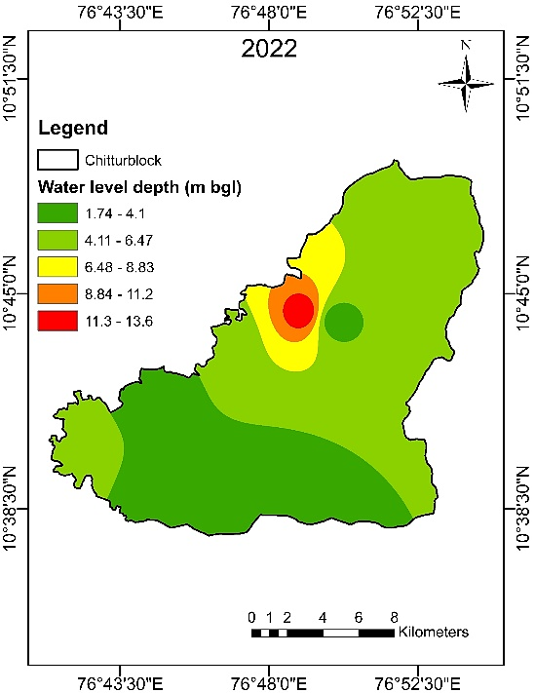
(e)
Fig. 6 Spatial variation of post-monsoon groundwater level in the years (a) 1994, (b) 2000, (c) 2010, (d) 2017, (e) 2022
4.2.3 Seasonal groundwater level fluctuations
The analysis of seasonal fluctuation (difference between pre- and post-monsoon levels), as shown in Fig. 7 ranged significantly between 0.5 m bgl and 10.3 m bgl. The highest fluctuation in 2017 coincided with years of below-normal rainfall and peak pumping intensity, indicating maximum hydrological stress. The lowest fluctuation in 1994 suggested relatively stable recharge–discharge conditions during that period.
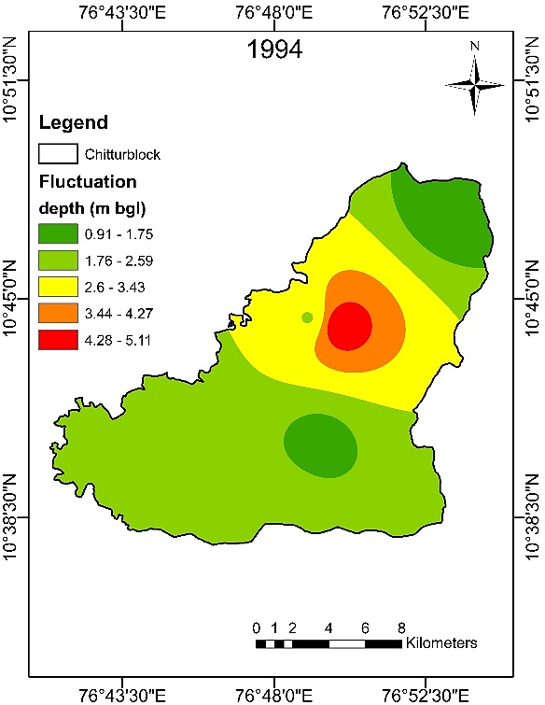  (a) | 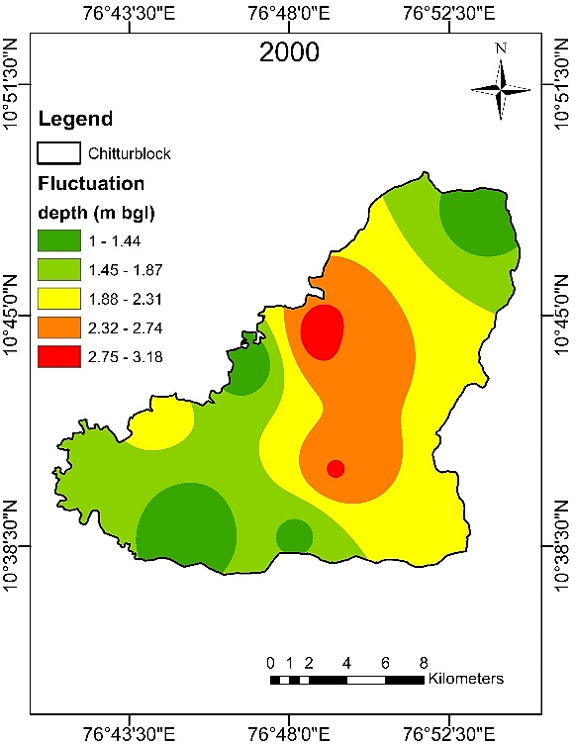  (b)
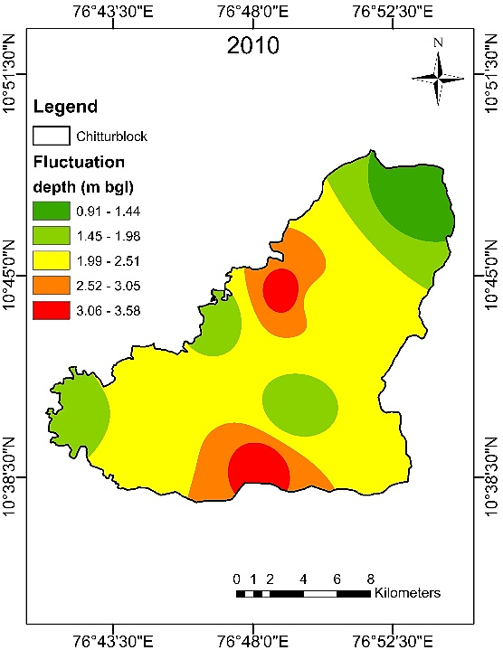  (c) | 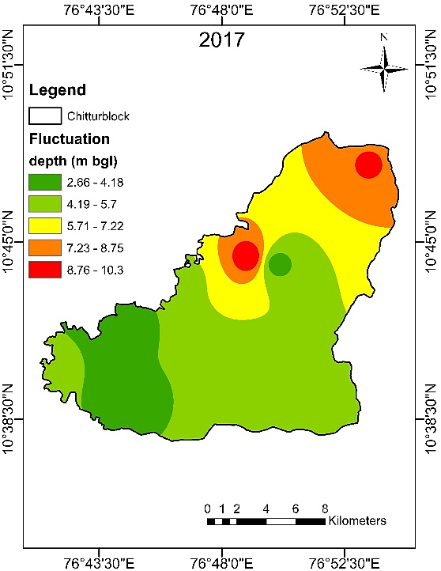  (d)
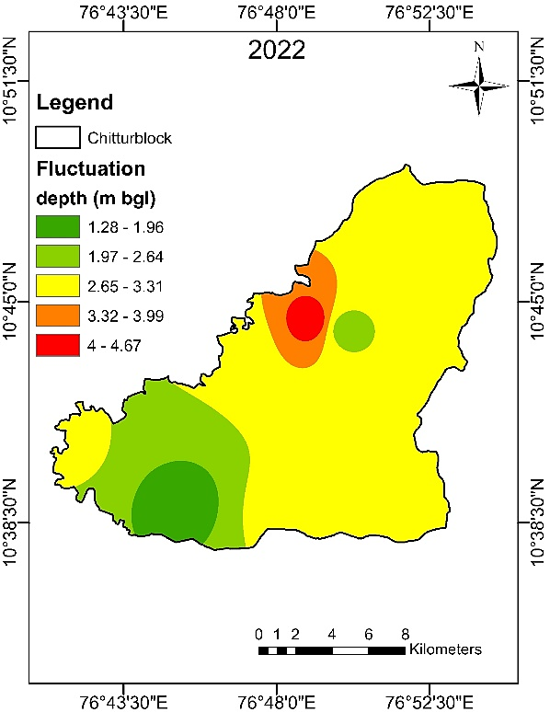
(e)
Fig. 7 Seasonal groundwater level fluctuations in the years (a) 1994, (b) 2000, (c) 2010, (d) 2017, (e) 2022
4.2.4 Long-term variation of groundwater level and its fluctuation during the period 1994-2022
The long-term spatial variation (1994–2022) of groundwater level revealed that during the pre-monsoon period, the central, western, and southern regions exhibited shallow groundwater levels (4.3–9.2 m bgl), as indicated by the green-shaded areas in the map (Fig 8a). These regions are hydrologically favourable, showing high potential for groundwater availability before the onset of the rainy season. In contrast, the north-central zone and smaller isolated patches recorded deeper groundwater levels (9.3–17 m bgl), reflecting intensive water withdrawal or inadequate recharge. In the post-monsoon period (Fig.8b), groundwater levels rise substantially across the study area, predominantly ranging between 2.1 m bgl and 13 m bgl, confirming the positive recharge effect of monsoonal rainfall.
The long-term fluctuation map (Fig.8c) distinctly delineated three zones. Low Fluctuations (1–1.9 m bgl) were observed in the central, southern, and western regions, indicating stable aquifer conditions due to consistent recharge and balanced demand. Moderate Fluctuations (2–2.7 m bgl) observed in the central-eastern and northern parts, representing moderately responsive aquifers where seasonal withdrawal and recharge effects are prominent. High Fluctuations (2.8–3.1 m bgl) are concentrated in the northern and north-eastern regions, representing the most intensive groundwater extraction zones, coupled with limited or slower recharge potential, leading to the greatest water table variation.
The long term spatio-temporal analysis (1994–2022) concluded a clear trend of progressive groundwater level decline in the high-abstraction zones of the northern and central regions of the Chittur block, while the southern and western parts remain relatively stable. The consistent post-monsoon recovery confirmed the vital importance of rainfall-driven recharge but also highlighted the uneven spatial distribution of aquifer stress.
The Chittur Block's status as a drought-prone and water-stressed area (Praseeja and Younus, 2024) requires a shift toward site-specific, demand-side, and supply-side management strategies to minimize spatial and temporal disparities in water availability. Effective measures such as regulating groundwater extraction, promoting water-efficient irrigation practices, and implementing artificial recharge structures (e.g., check dams, percolation tanks) in the high-fluctuation northern zones are essential for restoring aquifer balance and ensuring the long-term sustainability of the hard-rock aquifer system.
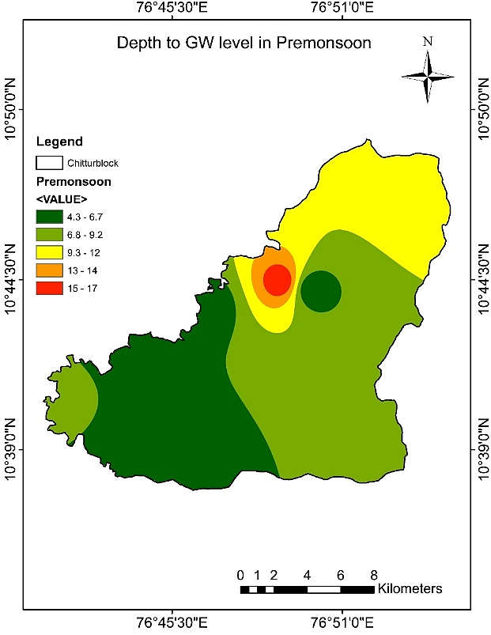  (a) | 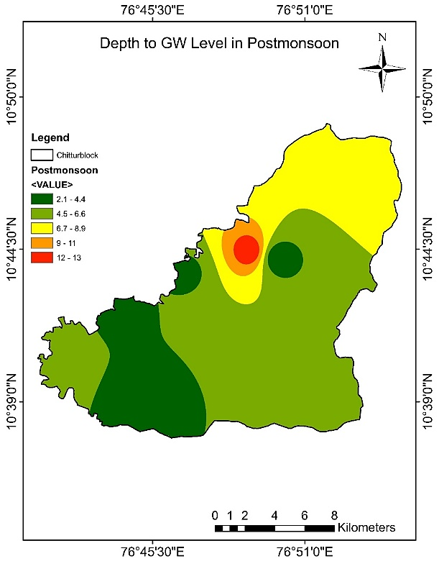  (b)
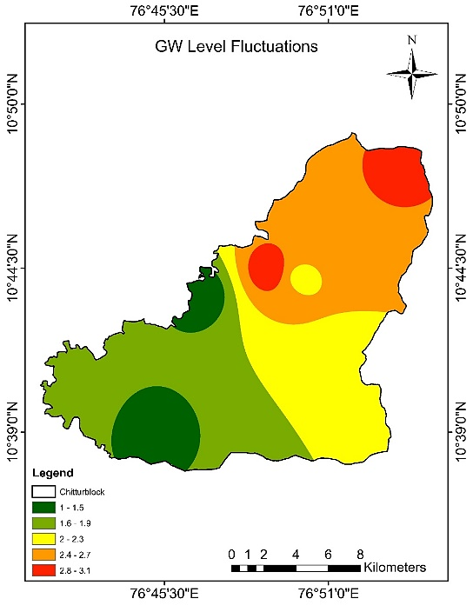
(c)
Fig. 8 Overall variation of groundwater levels and fluctuation during the period 1994-2022 (a) pre-monsoon, (b) post-monsoon and (c) fluctuations.
4.3 Trend analysis of groundwater level
This section presents the results of the long-term trend analysis of groundwater levels (GWLs) across the nine observation wells in the Chittur Block, spanning the period 1994–2022. The non-parametric Mann-Kendall (MK) test was utilized to determine the statistical significance of the trend, while Sen’s slope estimator was employed to quantify the magnitude (rate) of change in the GWL. The analysis was performed for the pre-monsoon (March–May), post-monsoon (October–November), and annual periods (Tables 2, 3, and 4, respectively). The trend analysis revealed significant spatial heterogeneity in long-term groundwater dynamics, emphasising the varied pressures and recharge conditions across the block.
Table 2 Trend analysis of groundwater level during the pre-monsoon period (Mar-May)
Well ID | VAR(S) | Z-Statistics  (Computed) | Z-value (10% Level of significance) | Z-value (5% Level of significance) | Slope | Trend
126 | 2842 | -1.437 | 1.645 | 1.96 | 0.462 | No
139 | 2842 | 1.191 | 1.645 | 1.96 | 1.115 | No
141 | 2842 | 1.987 | 1.645 | 1.96 | -0.623 | Decreasing
149 | 2842 | 1.934 | 1.645 | 1.96 | -0.010 | Decreasing
150 | 2842 | 0.924 | 1.645 | 1.96 | 0.159 | No
151 | 2842 | -0.048 | 1.645 | 1.96 | 1.175 | No
PKD S-6 | 2842 | 2.155 | 1.645 | 1.96 | -3.786 | Decreasing
PKD S-7 | 2842 | -0.589 | 1.645 | 1.96 | 1.464 | No
PKD S-8 | 2842 | 2.014 | 1.645 | 1.96 | -0.903 | Decreasing
Table 3: Trend analysis of groundwater level during the post-monsoon period (Oct-Nov)
Well ID | VAR(S) | Z-Statistics  (Computed) | Z-value (10% Level of significance) | Z-value (5% Level of significance) | Slope | Trend
126 | 2842 | -1.948 | 1.645 | 1.96 | 0.573 | No
139 | 2842 | 1.257 | 1.645 | 1.96 | 1.117 | No
141 | 2842 | 2.638 | 1.645 | 1.96 | -0.781 | Decreasing
149 | 2842 | 1.994 | 1.645 | 1.96 | -0.011 | Decreasing
150 | 2842 | 1.924 | 1.645 | 1.96 | 0.894 | No
151 | 2842 | -0.482 | 1.645 | 1.96 | 1.274 | No
PKD S-6 | 2842 | 1.962 | 1.645 | 1.96 | -2.589 | Decreasing
PKD S-7 | 2842 | -0.894 | 1.645 | 1.96 | 1.147 | No
PKD S-8 | 2842 | 1.024 | 1.645 | 1.96 | 0.917 | No

Table 4: Trend analysis of annual groundwater level
Well ID | VAR(S) | Z-Statistics  (Computed) | Z-value (10% Level of significance) | Z-value (5% Level of significance) | Slope | Trend
126 | 2842 | 1.256 | 1.645 | 1.96 | 0.645 | No
139 | 2842 | 1.973 | 1.645 | 1.96 | -0.984 | Decreasing
141 | 2842 | 2.126 | 1.645 | 1.96 | -0.947 | Decreasing
149 | 2842 | 1.998 | 1.645 | 1.96 | -0.105 | Decreasing
150 | 2842 | 1.247 | 1.645 | 1.96 | 0.258 | No
151 | 2842 | -0.645 | 1.645 | 1.96 | 1.247 | No
PKD S-6 | 2842 | 1.957 | 1.645 | 1.96 | -1.468 | Decreasing
PKD S-7 | 2842 | -0.459 | 1.645 | 1.96 | 1.863 | No
PKD S-8 | 2842 | 1.994 | 1.645 | 1.96 | -0.116 | Decreasing
Wells 141, 149, and PKD S-6 exhibited a statistically significant decreasing trend (negative Z-statistic in MK test and negative Sen’s slope value) across all three periods: pre-monsoon, post-monsoon, and annual. This consistent decline is a critical finding, indicating that the lowering of the water table is a long-term, cumulative process rather than merely a seasonal fluctuation. These wells are situated in zones where the groundwater abstraction rates consistently exceed the natural recharge capacity, leading to progressive aquifer depletion. This depletion is likely driven by intensive agricultural pumping in the surrounding area, coupled with potentially unfavourable hydrogeological characteristics (e.g., thinly weathered zones or poorly connected fracture systems) that restrict infiltration and storage capacity (Shaji et al., 2018).
Wells 139 and PKD S-8 showed a statistically significant decreasing trend in the annual GWL, but their trends during the pre-monsoon and post-monsoon periods were either weak or statistically insignificant (Z-statistic close to zero). This pattern suggested that, while the overall groundwater storage suffers a net annual loss, the intense seasonal recharge during the monsoon period is effective in temporarily stabilising or mitigating the immediate post-monsoon declines. However, heavy withdrawals during the subsequent dry seasons ultimately lead to a net annual loss, underscoring the dominant role of anthropogenic activity in long-term aquifer stress.
Wells 126, 150, 151, and PKD S-7 showed no statistically significant trend (low Z-statistic) across any observation period (pre-monsoon, post-monsoon, or annual). These wells are likely situated in zones where the groundwater abstraction is minimal or effectively balanced with recharge. Such stable conditions often correspond to favourable geomorphic settings (e.g., alluvial plains or gently sloping pediments) that enhance infiltration and promote longer-duration water retention (Kumar et al., 2021).
The positive values of Sen's slope for some of these wells indicate a slight, non-significant rising trend, suggesting a near-equilibrium state. The Sen’s slope estimator provided a quantitative measure of the decline, with wells showing a significant decreasing trend exhibiting negative slope values. Conversely, the remaining wells showed positive or near-zero slopes, reflecting either a non-significant or rising trend, reinforcing the spatial segmentation of aquifer health.
Overall, the observed patterns revealed marked spatial heterogeneity in groundwater dynamics within the Chittur block, with some regions experiencing critical depletion while others remain stable. This underscores the need for micro-level groundwater management strategies tailored to local hydrogeological and socio-economic conditions. The findings were consistent with those of Assainar and Joseph (2023), who reported similar spatial variability and declining groundwater trends across the Chittur block. These observations also aligned with national assessments by CGWB (2020) and regional modelling efforts by Kumar et al. (2021), both of which highlighted the growing stress on groundwater resources due to imbalanced recharge–extraction dynamics in Kerala’s semi-arid zones.
Table. 5. Abstract result of Mann-Kendall Z statistics and Sen’s slope estimation values for groundwater levels (1994-2022)
Well no | Pre monsoon |  | Post monsoon |  | Annual
Well no | Z- statistics | Slope | Z- statistics | Slope | Z- statistics | Slope
126 | -1.437 | 0.462 | -1.948 | -0.573 | 1.256 | -0.645
139 | 1.191 | 1.115 | 1.257 | 1.117 | 1.973* | 0.984
141 | 1.987* | -0.623 | 2.638* | -0.781 | 2.126* | -0.947
149 | 1.934* | -0.010 | 1.994* | -0.011 | 1.998* | -0.105
150 | 0.924 | 0.159 | 1.924 | 0.894 | 1.247 | 0.258
151 | -0.048 | 1.175 | -0.482 | 1.274 | -0.645 | 1.247
PKD S 6 | 2.155* | -3.786 | 1.962* | -2.589 | 1.957* | -1.468
PKD S 7 | -0.589 | 1.464 | -0.894 | 1.147 | -0.459 | 1.863
PKD S 8 | 2.014* | -0.903 | 1.024 | -0.917 | 1.994* | -0.116
(‘*’ Trend at 95% level of significance)
The identified zones of persistent groundwater decline (Wells 141, 149, PKD S-6) represent a significant threat to agricultural productivity within the block, especially during the crucial pre-monsoon planting and growing seasons. The lowering of the water table increases pumping costs and energy use, eventually rendering current abstraction methods unsustainable. This robust, scientific insight provides a valuable basis for micro-level groundwater management strategies that are tailored to local hydrogeological and socio-economic conditions. The results of this study revealed that water scarcity poses a significant threat to agricultural productivity within the block.
The research has successfully identified regions experiencing groundwater stress across different monsoon periods. These insights can assist planners in implementing immediate and effective groundwater management strategies to address the declining water levels. The use of statistical trend analysis provided a valuable foresight for sustainable groundwater development in the area. Overall, the study provided a scientific basis for informed decision-making and resource allocation in the context of integrated water resource management.
- CONCLUSIONS
This research provided a comprehensive spatiotemporal assessment of groundwater dynamics within the Chittur block of Palakkad district, leveraging a 29-year dataset (1994–2022) from nine observation wells. Through a synthesis of spatial interpolation and statistical trend analyses, the study successfully characterized the complex responses of the aquifer system to both climatic variability and anthropogenic pressures. The analysis clearly demonstrated a strong correlation between groundwater level fluctuations and rainfall patterns. Significant water-level declines were predominantly observed in the period preceding 2016, followed by notable, though often partial, recovery after 2018 due to subsequent high-rainfall years. This indicated that while the aquifer system has been subject to considerable stress in localized areas, it retains a capacity for natural recharge under favorable climatic conditions.
Northern and northeastern zones experienced the most substantial reduction, with declines ranging from 2 to 5 meters below ground level (m bgl) across all monsoon seasons. This degradation is linked to a confluence of factors, including limited infiltration, increased surface runoff, and intensified groundwater extraction. In contrast, the southern and western regions displayed more moderate fluctuations, and the central portion consistently maintained relatively shallow water levels, typically above 3 m bgl during both pre-monsoon and post-monsoon periods.
The long-term trend analysis solidified these findings, revealing an overall decreasing tendency in several key locations. A decline was established in three wells (141, 149, PKD S-6) during the post-monsoon period, escalating to four wells (141, 149, PKD S-6, and PKD S-8) in the critical pre-monsoon season. Annually, a decreasing trend was evident across five wells (139, 141, 149, PKD S-6, and PKD S-8) over the entire observation period. Crucially, the most acute pre-monsoon decline was concentrated in the southeastern and northeastern parts of the block. This severe seasonal stress is largely attributable to intensive groundwater use for irrigation, which exacerbates aquifer depletion during dry spells.
These observed spatial and temporal disparities in groundwater availability present significant challenges for the sustainability of local agricultural communities. Consequently, to safeguard the aquifer for long-term use, the immediate implementation of groundwater augmentation measures is essential. Priority should be given to the most vulnerable zones through the construction of suitable artificial recharge structures and techniques to enhance effective groundwater storage and promote resilience.
Disclaimer (Artificial intelligence)
Option 1:
Author(s) hereby declare that NO generative AI technologies such as Large Language Models (ChatGPT, COPILOT, etc.) and text-to-image generators have been used during the writing or editing of this manuscript.
Option 2:
Author(s) hereby declare that generative AI technologies such as Large Language Models, etc. have been used during the writing or editing of manuscripts. This explanation will include the name, version, model, and source of the generative AI technology and as well as all input prompts provided to the generative AI technology
Details of the AI usage are given below:
1.
2.
3.

REFERENCES
Abdullahi, M. G., Toriman, M. E., Gasim, M. B., & Garba, I. (2015). Trends analysis of groundwater: Using non-parametric methods in Terengganu Malaysia. Journal of Earth Science and Climatic Change, 6(1), 1–3.
Abdul, M., Altamash, S., & Hamza, F. G. (2024). Mapping and projecting spatiotemporal trends in groundwater levels and flow direction in Pakistan’s water scarce aquifer system. Groundwater for sustainable development, 26, no.101234.
Aggarwal, R., Kaushal, M. P., Kaur, S., & Farmaha, B. (2009). Water resource management for sustain able agriculture in Punjab, India. Water Science and Technology, 160(11), 2905–2911.
Amanpreet, S., Chandrashekhar, S., Jeyaseelan, A. T., & Chowdary, V. M. (2015). Spatio-temporal analysis of groundwater resources in Jalandhar district of Punjab state, India. Sustainable Water Resources Management, 1, 293–304.
Amrita, Singh, O., & Singh, K. P. (2016). Analysis of groundwater level trends in Kurukshetra District of Haryana: 1990–2013. Environmental Pollution Control Journal, 19(2), 23–31.
Arya, S., & Subramani, T. (2015). Groundwater flow & fluctuation using GIS in a hard rock region, South India. Indian Journal of Geo-Marine Sciences, 44(9), 1422–1427.
Arya, S., Vennila, G., & Subramani, T. (2018). Spatial & seasonal variation of groundwater levels in Vat tamalaikarai River basin, Tamil Nadu, India—A study using GIS and GPS. Indian Journal of Geo Marine Sciences, 47(9), 1749–1753.
Assainar, K. K. R., Joseph, A. & Sajeena, S. (2023). Trend analysis of groundwater levels in Kalpathypuzha sub-basin of Bharathapuzha, Kerala, India. International Journal of Environment and Climate Change, 13 (9), 1145-1157.
Basistha, A., Arya, D. S., & Goel, N. K. (2009). Analysis of historical changes in precipitation in the Indian Himalayas. International Journal of Climatology, 29(4), 555–572.

Bekir, S. K., Bilgehan, C., & Bekir, C. (2025). Spatial and temporal trend analysis of groundwater depth and salinity using geostatistics integrated with gis in the koprucay irrigation system in Antalya, Turkey. Irrigation and Drainage, 1-15. https://doi.org/10.1002/ird.70031.
Burn, D. H., & Elnur, M. A. H. (2002). Detection of hydrologic trends and variability. Journal of Hydrology. 255, 107–122.
Bui, D. D., Kawamura, A., Tong, T. N., Amaguchi, H., & Nakagawa, N. (2012). Spatio-temporal analysis of recent groundwater-level trends in the Red River Delta, Vietnam. Hydrogeology Journal, 20(8), 1635-1650.
Central Ground Water Board (CGWB). (2014). Groundwater booklet of Palakkad district, Kerala. Ministry of Water Resources, Government of India.
Central Ground Water Board (CGWB). (2020). Ground Water Year Book - Kerala State 2019–20. Ministry of Jal Shakti, Government of India.
Duhan, D., & Pandey, A. (2013). Statistical analysis of long term spatial and temporal trends of precipitation during 1901–2002 at Madhya Pradesh, India. Atmospheric Research. 122, 136–149.
Gemmer, M., Becker, S., & Jiang, T. (2004). Observed monthly precipitation trends in China 1951–2002. Theoretical and Applied Climatology. 77, 39–45.
Goyal, S. K., Chaudhary, B. S., Singh, O., Sethi, G. K., & Thakur, P. K. (2010). Variability analysis of groundwater levels—A GIS based case study. Journal of the Indian Society of Remote Sensing, 38(2), 355–364.
Gunarathana, M. H. J. P., Nirmanee, K. G. S., & Kumari, M. K. N. (2016). Geostatistical analysis of spatial and seasonal variation of groundwater level: A comprehensive study in Malwathu Oya cascade-I, Anu radhapura, Srilanka. International Research Journal of Environment Sciences, 5(8), 29–36.
Jasechko, S., & Perrone, D. (2021). Global groundwater wells at risk of running dry. Science, 372 (6540), 418–421.
Jasechko, S., Seybold, H., Perrone, D., Fan, Y., Shamsudduha, M., Taylor, R. G., Fallatah, O., & Kirchner, J. W. (2024). Rapid groundwater decline and some cases of recovery in aquifers globally. Nature, 625(7996), 715–721.
Karunanidhi, D., Vennila, G., & Suresh, M. (2012). GIS approach for rainfall fluctuation study in Omalur Taluk, Salem District, Tamil Nadu, India. Pollution Research, 31(3), 493–497.
Kendall, M. G. (1975). Rank correlation methods. Griffin, London. http://www.sciencedirect.com/science/ refhub/S0895-9811(15)00014-0/sref18.
Kshetrimayum, K. S., & Bajpai, V. N. (2012). Assessment of groundwater quality for irrigation use and evolution of hydrochemical facies in Markanda river basin, north western India. Journal of the Geological Society of India, 79, 189–198.
Kumar, P., Chandniha, S. K., Lohani, A. K., Krishnan, Gopal, & Nema, A. K. (2018). Trend analysis of groundwater level using non-parametric tests in alluvial aquifers of Uttar Pradesh, India. Current World Environment, 13(1), 44–54.
Kumar, P., Thomas, A. & Joseph, L. (2021). Groundwater level trends and recharge potential assessment in semi-arid regions of Kerala using long-term monitoring data. Hydro Research, 4(2), 67–79.
Mann, H. B. (1945). Non-parametric tests against trend. Econometrica, 13, 245–259.
Obot, N. I., Chendo, M. A. C., Udo, S. O. & Ewona, I. O. (2010). Evaluation of rainfall trends in Nigeria (1978-2007). International Journal of Physical Sciences, 5(14), 2217-2222.
Praseeja, A. V. & Younus, S. (2024). Monitoring of ground water level fluctuation in Chittur, Palakkad. International Journal of Energy and Water Resources, 91pp.
Sai, K. V. & Joseph, A. (2018). Trend analysis of rainfall of Pattambi region, Kerala. International Journal of Current Microbiology and Applied Science, 7(9), 3274-3281.
Shaji, E., Gómez-Alday, J. J., Hussein, S., Deepu, T. R. & Anilkumar, Y. (2018). Salinization and deterioration of groundwater quality by nitrate and fluoride in the Chittur Block, Palakkad, Kerala. Journal of Geological Society of India, 92(3), 337–345.
Siddharam, Janardan, B. K., Basavaraja, D. & Dandekar, A. T. (2022). Assessment of Long TermSpatio-temporal Variability in Temperature over the Kalaburgi District, North Eastern Region of Karnataka, India. Journal of Agrisearch, 9(1), 63-68.
Sivapragasam, C., Kannabiran, K., Karthik, G., & Raja, S. (2015). Assessing suitability of GP modeling for groundwater level. Aquatic Procedia, 4, 693–699.
Subramani, T., Babu, Savithri, & Elango, L. (2013). Computation of groundwater resources and recharge in Chithar River Basin, South India. Environmental Monitoring and Assessment. 185, 983–994.
Subramani, T., Prabaharan, S., & Karunanidhi, D. (2015). Groundwater prospecting in a part of Tami rabarani River basin, South India using Remote Sensing and GIS. Indian Journal of Geo-Marine Sciences, 44(9), 1401–1408.
Tabari, H., Nikbakht, J., & Some’e, B. S. (2012). Investigation of groundwater level fluctuations in the north of Iran. Environmental Earth Sciences, 66, 231–243.
Tapoglou, E., Karatzas, G. P., Trichakis, I. C., & Varouchakis, E. A. (2014). A spatio-temporal hybrid neural network-Kriging model for groundwater level simulation. Journal of hydrology, 519, 3193-3203.
United Nations Educational, Scientific and Cultural Organization (UNESCO). (2022). The United Nations World Water Development Report 2022 on groundwater, a synthesis. Water International, 47(6), 843–851.

