Assessment of the Environmental Situation through SWOT Analysis in Berat Municipality, Albania

.
ABSTRACT
The purpose of this study is to assess the current environmental situation in Berat Municipality and to identify the internal and external factors that influence its sustainable development, through a SWOT (Strengths, Weaknesses, Opportunities, and Threats) analysis. This study is conceived as a descriptive and evaluative analysis, based on secondary data and their interpretation through the SWOT approach, identifying the positive and negative aspects of the environmental situation. The methodology is based on a review of scientific literature and official documents, such as environmental strategies, municipal reports, and development plans, as well as on a comparative analysis of data on air pollution, waste management, water quality, land use, and biodiversity. The data have been interpreted to extract the constituent elements of the four SWOT analysis components. The results show that Berat Municipality has high natural and cultural potential but faces challenges in waste management, urban pollution, and the lack of ecological infrastructure. Opportunities are linked to the development of sustainable tourism and the improvement of environmental education, while threats include climate change and urban pressure. The study concludes that implementing integrated environmental strategies, raising public awareness, and engaging the community are essential for improving environmental sustainability in Berat Municipality. The study contributes to the development of local policies and environmental management strategies at the municipal level.

Keywords: SWOT analysis, environment, Berat Municipality, sustainable development, environmental management.

1. INTRODUCTION

The environment sustains life. Man needs to know the importance of environment and help keep the environment as healthy and productive as much as possible. Environmentalists around the world are constantly seeking sustainable solutions to preserve sustainable environment. The environmental crisis is one of the biggest challenges of the 21st century. For this reason, environmental problems are now much-discussed around the globe (Sadiku, Ashaolu & Ajayi-Majebi, 2020). The results of previous ways of managing natural resources have been inadequate and the management strategies have frequently prioritized short-term economic gain and yield over long-term sustainability (Khattra, Balaut, & Dogra 2024). Environmental sustainability has ascended as a paramount concern in recent epochs, propelled by the discernment of the profound ramifications human activities wield on planetary health and the progeny’s well-being. Historically, humanity has often exploited natural resources with scant regard for their finite nature, precipitating deforestation, depletion of fisheries, and the depletion of fossil fuels (Said, Hassan, Islam & Nawaz 2024). In this context, assessing the state of the environment and the factors that influence it takes on special importance for each region. Berat stands out for its rich natural and cultural heritage, but it simultaneously faces numerous anthropogenic pressures.
In Albania, the environment remains an area facing significant challenges due to rapid urbanization, industrial pollution, unsustainable waste management, and degradation of natural resources (UNEP, 2022).
According to (Milieukontakt Albania 2023), air quality in many Albanian cities has been affected by traffic, waste burning, and construction activities, while the pollution of surface and groundwater remains a serious problem in some water basins, including the Osum River that flows through the city of Berat. These problems reflect the lack of an integrated environmental management approach, as well as the need for better enforcement of environmental protection legislation (Milieukontakt Albania 2023).
The municipality of Berat is distinguished by a great physical-geographical diversity, with a relief that ranges from the fertile plains of Poshnja and Kutalli to the mountain ranges of Tomor and Shpirag. This diversity creates favorable conditions for the development of rich biodiversity and for the presence of many natural habitats of special ecological importance. This natural potential includes mountainous areas with dense forests, Mediterranean scrub, alpine vegetation, and aquatic ecosystems that contribute to preserving the ecological functions and environmental balance of the region. In particular, the territory of the Mount Tomor National Park represents an area of high natural value, where diverse geomorphological features, biodiversity, and cultural heritage are closely intertwined (Bollobani & Uruçi 2019). Tomorri National Park is one of the most important biodiversity conservation areas in Albania, including protected plant and animal species (Organisation for Social and Environmental Welfare 2017). In addition to its natural values, the area also has high cultural and historical values, which make Berat an important destination for cultural and ecological tourism (Qiriazi, 2020).
Mountainous and water landscapes offer a wide range of activities for adventurous tourists, such as hiking, rafting, kayaking and exploring natural habitats, contributing to the development of sustainable tourism (Pazari, Avdia, & Mamoci 2025).
However, the environment of Berat Municipality faces numerous challenges that threaten its natural balance. Among the most common problems are pollution of river waters, illegal dumping of urban waste, deforestation, soil erosion, and poor management of water resources. Additionally, climate change is manifesting with noticeable consequences in this area: average annual temperatures have risen significantly, while precipitation has shown a downward trend, affecting agricultural production and ecosystem sustainability (UNEP, 2022). Furthermore, the increase in drought periods and the greater incidence of wildfires pose an additional risk to biodiversity and air quality.
On the other hand, Berat has considerable potential for environmentally sustainable development. Clean water resources, solar energy, diverse natural landscapes, traditional agriculture, and ecotourism are some of the resources that can be sustainably exploited to promote local development. These potentials, combined with the community's growing awareness of environmental issues, can be transformed into significant factors for improving the current situation and for creating a development model that respects the environment (Municipality of Berat. 2015).
In this context, conducting a SWOT analysis for the environment in the Berat Municipality is an important step to comprehensively assess the current state of environmental factors. SWOT represents the four main components of strategic analysis: strengths, weaknesses, opportunities, and threats (Gürel & Tat, 2017).
The results of the SWOT analysis will be included in the strategic and analytical analysis (TOWS analysis), which helps identify the relationships among strengths, weaknesses, opportunities, and threats. (Braholli, 2021). This analysis will help identify the strengths (such as natural resources, biodiversity, and tourism potential), weaknesses (such as pollution, lack of management, and erosion), opportunities (such as the development of ecotourism, the use of renewable energy, and the improvement of environmental infrastructure), and threats (climate change, deforestation, and urban pressures). Such an approach will contribute to the development of appropriate strategies for environmental protection and improving the quality of life in Berat Municipality. This analysis aims to provide a clear framework of the current state and future prospects of the environment in this region, drawing on official data, scientific literature, and national strategic documents. Through this, the Municipality of Berat aims to gain a sustainable foundation for decision-making and long-term planning toward the effective conservation and management of the environment.
  - Study area.
The municipality of Berat, with an area of 22.8 km², is in the central part of Southern Albania and is one of the six municipalities in the county of the same name. (Plaku, 2010). It is bordered to the north by the municipality of Kuçovë, to the east by the municipality of Skrapar, to the south by the municipality of Poliçan, and to the west by the municipalities of Lushnjë and Mallakastër.

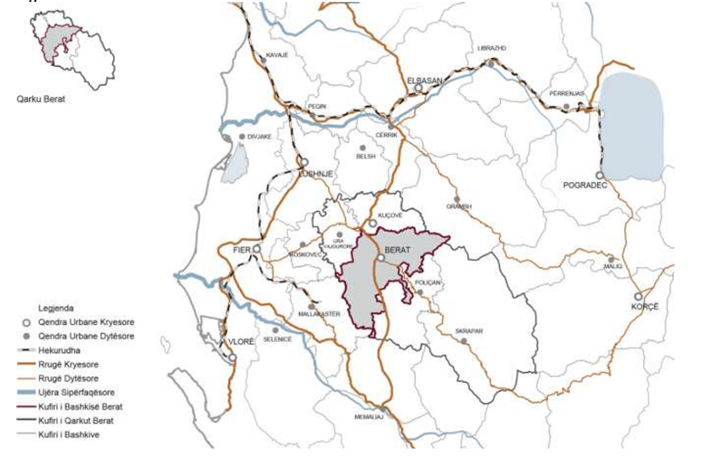
Fig.1. Positioning of Berat Municipality,
Source: Municipality of Berat and Co-PLAN, 2015

The administrative center is the city of Berat, one of the country's most important historical and cultural centers, a UNESCO World Heritage Site. Its geographical position in the Osum Valley, which serves as a connecting corridor between the mountainous interior and the western plain, gives the territory strategic importance from an economic and geographical standpoint (Albanian Development Fund 2021).
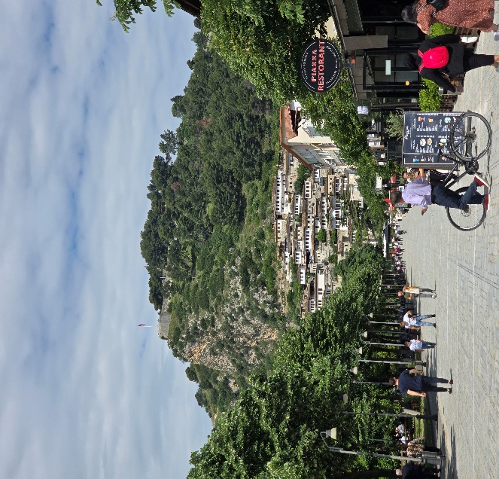
Fig. 2. Berat, photo by author
Relief is the difference between the highest and lowest elevations in an area. A relief shows changes in elevation over a given area of land. It is the expression of the interaction of several different phenomena and processes within the earth's crust and on its surface. Relief has a strong influence on the processes such as climate, hydrology etc. It is also a well-known fact that both natural and accelerated processes of soil erosion are largely dependent upon thenature of local relief. Relief is therefore intimately connected with many of the other elements of landscape resources (Jyothirmayi, & Sukumar 2019). The territory of Berat Municipality is characterized by a diverse relief, where flat areas in the west blend with hilly and mountainous areas in the east. To the east, the Tomorr (2416 m) and Shpirag (1218 m) mountain ranges rise, dominating the natural landscape and playing a significant role in shaping the local microclimate (Berat Municipality 2023)
In the western part, the fertile plains of Kutalli and Poshnja stretch, formed by the alluvial deposits of the Osum River, creating favorable conditions for the development of intensive agriculture (Municipality of Berat 2015).
Impacts of climate change are found in terms of increasing temperature, decreasing the number of rainy days, rainfall variations, frequent droughts, severe heatwaves, and evidence of periodic floods (Issahaku, 2023). Human activities over the last two centuries, marked by lifestyle changes and increased life expectancy, have led to the over-exploitation of natural resources, significantly contributing to global warming. Despite initial debates on the severity of climate change, it is now universally acknowledged as a significant threat to the planet and humanity. (Moshou & Drinia 2025).
The climate of Berat Municipality is Mediterranean-continental, with hot and dry summers and cold winters with significant precipitation. The average annual temperature is 15.9°C, with January being the coldest month (with average temperatures of 7.2°C and 6.5°C for the decades 1971–1980 and 1980–1990, respectively), and July the warmest month (average temperature 24°C). Autumn is warmer than spring due to the influence of the sea, as coastal winds easily penetrate through the Myzeqe plain toward the city. The annual temperature amplitude is 17.5°C (Bashkia Berat & Co-PLAN 2019). The city and Osum valley area is characterized by milder climatic conditions, while the mountainous areas of Tomor and Shpirag experience lower temperatures and greater snowfall. These differences affect the distribution of agricultural crops and the type of vegetation (Municipality of Berat 2016).
Earth is the only planet, so far known to have water and this makes it fit for life to thrive. However, with reckless abuse and increasing demand, due to growing population and unsustainable lifestyle, many countries are facing severe water crisis (Parmar, Joshi, & Bhatt, 2025).
The catchment network of Berat Municipality is dominated by the Osum River, which traverses the territory from east to west and constitutes the main hydrological element of the area. The river has a length of about 161 km and joins the Devoll to form the Seman River (Pano, 2015, p. 247). Besides the Osum, there are several secondary streams such as those of Velabisht and Bogova, which contribute to the territory's hydrological system. Groundwater is also important for supplying the population and for agriculture (Municipality of Berat 2019).
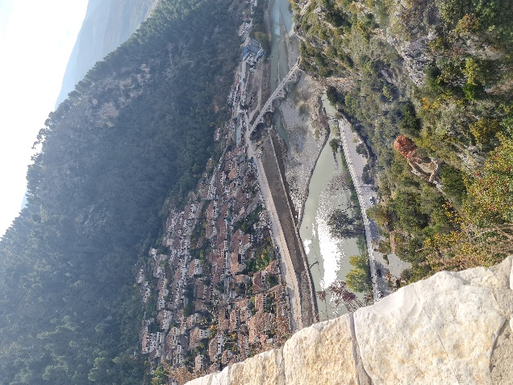
Fig. 3. Osum River (photo by author)
In the territory of the Berat Municipality, alluvial soils dominate along the Osum River valley, which are very fertile and suitable for intensive agricultural cultivation. (Gjoka, 2015, p.167) In the hilly and mountainous areas, brown soils appear, which are used sparsely in agriculture, with high slopes and low humus content. (Gjoka, 2015, p.162) These pedological conditions, combined with the climate and water runoff, favor the cultivation of olives, vineyards, cereals, and forage crops (Zhllima, Skreli, Xhoxhi & Imami, 2023).
Biodiversity has many facets encompassing, for example, taxo-nomic, evolutionary and functional differences, biotic interactions, the abundance in populations and the intraspecific variability be-tween individuals within populations, the species composition of communities and the size as well as functioning of ecosystems (Hillebrand, Dajka, Halbach, et al. 2025). The biodiversity of the Berat Municipality is diverse and varies with altitude. In the low-lying, flat areas, olive groves, vineyards, and Mediterranean scrub dominate, while the mountainous areas preserve oak, beech, and pine forests. (Plaku, 2010, p. 115). A significant portion of the eastern territory is included in the Tomorr National Park, which is one of the most biodiverse areas in Albania. This park is home to many protected species of flora and fauna (Bollobani & Uruçi 2019).
The territory of Berat Municipality, with its diverse natural conditions, fertile lands, and strategic location, offers significant opportunities for economic and agricultural development. At the same time, the area’s cultural and environmental assets add further value for sustainable development. However, climate change and challenges in managing natural resources require careful attention. These aspects will be further examined in the SWOT analysis to identify strengths, weaknesses, opportunities, and threats.

2. material and methods

This study was conducted to assess the environmental status of Berat Municipality and to identify the internal and external factors that influence its sustainable development through the use of SWOT analysis. The methodological approach is built on a combination of qualitative and quantitative methods and their analysis. The SWOT analysis allows for the systematic identification of strengths, weaknesses, opportunities, and threats related to the environmental condition of Berat Municipality. This approach is based on the methodological framework described by Gürel and Tat (2017), adapted for the local context. This method is applied in some studies (Gürel & Tat 2017; Mandal, Siddique & Roy, 2018; Cîineanu, Dulamă, Ilovan, , Jucu, Boţan, Păcurar& Colcer, 2021; Braholli, 2021; Kalafsky, & Sonnichsen, 2014; etc.).
The data were obtained from official and reliable sources such Albanian Development Fund. (2021), Organisation for Social and Environmental Welfare. (2017), as well as strategic documents of the Berat Municipality (2020, 2023). Environmental reports, local development plans, and scientific publications addressing the region's physio-geographic and environmental aspects (Municipal territorial development strategy of Berat 2019, Performance report of Municipality of Berat 2022) ect.
The analysis process was carried out in several steps:
1. Data collection included gathering information on natural factors (relief, climate, hydrology, biodiversity) and socio-economic factors (land use, pollution, urban development).
2. Data processing involved classifying and summarizing the factors according to their positive or negative impact on the environment.
3. Preparation of the SWOT analysis, where the factors were divided into four main categories and interpreted in relation to the region's sustainable development.
4. Evaluation and interpretation to draw conclusions about strategic priorities and possible directions for sustainable development.

3. results and discussion

SWOT analysis is a strategic tool widely used to assess the Strengths, Weaknesses, Opportunities, and Threats of a territory, organization, or project. This instrument helps identify internal and external factors that affect sustainable development, natural resource management, urban and economic planning, as well as to propose strategies that maximize potential and minimize risks. By using SWOT analysis, an organization can choose one of four strategic plans as follows:
• SO: The good use of opportunities through existing strengths.
• ST: The good use of strengths to eliminate or reduce the impact of threats
• WO: Taking into account weaknesses to obtain the benefits of opportunities.
• WT: Seeking to reduce the impact of threats by considering weaknesses (Abdel-Basset, Mohamed, & Smarandache 2018).
The Berat Municipality, known for its natural and cultural heritage, faces various environmental, social, and economic challenges. Soil and water pollution, anthropogenic pressure on natural habitats, climate change, and land fragmentation pose real threats to the territory's sustainable development. On the other hand, natural resources, fertile lands, biodiversity, and a strategic geographical position offer numerous opportunities for tourism, agricultural, and ecological development (Municipality of Berat 2015, Municipality of Berat 2022, Municipality of Berat & Co-PLAN 2019, Albanian Development Fund 2021). Below is a table with quantitative data of the municipality, which helps provide a comprehensive overview of it.
Table 1. General Data of the Municipality
Data | Fakt 2020 | Fakt 2021 | Fakt 2022 | Plan 2022
Total population under the administration of the municipality | 99970 | 99793 | 98875 | 98875
Population in the city | 63406 | 63408 | 63514 | -
Population in the administrative units | 36545 | 36385 | 36258 | -
Total area of the municipality (in km²) | 379.98 | 379.98 | 379.98 | -
Public area of the municipality (in km²) | - | - | - | -
Total area of the administrative units | 363.1 | 363.1 | 363.1 | 363.1
otal forest fund area (in ha) | 12709.33 | 11468.79 | 11468.79 | -
Total pasture land area (in ha) | 3690.33 | 3690.33 | 3690.33 | -
Agricultural land area (in ha) | 14764 | 14764 | 14764 | 14764
Total number of administrative units in the municipality | 4 | 4 | 4 | 4
Number of villages | 50 | 50 | 50 | 50
Total municipal employees | 724 | 740 | 776 | 776
Total female municipal employees | 74 | 68 | - | -
Total male municipal employees | 82 | 94 | - | -
Total employees working for the municipal administration | 140 | 156 | 162 | 162
Total female employees working for the municipal administration | 74 | 68 | - | -
Source: Municipality of Berat & Co-PLAN 2019
Before the SWOT analysis, it is important to describe the overall situation of the Municipality of Berat. The collected data highlight its natural, structural, and administrative potentials, as well as the challenges related to economic development and resource management. The SWOT analysis provides a clear overview of the strengths, weaknesses, opportunities, and threats, helping to identify strategies for sustainable development in this municipality. Following the general data description, the table below presents a summary of the SWOT analysis for the Municipality of Berat.
Table 2. SWOT Analysis
Strengths:  •Rich natural and cultural heritage, including the Tomorr National Park and the Osum Valley, which offers high biodiversity and attractions for ecotourism  •Availability of fertile lands and developed water networks for agriculture and various crops  •Strategic geographical position in the center of Southern Albania that facilitates economic connections and tourism.  •The level of local awareness for sustainable development and environmental protection is increasing. | Weaknesses:  •Pollution of waters and soils in some flat areas due to urban waste and the intensive use of chemical fertilizers.  •Land fragmentation and unplanned land use create difficulties for managing natural resources.  •Lack of sustainable infrastructure for the protection of natural areas and for waste management.
Opportunities:  •Development of ecotourism and cultural tourism as an alternative for diversifying the local economy.  •Implementation of sustainable land and water resource management projects.  •Opportunities for environmental education and community awareness-raising on sustainable practices. | Threats:  •Impacts of climate change, including droughts, sparse or erratic rainfall, and rising temperatures.  •Anthropogenic pressure on natural habitats and biodiversity, including unplanned construction and uncontrolled forest exploitation.  •Risk of land and water degradation in plains and mountainous areas due to intensive agricultural activity and lack of monitoring.

Table 3. Short SWOT Table
Factors | Brief Description
Strengths | Natural heritage, fertile land, strategic location, environmental awareness
Weaknesses | Water/soil pollution, land fragmentation, lack of sustainable infrastructure
Opportunities | Ecotourism development, land/water management projects, environmental education
Threats | Climate change, anthropogenic pressure, land and water degradation

The SWOT analysis of Berat Municipality shows that the territory has high development potential, mainly due to its natural and cultural heritage, fertile lands, and strategic location. These strengths offer significant opportunities for the development of ecotourism, agritourism, and sustainable natural resource management projects.
On the other hand, the identified weaknesses, such as soil and water pollution, land fragmentation, and the lack of sustainable infrastructure, present serious challenges for environmental management and sustainable development. Threats related to climate change, anthropogenic pressure on natural habitats, and the degradation of natural resources underscore the need for planned strategies and protective policies.
It appears that Berat Municipality has a balanced set of opportunities and risks, where effective resource management and community awareness can maximize benefits and minimize negative impacts. This summary suggests that sustainable territorial development can only be achieved through a strategic approach that integrates environmental, economic, and social factors, supporting both environmental conservation and the well-being of the local community.

4. Conclusion

After an in-depth analysis of the environmental, economic, and social situation of the Berat Municipality, as well as its assessment through the SWOT method, it can be concluded that this territorial unit possesses considerable development potential thanks to its rich natural and cultural resources, fertile lands, and favorable geographic location. These elements create favorable conditions for the development of ecotourism, agritourism, and initiatives that promote the sustainable management of natural resources.
However, challenges such as water and soil pollution, the fragmentation of agricultural land, and the lack of necessary infrastructure for sustainable management remain issues that require well-planned interventions and the implementation of effective protective policies to preserve ecosystems.
Environmental education and raising awareness among the local community play an important role in this regard, as they are essential for promoting sustainable practices and reducing negative impacts on the environment and biodiversity. Addressing the challenges related to climate change, anthropogenic pressure, and the degradation of natural resources requires integrated policies supported by strategic planning, continuous monitoring, and interinstitutional cooperation.
Thus, the sustainable development of Berat Municipality can only be achieved through a comprehensive approach that harmonizes environmental, economic, and social aspects, properly leveraging the territory's potential to ensure well-being and long-term development for the local community.

DISCLAIMER (ARTIFICIAL INTELLIGENCE)

Author hereby declare that NO generative AI technologies such as Large language Models (GhatGPT, COPILOT, etc) and text-to-image generators have been used during writing or editing of this manuscript.

References

Abdel-Basset, M., Mohamed, M., & Smarandache, F. (2018). An extension of neutrosophic AHP–SWOT analysis for strategic planning and decision-making. Symmetry, 10(4), 116. https://doi.org/10.3390/sym10040116

Albanian Development Fund. (2021). Environmental and social impact assessment of the project: Restoration of the historic urban landscape of Mangalem Quarter (Administrative Unit – Berat; Municipality – Berat). https://www.albaniandf.org/wp-content/uploads/2021/06/P.05_ESIA-Mangalem_compressed.pdf

Albanian Development Fund. (2021). Environmental and social impact assessment report: Gorica-Berat (VNM). https://www.albaniandf.org/wp-content/uploads/2021/01/Signed_GoricaBeratVNM_compressed.pdf
Bollobani Dodoveci, E., & Uruçi Luçka, R. (2019). Geotourism potentials of the National Park “Mali i Tomorrit”. International Journal of Geoheritage and Parks, 7(1). https://doi.org/10.1016/j.ijgeop.2019.03.001
Braholli, E. (2021). Natural conditions and the history of the establishment of rural settlements in the upper Devoll watershed https://www.researchgate.net/publication/368779718_KUSHTET_NATYRORE_DHE_HISTORIA_E_KRIJIMIT_TE_VENDBANIMEVE_RURALE_NE_PELLGUN_ME_TE_SIPERM_UJEMBLEDHES_TE_DEVOLLIT
Cîineanu, M.-D., Dulamă, M. E., Ilovan, O.-R., Jucu, I. S., Boţan, C. N., Păcurar, B. N., & Colcer, A.-M. (2021). Developing geographical thinking through the SWOT analysis of human settlements. In ERD 2020 – Education, Reflection, Development, Eighth Edition. The European Proceedings of Social and Behavioural Sciences (EpSBS). https://doi.org/10.15405/epsbs.2021.03.02.14
Gjoka, F. (2015). Pedogeografia. Tirana: Dita 2000 Publishing House.

Gürel, E., & Tat, M. (2017). SWOT analysis: A theoretical review. Journal of International Social Research, 10(51), 994–1006. https://doi.org/10.17719/jisr.2017.1832
Hillebrand, H., Dajka, J.-C., Halbach, M., et al. (2025). Operational perspectives for biodiversity indicators. Ecological Solutions and Evidence, 6(4). https://doi.org/10.1002/2688-8319.70134
Issahaku, A.-R. (2023). Impacts of climate change, land use and land cover changes on watersheds in the Upper East Region of Ghana. Journal of Geography, Environment and Earth Science International, 27(3), 33–44. https://doi.org/10.9734/JGEESI/2023/v27i3673
Kalafsky, R. V., & Sonnichsen, T. (2014). Employing SWOT analysis in coursework on the geographies of regional economic development and trade. Journal of Geography, 113(5), 177–187. https://doi.org/10.1080/00221341.2014.980438
Khattra, S. K., Balaut, A., & Dogra, R. (2024). Advancing sustainable ecosystem development. Journal of Geography, Environment and Earth Science International, 28(7), 52–59. https://doi.org/10.9734/jgeesi/2024/v28i7789

Mandal, M. H., Siddique, G., & Roy, A. (2018). Threats and opportunities of ecosystem services: A geographical study of Purbasthali Oxbow Lake. Journal of Geography, Environment and Earth Science International, 16(4), 1–24. https://doi.org/10.9734/JGEESI/2018/43229

Milieukontakt Albania. (2023). Urban air quality report 2023. https://milieukontakt.org/wp-content/uploads/2023/07/Raport-mbi-cilesine-e-ajrit-urban-2.pdf

Municipality of Berat & Co-PLAN. (2019). Strategjia e zhvillimit të territorit Bashkia Berat (STZH Berat). https://bashkiaberat.gov.al/wp-content/uploads/2019/11/STZH_BERAT_FINAL_.pdf

Municipality of Berat. (2015). Final environmental strategic assessment report of the General Territorial Plan of the Municipality of Berat. https://planifikimi.gov.al/index.php?eID=dumpFile&t=f&f=2313&token=4a55ac9355797c2da1f49a4dc28677b90994a348

Municipality of Berat. (2016). Final environmental strategic assessment report of the General Territorial Plan of the Municipality of Berat. Agjencia Kombëtare e Planifikimit të Territorit. https://planifikimi.gov.al/index.php?eID=dumpFile&t=f&f=2311&token=db03be84a306385b5e80c1f3cb91302a56caa16a
Municipality of Berat. (2019). Municipal territorial development strategy (STZH) Berat. https://bashkiaberat.gov.al/wp-content/uploads/2019/11/STZH_BERAT_FINAL_.pdf
Municipality of Berat. (2021). Monitoring report on the implementation of the annual budget 2021. https://bashkiaberat.gov.al/wp-content/uploads/2022/04/Bashkia-Berat-Raporti-i-Monitorimit-te-zbatimit-te-buxhetit-vjetor-2021.pdf?utm
Municipality of Berat. (2022). Performance report of Municipality of Berat 2022. https://bashkiaberat.gov.al/wp-content/uploads/2023/11/Raporti-i-Performanc%C3%ABs-Bashkia-Berat-2022.pdf?utm
Organisation for Social and Environmental Welfare. (2017). Indicator assessment report on the floristic, geological, and managerial values of the “Tomorr National Park”. Berat, Albania. http://www.natyraberat.org/wp-content/uploads/2017/05/raporti-web.pdf
Pano, N. (2015). Water resources of Albania. Tirana: Kristalina Publishing House.
Parmar, K., Joshi, J., & Bhatt, B. (2025). Exploring the structures of water resource management in ancient India: A geographical perspective. Journal of Geography, Environment and Earth Science International, 29(5), 16 - 27. https://doi.org/10.9734/jgeesi/2025/v29i5891
Pazari, F., Avdia, B., & Mamoci, E. (2025). Cultural heritage and experiential tourism: Opportunities and challenges in Greece-Albania cross-border area (Berat, Gjirokastra and Ioannina). GeoJournal of Tourism and Geosites, 61(3), 1656–1667. https://doi.org/10.30892/gtg.61324-1534
Plaku, Z. (2010). Berat – Encyclopedia. Tirana: Jonalda Publishing House.

Qiriazi, P. (2020). Natural Heritage of Albania. Tirana: Kristalina Publishing House.

Sadiku, M. N. O., Ashaolu, T. J., Ajayi-Majebi, A., & Musa, S. M. (2020). Environmental studies: An introduction. International Journal of Scientific Advances, 1(3), 153 - 157. https://www.researchgate.net/publication/348640513_Environmental_Studies_An_Introduction

Said, M., Hassan, F. U., Islam, M. S., & Nawaz, R. (2024). Environmental sustainability. In S. Idris (Ed.), Global challenges for the environment and climate change (Chapter 1). IGI Global. https://doi.org/10.4018/979-8-3693-2845-3.ch001

United Nations Environment Programme (UNEP, 2022) Annual report. https://wedocs.unep.org/bitstream/handle/20.500.11822/41679/Annual_Report_2022.pdf?sequence=3
Zhllima, E., Skreli, E., Xhoxhi, O., & Imami, D. (2023). Analysis of agriculture and rural development policy in Albania https://www.researchgate.net/publication/369092808_Analysis_of_Agriculture_and_Rural_Development_Policy_in_Albania#fullTextFileContent

