Spatiotemporal Evaluation of Environmental Flow using Remote Sensing and GIS in Hooghly District, India

Abstract
The investigation presents a spatio-temporal assessment of environmental flow and climate variability in the Hooghly district. By combining multi-decadal climatic indices with remote sensing and GIS-based hydrological analysis, it offers a deeper understanding of environmental changes in a critical and vulnerable river basin in the Hooghly district, West Bengal. The time series analysis (TSA) is done from 1990 to 2020. Various thematic maps, including Digital Elevation Model (DEM), Flow Accumulation, Flow Direction, Stream Order, Basin and sub-basins, and Hill shade, were generated using Q-GIS and remote sensing (RS). The indices such as Customer Disruption Days (CDD), Cumulative standardised Drought Index (CSDI), Warm Spell Duration Index (WSDI), Climatic Water Deficit (CWD), Diurnal Temperature Range (DTR), etc derived by taking the help of R-Studio. A combination of GIS and statistical software tools: ArcGIS 10.4, ERDAS, with SRTM DM data, the hydrological characteristics of the region, along with EXCEL software and R-Studio, the Time Series Analysis (TSA) of the maximum temperature (T_{max}), minimum temperature (T_{min}), and the precipitation in the Hooghly District has been performed and showing an increasing trend. The trends in climatic anomalies, interannual variability, and potential impacts of climate change in the region are identified and discussed. The findings provide valuable insights for improving flood management, environmental planning, and climate-resilient water-resource strategies. Thus, the work contributes to SDG-aligned scientific knowledge and policy frameworks for sustainable management of climate-sensitive riverine systems.

Keywords
Floods, Q-GIS, R- Studio, Gangetic Plains, Climate Change

Introduction
The Hooghly District, named after the River Hooghly, emerges from downstream of the Farakka Barrage at Nabadwip, where the Bhagirathi and Jalangi rivers join each other. The Hugli flows for about 260 km and later debouches into the Bay of Bengal (BoB) adjacent to Sagar Island. It runs through vast industrial /urban/ cosmopolis areas like Murshidabad, Nadia, Hooghly, North 24 Parganas, and two cities, Kolkata and Howrah. The rivers Ajay, the Damodar, the Rup Narayan, and the Haldi are the tributaries of the Hooghly River at its lower reaches. The floods in the highly meandered Hooghly River inundate a vast area in West Bengal (WB). The inundations vary in duration, are erratic, common, and devastating. They can be either Fluvial, Pluvial, or flash floods (Sinha et al., 2015; Ghosh et al., 2020; Mukhopadhyay et al., 2023).
The Hooghly district is the land of rivers in the Bengal fans before Kolkata in West Bengal with The Ganga Basin has a catchment area is of 73833 Km2 comprising of the Bhagirathi -Damodar river systems (Ghosh et al, 2020[2]), end reaches of many tributaries of the Hooghly, the Haldi, the Rupnarayan, the Saraswati, and the Ajay etc The length of the anastomosed drainages channels (DCs) in the district is 461.83 km. Mainly comprising of main rivers are the Damodar, Dwarakeswar, Hooghly, and Mundeswari. The auxiliary feeder drains are Sankari, Ghea, Kunti, Dankunikhal, and Baidyabatikhal, etc. (DSR Hooghly district 2022). (Fig 1).
a.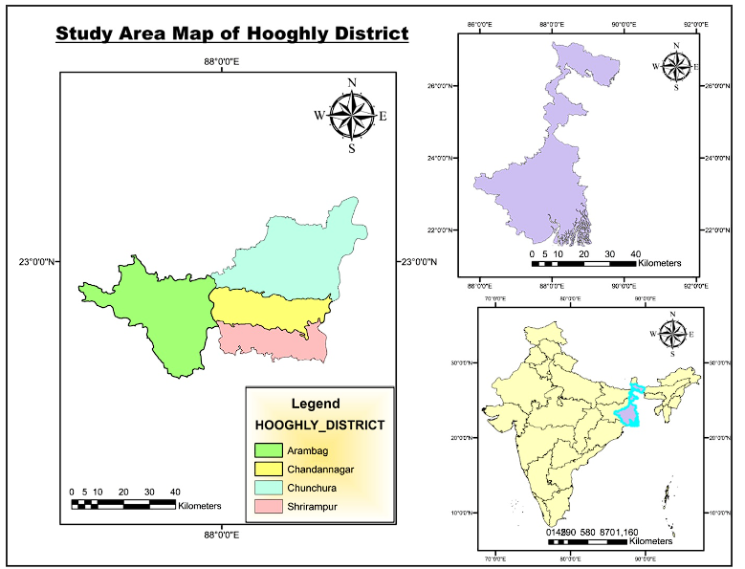 b. 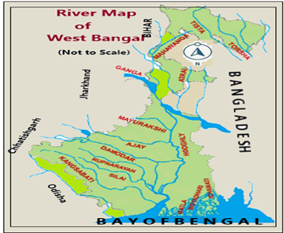
Figure 1: (a)The Index map/ River system of the study area, (b)the Hooghly District, W.B.
The Sundarbans area is difficult and complex for geomorphological investigation as inaccessible and tough (Mishra et al., 2024); (Pramanick et al, 2024). Remote sensing (RS) is one of the proper tools for mapping and monitoring inaccessible topography, and natural resources (Nandy et al., 2011); (Sahana et al., 2015); (Kushwaha et al., 2018); (Panda et al., 2021); (Mishra et al, 2023). The on-ground survey is hard, time-consuming, and laborious within mangrove tidal swamps. The RS methodology can be used to conduct the mapping and monitoring, and also by ground truthing for up-to-date information (Giri et al., 2014; Chanda et al., 2023). RS techniques have the potential to recognize, map, and monitor changes in the mangrove and its associates in coastal areas by using hyper-spectral satellite images and information for digital image processing to classify the mangroves (Nandy et al., 2021); (Doodee et al, 2023); (Sudirman et al., 2023); (Mishra et al, 2024).
District-wise environmental flow is rarely discussed and reported. The present study aims to search for the environmental flow assessment of the Hooghly District in West Bengal, entering the coastal Sundarbans areas, where the flow is complex and its assessment is a hard nut to crack.
Environmental Flow:
The Hooghly River receives peak flow from the Farakka Barrage, which is changing its course with the environmental flow of the district. The important estuarine Ganga-Brahmaputra-Meghana River basin systems in India carry heavy discharge from the largest monsoonal flow (Max 70500 Cumec) as peak flow at Farakka Table 1.
Table 1: The floods that occurred and inundated areas in WB from 1960-2024 (65 years)

Flood-Area Km² | Flood Type | Years Flood occurred (1960 to 2024) | Frequency
<500sq km | No Flood | 1985, 1989, 1992, 1994, 1997, 2001, 2002, 2005, 2006, 2010, 2012-2014, 2016, 2018, 2019, 2022, and 2023 | 18 years
501-2000 | Very Low | 1962-1966; 1972, 1975, 1996, 2003, 2004, 2011, 2015 &2020 | 13years
2001-5000 | Low | 1960, 1961, 1967, 1969, 1970, 1974, 1976, 1980, 1981, 1982, 1998, 2009, 2017, &2021 | 14years
5001-10000 | Medium | 1973, 1977, 1991, 1993, 1995, 2007, and 2008 | 7years
10001-15000 | High | 1968, 1979, 1983, 1990, and 1999 | 5years
15001-20000 | Very High | 1971, 1986, 1987, and 1988 | 4years
> 20001 | Extreme high | 1978, 1984, 2000, 2024 | 4 years
Source Updated: Annual Flood Report 2023, West Bengal
The West Bengal state in India has a 37660 km2 flood-prone area (FPA) sporadically housed over 111 blocks, when the geographical area of WB is 88752Km2. The district is an area of 3149 Km2 and a population of 5.52 million (2011 Census). It's characterized by its proximity to the Hooghly River Area Flood years in West Bengal in the WB are in (Irrigation and Waterways Dept. WB, 2023).
Study Area: (Hooghly District):
The Hooghly district in West Bengal has a latitude. 230 01’ 20’’ N to 220 39’ 32’’ N and Long. 880 30’ 15’’ E to 870 30’ 20’’ E. The name falls upon a marshy aquatic plant “HOGLA” growing in abundance in the low-lying lowlands in the Hooghly district, which was due to the separation of Burdwan Dist. in 1795. The district has four subdivisions: in the Hooghly district, such as Chinsurah (Headquarters), Chandan Nagar, Seram pore, and Arambagh. This district is housed in the Survey of India (SOI) Topo Sheet (TS) Nos. 73N/9, 73N/13-14, 73A/4, 73A/8,73B/1-2, 73B/5-6. The district has 7 blocks: Balagarh, Chinsura-Magra, Polbadadpur, Serampur-Uttarpara, Singpur, and Chanditala I.
The Hooghly district has Nadia district in the East, 24 Parganas (North) in the SE, Bardhaman district towards the North, Howrah towards the South, Paschim Medinipur extends towards the West, Bankura towards North-West (NW) respectively. The rivers Kasai, Bokaro, Konar, and Barker are tributaries of the Damodar River. The Bengal Delta is susceptible to flooding in ≈ 42.55% of the total area of the W.B. State. The historically recorded flood inundated in 1978 was about 30607 km2 and whereas in 2000, it was about 23,971 km2, Figure 2 (a and b).
Most flood-vulnerable areas in the Hooghly district are due to the Damodar river system. The south-western part of the district, like Khanakul I and II, Goghat I and II, Pursura, and Arambag are is significantly affected by the flood annually.
The significance of the presence study is as an important resource for researchers, policymakers, and environmental managers working on climate change adaptation and water security in similar river basin regions worldwide.
a.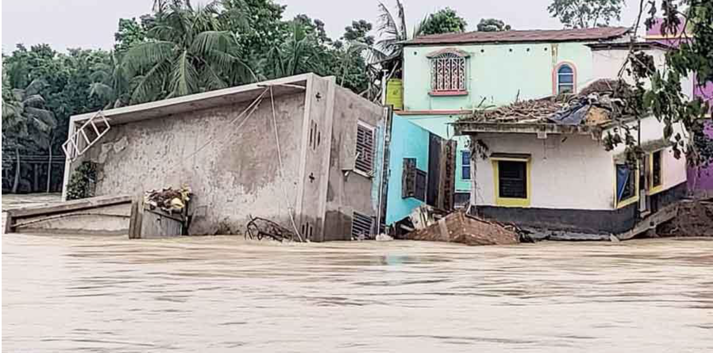 b. 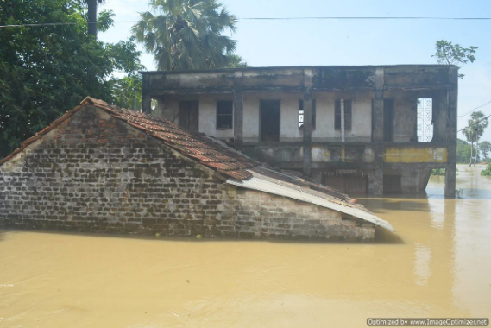
Figure 2: (a) The river map of W.B. (b) Flood devastation in Bandar Village (Khana Kul) in 2023. Source: P.C. (Ananda Adhikari)
The aim of the study: Visioning the flood disaster in Hooghly district to improve better flood management, environmental planning, and climate-resilient water-resource strategies. The study should focus on assessing environmental flow in the Hooghly region using remote sensing and Geographic Information Systems (GIS) techniques.
Objectives of the Study:
The research aims to conduct a comprehensive watershed analysis of the Hooghly district with the following specific objectives:
1) Delineation of the watershed boundaries by using high-resolution Digital Elevation Models (DEMs) and hydrological modelling techniques that shall provide a foundation for environmental flow and depict the hydrological connectivity within the district.
2) Portray and assess the hydrological, physiographic features, climate change (CC) bearings related to maximum, minimum, and rainfall on the vulnerable areas of the watershed.
Methodology:
All the thematic maps and the soil map of the Hooghly district have been prepared from the images downloaded from the USGS Site, confirmed by georeferencing done by Arc GIS 10.4 software, and Google Earth Engine (GEE). The digitisation has been done to find the boundary of the areas. The DEM (Digital Elevation Model) data (3-D) is gathered from the Shuttle Radar Topography Mission (SRTM). The ArcGIS software is used to prepare the 3-D images. Mosaic and sub-setting are needed wherever required for fixing the drains, rivers, railways, and roads, etc.. The closing layout plan is arranged by providing scale, caption, north arrow, legend, etc. For SRTM DEM (30m resolution) is used to analyse elevation and hydrological features.
a.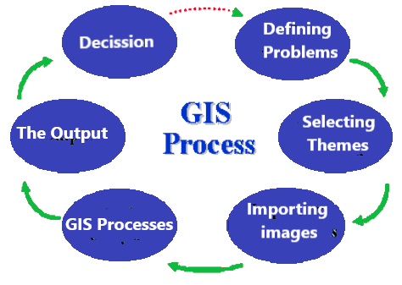 b. 
Figure 3: (a) The GIS processes, (b) The study and analysis work conducted for the study
In the case of the soil map, the secondary data is gathered from NBSC &LU P (National Bureau of Soil Survey and Land Use Planning) of 2020, collected, geo-referenced, and digitized for soil classification using Arc GIS Software, and the map is generated as usual.
The hydrological features, like Flow Direction, Flow Accumulation, and Stream Order maps, are also prepared. The slope aspect, Hill shade, and Basin maps are generated using DEM. Climatic Data Analysis has been done after preparing graphs: Rainfall and temperature (Temp.) data for 1990 and 2020 were mapped and later compared. (Fig. 3a, 3b)
The Temperature analysis has been by using the software. The analysis for this study was carried out using a combination of GIS and statistical software tools: ArcGIS 10.4 was used for spatial analysis and the preparation of various thematic maps, such as DEM, Temperature, Rainfall, and hydrological features maps, etc.. Microsoft Excel was employed for statistical calculations, data tabulation, and organization using pivot tables. R Studio was utilized for statistical analysis and graphical representation of the data derived from Excel tables, enabling clear visualization and interpretation of trends and patterns Figure 3 (a and b).
The drainage network in Hugli:
The Hooghly district has a flat landscape, encompassing alluvial plains, coastal areas, and some hilly regions. The district covers roughly 3149 km² and is drained by numerous drainage channels (DCs), including the Bhagirathi-Hooghly. Land use is mainly agricultural, interspersed with urban settlements and wetlands. The rivers flowing through Hugli District, emanating from the Choto Nagpur, have a catchment area up to Durgapur Barrage is 18026 km^{2,} against a total catchment of 22015 km². The Bhagirathi R. received the lion's share from the Ganges. The length of several arms of the river Damodar are the Barakar River (225km), the Konar River (160Km), the Bokaro River (150Km), and the Kasai River 120 km.
Land Status of Hooghly:
The land use pattern of the district is given in Table 2
Table 2: The Land use and Land cover of the Hooghly district in West Bengal (Thousand Ha)
LU/LC | Geographical | Cultivable | Forest types | Agricultural utility | Trees/crops/ Grooves | Cultivable waste | Others (Fallow)
Area | 317.00 | 220.35 | 0.53 | 89.12 | 1.89 | 1.33 | 3.78
Source: WB; Agriculture Contingency Plan for District: Hooghly
Rivers in Hooghly Dist:
The anastomosed drainage networks in the Hoogly district include the Ajay, Damodar, Rupnarayan, and Haldi (Prakash et al, 2023); (Dasgupta et al, 2024); (Mishra et al, 2025). The main river Hooghly, has a length of 260km in WB. The catchment area of the tributaries. The Hooghly River is in Table 3
Table 3: The East flowing d/c s in various basins/subbasins of the Hooghly R., in WB, India

Rivers  (Hooghly Dist.) | Damodar | Dwara  keswar | Haldi | Munde  swari | Jalang  i. | Saraswati  (Hooghly) | Rasulpur | Rup  narayan | Shilabati | Hooghly
Catch. Area  (WB) (Km²) | 4325 | 4292 | 614 | 1439 | 2537 | 285.69 | 1556 | 1226 | 4088 | 26568
Length of River  (km) | 592 | 220 | 24 | 42.29 | 250 | ≈79.4 | 40.5 | 80 | 69 | 260
Length in WB  (Km) | 23.83 | 26.51 | 24 | 42.29 | 130.59 | 77 | 19 | 72 | 26 | 86.93

Source: https://wbiwd.gov.in/uploads/anual_flood_report/Annual-Flood-Report-2023.pdf ; (Das et al, 2021)
The Dwarakeswar, the Mundeswari, the Damodar in the west, and the Kunti, the Saraswati, and the Hooghly Rivers in the east. Agricultural land covers > 60% of the area of the Hooghly, and paddy is the major crop. The built-up areas cover >30% of the total area of the district (PR Khalisani Mahavidyalaya, 2023). The Durgapur barrage receives runoff from a basin area of 18026 km². Very heavy rainfall in the Bengal basin causes heavy flooding in the flood-prone areas of the Hooghly District.
Topography:
The Hooghly district has flat terrain without any hills with elevation beyond 200m. The Relief features in the district are of the genesis and evolution of landforms, are old alluvium in the west from the Dwarakeswar R. and recent alluvial plains in the east, comprising natural Levee, Meandering flood plains Fig. 1, (a and b).
Geology and geography:
The district is on a flat landform with east-flowing rivers with low gradient anastomosed DCs with varying levees, swamps, and marshy lands. The regular flood-prone areas are flood plains of the Rupnarayan, the Mundeswari, with reconstructive (eroding and depositing levees. Geological and lithological subsurface depth up to 150m comprising slit, clay, and sand of different grades (mainly fine to coarse). The eastern fringe of the Hooghly is clayey and deep, whereas the western fragment of the Hooghly district is loamy. The Hooghly is housed in the western flank of the stable shelf zone of the Bengal Basin on Archaean basement (crystalline), Gondwana rocks, sediments, and Rajmahal traps of volcanics are of Mesozoic age. The surficial cover is of thick Quaternary alluvium, lying beneath by Tertiary and Mesozoic formations (Biswas, 1959). The Hooghly district is less anastomosed and has a smaller number of watersheds in comparison to neighbouring districts in the lower reaches of the Hooghly River, Fig. 4 (a).
Climate:
Hooghly district enjoyed a Tropical Savanna climate (Aw). The yearly average (av..) temp. Is 26.8 c (minimum to maximum temp. ranges from 160 c to 330 c and escalating to exceed 380 °C). The district suffers from a hard-hit summer with strong SW monsoon winds. Winter is soothing with ranges and has a temperature. Between 110 C to 170 °C. The av. wind speed NW-ly to NE-ly) In the Hooghly is 2.6 m/s, surging to around 11 m/s (max). The average temperature of the district has a favourable cropping pattern and other resources usage, Fig. 4 (b).
a.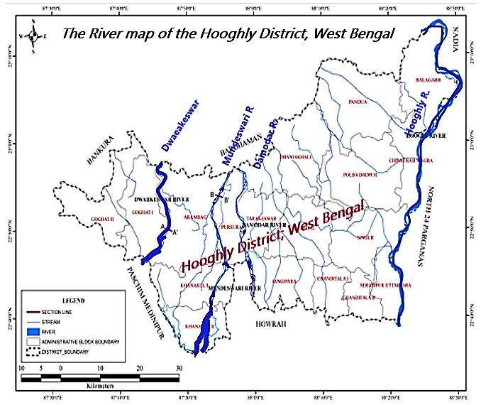, b. 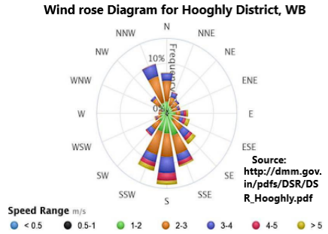
Fig. 4: (a) The drainage map, (b) The annual wind rose diagram of Hooghly Dist., WB
Rainfall:
Rainfall directly affects the cropping outline, the nature & sequence of agricultural operations. Optimum rainfall occurs in the SW monsoon period and is of average 905.2mm (June-Sept) and av. Annual rainfall of 1288.2mm, Fig 5 (a and b).
a.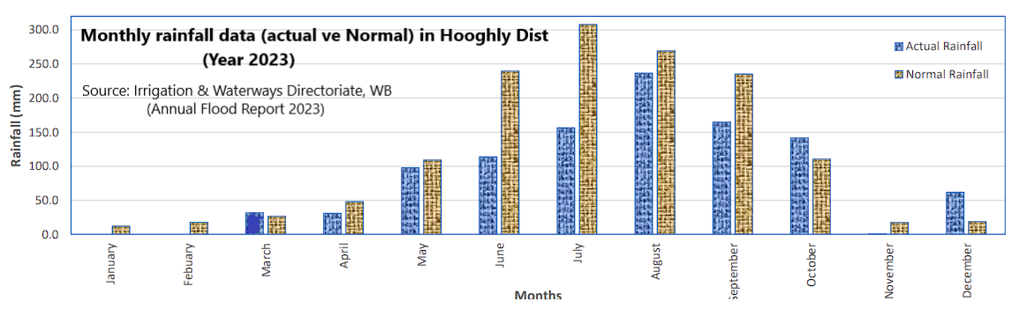
b.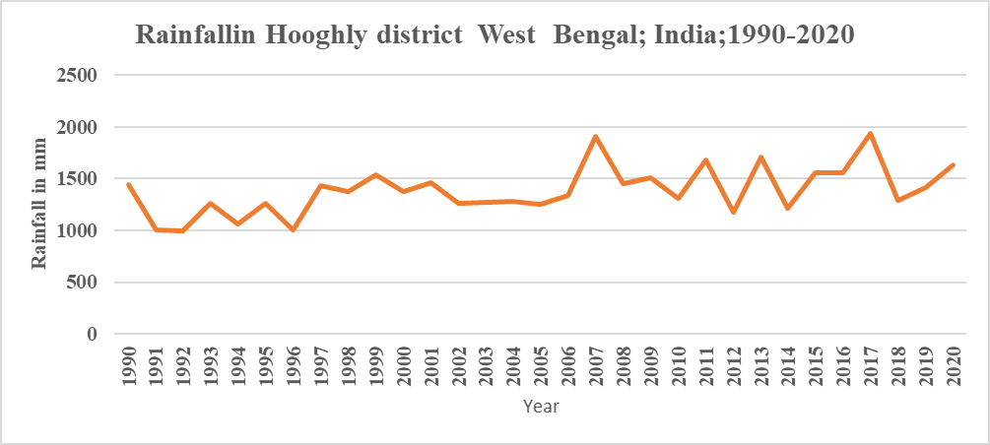
Figure 5: (a)The monthly (b) annual rainfall of Hooghly district, Source: Govt of WB
Bay of Bengal Storms:
The Hooghly district, housed over the tropic of cancer, falls under the trajectory of Intertropical Convergence Zone (ITCZ), Indian Summer Monsoon (ISM) throughline, or the trajectory of slammed tropical storms formed in the Bay of Bengal. In addition to ISM, the district receives the rainfall from residual cyclonic disturbances of the Bay of Bengal, westerly disturbances, and Kalbaisakhi every year. Last 20years, the district received cyclone Dana (Oct 2024), Yaas (May 2021), Amphan (2020), Bulbul (2019), Fani (2018), Hudhud (2014), Phailin (2013), Aila (2009), etc., and with the local instabilities in climate causing heavy floods, Fig 6 (a).
a.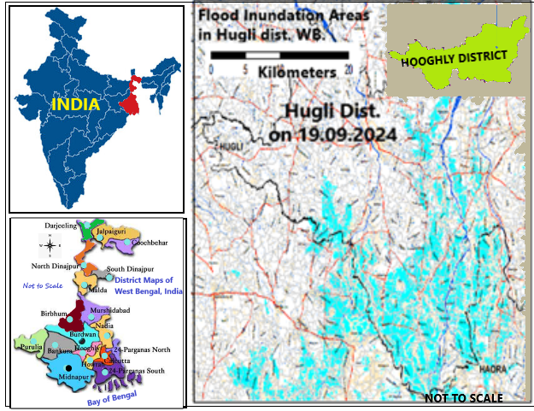, b.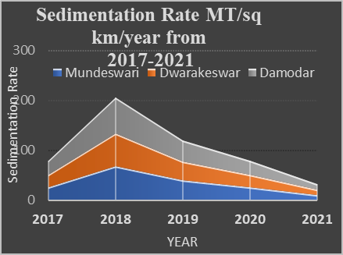
Figure 6: (a) Flood inundation map, (b) Sedimentation rate of Hooghly district, Source: NRSC Sentinel SAR Satellite image 19.09.2024, 1800IST image
Geomorphology
The Hooghly district has flat terrain with an elevation limited to 200m. The Hooghly, a tidal river in the east, with old and recent alluvium and is well anastomosed within the district. The Damodar is the major distributary of the Hooghly River with raised west Bank Fig 7 (a and b).
a.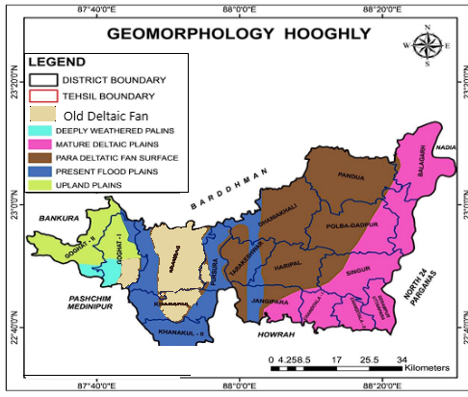, b.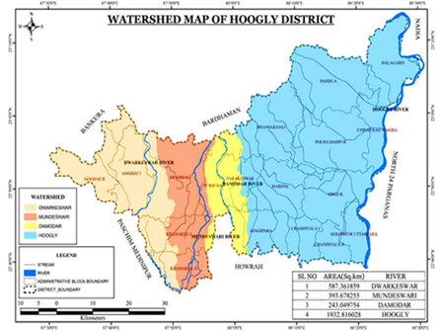
Fig 7: (a) the Geomorphology map, (b) the Watershed map of Hooghly Dist., W.B.
The flood plains in the east comprise Natural levees, meander/alluvial plains tidal effect prevails up to 290km U/S, which is roughly categorised as fresh, gradient, tidal, and marine zones. The Hooghly district in WB, India, is under increasing water resources pressure due to the combination of issues with population growth, urbanization, industrialization, and climate change effects. The Hooghly River, a major tributary of the mighty Ganges, significantly influences the district’s hydrology and socio-economic development. The district receives challenges of water scarcity during floods, droughts, strong winds, and moisture stresses, and the impact of industrial pollution on water quality, Fig. 6(a).
Sedimentation: The sedimentation of the major rivers (MT/Km2/year) has been taken from DSR Hooghly, WB, for the period 2017 to 2021. The rate of siltation rate of the DCs is dependent on the yearly rainfall of the district. The status of alluvial deposits in the major rivers, Mundeswari, Dwarakeswar, and Damodar, is shown in Figure 6 (b)
Damodar Valley Corporation (DVC): DVC is a post-independence first integrated river valley, multipurpose project (RVP). During post-independence, five dams, five dams out of eight, such as Kunur, Tenughat, Tilalya, Maithan, and Panchet Rivers, are in operation to store a volume of 3.58 lakh ham. These old, silted-up multipurpose projects have inadequate flood storage capacity at present. Any discharge above 20000Cumec flow downstream (d/s) of Barrage at Durgapur invites flood, reliant on the mouth status of the river Mundeswari at Harinkhola and Bay of Bengal. Instituted on 7th July, 1948, the DVC projects were to moderate flood, drainage, alleviate irrigation, water supply, and promote Hydel/Thermal power generation. The project also aims to upgrade public health, agriculture, and industrial activities by promoting afforestation and controlling soil erosion. The dams aim to debouch into the Durgapur barrage has created an irrigation potential of 483.5Th Ha of land out of the designed ultimate irrigation potential of 510.1 Th ha. Benefiting the districts of Burdwan, Bankura, Hooghly, and Howrah.
Socio-economic Importance:
The Hooghly district is an important agricultural region, with rice being the primary crop. It also supports a significant industrial base, including textile and jute industries. The district has a dense population and faces various challenges related to water resources management, such as water scarcity during dry periods, flooding during monsoon seasons, and the impact of industrial pollution on water quality. Societal strength and economy: As per NITI Ayog, the percentage of people who are multi-dimensionally poor in Hooghly district as per NFHS-5 (2019-21) shows 7.36% and the percentage point change in proportion of multidimensionally poor population is 7.56 for the dist. (NITI AYOGA, 2023).
Demographic Features:
The Hooghly district has a population of 5.519mi million, a population density of 1753 people/Km2, a sex ratio of 961 females/1000 males, and a literacy rate is 81.80%. The predicted population by 2025 is ≈0.61million. The urban to Rural population ratio was 38.57: 61.43 (Census, 2011).
Soil map/ stream order maps of Hooghly district:
The soil mainly available is alluvium of old and recent origin. The three types of soil available in the district are Gangetic alluvium (59150 ha), alluvium in the Damodar and Dwarakeswar valley(248950ha), and red soil (Latosol) towards the west. The deposits in the Damodar and Dwarakeswar Basin and the latosol/red soil zone (Laterites) of 68000ha of Holocene origin. The western patch comprises Latosol, grit, sand, and clay agglomerates in the western fringe of Hooghly from Pleistocene to Holocene origin. (Ministry MSME-2016-17) Fig 8 (a).
a.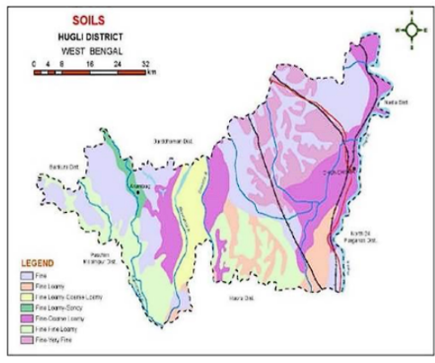, b.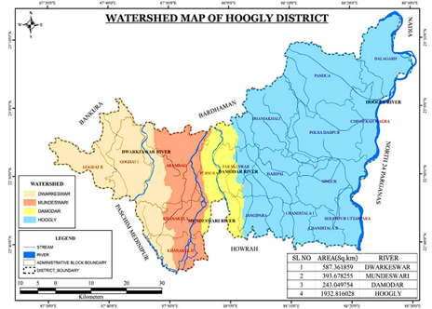
Fig. 8: (a) The soil; (b) The watershed map of Hooghly dist.. Source: World Wildlife Fund for Nature, Sept. 2020
The Basin and Subbasin Map:
The basin and sub-basin map of the district is in Fig. 8 (b). The basin map identifies the flood-prone zones. These maps shall be useful for flood management, WR planning, and environmental revisions. DEM Map: The DEM map revealed that the district has an elevation range of 0 to 30 meters, which indicates a predominantly flat terrain conducive to agriculture and prone to flooding. Fill DEM Map: The corrected DEM ensured accurate hydrological modelling by eliminating erroneous sinks. Flow Direction Map: This map highlights the direction of surface water flow, indicating dominant southward drainage patterns.
a.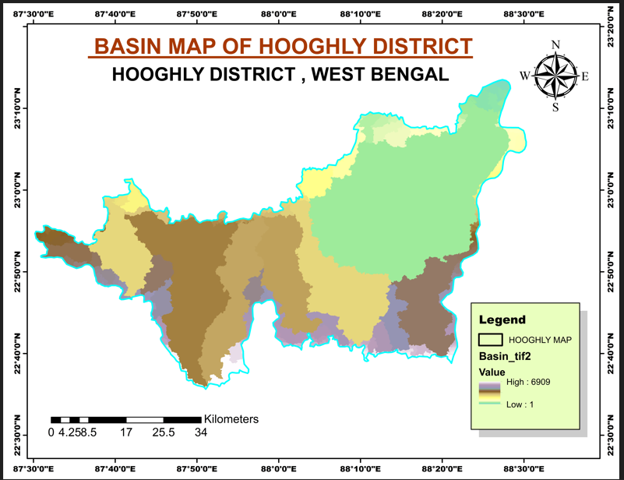, b.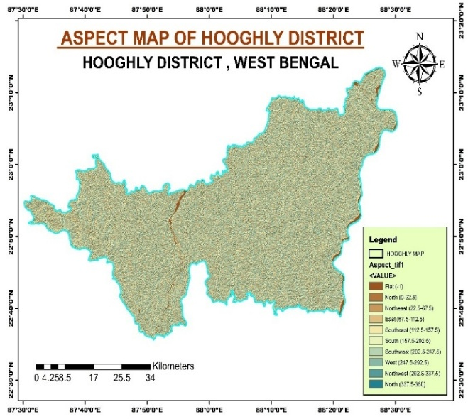
c.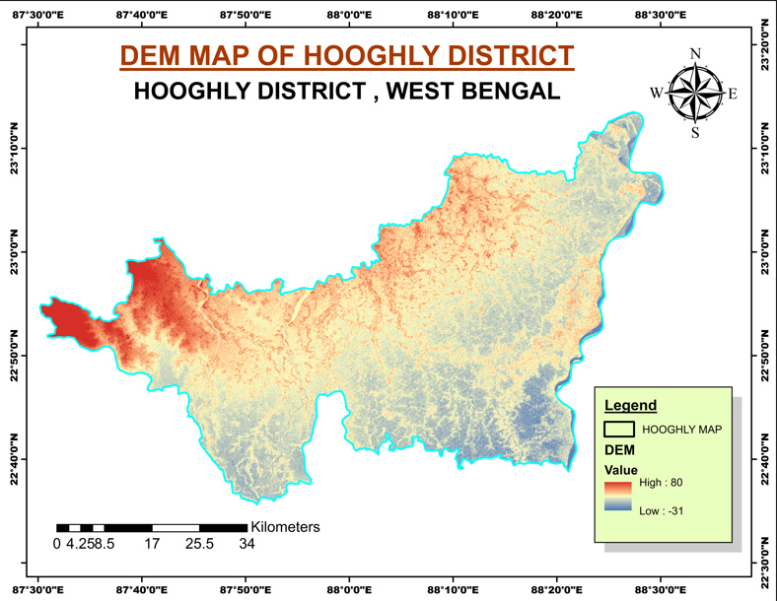, d.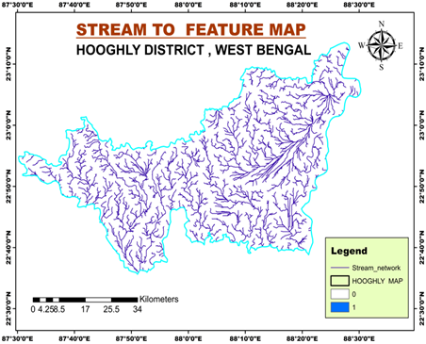
e.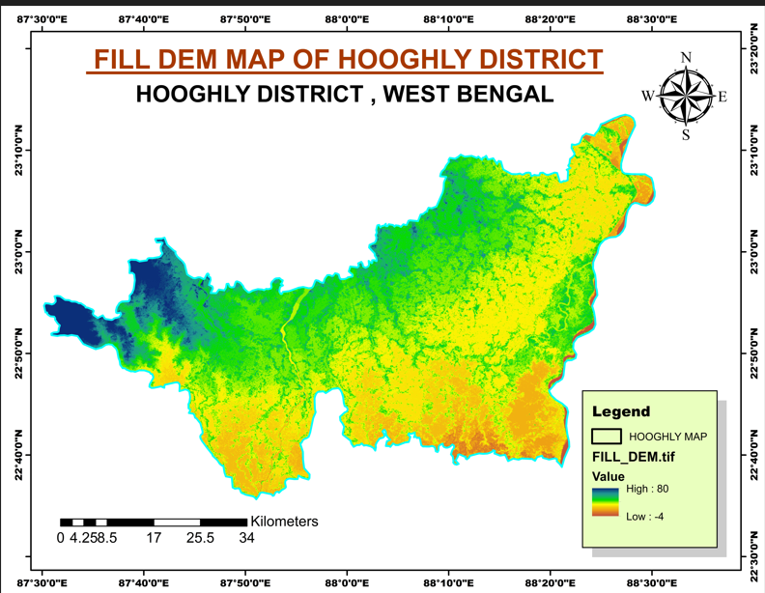, f.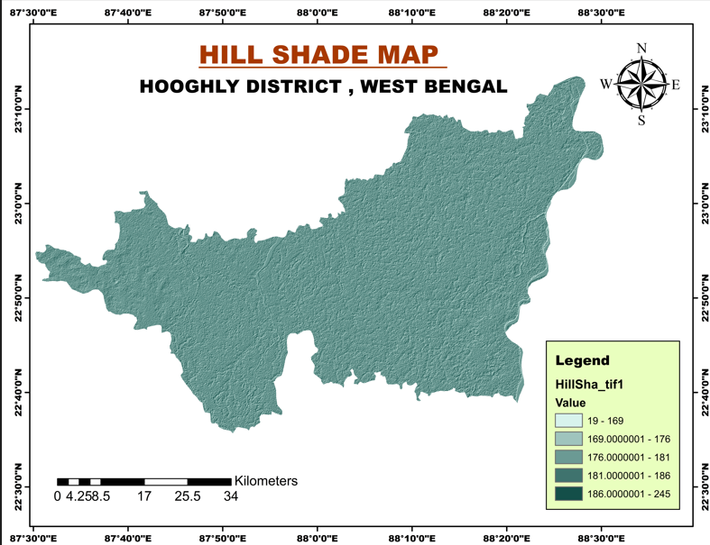
Fig 9 (a-f): The basin map (b), the Aspect map (c)DEM Map (d) Stream to feature map (e) fill DEM map, and the Hill shade map of the Hooghly District, West Bengal
Flow Accumulation Map: Areas of potential water accumulation, such as river valleys and lowlands, were identified. Hill shade Map: The shaded relief representation enhanced the visualization of subtle terrain features. Slope and Aspect Maps: Slope analysis revealed gentle gradients, while aspect analysis showed the orientation of slopes, influencing water flow and sunlight exposure Fig. 9a (a-f).
Climate change in Hooghly district
The role of Climate Change for the Hooghly district can be inferred through the daily maximum and minimum temperature optimal. The SRTM data for the maximum and minimum temperatures for the period 1990 to 2020 have been considered, and maps have been generated using GIS and ERDAS IMAGINE software. The maximum temperature in the past 30 years has an increasing trend within the district where whereas the minimum temperature has a depleting trend for the period. Fig10 (a-d):
a.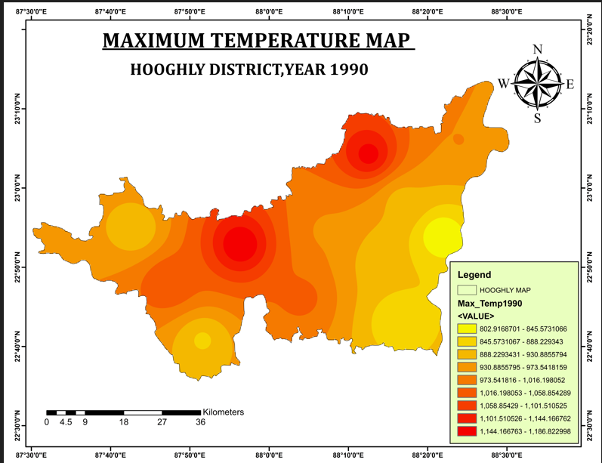, b.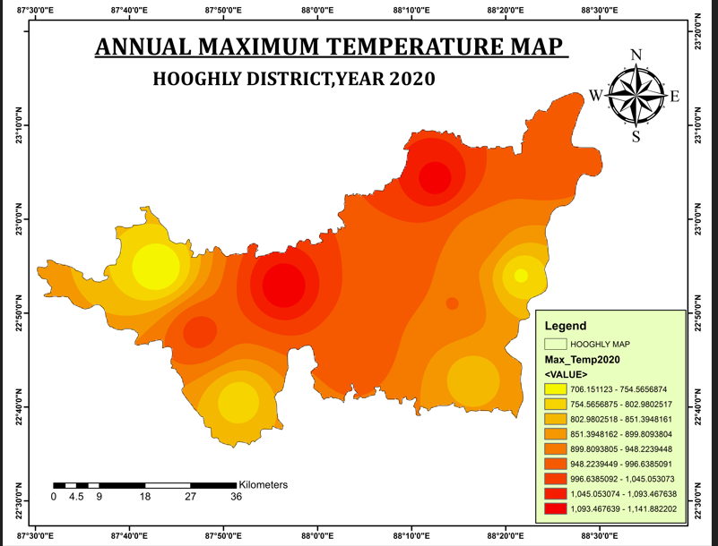
c.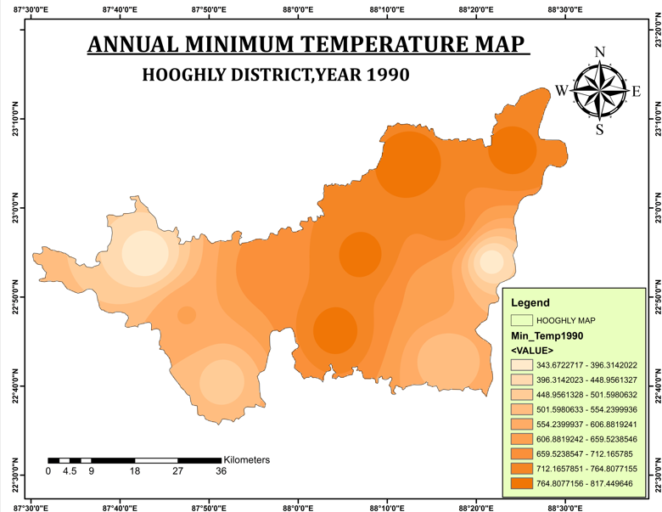, d.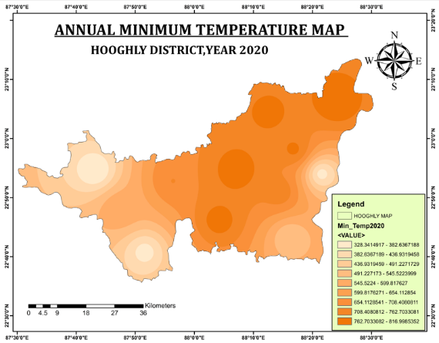
Figure 10 (a-d): The Land Surface annual Maximum and Minimum Temperature (1990-2020)
Precipitation
The Hooghly district receives rainfall and occasionally hailstorms. Rainfall Maps have been prepared considering the NIC data for the mean maximum and mean minimum temperature, which have been drawn using GIS and ERDAS IMAGINE software, and annual rainfall is shown in Fig. 11 (a-b).
a.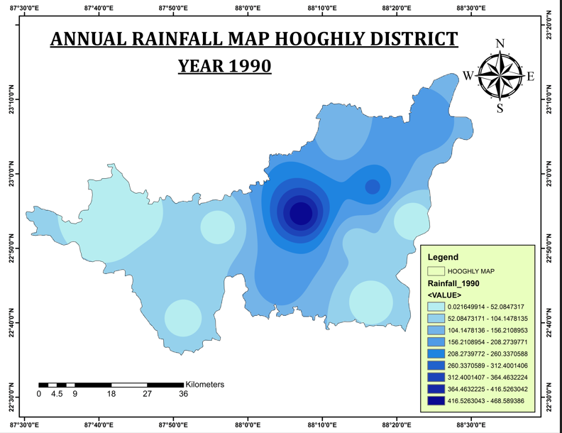, b.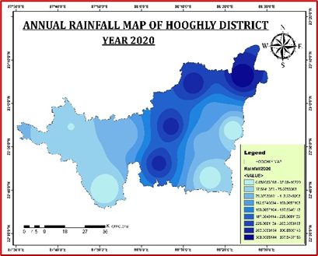
Fig 11 (a-b): The annual rainfall map in 1990 and 2020, the Trend is increasing.
From the image, the annual trend in rainfall in Hooghly district is increasing in the central and eastern fringe, attributing to a change in rainfall trend as in AR5 Synthesis Report: Climate Change 2014, as per the Intergovernmental Panel on Climate Change (IPCC 14) (Bera et al, 2022).
Customer disruption days (CDD): As per IPCC-2014, the CDD is a multi-hazard event involving stress‐testing the model of the Earth system with a large set of spatially comprehensible droughts, cyclones, and flood events. The CDD is used to calculate the number of water users whose supplies would be disrupted during an event, that is, the Customer Disruption Days (CDD). It is related to the Multi‐Hazard Risk Framework to Stress‐Test for Water Supply Systems to Climate‐Related Distractions (Becher et al, 2023).
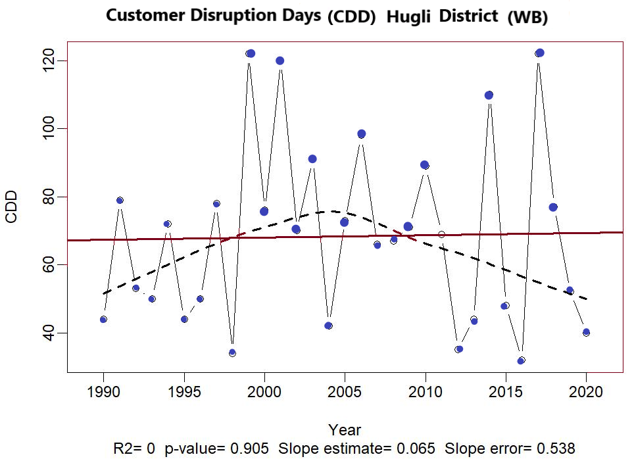
Fig 12 (a): The customer Disruption days due to flood in Hugli Dist. (WB) 1990-2020
It is estimated that the entire multi‐hazard yearly predictable disruptions are roughly 5 days/ year/ utility patron under current situations. There is an increase between 2 and 2.5 when end‐of‐century climate scenarios are propagated through the model, Fig. 12(a).
Cumulative Standardised Drought Index (CSDI)
CSDI is to examine the consequence of previous dry or wet periods on the drought event or the influence of drought on crop production (Gholinia et al., 2024), Fig. 12 (b).

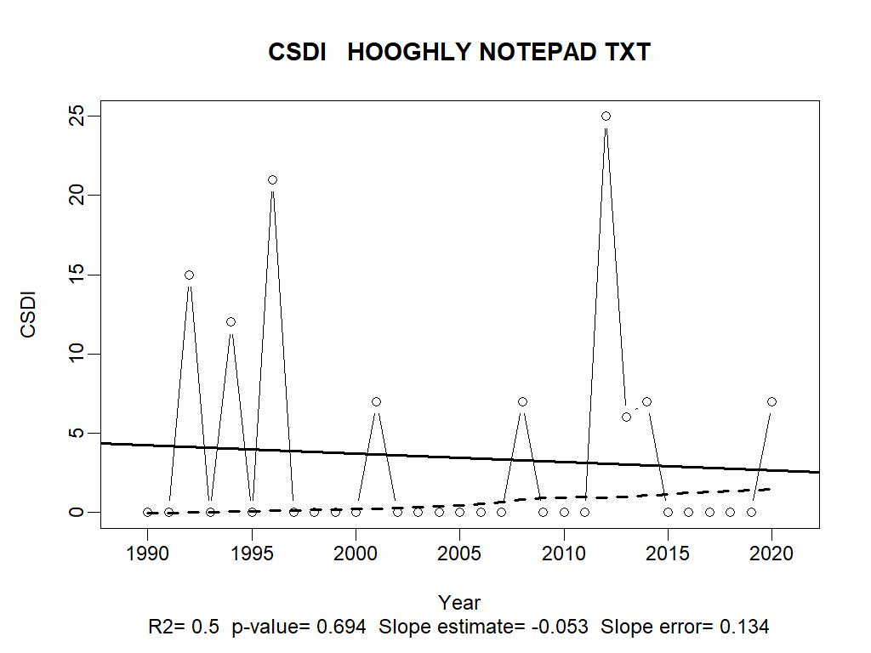
Fig 12 (b): The CSDI values of Hooghly Dist. WB, India (1990-2020)
Climatic Water Deficit (CWD): The evaporative demand that exceeds existing soil moisture, where S (soil moisture), AET (actual evapotranspiration), and D (climatic water deficit). It is he amount of water by which (PET) potential evapotranspiration exceeds actual AET (Gadain et al. 2023; Wand et al. 2025[33]). Factors that affect CWD are solar radiation, Surface air temperature (SAT), Drainage, soil moisture content, etc.
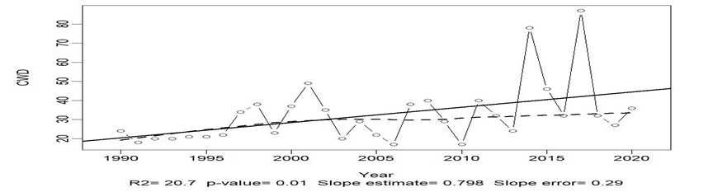
Fig 12 (c): The Climate water deficit (CWD) of Hooghly Dist. WB, India
The CWD reports on the plant water availability, irrigation demand, and distribution of types of plants suitable for the landscape. The CWD reflects climate change during wetter years, forest composition and structure, and soil water availability, i.e., irrigation water requirement, Fig. 12 (c).
Diurnal Temperature Range (DTR): is the difference between the daily maximum and daily minimum surface air temp. recorded. It is a crucial meteorological indicator related to climate change that plays a significant role in various hydrological processes, like reflecting the daily variation in temperatures, Evapotranspiration, Soil temperature and moisture, Snowmelt and Runoff, Climate change (CC), and its impact on the environment.
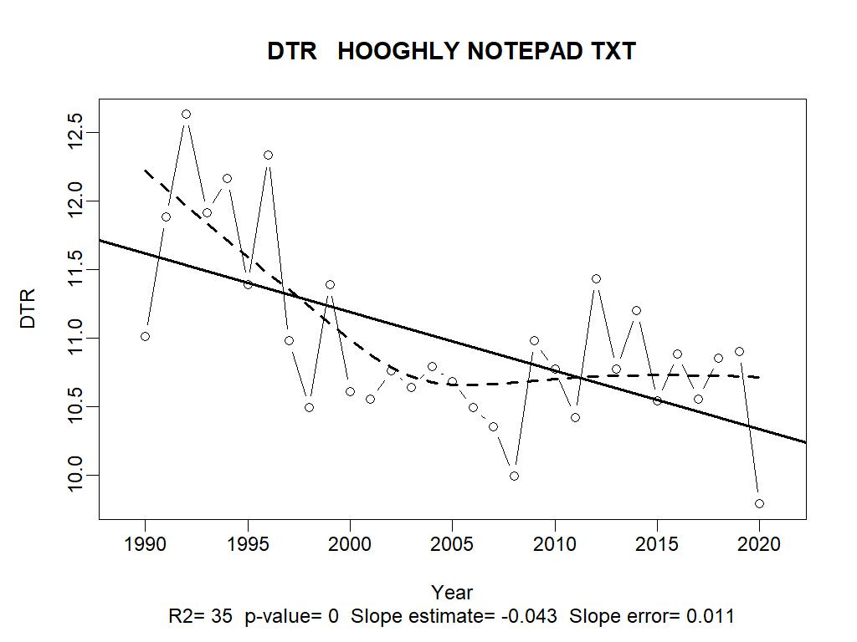
Fig 12 (d): The Diurnal Temperature Range of Hooghly Dist. WB, India
The diurnal temperature range is regulated by climate, land cover, and river characteristics, etc. DTR foretells about surged sediment accretion, Human/aquatic physiology, and the biological processes within the water bodies and the rivers. Presently, the graph of DTR trends over time tells that there are potential changes in river thermal regimes linked with climate change or LU/LC alterations (Katavoutas et al, 2023); (Bonacci et al., 2023) Fig. 12 (d).
Warm Spell Duration Index (WSDI):
The WSDI represents the days in a year contributing to “warm spells”, when the maximum temperature (TX) remains more than its climatological 90th percentile.
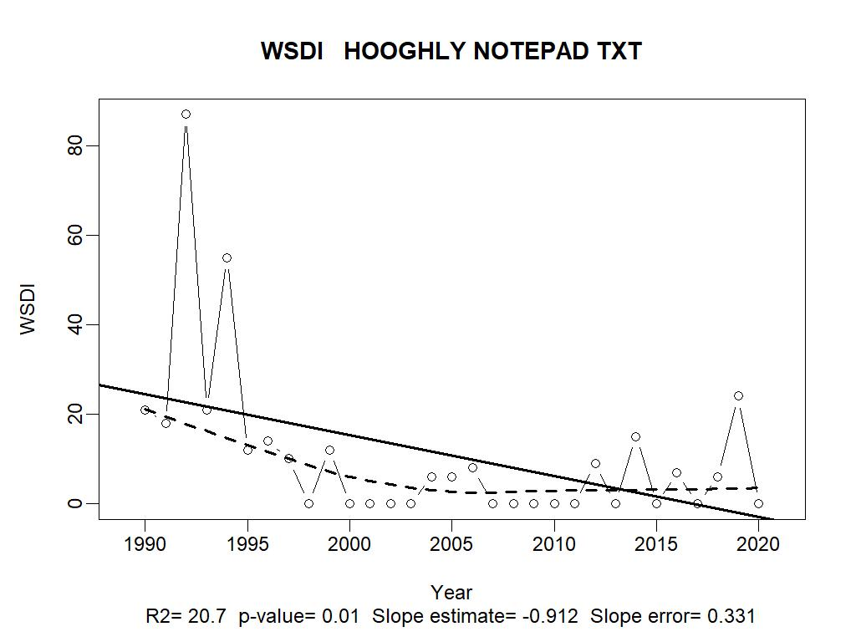
Fig 12 (e): The Warm Spell Duration Index (WSDI)of Hooghly District for 1990-2020
The spell which is comprised of at least six consecutive days to be suitable as a “warm spell”: All percentile-based temperature indices which is obtainable by European climate Assessment & Dataset (ECA&D) that uses the proposed method by Zhang to calculate the index (Zhang et al., 2005); (Xiao et al. 2020); (Rahim et al. 2023); (Kamali et al, 2023) Fig 12 (e)
Time Series Analysis (TSA) of Temperature and Precipitation:
1) Time Series Analysis of Maximum Temperature (Tmax) at Hooghly Station (1990–2021)
To assess temporal variations in maximum temperature, daily Tmax data for Hooghly station were plotted in a time series format for the period 1990 to 2021, subdivided into four decades: 1990–1999, 2000–2009, 2010–2019, and 2020–2021. Each sub-plot displays the annual temperature cycle with distinct seasonal peaks and troughs, reflecting typical temperature patterns influenced by the regional climate (Yao et al, 2023[43]). The plots reveal:
1)A consistent annual cycle with pronounced peaks each year, representing the summer maxima.
2)Year-to-year variation in the amplitude and shape of the curves, indicating potential climatic variability or anomalies.
3)A slight increasing trend in the peak temperature values over the decades, though not linear, suggesting a possible warming pattern.
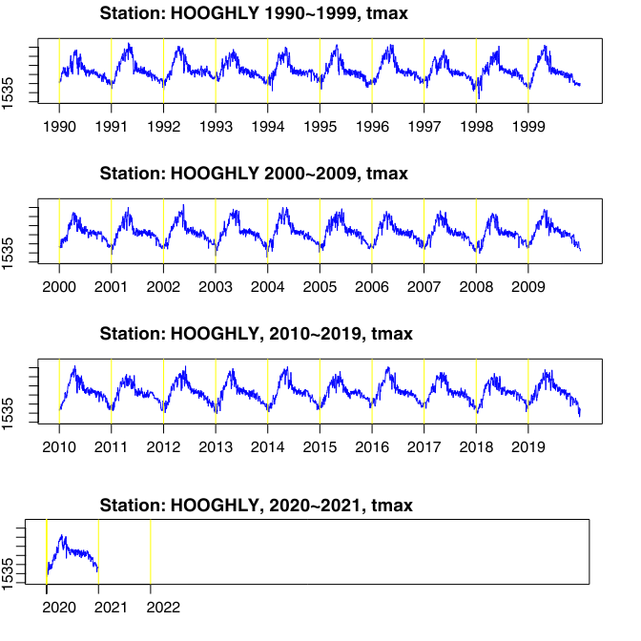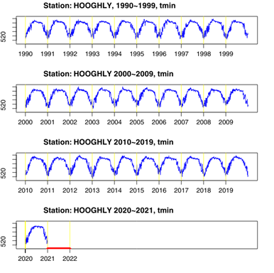
Fig 13 (a): TSA of Maximum Temp. (Tmax) at Hooghly Station (1990–2021)
These visualizations provide a clear picture of long-term temperature behaviour, assisting in identifying climatic trends, interannual variability, and potential impacts of climate change in the region (Devi et al, 2023[45]), Fig. 13 (a).
2) TSA of Minimum Temp. (Tmin) at Hooghly Station (1990–2021):
To analyze the temporal behaviour of minimum temperature, daily Tmin data for Hooghly station were plotted over the period 1990 to 2021, segmented into four intervals: 1990–1999, 2000–2009, 2010–2019, and 2020–2021. Fig 13 (b).
The time series plots reveal a distinct seasonal cycle with well-defined troughs each year, indicating lower Tmin values during the winter months (Zhang et al, 2023[44]). Key observations include:
1)The annual patterns are consistent and cyclical, reflecting regular seasonal fluctuations.
2)Each decade shows repetitive winter lows and summer plateaus, characteristic of the climatic regime of the region.
3)A gradual upward shift in Tmin values can be observed across decades, suggesting a possible warming trend, particularly in the winter minimums.
These graphs serve as important visual evidence for identifying long-term temperature dynamics, particularly minimum temperature changes, which play a critical role in ecological, agricultural, and climate impact studies Fig. 13 (b).
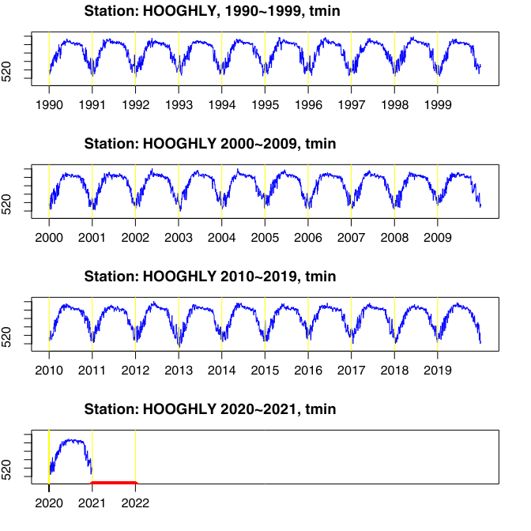
Fig 13(b): Time Series Analysis of Minimum Temperature (Tmin) at Hooghly Station (1990–2021)
3) TSA of Precipitation at Hooghly Station (1990–2021)
Daily precipitation data (in mm) for Hooghly station from 1990 to 2021 were analyzed to examine temporal variability and long-term trends. The data were divided into four time periods: 1990–1999, 2000–2009, 2010–2019, and 2020–2021, and plotted in time series format (Perez et al., 2021; Jamal et al., 2025). Key observations include:
1)Seasonal Concentration: Precipitation is largely concentrated during the monsoon months (June to September) across all decades, showing a consistent seasonal cycle.
2)1990–1999: This decade shows moderate rainfall events with relatively shorter and less intense spikes, indicating a stable monsoon phase with fewer extremes.
3)2000–2009: A noticeable increase in both the frequency and magnitude of rainfall events is observed, suggesting a more active and variable monsoon pattern during this period.
3)2010–2019: Rainfall patterns during this decade exhibit frequent high-intensity precipitation events, indicating an increasing trend in extreme rainfall.
Overall Trend: From 1990 to 2019, there has been a gradual shift toward more intense and variable precipitation, which may be linked to changing climatic conditions, such as the increased occurrence of localized heavy rainfall events.
These observed trends highlight the changing nature of monsoonal rainfall in the Hooghly region and underline the importance of continued monitoring for effective water resource management and disaster preparedness Fig. 13(c).
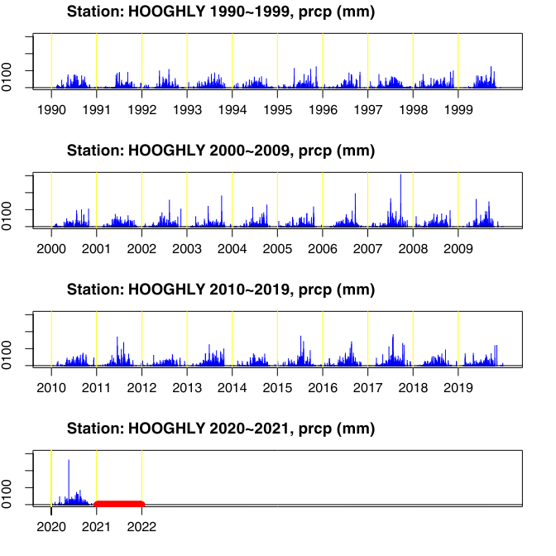
Fig 13 (c): Time Series Analysis of Precipitation at Hooghly Station (1990–2021)
The trend of the westerly shift of the Indian Summer Monsoon is mirrored in the district. In the future, the precipitation in the Hooghly district shall increase, which shall be reflected.
Results and Discussion
The mighty Ganges bifurcates at Farakka Barrage downstream as the Padma River flowing through Bangladesh, and the Bhagirathi-Damodar-Hooghly branch and Kati-Ganga River as the Hooghly River discharge to the Bay of Bengal in the western part of the Sunderban through the Roop-Narayan River.
Types and causes of floods in Hooghly District: The Hooghly flood in Hooghly district (in plains) are the fluvial floods (mostly during monsoon days); Flash (pluvial or urban) floods, snowmelt floods during summer, and coastal, flash floods due to storm surge inundations. The distresses occur due to misjudged dam releases, ungauged catchments that cause spill or breach of banks. The flash floods mainly snowmelts in the Hooghly River are devastating, as instantaneous, rapid, and last for a short period, area-specific, and fast flowing. The Coastal Floods are associated with tropical storms, high waves, storm surges, or high tides that are specifically apocalyptic to the coastal/fishers group. Modern concrete jungles may cause urban floods or pluvial floods in the Hooghly district (Mishra et al., 2020).
The players in causing floods/ droughts in the district are SW-monsoon Rainfall, Topography of the Terrain, Drainage pattern of the basin, erratic rainfall due to residual storms, inadequate channel section of rivers or drainage channels for smooth discharge, unplanned release of from dams in Damodar basin, climate change vagaries, breech in banks, encroachment of levees of drainage channels, deforestation, sedimentation of the DCs, etc.
Role of DVC Reservoirs
The Damodar Valley Corporation (DVC) has been functioning for the last 71years by flood retention, improper flood routing, and operation of its reservoirs upstream (U/S). During the pro-independence period in India, five multipurpose dams were constructed at Konar over (Konar R.), Maithon and Tilaiya dams over (Barkar), Panchet and Tenughat over Damodar R., draining to a barrage at Durgapur. (Mishra et al, 2025). These 71-year-old dams are silted up and have reduced their storage capacity. The tailrace and connecting drainage channels have silted up and aggravated the flooding situation in the Hooghly district. The Dams, dykes, or embankments are common due to weak maintenance. The carrying capacity of rivers/reservoirs has reduced due to inadequate flood control measures and catchment treatment plans in the basin. The Hooghly River, when it receives floods (>20000Cumec) due to the melting of snow ice, an affected by climate change and global warming may cause flood inundations.
The environmental loss
The historical tragic flood that was recorded in 1943 was protested by the people of Hooghly district as manmade (The Govt. https://dvc.gov .in/cmsweb/details; pages/13. The liable losses are farm inundations, loss of life and property, infrastructural collapse, transport disruption, and lowland flooding followed by waterborne diseases, environmental degradation, social and psychological burdens (Mishra et al, 2020).
Flood History
In 2024, the Hooghly district of WB faced severe flooding due to heavy rainfall and water release from the Damodar Valley Corporation (DVC) along with neighbouring districts Birbhum, Bankura, Howrah, and Hooghly. The Hooghly district received high floods from the Barkar and the Damodar River in the years above 15000 Cumec, other than the regular R., in the Damodar River. The G&D records (1933- 1970) infer that the peak flood was 18406 Cumec on Aug 6th, and was 21900 Cumec during Sept 1978 (WMO Tech report, 2003). The flood in the Damodar River in 2024 was claimed as manmade, for WB. (Ghosh, 2014[42]; WB Irrigation AR, 2010 2024[18]; Mishra et al, 2020[49]) and the post-dam peak flood was encountered (Steckler et al., 2021).
Four rivers in one basin:
The local people of Hooghly basin, Goghat, and Khanakul intimated that the area is surrounded by the four major rivers in the Hooghly district, the Damodar, the Mundeswari, the Rupnarayan, and the Dwarakeswar, with a common basin. When there is heavy rain, all four rivers swell and cause floods throughout the entire area.
Sand Mining: Sand mining of rivers controls the hydrology and morphology of rivers in the Hooghly district, which has been controlled by Anthropogenic activities for the last 50 years. The continuous large-scale excavation of sand from the river beds was initiated in the mid-1990s due to increased urbanization and industrialization adjacent to the river. The results were a change in Thalweg dynamics, embankment erosion/breaches, river bars instability, and Channel bifurcation are the major geomorphic impacts of sand mining. It is estimated that through 71 identified quarries sand has been lifted amount of 23755cum of sand between Sillaghat to Sadarghat, of distance of 40km. Mainly, the alluvial reach of all, including the lower Damodar River, is highly affected by uncontrolled sand excavation to have a sustainable sand mining in the name of urbanization (Ghosh et al, 2016), http://dmm.gov.in/pdfs/DSR/DSR_Hooghly
The population growth, changes in the style of livelihood, there is rapid urbanization and industrialization there is an alteration in land use and land cover (LULC). There are significant changes in the natural landscape and adversely affected by changes in climate, hydrological cycles, ecosystems, and services, especially in the modern world. There should be best crop rotation selection with the GIS-AHP Technique can be applied for better crop yield (Arulbalaji et al, 2019; Singh et al, 2020); (Sajilkumar et al., 2022).
Poised Flood control measures
The district has a low-lying landscape, and the annual monsoon rains contribute to the recurrent occurrence of natural and anthropogenic events. The flood control measures that can be implemented are River/ Reservoir/ Channel de-sedimentation, repair, renovation, and reconstruction by identifying potential zones of flooding hotspots, the health of the canal structures identification and maintenance, etc. Judicious framework of dam operation rules, proper forecasting of rainfall, trajectory of storms, reservoir storage management, regular and improved irrigation system/structures, and management. The lack of appropriate drains, the district can be well protected from floods through well-judged rule curves, regular dredging and de-siltation, proper barrage operation plans implementations with adequate preparedness, mitigation, and management.
Flood Impacts:
Floods in the district have bearings like fatalities/casualties, temporary shifts, agricultural losses, collapse of infrastructure, roads, bridges, buildings, and utilities, etc. The floodwater disrupts daily life and economic activities. Waterborne Diseases, snake bites, other health risks, environmental penalties, social and psychological impact, and erosion of banks, land, and livestock resources, and the irrigation network, etc. The South-Western part of the Hooghly district, comprising blocks like Khanakul -I and II, Pursura, Part of Arambagh, Goghat –I, is the worst affected.
Sociological, economic impacts:
The drowning deaths, hunger are common during floods. The property damages weaken the livelihood of the people in the district. Inundations and submergence cause temporary migrations. Health hazards from Cholera, snake bites are regularly reported. As the state is an agrarian one, there rampant loss of grains, agriculture, bovines, and zoonotic animals. Structural damages are shared with the village/house, i.e., Jangalpara village in Hooghly, during 2017. The Gangetic plains are accompanied by floods. The migration, shifts, and marginalisation occur after all devastating floods or droughts. The public utility system is disordered, students suffer, education has ceased, vegetables (about 30000 hectares of crop destroyed in 2021in Khankul block) become scarce and unavailable, Pisciculture is disturbed, etc.
The strategies for Preparedness, Mitigation, and Management
Preparedness: To augment preparedness, mitigation of flood hazards, the possible action plans are prompt Early Warning Systems, after the India Meteorological Department, climatological warnings, and district headquarters caveats. Nowadays old system of facing disasters has been changed by participatory flood management involving federal institutions, NGOs, and local champions to ameliorate floods.
Flood plain zoning: Developing flood plain zones within the district and restricting high-rise buildings in the flood-prone areas to avoid risk and maintain safety. Identifying the vulnerable embankments and pre-flood repair/ renovation are to be done through joint inspection by the administrative revenue department and Irrigation department higher authorities.
The reservoir sedimentation: There are 7 dams and four barrages. There are reservoir bed is sedimented annually during each monsoon season, and there is a gap of 36 years between historical high flood events. Because of these sediments, the amount of water in the reservoir can vary significantly during this period and into the future. The reservoir is silted up. Its capacity is reduced, warrants reservoir replanning and fixing of a new zero elevation level.
Groundwater toxicity by Arsenic: The groundwater of many villages in the Hooghly district is contaminated with arsenic. The users of the aquifer water are suffering from skin lesions, Keratitis, cancer, peripheral neuropathy, cardiovascular diseases, sleep disturbances, and increased risk of cerebrovascular diseases (Marghade et al., 2023). To mitigate the issue, it is needed to explore arsenic-free aquifers, develop community-level arsenic removal innovative technologies, aware users, and educate them not to drink toxic water.
Hydraulic Infrastructural Expansion: Identify and renovate the vulnerable/ dilapidated structures and embankments, levees, and canal protection structures to protect them from flooding and devastation. The natural drainage system should be maintained, de-sedimented,
Adequate Drainage System: The four major rivers, Damodar, the Mundeswari, the Rupnarayan, and the Dwarakeswar, drain to a part catchment of the Ganga basin, the inadequate drainage density and inefficient discharge through the DCs to the lower reaches. As a result, these drains are silted up, and the capacity of discharge depletes from year to year. The district warrants the construction of stormwater discharge drains and adequate pumping stations.
Sandmining norms: To save the rivers from further degradation and to achieve sustainable mining practice, cross-section mining from rivers and DCs, the beds to be protected, the barrages and bridges or any other structures should not be allowed for sand dredging, both U/S and D/S, road running embankments, wildlife sanctuaries, and structures. If there is a chance of erosion and the river sand is mixed with gravel, upstream of sand bars and boulders, mining should be prohibited (DSR, Mining Dept WB, 2023).
Ecosystem sustenance: Global warming and changes in ISM have brought climate change effects in the Gangetic plains. Sand Mining along the river domain makes beaches, causes flood plain submergence, and affects the flora, fauna, and the ecosystem and its natural habitats. Proper management of the floodplains can absorb the surplus floodwater and maintain resilience. Ex-ante protective measures are to be taken to bridge the economic gap through self-insurance, market insurance, self-protection, etc.1
Disaster Preparedness: Disaster preparedness involves mitigating potential hazards of earthquakes, very heavy rainfall, drought, and floods. Various stages include planning, identification of potential zones, Risk and Capacity analysis, and participatory Public Private Partnership (PPP). Preparedness involves the knowledge of disasters, shelter houses, shortest routes, emergency contacts, safety precautions, and available relief. The disasters can be ameliorated through (a) Assessment of short-term and long-term impacts (determining risk and impact by ground truthing, collation, evaluation, and interpretations), (b) Awareness Campaign to the entire mechanism, community, and stakeholders, (c) Vulnerability, and d) appropriate training to disaster managers and champions. d) Training: In an effort to sensitise the role players in disaster management, training.
Coordination and Emergency Response: The real coordination between the victims, government organisations, non-governmental organizations (NGOs), federal institutions, etc, should be alert and active during, pre- and post-disaster period, and prompt action must be taken as and where needed. Internal cooperation and preparation of the strategic plans demand inevitable and strict adherence to the plans are obligatory for sustainable ecological resilience.
Climate Change Adaptation: Climate change is in process, and it is necessary to take adaptation strategies to be taken during floods and other disasters. It is warranted to implement justifiable land and water management practices that have yet to be adopted as resilient infrastructure tools to withstand the devastation.
Research and Monitoring: Regular recording of in-situ data is urgent for future research and planning, and to formulate adequate monitoring programs. Expediting the innovative shared knowledge, experiences, and adopting the best practices in flood preparedness, mitigation, and management is essential for the Hooghly district.
Construction of new Dams, desilting of existing Reservoirs: During planning and design of dams in the Damodar River system was provided with 8 dams but actually constructed five only which have sedimented in the last 75 years and depleting the reservoir capacity. It is high time to desilt those reservoirs and construct the three dams in the U/S of the Damodar system.
Proper Budgeting and financial allocation: To relieve the flood havoc in the Gangetic plains, it is highly essential to have an integrated approach to stick to the plans, programmes, and execution for which adequate budget allotment and financial allocation must be made.
Complying with SDGs: SDG 13 is related to fighting climate change scenarios and addressing its impacts. SDG target 13.1 is particularly precise intent to fortify resilience and raise adaptive capacity to floods, droughts, waterlogging, and other climate-related hazards and natural disasters of the Hooghly district.
The present study has focussed on comprehensive and important assessment of environmental water flow and hydrological dynamics in the Hooghly region using advanced geospatial techniques and long-term climate data analysis. By integrating remote sensing, geographic information systems, and statistical tools, the research findings contribute significantly to sustainable water resource management planning and disaster risk reduction, in line with the Sustainable Development Goals. As such, this study serves as an important resource for researchers, policymakers, and environmental managers working on climate change adaptation and water security in similar river basin regions worldwide.
Conclusion
The Hooghly district in West Bengal is rich in agriculture (≈69%) of total land, with the spread of anastomosed natural drainage channels of total length 461.83 km. Mainly of the Damodar, the Dwarakeswar, the Hooghly, and the Mundeswari system. The present study details the rivers, drainage patterns, and natural disasters. It is inferred from the study that the average. The maximum temperature shall surge with a rise in precipitation. More space and more dams are to be created in the river sections of the Hooghly district. In the future, the Tmax and Tmin in the Hooghly district are exhibiting an upward trend from 1990 to 2020. The impact of maximum and minimum temperatures will bring more rain with climate change.
The south-western part of the district shall be significantly affected by the flood annually, and the blocks susceptible, like Khanakul I and II, Goghat I and II, Pursura, and Arambagh, are the major vulnerable areas for floods. The government and the federal institutions have to record and analyse all the causes and damages for the environmental flow of the Hooghly district to satisfy the SDG goal 13.1.
Disclaimer (Artificial intelligence)
Author(s) hereby declare that NO generative AI technologies such as Large Language Models (ChatGPT, COPILOT, etc.) and text-to-image generators have been used during the writing or editing of this manuscript.
References
1. Sinha K., Das (Saha) P., (2015) Desalination and Water Treatment Assessment of water quality index using cluster analysis and artificial neural network modelling: a case study of the Hooghly River basin, W.B., India. 54(1), 28-36, https://doi.org/10.1080/19443994.2014.880379
2. Ghosh, A., Roy, M.B. & Roy, P. (2020). Estimation and prediction of the oscillation pattern of meandering geometry in a sub-catchment basin of the Bhagirathi-Hooghly river, West Bengal, India. SN Appl. Sci. 2, 1497 https://doi.org/10.1007/s42452-020-03275-z
3. Mukhopadhyay, A., Acharyya, R., Habel, M., Pal, I., Pramanick, N., Hati, J. P., Sanyal, M. K., & Ghosh, T. (2023). Upstream River Erosion vis-a-vis Sediment Variability in Hugli Estuary, India: A Geospatial Approach. Water, 15(7), 1285. https://doi.org/10.3390/w15071285.
4. Department of Industry, Commerce & Enterprises, (2022). District Survey Report of Hooghly District. For Mining of Minor Minerals, Notification No. S.O.141 (E) ND., Government of West Bengal.
5. Mishra SP., Paramanick S. (2024). Gosaba Island in the Indian Sunderban: A Dystopia Allochthonous Ecosystem. Computer Research and Development 24(7), 2024
6. Pramanick, S., Mishra ( 2024). Budding Challenges of Arsenic Contamination in Bengal Fan in the Anthropocene Epoch. Journal of Scientific Research and Reports 30 (12): 824-46.https://doi.org/10.9734/jsrr/2024/v30i122725.
7. Nandy, S., Kushwaha, S.P.S., and Dadhwal, V.K. (2011). Forest degradation assessment in the upper catchment of the river Tons using remote sensing and GIS. Ecological Indicators,11(2), pp. 509–513
8. Sahana, M., Sajjad, H., Ahmed, R. (2015). Assessing spatio-temporal health of forest cover using forest canopy density model and forest fragmentation approach in Sundarbans reserve forest, India. Model. Earth Syst. Environ. 1, 49, https://doi. org/10.1007/s40808-015-0043-0
9. Kushwaha, S.P.S., Nandy, S., Shah, M.A., Agarwal, R. and Mukhopadhyay, S., 2018. Forest cover monitoring and prediction in a Lesser Himalayan elephant landscape. Current Science, 115(3), 510–516
10. Panda S. R., Mishra SP., Tripathy, J. Ku., (Sept 2021), The Failed Resilience, Grim Water Future, and Salinity Intrusion through GIS of Kendrapada Coast, Odisha. International Journal of Lakes and Rivers. ISSN 0973-4570, 14(2), 161-181; Research India Publications
11. Mishra, S. P., Nayak, J., Barik. K.K., Sethi, K.C., 2023. The Delineation of Watersheds in the Dhenkanal District, Odisha, India; Using Arc-GIS. Journal of Scientific Research and Reports, 29(5), 1-18, APR. 2023; DOI: 10.9734/JSRR/2023/v29i51743.
12. Giri, S., Mukhopadhyay, A., Hazra, S., Mukherjee, S., Roy, D., Ghosh, S., Ghosh, T., Mitra, D. (2014). A study on the abundance and distribution of mangrove species in the Indian Sundarbans using the RS technique. J. of Coastal Cons., 18(4), 359–367
13. Chanda A, Akhand A. Challenges towards the Sustainability and Enhancement of the Indian Sundarban Mangrove’s Blue Carbon Stock. Life. 2023; 13(8):1787. https://doi.org/10.3390/life13081787
14. Nandy, S., Tamang, M., Kushwaha, SPS., (2021), Plant Diversity Assessment in Indian Sundarbans Mangroves: A Geoinformatics Approach. Ch-5, In book: Sundarbans Mangrove Systems, DOI: 10.1201/9781003083573-5
15. Doodee MDD, Rughooputh SDDV, Jawaheer S. (2023). Remote sensing monitoring of mangrove growth rate at selected planted sites in Mauritius. S Afr J Sci.;119(1/2), DOI: 10.17159/sajs.2023/13716
16. Sudirman N., Salim, HL., Rustam, A, Ati1 RNA, Hernina R., Marini Y, Suryono1et DD, (2023). IOP Conf. Ser..: Earth Environ. Sci. 1148 012041, doi:10.1088/1755-1315/1148/1/012041
17. Mishra Sibaprasad, Saswat Mohapatra, Saswat Mishra, (2024). Quest for Mangroves in Anthropocene, South Odisha Coast. Afr.J.Bio.Sc.6.12(2024), 2712-2731, https://doi.org/10.48047/AFJBS.6.12.2024.2712-2731
18. Irrigation and Waterways Department, West Bengal,( 2010 to 2023), Flood management Report. https://wbiwd.gov.in/index.php/applications/flood_mgmt
19. Annual Flood Report for the Year (2023), Irrigation & Waterways Directorate, Govt. of West Bengal, https://wbiwd.gov.in/uploads/anual_flood_report/Annual-Flood-Report-2023.pdf
20. Agriculture Contingency Plan for District: HOOGHLY, West Bengal, (Seen on 13.06.2026) https://agriwelfare.gov.in/sites/default/files/WestBengal%207-Hooghly-31.12.2011_0.pdf
21. Prakash, D., Tiwary, C. B., & Kumar, R. (2023). Ecosystem Variability along the Estuarine Salinity Gradient: A Case Study of Hooghly River Estuary, West Bengal, India. Journal of Marine Science and Engineering, 11(1), 88. https://doi.org/10.3390/jmse11010088.
22. Dasgupta, M., Das, S. (2024). Extreme Flood Flow Routing for Panchet and Maithan Reservoirs of India Using Modified Puls Technique. Water, 16(5), 663. https://doi.org/10.3390/w16050663
23. Mishra SP., Roy R., Mishra S.. (2025). Cataclysmic Morpho Dynamics of the Lower Damodar River Basin, India”. J. of Geography, Env. and Earth Science Int. 29 (5):140-65. https://doi.org/10.9734/jgeesi/2025/v29i5899
24. Das R., Mondal M., (2021). RS-GIS-based Morphometric Analysis and Hydrogeomorphic Assessment of Rasulpur River Basin over Fluvio-coastal West Bengal. Int. J. for Res. in Eng. Application & Mangt. (IJREAM), 07(05), DOI : 10.35291/2454-9150.2021.0453 © 2021.
25. Khalisani Mahavidyalaya. University of Burdwan. Problems of flood in Hooghly District of West Bengal: a geographical investigation. Department of Geography, 2023, https://khalisani college.ac.in/pdf/Geography/study-tour/Flood-in-Hooghly.pdf
26. Biswas, B., 1959, Sub-surface geology of West Bengal, India, Proc. Symp. Dev. Petrol. Res. ECAFE, Min. Res. Dev. Sr. No. 10, p. 159-161
27. NITI Aayog, India. 2023. National Multidimensional Poverty Index, A Progress Review 2023. Government of India, Sansad Marg, New Delhi – 110001, 1-410.
28. Census (2011) Government of India. http://censusindia.gov.in
29. Ministry of MSME. (2017). Brief Industrial Profile of Hooghly District, West Bengal 2016, (1-7) Govt. of India, 1-19
30. Bera, A., Meraj, G., Kanga, S., Farooq, M., Singh, S. K., Sahu, N., & Kumar, P. (2022). Vulnerability and Risk Assessment to Climate Change in Sagar Island, India. Water, 14(5), 823. https://doi.org/10.3390/w14050823
31. Gupta, D., Kumar, P., Okano, N., & Sharma, M. (2025). Climate-Induced Migration in India and Bangladesh: A Systematic Review of Drivers, Impacts, and Adaptation Mechanisms. Climate, 13(4), 81. https://doi.org/10.3390/cli13040081
32. Becher O., Pant R., Verschuur J, Mandal A., Paltan H., et al. (2023). A Multi-Hazard Risk Framework to Stress-Test Water Supply Systems to Climate-Related Disruptions. Earth's Future, 11, e2022EF00294, Wiley, https://doi.org/10.1029/2022EF002946.
33. Gholinia, A., Abbaszadeh, P. (2024). Agricultural Drought Monitoring: A Comparative Review of Conventional and Satellite-Based Indices. Atmosphere, 15(9), 1129. https://doi.org/10.3390/atmos15091129
34. Gadain, H., & Libanda, B. (2023). Agricultural Water Deficit Trends in Yemen. Atmosphere, 14(8), 1263. https://doi.org/10.3390/atmos14081263
35. Wang, Y., & Zhao, J. (2025). Temporal–Spatial Patterns of the Water Deficit in the Main Maize-Cropping Regions of China. Agronomy, 15(3), 728. https://doi.org/10.3390/agronomy15030728
36. Katavoutas, G., Founda, D., Varotsos, K. V., & Giannakopoulos, C. (2023). Diurnal Temperature Range and Its Response to Heat Waves in 16 European Cities—Current and Future Trends. Sustainability, 15(17), 12715. https://doi.org/10.3390/su151712715
37. Bonacci, O., & Ðurin, B. (2023). The Behavior of Diurnal Temperature Range (DTR) and Annual Temperature Range (ATR) in the Urban Environment: A Case of Zagreb Grič, Croatia. Atmosphere, 14(9), 1346. https://doi.org/10.3390/atmos14091346
38. Zhang, X., Aguilar, E., Sensoy S., Melkonyan., Tagiyeva U., …… (2005). Others, Trends in Middle East climate extreme indices from 1950 to 2003. J. of Geophysical Research, V- 110, D22104, doi:10.1029/2005JD006181, 2005
39. Xiao, W., Wang, B., Liu, D. L., & Feng, P. (2020). Projecting Changes in Temperature Extremes in the Han River Basin of China Using Downscaled CMIP5 Multi-Model Ensembles. Atmosphere, 11(4), 424. https://doi.org/10.3390/atmos11040424
40. Rahim, A., Wang, X., Javed, N., Aziz, F., Jahangir, A., & Khurshid, T. (2023). Early 21st Century Trends of Temperature Extremes over the Northwest Himalayas. Atmosphere, 14(3), 454. https://doi.org/10.3390/atmos14030454
41. Kamali, S., Fattahi, E., & Habibi, M. (2025). Investigating the Trend Changes in Temperature Extreme Indices in Iran. Atmosphere, 16(4), 483. https://doi.org/10.3390/atmos16040483
42. Mishra, S.P., Roy, R., Mishra, S. (2025). Cataclysmic Morpho Dynamics of the Lower Damodar River Basin, India”. Journal of Geography, Environment and Earth Science International 29 (5):140-65.
43. Mishra, SP , Padhi S., Sahu DK., Ghosh A., Sethi, KC. (2025). Dooras: The Land of ‘Four Ts’ of India. Current Journal of Applied Science and Technology 44 (1):41-62. https://doi.org/10.9734/cjast/2025/v44i14475
44. Ghosh A, Schmidt S, Fickert T, Nusser M. The Indian Sunderban Mangrove Forests: History, Utilization, Conservation Strategies, and Local Perception. Diversity. 2015; 7(2):149-169. https://doi.org/10.3390/d7020149
45. Yao, K. M. A., Kola, E., Morenikeji, W., & Filho, W. L. (2023). Time Series Analysis of Temperature and Rainfall in the Savannah Region in Togo, West Africa. Water, 15(9), 1656. https://doi.org/10.3390/w15091656
46. Zhang, K., Huo, X., & Shao, K. (2023). Temperature Time Series Prediction Model Based on Time Series Decomposition and Bi-LSTM Network. Mathematics, 11(9), 2060. https://doi.org/10.3390/math11092060
47. Devi, R. R., & Chattopadhyay, S. (2023). An Interpretation of the Surface Temperature Time Series through Fuzzy Measures. Axioms, 12(5), 475. https://doi.org/10.3390/axioms12050475
48. Pérez, E., Molina, C., M., Navarro-González, F. J. (2021). Analysis of Rainfall Time Series with Application to Calculation of Return Periods. Sustainability, 13(14), 8051. https://doi.org/10.3390/su13148051
49. Jamal, N. A., Mohamed Noor, N., Jafri, I. A. M., & Wibowo, G. J. (2025). Assessment of Moving Average (MA) Method for Rainfall Prediction in Yogyakarta, Indonesia. Environmental and Earth Sciences Proceedings, 33(1), 5. https://doi.org/10.3390/eesp2025033005
50. Mishra S. P., Sethi K. C., Mohammad Siddique, 2020, Emerging threats during Anthropocene as urban Flooding of Bhubaneswar city, India, Water and Energy International, Central Board of Irrigation and Power, New Delhi, 63(RNI No 1); April 2020; 46-58
51. Mishra S. P., Ojha A. C., 2020, Fani, an Outlier among Pre-monsoon Intra-Seasonal Cyclones over Bay of Bengal, International Journal on Emerging Technologies 11(2): 271-282(2020), ISSN No. (Online): 2249-3255; 11(2); 271-282,
52. Steckler, M. S., Oryan, B., Jaman, Md. H., Mondal, D. R., Grall, C., Wilson, C. A., Akhter, S. H., DeWolf, S., and Goodbred, S. L.: Recent measurements of subsidence in the Ganges-Brahmaputra Delta, Bangladesh, EGU General Assembly 2021, online, 19–30 Apr 2021, EGU21-6562, https://doi.org/10.5194/egusphere-egu21-6562, 2021.
53. Ghosh P., Bandopadhya S., Jana NC., Mukhopadhya R., Sand Quarrying activities in an alluvial reach of Damodar River, Eastern India: Towards a Geomorphic Assessment, July 2016International Journal of River Basin Management 14(4), DOI: 10.1080/15715124.2016.1209509
54. Arulbalaji, P., Padmalal, D. & Sreelash, K. GIS and AHP Techniques Based Delineation of Groundwater Potential Zones: a case study from Southern Western Ghats, India. Sci Rep 9, 2082 (2019). https://doi.org/10.1038/s41598-019-38567-x
55. Singha, C., Swain, K. C., & Swain, S. K. (2020). Best Crop Rotation Selection with GIS-AHP Technique Using Soil Nutrient Variability. Agriculture, 10(6), 213. https://doi.org/10.3390/agriculture10060213
56. Sajil Kumar, P. J., Elango, L., & Schneider, M. (2022). GIS and AHP-Based Groundwater Potential Zones Delineation in Chennai River Basin (CRB), India. Sustainability, 14(3), 1830. https://doi.org/10.3390/su14031830
57. Marghade, D., Malpe, D.B., and Zade, A.B. (2011) Geochemical Characterization of Groundwater from the Northeastern Part of Nagpur Urban, Central India. Environmental Earth Sciences, 62, 1419-1430. http://dx.doi.org/10.1007/s12665-010-0627-y
58. Govt of WB, Mining Department, (2023). District Survey Report of Hooghly District.Department of Industry, Commerce & Enterprises, Government of WB, 1-238

