Original Research Article
Removal of oil spills on water using biochar of the fruit of Cerbera manghas (Wel Kaduru)

ABSTRACT
Marine ecosystems and inland surface water are important in maintaining the natural environmental balance, yet pollution, especially oil spills, has become a serious concern recently. Natural sorbents have emerged as a sustainable solution for oil spill removal, mainly due to their low-cost, availability, biodegradation, and buoyancy. Through this research, the capability of Cerbera manghas (Wel Kaduru in Sinhala) fruit, a natural sorbent and waste material, was investigated for oil spill removal. The efficiency of biochar produced by this natural sorbent was optimized for dosage, size, pore morphology, contact time, oil type, oil volume and salinity. Maximum adsorption capacities for crude, engine and motor oils are in the range of 4.90 +/- 0.00 and 11.10 +/- 0.03 g oil/g biochar, highlighting the fact that the maximum capacity strongly depends on the oil type. Moreover, with the variation of the biochar dosage, the maximum adsorption capacity ranges from 7.40 +/- 0.01 to 10.50 +/- 0.02 g oil/g biochar, indicating that the extent of oil adsorption increases with the biochar dosage. Variation of the contact time leads to maximum adsorption capacities within 30 ‒ 45 min. Oil removal is affected by the sorbent size, suggesting that smaller sizes are more effective. Another important aspect is that oil-adsorbed biochar can be used for energy production, as determined through temperature measurements, and residual ash could be used for dye removal. This highlights that oil-adsorbed biochar can also be utilized effectively without direct disposal. This adsorption process neither fits the Langmuir nor the Freundlich isotherm model, indicating multilayer adsorption and hydrophobic behavior. Functional groups determined by FTIR, surface images observed through SEM and metallic constituents detected by XRF aid mechanistic interpretation of oil removal. Overall, this biochar offers an effective approach to cleanup oil spills in water sources in a practical and sustainable manner.
Keywords: Adsorption, Biochar, Capacity, Sorbent, Sustainability
1. INTRODUCTION
The natural environment, which refers to the surroundings in which living organisms, including humans, exist and interact, encompasses the entire system of physical, biological and chemical factors that influence life on Earth. The natural environment provides resources such as clean air, water, food and habitat for diverse species to sustain life on Earth. Human activities, however, negatively impact the natural environment through pollution, deforestation, climate change, and other activities [1]. Among all natural resources, water is considered to be the most important; yet the availability of natural water sources has become scarce due to environmental pollution, which has continuously been on the rise [2].
Environmental pollution, at present, has become a serious concern with significant implications for ecosystems, human health, and the overall quality of life. Among all forms of pollution, water pollution has received the greatest attention, since natural water sources are gradually becoming polluted and being inappropriate for consumption and other uses, mainly due to anthropogenic factors, such as discharge of different oil types [3]. Oil spills in water are of serious concern in aquatic systems, especially in the marine environment, due to considerable activities in offshore and onshore oil exploration, production and transportation, which have increased over the recent years [4].
Among many chemical, physical and biological methods used in the removal of oil spills, the utilization of adsorbents, a physical removal method which follows the concept of adsorption, provides an efficient means of removing oil [5]. In this context, the phenomenon of adsorption takes place at the interface between solid adsorbent and polluted water. Adsorption can be either physisorption or chemisorption with respect to the mode of interactions taking place between the surface and adsorbate species. In physisorption, week physical intermolecular forces such as Van der Waals forces, hydrogen bonds and dipole−induced dipole interactions control the adsorption process which is reversible and non-dissociative leading to a multilayer uptake [6]. Since this is a non-activated process, kinetics of physisorption is fast and the adsorption enthalpy is related to factors such as molar mass and polarity. In contrast, highly specific chemical bond formation takes place in chemisorption, which is limited to monolayer adsorption often leading to dissociative mechanism [5]. Chemisorption may be irreversible, and kinetics of adsorption could be complex depending on the specific adsorption type [7],[8].
The degree of liquid packing that can occur in pores is determined using the adsorption capacity, which increases with the concentration of adsorbate and the surface area of adsorbent, can be calculated using the following equation [9],[10].
$$Adsorption capacity= \frac{Mass of adsorbed oil (g)}{Mass of biochar (g)}$$
where m$ass of adsorbed oil= Mass of biochar after adsorption-Initial mass of biochar$. The adsorption process would be effective if the dimensions of absorbate species and the pore sizes of the adsorbent surface are comparable.
The use of natural adsorbents has become an emerging topic. When selecting a precursor to develop a natural sorbent material, beneficial factors such as low-cost, availability, buoyancy, and environmentally friendly nature should be considered [11]. Natural precursors can be either organic or inorganic. Organic precursors include plants, animals, human hair, and materials such as rice husk, corncob, coconut coir, cotton fiber, rice straw, wheat straw and fruit waste, while inorganic minerals are mainly used as inorganic precursors[12],[13]. These precursors can be chemically modified with specific reagents for enhancement of interactions with intended adsorbates.
The fruit of Cerbera manghas (‘Wel Kaduru’ in Sinhala), which is commonly found in coastal areas and near inland water sources in Sri Lanka, is used in this study as it exhibits many advantages, as stated above. Typically, these fruits contain a relatively small seed. The natural buoyancy of the fruit, attributed to its thick fibrous-corky mesocarp and lignified endocarp, may aid in the potential for hydrochorous seed dispersal in natural environments[14],[15]. Cerbera manghas has been identified as a toxic plant where the seed is the most poisonous part due to the presence of the cardiac glycoside, cerberin, which is extremely toxic when ingested. Odollin, neriifolin and cerberoside are some other bioactive compounds present in the plant. Though Cerbera manghas has been identified as a toxic plant, it exhibits some beneficial uses too [14]. Biochar prepared from the dried fruit of Cerbera manghas is used in this research, as it can be efficiently used for the removal process and efficient post removal processes can also be applied for the oil-adsorbed biochar.
Biochar, generally known as carbonaceous material produced from organic matter, is produced by various physical, thermal and chemical methods, depending on the targeted application [16]. Physical methods, such as grinding and mechanical pressing, increase contact surface area and packing density properties, respectively, while pyrolysis and drying are thermal methods used in biochar production. In chemical modification, the sorbents are treated chemically to perform reactions such as acetylation and benzoylation [17]. Efficiency of adsorption can be further improved through activation processes. In physical activation, biochar is pressed with oxidizing agents (e.g., steam or CO₂) at different temperatures from 500 - 1000 ℃. In chemical activation, the biochar is mixed with NaOH, KOH, H₃PO₄, ZnCl₂ or FeCl₃, followed by a thermal treatment in an inert atmosphere. Finally, activated carbon can be obtained through washing and drying [16].
The use of sorbent materials to clean up oil spills from water sources has been studied widely as it is found to be an efficient remediation technology [18]. Though such studies are widely carried out worldwide, it is not an area of research that has been investigated much in Sri Lanka. This research project has thus been conducted to determine how effectively biochar made from the fruit of Cerbera manghas can be used to clean up oil spills on water sources. The goal of this study is to use environmentally friendly, locally available biochar material for practical applications of cleanup processes.
2. materials and methods
NaCl was purchased from Loba Chemie (Mumbai, India) and used as received. Laboratory instruments used to conduct this research project were analytical balance (Kern, ALJ 250-4AM, Germany) and electrical balance (KERN EW 2200-2NM) for mass measurements, oven (Ecogain Series-7047DT-091) for drying, Fourier transform infrared (FTIR) spectra were recorded on JASCO FTIR - 6700 spectrophotometer and scanning electron microscopic (SEM) images were recorded at 500X, 1000X and 5000X magnifications on Carl Zeiss Evo Is 15 model. X-ray fluorescence (XRF) spectra were recorded using Fischerscope Model-DF500FG-456.
2.1 Preparation of raw sorbent material
Dried fruits of Cerbera manghas were collected from lagoons and coastal areas in Negombo, Sri Lanka. The fruits collected were soaked in water for 24 h and the remaining water was discarded. This procedure was repeated for another 24 h and the fruits were air dried for 7 days until all the moisture was removed [19],[20]. The mesocarp of the fruit was separated, and the rest of the fruit was cut into cubes of similar dimensions of approximately 2.5 cm. Cut pieces were then used to prepare biochar.
2.2 Preparation of biochar
Uniformly cut pieces of Cerbera manghas were pyrolyzed (350 − 400 ℃, 20 min) in a household kiln under limited oxygen conditions [21],[22].
2.3 Adsorption studies
Adsorption studies were performed using three main oil types, crude oil, engine oil and motor oil. Using these oil types, different parameters were varied, and the adsorption capacities were calculated. Optimization experiments were conducted, in triplicate, as stated below, and the average values were reported.
Variation of biochar dosage was studied using different amounts (0.50, 1.00, 2.00, 3.00, 4.00, 5.00 g) of biochar [23]. An aliquot of 500.0 mL of water was added to 30.0 mL of each oil type, and the system was thoroughly agitated. Thereafter, weighed samples of biochar were added separately into each beaker. The system was kept for 30 min to reach adsorption equilibrium. Thereafter, biochar was removed from the oil/water suspension, and air dried for 30 min until excess oil was dripped off. Biochar samples were then oven-dried for 1.0 h at 105 °C to remove the remaining moisture and was allowed to cool to room temperature through natural convection [24]. The mass of biochar was recorded, and its adsorption capacity was determined. The control was also run simultaneously. The mass of biochar which gave the maximum adsorption capacity was selected as the optimum mass for further studies.
To study the variation of contact time, the selected oil type (30.0 mL) was added to 500.0 mL of water sample, followed by thorough agitation. Thereafter, the optimum mass of biochar was added to each sample and kept for 15, 30, 45, 60 and 75 min separately [25]. After adsorption, a similar procedure as stated above was repeated to find the optimum time of adsorption.
To examine the variation of oil volume, different volumes (10.0, 20.0, 30.0, 40.0, 50.0, 60.0, 70.0 and 80.0 mL) of the selected oil type were added to 500.0 mL of water separately and mixed well [24]. Then, the optimum mass of biochar was added to each sample and kept for the optimum adsorption (contact) time. After adsorption, a similar procedure was repeated to find the optimum oil volume of adsorption.
The variation of salinity was studied using three NaCl solutions of different concentrations (0.49, 0.59 and 0.69 mol L⁻¹) and deionized water. The selected oil type (30.0 mL) was added to each NaCl (500.0 mL) solution separately, and mixed well [26]. The optimum mass of biochar was added to each sample and kept in each oil type for the optimum contact time for adsorption. Thereafter, a similar procedure was repeated to determine the behavior of the biochar at different salinities.
Engine oil was used to study the effect of the size of biochar. The mass of biochar of the entire fruit was recorded, and a similar mass of half of the fruit, quarter of the fruit and smaller pieces were taken. Excess engine oil was added to 500.0 mL of water sample, and mixed. Then, known masses of biochar were added to water samples separately, and each system was kept for 30 min for adsorption. After adsorption, the same procedure was repeated to find which size of biochar is most suitable for the oil removal[27].
Motor oil was used to study the effect of weathering. For this, an aliquot of 30.0 mL of motor oil was added to 500.0 mL of water and mixed well. The resulting suspension was kept for 1 day, 3 days, 5 days, 7 days, and 9 days, separately [13]. Then a sample of 0.50 g of biochar was added to each sample and kept for 30 min for adsorption, and thereafter, the maximum adsorption capacity of each system was determined [28].
2.4 Applications of oil adsorbed biochar
A 1.00 g sample of each oil−adsorbed biochar was burnt, and the energy released during the burning process was used to heat water in a thermostat setup. The initial temperature and the temperature of water at 1 min intervals up to 20 min were recorded. This procedure was followed to check whether oil adsorbed biochar can be used for energy production.
3. results and discussion
3.1 Pyrolysis control
Carbonization of hemi cellulose and cellulose in organic materials begins at temperatures between 180–240 °C and 230–310 °C, respectively. During carbonization, the mass of the raw material is reduced, creating more pores. Additional stability to biochar is provided through breakdown of lignin which starts at temperatures above 160 °C, while at temperatures above 400 °C, aromatization reactions are prominent, and the carbon structure becomes more ordered, with a high carbon content and a low oxygen content. In this study, the starting temperature of pyrolysis was set to 350 °C. This pyrolysis process increases the surface area of biochar for adsorption. It has been reported that low-temperature–pyrolyzed biochar has high cation exchange capacities. The aim of this study is to remove oil spills in water with ease of handling in a practical manner. As higher temperatures can lead to a reduction in biochar yield with high energy consumption, pyrolysis temperature to prepare biochar in this study was set for 350 °C [21]. The reduction of yield occurs when cellulose and hemicellulose biomasses are converted to gases and bio-oil, and due to faster decomposition and devolatilization, lower temperatures lead to higher biochar yields [29].
3.2 Variation of biochar dosage
The maximum adsorption capacities of biochar of dosage of 0.50 g for all three oil types are 7.48 +/- 0.01 g oil/g biochar for crude oil, 8.06 +/- 0.02 g oil/g biochar for engine oil and 10.56 +/- 0.02 g oil/g biochar for motor oil (Fig. 1.). The sorbent dosage affects the interactions between the oil and the sorbent [30]. Though the extent of oil adsorbed increases with the biochar dosage, the maximum adsorption capacity decreases. This occurrence is linked to a rise in the number of pores for adsorption at higher sorbent dosages. Nevertheless, the sorption capacity diminishes as the sorbent dosage increases, primarily due to the increase of unsaturated oil binding sites. Furthermore, the saturation effect contributes to a decline in the efficiency of oil removal once the maximum sorption capacity is attained [12],[30]. Though the sorbent dosage has increased, there may not be an adequate amount of oil molecules for all the exchange sites on the sorbent. This may lead to a decrease in adsorption [26].

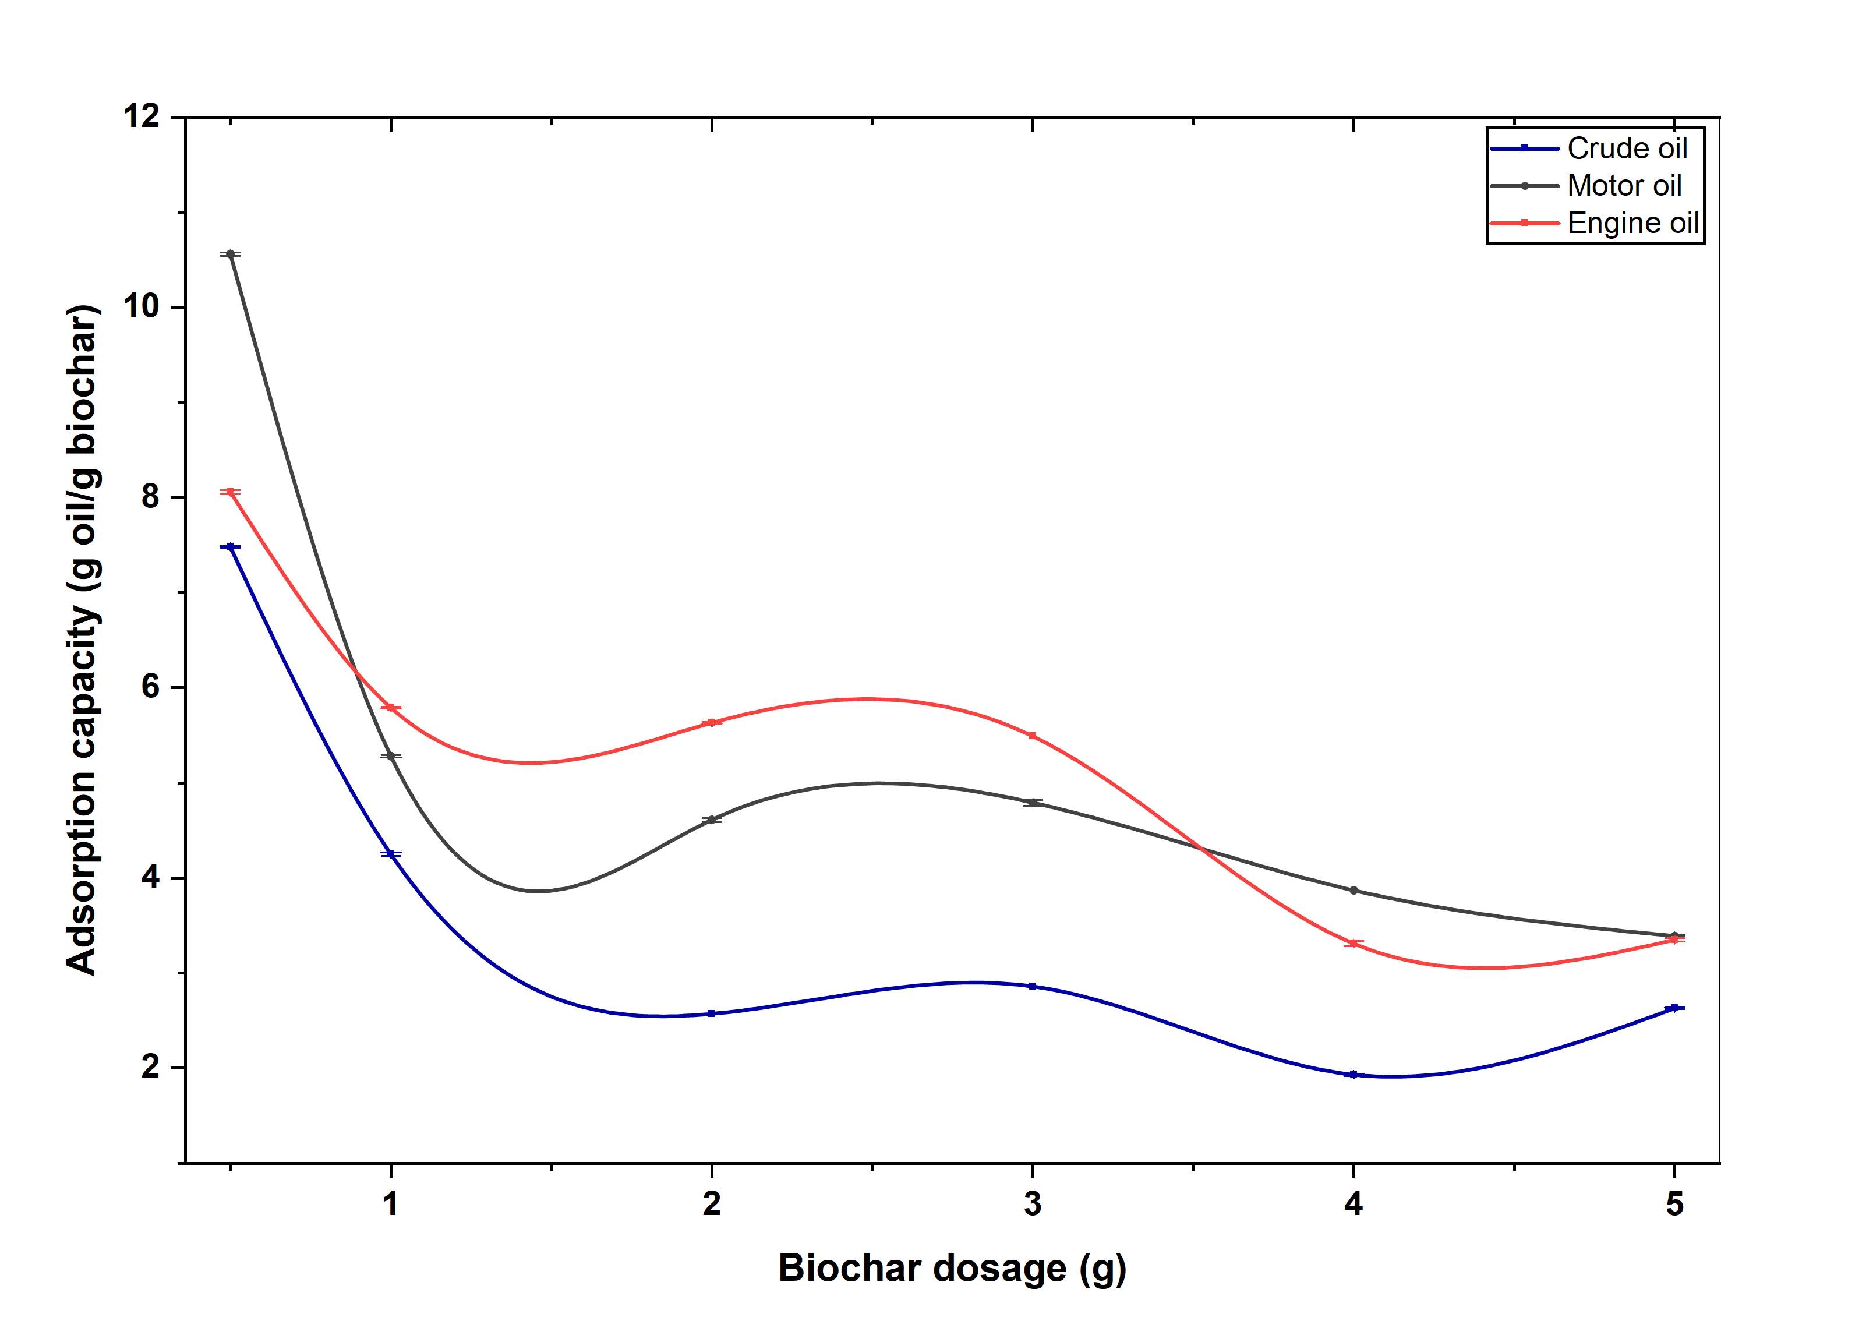

Fig. 1. Effects of varying biochar dosage (g) on adsorption capacity (g oil/g biochar) of different oil types
3.3 Variation of oil volume
It is revealed that motor oil shows the highest adsorption capacity at an initial volume of
60.0 mL, and moreover, the adsorption capacity is comparatively higher than that of other oil types (Fig. 2.). Adsorption capacity of engine oil shows a maximum value when 20.0 mL of oil is added initially. The maximum volume of crude oil giving the highest adsorption capacity is 40.0 mL. The aspect of investigation on oil concentration lies in its ability to significantly influence the adsorption kinetics, and more precisely, directs the equilibrium behavior of the sorption process on the prepared sorbents. Elevated concentrations enhance the gradient between the bulk solution and the center of the sorbent particle, leading to improved distribution of oil residue throughout the film surrounding the particle and within the internal network of the prepared sorbents [12],[31].

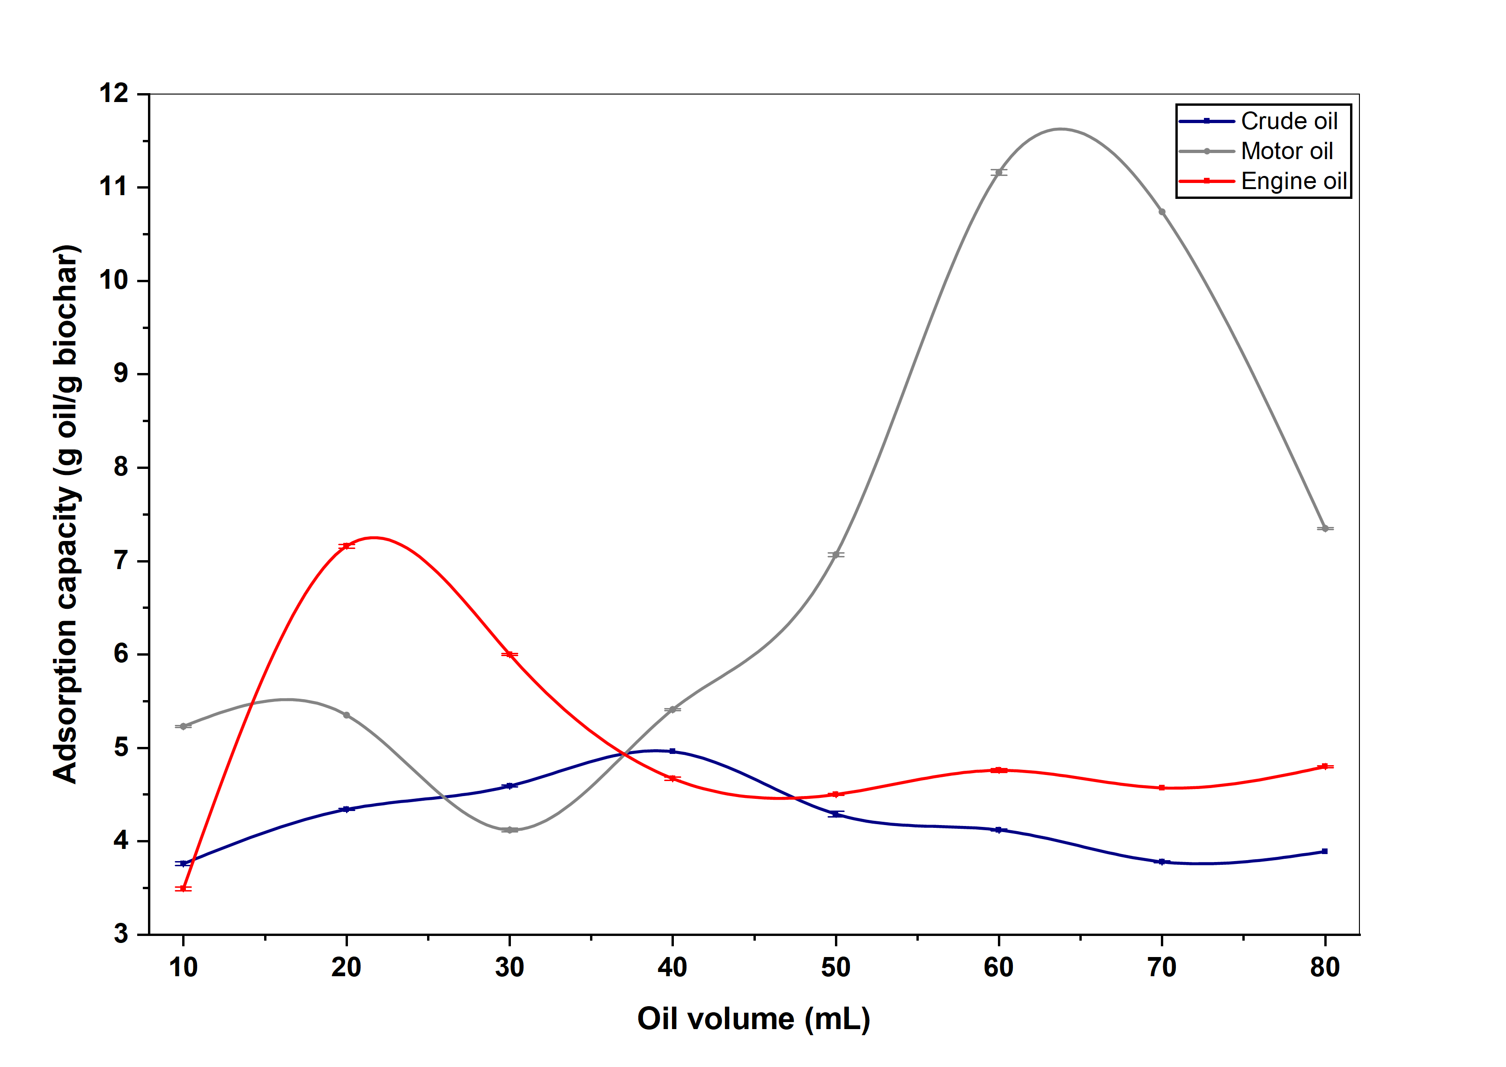

Fig. 2. Effects of varying oil volume (mL) on adsorption capacity (g oil/g biochar) of oil types
3.4 Variation of contact time
When considering the maximum adsorption capacity values determined, the highest capacity for crude oil is observed at a contact time of 30 min (Fig. 3.). The contact time required for the maximum capacity is observed to be 45 min for both engine oil and motor oil. According to the results, the maximum adsorption capacity increases with contact time, and after a certain point, it starts to decrease giving an optimum contact time for the maximum adsorption. As the concentration gradient between solution and oil spill is initially high, the sorption rate increases and after the maximum is reached, the sorption rate gradually decreases due to a decrease in concentration difference. The majority of adsorption sites within the adsorbent structure is occupied by oil. As the contact time increases, adsorption as well as desorption would take place as the adsorption sites get more occupied. When desorption increases over adsorption, adsorption capacity decreases leading to the results stated above. The high adsorption capacity can be due to the existence of empty active sites on the surface and due to the reducing strong attractive forces between the oil molecules and the adsorbent as the contact time increases [11]. The adsorption capacity after reaching the maximum value is not significantly changed thereafter, probably due to the establishment of equilibrium between adsorption and desorption processes that occur after saturation [11], [32]. Fig. 4. illustrates how oil is adsorbed to biochar with time over a 40 min period.
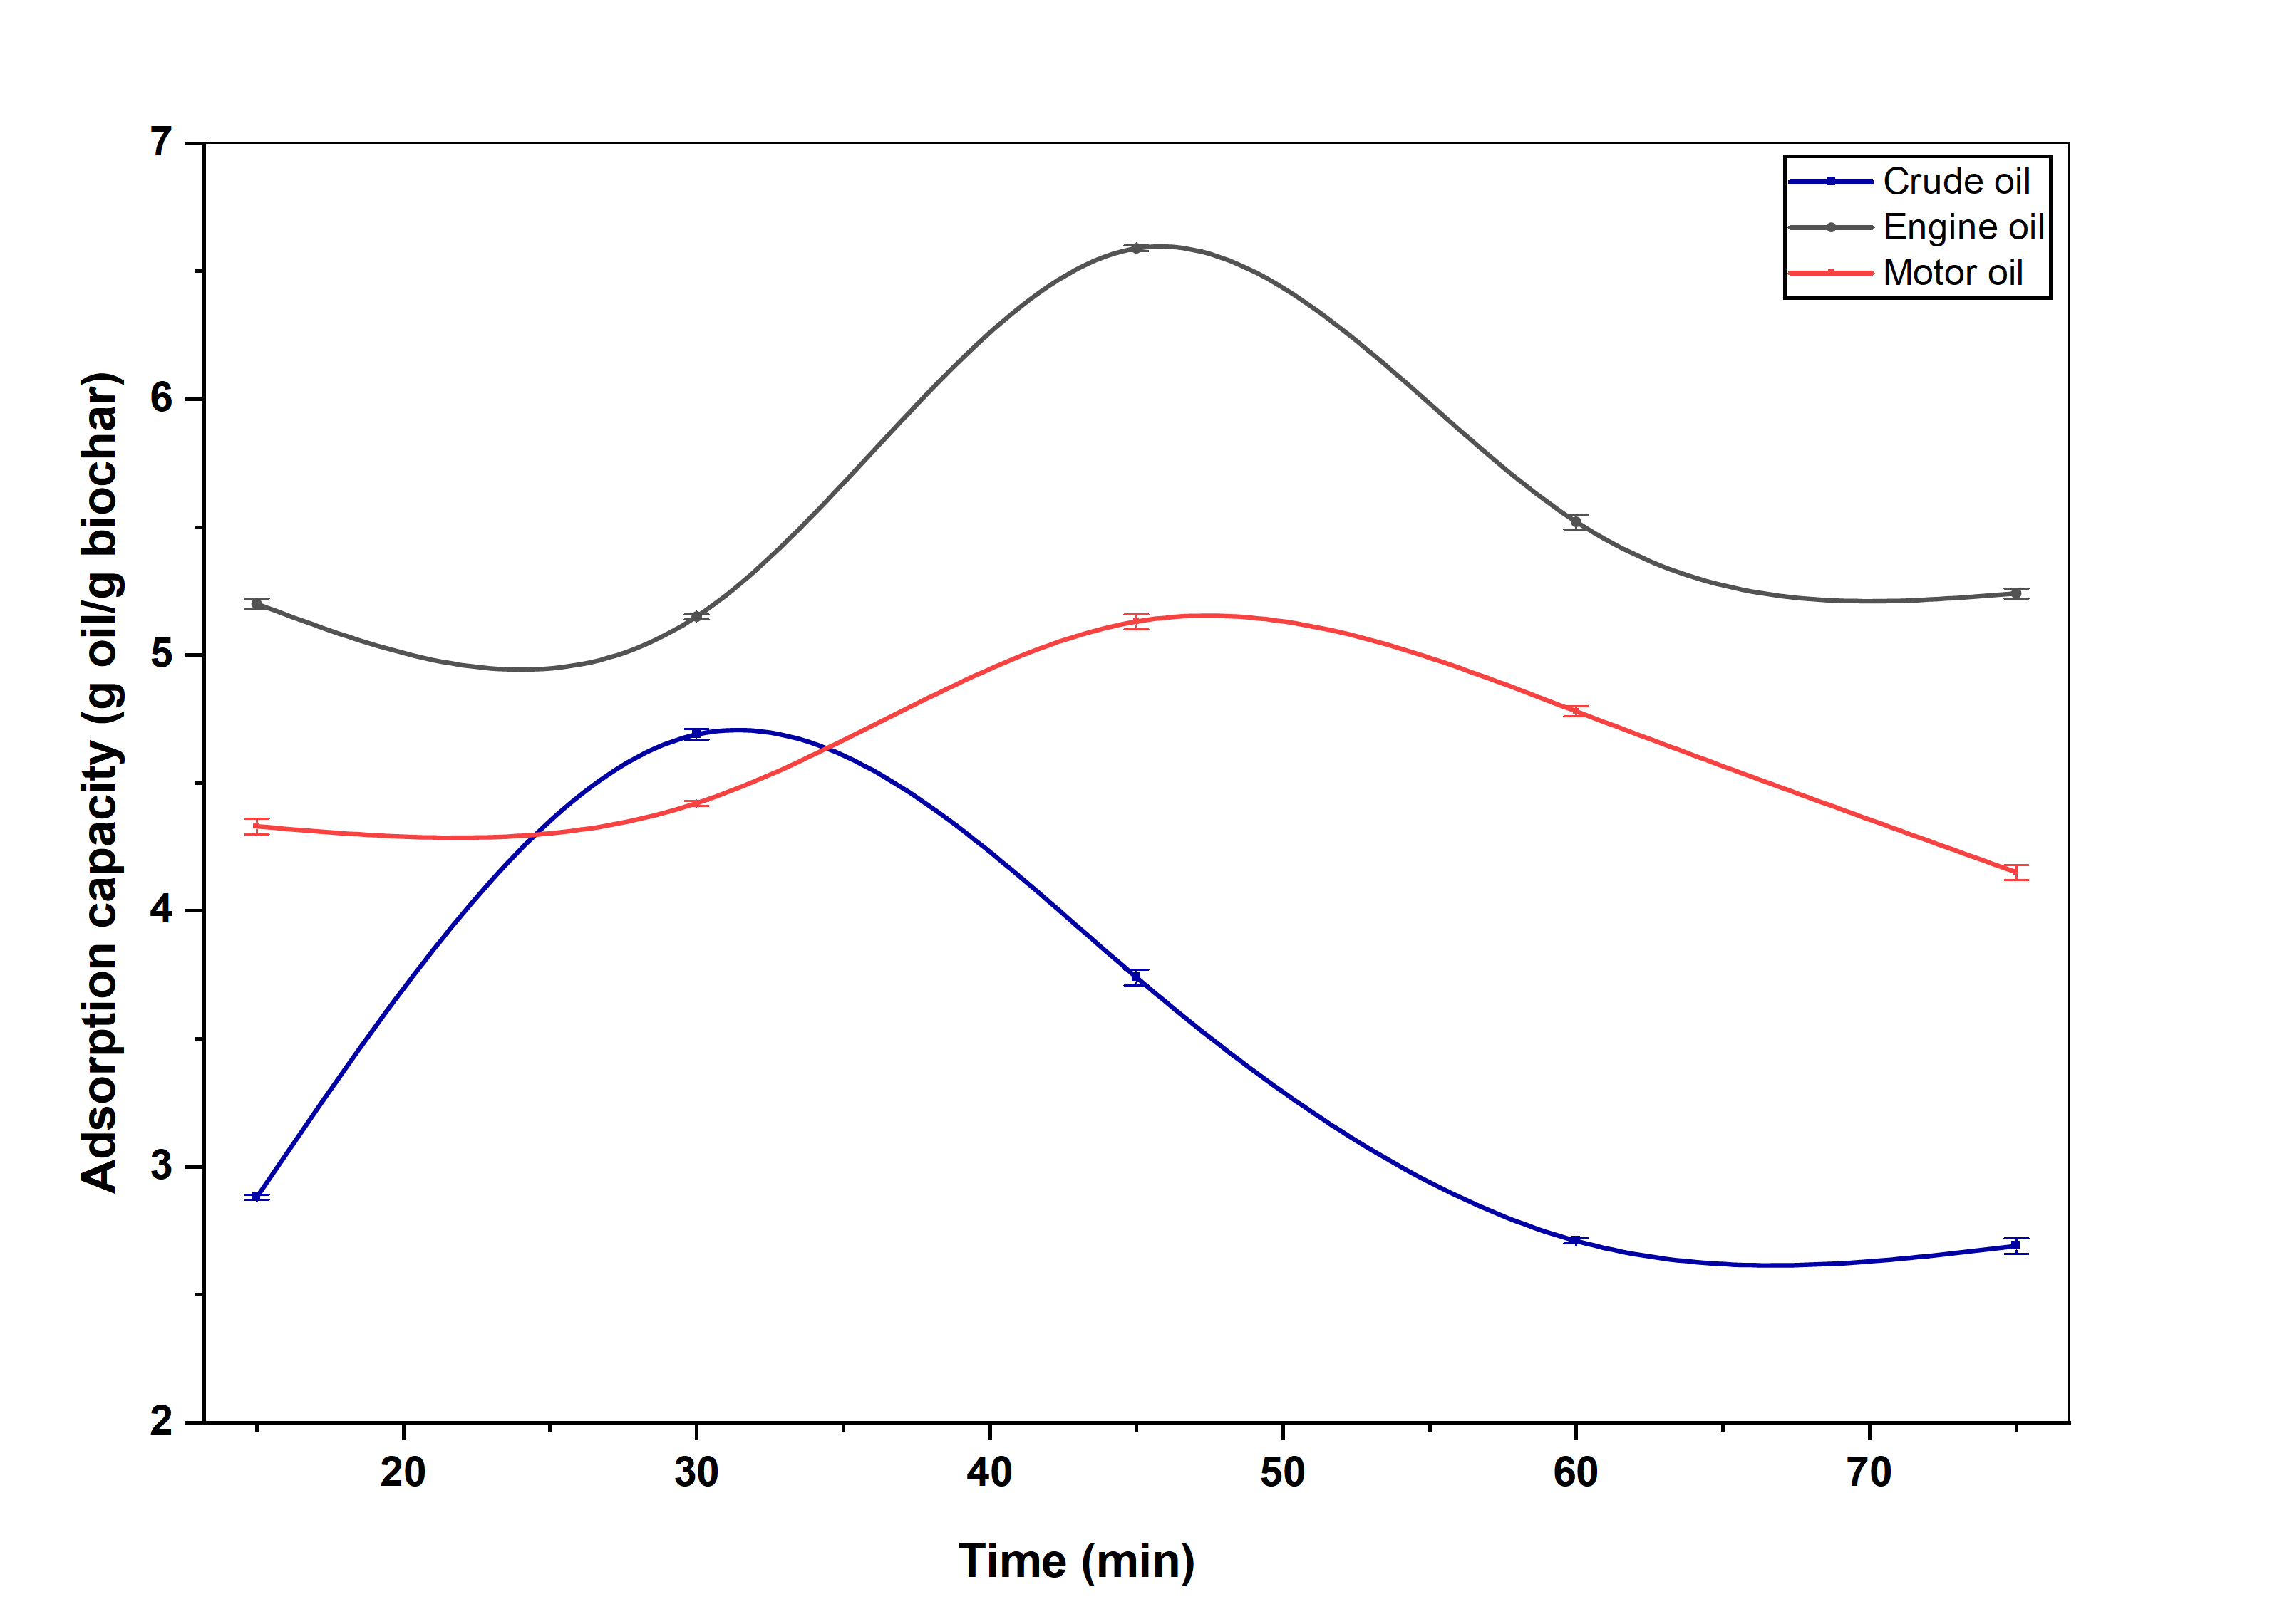

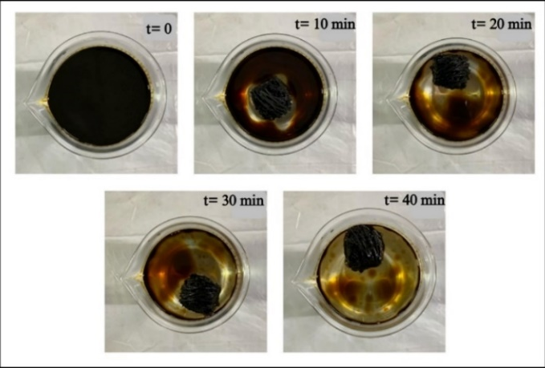
Fig. 3. Effects of varying contact time (min) on adsorption capacity (g oil/g biochar) of oil types

Fig. 4. Removal of oil from the water surface with time

3.5 Variation of size of adsorbent
According to the results obtained, the highest average adsorption capacity of 9.61 g oil/g biochar is shown by pieces of approximately 0.50 g, and the lowest capacity of 3.57 g oil/g biochar is shown by the entire fruit of biochar (Fig. 5.). The biochar of half of the fruit and quarter of the fruit showed adsorption capacity values between 7.01 g oil/g biochar and 7.62 g oil/g biochar, respectively; however, these two types do not exhibit a significant difference in capacities. Oil absorptivity depends on the active surface area of a sorbent material as the adsorption capacity increases with the surface area [33]. When considering the size of a sorbent material, the available surface area for oil binding becomes high when the size is smaller, showing higher adsorption capacities. Though larger pieces can capture more oil because of increased collisions with the oil-sorbent, their higher shear forces decrease the likelihood of retaining the oil. When considering the morphology of Cerbera manghas, the exocarp shows low adsorption and the middle sponge like mesocarp shows higher adsorption. The mesocarp is not exposed for adsorption because of the outer exocarp [33]. The increase in oil sorption capacity achieved by reducing the average size can be attributed to the expansion of the interfacial area [27].
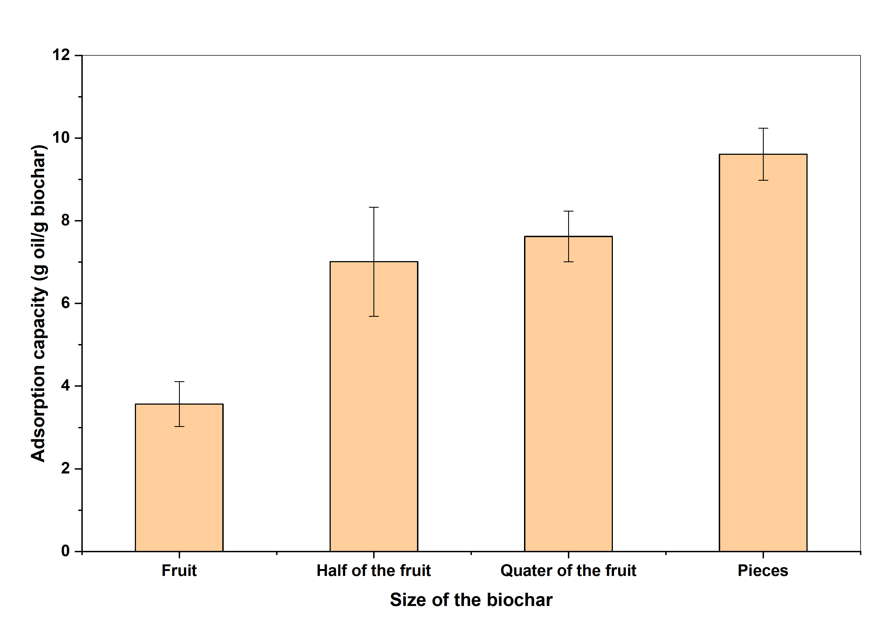

Fig. 5. Effects of varying adsorbent size on adsorption capacity of engine oil
3.6 Variation of salinity
It is clear from the results obtained that saltwater solutions experience greater adsorption capacity. As Fig. 6. illustrates, motor oil exhibits the highest adsorption capacity for all the three NaCl solutions, followed by engine oil and then crude oil. The variation of adsorption capacity with salinity can be explained using the presence of functional groups on the surface of the sorbent material. Biochar has a large surface area, and it contains functional groups that can interact with the ions in the saline solution. Polar functional groups interact via electrostatic interactions while nonpolar functional groups interact via hydrophobic interactions. Accessibility and availability of certain functional groups are affected by changing the pH and ionic strength of the solution. However, depending on the nature of the adsorbate and the salt concentration, the adsorption capacity differs [34].
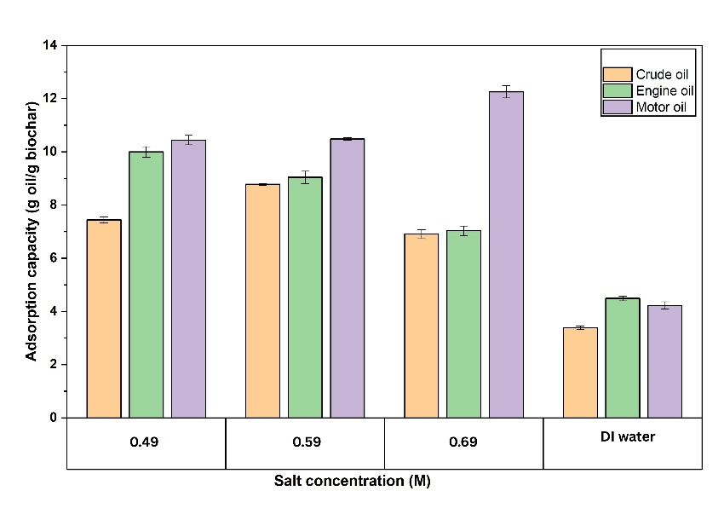

Fig. 6. Effects of varying salt concentration (M) on adsorption capacity (g oil/g biochar) of oil types. Deionized (DI) water was used as the control
3.7 Investigation of the effect of weathering of oil on adsorption
As observed in Fig. 7, adsorption capacity decreases with increase in standing time of the adsorbate oil. This clearly indicates that, when oil is kept unused for a longer time in a water body, its properties diminish and the ability of adsorption by a sorbent material becomes less. The highest capacity of 6.71 g oil/g biochar is observed after 1 day of an oil spill and according to the experimental procedure, while the lowest capacity of 5.30 g oil/g biochar is observed after 9 days of an oil spill (Fig. 7.). These capacity values would probably further decrease with the increase in standing time. Initially, an oil layer was observed on the top of the water surface, and thereafter, a sticky nature was observed with time where the floating oil started to gradually sink. Sinking particles were observed as globules after one week. Such observations could be attributed to compositional changes of oil associated with weathering. Fresh oil is less viscous, more volatile and floats on water. It contains more water-soluble components and is easily dispersed from the source. With time, weathering takes place, and weathered oil initially loses volatile components, and the oil becomes more viscous and more likely to coagulate giving a sticky nature. Over time, the ongoing process of weathering alters the composition of oil until it breaks down in the environment, eventually leaving behind minimal remnants such as tar balls [35],[36].
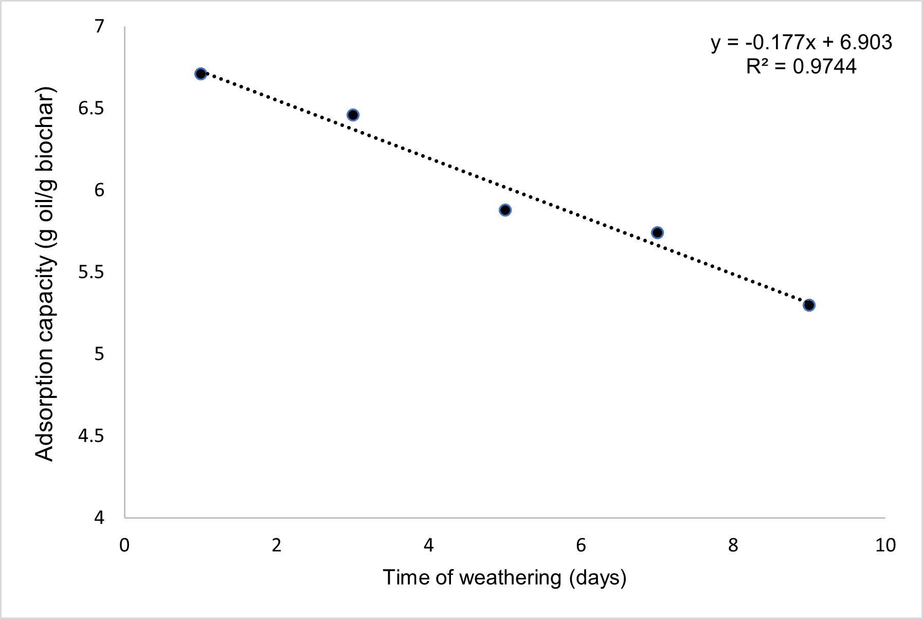

Fig. 7. Effects of varying time of weathering (days) on adsorption capacity (g oil/g biochar) of crude oil

3.8 Energy production from oil adsorbed biochar
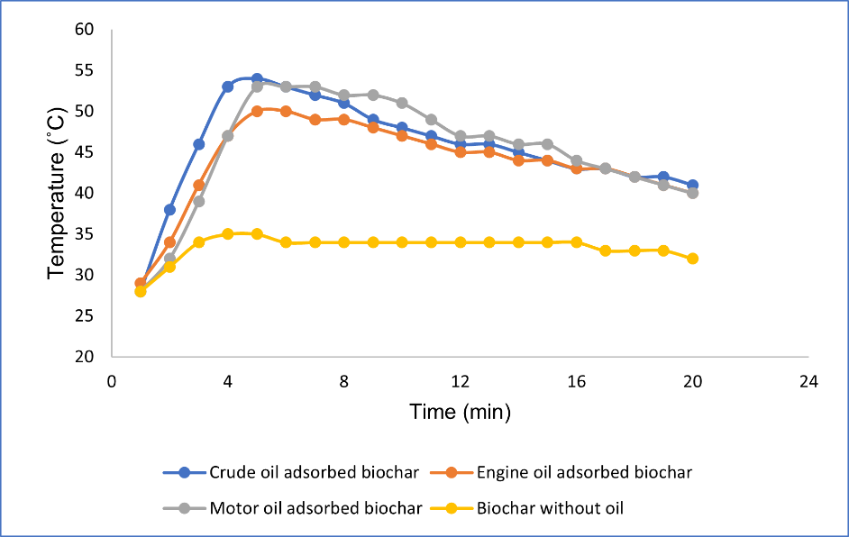
After the oil removal process, the possibility of energy production using oil-adsorbed biochar was investigated as a sustainable approach. In this context, the heat energy generated as indicated by the temperature rise can be used as an effective measure of energy production. Oil adsorbed biochar and biochar without oil being adsorbed are compared in Fig. 8, where in all cases a maximum temperature is reached followed by gradual decrease. Only a maximum temperature of 35 °C is obtained when raw biochar (i.e., without oil adsorption) is burnt, and higher maximum temperatures are obtained when oil adsorbed biochar is burnt. Among the three oil types, the highest temperature achieved is 54 °C for crude oil, and 50 °C for both engine and motor oil. This highlights the fact that oil adsorbed biochar can be effectively used to produce heat energy, and efficiency of this approach should be optimized by varying experimental parameters for large-scale applications. Though this process is advantageous due to the application of used biochar in an effective manner, a major drawback is the production of CO₂ during the burning process.

Fig. 8. Variation of temperature (℃) with time (min)

3.9 Isotherm studies
According to the results obtained, the adsorption process conforms to neither the Langmuir nor the Freundlich isotherm models (Fig. 9. [a], [b]) Therefore, it can be argued that the interaction of oil with biochar is not a chemisorption process, and hence, monolayer adsorption is not possible. Therefore, adsorption of oil by biochar of Cerbera manghas would take place via physisorption, indicating multilayer adsorption, where the entire process can be explained by adhesive and cohesive forces. Adhesive forces take place between oil molecules while cohesive forces take place between oil molecules and the surface of the sorbent material. Initially, pores of the sorbent may get occupied by oil molecules by cohesive forces. Thereafter, the other adsorbing oil molecules may bind to the initially adsorbed oil molecules via adhesive forces forming another layer on top of the initial oil layer [30]. This process would continue until the maximum capacity is reached. During the dripping period, excess of oil is removed from the sorbent which can be clearly observed. Smooth oil layers may not form on top of another due to the heterogenous nature of the sorbent material. Since the fruit of Cerbera manghas is a natural sorbent, the same conditions would not be possible in every fruit, and accordingly, the porosity and the efficiency of adsorption could differ. The oil adsorption process that occurs through adhesive−cohesive forces highlight the hydrophobic nature of the adsorbent. This hydrophobicity will allow the sorbent to be more likely to oil molecules over water molecules, specifying the fact that it would be more efficient to remove oil spills from water bodies. The use of biochar prepared from the fruit of Cerbera manghas highlights the importance of extending these findings toward large-scale applications. The biochar of the fruit of Cerbera manghas is extremely light and consequently, the ease of handling it is another advantage [18].
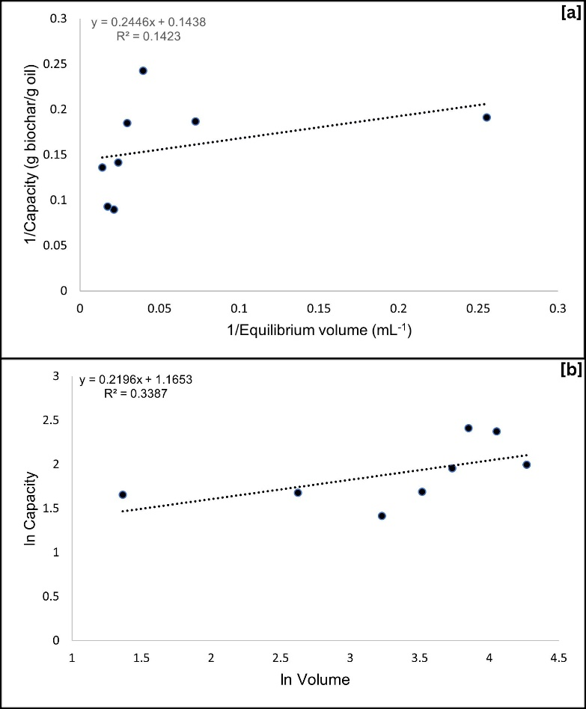

Fig. 9. Linearized [a] Langmuir and [b] Freundlich adsorption isotherm models for motor oil on biochar

3.10 Characterization of biochar
XRF spectral data clearly indicates that biochar used in this study contains Ca, Fe and K (Fig. 10. [a]). Higher Ca content, and the presence of K and Fe could be attributed to the fact that Cerbera manghas grows near coastal areas. Adsorption of oil has led to the disappearance of K or decrease in levels below its detection limit (Fig. 10. [b]). Moreover, the Fe content has increased, while the Ca content has decreased during oil adsorption. Most K exists on biochar surfaces in water-soluble forms, such as K₂O or KOH, and hence, upon the addition of oil to water, some K⁺ ions would transfer from the biochar phase to water phase. The disappearance of K signals may also result from surface masking caused by the adsorbed oil layer. The reason for the increase in the Fe amount would probably be due to the presence of Fe in the oil sample, which would result in the concomitant decrease in the relative extent of Ca [37].
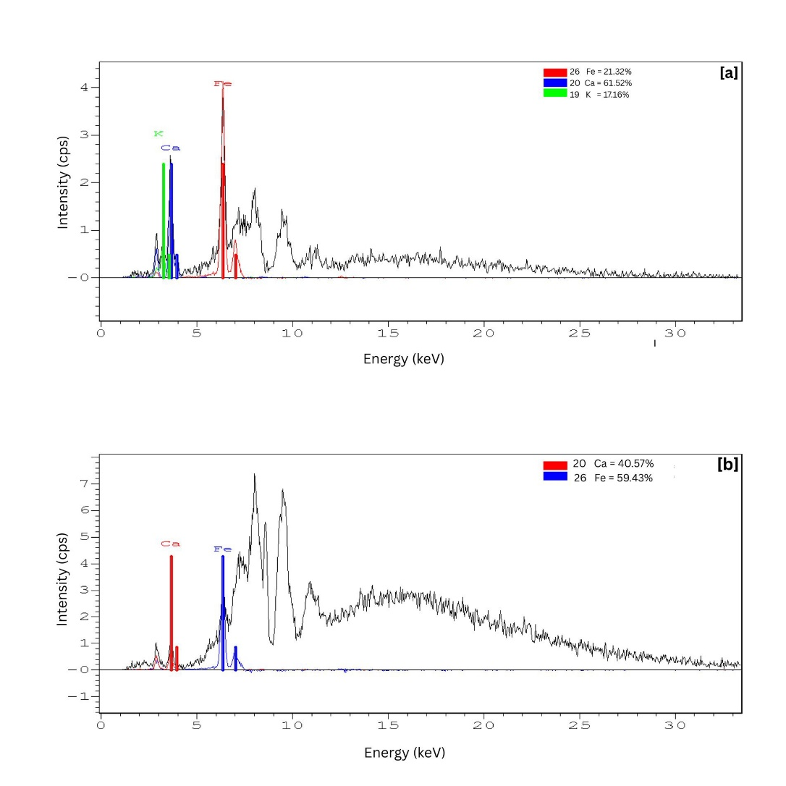

Fig. 10. XRF spectra of [a] biochar without oil and [b] biochar with engine oil
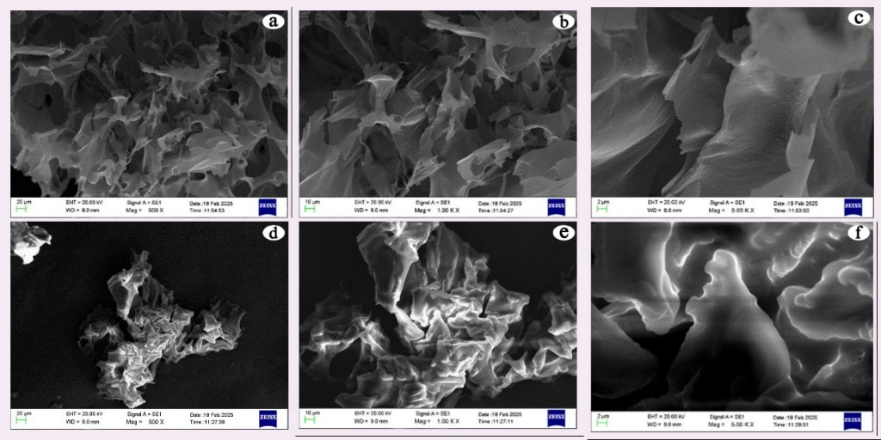
SEM was used to analyze the surface morphologies of the biochar prepared from Cerbera manghas before oil adsorption (Fig. 11. [a], [b] and [c]) and biochar with crude oil (Fig. 11. [d], [e] and [f]). SEM images of biochar before oil adsorption reveals an irregular structure and a porous surface [34], which could be due to the amorphous nature of organic raw materials used during pyrolysis. Pyrolysis carbonizes the carbonaceous raw materials used, creating many adsorbent surfaces capable of adsorbing molecules. The pyrolysis temperature of 350 − 400 ℃ used for a period of 20 min would be sufficient for the above-mentioned process [34]. After oil is adsorbed to biochar, pores get filled with oil, and hence, the adsorbent becomes compact as shown in Fig. 11 [d], [e] and [f].

Fig. 11. SEM images of [a][b][c] biochar before adsorption and [d][e][f] biochar with crude oil

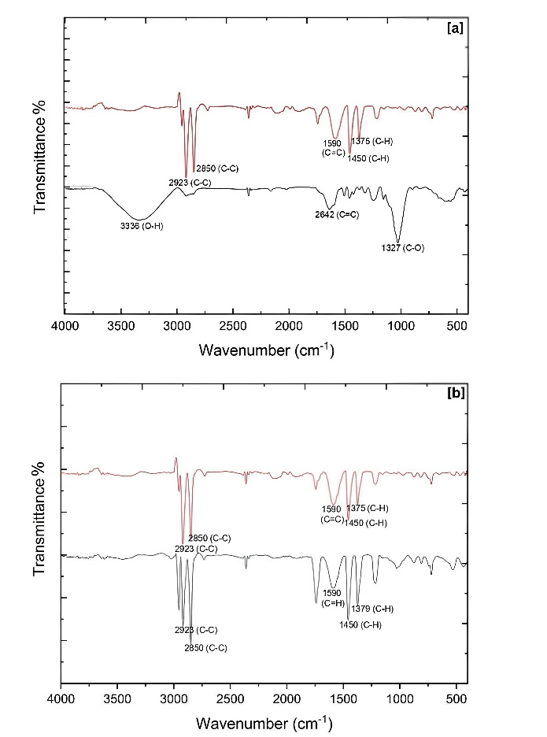
The FTIR spectrum of the raw sorbent material consists of a band at 3336 cm⁻¹ which is attributed to the O–H stretching vibration of hydroxyl groups (Fig.12. [a] – black spectrum). The bands at 1590 cm⁻¹ and 1642 cm⁻¹ indicate strong stretching vibration of non-conjugated dienes (-C=C-) or aromatic hydrocarbons having benzene like rings, while the band at 1027 cm⁻¹ is assigned to carbonyl components such as esters, ethers, alcohols and acids[38]. The FTIR spectrum of biochar before oil adsorption (Fig. 12. [a] – red spectrum) highlights major differences, where the peaks of O-H and carbonyl components have disappeared and sharp bands at 2850 cm⁻¹ and 2923 cm⁻¹ have appeared, and they can be attributed to C-H stretching vibration on aliphatic compounds[38],[39]. The presence of a large number of polar organic functionalities in the adsorbent provides necessary condition for oil molecules, which are also organic in nature, to be attracted through intermolecular forces. These interactions are, however, not specific to support the physisorption nature of attraction as indicated through adsorption isotherm studies. Nevertheless, it can be argued that due to the compatibility of size factors, adsorbed oil molecules are trapped within the adsorbent phase, leading to effective oil removal. Furthermore, bands in the range of 1375 cm⁻¹ and 1450 cm⁻¹ indicate bending vibration of C-H bond. These results highlight the fact that after charring, surface water molecules have been replaced by H atoms. Comparison of the two FTIR spectra of biochar before and after crude oil adsorption indicates that there is no significant difference between the two spectra (Fig. 12. [b]). This proves that there is no chemical bond formation or chemical bond cleavage during the oil adsorption process, further providing evidence for physical adsorption.

Fig. 12. FTIR spectrum of ([a]-black) raw material, ([a], [b]-red) biochar without oil and ([b]-black) biochar after adsorption of crude oil

4. Conclusion
This study highlights the use of biochar of the fruit of Cerbera manghas as a natural sorbent material to clean up oil spills from water bodies. The efficiency of biochar produced by this natural sorbent is studied by varying experimental parameters, such as biochar dosage, size of biochar, contact time, oil type, oil volume, salinity, and the effect of weathering. The results suggest that the adsorption process does not conform to Langmuir or Freundlich isotherm models, indicating a multilayer adsorption process and highlighting the hydrophobic nature of the adsorbent. This can be extended by studying other types of oil as well. Efficiency of adsorption can be further studied by applying modifications to biochar prepared via different activation processes. The use of this natural sorbent presents a beneficial and effective approach for cleaning up oil spills in water sources in a practical and applicable manner. Metals, Ca, K and Fe, are predominant on the surface of biochar adsorbent according to XRF investigation, while SEM images confirms that the biochar has high porosity and an irregular structure. Upon adsorption of oil, pores get filled with oil and the adsorbent becomes compacted. FTIR data indicate that there is no significant difference between surface functional groups before and after oil adsorption, which highlights the fact that there is no chemical bond formation or chemical bond cleavage during adsorption. Furthermore, the use of this biochar can be expanded for large-scale oil removal processes, where a mesh can be used to place the biochar in water sources. Because of the buoyant nature of this biochar, it can easily be removed after oil adsorption, making it a more practical, effective and sustainable approach.
Disclaimer (Artificial intelligence)
Author(s) hereby declares that NO generative AI technologies such as Large Language Models (ChatGPT, COPILOT, etc.) and text-to-image generators have been used during the writing or editing of this manuscript.
References
[1] V. Saxena, Water Quality, Air Pollution, and Climate Change: Investigating the Environmental Impacts of Industrialization and Urbanization, vol. 236, no. 2. Springer International Publishing, 2025. doi: 10.1007/s11270-024-07702-4.
[2] M. I. Bastos, P. C. Roebeling, F. L. Alves, and S. Villasante, “Ecological Informatics High risk water pollution hazards affecting Aveiro coastal lagoon ( Portugal ) – A habitat risk assessment using InVEST,” vol. 76, no. November 2022, 2023, doi: 10.1016/j.ecoinf.2023.102144.
[3] D. R. E. Ewim et al., “Survey of wastewater issues due to oil spills and pollution in the Niger Delta area of Nigeria: a secondary data analysis,” Bull. Natl. Res. Cent., vol. 47, no. 1, pp. 1–20, 2023, doi: 10.1186/s42269-023-01090-1.
[4] B. Zhang, E. J. Matchinski, B. Chen, X. Ye, L. Jing, and K. Lee, Marine oil spills-oil pollution, sources and effects, Second Edi. Elsevier Ltd., 2018. doi: 10.1016/B978-0-12-805052-1.00024-3.
[5] A. Upamali, P. B. T. Pradeep, K. S. Triantafyllidis, and M. Vithanage, “Propensity and appraisal of biochar performance in removal of oil spills : A comprehensive review,” Environ. Pollut., vol. 288, no. June, p. 117676, 2021, doi: 10.1016/j.envpol.2021.117676.
[6] P. L. Yap, M. J. Nine, K. Hassan, T. T. Tung, D. N. H. Tran, and D. Losic, “Graphene-Based Sorbents for Multipollutants Removal in Water: A Review of Recent Progress,” Adv. Funct. Mater., vol. 31, no. 9, pp. 1–25, 2021, doi: 10.1002/adfm.202007356.
[7] I. Ali, M. Asim, and T. A. Khan, “Low cost adsorbents for the removal of organic pollutants from wastewater,” J. Environ. Manage., vol. 113, pp. 170–183, 2012, doi: 10.1016/j.jenvman.2012.08.028.
[8] O. D. Agboola and N. U. Benson, “Physisorption and Chemisorption Mechanisms Influencing Micro (Nano) Plastics-Organic Chemical Contaminants Interactions: A Review,” Front. Environ. Sci., vol. 9, no. May, pp. 1–27, 2021, doi: 10.3389/fenvs.2021.678574.
[9] F. E. Khalid et al., “Application of Cogon Grass ( Imperata cylindrica ) as Biosorbent in Diesel-Filter System for Oil Spill Removal,” 2021.
[10] T. Dong, G. Xu, and F. Wang, “Oil spill cleanup by structured natural sorbents made from cattail fibers,” Ind. Crops Prod., vol. 76, pp. 25–33, 2015, doi: 10.1016/j.indcrop.2015.06.034.
[11] U. A. Abel, G. R. Habor, and O. I. Oseribho, “Adsorption Studies of Oil Spill Clean-up Using Coconut Coir Activated Carbon Adsorption Studies of Oil Spill Clean-up Using Coconut Coir Activated Carbon ( CCAC ),” no. April, 2020, doi: 10.11648/j.ajche.20200802.11.
[12] Y. G. Anusha, A. A. Machado, and L. Mulky, “A Comparative Study of Treatment Methods of Raw Sugarcane Bagasse for Adsorption of Oil and Diesel,” Water. Air. Soil Pollut., vol. 234, no. 4, 2023, doi: 10.1007/s11270-023-06210-1.
[13] S. E. Agarry, K. M. Oghenejoboh, E. O. Oghenejoboh, C. N. Owabor, and O. O. Ogunleye, “Adsorptive Remediation of Crude Oil Contaminated Marine Water Using Chemically and Thermally Modified Coconut ( Cocos nucifera ) Husks,” vol. 8, no. 2, pp. 694–707, 2020.
[14] D. Quigley and D. Fenwick, “Cerbera sp. (Apocynaceae) drift mesocarps: first record from British waters and a summary of previous records from north-western Europe,” Cah. Biol. Mar., vol. 60, no. October, pp. 419–423, 2019, doi: 10.21411/CBM.A.A9AA3201.
[15] M. Eddleston and S. Haggalla, “Fatal injury in Eastern Sri Lanka, with special reference to cardenolide self-poisoning with Cerbera manghas fruits,” Clin. Toxicol., vol. 46, no. 8, pp. 745–748, 2008, doi: 10.1080/15563650701668617.
[16] D. Bryan, A. Sommer-m, P. E. Ordoñez, E. Bastardo-gonz, M. Ricaurte, and C. Navas-c, “Biochar-Based Materials for Wastewater Treatment : A Review,” 2024.
[17] A. Review, “Application of Sorbents for Oil Spill Cleanup Focusing on Natural-Based Modified Materials :,” pp. 1–22, 2020.
[18] Z. Zhang et al., “Enhanced properties of magnetic ultralight pear sponge assisted by Fenton-like reaction for oil-water separation,” J. Taiwan Inst. Chem. Eng., vol. 126, pp. 332–340, 2021, doi: 10.1016/j.jtice.2021.07.009.
[19] M. Yang, J. Wang, Y. Chen, and J. Gao, “Biochar produced from cotton husks and its application for the adsorption of oil products Biochar produced from cotton husks and its application for the adsorption of oil products,” 2020, doi: 10.1088/1755-1315/545/1/012022.
[20] J. Saj, K. George, R. Dewan, M. Mittal, and A. Irshad, “Oil Spill Removal Using Natural Sorbents,” vol. VII, no. 13, pp. 13–18, 2020.
[21] D. S. M. De Silva, “Surface modification of Trema orientalis wood biochar using natural coconut vinegar and its potential to remove aqueous calcium ions : column and batch studies,” vol. 28, no. 1, pp. 0–3, 2023.
[22] K. O. Iwuozor, E. Chizitere, J. O. Ighalo, F. O. Omoarukhe, P. E. Omuku, and A. George, “A Review on the thermochemical conversion of sugarcane bagasse into biochar,” vol. 6, no. April, 2022.
[23] A. O. Ifelebuegu, T. Vu, A. Nguyen, and P. Ukotije-ikwut, “Journal of Environmental Chemical Engineering Liquid-phase sorption characteristics of human hair as a natural oil spill sorbent,” Biochem. Pharmacol., 2015, doi: 10.1016/j.jece.2015.02.015.
[24] O. Abdelwahab, “Assessment of raw luffa as a natural hollow oleophilic fibrous sorbent for oil spill cleanup,” Alexandria Eng. J., vol. 53, no. 1, pp. 213–218, 2014, doi: 10.1016/j.aej.2013.11.001.
[25] A. T. Hoang and X. D. Pham, “An investigation of remediation and recovery of oil spill and toxic heavy metal from maritime pollution by a new absorbent material,” vol. 4177, 2018, doi: 10.1080/20464177.2018.1544401.
[26] T. M. Tamer, A. M. Omer, R. E. Khalifa, A. A. Ali, Y. A. Ammar, and M. S. M. Eldin, “Aminated chitosan-g-poly ( butyl acrylate ) copolymer for heavy oil spills removal : kinetic , isotherm , and thermodynamic investigations,” vol. 226, pp. 319–327, 2021, doi: 10.5004/dwt.2021.27275.
[27] R. Behnood, B. Anvaripour, N. Jaafarzade, and H. Fard, “Application of Natural Sorbents in Crude Oil Adsorption,” vol. 2, no. 4, pp. 1–11, 2013.
[28] G. A. El-din, A. A. Amer, G. Malsh, and M. Hussein, “Study on the use of banana peels for oil spill removal,” Alexandria Eng. J., 2017, doi: 10.1016/j.aej.2017.05.020.
[29] G. Kataya, M. Issa, and M. Jeguirim, “Characterization and Environmental Application Potential of Banana Peels Biochar †,” 2023.
[30] J. J. D. T. Urgel, J. M. A. Briones, E. B. Diaz, K. M. N. Dimaculangan, K. L. Rangel, and E. C. R. Lopez, “Batch adsorption of diesel oil in water using saba banana peel biochar immobilized in teabags,” J. Eng. Appl. Sci., vol. 71, no. 1, pp. 1–19, 2024, doi: 10.1186/s44147-024-00398-7.
[31] R. Ghonim, C. Of, T. Applications, and Y. A. Ammar, “Efficient eco-friendly crude oil adsorptive chitosan derivatives : kinetics , equilibrium and thermodynamic studies Efficient eco-friendly crude oil adsorptive chitosan derivatives : kinetics , equilibrium and thermodynamic studies,” no. January, 2019, doi: 10.5004/dwt.2019.24166.
[32] P. R. Ukotije-ikwut, A. K. Idogun, C. T. Iriakuma, and A. Aseminaso, “A Novel Method for Adsorption using Human Hair as a Natural Oil Spill Sorbent,” vol. 7, no. 8, pp. 1754–1764, 2016.
[33] R. Wahi, L. C. Abdullah, T. Choong, S. Yaw, Z. Ngaini, and M. N. Mobarekeh, “Oil Removal from Aqueous State by Natural Fibrous Sorbent : An Overview Department of Chemistry , Universiti Malaysia Sarawak , 94300 Kota Samarahan , Sarawak ,” Sep. Purif. Technol., 2013, doi: 10.1016/j.seppur.2013.04.015.
[34] J. Jun et al., “Removal of diesel oil from water using biochar derived from waste banana peels as adsorbent,” Carbon Res., 2024, doi: 10.1007/s44246-024-00100-9.
[35] P. Zito, E. B. Overton, G. M. Olson, P. L. Adhikari, and T. O. Society, “THE OFFICIAL MAGAZINE OF THE OCEANOGRAPHY SOCIETY CITATION Tarr, M.A., P. Zito, E.B. Overton, G.M. Olson, P.L. Adhikari, and C.M. Reddy. 2016. Weathering of oil spilled in the marine environment.,” vol. 29, no. 3, pp. 126–135, 2016.
[36] I. A. Mendelssohn et al., “Oil impacts on coastal wetlands: Implications for the Mississippi River delta ecosystem after the deepwater horizon oil spill,” Bioscience, vol. 62, no. 6, pp. 562–574, 2012, doi: 10.1525/bio.2012.62.6.7.
[37] G. Gascó, S. P. Barragán-Mantilla, J. Paz-Ferreiro, and A. Méndez, “The effect of thiourea activation on physicochemical and catalytic properties of biochars and hydrochars from sugarcane bagasse: Application to metal recovery from wastes,” Waste Manag., vol. 200, no. April, 2025, doi: 10.1016/j.wasman.2025.114773.
[38] M. Bardalai and D. K. Mahanta, “Characterisation of Biochar Produced by Pyrolysis from Areca Catechu Dust,” Mater. Today Proc., vol. 5, no. 1, pp. 2089–2097, 2018, doi: 10.1016/j.matpr.2017.09.205.
[39] S. Yoshimoto, N. Luthfi, K. Nakano, T. Fukushima, and K. Takisawa, “Effects of potassium on hydrothermal carbonization of sorghum bagasse,” Bioresour. Bioprocess., vol. 10, no. 1, pp. 4–11, 2023, doi: 10.1186/s40643-023-00645-4.

