Assessment of the Physical Development Trends of Residential Areas in Natural Hazard-Prone Regions of Kurdistan Province, Western Iran

Abstract
Cities in Kurdistan Province have a high potential for vulnerability to natural hazards. Given the importance of this issue, this study evaluates the trend of physical development in the cities of Kurdistan Province towards areas that are susceptible to natural hazards. The Landsat satellite images, ALOS PALSAR 12.5m DEM, and digital information layers were used as the main data sources. The main analytical tools used in this study are ArcGIS and ENVI. The results of the physical development assessment indicate that Sanandaj city has experienced the most significant physical development, with an increase of 12.35 km² over 30 years. However, in terms of relative physical development (development relative to the area of the city), Sarvabad city has shown the highest relative physical development, with an increase of approximately 2.3 times over the same period. Furthermore, the examination of physical development in relation to the geomorphological conditions of the cities indicates that geomorphological factors play a primary role in the trend and direction of physical development in Kurdistan Province. Geomorphological constraints have led many residential areas to encroach into hazardous regions in recent years. According to the results obtained from 1992 to 2022, the following areas have encroached into hazardous zones: 1.84 km² from Baneh, 0.51 km² from Bijar, 0.29 km² from Dehgolan, 0.33 km² from Divandareh, 0.14 km² from Sarvabad, 1.49 km² from Saghez, 2.72 km² from Sanandaj, 0.36 km² from Qorveh, 0.23 km² from Kamyaran, and 1.06 km² from Marivan. Based on these results, it is recommended that urban planners prioritize the expansion of residential areas in safer locations and implement risk reduction strategies in hazardous zones. Future urban development should integrate geomorphological assessments to minimize vulnerability to natural hazards. These findings can serve as guidelines for sustainable urban planning and disaster risk management in Kurdistan Province.
Keywords: Geomorphology, Physical Development, Vulnerability to Natural Hazards, Urban Planning, Risk Management, Kurdistan Province, Residential Expansion.

1. Introduction
The steady rise in population in recent years has resulted in the rapid expansion of urban areas (Hassan et al., 2023). This increase in population density and urban development has created conditions that heighten exposure to human-induced hazards and elevate the risk of natural disasters (Lewis & Jaana, 2005; Gibson et al., 2016; Aarthi et al., 2018; Bharath et al., 2018; Fekt et al., 2022). Since many natural hazards frequently occur within cities (Bakkensen et al., 2016), these events affect millions of people every year (Jha, 2012). Natural hazards manifest in various forms, and the occurrence of one type can often trigger others (Malalgoda et al., 2010; Mas et al., 2014). For example, earthquakes may cause landslides, flooding, or ground subsidence (Ganjaeian et al., 2023), while tectonic activity can influence the utilization of river resources (Goorabi et al., 2022). Additionally, natural hazards can serve as precursors to human-induced hazards such as pollution, indicating that one hazard can lead to a chain of subsequent risks. The susceptibility of different regions to these hazards depends on geomorphological, geological, hydrological, and climatic factors (Ganjaeian et al., 2020; Negahban et al., 2019). Urban environments are particularly vulnerable (Salari et al., 2020; Nayyeri et al., 2017) because any hazard occurring within cities often results in extensive destruction and losses.
Analyses of natural hazards reveal that Iran ranks among the world’s most hazard-prone nations. In recent years, the country has frequently experienced floods, earthquakes, ground subsidence, and mass movements. Due to Iran’s considerable geological, geomorphological, and hydroclimatic diversity—especially in Kurdistan Province (Ganjaeian et al., 2021)—different areas within Kurdistan demonstrate varying levels of susceptibility to specific hazards. As a result, many of its cities face a significant risk of geomorphological hazards. This high exposure, combined with weak management and insufficient attention to urban vulnerability, has driven urban expansion into high-risk zones, thereby intensifying the damage from such hazards. Given these circumstances, evaluating and monitoring the vulnerability of Kurdistan’s cities to natural hazards is critically important. Moreover, one of the major contributors to rising urban vulnerability in this region has been the unplanned physical expansion of cities without consideration of environmental constraints. Therefore, alongside determining the degree of vulnerability of Kurdistan’s cities to environmental hazards, it is vital to assess and regulate urban growth trends extending into high-risk zones. In light of these issues, the present study seeks to analyze patterns of urban expansion in Kurdistan Province, evaluate their exposure to natural hazards, and investigate how physical development has progressed toward hazardous regions. Based on these considerations, the study aims to answer the following research questions:
- What has been the trend of physical development in the cities of Kurdistan Province from 1992 to 2022?
- Which areas within the cities of Kurdistan Province exhibit a high potential for vulnerability to natural hazards?
- What has been the trend of physical development and development towards vulnerable areas of cities in Kurdistan province in recent years?
The importance of this research topic has motivated numerous studies in related fields. Several prior investigations have analyzed urban physical growth patterns through the use of multi-temporal satellite imagery (Bagan & Yamagata, 2012; Notti et al., 2018; Chini et al., 2019; Negahban et al., 2020; Hussain et al., 2022; Liang et al., 2024). Other works have concentrated on determining areas susceptible to natural hazards by integrating various environmental and anthropogenic factors (Herryal et al., 2017; Bourenane et al., 2019; Saha & Agrawal, 2020; Ghosh et al., 2022; Vekaria et al., 2023; Sundaram et al., 2023; Osman & Das, 2023; Qi et al., 2024). Moreover, some studies have aimed to identify potential zones for urban expansion by examining both natural and human parameters (Ramadan et al., 2021; Gao et al., 2023; Xiang et al., 2024). In addition, several researchers have investigated management approaches for monitoring and regulating urban growth in relation to natural hazard exposure (Ansah, 2016; Parhi et al., 2018; Munoz et al., 2022; Cao et al., 2024; Boateng).
An examination of the literature reveals that the majority of existing studies have either concentrated on the physical expansion of urban areas or identified potential development zones without sufficiently addressing the risks these cities face. Unlike many of these prior efforts, the present research not only analyzes the patterns of urban growth but also maps out the vulnerable regions within the urban and peri-urban zones of cities in Kurdistan Province. Furthermore, it evaluates the extent to which residential development has expanded toward these hazard-prone areas.

2. Study Area
In this study, the urban areas (county centers) of Kurdistan Province in western Iran have been selected as the study area. Kurdistan Province consists of ten counties and is bordered to the south by Kermanshah Province, to the north by Zanjan and West Azerbaijan Provinces, to the east by Hamadan and Zanjan Provinces and to the west by Iraq (Fig. 1). Due to its location within various geological units, Kurdistan Province exhibits a high diversity of landforms including mountains, hills, alluvial fans, plains, and floodplains, among others (Yamani et al., 2020). Additionally, the province demonstrates significant climatic variability, with precipitation levels ranging from an average of 900 mm in Marivan to an average of 300 mm in Qorveh and Bijar.

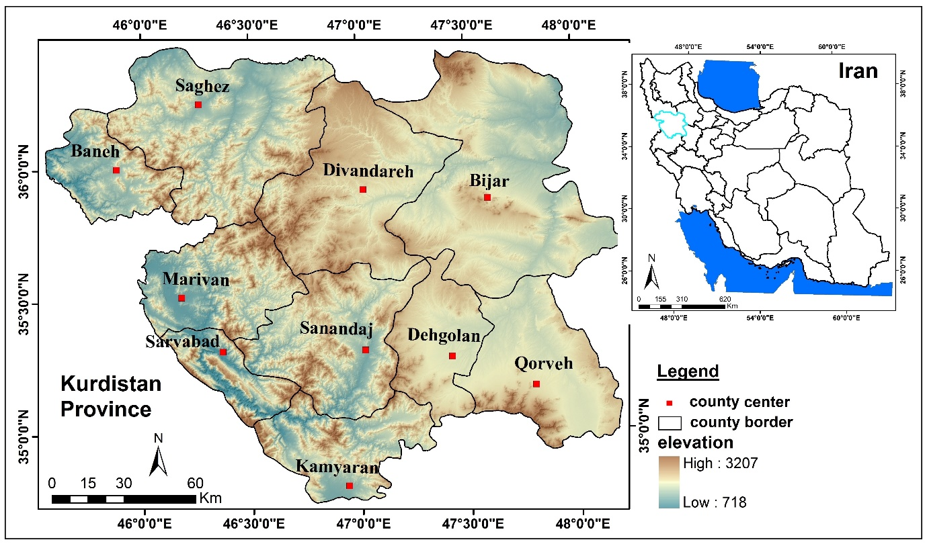
Fig. 1. Location of the study area

3. Materials and methods
In this study, descriptive-analytical methods and software tools have been employed. The research data includes 1:50000 topographic maps for urban areas in Kurdistan Province (to assess the topographic conditions of urban areas), 12.5 m ALOS PALSAR digital elevation model (DEM) (for preparing elevation maps and drainage networks), as well as Landsat satellite images (Landsat 5, 7, and 8, sensors TM, ETM, and OLI) for preparing land use maps of urban areas over the years 1992, 2002, 2012, and 2022. The research tools also include ENVI (for preparing land use maps of urban areas during the studied periods), ArcGIS (for preparing elevation and drainage maps and final outputs), and SPSS (for calculating changes in the physical development of cities).
The research was carried out in four phases, which are as below:
- Assessment of the Geomorphological Conditions of the Area: For this purpose, a Digital Elevation Model (DEM) with a resolution of 12.5 meters was utilized to generate elevation and drainage network maps for the urban areas. The objective of preparing these maps is to examine the prevailing geomorphological conditions in the studied cities.
- Evaluation of the Physical Development Trends of the Cities: Remote sensing methods are widely used in the study of land surface changes (Asadi et al, 2021., Safari Namivandi et al, 2024., Negahban et al, 2025). In this study, this method was used to evaluate the physical development process of cities in Kurdistan Province. For this purpose, images corresponding to the years 1992, 2002, 2012, and 2022 (July) from the TM, ETM, and OLI sensors were obtained. After acquiring the images, the data were preprocessed and so examined for geometric and radiometric errors before any analysis and processing. Subsequently, to prepare urban land use maps, training samples were defined in two classes: urban areas and non-urban areas. Finally, using the maximum likelihood method, urban land use maps for the years 1992, 2002, 2012, and 2022 were generated for the studied cities. To validate the results, the overall accuracy coefficient of these maps was calculated, as shown in Table 1.

Table 1. Evaluation of overall accuracy of the prepared maps
2022 | 2012 | 2002 | 1992 | Year  City
0.94 | 0.92 | 0.88 | 0.84 | Baneh
0.94 | 0.90 | 0.88 | 0.84 | Bijar
0.94 | 0.92 | 0.90 | 0.88 | Dehgolan
0.92 | 0.90 | 0.88 | 0.86 | Divandareh
0.94 | 0.92 | 0.88 | 0.84 | Sarvabad
0.94 | 0.94 | 0.88 | 0.86 | Saghez
0.96 | 0.92 | 0.88 | 0.86 | Sanandaj
0.94 | 0.92 | 0.88 | 0.88 | Qorveh
0.94 | 0.94 | 0.90 | 0.86 | Kamyaran
0.96 | 0.94 | 0.88 | 0.86 | Marivan

- Evaluation of the role of geomorphology and urban expansion directions: after the preparation of urban land use maps over the studied time periods, the trends of physical development in the cities have been evaluated. The extent of physical development for each city, as well as the role of geomorphological factors in this development and the changing directions of urban expansion, have been analyzed.
- Assessment of Urban Physical Development towards Hazardous Areas: After preparing the maps of physical development of the cities, a map of hazardous areas was prepared to evaluate the trends of physical development towards hazardous regions. For this purpose, parameters such as slope, slope direction, distance from rivers, and distance from faults were utilized (Negahban et al, 2019). Following the preparation of the hazardous areas map, the trends of physical development in the studied cities within hazardous areas from 1992 to 2022 were evaluated. Fig.2 illustrates the flowchart of the research.

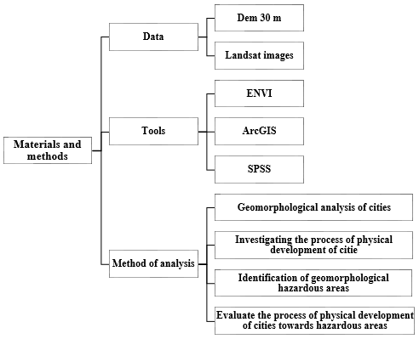
Fig. 2. The Research Flowchart

4. RESULTS AND DISCUSSION
In recent years, the physical development of cities in Kurdistan Province has experienced an increasing trend. Given the varying geomorphological conditions of the cities in this province, this upward trend has, in some cases, directed development towards hazardous areas. Accordingly, in the present study, the geomorphological status prevailing in the cities of Kurdistan Province has been examined first, followed by an evaluation of their physical development trends.

4.1. Geomorphological Conditions of Cities in Kurdistan Province
In general, it can be stated that Kurdistan Province is divided into two geomorphological sections: the western and eastern parts. The western section is primarily characterized by mountainous units and intermountain plains with valleys, while the eastern part consists of high plains, scattered hills, and mountainous units. Among the cities in the western part of the province is Baneh, which with continuous increase in population in recent years has faced limitations in its physical development. Baneh is surrounded by mountainous units, including Mount Arbaba and steep slopes, and the presence of a river terrace within the urban area also considered another limitation for this city. Currently, given the prevailing geomorphological conditions, the western part of Baneh has greater potential for physical development.
Saghez is another city in the west and the second most populous city in the province. This city faces limitations due to its rugged terrain, specifically the presence of hilly areas and mountainous units, as well as constraints from the Saghez River and its surrounding floodplain. While this river has its attractions and positive aspects, it is also considered a limitation for the physical development of the city. Due to its high flow and flood-prone nature, attention to its buffer zone is essential. In recent years, the trend of development in Saghez has been towards the northern and southern areas of the city.
Marivan is another city in the province that leads to Lake Zeribar from the west. This city is also limited by mountainous units and steep slopes from the north and south. The geomorphological limitations of Marivan have altered its physical development trend, causing it to expand eastward in recent years. Sarvabad is among the cities that face geomorphological constraints from various directions. This city is bordered by mountainous units to the north and east, and by river terraces to the west and southwest. Given the geomorphological conditions, its physical development has progressed towards the southeast in recent years.
Sanandaj, as the provincial capital, faces numerous geomorphological limitations. The presence of mountainous units in various directions (including Mount Abidar) and numerous hills within the urban limits have restricted the city’s physical development. Additionally, the terrace of Qashlaq River and its floodplain to the east of Sanandaj pose serious limitations for the city’s physical development due to high flow and flood-prone characteristics. In recent years, the trend of physical development in Sanandaj has been directed towards the southern areas of the urban limits.
Kamyaran, the southernmost city in the province, also faces limitations due to river terraces, which not only restrict development within the urban area but also limit the southern part of Kamyaran. Furthermore, mountainous units restrict parts of the northern areas of the city. Considering the geomorphological conditions of Kamyaran, its development trend in recent years has been towards the eastern areas.
Bijar and Divandareh are considered northern cities of the province. Bijar is the highest city in the province, bordered by mountainous units from the north, south, and east. The river terrace in the eastern part also constitutes a limitation for the city’s physical development. The geomorphological constraints from various directions have led to the physical development of Bijar trending towards the western areas of the urban limits in recent years. Similarly, Divandareh faces numerous limitations from various directions. The presence of hilly areas within the urban limits of Divandareh is one of the main constraints on its physical development. Additionally, the river terrace with a northwest-southeast trend encompasses the western part of Divandareh, limiting physical development in that direction. Consequently, the physical development of Divandareh has occurred in the eastern part of the city, trending northwest-southeast in recent years.
Qorveh and Dehgolan are considered eastern cities of the province, situated on a plain. Qorveh is established on a plain from a geomorphological perspective (Ganjaeian, 2024). The city extends towards the southwestern slopes of Mount Kovalau, which has led to some residential areas being located on steep slopes. Additionally, it is bordered to the east by a river terrace, which has created limitations for its physical development. However, despite these factors, Qorveh faces relatively few geomorphological constraints for the development of residential areas, allowing for physical development in various directions in recent years.
Dehgolan, like Qorveh, also faces few geomorphological constraints for physical development. This city is located on a plain and lacks steep areas due to the minimal elevation differences within its urban limits. Currently, the river terrace on the western side of this city is considered the most significant limiting factor for its physical development, which has resulted in the trend of development in recent years being directed towards the eastern areas of the urban limits.
Divandareh, like the Bijar, faces numerous limitations from various aspects. The presence of hills within the urban boundaries of Divandareh is considered one of the most significant constraints on the physical development of this city. Additionally, the river terrace unit, with a northwest-southeast trend, encompasses the western part of Divandareh, restricting physical development in that direction. These factors have led to the physical development of Divandareh occurring primarily in the eastern section of the city, following a northwest-southeast trend.
The cities of Qorveh and Dehgolan are regarded as eastern cities of the province, situated within the plain unit. In terms of Geomorphology, Qorveh is established on a plain unit. This city extends southwestward to the slopes of Mount Kovalau, which has resulted in part of its residential areas being located on steep slopes. Furthermore, it also terminates to the east at the river terrace unit, which has created limitations for the physical development of this city. However, despite these factors, Qorveh faces relatively few geomorphological constraints for the development of residential areas, allowing for physical expansion in various directions in recent years.
Similarly, Dehgolan, like Qorveh, encounters minimal geomorphological limitations for physical development. This city is established on a plain unit and, due to the slight elevation differences within its urban area, lacks steep regions. Currently, the river terrace unit on the western side of this city is considered the most significant limiting factor for its physical development, resulting in the trend of physical expansion in recent years being directed toward the eastern areas of the urban boundary. Fig. 3 illustrates the topographic status of the cities in Kurdistan Province.

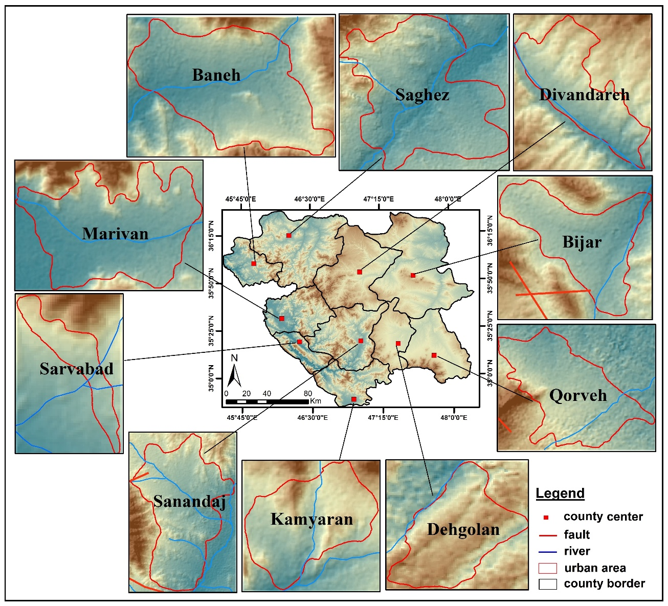
Fig. 3. Elevation map of cities in Kurdistan province

4.2. The Trend of Physical Development of Cities in Kurdistan Province
Due to the population growth and migration from rural areas to urban regions, urban settlements in Kurdistan Province have experienced significant growth in recent years. In this study, Landsat images of the years 1992, 2002, 2012, and 2022 have been utilized to assess the trend of physical development of the cities in Kurdistan Province. The results obtained are presented in Table 2.

Table 2. Urban area of ​​cities in Kurdistan Province (km²)
2022 | 2012 | 2002 | 1992 | Year  City
12.48 | 10.44 | 6.13 | 3.9 | Baneh
5.9 | 5.22 | 4.24 | 3.61 | Bijar
2.53 | 2.13 | 1.51 | 1.03 | Dehgolan
3.15 | 2.49 | 1.75 | 1.12 | Divandareh
0.56 | 0.41 | 0.33 | 0.24 | Sarvabad
12.04 | 10.21 | 7.63 | 6.1 | Saghez
27.11 | 25.24 | 19.78 | 14.76 | Sanandaj
7.33 | 5.34 | 4.19 | 3.31 | Qorveh
2.9 | 2.4 | 1.77 | 1.44 | Kamyaran
9.09 | 8.18 | 5.38 | 3.9 | Marivan

Based on the above table, the cities in Kurdistan Province have experienced significant physical development. Baneh, due to its commercial position, has experienced significant physical growth in recent years, with the total area of urban settlements and infrastructure in Baneh being approximately 3.9 km² in 1992. This figure increased to 6.13, 10.44, and 12.48 km² in 2002, 2012, and 2022, respectively, indicating a multiple physical growth of this city over a 30-year period (Fig. 4). Additionally, Bijar had an area of approximately 3.61 km² in 1992, which increased to 4.24, 5.22, and 5.9 km² in 2002, 2012, and 2022, respectively, indicating that Bijar experienced about 2.3 km² of physical development over the 30-year period (Fig. 5).
Dehgolan also had more than double its physical development over the 30-year period, with an area of approximately 1.03 km² in 1992, which increased to 1.51, 2.13, and 2.53 km² in 2002, 2012, and 2022, respectively (Fig. 6). Divandareh experienced even more growth compared to Dehgolan, starting with an area of approximately 1.12 km² in 1992, which increased to 1.75, 2.49, and 3.15 km² in 2002, 2012, and 2022, respectively (Fig. 7).
Sarvabad, as the smallest county center in Kurdistan Province, had an area of approximately 0.24 km² in 1992, which increased to 0.33, 0.41, and 0.56 km² in 2002, 2012, and 2022, respectively (Fig. 8). Saghez, which is considered the second most populous city in the province after Sanandaj, has also experienced significant physical growth. The area of Saghez was approximately 6.1 km² in 1992, increasing to 7.63, 10.21, and 12.04 km² in 2002, 2012, and 2022, respectively (Fig. 9).
Sanandaj, as the most populous and largest city in the province, has also experienced considerable growth, with its area approximately doubling over the 30-year period. In 1992, Sanandaj had an area of approximately 14.76 km², which increased to 19.78, 25.24, and 27.11 km² in 2002, 2012, and 2022, respectively (Fig. 10). Qorveh, like other cities in the province, has also experienced physical development. The area of Qorveh was approximately 3.31 km² in 1992, which increased to 4.19, 5.34, and 7.33 km² in 2002, 2012, and 2022, respectively (Fig. 11).
Kamyaran has also shown significant growth, with an area of approximately 1.44 km² in 1992, which increased to 1.77, 2.4, and 2.9 km² in 2002, 2012, and 2022, respectively (Fig. 12). Finally, Marivan is one of the cities that has had the most significant physical development, starting with an area of approximately 3.9 km² in 1992, which increased to 5.38, 8.18, and 9.09 km² in 2002, 2012, and 2022, respectively (Fig. 13).

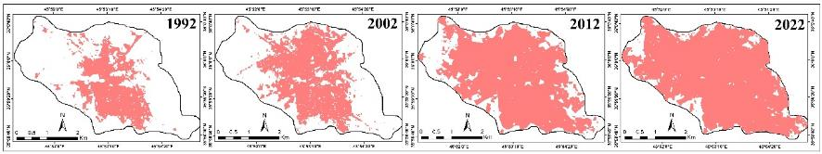
Fig. 4. Trend of Physical Development of Baneh City over the Years 1992, 2002, 2012, and 2022.

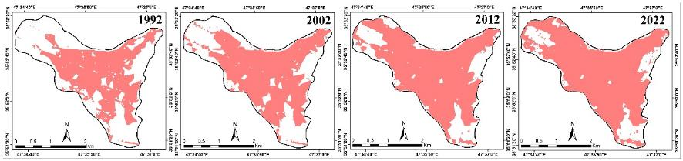
Fig. 5. Trend of Physical Development of Bijar City over the Years 1992, 2002, 2012, and 2022.

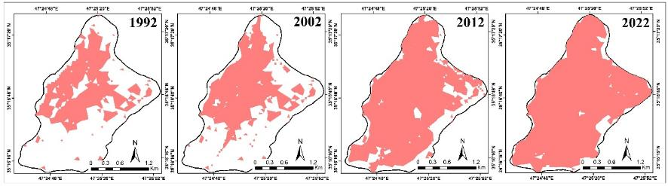
Fig. 6. Trend of Physical Development of Dehgolan City over the Years 1992, 2002, 2012, and 2022.

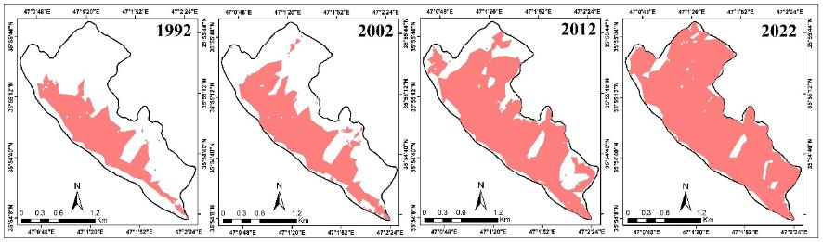
Fig. 7. Trend of Physical Development of Divandareh City over the Years 1992, 2002, 2012, and 2022.

Fig. 8. Trend of Physical Development of Sarvabad City over the Years 1992, 2002, 2012, and 2022.

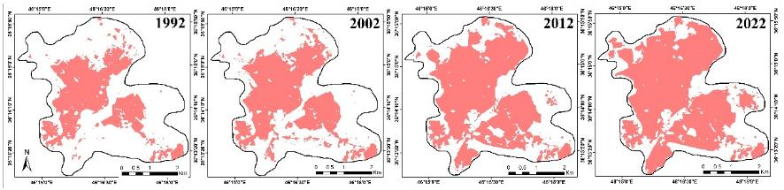
Fig. 9. Trend of Physical Development of Saghez City over the Years 1992, 2002, 2012, and 2022.

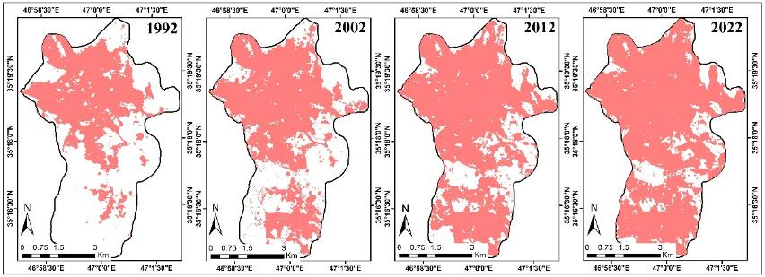
Fig. 10. Trend of Physical Development of Sanandaj City over the Years 1992, 2002, 2012, and 2022.

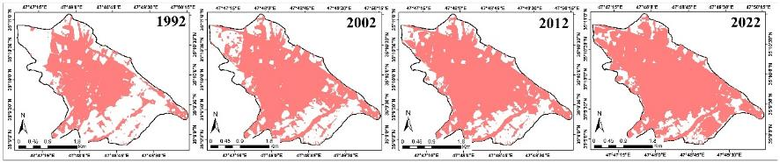
Fig. 11. Trend of Physical Development of Qorveh City over the Years 1992, 2002, 2012, and 2022.

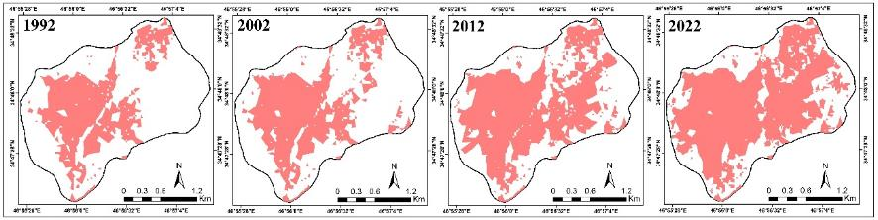
Fig. 12. Trend of Physical Development of Kamyaran City over the Years 1992, 2002, 2012, and 2022.

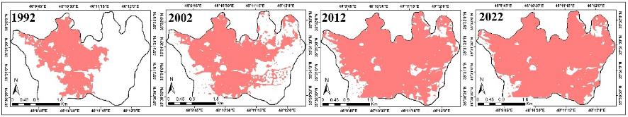
Fig. 13. Trend of Physical Development of Marivan City over the Years 1992, 2002, 2012, and 2022.

4.3. Evaluation of Physical Changes in the Cities of Kurdistan Province
The assessment of the physical development trends in the cities of Kurdistan Province indicates that, in terms of the extent of physical development, Sanandaj, as the provincial capital, has experienced the most significant growth with an area of 12.35 km² over the 30-year period. Additionally, the cities of Baneh and Saghez with 8.58 and 5.94 km², respectively, are ranked next. However, in terms of relative physical development (development relative to the city area), Sarvabad has shown the highest rate over the 30-year period, with an increase of approximately 2.3 times its area. Furthermore, the cities of Divandareh and Dehgolan have also exhibited significant relative physical development, with increases of 2.8 and 2.5 times, respectively.
The assessment of the trends and directions of physical development in the cities of Kurdistan Province indicates that their level of development is directly influenced by the geomorphological factors prevailing in the areas. Table 3 and Fig. 14 illustrate the status of physical and relative development of the cities in the province (from 1992 to 2022), as well as the geomorphological constraints for each city.
According to the table 3, the most significant geomorphological constraints for the physical development of the cities of Baneh, Bijar, Qorveh, and Kamyaran are the mountainous unit and river terrace. For the cities of Sanandaj and Saghez, the mountainous and hilly unit, terrace, and floodplain are considered as limiting geomorphological barriers. In Divandareh, the hilly unit and terrace act as important barriers to physical development. For Dehgolan, the terrace and floodplain to the west of the city are significant barriers to physical development. In Sarvabad, the mountainous unit, terrace, and valley are considered limiting geomorphological factors, while in Marivan, the mountainous unit, terrace, and lake are considered as constraints.

Table 3. Status of Physical and Relative Development of the Cities in the Province and Limiting Geomorphological Constraints
Limiting Geomorphological Constraints | Relative Development | Physical Development (Km²) | City
Mountainous unit and river terrace | 3.2 | 8.58 | Baneh
Mountainous unit and river terrace | 1.6 | 2.29 | Bijar
River terrace and floodplain | 2.5 | 1.5 | Dehgolan
Hilly unit and river terrace | 2.8 | 2.03 | Divandareh
Mountainous unit, river terrace, and valley | 2.3 | 0.32 | Sarvabad
Mountainous and hilly unit, river terrace, and floodplain | 2.0 | 5.94 | Saghez
Mountainous and hilly unit, river terrace, and floodplain | 1.8 | 12.35 | Sanandaj
Mountainous unit and river terrace | 2.2 | 4.02 | Qorveh
Mountainous unit and river terrace | 2.0 | 1.46 | Kamyaran
Mountainous unit, river terrace, and lake | 2.3 | 5.19 | Marivan

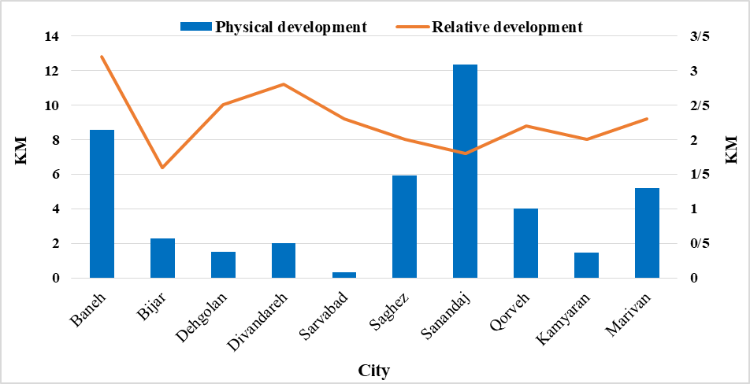
Fig. 14. Status of Physical (Km²) and Relative Development of the Cities in the Province from 1992 to 2022

4.4. Evaluating The Trend of Physical Development of Cities Towards Hazardous Areas
Urban hazards are influenced by the geomorphological position of the region. In fact, many cities are prone to hazards due to their geomorphological location. Meanwhile, population growth and the trend of physical development of cities have caused many residential areas to move towards hazardous regions. The geomorphological position of the cities in Kurdistan Province has made many of these cities susceptible to hazards. In this study, to asses the hazard susceptibility of the cities in Kurdistan Province, hazard-prone areas within the cities of the province have been identified based on parameters such as distance from rivers, distance from fault lines, slope, and slope direction (Table 4). The map of hazard-prone areas in the cities of Kurdistan Province has been identified (Fig. 15).

Table 4. Prohibited Areas for Urban Development
Hazardous Areas | Criterion | Row
Areas with a slope greater than 15 degrees | Slope | 1
North-facing slopes | Slope Direction | 2
500-meter buffer zone | Fault | 3
100-meter buffer zone | River | 4

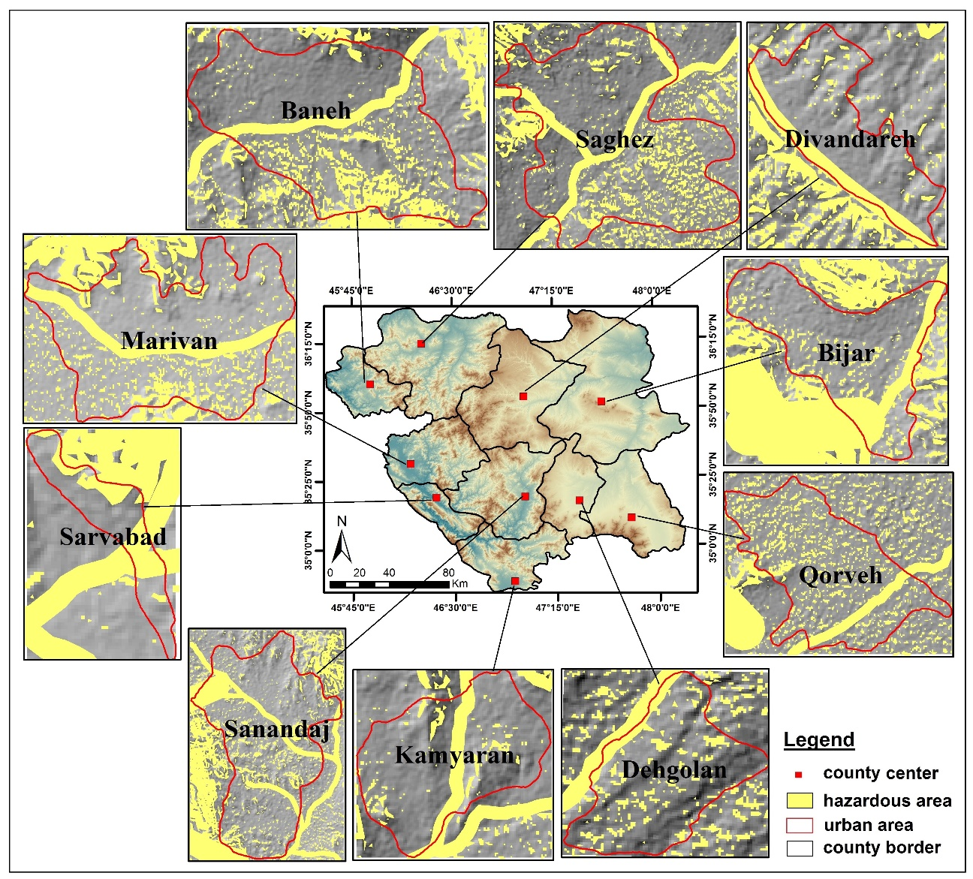
Fig. 15. Map of Hazard-Prone Areas within the Cities of Kurdistan Province

After preparing the hazard-prone areas map, the trend of urban development towards hazardous areas has been assesd from 1992 to 2022 (Table 5 and Fig. 16). The results indicate that alongside the physical development of cities, residential areas have progressed towards hazardous regions. Based on the obtained results, in 1992, approximately 1.18 km² of the city of Baneh was located in hazardous areas, which increased to 1.45, 1.59 and 3.02 km² in 2002, 2012 and 2022, respectively 2022. In 1992, about 0.08 km² of the city of Bijar was in hazardous areas, which increased to 0.94, 1.2 and 1.31 km² in 2002, 2012 and 2022, respectively. In 1992, around 0.14 km²of the city of Dehgolan was in hazardous areas, which increased to 0.15, 0.37, and 0.43 km² in 2002, 2012 and 2022, respectively. In 1992, approximately 0.18 km² of the city of Divandareh was in hazardous areas, increasing to 0.25, 0.40, and 0.51 km² in 2002, 2012 and 2022, respectively. In 1992, about 0.04 km² of the city of Sarvabad was in hazardous areas, which increased to 0.06, 0.1 and 0.18 km² in 2002, 2012 and 2022, respectively. In 1992, approximately 1.4 km² of the city of Saghez was in hazardous areas, which increased to 1.62, 2.32, and 2.8902 km² in 2002, 2012 and 2022, respectively. In 1992, about 2.98 km² of the city of Sanandaj was in hazardous areas, which increased to 3.95, 4.97, and 5.7 km² in 2002, 2012 and 2022, respectively. In 1992, approximately 0.12 km² of the city of Qorveh was in hazardous areas, which increased to 0.19, 0.34, and 0.48 km² in 2002, 2012 and 2022, respectively. In 1992, about 0.16 km² of the city of Kamyaran was in hazardous areas, which increased to 0.23, 0.32, and 0.39 km² 2002, 2012 and 2022, respectively. In 1992, approximately 1.17 km² of the city of Marivan was in hazardous areas, which increased to 1.25, 2.16, and 2.23 km² in 2002, 2012 and 2022, respectively.

Table 5. Area of Hazardous Urban Zones in the Cities of Kurdistan Province (Km²)
2022 | 2012 | 2002 | 1992 | Year  City
3.02 | 2.59 | 1.45 | 1.18 | Baneh
1.31 | 1.20 | 0.94 | 0.08 | Bijar
0.43 | 0.37 | 0.15 | 0.14 | Dehgolan
0.51 | 0.40 | 0.25 | 0.18 | Divandareh
0.18 | 0.10 | 0.06 | 0.04 | Sarvabad
2.89 | 2.32 | 1.62 | 1.40 | Saghez
5.70 | 4.97 | 3.95 | 2.98 | Sanandaj
0.48 | 0.34 | 0.19 | 0.12 | Qorveh
0.39 | 0.32 | 0.23 | 0.16 | Kamyaran
2.23 | 2.16 | 1.25 | 1.17 | Marivan

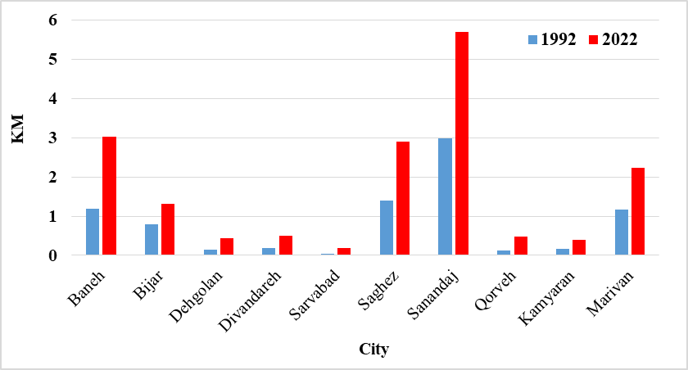
Fig. 16. Diagram of the area of hazardous urban areas in cities of Kurdistan province

5. Conclusion
The findings of this study demonstrate that the cities of Kurdistan Province have undergone substantial physical expansion in recent decades, primarily driven by a growing population. However, much of this development has occurred in an unplanned manner, resulting in the expansion of residential areas into geomorphologically hazardous zones. Highest absolute growth occurred in Sanandaj (12.35 km²), followed by Baneh (8.58 km²), Saqez (5.94 km²), and Marivan (5.19 km²). In contrast, cities like Sarvabad (0.32 km²) and Dehgolan (1.5 km²) saw relatively limited growth. Notably, when considering relative physical development (i.e., growth in proportion to the original area), Sarvabad exhibited the most significant expansion—approximately 2.3 times its original size. The spatial analysis also revealed that geomorphological factors have played a critical role in shaping urban growth patterns. Many cities have expanded into areas classified as hazardous. Specifically, from 1992 to 2022, encroachments into such areas totaled 2.72 km² in Sanandaj, 1.84 km² in Baneh, and over 1 km² in both Saqez and Marivan. Although the absolute figures vary, all cities experienced some degree of unsafe expansion. These patterns suggest that insufficient planning and inadequate regulation of urban growth have exacerbated exposure to environmental risks. To mitigate future hazards, it is crucial to enhance regulatory oversight and integrate geomorphological assessments into urban planning frameworks across Kurdistan Province.

Disclaimer (Artificial intelligence)
The author(s) hereby declare that no generative AI technologies, including large language models (such as ChatGPT, COPILOT, etc.) or text-to-image generators, were used in the writing or editing of this manuscript."

References
- Aarthi, A. D., & Gnanappazham, L. (2018). Urban growth prediction using neural network coupled agents-based Cellular Automata model for Sriperumbudur Taluk, Tamil Nadu, India. Egyptian Remote Sensing and Space Science, 21(3), 353-362. https://doi.org/10.1016/j.ejrs.2017.12.004
- Ansah, J.K.O., & Boateng, F.A. (2016). The spatial expression of physical development controls in a fast growing Ghanaian city. Land Use Policy, 54, 147-157. https://doi.org/10.1016/j.landusepol.2016.02.012
- Asadi, M., Ganjaeian, H., Javedani, M., & Ghaderi Hasab, M. (2021). Evaluation of the Relationship between Natural Factors and Subsidence in Ivanaki Plain Using Radar Imaging. Hydrogeology, 6(1), 13-22. https://doi.org/10.22034/hydro.2021.13016 [In Persian]
- Bagan. H., & Yamagata. Y. (2012). Landsat Analysis of Urban Growth: How Tokyo became the world's largest megacity during the last 40 years. Remote Sensing of Environment, 127, 210 –222. http://dx.doi.org/10.1016/j.rse.2012.09.011
- Bakkensen, L. A., Lent, C., Laura, K., Read, L.K., & Linkov, I. (2016). Validating Resilience and Vulnerability Indices in the Context of Natural Disasters. Risk Analysis, 37 (5), 982-1004. http://dx.doi.org/10.1111/risa.12677
- Bharath, H. A., Chandan, M. C., Vinay, S., & Ramachandra, T. V. (2018). Modelling urban dynamics in rapidly urbanising Indian cities. Egyptian Remote Sensing and Space Science, 21(3), 201–210. https://doi.org/10.1016/j.ejrs.2017.08.002
- Bourenane, H., Bouhadad, Y., & Guettouche, M.S. (2019). Flood hazard mapping in urban area using the hydrogeomorphological approach: case study of the Boumerzoug and [11] Rhumel alluvial plains (Constantine city, NE Algeria), African Earth Sciences, 160 (1). https://doi.org/10.1016/j.jafrearsci.2019.103602
- Cao, N., Wen, Y., Wang, J., Gao, X., & Sun, P. (2024). Identifying shrinking cities from a physical city perspective and influencing factors: A case study of the Chengdu-Chongqing economic circle in China. Applied Geography, 168. https://doi.org/10.1016/j.apgeog.2024.103314
- Chini, M., Pelich, R., Pulvirenti, L., Pierdicca, N., Hostache, R., & Matgen, P. (2019). Sentinel-1 InSAR Coherence to Detect Floodwater in Urban Areas: Houston and Hurricane Harvey as a Test Case, Remote Sensing, 11, 107. http://dx.doi.org/10.3390/rs11020107
- Fekete, A. (2022). Peri-urban growth into natural hazard-prone areas: mapping exposure transformation of the built environment in Nairobi and Nyeri, Kenya, from 1948 to today. Natural Hazards, 119, 859-882. https://doi.org/10.1007/s11069-022-05515-4
- Ganjaeian, H. (2024). Identification of sinkhole-prone areas using radar images (Case study: Qorveh Plain). E.E.R, 14(2), 87-105. http://dx.doi.org/10.61186/jeer.14.2.6 [In Persian]
- Ganjaeian, H., Asadi, M., Menbari, F., & Ebrahimi, A. (2023). Analysis of Subsidence Status in Hamedan Urban Area using Radar and Satellite Images. Journal of Geography and Environmental Hazards, 11(4), 236-221. https://doi.org/10.22067/geoeh.2022.76383.1217 [In Persian]
- Ganjaeian, H., Rezaei Arefi, M., Peysoozi, T., & Emami, K. (2021). Zonning susceptible areas of landslide using WLC and OWA methods -A case study in Mountain cliff Khan, Iran. Sustainable Earth Trends, 1(2), 35-43. https://doi.org/10.52547/sustainearth.1.2.43
- Ganjaeian, H., Yamani, M., Goorabi, A., & Maghsoudi, M. (2020). Analyzing Tangible and Intangible Effects of Kermanshah Ezgeleh Earthquake on Landforms. Geography and Environmental Sustainability, 10(2), 89-103. https://doi.org/10.22126/ges.2020.5571.2274 [In Persian]
- Ganjaeian, H., Yamani, M., Goorabi, M., & Maghsoudi, M. (2024). Evaluating the Impacts of Earthquake in Ezgele, Kermanshah (Iran) (Occurred on 2017/11/12). Current Research in Environmental Science and Ecology Letters, 1(1), 1-10. https://doi.org/10.33140/CRESEL.01.01.06
- Gao, C., Zhang, B., Shao, S., Hao, M., Zhang, Y., Xu, Y., Kuang, Y., Dong, L., & Wang, Z. (2023). Risk assessment and zoning of flood disaster in Wuchengxiyu Region, China. Urban Climate, 49. https://doi.org/10.1016/j.uclim.2023.101562
- Ghosh, A., Dey, P., & Ghosh, T. (2022). Integration of RS-GIS with Frequency Ratio, Fuzzy Logic, Logistic Regression and Decision Tree Models for Flood Susceptibility Prediction in Lower Gangetic Plain: A Study on Malda District of West Bengal, India. Indian Society of Remote Sensing, 50: 1725-1745. https://doi.org/10.1007/s12524-022-01560-5
- Gibson, T. Pelling, M., Ghosh, A., Matyas, D., Siddiqi, A., Solecki, W., Johnson, L., Kenney, C., Johnston, D., & Du Plessis, R. (2016). Pathways for transformation: disaster risk management to enhance resilience to extreme events. J Extreme Events, 3(1). https://doi.org/10.1142/S2345737616710020
- Goorabi, A., Yamani, M., Mohammadkhan, Sh., & Hosseini, S. J. (2023). Evaluating the effects of fault tectonics on the geomorphology of Zanjanrud basin using remote-sensing and geomorphometry techniques. Physical Geography Research Quarterly, 55 (2), 89-110. http://doi.org/ 10.22059/JPHGR.2023.354037.1007741
- Hassan, M.D., Anzum, N., Shaibur, M.R., Nahar, N., Akber, A., Sabbir Hossain, M.D., & Al Mamun, S. (2023). Changing dynamics of river ecosystem from aquatic to terrestrial: A case of Bhairab River, Jashore, Bangladesh. Watershed Ecology and the Environment 5 (1), 1-27. https://doi.org/10.1016/j.wsee.2023.05.001
- Herryal, Z. A., Yustiningrum, E., Andriana, N., Sagala, A., & Anggun, M. S. (2017). Measuring Community Resilience to Natural Hazards: Case Study of Yogyakarta Province, Disaster Risk Reduction in Indonesia, 609-633. http://dx.doi.org/10.1007/978-3-319-54466-3_25
- Hussain, S., Mubeen, M., & Karuppannan, S. (2022). Land use and land cover (LULC) change analysis using TM, ETM+ and OLI Landsat images in district of Okara, Punjab, Pakistan. Physics and Chemistry of the Earth, Parts A/B/C, 126. https://doi.org/10.1016/j.pce.2022.103117
- Jha, K.‚ Miner‚ W & Geddes‚ S. (2012). Building urban resilience: principles, tools, and practice. The World Bank, 155. https://ideas.repec.org/b/wbk/wbpubs/13109.html
- Lewis, D., & Jaana, M. (2005). Urban vulnerability and good government.Journal of contingencies and crisis management, Contingencies and Crisis Management, (13)2, 50–53. http://dx.doi.org/10.1111/j.1468-5973.2005.00456.x
- Liang, J., Chen, C., Song, Y., Sun, W., & Yang, G. (2024). Long-term mapping of land use and cover changes using Landsat images on the Google Earth Engine Cloud Platform in bay area - A case study of Hangzhou Bay, China. Sustainable Horizons, 7. https://doi.org/10.1016/j.horiz.2023.100061
- Malalgoda, C., Amaratunga, R.D.G., & Pathirage, C.P. (2010). Exploring disaster risk reduction in the built environment. School of the Built Environment, University of Salford, uk. https://www.preventionweb.net/files/15204_16141
- Mas, J.F., Kolb, M., Paegelow, M., & Camacho Olmedo, M.T. (2014). Inductive pattern-based land use/cover change models: A comparison of four software packages. Environmental Modelling & software, 51, 94-111. https://doi.org/10.1016/j.envsoft.2013.09.010
- Munoz, G.A., Gil-Costa, V., & Marin, M. (2022). Efficient simulation of natural hazard evacuation for seacoast cities. International Journal of Disaster Risk Reduction, 81. https://doi.org/10.1016/j.ijdrr.2022.103300
- Nayyeri, H., Salari, M., Ganjaeian, H., & Amani, K. (2017). Geomorphological Assessment of Land Suitability for the Physical Expansion of Sanandaj City Applying Restricted Areas. Geographical Urban Planning Research (GUPR), 5(1), 127-145. https://doi.org/10.22059/jurbangeo.2017.63213
- Negahban, S., Ganjaeian, H., Ebrahimi, A. & Emami, K. (2019). Monitoring and predicting the trend of changes in residential areas using multi-timed images (Case study: Songhor city). Journal of the Earth and Space Physics, 45(2), 343-354. https://doi.org/10.22059/jesphys.2019.275076.1007084 [In Persian]
- Negahban, S., Ganjaeian, H., Ebrahimi, A., & Gheysarian, S. S. (2025). Analysis of the Roles of Environmental Factors in the Occurrence of Floods Using the Google Earth Engine System (Case Study: West of Golestan Province). Geography and Environmental Planning, 35(4), 1-18. https://doi.org/10.22108/gep.2024.142342.1659 [In Persian]
- Negahban, S., Ganjaeian, H., Feraydooni Kordestani, M., & Cheshmeh sefidi, Z. (2019). Assessing the physical development of cities and extending to geomorphological prohibited areas Using LCM (Case Study: Sanandaj City). Journal of Natural Environmental Hazards, 8(20), 39-52. https://doi.org/10.22111/jneh.2018.21943.1317 [In Persian]
- Negahban, S., Ganjaeian, H., Saeedi, S., & Ghasemi, A. (2020). Study of vertical displacement caused by 2019 Turkmanchay earthquake based on InSAR method. Journal of the Earth and Space Physics, 46(3), 445-456. https://doi.org/10.22059/jesphys.2020.295046.1007182 [In Persian]
- Notti, D., Giordan, D., Caló, F., Pepe, A., Zucca, F., & Galve, J.P. (2018). Potential and Limitations of Open Satellite Data for Flood Mapping, Remote Sensing, 10. https://doi.org/10.3390/rs10111673
- Osman, S.A., & Das, j. (2023). GIS-based flood risk assessment using multi-criteria decision analysis of Shebelle River Basin in southern Somalia. SN Applied Sciences, 5 (134). https://doi.org/10.1007/s42452-023-05360-5
- Parhi, P. K. (2018). Flood Management in Mahanadi Basin using HEC-RAS and Gumbel’s Extreme Value Distribution. Journal of the Institution of Engineers (India). 99 (4), 751– 755. https:// doi: 10.1007/s40030-018-0317-4
- Qi, S., Hu, S., & Cao, S. (2024). Spatial and temporal changes of social vulnerability of cities to natural hazards in Zhejiang province, China. Helion, 10 (6). https://doi.org/10.1016/j.heliyon.2024.e27120
- Ramadan, M.S., & Effat, H.A. (2021). Geospatial modeling for a sustainable urban development zoning map using AHP in Ismailia Governorate, Egypt. The Egyptian Journal of Remote Sensing and Space Science, 24 (2), 191-202. https://doi.org/10.1016/j.ejrs.2021.01.003
- Safari namivandi, M., Ganjaeian, H., Nosrati, M., & Mohammadian, K. (2024). Identification of flooded areas and analysis of factors influencing its occurrence (Case study: Southeast of Sistan and Baluchestan province). Quantitative Geomorphological Research, 13(2), 181-194. https://doi.org/10.22034/gmpj.2024.449586.1494 [In Persian]
- Saha, A.K., & Agrawal, S. (2020). Mapping and assessment of flood risk in Prayagraj district, India: a GIS and remote sensing study. Nanotechnology for Environmental Engineering, 5 (11). https://doi.org/10.1007/s41204-020-00073-1
- Salari, M., Nayyeri, H., Ganjaeian, H., & Amani, K. (2020). Assessment and Prediction of the process of expansion of residential areas with Geomorphological Approach and Environmental Management (Case Study: Paveh City). Quantitative Geomorphological Research, 9(1), 86-101. https://doi.org/10.22034/gmpj.2020.109536 [In Persian]
- Sundaram, S., Devaraj, S., & Yarrakula, K. (2023). Mapping and assessing spatial extent of floods from multitemporal synthetic aperture radar images: a case study over Adyar watershed, India. Environmental Science and Pollution Research, 30, 63006–63021. https://doi.org/10.1007/s11356-023-26467-7
- Vekaria, D., Chander, S., Singh, R.P., & Dixit, S. (2023). A change detection approach to flood inundation mapping using multi-temporal Sentinel-1 SAR images, the Brahmaputra River, Assam (India): 2015–2020. Earth System Science, 132(3). https://doi.org/10.1007/s12040-022-02020-x
- Xiang, H., Yang, Y., & Qi, X. (2024). Intelligent vs. Cultural: Research on the path to improve the resilience of urban and rural community governance based on the AHP-FCE model. Helion, 10(20). https://doi.org/10.1016/j.heliyon.2024.e39199
- Yamani, M., Ganjaeian, H., Garoso, L., & Javedan, M. (2020). Identification of susceptible areas for the development of agricultural lands based on parameters Hydro geomorphology (Case study: Sanandaj city). Journal of Hydrogeomorphology, 7(23), 20-1. https://doi.org/10.22034/hyd.2020.11087 [In Persian]

. https://earthexplorer.usgs.gov

