Tourism Driven Light Pollution in Indian Coastal Regions: A VIIRS and SQM Based Analysis

ABSTRACT
The growth of coastal tourism in India over the last few decades has contributed substantial socio-economic benefits but has also resulted in environmental stress in fragile coastal ecosystems. One of the increasingly significant impacts of coastal tourism is light pollution, particularly artificial light at night (ALAN), which alters natural nightscapes and disrupts ecological balance. This study provides a comprehensive assessment of tourism driven light pollution along the coastal regions of India by integrating satellite based data from the Visible Infrared Imaging Radiometer Suite (VIIRS) with ground based Sky Quality Meter (SQM) observations from 2012 to 2024. The research focuses on identifying spatial and temporal patterns of light pollution across major coastal tourist spots, including Goa, Kerala, Tamil Nadu, and Odisha. Results indicate a strong positive correlation (Pearson’s correlation coefficient of 0.84) between tourism intensity and increased night sky brightness levels, especially in urbanized beachfront areas and locations with dense tourist infrastructure. Seasonal fluctuations in light pollution were also observed, aligning with peak tourist seasons, suggesting a direct influence of human activity related to tourism. The ecological consequences of such light pollution are substantial, with potential disruptions to circadian rhythms of nocturnal species, interference with sea turtle nesting behaviour. Furthermore, the study highlights the growing concern of losing dark sky environments in these regions, which has great implications for both biodiversity conservation and the promotion of sustainable tourism. The integration of high-resolution remote sensing data with localized ground measurements offers insights into the tourism-driven nature of coastal light pollution. The findings show the urgency of incorporating light pollution mitigation into tourism development and coastal management policies. Adopting responsible lighting practices in the coastal areas can serve as effective strategies to balance tourism activities with environmental sustainability in India’s coastal regions.

Keywords: Biodiversity, coastal tourism, coastal management, ecological balance, light pollution, nocturnal species.

1. INTRODUCTION
Light pollution is an increasingly recognized environmental concern that results from the uncontrolled or excessive use of artificial lighting. As a minor by-product of urban and infrastructural development activities, ALAN has garnered significant scientific attention due to its adverse impacts on human health, wildlife behaviour, and ecosystem dynamics (Falchi et al., 2016; Kyba et al., 2017). Unlike other forms of pollution, light pollution is non-invasive and largely invisible to the naked eye during the day, making it an often overlooked threat. However, its consequences, ranging from the disruption of circadian rhythms to the masking of celestial visibility, are profound and far reaching (Longcore & Rich, 2004; Hölker et al., 2010). While urbanization and industrialization are widely recognized drivers of ALAN, tourism has emerged as a critical contributor, especially in environmentally sensitive coastal zones. In coastal tourism centres, the demand for aesthetic lighting, extended nightlife, beachfront resorts, and recreational facilities often leads to the installation of high intensity and poorly shielded lighting systems (Pawson & Bader, 2014). Such lighting, while enhancing the visitor experience and supporting local economies, can have unintended consequences to the surrounding environment. Various studies have highlighted the detrimental effects of ALAN on nocturnal species, including disorientation of sea turtle hatchlings, altered migration patterns of birds, and behavioural changes in fish and invertebrates (Witherington, & Martin, 2000; Jägerbrand & Bouroussis, 2021). Growing evidence suggests that artificial illumination at night disrupts insect populations, with cascading effects on pollination networks, food webs, and biodiversity (Stewart, 2021).
India, with a coastline stretching over 7,500 kilometres, is particularly vulnerable to the adverse effects of tourism driven light pollution. Coastal states such as Goa, Kerala, Tamil Nadu, and Odisha are major tourism hubs, attracting millions of visitors annually (Ministry of Tourism, 2023). These regions not only carry immense economic importance but are also ecologically supporting mangrove forests, marine turtles, and various migratory species. However, the growth of coastal tourism infrastructures has resulted a surge in artificial lighting, often unregulated and poorly planned (MoEFCC, 2021). The expansion of resorts, boardwalks, piers, and beachfront commercial zones typically involves intensive artificial illumination, contributing significantly to localized light pollution. Despite these developments, there remains a remarkable gap in the literature regarding the spatial and temporal extent of light pollution in Indian coastal zones and its linkage with tourism activity (Bedi et al, 2021). This research aims to bridge that gap by conducting a detailed investigation of tourism driven light pollution in Indian coastal regions using satellite based data and ground measurements. The study utilizes the VIIRS Day/Night Band (DNB), a remote sensing dataset widely employed for detecting artificial lighting from space, alongside SQM observations to validate and supplement satellite data at specific tourist locations. The integration of these two data sources allows for a detailed understanding of both large scale patterns and localized lighting impacts, providing a strong foundation for analysis. The prime objectives of this study were to map and quantify the intensity of light pollution in coastal areas with significant tourism activity; to examine the seasonal and temporal variations in light pollution, particularly during peak tourist seasons; and to examine the correlations between tourism intensity and changes in light emission patterns. By focusing on areas with high tourism density, such as Goa, Kerala, Tamil Nadu, and Odisha, this research seeks to identify light pollution hotspots and understand the role of tourism as a driving factor. Beyond the scientific and technical analysis, this study also addresses important ecological and policy implications. The disruption of dark sky environments can bring about several adverse consequences for coastal biodiversity, especially for species that rely on natural darkness for reproduction and navigation. Moreover, the degradation of nightscapes also affects the emerging sector of astro-tourism and eco-tourism, which rely on pristine dark skies as a core attraction (Gaston et al., 2013). Hence, this research highlights the need for evidence based policy interventions and sustainable lighting guidelines that balance economic development with ‘dark sky’ preservation in the coastal areas. The findings of this study will provide a scientific basis for stakeholders, including environmental planners, tourism authorities, urban developers, and coastal policymakers, to adopt low impact lighting practices.
Despite of a growing global awareness of ALAN and its ecological consequences, empirical and regional research on light pollution in Indian coastal regions remains extremely limited. Existing studies on light pollution in India have mainly concentrated on urban centres (e.g., Delhi, Mumbai, Bengaluru) with very little attention to coastal environments where tourism, ecology, and community livelihoods intersect. While international research has explored the role of tourism as a driver of ALAN, no comprehensive study has yet quantified or temporally analysed tourism driven light pollution in the Indian context. Another critical gap lies in methodological integration. Most studies rely solely on satellite imagery to estimate night time brightness, often overlooking the necessity of ground based validation through field based luminance data. This omission limits accuracy in capturing micro scale lighting variations common in coastal tourism hubs, such as beachfront resorts and other recreation hubs. Policy level studies, including those linked to the Coastal Regulation Zone framework, hardly address artificial lighting as a measurable environmental pollutant, despite its proven ecological and cultural consequences. This research directly addresses these gaps by offering an integrated approach that combines VIIRS satellite derived night time radiance data with in situ SQM measurements across major coastal tourism regions of India, namely Goa, Kerala, Tamil Nadu, and Odisha. Through this dual data methodology, the study not only identifies spatial hotspots of light pollution but also correlates them with tourism intensity and seasonality, a dimension previously unexplored in Indian environmental monitoring. The study’s novelty further lies in its cross disciplinary framework, bridging remote sensing, tourism geography, and coastal ecology to reveal how human recreational activity transforms nocturnal environment.

2. material and methods

The study focuses on selected coastal states of India that are prominent tourism destinations, including Goa, Kerala, Tamil Nadu, and Odisha. These states were selected due to their high annual tourist influx and their reported vulnerability to tourism driven light pollution, particularly in coastal urban clusters and beach resorts. This study combines tourist arrival data from Ministry of Tourism, Government of India, remote sensing data from VIIRS and ground based SQM measurements to assess tourism driven ALAN spread in coastal regions of India. The methodology integrates spatial data analysis with in-situ measurements to achieve a comprehensive understanding of light pollution patterns across diverse tourism hotspots along India’s coastline. VIIRS-DNB data provides high resolution night time light data at the global scale, allowing for the assessment of artificial light intensity across vast regions. The VIIRS-DNB product, which captures emitted artificial light in nano Watts/cm2/sr (nW/cm²/sr) at night, was obtained from NASA’s Earth Observing System Data for the years 2012 to 2024. Data was accessed in 1 km × 1 km resolution, and annual averages were calculated to analyse temporal patterns in light pollution. The VIIRS-DNB data was processed and analysed using QGIS-3.10 software for spatial patterns of light pollution. The analysis focused on identifying areas with high light emission, particularly those related to tourist activities, such as beach resorts, entertainment hubs, and transportation networks. It has also been focused to identify seasonal peaks in light pollution, especially during the high tourist seasons, which generally coincide with major festivals, holidays, and winter months. It has also helped in the identification of potential correlations between high tourism activity and increased light pollution. Statistical methods, such as Pearson’s correlation and regression analysis, were employed to quantify the relationship between tourism intensity and the degree of light pollution in each region.
To substantiate the satellite based VIIRS data, ground based sky quality measurements were conducted using portable SQM. SQM is an instrument designed to measure the brightness of the night sky in magnitudes per square arcSecond (mag/arcSec2), where higher values indicate darker skies. These SQM data provide the sky brightness levels in a given area. The SQM readings were taken at twenty locations within each study site, including areas with high tourism activity (e.g., beachfront resorts, tourist parks) and areas with minimal lighting to serve as reference points (e.g., conservation zones, rural outskirts). SQM measurements were taken randomly during the night (between 20:00 hours and 23:59 hour) over a period of six months (October 2023 to March 2024). The data were recorded at regular intervals of 1 km apart from the centre of the tourism hubs towards rural outskirts to capture both localized and broader trends in sky brightness. In total, 80 SQM readings were taken across the four study sites with 20 readings for each.

3. results and discussion
  - Spatio -Temporal Variation in Light Pollution
The VIIRS-DNB data revealed significant spatial variation in light pollution levels across the study regions (Figure -1). Goa, Kerala, and Tamil Nadu exhibited the highest levels of artificial lighting, particularly in areas with concentrated tourism activity, such as beach resorts, entertainment centres, and transportation hubs. In contrast, Odisha, showed comparatively lower ALAN, though certain areas near tourist resorts and beaches still displayed high levels of light pollution. In Goa, the northern beaches (e.g., Calangute beach, Baga beach) showed very high levels of light pollution, with radiance values exceeding 50-60 nW/cm²/sr. These areas are characterized by dense tourism activity, including nightlife, retail establishments and resort infrastructures. The southern beaches (e.g., Palolem, Agonda), are less developed and are focused to cater eco-tourism. These beaches exhibited lower levels of light pollution, with radiance values ranging between 25-35 nW/cm²/sr. In Kerala, the regions surrounding Kovalam beach and Varkala beach displayed moderate to high level of light pollution. The concentration of resorts and tourist infrastructures along the coastal belt contributed to this increase, with radiance values often exceeding 40 nW/cm²/sr. In contrast, less developed coastal areas such as Munroe Island showed much lower light pollution, aligning with the focus on sustainable tourism in these areas. Mahabalipuram beach, in Tamil Nadu, showed a similar trend, with light pollution peaking in areas near the tourist oriented infrastructures. The highest levels of ALAN were found near the main beach areas and the cluster of hotels, where radiance values exceeded 60 nW/cm²/sr. The areas surrounding the beach front areas, on the other hand, exhibited lower lighting intensities, with values between 25-35 nW/cm²/sr.
The temporal analysis of VIIRS-DNB data, focusing on monthly variations, revealed a clear seasonal pattern in light pollution levels. Tourist regions experienced a significant increase in artificial lighting during the peak tourist season, typically from November to March. This was particularly evident in Goa and Kerala, where light pollution levels were substantially higher during these months. For example, Goa’s northern beaches recorded a 30-40% increase in light radiance during the peak tourist season compared to the off season months (June to September). Similar trends were observed in Kerala and Tamil Nadu, with light pollution intensifying during the winter months when international and domestic tourist arrivals reach peak point. In contrast, Odisha displayed less pronounced seasonal variations, with light pollution levels remaining relatively constant throughout the year. However, even in these regions, there was a notable increase in light pollution during the Rathyatra festival corresponding with the influx of both domestic and international tourists. The temporal analysis highlights the direct correlation between tourism activity and the increase in artificial lighting. During the off-peak season, when tourist numbers were low, light pollution levels tended to decrease significantly, as many resorts and entertainment venues reduced their operations. The seasonal fluctuations further emphasize the role of tourism infrastructures and activities in driving light pollution levels along the coast.
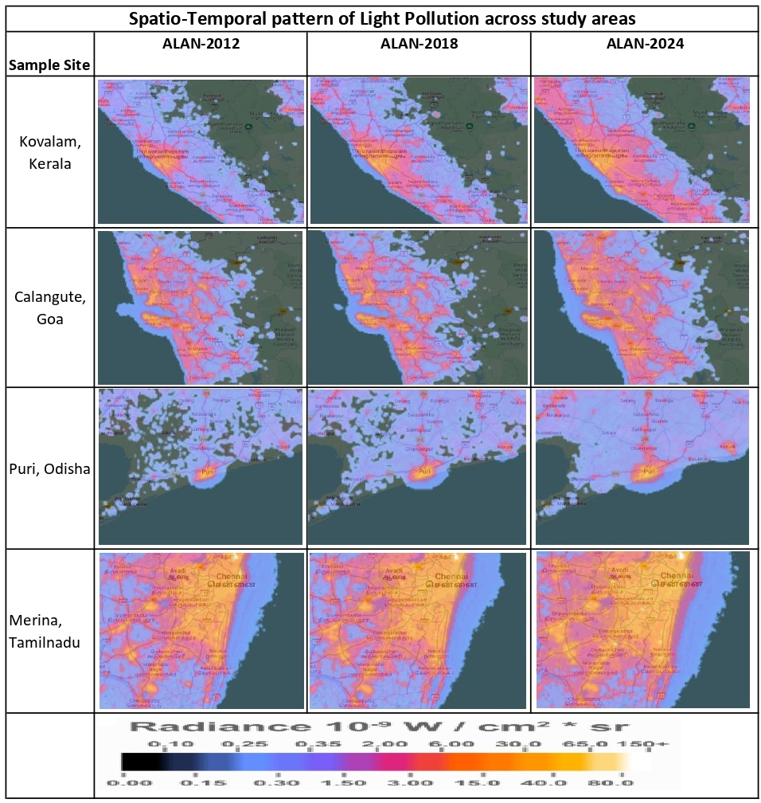
Figure -1 Spatio-temporal pattern of light pollution over Kovalam, Kerala; Galangute, Goa; Puri, Odisha and Merina, Tamilnadu

  - Ground Based SQM Measurements and Validation
Ground based SQM measurements were taken across the study areas to validate and complement the satellite based VIIRS data. The SQM readings aligned closely with the VIIRS data, confirming the high light pollution levels in tourist hotspots and lower light levels in more remote areas. For example, in Goa, the SQM readings ranged from 19.12 to 21.27 mag./arcSec² in high tourism density areas such as Calangute beach and Baga beach, reflecting high levels of skyglow. In contrast, readings in rural or less developed areas such as Palolem were recorded at 21.5 to 22.0 mag./arcSec², indicating better preservation of natural nightscapes. The skyglow intensity was categorized into five distinct levels based on the observed SQM values: very low, low, moderate, high, and very high (Table -1). These categories helped in identifying tourism driven hotspots of artificial light along the coastline. Additionally, urbanization and proximity to key infrastructures, such as airports, transport hubs, and nightlife dominated areas, were considered to assess their influence on light pollution.
Table-1: Observed SQM values from coastal tourism hubs towards countryside
Location | SQM Value ( mag./arc sec2)
Location | 0 - 1 km | 1 - 2 km | 2 - 4 km | 4 - 6 km | Beyond 6 km
Goa (15"32"24'N/73"45"48'E) | 20.12 | 20.43 | 20.54 | 20.82 | 20.87
Kerala (8"22"45'N/76"59"22'E) | 19.87 | 20.06 | 20.01 | 20.36 | 20.85
Tamil Nadu (13"03"47'N/80"17''01'E) | 19.02 | 19.18 | 19.34 | 19.92 | 19.97
Orissa (19"18"19'N/85"49"23'E) | 19.41 | 19.38 | 19.9 | 20.52 | 20.91
Type of Light Pollution | Very High | High | Moderate | Low | Very Low
Source: Field observations, 2023-24. (coordinates represent the central tourism hub/starting point for the transect)
In Kerala’s Kovalam beach area, SQM readings ranged from 18.57 to 21.85 mag./arcSec² in tourism hubs, whereas less developed areas near conservation zones such as Munroe Island registered readings of 22.5 mag./arcSec², indicating significantly darker skies. Similarly, Mahabalipuram’s SQM readings varied between 18.02 to 20.07 mag./arcSec² in areas close to the beach, while the more distant parts of the region exhibited sky brightness values in between 21.0 to 22.0 mag./arcSec². These SQM measurements substantiated the findings from the VIIRS data, confirming that the presence of concentrated tourism activity directly influenced the intensity of light pollution. The validation also showed the importance of integrating ground based and satellite data for a more accurate assessment of light pollution levels.
  - Correlation Between Tourism Intensity and Light Pollution
The tourist arrivals across the four coastal states showed a rapid increasing trend from 2012-13 to 2023-24 (Table-2). This momentum corresponds closely with increasing ALAN intensity captured in VIIRS-DNB data, particularly in high tourism activities dominated areas. Goa recorded an increase in arrivals from 4.2 million in 2012-13 to 10.6 million in 2023-24, with 152.38 percentage increase within a span of 12 years. VIIRS-DNB radiance in North Goa’s coastal belt (Calangute beach and Baga beach) rose by nearly 26.37 percentage between 2012 and 2024. Kerala saw tourist arrivals growth from 10.78 million in 2012-13 to 19.4 million in 2023-24, with 79.76 percentage increase. Corresponding, VIIRS radiance in coastal tourism hubs such as Kovalam beach and Alappuzha beach has been increased by 248.35 percentage during the same time span, reflecting the ALAN spread due to rapid development of resorts, and beachfront commercial activities. Tamil Nadu also registered tourist arrivals rising from 18.7 million in 2012-13 to 26.2 million in 2023-24, with 40.11 percentage increase. Marina Beach (Chennai) and Mahabalipuram recorded the sharpest rise in night time radiance, with VIIRS values increasing by over 70.1 percentage during the same time frame. Tourist arrivals in Odisha exhibited moderate but consistent growth, from 9.12 million in 2012-13 to 12.8 million in 2023-24, with 40.35 percentage increase. In Puri, one of India’s major pilgrimage and beach destinations, VIIRS radiance increased by 26.89 percentage over the span of the same period.
The integration of tourist arrival statistics with satellite based measurement clearly illustrates the tourism driven amplification of light pollution in India’s coastal regions. Periods of peak tourist influx (December to January in Goa, November to January in Tamil Nadu, and December to March in Kerala) coincided with the brightest VIIRS-DNB radiance levels, suggesting direct correlations between seasonal tourism activities and ALAN intensity. It is noteworthy to mention that the urban ALAN saturation thresholds were evident in Goa and Tamil Nadu, where further increases in tourist numbers after 2017-18 did not proportionally raise radiance, indicating that coastal lighting has reached near maximum levels of skyglow. In contrast, Kerala and Odisha continue to display the skyglow in an incremental pattern, reflecting expanding resort infrastructure and event based illumination.
Table-2 Relationship between tourist arrival and VIIRS magnitude from 2012-13 to 2023-24
 | Goa (15"32"24'N/73"45"48'E) |  | Kerala (8"22"45'N/76"59"22'E) |  | Tamil Nadu (13"03"47'N/80"17''01'E) |  | Orissa (19"18"19'N/85"49"23'E)
Year | Tourists Arrival (Million) | VIIRS Value (nW/cm²/sr) | Tourists Arrival (Million) | VIIRS Value (nW/cm²/sr) | Tourists Arrival (Million) | VIIRS Value (nW/cm²/sr) | Tourists Arrival (Million) | VIIRS Value (nW/cm²/sr)
2012-13 | 4.2 | 29.2 | 10.87 | 9.1 | 18.7 | 44.4 | 9.12 | 51.4
2013-14 | 4.5 | 30.1 | 11.45 | 9.4 | 21.6 | 48.6 | 9.87 | 53
2014-15 | 5 | 30 | 12.62 | 11.5 | 24.2 | 55.5 | 10.86 | 69.6
2015-16 | 5.3 | 32.4 | 13.44 | 10.6 | 27.8 | 58.6 | 11.85 | 53.1
2016-17 | 5.8 | 30.4 | 14.21 | 14.3 | 30.4 | 58 | 12.92 | 58.5
2017-18 | 6.5 | 32.2 | 15.77 | 15.2 | 31 | 66.5 | 14.11 | 55.2
2018-19 | 7 | 31.2 | 16.7 | 14.1 | 32.6 | 60.3 | 15.32 | 48.5
2019-20 | 7.5 | 32.7 | 19.57 | 16 | 30.2 | 62.4 | 15.42 | 59.9
2020-21 | 1.8 | 30.1 | 5.33 | 17.4 | 14.7 | 65.4 | 4.63 | 47.1
2021-22 | 2.5 | 23.4 | 7.6 | 19.1 | 15 | 68.4 | 5 | 73.5
2022-23 | 8 | 29.1 | 19.21 | 23.5 | 23.6 | 68 | 10.1 | 67.8
2023-24 | 10.6 | 36.9 | 19.4 | 31.7 | 26.2 | 75.5 | 12.8 | 65.2
Source: 1. Ministry of Tourism, Government of India, 2012-13 to 2023-24 and 2.VIIRS - NOAA Earth Observation Group. https://eogdata.mines.edu/
Statistical analysis revealed a strong positive correlation between tourism intensity and light pollution in the study regions (Figure-2). In Goa, the increased number of tourists (measured by tourist arrivals) showed a significant positive correlation with light intensity, with a Pearson’s correlation coefficient of 0.84 (p < 0.01). Similarly, in Kerala and Tamil Nadu, higher tourist arrivals were associated with higher light radiance levels, particularly in areas with large scale resorts and entertainment infrastructures.
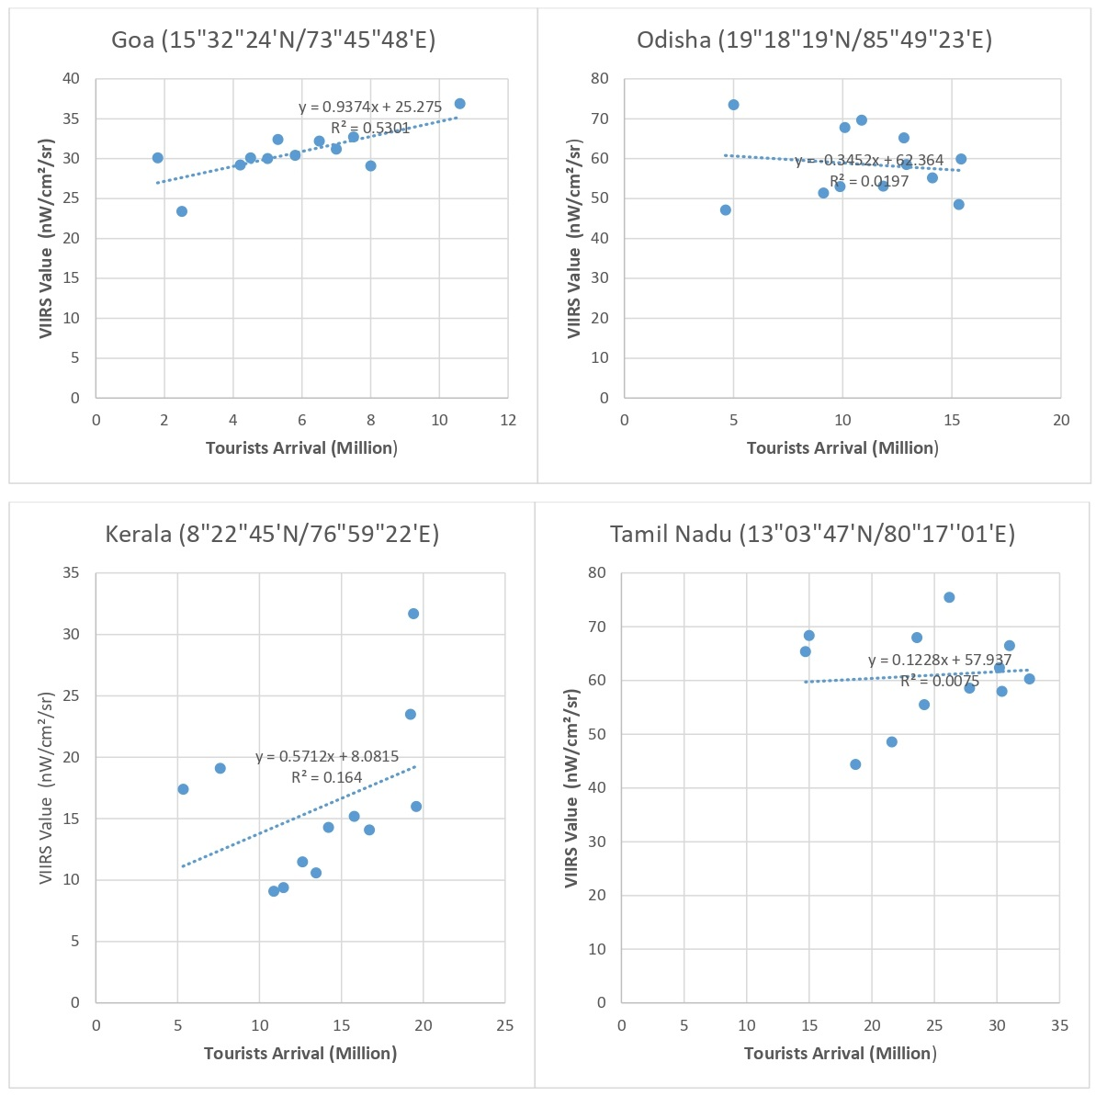Figure-2 Co-relation between tourist arrival and VIIRS value at Goa, Orissa, Kerala and Tamil Nadu
Regression models indicated that for every 10% increase in tourism activity, there was an average increase of 5-7 nW/cm²/sr in light radiance. This highlights the significant role of tourism infrastructures in creating light pollution, particularly in coastal regions where artificial lighting is often concentrated in tourist centric areas.

  - Ecological and Policy Implications
Tourism induced ALAN exerts significant ecological impacts directly or indirectly. Along Odisha and Tamil Nadu’s turtle nesting beaches, excessive beachfront lighting has been consistently associated with the disorientation of sea turtle hatchlings. Similarly, enhanced skyglow in the coastal areas of Goa and Kerala disrupts nocturnal insect assemblages, with adverse effects on bat populations and amphibians that depend on these taxa for foraging. In addition, the proliferation of light sources along estuarine and wetland corridors near coastal areas poses risks for avian migration. Artificial illumination is known to interfere with orientation cues used by nocturnal migrating birds, raising concerns for local biodiversity rich areas such as Kerala’s backwaters and the Chilika lagoon in Odisha. More specifically, the spread of ALAN reduces the availability of ‘dark corridors’ essential for the maintenance of circadian rhythms, predator-prey relationships, and reproductive behaviours for the light sensitive species.
Despite its growing ecological concern, ALAN remains largely absent from Indian environmental regulation. Environmental Impact Assessments (EIAs) for tourism and coastal infrastructure projects do not incorporate light pollution in its framework. So the environmental risks associated with ALAN are not evaluated by the existing norms of EIA. The inclusion of radiance thresholds and sky brightness metrics into EIA frameworks would provide a more comprehensive assessment of development impacts. The designation of legally recognized ‘Dark Sky Reserves’ within coastal rural belts represents another viable intervention. Such reserves, already implemented in parts of Europe and North America, could be adapted for ecologically sensitive stretches of India’s coastline, including turtle nesting beaches in Odisha, Tamil Nadu and the forest adjacent coastal zones in Goa. Tourism specific lighting guidelines should also be developed, emphasizing the adoption of downward directed fixtures, warm spectrum, and low intensity lighting technologies. Temporal restrictions on non-essential illumination during ecologically sensitive seasons (e.g., turtle nesting and bird migration period) could be enforced as part of sustainable tourism management practices. There is a need for a centralized monitoring system that integrates satellite based observations (e.g., VIIRS-DNB), ground based SQM measurements, and tourism statistics. Such type of integrated framework would enable dynamic assessment of ALAN trends and facilitate evidence based policy interventions. The involvement of local communities and eco-tourism operators should participate in night sky monitoring processes, which could further enhance the ALAN data availability for better management of coastal tourism focusing the ecological health of the light sensitive species.

4. Conclusion

This study gives a comprehensive analysis of tourism driven light pollution along India’s coastal regions, employing both satellite based VIIRS data and ground based SQM measurements to quantify and understand the spatial and temporal dynamics of light pollution. The findings show the significant role of tourism activities in contributing to light pollution, with notable variations across different coastal regions, including Goa, Kerala, Tamil Nadu, and Odisha. The spatial analysis revealed that the coastal regions with high tourist density, such as Calangute, Kovalam and Merina beaches, exhibited high levels of artificial light, with radiance values exceeding 50 nW/cm²/sr during peak tourist seasons. In contrast, more remote and less developed areas, such as Palolem beach and Munroe Island, demonstrated lower levels of light pollution, which aligns with a reduced tourism footprint. Temporal analysis confirmed that the intensity of light pollution has significantly been increased from 2012 to 2024. Intensification of ALAN has also been noticed during peak tourist seasons, notably between November and March, highlighting the seasonal influence of tourism activity on light emissions. The correlation between increased tourism intensity and light pollution suggests that coastal areas with extensive tourism infrastructure are particularly vulnerable to excessive artificial lighting, which brings adverse impact on both the natural environment and local ecosystems.
The ground based SQM measurements validated the satellite based VIIRS data, providing critical insights into the localized impact of light pollution. The data showed that areas near tourist hotspots, such as beach resorts and entertainment centres, recorded higher level light pollution. On the contrary, more ecologically focused zones, such as conservation areas and rural beaches, maintained better night sky conditions. These findings reinforce the importance of integrating satellite and ground based measurements to accurately assess light pollution levels. This study also highlights the detrimental impacts of artificial light on coastal biodiversity, particularly on nocturnal species like sea turtles, migratory birds, and other marine lives. The disruption of natural darkness due to ALAN affects species' behaviour and reproduction, thus threatening the sustainability of these ecosystems. To mitigate the effects of tourism driven light pollution, this research focuses on the adoption of sustainable lighting practices, such as the use of low intensity, shielded lighting, and the implementation of lighting guidelines in sensitive ecological areas. Policymakers, urban planners, and Coastal Regulation Zone Authority must collaborate to frame and enforce regulations that balance the demands of tourism with the need to preserve the natural darkness in the coastal areas.

Consent

The author declares that ‘written informed consent was obtained from the patient (or other approved parties) for publication of this case report and accompanying images. A copy of the written consent is available for review by the Editorial office/Chief Editor/Editorial Board members of this journal.

Ethical approval

The author hereby declares that "Principles of laboratory animal care" (NIH publication No. 85-23, revised 1985) were followed, as well as specific national laws where applicable. All experiments have been examined and approved by the appropriate ethics committee”

Disclaimer (Artificial intelligence)
Author(s) hereby declare that NO generative AI technologies such as Large Language Models (ChatGPT, COPILOT, etc.) and text-to-image generators have been used during the writing or editing of this manuscript.

REFERENCES
- Bedi, T. K., Puntambekar, K., & Singh, S. (2021). Light pollution in India: Appraisal of artificial night sky brightness of cities. Environment, Development and Sustainability, 23(2). https://doi.org/10.1007/s10668-021-01384-2
- Falchi, F., Cinzano, P., Duriscoe, D., Kyba, C. C. M., Elvidge, C. D., Baugh, K., ... & Furgoni, R. (2016). The new world atlas of artificial night sky brightness. Science Advances, 2(6), e1600377. https://doi.org/10.1126/sciadv.1600377
- Gaston, K. J., Visser, M. E., & Hölker, F. (2013). The biological impacts of artificial light at night: the research challenge. Philosophical Transactions of the Royal Society B: Biological Sciences, 370(1667), 20140133. https://doi.org/10.1098/rstb.2014.0133
- Hölker, F., Wolter, C., Perkin, E. K., & Tockner, K. (2010). Light pollution as a biodiversity threat. Trends in Ecology & Evolution, 25(12), 681–682. https://doi.org/10.1016/j.tree.2010.09.007
- Jägerbrand, A. K., & Bouroussis, C. A. (2021). Ecological Impact of Artificial Light at Night: Effective Strategies and Measures to Deal with Protected Species and Habitats. Sustainability, 13(11), 5991. https://doi.org/10.3390/su13115991
- Kyba, C. C. M., Kuester, T., de Miguel, A. S., Baugh, K., Jechow, A., Hölker, F., ... & Gaston, K. J. (2017). Artificially lit surface of Earth at night increasing in radiance and extent. Science Advances, 3(11), e1701528. https://doi.org/10.1126/sciadv.1701528
- Longcore, T., & Rich, C. (2004). Ecological light pollution. Frontiers in Ecology and the Environment, 2(4), 191–198. https://doi.org/10.1890/1540-9295(2004)002[0191:ELP]2.0.CO;2
- Ministry of Environment, Forest and Climate Change (MoEFCC). (2021). Coastal Regulation Zone Notification and Coastal Zone Management Plans. Government of India.
- Ministry of Tourism. (2023). India Tourism Statistics 2023. Government of India.
- Pawson, S. M., & Bader, M. K.-F. (2014). LED lighting increases the ecological impact of light pollution irrespective of color temperature. Ecological Applications, 24(7), 1561–1568. https://doi.org/10.1890/14-0468.1
- Stewart, A. J. A. (2021). Impacts of artificial lighting at night on insect conservation. Insect Conservation and Diversity. Royal Entomological Society, wiley, Special Issue. https://doi.org/10.1111/icad.12490
- Witherington, B. E., & Martin, R. E. (2000). Understanding, assessing, and resolving light pollution problems on sea turtle nesting beaches. Florida Marine Research Institute Technical Report TR-2.

