Shoreline Dynamics of the Forcados River Section Near Patani Bridge, Nigeria: A DSAS-Based Assessment

ABSTRACT
Shorelines are highly dynamic boundaries where land meets water, continuously reshaped by natural forces such as waves, tides, currents, and sea-level rise, as well as human activities including sand mining, dredging, and coastal development. The study assessed the shoreline dynamics of a section of the Forcados River, Nigeria, using the digital shoreline analysis system. This study investigates the shoreline dynamics of a section of the Forcados River in the Niger Delta, Nigeria, over a 20-year period (2004–2024). This study assessed the Spatio-temporal variations in the shoreline of a specific segment of the Forcados River, specifically around the Patani Bridge in the Niger Delta region of Nigeria. It focuses on three key time periods: 2004, 2014, and 2024. Employing advanced geospatial techniques and the Digital Shoreline Analysis System (DSAS), the research seeks to quantify and visualise shoreline changes across these epochs. Multi-temporal satellite imagery, Landsat and Sentinel-2, were acquired and processed to delineate shoreline positions for 2004, 2014, and 2024. Pre-processing steps included radiometric and geometric correction to ensure accuracy and consistency across epochs. To enhance shoreline detection, the Sobel edge detection filter was applied in IDRISI TerrSet, after which the shorelines were digitised, exported in GeoJSON format, and integrated into DSAS for quantitative analysis. The results revealed significant spatial and temporal variability in shoreline behaviour, characterised by alternating zones of erosion and accretion. On the north side of the bridge, erosion was dominant, accounting for approximately 31.53% (409,772.22 m²) of total shoreline change, while accretion covered only 10.43% (135,591.04 m²). Conversely, the south side exhibited strong accretion, with 46.75% (607,489.07 m²) of total change, compared to erosion of 11.29% (146,708.48 m²). In the northern section, 35.8% (EPR) and 37.66% (LRR) of transects recorded accretion. Similarly, the southern section showed accretion at 28.36% (EPR) and 28.79% (LRR). Transect-based analyses using End Point Rate (EPR) and Linear Regression Rate (LRR) confirmed these trends, with erosion hotspots concentrated along the north bank and major accretional zones dominating the south bank. The study underscores the relevance of geospatial technologies in shoreline monitoring and provides evidence-based insights to support adaptive management, conservation strategies, and sustainable coastal planning in the Niger Delta. This study has provided an evidence-based understanding of the shoreline dynamics of the section of the Forcados River, offering insights that can guide future interventions aimed at preserving riverbank stability, protecting infrastructure, and ensuring sustainable use of the river environment.

Keywords: Accretion, Digital Shoreline Analysis System, Erosion, Forcados River, Geographic Information System, Niger Delta

1.0 INTRODUCTION
Since the shorelines are important geographical boundaries, monitoring shoreline change plays an important role in integrated coastal management (Wang et al., 2023; Dang et al., 2022). Shorelines are highly dynamic boundaries where land meets water, continuously reshaped by natural forces such as waves, tides, currents, and sea-level rise, as well as human activities including sand mining, dredging, and coastal development (Boak & Turner, 2005; Di Paola, Rodríguez & Rosskopf, 2023). These changes manifest as erosion, the landward retreat of shorelines or accretion, the seaward build-up of sediments (Brown & Adekunle, 2015; Nwilo, 2005). Shoreline change can be quite complex in terms of driving forces, unsteady in both spatial and temporal domains. The change in the shoreline is an indicator for coasts to be classified according to their susceptibility to short and long-term environmental hazards (Görmüş et al., 2021). In deltaic systems such as the Niger Delta, shoreline instability is intensified by climate change, oil exploration, and anthropogenic modifications (Amangabara & Onyewuchi, 2021; Ankrah, Monteiro & Madureira, 2023).
Past studies across the Niger Delta reveal widespread erosion and accretion, with Bayelsa State alone contributing over 66% of recorded erosion between 1991 and 2018 (Abija et al., 2020). Communities in the region remain particularly vulnerable due to their low-lying topography and dependence on fishing and farming (Oyegun, 2007). However, most research has been concentrated on Lagos and Bonny, leaving critical knowledge gaps in other areas such as the Forcados River corridor. Given its ecological and socio-economic importance, coupled with its strategic role in oil exploration and navigation, understanding shoreline dynamics along the Forcados River—particularly the Patani Bridge area is vital for sustainable management, conservation, and climate resilience (Adegoke & Ologunorisa, 2010; Odubo & Amah, 2025).
The Forcados River is experiencing accelerated shoreline changes characterised by erosion, land loss, and ecological degradation. Drivers include sediment starvation, oil exploration, sand mining, and poorly planned development. These factors threaten biodiversity, navigation, infrastructure, and community livelihoods. Yet, existing shoreline assessments in the Niger Delta often generalise findings without providing high-resolution, location-specific data for the Forcados corridor. This gap limits the identification of erosion hotspots and hampers adaptive management. As a result, vulnerable communities, ecosystems, and critical infrastructure face escalating risks from shoreline instability (Amangabara & Onyewuchi, 2021; Abija et al., 2020).
The Forcados River, a distributary of the Niger River, flows about 200 km through diverse ecosystems in the Niger Delta, including mangrove swamps, freshwater swamps, and coastal barrier islands, before emptying into the Atlantic Ocean at the Bight of Benin. The Patani Bridge area, located at the Delta / Bayelsa boundary within the western Niger Delta, is a strategic corridor historically used for navigation and trade, and now heavily utilised for oil exploration and crude oil transport. Its geographical coordinates range between 05°14'26.59"N–05°11'45.73"N and 006°10'33.44"E–006°12'56.51"E. The bridge itself spans 850 meters and has transformed navigational patterns along the river. However, oil exploration and transportation activities have contributed to water pollution, environmental degradation, and declining aquatic life, thereby threatening the livelihoods of fishing communities that depend on the river.
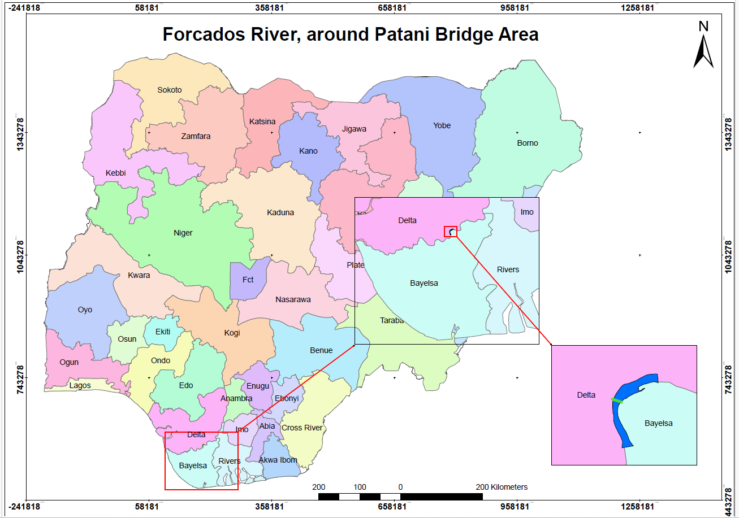
Beyond pollution, the riverine environment faces recurrent flooding that destroys property, forces evacuations, and disrupts agricultural activities by compelling farmers to harvest prematurely. The Forcados splits from the Niger River at Toru-Abubou near Agbere in Bayelsa State, sharing the same bifurcation point as the Nun River. Offshore petroleum deposits at Burutu further emphasise its economic significance while amplifying ecological risks. The study area, covering approximately 5,000,000 m², has been experiencing notable shoreline changes driven by erosion, accretion, and anthropogenic pressures. Figure 1 is the study area map.

Figure 1: Area of Study Along the Forcados River (Source: Author's Desktop work, 2025)

The study assessed the shoreline dynamics of a section of the Forcados River, Nigeria, using the digital shoreline analysis system. The objectives are:
- Accurately delineate multi-temporal shoreline dynamics of the study area over 20 years (2004–2024),
- Apply the Digital Shoreline Analysis System (DSAS) to evaluate shoreline change rates,
- Map and analyse the spatial variability of erosion and accretion along the river section,
- Assess shoreline movements on both sides of the Forcados River along the study section.

2.0 MATERIALS and METHODS
2.1 Data Acquisition
Satellite imagery for the years 2004, 2014, and 2024 was sourced from the Earth Resources Observation and Science (EROS 2020) Centre, provided by (USGS, and Copernicus Open Access Hub (CEMS, 2025), provided by the European Space Agency (ESA), as shown in Figure 2. The imageries were selected from the Landsat 7 ETM + and Sentinel-2 mission, which offers high-resolution multispectral data suitable for shoreline analysis. Priority was given to images with minimal cloud cover and clear visibility of land-water boundaries to ensure optimal shoreline delineation. Each image was carefully checked for metadata such as acquisition date, cloud percentage, and sensor mode before selection.
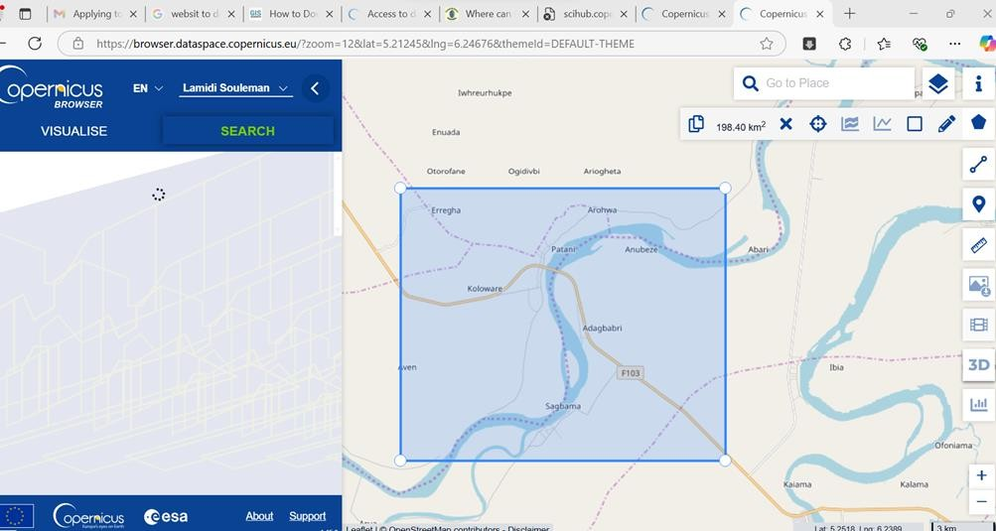

Figure 2: Process of Sentinel II Imagery Data Acquisition (Source: Author, 2025)

2.2 Data Pre-Processing
2.2.1 Radiometric and Atmospheric Correction
To improve spectral fidelity, images were downloaded in Level-1C (Top-of-Atmosphere reflectance) format and were processed to Level-2A (Bottom-of-Atmosphere reflectance) using Sen2Cor in SNAP or an equivalent atmospheric correction tool. This correction minimised the effects of atmospheric scattering and absorption. Also, Dark Object Subtraction (DOS) or FLAASH (Fast Line-of-sight Atmospheric Analysis of Spectral Hypercubes) techniques were considered to enhance image quality.

2.2.2 Geometric Correction and Georeferencing
Although Sentinel-2 imagery is orthorectified by default, the accuracy of geolocation was verified. All images were projected into a common coordinate reference system: WGS 1984, UTM Zone 32N, which is appropriate for southern Nigeria. The Root Mean Square Error (RMSE) of image alignment was assessed and kept below 0.5 pixels to ensure spatial accuracy across time steps.

2.2.3 Image Enhancement
To facilitate better edge detection and visual contrast between land and water, the images were converted to grayscale (single band) using band 8 (Near Infrared) or band 4 (Red), depending on contrast quality. Histogram equalisation and contrast stretching were applied to enhance the shoreline features prior to delineation.

2.3 Data Processing
2.3.1 Shoreline Delineation
The shoreline was delineated using the visually defined land-water boundary as indicated by the Mean High-Water Line (MHWL). This is justified because Sentinel-2 imagery reflects water absorption features clearly in the NIR band, making the MHWL detectable in cloud-free scenes. Shoreline extraction was conducted using a semi-automated edge detection technique, specifically the Sobel Edge Detection Algorithm in IDRISI TerrSet, as shown in Figures 3 and 4. This was followed by manual refinement in QGIS. The Sobel operator highlights pixel intensity gradients
that correspond to the shoreline boundary. The output lines were converted into vector polyline shapefiles for further analysis.

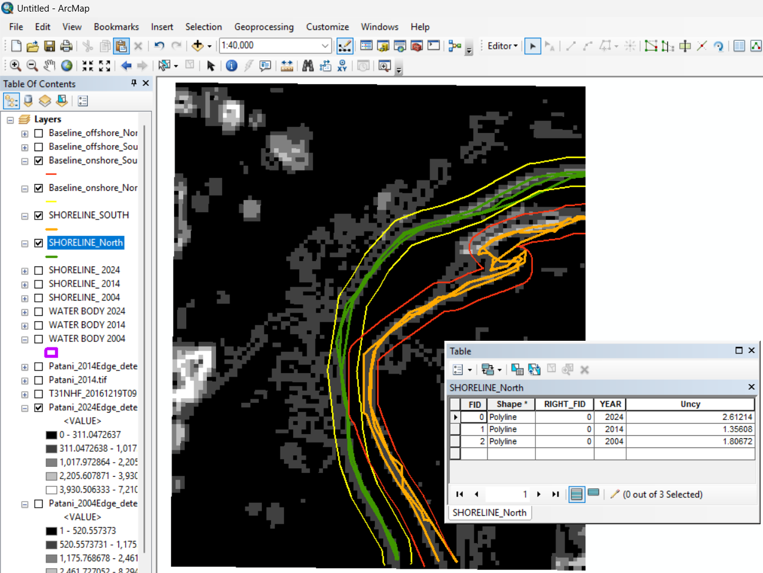
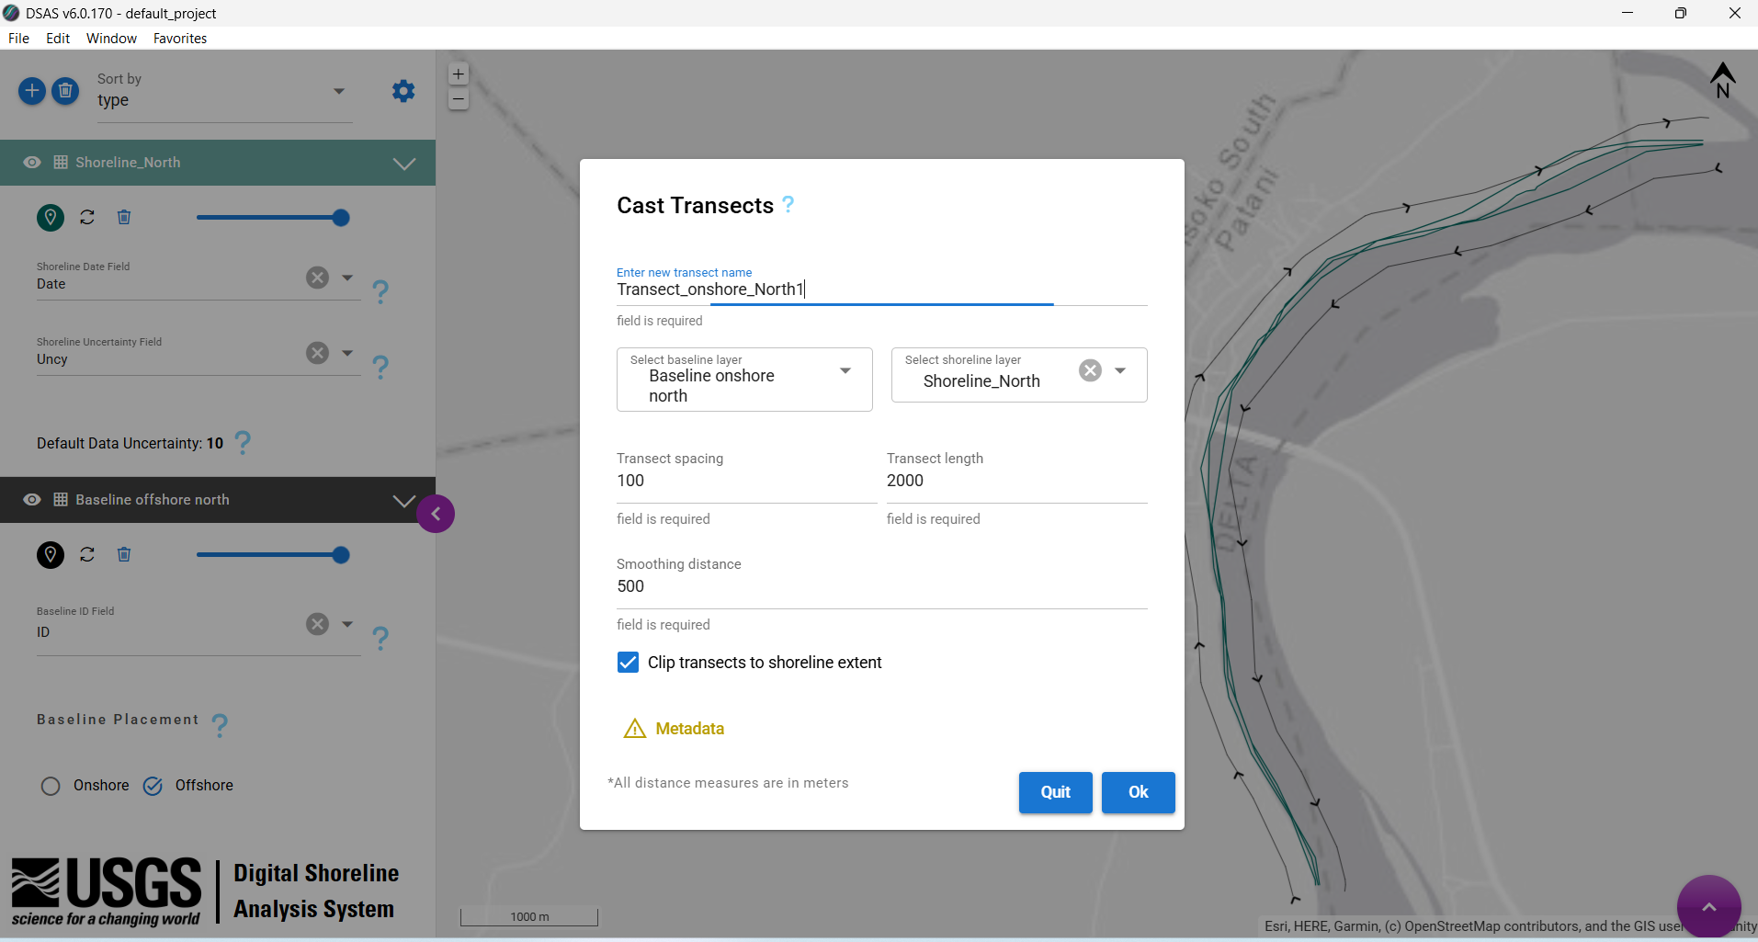

Figure 3: Digitization of Shoreline and Baseline using Edge Detection (Author, 2025)

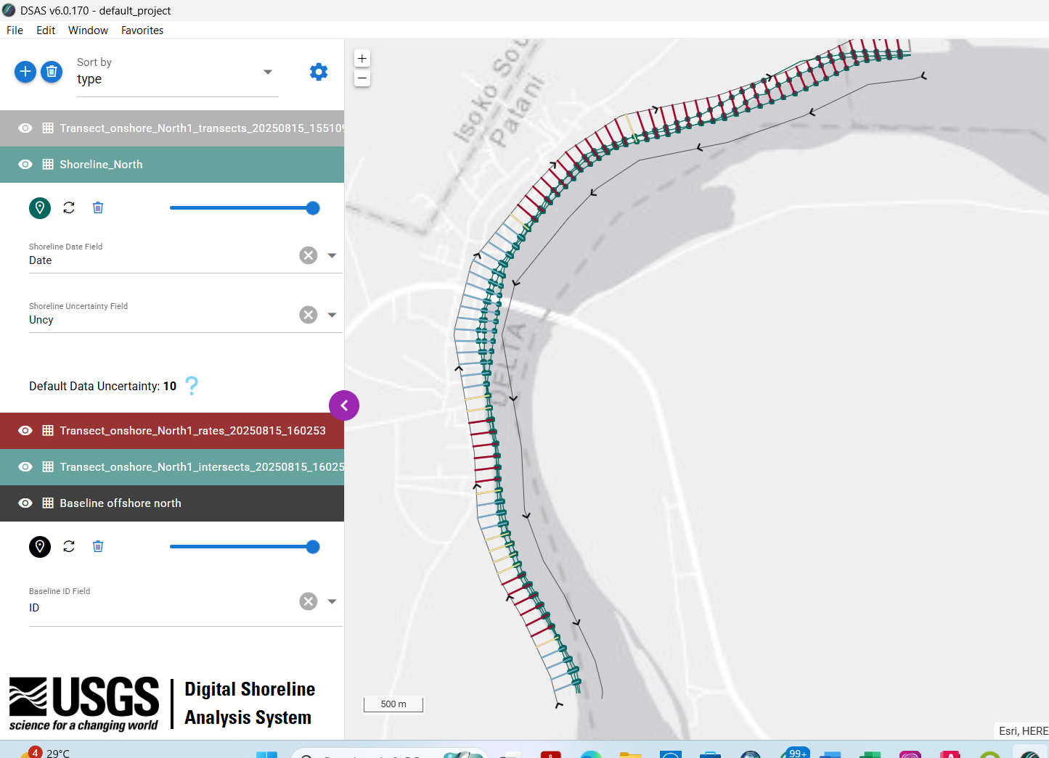

Figure 4: Shoreline and Transects Digitization in DSAS (Source: Author, 2025)

2.4 METHODS
This study adopted a multi-method research design that combined remote sensing, Geographic Information System (GIS)-based spatial analysis, and statistical modelling to examine shoreline dynamics of the Forcados River around the Patani Bridge area over a 20-year period (2004–2024). Landsat ETM+ and Sentinel-II satellite imageries were sourced from the United States Geological Survey (USGS) Earth Explorer and the Copernicus Open Access Hub, ensuring minimal cloud cover and clear shoreline visibility. These datasets were pre-processed through radiometric and atmospheric correction using Sen2Cor in SNAP to minimise distortions, and georeferenced to the WGS 1984 UTM Zone 32N coordinate system with sub-pixel accuracy. Image enhancement and band combinations were applied to improve shoreline detection. The shoreline positions were subsequently digitised and analysed using the Digital Shoreline Analysis System (DSAS) in ArcGIS and QGIS environments, which enabled the quantification of shoreline change through established statistical techniques.
To assess shoreline variability and long-term change, two metrics were computed: End Point Rate (EPR) and Linear Regression Rate (LRR), to capture maximum positional variation. Transects were generated at 100-meter intervals along the shoreline, providing consistent coverage and spatial resolution across the study area. Uncertainty was quantified with an estimated ±10 m margin, accounting for sensor resolution, tidal variability, and digitisation error. The results were mapped using GIS-based visualisation techniques, highlighting spatial zones of erosion, accretion, and stability across decades. By integrating spatial, temporal, and hydrological analyses, this methodology provided a holistic assessment of shoreline change, linking observed dynamics to both natural processes (tides, sediment transport, flooding) and anthropogenic drivers (sand mining, dredging, oil exploration, and infrastructure development).

3.0 RESULTS and DISCUSSION
The first objective, which sought to accurately delineate multi-temporal shoreline dynamics over a 20-year period (2004–2024), revealed clear evidence of spatial adjustments within the Forcados River corridor. The analysis of shoreline positions for 2004, 2014, and 2024 indicated a consistent decrease in the water body. Similarly, shoreline length fluctuated across the three epochs. These variations confirm the dynamic and unstable nature of the shoreline, characterized by alternating processes of erosion and accretion that collectively reshape the riverbanks over time, as shown in Table 1 and Figure 5.
Table 1: Evaluation of Multi-Temporal Shorelines Dynamics 2004 to 2024
Year | Area of Water Body (m²) | Shoreline Length (m)
2004 | 4,602,409.133 | 16,065.45976
2014 | 4,593,093.929 | 16,504.61563
2024 | 4,355,368.259 | 15,824.96608
Source: Author, 2025

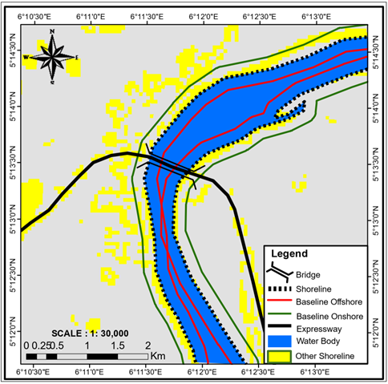
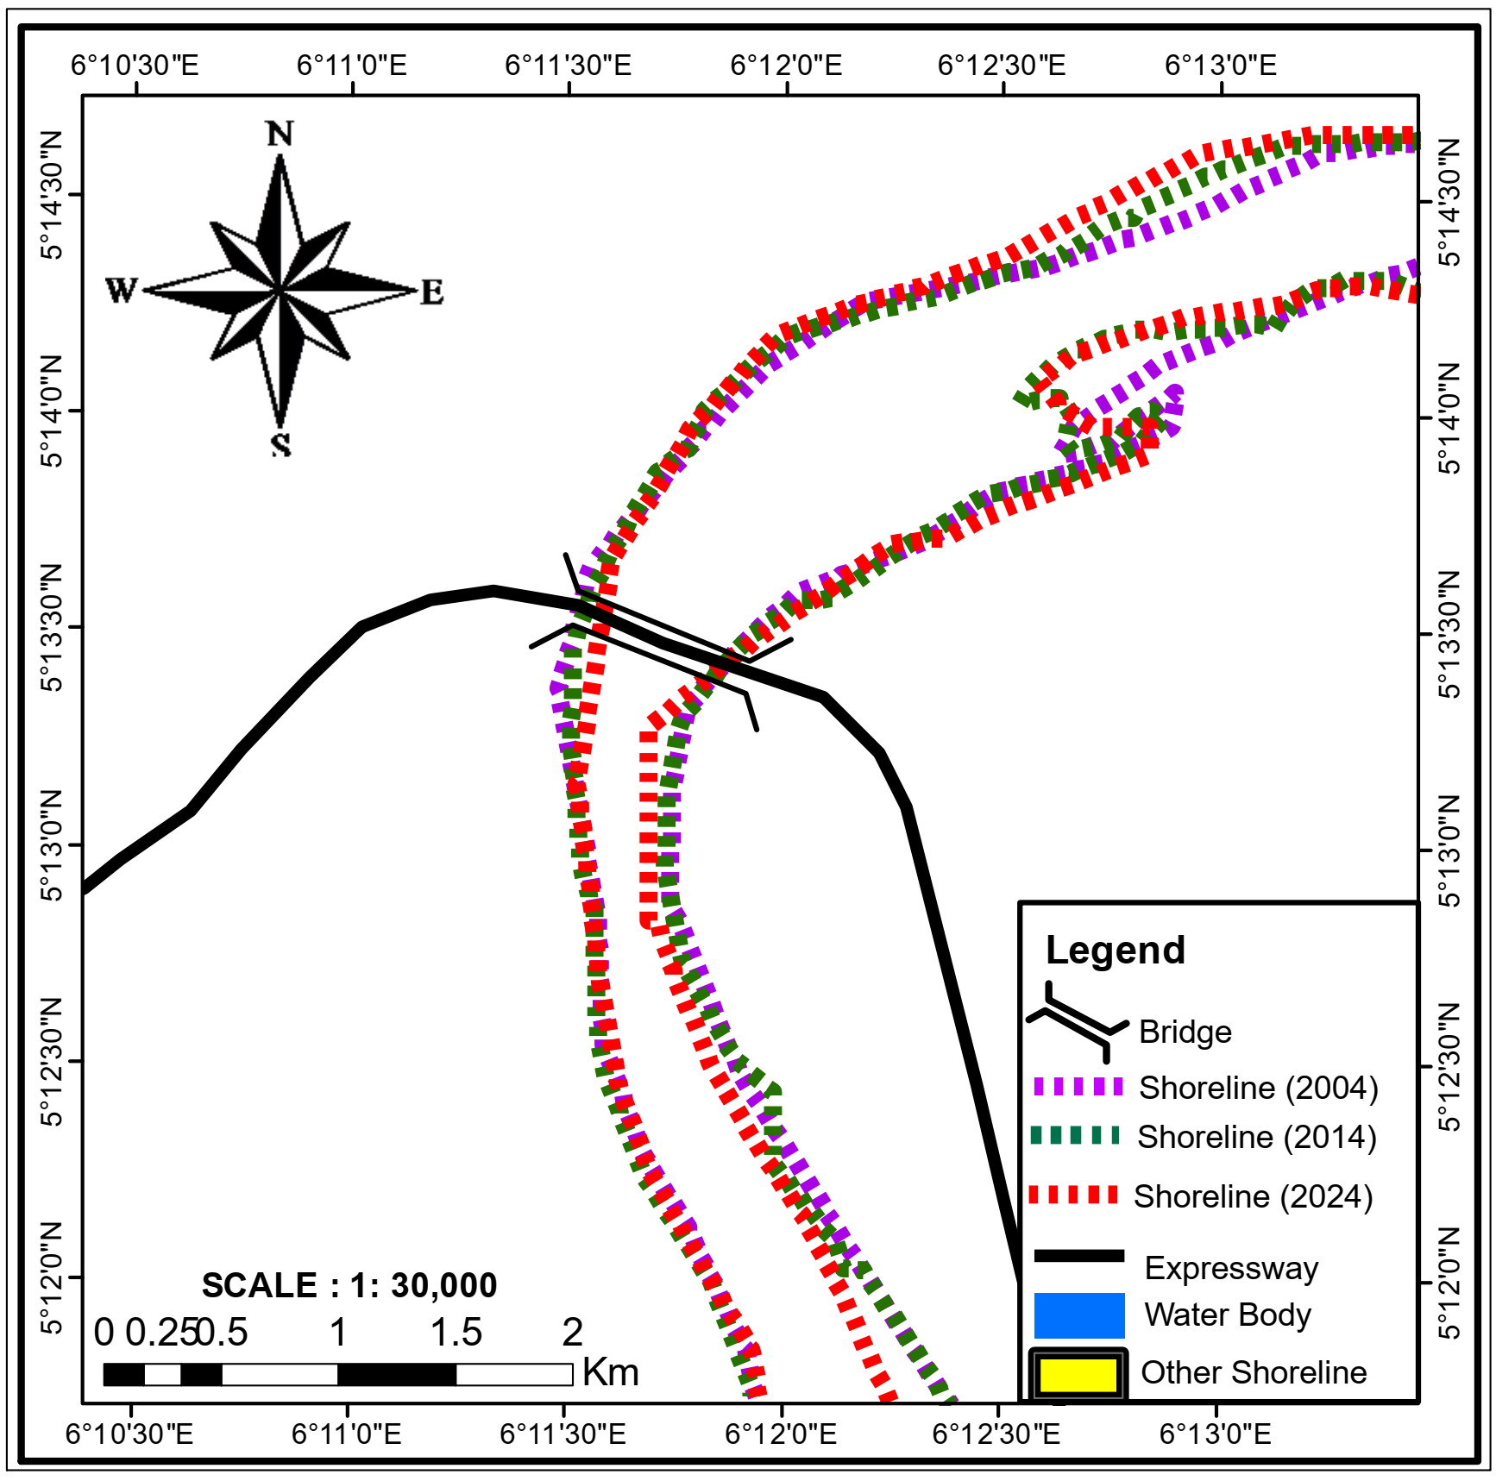
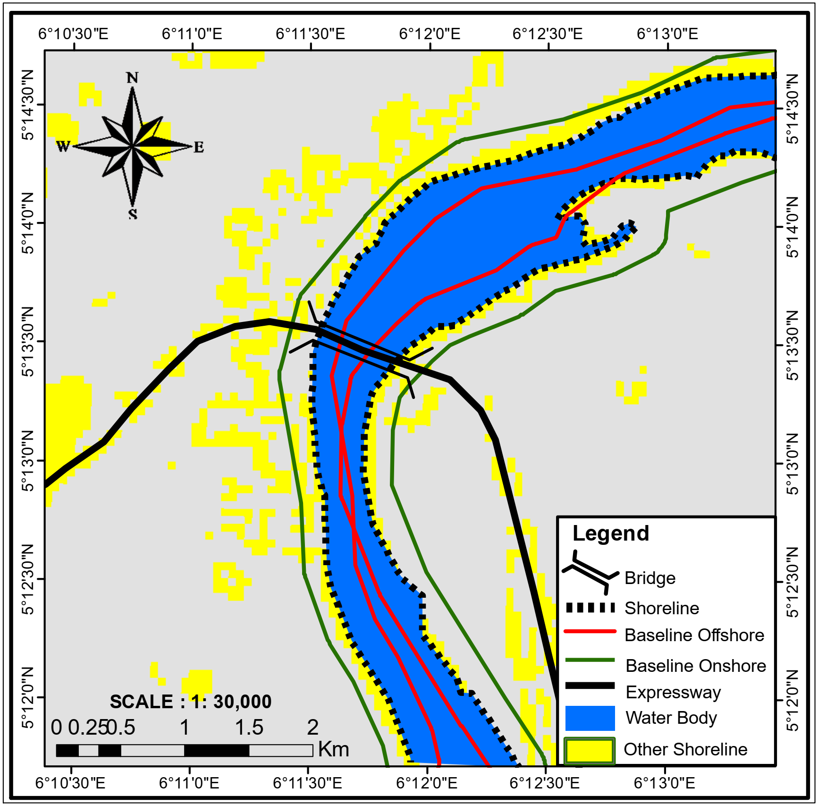
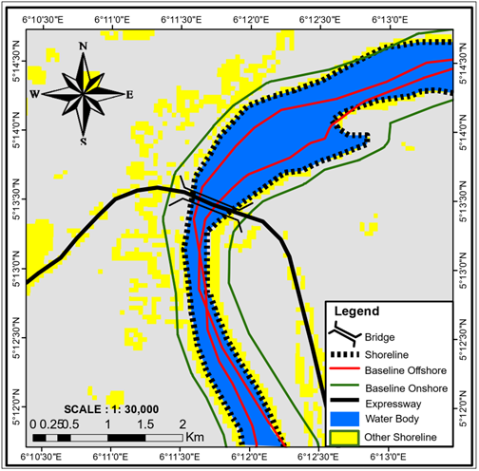
Figure 5: Multi-Temporal Shorelines Dynamics between 2004 to 2024
5a) Shoreline Dynamics 2004 5b) shoreline Dynamics 2004-2024
5c) shoreline Dynamics 2014 5d) shoreline Dynamics 2004

The second objective applied the Digital Shoreline Analysis System (DSAS) to compute shoreline change rates using End Point Rate (EPR) and Linear Regression Rate (LRR). These are shown on tables 2 and 3 and Figure 6.

Table 2: Shoreline Change Rates in the North Direction of the Study Area
Rate Type | EPR (End Point Rate) | LRR (Linear Regression Rate)
Total Transects | 81 | 77
Average Rate (m/yr) | -1.42 | -0.85
Number of Erosional Transects | 52 | 48
Per cent Erosional (%) | 64.2 | 62.34
Max Erosion (m/yr) | -12.95 | -9.6
Max Erosion Transect ID | 73 | 70
Average Erosional Rate (m/yr) | -3.51 | -2.77
Number of Accretional Transects | 29 | 29
Per cent Accretional (%) | 35.8 | 37.66
Max Accretion (m/yr) | 6.79 | 6.79
Max Accretion Transect ID | 34 | 34
Average Accretional Rate (m/yr) | 2.32 | 2.32
Source: Author, 2025
Table 3: Shoreline Change Rates in the South Direction of the Study Area
Rate Type | EPR (End Point Rate) | LRR (Linear Regression Rate)
Total Transects | 67 | 66
Average Rate (m/yr) | -3 | -3.04
Number of Erosional Transects | 48 | 47
Per cent Erosional (%) | 71.64 | 71.21
Max Erosion (m/yr) | -21.43 | -21.43
Max Erosion Transect ID | 14 | 14
Average Erosional Rate (m/yr) | -5.16 | -5.27
Number of Accretional Transects | 19 | 19
Per cent Accretional (%) | 28.36 | 28.79
Max Accretion (m/yr) | 4.71 | 4.71
Max Accretion Transect ID | 2 | 2
Average Accretional Rate (m/yr) | 2.46 | 2.46

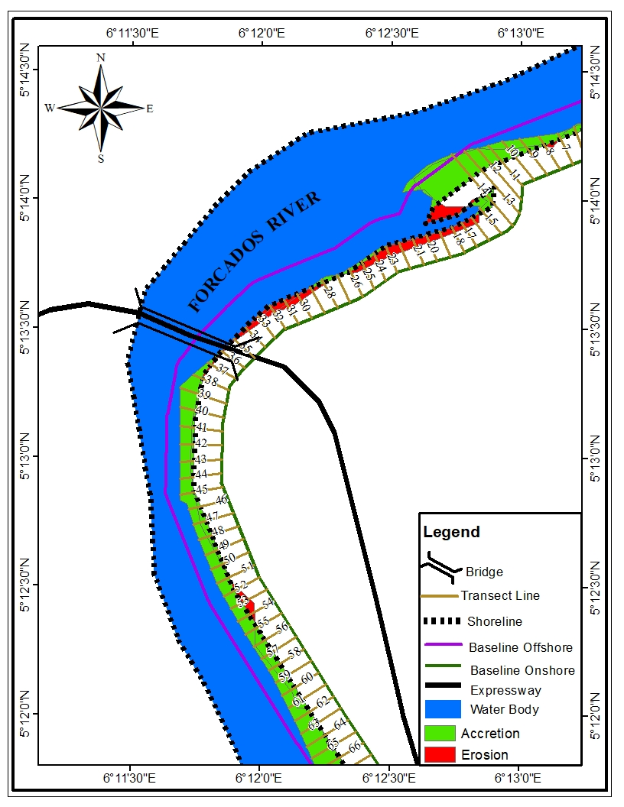
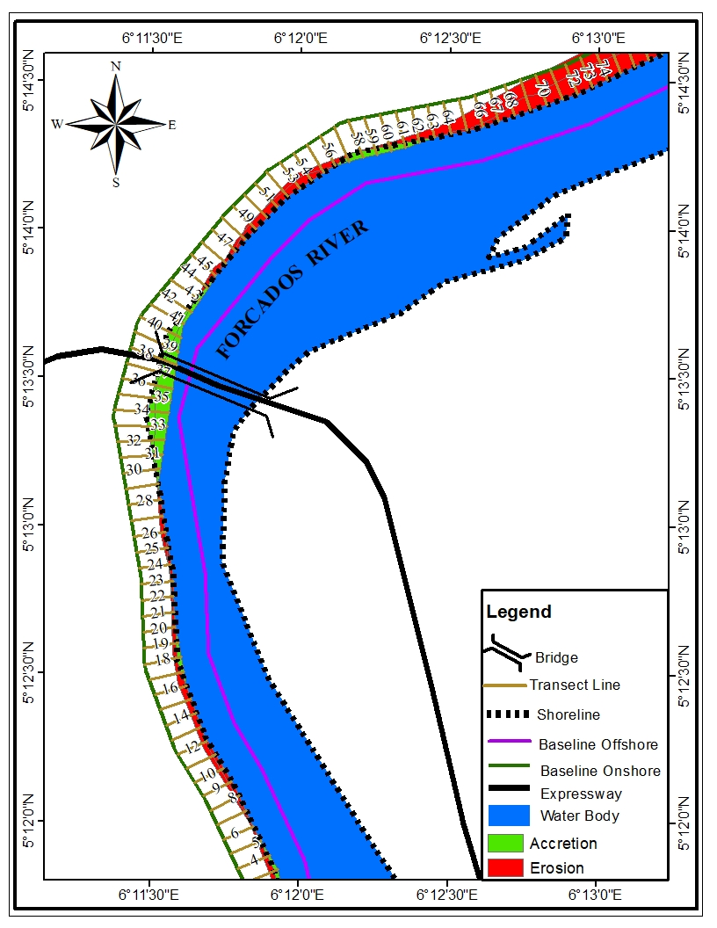

Figure 6.: Spatial variability of Erosion, Accretion, along the river section in the South and North Side of the Bridge.

The results of objective 3 were satisfied as shown in Figure 6 and Tables 4 and 5, the spatial distribution of erosion and accretion patterns along the river section at the North side and South side of the study area. The results indicate significant variability in the dynamics of the shoreline, with alternating sections of erosion and accretion.
Table 4: Evaluation of Erosion, Accretion, along the River Section on the North Side of the Bridge
Transect | Area(m²) | Impact
1-6 | 7,607.44 | Accretion
1-30 | 71,409.84 | Erosion
13-21 | 6,317.83 | Accretion
27-45 | 102,081.24 | Accretion
42-83 | 338,362.38 | Erosion
55-64 | 19,584.53 | Accretion
Source: Author, 2025

Table 5: Evaluation of Erosion, Accretion, along the River Section in the South Side of the Bridge
Transect | Area(m²) | Impact
1-4 | 16,460.04 | Erosion
3-19 | 210,505.70 | Accretion
7-8 | 2,796.577 | Accretion
7-8 | 2,050.33 | Erosion
14-16 | 1,059.56 | Erosion
15-19 | 2,270.47 | Accretion
15-27 | 76,056.4 | Erosion
23-30 | 13,101.83 | Accretion
27-38 | 36,548.12 | Erosion
34-35 | 83.27828 | Accretion
35-69 | 378,731.2 | Accretion
44-45 | 48.71389 | Erosion
51-55 | 13,327.18 | Erosion
61-67 | 1,158.134 | Erosion

The results of objective 4 were satisfactory as shown in table 6 and figures 7 and 8.
Table 6: Area of (m²) of Accretion and Erosion
S/N | Impact on Both Sides | Area (m2) | Percentage
1. | Erosion (North) | 409,772.22 | 31.53%
2. | Erosion (South) | 146,708.48 | 11.29%
3. | Accretion (North) | 135,591.04 | 10.43%
4. | Accretion (South) | 607,489.07 | 46.75%
5. | Total | 1299,560.80 | 100.00%
Source: Author, 2025

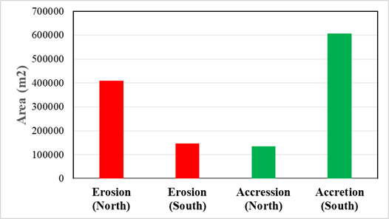

Figure 7: Histogram of Shoreline Impact on both sides of the river (Source: Author, 2025)

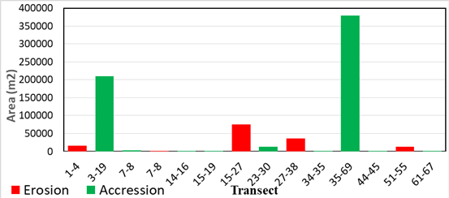
Figure 8: Histogram of Shoreline Impact along the Transects (Source: Author, 2025)

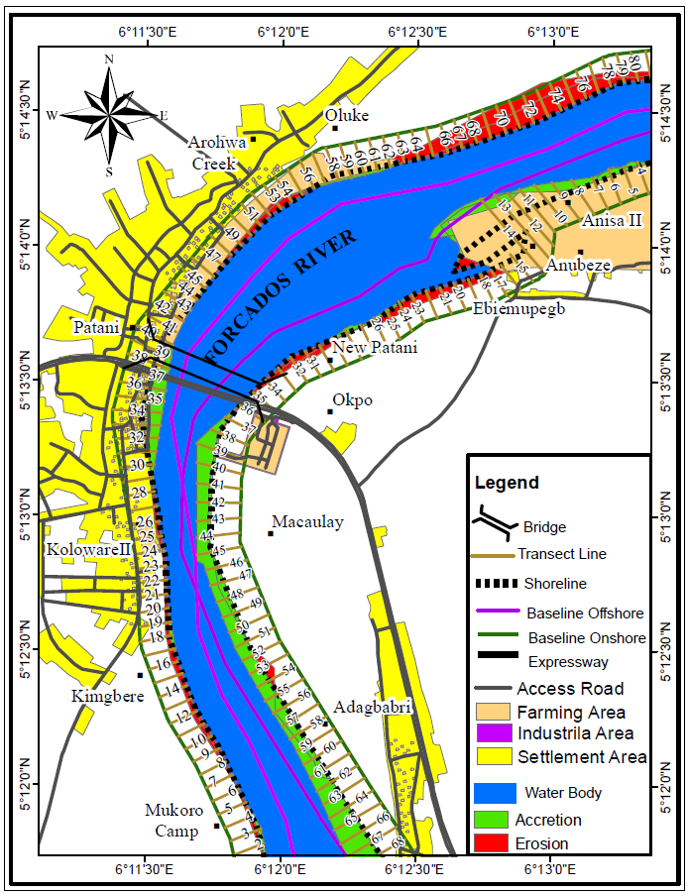

Figure 9: A Composite Map showing Shoreline Impact on both sides of the river
Source: Author, 2025

The results of this study provide a comprehensive understanding of the shoreline dynamics along the Patani Bridge area of the Forcados River from 2004 to 2024, revealing both erosional and accretional processes. The delineation of multi-temporal shorelines (Table 1 and Figure 5) indicates a consistent decrease in the water body area, from 46,020,639 m² in 2004 to 45,935,958 m² in 2014, and further to 45,355,856 m² in 2024. This reduction of approximately 664,782 m² over the 20-year period is indicative of a progressive encroachment of land and sediment deposition, consistent with findings by Blum & Roberts (2008), who also observed sediment deposition as a key driver of shoreline shrinkage in river systems.

The fluctuation in shoreline length from 16,685.460 m in 2004, 16,504.62 m in 2014, and 15,824.97 m in 2024 (Table 1) underscores the dynamic nature of the river’s shoreline, which is characterised by both retreat and advancement. This behaviour is similar to the observations made by Ankrah et al. (2023), who documented similar fluctuating shoreline lengths in riverine systems experiencing natural and anthropogenic influences. Figures 5a, c &d further support these trends, where areas of landward retreat and riverbank expansion are clearly depicted, and the shoreline change map (Figure 5b) demonstrates these processes through the use of red and blue arrows for erosion and accretion, respectively.
The shoreline changes’ rates, calculated using End Point Rate (EPR) and Linear Regression Rate (LRR), reveal a dominant erosional trend in the northern section of the river (Tables 2 and 3 and Figure 6). The average EPR of -1.42 m/yr and LRR of -0.85 m/yr in the Northern direction are indicative of steady shoreline retreat, consistent with the findings of Yusoff and Zainal (2016), who observed similar patterns of erosion in river sections influenced by both hydrodynamic forces and human activities such as sand mining. The maximum erosion rate of -12.95 m/yr at transect 73 further highlights areas of severe erosion, reflecting hotspot zones identified in other studies, such as the work of Vermeer and Rahmstorf (2009), who observed accelerated erosion rates in unstable riverbank zones.
In contrast, the southern section (Table 2 and 3 and Figure 6) showed a more pronounced erosional trend with an average EPR of -3.0 m/yr and LRR of -3.04 m/yr, similar to the findings of Yusoff and Zainal (2016), who reported higher erosion rates in southern river sections. The maximum erosion rate of -21.43 m/yr at transect 14, indicating extreme shoreline instability, underscores the vulnerability of the southern riverbank to degradation, as highlighted by Yesuph, & Dagnew (2019), who noted that such rapid erosion often results from a combination of natural forces and human-induced changes such as land use and construction.

Despite the dominance of erosion, both northern and southern sections also exhibit localised accretion. In the northern section, 35.8% (EPR) and 37.66% (LRR) of transects recorded accretion, with a maximum rate of +6.79 m/yr at transect 34. This is in line with the findings of Shi, Cooper, Li, Yang, Yang, Yu, and Wang (2019), who observed that even in highly erosive environments, accretion can still occur in certain areas due to sediment deposition and hydrodynamic conditions. Similarly, the southern section showed accretion at 28.36% (EPR) and 28.79% (LRR), with the maximum accretion rate of +4.71 m/yr, supporting the results found by Lu, X. Zhou, Li, Yao, Yan, Jin and Lu (2020). who documented accretional processes occurring in areas with favourable sediment transport conditions.

The spatial variability of erosion and accretion along the river (Figure 6) further demonstrates the heterogeneous nature of shoreline change, with alternating zones of erosion and accretion. In the northern section, transects 42–83 experienced significant erosion, while transects 27–45 recorded notable accretion, a pattern similar to that observed by Doody, Cuddy and Bhatta (2016), in dynamic river systems. Similarly, in the southern section, transects 35–69 exhibited substantial accretion, while erosion was prevalent in other zones. This variability reflects the complex interactions between sediment transport, hydrodynamic conditions, and human interventions that shape riverine environments.

The comparative evaluation of shoreline impacts on both sides of the river (figures 7, 8 and 9) and tables 4, 5 and 6. The results show a stark contrast between the northern and southern shores. On the northern side, erosion accounted for 31.53% of the total area (409,772.22 m²), while accretion covered only 10.43% (135,591.04 m²), emphasising the erosion-prone nature of this section, as also reported by Mentaschi et al. (2018), in their study of erosion-dominated shorelines. Conversely, the southern side exhibited a higher rate of accretion, covering 46.75% of the area (607,489.07 m²), with only 11.29% (146,708.48 m²) eroded. This significant difference supports the findings of Zhang, Huang, Carling, and Zhang (2015), who documented that sediment accumulation is often more pronounced in the lower reaches of rivers, where sediment deposition is favoured over erosion. Overall, the study reveals a highly dynamic shoreline system, with pronounced differences between the northern and southern banks. While the northern section is dominated by erosion, the southern section exhibits a stronger trend of accretion. This pattern reflects the complex interactions of natural hydrodynamic forces, sediment transport, and human activities, which continue to shape the shoreline of the section of the Forcados River over time.

4.0 CONCLUSION
This study successfully applied remote sensing and geospatial techniques to delineate and analyse the multi-temporal shoreline dynamics of a section of the Forcados River over a 20-year period. The results revealed that the shoreline is highly dynamic, with significant spatial and temporal variability between 2004, 2014, and 2024. The reduction in water body area and fluctuating shoreline lengths point to continuous reconfiguration of the riverbanks, shaped by both erosional retreat and accretional advancement. The assessment of transects highlighted that while erosion and accretion alternate along the river sections, erosion is particularly severe on the north side of the bridge, where over 30% of the total shoreline change impact was attributed to land loss. Conversely, the south side of the bridge exhibited dominant accretion, accounting for nearly half (46.75%) of the total changes. This imbalance underscores the role of localised sediment deposition processes and hydrodynamic conditions that favour accumulation on the south bank while exposing the north bank to persistent erosion pressures. Overall, the study demonstrates that the section of the Forcados River is undergoing measurable shoreline transformations, with accretion dominating at the system scale, but with critical erosion hotspots that threaten the stability of the north bank and adjacent infrastructure. The integration of the End Point Rate (EPR) and Linear Regression Rate (LRR) methods within the DSAS framework proved effective for quantifying change rates, providing a reliable basis for spatial and temporal shoreline monitoring. The findings emphasise the need for continuous shoreline monitoring and management strategies that prioritise erosion control on the north side, while sustainably managing accretional areas on the south side. This study has provided an evidence-based understanding of the shoreline dynamics of the section of the Forcados River, offering insights that can guide future interventions aimed at preserving riverbank stability, protecting infrastructure, and ensuring sustainable use of the river environment.

DISCLAIMER (ARTIFICIAL INTELLIGENCE)

Authors hereby declare that no generative AI technologies such as Large Language Models (ChatGPT, manuscript) were used.

REFERENCES
Abija F.A., Abam, T.K.S., Teme, S.C. and Eze, C. L. (2020). Relative Sea Level Rise, Coastline Variability and Coastal Erosion in the Niger Delta, Nigeria: Implications for Climate Change Adaptation and Coastal Zone Management. J Earth Sci Climate Change 11(9)
Adegoke, J. O., & Ologunorisa, T. E. (2010). An assessment of recent changes in the Niger Delta coastline using satellite imagery. Journal of Sustainable Development, 3(3), 277–296. https://doi.org/10. 5539jsd.v3n4p277
Amangabara, G. T., & Onyewuchi, O. M. (2021). Morphological changes along the shoreline of the arcuate Niger Delta from parts of Delta State to Akwa Ibom State between 1986 and 2016. Ghana Journal of Geography, 13(1), 221–234. https://doi.org/10.4314/gjg.v13i1.11
Ankrah, J., Monteiro, A., & Madureira, H. (2023). Shoreline change and coastal erosion in West Africa: A systematic review of research progress and policy recommendation. Geosciences, 13(2), 59. https://doi.org/10.3390/geosciences13020059
Blum, M.D., & Roberts, H.H. (2008). Drowning of the Mississippi Delta due to insufficient sediment supply and global sea-level rise. Nature Geoscience, 2(7), 488–491. https://doi.org/10.1038/ngeo553
Boak, E. H., & Turner, I. L. (2005). Shoreline definition and detection: A review. Journal of Coastal Research, 21(4), 688–703. https://www.jstor.org/stable/4299462
Brown, B. J., & Adekunle, M. F. (2015). Geospatial analysis of shoreline changes in Nigeria. International Journal of Geoinformatics, 11(3), 33–40.
Di Paola, G., Rodríguez, G., & Rosskopf, C. M. (2023). Shoreline dynamics and beach erosion. Geosciences, 13(3), 74. https://doi.org/10.3390/geosciences13030074
Doody, T. M., Cuddy, S. M., & Bhatta, L. D. (2016). Connecting flow and ecology in Nepal: Current state of knowledge for the Koshi Basin. CSIRO Land and Water, Australia. 194 pages. Published under the South Asia Sustainable Development Investment Portfolio (SDIP), supported by the Australian Government.
Lu, X. X., Zhou, Y., Li, D., Yao, S., Yan, X., Jin, Z., & Lu, J. (2020). Distinguishing the multiple controls on the decreased sediment flux in the Jialing River basin of the Yangtze River, Southwestern China. Catena, 193, 104593. https://doi.org/10.1016/j.catena.2020.104593

Mentaschi, L., Vousdoukas, M. I., Pekel, J. F., Voukouvalas, E., & Feyen, L. (2018). Global long-term observations of coastal erosion and accretion. Scientific Reports, 8, Article 12876. https://doi.org/10.1038/s41598-018-31208-9
Nwilo, P. C., Olusegun, A., & Badejo, O. T. (2005). Impacts of oil spills along the Nigerian coast. Proceedings of the International Oil Spill Conference, 2005(1), 567–570. https://doi.org/10.7901/2169-3358-2005-1-567
Odubo, T. V., & Amah, N. W. (2025). Estuary shoreline dynamics: Local consequences and adaptation strategies. International Journal of Innovative Environmental Studies Research, 13(2), 46–55. https://doi.org/10.5281/zenodo.15271223
Oyegun, R. A. (2007). Coastal erosion in the Niger Delta: An overview. IOSR Journal of Environmental Science, Toxicology and Food Technology, 4(2), 15–22.
Shi, B., Cooper, J. R., Li, J., Yang, Y., Yang, S. L., Luo, F., Yu, Z., & Wang, Y. P. (2019). Intratidal bed-level changes within total tidal cycle on an exposed and highly turbid mudflat: Importance of very shallow water stage. Marine Geology, 412, 1–11. https://doi.org/10.1016/j.margeo.2019.03.004
Vermeer, M., & Rahmstorf, S. (2009). Global sea level linked to global temperature. Proceedings of the National Academy of Sciences of the United States of America, 106(51), 21527–21532. https://doi.org/10.1073/pnas.0907765106
Yesuph, A. Y., & Dagnew, A. B. (2019). Land use/cover spatiotemporal dynamics, driving forces and implications at the Beshillo catchment of the Blue Nile Basin, Northeastern Highlands of Ethiopia. Environmental Systems Research, 8, Article 21. https://doi.org/10.1186/s40068-019-0148-y
Yusoff, N., & Zainal Abidin, R. (2013). Riverbank Erosion Risk with Regards to Rainfall Erosivity. Infrastructure University Kuala Lumpur Research Journal 1(1)
Zhang, M., Huang, H. Q., Carling, P. A., & Zhang, M. (2015). Sedimentation of overbank floods in the confined complex channel–floodplain system of the Lower Yellow River, China. Hydrological Processes, 29(25), 5342–5357. https://doi.org/10.1002/hyp.1126
Görmüş, T., Ayat, B., Aydoğan, B., & Tătui, F. (2021). Basin scale spatiotemporal analysis of shoreline change in the Black Sea. Estuarine, Coastal and Shelf Science, 252, 107247.

Wang, J., Wang, L., Feng, S., Peng, B., Huang, L., Fatholahi, S. N., ... & Li, J. (2023). An overview of shoreline mapping by using airborne LiDAR. Remote Sensing, 15(1), 253.

Dang, K. B., Vu, K. C., Nguyen, H., Nguyen, D. A., Nguyen, T. D. L., Pham, T. P. N., ... & Do, T. H. (2022). Application of deep learning models to detect coastlines and shorelines. Journal of Environmental Management, 320, 115732.

