Original Research Article
Exploring the Interplay of Secondary Traumatic Stress and Ethical Injury on Mental Health Among Police Practitioners

ABSTRACT
Introduction: Having helping nature and being as first responders to any kind of emergency situations is always appreciable. Social workers, medical professionals, police practitioners etc., are the first ones who are getting the label of first responders. When it comes to the Police practitioners, their duty is not only limited to the immediate assistance to the public. But their profession continuously involves handling of crime investigation and victim assistance. A common stereotypical belief of the public is that the police practitioners are always physically and mentally strong. On the other hand, the existing literatures proved that the police practitioners are going through different kind of physical ailment and mental trauma including professional stress, depression, secondary traumatic stress (STS), moral injury, etc.
Aim: To identify the relationship between STS and Ethical Injury (EI) among police practitioners, and to understand the impact of STS and EI on Police Mental Health.
Study design: Exploratory research design
Area and Duration of the Study: The study was conducted during the period between August and September, 2024 in Jodhpur, Rajasthan.
Methodology: A multistage sampling method was used to choose 45 police practitioners who were taking part of criminal investigation of murder/grievous hurt/aggravated form of sexual offenses/grave accidents/suicide etc., within the last one-month period of time. The pertinent data were collected through structured interview schedules including validated STS scale and Ethical Injury scale. The collected data were analyzed using SPSS.
Results: 71% of the police practitioners suffered due to any form of emotional impact after investigating violent crimes. 33.33% police practitioners found with high level of STS. A moderate positive correlation (r=.392, ρ<.01) between Secondary Traumatic Stress and Ethical Injury was found.
Conclusion: Higher the ethical injury makes the police practitioners more vulnerable towards secondary traumatic stress. The police have multiple roles for the benefit of society; hence their mental health status should be assessed periodically to assure their wellbeing and performance. The study urges the police department to address or alleviate the issue of STS among police officials for their improved performance.

Keywords: Secondary Traumatic Stress (STS), Ethical Injury (EI), Mental Health, Police Practitioner

INTRODUCTION
Policing is a very dynamic and challenging field. It is the legal duty and obligation of the police force to be vigilant for the public safety round the clock, as well as to provide assistance and support to the victims of crime who are with emergency needs. They are known as the frontline or first responders in the society (Lamb, et al. 2002). The work of police officers includes investigating crime scenes, conducting undercover operations, dealing with the law-and-order issues, deaths or injuries of others, and mass protests. Their complex work environments involve some unique difficulties and challenges such as long working hours, low staffing levels, and increasing crime rates that lead them to stressful situations (Savarimalai, et al. 2023).
Based on number of research studies, occupational stress has directly impacted employees within the organization and is now one of the most significant health issues in the modern world (Lu, et al. 2003; Cooper & Payne, 1988 & Beheshtifar & Nazarian, 2013). Steers (1981) in his study indicates that occupational stress has detrimental mental and psychological effects on employees (Beheshtifar & Nazarian, 2013). In the case of the police profession, especially in India, the increasing workload due to the low police-civilian ratio increases the stress level (Savarimalai, et al. 2023). But in most cases, the public has portrayed the police as misleading or inaccurate based on movies, series, or other politically biased opinions.
In India, researches on the victimization of police are relatively inadequate. Most of the studies focuses on identifying distinct stressors of policing such as irregular or long working hours, heavy workload, lack of staff strength, lack of social life, lack of promotion etc. (Shekhar, B & Somasundaram, V., 2011). Police professionals are sometimes threatened or severely injured due to the complex work situations they face; such events are sometimes associated with an increased risk of post-traumatic stress disorder (PTSD). Witnessing or dealing with the suffering of others can also lead to secondary traumatic stress (STS), especially when dealing with horrific crimes and being exposed to traumatic events experienced by victims of crimes, usually accidents, assaults, rapes, murders, etc. (Nina, et al., 2022).
The highly hierarchical nature of the police profession can contribute to the persistence of moral injury. Moral injury can occur among police officers when they are unable to protect and provide justice to victims when witnessing violence, or when they are forced to act or need to ignore certain wrong practices which are contrary to their moral values ​​due to pressure or unwritten orders of senior officers or departmental policies. This also leads to a violation of the ethics of the profession. Such ethical injuries can cause emotional consequences such as guilt, shame, and loss of trust in themselves or institutions (Papasoglou et al., 2020).

REVIEW OF LITERATURE
Shekhar, B., and Somasundaram, V. (2011) collected and analysed data from 384 Hindu sub-inspectors in Tamil Nadu to identify factors that contribute to secondary trauma among police officers. The study discovered that more than two-thirds (67%) of the subjects had experienced secondary trauma. Seven factors were found as having considerable variation in the research population by factor analysis. Lack of information and stigma in seeking treatment and consulting a counsellor were two main factors impacting secondary trauma among Tamil Nadu police officers. The study concluded that media tolerance and public awareness can help create an environment where police officers do not hesitate to seek treatment or counselling.
A theoretical review done by Papazoglou, et al., (2020) on moral suffering in police work through reviewing various literatures highlighted the importance of assessing moral injuries or sufferings among police officers. It found that the multidimensional nature of police work can lead to have complex nature of moral suffering. The study pointed out that the counsellors need to build relevant and empirically validated interventions into their counselling plans along with practice-based and relevant based techniques to treat the officers who experience moral sufferings. It also highlights the need of future researches on the topic considering that the less exposure in this area.
Litam & Balkin, (2020) conducted a study among 109 healthcare workers to understand the association between secondary traumatic stress and moral injury. Being in the medical profession they are one of the frontline workers. The existing literatures in the study found that the presence of STS and moral injury is high. Hence, the authors of the study tried to find out the possibility of association between STS and Moral Injury. The results of the study found significant association between two. The study also found high level of secondary traumatic stress among the participants. The health care workers in the study explained the preoccupation with wellbeing of others, hypervigilance, enmeshment with patients’ difficulty sleeping, feeling on edge, and avoidance of activities. The study found that workload, compassion fatigue and stress as primary factors to burnout.
In another study done by Tuttle, et al., (2019) among National Police of Finland found greater levels of compassion fatigue (also known as secondary traumatic stress) and moral injury were significantly associated with low levels of compassion satisfaction. The study included 454 police officers from the national police of Finland as participants. The outcome of the study mentioned that it is possible that the officers who feel less compassion and satisfaction over their years of service may resign, retire, or move to position that does not entail exposure to traumatic incidents. It suggested the law enforcement agencies and clinicians while working to reduce the effects of compassion fatigue and moral injury to integrate policies and practices that promote compassion satisfaction among police officers.
In a systematic literature review-based study conducted by Singh, Jhajharia, & Saluja (2025) emphasised the importance of introducing the interventions such as “cognitive behavioural therapies, resilience training, peer support system, and virtual reality-based programs” to improve mental health of police forces. These interventions can be useful in mitigating the adverse effect of secondary traumatic stress among police officials.

RESEARCH GAP
Figley (1995) who is believed to firstly define the term secondary traumatic stress as the stress experienced by helping a traumatized or distressed person, which affects psychological, emotional, and cognitive outcomes. As discussed above, there is a paucity of studies related victimization of police, particularly on secondary traumatic stress among police officers. The available studies are relatively old and the studies related to current scenario is not available.
The risk of moral injury is much higher in the case of station-level police officers, from constables to inspectors. No study has been found in India that assesses the level of moral injury. Either of the two, secondary traumatic stress and ethical injury, can greatly affect the mental health of police officers. (Daniel & Treece,2022; Hanley,2025; Papazoglou et al.,2019). Police officers experiencing moral injury may also suffer from compassion fatigue, which impacts their psychological well-being (Tuttle et al., 2019). It is also assumed that STS and ethical injury may have a significant association, either directly or in combination with another extraneous variable or moderator variable.

OBJECTIVES
- To understand the level of secondary traumatic stress among station-level police officers.
- To explore the level of Ethical Injury among station-level police officers.
- To analyse the relationship between secondary traumatic stress and ethical injury among station-level police officers.
- To discuss the importance of implementation of different policies to upgrade good mental health among station-level police officers by law-enforcement agencies.

HYPOTHESIS (NULL HYPOTHESIS)
1. H₀: There is no significant relationship between secondary traumatic stress and ethical injury among station-level officers in Jodhpur.
2. H₀: There is no significant relationship between years of service in police and secondary traumatic stress among station-level officers in Jodhpur.
3. H₀: There is no significant relationship between years of service in police and ethical injury stress among station-level officers in Jodhpur.

MATERIALS AND METHODS
Exploratory research design was used for this empirical study. For this minor study, the data was collected through multistage random sampling and at station-level purposive sampling technique from 45 station-level police officers in Jodhpur. Sample of the study is limited to Police officers from Rajasthan state police service (only civil police officers) irrespective of the proportion of the gender and specifically among the police staff in the ranks of constabulary to Investigation officers those who were taking part of investigation of murder/grievous hurt/aggravated form of sexual offenses/grave accidents/suicide etc., within the last one-month period of time. This study is a part of doctoral research study at Rajasthan state level.
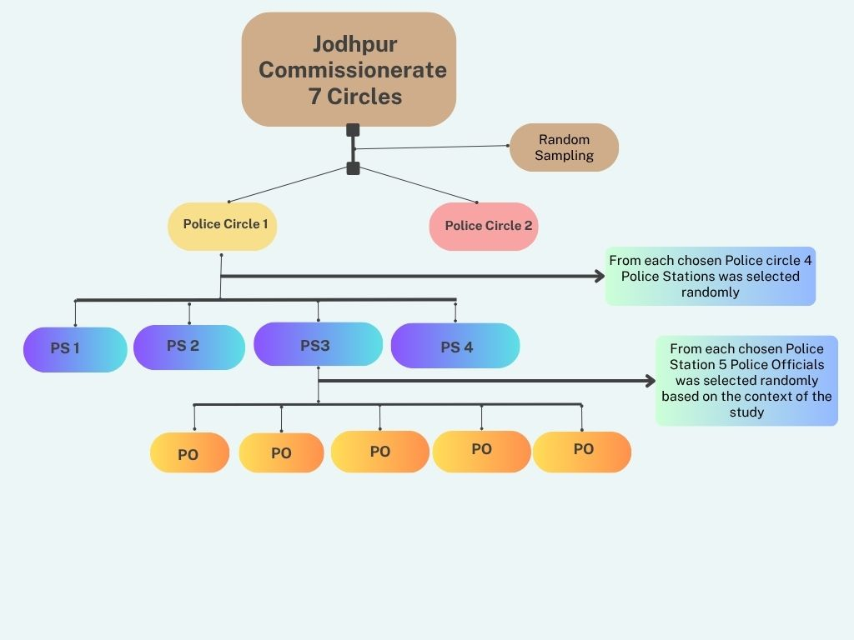
Figure 1: Sampling Method - Multistage Random Sampling
Source: Primary source (Created using Canva)
Inclusion criteria: The samples who have taken part in investigation of murder/grievous hurt/aggravated form of sexual offenses/grave accidents/suicide etc. within one month from the data collection.
Exclusion criteria: The samples who have fulfil the inclusion criteria but reluctant to cooperate to the survey.
As a part of fulfilling the objectives, a structured interview schedule including both open and close ended questions was constructed. Before commencing the data collection approval from DGP Rajasthan Police and written informed consent from the participants of the study was obtained. The participants were explained confidentiality of the data and identity of them would be completely ensured. With the constructed tool, personal interviews were conducted to collect the primary data. Secondary sources also will be used to gather the study related information. The analysis was done using SPSS including frequency analysis, and correlations. The results are portrayed using figures and tables. Qualitative analysis was also done to find out the impact of STS and ethical injury on quality mental health of police personnels.

MEASURES/SCALES
The Secondary Traumatic Stress Scale (STSS) (Bride et al., 2004) was used to measure the secondary traumatic stress (STS). It is a 5-point Likert scale consisting of 17 items. The scale was reframed into Indian context to fulfil the research objectives. The subject experts worked in the research area were requested to validate the tool. Their suggestions were incorporated to ensure the validity of the scale. For the purpose of checking the reliability of the scale, Cronbach’s Alpha was calculated. The Cronbach’s alpha of the scale for the study is 0.865.
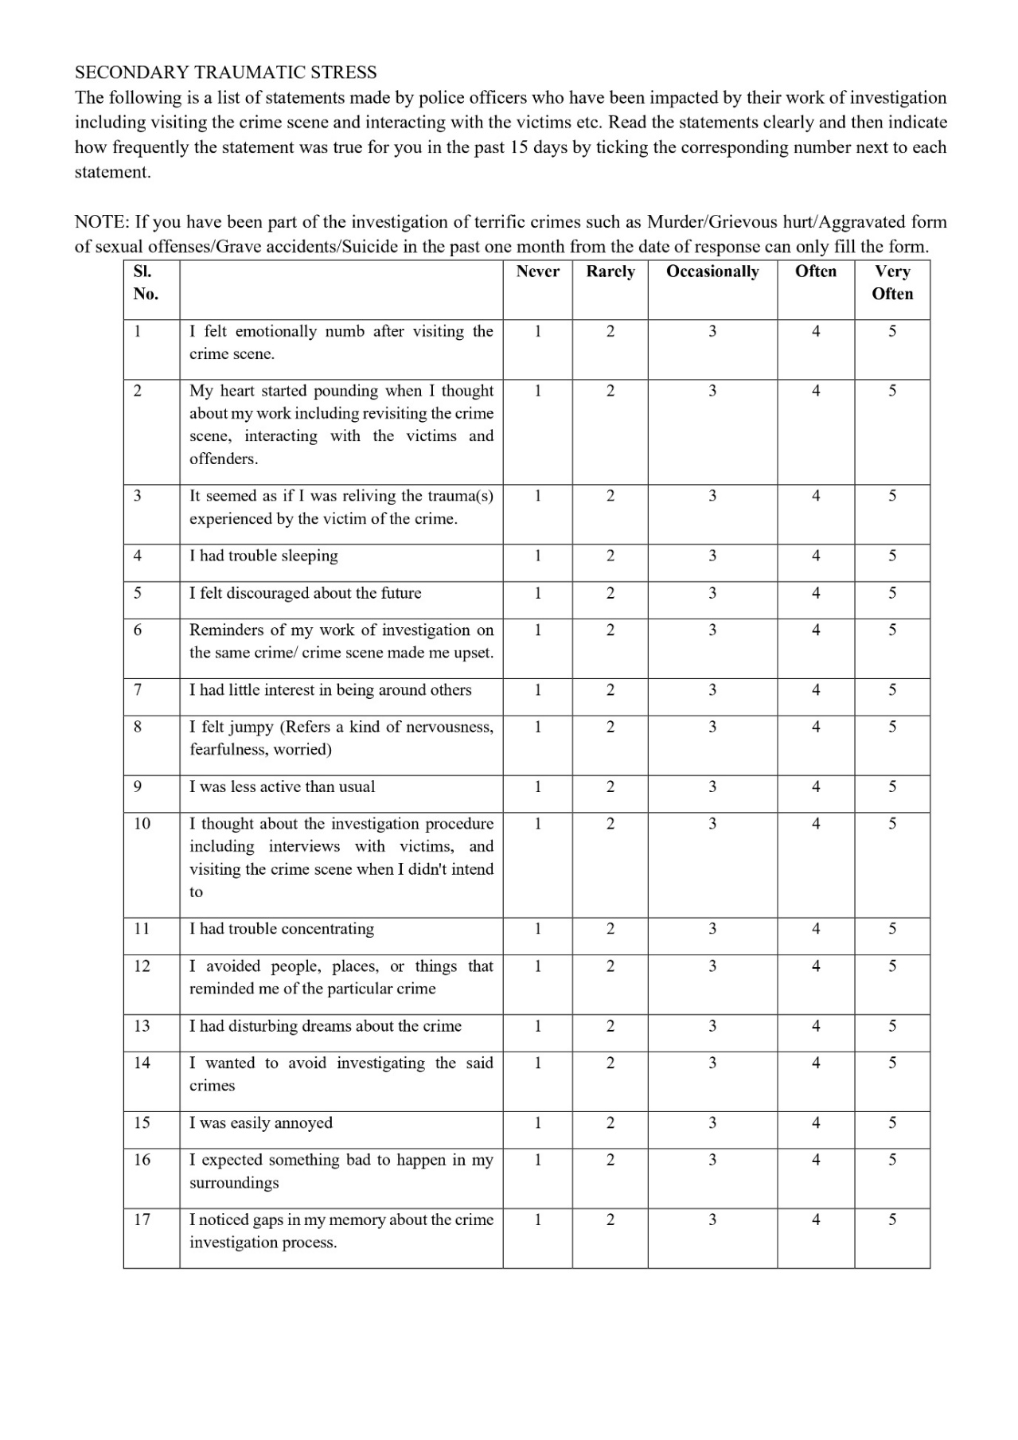
List 1-: Secondary Traumatic Stress Scale
Source: Primary source
With reference of 9 itemed 6-point Likert Moral Injury Event Scale (MIES) (Nash et al., 2013) based on expert opinion a new 19 itemed Ethical Injury scale was invented by the researchers to assess the level of ethical injury among police officers. The Cronbach’s alpha was calculated to test the reliability of the study. The Cronbach’s alpha for the scale is 0.870.
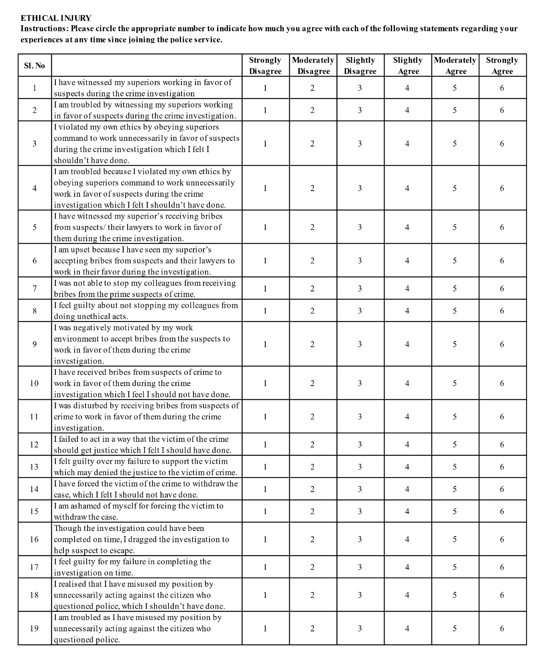
List 2-: Ethical Injury Scale
Source: Primary source

SIGNIFICANCE OF THE STUDY
As mentioned above, it is very important to understand the mental health of police professionals, as good mental health is very important for effective functioning. Given the paucity of research assessing the level of STS and ethical injury and their relationship and impact on the mental health of police officers, the objectives of this study are to critically explore the impact of secondary traumatic stress and ethical injury on the mental health of police officers in Rajasthan Police. The results of the study will further contribute to the need for larger studies in Indian Police to assess the quality of mental health and to provide suggestions on the implementation of new policies in the police service of states in India to improve the good mental health of police officers.

RESULTS & DISCUSSION
With the help of statistical package for social sciences (SPSS), the data was analysed and presented in the following sections.

DEMOGRAPHIC DETAILS
The study included the police officers from station-level, their age ranges from 26 years to 58 years. The work experience of the participants is minimum of 4 years and up to 39 years.
Figure 2: Present Rank of the Participants

Source: Primary Data (N=45)
Figure- 2 depicts the percentage of different ranks of the participants. According to the figure 13% of the participants are of Inspector/Circle Inspector rank followed by Sub-inspector and Assistant Sub-inspector rank 20% each. The head constable is 25% and last but not the least the constables are 22%. The researchers chose the participants from constabulary to inspector level because, they are the one works in the ground level and they are the one who becomes immediate respondents. Why constables because, even though there is investigating officers to investigate the crimes, the constables are the one who assists the investigating officers in investigation.

FREQUENCY ANALYSIS
The level of secondary traumatic stress (STS) is divided into 3 levels. Low/Ignorable level, Moderate level followed by high level.

Figure 3: Level of Secondary Traumatic Stress

Source: Primary Data (N=45)
Figure-3 shows that one third of the participants diagnosed of high level (33.33%) STS and approximately 36% of the participants having moderate level of STS. The results of this study replicate previous findings, showing that more than two third of the participants reported moderate to high levels of STS (Shekhar, B., & Somasundaram, V., (2011); Cronje & Vilakazi, (2020)). The results contradict the circulating myth among the police officers, media and public that the training provided to the police officers and their experiences make them resilient to any traumatic impacts. Based on the interview experience by researchers in this study, it found that the myth becoming true to the outsiders when the police officers making themselves to be rigid and trying to ignore the emotional impact while they contact with the victims of crime.
Figure 4: Level of Ethical Injury

Source: Primary Data (N=45)
Figure-4 depicts the similar results to figure-3. Approximately 36% of the participants have observed with moderate level of ethical injury followed by 33.3% among the participants observed with high level of ethical injury. Only 31.1% of the participants have observed low/ignorable level of ethical injury. The results replicate the results of other similar studies related to moral injury (Papazoglou, et al., (2019); Litz, et al., (2009); Papazoglou, et al., (2020); Papazoglou & Chopko, (2017)). Exposure to moral injurious experiences can lead the individuals to what they believe, especially in case of police officers the experiences shared by the participants it was told as “When we joined the service, we believed that policing was a powerful job, that we could provide justice to victims, serve the public directly, and be free from any interference. But the reality is not like that, and pressure comes from some quarters, which forces us to act against moral values ​​and professional ethics”. The greater exposure to morally injurious events results to feeling guilt, shame, frustration etc. (Papazoglou, et al., (2019)).

RESULTS OF HYPOTHESIS TEST
Null Hypothesis: H₀: There is no significant relationship between secondary traumatic stress and ethical injury among station-level officers in Jodhpur.
Table 1: Pearson Correlation for Secondary Traumatic Stress and Ethical Injury
Correlations
 |  | STS Total Score | EI Total Score
STS Total Score | Pearson Correlation | 1 | .392**
STS Total Score | Sig. (2-tailed) |  | .008
STS Total Score | N | 45 | 45
EI Total Score | Pearson Correlation | .392** | 1
EI Total Score | Sig. (2-tailed) | .008
EI Total Score | N | 45 | 45
**. Correlation is significant at the 0.01 level (2-tailed).
Source: Primary Data (N=45)
Table-1 depicts the moderate positive correlation (r=.392, p<0.01) between secondary traumatic stress score and ethical injury score at 0.01 significant level. The positive correlation at 1% level of significance suggests that the police officers those who have high score of secondary traumatic stress tend to have increasing level ethical injury. Thus, the null hypothesis can be rejected. The significant relationship between STS and ethical injury replicate the results of the study related to the association between STS and moral injury found by Litam & Balkin (2020). The compassion fatigue and moral injury have direct impact on police compassion satisfaction (Tuttle, et al., 2019). Therefore, it seems that secondary traumatic stress and moral injury in the police profession, as revealed in the current study, may negatively affect the professional contribution of police officers. For example, it may reduce job performance and satisfaction.
Null Hypothesis: H₀: There is no significant relationship between years of service in police and secondary traumatic stress among station-level officers in Jodhpur.

Table 2: Pearson Correlation for Years of Service in Police and STS Score
Correlations
 |  | Years of Service in Police Profession | STS Total Score
Years of Service in Police Profession | Pearson Correlation | 1 | -.330*
Years of Service in Police Profession | Sig. (2-tailed) |  | .027
Years of Service in Police Profession | N | 45 | 45
STS Total Score | Pearson Correlation | -.330* | 1
STS Total Score | Sig. (2-tailed) | .027
STS Total Score | N | 45 | 45
*. Correlation is significant at the 0.05 level (2-tailed).
Source: Primary Data (N=45)
The above table indicates the Pearson correlation for the variable’s years of experience and STS total score. The result in the table-2 shows negative correlation (r=-.330, p<0.05) between the variables at 0.05 significant level. The results suggest that when the years of service in police increases, the possibility of having secondary traumatic stress decreases. Thus, we can reject null hypothesis. The result contradicts the results discussed in similar studies (Turgoose, et al., (2017)) that longer serviced specialist had positive correlation with STS, however the overall work experience has no connection with presence of STS (Turgoose, et al., (2017); Greinacher, et al., (2019)). The statistical result of the present study along with the experience shared by the participants with the researchers that the emotional feelings or secondary trauma get decreases when they deal with similar cases or victims of crime repeatedly.
Null Hypothesis: H₀: There is no significant relationship between years of service in police and ethical injury stress among station-level officers in Jodhpur.
Table 3: Pearson Correlation for Years of Service in Police and Ethical Injury Score
Correlations
 |  | Years of Service in Police Profession | EI Total Score
Years of Service in Police Profession | Pearson Correlation | 1 | -.098
Years of Service in Police Profession | Sig. (2-tailed) |  | .522
Years of Service in Police Profession | N | 45 | 45
EI Total Score | Pearson Correlation | -.098 | 1
EI Total Score | Sig. (2-tailed) | .522
EI Total Score | N | 45 | 45
Source: Primary Data (N=45)
The above table-3 shows that there is no relationship between the variables of years of service in police and ethical injury score. It is clear that, years of service in police does not have any impact on having ethical injury. Thus, the null hypothesis cannot be rejected. The study results replicate the result of the study done by Williamson, et al., (2021) among U.K. veterinary professionals about the relationship between years of service and moral injury. There are no further studies found related to the same among any of the law enforcements. Based on the present study results it can be assumed that the presence of morality in inbuilt in an individual from childhood. The experience levels do not have relative impact on reducing the moral belief. The one who raised with strong moral belief and values will also tend to follow professional ethics.

CONCLUSION
This study explored the association between secondary traumatic stress and ethical injury among station-level police officers in Jodhpur, Rajasthan and its impact on the police mental health. The study findings showed the presence of both STS and ethical injury among more than two-third of the participants at moderate to high levels. As expected, the results showed moderate significant association between both the variables. The study concludes that exposure to ethical injury significantly predicts secondary traumatic stress among police officers (Floyd, (2024)). The study results give a relative idea that, increasing years of service on the police makes them to reduce the possibility of experiencing secondary traumatic stress. But it is not true in all the cases, when the victim is child and the nature of crime is heinous makes the police officers to feel emotionally numb, explained by the participants. Years of service in police do not significantly impact the presence of ethical injury. The ethical injury or moral injury can be experienced in any stage of the service (Papazoglou & Chopko, (1999)). The police personnels are not able to avoid or stop the situations related to ethical injuries because of the inner fear of losing job and related issues (Li, et al., (2025)). The secondary traumatic stress and ethical injury contribute to poor mental health among police officers, with effects comparable to those caused by post-traumatic stress disorder (PTSD), not less it will lead them to adapt substance abuse as negative coping strategy (Papazoglou, et al., (2019)). As discussed earlier, the police have an incredible role in the society, hence their mental health status should be assessed timely to assure the good mental health status. For the purpose several implications needed to be done in the policies of law enforcement. The police department should be tasked with testing or assessing the mental health of police practitioners at least once a year using validated psychological instruments, and, if necessary, take necessary interventions to maintain the mental health of police officers.

RECOMMENDATIONS
The citations of the present study itself give an example for unavailability of Indian research studies on the topic. Based on the international and national studies along with the results of current study it is evident that the impact of secondary traumatic stress, ethical injury or moral injury and other related psychological trauma is not less in law enforcement professionals, especially among police officers. Thus, deeper research is needed to be conducted state-level and national level to find out the prevalence of the traumatic experiences among police officers. At least once in a year continuous screening needed to be done among station-level officers to assess the mental health of officers with the help of valid tools. In case of those who assessed with threshold level of secondary traumatic stress and ethical injury problem-oriented treatment strategies should be adopted by the mental health experts. Those who assessed with STS level frequently can be changed from the exposure to heinous crime investigation and can be changed into the less stressful work field in the department.
ETHICS APPROVAL & Consent
As per the requirements all the ethical considerations, including obtaining permission letters, written informed consent from all the participants, ensuring confidentiality, privacy, minimizing potential for harm and anonymity of the participants were strictly followed throughout the research study.
DISCLAIMER (ARTIFICIAL INTELLIGENCE)
Author(s) hereby declares that NO generative AI technologies such as Large Language Models (ChatGPT, COPILOT, etc.) and text-to-image generators have been used during the writing or editing of this manuscript.

REFERENCES
- Beheshtifar, M., & Nazarian, R., (2013). Role of Occupational Stress in Organizations. Interdisciplinary Journal of Contemporary Research in Business. 4(9): 648-657.
- Bride, B. E., Robinson, M. R., Yegidis, B. R., & Figley, C. (2004). SECONDARY TRAUMATIC STRESS SCALE.
- Bulik, N.O., Bak, G., & Michalska, P., (2022). Secondary Traumatic Stress among Police Officers- the Relationship with Personality and Ruminations, Current Issues in Personality Psychology, 1-10. doi: https://doi.org/10.5114/cipp.2021.112335
- Cooper, C. L., & Payne, R. (Eds.). (1988). Causes, coping, and consequences of stress. Chichester, UK: Wiley.
- Cronje, J.H., & Vilakazi, M.J., (2020). Secondary traumatic stress in police detective officers dealing with complainants of sexual crimes. South African Journal of Psychology. 1-10. DOI: https://doi.org/10.1177/0081246320923819
- Daniel, A. M., & Treece, K. S. (2022). Law enforcement pathways to mental health: Secondary traumatic stress, social support, and social pressure. Journal of Police and Criminal Psychology. 37(1), 132–140. https://doi.org/10.1007/s11896-021-09476-5
- Figley, C.R., (1995), Compassion fatigue as Secondary Traumatic Stress Disorder: An Overview, Compassion fatigue: Coping with secondary traumatic stress disorder in those who treat the traumatized. Brunner/Mazel.
- Floyed, C., (2024). Moral injury and its connection to compassion fatigue, compassion satisfaction and burnout. Thesis. Georgia State University. Doi: https://doi.org/10.57709/37404045
- Greinacher, A., Greevan, C.D., Herzog, W & Nikendei, C., (2019). Secondary traumatization in first responders: a systematic review. European journal of Psychotraumatology. 10, 1-22. Doi: https://doi.org/10.1080/20008198.2018.1562840
- Hanley, K. R. (2025). The toll of protecting and serving: Treating concurrent moral injury and posttraumatic stress disorder in male police officers. Journal of Police and Criminal Psychology. https://doi.org/10.1007/s11896-025-09737-7
- Lamb, H. R., Weinberger, L. E., & DeCuir, W. J. (2002). The Police and Mental Health. Psychiatric Services. 53(10), 1266–1271. https://doi.org/10.1176/appi.ps.53.10.1266
- Li, F., Sun, L. & Jia, F. (2025). The impact of moral injury on healthcare workers’ career calling: exploring authentic self-expression, ethical leadership, and self-compassion. BMC Med Ethics. 26, 18. https://doi.org/10.1186/s12910-025-01175-8
- Litam, S.D.A. & Balkin, R.S., (2020). Moral Injury in Health-Care Workers During COVIC-19 Pandemic, Traumatology, Advance online publication. http://dx.doi.org/10.1037/trm0000290
- Litz, B.T., Stein, N., Delaney, E., Lebowitz, L., Nash, W.P., Silva, C., & Maguen, S., (2009). Moral Injury and moral repair in war veterans: A preliminary model and intervention strategy, Clinical psychology review. 29, 695-706. doi: 10.1016/j.cpr.2009.07.003
- Lu, L., Cooper, C. L., Kao, S.-F., Zhou, Y. (2003). Work stress, control beliefs and well-being in Greater China – An exploration of sub-cultural differences between the PRC and Taiwan, Journal of Managerial Psychology, 18(6): 479
- Nash, W. P., Marino Carper, T. L., Mills, M. A., Au, T., Goldsmith, A., & Litz, B. T. (2013). Psychometric evaluation of the moral injury events scale. Military Medicine, 178(6), 646–652.
- Papazoglou, K., & Chopko, B., (2017), The role of moral suffering (Moral distress and moral injury) in Police compassion fatigue and PTSD: An unexplored topic. Frontiers in psychology, V.8, 1-5. https://www.researchgate.net/publication/321070754
- Papazoglou, K., Blumberg, D. M., Chiongbian, V. B., Tuttle, B. M., Kamkar, K., & Chopko, B. (2020,). The role of moral injury in PTSD among law enforcement officers: A brief report. Frontiers in Psychology, 11, 310. https://doi.org/10.3389/fpsyg.2020.00310
- Papazoglou, K., Blumberg, D.M., Kamkar, K., Smith, A.M., & Koskelainen, M., (2020). Addressing Moral Suffering in Police Work: Theoretical Conceptualization and Counselling Implications. Canadian Journal of Counselling and Psychotherapy, 54(1), 71-87.
- Papazoglou, K., Bonanno, G., Blumberg, D., & Keesee, T., (2019). Moral Injury in Police Work. FBI Law Enforcement Bulletin. ResearchGate. https://www.researchgate.net/publication/335842788
- Savarimalai, R., Christy, J., Binu, V. S., & Sekar, K. (2023). Stress and coping among police personnel in South India. Indian Psychiatry Journal, 32(2), 247–254. https://doi.org/10.4103/ipj.ipj_30_22
- Singh, B., Jhajharia, P., & Saluja, S. (2025). Interventions for stress management in police forces: A systematic literature review and meta-analytical synthesis with special focus on CRPF. Journal of Informatics Education and Research, 5(2), 4137.
- Turgoose, D., Glover, N., Barker, C., & Maddox, L. (2017). Empathy, compassion fatigue, and burnout in police officers working with rape victims. Traumatology, 23(2), 205–213. https://doi.org/10.1037/trm0000118
- Tuttle, B.M., Stancel, K., Russo, C., Koskelainen, M., & Papazoglou, K., (2019). Police Moral Injury, Compassion fatigue, and Compassion Satisfaction: A Brief Report. Salus Journal, 7(1), 42-57.
- Williamson, V., Murphy, D., & Greenberg, N. (2022). Experiences and impact of moral injury in U.K. veterinary professional wellbeing. European Journal of Psychotraumatology, 13(1). https://doi.org/10.1080/20008198.2022.2051351

