Art Therapy in Child Road Safety Education

ABSTRACT

Background: Child traffic fatality has given rise to concerns from different road safety professionals and bodies seeking to find an antidote to the problem. Low cognitive development is a major factor contributing to child fatalities, among other causes. Child road traffic fatality has been inversely proportional to the intensity of child road traffic education, posing challenges to conventional methods of education.
Aim: The aim of this study is to employ art therapy to assimilate traffic culture into children as a conventional developmental process to enhance cognition for the needed comprehension of the complexity of the traffic environment.
Place and Duration of Study: The study was carried out in the St. Peter’s School in Kumasi, Ghana, in a period of one term (approximately four months).
Methodology: Forty children, aged between five and ten, from Ghana were studied. The children were carefully observed in a one-school-term period longitudinal study. The study population went through four therapy sessions, from which they produced a total of 160 drawings, which formed the basis for studying the children’s behaviour in traffic in a pre-survey and post-survey road crossing design. The art therapy involved a storytelling on a case of road traffic crashes, respondents subsequently made drawings out of the stories, and each respondent stood in front of the class and told a story from their drawing.
Results: Performance results of the Test Group and Control Group in a final post survey indicated mean values of 18, 26, 33 and 37 for the Test Group, with corresponding 13, 14, 19 and 15 mean values for the Control Group. Theories of child development, psychology and art education were applied to the children to aid teaching and learning.

Conclusion: Art therapy sessions had a tremendous impact on the Test Group. From the first participation, respondents in the Test Group showed significant performance improvement. The Control Group, which had had the conventional road traffic education, did not improve in performance.

Keywords: Art therapy, children’s behaviour, drawings, teaching and learning method, road traffic education

1. INTRODUCTION

Escalating trends in child traffic fatalities, commonly discernible in countries all over the world, spurred on discussions and concerns which eventually culminated in the first-ever World Youth Assembly for Road Safety held at the United Nations Palais des Nations in Geneva, Switzerland, 23 - 24 April 2007. The Youth Assembly made an eight-point declaration which sought to make the roads of the world safer and more secure, not only for the youth but also for everyone and for generations to come (WHO, 2007:2,10). Prior to this global youth activity, individuals, organisations and nations independently strove to work on the problem of child traffic fatality. These preliminary stages of segmented problem-solving were what prepared the grounds for a more collective universal approach to child road safety.
Road Crashes are the leading cause of deaths for young people worldwide (Waring et al., 2024; Fowode & Nwaogazie., 2024; Agebure et al., 2023). An estimated 1.4 million people die from road crashes annually, the majority being the youth, from developing countries. In Ghana, out of every 100,000 population, 72 persons suffered from grievous bodily injury, and close to eight of the same 100,000 population died from road traffic crashes over the past decade. Over 60% of road traffic crashes involved children and young persons under 35 years of age. The impact of road traffic trauma and fatalities on health and financial expenditures is highly substantial (Popa et al., 2023). Aside from the mortality and morbidity related to the road crashes, Ghanaian households spent an average of US$1687.65 in direct and indirect costs on severe road crash injuries (Blankson P.K. and Lartey M, 2020). Therefore, effective road safety education is vital for children and must include teaching theoretical knowledge, as well as a fair amount of practical exercises (Khan et al., 2021).
Child road traffic education has been extensively criticised, much so because child-pedestrian fatalities are incongruous with the amount of education given to children. Some experts have taken a devout pessimistic stance and argued that children, by nature of their biological and physiological limitations, can never respond properly to the demands of traffic. Hillman et al (1990) think that even the insignificant decreases in child pedestrian casualties are attributable to a reduction in child exposure to traffic as a result of parental anxiety towards their children’s safety. Sandels (1975) asserts that it is impossible to fully adapt children below age 10 to the traffic environment because they are incapable of managing its demanding contents.
That notwithstanding, opponents of the same view think that it is possible to train young children to adjust to traffic. Department for Transport (nd:24) reveals that the long-established tradition in road safety, asserting that children's skills in road safety cannot be improved through education until a particular stage of development has been reached, is challenged, given its inconsistency with the advancement of contemporary research in developmental psychology. Justifying this claim are attempts made by researchers to improve children’s performance on a range of clearly defined pedestrian skills, which have actually produced empirical evidence that such skills can be accelerated, provided suitable training is given. The proponents further argue that child traffic education is not working because educational measures are knowledge-based and restricted to the classroom. Classroom techniques such as reliance on the Green Cross Code and the conventional “look left and right” before crossing the road are not properly commendable for children below seven years due to the verbal skills they require for this task. However, when taught behaviourally, Rothengatter (1981) opines that these same techniques can lead to significant improvements in the roadside judgement of even younger children, four years of age. They advocate a shift to a more behaviour-affecting type of teaching, founded on research findings.
Synonymous with this, there is substantial literature in the field of child road safety demonstrating the efficacy of training in diverse road safety skills. Proving this case are studies which have demonstrated a comparative evidence of the advantage of roadside instruction over classroom instruction (Shagen and Rothengatter, 1997); the application of developmental psychology to child road safety (Demetre, 1997); roadside simulated study in the classroom (Fyhri et al., 2004); looking behaviour of children (Zeedyk et al., 2002); finding safe places to cross (Ampofo et al., 1991); crossing safely at junctions (Rothengatter, 1981); plan safe routes (Thomson et al. 1992); crossing where cars are parked (Rothengatter, 1981); ability to make roadside timing judgements (Lee et al; 1984; Demetre et al; 1992).
Child traffic educational programmes, which assume that children will spontaneously transfer the understanding gained in the classroom to behaviour on the road, are poorly supported by theory and empirical evidence. The implication is that, Department for Transport (nd:6), “it would be better to focus on promoting development from scratch in the context in which the learning will be used - i.e., at the roadside or something closely analogous - than in general discussions about what one might or might not do while sitting round a table”.
Another method, art therapy, used by this study, does not initially simulate a plastic or physical reality of the traffic environment but extends a realistic representation of the child’s thoughts and perceptions about the traffic environment and what goes on in there. Art therapy in education combines artistic expression with psychological support, using visual arts, music, dance, and drama as therapeutic tools (Rege, 2025). It does not bear all the environmental associated risks and financial expenses associated with other realistic simulating models, but has the advantage of exploring the child’s emotional involvement in the exercise. Emotional temperatures form a fundamental diagnostic feature that increases the child’s propensity for appreciating and measuring the realities of pain and anguish associated with death, especially of a loved one. The interspersing rotation of the child’s personal contact with the traffic environment and more therapy sessions builds a cumulative experience on the child’s previous perceptions. This cycle gradually fosters improved perceptions, which translate into behavioural changes required of the child in traffic.
The objective of the study is to use art therapy as a teaching and learning method for one of two groups of school children, after which the relative performance of each group is measured to ascertain the effectiveness of art therapy as a child road safety teaching method.

2. methodology

2.1 Longitudinal Experiment

The study is predominantly an observational one that used the longitudinal approach to study a cohort of lower primary pupils between the ages of five and 10, for a period of one school term. The age range of five to 10 has been identified as the prevalent age group of children that is most vulnerable to road traffic crashes in Ghana and all over the world. The traffic behaviour of 40 pupils from St. Peter’s school in Ghana was observed in a before-and-after study, noting differences in behavioural change. The nature of this research dictated an inclination towards the Trend Studies and Cohort Analysis types of Longitudinal Research. Regarding Trend Studies, different sets of respondents were studied using the same methods. Regarding Cohort Studies, these sets of respondents bore the same age demographics whose developmental pattern was analysed for changes over a period of time to determine a cohort effect.

2.2 Test Group and Control Group

In St. Peter’s School, respondents were studied in two groups: the Control Group, and the Test Group. The Control Group was adopted from an existing club in the school (the Road Safety Club), while the Test Group was formed from one class in the school. St. Peter’s School had a unique feature that the study took advantage of. This group categorisation approach was influenced by the unique feature of existing group structures in the School. These group structures were Clubs such as Road Safety Club, Cultural Society, Bible Society, and Red Cross Society. The study adopted the Road Safety Club as the Control Group. The demographic characteristics of the Control Group were more diverse compared to the Test Group. Age range in the Control Group, for instance, was from five to 13. This means that the maturity level of the Control Group was relatively higher. The Control Group also had the advantage of a frequent study of road safety activities.
The Test Group, by contrast, was the constitution of one class, primary four, whose age demographics satisfied the age range (five to 10 years) for the research. Primary four pupils, who were members of the Road Safety Club forming the Control Group, were excluded from the Test Group. This was to prevent the expected advanced knowledge of road safety activities of respondents in the Control Group from influencing the Test Group.
The purpose of the Test Group and Control Group comparative study was to test the relative child pedestrian skills of respondents in both groups, using the Control Group as a yardstick of measurement because of the extra-knowledge advantage of the Control Group.

2.3 Measurement Techniques
2.3.1 Pre-test Survey and Post-test Surveys
A multi-task intervention study using a pre-test survey was used to examine respondents’ existing knowledge (skills) on child pedestrian road crossing skills. After art therapy sessions, respondents were tested again using the Zeedyke Model. The essence of the post-test survey was to measure the extent of behavioural change in respondents’ road crossing skills.

2.3.2 Survey tool
Child road user behaviour was recorded by video and photography using a still camera. Field Assistants (FAs) were placed at concealed locations to record data on child pedestrian skills using the conventional kerb drill by Zeedyk et al (2002). It was found that the Kerb drill was most appropriate for the study. It was consequently adopted by this study and called the Zeedyk Model:
- Looked left and/or right before reaching the kerb
- First look
- Second look
- Third look
- Stopped at the kerb
- Looked left and/or right while stopped at the kerb
- First look
- Second look
- Third look
- Stopped at the kerb
- Looked at a moving car
- Waited for the car to move off before crossing
- Looked right and/or left while crossing
- First look
- Second look
- Third look
- Style of crossing
- Walking
- Running

Field Assistants were positioned such that they would not be noticed by respondents so that the FAs presence would not interfere with the spontaneity required of respondents.
The observation periods were 0700 hours to 0830 hours for the morning period, and 1330 hours to 1430 hours for the afternoon period when school children were returning from school.
Ninety-five per cent of the decisions made by Field Assistants were commonly convergent. Of the remaining 5% cases where there was disparity in coding, final decisions were made in consultation with the researcher.

2.4 Art Therapy Sessions
Art therapy was used as the major medium of training for the children. The study involved a story on a case of road traffic crashes in which a child was fatally hit by a vehicle and died. Since respondents were used to their teacher, the teacher was made to tell the story to the class. The respondents subsequently made drawings out of the stories. Each respondent stood in front of the class and told a story from their drawing. The class interacted with the storyteller. The essence of the art therapy sessions was to:
- Let the children create their own virtual traffic environment
- Study children’s perceptions about road safety
- Study children’s emotional reactions to death and danger on the road
Forming a scheme from their expressions and using the fear-appeal method and Pavlov’s conditioning theory, children’s perception of road safety from their own drawings was reinforced. The researcher played the role of clinician and used the Piagetian and Vygotskian interactive approach to enhance respondents’ perceptual development of the traffic environment. These were evident in the application of the Zone of Proximal Development and the monitoring of respondents’ private speech during the therapy sessions.

3. results and discussion

The superior traffic knowledge advantage of the Control Group manifested in the first pre-survey observation, where respondents in the Control Group performed relatively better than respondents in the Test Group (Table 1). In the first post-survey observation, the Test Group outperformed the Control Group and improved upon it cumulatively. Respondents in the Test Group were exclusively engaged in art therapy sessions and were observed to ascertain the significance of art therapy sessions on the traffic behaviour of children. In all subsequent observations (Tables 2 to Table 4), respondents in the Test Group performed better than respondents in the Control Group. Performance of respondents in the Control Group fluctuated in both the pre-survey and post-survey studies, none of which, besides the first, proved better.
Assessed individually, however, there were few instances where performance of respondents in the Test Group in waiting for car to move off before crossing, dropped after a therapy session less than before the session (Table 2). The impact of the therapy sessions generally produced conscious conforming attitudes in the respondents (Figure 1), which contrasted sharply against the erratic and sporadic movement of respondents on the streets.
Figure 1: Respondents stop at the kerb to observe the ‘look left and right’ drill (post-survey)
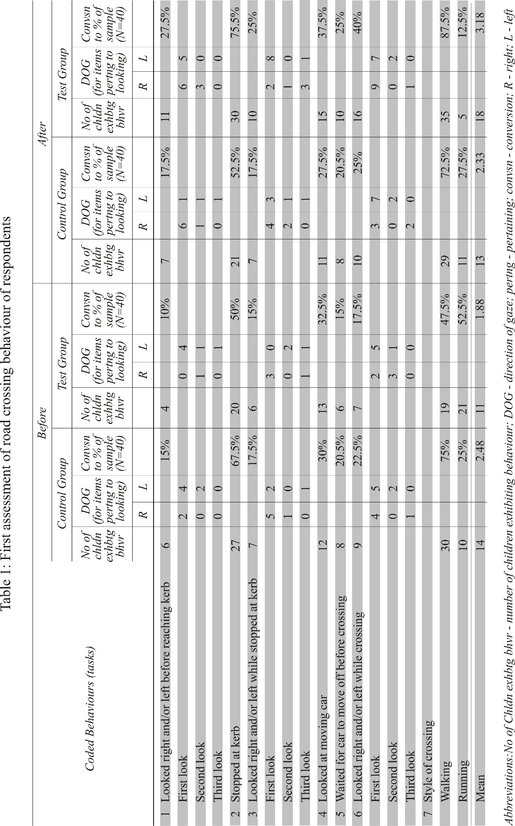
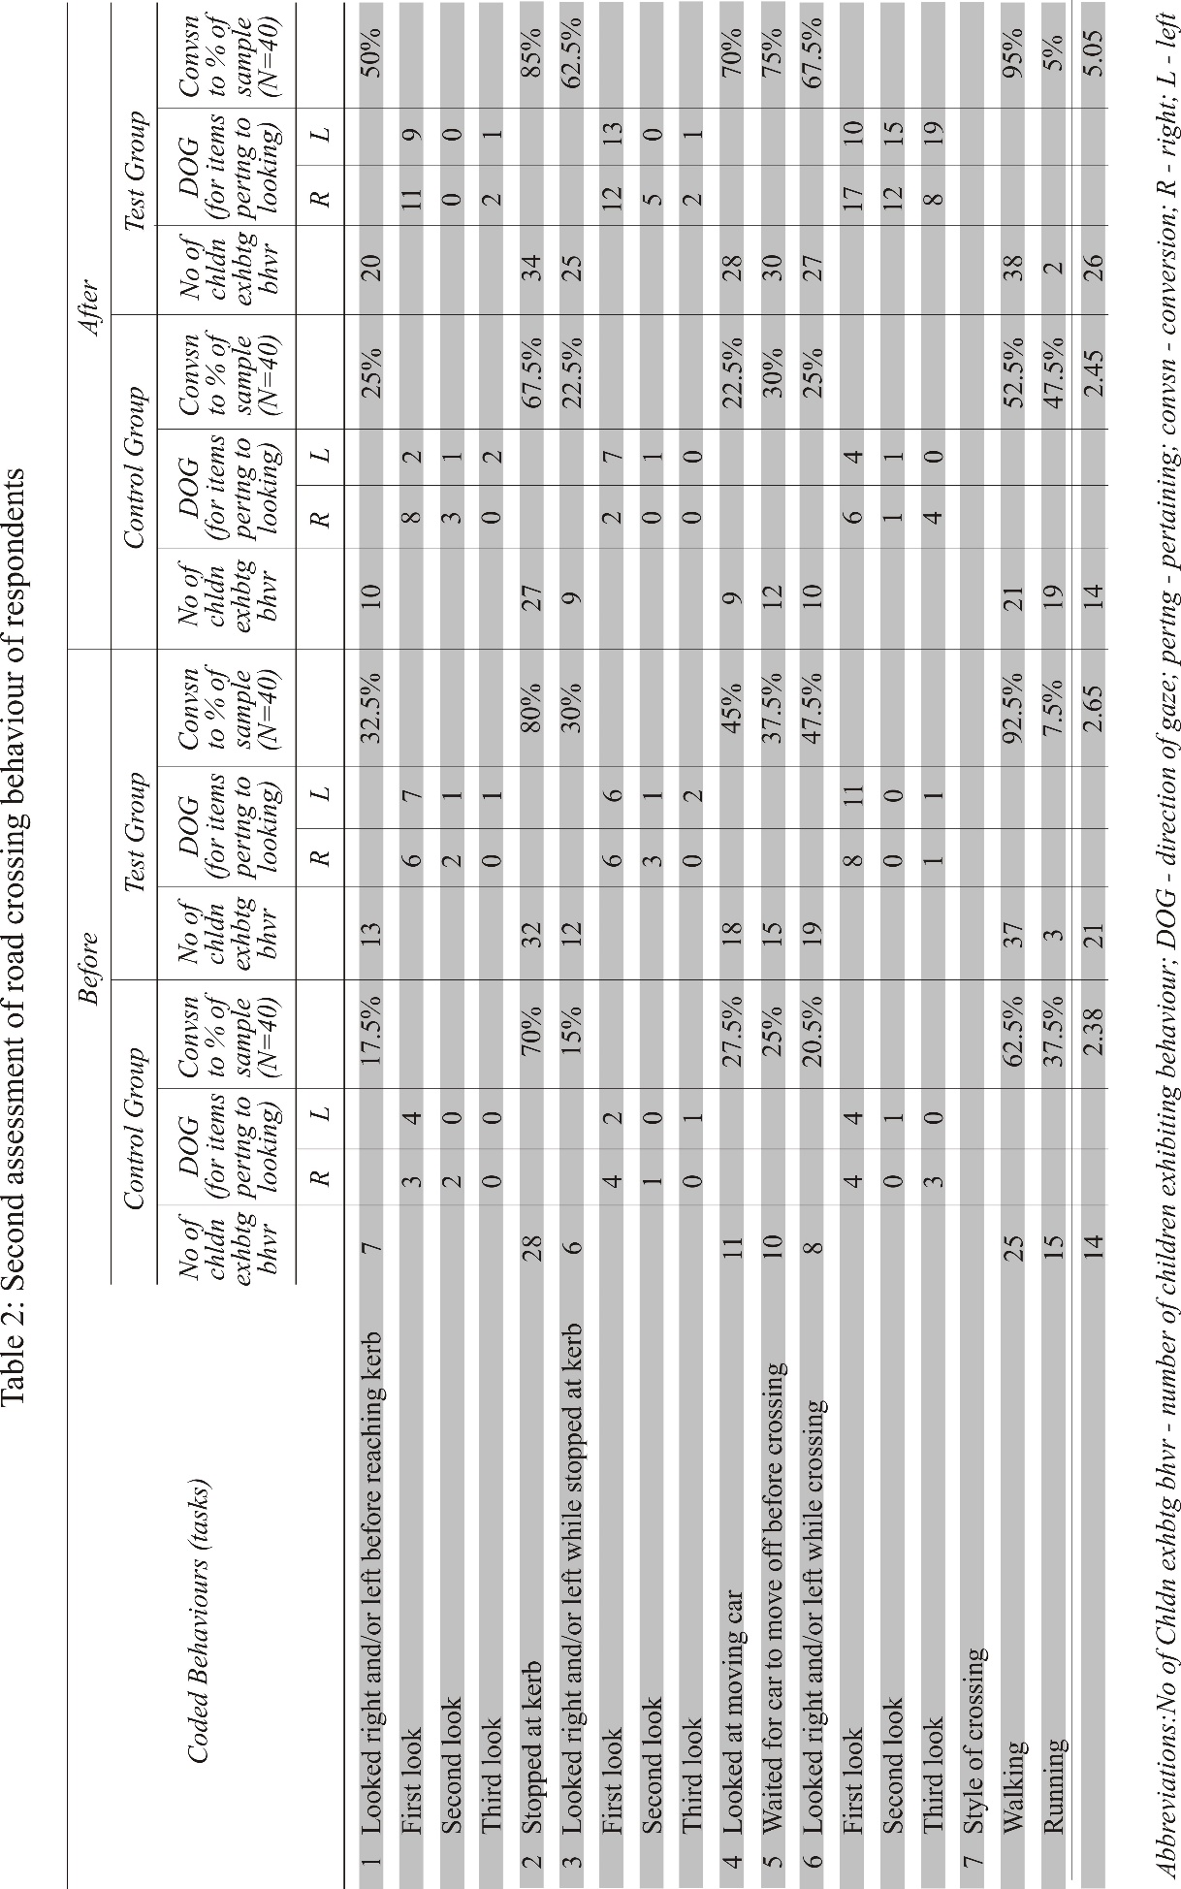
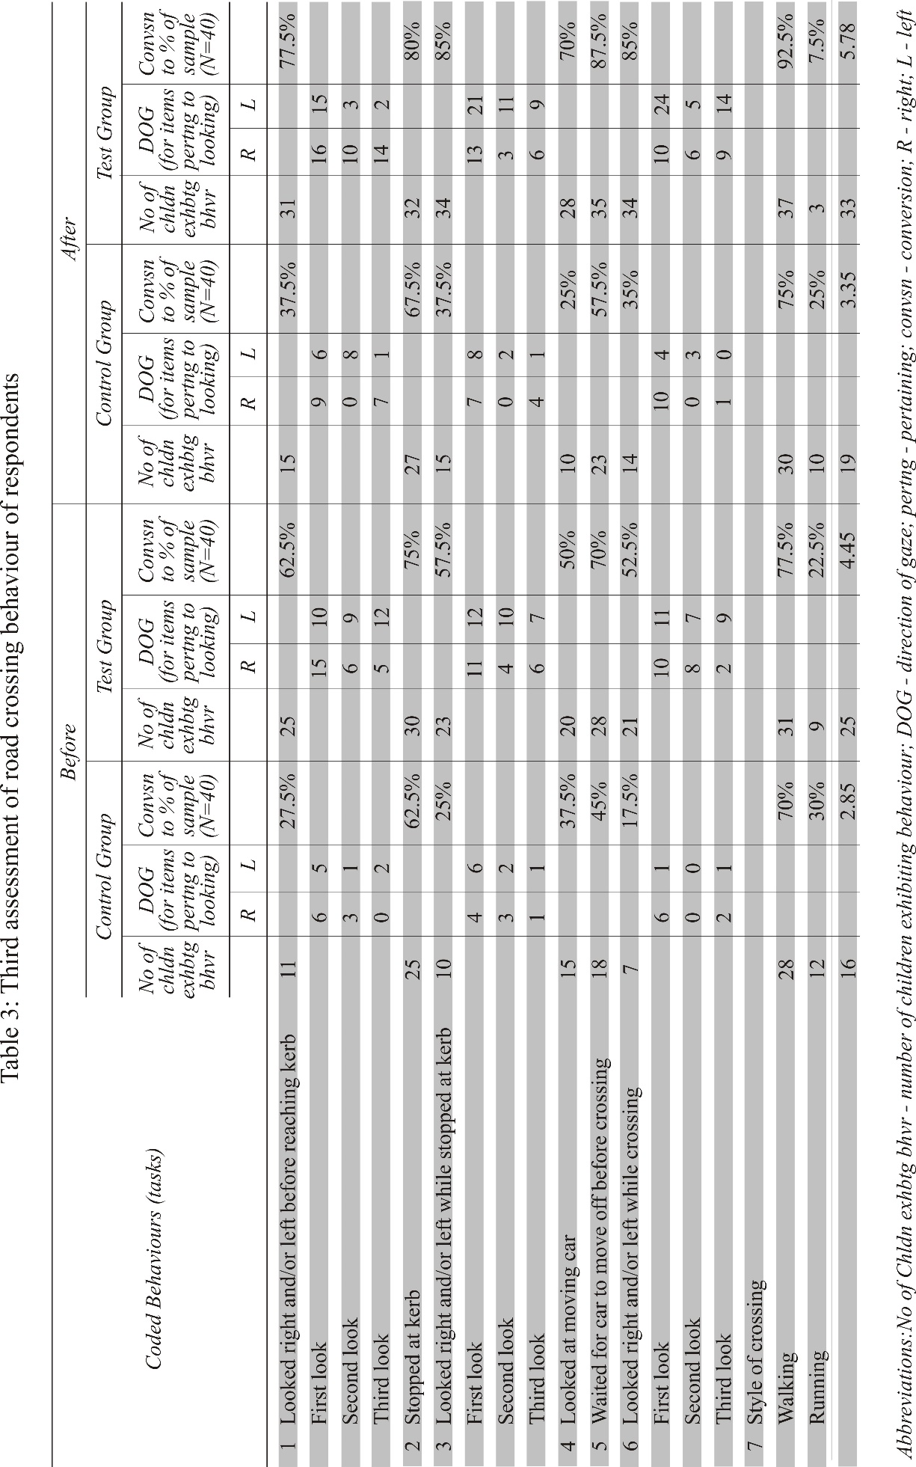
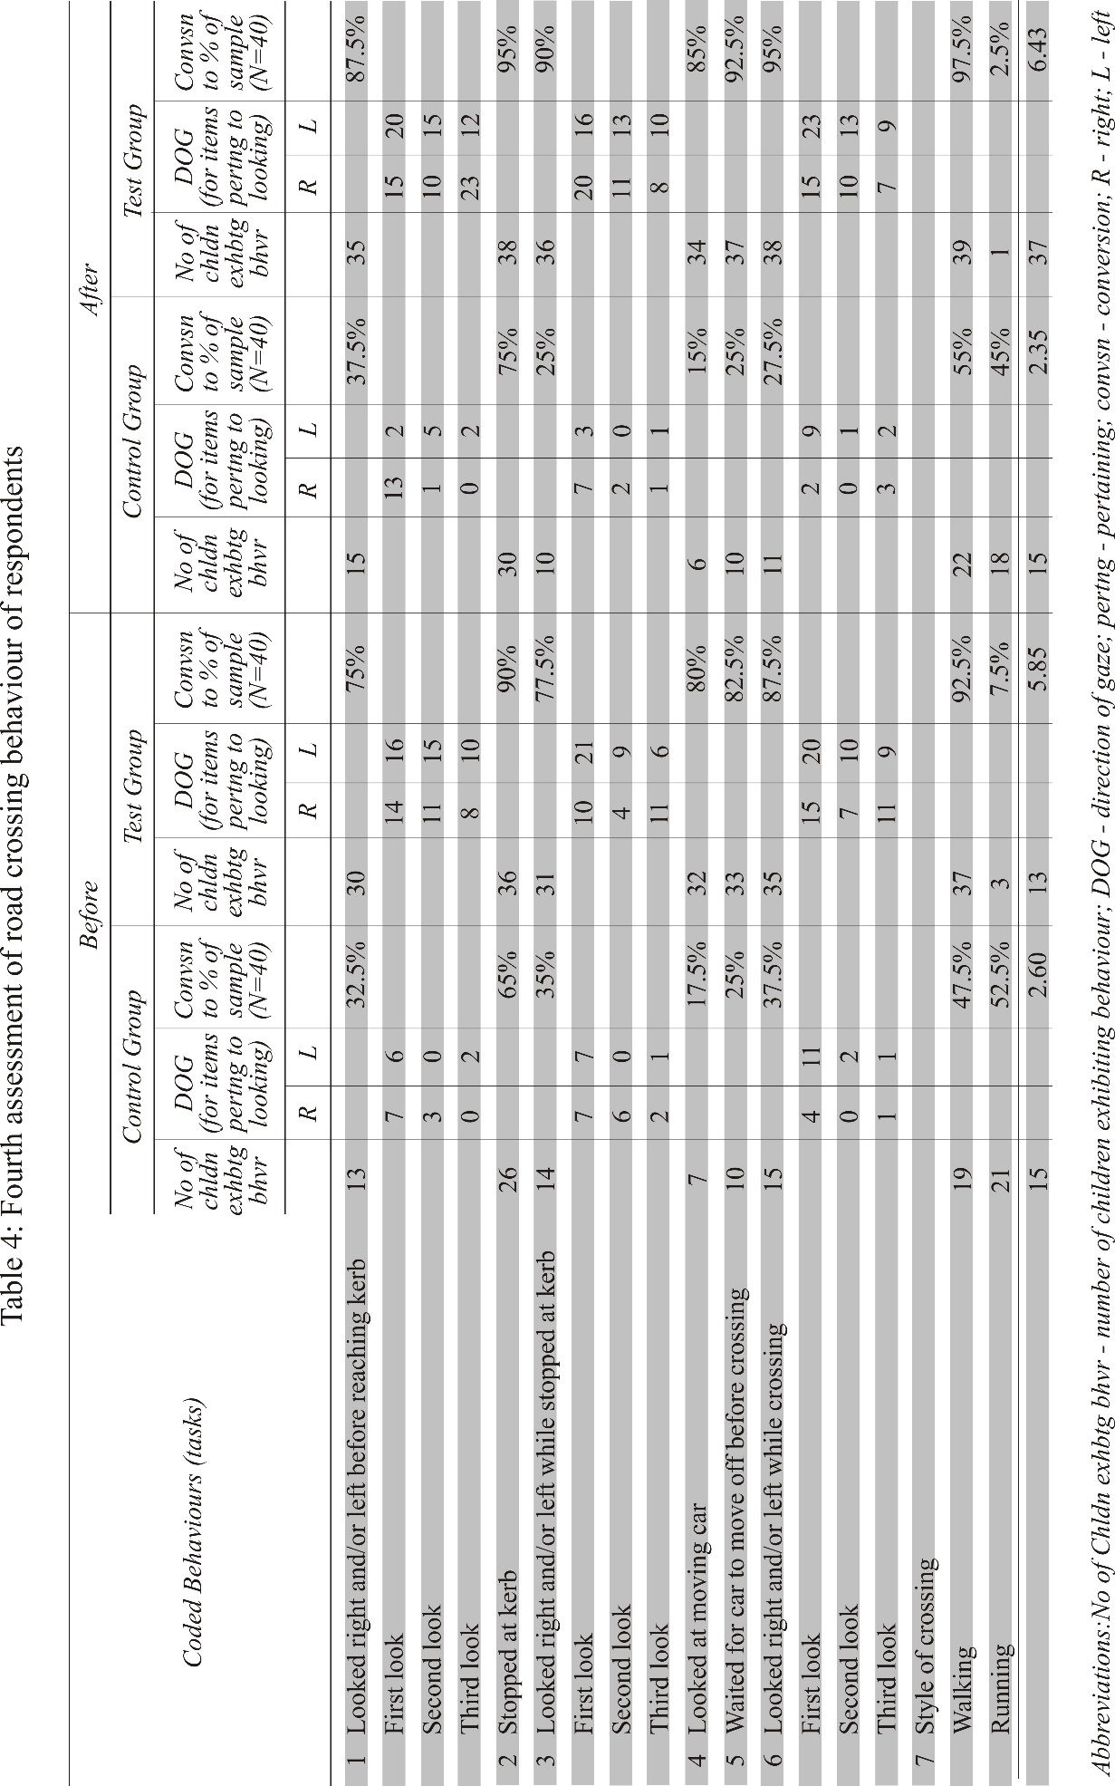
3.1 Performance Assessment
Analyses of results from respondents’ coded behaviour in traffic were done in two different stages. First, assessment was by group (or en-bloc) performance, and second, by specific performance.
Though the focus was on the Test Group, the relativity of the Control Group proved the effectiveness of the teaching method for the Test Group. The Control Group, therefore, served as a relative measure for the Test Group. Assessment of performance was as follows:
- Performance of the Control Group in the pre-survey and post-survey (Appendices 1 - 4)
- Performance of the Test Group in the pre-survey and post-survey (Appendices 5 - 8)
- Performance of Control Group and Test Group in pre-survey (Appendices 9 - 12)
- Performance of Control Group and Test Group in post-survey (Appendices 13 - 16)
- Performance of respondents in pre-survey and post-survey (Appendices 17 - 20)

3.1.1 Performance of the Control Group in the pre-survey and post-survey
Performance improvement of the Control Group was calculated as:
X(cgA) - X(cgB),
where X = mean, cg = control group, A = after (post-survey), B = before (pre-survey).
Thus:
- First observation
13 (cgA) - 14 (cgB) = -1
- Second observation
14 (cgA) - 14 (cgB) = 0
- third observation
19 (cgA) - 16 (cgB) = 3
- Forth observation
15 (cgA) - 15 (cgB) = 0

Group performance of the Control Group showed no significant improvement. In the first observation, the mean score of the Control Group in the pre-survey was 14, which dropped to 13 in the post-survey. In the second observation, the mean score improved back to 14 in the pre-survey and remained the same in the post-survey. This means that improvement in the second observation was static. The third observation recorded a sharp improvement to a mean score of 19, which later decreased slightly by 3 points, resulting in a mean score of 16. In the fourth observation, the mean score in the pre-survey further dropped to 15 and remained static in the post-survey. The performance improvement data of the Control Group is graphically represented in Figure 1.

Figure 2: Performance of Control Group in Pre-survey and Post-survey

3.1.2 Performance of TG in the Pre-survey and Post-survey
Performance improvement of the Test Group was calculated as:
X(tgA) - X(tgB)
where X = mean, tg = test group, A = after (post-survey), B = before (pre-survey).
Thus:
- First observation
- tgA) - 11 (tgB) = 7
- Second observation
26 (tgA) - 21 (tgB) = 5
- Third observation
33 (tgA) - 25 (tgB) = 8
- Forth observation
37 (tgA) - 33 (tgB) = 4

In the first pre-survey of the Test Group, respondents’ performance was relatively poor. They scored 11 as compared to 14 by the Control Group in the first pre-survey. This is attributed to the difference in the depth of knowledge of traffic education that each group had at the start of the study. From the first post-study, however, the Test Group showed significant steady improvement in both the pre-survey and post-survey. Respondents’ performance in the pre-survey showed a progressive improvement of 18, 26, 33, 37, indicating a difference of 8 between first and second observation, that is 26 (tgA2) - 18 (tgA1), where 1 = first observation, and 2 = second observation; a difference of 7 between the second and third observation, that is 33 (tgA3) - 26 (tgA2), where 2 = second observation and 3 = third observation; a difference of 4 between the third and forth observation, that is 37 (tgA4) - 33 (tgA3).
Performance of respondents in the post-survey equally showed an improvement in every stage of the observation thus 11, 21, 25, 33, indicating a difference of 10 between first and second observation, that is 21 (tgB2) - 11 (tgB1), where 1 = first observation, and 2 = second observation; a difference of 4 between the second and third observation, that is 25 (tgB3) - 21 (tgB2), where 2 = second observation and 3 = third observation; a difference of 8 between the third and forth observation, that is 33 (tgB4) - 25 (tgB3). Improvement in the pre-survey and post-survey is graphically indicated in Figure 2.

Figure 3: Performance of Control Group and Test Group in Pre-survey and Post-survey

3.1.3 Performance of Control Group and Test Group in the Pre-survey
Performance of the Test Group and Control Group was calculated as:
X(tgB) - X(cgB)
where X = mean, tg = test group, B = before (pre-survey).
Thus:
- Mean values of Test Group in pre-survey = 11₍₁₎ 21₍₂₎ 25₍₃₎ 33₍₄₎
- Mean values of Control Group in pre-survey = 14₍₁₎ 14₍₂₎ 16₍₃₎ 15₍₄₎
Where (1), (2), (3), (4) = survey sequence.
In the first observation, the Control Group performed better than the Test Group by a mean score difference of 3 (that is 11(tgB) - 14(cgB). From the second observation onwards, the Test Group performed better. The Test Group improved by a difference of 7 (that is 21(tgB) - 14(cgB), 9 (that is 25(tgB) - 16(cgB), 18 (that is 33(tgB) - 15(cgB) respectively in the second, third and fourth observations. The performance relationship is graphically represented in Figure 3.

Figure 4: Performance of Control Group and Test Group in pre-survey

3.1.4 Performance of Control Group and Test Group in the post-survey
The relative performance of the Test Group and Control Group was calculated as:
X(tgA) X(cgA), where X = mean, tg = test group, A = after (post-survey).
Thus:
- Mean values of Test Group in post-survey = 18₍₁₎ 26₍₂₎ 33₍₃₎ 37₍₄₎
- Mean values of Control Group in post-survey = 13₍₁₎ 14₍₂₎ 19₍₃₎ 15₍₄₎
Where (1), (2), (3), (4) = survey sequence.

From the time the Test Group participated in the therapy sessions, its performance improved after the poor performance in the pre-survey, and remained progressively better in the other observations. In the first observation, the Test Group performed better than the Control Group by a mean score difference of 5 (that is 18(tgA) - 13(cgA). The Test Group performed exponentially better. The Test Group improved by a difference of 12 (that is 26(tgA) - 14(cgA), 14 (that is 33(tgA) - 19(cgA), 22 (that is 37(tgA) - 15(cgA) respectively in the second, third and fourth observations. The performance relationship is graphically represented in Figure 4.

Figure 5: Performance of Control Group and Test Group in post-survey

4.0 Conclusions
4.1 Performances
Specifically, the traffic action in which respondents performed best (x ≥ 50%, where x = all performances in one coded behaviour) was the style of crossing the road. This means that a greater number of respondents stopped at the kerb before crossing the road. The least score was 50%, by the Test Group in the first observation of the pre-survey. The highest score was 95%, by the same Test Group in the fourth observation of the post-survey.

4.2 Performance Improvements
The preceding analyses show that the art therapy sessions had a tremendous impact on the Test Group. From the first participation, respondents in the Test Group showed significant improvement in performance. The Control Group, which had had the conventional road traffic education, did not improve in performance. Performance of respondents in the Control Group fluctuated between 14 in the pre-survey and 15 in the survey, with the modal performance being 19. Performance of the Test Group improved from 11 in the pre-survey to 37 in the post-survey.

4.3 Art therapy
The art therapy approach proved effective in teaching children about road safety. First, children were told a story about road safety. Second, they created based on the story. Third, the children told the story of their drawings to the class. Fourth, the children made contributions to the story. The children behaved on the road according to the virtual traffic environment they created from their drawings.

5.0 Recommendations
Child road safety education has been established on rote learning with incommensurate results, lending deprecations of child road safety education a justification for its impossibility. Yielding results in the use of art therapy as a teaching and learning tool in child road safety education is testimony to its efficacy. Besides, art therapy has demonstrated potency in behaviour-affecting learning. Stakeholders in road safety education are therefore encouraged to consider its appropriate adoption and integration into their programs.
6.0 Limitation and Future Research

One key limitation of this study is its relatively small sample size, as it was based on the observation of 40 children from a single school. Future research is required with a larger and more diverse sample to better understand the role of art therapy in child road safety education.

Disclaimer (Artificial intelligence)
Option 1:
Author(s) hereby declare that NO generative AI technologies such as Large Language Models (ChatGPT, COPILOT, etc.) and text-to-image generators have been used during the writing or editing of this manuscript.
Option 2:
Author(s) hereby declare that generative AI technologies such as Large Language Models, etc. have been used during the writing or editing of manuscripts. This explanation will include the name, version, model, and source of the generative AI technology and as well as all input prompts provided to the generative AI technology
Details of the AI usage are given below:
1.
2.
3.

References

World Health Organisation (2007). Youth and road safety. Geneva: WHO Press. https://iris.who.int/handle/10665/43607

Blankson PK & Lartey M (2020). Road traffic accidents in Ghana: contributing factors and economic consequences. Ghana Medical Journal. 54(3):131. Doi: https://doi.org/10.4314/gmj.v54i3.1

Hillman, M., Adams J., & Whitelegg J. (1990). One False Move ... A Study of
Children’s Independent Mobility. London: Institute for Policy Studies.

Sandels, S. (1975). Children in Traffic. https://books.google.co.in/books/about/Children_in_Traffic.html?id=ZM5aAAAAYAAJ&redir_esc=y

Department for Transport (n.d). Child Development and the aims of Road Safety
Education (No.01), London.

Rothengatter, J. A. (1981). The influence of instructional variables on the effectiveness of traffic education. Accident Analysis and Prevention, 13(3), 241–253. https://doi.org/10.1016/0001-4575(81)90007-5

Schagen, I. V., & Rothengatter T. (1997). Classroom Instructions versus Roadside
Training in Traffic Safety Education. Ablex Publishing Corporation.

Demetre, J. D. (1997). Applying developmental psychology to children's road safety: Problems and prospects. Journal of applied developmental psychology, 18(2), 263-270.

Fyhri, A. Bjornskau T., & Ulleberg P. (2004). Traffic Education for Children with a
Tabletop Model. Transport Research Part F, Elsevier.

Zeedyk, M. S., Wallace, L., & Spry, L. (2002). Stop, look, listen, and think? What young children really do when crossing the road. Accident; analysis and prevention, 34(1), 43–50. https://doi.org/10.1016/s0001-4575(00)00101-9

Ampofo‐Boateng, K., & Thomson, J. A. (1991). Children's perception of safety and danger on the road. British Journal of Psychology, 82(4), 487-505.

Thomson, J. A., & Tagg, M. (1992). An Ecological Approach to Spatial Orientation
and Action Planning. Paper presented at the Second European Conference in Ecological Psychology, Glasgow.

Lee, D. N, Young, D. S & McLaughlin, C. M. (1984). A roadside simulation of road crossing for children. Ergonomics, 27(12), 1271–1281. https://doi.org/10.1080/00140138408963608

Demetre, J. D., Lee D. N., Pitcairn, T. K., Grieve, R., Thomson J. A & Ampofo-
Boateng, K. (1992). Errors in Young Children’s Decisions About Traffic Gaps: Experiments with Roadside Simulations. British Journal of Psychology, 83(2), 189-202.

Popa, Ș., Ciongradi, C. I., Sârbu, I., Bîcă, O., Popa, I. P., & Bulgaru-Iliescu, D. (2023). Traffic accidents in children and adolescents: a complex orthopedic and medico-legal approach. Children, 10(9), 1446.
Khan, N., Muhammad, K., Hussain, T., Nasir, M., Munsif, M., Imran, A. S., & Sajjad, M. (2021). An adaptive game-based learning strategy for children road safety education and practice in virtual space. Sensors, 21(11), 3661.
Rege, S. (2025). Art therapy as an educational tool—Benefits and limitations: A critical study. IOSR Journal of Multidisciplinary Research (IOSR-JMR), 2(2, Series 2), 46–53. https://doi.org/10.9790/7439-0202024653
Fowode, K. V. ., & Nwaogazie, I. L. . (2024). Road Safety Reimagined: Exploring Causes, Effects, and Innovative Educational Interventions for Accident Prevention. An Overview of Literature, Language and Education Research Vol. 7, 1–34. https://doi.org/10.9734/bpi/aoller/v7/2900
Waring, S., Almond, L., & Halsall, L. (2024). Examining the effectiveness of an education-based road safety intervention and the design and delivery mechanisms that promote road safety in young people. Transportation research part F: traffic psychology and behaviour, 105, 336-349.
Agebure , A. B., Amedorme , S. K., & Johnson , A. N. (2023). Causes and Strategies for Reducing Road Traffic Accidents in the Bongo District of Ghana. Journal of Engineering Research and Reports, 25(9), 166–178. https://doi.org/10.9734/jerr/2023/v25i9990

APPENDIces

Appendix 1
Observation 1: Performance of Test Group in the pre-survey and post-survey

Tasks | 1 | 2 | 3 | 4 | 5 | 6 | 7 | Total
tgB $(x)$ | 4 | 20 | 6 | 13 | 6 | 7 | 19 | 75
tgA $(y)$ | 11 | 30 | 10 | 15 | 10 | 16 | 35 | 127
$$D_{i}=y-x$$ | 7 | 10 | 4 | 2 | 4 | 9 | 16 | 52
$${\left(D_{i}-\overline{D}\right)}^{2}$$ | 0.20 | 6.60 | 11.80 | 29.50 | 11.18 | 2.50 | 73.44 | 135.84

$$\overline{D}=\frac{7+10+4+2+4+9+16}{7} = \frac{ 52}{7} = 7.43$$
$$S_{\overline{D}}=\sqrt{\frac{\sum{{(D_{i}-\overline{D})}^{2}}}{n-1}} = \sqrt{\frac{135.84}{6}} = \sqrt{22.60} = 4.753$$
$${\hat{S}}_{\overline{D}}= \frac{S_{\overline{D}}}{\sqrt{n}} = \frac{4.753}{\sqrt{7}} = \frac{4.753}{2.646} = 1.80$$
$$t_{cal}= \frac{\overline{D}}{{\hat{S}}_{\overline{D}}} = \frac{4.753}{1.80} = 2.640$$

Appendix 2

Observation 2: Performance of Test Group in the pre-survey and post-survey

Tasks | 1 | 2 | 3 | 4 | 5 | 6 | 7 | Total
tgB $(x)$ | 13 | 32 | 12 | 18 | 15 | 19 | 37 | 146
tgA $(y)$ | 20 | 34 | 25 | 28 | 30 | 27 | 38 | 202
$$D_{i}=y-x$$ | 7 | 2 | 13 | 10 | 15 | 8 | 1 | 56
$${\left(D_{i}-\overline{D}\right)}^{2}$$ | 1 | 36 | 25 | 4 | 49 | 0 | 49 | 164

$$\overline{D}= \frac{7+2+13+10+15+8+1}{7} = \frac{56}{7}= 8$$
$$S_{\overline{D}} = \sqrt{\frac{\sum{{\left(D_{i}-\overline{D}\right)}^{2}}}{n-1}} = \sqrt{\frac{164}{6}} = \sqrt{27.333} = 5.228$$
$${\hat{S}}_{\overline{D}}= \frac{S_{\overline{D}}}{\sqrt{n}} = \frac{5.228}{\sqrt{7}} = \frac{5.228}{2.646} = 1.976$$
$$t_{cal}= \frac{\overline{D}}{{\hat{S}}_{\overline{D}}} = \frac{8}{1.976} = 4.04$$

Appendix 3

Observation 3: Performance of Test Group in the pre-survey and post-survey

Tasks | 1 | 2 | 3 | 4 | 5 | 6 | 7 | Total
tgB $(x)$ | 25 | 30 | 23 | 20 | 28 | 21 | 31 | 178
tgA $(y)$ | 31 | 32 | 34 | 28 | 35 | 34 | 37 | 231
$$D_{i}=y-x$$ | 6 | 2 | 11 | 8 | 7 | 13 | 6 | 53
$${\left(D_{i}-\overline{D}\right)}^{2}$$ | 2.47 | 31.04 | 11.76 | 0.18 | 0.33 | 29.47 | 2.47 | 77.71

$$\overline{D}= \frac{6+2+11+8+7+13+6}{7} = \frac{53}{7}= 7.571$$
$$S_{\overline{D}} = \sqrt{\frac{\sum{{\left(D_{i}-\overline{D}\right)}^{2}}}{n-1}} = \sqrt{\frac{77.71}{6}} = \sqrt{12.952} = 3.599$$
$${\hat{S}}_{\overline{D}}= \frac{S_{\overline{D}}}{\sqrt{n}} = \frac{3.599}{\sqrt{7}} = \frac{3.599}{2.646} = 1.3602$$
$$t_{cal}= \frac{\overline{D}}{{\hat{S}}_{\overline{D}}} = \frac{7.571}{1.3602} = 5.566$$

Appendix 4

Observation 4: Performance of Test Group in the pre-survey and post-survey

Tasks | 1 | 2 | 3 | 4 | 5 | 6 | 7 | Total
tgB $(x)$ | 30 | 36 | 31 | 32 | 33 | 35 | 37 | 234
tgA $(y)$ | 35 | 38 | 36 | 34 | 37 | 38 | 39 | 257
$$D_{i}=y-x$$ | 5 | 2 | 5 | 2 | 4 | 3 | 2 | 23
$${\left(D_{i}-\overline{D}\right)}^{2}$$ | 2.94 | 1.65 | 2.94 | 1.65 | 0.51 | 0.08 | 1.65 | 11.43

$$\overline{D}= \frac{5+2+5+2+4+3+2}{7} = \frac{23}{7}= 3.29$$
$$S_{\overline{D}} = \sqrt{\frac{\sum{{\left(D_{i}-\overline{D}\right)}^{2}}}{n-1}} = \sqrt{\frac{11.475}{6}} = \sqrt{1.9124} = 1.3829$$
$${\hat{S}}_{\overline{D}}= \frac{S_{\overline{D}}}{\sqrt{n}} = \frac{1.3829}{\sqrt{7}} = \frac{1.3829}{2.646} = 0.523$$
$$t_{cal}= \frac{\overline{D}}{{\hat{S}}_{\overline{D}}} = \frac{3.29}{0.523} = 6.295$$

Appendix 5

Observation 1: Performance of Control Group in the pre-survey and post-survey

Tasks | 1 | 2 | 3 | 4 | 5 | 6 | 7 | Total
cgB $(x)$ | 6 | 27 | 7 | 12 | 8 | 9 | 30 | 99
cgA $(y)$ | 7 | 21 | 7 | 11 | 8 | 10 | 29 | 93
$$D_{i}=y-x$$ | 1 | -6 | 0 | -1 | 0 | 1 | -1 | -6
$${\left(D_{i}-\overline{D}\right)}^{2}$$ | 3.45 | 26.45 | 0.73 | 0.02 | 0.73 | 3.45 | 0.02 | 34.86

$$\overline{D}= \frac{1+-6+0+-1+0+1+-1}{7} = \frac{-6}{7}= -0.8571$$
$$S_{\overline{D}} = \sqrt{\frac{\sum{{\left(D_{i}-\overline{D}\right)}^{2}}}{n-1}} = \sqrt{\frac{35.143}{6}} = \sqrt{5.857} = 12.42$$
$${\hat{S}}_{\overline{D}}= \frac{S_{\overline{D}}}{\sqrt{n}} = \frac{2.42}{\sqrt{7}} = \frac{2.42}{2.646} = 0.9146$$
$$t_{cal}= \frac{\overline{D}}{{\hat{S}}_{\overline{D}}} = \frac{- 0.8571}{0.9146} = - 0.937$$

Appendix 6

Observation 2: Performance of Control Group in the pre-survey and post-survey

Tasks | 1 | 2 | 3 | 4 | 5 | 6 | 7 | Total
cgB $(x)$ | 7 | 28 | 6 | 11 | 10 | 8 | 25 | 95
cgA $(y)$ | 10 | 27 | 9 | 9 | 12 | 10 | 21 | 98
$$D_{i}=y-x$$ | 3 | -1 | 3 | -2 | 2 | 2 | -4 | 3
$${\left(D_{i}-\overline{D}\right)}^{2}$$ | 6.61 | 2.04 | 6.61 | 5.90 | 2.47 | 2.47 | 19.61 | 45.71

$$\overline{D}= \frac{3+-1+3+-2+2+2+-4}{7} = \frac{3}{7}= 0.429$$
$$S_{\overline{D}} = \sqrt{\frac{\sum{{\left(D_{i}-\overline{D}\right)}^{2}}}{n-1}} = \sqrt{\frac{45.714}{6}} = \sqrt{7.619} = 2.7603$$
$${\hat{S}}_{\overline{D}}= \frac{S_{\overline{D}}}{\sqrt{n}} = \frac{2.7603}{\sqrt{7}} = \frac{2.7603}{2.646} = 1.043$$
$$t_{cal}= \frac{\overline{D}}{{\hat{S}}_{\overline{D}}} = \frac{0.429}{1.043} = 0.4112$$

Appendix 7

Observation 3: Performance of Control Group in the pre-survey and post-survey

Tasks | 1 | 2 | 3 | 4 | 5 | 6 | 7 | Total
cgB $(x)$ | 11 | 25 | 10 | 15 | 18 | 7 | 28 | 114
cgA $(y)$ | 15 | 27 | 15 | 10 | 23 | 14 | 30 | 134
$$D_{i}=y-x$$ | 4 | 2 | 5 | -5 | 5 | 7 | 2 | 20
$${\left(D_{i}-\overline{D}\right)}^{2}$$ | 1.31 | 0.73 | 4.59 | 61.73 | 4.59 | 17.16 | 0.73 | 90.86

$$\overline{D}= \frac{4+2+5+-5+5+7+2}{7} = \frac{20}{7}= 2.86$$
$$S_{\overline{D}} = \sqrt{\frac{\sum{{\left(D_{i}-\overline{D}\right)}^{2}}}{n-1}} = \sqrt{\frac{90.8572}{6}} = \sqrt{15.143} = 3.891$$
$${\hat{S}}_{\overline{D}}= \frac{S_{\overline{D}}}{\sqrt{n}} = \frac{3.891}{\sqrt{7}} = \frac{3.891}{2.646} = 1.471$$
$$t_{cal}= \frac{\overline{D}}{{\hat{S}}_{\overline{D}}} = \frac{2.86}{1.471} = 1.944$$

Appendix 8

Observation 4: Performance of Control Group in the pre-survey and post-survey

Tasks | 1 | 2 | 3 | 4 | 5 | 6 | 7 | Total
cgB $(x)$ | 13 | 26 | 14 | 7 | 10 | 15 | 19 | 104
cgA $(y)$ | 15 | 30 | 10 | 6 | 10 | 11 | 22 | 104
$$D_{i}=y-x$$ | 2 | 4 | -4 | -1 | 0 | -4 | 3 | 0
$${\left(D_{i}-\overline{D}\right)}^{2}$$ | 4 | 16 | 16 | 1 | 0 | 16 | 9 | 62

$$\overline{D}= \frac{2+4+-4+-1+0+-4+3}{7} = \frac{0}{7}= 0$$
$$S_{\overline{D}} = \sqrt{\frac{\sum{{\left(D_{i}-\overline{D}\right)}^{2}}}{n-1}} = \sqrt{\frac{62}{6}} = \sqrt{10.33} = 3.215$$
$${\hat{S}}_{\overline{D}}= \frac{S_{\overline{D}}}{\sqrt{n}} = \frac{3.215}{\sqrt{7}} = 1.215$$
$$t_{cal}= \frac{\overline{D}}{{\hat{S}}_{\overline{D}}} = \frac{0}{1.215} = 0$$

Appendix 9

Observation 1: Performance of Control Group and Test Group in the pre-survey

Tasks | 1 | 2 | 3 | 4 | 5 | 6 | 7 | Total
tgB $(x)$ | 4 | 20 | 6 | 13 | 6 | 7 | 19 | 75
cgB $(y)$ | 6 | 27 | 7 | 12 | 8 | 9 | 30 | 99
$$D_{i}=y-x$$ | 2 | 7 | 1 | -1 | 2 | 2 | 11 | 24
$${\left(D_{i}-\overline{D}\right)}^{2}$$ | 2.04 | 12.76 | 5.90 | 19.61 | 2.04 | 2.04 | 57.33 | 101.71

$$\overline{D}= \frac{2+7+1+-1+2+2+11}{7} = \frac{24}{7}= 3.43$$
$$S_{\overline{D}} = \sqrt{\frac{\sum{{\left(D_{i}-\overline{D}\right)}^{2}}}{n-1}} = \sqrt{\frac{101.715}{6}} = \sqrt{16.9525} = 4.117$$
$${\hat{S}}_{\overline{D}}= \frac{S_{\overline{D}}}{\sqrt{n}} = \frac{4.117}{\sqrt{7}} = 1.556$$
$$t_{cal}= \frac{\overline{D}}{{\hat{S}}_{\overline{D}}} = \frac{3.43}{1.556} = 2.217$$

Appendix 10

Observation 2: Performance of Control Group and Test Group in the pre-survey

Tasks | 1 | 2 | 3 | 4 | 5 | 6 | 7 | Total
tgB $(x)$ | 13 | 32 | 12 | 18 | 15 | 19 | 37 | 146
cgB $(y)$ | 7 | 28 | 6 | 11 | 10 | 8 | 25 | 95
$$D_{i}=y-x$$ | 6 | 4 | 6 | 7 | 5 | 11 | 12 | 51
$${\left(D_{i}-\overline{D}\right)}^{2}$$ | 1.65 | 10.80 | 1.65 | 0.08 | 5.22 | 13.80 | 22.22 | 55.43

$$\overline{D}= \frac{6+4+6+7+5+11+12}{7} = \frac{51}{7}= 7.29$$
$$S_{\overline{D}} = \sqrt{\frac{\sum{{\left(D_{i}-\overline{D}\right)}^{2}}}{n-1}} = \sqrt{\frac{55.4287}{6}} = \sqrt{9.238} = 3.04$$
$${\hat{S}}_{\overline{D}}= \frac{S_{\overline{D}}}{\sqrt{n}} = \frac{3.04}{\sqrt{7}} = \frac{3.04}{2.646} = 1.149$$
$$t_{cal}= \frac{\overline{D}}{{\hat{S}}_{\overline{D}}} = \frac{7.29}{1.149} = 6.345$$

Appendix 11

Observation 3: Performance of Control Group and Test Group in the pre-survey

Tasks | 1 | 2 | 3 | 4 | 5 | 6 | 7 | Total
cgB $(x)$ | 11 | 25 | 10 | 15 | 18 | 7 | 28 | 114
tgB $(y)$ | 25 | 30 | 23 | 20 | 28 | 21 | 31 | 178
$$D_{i}=y-x$$ | 14 | 5 | 13 | 5 | 10 | 14 | 3 | 64
$${\left(D_{i}-\overline{D}\right)}^{2}$$ | 23.59 | 17.16 | 14.88 | 17.16 | 0.73 | 23.59 | 37.73 | 134.86

$$\overline{D}= \frac{14+5+13+5+10+14+3}{7} = \frac{64}{7} = 9.143$$
$$S_{\overline{D}} = \sqrt{\frac{\sum{{\left(D_{i}-\overline{D}\right)}^{2}}}{n-1}} = \sqrt{\frac{134.854}{6}} = \sqrt{22.476} = 4.74$$
$${\hat{S}}_{\overline{D}}= \frac{S_{\overline{D}}}{\sqrt{n}} = \frac{4.74}{\sqrt{7}} = \frac{4.74}{2.646} = 1.792$$
$$t_{cal}= \frac{\overline{D}}{{\hat{S}}_{\overline{D}}} = \frac{9.143}{1.792} = 5.10$$

Appendix 12

Observation 4: Performance of Control Group and Test Group in the pre-survey

Tasks | 1 | 2 | 3 | 4 | 5 | 6 | 7 | Total
cgB $(x)$ | 13 | 26 | 14 | 7 | 10 | 15 | 19 | 104
tgB $(y)$ | 30 | 36 | 31 | 32 | 33 | 35 | 37 | 234
$$D_{i}=y-x$$ | 17 | 10 | 17 | 25 | 23 | 20 | 18 | 130
$${\left(D_{i}-\overline{D}\right)}^{2}$$ | 2.47 | 73.47 | 2.47 | 41.33 | 19.61 | 2.04 | 0.33 | 141.71

$$\overline{D}= \frac{17+10+17+25+23+20+18}{7} = \frac{130}{7} = 18.57$$
$$S_{\overline{D}} = \sqrt{\frac{\sum{{\left(D_{i}-\overline{D}\right)}^{2}}}{n-1}} = \sqrt{\frac{141.71}{6}} = \sqrt{23.618} = 4.86$$
$${\hat{S}}_{\overline{D}}= \frac{S_{\overline{D}}}{\sqrt{n}} = \frac{4.86}{\sqrt{7}} = \frac{4.86}{2.646} = 1.837$$
$$t_{cal}= \frac{\overline{D}}{{\hat{S}}_{\overline{D}}} = \frac{18.57}{1.837} = 10.11$$

Appendix 13

Observation 1: Performance of Control Group and Test Group in the post-survey

Tasks | 1 | 2 | 3 | 4 | 5 | 6 | 7 | Total
cgA $(x)$ | 7 | 21 | 7 | 11 | 8 | 10 | 29 | 93
tgA $(y)$ | 11 | 30 | 10 | 15 | 10 | 16 | 35 | 127
$$D_{i}=y-x$$ | 4 | 9 | 3 | 4 | 2 | 6 | 6 | 34
$${\left(D_{i}-\overline{D}\right)}^{2}$$ | 0.73 | 17.16 | 3.45 | 0.73 | 8.16 | 1.31 | 1.31 | 32.86

$$\overline{D}= \frac{4+9+3+4+2+6+6}{7} = \frac{34}{7}= 4.86$$
$$S_{\overline{D}} = \sqrt{\frac{\sum{{\left(D_{i}-\overline{D}\right)}^{2}}}{n-1}} = \sqrt{\frac{32.8575}{6}} = \sqrt{5.47625} = 2.340$$
$${\hat{S}}_{\overline{D}}= \frac{S_{\overline{D}}}{\sqrt{n}} = \frac{2.340}{\sqrt{7}} = \frac{2.340}{2.646} = 0.884$$
$$t_{cal}= \frac{\overline{D}}{{\hat{S}}_{\overline{D}}} = \frac{4.86}{0.884} = 5.495$$

Appendix 14

Observation 2: Performance of Control Group and Test Group in the post-survey

Tasks | 1 | 2 | 3 | 4 | 5 | 6 | 7 | Total
tgA $(x)$ | 20 | 34 | 25 | 28 | 30 | 27 | 38 | 202
cgA $(y)$ | 10 | 27 | 9 | 9 | 12 | 10 | 21 | 98
$$D_{i}=y-x$$ | 10 | 7 | 16 | 19 | 18 | 17 | 17 | 104
$${\left(D_{i}-\overline{D}\right)}^{2}$$ | 23.59 | 61.73 | 1.31 | 17.16 | 9.88 | 4.59 | 4.59 | 122.86

$$\overline{D}= \frac{10+7+16+19+18+17+17}{7} = \frac{104}{7}= 14.86$$
$$S_{\overline{D}} = \sqrt{\frac{\sum{{\left(D_{i}-\overline{D}\right)}^{2}}}{n-1}} = \sqrt{\frac{122.86}{6}} = \sqrt{20.4766} = 4.525$$
$${\hat{S}}_{\overline{D}}= \frac{S_{\overline{D}}}{\sqrt{n}} = \frac{4.525}{\sqrt{7}} = \frac{4.525}{2.646} = 1.710$$
$$t_{cal}= \frac{\overline{D}}{{\hat{S}}_{\overline{D}}} = \frac{14.86}{1.710} = 8.688$$

Appendix 15

Observation 3: Performance of Control Group and Test Group in the post-survey

Tasks | 1 | 2 | 3 | 4 | 5 | 6 | 7 | Total
cgA $(x)$ | 15 | 27 | 15 | 10 | 23 | 14 | 30 | 134
tgA $(y)$ | 31 | 32 | 34 | 28 | 35 | 34 | 37 | 231
$$D_{i}=y-x$$ | 16 | 5 | 19 | 18 | 12 | 20 | 7 | 97
$${\left(D_{i}-\overline{D}\right)}^{2}$$ | 4.59 | 78.45 | 26.45 | 17.16 | 3.45 | 37.73 | 47.02 | 214.86

$$\overline{D}= \frac{16+5+19+18+12+20+7}{7} = \frac{97}{7} = 13.857$$
$$S_{\overline{D}} = \sqrt{\frac{\sum{{\left(D_{i}-\overline{D}\right)}^{2}}}{n-1}} = \sqrt{\frac{214.885}{6}} = \sqrt{35.814} = 5.984$$
$${\hat{S}}_{\overline{D}}= \frac{S_{\overline{D}}}{\sqrt{n}} = \frac{5.984}{\sqrt{7}} = \frac{8.984}{2.646} = 2.262$$
$$t_{cal}= \frac{\overline{D}}{{\hat{S}}_{\overline{D}}} = \frac{13.857}{2.262} = 6.127$$

Appendix 16

Observation 4: Performance of Control Group and Test Group in the post-survey

Tasks | 1 | 2 | 3 | 4 | 5 | 6 | 7 | Total
cgA $(x)$ | 15 | 30 | 10 | 6 | 10 | 11 | 22 | 104
tgA $(y)$ | 35 | 38 | 36 | 34 | 37 | 38 | 39 | 257
$$D_{i}=y-x$$ | 20 | 8 | 26 | 28 | 27 | 27 | 17 | 153
$${\left(D_{i}-\overline{D}\right)}^{2}$$ | 3.45 | 192.02 | 17.16 | 37.73 | 26.45 | 26.45 | 23.59 | 326.86

$$\overline{D}= \frac{20+8+26+28+27+27+17}{7} = \frac{153}{7} = 21.86$$
$$S_{\overline{D}} = \sqrt{\frac{\sum{{\left(D_{i}-\overline{D}\right)}^{2}}}{n-1}} = \sqrt{\frac{326.86}{6}} = \sqrt{54.48} = 7.38$$
$${\hat{S}}_{\overline{D}}= \frac{S_{\overline{D}}}{\sqrt{n}} = \frac{7.38}{\sqrt{7}} = \frac{7.38}{2.646} = 2.789$$
$$t_{cal}= \frac{\overline{D}}{{\hat{S}}_{\overline{D}}} = \frac{21.86}{2.789} = 7.84$$

Appendix 17

Observation 1: Performance of respondents in the pre-survey and post-survey

Tasks | 1 | 2 | 3 | 4 | 5 | 6 | 7 | Total
B $(x)$ | 0 | 1 | 0 | 2 | 1 | 1 | 4 | 9
A $(y)$ | 2 | 3 | 3 | 4 | 2 | 3 | 6 | 23
$$D_{i}=y-x$$ | 2 | 2 | 3 | 2 | 1 | 2 | 2 | 14
$${\left(D_{i}-\overline{D}\right)}^{2}$$ | 0 | 0 | 1 | 0 | 1 | 0 | 0 | 2

$$\overline{D}= \frac{2+2+3+2+1+2+2}{7} = \frac{14}{7}= 2.0$$
$$S_{\overline{D}} = \sqrt{\frac{\sum{{\left(D_{i}-\overline{D}\right)}^{2}}}{n-1}} = \sqrt{\frac{2}{6}} = 0.577$$
$${\hat{S}}_{\overline{D}}= \frac{S_{\overline{D}}}{\sqrt{n}} = \frac{0.577}{\sqrt{7}} = \frac{0.577}{2.646} = 0.22$$
$$t_{cal}= \frac{\overline{D}}{{\hat{S}}_{\overline{D}}} = \frac{2.0}{0.22} = 9.091$$

Appendix 18

Observation 2: Performance of respondents in the pre-survey and post-survey

Tasks | 1 | 2 | 3 | 4 | 5 | 6 | 7 | Total
B $(x)$ | 2 | 4 | 3 | 5 | 3 | 4 | 7 | 28
A $(y)$ | 4 | 6 | 4 | 5 | 4 | 4 | 8 | 35
$$D_{i}=y-x$$ | 2 | 2 | 1 | 0 | 1 | 0 | 1 | 7
$${\left(D_{i}-\overline{D}\right)}^{2}$$ | 1 | 1 | 0 | 1 | 0 | 1 | 0 | 4

$$\overline{D}= \frac{2+2+1+0+1+0+1}{7} = \frac{7}{7}= 1.0$$
$$S_{\overline{D}} = \sqrt{\frac{\sum{{\left(D_{i}-\overline{D}\right)}^{2}}}{n-1}} = \sqrt{\frac{4}{6}} = 0.816$$
$${\hat{S}}_{\overline{D}}= \frac{S_{\overline{D}}}{\sqrt{n}} = \frac{0.816}{\sqrt{7}} = \frac{0.816}{2.646} = 0.309$$
$$t_{cal}= \frac{\overline{D}}{{\hat{S}}_{\overline{D}}} = \frac{1.0}{0.309} = 3.24$$

Appendix 19

Observation 3: Performance of respondents in the pre-survey and post-survey

Tasks | 1 | 2 | 3 | 4 | 5 | 6 | 7 | Total
B $(x)$ | 5 | 6 | 5 | 6 | 4 | 4 | 8 | 38
A $(y)$ | 6 | 7 | 6 | 7 | 6 | 5 | 9 | 46
$$D_{i}=y-x$$ | 1 | 1 | 1 | 1 | 2 | 1 | 1 | 8
$${\left(D_{i}-\overline{D}\right)}^{2}$$ | 0.02 | 0.02 | 0.02 | 0.02 | 0.73 | 0.02 | 0.02 | 0.86

$$\overline{D}= \frac{1+1+1+1+2+1+1}{7} = \frac{8}{7} = 1.143$$
$$S_{\overline{D}} = \sqrt{\frac{\sum{{\left(D_{i}-\overline{D}\right)}^{2}}}{n-1}} = \sqrt{\frac{0.8572}{6}} = \sqrt{0.143} = 0.378$$
$${\hat{S}}_{\overline{D}}= \frac{S_{\overline{D}}}{\sqrt{n}} = \frac{0.378}{\sqrt{7}} = \frac{0.378}{2.646} = 0.143$$
$$t_{cal}= \frac{\overline{D}}{{\hat{S}}_{\overline{D}}} = \frac{1.143}{0.143} = 8.001$$

Appendix 20

Observation 4: Performance of respondents in the pre-survey and post-survey

Tasks | 1 | 2 | 3 | 4 | 5 | 6 | 7 | Total
B $(x)$ | 6 | 6 | 7 | 8 | 7 | 6 | 9 | 49
A $(y)$ | 7 | 8 | 8 | 9 | 8 | 7 | 9 | 56
$$D_{i}=y-x$$ | 1 | 2 | 1 | 1 | 1 | 1 | 0 | 7
$${\left(D_{i}-\overline{D}\right)}^{2}$$ | 0 | 1 | 0 | 0 | 0 | 0 | 1 | 2

$$\overline{D}= \frac{1+2+1+1+1+1+0}{7} = \frac{7}{7} = 1.0$$
$$S_{\overline{D}} = \sqrt{\frac{\sum{{\left(D_{i}-\overline{D}\right)}^{2}}}{n-1}} = \sqrt{\frac{2}{6}} = 0.577$$
$${\hat{S}}_{\overline{D}}= \frac{S_{\overline{D}}}{\sqrt{n}} = \frac{0.577}{\sqrt{7}} = \frac{0.577}{2.646} = 0.22$$
$$t_{cal}= \frac{\overline{D}}{{\hat{S}}_{\overline{D}}} = \frac{1.0}{0.22} = 4.55$$

