Morphology-Driven Map Processing and Key-Point Optimization for Enhanced Path Planning in ROS-Based Autonomous Vehicles

.
ABSTRACT

Path planning is a critical component of autonomous vehicles, intelligent transportation, and robotic navigation. However, conventional algorithms such as A*, Dijkstra, bidirectional A*, and RRT often suffer from local optima, redundant turning points, excessive cumulative turning angles, and computational overhead in maintaining safe distances, limiting their real-time performance and stability in complex, high-resolution maps. To address these issues, we propose a path planning optimization framework that integrates morphological preprocessing with polar-coordinate-based key-point extraction. Morphological dilation is applied to map representations to adaptively enforce obstacle clearance during planning, improving robustness and efficiency. Subsequently, a polar-coordinate key-point extraction strategy reduces redundant nodes, minimizes cumulative turning angles, and alleviates local optima. The approach was implemented on a ROS–Gazebo simulation platform and systematically compared with multiple baseline algorithms across maps of varying sizes. Experimental results demonstrate that the proposed method reduces path nodes by over 50%, decreases cumulative turning angles by 85%, shortens path length by 23.8%, and improves planning response time by 69%. These results highlight the effectiveness of the method in enhancing path smoothness, computational efficiency, and global optimality, providing a reliable basis for safe autonomous navigation in complex environments.

Keywords: Path planning; A* algorithm; Key point extraction; Morphology.

- INTRODUCTION (Arial, Bold, 11 font, left aligned, caps)

With the rapid advancement of artificial intelligence and robotics, mobile robots have been widely deployed in industrial manufacturing, warehouse logistics, intelligent transportation, and service applications. Within autonomous navigation systems, path planning plays a pivotal role, as its effectiveness directly influences both motion efficiency and operational safety in complex environments. Consequently, the development of efficient, stable, and scalable path planning methods has become a central research direction in intelligent mobile systems(M. Reda et al., 2024).
The primary goal of path planning is to generate an optimal and executable trajectory from a start position to a target position in a known or partially known environment, while avoiding obstacles and satisfying kinematic and environmental constraints. This problem is of strong theoretical interest but also presents practical challenges, including environmental uncertainty, incomplete sensing, and diverse scene complexity. Depending on the modeling strategy and application requirements, path planning techniques are generally categorized into global and local methods. Classical approaches include graph-based search (e.g., Dijkstra, A*, JPS), sampling-based methods (e.g., PRM, RRT, EST)(L. Liu et al., 2023), optimization-based approaches (e.g., gradient descent, artificial potential fields)(J. R. Sánchez-Ibáñez et al., 2021), as well as emerging data-driven techniques leveraging deep learning and reinforcement learning(A. A. N. Kumaar and S. Kochuvila,2023).
To address limitations in efficiency and path quality, numerous improvements have been proposed. For example, (X. Fu et al., 2025) enhanced A* by adapting the search neighborhood and introducing dynamic weighting in the cost function; (H. Zhang et al., 2024) improved RRT efficiency by integrating probabilistic factors and node-selection strategies for replanning; (Y. Chen et al., 2021) combined bidirectional search with ant colony optimization to reduce computation time; (S. Meng et al., 2024) incorporated large language models into A* to balance precision and reasoning capability; (H. Tang et al., 2025) introduced map inflation and adaptive sampling strategies to improve feasibility; (Y. Miao et al., 2025) designed an enhanced RRT* that accounts for multiple factors such as direction consistency and obstacle distribution; (J. Liu et al., 2024) optimized JPS by refining heuristics and merging path segments for smoother trajectories. Other hybrid strategies combining reinforcement learning, heuristic optimization, or multi-stage search have also been explored(C. Su,2025;Y. Li,2022;H. Tu,2024;H. Wang,2021;H. Liu,2025).
Despite these advances, path planning in complex environments continues to face common challenges such as excessive turning points, susceptibility to local optima, limited obstacle avoidance space, large search domains, and high computational cost. These issues reduce path smoothness, feasibility, and real-time performance, constraining robot autonomy in high-precision and dynamic scenarios. Existing improvements often target individual algorithms, lack modularity, and provide limited generalization across frameworks, which restricts adaptability and practical deployment.
To overcome these limitations, this study introduces a general optimization framework for path planning that integrates morphological image processing as a preprocessing step and polar-coordinate-based keypoint extraction as a postprocessing step. These modules can be embedded into diverse planning algorithms to reduce computational complexity, enhance adaptability, and improve integration potential, as illustrated in Figure 1.
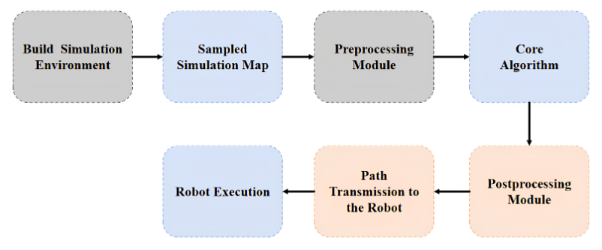
Figure 1 Optimization Module

In the proposed framework, the preprocessing module applies morphological dilation to refine obstacle boundaries and safety margins, thereby improving distance-keeping strategies and significantly accelerating the planning process. After path generation, a postprocessing module extracts keypoints through polar coordinate transformation, which removes redundant nodes and unnecessary turns, leading to smoother and more efficient trajectories. The study is implemented on the ROS robotic simulation platform with Gazebo, where systematic experiments are conducted across maps of different scales and with multiple path planning algorithms. By embedding the proposed preprocessing and postprocessing modules into diverse algorithms, and performing parameter analysis and optimization based on experimental results, the framework achieves optimized configurations for path planning performance.

- material and methods

2.1 Safety and Feasibility Analysis in Path Planning: A* Algorithm Case Study
The A* algorithm is a representative heuristic search method widely applied in artificial intelligence and path planning. Its core principle is to incorporate heuristic information into the search process by constructing an evaluation function that estimates the cost of candidate nodes, thereby guiding the search toward the target node, accelerating convergence, and improving overall planning efficiency. To illustrate the role of the proposed preprocessing and postprocessing framework, this section takes the A* algorithm as an example and discusses the common issues encountered in practical path planning.

2.1.1 Cost Evaluation
The total cost function of A* can be defined as:
$$f\left(n\right)=g\left(n\right)+h(n)$$
Here, $f(n)$represents the estimated total cost from the start node to the goal node via the current node; $g(n)$denotes the actual cost from the start node to node $n$; and $h(n)$ is the heuristic estimate from node $n$ to the goal, also referred to as the heuristic function. The choice of $h(n)$ plays a critical role in determining algorithm performance: it not only affects the rationality of the search path but also directly influences convergence efficiency and the guarantee of optimality. Commonly used heuristic functions can be broadly categorized as follows:
Manhattan Distance: $h\left(n\right)=\left|x_{n}-x_{g}\right|+|y_{n}-y_{g}|$
Euclidean Distance: $h\left(n\right)=\sqrt{{\left(x_{n}-x_{g}\right)}^{2}+{(y_{n}-y_{g})}^{2}}$
Chebyshev Distance: $h\left(n\right)=max⁡(|x_{n}-x_{g}|,|y_{n}-y_{g}|)$
In grid environments where diagonal movement is permitted, the Euclidean distance heuristic provides a more accurate representation of the geometric characteristics of the path. This often results in smoother trajectories that more closely approximate the true shortest path. In contrast, Manhattan and Chebyshev distance heuristics produce more discrete variations in certain directions, which may lead to visibly segmented or zigzag paths, thereby reducing the naturalness and smoothness of the planned trajectory. Based on this analysis, the Euclidean distance heuristic is adopted in the A* algorithm example of this study to enhance path continuity and practical feasibility.

2.1.2 Path Planning
The A* algorithm begins at the start node and iteratively evaluates the costs of its neighboring grid cells. Among these candidates, the grid cell with the lowest total cost that is not occupied by an obstacle is selected as the next search node. This process is repeated within the newly expanded search region until the path is extended to the goal node. Figure 2(a) illustrates the cost distribution in the neighborhood of the start node, where the upper-right neighbor has the lowest cost and is therefore chosen as the next search node. Figure 2(b) shows the intermediate search states as the path progressively expands, while Figure 2(c) presents the final planned path together with the explored search region.
The colors in the Figure 2 are defined as follows: white cells represent the nodes along the current path; gray cells indicate the explored grids; yellow cells correspond to the neighboring nodes under evaluation in the current step; black cells denote obstacles; the green cell marks the start position; and the red cell indicates the goal position.
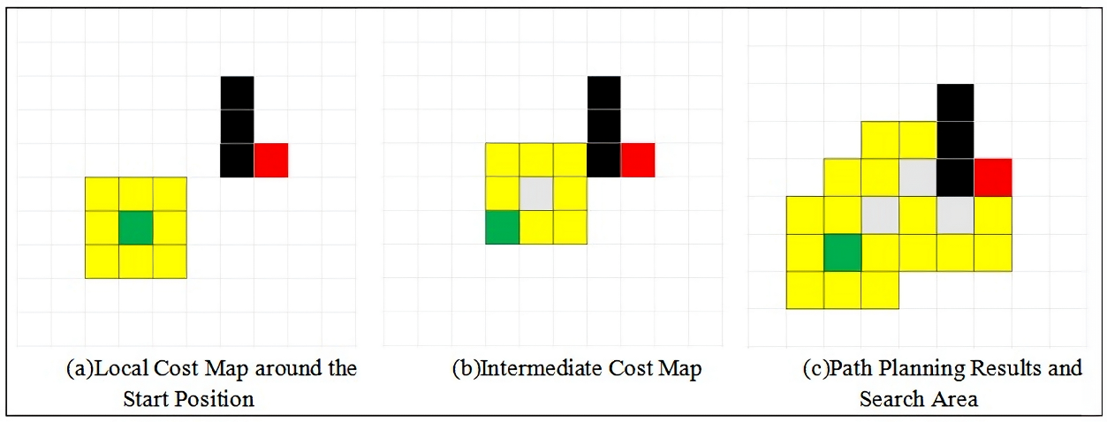
Figure 2 Path Planning Process Diagram

2.1.3 Conventional Obstacle Safety Distance Methods
In addition to explicitly modeled obstacles, path planning must also account for a safety margin between the robot body and surrounding obstacles. However, existing studies have shown limited optimization in this regard, often producing paths that run excessively close to obstacle boundaries or exhibit insufficient clearance between path nodes and obstacles (as illustrated in Figure 3). While such paths may remain theoretically feasible, they present a high risk of collision in practical applications due to the finite geometric dimensions of the robot and inevitable perception errors during map construction.
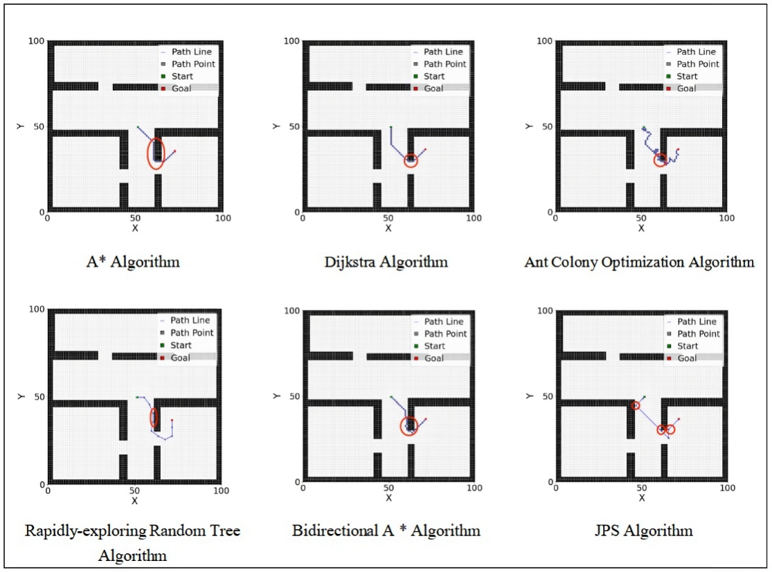
Figure 3 Common Issues in Path Planning Algorithms I

To mitigate such risks, a commonly adopted strategy is to offset the path nodes along the obstacle`s normal or gradient direction by a certain distance, thereby establishing an effective safety margin between the planned path and the obstacle. This adjustment enhances both the feasibility and robustness of the resulting path. The basic procedure is illustrated in Figure 4,where the path adjustment mechanism ensures that the robot maintains a sufficient clearance from obstacles throughout its motion.
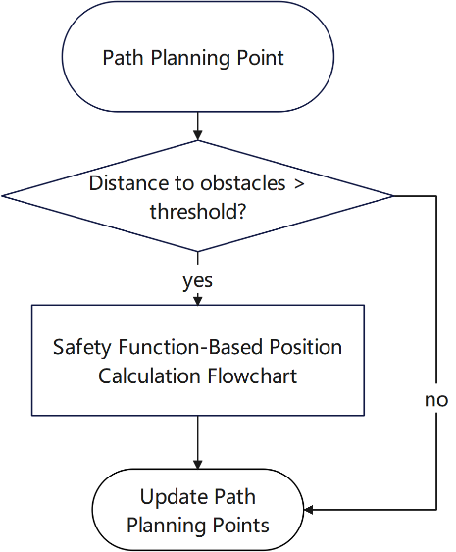
Figure 4 lowchart of the Obstacle-Avoidance Thrust Function for Path Planning

The specific procedure can be described as follows:
1 Compute the distance between each path point and all obstacles.
2 Check whether this distance satisfies a predefined threshold.
3 While the distance is below the threshold, adjust the coordinates of the path point along the direction opposite to the obstacle using a repulsive force function.
The mathematical formulation of the repulsive force function is as follows:
$$f\left(x_{1},y_{1}\right)=\left(x_{1}+\frac{c·cos\left(arctan\frac{y_{1}-y_{2}}{x_{1}-x_{2}}\right)·\sqrt{\left(x_{1}-x_{2}\right)+(y_{1}-y_{2})}}{\sqrt{{\left(x_{1}-x_{2}\right)}^{2}+{(y_{1}-y_{2})}^{2}}+0.1},y_{1}+\frac{c·sin\left(arctan\frac{y_{1}-y_{2}}{x_{1}-x_{2}}\right)·\sqrt{\left(x_{1}-x_{2}\right)+(y_{1}-y_{2})}}{\sqrt{{\left(x_{1}-x_{2}\right)}^{2}+{(y_{1}-y_{2})}^{2}}+0.1}\right)$$
$(x_{1},y_{1})$ denotes a path node that does not satisfy the obstacle safety threshold,$(x_{2},y_{2})$ represents the coordinates of the corresponding obstacle, and $f(x_{1},y_{1})$ indicates the updated path node after applying the repulsive force function. Taking the A* algorithm as an example, Figure 5(a) shows the original path planning result, while Figure 5(b) illustrates the path after incorporating the repulsive force-based safety adjustment.
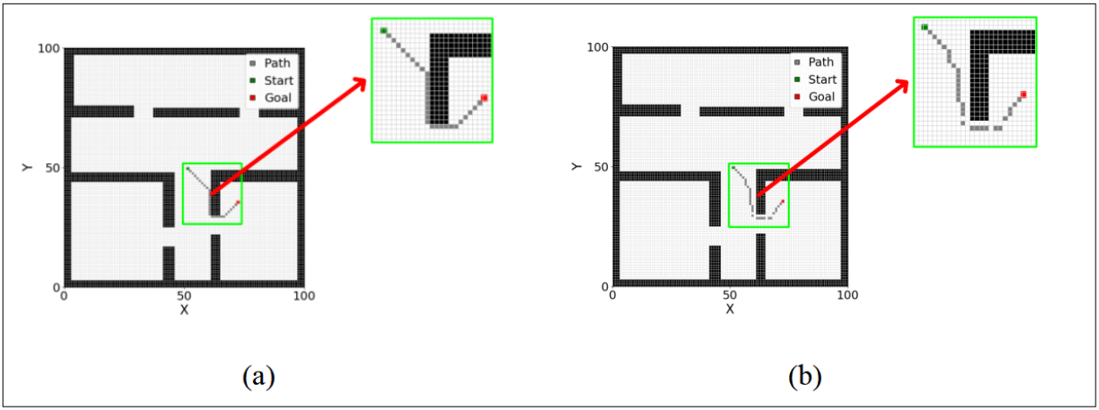
Figure 5Path Planning Diagram Using the A* Algorithm

As observed in the figures, during classical path planning, path nodes near obstacles tend to align along obstacle boundaries, failing to maintain sufficient safety clearance. After introducing the repulsive force function, an effective distance between the path nodes and obstacles is established, enhancing the safety of the path. However, the resulting path still exhibits significant fluctuations, uneven node distribution, and an increased number of turning points, which may cause the mobile robot to perform frequent steering and unnecessary oscillations during motion,
thereby reducing the path’s executability and stability.
To address these issues, this study further improves the algorithm in Next Chapter, aiming to enhance path smoothness and execution efficiency while maintaining adequate safety margins.

2.2 Path Planning Optimization via Morphological Preproce-ssing and Keypoint postprocessing

2.2.1Technical Framework
This study addresses the limitations of existing path planning algorithms in high-resolution and complex environments, where they are prone to local optima and insufficient path smoothness. We propose a path planning optimization method that integrates morphological preprocessing with keypoint-based postprocessing. The technical workflow is illustrated in Figure 6. First, a binary map of the environment is input, and morphological dilation is applied to expand obstacle regions, generating a preprocessed map that automatically reserves a safety margin. Next, a path planning algorithm is executed on this map to obtain an initial path. Subsequently, keypoints are extracted from the initial path based on polar coordinate principles combined with obstacle detection, removing redundant nodes to simplify the path structure and improve smoothness. Finally, the optimized path is evaluated by comparing it with the original path in terms of path length, cumulative turning angle, and computation time, thereby validating the adaptability and effectiveness of the proposed method and producing the optimization results and conclusions.
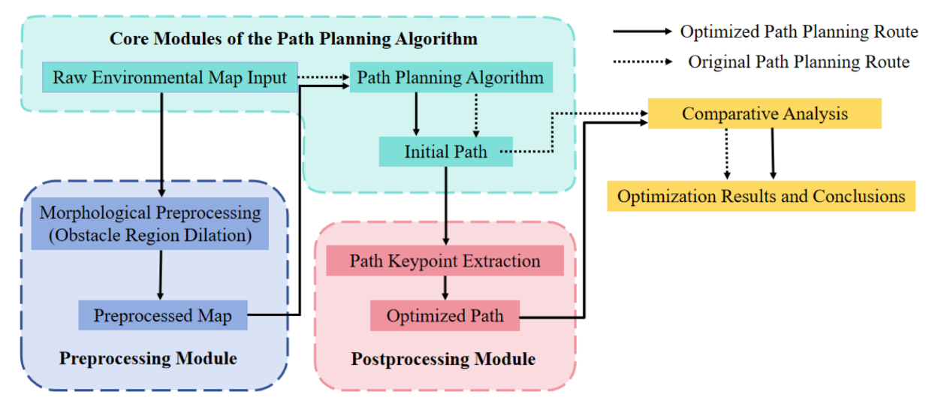
Figure 6 Technical Roadmap

2.2.2Morphological Preprocessing Module
Classical path planning algorithms typically do not consider a safety margin between the path and surrounding obstacles. Traditional strategies for maintaining safety distance mainly involve calculating the distance between each path node and nearby obstacles for adjustment. While acceptable in low-resolution maps, this point-by-point computation becomes computationally intensive in high-resolution environments, as both the number of path nodes and obstacle detection operations increase exponentially, significantly reducing algorithm efficiency and limiting real-time applicability.
To address this issue, this study introduces the concept of morphological “dilation” from computer vision. The preprocessing module performs obstacle dilation on the environment map prior to path planning, effectively expanding obstacle boundaries and automatically reserving a safety margin during the search phase, thereby eliminating the need for repeated point-wise distance calculations.
Binary image dilation is a typical morphological operation that structurally adjusts the foreground regions (usually white) in an image. By applying a convolution kernel (structuring element) of specific size and shape, the dilation operation locally expands image features, filling small holes, connecting adjacent foreground regions, and enlarging object edges, thereby enhancing overall morphological characteristics. In binary images, dilation expands foreground regions outward and increases contour size while reducing background areas; in grayscale images, it enhances local bright regions, making edges more distinct and diffusing brightness outward.
The size of the convolution kernel has a significant impact on the dilation results. Smaller kernels (e.g., $3×3$ or $5×5$) produce slight local expansion, suitable for fine detail processing or filling minor gaps. Larger kernels (e.g., $7×7$, $9×9$, or larger) substantially alter object boundaries, allowing larger safety margins or the removal of isolated noise points in path planning. Therefore, in practical applications, the kernel size should be flexibly chosen based on image resolution, obstacle density, and safety requirements, balancing necessary detail retention and computational efficiency. Figure 7 compares the effects of dilation with different kernel sizes.
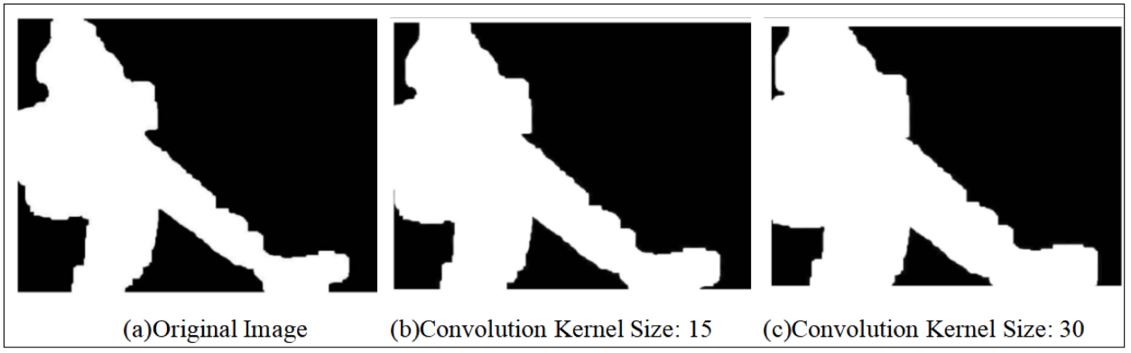
Figure 7 Dilation Illustration

Moreover, the size of the convolution kernel in the dilation operation can be flexibly adjusted according to specific requirements. Different kernel sizes correspond to varying degrees of obstacle expansion, providing good tunability and adaptability for safety margin settings. Applying dilation to a sample map (Figure 8 (a)) produces a preprocessed map (Figure 8(b)), which, as illustrated, does not represent the true environment but rather an expanded version of the original map boundaries.
Taking the A* algorithm as an example, path planning performed on the dilated map can be compared with results obtained using the traditional point-wise safety distance strategy (Figure 8(c)). The results demonstrate that paths generated on the dilated map (Figure 8(d)) are more structured and smoother. Additionally, this approach significantly simplifies the conventional point-wise computation of safety distances, greatly reducing computational time.
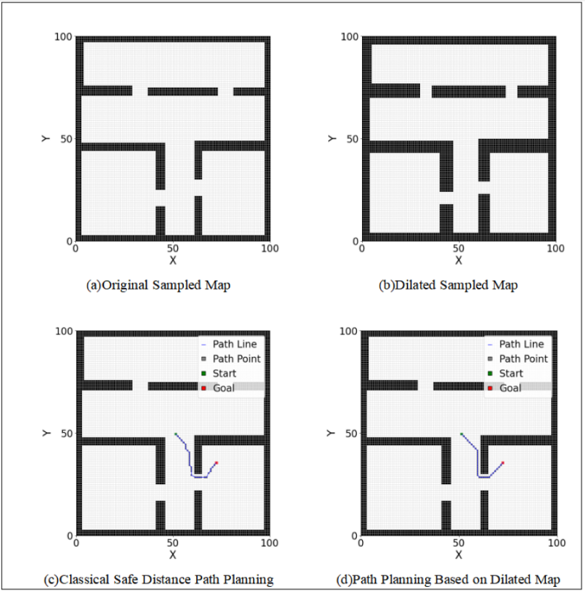
Figure 8 Comparison Diagram of A* Path Planning

2.2.3eypoint Extraction postprocessing Module
In mainstream path planning algorithms, in addition to the challenge of maintaining a safety distance from obstacles, the presence of local optima is another critical factor affecting global path performance. This chapter addresses the tendency of traditional path planning algorithms to become trapped in local optima by introducing a postprocessing optimization module. Local optima may appear reasonable within a limited region but are often suboptimal from a global perspective. For instance, during path planning, the path may advance rapidly along a straight line toward the goal and only turn near obstacles, resulting in redundant turning points or unnecessary detours (Figure 9). As illustrated, local segments of the path (indicated by red arrows) are planned as short paths, yet the resulting full path does not achieve global optimality, remaining constrained by local optima.
To address this issue, this study proposes a keypoint-based postprocessing optimization module. This module identifies critical turning points along local paths and, combined with morphological processing, performs overall path refinement and smoothing. The approach effectively reduces redundant turning points and mitigates the risk of the algorithm being trapped in local optima.

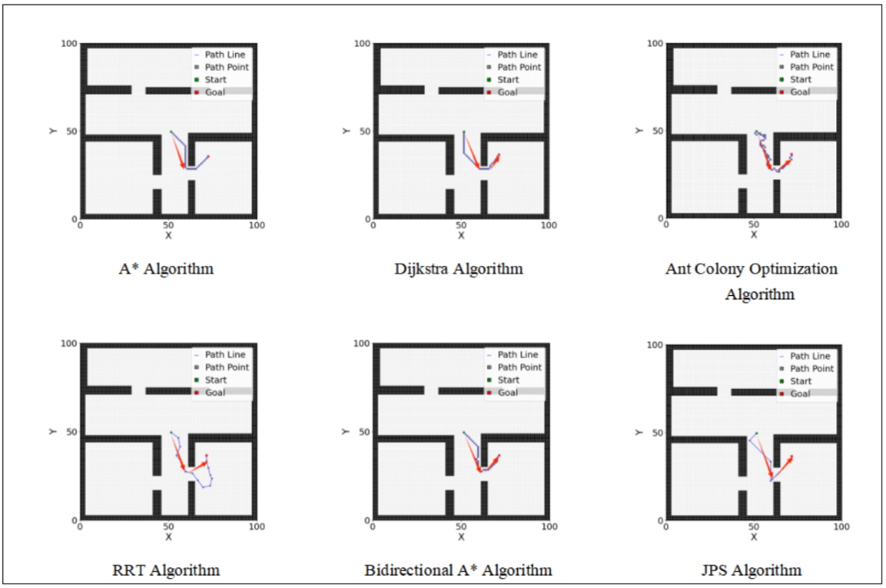
Figure 9 Common Issues in Path Planning Algorithms Ⅱ

In the proposed method, the path’s start point is designated as the pole, and the radial distance and angle between obstacles and the pole are computed. For each path node, its radial distance and angular position relative to the pole are calculated sequentially according to the node order. The algorithm then examines whether any obstacles exist within the radial and angular sectors formed by adjacent path nodes. If no obstacles are present, the earlier node in the sequence is removed, and the process is repeated for the subsequent node and its neighbor, continuing until an obstacle is detected within the sector between adjacent nodes. The start and end nodes are always retained, while intermediate nodes may be eliminated. When an obstacle is encountered, the current preceding node becomes the new pole, and the procedure is repeated for the remaining path nodes until the goal is reached.
Finally, the retained intermediate nodes, together with the start and end points, form a new path list representing the keypoints. This keypoint extraction process produces a smoother and more efficient path. The optimization workflow is illustrated in Figure 10.
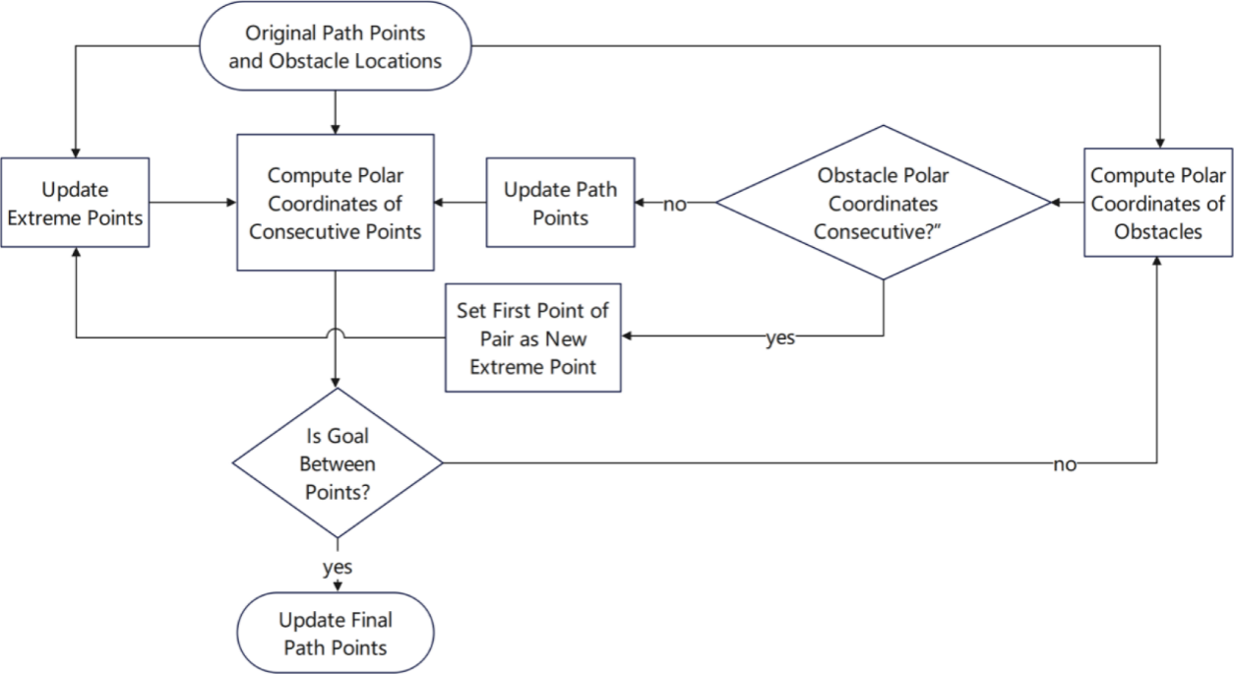
Figure 10 Flowchart of Path Keypoint Extraction

The intuitive workflow of keypoint extraction is illustrated in Figure 11. First, the radial distance and angle of all obstacle points(Figure 11(a)), including the dilated points, are calculated relative to the start point. Next, along the path node sequence, the start point is designated as the pole, and the radial distance and angle to each subsequent path node are computed (Figure 11(b)). During this process, adjacent nodes are examined to determine whether obstacle points exist within the specified sector interval. If no such obstacles are detected, the algorithm proceeds sequentially along the path until a point within the sector interval is identified or the goal is reached. The corresponding Cartesian coordinates are added to the keypoint path list, and this node is set as the new pole for processing the remaining nodes (Figure 11(c)), continuing until the goal node is reached (Figure 11(d)).
Finally, the start and goal points are appended to the keypoint list. The resulting set of keypoints and the obstacle-free keypath are illustrated in Figure 11(e) and Figure 11(f), respectively. This approach produces a concise representation of the path while preserving critical turning points and ensuring obstacle avoidance.The mathematical formulation for determining whether obstacle points fall within the sector interval is given as follows.
$$\left\{\begin{matrix}min(θ_{n},θ_{n+1})<θ_{ob}<max(θ_{n},θ_{n+1}) \\ r_{ob}<max⁡(r_{n},r_{n+1})\end{matrix}\right.$$
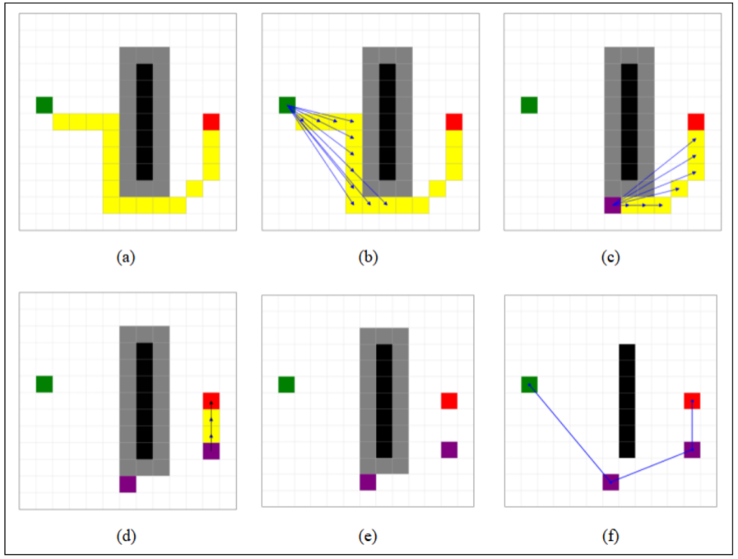
Figure 11 Flow of Keypoint Extraction

In Figure 11, the green and red grids represent the start and goal points of the path, respectively. The yellow region indicates the planned path generated by the algorithm, the black region represents the obstacle distribution, and the gray area denotes the safety margins resulting from obstacle dilation.

- results
3.1 Optimization Results
To evaluate the adaptability and effectiveness of the proposed preprocessing and postprocessing optimization modules, multiple comparative path planning experiments were designed across various environments, testing different algorithms under representative scenarios. Due to space limitations, Table 1 presents only a subset of the experimental results.
As shown in Table 1, the introduction of the keypoint extraction mechanism leads to significant improvements in both total path length and cumulative turning angle, demonstrating the effectiveness of the proposed method in enhancing global optimality, smoothness, and feasibility of the planned paths. Detailed analysis of the optimization magnitude and computation time for each scenario will be provided in the next chapter, along with corresponding experimental data and visualizations.

Table 1 Comparison Chart of Path Planning Optimization
Core Algorithm | without  optimization module | with  preprocessing module | with preprocessing and postprocessing modules
A*  Algorithm | 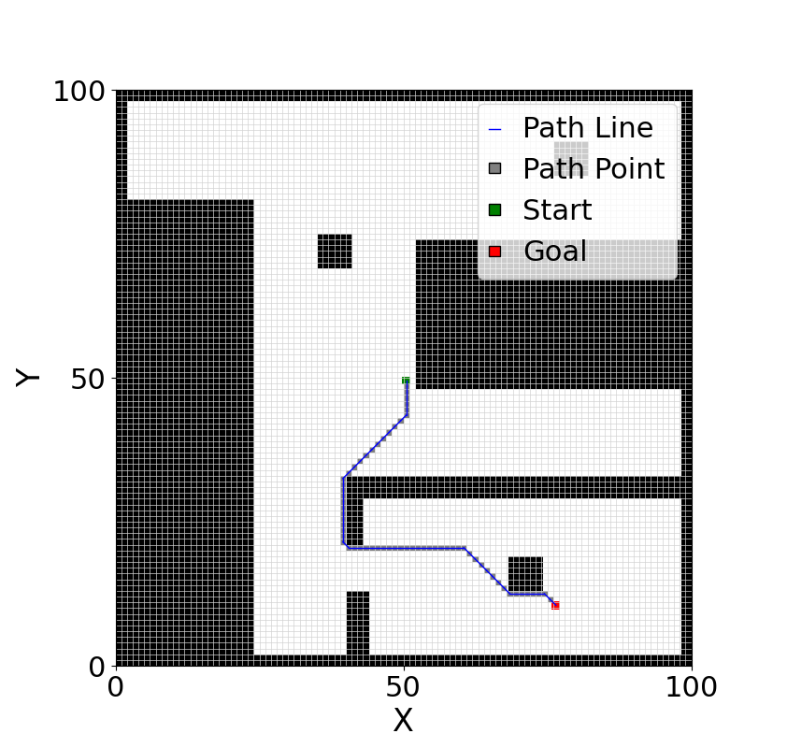 | 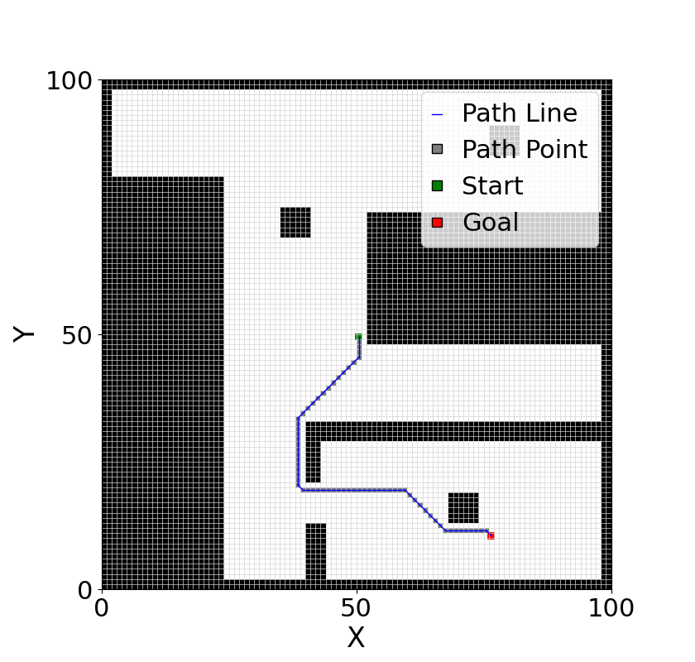 | 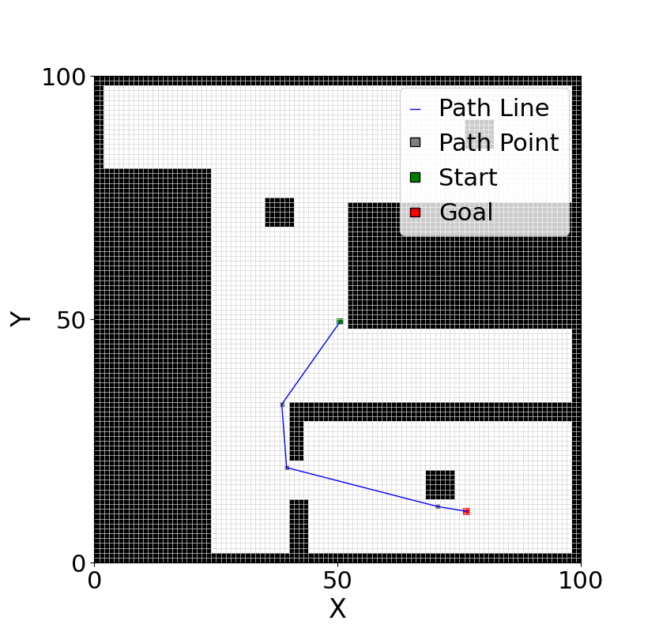
Dijkstra  Algorithm | 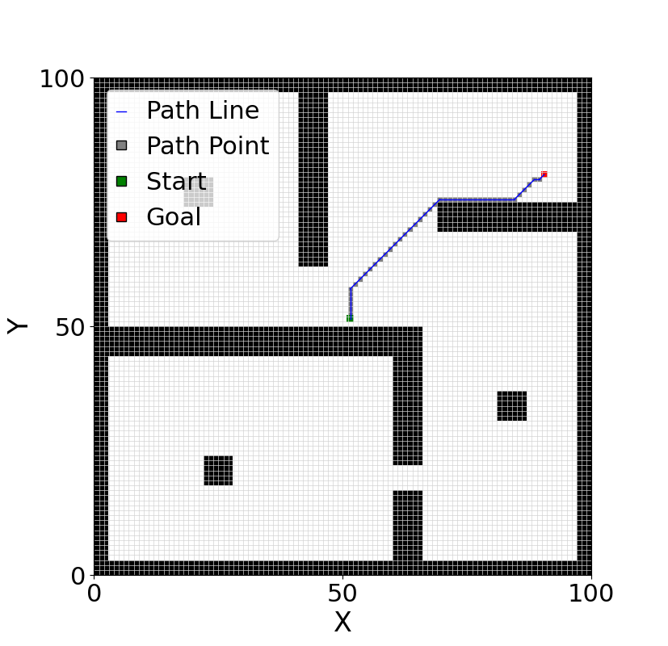 | 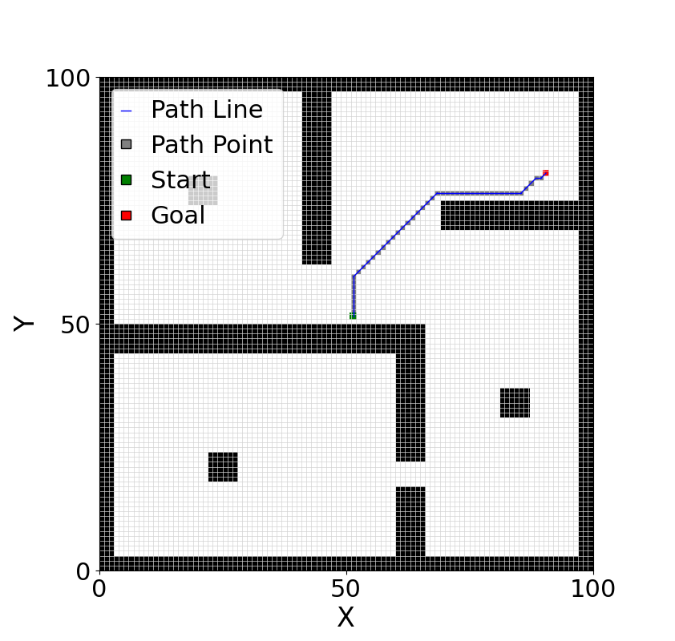 | 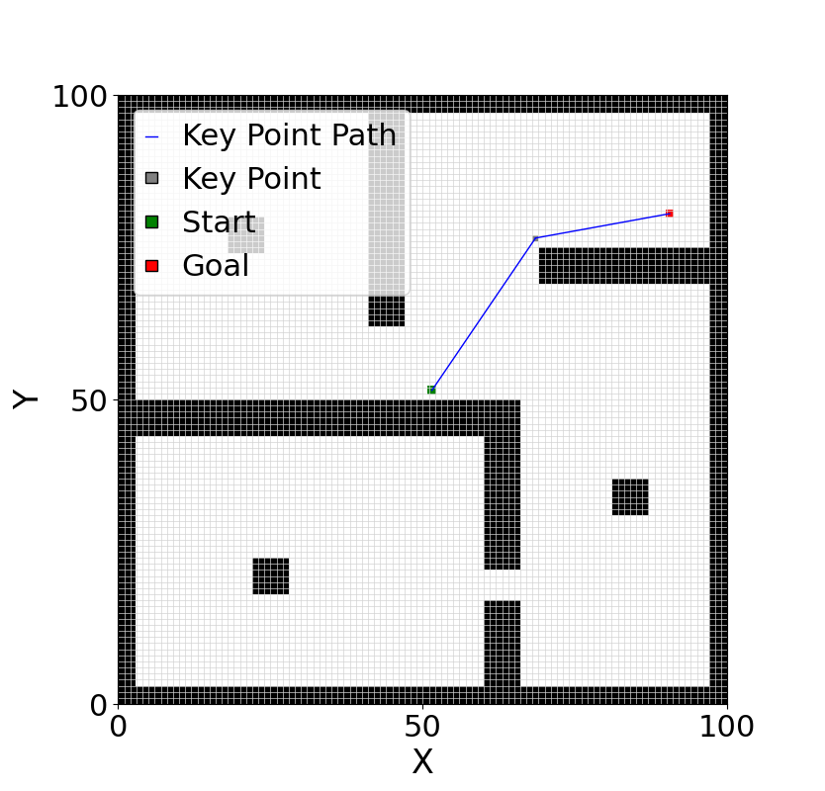
Ant Colony Algorithm | 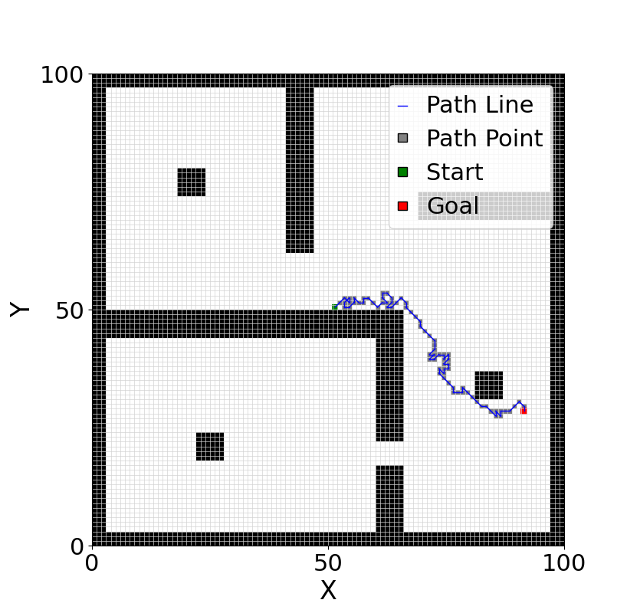 | 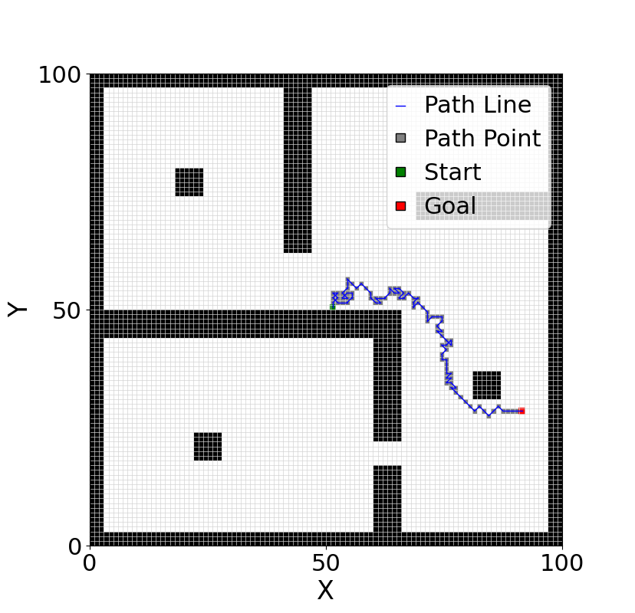 | 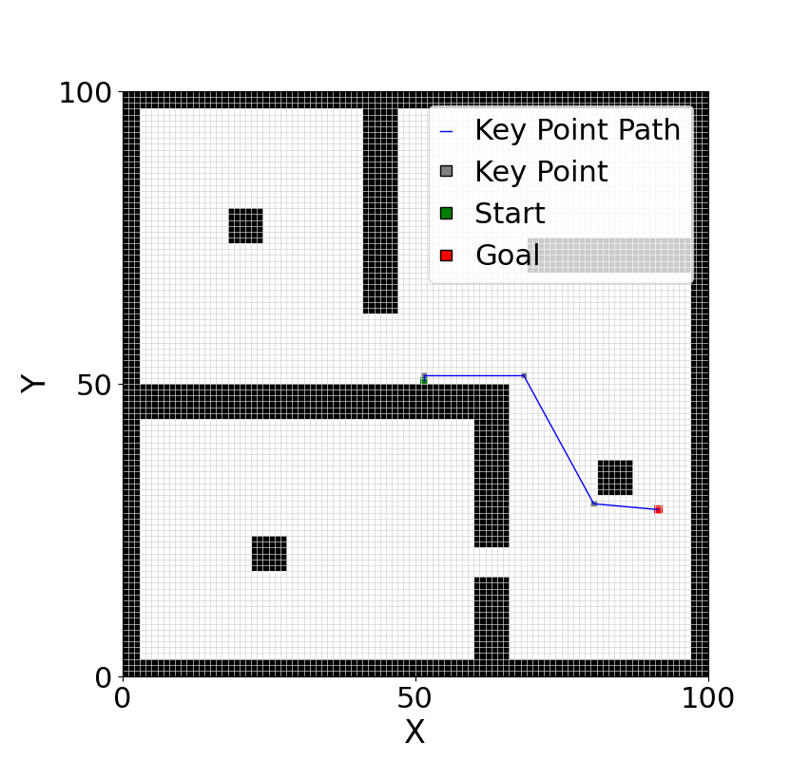
Bidirectional  A* Algorithm | 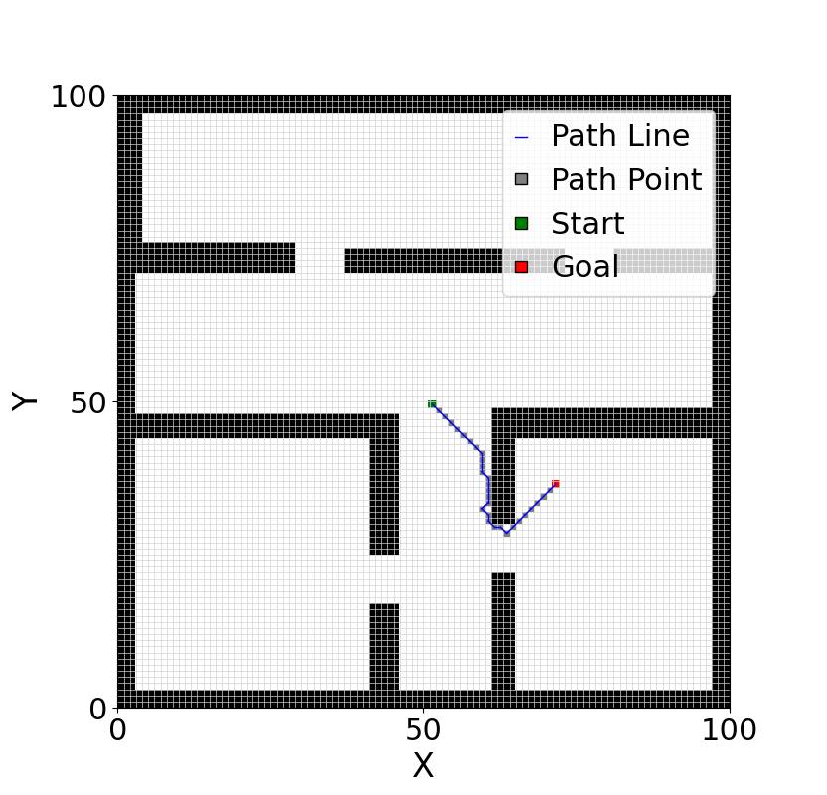 | 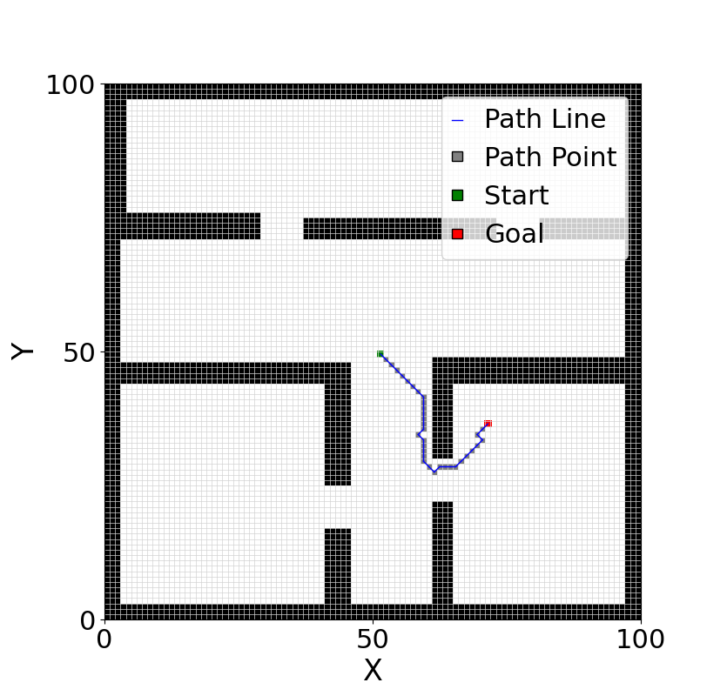 | 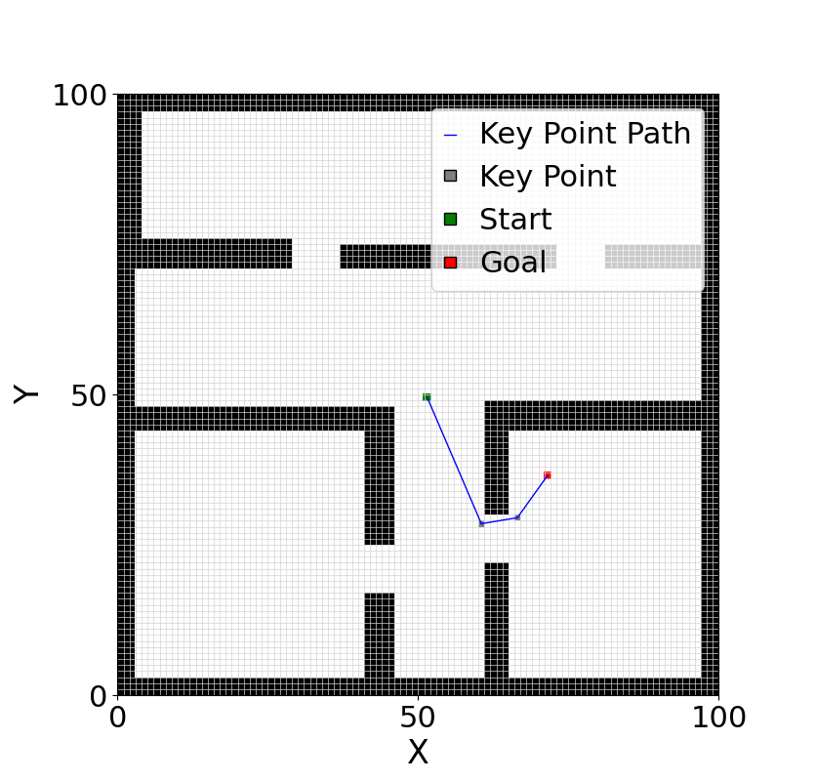
JPS  Algorithm | 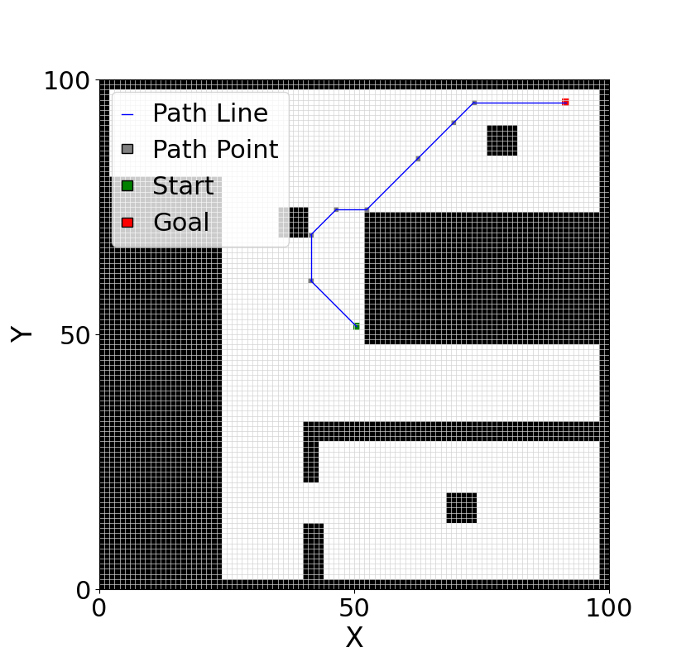 | 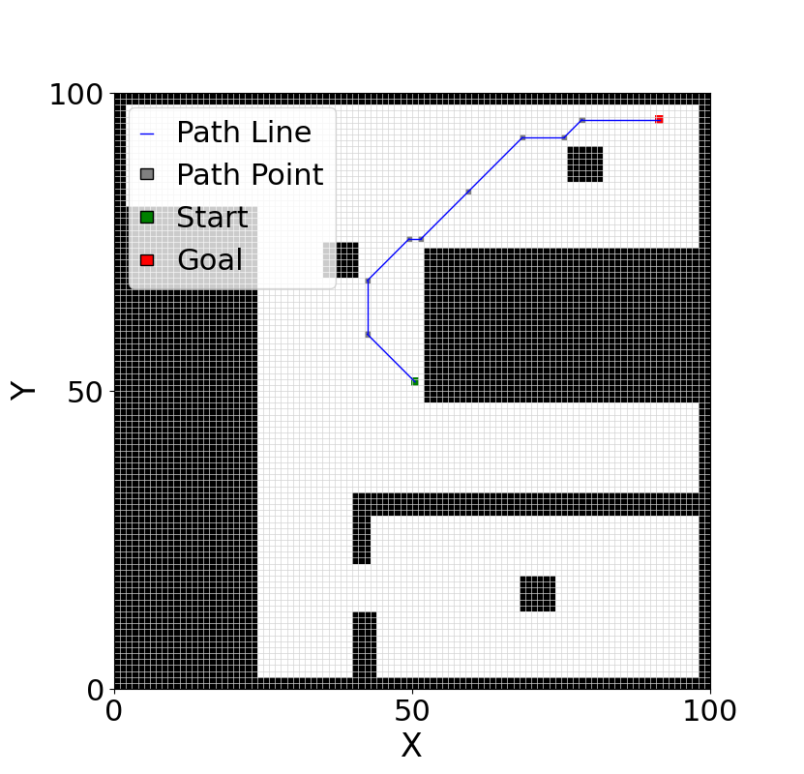 | 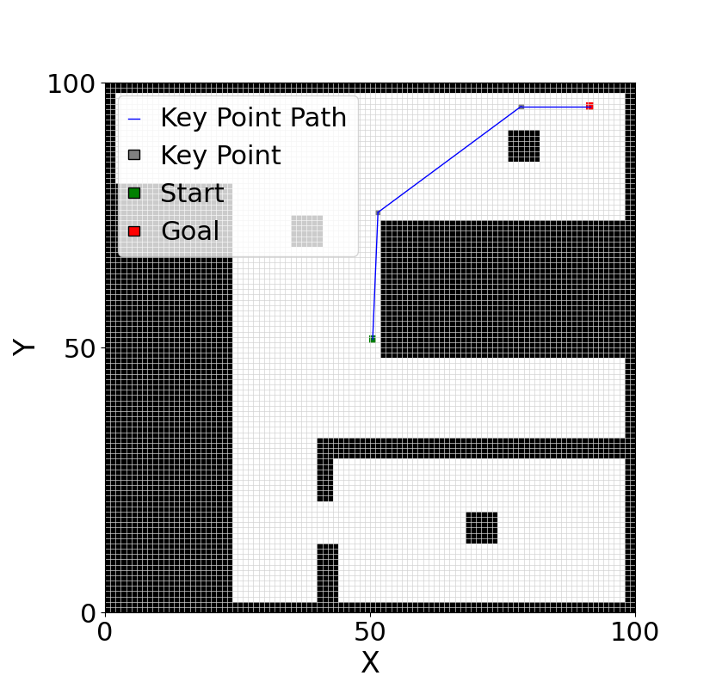
RRT  Algorithm | 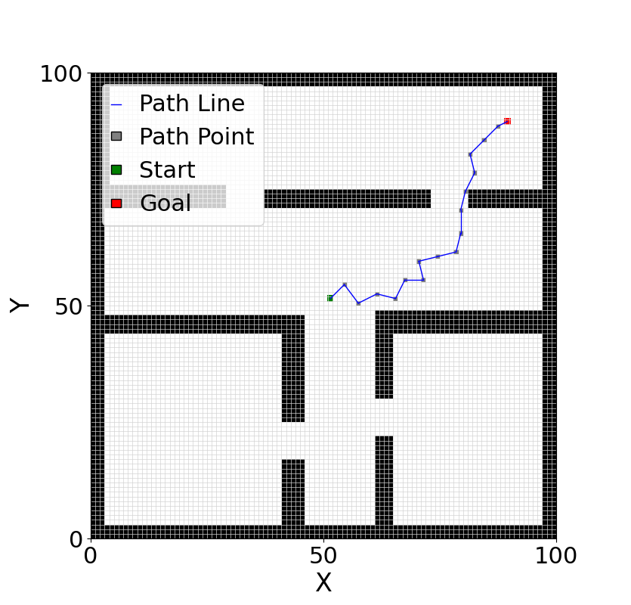 | 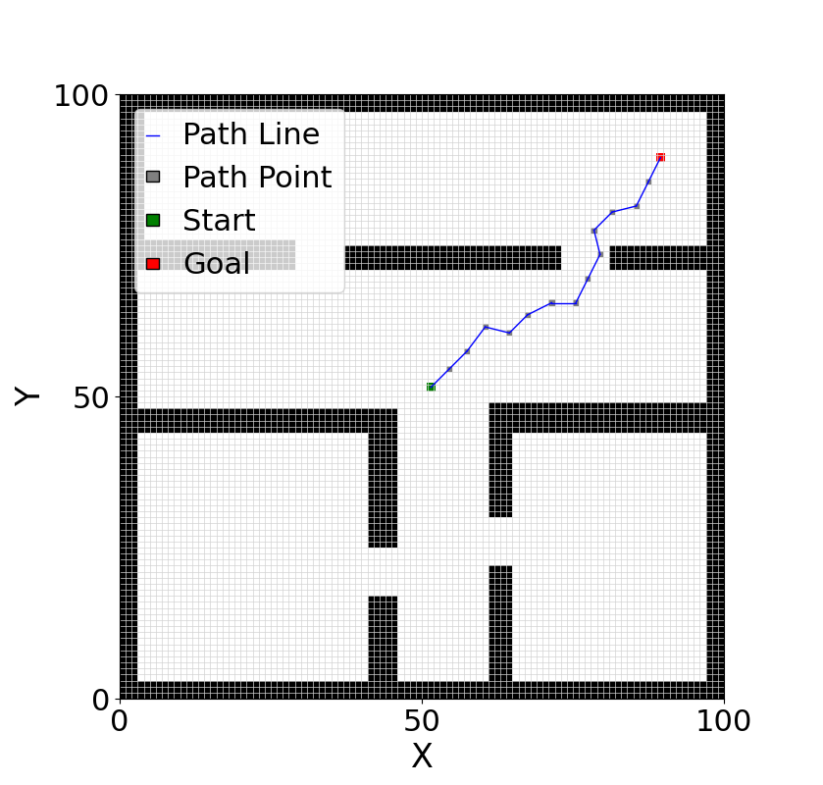 | 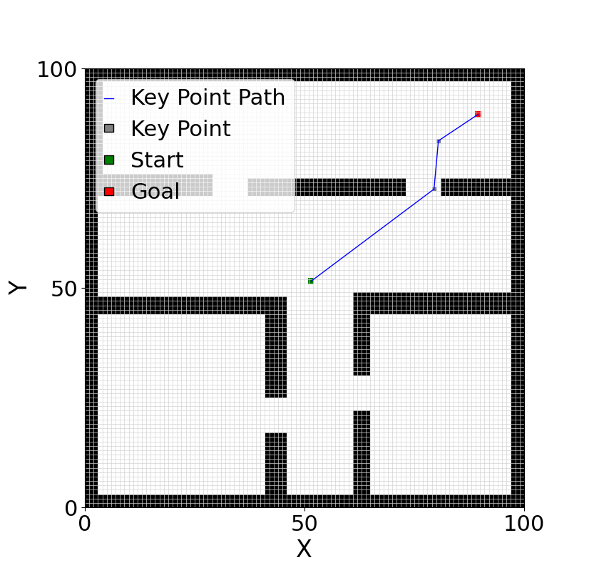

3.2 Simulation Environment Hardware Configuration
The experiments were conducted on a hardware platform configured with an AMD R7-7840H processor running at 3.8 GHz, an NVIDIA GeForce RTX 4060 Laptop GPU with 8 GB of VRAM, and 32 GB of system memory. The operating system was Ubuntu 20.04.6. This hardware setup provided a reliable foundation for stable simulation execution and efficient graphical processing.

3.3 Robot Model and Simulation Environment Setup
Before constructing a physical robot, simulating and modeling its behavior can significantly reduce development time and costs while allowing optimization of design and path planning strategies. In this study, a four-wheeled simulated robot model was developed by integrating multiple simulation and modeling software tools, and its path planning performance was systematically tested in virtual environments.
The simulated robot features a rectangular chassis measuring 30 cm in length, 8 cm in width, with a ground clearance of 1.5 cm. All four drive wheels have a radius of 3 cm and a tire width of 1.5 cm. A LiDAR sensor with a diameter of 5 cm and a height of 4 cm is mounted on the top of the robot. The complete model, shown in Figure 12(a), possesses basic mobility and environmental perception capabilities, providing a feasible platform for validating path planning algorithms.
Unlike traditional methods that validate path feasibility by directly plotting paths on grid maps, this study constructs diverse simulation environments within the Gazebo platform and generates realistic grid maps through autonomous mapping (SLAM). Various simulated scenarios with differing shapes and complexity levels were designed, and the planned path commands were sent in real time to the robot for execution. This approach ensures effective verification of the path planning algorithm and provides reproducible experimental conditions, enhancing the representativeness and practical relevance of the results. An example of the simulated map environment is shown in Figure 12(b).

3.4 Grid Map Construction
Initially, the environment was scanned using a LiDAR sensor integrated with the ROS system, and the resulting map was stored within ROS, as shown in Figure 12(d). The raw map was subsequently processed using image processing techniques for cropping and optimization, yielding the result illustrated in Figure 12(c).
After map construction, the original map was converted into grid maps with varying resolutions (e.g., 50×50, 100×100, 200×200) to facilitate testing of path planning algorithms under different levels of spatial precision. The use of grid maps not only enhances the search efficiency and feasibility of path planning algorithms but also allows flexible adaptation across multiple resolutions. Additionally, grid maps provide clear visualization capabilities, enabling intuitive analysis and verification of environmental information and path planning results during the development process.
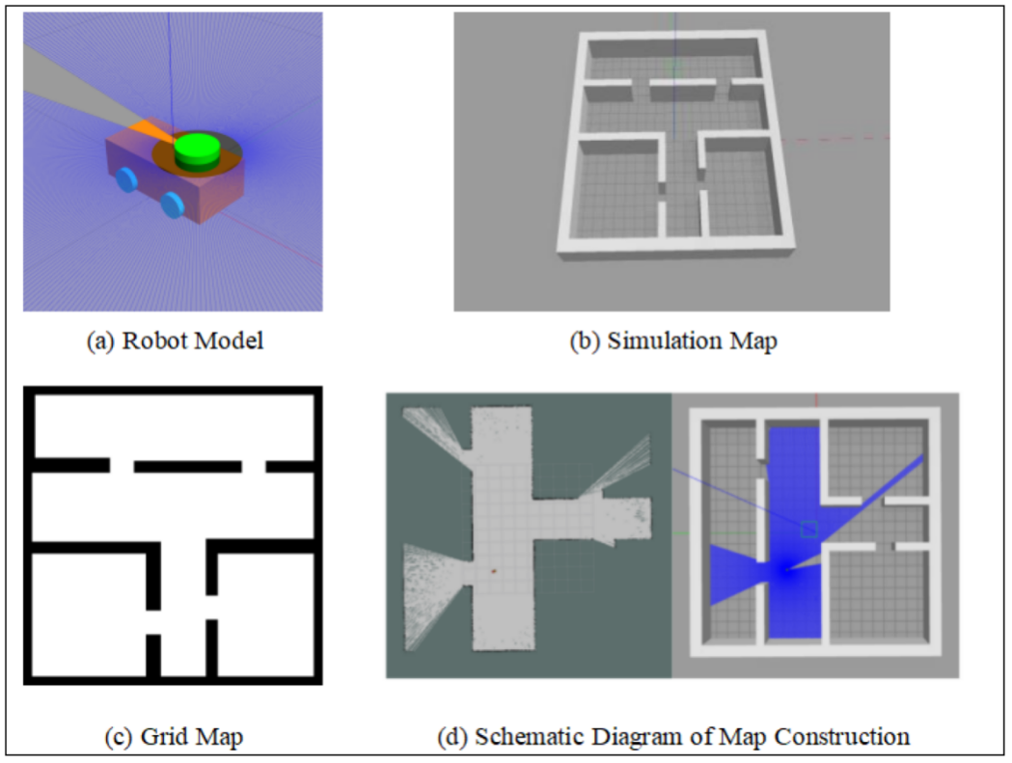
Figure 12 Example of Robot Simulation

3.5 Experimental Results Analysis
To evaluate the feasibility of the proposed path planning optimization method, a series of simulation experiments were conducted in the ROS environment across maps with varying resolutions. The experiments compared the performance of different algorithms incorporating the proposed image morphology-based preprocessing and keypoint extraction-based postprocessing modules against conventional safety distance maintenance strategies. Key metrics, including path length, cumulative turning angle, and computation time, were recorded for each algorithm under different map resolutions, as summarized in Table 2 and Table 3 . The results are presented as follows.

Table 2 Comparison of Simulation Results of Different Algorithms Ⅰ
Map | Algorithm | Original Search Time / s | Optimized Search Time / s | Time Reduction Rate / % | Original  Node Count | Optimized Node Count | Node Reduction Rate / %
50×50 | A* Algorithm | 0.3380 | 0.0350 | 89.64 | 34 | 6 | 82.35
 | JPS Algorithm | 0.0818 | 0.0172 | 78.97 | 9 | 4 | 55.56
 | RRT Algorithm | 0.0638 | 0.0371 | 41.85 | 11.65 | 4 | 65.67
 | Bidirectional A* Algorithm | 0.0854 | 0.0110 | 87.12 | 17 | 4 | 76.47
 | Ant Colony Algorithm | - | - | - | 32 | 4 | 87.5
 | Dijkstra Algorithm | 0.1340 | 0.0240 | 82.09 | 24 | 3 | 87.5
100×100 | A* Algorithm | 0.6463 | 0.1860 | 71.22 | 64 | 4 | 93.75
 | JPS Algorithm | 0.1280 | 0.0710 | 44.53 | 9 | 4 | 55.56
 | RRT Algorithm | 0.0836 | 0.0335 | 59.93 | 15.55 | 3.25 | 79.10
 | Bidirectional A* Algorithm | 0.4502 | 0.0590 | 86.89 | 31 | 4 | 87.10
 | Ant Colony Algorithm | - | - | - | 89 | 5 | 94.38
 | Dijkstra Algorithm | 0.5612 | 0.3786 | 32.54 | 32 | 4 | 87.50
200×200 | A* Algorithm | 5.4466 | 1.2564 | 76.93 | 130 | 4 | 96.92
 | JPS Algorithm | 0.4414 | 0.1770 | 59.90 | 8 | 4 | 50.00
 | RRT Algorithm | 0.7115 | 0.1680 | 76.38 | 33.30 | 3.1 | 90.69
 | Bidirectional A* Algorithm | 1.2522 | 0.3497 | 72.07 | 63 | 4 | 93.65
 | Ant Colony Algorithm | - | - | - | 179 | 4
 | Dijkstra Algorithm | 2.0056 | 0.5291 | 73.61 | 91 | 3 | 96.70

Table 3 Comparison of Simulation Results of Different Algorithms Ⅱ
Map | Algorithm | Original  Path Length | Optimized Path Length | Path Length Reduction Rate / % | Original Cumulative Steering Angle/° | Optimized Cumulative Steering Angle/° | Steering Angle Optimization Rate/%
50×50 | A* Algorithm | 56.14 | 38.55 | 31.34 | 1566.87 | 176.19 | 88.76
 | JPS Algorithm | 41.93 | 37.19 | 11.30 | 314.23 | 88.99 | 71.68
 | RRT Algorithm | 43.00 | 39.08 | 9.12 | 407.83 | 122.55 | 69.95
 | Bidirectional A* Algorithm | 26.61 | 20.97 | 21.20 | 450.00 | 138.18 | 69.29
 | Ant Colony Algorithm | 45.66 | 26.84 | 41.22 | 1926.87 | 98.13 | 94.91
 | Dijkstra Algorithm | 35.44 | 26.81 | 24.35 | 945.00 | 56.94 | 93.98
100×100 | A* Algorithm | 80.99 | 37.42 | 53.80 | 1010.61 | 111.80 | 88.94
 | JPS Algorithm | 79.15 | 70.62 | 10.78 | 175.06 | 87.61 | 79.95
 | RRT Algorithm | 70.57 | 56.32 | 20.19 | 506.43 | 27.83 | 94.50
 | Bidirectional A* Algorithm | 44.99 | 37.53 | 16.58 | 900.00 | 121.26 | 86.53
 | Ant Colony Algorithm | 120.29 | 54.11 | 55.02 | 7719.39 | 207.58 | 97.31
 | Dijkstra Algorithm | 43.92 | 37.42 | 14.81 | 695.61 | 111.80 | 83.93
200×200 | A* Algorithm | 161.54 | 140.37 | 13.11 | 1039.35 | 108.37 | 89.57
 | JPS Algorithm | 163.57 | 143.68 | 12.53 | 135.00 | 86.35 | 36.04
 | RRT Algorithm | 139.11 | 112.24 | 19.32 | 1045.00 | 23.06 | 97.80
 | Bidirectional A* Algorithm | 85.22 | 71.36 | 16.26 | 1341.87 | 114.36 | 91.48
 | Ant Colony Algorithm | 224.46 | 106.06 | 52.95 | 12327.83 | 109.80 | 99.11
 | Dijkstra Algorithm | 114.39 | 104.15 | 8.87 | 891.87 | 42.64 | 95.22

The results indicate that incorporating the morphology-based preprocessing and keypoint extraction-based postprocessing modules significantly improves both search efficiency and path quality across all tested path planning algorithms. Due to the inherent randomness of the RRT algorithm, its outcomes were averaged over 20 runs to ensure statistical reliability. The ant colony algorithm, given its iterative learning nature, was excluded from computation time comparisons and analyzed solely in terms of node count and path smoothness. After embedding the proposed modules, A*, bidirectional A*, and ant colony algorithms exhibited notable reductions in the number of nodes, along with decreased path lengths and cumulative turning angles. In particular, the ant colony algorithm demonstrated the most pronounced improvement in path smoothness. Overall, these results demonstrate that the proposed optimization method is applicable to multiple algorithms and map scales, effectively enhancing the efficiency and practicality of path planning.

3.6 Algorithm Validation on the Experimental Platform
To further evaluate the practical feasibility and engineering applicability of the proposed path optimization strategy, the optimized path points of the bidirectional A* algorithm (as listed in Table 1) were transmitted to the mobile robot via ROS topic communication, enabling the robot to follow the planned trajectory in a simulation environment.Figure 13 illustrates the robot's motion trajectory and the corresponding path tracking results during the simulation.
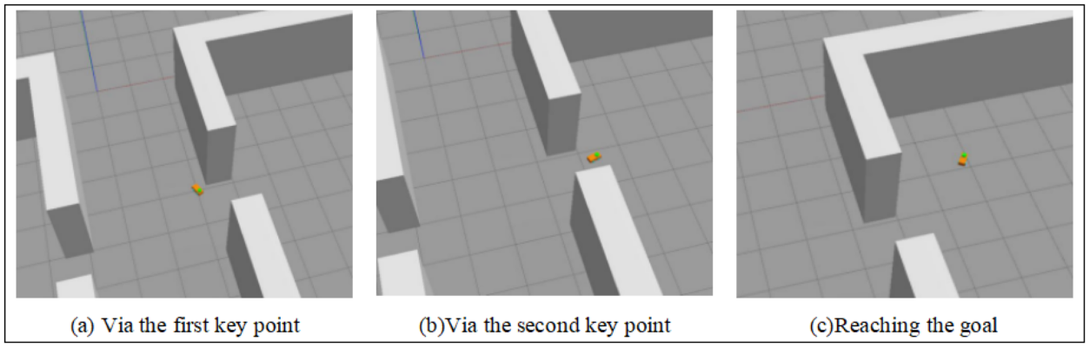
Figure 13 Simulation-Based Experimental Validation

The simulation results demonstrate that the optimized paths can be successfully executed by the robot while exhibiting superior performance in terms of path smoothness, obstacle avoidance, and steering control. Compared with the original paths, the robot experienced fewer unnecessary sharp turns and path oscillations during motion, effectively improving trajectory tracking stability and execution efficiency.
Furthermore, the sparser and more evenly distributed path points allowed the system to respond more rapidly to control commands, enhancing adaptability. These results indicate that the proposed optimization strategy is highly deployable and capable of meeting the navigation requirements of mobile robots in complex environments, demonstrating substantial practical and engineering value.

- Discussion AND Conclusion
The proposed path planning optimization method demonstrates significant improvements in search efficiency, path node optimization, and path quality across various algorithms and map scales.
Search efficiency. The morphological preprocessing module substantially reduces computational load. For instance, the A* algorithm achieved execution time reductions of 89.64%, 71.22%, and 76.93% on 50×50, 100×100, and 200×200 maps, respectively, while the bidirectional A* algorithm improved by 87.12%, 86.89%, and 72.07%. These results indicate that the preprocessing module effectively enhances algorithm robustness and applicability across different map sizes.
Path node optimization. The polar-coordinate keypoint postprocessing module efficiently eliminates redundant nodes. In 200×200 maps, the A* algorithm reduced the number of nodes by 96.92%, and the Dijkstra algorithm by 96.70%, demonstrating that keypoint extraction can optimize path structure while preserving overall topology.
Path quality. The optimized paths exhibit substantial improvements in smoothness and length. The cumulative steering angle of the A* algorithm decreased by nearly 90%, while the ant colony algorithm consistently achieved a path length reduction exceeding 41% and a maximum cumulative steering angle reduction of 99.11% across different map scales. Gazebo-based simulations further validated the practical value of the proposed approach, showing smoother trajectories, more stable steering control, and effective elimination of abrupt turns and oscillations, thereby improving path-tracking stability and execution efficiency.
This study presents a path planning optimization algorithm that integrates morphological preprocessing with polar-coordinate-based keypoint postprocessing. Through a modular approach, the method significantly enhances the performance of various path planning algorithms in terms of path structure complexity, search efficiency, and path quality, effectively addressing common issues in complex environments such as local optima, redundant turning points, excessive cumulative steering angles, and computational overhead for safety distance maintenance.
The experimental results confirm that the proposed approach can substantially reduce computation time, optimize path nodes, and improve path smoothness and stability. While the algorithm’s effectiveness has been verified in simulation, adaptive parameter adjustment has not yet been incorporated. Future work will focus on developing intelligent adaptive strategies to dynamically adjust parameters according to environmental complexity, obstacle distribution, and robot performance, further enhancing the algorithm’s generalization and robustness.

AcknowledgEments
I would like to express my heartfelt gratitude to my supervisor, Prof. Haichao Liu, for his patient and meticulous guidance throughout the course of my research. He not only provided invaluable advice on research ideas, experimental design, and thesis writing, but also offered great care and support in both life and personal development. His rigorous academic attitude, pragmatic scientific spirit, and admirable character will continue to inspire me in my future studies and work.
I am also sincerely grateful to my colleagues and friends in the laboratory for their generous help and encouragement. During the research process, our discussions and exchanges of experience not only broadened my academic perspective but also deepened my appreciation for the importance of teamwork and scholarly collaboration.
Finally, I would like to extend my highest respect and deepest thanks to all those who have supported and assisted me along the way.

Competing interests
“Authors have declared that no competing interests exist.”

Authors’ Contributions
“Zhiguang Zhang and Haichao Liu” designed the study, performed the statistical analysis, wrote the protocol.“Zhiguang Zhang” wrote the first draft of the manuscript. “Haoyu Liang” and “Yaolin Wang” managed the analyses of the study. “Miao Yu” managed the literature searches.All authors read and approved the final manuscript.

Disclaimer (Artificial intelligence)
Option 1:
Author(s) hereby declare that NO generative AI technologies such as Large Language Models (ChatGPT, COPILOT, etc.) and text-to-image generators have been used during the writing or editing of this manuscript.
Option 2:
Author(s) hereby declare that generative AI technologies such as Large Language Models, etc. have been used during the writing or editing of manuscripts. This explanation will include the name, version, model, and source of the generative AI technology and as well as all input prompts provided to the generative AI technology
Details of the AI usage are given below:
1.
2.
3.

References
M. Reda, A. Onsy, A. Y. Haikal, and A. Ghanbari, "Path planning algorithms in the autonomous driving system: A comprehensive review," Robotics and Autonomous Systems, vol. 174, p. 104630, 2024, doi: 10.1016/j.robot.2024.104630.
L. Liu, X. Wang, X. Yang, H. Liu, J. Li, and P. Wang, “Path planning techniques for mobile robots: Review and prospect,” Expert Systems with Applications, vol. 227, p. 120254, 2023, doi: 10.1016/j.eswa.2023.120254.
J. R. Sánchez-Ibáñez, C. J. Pérez-del-Pulgar, and A. García-Cerezo, "Path planning for autonomous mobile robots: A review," Sensors, vol. 21, no. 23, p. 7898, 2021, doi: 10.3390/s21237898.
A. A. N. Kumaar and S. Kochuvila, "Mobile service robot path planning using deep reinforcement learning," IEEE Access, vol. 11, pp. 100083–100096, 2023, doi: 10.1109/ACCESS.2023.3311519.
X. Fu, Z. Huang, G. Zhang, W. Wang, and J. Wang, "Research on path planning of mobile robots based on improved A* algorithm," PeerJ Computer Science, vol. 11, e2691, 2025, doi: 10.7717/peerj-cs.2691.
H. Zhang, X. Xie, M. Wei, X. Wang, D. Song, and J. Luo, "An improved goal-bias RRT algorithm for unmanned aerial vehicle path planning," in Proc. 2024 IEEE Int. Conf. Mechatronics and Automation (ICMA), Tianjin, China, 2024, pp. 1360–1365, doi: 10.1109/ICMA61710.2024.10633102.
Y. Chen, J. Guo, H. Yang, et al., "Research on navigation of bidirectional A* algorithm based on ant colony algorithm," The Journal of Supercomputing, vol. 77, pp. 1958–1975, 2021, doi: 10.1007/s11227-020-03303-0.
S. Meng, Y. Wang, C.-F. Yang, N. Peng, and K.-W. Chang, "LLM-A*: Large language model enhanced incremental heuristic search on path planning," in Findings of the Association for Computational Linguistics: EMNLP 2024, Miami, FL, USA, 2024, pp. 1087–1102.
H. Tang, H. Dou, Q. Gao, Z. Mao, Y. Ji, and J. Liu, "An improved Gaussian sampling-based bidirectional RRT algorithm in 3D path planning for low-altitude urban environments," in Proc. 2025 37th Chinese Control and Decision Conf. (CCDC), Xiamen, China, 2025, pp. 2494–2499, doi: 10.1109/CCDC65474.2025.11090943.
Y. Miao, H. Liu, Z. Zhang and Y. Liang, "Leveraging RRT*: Probabilistically Interpreted Mechanisms Enhanced With P-HOPE and FLEX-OPT for Complex Path Planning," in IEEE Access, vol. 13, pp. 15965-15980, 2025, doi: 10.1109/ACCESS.2025.3526195.
J. Liu, X. Hu, S. Ma and J. Geng, "A Research on the Application of Theta* Algorithm in Path Planning Based on JPS Optimization," 2024 3rd International Conference on Artificial Intelligence and Software Engineering (ICAISE), Singapore, Singapore, 2024, pp. 72-77, doi: 10.1109/ICAISE65384.2024.00019.
C. Su, L. Zhao, and D. Xiang, "Adaptive A*–Q-learning–DWA fusion with dynamic heuristic adjustment for safe path planning in spraying robots," Applied Sciences, vol. 15, no. 17, p. 9340, 2025, doi: 10.3390/app15179340.
Y. Li, Z. Wang and S. Zhang, "Path Planning of Robots Based on an Improved A-star Algorithm," 2022 IEEE 5th Advanced Information Management, Communicates, Electronic and Automation Control Conference (IMCEC), Chongqing, China, 2022, pp. 826-831, doi: 10.1109/IMCEC55388.2022.10019799.
H. Tu, Y. Deng, Q. Li, M. Song, and X. Zheng, “Improved RRT global path planning algorithm based on Bridge Test,” Robotics and Autonomous Systems, vol. 171, p. 104570, 2024, doi: 10.1016/j.robot.2023.104570.
B. B. K. Ayawli, A. Y. Appiah, I. K. Nti, F. Kyeremeh, and E. I. Ayawli, "Path planning for mobile robots using Morphological Dilation Voronoi Diagram Roadmap algorithm," Scientific African, vol. 12, p. e00745, 2021, doi: 10.1016/j.sciaf.2021.e00745.
X. Li, Y. He, Y. Sun, X. Zhang, and X. Zhang, "Autonomous exploration of mobile robot based on compound cooperative strategy," Robot, vol. 43, no. 1, pp. 44–53, 2021, doi: 10.13973/j.cnki.robot.200009.
J. Hou, W. Jiang, Z. Luo, L. Yang, X. Hu, and B. Guo, "Dynamic path planning for mobile robots by integrating improved sparrow search algorithm and dynamic window approach," Actuators, vol. 13, no. 1, p. 24, 2024, doi: 10.3390/act13010024.
B. Song, S. Tang, and Y. Li, "A new path planning strategy integrating improved ACO and DWA algorithms for mobile robots in dynamic environments," Mathematical Biosciences and Engineering, vol. 21, no. 2, pp. 2189–2211, 2024, doi: 10.3934/mbe.2024096.
M. Yao, H. Deng, X. Feng, P. Li, Y. Li, and H. Liu, "Improved dynamic windows approach based on energy consumption management and fuzzy logic control for local path planning of mobile robots," Computers & Industrial Engineering, vol. 187, p. 109767, 2024, doi: 10.1016/j.cie.2023.109767.
T. Yang, B. Liu, R. Sun, B. Chen, and G. Ji, "Path planning for flexible needle puncture based on multi-objective particle swarm optimization," Applied Soft Computing, 2025, Art. no. 113838, doi: 10.1016/j.asoc.2025.113838.
Fei, D. Liu, W. Bao, X. Zhu, and X. Li, "Task-driven multi-UAV path planning via three-stage optimization strategy for urban region surveillance," Advanced Engineering Informatics, vol. 68, no. C, 2025, Art. no. 103771, doi: 10.1016/j.aei.2025.103771.

