Original Research Article

Comparative Characterisation of Aluminium Bars Produced from Discarded Aluminium Parts

.
ABSTRACT

This research explores the mechanical and microstructural properties of aluminium bars made from discarded automotive, construction, and household materials. Samples: Ford gearbox casing (AGBC), Maltina cans (AMC), Tower long-span roofing sheets (ARS) and 33 kV overhead line cables (AHVC) were remelted and recast using the sand moulding method. The tests of hardness and impact were performed depending on ASTM E10 and ASTM E23, respectively. There was a significant difference in mechanical behaviour: AGBC had the highest Brinell hardness (382.39 +/- 3.12 BHN) and lowest impact energy (20.40 +/- 0.61 J), and AHVC had the best toughness (65.01 +/- 0.52 J) and moderate hardness (137.79 +/- 2.11 BHN). Analysis of the SEM indicated that porosity and Si- and Fe-rich intermetallics were the causes of the strength-ductility trade-offs in the samples. It is concluded that in recycled aluminium, alloy composition and solidification control are the determining factors in performance. These results offer a strategic framework in the selection and improvement of aluminium scrap towards specific industrial applications, including automotive, building construction, lightweight structural parts, etc.

Keywords: Aluminium recycling; Mechanical properties; Microstructure; Impact strength;
Sustainability.

1. INTRODUCTION

The most common metallic component in the crust of the earth is aluminium, which is important in present-day industry because of its low density, great corrosion resistance, and high electrical and thermal conductivity (Keith et al., 2008; Barabasz et al., 2001). It is extensively applied to transportation, construction, packaging, and electronics and is the second most commonly used metal in the world, behind iron (Billy, 2012; International Aluminium Institute, 2018).

Although production of primary aluminium is of industrial significance, it poses significant environmental problems. The Bayer and Hall-Heroult processes that convert the bauxite to the aluminium metal are very energy-consumptive and release a lot of greenhouse gases (Schlesinger, 2013; Liaw et al., 2022). Such processes create waste, use enormous amounts of natural resources, and lead to global warming, which inspires the transition to sustainable alternatives on a global scale.

Recycling of aluminium saves up to 95 per cent of energy used in primary production, which is approximately about 700 kg of crude oil per tonne (Skurkova & Ingaldi, 2014). This leads to reduction of emissions and low cost of production (Wieman, 2013; Green, 2007). Recycling also avoids approximately four tonnes of bauxite per tonne of recovered aluminium, which helps to preserve the ecosystem and reduce pollution (Skurkova and Ingaldi, 2014; Magaldi, 2020).

Moreover, aluminium is a perfect material to recycle because it does not degrade its mechanical and chemical properties and can be recycled indefinitely (Kucharikova et al., 2016; Liaw et al., 2022). This is not only energy-saving but also provides workplaces in the collection and processing industries, which fosters growth of the local economy (Mwanza, 2021; Alaekwe, 2019; Master Recycler Program, 2020; EAA, 2007). Recycled aluminium has also been enhanced by the use of specific technological devices like eddy current separators and X-ray fluorescence analysers to enhance its efficiency and purity (AJO Editorial Team, 2024).

Recycling of aluminium also significantly influences the reduction of emissions worldwide. The industry annually emits about 500 million tonnes of CO₂, which is more than the total emissions of the world’s aviation industry (Svensson, 2014). For instance, aluminium beverage cans recycled by the European Union reach 76 per cent, avoiding 4.7 million tonnes of CO₂ emission (AJO Editorial Team, 2024).

However, certain challenges, including scrap contamination, volatile market prices, and inconsistent quality of recycled materials, are also recognised (Rakiman et al., 2014). To address these challenges, the stakeholders should improve recycling systems and establish uniform quality standards.

Recent developments in the recycling of aluminium have been aimed at enhancing not only the environment but also the quality of the alloy and the mechanical performance. Indicatively, Chen et al. (2025) critically review the re-melting of aluminium alloy chips and indicate that the defects can be greatly reduced and strength can be advanced by means of better pre-treatment and controlled melting. It has been demonstrated that direct strip casting leads to enhanced tolerance to iron contamination and fewer coarse intermetallics and enhanced ductility in recycled aluminium (Jiang et al., 2024). High-pressure roll bond (accumulative roll bonding: AA6063 chips) recycling methods of solid-state alloys are also promising avenues towards scrap collection that can achieve mechanical properties close to those of bulk alloy (Carta et al., 2025). In the meantime, a correlation between the morphology of the aluminium scrap (chips, dross or machined swarf) and the final properties, which is evident in the porosity, intermetallic phase formation, and microstructure refinement, has been confirmed (Altharan et al., 2024). In this way, reusing waste aluminium by means of new manufacturing processes or in other applications (utilisation of aluminium dross to produce cement matrix materials, for example) is also gaining ground as a circular economy strategy (Munoz-Velez et al., 2023). All these developments underscore the need not only to recycle more but also to recycle better, which means to keep a tight rein on the alloy composition, the processing conditions, and the scrap selection.

Nevertheless, the majority of the research is dedicated to single sources of scrap or single recycling techniques. Comparative analyses of various types of wastes, like automotive and electrical wastes and construction and packaging scraps, are still lacking, especially on the divergence of their microstructure and mechanical characteristics. This paper thus seeks to fill that gap by evaluating and comparing the physical and mechanical characteristics of aluminium recycled out of the various discarded materials with a view to establishing the most available materials to be recycled into new pieces of aluminium.

2. material and methods

2.1 Experimental Setup
This experiment used discarded aluminium materials that were acquired from four sources, that is, beverage containers (UBCs), aluminium roofing sheets, high-voltage aluminium cables, and gearbox casings. All types of scrap were melted down and cast into bars of aluminium. The containers used were the used cans of Maltina beverages, which are considered high-purity aluminium beverage containers, which are easy in weight, corrosion resistant and widely recycled because of their light weight and non-corrosive properties. The tower long-span type of aluminium roofing sheets was defined as the ones with a curved crest, a first smooth surface, an embossed surface, six pitches, a single lap of 900 mm, a two-lap lap of 750 mm, a profile pitch of 150 mm, and a profile depth of 32 mm (Tower, 2014). Ford products which were discarded included the gearbox casings, and the high-voltage aluminium cables were taken as scraps. The choice of such cables is aluminium due to its high conductivity of electricity, low weight, and affordability as opposed to copper.

The aluminium bars were designed at 150 x 20 x 20 mm, whereas the wooden patterns of cavity moulding were to be made at 170 x 25 x 25 mm. The extra dimensions were used as machining and shrinkage allowance. The four types of aluminium waste were obtained in Ede Land, Osun State, in Nigeria. The samples after collection were sorted by hand to eliminate foreign substances and undesired metals. They were also washed in depth to remove dirt, food residues and liquid contaminants and dried in the sun.

The Maltina cans that were emptied were pressed using a hydraulic press and compacted into smaller sizes. The long-span roofing sheets were cut in smaller sizes with the help of an arc saw and pounded with a hammer. High-voltage cables were also cut with an arc saw into shorter sizes to allow them to be charged to the crucible. These processes guaranteed that more of each sample was well accommodated during melting.

Calculations of the volume of aluminium to be cast were made according to the size of the bar and pattern. Each bar had a volume of 60 cm³ and a pattern of 106.25 cm³. The mass needed to cast one bar was determined by using the normal density of aluminium (2.7 g/cm³) and is 286.88 g. Thus, the weight of four bars of each category of samples that needed to be cast was 860.64 g.

Patterns made in cubic form (170 x 25 x 25 mm) were wooden split-type, and allowance was made to take into consideration the shrinkage during solidification and later machining. Sieved foundry sand was used to prepare moulds combined with a small quantity of water in order to achieve sufficient binding. Patterns were positioned in between the drag and cope boxes, and parting sand had been applied to make it easily removable. The moulding sand was rammed and poured into place in a uniform layer by using a hand rammer. The cope and drag boxes were then separated after filling, and the patterns were carefully removed to form the necessary cavities. To allow smooth flow of the molten metal, runners and risers were included. The moulds were sprayed, smoothed and blown with a bellows to get rid of the loose particles before being closed to cast.

Melting was done in a small furnace made of pit; the fuels used were lubricating oil, a little petrol and dry wood to improve burning. Each sample (860.64 g each) was melted in its own crucible and processed at different times. A pyrometer was used to record the temperature at five-minute intervals and at the beginning and end of melting. When the crucible was fully melted, tongs were used to lift it, and the molten metal was poured out to the runner of each mould till it appeared at the riser. The bars of the casts were permitted to cool and harden and then removed.

After casting, the samples were tagged to recognise each of them as aluminium Maltina cans (AMC1-AMC4), aluminium roofing sheets (ARS1-ARS4), aluminium high-voltage cables (AHVC1-AHVC4) and aluminium gearbox casings (AGBC1-AGBC4). The tag represents four cast bars of the same type of sample. Machining of runners and risers was done after solidification to get the bars to size 150 x 20 x 20 mm by using an arc saw, which were then milled and filed to the exact size.
2.2 Analytical Techniques
The physical, mechanical and microstructural characteristics of all the aluminium bars were studied to assess the effect of scrap source on performance attributes.
2.2.1 Physical Properties
A pyrometer and stopwatch were used to measure the melting temperature and time, respectively, whereas mass was measured using a beam balance. Density was determined as a ratio of mass to volume (g/cm³).
2.2.2 Brinell Hardness
Hardness tests were made according to the Standard Test Method of Brinell Hardness of Metallic Materials ASTM E10. The indenter was a 10 mm diameter steel ball with a load of 500 to 3000 kg and a dwell time of 10-30 s. The indentation diameters were taken under a low-power microscope with an eyepiece scale, and the values of Brinell Hardness Number (BHN) were determined using a standard conversion chart.
2.2.3 Impact Strength
The impact strength was tested using a Charpy impact testing machine in accordance with ASTM E23: Standard Test Methods for Notched Bar Impact Testing of Metallic Materials. A pendulum arm with fixed potential energy was released to strike each specimen after it was notched, which resulted in the sample fracturing. The energy absorbed was recorded on the machine scale.
2.2.4 Microstructural Properties
Microstructural analysis was performed with the help of a JEOL JSM-7600F (Scanning Electron Microscope, SEM). Grades 240, 320, 400 and 600 abrasive papers were utilised in sectioning and grinding each sample. A two-step polishing process was applied which consisted of a first polish using emery cloth and silicon carbide powder (1.0 µm) and a second polish with a 0.5 µm solution. Before imaging, grain boundaries were revealed by etching with a 2% sodium hydroxide (NaOH) solution. The average grain morphology was compared between samples, and representative regions were examined. Where feasible, quantitative image analysis (such as porosity or grain size) was carried out, and its limitations were noted.

2.3 Statistical Analysis

For every sample category, three duplicates of each experimental test, including mass, density, hardness, and impact strength, were conducted. The mean +/- standard deviation (SD) is used to display the data. One-way analysis of variance (ANOVA) was used to compare the four aluminium groups (AMC, ARS, AHVC, and AGBC) statistically in order to assess any significant variations in the properties that were measured. At a confidence level of P = .05, differences were deemed statistically significant. Veusz (for data visualisation and error plotting) and Microsoft Excel (for ANOVA) were used for all statistical analyses.

2.4 Chemical Composition Analysis

Due to restricted access to X-ray fluorescence (XRF) and optical emission spectroscopy (OES) facilities, a direct chemical composition analysis of the aluminium scrap samples was not carried out. However, based on the known alloy series and common uses of each scrap source, compositional information was deduced from the body of established literature.

2.4.1 Beverage Can

Al–Mn–Mg alloys containing about 0.8–1.5 weight per cent Mn and 0.8–1.2 weight per cent Mg added to improve strength and corrosion resistance, such as AA3004 or AA3104, are the common starting material for beverage can aluminium (AMC). Akindapo et al. (2024) reported the XRF composition of Maltina beverage cans to be Al < 95.9 wt.%, Mn 1.22 wt.%, Mg 1.14 wt.%, Fe > 0.60 wt.%, Cu 0.31 wt.%, Si 0.29 wt.%, and Zn 0.09 wt.%, with trace elements all below 0.07 wt.%. This confirms the alloy is a member of the Al–Mn–Mg family, which is commonly used to make beverage cans.

2.4.2 Aluminium Roofing Sheets

AA1050 alloys are widely employed in the production of aluminium roofing sheets (ARS), which are locally used. The high-purity AA1050 aluminium sheet is used in roofing, packaging and decoration applications because of its superior corrosion resistance, high reflectivity, formability and low strength (Hwalu, 2025). AZOM (2025) reports that the typical chemical composition of AA1050 alloy is presented in the following: Si (0–0.25%), Fe (0–0.40%), Cu (0–0.05%), Mn (0–0.05%), Mg (0–0.05%), Zn (0–0.07%), and Ti (0–0.05%) with Al as the balance. The alloy has an excellent corrosion performance and ductility for building applications in humid or coastal environments due to the presence of very few alloying elements.

2.4.3 High-Voltage Cable Aluminium

According to ZMC (2010), high-voltage cable aluminium (AHVC) is usually equivalent to AAAC (All-Aluminium Alloy Conductor), which is made of high-conductivity (≥53% IACS) aluminium–magnesium–silicon alloy that contains Mg (0.6–0.9 wt.%) and Si (0.5–0.9 wt.%) and has been thermally treated to increase mechanical strength. Compared to conventional ACSR conductors, AAAC conductors, which are concentrically stranded and part of the 6000-series Al–Mg–Si system, offer superior corrosion resistance, high tensile strength, and excellent conductivity (Henan Chalco, 2022).

2.4.4 Gearbox Casing Aluminium

Al–Si–Mg cast alloys (such as A380 with 7.5–9.5 wt.% Si, 3.0–4.0 wt.% Cu, ≤1.3 wt.% Fe, ≤3.0 wt.% Zn, ≤0.5 wt.% Mn, ≤0.5 wt.% Ni, and the balance aluminium) are typically compliant with gearbox casing aluminium (AGBC) (OEForm, 2024). According to ASTM B85, nickel enhances high-temperature properties, copper increases strength but lessens corrosion resistance, and silicon increases fluidity but lessens shrinkage. For these reasons, A380 is ideal for casting components which require good strength, castability and wear resistance, such as gearbox housings.

3. results and discussion
3.1 Physical Properties of the Aluminium Bars
3.1.1 Melting Point Temperature and Melting Time
Figure 1 shows the melting behaviour of aluminium recovered from the four waste sources. The gearbox casing (AGBC) had the highest melting range, starting at 818.6°C and finishing at 997.0°C after 20 minutes. The faster melting started at 661°C for the roofing sheets (ARS) sample and 654°C for the beverage cans (AMC), finishing in 4 minutes at 859°C and 810°C, respectively. The high-voltage cable (AHVC) melted between 374.7 and 926°C after ten minutes.
These variations were attributed to the different alloy composition and impurity levels in each scrap source. A380 aluminium alloy is widely used to produce aluminium gearboxes, for which silicon content is around 7.5–9.5% and copper 3.0–4.0%. In addition to increasing the melting range, these alloying elements form strengthening intermetallic phases (OEForm, 2024). Thus, they increase strength and wear resistance. As a result, A380-type alloys often have a melting point higher than 800°C, which correlates with the AGBC sample's higher melting temperature.
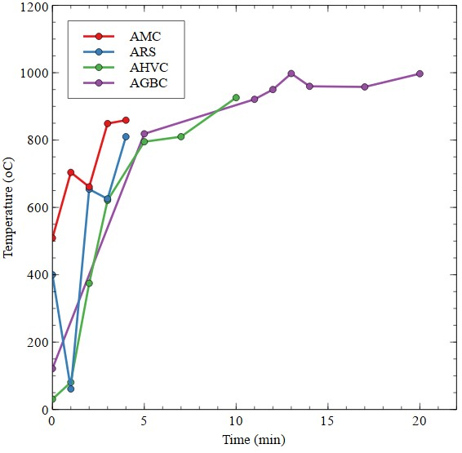

Fig. 1. Melting temperature and time recorded for aluminium samples from gearbox casing (AGBC), beverage can (AMC), high-voltage cable (AHVC), and roofing sheet (ARS).
On the other hand, 1050 aluminium alloy, a commercially pure grade of aluminium that contains over 99.5% Al with only minor alloying additions like Si (≤0.25%) and Fe (≤0.4%), is typically used to make aluminium roofing sheets (Hwalu, 2025; AZOM, 2025). This composition helps to explain the ARS sample's faster melting behaviour by contributing to its narrow melting range and relatively low melting onset, which occurs around 650–660°C. Remaining materials, fluxing agents, or low-melting eutectic phases could cause early partial melting before the bulk aluminium matrix reaches its full melting temperature, which would explain the AHVC sample's lower onset temperature.
3.1.2 Colour
As soon as the samples were cast, they acquired a definite colour (Table 1): AMC dark silvery, AGBC light silvery, AHVC dark yellowish-silvery, and ARS light yellowish-silvery. Upon machining, all the bars were uniformly bright silvery coloured.

The variations in colour depend on the residual alloying elements and oxidation behaviour of each scrap source. The dull silvery colour of AGBC could be due to relatively high Si (7.5-9.5%) and Cu (3-4%) contents that are characteristic of A380-type cast alloys and promote surface oxidation as well as reducing reflectivity. The bright silvery colour of AMC is in line with the Al-Mn-Mg (AA3004/3104) system, which has fewer surface reactive elements and which results in a thinner and more adherent oxide layer. In the meantime, the yellowish colouration of AHVC and ARS can be explained by the presence of an oxide film (Al₂O₃) and traces of Fe, Zn or Cu, which respectively locally distort the light scattering on the surface.

Similar discolouration effects have been reported in aluminium alloys, in which localised yellow or brownish discolouration is generated by rough oxide/alloy interfaces which are formed by the selective oxidation of intermetallic phases such as β'(Mg₂Si) and Al-Fe-Si compounds (Ma et al., 2014). These oxide layers are customarily removed in machining or polishing to give the aluminium bars back their splendid metallic look.
Table 1. Colours of the aluminium bars immediately after casting
S/N | Samples | Colour
1 | AGBCs | Dull silvery colour
2 | AMCs | Bright silvery colour
3 | AHVCs | Deep yellowish silvery colour
4 | ARSs | Faint yellowish silvery colour

3.1.3 Mass and Density
Figures 2 and 3 respectively show the measured mass and density of the aluminium samples. AHVC has the highest mass (172.5 +/- 1.2 g) and density (2.875 +/- 0.004 g/cm³), while ARS has the lowest (149.9 +/- 0.9 g, 2.498 +/- 0.006 g/cm³). The masses and densities of AMC and AGBC fall in between these two and are 154.35 +/- 1.0 g, 2.573 +/- 0.005 g/cm³ and 150.15 +/- 0.8 g, 2.503 +/- 0.003 g/cm³, respectively.

These values are within the range of recycled or mixed aluminium alloys, generally between 2.64 and 2.90 g/cm³, depending on the alloy composition, microstructure and oxides or porosity, which can contaminate these values (Shengxin Aluminium, 2023). The comparatively low density of ARS is in line with the fact that it is derived by using AA1050 roofing sheets, which are commercially pure aluminium alloy with low alloying elements (Al ≥ 99.5%) and extremely low content of Mg, Si, and Fe (Hwalu, 2025; AZOM, 2025). The diminished density is a result of the low alloying content and possibility of porosity during recycling.
Comparatively, the increased structure of AHVC is indicative of its structure as a high-purity AAAC (Al-Mg-Si, 6000-series) conductor, with Mg and Si additions and few impurities, resulting in a smaller microstructure. AMC, which is an Al-Mn-Mg (AA3004/3104) beverage can, displays a minor reduction in density as a result of reduced overall alloying content and possible surface oxidation. AGBC, which is equivalent to Al-Si-Mg (A380/A356-type) castings, has moderate density even though it contains a lot of Si, and this may be attributed to trapped porosity and coarse intermetallic phases created during the solidification process.

On the whole, the densities of all measured scrap sources of aluminium sources are consistent with the known composition and microstructure of each type of scrap and underscore the effects of alloy type and processing on finished physical qualities.
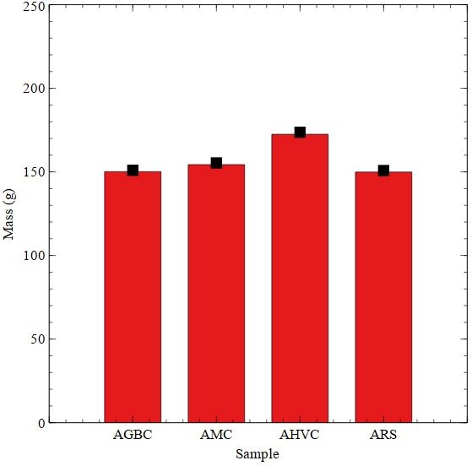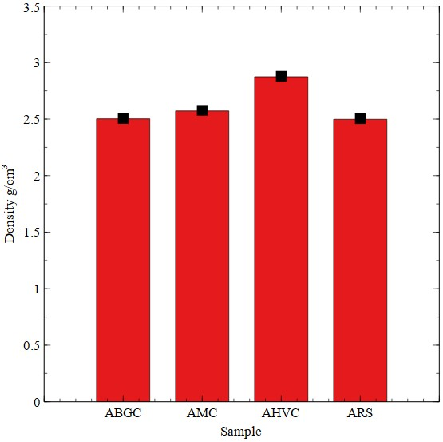
Fig. 2. Mass of the aluminium bars Fig. 3. Density of the aluminium bars
3.2 Mechanical Properties of the Aluminium Bars
3.2.1 Microstructural (Optical) Analysis
Figure 4 indicates that there are distinct microstructural differences between the aluminium samples using SEM micrographs. The AGBC and AMC samples have observable pores and dendritic forms of solidification, meaning that gas entrapment and solidification defects are evident in recycled cast aluminium alloys. Conversely, the samples of the AHVC and ARS have less dendritic and smoother and more uniform microstructures.

These differences are in line with compositional effects on microstructural development in the alloys of aluminium. Regular cast alloys of the type A380 (characteristic of gearbox casings) include large amounts of Si and Fe additives, which encourage the development of Fe-rich intermetallics, including β-Al5FeSi and α-Al15(Fe-Mn)3Si2. The β-Al₅FeSi phase is plate-like and brittle, acting as a crack initiator and detrimental to ductility. The α-Al₁₅(Fe-Mn)₃Si₂ phase is more compact and polygonal or Chinese-script in appearance, less detrimental but still affects mechanical properties. Song et al. (2022) state that as the Fe content of the Al-7Si-Fe-Mn alloys increases, the morphological transition between coarse Chinese-script and polygonal structure becomes plate-like and mixed intermetallic structure, which can serve as crack initiators and decrease ductility. The porosity and the dendritic structures in the AGBC and AMC samples are thus explained by the segregation of these intermetallics at the time of solidification
.
In contrast, the AHVC and ARS samples have less coarse-grained structures and more homogeneous structures, which indicates a reduced percentage of coarse intermetallic or enhanced solidification control. The advantageous microstructure of the ARS sample of AA1050 aluminium is probably due to its high purity (>99.5% Al) that yields reduced intermetallic and compact microstructure. These microstructural characteristics are associated with the enhanced mechanical integrity of the AHVC and ARS samples in contrast to the more porous and alloyed AGBC and AMC samples.
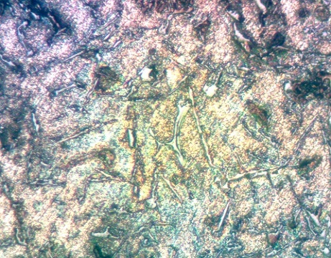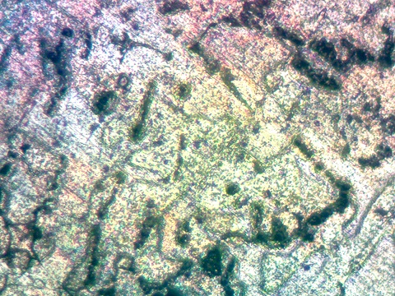
(a) (b)
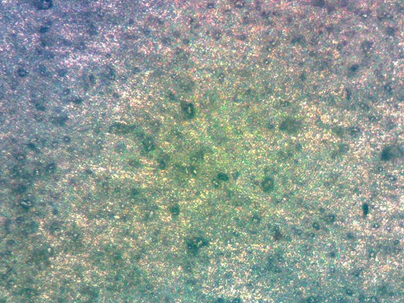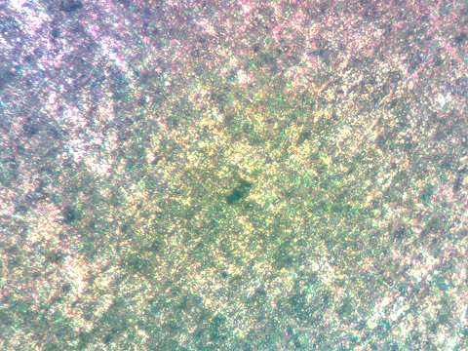
(c) (d)
Fig. 4. Microstructure (a) AGBC samples (b) AMC samples (c) AHVC samples
(d) ARS Samples

Although this SEM assessment gave information of great qualitative nature about the solidification behaviour of the recycled aluminium samples, it was more than a description. A more accurate correlation can surely be made between microstructure and mechanical properties with a quantitative microstructural analysis (e.g., grain size distribution, percentage of porosity, phase fraction determination via image processing (e.g., ImageJ)) as opposed to a qualitative one. Inclusion of these metrics in research in the future will give a more rigorous insight into the effect of alloy composition and casting parameters on microstructural refinement and performance.

3.2.2 Impact Strength
The obtained values of impact energy (mean +/- SD, n = 3) are listed in Figure 5: AHVC - 65.01 +/- 0.52 J (maximum), ARS - 35.36 +/- 0.68 J, AMC - 27.20 +/- 0.57 J and AGBC - 20.40 +/- 0.61 J (minimum).
These differences are associated with the difference in alloy composition, porosity, and the structure of intermetallic phases. Samples that have lower brittle Fe- and Si-rich intermetallics and less density of defects will absorb extra energy prior to breaking. The intermetallics present in the recycled aluminium alloys, like β-Al₅FeSi, are centres of cracks, which decrease the impact toughness. Song et al. (2022) found that the higher the Fe content in the Al-7Si-2Fe, the higher the amount of coarse β-Al₅FeSi platelets formed, which inhibits plastic deformation and reduces impact resistance.
The low impact energy of the AGBC sample is consistent with its common A380-type composition, which includes large amounts of Si (7.5-9.5%) and Cu (3.0-4.0%) additions, which make the material stronger but contribute to the formation of brittle intermetallics. On the other hand, AHVC sample high-impact toughness implies cleaner composition, lower embrittling phases and high-quality solidification, which could be due to enhanced heat dissipation during the casting process.
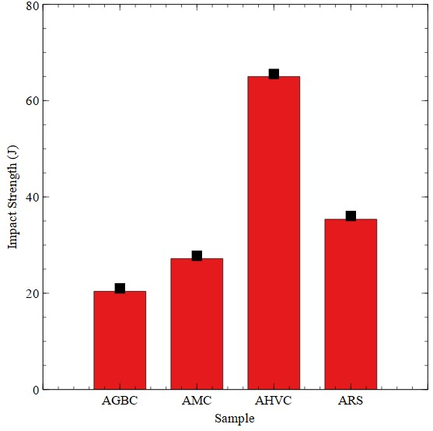
Fig. 5. Impact strength of the aluminium bars
The intermediate impact value of ARS (AA1050 based) is characteristic for high-purity aluminium with limited alloying, which generally provides good ductility but lower strength compared to heat-treated or intentionally alloyed materials. In summary, the present results evidence that the chemical composition and casting microstructure are the major determinants for the energy absorption capability of recycled aluminium alloys.
3.2.3 Hardness
Figure 6 shows the results of Brinell hardness (mean +/- SD, n = 3) in order AGBC - 382.39 +/- 3.12 BHN (highest), AMC - 238.93 +/- 2.45 BHN, ARS - 159.49 +/- 1.78 BHN and AHVC - 137.79 +/- 2.11 BHN (lowest).

The AGBC sample is hard due to the effect of A380-type composition, which consists of large quantities of silicon (7.5-9.5%) and copper (3.0-4.0%) (OEForm, 2024). These alloying components create hard intermetallics with Si-Fe-Mg, like Al₅FeSi and Mg₂Si, which facilitate solid-solution and precipitation strengthening. This is the reason why these alloys showed a greater indentation resistance, as well as ductility.

AMC is intermediately hardened, which is due to its Al-Mn-Mg alloy (AA3004/3104 type), with manganese and magnesium playing a moderate strengthening role through dispersoid and solid-solution hardening. The ARS (AA1050-based) sample was relatively soft with a high level of aluminium purity (>99.5%) and the absence of significant strengthening elements (Hwalu, 2025; AZOM, 2025). Also, AHVC, which is mainly made of AI-Mg-Si alloy (AAAC-type), showed the lowest hardness, which may be because of the reduced levels of Si and Fe and porosity in the microstructure, which is the result of the casting operation.

This general tendency is consistent with the results of Shi et al. (2025) that indicated that the recycled Al-7Si-0.3Mg-1Fe alloys with an increased Si-Mg content are more prone to hardness but experience low impact strength as a consequence of the appearance of brittle intermetallic phases. These findings therefore indicate a high negative correlation between hardness and impact energy, which are controlled by alloy composition and solidification behaviour.

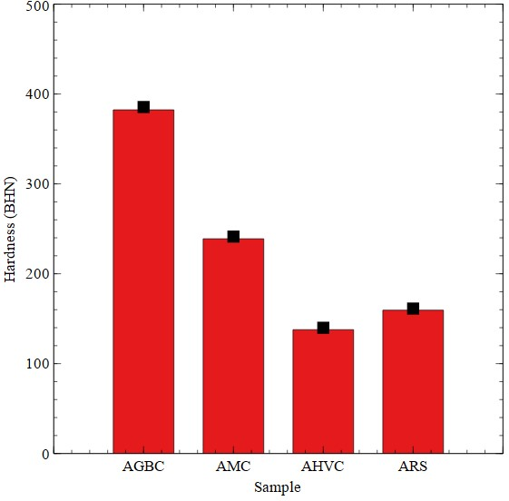
Fig. 6. Brinell hardness of the aluminium bars
3.3 Comparative Discussion and Implications
Comparative analysis of the aluminium bars leads to the identification of specific trends of performance that are strongly related with the alloy series, the chemical composition and the microstructural features.

The combination of density (2.875 +/- 0.004 g/cm³) and impact strength (65.01 +/- 0.52 J) was the best in the sample of high-voltage cable (AHVC), which could be applied in the context of structures and non-wear components because of its toughness and energy absorption. AHVC is associated with the AAAC-type Al-Mg-Si alloy, which has 0.6-0.9 wt.% Mg and 0.5-0.9 wt.% Si, which makes the alloy stronger without over-brittleness. Its low hardness (137.79 +/- 2.11 BHN) and ductile microstructure are in line with the results that aluminium alloys with fewer Fe-rich intermetallics in them have higher impact energy absorption rates as a result of refined α-Al microstructures (Song et al., 2022).

Conversely, the sample (gearbox casing, AGBC) that was related to A380-type aluminium alloy exhibited the greatest hardness (382.39 +/- 3.12 BHN) because it contained large quantities of Si (7.5-9.5%) and Cu (3.0-4.0%). These factors facilitate the development of hard Al-Si and Al-Fe-Si intermetallics, which offer solid-solution and precipitation hardening but low ductility. As a result, the low impact toughness (20.40 +/- 0.61 J) of AGBC highlights the general trade-off between hardness and toughness in Al-Si-Cu-Mg systems (OEForm, 2024; Song et al., 2022). This renders AGBC well in cleaning up wear-resistant parts like automotive gear housings or load-bearing parts where high surface strength is of more consideration than impact resistance.

The roofing sheet (ARS) was made of commercially pure aluminium (>99.5% Al), with only slight strengthening agents, which was low-density (2.498 +/- 0.006 g/cm³) and moderately hard (159.49 +/- 1.78 BHN) when made of AA1050 aluminium. This is the reason why it is lightweight and ductile in nature and thus applicable in applications requiring lightweight, corrosion-free and formable products like roofing and cladding.

On the same note, the beverage can (AMC), made of AA3004/3104 Al-Mn-Mg alloy, exhibited intermediary hardness (238.93 +/- 2.45 BHN) and impact energy (27.20 +/- 0.57 J) because of the presence of Mn (1.22 wt.%) and Mg (1.14 wt.%), which enhances both dispersoid and solid-solution hardening (Akindapo et al., 2021). Its moderate strength combined with balance renders it applicable in packaging or moderate strength.

Observation of colour and density also shows that the post-casting machining enhanced uniformity of the surface, giving bright silvery bars. But internal porosity and intermetallic inclusions were also important factors that affected the mechanical performance. This shows the importance of controlled melting, degassing, and solidification operations to increase both the mechanical integrity and surface finish of recycled aluminium (Mathew et al., 2024; Royal Society of Chemistry, 2024).

In general, the comparative analysis has shown that alloy composition and solidification features are the main determinants of the mechanical response of recycled aluminium. In this way, recycling effectiveness and material behaviour can be maximised by choice of scrap source based on alloy system: AHVC (high-toughness) parts, AGBC (wear-resistant parts), ARS (lightweight structures) and AMC (general-purpose).

4. Conclusion

This paper has shown that there are significant differences in melting point, density, microstructure, impact strength and hardness in aluminium scrap materials, which highlighted that application-specific recycling can be possible.

The lowest complete melting point of 810°C was observed in the long-span tower roofing sheets (AA1050), which are highly purified in terms of the content of aluminium, hence suitable in energy-saving recycling where mid-range mechanical strength is sufficient. On the other hand, higher melting points of 997°C and 926°C were registered with Ford gearbox casings (Al-Si-Mg-based alloys) and high-voltage cables (Al-Fe-based alloys), respectively, which are in line with those of alloys that have been engineered to face automotive service and electrical conduction, respectively. The mentioned observation is consistent with Mathew et al. (2024), who associated greater alloying element concentrations with greater thermal stability and service temperature.
Mechanically, AHVC presented the highest impact strength (65.01 +/- 0.52 J) and would be the first choice for toughness-sensitive applications, such as electrical connectors or structural fasteners. On the other hand, AGBC had the highest hardness (382.39 +/- 3.12 BHN) and the lowest impact strength (20.40 +/- 0.61 J) and had a hard-but-brittle profile. This is the common trait of Al–Si–Mg alloys strengthened mainly by intermetallic phases (Shi et al., 2025). Roofing sheets and Maltina can also offer an intermediate compromise between strength and ductility and can be used to produce lightweight, formable components.

The main limitation of this study was the lack of compositional analysis (X-ray fluorescence or optical emission spectroscopy) of the scrap and cast aluminium. This precluded a direct correlation of alloying elements with microstructural or mechanical properties. Another potential limitation is scrap variation and contamination during scrap collection.
Future work should therefore focus on:
- Conducting comprehensive compositional and phase analyses to quantify the influence of alloying elements on performance;
- Employing alloy-specific refining and grain modification techniques to minimise porosity and brittle intermetallic;
- Integrating additive alloying or thermal treatments to improve recycled metal quality and mechanical properties;
- Developing composition-based sorting systems to optimise scrap recovery for targeted applications; and
- Extending experimental investigations to include fatigue, corrosion, and thermal stability testing for broader performance evaluation.
COMPETING INTERESTS DISCLAIMER:
Authors have declared that they have no known competing financial interests OR non-financial interests OR personal relationships that could have appeared to influence the work reported in this paper.
Disclaimer (Artificial intelligence)

Authors hereby declare that NO generative AI technologies such as Large Language Models (ChatGPT, COPILOT, etc.) and text-to-image generators have been used during the writing or editing of this manuscript.

References

Akindapo, J. O., Dayak, M. J., & Orueri, D. U. (2024). Development of aluminium roofing sheets from waste beverage cans. Academy Journal of Science and Engineering (AJSE). 18(2).
Alaekwe, I. O. (2019). Aluminium recycling, energy conservation and environmental concerns: A review. International Journal of Research and Scientific Innovation (IJRSI), 6(5), 1–7. ISSN 2321–2705.
Altharan, Y. M., Shamsudin, S., Al-Alimi, S., Saif, Y., & Zhou, W. (2024). A review on solid-state recycling of aluminium machining chips and their morphology effect on recycled part quality. Heliyon. 10(14), e34433. https://doi.org/10.1016/j.heliyon.2024.e34433
Aluminium Journal Editorial Team. (2024). Recycling. International Aluminium Journal. https://www.aluminium-journal.com/topic/recycling
AZOM. (2025). Aluminium alloys: Aluminium 1050 properties, fabrication and applications. AZO Materials. https://www.azom.com/article.aspx?ArticleID=2798
Barabasz, W., Albińska, D., Jaśkowska, M., & Lipiec, J. (2002). Ecotoxicology of aluminium. Polish Journal of Environmental Studies, 11(3), 199–203.
Billy, R. (2012). Material flow analysis of extruded aluminium in French buildings: Opportunities and challenges for the implementation of a window-to-window system in France [Master’s thesis, Norwegian University of Science and Technology].
Carta, M., Ben Khalifa, N., Buonadonna, P., Aymerich, F., & El Mehtedi, M. (2025). Solid-State Recycling of AA6063 Aluminium Chips via Accumulative Roll Bonding: A Green Pathway to High-Performance Materials. Metals, 15(9), 1042. https://doi.org/10.3390/met15091042
Chen, X., Ben Saada, M., Lavisse, B., & Ammar, A. (2025). Recent advances in the re-melting process for recycling aluminium alloy chips: A critical review. International Journal of Material Forming. https://doi.org/10.1007/s12289-025-01904-9
Mwanza, B. G. (2021). Introduction to recycling. In J. Parameswara Pillai, et al. (Eds.), Recent developments in plastic recycling (pp. 1–24). Springer Nature Singapore. https://doi.org/10.1007/978-981-16-3627-1_1
European Aluminium Association. (2007). Aluminium recycling in Europe: The road to high quality products (p. 15).
Henan Chalco. (2022). AAAC: A new choice for overhead transmission lines. https://www.chalcoaluminum.com/application/aluminum-electrical/overhead-line-conductors/
Hwalu. (2025). Top quality hot rolled 1050 aluminium roofing sheet for building materials. https://www.aluroofingsheet.com/top-quality-hot-rolled-1050-aluminum-roofing-sheet-for-building-materials/
International Aluminium Institute. (2018). The aluminium story. http://www.thealuminiumstory.com
Jiang, L., Marceau, R. K. W., & Dorin, T. (2024). Improved iron-tolerance in recycled aluminium alloys via direct strip casting process. Journal of Sustainable Metallurgy, 10(1986). https://doi.org/10.1007/s40831-024-00844-z
Keith, S., Jones, D., Rosemond, Z., Ingerman, L., & Chappell, L. (2008). Potential for human exposure. In Toxicological profile for aluminium (pp. 175–227).
Kuchariková, L., Tillová, E., & Bokůvka, O. (2016). Recycling and properties of recycled aluminium alloys used in the transportation industry. Transport Problems, 11(2), 117–124. https://doi.org/10.20858/tp.2016.11.2.11
Liaw, L. L., & Yusuf, N. K. (2022). A review on aluminium alloy recycling technique. Research Progress in Mechanical and Manufacturing Engineering, 3(1), 175–183.
Magaldi Group. (2020). Secondary aluminium smelting. Magaldi Group. https://www.magaldi.com/en/expertise/secondary-aluminum-smelting
Master Recycler Program. (2020). Recycling processes (Chapter 4, p. 88).
Mathew, J., Williams, M. A., & Srirangam, P. (2024). Effect of superheat on microstructure and mechanical properties of Al-7Si-2Fe alloy. JOM. https://doi.org/10.1007/s11837-023-06226-2
Ma, Y., Zhou, X., Wang, J., Thompson, G. E., Huang, W., Nilsson, J.-O., Gustavsson, M., & Crispin, A. (2014). Discoloration of anodized AA6063 aluminium alloy. Journal of The Electrochemical Society, 161(6), C312–C320. https://doi.org/10.1149/2.065406jes
Muñoz-Vélez, M. F., Salazar-Serna, K., Escobar-Torres, D., Rojas-Manzano, M. A., Gómez-Gómez, A., & Maury-Ramírez, A. (2023). Circular Economy: Adding Value to the Post-Industrial Waste through the Transformation of Aluminium Dross for Cement Matrix Applications. Sustainability, 15(18), 13952. https://doi.org/10.3390/su151813952
OEForm. (2024). A380 aluminium alloy: Properties, applications & processing guide. https://oeform.com/die-cast-aluminium-alloy-a380-properties/
Royal Society of Chemistry. (2024). Aluminium: Properties and applications. RSC Publishing.
Schlesinger, M. E. (2013). Aluminium recycling (2nd ed.). Taylor & Francis.
Shengxin Aluminium. (2023). Density of aluminium and aluminium alloys: Typical ranges and influencing factors. https://www.shengxinaluminium.com
Shi, W., Chen, L., He, B., Lu, B., & Yang, J. (2025). Effect of Al-5Ti-2B on the microstructure and mechanical properties of recycled Al-7Si-0.3Mg-1Fe alloy. Crystals, 15(7), 584. https://doi.org/10.3390/cryst15070584
Škůrková, K. L., & Ingaldi, M. (2014). Recycling process of aluminium cans as an example of renewable material sources. Advanced Materials Research, 1001, 103–108.
Song, D., Jia, Y., Li, Q., Zhao, Y., & Zhang, W. (2022). Effect of initial Fe content on microstructure and mechanical properties of recycled Al-7.0Si-Fe-Mn alloys with constant Mn/Fe ratio. Materials, 15(4), 1618. https://doi.org/10.3390/ma15041618
Svensson, J. P. (2014). The importance of recycling. Abstract presented at the Symposium on Recycling of Metals, Studsvik, April 8–10, 2014.
Rakiman, U. S., Rasi, R. Z. R. M., & Latiffi, A. A. (2014). Value chain analysis: The insight of aluminium recycling. Australian Journal of Basic and Applied Sciences, 8(15), 377–382.
Wieman, B. (2013). What are the benefits of recycling aluminium? SFGate. http://homeguides.sfgate.com/benefits-recycling-aluminium-79200.html
ZMC. (2010). Overhead line conductor. Cable Trans More. https://kvcable.com/products/overhead-lines/

