Multi-objective optimization of TA1 sheet incremental forming based on ABAQUS finite element simulation and NSGA-II

.
ABSTRACT

Based on the Box-Behnken experimental design method and NSGA-II multi-objective optimization algorithm, combined with ABAQUS finite element simulation, this study optimizes and analyzes the four key parameters of the initial thickness, pitch, tool head diameter and bottom side length of the TA1 sheet single point incremental forming process. Firstly, the incremental forming model of truncated cone under ABAQUS environment is established, and the reliability of the model is verified by the experimental results of wall thickness. Taking the average wall thickness reduction rate (φ) and size error (ε) as the evaluation indexes of forming quality, the forming quality is significantly improved by optimization analysis. The results show that the optimized φ and ε are reduced by 8.22 % and 14.09 % respectively, which effectively improves the wall thickness uniformity and dimensional accuracy of the parts. In addition, the Pareto front solution set obtained in this study can provide a scientific basis for the engineering selection of TA1 sheet incremental forming process parameters.

Keywords: ABAQUS; NSGA-II; TA1; Incremental forming

1. INTRODUCTION
Incremental Sheet Forming (ISF), as a highly flexible sheet plastic forming technology, has attracted much attention in the field of lightweight complex parts manufacturing since the concept was proposed[1]. The technology realizes the dieless forming of three-dimensional parts by the point-by-point local deformation accumulation of the forming tool along the preset trajectory. Taking the forming process of a typical truncated cone as an example, after the tool head completes the first ring contour processing, it moves down layer by layer along the axial direction and repeats the processing cycle. After multiple rounds of forming, the target geometric structure is finally formed[2]. Compared with the traditional stamping process, ISF does not need a special die, and can be directly driven by the computer aided design model to complete the rapid manufacturing of small batch and customized parts, which has significant advantages in saving die cost and shortening the development cycle. More importantly, its flexible forming method can greatly improve the forming limit of the sheet, which opens up a new path for the manufacture of high-difficulty components[3]. In order to further optimize the forming efficiency of ISF, the industry has explored a variety of innovative technical directions such as Multi-step Incremental Sheet Forming (Multi-step ISF)[4], Electromagnetic Incremental Sheet Forming (EISF)[5] and Heat-assisted Incremental Sheet Forming(HAISF)[6]. These studies continue to expand the boundary of ISF process optimization and industrial application, and also lay a technical background for the parameter optimization of specific parts in this study.
In addition to the innovation of the SPIF process itself, many scholars have also devoted themselves to the optimization of processing parameters. Su et al[7]. proposed a forming limit evaluation method based on forming limit angle and maximum thinning rate. The influence of process parameters on the forming performance of aluminum sheet was revealed by experiments and numerical simulation, and the optimal process window was determined. Lu et al[8]. studied the influence of process parameters on thickness uniformity in two-point incremental forming of irregular stepped parts of AA1060 aluminum alloy. Combined with orthogonal test and numerical simulation, the optimal parameter combination was determined : tool diameter 12 mm, feed speed 1500 mm / min, step distance 0.4 mm. Li et al[9]. systematically analyzed the effects of step size, plate thickness and die diameter on wall thickness distribution and mechanical properties by response surface method. It was found that increasing the step size and die diameter could reduce the maximum thinning rate, while the strain hardening effect significantly improved the hardness, yield strength and tensile strength. In addition, Mariem[10], Nikhil[11] and other scholars have also carried out corresponding process optimization research from the key forming indicators such as surface roughness and average thinning rate.
With the rapid development of machine learning technology, its application in parameter optimization is becoming more and more extensive, and genetic algorithm as a typical representative has received extensive attention[12-14]. The algorithm simulates the natural evolution mechanism and achieves global optimization through selection, crossover and mutation operations[15]. In the parameter optimization problem, genetic algorithm does not depend on gradient information, and can effectively deal with multi-objective, nonlinear and high-dimensional complex problems, and has good local optimal avoidance ability, so it shows high efficiency and strong robustness in complex system optimization. Bahloul et al[16]. used a self-developed genetic algorithm to perform multi-objective optimization with the goal of minimizing plate thinning rate and punch load. The effectiveness and generalization ability of the algorithm in high-order nonlinear problems were verified by test functions with known extreme values. Xiao et al[17]. used the response surface model as the fitness function, combined with the genetic algorithm to solve the Pareto optimal solution set that maximizes the forming angle and minimizes the thickness reduction, which provides practical guidance for the optimization of ISF process parameters.
However, the current research mostly focuses on aluminum alloy[18] and magnesium alloy[19], and the research on titanium alloy with excellent biocompatibility in incremental forming is still relatively limited. The combination of titanium alloy and incremental forming technology is expected to achieve efficient manufacturing of personalized artificial implants, showing a broad clinical application prospect[20-22].
Therefore, in this study, ABAQUS finite element model and non-dominated sorting genetic algorithm (NSGA-II) are combined to carry out multi-objective optimization research on the average thinning rate and size deviation of truncated square cone single point incremental forming parts for the four process parameters of initial thickness, pitch, tool head diameter and bottom side length of TA1 plate. This work provides a theoretical basis and decision support for the optimization of single point incremental forming process of TA1 sheet.

2. Materials and methods

2.1 Materials
The material used in this study was 1mm TA1 plate. In order to obtain the mechanical properties of the material and establish an accurate numerical simulation model, this study designed a standard uniaxial tensile test (as shown in Figure 1). Due to the strong anisotropy of TA1 alloy, standard tensile parts were made along the rolling direction of 0°, 45° and 90° in this study[23]. The size of standard tensile parts was based on GB/T228.1-2010.
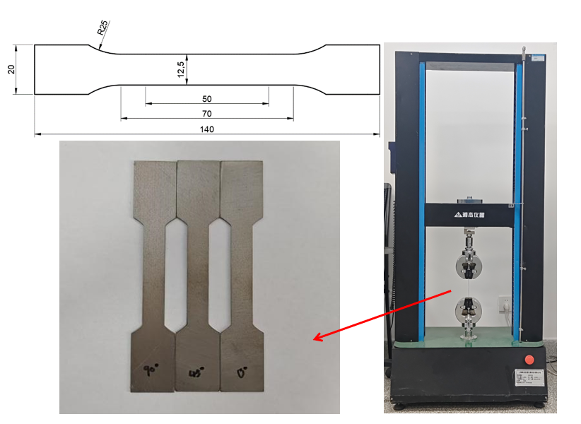
Figure 1. Schematic diagram of standard tensile test

At room temperature, the standard tensile test was carried out at a tensile rate of 1mm / min by using an electronic universal tensile testing machine, and the engineering stress-strain curve of TA1 was obtained[24]. However, the engineering stress-strain curve is calculated based on the initial size. Therefore, it is necessary to convert the engineering stress-strain curve into a real stress-strain curve, and then through data processing, the mechanical properties of TA1 titanium alloy can be obtained (as shown in Table 1).

Table 1. Material parameters of TA1.
Material Name | Modulus of Elasticity  E/GPa | Poisson’s Ratio  v | Yield Strength  δ _{b}/MPa | Tensile Strength  δ _{s}/MPa | Density  g/mm³
TA1 | 107 | 0.33 | 178 | 452 | 4.5

Hill48 is a plastic anisotropic yield criterion proposed by R. Hill in 1948[25]. It quantifies the yield difference of materials in different directions by introducing six anisotropic parameters, which is more in line with the actual mechanical behavior of materials. Therefore, Hill48 yield criterion was used to characterize the anisotropic yield behavior of TA1 titanium alloy in this study. The specific equations are as follows:
(1)
In the formula, F, G, H, L, M and N are constants that determine the tensile yield stress and shear yield stress of the material in three directions. These constants can be obtained by Equation (2):
(2)
In formula (2), R_{ij} denotes the ratio of anisotropic yield stresses. The conversion relationship between R_{ij} and the thickness anisotropy index r is shown in Formula (3):
(3)
In Eq. (3), r0, r45 and r90 are the thickness anisotropy indexes of anisotropic material TA1 along the rolling direction of 0°, 45° and 90°. The r0, r45 and r90 measured by standard tensile test were 0.796, 2.661 and 0.669, respectively.
2.2 Numerical simulation model
In this study, the finite element model of single point incremental forming of TA1 sheet was established by using ABAQUS explicit solver. The solver has significant advantages in dealing with such highly nonlinear contact problems. Firstly, it can effectively deal with the complex contact interaction between the tool and the plate without iteration and has good convergence. Secondly, the explicit algorithm is suitable for simulating the ' step-by-step incremental ' dynamic process such as incremental forming, which can accurately capture the real-time changes of the plastic flow history and contact state of the material. In addition, compared with the implicit method, it is not easy to be interrupted due to convergence difficulties when dealing with large deformation problems, thus ensuring the stability of the calculation process and the accuracy of the simulation results.
According to the actual working conditions of TA1 sheet incremental forming, the ball-end tool is set as an analytical rigid body with a diameter of 10 mm. The TA1 plate was modeled as a deformable body with a size of 160 mm × 160 mm. Since the thickness of the plate is much smaller than its plane size, the S4R element (four-node reduced integral shell element) is used to discretize it, and five integral points are set in the thickness direction. This element type can ensure the simulation accuracy while taking into account the computational efficiency. In terms of mesh generation, a fine mesh of 1 mm is used in the central deformation area, and a coarse mesh of 1.5 mm is used in the surrounding area to adapt to the deformation characteristics of different areas and optimize the use of computing resources (as shown in Fig.2a).
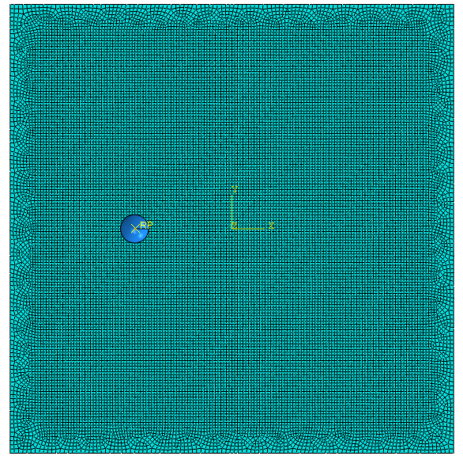 | 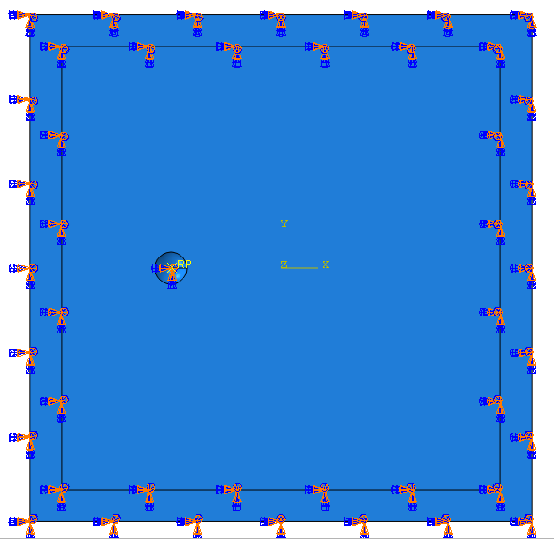
(a) | (b)
Figure 2. ABAQUS finite element model. (a) Mesh generation;(b) Boundary condition definition

The definition of contact conditions and boundary conditions will directly affect the computational efficiency and accuracy of the model. In this study, the contact between the tool and the deformed plate is defined as the surface-to-surface contact based on the penalty function, and the friction coefficient is set to 0.1. According to the fixed conditions of sheet metal processing, the boundary conditions around the sheet metal are set to be completely fixed (as shown in Figure 2b).
In ABAQUS, it is difficult to directly read the NC machining code to define the running track of the tool, and it is necessary to convert the code into the relationship between spatial coordinates and time. Therefore, this paper uses UG NX to generate a truncated cone tool path (as shown in Figure 3). The forming depth is 10 mm, the forming angle is 34 °, the original thickness of the sheet is 1 mm, the layer feed is 0.5 mm, the tool diameter is 10 mm, and the bottom side length is 48 mm. Then it is converted into the relationship between X, Y and Z coordinates with time by MATLAB.
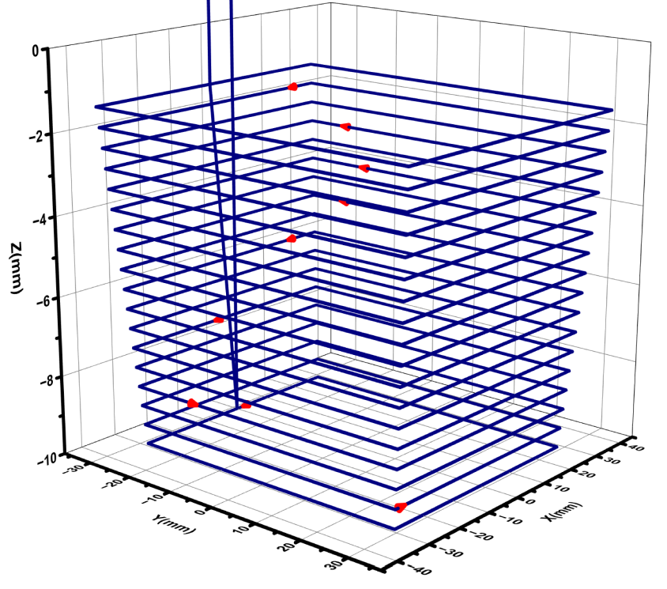
Figure 3. SPIF path schematic for truncated square pyramid.
The incremental forming experiment of TA1 titanium plate was carried out on the JJCX300 three-axis CNC incremental forming testing machine. In the experiment, MoS2 powder was used as a lubricant to effectively inhibit the adhesion between the TA1 plate and the tool head. The final formed part and its corresponding ABAQUS numerical model are shown in Figure 4. By extracting the wall thickness data of the experimental part along the path (as shown in Figure 5) and comparing it with the finite element simulation results, it is found that the deviation between the two is controlled within 5 %, which verifies the reliability and accuracy of the established ABAQUS finite element model[26].
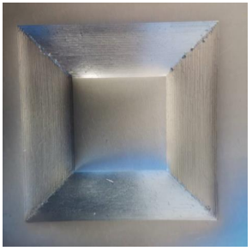 | 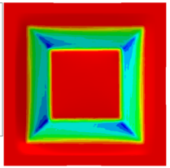
(a) | (b)
Figure 4. Cut square cone forming part schematic diagram. (a) The experiment diagram; (b) Simulation diagram.
2.3 Data acquisition
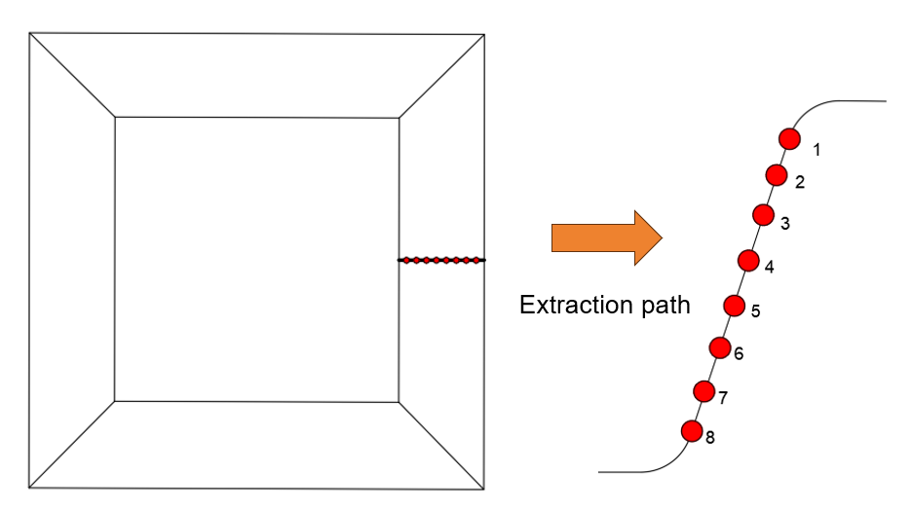
Figure 5. Extraction path schematic diagram.
In this paper, the average wall thickness thinning rate (ϕ) and size error (ε) are used to characterize the performance of single point incremental forming of TAI sheet truncated cone. For the truncated cone forming part, the wall thickness values of 8 points are extracted along the side wall of the truncated cone forming part (as shown in figure 5), and the average wall thickness reduction rate can be calculated by formula (4).
(4)
where, t0 is the initial sheet thickness of the side wall, and t is the sheet thickness after deformation.
For the size error, the Z coordinates of the 8 points are extracted equidistantly along the path shown in Figure 5, and the value is calculated by Formula (5).
(5)
where h₀ is the theoretical depth of the sidewall and h₁ is the actual depth of the sidewall.

3.Multiobjective optimization

3.1 Experimental design
BBD (Box-Behnken Design) is a classical response surface method. Its core purpose is to efficiently find the best process conditions among a number of influencing factors, and accurately characterize the nonlinear relationship between factors and responses. Due to its ingenious structure, BBD usually requires fewer experiments than some factorial designs, especially when the number of factors increases, showing high efficiency. Therefore, in this study, the original thickness of the plate t₀, pitch P, tool diameter D, and bottom side length L were used as independent variables, and as dependent variables. The design experiment is shown in Table 2:

Table 2. Factor Level Table for Experimental Design.
Parameter | Notable | Unit | Levels
Parameter | Notable | Unit | -1 | 0 | 1
Initial Sheet Thickness | t₀ | mm | 1.0 | 1.2 | 1.4
Pitch | P | mm | 1.80 | 2.25 | 2.70
Tool diameter | D | mm | 7.5 | 10 | 12.5
Base side length | L | mm | 43 | 53 | 63
Based on this scheme, the numerical simulation experiments of 29 sets of parameters are carried out, and the results are shown in Table 3.
Table 3. Numerical Simulation Experimental Parameters and Their Results.
N | t₀（mm） | P（mm） | D（mm） | L（mm） | ϕ（%） | ε（mm）
1 | 1.2 | 2.25 | 10 | 53 | 10.0219 | 1.35071
2 | 1.2 | 2.25 | 10 | 53 | 10.0219 | 1.35071
3 | 1.2 | 2.25 | 10 | 53 | 10.0219 | 1.35071
4 | 1.2 | 1.8 | 12.5 | 53 | 10.39 | 2.24951
5 | 1 | 2.25 | 10 | 63 | 10.92 | 1.90676
6 | 1 | 1.8 | 10 | 53 | 10.27 | 2.08968
7 | 1.4 | 2.25 | 10 | 63 | 10.52 | 2.12192
8 | 1.4 | 1.8 | 10 | 53 | 10.41 | 2.20321
9 | 1.2 | 2.7 | 10 | 43 | 9.5 | 1.86142
10 | 1.4 | 2.25 | 7.5 | 53 | 9.73 | 2.08529
11 | 1 | 2.25 | 7.5 | 53 | 10.02 | 1.86407
12 | 1.4 | 2.7 | 10 | 53 | 9.64 | 2.20782
13 | 1.2 | 2.25 | 7.5 | 63 | 10.44 | 2.01393
14 | 1 | 2.25 | 12.5 | 53 | 10.4 | 2.10793
15 | 1.2 | 2.25 | 10 | 53 | 10.0219 | 1.35071
16 | 1 | 2.7 | 10 | 53 | 10.08 | 1.9438
17 | 1.4 | 2.25 | 10 | 43 | 9.63 | 1.98249
18 | 1.4 | 2.25 | 12.5 | 53 | 10.24 | 2.32043
19 | 1.2 | 2.7 | 10 | 63 | 10.22 | 2.10729
20 | 1 | 2.25 | 10 | 43 | 10.07 | 1.8919
21 | 1.2 | 2.25 | 7.5 | 43 | 9.44 | 1.71256
22 | 1.2 | 2.7 | 7.5 | 53 | 9.43 | 2.01323
23 | 1.2 | 2.25 | 10 | 53 | 10.0219 | 1.35071
24 | 1.2 | 1.8 | 10 | 63 | 10.95 | 2.12193
25 | 1.2 | 1.8 | 10 | 43 | 10.03 | 1.84575
26 | 1.2 | 2.25 | 12.5 | 63 | 10.95 | 2.20436
27 | 1.2 | 2.25 | 12.5 | 43 | 10.04 | 2.02645
28 | 1.2 | 2.7 | 12.5 | 53 | 9.86 | 2.19721
29 | 1.2 | 1.8 | 7.5 | 53 | 9.96 | 2.03683

3.2 Neural network training
BPNN, also known as Back Propagation Neural Network, is a multi-layer feedforward neural network and one of the most classical and widely used neural network models. Its core idea includes two processes: forward propagation and reverse propagation. By continuously repeating these two processes, the network can gradually ' learn ' and reduce errors, and finally achieve accurate mapping of complex nonlinear relationships. The powerful nonlinear fitting ability of BPNN can capture and model the extremely complex and high-order interaction between parameters and targets, which is difficult to achieve by many traditional optimization methods (such as response surface method).Therefore, in this study, based on the MATLAB software, the processing parameters t₀, P, D, and L were used as input quantities, ϕand εwere used as output quantities to train a BPNN neural network model, in order to map the relationship between processing parameters and forming performance. The specific structure is shown in Figure 6:
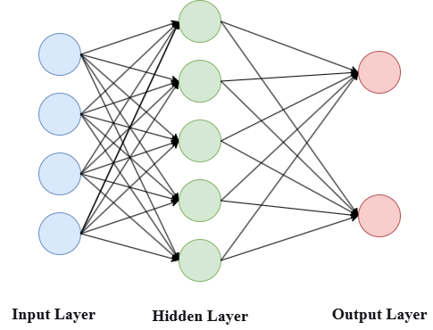
Figure 6. Schematic diagram of BPNN structure

When training the neural network, the input of the kth neuron in the hidden layer is calculated by the weighted sum from the input layer, as shown in Formula (6). The weighted sum is used as the input of the activation function.
(6)
Here, k is the index of the hidden layer neuron, and j is the index of the output variable. b (or b_{k}) is the bias vector, and w_{kj} is the weight of the j variable in the input layer to the k neuron in the hidden layer, reflecting the connection strength between the two; x_{j} is the j variable of the input layer; w^{T}x is the dot product of the weight vector and the input vector.
The neural network introduces nonlinearity through the activation function, so that the network can learn complex relationships. As shown in Formula (7) and Formula (8):
(7)
(8)
The Sigmoid function is to map the input net_{k} to the (-1,1) interval and introduce nonlinearity to the hidden layer output. The Identity function converts the hidden layer output into a predicted value.
In order to quantify the difference between the predicted value and the actual value, the mean square error (MSE) of the loss function is introduced:
(9)
here,ϕ_{actual} is the actual value and ϕ_{predicted} is the predicted value.
The training of BPNN adopts Levenberg-Marquardt algorithm, which combines the advantages of ' gradient descent ' and ' Gauss-Newton method ', and is suitable for nonlinear least squares problems. The algorithm mainly includes the weight update formula (Formula 10), and the Jacobian matrix (11):
(10)
where w_{i} is the weight of the i iteration, J is the Jacobian matrix; μ_{i} damping factor to balance the convergence speed and stability of the algorithm; n is the residual vector, diag(JTJ) is the diagonal matrix extracted from the Hessian matrix for approximating the curvature information.
(11)
where r is the residual and Δw is the small variation of the weight.
The data in Table 2 are input into the neural network for training. After many times of training, it is found that the training effect is the best when the number of hidden neurons is 5. The regression analysis with the predicted value and the actual value is shown in Figure 7. From the diagram, it can be found that the R² (regression coefficient of determination) between the predicted value and the actual value is 0.96415 and 0.96401 (both greater than 95 %), which means that the trained model can explain 96.415 % (or 96.401 %) of the variation of the measured size deviation (i.e. data fluctuation), and the remaining about 3.585 % (or 3.599 %) of the variation is explained by factors not considered in the model or random errors. Therefore, it can be considered that the trained BPNN model is reliable. The specific data of the predicted value and the actual value are shown in Table 4.
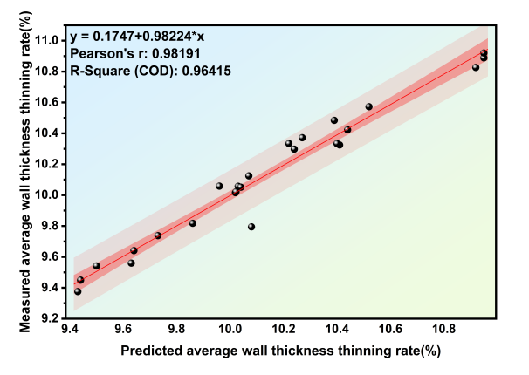 | 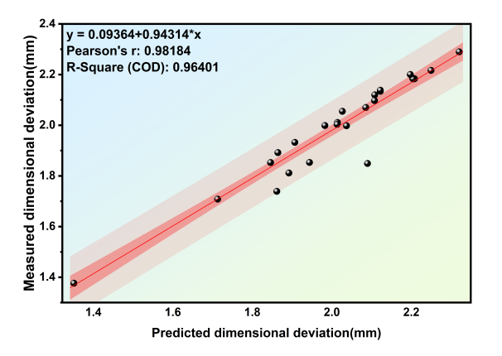
(a) | (b)
Figure 7. Regression analysis plot of predicted and actual values. (a) Average wall thickness thinning rate; (b) Dimensional deviation.

Table 4. Results of BPNN
N | ϕ_{actual} | ϕ_{predicted} | ε_{actual} | ε_{predicted}
1 | 10.022 | 10.021 | 1.351 | 1.376
2 | 10.022 | 10.021 | 1.351 | 1.376
3 | 10.022 | 10.021 | 1.351 | 1.376
4 | 10.390 | 10.484 | 2.250 | 2.217
5 | 10.920 | 10.826 | 1.907 | 1.932
6 | 10.270 | 10.372 | 2.090 | 1.849
7 | 10.520 | 10.572 | 2.122 | 2.134
8 | 10.410 | 10.325 | 2.203 | 2.186
9 | 9.500 | 9.542 | 1.861 | 1.739
10 | 9.730 | 9.738 | 2.085 | 2.070
11 | 10.020 | 10.016 | 1.864 | 1.892
12 | 9.640 | 9.641 | 2.208 | 2.184
13 | 10.440 | 10.423 | 2.014 | 2.011
14 | 10.400 | 10.334 | 2.108 | 2.120
15 | 10.022 | 10.021 | 1.351 | 1.376
16 | 10.080 | 9.795 | 1.944 | 1.853
17 | 9.630 | 9.560 | 1.982 | 1.999
18 | 10.240 | 10.298 | 2.320 | 2.290
19 | 10.220 | 10.334 | 2.107 | 2.098
20 | 10.070 | 10.125 | 1.892 | 1.811
21 | 9.440 | 9.450 | 1.713 | 1.708
22 | 9.430 | 9.376 | 2.013 | 2.004
23 | 10.022 | 10.021 | 1.351 | 1.376
24 | 10.950 | 10.889 | 2.122 | 2.138
25 | 10.030 | 10.057 | 1.846 | 1.853
26 | 10.950 | 10.920 | 2.204 | 2.183
27 | 10.040 | 10.051 | 2.026 | 2.055
28 | 9.860 | 9.817 | 2.197 | 2.201
29 | 9.960 | 10.058 | 2.037 | 1.998

3.3 Non-dominated Sorting Genetic Algorithm (NSGA-II)

Genetic algorithm is a global optimization algorithm inspired by biological evolution. It simulates the natural evolution process of ' natural selection and survival of the fittest '. Through iterative evolution of a group representing potential solutions, it gradually produces better and better approximate optimal solutions. It is particularly good at dealing with parameter optimization problems with complex, non-differentiable or multi-peak objective functions, which are difficult to be effectively solved by traditional optimization methods (such as gradient-based algorithms).
In the multi-objective optimization of machining parameters, there is often a conflicting competitive relationship between the objectives. Therefore, there is usually no single solution that achieves the best in all objectives, but there is a set of non-dominated solutions called Pareto optimal solution set. The essential characteristic of this kind of solution set is that any improvement in one target performance will inevitably lead to the sacrifice of at least one other target performance. The surface or curve formed by all Pareto optimal solutions in the target space is called ' Pareto front '. As a classical multi-objective optimization algorithm, the core mechanism of NSGA-II is to stratify the candidate solutions according to their advantages and disadvantages by fast non-dominated sorting, so as to guide the search process to converge towards the real Pareto front.
The advantage of NSGA-II algorithm is that it combines fast non-dominated sorting with crowding distance calculation, so that it can efficiently drive the search population to approach the real Pareto frontier without pre-setting weights or preference information. At the same time, the crowding mechanism automatically maintains the breadth and uniformity of the distribution of the solution set in the target space during the evolutionary selection process, thus stably providing a set of candidates for decision makers to reach a balanced compromise between multiple conflicting targets. The algorithm flow is shown in Figure 8:
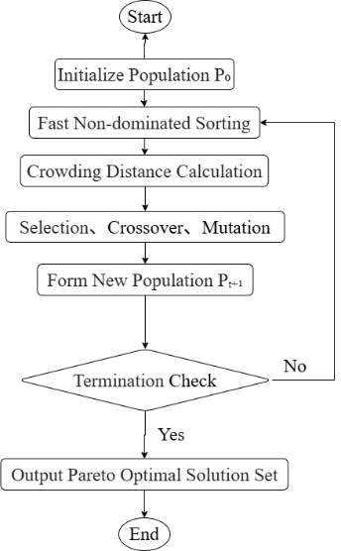
Figure 8. Logic Diagram of NSGA-II.

Firstly, the parent population with a scale of 50 is initialized, and the individual codes corresponding to the parameters to be optimized are randomly generated. Then, all the individuals in P_{o} were sorted by fast non-dominated sorting, and they were divided into different non-dominated levels. The first level was the optimal individual, and the advantages and disadvantages of the subsequent levels decreased in turn. On this basis, the crowding degree of individuals in each non-dominated hierarchy is calculated to quantify the distribution density of individuals in the solution space and avoid the aggregation of solutions. Based on the non-dominated hierarchy and crowding index, the tournament selection method was used to perform the selection operation, and the high-quality individuals were screened from the parent population and the mating pool was established. Next, under the preset crossover probability (0.8), binary crossover or real crossover operation is performed on the individuals in the mating pool to generate offspring individuals with excellent genetic characteristics of the parent generation. In order to maintain the diversity of the population and prevent the algorithm from falling into local optimum, the mutation operation is performed by randomly modifying the individual gene under the preset mutation probability (0.05). The new parent population P_{t+1} is formed by the elite retention strategy: the parent population P_{t} and the offspring population Q_{t} are merged into a population with a size of 100, and the merged population is re-ranked by fast non-dominated sorting and crowding degree calculation. The top 50 optimal individuals are selected to form a new parent population P_{t+1}.Finally, the termination check is performed to determine whether the preset termination conditions (such as the maximum number of iterations, the convergence of the optimal solution, or the population diversity below the threshold) are satisfied. If the condition is satisfied, the Pareto optimal solution set is output and the algorithm is terminated. If not satisfied, the fast non-dominated sorting step is returned to start the next iteration. The final Pareto front solution set distribution is shown in Figure 9:
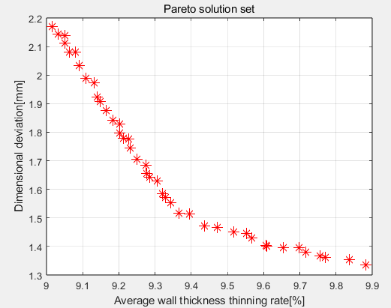
Figure 9. Pareto front solution set distribution plot
The NSGA-II algorithm can efficiently generate a Pareto front solution set with wide coverage and uniform distribution, and provide rich non-dominated solutions as candidate solutions for multi-objective optimization problems. However, it cannot automatically determine the final decision scheme among many optimal solutions. To this end, this study further introduces the TOPSIS decision algorithm, which calculates the relative closeness between each Pareto solution and the ideal solution by constructing the ideal solution and the negative ideal solution, so as to realize the systematic evaluation and ranking of the non-dominated solution set. This strategy not only helps to reduce the deviation caused by subjective judgment and improve the scientificity and objectivity of scheme selection, but also effectively connects the multi-objective optimization process with the actual engineering decision-making needs, making the optimization results easier to be transformed into executable engineering schemes, which significantly enhances the practical value and decision-making support ability of the research. The final decision results are shown in Figure 10:
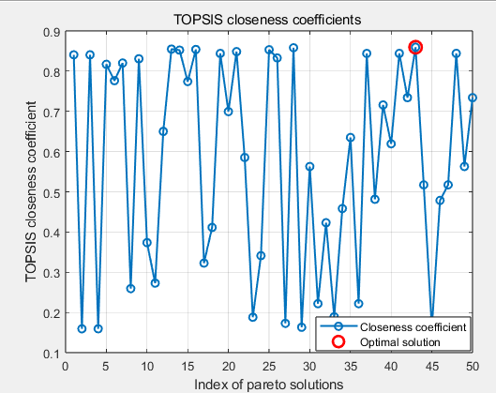
Figure 10. TOPSIS Closeness Coefficient Distribution Plot.
According to the distribution diagram of TOPSIS closeness degree, the 43rd group of solutions has the highest closeness degree. Therefore, it can be considered that in the Pareto front solution set, the truncated cone forming part under this parameter combination has the best forming performance. The specific parameter combination is shown in Table 5:
Table 5. Data comparison and analysis before and after optimization.
N | t₀（mm） | P（mm） | D（mm） | L（mm） | ϕ（%） | ε（mm）
1 | 1.00 | 1.8 | 10 | 48 | 10.4700 | 1.6300
2 | 1.28 | 2.06 | 8.40 | 46 | 9.6094 | 1.4004
It can be seen from Table 5 that the optimized characterization parameter φ decreased from 10.4700 % to 9.6094 %, with a decrease of 8.22 %. ε decreased from 1.6300 mm to 1.4004 mm, a decrease of 14.09 %. In summary, this study uses the NSGA-II algorithm based on ABAQUS simulation data to effectively improve the forming quality and accuracy of the single-point incremental forming process of the truncated cone.

4. Conclusion

Based on the ABAQUS finite element model and non-dominated sorting genetic algorithm (NSGA-II), this study carried out multi-objective optimization research on the four process parameters of initial plate thickness, pitch, tool head diameter and bottom side length. Finally, the following conclusions are drawn:
- The finite element model of single point incremental forming of truncated cone based on TA1 titanium plate was successfully constructed. By comparing the wall thickness distribution characteristics of the formed part and the simulation model, the reliability and accuracy of the established ABAQUS model were verified, which provided a credible basic model for subsequent numerical simulation and parameter optimization.
- The BBD experimental design method was used to carry out 29 sets of numerical simulation experiments, and the average wall thickness reduction rate (φ) and size error (ε) were selected as the response indexes. The simulation experiment data are used as training samples to construct a back propagation neural network (BPNN) model. The regression analysis shows that the model has good prediction accuracy and can effectively characterize the mapping relationship between process parameters and forming quality indicators.
- The multi-objective optimization model is established by coupling NSGA-II algorithm and TOPSIS decision method, and the above process parameters are collaboratively optimized. The optimization results show that the average wall thickness reduction rate (φ) of the formed part is reduced by 8.22 % and the size error (ε) is reduced by 14.09 % compared with that before optimization, which significantly improves the process performance of the single-point incremental forming of the truncated cone, and provides an efficient and feasible technical solution for the parameter optimization of the forming process.
The limitation of this study is that its optimization analysis is only for the truncated pyramid incremental forming process of TA1 sheet, and does not involve other geometric shapes (such as truncated cone). In addition, the range of parameters used in the study is relatively limited, and these factors together restrict the universality of the current research conclusions. Therefore, the follow-up work will incorporate more complex shapes and systematically explore within a broader window of process parameters to improve the applicability of the research results.

DISCLAIMER (ARTIFICIAL INTELLIGENCE)

Author(s) hereby declare that NO generative AI technologies such as Large Language Models (ChatGPT, COPILOT, etc) and text-to-image generators have been used during writing or editing of manuscripts.

Competing interests

Author has declared that no competing interests exist.

COMPETING INTERESTS DISCLAIMER:
Authors have declared that they have no known competing financial interests OR non-financial interests OR personal relationships that could have appeared to influence the work reported in this paper.
Ethics approval and consent to participate

The author states that there are no ethical problems in this study.

References

1. Behera, A.K.; de Sousa, R.A.; Ingarao, G.; Oleksik, V. Single point incremental forming: An assessment of the progress and technology trends from 2005 to 2015. JOURNAL OF MANUFACTURING PROCESSES 2017, 27, 37-62, doi:10.1016/j.jmapro.2017.03.014.
2. Duflou, J.R.; Habraken, A.M.; Cao, J.; Malhotra, R.; Bambach, M.; Adams, D.; Vanhove, H.; Mohammadi, A.; Jeswiet, J. Single point incremental forming: state-of-the-art and prospects. International Journal of Material Forming 2018, 11, 743-773, doi:10.1007/s12289-017-1387-y.
3. Li, Y.L.; Chen, X.X.; Liu, Z.B.; Sun, J.; Li, F.Y.; Li, J.F.; Zhao, G.Q. A review on the recent development of incremental sheet-forming process. International Journal of Advanced Manufacturing Technology 2017, 92, 2439-2462, doi:10.1007/s00170-017-0251-z.
4. Duflou, J.R.; Verbert, J.; Belkassem, B.; Gu, J.; Sol, H.; Henrard, C.; Habraken, A.M. Process window enhancement for single point incremental forming through multi-step toolpaths. CIRP Annals 2008, 57, 253-256, doi:https://doi.org/10.1016/j.cirp.2008.03.030.
5. Feng, F.; Li, J.J.; Chen, R.C.; Huang, L.; Su, H.L.; Fan, S. Multi-point die electromagnetic incremental forming for large-sized sheet metals. Journal of Manufacturing Processes 2021, 62, 458-470, doi:10.1016/j.jmapro.2020.12.022.
6. Liu, Z.B. Heat-assisted incremental sheet forming: a state-of-the-art review. International Journal of Advanced Manufacturing Technology 2018, 98, 2987-3003, doi:10.1007/s00170-018-2470-3.
7. Su, C.; Lv, S.; Wang, R.; Lv, Y.; Lou, S.; Wang, Q.; Guo, S. Effects of forming parameters on the forming limit of single-point incremental forming of sheet metal. The International Journal of Advanced Manufacturing Technology 2021, 113, 483-501, doi:10.1007/s00170-020-06576-0.
8. Ou, L.; An, Z.; Gao, Z.; Zhou, S.; Men, Z. Effects of Process Parameters on the Thickness Uniformity in Two-Point Incremental Forming (TPIF) with a Positive Die for an Irregular Stepped Part. Materials 2020, 13, doi:10.3390/ma13112634.
9. Li, Y.; Chen, X.; Zhai, W.; Wang, L.; Li, J.; Guoqun, Z. Effects of process parameters on thickness thinning and mechanical properties of the formed parts in incremental sheet forming. The International Journal of Advanced Manufacturing Technology 2018, 98, 3071-3080, doi:10.1007/s00170-018-2469-9.
10. Dakhli, M.; Boulila, A.; Manach, P.-Y.; Tourki, Z. Optimization of processing parameters and surface roughness of metallic sheets plastically deformed by incremental forming process. The International Journal of Advanced Manufacturing Technology 2019, 102, 977-990, doi:10.1007/s00170-018-03265-x.
11. Bari, N.; Kumar, S. Multi-stage single-point incremental forming: an experimental investigation of thinning and peak forming force. Journal of the Brazilian Society of Mechanical Sciences and Engineering 2023, 45, doi:10.1007/s40430-023-04055-7.
12. Sbayti, M.; Bahloul, R.; Belhadjsalah, H. Efficiency of optimization algorithms on the adjustment of process parameters for geometric accuracy enhancement of denture plate in single point incremental sheet forming. Neural Computing & Applications 2020, 32, 8829-8846, doi:10.1007/s00521-019-04354-y.
13. Maji, K.; Kumar, G. Inverse analysis and multi-objective optimization of single-point incremental forming of AA5083 aluminum alloy sheet. Soft Computing 2020, 24, 4505-4521, doi:10.1007/s00500-019-04211-z.
14. Fu, Z.M.; Mo, J.H.; Chen, L.; Chen, W. Using genetic algorithm-back propagation neural network prediction and finite-element model simulation to optimize the process of multiple-step incremental air-bending forming of sheet metal. Materials & Design 2010, 31, 267-277, doi:10.1016/j.matdes.2009.06.019.
15. Nagargoje, A.; Kankar, P.K.; Jain, P.K.; Tandon, P. Application of artificial intelligence techniques in incremental forming: a state-of-the-art review. Journal of Intelligent Manufacturing 2023, 34, 985-1002, doi:10.1007/s10845-021-01868-y.
16. Bahloul, R.; Arfa, H.; BelHadjSalah, H. A study on optimal design of process parameters in single point incremental forming of sheet metal by combining Box–Behnken design of experiments, response surface methods and genetic algorithms. The International Journal of Advanced Manufacturing Technology 2014, 74, 163-185, doi:10.1007/s00170-014-5975-4.
17. Xiao, X.; Kim, J.-J.; Hong, M.-P.; Yang, S.; Kim, Y.-S. RSM and BPNN Modeling in Incremental Sheet Forming Process for AA5052 Sheet: Multi-Objective Optimization Using Genetic Algorithm. Metals 2020, 10, doi:10.3390/met10081003.
18. Kumar, G.; Maji, K. Investigations into Enhanced Formability of AA5083 Aluminum Alloy Sheet in Single-Point Incremental Forming. Journal of Materials Engineering and Performance 2021, 30, 1289-1305, doi:10.1007/s11665-021-05455-3.
19. Mohanraj, R.; Elangovan, S.; Kumar, S.P. Experimental investigations of warm incremental sheet forming process on magnesium AZ31 and aluminium 6061 alloy. Proceedings of the Institution of Mechanical Engineers Part L-Journal of Materials-Design and Applications 2023, 237, 283-300, doi:10.1177/14644207221110783.
20. Jiang, B.; Yang, W.B.; Zhang, Z.Y.; Li, X.F.; Ren, X.P.; Wang, Y.Q. Numerical Simulation and Experiment of Electrically-Assisted Incremental Forming of Thin TC4 Titanium Alloy Sheet. Materials 2020, 13, doi:10.3390/ma13061335.
21. Li, R.X.; Wang, T.; Li, F. The Formability of Perforated TA1 Sheet in Single Point Incremental Forming. Materials 2023, 16, doi:10.3390/ma16083176.
22. McPhillimy, M.; Yakushina, E.; Blackwell, P. Tailoring Titanium Sheet Metal Using Laser Metal Deposition to Improve Room Temperature Single-Point Incremental Forming. Materials 2022, 15, doi:10.3390/ma15175985.
23. Li, R.; Wang, T.; Li, F. The Formability of Perforated TA1 Sheet in Single Point Incremental Forming. Materials 2023, 16, doi:10.3390/ma16083176.
24. Li, R.; Wang, T. Research on Single Point Incremental Forming Characteristics of Perforated TA1 Sheet. Metals 2022, 12, doi:10.3390/met12111944.
25. Gatea, S.; Ou, H.; Lu, B.; McCartney, G. Modelling of ductile fracture in single point incremental forming using a modified GTN model. Engineering Fracture Mechanics 2017, 186, 59-79, doi:10.1016/j.engfracmech.2017.09.021.
26. Jaleel, A.; Narayanan, C.S. Formability investigation of perforated austenitic SS 304L sheets using SPIF. Journal of Manufacturing Processes 2023, 104, 44-58, doi:10.1016/j.jmapro.2023.08.052.

