Impact of Static Var Compensator (SVC) on Voltage Stability and Losses in the N'Djamena Power Network

ABSTRACT

This study investigates the impact of a Static Var Compensator (SVC) on voltage stability enhancement and loss reduction in the N'Djamena distribution network, Chad. Using the NEPLAN software environment, a detailed model of the 32-node network was developed and power flow analyses were conducted using the Newton-Raphson method under both nominal (100%) and stressed (120%) loading conditions. The SVC, equipped with a Proportional-Integral (PI) control scheme and an operating range of -50 to +50 Mvar, was implemented for dynamic reactive power compensation. Simulation results demonstrate substantial performance improvements: voltage levels at critical nodes (NT30, N1T100, N2T100, N15LA) increased by up to 20.19 percentage points under maximum load conditions, while active power losses were reduced by up to 1.586 MW and reactive power losses by up to 3.677 Mvar. The findings quantitatively confirm that SVC implementation significantly enhances voltage stability margins and reduces technical losses in weak distribution networks. This research provides a validated framework for SVC integration in similar developing power systems and offers practical insights for utility planners seeking to improve grid performance while accommodating future renewable energy integration.

Keywords: Energy Losses, N’Djamena Electrical Network, Reactive Power Compensation, SVC, Voltage Stability.
1. INTRODUCTION

The electrical network of N’Djamena, like many urban networks in developing countries, faces growing challenges related to voltage stability and energy losses [1–4]. Historically managed by electromechanical devices with limited regulation capabilities, this network now reveals its limitations in supporting the demographic and economic growth of the Chadian capital [5–7]. Pronounced voltage drops, particularly in peripheral areas, coupled with increasing active and reactive power losses compromise both the quality of electricity supply and the economic viability of the system [3, 8].
In this context, FACTS (Flexible AC Transmission Systems) technologies emerge as a promising solution for modernising existing infrastructure without requiring heavy investments in new generation or transmission capacity [6]. Among these technologies, the Static Var Compensator (SVC) stands out due to its technical maturity and performance-cost ratio well-suited to the constraints of African networks [6]. Capable of providing dynamic and bidirectional reactive power compensation, the SVC effectively helps maintain voltage stability [3, 6] while reducing energy losses [5].
This article presents an in-depth study of the impact of SVC integration on the N’Djamena electrical network [9]. Through simulations performed using NEPLAN software, we evaluate the improvement in the voltage profile and the reduction of losses across different load scenarios [10]. Our methodological approach combines a critical node analysis with SVC modelling based on industry standards [11, 12], thereby providing a solid foundation for the modernisation planning of the Chadian grid.
The originality of this work lies in its specific application to the specific context of Chad, characterised by unique infrastructure constraints and an urgent need to optimise existing networks. The results obtained provide concrete technical arguments to guide investment decisions for the modernisation of the national electrical system.
2. Theoretical framework

2.1 The issue of reactive power compensation

Modern electrical networks, particularly in developing countries, face significant challenges related to reactive power management [13]. Poor management leads to significant technical consequences:
- significant voltage drops in weakly meshed areas;
- increase in active losses due to the Joule effect;
- reduction in the power transmission capacity of transmission lines;
- risks of voltage instability potentially leading to complete system collapse.
Figure 1 presents a simplified model of a two-node network for analysing the fundamental phenomena governing voltage stability.
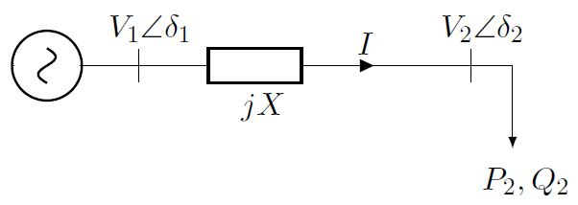
Fig. 1. Simplified model of a two-node electrical network.

The fundamental equations governing this system are as follows.
The apparent power injected at node 2 is expressed as:
$\overline{S_{2}}=V_{2}\overline{I^{*}}=P_{2}+jQ_{2}$ (1)
The current in the line is given by:
$I =\frac{V_{1}- V_{2}}{jX}$ (2)
By developing these expressions, we obtain the active and reactive powers:
$P_{2}=\frac{V_{1}V_{2}}{X}sinδ_{2}$ (3)
$Q_{2}=\frac{V_{1}V_{2}}{X}cosδ_{2}-\frac{V_{2}^{2}}{X}$ (4)
By eliminating the $δ_{2}$ using the trigonometric identity $\cos_{2}{δ_{2}^{2}+\sin_{2}{δ_{2}^{2}=1}}$, we obtain the characteristic equation:
$P_{2}^{2}+ {\left[Q_{2}+\frac{V_{2}^{2}}{X}\right]}^{2}=\frac{V_{1}^{2}V_{2}^{2}}{X^{2}}$ (5)
This leads to a quadratic equation in $V_{2}^{2}$:
$V_{2}^{4}+ \left(2Q_{2}X - V_{1}^{2}\right)V_{2}^{2}+ \left(P_{2}^{2}+ Q_{2}^{2}\right)X^{2}= 0$ (6)
By setting $Q_{2}=P_{2}\tan{ϕ}$, this equation becomes:
$V₂ = √\left[\frac{V_{1}^{2}- 2P^{2}X tanϕ}{2}±\frac{\sqrt{V_{1}^{4}- 4P_{2}^{2}X^{2}- 4P_{2}XV_{1}^{2}tanϕ}}{2}\right]$ (7)
Figure 2 presents the P-V curves derived from equation (7), illustrating the critical link between the voltage at node 2 and the active power for different power factors.
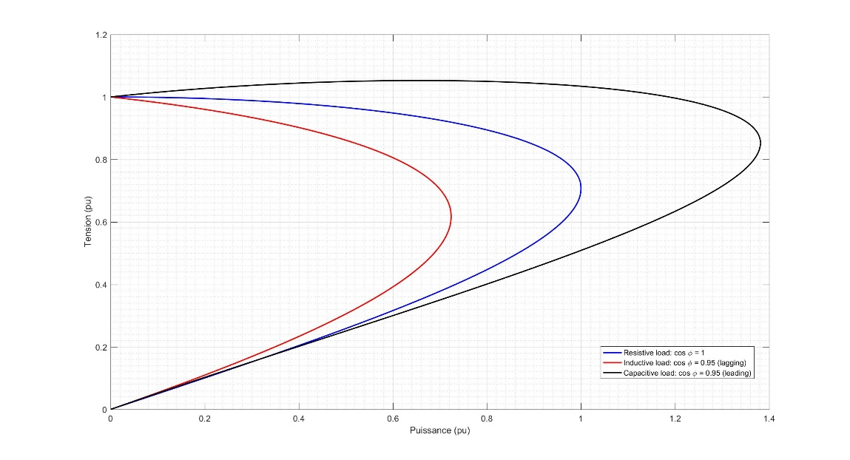

Fig. 2. Voltage evolution as a function of power.

Analysis of the P-V curves (Figure 2) reveals the existence of a collapse point beyond which the system becomes unstable [14]. Appropriate reactive power compensation moves this critical point further away and increases the stability margin.
2.2 Compensation techniques

2.2.1 Traditional compensation

Capacitor banks represent the traditional solution for reactive power compensation. Their operating principle is based on the injection of capacitive reactive power proportional to the square of the voltage [15]:
$Q_{C}= V^{2}·ωC =\frac{V^{2}}{X_{C}}, \text{avec} X_{C}=\frac{1}{ωC}$ (8)
Where C est la capacité de la batterie et $ω=2πf$ angular frequency.
Capacitor banks represent the traditional solution for reactive power compensation. Their widespread adoption is explained by several technical and economic advantages [16]:
- Cost-effective and proven solution: their acquisition and installation costs remain lower than those of advanced compensators, with a technology that has been mastered for several decades.
- Low maintenance costs: The absence of moving parts and the simplicity of their design reduce maintenance operations to periodic visual inspections.
- Simple installation: Their implementation does not require complex control systems, which facilitates their deployment in existing networks.
However, this technology has significant limitations that reduce its effectiveness in modern networks [16]:
- Quadratic dependence on voltage ($Q_{C}∝ V^{2}$): the injected reactive power decreases significantly during voltage drops, precisely when the need for compensation is most critical.
- Stepped, non-continuous compensation: the switching of capacitor stages creates abrupt transitions that can cause disturbances in the network.
- Inability to respond to rapid load variations: the high response time (on the order of seconds) makes them unsuitable for rapid fluctuations of industrial loads.
- Risk of overvoltage under light load conditions: excessive compensation can lead to dangerous overvoltages for equipment.
- Non-adaptive compensation: the lack of automatic regulation requires manual adjustments to adapt to changes in network configuration.

2.2.2 Advanced solutions

To overcome the limitations of traditional compensators, FACTS (Flexible AC Transmission Systems) technologies offer dynamic and controllable compensation [12, 16]. Among these, the Static Var Compensator (SVC) stands out due to its technological maturity and favorable performance/cost ratio [16].
2.2.2.1 SVC architecture
The SVC consists of a judicious combination of power electronics components enabling dynamic and precise compensation [16]:
- TSC (Thyristor Switched Capacitors): Capacitor banks switched by thyristors allowing rapid injection of capacitive reactive power. Each stage can be connected or disconnected within a few milliseconds [16].
- TCR (Thyristor Controlled Reactors): Thyristor-controlled reactors allowing the absorption of inductive reactive power. Phase angle control enables continuous variation of the absorbed power [16].
- Harmonic filters: Passive LC systems eliminating harmonics generated by thyristor switching, ensuring the quality of the voltage waveform [16].
- Control system: A real-time electronic regulation unit that measures the grid voltage and continuously adjusts the SVC’s susceptance to maintain the voltage at its setpoint [16].
This modular architecture allows the SVC to operate as a source/sink of reactive power with a continuous control range, offering good operational flexibility [16].

2.2.2.2 Advanced SVC modeling

Beyond the basic proportional model $Q_{SVC} = k (V_{ref}- V)$, modern SVCs implement sophisticated control strategies enabling robust and high-performance regulation of electrical networks [12, 16].
Complete dynamic model:
$Q_{SVC} = B_{SVC}V^{2}$ (9)
where $B_{SVC}$ represents the variable susceptance dynamically controlled by the electronic control system. This quadratic relationship reflects the dependence of the injected reactive power on the square of the voltage at the coupling point [16].
Advanced control scheme:
$B_{SVC}= K_{p\left(V_{ref}- V\right)}+ K_{i}∫\left(V_{ref}- V\right)dt$ (10)
This PI (Proportional-Integral) control structure eliminates steady-state error while ensuring an optimised dynamic response for network transients. The proportional term ensures a rapid reaction to voltage deviations, while the integral action cancels the residual error [16].
Implemented control strategies:
- PI/PID controllers with anti-windup: limiting the integrator wind-up effect during actuator saturation.
- Phase lead compensators: phase margin correction to improve closed-loop stability.
- Adaptive control: automatic adjustment of gains Kp and Ki based on network operating conditions.
- Current and voltage limiters: protection of semiconductor components against overstress [16].
Differential advantages of SVCs compared to traditional compensators [16]:
- Continuous and adaptive compensation: real-time regulation without jerks, with automatic adjustment to load variations.
- Rapid response: response time less than 20-50 ms, allowing it to follow the fastest fluctuations.
- Bidirectionality of reactive power: ability to supply (capacitive mode) or absorb (inductive mode) according to network needs.
- Improvement of transient stability: active voltage support during faults and abrupt load changes.
- Damping of oscillations: reduction of electromechanical power oscillations thanks to the stabilizing action.
- Independence from voltage: ability to inject reactive power even during severe voltage drops.
These advanced characteristics give SVCs a manifest technical superiority for applications requiring high-performance dynamic compensation [16].

3. Literature review

Reactive power compensation is a cornerstone of the stability and efficiency of electrical networks. This literature review traces the evolution of compensation solutions, from theoretical foundations to modern applications, highlighting the emergence of FACTS technologies and the particular relevance of SVC for networks with constraints similar to those in N’Djamena.
3.1 Theoretical foundations and emergence of FACTS technologies

The theoretical foundations of reactive compensation were established by reference works. Kundur (1994), in his seminal work Power System Stability and Control, identified reactive compensation as a key factor in preventing voltage collapse, particularly in weakly meshed and heavily loaded networks [9]. Concurrently, Hingorani and Gyugyi (2000) laid the groundwork for FACTS systems in Understanding FACTS, demonstrating their ability to radically improve network stability and controllability. For instance, they showed that FACTS devices could increase transmissible power by up to 30% on critical lines [17]. This work paved the way for dynamic compensators like the SVC.
3.2 Technical superiority of SVC

Faced with the limitations of traditional compensators (capacitor banks), notably their quadratic dependence on voltage and their slow, stepped response, the SVC stands out as an optimal solution. Dixon et al. (2005) conducted a comprehensive review of the technologies, concluding that the SVC offers the best performance-cost compromise for voltage regulation in medium-sized networks [16]. Its ability to provide bidirectional (injecting or absorbing reactive power), continuous, and fast (response time < 50 ms) compensation gives it a decisive advantage for maintaining a stable voltage profile and reducing energy losses, as quantified by El-Hawary (2008) and others [18].
3.3 Applications and challenges in african networks

Building on this foundation, very recent research provides quantitative evidence for the effectiveness of intelligent SVC control in African networks. A study on the Congolese network of Maloukou demonstrated that a fuzzy logic-controlled SVC could maintain voltage within a 0.98-1.02 p.u. range, reduce the stabilisation time to less than 0.45 seconds, and achieve approximately 15% reduction in active power losses, significantly outperforming a traditional PI controller [19]. Similarly, a comparative analysis in the Middle Egypt Electricity Zone confirmed the superiority of Fuzzy Logic over a PI controller for a STATCOM (a related FACTS device), limiting the maximum voltage deviation to 4.67% compared to 5.9% with PI [20]. These findings create a compelling case for the adoption of advanced control strategies for reactive compensation in contexts similar to N'Djamena.
3.4 Future prospects: integration of renewable energies and artificial intelligence

The ongoing evolution of power systems, characterized by the massive penetration of intermittent renewable energies (solar, wind), reinforces the need for dynamic compensation. Research is now exploring hybrid architectures combining SVC and energy storage systems to simultaneously manage production variations and reactive power needs. An emerging trend involves applying Machine Learning for SVC control, aiming to develop self-adaptive systems capable of anticipating load and generation fluctuations, thereby enhancing grid resilience.
3.5 Positioning of the present study

Within this scientific landscape, and informed by the recent results from neighbouring networks [19, 20], the present study provides concrete, contextualized experimental validation of the impact of a classical SVC with standard PI control on the real network of N'Djamena. By demonstrating significant improvements in voltage profile (up to 20 points) and loss reduction (up to 1.59 MW) with a mature and robust control solution, this work addresses a critical gap for utilities where the immediate implementation of advanced controllers like Fuzzy Logic might be a secondary step. Thus, it offers a solid and pragmatic technical rationale for the initial integration of SVC technology, laying the groundwork for future controller optimizations in the Chadian network and similar systems.
4. Methodology

4.1 Description of the studied network

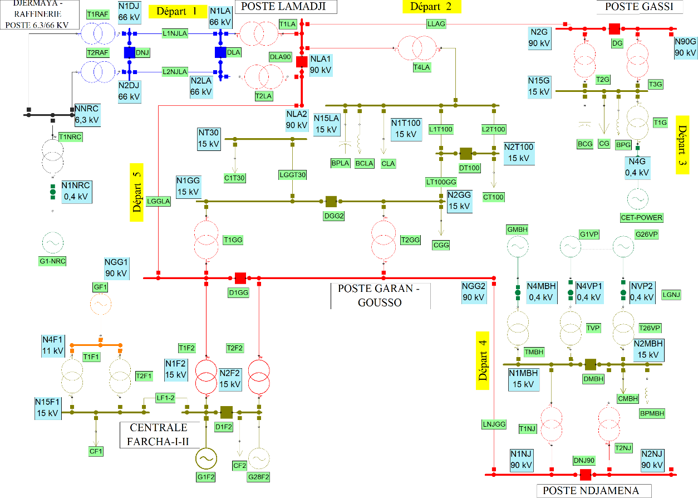
The modelled N’Djamena network comprises 31 nodes, 31 lines, 8 generating units, and 8 loads, with passive compensators at Lamadji, Gassi, Garangosso, and Djambalbar. This topology faithfully represents the real network of the Chadian capital, as shown in Figure 3.

Fig. 3. Single-line diagram of the N’Djamena network.

4.2 Simulation tools and parameters

Simulations were performed using NEPLAN software, utilising the Newton-Raphson algorithm for power flow calculation. The calculations are based on the fundamental equations governing active and reactive power flows between nodes i and j:
$\left\{\begin{aligned}P_{ij}= V_{i}{ V}_{j}{ Y}_{ij} cos(θ_{i} - θ_{j} -ϕ_{ij}) \\ Q_{ij}= V_{i}V_{j}Y_{ij} sin(θ_{i} - θ_{j} -ϕ_{ij})\end{aligned}\right.$ (11)
These equations determine the complete state of the network (voltages, powers, losses) in the different scenarios considered.
The total active energy losses in the network were calculated by aggregating the losses on each line. The formula used is as follows:
$P_{loss} = \sum_{(i,j)}{R_{ij} }· \left(\frac{{\left|S_{ij}\right|}^{2}}{{\left|V_{i}\right|}^{2}}\right)$ (12)
where $R_{ij}$ is the resistance of the line between i and j, $S_{ij}$ is the apparent power flowing in this line, and $V_{i}$ is the voltage at node i. This method allows a precise evaluation of the impact of SVC on the network’s energy efficiency.
4.3 Study scenarios

Two scenarios are analysed:
- Nominal load (100%) with and without SVC;
- Maximum load (120%) with and without SVC.
The placement of the SVC was determined by an analysis of critical voltage deviations identified at nodes NT30, N1T100, N2T100, and N15LA, which exhibited the most severe voltage drops (>10%). The SVC power was sized to cover the global reactive power deficit observed during preliminary simulations. This strategic choice aims to maximise the impact of the compensators on the overall voltage stability.
5. Results and discussion

5.1 Presentation of simulation results

Simulations conducted on the N'Djamena network clearly demonstrate the substantial impact of SVC integration on voltage stability, as quantitatively summarised in Table 1 and Table 2. These tables compare voltages at critical nodes and system losses with and without SVC compensation under both nominal (100%) and maximum (120%) loading conditions.

Table 1. Impact of SVC on voltage profile and losses at nominal load (100%)

Parameter / Node | Without SVC | With SVC | Absolute improvement
Voltage profile (% of nominal)
N15LA | 89.78 % | 92.83 % | +3.05 points
N1T100 | 85.05 % | 92.53 % | +7.48 points
N2T100 | 85.03 % | 92.52 % | +7.49 points
NT30 | 79.01 % | 92.51 % | +13.50 points
Energy losses
Active losses (MW) | 9.104 | 8.296 | -0.808 MW
Reactive losses (MVar) | 7.912 | 6.059 | -1.853 MVar

Table 2. Impact of SVC on voltage profile and losses at maximum load (120%)

Parameter / Node | Without SVC | With SVC | Absolute improvement
Voltage profile (% of nominal)
N15LA | 86.68 % | 91.49 % | +4.81 points
N1T100 | 80.57 % | 92.39 % | +11.82 points
N2T100 | 80.55 % | 92.38 % | +11.83 points
NT30 | 72.18 % | 92.37 % | +20.19 points
Energy losses
Active losses (MW) | 13.224 | 11.638 | -1.586 MW
Reactive losses (MVar) | 18.808 | 15.131 | -3.677 MVar

These initial quantitative results form the basis of the comparative analysis presented in the following section, aiming to interpret the physical and dynamic influence of the SVC on the voltage behaviour of the network.
5.2 Comprehensive analysis of voltage profile improvements

The most significant improvement revealed in Table 2 was observed at node NT30, which exhibited the most severe voltage drops in the uncompensated scenario. Under nominal load conditions (Table 1), this node experienced a substantial 13.50 percentage point increase, from 79.01% to 92.51% of nominal voltage. This improvement became even more pronounced under stressed conditions (120% load), where Table 2 shows node NT30 registered a dramatic 20.19 percentage point increase from 72.18% to 92.37%.

As evidenced in Table 1, nodes N1T100 and N2T100 showed consistent improvements of approximately 7.48-7.49 percentage points under nominal load, increasing from 85.03-85.05% to 92.52-92.53%. Table 2 demonstrates that under maximum load conditions, these improvements escalated to 11.82-11.83 percentage points, reaching stable voltage levels of 92.38-92.39%. Node N15LA exhibited more moderate but still significant improvements of 3.05 and 4.81 percentage points under nominal and maximum loads, respectively, as documented in both tables.

The comprehensive data presented in Table 1 and Table 2 reveals a crucial pattern: the most substantial benefits occurred at nodes farthest from generation sources, effectively addressing the classic voltage drop problem in radial distribution networks. This strategic compensation resulted in a remarkably flattened voltage profile, reducing the voltage differential between nodes from approximately 10.77 percentage points to just 0.32 percentage points under nominal load conditions.

5.3 Loss reduction mechanisms and system efficiency

The results presented in Table 1 and Table 2 demonstrate significant reductions in active and reactive losses achieved through SVC compensation. Under nominal load conditions (Table 1), active losses decrease by 0.808 MW (equivalent to 8.9%), while reactive losses are reduced by 1.853 MVar (23.4%). Under maximum load conditions (Table 2), these reductions reach 1.586 MW (12.0%) for active losses and 3.677 MVar (19.5%) for reactive losses.
This improvement in efficiency can be attributed to the ability of the SVC to provide localised reactive compensation, thereby reducing reactive power flows through the lines and lowering the current transmitted. This, in turn, reduces resistive (I²R) losses. Such optimisation is particularly advantageous for networks like N'Djamena, where energy efficiency has a direct impact on economic viability.
The difference between the percentages of active and reactive loss reduction underscores the primary role of the SVC in reactive power management, while also highlighting the coupling between active and reactive power flows in distribution networks.
5.4 Comparative performance under different loading conditions
The comparison of results between nominal load (Table 1) and maximum load (Table 2) scenarios highlights the adaptability and effectiveness of the SVC. Voltage improvements are consistently more significant under maximum load conditions, confirming the added value of the compensator during periods of high network demand.
Loss reduction evolves non-linearly with increasing load. The transition from nominal to maximum load is accompanied by a 96% increase in active loss reduction (from 0.808 MW to 1.586 MW) and 98% for reactive losses (from 1.853 MVar to 3.677 MVar). These results indicate that the benefits of SVC become more pronounced as the network approaches its operational limits.
The homogenisation of the voltage profile, observable in both tables, is also more marked under maximum load, with the voltage differential between nodes reduced from 14.5 percentage points to just 0.89 points, representing a 94% improvement.
5.5 Practical Implications for Network operators
The quantified improvements presented in Tables 1 and 2 have direct operational implications. The enhanced voltage stability margin provides greater operational flexibility and reduces the risk of voltage-related outages. For the N'Djamena network, these results validate svc deployment as a cost-effective alternative to network reinforcement through new line construction.
The economic benefits extend beyond mere loss reduction. The improved voltage profile enables better utilisation of existing infrastructure and could potentially defer investments in network expansion. Furthermore, the enhanced system capacity and stability can support economic development by providing more reliable power supply to industrial and commercial consumers.
For network planners, the quantitative relationships established in this study between compensation implementation and system performance improvements offer a reliable framework for planning and optimising reactive power compensation in resource-constrained environments.
6. conclusion

This study has evaluated the effectiveness of the SVC in improving voltage stability and reducing electrical losses in the N’Djamena distribution network. The simulation results confirm that the integration of this device contributes significantly to improving the voltage profile and the optimising of the overall system operation.
6.1 Summary of improvements

Comparative analyses have shown that the introduction of the SVC makes it possible to maintain all critical nodes within an admissible voltage range, between 92 and 93% of the nominal voltage, compared to 72 to 90% in the absence of compensation. This effective voltage regulation is accompanied by a notable reduction in active losses (up to 12%) and reactive losses (up to 23.4%), reflecting better utilisation of transmitted power and a limitation of unnecessary reactive flows. Furthermore, the network retains good robustness even under maximum load conditions (120%), while eliminating the risk of voltage collapse at the most sensitive nodes. These performances confirm the essential role of the SVC in strengthening the operational security of the network.
6.2 Main contributions

Beyond the specific results, this study provides several notable contributions. Firstly, it offers experimental validation of the effectiveness of SVC technology within the particular context of African networks, which are often characterised by ageing infrastructure and high load variability. Secondly, it proposes a rigorous methodology for identifying critical nodes, enabling the strategic targeting of network locations where the installation of compensation devices yields the greatest benefit. Finally, it provides a precise quantification of the technical gains in terms of voltage stability and energy efficiency, thereby establishing a solid scientific basis for planning and modernising local electrical networks.
6.3 Perspectives

This work paves the way for several promising avenues of further research:
- A primary direction involves optimising the placement and sizing of SVC to maximise their technical impact while minimising investment costs.
- The joint integration of SVC with renewable energy sources constitutes a major challenge, particularly in a context of energy transition where generation variability increases the need for dynamic reactive compensation.
- Furthermore, an in-depth cost-benefit analysis is needed to economically justify the implementation of these solutions on a larger scale.
- Finally, the coordination of the SVC with other FACTS devices ould offer a more holistic approach to managing voltage stability and optimising power flows.

In summary, the results obtained demonstrate that the SVC constitutes a mature, high-performance, and adaptable technological solution for improving the voltage stability of developing electrical networks. Its large-scale adoption could significantly contribute to enhancing the reliability, efficiency, and sustainability of electrical systems, particularly in contexts similar to that of the N’Djamena network.

Disclaimer (Artificial intelligence)
Option 1:
Author(s) hereby declare that NO generative AI technologies such as Large Language Models (ChatGPT, COPILOT, etc.) and text-to-image generators have been used during the writing or editing of this manuscript.

All content in this manuscript, including theoretical analysis, methodology development, result interpretation, and conclusions, represents the original work of the human authors. The research concepts, technical approach, data analysis, and scholarly writing were entirely conceived and executed by the authors without AI assistance. While AI tools were consulted during the peer review response process for language polishing, no AI technologies were employed in the actual creation of the research content, mathematical formulations, simulation work, or scientific conclusions presented in this manuscript.

References

- Kanchev, H. (2014). Energy flow management in a hybrid renewable energy system: Optimization of operational planning and adjustment of an urban microgrid [Doctoral dissertation, Ecole Centrale de Lille and Sofia Technical University].
- Omar, C. I. (2023). Modeling, optimization, and energy management of a hybrid renewable energy power plant [Doctoral dissertation, Normandie Université].
- Turitsyn, K., Sulc, P., Backhaus, S., & Chertkov, M. (2011). Options for control of reactive power by distributed photovoltaic generators. Proceedings of the IEEE, 99(6), 1063–1073. https://doi.org/10.1109/JPROC.2011.2116750
- Ganongo, A. O., Gogom, M., Nianga-Apila, Obita, L. L. A., & Ganga, G. (2024). Optimization of lightning current discharge to the ground in electrical networks: Introduction of the proportionality coefficient (k). Electric Power Systems Research, 231, 110348. https://doi.org/10.1016/j.epsr.2024.110348
- Gogom, M., Oko Ganongo, A., Apila, N., & Lilonga-Boyenga, D. (2020). Optimization of power transit through a double-term line term by the UPFC. Science Journal of Energy Engineering, 8(4), 44–53. https://doi.org/10.11648/j.sjee.20200804.11
- Omboua Eyandzi, A., Gomba, R., Nianga-Apila, Nsongo, T., & Kani Mboyo, U. V. (2025). Analysis of dynamic interactions between reactive compensation and voltage stability in THT networks with svc. American Journal of Electrical Power and Energy Systems, 14(3), 45–63. https://doi.org/10.11648/j.epes.20251403.11
- Li, C., Disfani, V., Haghi, H.V., & Kleissl, J. (2019). Optimal voltage regulation of unbalanced distribution networks with coordination of OLTC and PV generation. arXiv. https://arxiv.org/abs/1901.09509
- Prasetya, C. A., & Sudiarto, B. (2023). The Impact of a 1.1 MWp PV Rooftop Integration in Medium Voltage Distribution Networks. International Journal of Electrical, Computer, and Biomedical Engineering, 1(1), 11–23. https://ijecbe.ui.ac.id/go/article/view/7
- Acha, E., Fuerte-Esquivel, C. R., Ambriz-Pérez, H., & Angeles-Camacho, C. (2004). FACTS: Modeling and Simulation in Power Networks. Wiley.
- Kundur, P. (1994). Power System Stability and Control. McGraw-Hill.
- IEEE Power Engineering Society. (2011). IEEE Guide for the Functional Specification of Transmission Static Var Compensators.
- Shea, J.J., Hingorani, N.G., Gyugyi, L., et al. (2002). Understanding facts-concepts and technology of flexible ac transmission systems. IEEE Electrical Insulation Magazine, 18(1), 46. https://doi.org/10.1109/MEI.2002.981326
- Andersson, G. (2012). Power System Analysis (2nd ed.). CRC Press.
- Van Cutsem, T., & Vournas, C. (2015). Voltage Stability of Electric Power Systems. Springer.
- Grainger, J. J., & Stevenson, W. D. (1994). Power System Analysis (1st ed.). McGraw-Hill.
- Dixon, J., Morán, L., Rodríguez, J., & Domke, R. (2005). Reactive power compensation technologies: State-of-the-art review. Proceedings of the IEEE, 93(12), 2144–2164. https://doi.org/10.1109/JPROC.2005.859937
- Hingorani, N. G., & Gyugyi, L. (2000). Understanding FACTS: Concepts and Technology of Flexible AC Transmission Systems. IEEE Press.
- El-Hawary, M. E. (2008). Electrical Power Systems. CRC Press.

- A. O. Eyandzi, R. Gomba, Nianga-Apila, F. L. Mobonda, T. Nzongo, T. L. Ngouloubi, and R. E. Ndouniama, "Intelligent Control of an SVC by Fuzzy Logic for Optimizing Dynamic Stability in a THT Network," Journal of Power and Energy Engineering, vol. 13, no. 10, pp. 144-169, Oct. 2025. https://doi.org/10.4236/jpee.2025.1310010

- A. A. Z. Diab, I. Y. Fawzy, A. M. Elsawy, and A. G. A. El-Magd, "Voltage Stability Enhancement in Electrical Transmission Networks Using STATCOM with Two Different Controllers: Case Study in Middle Egypt Electricity Zone," Journal of Advanced Engineering Trends, vol. 44, no. 1, pp. 315-343, Jan. 2025.

APPENDIX

These tables (tables 3, 4, 5 and 6) presents the detailed results of the simulations performed under the different load Scenarios, with and without the integration of the static var compensator (SVC). The tables below provide the complete values of voltages, active and reactive powers at the different nodes of the N’Djamena Electrical network. These data allow visualisation of the precise impact of the SVC on the voltage profile and on power Flows, and constitute the numerical support for the analyses presented in the main body of the article.

Table 3. Voltages and powers at different nodes without SVC (nominal load 100%)

BUS | U (kV) | U (%) | P_{R}(MW) | Q_{R}(MV AR) | P_{G}(MW) | Q_{G}(MV AR)
N15F1 | 15 | 100 | 0.3 | 0.13 | 0 | 0
N15G | 14.716 | 98.11 | 18 | 4.5 | 0 | 0
N15LA | 13.467 | 89.78 | 18 | 4.5 | 0 | 0
N1AGG | 0.414 | 103.45 | 0 | 3 | 28 | 0
N1DJ | 65.553 | 99.32 | 0 | 0 | 0 | 0
N1F2 | 15.024 | 100.16 | 0 | 0 | 76.004 | 35.278
N1GG | 13.891 | 92.61 | 0 | 0 | 0 | 0
N1LA | 64.898 | 98.33 | 0 | 0 | 0 | 0
N1MBH | 14.086 | 93.91 | 0 | 0 | 0 | 0
N1NJ | 87.996 | 97.77 | 0 | 0 | 0 | 0
N1T100 | 12.757 | 85.05 | 0 | 0 | 0 | 0
N2DJ | 65.553 | 99.32 | 0 | 0 | 0 | 0
N2F2 | 15.01 | 100.07 | 0.8 | 0.33 | 0 | 0
N2G | 88.188 | 97.99 | 0 | 0 | 0 | 0
N2GG | 13.889 | 92.59 | 26 | 6.5 | 0 | 0
N2LA | 64.898 | 98.33 | 0 | 0 | 0 | 0
N2MBH | 14.078 | 93.85 | 40 | 10 | 0 | 0
N2NJ | 87.995 | 97.77 | 0 | 0 | 0 | 0
N2T100 | 12.755 | 85.03 | 10 | 2.5 | 0 | 0
N4F1 | 10.992 | 99.93 | 0 | 3 | 7 | 0
N4G | 0.4 | 100 | 0 | 0 | 5.3 | 9.594
N4MBH | 0.38 | 95.12 | 0 | 0 | 5.3 | 0
N4VP1 | 0.379 | 94.72 | 0 | 0 | 5.3 | 0
N9OG | 88.188 | 97.99 | 0 | 0 | 0 | 0
NAGG | 6.33 | 100.48 | 0 | 0 | 0 | 0
NGG1 | 88.305 | 98.12 | 0 | 0 | 0 | 0
NGG2 | 88.305 | 98.12 | 0 | 0 | 0 | 0
NLA1 | 87.645 | 97.38 | 0 | 0 | 0 | 0
NLA2 | 87.646 | 97.38 | 0 | 0 | 0 | 0
NT30 | 11.852 | 79.01 | 10 | 2.5 | 0 | 0
NVP2 | 0.379 | 94.66 | 0 | 0 | 5.3 | 0

BUS | U (kV) | U (%) | P_{R} (MW) | Q_{R} | (MVAR) | P_{G} (MW) | Q_{G} (MVAR)
N15F1 | 15 | 100 | 0.3 |  | 0.13 | 0 | 0
N15G | 14.783 | 98.55 | 18 |  | 4.5 | 0 | 0
N15LA | 13.924 | 92.83 | 18 |  | 4.5 | 0 | 0
N1AGG | 0.418 | 104.41 | 0 |  | 3 | 28 | 0
N1DJ | 66.199 | 100.3 | 0 |  | 0 | 0 | 0
N1F2 | 15.024 | 100.16 | 0 |  | 0 | 75.196 | 20.816
N1GG | 14.271 | 95.14 | 0 |  | 0 | 0 | 0
N1LA | 65.546 | 99.31 | 0 |  | 0 | 0 | 0
N1MBH | 14.2 | 94.67 | 0 |  | 0 | 0 | 0
N1NJ | 88.652 | 98.5 | 0 |  | 0 | 0 | 0
N1T100 | 13.88 | 92.53 | 0 |  | 0 | 0 | 0
N2DJ | 66.199 | 100.3 | 0 |  | 0 | 0 | 0
N2F2 | 15.01 | 100.07 | 0.8 |  | 0.33 | 0 | 0
N2G | 88.835 | 98.71 | 0 |  | 0 | 0 | 0
N2GG | 14.268 | 95.12 | 26 |  | 6.5 | 0 | 0
N2LA | 65.546 | 99.31 | 0 |  | 0 | 0 | 0
N2MBH | 14.192 | 94.61 | 40 |  | 10 | 0 | 0
N2NJ | 88.651 | 98.5 | 0 |  | 0 | 0 | 0
N2T100 | 13.878 | 92.52 | 10 |  | 2.5 | 0 | 0
N4F1 | 10.992 | 99.93 | 0 |  | 3 | 7 | 0
N4G | 0.4 | 100 | 0 |  | 0 | 5.3 | 7.043
N4MBH | 0.384 | 95.88 | 0 |  | 0 | 5.3 | 0
N4VP1 | 0.382 | 95.47 | 0 |  | 0 | 5.3 | 0
N9OG | 88.834 | 98.7 | 0 |  | 0 | 0 | 0
NAGG | 6.392 | 101.46 | 0 |  | 0 | 0 | 0
NGG1 | 88.956 | 98.84 | 0 |  | 0 | 0 | 0
NGG2 | 88.956 | 98.84 | 0 |  | 0 | 0 | 0
NLA1 | 88.519 | 98.35 | 0 |  | 0 | 0 | 0
NLA2 | 88.521 | 98.36 | 0 |  | 0 | 0 | 0
NT30 | 13.877 | 92.51 | 10 |  | 2.5 | 0 | 0
NVP2 | 0.382 | 95.42 | 0 |  | 0 | 5.3 | 0

Table 4. Voltages and powers at different nodes with SVC (nominal load 100%)

Table 5. Voltages and powers at different nodes without SVC (maximum load 120%)

BUS | U (kV) | U (%) | P_{R} (MW) | Q_{R} (MVAR) | P_{G} (MW) | Q_{G} (MVAR)
N15F1 | 15 | 100 | 0.36 | 0.156 | 0 | 0
N15G | 14.823 | 98.82 | 21.6 | 5.4 | 0 | 0
N15LA | 13.723 | 91.49 | 21.6 | 5.4 | 0 | 0
N1AGG | 0.418 | 104.41 | 0 | 3 | 28 | 0
N1DJ | 65.657 | 99.48 | 0 | 0 | 0 | 0
N1F2 | 15.025 | 100.17 | 0 | 0 | 103.158 | 28.893
N1GG | 14.108 | 94.05 | 0 | 0 | 0 | 0
N1LA | 65.004 | 98.49 | 0 | 0 | 0 | 0
N1MBH | 14.200 | 94.67 | 0 | 0 | 0 | 0
N1NJ | 88.252 | 98.06 | 0 | 0 | 0 | 0
N1T100 | 13.858 | 92.39 | 0 | 0 | 0 | 0
N2DJ | 65.657 | 99.48 | 0 | 0 | 0 | 0
N2F2 | 15.006 | 100.04 | 0.96 | 0.396 | 0 | 0
N2G | 88.435 | 98.26 | 0 | 0 | 0 | 0
N2GG | 14.105 | 94.03 | 31.2 | 7.8 | 0 | 0
N2LA | 65.004 | 98.49 | 0 | 0 | 0 | 0
N2MBH | 14.192 | 94.61 | 48 | 12 | 0 | 0
N2NJ | 88.251 | 98.06 | 0 | 0 | 0 | 0
N2T100 | 13.857 | 92.38 | 12 | 3 | 0 | 0
N4F1 | 10.992 | 99.93 | 0 | 3 | 7 | 0
N4G | 0.4 | 100 | 0 | 0 | 5.3 | 9.651
N4MBH | 0.384 | 95.88 | 0 | 0 | 5.3 | 0
N4VP1 | 0.382 | 95.47 | 0 | 0 | 5.3 | 0
N9OG | 88.434 | 98.26 | 0 | 0 | 0 | 0
NAGG | 6.392 | 101.46 | 0 | 0 | 0 | 0
NGG1 | 88.556 | 98.40 | 0 | 0 | 0 | 0
NGG2 | 88.556 | 98.40 | 0 | 0 | 0 | 0
NLA1 | 88.119 | 97.91 | 0 | 0 | 0 | 0
NLA2 | 88.121 | 97.91 | 0 | 0 | 0 | 0
NT30 | 13.856 | 92.37 | 12 | 3 | 0 | 0
NVP2 | 0.382 | 95.42 | 0 | 0 | 5.3 | 0

Table 6. Voltages and powers at different nodes with SVC (maximum load 120%)

BUS | U (kV) | U(%) | P_{R} (MW) | Q_{R} (MVAR) | P_{G} (MW) | Q_{G} (MVAR)
N15F1 | 15 | 100 | 0.36 | 0.156 | 0 | 0
N15G | 14.72 | 98.13 | 21.6 | 5.4 | 0 | 0
N15LA | 13.724 | 91.49 | 21.6 | 5.4 | 0 | 0
N1AGG | 0.416 | 103.95 | 0 | 3 | 28 | 0
N1DJ | 65.887 | 99.83 | 0 | 0 | 0 | 0
N1F2 | 15.025 | 100.17 | 0 | 0 | 103.158 | 26.516
N1GG | 14.113 | 94.09 | 0 | 0 | 0 | 0
N1LA | 65.233 | 98.84 | 0 | 0 | 0 | 0
N1MBH | 13.942 | 92.95 | 0 | 0 | 0 | 0
N1NJ | 88.144 | 97.94 | 0 | 0 | 0 | 0
N1T100 | 13.859 | 92.39 | 0 | 0 | 0 | 0
N2DJ | 65.887 | 99.83 | 0 | 0 | 0 | 0
N2F2 | 15.006 | 100.04 | 0.96 | 0.396 | 0 | 0
N2G | 88.421 | 98.25 | 0 | 0 | 0 | 0
N2GG | 14.109 | 94.06 | 31.2 | 7.8 | 0 | 0
N2LA | 65.233 | 98.84 | 0 | 0 | 0 | 0
N2MBH | 13.932 | 92.88 | 48 | 12 | 0 | 0
N2NJ | 88.143 | 97.94 | 0 | 0 | 0 | 0
N2T100 | 13.857 | 92.38 | 12 | 3 | 0 | 0
N4F1 | 10.992 | 99.93 | 0 | 3 | 7 | 0
N4G | 0.4 | 100 | 0 | 0 | 5.3 | 9.455
N4MBH | 0.377 | 94.18 | 0 | 0 | 5.3 | 0
N4VP1 | 0.375 | 93.77 | 0 | 0 | 5.3 | 0
N9OG | 88.421 | 98.25 | 0 | 0 | 0 | 0
NAGG | 6.362 | 100.99 | 0 | 0 | 0 | 0
NGG1 | 88.599 | 98.44 | 0 | 0 | 0 | 0
NGG2 | 88.598 | 98.44 | 0 | 0 | 0 | 0
NLA1 | 88.096 | 97.88 | 0 | 0 | 0 | 0
NLA2 | 88.098 | 97.89 | 0 | 0 | 0 | 0
NT30 | 13.855 | 92.37 | 12 | 3 | 0 | 0
NVP2 | 0.375 | 93.7 | 0 | 0 | 5.3 | 0

